Article

pubs.acs.org/JAFC

Glycyrrhetinic Acid Suppressed NF-κB Activation in TNF-α-Induced
Hepatocytes
Hong-Jhang Chen,† Shih-Pei Kang,§ I-Jung Lee,† and Yun-Lian Lin*,†,#

†National Research Institute of Chinese Medicine, Ministry of Health and Welfare, Taipei, Taiwan
§Institute of Traditional Medicine, National Yang-Ming University, Taipei, Taiwan
#School of Pharmacy, National Taiwan University, Taipei, Taiwan

* Supporting Information

ABSTRACT: Tumor necrosis factor-alpha (TNF-α) is a crucial inﬂammatory cytokine when hepatocytes are damaged. Glycyrrhiza uralensis Fisch. (Chinese licorice) has been widely used in Chinese herbal prescriptions for the treatment of liver diseases and as a food additive. Nuclear factor-kappa B (NF-κB) reporter gene assay in TNF-α-induced HepG2 was used as a screening platform. IκBα phosphorylation and p65 translocation were measured by Western blotting, and nitric oxide (NO)
production and inducible nitric oxide synthase (iNOS) gene expression were further conﬁrmed in rat primary hepatocytes. Results showed that TNF-α enhanced NF-κB activity was signiﬁcantly attenuated by glycyrrhetinic acid in a concentration-
dependent manner in the NF-κB reporter gene assay. Glycyrrhetinic acid decreased the gene expression of iNOS through
inhibited IκBα phosphorylation and p65 translocation in protein level. Furthermore, NO production and iNOS expression were reduced by glycyrrhetinic acid in TNF-α-induced rat primary hepatocytes. These results suggest that glycyrrhetinic acid may
provide hepatoprotection against chronic liver inﬂammation through attenuating NF-κB activation to alleviate the inﬂammation.
KEYWORDS: TNF-α, hepatocytes, Glycyrrhiza uralensis, NF-κB, glycyrrhetinic acid

■ INTRODUCTION
Chronic liver injury, resulting from viral infection, alcohol

IκBα. Dissociation of p65 from IκBα, through phosphorylation of IκBα followed by proteolysis via ubiquitination, is a
8

consumption, chemical substances, drugs, autoimmune dis-
prerequisite for p65 translocation.
NF-κB is a redox-sensitive

eases, and so on, induces liver ﬁbrogenesis that can lead to the
onset of cirrhosis or even hepatocellular carcinoma. When a
transcription factor that regulates many genes related to inﬂammation, such as iNOS, interleukin-8 (IL-8), and cyclo-
9

liver is damaged, hepatocytes live in an inﬂammatory microenvironment. Liver inﬂammation can be induced by
xenobiotic toxicity (such as alcohol and chemicals) or
oxygenase-2 (COX-2) at the transcription level.
The dried root of Glycyrrhiza uralensis Fisch. (Chinese
licorice or Gan-Cao in Chinese) is widely used in traditional

endogenous stimulation (such as LPS and cytokines). TNF-α,
Chinese prescriptions10
and as a ﬂavoring additive in the food

which is mainly released by Kupﬀer cells in the liver, has
emerged as a key cytokine in various liver diseases.1 TNF-α
production is one of the earliest events in many types of liver injury, triggering the production of other cytokines that
together recruit inﬂammatory cells, inducing hepatocyte
apoptosis and initiating hepatic wound-healing response, including ﬁbrogenesis. The involvement of TNF-α has been
demonstrated in both acute and chronic alcoholic hepatitis2 and in type B and C virus hepatitis.3 Liver injury and ﬁbrosis are reduced in TNF-α−/− mice4 and TNF receptor (TNFR)1−/− mice,5 and liver ﬁbrosis induced by carbon tetrachloride (CCl4) is also alleviated in TNFR1−/− mice.6 Therefore, TNF-α has been considered as a crucial inﬂammatory cytokine for liver injury and subsequent liver ﬁbrosis. NF-κB, a major down-
stream of TNF-α, is permissive to α1(I) collagen expression
and prevents apoptosis in activated hepatic stellate cells, which are key players in liver ﬁbrosis. On the basis of this knowledge,
inhibition of NF-κB is one important target for the therapeutic blockade of ﬁbrogenesis.7 NF-κB is a family of heterodimeric
proteins including a proteolytic processing the p50 subunit as well as p65 subunit. NF-κB is ordinarily inactivated in a latent cytoplasmic form by association with various inhibitors such as
industry. Triterpenes such as glycyrrhizin (glycyrrhizic acid)
and glycyrrhetinic acid, as well as ﬂavonoids, such as
neoliquiritin, liquiritigenin, and liquiritin, are two kinds of its
major constituents.11 Longyin decoction12 and Sho-saiko-to13
are famous Chinese prescriptions containing licorice for hepatoprotective eﬀects. Glycyrrhizin, the major sweetening
component, has been reported to exhibit hepatoprotective eﬀects in diﬀerent chemical-induced liver injury models.
Tsuruoka et al. reported that glycyrrhizin (10.5 mg/kg, ip)
suppresses increases in AST and ALT, inhibiting iNOS mRNA
expression and protein, cell inﬁltration, and the degeneration of
hepatocytes in the liver of concanavalin A-treated mice.14 Lee et
al. reported that glycyrrhizin (200 mg/kg, ip) alleviates CCl4- induced liver injury by diminishing free radical toxic properties
and down-regulating pro-inﬂammatory mediators.15 Both glycyrrhizin and glycyrrhetinic acid exhibit protective eﬀects
on retrorsine-induced liver damage in rats,16 inhibit Smad3-

Received: August 16, 2013
Revised: January 2, 2014
Accepted: January 4, 2014
Published: January 5, 2014



© 2014 American Chemical Society 618 dx.doi.org/10.1021/jf405352g | J. Agric. Food Chem. 2014, 62, 618−625

Journal of Agricultural and Food Chemistry Article

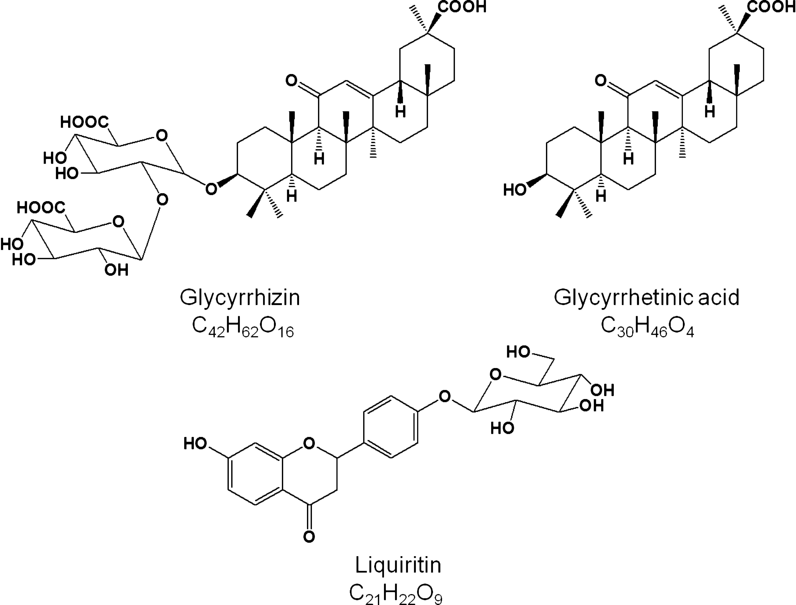

Figure 1. Structures of three major isolated pure compounds from G. uralensis.

mediated type I collagen gene transcription, and suppress experimental murine liver ﬁbrosis.17 Flavonoids from licorice
have been reported to exhibit potent radical-scavenging activity.18 A CO2-supercritical licorice extract exhibited potent
anti-inﬂammatory properties in LPS-induced IL-1β, -6, and -8
and TNF-α responses of macrophages.19 Furthermore, two isoﬂavans, licoricidin and licorisoﬂavan A, isolated from the
above supercritical licorice extract were potent inhibitors of the pro-inﬂammatory cytokine in the ex vivo human whole blood model, suggesting that these two isoﬂavans could be potential
candidates for the development of a new therapy to prevent and/or treat periodontitis-associated tissue destruction.20
However, the eﬀects of licorice against endogenous stimulation
such as TNF-α in hepatocytes are not clear.
The TNF-α-activated HepG2 cell model has been used for evaluating the translocation of the p65 of NF-κB subunits mediated by its inhibitor (IκBα) proteolysis.21 The hepatopro-
tective eﬀects of G. uralensis in TNF-α-induced HepG2 and rat primary hepatocyte inﬂammation were investigated in this
study.
■ MATERIALS AND METHODS
Materials and Equipment. Silica gel (230−400 mesh) and
Sephadex LH-20 (Amersham Biosciences, Uppsala, Sweden) were
used for column chromatography. Solvents (analytical grade) were purchased from Merck (Darmstadt, Germany). Nuclear magnetic resonance (NMR) spectra were run in methanol-d4 (Sigma-Aldrich Co., St. Louis, MO, USA) on a Varian unity INOVA-500 or VNMRS
600 (Varian, Palo Alto, CA, USA) using standard pulse sequences. Mass spectra (ESIMS) were recorded on a Finnigan MAT LCQ ion trap mass spectrometer system (Thermoquest, San Jose, CA, USA).
Dulbecco’s modiﬁed Eagle’s medium (DMEM) and nonessential
amino acids (NEAA) were purchased from Gibco BRL (Carlsbad, CA,
USA). Fetal bovine serum (FBS) was purchased from Gibco BRL (Gaithersburg, MD, USA). pNF-κB-Luc was purchased from Stratagene (La Jolla, CA, USA). pCMV-β-gal was purchased from Life Technologies (Grand Island, NY, USA). Antiphospho-IκBα, antiphospho-IKKα/β, anti-p65, anti-lamin A/C, and anti-α-tubulin
monoclonal antibodies were purchased from Cell Signaling (Danvers, MA, USA). HRP conjugated secondary antibodies were used. Pyrrolidine dithiocarbamate (PDTC) was purchased from Merck. All other chemicals used were of analytical grade and purchased from a commercial supplier (Sigma-Aldrich Co.).
Preparation of G. uralensis Extract and Isolation of Pure Compounds. G. uralensis was purchased from an herbal retailer in Taipei. A voucher herbarium specimen has been deposited at the Herbarium of National Research Institute of Chinese Medicine
(NRICM) (NHP00917) and was identiﬁed by Dr. I-Jung Lee,
herbarium leader of NRICM. The dried slices of G. uralensis (3 kg)
were extracted at 60 °C by aqueous ethanol (80% ethanol/H2O) overnight three times. The extract was concentrated with a vacuum rotary evaporator under reduced pressure and dried in a vacuum oven (491 g). The dried sample (GUE, about 16.4% yield based on dry raw materials) was sequentially partitioned with ethyl acetate (EtOAc) and n-butanol (BuOH) to give ethyl acetate- (GUE-EtOAc, 87.8 g, 2.93% of raw materials), n-butanol- (GUE-BuOH, 125.2 g, 4.17% of raw materials), and water- (GUE-H2O, 265.3 g, 8.84% of raw materials) soluble fractions. The bioactive fraction, GUE-EtOAc, was chromato- graphed by silica gel column (5.5 × 60 cm) and eluted with an n-
hexane/EtOAc gradient. The active fraction of 30−50% EtOAc elute was further puriﬁed over Sephadex LH-20 (3.8 × 40 cm, 50% EtOAc/
MeOH elution) and then silica gel columns (2.8 × 30 cm, 30 or 40%
EtOAc/n-hexane) to give glycyrrhetinic acid (0.024 g). The other two major components, glycyrrhizin (1.03 g) and liquiritin (1.35 g), were isolated from the BuOH subfraction by repeated Sephadex LH-20 column chromatography (Figure 1). All of the isolated compounds
were mainly identiﬁed by 1D- and 2D-NMR and MS and further
compared with an authentic sample, respectively (see the Supporting
Information). For bioassay, the extracts and isolated pure compounds were all dissolved in dimethyl sulfoxide (DMSO) and diluted with a
medium to give a ﬁnal DMSO concentration of <0.1%. The vehicle
control group contained 0.1% DMSO. Curcumin, a bioactive phenol
compound from the Zingiberaceae family, was used as a positive control.22,23
Cell Culture. HepG2 cells were obtained from the Bioresource
Collection and Research Center (BCRC, Food Industry Research and Development Institute, Hsinchu, Taiwan, no. 60025) and were cultured with DMEM containing 10% heat-inactivated FBS, 2%
NEAA, and 2% glutamine in a 5% CO2 incubator at 37 °C. Cells were

detached with trypsin−EDTA solution. After washing, the cells were resuspended in fresh medium and used for subsequent experiments.
Cytotoxicity Assay. The assay of reduction of 3-(4,5-dimethylth- iazol-2-yl)-2,5-diphenyltetrazolium bromide (MTT) was performed to evaluate the cytotoxicity of crude extract, subfractions, and isolated pure compounds. All test samples mentioned above were dissolved in
DMSO, and the ﬁnal concentration of DMSO was <0.1%; 0.1%
DMSO was used as the control group.
Transfection and Reporter Assay. Transient transfection was conducted with Genejuice (Merck) according to the instructions of
the manufacturer. HepG2 cells were seeded into 24-well plates at a density of 1 × 105 cells/well and cotransfected with the pNF-κB-Luc (0.2 μg/well) and pCMV-β-gal (0.02 μg/well). The total DNA amount was normalized with empty vectors in the transfection mixture. After transfection (24 h), the cells were cultured in FBS-free DMEM for the treatment of the test sample for 30 min and then incubated in TNF-α (10 ng/mL) for another 6 h. The total cells were
harvested for luciferase assay. The luciferase assay was conducted using a 96-well luminometer with the dual luciferase substrate system (Promega, Madison, WI, USA). Relative luciferase activity was normalized to the β-gal assay and presented as the ratio of cells with and without TNF-α treatment. Each experiment was repeated at least three times.
mRNA Expression of iNOS, COX-2, and IL-8 by Real-Time
Polymerase Chain Reaction (PCR). HepG2 cells were seeded into
6-well plates at a density of 5 × 105 cells/well. After incubation overnight, cells were washed with PBS, and the medium was replaced
with FBS-free DMEM. After 24 h of starvation, cells were pretreated
with test samples for 6 h and then stimulated with TNF-α (10 ng/mL)
for another 3 h. After washing with cold phosphate-buﬀered saline
(PBS), the total RNA was prepared by TriPure isolation reagent
(Roche, Mannheim, Germany) following the manufacturer’s direc- tions. After that, cDNA preparation and PCR were performed by a
RevertAid First Strand cDNA synthesis kit (Fermentas, USA)
according to the manufacturer’s protocol. For real-time PCR, the ampliﬁcation was carried out in a total volume of 20 μL containing 0.5
μM of each primer, 4 mM MgCl2, 10 μL of SYBR Green Master (Roche), and 10 μL of 1:10 diluted cDNA. Real-time PCR was performed using the LightCycler480 (Roche), and PCR reactions were performed in duplicate and heated to 95 °C for 5 min, followed by 45 cycles of denaturation at 95 °C for 10 s, annealing at 55 °C for 10 s, and extension at 72 °C for 12 s. The sequences of primers for real-time PCR are listed in Table S1 (Supporting Information). Data are
represented as the fold induction of inﬂammatory-related genes by
TNF-α-induced compared to the spontaneous group. PDTC, a speciﬁc
NF-κB inhibitor, was used as a positive control.24
Protein Preparation and Western Blotting. HepG2 cells were seeded into a 10 cm culture plate at a density of 2 × 106. After incubation overnight, cells were washed with PBS and the medium was replaced with FBS-free DMEM. After 24 h of starvation, cells were pretreated with test samples for 6 h and then stimulated with TNF-α
(10 ng/mL) for another 30 min. The cells were washed twice with ice- cold PBS and then lysed in RIPA lysis buﬀer (20 mM Tris-HCl, 2 mM
EDTA, 500 μM sodium orthovanadate, 10 μg/mL aprotinin, 10 mM NaF, 1% Triton X-100, and 0.1% SDS, pH 7.4) on ice for 20 min. The
total cell lysates were clariﬁed by centrifugation at 10000g for 30 min
at 4 °C. The supernatants were collected for phosphor-IκBα assay.
For nuclear p65 assay, nuclear extraction was performed by a nuclear extraction kit (Millipore, Billerica, MA, USA). Brieﬂy, HepG2 cells were lysed in ice-cold cytoplasmic lysis buﬀer and incubated on
ice for 15 min. After centrifugation at 10000g for 5 min at 4 °C, the
supernatants were discarded and the cell pellets resuspended with ice- cold cytoplasmic lysis buﬀer. After cytoplasma extraction by syringing
with a 27 gauge needle, the supernatants were removed, and the remaining pellet consisted of the nuclear portion of the cell lysates.
The nuclear pellet was suspended in ice-cold nuclear extraction buﬀer
and incubated for 1 h. Nuclear proteins were harvested in the
supernatant after centrifugation at 10000g for 10 min at 4 °C.
The protein contents of the supernatants were measured with the
Bio-Rad Protein Assay Kit. Equal amounts (50 μg) of the samples

were subjected to SDS-PAGE using 10% running gels and then transferred onto a PVDF membrane. The membrane was blocked with
5% nonfat milk in TBS-Tween buﬀer (25 mM Tris, 190 mM NaCl,
and 0.5% Tween-20, pH 7.5) for 1 h at room temperature and
subsequently incubated overnight at 4 °C with appropriate primary antibodies. After hybridization with the primary antibodies, the
membrane was incubated with an HRP-labeled secondary antibody for 1 h. Following washing with TBS-Tween buﬀer, the membrane was
developed with enhanced chemiluminescence (ECL) Western blotting reagents (Amersham Pharmacia Biotech). Immunoblot images were analyzed by ImageJ (NIH, USA).
Isolation and Culture of Primary Rat Hepatocytes. Isolation of rat hepatocytes from Sprague−Dawley (SD) rats was performed using
the two-step collagenase perfusion method outlined in a previous study.25 The isolated hepatocytes were cultured in Leibovitz L-15 medium supplemented with 10% FBS, 45 μg/mL penicillin G, and 50 μg/mL streptomycin in collagen-precoated 24-well plates (1 × 105 cells/mL) and incubated under 5% CO2 in air at 37 °C.
Assay of NO Release. An NO release assay was carried out according to the method described by Chen et al.26 Brieﬂy, rat primary
hepatocytes were seeded at 1 × 105 cells/well in a 96-well plate. After a washing with PBS, cells were pretreated with glycyrrhetinic acid (40 μM) for 6 h and then incubated with 10 ng/mL TNF-α for another 24
h. The supernatant (100 μL) was mixed with the same volume of Griess reagent (1% sulfanilamide in 5% phosphoric acid and 0.1% N- (1-naphthyl)ethylenediamine dihydrochloride in water) and incubated for 15 min in the dark. The absorbance of the water-soluble purplish- red product was read at 570 nm with an enzyme-linked
immunosorbent assay (ELISA) reader. The amount of NO was calculated by a calibration curve established with 1.5−100 μM NaNO2.
Statistical Analysis. Results are expressed as the mean ± standard deviation (SD) for three independent experiments. Diﬀerences between speciﬁc means were analyzed by one-way analysis of variance
(ANOVA) using the SPSS system, vers. 11.0 (SPSS, Chicago, IL,
USA). Group means were compared using one-way ANOVA followed by S−N−K test. p values of <0.05 were considered signiﬁcant.
■ RESULTS
Extracts and Isolated Compounds of G. uralensis
Attenuated the NF-κB Activation in TNF-α-Induced
HepG2 Cells. The cytotoxicity of the extracts of G. uralensis
were measured by MTT assay. Results showed that the ethanolic crude extract (GUE) and its subfractions have no
direct cytotoxicity to HepG2 cells at the working concen-
trations (5−25 μg/mL) (Figure S1 in the Supporting
Information). To determine the eﬀect of G. uralensis on
TNF-α-induced NF-κB activation, HepG2 cells were trans-
fected with NF-κB cis-reporter plasmid, pNF-κB-Luc, which contains ﬁve repeats of NF-κB binding element GGGGAC-
TTTCC in the enhancer element of the plasmid. Thereafter, cells were pretreated with or without 30 min GUE and its subfractions and then incubated with TNF-α (10 ng/mL) for 6
h. As shown in Figure 2, TNF-α signiﬁcantly increased the NF-
κB activation by a factor of 2.1 over the spontaneous control.
GUE (25 μg/mL) treatment clearly attenuated the NF-κB activation induced by TNF-α with an IC50 = 18.1 ± 2.8 μg/mL. In addition, GUE-EtOAc suppressed the activation of NF-κB at a lower concentration (10 μg/mL), but not in other subfractions. This result may imply that bioactive compounds exist in the EtOAc subfraction of GUE.
Under activity-guided fractionation to investigate the bioactive components in G. uralensis, glycyrrhetinic acid was isolated from GUE-EtOAc as an active compound. Two other major pure compounds were isolated from GUE-BuOH, named glycyrrhizin and liquiritin, for comparison. Figure 3 shows that
glycyrrhetinic acid signiﬁcantly decreased the activation of NF-

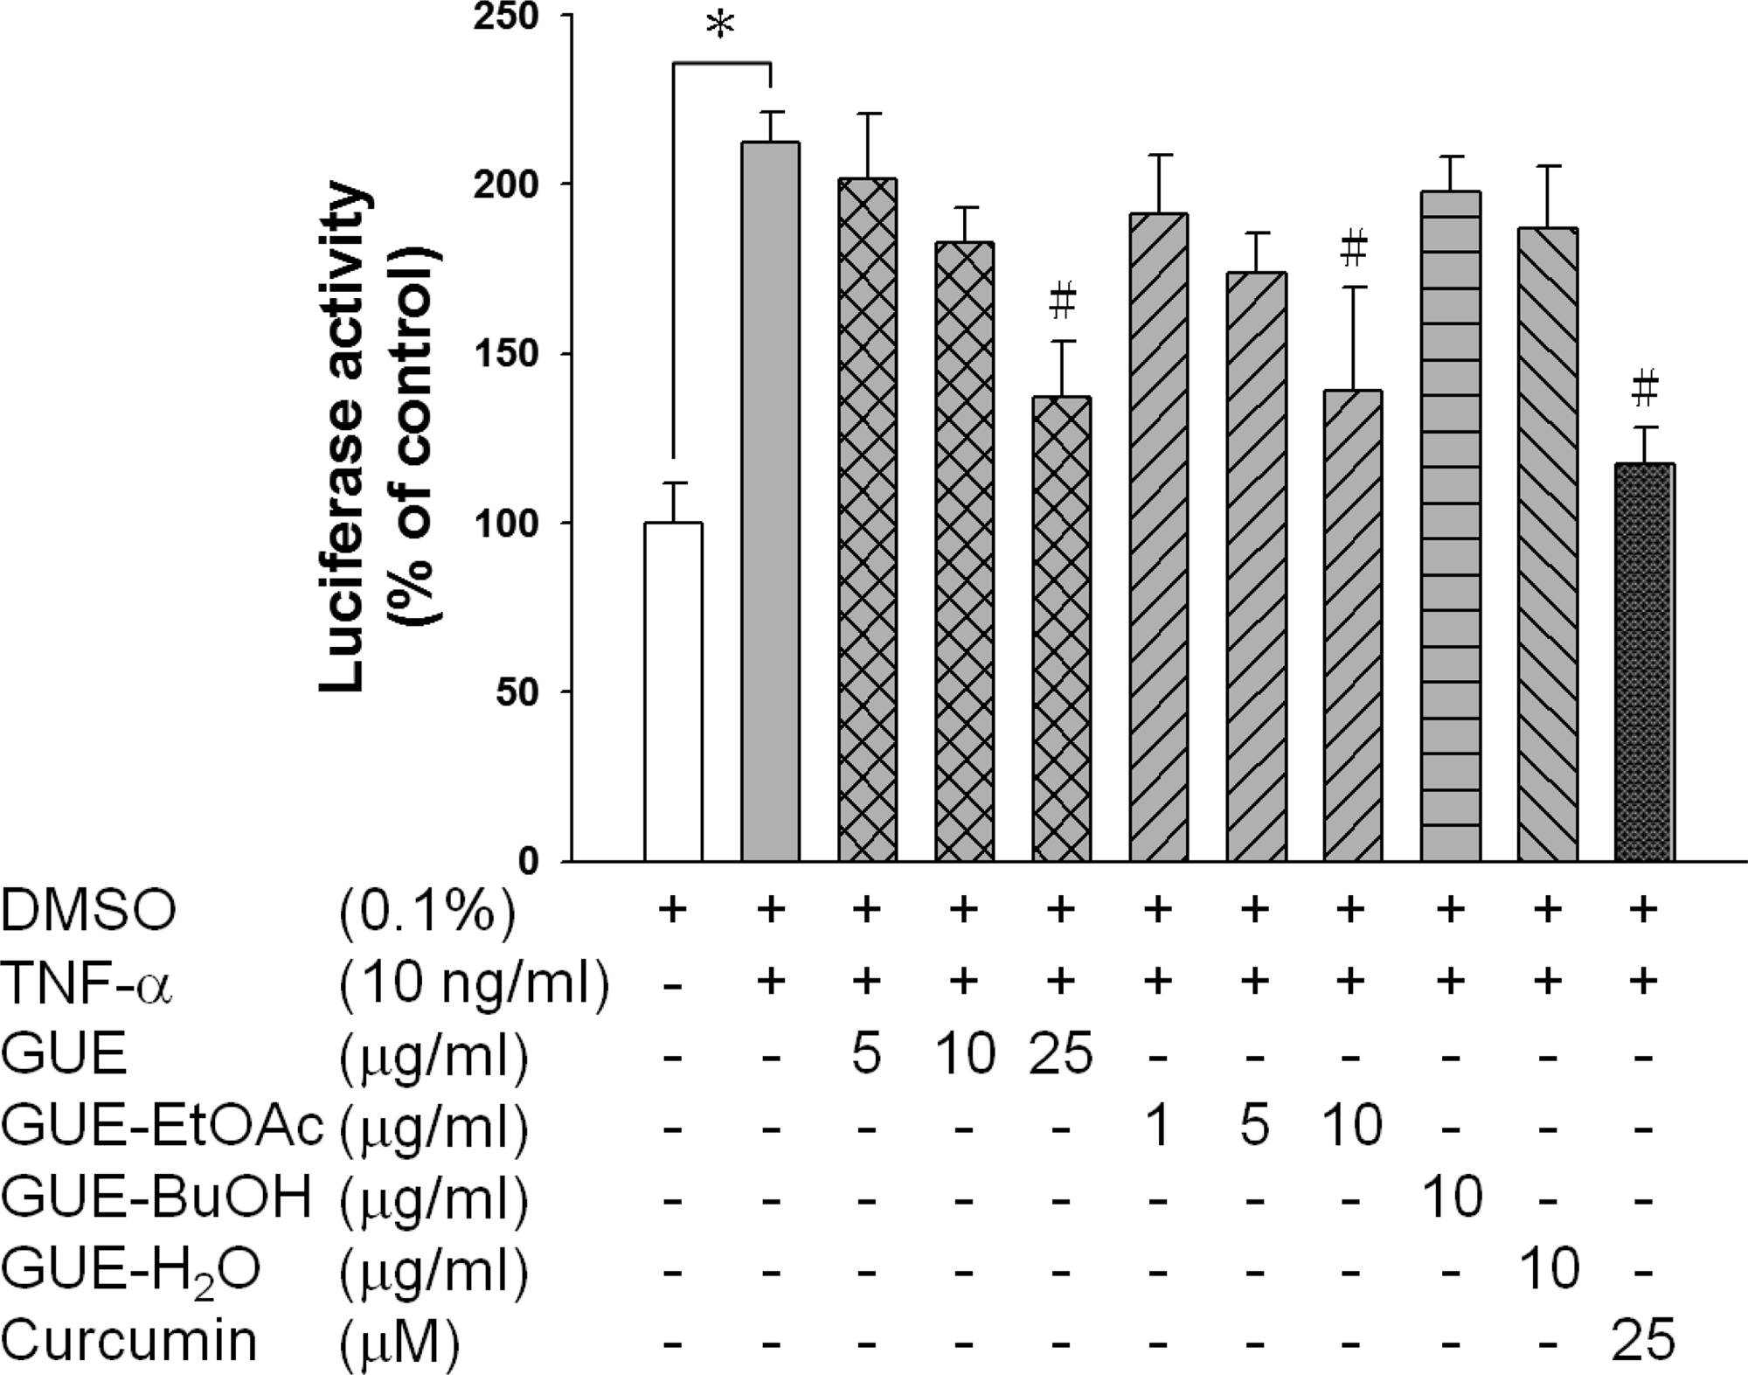
Figure 2. Eﬀect of extracts of G. uralensis on the TNF-α-induced NF- κB activation in HepG2 cells. HepG2 cells were transiently cotransfected with pNF-κB-Luc and pCMV-β-gal for 24 h. The transfected cells were pretreated with or without test samples for 30 min, prior to 6 h of treatment with TNF-α (10 ng/mL). Spontaneous HepG2 cells acted as a negative control. Cells were then harvested, and luciferase activities were assessed with normalization by β-gal assay. Curcumin was used as a positive control. Data are presented as
the mean ± SD of three independent experiments. ∗, p < 0.05,
compared with the spontaneous control. #, p < 0.05, compared with
the TNF-α-induced group.

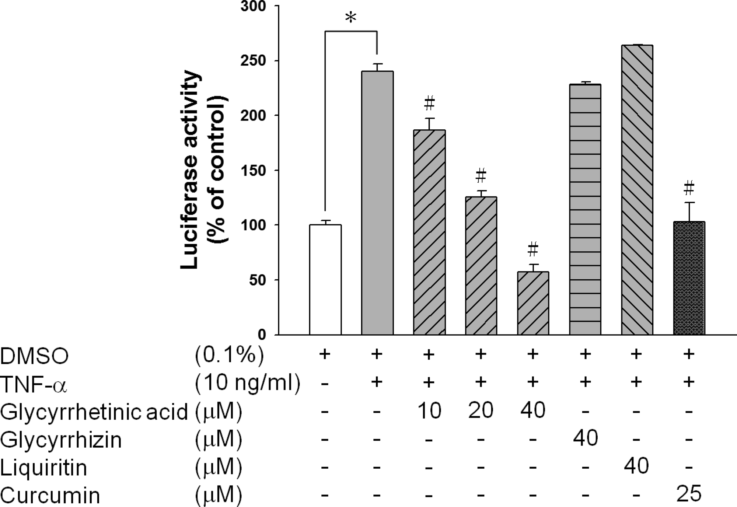
Figure 3. Eﬀect of pure compounds isolated from G. uralensis on the activation of NF-κB in TNF-α-induced HepG2 cells. HepG2 cells were cotransfected with pNFκB-Luc and pCMV-β-gal for 24 h. The transfected cells were pretreated with or without various concen- trations of pure compounds isolated from GUE for 30 min followed by TNF-α (10 ng/mL). After 6 h of incubation, the luciferase and β-gal
activity assays were performed. The eﬃciency of transfection was
normalized by β-gal activity. Curcumin was used as a positive control.
Data are presented as the mean ± SD of three independent experiments. ∗, p < 0.05, compared with the spontaneous control. #,
p < 0.05, compared with the TNF-α-induced group.

κB in a concentration-dependent manner (10−40 μM, R =
0.898, p < 0.05). However, glycyrrhizin and liquiritin have no eﬀects in this NF-κB reporter gene assay even at a
concentration of 40 μM. For a positive control, curcumin has an anti-inﬂammatory eﬀect, as shown in the inhibition of NF-
κB activation at 25 μM.

Glycyrrhetinic Acid Suppressed the Gene Expression of iNOS and COX-2 but Not IL-8 in TNF-α-Induced
HepG2 Cells. To evaluate the expression of inﬂammatory
genes in TNF-α-induced HepG2 cells, quantitative real-time
PCR was performed. After prescreening of the gene expressions in TNF-α-induced HepG2 cells, iNOS, COX-2, and IL-8 were selected as indicators for further experiments. As shown in Figure 4, HepG2 cells were stimulated with TNF-α (10 ng/ mL) for 3 h, and the mRNA expressions of iNOS, COX-2, and
IL-8 were signiﬁcantly enhanced compared with the sponta-
neous control (2.3-, 3.1-, and 4.3-fold, respectively). Glycyr-
rhetinic acid (40 μM) dramatically suppressed the mRNA
expression of iNOS and COX-2 by 57 and 53%, respectively. However, the mRNA expression of IL-8 showed no signiﬁcant
changes in either glycyrrhetinic acid or curcumin in TNF-α- induced HepG2 cells.
Glycyrrhetinic Acid Suppressed the TNF-α-Induced
Activation of NF-κB via Decreased Phosphorylation of IκBα and Translocation of p65. To explore whether glycyrrhetinic acid inhibition of iNOS expression is mediated by blocking the IκBα/NF-κB pathway, the protein levels of phospho-IκBα in cytosol and NF-κB p65 in the nucleus were analyzed by Western blotting. With or without pretreatment of glycyrrhetinic acid (40 μM) for 6 h, HepG2 cells were stimulated with TNF-α for 30 min. After TNF-α treatment, phosphorylation of IκBα in cytosol was apparently increased, because IκBα was degraded by ubiquitination. Thereby, NF-κB was activated (Figure 5A). Moreover, the translocation of p65 from cytosol into the nucleus revealed that the transcription factor, NF-κB, was activated in the nucleus (Figure 5B). Glycyrrhetinic acid suppressed the phosphorylation of Akt, inhibited the activation of IKK-α/β, and decreased the phosphorylation of IκBα, thereby inactivating NF-κB activity.
PDTC, a speciﬁc inhibitor of NF-κB activation, inhibited the
nuclear translocation of the NF-κB p65 subunit by reducing
IκBα degradation and served as a positive control.
Glycyrrhetinic Acid Has an Anti-inﬂammatory Eﬀect
on TNF-α-Induced Rat Primary Hepatocytes. To clarify the anti-inﬂammatory eﬀect on the liver ex vivo, the rat primary
hepatocytes were stimulated by TNF-α and all samples were tested at noncytotoxic concentration as shown in Figure S2 (Supporting Information). NO is a molecular mediator of many
physiological processes, including inﬂammation. After 24 h of
rat primary hepatocyte stimulation by TNF-α, the nitrite
concentration in the culture medium was measured as an indicator of NO production according to the Griess reaction. TNF-α (10 ng/mL) caused distinct increase of NO production compared to the spontaneous control (18.1 vs 10.7 μM, p <
0.05). As shown in Figure 6A, glycyrrhetinic acid signiﬁcantly
decreased NO production. Moreover, the biosynthesis gene,
iNOS, was investigated at the transcription level by quantifying the mRNA level. TNF-α-induced iNOS expression was
signiﬁcantly reduced by 62% by glycyrrhetinic acid (Figure
6B). Curcumin served as the positive control showing anti-
inﬂammatory eﬀects in both NO production and iNOS
expression.
■

DISCUSSION
In the present study, the NF-κB reporter gene assay was performed to evaluate the hepatoprotective qualities of G. uralensis. We demonstrated that glycyrrhetinic acid (a) attenuated the activation of NF-κB in a concentration-
dependent manner (10−40 μM); (b) decreased the mRNA

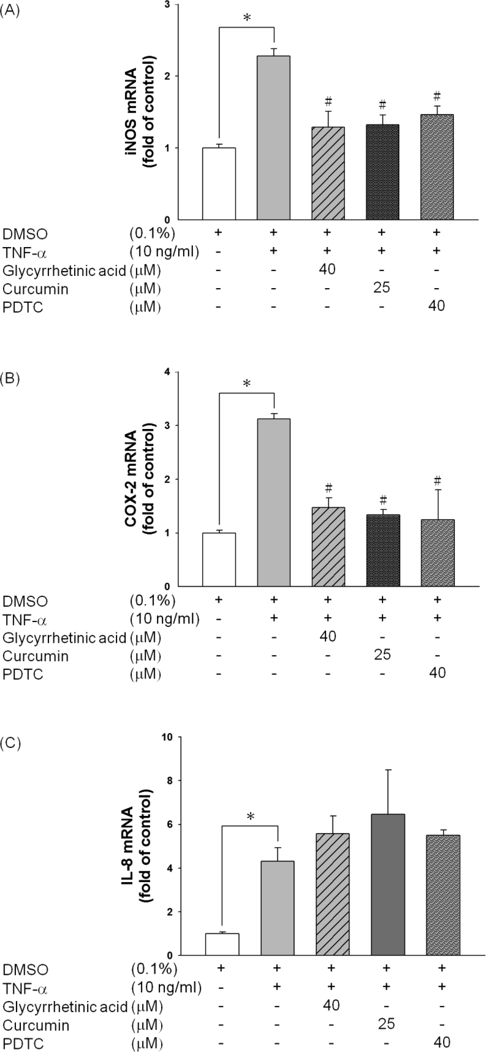
Figure 4. Eﬀect of glycyrrhetinic acid on the mRNA expression of iNOS (A), COX-2 (B), and IL-8 (C) in TNF-α-induced HepG2 cells. HepG2 cells were pretreated with glycyrrhetinic acid (40 μM) for 6 h, followed by treatment with TNF-α (10 ng/mL) for 3 h. The expression of iNOS, COX-2, or IL-8 mRNA was analyzed by quantitative real-time PCR. The level of iNOS, COX-2, or IL-8 mRNA expression was normalized to GAPDH. Curcumin and PDTC were used as positive controls. Data are presented as the mean ± SD
of three independent experiments. ∗, p < 0.05, compared with the
spontaneous control. #, p < 0.05, compared with the TNF-α-induced
group.

levels of iNOS and COX-2; (c) signiﬁcantly inhibited the phosphorylation of IκBα and nuclear translocation of p65 in TNF-α-induced HepG2 cells; and (d) reduced NO production

via suppression of iNOS expression in TNF-α-induced rat primary hepatocytes.
TNF-α is a pleiotropic cytokine triggering pro-inﬂammatory eﬀects via NF-κB related pathways in various liver injuries.
Therefore, therapeutic intervention in TNF-α/NF-κB signaling is technically feasible and could be of potential beneﬁt in inﬂammatory liver disease.27 Wu et al. reported that a n-
hexane/ethanol (9:1; v/v) nonpolar extract of licorice inhibited
LPS-induced nitrate oxide production in RAW 264.7 cells and also showed Nrf2-dependent transcriptionally active Nrf2- mediated antioxidant and induced phase II detoxifying agents genes in the Nrf2 knocked out mice.28 Recently, Chen et al. reported that glycyrrhetinic acid (25 mg/kg, ig) protects the liver from CCl4-induced oxidative stress through activation of the Nrf2 signaling, thereby reserving its hepatoprotective
eﬀect.29 Furthermore, with chemical acute toxicity, endogenous
factors, such as TNF-α and LPS, stimulate hepatocytes, causing chronic liver inﬂammation.1,30 Ngan et al. reported that Ginkgo biloba revealed anti-inﬂammatory eﬀects via activation of the
PPARs transcriptional activity in TNF-α-induced HepG2 cell.31
In our study, we focused on the role of G. uralensis in TNF-α- induced chronic liver inﬂammation. GUE and GUE-EtOAc
attenuated the activation of NF-κB induced by TNF-α in a concentration-dependent manner with IC50 values of 18.1 ± 2.8 and 8.5 ± 3.2 μg/mL, respectively. Glycyrrhetinic acid, the bioactive compound isolated from GUE-EtOAc, showed
suppression eﬀects on NF-κB activation with an IC50 value of
14.3 ± 1.1 μM (∼6.73 μg/mL) by reporter gene assay. A
previous study demonstrated that glycyrrhetinic acid inhibited
NF-κB activation in TNF-α-activated HUVEC cells.32 Our ﬁndings provide evidence that glycyrrhetinic acid protects the liver from inﬂammation via inactivation of NF-κB signaling.
Curcumin, as a positive control, has also been reported with hepatoprotective and anti-inﬂammatory eﬀects via suppression
of NF-κB activation both in vivo22 and in vitro.23
The transcription factor NF-κB is important for the regulation of various genes involved in immune and acute
phase inﬂammatory responses.8 Most anti-inﬂammatory func-
tional foods, such as mulberry leaf,33 Dunaliella salina alga,34 and Magnolia oﬃcinalis,35, have been shown to suppress the expression of pro-inﬂammatory genes by inhibiting the NF-κB
activation pathway. The NF-κB signal transduction pathway is
directly engaged by the TNFR/Akt/IKK pathway with TNF-α stimulation.36 Our study showed that glycyrrhetinic acid markedly suppressed NF-κB activation through the suppression of Akt phosphorylation and inhibition of IκBα phosphorylation, thereby inhibiting p65 translocation (Figures 3 and 5). These
results are coincident with the eﬀect of curcumin on NF-κB
signaling.37 The pro-inﬂammatory-related genes, inducible
iNOS, COX-2, and IL-8, are downstream from NF-κB and are
related to liver diseases. When a liver is damaged, iNOS is induced, followed by increased NO production, thereby
decreasing the liver’s detoxiﬁcation ability and resulting in
ﬁbrosis or hepatitis.38 COX-2 is a pro-inﬂammatory mediator
that is correlated with chronic hepatitis, liver cirrhosis, and
hepatocarcinogenesis.39 IL-8, which is produced in response to stimulation by TNF-α, is a potent chemokine that may be
implicated in inﬁltration of neutrophils causing acute
hepatitis.40 Our results showed that the mRNA expressions of
iNOS, COX-2, and IL-8 were signiﬁcantly enhanced after being
stimulated with TNF-α for 3 h in HepG2 cells. Glycyrrhetinic acid eﬀectively suppressed mRNA expression of iNOS and
COX-2, but not that of IL-8 (Figure 4). Various transcription

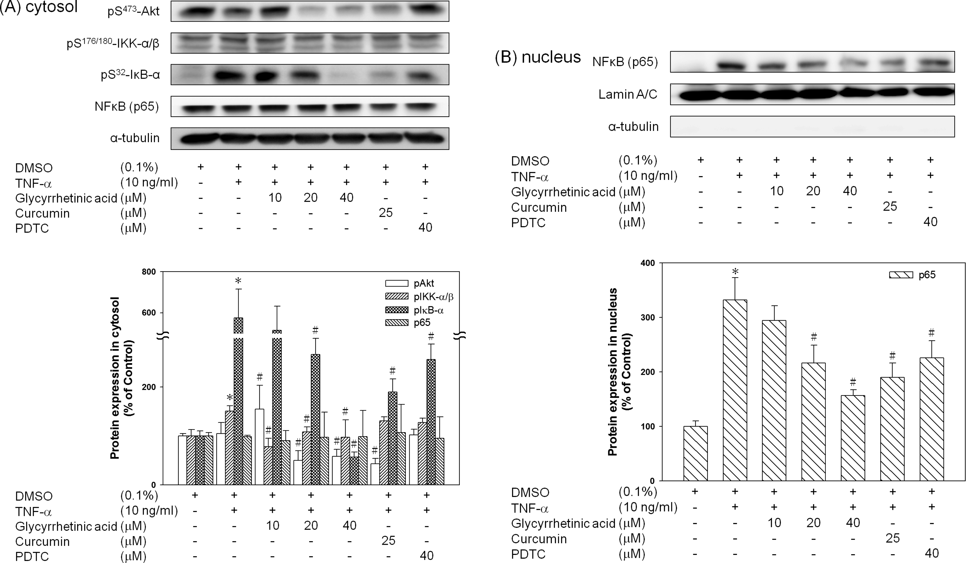
Figure 5. Eﬀect of glycyrrhetinic acid on (A) TNFR/Akt/NF-κB signaling and (B) p65 translocation in TNF-α-induced HepG2 cells. HepG2 cells were pretreated glycyrrhetinic acid (40 μM) for 6 h, followed by treatment with TNF-α (10 ng/mL) for 30 min. The total cell lysate was collected to detect the levels of phospho-Akt, -IKKα/β, and -IκBα, and the nucleus lysate was collected to detect the level of p65 by Western blotting. Curcumin
and PDTC were used as positive controls. Data are presented as the mean ± SD of three independent experiments. ∗, p < 0.05, compared with the
spontaneous control. #, p < 0.05, compared with the TNF-α-induced group.

factors induced by TNF-α such as NF-κB and AP-1 modulate
IL-8 expression.41 The eﬀect of glycyrrhetinic acid on the
regulation of AP-1 in TNF-α-induced hepatocytes is not clear
and remains to be further investigated.
Although HepG2 is frequently used to replace primary human hepatocytes in in vitro models for various experiments,
cell lines still have some restriction such as lack of phase I enzymes and thereby cannot reﬂect real organisms.42 There- fore, we further isolated primary rat hepatocytes to conﬁrm the eﬀects of glycyrrhetinic acid on TNF-α-induced inﬂammation.
Modulation of iNOS gene expression and suppression of NO

acid attenuate the generation of excessive NO, by suppressing the expression of pro-inﬂammatory genes via inhibition of NF-
κB in a LPS-induced RAW 264.7 cell model.46 This result may
imply that glycyrrhizin cannot competitively inhibit the TNF receptor to inactive the NF-κB. Therefore, the suppression of NF-κB activation by glycyrrhizin may go through other pathways, such as the PI3K/Akt/GSK3β pathway.47 Further-
more, roasted licorice extract inhibits acute inﬂammation more
potently than raw licorice extract, and the glycyrrhetinic acid
48

production are important targets for anti-inﬂammatory proper-
levels in licorice are increased after roasting.
Our results

ties in screening natural compounds.43 Our results showed that glycyrrhetinic acid inhibited NO production and concomitantly suppressed iNOS expression at the mRNA level in primary hepatocytes (Figure 6). These results were also supported by the hepatoprotective property of G. uralensis in animal models.44
Glycyrrhizin and glycyrrhetinic acid are two major bioactive components in G. uralensis.45 Glycyrrhizin, a glucuronide of glycyrrhetinic acid, is much more polar. It may hydrolyze in vivo to glycyrrhetinic acid, which is responsible for most of its pharmacological properties. Lin et al. reported that a 3 day pretreatment with either glycyrrhizin (200 mg/kg, ip) or
glycyrrhetinic acid (10 mg/kg, ip) exhibited protective eﬀects
on retrorsine-induced liver damage in rats.16 However,
glycyrrhizin may have too high of a polarity to pass through the cell membrane. Therefore, it has not shown an eﬀect on
NF-κB activation in the in vitro study (Figure 3). Nonetheless, Wang et al. reported that both glycyrrhizin and glycyrrhetinic
support this ﬁnding and suggest that glycyrrhetinic acid, an
aglycone triterpene, may be a more potent inﬂammatory
inhibitor than its glycoside, glycyrrhizin. Likewise, liquiritin, a
glycoside of liquiritigenin with O-glucopyranosyl at C-4′ of the
B-ring, has no eﬀect in the reporter gene assay.
Our results suggest that glycyrrhetinic acid in G. uralensis
contributed, at least partially, to its anti-inﬂammatory eﬀect by
inactivating NF-κB through decreasing phosphorylation of IκB
and thereby inhibiting the translocation of p65. To our knowledge, this is the ﬁrst study related to the inhibitory eﬀect
of TNF-α/NF-κB signaling in hepatocytes demonstrating the anti-inﬂammatory ability of glycyrrhetinic acid. These ﬁndings
provide the molecular mechanisms for the hepatoprotective action of glycyrrhetinic acid against TNF-α-induced chronic
inﬂammation and may be beneﬁcial to the prevention of
chronic liver injury.

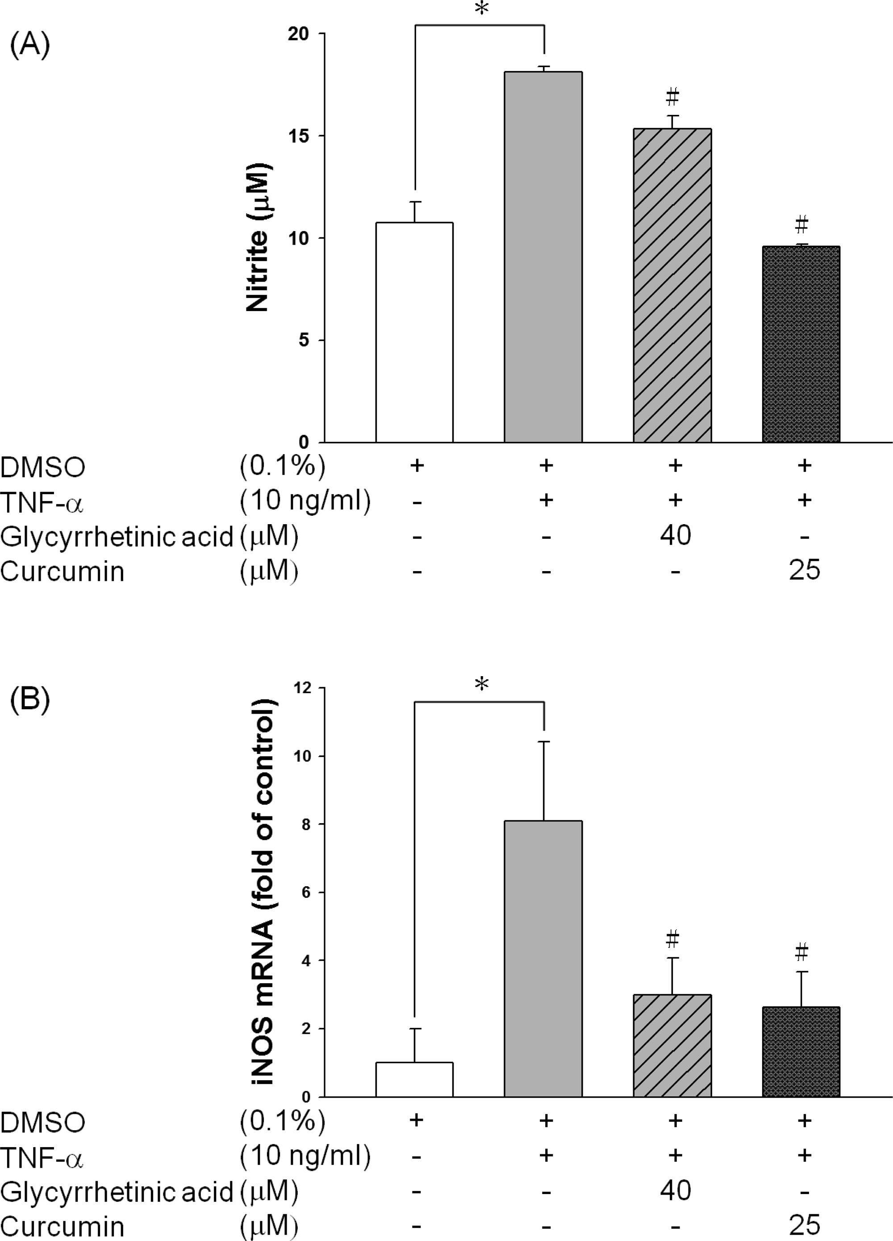
Figure 6. Eﬀect of glycyrrhetinic acid on (A) NO production and (B) iNOS mRNA expression in TNF-α-induced rat primary hepatocytes. Rat primary cells were pretreated with glycyrrhetinic acid (40 μM) for
6 h. NO production and iNOS mRNA expression waere measured after TNF-α (10 ng/mL) treatment for 24 and 6 h, respectively. Curcumin was used as a positive control. Data are presented as the
mean ± SD of three independent experiments. ∗, p < 0.05, compared
with the spontaneous control. #, p < 0.05, compared with the TNF-α-
induced group.

■ ASSOCIATED CONTENT

■ ABBREVIATIONS USED
DMSO, dimethyl sulfoxide; DMEM, Dulbecco’s modiﬁed
Eagle’s medium; (FBS, fetal bovine serum; GUE, ethanolic
extracts of Glycyrrhiza uralensis; iNOS, inducible nitric oxide synthase; IL-8, interleukin-8; NO, nitric oxide; NF-κB, nuclear factor-kappa B; PDTC, pyrrolidine dithiocarbamate; TNF-α, tumor necrosis factor-alpha; TNFR, TNF receptor
■

REFERENCES
(1) Tacke, F.; Luedde, T.; Trautwein, C. Inflammatory pathways in liver homeostasis and liver injury. Clin. Rev. Allergy Immunol. 2009, 36,
4−12.
(2) Tosello-Trampont, A. C.; Landes, S. G.; Nguyen, V.;
Novobrantseva, T. I.; Hahn, Y. S. Kuppfer cells trigger nonalcoholic steatohepatitis development in diet-induced mouse model through tumor necrosis factor-alpha production. J. Biol. Chem. 2012, 287,
40161−40172.
(3) Brenndorfer, E. D.; Weiland, M.; Frelin, L.; Derk, E.; Ahlen, G.;
Jiao, J.; Bode, J. G.; Sallberg, M. Anti-tumor necrosis factor alpha treatment promotes apoptosis and prevents liver regeneration in a transgenic mouse model of chronic hepatitis C. Hepatology 2010, 52,
1553−1563.
(4) Gabele, E.; Froh, M.; Arteel, G. E.; Uesugi, T.; Hellerbrand, C.;
Scholmerich, J.; Brenner, D. A.; Thurman, R. G.; Rippe, R. A. TNFα is required for cholestasis-induced liver fibrosis in the mouse. Biochem.
Biophys. Res. Commun. 2009, 378, 348−353.
(5) Tarrats, N.; Moles, A.; Morales, A.; Garcia-Ruiz, C.; Fernandez-
Checa, J. C.; Mari, M. Critical role of tumor necrosis factor receptor 1, but not 2, in hepatic stellate cell proliferation, extracellular matrix
remodeling, and liver fibrogenesis. Hepatology 2011, 54, 319−327.
(6) Sudo, K.; Yamada, Y.; Moriwaki, H.; Saito, K.; Seishima, M. Lack
of tumor necrosis factor receptor type 1 inhibits liver fibrosis induced by carbon tetrachloride in mice. Cytokine 2005, 29, 236−244.
(7) Hellerbrand, C.; Jobin, C.; Iimuro, Y.; Licato, L.; Sartor, R. B.; Brenner, D. A. Inhibition of NFκB in activated rat hepatic stellate cells
by proteasome inhibitors and an IκB super-repressor. Hepatology 1998,
27, 1285−1295.
(8) Robinson, S. M.; Mann, D. A. Role of nuclear factor κB in liver health and disease. Clin. Sci. (London) 2010, 118, 691−705.
(9) Tilg, H.; Kaser, A.; Moschen, A. R. How to modulate inflammatory cytokines in liver diseases. Liver Int 2006, 26, 1029−
1039.
(10) Zhiao, Z. Z.; Xiao, P. G. Encyclopedia of Medicinal Plants 1; Shanghai World Publishing: Shanghai, China, 2009; pp 436−441.
(11) Shin, Y. W.; Bae, E. A.; Lee, B.; Lee, S. H.; Kim, J. A.; Kim, Y. S.; Kim, D. H. In vitro and in vivo antiallergic effects of Glycyrrhiza glabra

and its components. Planta Med. 2007, 73, 257
−261.

* Supporting Information
Additional experimental details. This material is available free of charge via the Internet at http://pubs.acs.org.
■

AUTHOR INFORMATION
Corresponding Author
*(Y.-L.L.) Mailing address: National Research Institute of Chinese Medicine, Ministry of Health and Welfare, No. 155-1, Sec. 2, Linong St., Beitou District, Taipei 11221, Taiwan. Phone: +886-2-28201999, ext. 6531. Fax: +886-2-28250743. E- mail: yllin@nricm.edu.tw.
Funding
This work was supported by the National Science Council (NSC 99-2628-B-077-001-MY3) and the National Research Institute of Chinese Medicine (NRICM100-DMC-02) in Taiwan.
Notes
The authors declare no competing ﬁnancial interest.
(12) Wang, C.; Zhang, T.; Cui, X.; Li, S.; Zhao, X.; Zhong, X.
Hepatoprotective effects of a chinese herbal formula, longyin decoction, on carbon-tetrachloride-induced liver injury in chickens.
Evidence-Based Complement. Alternat. Med. 2013, 2013, 392743.
(13) Lee, J. K.; Kim, J. H.; Shin, H. K. Therapeutic effects of the oriental herbal medicine Sho-saiko-to on liver cirrhosis and carcinoma.
Hepatol. Res. 2011, 41, 825−837.
(14) Tsuruoka, N.; Abe, K.; Wake, K.; Takata, M.; Hatta, A.; Sato, T.;
Inoue, H. Hepatic protection by glycyrrhizin and inhibition of iNOS
expression in concanavalin A-induced liver injury in mice. Inflamm. Res. 2009, 58, 593−599.
(15) Lee, C. H.; Park, S. W.; Kim, Y. S.; Kang, S. S.; Kim, J. A.; Lee, S. H.; Lee, S. M. Protective mechanism of glycyrrhizin on acute liver
injury induced by carbon tetrachloride in mice. Biol. Pharm. Bull. 2007,
30, 1898−1904.
(16) Lin, G.; Nnane, I. P.; Cheng, T. Y. The effects of pretreatment
with glycyrrhizin and glycyrrhetinic acid on the retrorsine-induced hepatotoxicity in rats. Toxicon 1999, 37, 1259−1270.
(17) Moro, T.; Shimoyama, Y.; Kushida, M.; Hong, Y. Y.; Nakao, S.; Higashiyama, R.; Sugioka, Y.; Inoue, H.; Okazaki, I.; Inagaki, Y.
Glycyrrhizin and its metabolite inhibit Smad3-mediated type I collagen

gene transcription and suppress experimental murine liver fibrosis. Life
Sci. 2008, 83, 531−539.
(18) Fu, Y.; Chen, J.; Li, Y. J.; Zheng, Y. F.; Li, P. Antioxidant and
anti-inflammatory activities of six flavonoids separated from licorice.
Food Chem. 2013, 141, 1063−1071.
(19) Bodet, C.; La, V. D.; Gafner, S.; Bergeron, C.; Grenier, D. A
licorice extract reduces lipopolysaccharide-induced proinflammatory cytokine secretion by macrophages and whole blood. J. Periodontol.
2008, 79, 1752−1761.
(20) La, V. D.; Tanabe, S.; Bergeron, C.; Gafner, S.; Grenier, D.
Modulation of matrix metalloproteinase and cytokine production by licorice isolates licoricidin and licorisoflavan A: potential therapeutic
approach for periodontitis. J. Periodontol. 2011, 82, 122−128.
(21) Han, Y.; Brasier, A. R. Mechanism for biphasic rel A. NF-
kappaB1 nuclear translocation in tumor necrosis factor alpha- stimulated hepatocytes. J. Biol. Chem. 1997, 272, 9825−9832.
(22) Wu, S. J.; Tam, K. W.; Tsai, Y. H.; Chang, C. C.; Chao, J. C.
Curcumin and saikosaponin a inhibit chemical-induced liver inflammation and fibrosis in rats. Am. J. Chin. Med. 2010, 38, 99−111.
(23) Kuo, J. J.; Chang, H. H.; Tsai, T. H.; Lee, T. Y. Curcumin
ameliorates mitochondrial dysfunction associated with inhibition of gluconeogenesis in free fatty acid-mediated hepatic lipoapoptosis. Int.
J. Mol. Med. 2012, 30, 643−649.
(24) Brennan, P.; O’Neill, L. A. Effects of oxidants and antioxidants
on nuclear factor kappa B activation in three different cell lines:
evidence against a universal hypothesis involving oxygen radicals.
Biochim. Biophys. Acta 1995, 1260, 167−175.
(25) Lin, Y. L.; Wu, C. H.; Luo, M. H.; Huang, Y. J.; Wang, C. N.;
Shiao, M. S.; Huang, Y. T. In vitro protective effects of salvianolic acid
B on primary hepatocytes and hepatic stellate cells. J. Ethnopharmacol.
2006, 105, 215−222.
(26) Chen, H. J.; Chung, C. P.; Chiang, W.; Lin, Y. L. Anti-
inflammatory effects and chemical study of a flavonoid-enriched fraction from adlay bran. Food Chem. 2011, 126, 1741−1748.
(27) Liedtke, C.; Trautwein, C. The role of TNF and Fas dependent
signaling in animal models of inflammatory liver injury and liver cancer. Eur. J. Cell Biol. 2012, 91, 582−589.
(28) Wu, T. Y.; Khor, T. O.; Saw, C. L.; Loh, S. C.; Chen, A. I.; Lim,
S. S.; Park, J. H.; Cai, L.; Kong, A. N. Anti-inflammatory/anti-oxidative stress activities and differential regulation of Nrf2-mediated genes by non-polar fractions of tea Chrysanthemum zawadskii and licorice
Glycyrrhiza uralensis. AAPS J. 2011, 13, 1−13.
(29) Chen, S.; Zou, L.; Li, L.; Wu, T. The protective effect of
glycyrrhetinic acid on carbon tetrachloride-induced chronic liver fibrosis in mice via upregulation of Nrf2. PLoS One 2013, 8, e53662. (30) Seki, E.; Schnabl, B. Role of innate immunity and the microbiota in liver fibrosis: crosstalk between the liver and gut. J. Physiol. 2012,
590, 447−458.
(31) Ngan, N. T.; Quang, T. H.; Tai, B. H.; Song, S. B.; Lee, D.; Kim,
Y. H. Anti-inflammatory and PPAR transactivational effects of components from the stem bark of Ginkgo biloba. J. Agric. Food
Chem. 2012, 60, 2815−2824.
(32) Chang, Y. L.; Chen, C. L.; Kuo, C. L.; Chen, B. C.; You, J. S.
Glycyrrhetinic acid inhibits ICAM-1 expression via blocking JNK and
NF-κB pathways in TNF-α-activated endothelial cells. Acta Pharmacol. Sin. 2010, 31, 546−553.
(33) Park, E.; Lee, S. M.; Lee, J.; Kim, J. H. Anti-inflammatory
activity of mulberry leaf extract through inhibition of NF-κB. J. Funct. Foods 2013, 5, 178−186.
(34) Yang, D. J.; Lin, J. T.; Chen, Y. C.; Liu, S. C.; Lu, F. J.; Chang, T.
J.; Wang, M.; Lin, H. W.; Chang, Y. Y. Suppressive effect of carotenoid extract of Dunaliella salina alga on production of LPS-stimulated pro-
inflammatory mediators in RAW264.7 cells via NF-κB and JNK
inactivation. J. Funct. Foods 2013, 5, 607−615.
(35) Lai, C. S.; Lai, Y. S.; Kuo, D. H.; Wu, C. H.; Ho, C. T.; Pan, M.
H. Magnolol potently suppressed lipopolysaccharide-induced iNOS
and COX-2 expression via downregulating MAPK and NF-κB
signaling pathways. J. Funct. Foods 2011, 3, 198−206.
(36) Ozes, O. N.; Mayo, L. D.; Gustin, J. A.; Pfeffer, S. R.; Pfeffer, L. M.; Donner, D. B. NF-kappaB activation by tumour necrosis factor
requires the Akt serine-threonine kinase. Nature 1999, 401, 82−85.
(37) Kim, K. H.; Lee, E. N.; Park, J. K.; Lee, J. R.; Kim, J. H.; Choi,
H. J.; Kim, B. S.; Lee, H. W.; Lee, K. S.; Yoon, S. Curcumin attenuates
TNF-alpha-induced expression of intercellular adhesion molecule-1, vascular cell adhesion molecule-1 and proinflammatory cytokines in
human endometriotic stromal cells. Phytother. Res. 2012, 26, 1037−
1047.
(38) Kanwar, J. R.; Kanwar, R. K.; Burrow, H.; Baratchi, S. Recent advances on the roles of NO in cancer and chronic inflammatory
disorders. Curr. Med. Chem. 2009, 16, 2373−2394.
(39) Kwon, S. H.; Jeong, S. W.; Jang, J. Y.; Lee, J. E.; Lee, S. H.; Kim,
S. G.; Kim, Y. S.; Cho, Y. D.; Kim, H. S.; Kim, B. S.; Jin, S. Y. Cyclooxygenase-2 and vascular endothelial growth factor in chronic
hepatitis, cirrhosis and hepatocellular carcinoma. Clin. Mol. Hepatol.
2012, 18, 287−294.
(40) Goral, V.; Atayan, Y.; Kaplan, A. The relation between
pathogenesis of liver cirrhosis, hepatic encephalopathy and serum cytokine levels: what is the role of tumor necrosis factor α? Hepato-
Gastroenterology 2011, 58, 943−948.
(41) Roebuck, K. A.; Carpenter, L. R.; Lakshminarayanan, V.; Page,
S. M.; Moy, J. N.; Thomas, L. L. Stimulus-specific regulation of chemokine expression involves differential activation of the redox-
responsive transcription factors AP-1 and NF-κB. J. Leukocyte Biol.
1999, 65, 291−298.
(42) Wilkening, S.; Stahl, F.; Bader, A. Comparison of primary
human hepatocytes and hepatoma cell line Hepg2 with regard to their biotransformation properties. Drug Metab. Dispos. 2003, 31, 1035−
1042.
(43) Conforti, F.; Menichini, F. Phenolic compounds from plants as nitric oxide production inhibitors. Curr. Med. Chem. 2011, 18, 1137−
1145.
(44) Yin, G.; Cao, L.; Xu, P.; Jeney, G.; Nakao, M.; Lu, C. Hepatoprotective and antioxidant effects of Glycyrrhiza glabra extract
against carbon tetrachloride (CCl4)-induced hepatocyte damage in common carp (Cyprinus carpio). Fish Physiol. Biochem. 2011, 37, 209−
216.
(45) Wang, Y. C.; Yang, Y. S. Simultaneous quantification of flavonoids and triterpenoids in licorice using HPLC. J. Chromatogr., B:
Anal. Technol. Biomed. Life Sci. 2007, 850, 392−399.
(46) Wang, C. Y.; Kao, T. C.; Lo, W. H.; Yen, G. C. Glycyrrhizic acid
and 18β-glycyrrhetinic acid modulate lipopolysaccharide-induced inflammatory response by suppression of NF-κB through PI3K
p110δ and p110γ inhibitions. J. Agric. Food Chem. 2011, 59, 7726−
7733.
(47) Kao, T. C.; Shyu, M. H.; Yen, G. C. Glycyrrhizic acid and 18β- glycyrrhetinic acid inhibit inflammation via PI3K/Akt/GSK3β signal-
ing and glucocorticoid receptor activation. J. Agric. Food Chem. 2010,
58, 8623−8629.
(48) Hwang, I. K.; Lim, S. S.; Choi, K. H.; Yoo, K. Y.; Shin, H. K.;
Kim, E. J.; Yoon-Park, J. H.; Kang, T. C.; Kim, Y. S.; Kwon, D. Y.; Kim, D. W.; Moon, W. K.; Won, M. H. Neuroprotective effects of roasted
licorice, not raw form, on neuronal injury in gerbil hippocampus after transient forebrain ischemia. Acta Pharmacol. Sin. 2006, 27, 959−965.

