Journal of Food and Nutrition Research
Potential Genitourinary Toxicity and Lithogenic Effect of Ractopamine
Wen-Chi Chen^{1,2} Yu-Chi Wang,³ Jui-Lung Shen,^{4,5} Huey-Yi Chen,^{1,2} Chiao-Hui Chang,^{1,2} Fuu-Jen Tsai,^{1,2}
Wei-Yong Lin,^{1,2} Yung-Hsiang Chen^{1,2,6,}*
¹ Graduate Institute of Integrated Medicine, College of Chinese Medicine, Research Center for Chinese Medicine & Acupuncture, China Medical University, Taichung 40402, Taiwan
² Departments of Obstetrics and Gynecology, Medical Research, and Urology, China Medical University Hospital, Taichung 40447, Taiwan
³ Department of Animal Science, Chinese Culture University, Taipei 11114, Taiwan
⁴ Center for General Education, Feng Chia University, Taichung 40724, Taiwan
⁵ Department of Dermatology, Taichung Veteran General Hospital, Taichung 40705, Taiwan
⁶ Department of Psychology, College of Medical and Health Science, Asia University, Taichung 41354, Taiwan
*Corresponding author: d87a03@ym.edu.tw

Received Month X, XXXX; revised Month X, XXXX; accepted Month X, XXXX
Abstract Ractopamine is a β-adrenoreceptor agonist that excites sympathetic nerves. It has been used to increase cattle weight, for breeding, and to enhance muscle content in some countries. The concentration allowed in the environment is below 10 parts per billion (ppb). However, there are increasing concerns about the effect of long-term ractopamine on health. Our study aimed to investigate the potential effects of a “safe” dosage of ractopamine on urinary tract by using genitourinary cell cultures and our well-established translational model, Drosophila melanogaster. The results showed that ractopamine dose-dependently induces cytotoxicity in SV40 MES 13 and SV-HUC-1 cells. After 21 days of 10 ppb ractopamine administration, the rate of crystal formation in the ractopamine group significantly increased. We also found that long-term administration of ractopamine to flies decreases their climbing ability and shortens their lifespan. Overall, the long-term effects of ractopamine on the urinary tract system were evident in our cell and animal studies. In particular, renal mesangial and urothelial cells are more susceptible to damage; urolithiasis and neurological damage are other possible side effects of ractopamine. These effects on the human urinary tract should be further investigated.
Keywords: Climbing ability, Drosophila, Genitourinary cells, Ractopamine, Urolithiasis

1. Introduction
Although the use of ractopamine in beef imported from the USA is legal in Taiwan, there are still some issues about its safety during long-term consumption. Recently, events associated with ractopamine in beef, melamine, plasticizer, food oil, and other foods have brought attention to food additive safety in Taiwan [1-3]. Owing to the these events, WHO published a recommended dose of ractopamine of 1 mg/kg daily [4, 5]. However, the long-term effects of ractopamine, such as in the genitourinary system, have not been elucidated.
Ractopamine is a β-adrenoreceptor agonist, and thus excites sympathetic nerves. It has been used to increase cattle weight, for breeding, and to increase muscle content in some countries. The dosage used in cattle is about 5-30 mg/kg [6, 7]. However, it is prohibited as an additive in cattle feed in Taiwan. Therefore, exposure to ractopamine mostly occurs owing to consumption of imported beef. Ractopamine has some toxic effects, and its pharmacological safe dose was defined as 67 μg/kg body weight (BW) by the Food and Agriculture Organization of the United Nations and the WHO. Daily intake allowance was 1 μg/kg BW. Nausea, muscle tremors, elevation of blood pressure, palpitations, general weakness, and dizziness may occur upon overdose. [8].
Beef containing ractopamine is allowed on the market by Taiwan’s government. However, ractopamine’s long-term effects on the urinary tract have not been established. The current concentration allowed is below 10 parts per billion (ppb) [9]. Our study aimed to investigate the effects of a safe dosage of ractopamine on the urinary tract via our well-established cell culture and Drosophila platforms on urinary tract disorders.
2. Materials and Methods
2.1. Genitourinary cell culture
Various genitourinary cell lines including HK-2 (human kidney 2, a proximal tubular cell line), MBT-2 (mouse bladder carcinoma cells), MDCK (Madin-Darby canine kidney cells), SV40 MES 13 (glomerulus mesangial cells), and SV-HUC-1 (human ureter uroepithelial cells) were grown in culture flasks in medium supplemented with fetal bovine serum, penicillin (100 U/mL), streptomycin (100 pg/mL), and Fungizone (1.25 mg/mL). The growth medium was changed every other day until confluence.
2.2. Cell viability
Mitochondrial dehydrogenase activity was measured as an index of cell viability using the 3-(4,5-dimethylthiazol-2-yl)-2,5-diphenyl tetrazolium bromide (MTT) assay. In brief, MTT (0.5 mg/mL) was applied to cells for 4 h to allow the conversion of MTT into formazan crystals, then, after washing with phosphate-buffered saline, the cells were lysed with dimethyl sulfoxide, and the absorbance read at 530 and 690 nm with a DIAS Microplate Reader (Dynex Technologies, Virginia, USA). The reduction in optical density caused by cytokine and drug treatment was used as a measurement of cell viability, normalized to cells incubated in control medium, which were considered 100% viable [10].
2.3. Fly stocks and rearing conditions
We used wild type adult male flies, Drosophila melanogaster CS, in these experiments. We used 150 to 180 wild type adult male flies, Drosophila melanogaster CS, flies in each group, bred in plastic vials containing standard fly medium at 25°C and 60% humidity with a 12 h light-dark cycle. The formula of standard fly medium consisted of 6.7 g agar, 21.7 g yeast, 13.1 g sugar, and 66.6 g corn syrup, with the addition of water to a final volume of 1 L.
The solution was heated in the microwave, and after cooling to 85°C, 13.3 mL 99% alcohol and 3.4 g β-hydroxybenzoic acid methyl ester was added. Then, 10 mL of medium was decanted into a 50-mL test tube, and left to return to room temperature before its storage at 4°C. It should be noted that freshly prepared solution was ready for use only within a 2-week interval [11].
2.4. CaOx formation in Malpighian tubules of Drosophila
The details for the breeding of lithogenic flies are in accordance with our previous study. In brief, a solution of 0.5% ethylene glycol (EG, Sigma, St Louis, USA) was used as a positive lithogenic agent for CaOx crystal formation in Malpighian tubules. Ten ppb ractopamine (Sigma, St Louis, USA) was added to the fly medium (wt/vol%) and used as a test agent (n = 150 – 180 for each group).
After 21 days, the flies were subjected to climbing assay followed by CO₂ narcotization, and the Malpighian tubules were dissected, removed, and processed for polarized light microscopy examination 3 weeks after breeding [11-14].
2.5. Polarized light microscopy
The Malpighian tubules were dissected and immediately observed under normal and polarized white light with an Olympus BX51 (Hicksville NY, USA) optical microscope after the CaOx crystal induction period. Pertinent aspects of the tubules were photographed, and scales were obtained with the projection of a micrometric slide under the same conditions used in the illustrations [11-14].
2.6. Climbing assay
The climbing assay was modified from previous studies [15, 16]. From each test vial, 10 flies were placed into an empty vial with a mark placed 2 cm from the bottom. The flies were gently knocked to the bottom of the vial by tapping on the counter and the number of flies that climbed above a 2 cm line was counted after 20 s. This was repeated 5 times per vial with 2 vials per condition. Climbing ability was expressed as a percent of the number of flies above the 2 cm line as compared to the total number of flies.
2.7. Lifespan assay
Prior to conducting the lithogenic assays, we studied the effects of ractopamine on the flies’ survival. To set up these lifespan assays, new emergents were collected under light CO₂ anesthesia. Foam plugs were used in place of cotton ones, and food vials were kept horizontally to prevent weaker flies from accidentally adhering to food or foam.
Survivors in each vial were counted, and dead flies were removed daily. Survivorship was compared and tested for significance with log-rank tests, and lifespan curves were from pooled counts of a large number of vials (n ≅ 150) [11-14].
2.8. Statistical analyses
The data are presented as mean ± standard deviation (S.D.). Statistical differences among groups were determined by analysis of variance. For comparison between two lifespan curves, we determined the P value in the log-rank test. All statistics were performed using the Sigma Stat software (SPSS; Systat Software, USA).
3. Results
3.1. Cytotoxicity of ractopamine
Toxicity of ractopamine in various genitourinary cell lines including HK-2, MBT-2, MDCK, SV40 MES 13, and SV-HUC-1 was assessed by MTT assay. Treatment of HK-2, MBT-2, or MDCK cells with ractopamine (0.9-60 μg/mL for 24 h) did not result in cytotoxicity (Fig. 1A). However, ractopamine dose-dependently induced cytotoxicity in SV40 MES 13 and SV-HUC-1 cells (P < 0.05) (Fig. 1B).

A
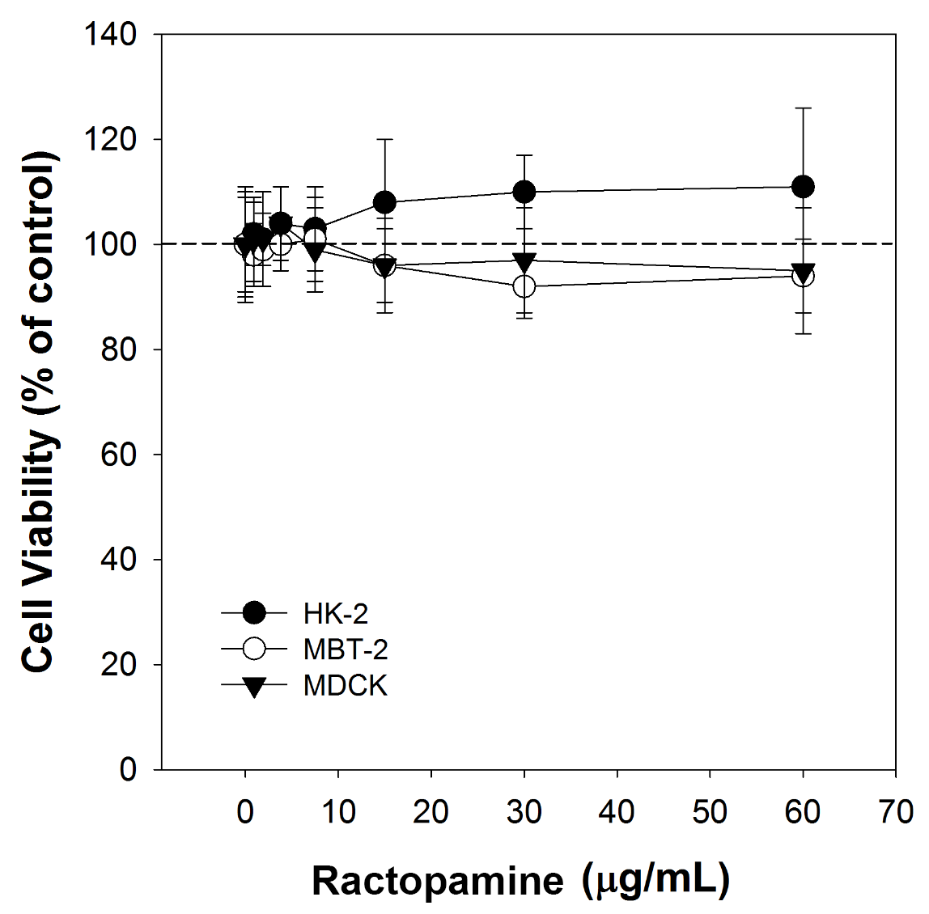

B
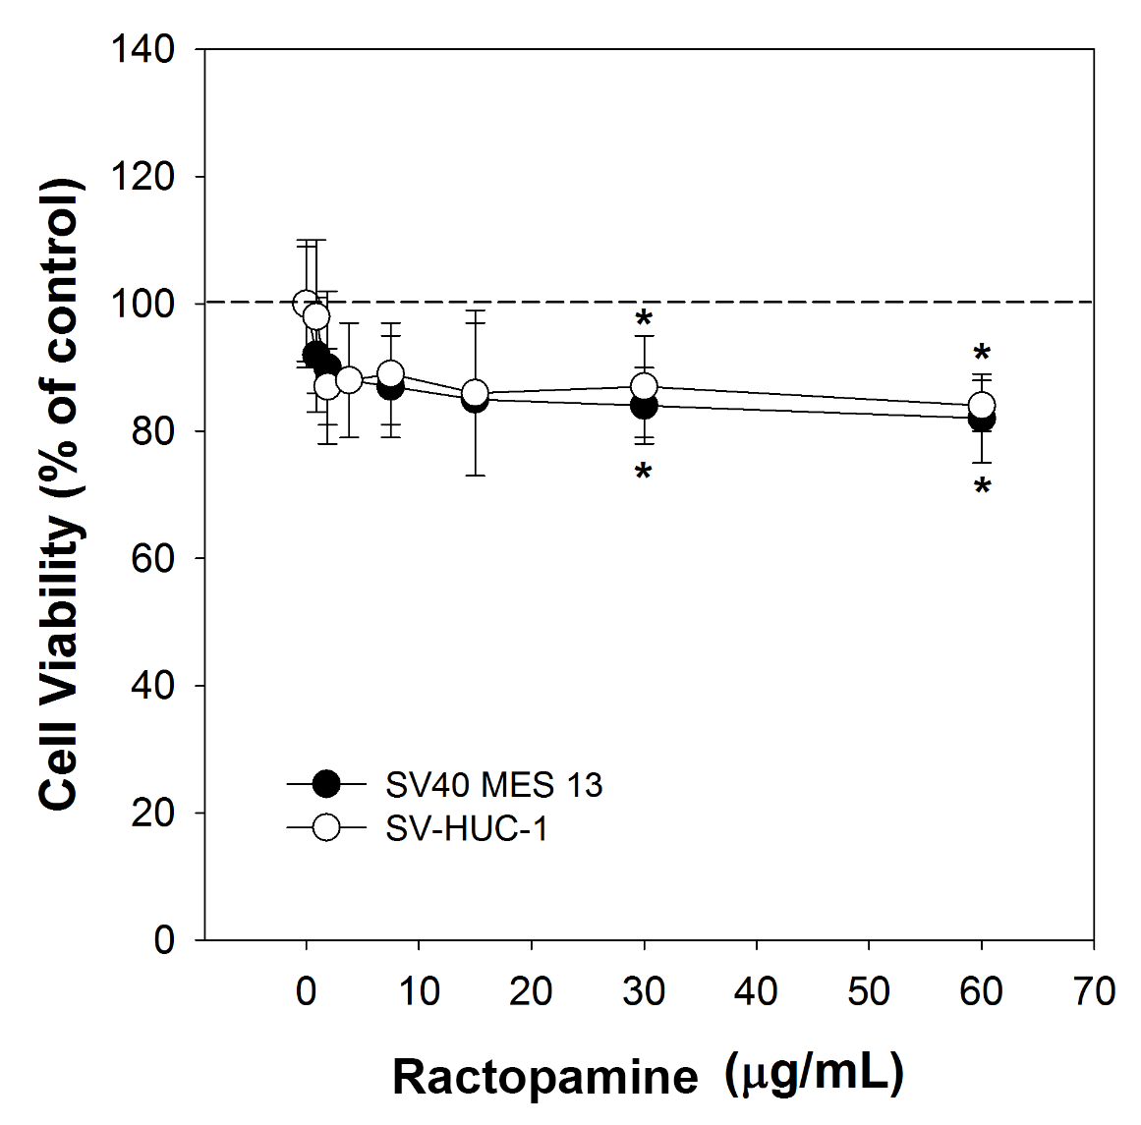
Fig. 1. Effect of ractopamine on cell viability in (A) HK-2, MBT-2, MDCK, (B) SV40 MES 13, and SV-HUC-1 cells. Cells were incubated with medium alone (control) or various concentrations of ractopamine for 24 h, and the cell viability was measured using the MTT assay. Data are means ± S.D. from 3 independent experiments. *P < 0.05 vs. control condition.
3.2. CaOx crystal formation
Compared with the control group, EG-induced crystal formation in Drosophila Malpighian tubules was clearly observed using microscopy (Fig. 2A) and was previously identified as CaOx [12].
After 21 days, the rates of CaOx crystal formation in the control, 0.5% EG, and 10 ppb ractopamine groups were 14.6%, 82.1% (P < 0.001), and 35.7% (P < 0.05), respectively (Fig. 2B).

A
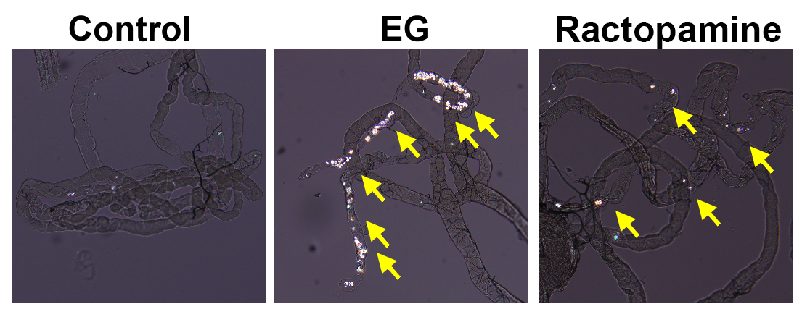

B
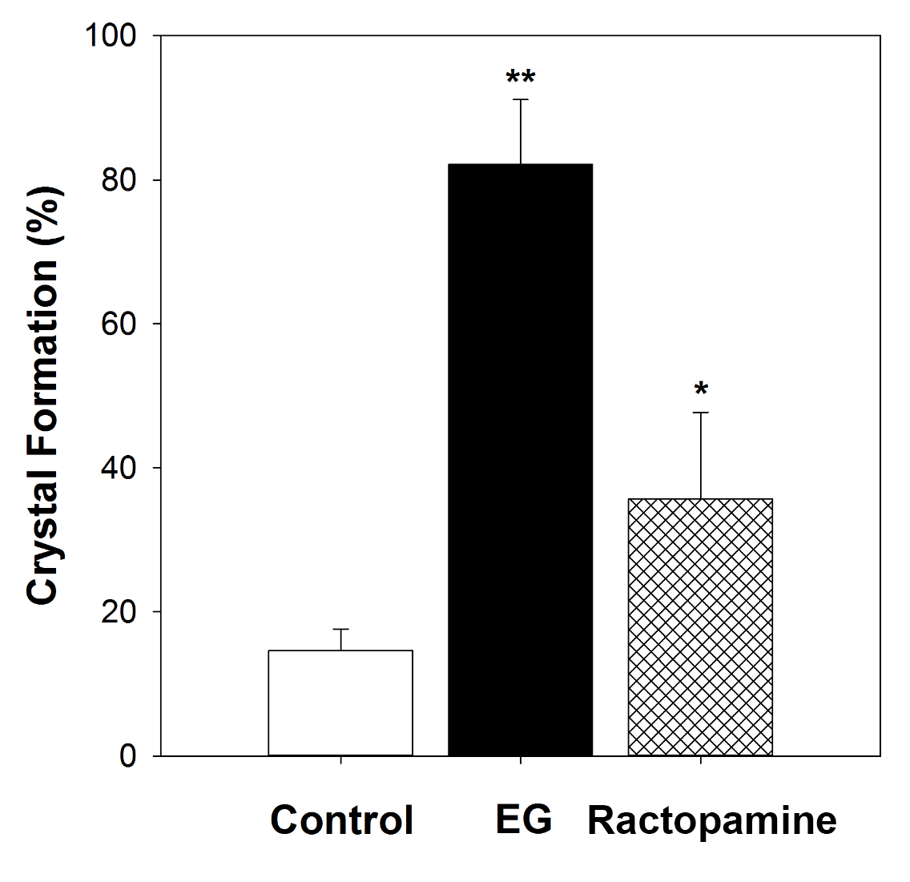
Fig. 2. EG- and ractopamine-induced crystal deposition in the Malpighian tubules of Drosophila. (A) The images show representative polarized microscopy for the flies with 0.5% EG- and 10 ppb ractopamine-induced crystal formation in Malpighian tubules. (B) Rates of crystal formation in control, 0.5% EG-, and 10 ppb ractopamine-treated Drosophila (n ≅ 150 for each group). **P < 0.001, *P < 0.05, compared to the control group.
3.3. Climbing behaviour
Climbing behaviour of ractopamine-treated flies was measured on day 21. Ractopamine induced a decrease in climbing ability (geotaxis). Climbing ability was impaired at the non-lethal 10 ppb ractopamine concentration on day 21 (P < 0.05) (Fig. 3).

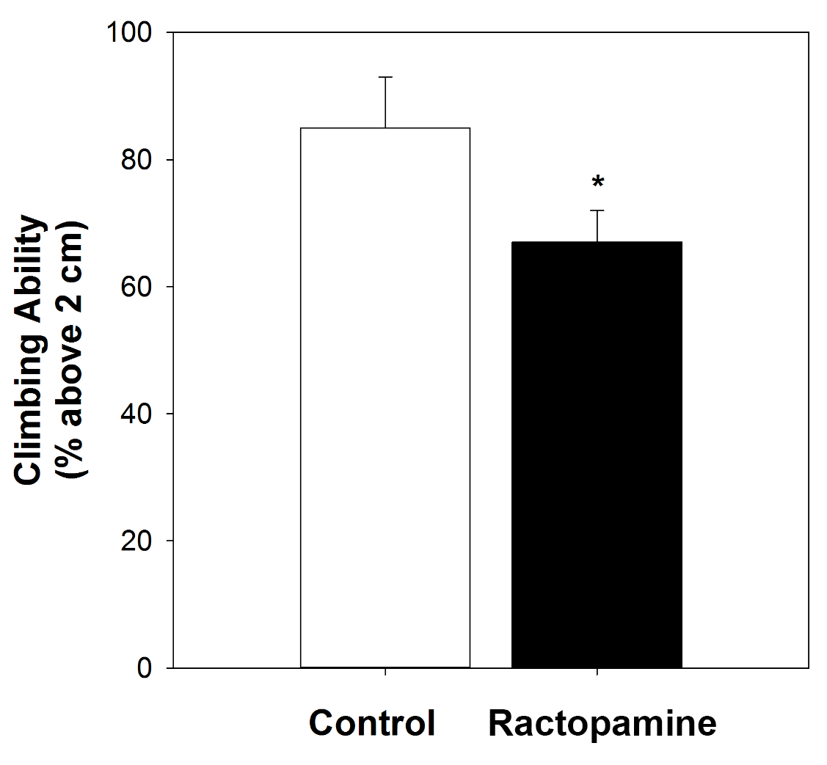
Fig. 3. Ractopamine inhibited geotaxis climbing behavior. Climbing behavior were measured in ractopamine-treated flies on day 21. Ractopamine induced a decrease in fly geotaxis climbing ability. Climbing ability was impaired at non-lethal ractopamine concentration on day 21. *P < 0.05, compared to the control group.
3.4. Drosophila lifespan
To test whether the effect of 10 ppb ractopamine was associated with a decreased mortality rate, the lifespans of Drosophila were measured after supplementing their food with 10 ppb ractopamine. The mean life span significantly reduced after administration of ractopamine-supplemented food compared with the control group (P < 0.05) (Fig. 4).

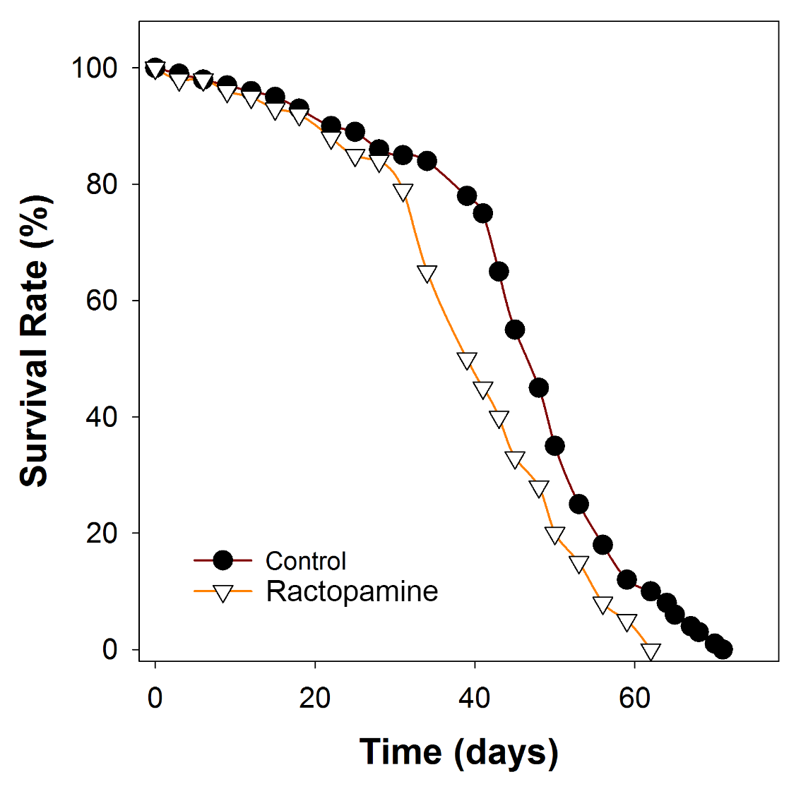
Fig. 4. Lifespan of control and ractopamine-treated flies. Cumulative survival distributions by administration of 10 ppb ractopamine. Flies treated with ractopamine showed significant life-span reduction compared with control group (n ≅ 150 for each group, P < 0.05 from log-rank test).
4. Discussion
In the present study, for the first time, we show a potential negative genitourinary and lithogenic effect of ractopamine in cell culture and in an animal model of Drosophila melanogaster.
Ractopamine had variable effects on the viability of various urogenital cells [17, 18]. The survival rate of tubule and parenchymal cells are similar to that of control. However, human urinary bladder SV-HUC-1 cells and murine mesangial SV40 MES 13 cells were found to have decreased survival rates. Urothelial cells and renal mesangial cells were particularly susceptible to damage. In addition, we also studied the effect of ractopamine on cancer cells (mouse bladder tumour cell MBT-2) and did not find any antitumor or proliferative effects. However, the urothelium should be further observed in humans after long-term consumption of ractopamine-containing beef [19, 20].
We also found that long-term administration of ractopamine in flies shortens their lifespans, as evident in the in vivo study. The average lifespan of flies ingesting 10 ppb ractopamine daily was shorter than that of the control flies. Ractopamine also increased CaOx crystal formation in the flies when compared with the control group. This indicates that long-term ingestion of ractopamine might also increase urinary stone formation in humans. The climbing ability of the flies was also influenced by ractopamine, possibly owing to a neurologic effect that could be associated with urological smooth muscle contraction with further effects on ureteral peristalsis and voiding [21-23]. Although Taiwan’s government has approved ractopamine-containing imported beef, the issue of food safety is still problematic. Further observation of its effect on the human urological system is warranted.
Twenty-six countries have approved ractopamine for pigs. The United States approved ractopamine use in cattle in 2003. However, the European Union has prohibited the use of β-adrenoreceptor agonists in food-producing animals since 1996. The maximal residual limit was set at 10 μg/kg (ppb) in pork or beef by the WHO Food Additives Series. Taiwan’s government set limits for these additives in food according to this report. While consumption of less than 6 kg of beef might seem safe in 60 kg BW adults, in actuality, this could lead to acute toxicity. The half-life of ractopamine is 3.94 h, and it is not detectable in the serum after 24 h. After 6 h, 72% of the consumed ractopamine is excreted in the urine [24, 25]. Therefore, the long-term effects of ractopamine on the urinary tract should be investigated.
The climbing activity of Drosophila decreased in the group that was administered ractopamine. We also found that fly lifespan decreased. Since ractopamine is a β-adrenoreceptor agonist, we hypothesize that these two findings could be attributable to its neurological toxicity.
More recently, Zhuang et al. provided evidence to indicate the utility of the Caenorhabditis elegans assay system in assessing the in vivo toxicity of ractopamine. With the aid of brood size, head thrash, body bend, intestinal auto-fluorescence, intestinal reactive oxygen species production, and lifespan as the endpoints, they investigated the toxicity from exposure to ractopamine at 0.1 mg/L (acute exposure) and 0.01 μg/L (prolonged exposure). Thus, C. elegans may be a relatively sensitive assay system to assess the toxicity of food additives. The prolonged exposure assay system especially may be more suitable for detecting the potential toxicity of long-term weight loss agents. The authors hypothesized that ractopamine might induce toxicity in nematodes through different molecular mechanisms. The data will be helpful for further understanding the potential damage on human health from the illegal use of weight loss agents and may lead to the future design of effective strategies against these adverse effects [26].
Our study found that ractopamine has a potential long-term adverse effect on the urological system. However, there are some limitations to this study. We used invertebrate animals and cells that may not completely represent the effects in humans. In addition, effects were observed after administration of a daily fixed dosage, and thus, this effect should be correlated to daily consumption of ractopamine-containing beef.
5. Conclusions
Long-term effects of ractopamine in the urinary tract system were evident from our cell and animal studies. Renal mesangial and urothelial cells are potentially damaged by ractopamine. Urolithiasis and neurological damage are other side effects of ractopamine in animals. Therefore, long-term effects of ractopamine on the human urinary tract should be further investigated.
Acknowledgement
The authors declare that they have no conflict of interest. This study is supported in part by Taiwan Ministry of Health and Welfare Clinical Trial and Research Center of Excellence (MOHW 104-TDU-B-212-113002), Taiwan Ministry of Science and Technology (MOST 104-2320-B-039-016-MY3), China Medical University (CMU 103-S-19), and CMU under the Aim for Top University Plan of the Taiwan Ministry of Education (A-5-2-A). Y.H.C. and W.C.C contributed equally to this study.
References
[1] I. Ntshepang Makabanyane, R. Victress Ndou, and C. Njie Ateba, "Genotypic Characterization of Shigella Species Isolated from Abattoirs in the North West Province, South Africa Using PCR Analysis," Journal of Food and Nutrition Research, 3 (2). 121-125. 2015.
[2] X. Wang, and L. Xu, "Influence Factors on the Formation of Acrylamide in the Amino Acid/Sugar Chemical Model System," Journal of Food and Nutrition Research, 2 (7). 344-348. 2014.
[3] P. Wu, C. Cai, D. Yang, L. Wang, Y. Zhou, X. Shen, B. Ma, and J. Tan, "Changes of Ethyl Carbamate in Yellow Rice Wine during Shelf-Life and Formation in Simulated Ethanol and Urea Solutions," Journal of Food and Nutrition Research, 2 (12). 872-875. 2014.
[4] T. J. Centner, J. C. Alvey, and A. M. Stelzleni, "Beta agonists in livestock feed: status, health concerns, and international trade," Journal of Animal Science, 92 (9). 4234-4240. 2014.
[5] F. A. O. W. H. O. E. C. o. F. A. Joint, "Evaluation of certain veterinary drug residues in food. Sixty-sixth report of the Joint FAO/WHO Expert Committee on Food Additives," World Health Organization Technical Report Series, (939). 1-80, backcover. 2006.
[6] A. J. Garmyn, and M. F. Miller, "MEAT SCIENCE AND MUSCLE BIOLOGY SYMPOSIUM--implant and beta agonist impacts on beef palatability," Journal of Animal Science, 92 (1). 10-20. 2014.
[7] J. H. Li, W. J. Yu, Y. H. Lai, and Y. C. Ko, "Major food safety episodes in Taiwan: implications for the necessity of international collaboration on safety assessment and management," Kaohsiung Journal of Medical Sciences, 28 (7 Suppl). S10-16. 2012.
[8] M. J. Yaeger, K. Mullin, S. M. Ensley, W. A. Ware, and R. E. Slavin, "Myocardial toxicity in a group of greyhounds administered ractopamine," Veterinary Pathology, 49 (3). 569-573. 2012.
[9] D. J. Smith, and W. L. Shelver, "Tissue residues of ractopamine and urinary excretion of ractopamine and metabolites in animals treated for 7 days with dietary ractopamine," Journal of Animal Science, 80 (5). 1240-1249. 2002.
[10] D. T. Loo, and J. R. Rillema, "Measurement of cell death," Methods in Cell Biology, 57. 251-264. 1998.
[11] W. C. Chen, W. Y. Lin, H. Y. Chen, C. H. Chang, F. J. Tsai, K. M. Man, J. L. Shen, and Y. H. Chen, "Melamine-induced urolithiasis in a Drosophila model," Journal of Agricultural and Food Chemistry, 60 (10). 2753-2757. 2012.
[12] Y. H. Chen, H. P. Liu, H. Y. Chen, F. J. Tsai, C. H. Chang, Y. J. Lee, W. Y. Lin, and W. C. Chen, "Ethylene glycol induces calcium oxalate crystal deposition in Malpighian tubules: a Drosophila model for nephrolithiasis/urolithiasis," Kidney International, 80 (4). 369-377. 2011.
[13] C. Y. Ho, Y. H. Chen, P. Y. Wu, C. H. Chang, H. Y. Chen, K. M. Man, J. L. Shen, F. J. Tsai, W. Y. Lin, Y. J. Lee, and W. C. Chen, "Effects of commercial citrate-containing juices on urolithiasis in a Drosophila model," Kaohsiung Journal of Medical Sciences, 29 (9). 488-493. 2013.
[14] S. Y. Wu, J. L. Shen, K. M. Man, Y. J. Lee, H. Y. Chen, Y. H. Chen, K. S. Tsai, F. J. Tsai, W. Y. Lin, and W. C. Chen, "An emerging translational model to screen potential medicinal plants for nephrolithiasis, an independent risk factor for chronic kidney disease," Evidence-Based Complementary and Alternative Medicine, 2014. 972958. 2014.
[15] G. Orso, A. Martinuzzi, M. G. Rossetto, E. Sartori, M. Feany, and A. Daga, "Disease-related phenotypes in a Drosophila model of hereditary spastic paraplegia are ameliorated by treatment with vinblastine," Journal of Clinical Investigation, 115 (11). 3026-3034. 2005.
[16] J. L. Podratz, N. P. Staff, D. Froemel, A. Wallner, F. Wabnig, A. J. Bieber, A. Tang, and A. J. Windebank, "Drosophila melanogaster: a new model to study cisplatin-induced neurotoxicity," Neurobiology of Disease, 43 (2). 330-337. 2011.
[17] X. Liu, D. K. Grandy, and A. Janowsky, "Ractopamine, a livestock feed additive, is a full agonist at trace amine-associated receptor 1," Journal of Pharmacology and Experimental Therapeutics, 350 (1). 124-129. 2014.
[18] D. B. Hausman, R. J. Martin, E. L. Veenhuizen, and D. B. Anderson, "Effect of ractopamine on insulin sensitivity and response of isolated rat adipocytes," Journal of Animal Science, 67 (6). 1455-1464. 1989.
[19] H. Gao, J. Han, S. Yang, Z. Wang, L. Wang, and Z. Fu, "Highly sensitive multianalyte immunochromatographic test strip for rapid chemiluminescent detection of ractopamine and salbutamol," Analytica Chimica Acta, 839. 91-96. 2014.
[20] J. Wang, Y. She, M. Wang, M. Jin, Y. Li, J. Wang, and Y. Liu, "Multiresidue Method for Analysis of beta Agonists in Swine Urine by Enzyme Linked Receptor Assay Based on beta2 Adrenergic Receptor Expressed in HEK293 Cells," PloS One, 10 (9). e0139176. 2015.
[21] R. E. Slavin, and M. J. Yaeger, "Segmental arterial mediolysis--an iatrogenic vascular disorder induced by ractopamine," Cardiovascular Pathology, 21 (4). 334-338. 2012.
[22] E. J. Lezama, A. A. Konkar, M. M. Salazar-Bookaman, D. D. Miller, and D. R. Feller, "Pharmacological study of atypical beta-adrenoceptors in rat esophageal smooth muscle," European Journal of Pharmacology, 308 (1). 69-80. 1996.
[23] W. E. Colbert, P. D. Williams, and G. D. Williams, "Beta-adrenoceptor profile of ractopamine HCl in isolated smooth and cardiac muscle tissues of rat and guinea-pig," Journal of Pharmacy and Pharmacology, 43 (12). 844-847. 1991.
[24] F. Yang, P. Wang, R. Wang, Y. Zhou, X. Su, Y. He, L. Shi, and D. Yao, "Label free electrochemical aptasensor for ultrasensitive detection of ractopamine," Biosensors and Bioelectronics, 77. 347-352. 2015.
[25] S. H. Liou, G. C. Yang, C. L. Wang, and Y. H. Chiu, "Monitoring of PAEMs and beta-agonists in urine for a small group of experimental subjects and PAEs and beta-agonists in drinking water consumed by the same subjects," Journal of Hazardous Materials, 277. 169-179. 2014.
[26] Z. Zhuang, Y. Zhao, Q. Wu, M. Li, H. Liu, L. Sun, W. Gao, and D. Wang, "Adverse effects from clenbuterol and ractopamine on nematode Caenorhabditis elegans and the underlying mechanism," PloS One, 9 (1). e85482. 2014.

