Impact of An Integrative Healthcare Quality Improvement Program for asthmatic children and primary care-givers:
A Hospital-Based Observational Preliminary Report
Authors
Wan-Yu Lai ¹, Pei-yin Lin ¹ , Chao-Hui Yu ¹ , Hsu-Min Tseng ², , Sien-Hung Yang ^{1,4}, Liang-Shiou Ou ³, Tsung-Chieh Yao ³ , Jiun-Liang Chen ^{1,4*}
賴琬郁 ¹、林沛穎 ¹、余兆蕙 ¹、曾旭民 ²、楊賢鴻 ^{1,4}、歐良修 ³、姚宗杰 ³、陳俊良 ^{1,4*}
Affiliations
¹Division of Chinese Internal-pediatrics, Department of Traditional Chinese Medicine, Chang Gung Memorial Hospital, Taoyuan, Taiwan ;
²Department of Health Care Management ,Chang Gung University, Taoyuan, Taiwan ; ³Division of Allergy, Asthma and Rheumatology, Department of Pediatrics, Chang Gung Memorial Hospital, and Chang Gung University, Taoyuan, Taiwan ;
⁴School of Traditional Chinese Medicine, Chang Gung University, Taoyuan, Taiwan.

¹桃園長庚紀念醫院中醫內兒科，桃園，台灣
²長庚大學，醫務管理學系，桃園，台灣
³林口長庚紀念醫院小兒過敏氣喘風濕免疫科，桃園，台灣
⁴長庚大學中醫學系，桃園，台灣
*Address for correspondence:
Jiun-Liang Chen
Division of Chinese Internal-pediatrics, Department of Traditional Chinese Medicine, Chang Gung Memorial Hospital, Taoyuan, Taiwan
Address: No.123, Dinghu Rd., Guishan Township, Taoyuan County 333, Taiwan
Tel.: 03-319-6200 # 2611
Fax: 03-329-8995
E-mail: a12015@adm.cgmh.org.tw
*通訊作者
陳俊良
桃園長庚紀念醫院中醫內兒科，桃園，台灣
地址:333,桃園市龜山區頂湖路123號
電話: 03-319-6200 分機:2611
傳真: 03-329-8995
電子郵件: a12015@adm.cgmh.org.tw
Abstract
Background: Asthma has been a common allergic disorder with increasing prevalence and morbidity in Taiwan. To provide a comprehensive management integrating Traditional Chinese Medicine, we initiated a government-sponsored Integrative Healthcare Quality Improvement Program (IHQIP) for children with asthma in 2006. However, the clinical objective evaluation for the impact of IHQIP on asthmatic children is still lacking. The aim of this study was to investigate the impact of this program on asthma control and quality of life among asthmatic children and their care-givers.
Material and Methods: Forty-three children aged 4-11 years, who were diagnosed with asthma and had acute asthma exacerbation over the past 6 months were enrolled since February 2013 to December 2013. The study subjects received the IHQIP for 3 months. The Childhood Asthma Control Test (C-ACT) was used to evaluate the asthma control before treatment and monthly for 3 months. Two questionnaires, the Integrated Therapeutics Group Child Asthma Short Form (ITG-CASF) and the Pediatric Asthma Caregiver’s Quality of Life Questionnaire (PACQLQ) were used to assess the quality of life of patients and caregivers before and after treatment.
Results: Overall, 33 children completed the study. The mean score of C-ACT had significantly increased on each month (P<0.05) and significantly increased in 1 and 2 month compared to previous month (P<0.05). Asthmatic children had significant improvement in functional limitation (P<0.05) and daytime symptoms (P<0.05) in ITG-CASF. Primary caregivers had significant improvement in activity (P<0.005) and emotion (P<0.005) in PACQLQ. None of the patients complained of severe adverse effects.
Conclusions: Integration with Traditional Chinese Medicine ameliorated symptoms of childhood asthma and improved quality of life in asthmatic children and caregivers. Further randomized controlled clinical trial is warranted.
Key words: acupuncture; asthma; complementary and alternative medicine; herbal paste; pediatrics; traditional Chinese medicine
Abbreviations
CAM: complementary and alternative medicine, TCM: Traditional Chinese medicine, CGMH: Chang Gung Memorial Hospital, IHQIP: Integrative Healthcare Quality Improvement Program, QOL: quality of life, C-ACT: Childhood asthma control test, PACQLQ: Pediatric Asthma Caregiver’s Quality of Life Questionnaire, ITG-CASF: Integrated Therapeutics Group Child Asthma Short Form, ICS: inhaled corticosteroids, LABA: long-acting beta 2 agonist

Introduction

Asthma is a chronic inflammatory disorder of airways and one of the most common childhood diseases in the world. The prevalence of asthma had been increasing over the past few decades¹ and also markedly increased in Taiwan ². The average admission rate in Taiwan was 105.0 per 100,000 population, which increased by 6.5% annually in asthmatic children ³. Asthma had posed a great impact on children including restriction of activities, interrupted sleep, disrupted routines, increased stress, and poor school performance ⁴. The caregivers had limitation in their daily activities, anxiety and emotional stresses due to their children’s asthma, which is also highly correlated with severity of asthma ⁵ .

Asthma is a multi-factorial disease ⁶ and need comprehensive pharmacologic therapy for long-term management to reverse and prevent the airway inflammation. Moreover, there has been no curative and preventive therapy for asthma by now ⁷. Patients with asthma and their parents often seek complementary and alternative medicine (CAM) treatment because of recurrent exacerbations ⁸. The most common CAM therapies used in asthmatic children were breathing techniques, diet therapy, herbal medicine, homeopathy, massage, positive therapy, physical therapy, prayer, relaxation techniques, vitamins and minerals ⁹.

Traditional Chinese medicine (TCM) has been used for more than 2,000 years in China and is also popular in Taiwan ¹⁰. It contains various practices including herbal medicine, acupuncture, moxibustion, herbal paste, manipulative therapy, and qi gong. TCM has also been commonly used to treat asthma with fair results and few side effects .

The Department of TCM at Chang Gung Memorial Hospital (CGMH), which is a tertiary university-afﬁliated medical center in Taiwan, had launched a government-sponsored Integrative Healthcare Quality Improvement Program (IHQIP) for children with asthma since 2006¹². This program included herbal medicine, acupuncture, herbal paste, manipulative therapy, aerosol inhalation and asthma care education. The previous study reported that the IHQIP could reduce ER visits and hospitalizations in asthmatic children¹². Only 9 patients received IHQIP, so the evidence of this study was not strong enough. The clinical evaluation for the impact of IHQIP on asthmatic children is still lacking. We hypothesized that IHQIP can help to control asthma and improve quality of life (QOL) of those children and their parents to alleviate the burden of asthma. In this study, we prospectively enrolled asthmatic children into the IHQIP in our asthma daycare clinic. The objective was to evaluate the asthma control and QOL of these patients and their parents before and after treatment.
Materials and Methods
Study population and Study protocol
We included children who were below 12 years old, diagnosed with asthma by pediatricians, and had acute asthma exacerbation over the past 6 months. The asthma exacerbations are acute episodes of progressively worsening shortness of breath, cough, wheezing, and chest tightness. We excluded those who (1) needed admission or (2) had renal diseases, liver functional impairment and (3) severe systemic diseases. Forty-three children aged 4-11 years were recruited from TCM or pediatric outpatient clinics of CGMH in northern Taiwan since February 2013 to December 2013. These patients entered the IHQIP and received treatments 2-4 times per month according to the severity of asthma. The treatment course had kept 3 months. Three assessments were used to evaluate the asthma control of patients and QOL of caregivers before treatment and in the first, second, and third month during the program (Figure 1).
Ethics statement
The research was approved by institutional review board (IRB) of Chang Gung Medical Foundation. The IRB approved number is 102-0236B.We had well explained the study and obtained the informed consent written by the parents of participants.
Integrative Healthcare Quality Improvement Program (IHQIP)
The healthcare providers in the IHQIP were board-certified TCM doctors with dual training in TCM and Western medicine. Registered nurses were also trained both in Western medicine and TCM. The program was executed in our daycare asthma clinic. It contained comprehensive treatment including herbal medicine, acupuncture, herbal paste, manipulative therapy, and aerosol inhalation ¹². The TCM doctors gave inquiry and examined patient during each visit. They prescribed oral herbal medicine and all other treatment. The children received acupuncture with a disposable 0.2mm x 1.5mm auricular needle on acupoints of LI4, LI20, and ST36 for 1 hour. Then the manipulative therapy was done by massage over spine and chest. We applied herbal paste on the acupoints GV14, BL12, and BL13 for 90 minutes. Besides, the aerosol inhalation was given with 0.45% normal saline for 30 minutes during the treatment. Two to four times treatment per month was given according to their severity of asthma. The treatment course had kept 3 months.
Evaluation
We used one assessment tool to evaluate the asthma control of patients and two questionnaires to measure health related QOL for patients and caregivers.
Childhood asthma control test (C-ACT)
The C-ACT is a validated questionnaire, which has been used to measure asthma control in 4-11 years old asthmatic children. The C-ACT contains two parts. Four questions for the asthmatic children include perception of asthma control, limitation of activities, coughing and awakenings at night. Three questions for the caregivers include daytime complaints, daytime wheezing, and awakenings at night over the past 1 month. The C-ACT scores range from 0 to 27 and the higher score reveals better control of asthma. The score of 19 or less indicates inadequate control of asthma ¹³. The score of 12 or less indicates very poorly controlled asthma ¹⁴. Patients and their caregivers needed to fill in C-ACT before, in the first, second, and third month of enrollment.

Questionnaires to measure health-related quality of Life

The caregivers completed the Pediatric Asthma Caregiver’s Quality of Life Questionnaire (PACQLQ) and the Integrated Therapeutics Group Child Asthma Short Form (ITG-CASF) before and after 3 months of treatment. The PACQLQ contains 13 items including 4 items concern activity limitations and 9 concern emotional functions ¹⁵. The ITG-CASF was a short form of a 17-item questionnaire measuring symptoms and disability in pediatric asthma patients developed by Usherwood et al ¹⁶. This is a modified version of the asthma-specific questionnaire developed by DA Bukstein et al. ¹⁷. The ITG-CASF (Figure 2) contains 8 items including each 2 items concern daytime symptoms and nighttime symptoms. 4 items concern functional limitations. All scales of PACQLQ and ITG-CASF were summed and linearly transformed from 0 to 100. The higher scores indicate better health related QOL.
Statistical analysis
Descriptive statistics were illustrated for continuous variables and categorical variables. Paired T test for continuous variables was used to compare characteristics between mean C-CAT of four month groups: before, after one, two, three months. Pearson chi-square test was utilized to compare difference between the groups of C-ACT ≦19 and >19 within each month. Simple regression was applied to compare the differences of increasing C-ACT score within time in well-controlled group (C-ACT≧22). Comparisons of continuous outcomes of ITG-CASF and PACQLQ before and after three months were performed using paired two sample t-test as well. The above analyses were performed by STATA software (version 13.1: Stata Corp, College Station, TX, USA). All analysis were two-tailed and p- value<0.05 was considered statistically significant.
Sample size Estimation
We estimated sample size based on a paired t-test. According to our pilot study, the mean of difference was 10 and standard deviation (SD) was 18. A two-sided type I error was 5% and a power was 80%. The inclusion needed more than 30 patients to study differences for ITG-CASF and C-ACT.

Results
There were thirty-three children completed the program and ten children dropped out from our study. One patient returned back to original western clinic because her parent thought she had better response to western medicine. Nine patients lost of follow up. The mean age of these thirty-three children is 7.2 years. Twenty-seven patients (82%) are boys and six patients (18%) are girls. We used the Global Initiative for Asthma (GINA) 2012 asthma severity to classification the patients into four groups: intermittent (N=6; 18%), mild persistent (N=6; 18%), moderate persistent (N=21; 64%) and severe persistent (N=0; 0%). Overall, the mean of C-ACT was 19.7 ±3.4 (SD), ranged from 11 to 24, at the baseline. Twenty-eight patients (84.8%) were under controller therapy included ICS or ICS plus long-acting beta 2 agonist (LABA). The co-morbidity of allergic rhinitis and atopic dermatitis was 69.7% and 12.1% in these patients (Table 1).
The mean score of C-ACT were 19.7, 22, 23.7, and 24.1 at the baseline and each month afterward (Figure 3). There were significant increase in mean score on each month compared to baseline and significant increase in 1 and 2 month compared to previous month. The number of children with controlled asthma (C-ACT＞19) had significantly increased before and after one, two, three months (Table 2). We used these three cut-off points 22, 19, 12 to divide our patients to four groups, which are well-controlled (C-ACT=22-27), controlled (C-ACT=20-21), not controlled (C-ACT=13-19), and very poorly controlled (C-ACT=0-12). We found a significant increase of C-ACT score within time in well-controlled group. (C-ACT≧22) (Figure 4).
The ITG-CASF was used to assess asthmatic children’s QOL and was filled in by their primary caregivers. The total mean score had significant increased after 3 months treatment compared to baseline.(84.4 vs.74.8, p<0.05) The scores of functional limitation had significantly increased compared to baseline (85.9 vs. 72.3, p<0.05). Significantly increased score was also found in daytime symptoms (85.7 vs. 76.7, p<0.05). The score of nighttime symptoms had increased compared to baseline but was not statistically significant (77.3 vs. 71.7, p=0.29) (Table3).
The PACQLQ was used to assess caregivers’ QOL. All of these patients’ caregivers are their parents. The scores of activity and emotion both had significantly increased after 3 months treatment compared to baseline (activity: 49.27 vs. 67.27, p<0.05) (functional limitation: 66.69 vs.47.60, p<0.05) (Table 4).
Among 28 children under controller therapy including ICS or ICS and LABA before IHQIP, the experiences of controller therapy after 3 months were shown in Table5. 23(82%) children had kept the same does of controller,2(7%) children could tapper down the controller ,and 3(11%) children discontinued the controller therapy.
There were no serious adverse effects found during the IHQIP. Some children felt hot sensation and erythematous change over the acupoints of herbal pastes. It could recover naturally and neither vesicle nor wound was found.
Discussion
Our hospital-based observational study demonstrated that integration of comprehensive TCM therapy into the conventional treatment could improve the asthmatic symptoms and QOL of asthmatic children and their care-givers. This preliminary report could be useful for further initiation of a randomized controlled clinical trial in the future.
Current trends in the treatment of asthma mostly focus on the western medicine. This is the first study to integrate comprehensive TCM therapy into the conventional treatment in pediatric asthma. Our study proved IHQIP provide better asthma control and life quality for patients and care-givers. However, there were some limitations. First, it lacked of compact methodology, such as randomized controlled trials and a control group. It was under the consideration of ethical issue especially design a control group for child group. To our knowledge, it will do benefit to the asthmatic children with IHQIP though this believe lack of objective evidence. Therefore we designed this preliminary study first. Second, we used combined modality therapy instead of simply herbal medicine or acupuncture because TCM is a holistic healthcare medicine and some studies had reported comprehensive TCM therapy for asthma was better than simply one therapy. Besides, we believe multifaceted intervention for asthma is better than mono-faced intervention because asthma is a multi-factorial and complicated disease according to the current studies for asthma. Third, our study lacked objective examination, such as blood biochemical data or pulmonary function test. Blood test is a scary examination for children and pulmonary function test had less accuracy in preschool children. We decided to evaluate the efficacy of the IHQIP by questionnaires without invasive examination first. The questionnaires we used are all validated, which can strengthen the reliability and validity of our study. We will recruit the elder population and add blood biochemical data and pulmonary function test as objective evaluations in the future study.
According to the characteristics of participants, 64% patients enrolled in our study were moderate persistent asthmatic children and 84.8% patients had been under inhaled controller therapy. However, 39.4% of these children didn’t have adequately controlled asthma and one 8-year-old patient was very poorly controlled even under standard therapy. For these children, comprehensive therapy may be needed in addition to ordinary convention therapy.
After IHQIP, the C-ACT mean score had significantly increased on each month. The number of controlled asthmatic patients (C-ACT＞19) had significant increased during and after treatment. Our study also showed that these asthmatic children had better asthma control after enrolling into IHQIP for 1 month and got well-controlled after 2 months treatment, which C-ACT mean score >22. It also meant integration of comprehensive TCM therapy into the conventional treatment might be better than the conventional treatment alone.
According to analysis of ITG-CASF score, the total mean score had significant improved (p<0.05) after three months treatment in asthmatic children. The daytime symptoms and functional limitations got significant improved (p<0.05). The nighttime symptoms had increased but not to reach statistical significance (p=0.289). In our opinion, some caregivers who didn’t sleep with their children couldn’t notice the nighttime symptoms exactly. Gorelick et al. reported ITG-CASF score had significant correlation with the number of days of school missed or limited activities ²³. Kwok et al. thought that ITG-CASF score had stronger association with the asthma severity than the number of emergency department visits and hospitalizations for asthma ²⁴. Therefore, we assume that IHQIP can help asthmatic children to decrease school absenteeism and alleviate severity of asthma.
There were also other alternative therapies that had efficacy to help controlling asthma and to improve quality of life such as yoga, exercise, breathing technique, and asthma education . However, these therapies especially yoga and breathing technique need professional training and are more suitable for elder children only. In contrast, our IHQIP can be applied to pre-school age and had boarder range of patient population. Some studies investing the impact of education program had used the same questionnaire PACQLQ to evaluate QOL of parents²⁷. Dolinar et al. found PACQLQ score remained unchanged over the intervention period. There was no significantly improvement of PACQLQ in the intervention group except the domain of activities reported by Watson et al. In Julian et al study of short early therapeutic education program, they had the similar population (aged 5-11 years) and patient number (N=31) to our study. The severity of asthma among their children were mostly mild persistent and intermittent and was relatively milder than our group. Their result reported that PACQLQ score had improved but no improvement in QOL of asthmatic children. In our study, we had both improvement in QOL of asthmatic children and parents. The C-ACT score change from 19.7 to 24.1,that revealed our study had better asthma control compare with theirs (C-ACT :20.8 to 22) ²⁷. The IHQIP is more effective on asthma control than education program.
Most asthmatic children in Asia didn’t have adequately controlled asthma status ²⁸, and some parents would seek for TCM therapy. Some controlled clinical trials with anti-asthma TCM formulas proved the potential of herbal medicine to be efficacious and safe alternatives or complements to treat and control asthma ²⁹. Guiney et al reported significant improvement in peak expiratory flow in the osteopathic manipulative (OMT) group and concluded that OMT has a therapeutic effect in asthmatic children ³⁰. Applying Chinese herbal medicine paste to acupoints can relieve symptoms in allergy disease.³¹ Li et al had reported that Chinese medication has a regulatory effect on leukotriene receptor gene expression and the imbalance of Th1/Th2 immune cells in asthma attacked of pediatric patients, which IL-4 decreased and increased in IFN-gamma compared to western medication ³². Hsieh KH reported TCM could decrease production of histamine and Leukotriene C4 and increase production of Prostaglandin E2 in asthmatic children ³³. The IHQIP sum up the above treatments and we speculate IHQIP can reduce airway hyperactivity reaction and had protective effect on the late asthmatic reaction by altering immune regulatory function and inflammatory mediators. Further studies of investigating the immune mechanisms of TCM on asthma are warranted. According to the previous studies, it took longer therapeutic time(about 3-6 months) than ours(1-2months) to have effective effect on asthma by only Chinese herbal medication. It also lacked completed evaluation of the treatment efficacy of QOL for both asthmatic children and their caregivers in current studies.³⁴ We used validated questionnaires to evaluate asthma control (C-ACT) and QOL of patients and their caregivers (ITG-CASF and PACQLQ), that can strengthen the validity and reliability of our study. The result showed asthma had better control and could shorten the treatment course after entering the IHQIP. In addition to up-step the standard medical treatment, the IHQIP may be another choice for poorly controlled asthma.
Regarding the experiences of controller therapy after 3 months, most children had kept the same does of ICS. Nevertheless, none of these children had visited emergency department and needed hospitalization during the course of treatment. It may need longer treatment course and follow up to make sure if entering IHQIP can alleviate the doses of steroid or western medicine. Overall, the current asthma medication integrated with IHQIP could help to control asthma and improve QOL of asthmatic children.
Although, there were no serious adverse effects found during the IHQIP. Ten patients dropped out from our study. One of them returned to the original pediatric clinic and the others loss of follow up without contact. There are some reasons we assumed they refused to keep treatment. The each IHQIP therapy took at least 90 minutes. It was difficult to take time for busy parents to bring their children to our clinic. Some children are afraid of acupuncture and refused to receive treatment. Some children had well-controlled asthma after entering our program and their parents thought they could stop treatment on their own.
This study had proved that in addition to conventional medication, multi-aspect TCM therapies are better than simply one kind of TCM therapy and can shorten the treatment course. Through IHQIP, those asthmatic children have better asthma control within 2 months, and even both of them and their caregivers can have better QOL within 1 month. Asthmatic children could have better QOL because symptoms relieved. Parents can also have less stress and didn’t interrupt their activity due to asthma exacerbation of their children. These improvements can alleviate the burden of asthma.
Conclusions
This study disclosed the current asthma medication integrated with the TCM treatment could help to control asthma and improve QOL of asthmatic children and caregivers. Diversified therapies are helpful for asthma, which is a multi-factorial disease. The objective evaluation, such as blood biochemical data, the dosage and the treatment course of oral steroid or inhalation corticosteroid, and pulmonary function test should take into consideration in the future study. Further large number of poorly controlled asthmatic children and randomized controlled clinical trials are needed.

Acknowledgements
The authors thank Chang Gung Memorial Hospital for supporting to establish the asthma daycare clinic and Li-Min Chen for statistical consulting and data analysis. This work was supported by grants from Committee on Chinese Medicine and Pharmacy
( PMRPG5C0021 ).

Reference:
1.Asher MI, Montefort S, Bjorksten B, Lai CK, Strachan DP, Weiland SK, Williams H. Worldwide time trends in the prevalence of symptoms of asthma, allergic rhinoconjunctivitis, and eczema in childhood: ISAAC Phases One and Three repeat multicountry cross-sectional surveys. Lancet.,368(9537):733-743,2006.
2.Yao TC, Ou LS, Yeh KW, Lee WI, Chen LC, Huang JL. Associations of age, gender, and BMI with prevalence of allergic diseases in children: PATCH study. J. asthma.,48(5):503-510,2011.
3.Yeh KW, Fang W, Huang JL. Increasing the hospitalization of asthma in children not in adults - from a national survey in Taiwan 1996-2002. Pediatr Allergy immunol.,19(1):13-19,2008.
4.O'Connell EJ. The burden of atopy and asthma in children. Allergy.,59 78:7-11,2004.
5.Townsend M, Feeny DH, Guyatt GH, Furlong WJ, Seip AE, Dolovich J. Evaluation of the burden of illness for pediatric asthmatic patients and their parents. Ann Allergy.,67(4):403-408,1991.
6.Bener A, Janahi IA, Sabbah A. Genetics and environmental risk factors associated with asthma in schoolchildren. Eur Ann Allergy Clin immunol.,37(5):163-168,2005.
7.Expert Panel Report 3 (EPR-3): Guidelines for the Diagnosis and Management of Asthma-Summary Report 2007. J Allergy Clin immunol.,120(5 Suppl):S94-138,2007.
8.Li XM, Brown L. Efficacy and mechanisms of action of traditional Chinese medicines for treating asthma and allergy. J Allergy Clin immunol.,123(2):297-306; quiz 307-298,2009.
9.Torres-Llenza V, Bhogal S, Davis M, Ducharme F. Use of complementary and alternative medicine in children with asthma. Can Respir J., 17(4):183-187,2010.
10.Huang TP, Liu PH, Lien AS, Yang SL, Chang HH, Yen HR. A nationwide population-based study of traditional Chinese medicine usage in children in Taiwan. Complement Ther Med.,22(3):500-510,2014.
11.Huang TP, Liu PH, Lien AS, Yang SL, Chang HH, Yen HR. Characteristics of traditional Chinese medicine use in children with asthma: a nationwide population-based study. Allergy.,68(12):1610-1613,2013.
12.Hung YC, Hung IL, Sun MF, Muo CH, Wu BY, Tseng YJ, Hu WL. Integrated traditional Chinese medicine for childhood asthma in Taiwan: a Nationwide cohort study. BMC Complement Altern Med.,14:389,2014.
13.Liu AH, Zeiger R, Sorkness C, Mahr T, Ostrom N, Burgess S, Rosenzweig JC, Manjunath R. Development and cross-sectional validation of the Childhood Asthma Control Test. J Allergy Clin immunol.,119(4):817-825,2007.
14.Liu AH, Zeiger RS, Sorkness CA, Ostrom NK, Chipps BE, Rosa K, Watson ME, Kaplan MS, Meurer JR, Mahr TA, Blaiss MS, Piault-Louis E, McDonald J. The Childhood Asthma Control Test: retrospective determination and clinical validation of a cut point to identify children with very poorly controlled asthma. J Allergy Clin immunol.,126(2):267-273, 273 e261,2010.
15.Juniper EF, Guyatt GH, Feeny DH, Ferrie PJ, Griffith LE, Townsend M. Measuring quality of life in the parents of children with asthma. Qual Life Res.,5(1):27-34,1996.
16.Usherwood TP, Scrimgeour A, Barber JH. Questionnaire to measure perceived symptoms and disability in asthma. Arch Dis in Child.,65(7):779-781,1990.
17.Bukstein DA, McGrath MM, Buchner DA, Landgraf J, Goss TF. Evaluation of a short form for measuring health-related quality of life among pediatric asthma patients. J Allergy Clin immunol.,105(2, Part 1):245-251,2000.
18.Voorend-van Bergen S, Vaessen-Verberne AA, Landstra AM, Brackel HJ, van den Berg NJ, Caudri D, de Jongste JC, Merkus PJ, Pijnenburg MW. Monitoring childhood asthma: web-based diaries and the asthma control test. J Allergy Clin immunol.,133(6):1599-1605 e1592,2014.
19.董秀蘭, 楊向娜, 王麗清, 莊禮興. 益氣活血貼外敷治療小兒哮喘非急性發作期30例臨床研究. 黑龍江中醫藥.4:18-19,2011.
20.趙杜鵑, 謝菁, 潘善根. 內外合治綜合療法治療支氣管哮喘臨床研究. 上海中醫藥雜誌.43(2):44-46,2009.
21.Cornell A, Shaker M, Woodmansee DP. Update on the pathogenesis and management of childhood asthma. Curr Opin Pediar.,20(5):597-604,2008.
22.Lemmens KM, Nieboer AP, Huijsman R. A systematic review of integrated use of disease-management interventions in asthma and COPD. Respir Med.,103(5):670-691,2009.
23.Gorelick MH, Brousseau DC, Stevens MW. Validity and responsiveness of a brief, asthma-specific quality-of-life instrument in children with acute asthma. Ann Allergy, Asthma Immunol.,92(1):47-51,2004.
24.Kwok MY, Walsh-Kelly CM, Gorelick MH, Grabowski L, Kelly KJ. National Asthma Education and Prevention Program severity classification as a measure of disease burden in children with acute asthma. Pediatrics.117(4 Pt 2):S71-77,2006.
25.Eichenberger PA, Diener SN, Kofmehl R, Spengler CM. Effects of exercise training on airway hyperreactivity in asthma: a systematic review and meta-analysis. Sports Med.,43(11):1157-1170,2013.
26.Cramer H, Posadzki P, Dobos G, Langhorst J. Yoga for asthma: a systematic review and meta-analysis. Ann Allergy, Asthma Immunol.,112(6):503-510 e505,2014.
27.Julian V, Amat F, Petit I, Pereira B, Fauquert JL, Heraud MC, Labbe G, Labbe A. Impact of a short early therapeutic education program on the quality of life of asthmatic children and their families. Pediatr Pulmonol.,.2014.
28.Wong GW, Kwon N, Hong JG, Hsu JY, Gunasekera KD. Pediatric asthma control in Asia: phase 2 of the Asthma Insights and Reality in Asia-Pacific (AIRIAP 2) survey. Allergy.68(4):524-530,2013.
29.Li XM. Traditional Chinese herbal remedies for asthma and food allergy. The J Allergy Clin immunol.,120(1):25-31,2007.
30.Guiney PA, Chou R, Vianna A, Lovenheim J. Effects of osteopathic manipulative treatment on pediatric patients with asthma: a randomized controlled trial. The J Am Osteopath Assoc.,105(1):7-12,2005.
31.Tai CJ, Chien LY. The treatment of allergies using Sanfujiu: A method of applying Chinese herbal medicine paste to acupoints on three peak summer days. The Am J Chi Med.,32(6):967-976,2004.
32.Li S, Wang Y, Shi Y, Yu J, Sun W, Hu H, Zhang Y. Regulatory effects of stage-treatment with established Chinese herbal formulas on inflammatory mediators in pediatric asthma. J Tradit Chin Med.,33(6):727-732,2013.
33.Hsieh KH. Evaluation of efficacy of traditional Chinese medicines in the treatment of childhood bronchial asthma: clinical trial, immunological tests and animal study. Taiwan Asthma Study Group. Pediatr Allergy Immunol.,7(3):130-140,1996.
34.Clark CE, Arnold E, Lasserson TJ, Wu T. Herbal interventions for chronic asthma in adults and children: a systematic review and meta-analysis. Prim Care Respir J.,19(4):307-314,2010.

Table1:
Characteristics | N=33
Age , years 〔mean (SD)〕 | 7.2 (2.24)
male, n(%) | 27(82%)
asthma severity(GINA 2012)
intermittent ,n(%) | 6 (18%)
mild persistent , n(%) | 6(18%)
moderate persistent , n(%) | 21(64%)
severe persistent , n(%) | 0(0%)
C-ACT 〔 mean (SD)〕 | 19.7 (3.4)
Controller therapy included ICS or ICS and LABA | 28(84.8%)
Frequency of controller
BID | 23(82%)
HS | 5(18%)
Co-morbidity
Allergic rhinitis | 23(69.7%)
Atopic dermatitis | 4(12.1%)
Table 1. Characteristics of asthmatic children in the Integrative Healthcare Quality Improvement Program (IHQIP). SD: standard deviation, C-ACT: childhood asthma control test, ICS: inhaled corticosteroids, LABA: long-acting beta agonist, BID: twice a day, HS: once before sleep.
Table2:
 | baseline | 1 M | 2 M | 3 M
Not controlled  (C-ACT≦19) | 13(39.4%) | 7(21.2%) | 5(15.2%) | 3(9%)
Controlled  (C-ACT>19) | 20(60.6%) | 26(78.8%)* | 28(84.8%)* | 30(91%)*
Table2. Number and percentage of controlled (C-ACT＞19) and not well controlled (C-ACT≦19) asthmatic children before and after 1, 2, 3 months. ＊ denotes P value <0.05. Significant increase number of control group before and after 1, 2, 3 months (M) as determined by Pearson chi-square test. C-ACT: childhood asthma control test (N=33)
Table3:
The Integrated Therapeutics Group Child Asthma Short Form(ITG-CASF)
 | Baseline  Mean ±SD | After 3 months treatment  Mean ±SD | P-value
Total score | 74.8 ±21.1 | 84.4 ±18.8 | 0.01*
Functional limitation | 72.3 ±28.1 | 85.9 ±20.4 | 0.006*
Nighttime symptoms | 71.7 ±25.4 | 77.3 ±23.3 | 0.29
Daytime symptoms | 76.7 ±26.2 | 84.4 ±18.8 | 0.04*
Table 3. Comparison of the Integrated Therapeutics Group Child Asthma Short Form (ITG-CASF) mean score between baseline and completed treatment. * denotes a P value <0.05. There were significant differences between baseline and completed treatment determined by paired two sample t-test. SD: standard deviation
Table 4:
The Pediatric Asthma Caregiver’s Quality of Life Questionnaire(PACQLQ)
 | Baseline  Mean±SD | After 3 M  Mean | P-value
Total score | 48.4 ±22.7 | 67.0 ±27.0 | <0.001*
Activity | 47.6 ±24.9 | 66.7 ±28.0 | 0.001*
Emotion | 49.3 ±22.5 | 67.3 ± 28.9 | 0.002*
Table 4. Comparison of the Pediatric Asthma Caregiver’s Quality of Life Questionnaire (PACQLQ) mean score between baseline and completed treatment. * denotes a P value <0.05. There were significant differences between baseline and completed treatment determined by paired two sample t-test. SD: standard deviation
Table5:
Experiences of inhaled controller therapy after 3 months, N=28
Keep the same does of controller | 23(82%)
Tapper down the controller | 2(7%)
Discontinue the controller therapy | 3(11%)
Table 5. Experiences of controller therapy including inhaled corticosteroids or combined inhaled corticosteroids and long-acting beta agonist after 3 months among 28 children under inhaled controller.

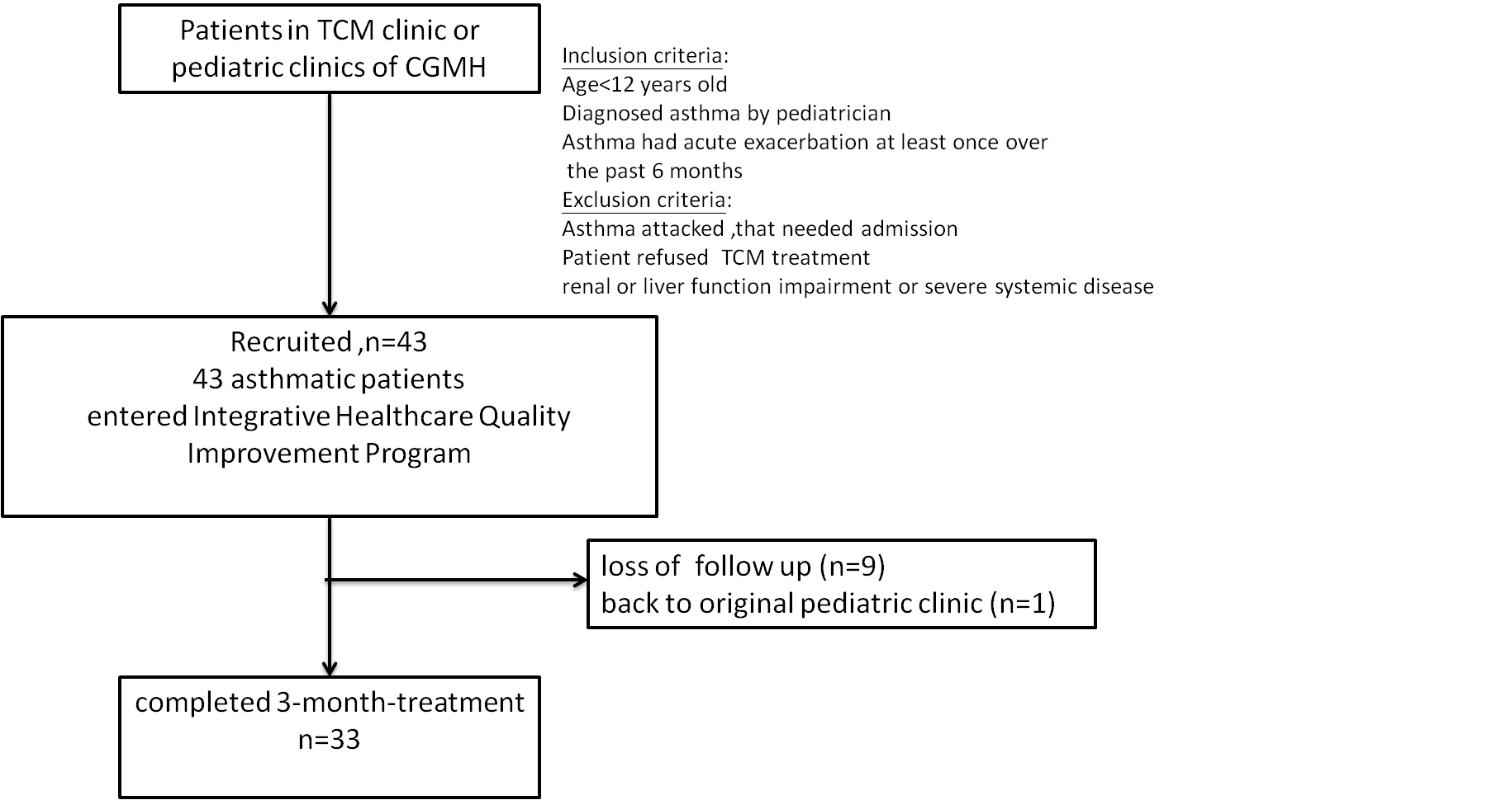
Figure 1. The study protocol of Integrative Healthcare Quality Improvement Program (IHQIP) for asthmatic children. TCM: Traditional Chinese Medicine

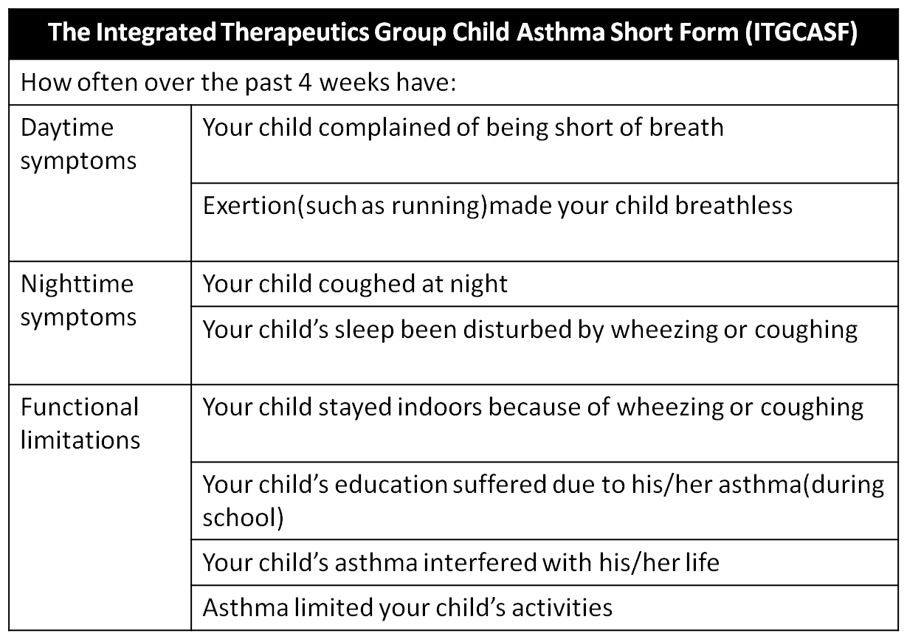

Figure 2. Content of the Integrated Therapeutics Group Child Asthma Short Form

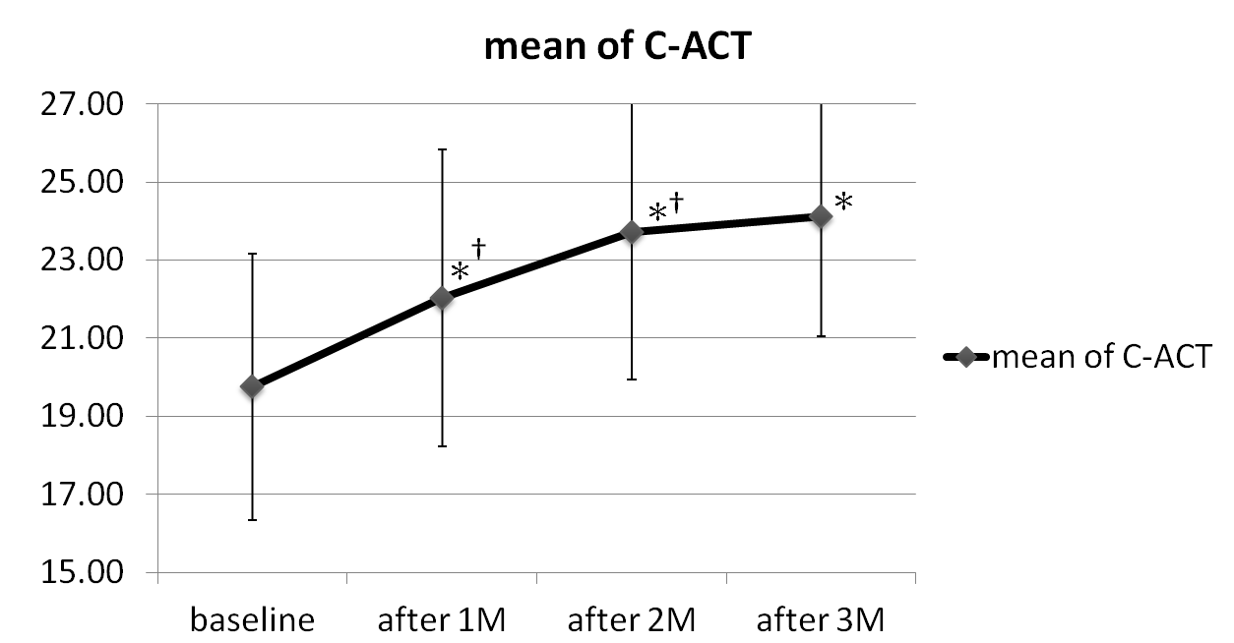
Figure 3. The mean score of Childhood Asthma Control Test (C-ACT) in asthmatic children enrolled into the Integrative Healthcare Quality Improvement Program (IHQIP) at base line, 1st, 2nd, and 3rd month (M) post-treatment. *denotes P value < 0.005. Significant difference compared to baseline as determined by paired T test. †denotes P value <0.005. Significant difference between each month as determined by paired T test.
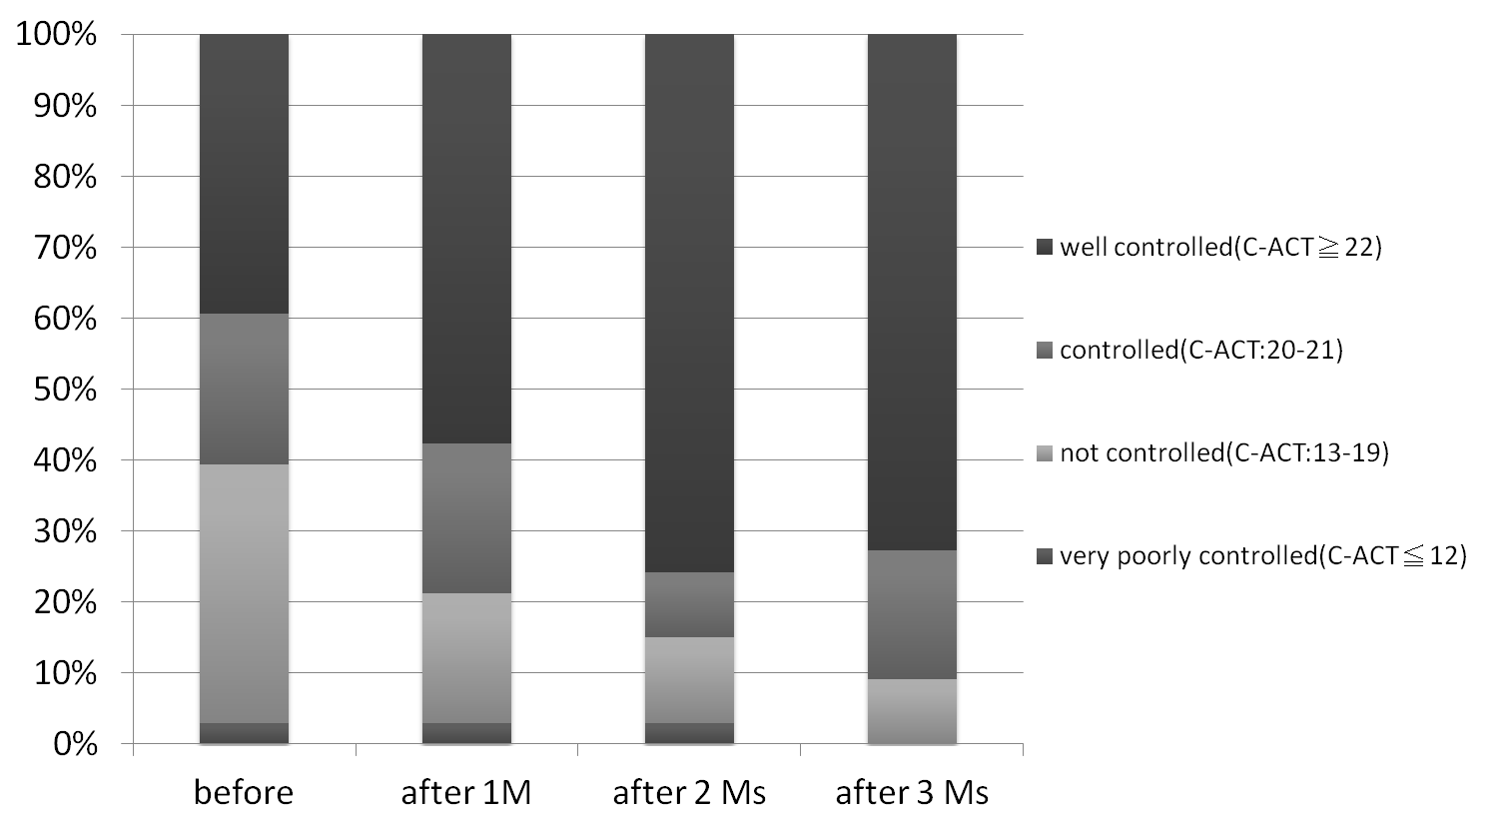
Figure 4. Percentage of children in Integrative Healthcare Quality Improvement Program (IHQIP) with well controlled, controlled, not controlled, very poor controlled asthma before and during each month (M). * denotes significant increase of C-ACT score within time in well-controlled group compare by simple regression.

中醫整合型健康照護計畫對氣喘患童與主要照顧者的影響:前瞻性觀察型研究
賴琬郁 ¹、林沛穎 ¹、余兆蕙 ¹、曾旭民 ²、楊賢鴻 ^{1,4}、歐良修 ³、姚宗杰 ³、陳俊良 ^{1,4*}
¹長庚醫療財團法人林口長庚紀念醫院中醫內兒科，桃園，台灣
²長庚大學，醫務管理學系，桃園，台灣
³林口長庚紀念醫院小兒過敏氣喘風濕免疫科，桃園，台灣
⁴長庚大學中醫學系，桃園，台灣

目的:氣喘在台灣是常見的過敏性疾病之一，盛行率逐年增加。為了提供氣喘患童更全面性的治療來加強氣喘控制，本院自2006年施行健保給付小兒氣喘中醫整合型健康照護計畫，此計畫實施已久但仍缺乏實際臨床客觀的療效評估，本研究目的在評估此計畫之療效成果，對患童氣喘的控制程度、患童與主要照顧者的生活品質是否有幫助。
方法:本研究為前瞻性觀察型研究，於2013年2月 ～ 2013年12月收入43位年紀4-11歲氣喘患童接受此健康照護計畫，進入計畫後共接受治療療程三個月。介入前、進入療程後第1,2,3個月後使用兒童氣喘控制測驗(C-ACT)評估患童哮喘控制程度，另外使用簡式小兒氣喘生活品質量表(ITG-CASF)與主要照顧者生活品質量表(PACQLQ)評估生活品質改善程度。
結果：最後共有33位患童完成治療療程，接受治療各個月的平均C-ACT分數與治療前相比較均有顯著增加(p<0.05)、且治療第1,2個月平均C-ACT分數與前月份相比較亦有顯著增加(p<0.05)。患童生活品質在活動受限與白天症狀部分較治療前顯著改善(P<0.05)。主要照顧者生活品質在活動與情緒部分較治療前必較亦有顯著改善(P<0.05)。
結論：中醫整合型健康照護計畫可助患童的氣喘控制與改善患童與主要照顧者生活品質。未來將進行更大規模並有隨機對照組之前瞻性臨床療效試驗。
關鍵字:針灸，氣喘，另類及替代醫學，穴位敷貼，中醫，中藥。

