Molecular and Cellular Pathobiology

JARID1D Is a Suppressor and Prognostic Marker of
Prostate Cancer Invasion and Metastasis
Na Li1, Shilpa S. Dhar1, Tsai-Yu Chen1, Pu-Yeh Kan1, Yongkun Wei1, Jae-Hwan Kim1, Chia-Hsin Chan1, Hui-Kuan Lin1, Mien-Chie Hung1,2,3, and Min Gyu Lee1,2

Abstract
Cancer
Research

Entire or partial deletions of the male-speciﬁc Y chromosome are associated with tumorigenesis, but whether any male-speciﬁc genes located on this chromosome play a tumor-suppressive role is unknown. Here, we report that the histone H3 lysine 4 (H3K4) demethylase JARID1D (also called KDM5D and SMCY), a male- speciﬁc protein, represses gene expression programs associated with cell invasiveness and suppresses the invasion of prostate cancer cells in vitro and in vivo. We found that JARID1D speciﬁcally repressed the invasion-associated genes MMP1, MMP2, MMP3, MMP7, and Slug by demethylating trimethyl H3K4, a gene-acti- vating mark, at their promoters. Our additional results demon-
strated that JARID1D levels were highly downregulated in met- astatic prostate tumors compared with normal prostate tissues and primary prostate tumors. Furthermore, the JARID1D gene was frequently deleted in metastatic prostate tumors, and low JARID1D levels were associated with poor prognosis in prostate cancer patients. Taken together, these ﬁndings provide the ﬁrst evidence that an epigenetic modiﬁer expressed on the Y chromo- some functions as an anti-invasion factor to suppress the pro- gression of prostate cancer. Our results also highlight a preclinical rationale for using JARID1D as a prognostic marker in advanced prostate cancer. Cancer Res; 76(4); 831–43. @2016 AACR.

Introduction
Histone lysine methylation plays a pivotal role in epigenet- ically regulating gene expression at the genome-wide level (1, 2). This modiﬁcation is associated with either gene activa- tion or silencing, depending on the site of lysine residues. For instance, methylated histone H3 lysine 4 (H3K4) is related to active or poised gene states, whereas methylated H3K27 is linked to gene repression. Lysine residues can be methylated in three different states: mono-, di-, and trimethylation (me1, me2, and me3). Distribution patterns and functions of the three methylation states in the mammalian genome are often distinct but overlap substantially. For example, trimethyl H3K4 (H3K4me3) is generally located at the transcription initiation sites (3). Its levels are positively linked to the transcription frequency of active genes but can be found at poised promoters,

1Department of Molecular and Cellular Oncology, The University of
2
which also contain the repressive mark H3K27me3. Most of dimethyl H3K4 (H3K4me2) is colocalized with H3K4me3 at
the 50 -ends of active genes, and its subset is localized at the
enhancers and bodies of active genes.
Histone lysine methylation is reversibly modulated by spe- ciﬁc lysine methyltransferases and demethylases (4, 5). H3K4 methylation is established by several methyltransferases, including mixed lineage leukemia (MLL) 1–4, SET1, SET7 (alias SET9), SMYD1, and SMYD2 (6). It can be reversed by several H3K4 demethylases, including LSD1, LSD2, and JARID1A–D (7–13).
The entire or partial regions of the male-speciﬁc Y chromo-
some are deleted in up to 52% of prostate tumors, although the entire loss of the Y chromosome may be rare in these male- speciﬁc tumors (14). Of interest, alterations of the Y chromo- some also occur in other types of cancer, including testicular tumors, male-predominant esophageal tumors (about 33%), male bladder tumors (10% to 40%), and male pancreatic
tumors (15–19). Vijayakumar and colleagues showed that the

Texas MD Anderson Cancer Center, Houston, Texas.
Cancer Biology
reintroduction of a Y chromosome in the Y chromosome–

Program, The University of Texas Graduate School of Biomedical
Sciences at Houston, Houston, Texas. 3Center for Molecular Medicine, China Medical University, Taichung, Taiwan.
Note: Supplementary data for this article are available at Cancer Research
Online (http://cancerres.aacrjournals.org/).
Current address for J.-H. Kim: Department of Biomedical Sciences, Seoul National University College of Medicine, Seoul, Republic of Korea and current address for C.-H. Chan, Department of Pharmacological Sciences, Stony Brook University, Stony Brook, New York.
Corresponding Author: Min Gyu Lee, Department of Molecular and Cellular Oncology, The University of Texas MD Anderson Cancer Center, 1515 Holcombe Boulevard, Houston, TX 77030. Phone: 713-792-3678; Fax: 713-794-3270; E-mail: mglee@mdanderson.org

deﬁcient human prostate cancer cell line PC-3 impeded tumor formation in vivo (20). These studies indicate that the Y chromosome has a tumor-suppressive function in addition to its roles in sex determination and male fertility. This notion is further supported by a recent report showing that the loss of the Y chromosome in peripheral blood is correlated with a high risk of cancer (21). However, whether a male-speciﬁc protein expressed on the Y chromosome may function as a tumor or metastasis suppressor remains unknown.
We previously showed that the histone demethylase JARID1D (also known as KDM5D and SMCY) downregulates gene expres- sion by demethylating H3K4me2 and H3K4me3 (7). Of H3K4 methyltransferases and demethylases, only JARID1D is male- speciﬁc, because only JARID1D is localized on the Y chromosome.

The JARID1D gene is often deleted in prostate tumor samples (15). Therefore, we sought to determine the role of JARID1D in prostate cancer. We found that JARID1D suppresses the invasion, but not proliferation or migration, of prostate cancer cells and represses invasiveness-associated gene programs in these cells. We demonstrated that JARID1D's demethylase activity is necessary for the repression of multiple invasiveness genes, including MMP1, MMP2, MMP3, MM7P, and Slug (also known as SNAI2). In metastatic prostate tumors, JARID1D mRNA and protein levels were commonly decreased. Low JARID1D mRNA and protein levels were correlated with poor survival in prostate cancer patients. Our results indicate that JARID1D is an anti-invasiveness factor and a prognostic marker for prostate cancer.

Materials and Methods
Cell lines, antibodies, and expression plasmids
DU145 and PC3 prostate cell lines and HEK293T cells were purchased from ATCC, which conﬁrms cell lines using short tandem repeat analysis, and were cultured within 15 times of passages. Cell culture reagents were obtained from Invitrogen/ Gibco. Anti-JARID1D antibodies were from Bethyl (A310-624A) and Santa Cruz Biotechnology (sc-83944). Anti-JARID1A (A300-
897A), anti-JARID1B (A301-813A), and anti-JARID1C (A301-
034A) antibodies were from Bethyl. Anti-H3, anti-H3K4me3, and anti-H3K27me3 antibodies were from Millipore. Normal Rabbit IgG was from Santa Cruz Biotechnology (sc-2027). Anti-FLAG (M2, F1804) and anti-b–actin (A5441) antibodies were from Sigma Aldrich. The anti-p84 antibody was from Gene- Tex. JARID1D and its catalytic mutant (HE/AA) was cloned into the pFlag-CMV2 vector (Sigma). We previously reported that JARID1D's catalytic mutant mJARID1D (HE/AA) in a baculoviral recombinant form is enzymatically inactive (7).

Knockdown and ectopic expression experiments
Three independent small hairpin (sh) RNAs against JARID1D were used for knockdown of JARID1D. shJARID1D-N1 (TRCN0000234751), shJARID1D-N4 (TRCN0000234754), and shLuciferase (shLuc; control shRNA) in the puromycin-resistant PLKO.1 vector were purchased from Sigma Aldrich. shJARID1D-4 (GCCAACCATGTGCAATGTAAC) was cloned into the PLKO.1 vector. Lentiviruses were generated by cotransfecting HEK293T cells with a shJARID1D (or shLuc)-expressing plasmid, a packing plas- mid (deltaR8), and an envelope plasmid (VSV-G). Fourteen hours later, the medium was replaced with DMEM supplemented with
10% fetal bovine serum. Media with virus particles were used to infect the DU145 prostate cancer cells. Infected cells were selected by puromycin for 72 hours. Knockdown efﬁciency was determined by quantitative reverse transcription polymerase chain reaction (RT-PCR) and Western blot analysis.
To ectopically express JARID1D and its catalytic mutant mJAR- ID1D, we transfected the PC3 prostate cancer cells with the JARID1D or mJARID1D cDNA construct using Lipofectamine
3000 (Life Technologies) or the Continuum transfection reagent
(Gemini) according to the manufacturer's instructions. Following
24 to 48 hours of incubation, the cells were harvested, and the total RNAs were isolated for further analysis.

Cell proliferation, migration, and invasion assays
For the cell proliferation assays, cells infected with viruses containing shLuc or shJARID1D were seeded in 24-well plates at
a density of 15,000 cells per well in triplicate, and cells were counted 1, 2, 3, and 4 days after plating. Migration assays were performed as previously described (22–24) with some modiﬁca-
tion. Brieﬂy, cells (1.0 x 105) in 500 mL of serum-free DMEM were
seeded on the porous membrane of each insert, and 500 mL of
DMEM media containing 10% fetal bovine serum was added to each well. Twenty-four hours later, the cells that had migrated to the other side of the membrane were ﬁxed with 4% paraformal- dehyde and stained with crystal violet. For the cell invasion assay,
DU145 cells (1.0 x 105) and PC3 cells (1.0 x 105) were sus-
pended in DMEM with 0.1% bovine serum albumin and seeded
on the Matrigel-coated membrane in each insert. Twenty-four hours later, the cells that had invaded the Matrigel and moved to the other side of the membrane were ﬁxed and stained as in the migration assays.

Mouse xenograft studies
DU145 cells were transfected with the pGL4.51 [luc2/CMV/ Neo] plasmid (Promega) and selected with 500 mg/mL G418. Two weeks later, single-cell colonies that stably expressed biolumines- cence signals were selected using the IVIS 100 Imaging System (Xenogen). A clone (DU145-Luc2, #9) was used in the mouse xenograft studies. DU145-Luc2 cells were infected with viruses containing shScramble or shJARID1D-4. Cells were selected for at least 3 days using puromycin.

The cells were injected into the tail veins of 6- to 8-week-old male athymic nu/nu mice (1 x 106 cells per mouse) obtained
from The University of Texas MD Anderson Cancer Center (Hous- ton, Texas). After cell implantation, metastasized loci and tumor growth were monitored using the IVIS 100 Imaging System. Eight to 10 weeks after implantation, the mice were humanely eutha- nized, and their lung tissues were collected for standard histo- logical examination. MD Anderson's Institutional Animal Care and Use Committee approved the care and use of the mice used in these experiments.

RNA isolation, cDNA synthesis, and quantitative RT-PCR
Total RNAs were extracted using RNeasy kits (Qiagen). cDNAs were synthesized using the iScript cDNA Synthesis Kit (Bio-Rad) according to the manufacturer's instructions. Quantitative RT-PCR was carried out in triplicate using SYBR-Green. Gene expression levels were measured quantitatively using CFX Man- ager software (Bio-Rad) and were normalized to GAPDH. The relative fold is the fold change compared with the control. The RT-PCR primer sequences are listed in Supplementary Table S1.

cDNA microarray
DU145 cells were infected with shLuc- or shJARID1D-contain- ing lentiviruses three times and selected with puromycin for 72 hours. Total RNAs were prepared using an RNeasy Kit (Qiagen), and knockdown efﬁciency was assessed by quantitative RT-PCR. Affymetrix U133P GeneChips were used for the microarray experiments.

Chromatin immunoprecipitation assay
Chromatin immunoprecipitation (ChIP) assays were carried out as previously described (25). Rabbit immunoglobulin (IgG) was used as a control for the ChIP assay, and the PCR values of ChIP DNA were normalized to input. The ChIP PCR primer sequences are listed in Supplementary Table S2.

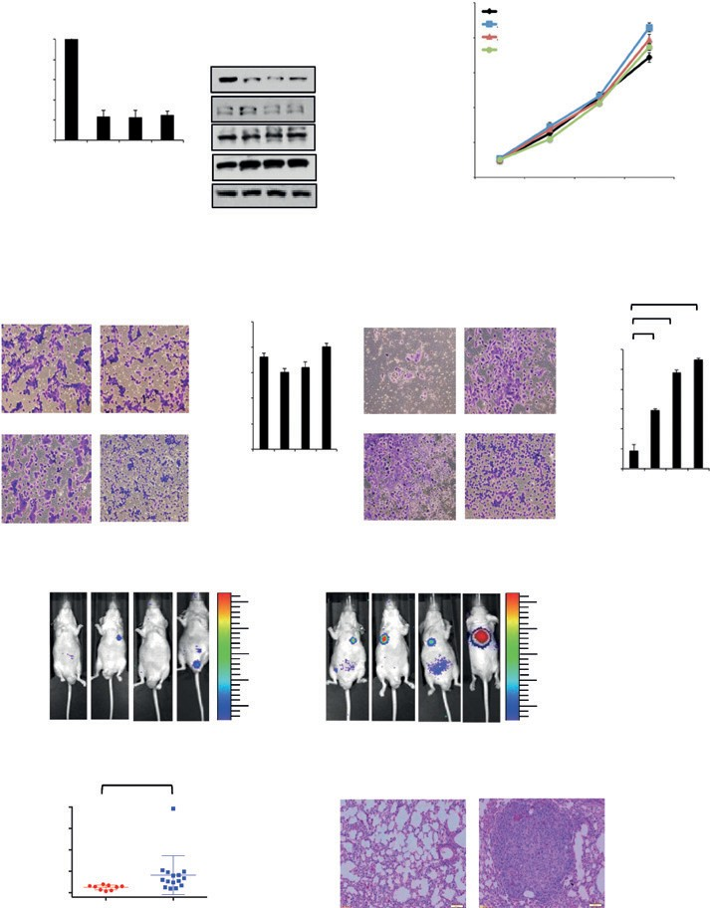
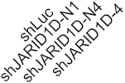
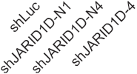
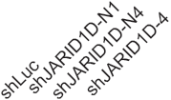
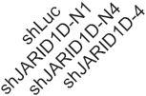
A
Relative JARID1D
mRNA level

Figure 1.
JARID1D knockdown increases the invasive abilities of prostate cancer cells. A, analysis of JARID1D mRNA and JARID1A–D protein levels following
shRNA treatment. shRNAs were used
to deplete JARID1D in DU145 prostate

1.0
0.8
0.6
0.4
0.2
0

DU145 cells

*** *** ***
B

JARID1D JARID1A JARID1B
JARID1C

p84

15 shLuc shJARID1D-N1
Cell number (×104)
12 shJARID1D-N4 shJARID1D-4
9

6

3

0

cancer cells. Total RNAs were analyzed C
using quantitative RT-PCR. The relative
fold represents the expression levels in
Cell numbers per field
DU145 cells
Migration
D DU145 cells
Invasion

***
Cell numbers per field

individual samples over those in
control shLuc samples. For Western blot analysis, nuclear proteins were extracted and blotted with anti-
JARID1D and anti-p84 antibodies. B–D,
effects of JARID1D knockdown on the
shLuc
shJARID1D-N1
500
400
300
200
shLuc shJARID1D-N1
**
**
600
500
400
300

proliferation (B), migration (C), and
invasion (D) of DU145 cells. Cells that had migrated and invaded were counted in at least ﬁve ﬁelds. E and F, effects of JARID1D knockdown on the metastatic abilities of DU145 cells in an intravenous mouse xenograft model.
shJARID1D-N4 shJARID1D-4
100
0
shJARID1D-N4 shJARID1D-4
200
100
0

Metastasized loci were monitored E
shScramble
8–10 weeks
shJARID1D-4

using a bioluminescence imaging
DU145 –Luc2 cells
system. Representative
bioluminescent images of mice (8 to 10 weeks after tail-vein injections) are
shown (dorsal view for No. 43 and ventral view for all the others; E). Quantiﬁed bioluminescent signals were individually plotted for the
shScramble and shJARID1D groups
(shScramble, n ¼ 9; shJARID1D, n ¼ 15;
F). G, representative images of F
#15 #16 #22

Fold: 3.33
#37

3.0
2.5
2.0 ×104
1.5

1.0

G
#23
#29
#30
#43

3.0

2.5
2.0 ×104

1.5
1.0

hematoxylin and eosin–stained lung
tissues in shScramble and shJARID1D
mice.

20
15 P = 0.028
10
5
0
Normal lung Tumor

shScramble (# 15)
Total flux (×105 p/s)

shJARID1D-4 (# 29)

ChIP-Seq
For H3K4me3 ChIP-Seq, DU145 prostate cells infected with shLuc- or shJARID1D-containing viruses were cross-linked with
1% formaldehyde at room temperature for 10 minutes and then sonicated to fragment genomic DNA sizes to 200 to 500 bp. ChIP was performed using anti-H3K4me3 antibody. After library prep- aration and quantiﬁcation, DNA was subjected to HiSeq 2500 sequencing platform (UCI Genomics HTF). Reads were aligned to the human genome (UCSC hg19) using the Bowtie aligner. If a read maps to more than one genomic locations, the read align- ment was suppressed (26). Then the unmapped reads were removed using Sam tool. MACS software was used for peak
calling. In MACS, the parameter with no model and a shift size of 100 bp was chosen, and input data were used as a control for normalization (27). Bigwig track were generated to visualize ChIP-seq data in the UCSC genome browser. Integrative analysis of gene proﬁle around TSS and heatmap generation was per- formed using Cistrome platform (28)

Immunohistochemistry
The avidin–biotin immunoperoxidase method was used to visualize proteins in tissue microarrays (Biomax PR955 and PR8011). Tissues in microarrays were deparafﬁnized, treated with citrate buffer, and heated with a microwave for 20 minutes. Then,


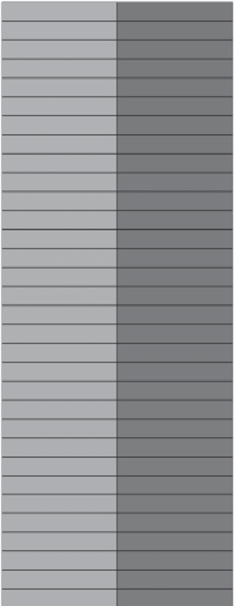
A Genes upregulated by JARID1D knockdown B

Translation
Cell adhesion
Transport Transmembrane transport Signal transduction
Cell proliferation Protein complex assembly Cell differentiation
Cell cycle
Ribosome biogenesis Cell division Mitosis
Protein folding
Carbohydrate metabolic processs
Cell death Extracellular matrix organization Cytoskeleton organization
Cell motility
Vesicle-mediated transport Response to stress Nucleocytoplasmic transport Embryo development
Protein maturation

C

25
P value
4.82E−07
6.20E−07
1.12E−06
1.61E−06
1.95E−06
8.18E−06
1.62E−05
1.74E−05
2.37E−05
9.94E−05
2.30E−04
2.62E−04
5.43E−04
7.10E−04
8.34E−04
6.04E−03
6.65E−03
9.04E−03
1.41E−02
1.44E−02
1.54E−02
2.28E−02
2.61E−02

0 10 20 30 40 50 60 70 80 90
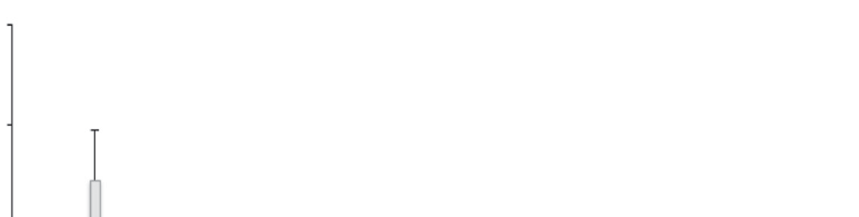
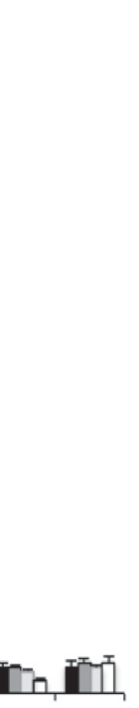
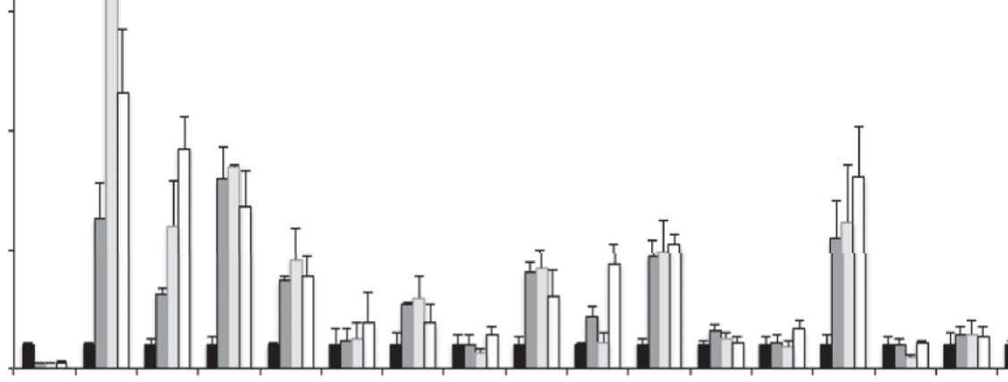
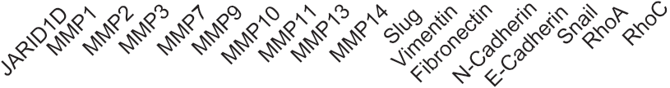
Number of genes in GO category

DU145 cells

LOC730755
PTHLH ADAMTS6
MMP1
ID2
Slug/SNAI2
IGFBP3
BMP2
ANGPTL4
TFPI2
EGR1
HMGA2
SCG5
LOX
CYP24A
GPR87
RSPO3
SPOCK1
EFNB2
TMEM87A
RNF182
NOG
KIAA1199
PPARD
ANKRD1
GKN2
ADAM19
FERMT1
PMEPA1
ODC1
PTPRO
PPAPDC1A SMARCE1
RCBTB2
WDR69
TMEM158
NR2F1
DCBLD1
TGFB1
C1orf43
CDKN1A
SPHK1
DUSP4
IVL
HBEGF MIR155HG ZNF185
HS2ST1
NT5E SLC35F3
DUSP3
ZNF451
CHD9
SPINK1
MTHFD2L ID3
ITGA2
TFRC
LOC100131262
CAMK2N1

DCBLD2
DLEU2
DNER STC1

shLuc
Relative mRNA level (fold)
*
shJARID1D-N1
*
20 shJARID1D-N4 shJARID1D-4

15
*

10
*

*
**
****

5
**
***
*
*** *
*
*
**
*
*

0
GLIPR1
PDCD2
FLJ42709
C4orf26
MMP14
SGEF LAMC2
MPHOSPH6
EIF4EBP2
C6orf114
NF2
COL4A2
LOC283567
BTC FLRT2
HIST1H2BG
C16orf52
SLAMF7
TNIK
PHF20
TRIM36
SLC26A2
ZBTB47
YKT6
ANKRD13C MDM1
SLC25A32
PSME3

Expression (log2)
***
**
*
*
– 2.5 0 2.5

microarrays were incubated with the primary antibodies (e.g., anti-JARID1D) for 1 hour at room temperature. Staining intensity was assessed by Chromavision Automated Cellular Imaging Sys- tem (ACIS-III) from Dako.

Analysis of expression levels in tumor samples and of patient survival
For the Oncomine database analysis, the mRNA levels were normalized to the median value of the dataset, and expression levels were log2-transformed (www.oncomine.com). Kaplan– Meier overall survival curves were generated for patients for whom follow-up data were available. The log-rank (Mantel–Cox) test was used to analyze survival differences between groups.

Statistical analysis
Data are presented as the means 土 SEMs (error bars). A Student
t test was used to assess whether differences between two different groups were statistically signiﬁcant. 牢 , P < 0.05; 牢牢 , P < 0.01; and
牢牢牢 , P < 0.001 indicate statistically signiﬁcant changes.

Results
JARID1D suppresses the invasive but not the proliferative or migratory abilities of prostate cancer cells
As an initial step toward understanding the role of JARID1D
in prostate cancer events, we determined whether JARID1D regulates the proliferation, migration, and invasion of prostate cancer cells. In particular, we examined the effect of JARID1D knockdown on these cellular characteristics using the widely used and weakly metastatic prostate cancer cell line DU145 (29, 30). All three shJARID1Ds used in this study speciﬁcally reduced JARID1D mRNA and proteins levels (Fig. 1A; Supple- mentary Fig. S1), but JARID1D depletion did not have a signiﬁcant effect on the proliferative and migratory abilities of DU145 cells (Fig. 1B and C). The cell migration assay, because it lacks an extracellular matrix barrier, scores the simple migra- tory abilities of cancer cells. In contrast, the invasion assay measures the abilities of cancer cells to degrade and invade a Matrigel matrix that mimics the in vivo matrix barrier. Therefore, we also examined the effect of JARID1D knockdown on cell invasion. In sharp contrast to cell migration, cellular invasive- ness was highly increased by JARID1D depletion (Fig. 1D). These results indicate that JARID1D may act as an epigenetic repressor of the invasion, but not proliferation or migration, of prostate cancer cells.

JARID1D inhibits the invasiveness of prostate cancer cells
in vivo
To assess the effect of JARID1D on the invasiveness of prostate cancer cells in vivo, we used an intravenous mouse xenograft model. For this experiment, we generated a DU145 cell line expressing a luciferase (DU145-Luc2 cells) that enabled us to
monitor tumor growth in vivo. Following the treatment of DU145- Luc2 cells with shJARID1D or control shRNA, cells were injected into tail veins of mice. In this xenograft model, cancer cells invade into a distant organ during extravasation (departure from the blood system) and grow as a tumor at the metastatic site (pri- marily, the lung). This mouse xenograft experiment demonstrated that 8th to 10th weeks after cell injection, luciferase signals in the
shJARID1D mice (n ¼ 15) were signiﬁcantly higher than those in
the control shRNA mice (n ¼ 9; Fig. 1E and F). Tumor formation in
shJARID1D group mice was conﬁrmed by hematoxylin and eosin staining (Fig. 1G). These results suggest that JARID1D suppresses the invasive capacities of DU145 prostate cancer cells in vivo.

JARID1D represses the expression of invasiveness-associated genes
To determine how JARID1D suppresses the invasive ability
of prostate cancer cells, we compared the whole genome mRNA expression proﬁle of JARID1D-depleted DU145 cells to that of control (shLuc-treated) DU145 cells using Affymetrix micro- arrays. Consistent with JARID1D's inhibition of cellular inva- siveness, gene ontology analysis showed that JARID1D knock- down upregulated gene expression programs associated with cellular invasiveness, including cell adhesion, cytoskeleton organization, and extracellular matrix organization (Fig. 2A and B). The number of invasiveness-associated genes upregu- lated by JARID1D knockdown was higher than the number of those genes downregulated by JARID1D knockdown (Fig. 2A vs. Supplementary Fig. S2). Interestingly, expression levels of several invasion-associated genes, including the matrix metal- loproteinase 1 (MMP1) and the transcriptional repressor gene Slug, were increased by JARID1D knockdown (Fig. 2B). Our quantitative RT-PCR analysis conﬁrmed that JARID1D knock- down upregulated expression levels of MMP1 and Slug (Fig.
2C).
MMPs are known to facilitate cell invasion and metastasis by enzymatically degrading extracellular matrix components (31). The mesenchymal cell–cell adhesion molecule N-cadherin and Slug promote epithelial-to-mesenchymal transition (EMT), a reversible, temporary but complex process in which immotile epithelial cells convert to motile and invasive mesenchymal cells. In contrast, the epithelial cell–cell adhesion molecule E-cadherin inhibits this process (32, 33). However, the expression of multiple well-known invasion-associated genes, including several MMPs, E-cadherin, and N-cadherin, was not detected by the Affymetrix microarrays (Fig. 2B). Therefore, we manually analyzed the effect of JARID1D knockdown on these genes using quantitative RT-PCR. Our results demonstrated that in addition to the upre- gulation of MMP1 and Slug, JARID1D knockdown also upregu- lated the MMP2, MMP3, MMP7, MMP10, MMP13, MMP14, and N-cadherin genes in DU145 cells (Fig. 2C). In agreement with JARID1D's lack of effect on cell migration, JARID1D depletion did not affect the expression of several genes associated with cell

Figure 2.
JARID1D represses the expression of several invasiveness-associated genes. A, gene ontology analysis for genes upregulated by JARID1D knockdown in DU145 cells. The mRNA levels were measured using the Affymetrix U133P gene expression microarray. Gene ontology analysis was performed for 1,416 genes whose expression levels in the shJARID1D group were 1.5-fold higher than those in the shLuc group (i.e., shJARID1D/shLuc: >1.5). B, heatmap of genes upregulated by JARID1D knockdown in DU145 cells as measured by microarray. C, effects of JARID1D knockdown on the expression of invasiveness-associated genes. Quantitative RT-PCR analysis of genes showed that JARID1D knockdown increased MMP1, MMP2, MMP3, MMP7, MMP10, MMP13, MMP14, N-cadherin, and Slug mRNA
levels in DU145 cells.

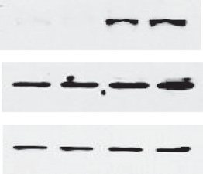
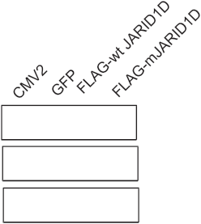
A B C

pFlag-CMV2

JARID1D
Relative mRNA levels


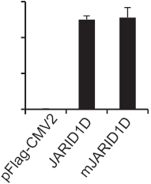
600 ***

400

200

0

D
MMP1

***

Actin

PC3 Cells

E F

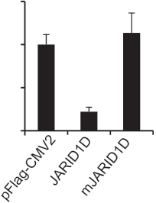
MMP2

JARID1D

mJARID1D

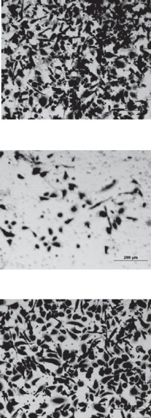
MMP3
Relative mRNA levels
250
200
Cell numbers per field

100
50
0

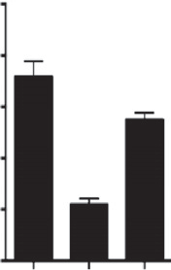
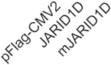
PC3 cells

4.0
Relative mRNA levels

3.0

2.0

1.0

0

G


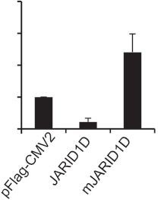
**

MMP7
Relative mRNA levels

***

1.5
Relative mRNA levels

1.0

0.5

0

H


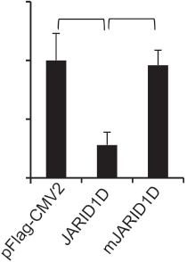
Slug
*** *


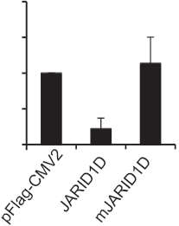
2.0

1.5

1.0

0.5

0

** *
were transfected with control
plasmids (pFLAG-CMV2 and GFP), pFLAG-CMV2-JARID1D, or pFLAG-
CMV2-mJARID1D. The mRNA levels of
JARID1D and mJARID1D were
measured using quantitative RT-PCR (A). JARID1D protein and H3K4me3 levels were assessed using Western blot analysis (B). C, effects of ectopic expression of JARID1D and mJARID1D on the invasiveness of PC3 cells.
Representative images are shown.
Cells that had invaded were counted in at least ﬁve ﬁelds. D–H, effects of
JARID1D and mJARID1D on MMP1 (D), MMP2 (E), MMP3 (F), MMP7 (G), and


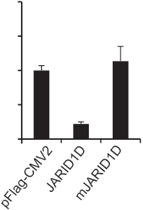
2.0
Relative mRNA levels

1.5

** **
1.5 * *

1.0
Slug (H) expression in PC3 cells.

1.0

0.5

0

0.5

0

migration, such as RhoA and RhoC. These results suggest that JARID1D suppresses cell invasion by transcriptionally repressing multiple invasion-associated genes.

JARID1D's enzymatic activity is required for JARID1D's anti-invasive function
A histone demethylase can regulate cellular functions depen-
dent or independent of its catalytic activity. For example, we have shown that the demethylase activity of the H3K27 demethylase UTX (also called KDM6A) is indispensable for the regulation of the proliferative and invasive abilities of breast cancer cells (24). In contrast, the demethylase activity of UTX is dispensible for several other biologic processes, such as T-box family member– dependent gene expression (34), mesoderm differentiaion of mouse embryonic stem cells (35), and mouse embryonic devel- opment (36).
To assess whether the enzymatic activity of JARID1D is neces- sary for cellular invasiveness and to complement shRNA-medi- ated JARID1D knockdown experiments, we determined the effect of JARID1D's ectopic expression in the prostate cancer cell line PC3, which lacks endogenous JARID1D because of the absence of the Y chromosome. As shown in Fig. 3A and B, wild-type JARID1D and its catalytic mutant mJARID1D were similarly expressed, and their overexpression had no obvious effect on total cellular H3K4me3 levels. Our results also showed that JARID1D but not mJARID1D signiﬁcantly decreased the invasive abilities of PC3 cells in vitro (Fig. 3C). Consistent with this, the ectopic expression of JARID1D but not that of mJARID1D signiﬁcantly reduced the expression levels of the MMP1, MMP2, MMP3, MMP7, and Slug genes in PC3 cells (Fig. 3D–H). These results indicate that JAR- ID1D has an anti-invasiveness function that depends largely on JARID1D's catalytic activity.

A B C

MMP1 TSS

MMP2
TSS
MMP3
TSS

1 kb a b

1 kb a b

1 kb a b

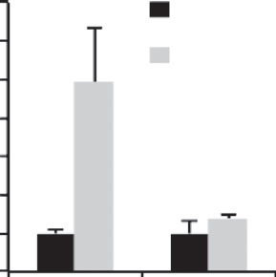
7 * IgG
Fold enrichment

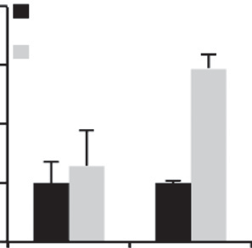
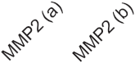
4 IgG
*
IgG *
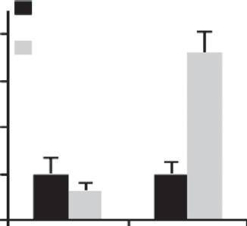
4
Fold enrichment

Figure 4.
JARID1D occupies invasiveness- associated genes, including several
MMPs and Slug. A–E, quantitative ChIP analysis of JARID1D levels at the MMP1 (A), MMP2 (B), MMP3 (C), MMP7 (D), and Slug (E) genes in DU145 cells. The relative occupancy represents the fold changes in PCR values from speciﬁc
antibody over those from the IgG.
Schematic representation of the D
promoter regions of the MMP1, MMP2,
6
5
4
3
2
1
0

MMP7
JARID1D

TSS
3 JARID1D

2
Fold enrichment

1

0

E
Slug

TSS
JARID1D
3
2

1

0

MMP3, MMP7, and Slug genes are
shown. Two primer sets were used to amplify the proximal promoter regions in individual genes. The lines and primer set numbers below
1 kb a b

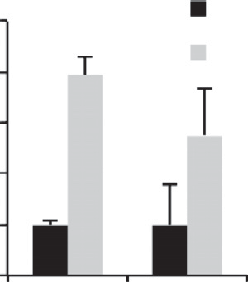
5 * IgG

1 kb a b

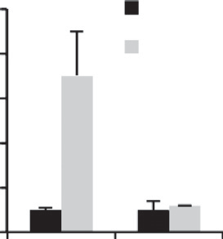
10 * IgG
Fold enrichment

indicate the PCR-ampliﬁed regions. 4
Fold enrichment
TSS, transcriptional start site.
3

2

1
0
JARID1D 8
6
4
2
0
JARID1D

JARID1D occupies multiple invasiveness-associated genes and demethylates H3K4me3 at their promoters
JARID1D represses gene expression by demethylating
H3K4me3 at the gene promoter regions (7). Therefore, genes upregulated by JARID1D knockdown may be targeted by JAR- ID1D. We tested this possibility by performing ChIP experiments. In particular, we examined different promoter regions of the MMP1, MMP2, MMP3, MMP7, and Slug genes. Our ChIP results showed that JARID1D occupied speciﬁc promoter regions in the MMP1, MMP2, MMP3, MMP7, and Slug genes (Fig. 4A–E).
Because we previously showed that JARID1D demethylates H3K4me3 to repress gene expression (7), we sought to deter- mine whether JARID1D demethylates H3K4me3 at the promo- ters of JARID1D-repressed genes in DU145 cells. Speciﬁcally, we assessed the effect of JARID1D knockdown on H3K4me3 levels at gene promoters using a ChIP-Seq approach. JARID1D knockdown slightly increased the average of H3K4me3 ChIP- Seq peaks of all the gene-regulatory regions spanning –6 kb to
þ6 kb (Fig. 5A; Supplementary Fig. S3) and also augmented the
averaged ChIP-Seq peak of H3K4me3 signals of the top 150
genes upregulated by shJARID1D (Fig. 5B; Supplementary Table S3; see also Fig. 2B). The averaged H3K4me3 ChIP-Seq peak of the 150 genes was slightly higher than that of all the gene-regulatory regions (Fig. 5A), suggesting that JARID1D preferentially represses genes whose H3K4me3 levels are higher than the average H3K4me3 level. Modest increases of H3K4me3 peaks at the 150 genes upon JARID1D knockdown
were correlated with substantial increases in their gene expres- sion (Supplementary Table S3 vs. Fig. 5B).
We also examined the effect of JARID1D knockdown on
H3K4me3 ChIP-Seq peaks at individual genes using our ChIP- Seq data. JARID1D knockdown modestly increased H3K4me3 levels at MMP1, MMP3, MMP7, and Slug promoters, whereas it had no obvious effect on H3K4me3 levels at the ACTB promoter (Fig. 5C–G). However, some genes, including MMP2, did not show a detectable H3K4me3 ChIP-Seq signal upon JARID1D knockdown, although their expression levels were upregulated by JARID1D knockdown (data not shown). In the analysis of chromatin occupancy of histone marks and chromatin-binding proteins, the sensitivity of quantitative ChIP is often higher than that of ChIP-Seq. Therefore, we performed quantitative ChIP to manually detect H3K4me3 levels at the MMP2 promoter. Our quantitative ChIP results showed that JARID1D knockdown increased H3K4me3 levels at the MMP2 promoter in addition to the MMP1, MMP3, MMP7, and Slug promoters (Fig. 5H). These results indicate that the JARID1D-catalyzed demethylation of H3K4me3 is linked to the JARID1D-mediated repression of several invasion-associated genes.

JARID1D levels are low in metastatic prostate tumors, and the JARID1D gene is frequently deleted in metastatic prostate cancer but not in primary tumors
To determine whether JARID1D expression is dysregulated in primary and metastatic prostate tumors, we compared JARID1D

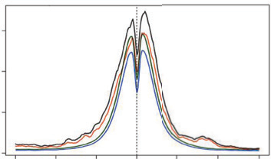
A

150
H3K4me3 average profile

shJARID1D (whole genome)
shLuc

shJARID1D (150 genes)
shLuc
(150 genes)
C chr11
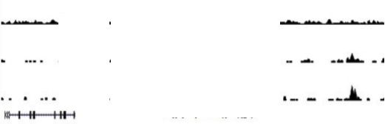
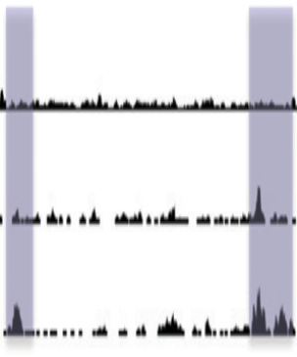
35
0
35

0
35

10 kb a

Input shLuc
shJARID1D

100 (whole genome)

50
0

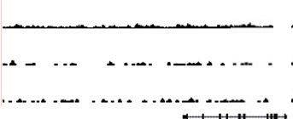
D chr11

MMP 0

MMP1

10 kb

0
–6K –4K –2K

H3K4me3
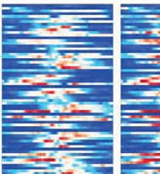
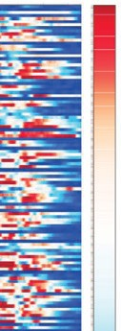
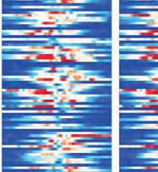
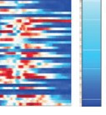
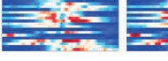
B (shLuc)
35
TSS 2K 4K 6K 0
35
0
H3K4me3 35
(shJARID1D) 0
312
Input shLuc shJARID1D
b

M P3

E chr11
150 genes upregulated by JARID1D knockdown

10 kb

202

102
35
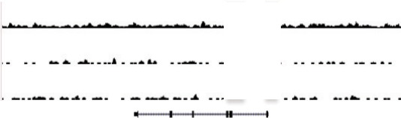
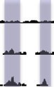
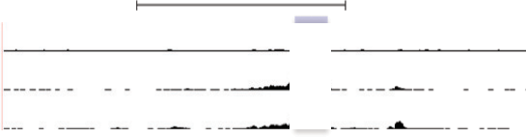

0
35
0
35
0

F
150
0
150
0
150
0

chr8
Input shLuc shJARID1D

Input shLuc
shJARID1D
a

MMP7

10 kb a

–2K

H

TSS

2K –2K

TSS 2K 0

G

400
0
400
0
400
0

chr7

Input shLuc shJARID1D
Slug

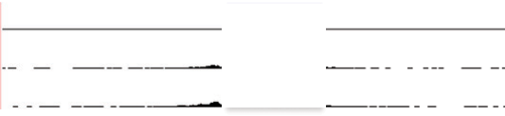
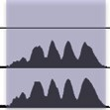
10 kb

ACTB

shLuciferase
shJARID1D-4

MMP1 (a)

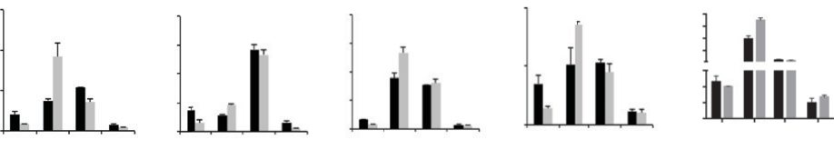
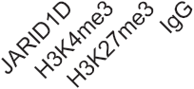
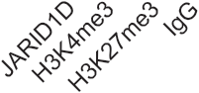
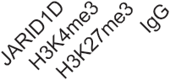
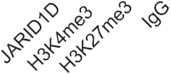
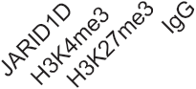
MMP2 (b)
MMP3 (b)
MMP7 (a)
Slug (a)

0.15
*
Input %
0.10
*
0.05 *

0.00
0.20

0.15
0.10

0.05

0.00

* **
0.20
0.15 *

0.10
0.05 **
0.00
0.10 *

0.05 *

0.00
2.0 *
1.5
0.5
0.03

0.00

protein levels among normal tissues, primary prostate tumors, and metastatic prostate tumors using IHC analysis. Compared with those in normal tissues (10%, 2/21), JARID1D protein levels in metastatic prostate tumors were drastically downregulated (100%, 6/6), and those in primary prostate tumors were sub- stantially decreased (41%, 28/68; Fig. 6A and B). We also deter- mined whether JARID1D mRNA levels are decreased in prostate tumor samples using the publicly available database Oncomine. The JARID1D mRNA levels in metastatic prostate tumors were signiﬁcantly lower than those in primary prostate tumors and normal tissues (Fig. 6C; and Supplementary Fig. S4A and B).
Because the Y chromosome, on which the JARID1D gene is localized, frequently undergoes complete or partial deletion in prostate tumors (15), we assessed the status of the JARID1D gene in primary and metastatic prostate tumors and compared it with those of other histone methylation modiﬁers. Our analysis of publicly available database showed that the JARID1D gene was more frequently lost in metastatic prostate cancer than in primary prostate tumors (Fig. 6D; ref. 37). Of interest, the JARID1D gene was deleted more frequently than were genes encoding other histone lysine methyltransferases and demethylases in metastatic tumors (Fig. 6E).

Low JARID1D levels are associated with high MMP1 and MMP3 mRNA levels and with poor prognosis in prostate cancer patients
To determine whether JARID1D levels are associated with the
expression of certain JARID1D target genes in prostate tumor samples, we compared the expression levels of JARID1D to those of its target genes using the cBioPortal (NCBI GEO Database
#GSE21032). Our database analysis showed that JARID1D mRNA
levels were inversely correlated with the mRNA levels of MMP1 and MMP3 but not those of other JARID1D target genes, including MMP2, MMP7, MMP10, and Slug (Fig. 7A and B; Supplementary Fig. S5).
To determine whether JARID1D levels are linked to the clinical outcomes of prostate cancer patients, we performed a Kaplan– Meier survival analysis of 39 prostate cancer patients grouped by immunochemistry-assessed JARID1D protein levels. This analysis revealed that low JARID1D protein levels were signiﬁcantly asso- ciated with poor overall survival in prostate cancer patients (Fig.
7C). Moreover, our analysis of the publicly available databases showed that low JARID1D mRNA levels also signiﬁed poor overall survival in two different cohorts of prostate cancer patients (Fig.
7D and E). These results suggest that JARID1D is a novel prog- nostic marker of prostate cancer.

Discussion
Our results indicate that the male-speciﬁc histone demethylase JARID1D suppresses the invasive ability of prostate cancer cells in vitro and in vivo by downregulating invasion-associated gene programs. Compared with normal prostate tissues, primary pros-
tate tumors had low JARID1D levels, and metastatic prostate tumors had even lower JARID1D levels than primary prostate tumors did. These ﬁndings are strengthened by our public data- base analysis, which showed that the JARID1D gene was frequent- ly deleted in metastatic prostate tumors but not in primary tumors. Furthermore, our ﬁndings demonstrated that low JAR- ID1D mRNA and protein levels were linked to poor survival in prostate cancer patients, indicating that JARID1D is a prognostic marker for prostate cancer.
The overall function of the Y chromosome appears to be associated with tumor suppression (20, 21). However, multiple Y chromosome–speciﬁc genes, including Sry and TSPY, have been reported to have oncogenic function (38, 39). The current study, which indicates that JARID1D has a metastasis-suppressive role in prostate cancer progression, provides new molecular insight into how the partial or entire loss of the Y chromosome may reduce or nullify its overall tumor-suppressive function. To our knowledge, JARID1D is the ﬁrst Y chromosome–speciﬁcally expressed protein to be identiﬁed as an anti-invasiveness factor. Walport and col- leagues recently reported that the Y chromosome contains an additional histone methylation modiﬁer called UTY (40). UTY has a weak H3K27 demethylase activity, but its function in prostate tumorigenesis is not known.
Global H3K4me3 levels are signiﬁcantly increased in many advanced prostate tumors, including prostate cancer metastases (41). Our data indicated that low JARID1D levels were not corre- lated with high global H3K4me3 levels in prostate tumor samples (data not shown). In addition, our results showed that JARID1D overexpression had no detectable effect on global H3K4me3 levels while JARID1D knockdown only weakly increased global H3K4me3 levels (Fig. 5A). These results are not surprising, because global H3K4me3 levels may be coregulated by several H3K4 methyltransferases and demethylases. In support of this, previous studies have shown that total cellular levels of the H3K4me3 demethylase JARID1B and the H3K4me2 demethylase LSD1 are increased in prostate tumors, although these studies included small numbers of tumors (42, 43). Together, these ﬁndings suggest that low JARID1D levels enhance cellular invasion by increasing H3K4me3 levels at speciﬁc invasiveness-associated genes (rather than at the whole genomic level) and activating such genes.
Metastasis is a complicated process in which tumor cells under- go the detachment from the primary site, intravasation into blood vessels, extravasation to a different body location, and coloniza- tion at the secondary site (44). Mounting evidence suggests that EMT is required for metastasis. In the present study, JARID1D knockdown increased expression levels of key EMT regulators, such as N-cadherin and Slug. In contrast, JARID1D did not affect the expression of E-cadherin (Fig. 2C), suggesting that E-cadherin may not be an important factor for the JARID1D-mediated regulation of cell invasion. In line with this, Nieman and collea- gues reported that overexpression of N-cadherin enhances the mobility and invasion of cancer cells regardless of E-cadherin

Figure 5.
JARID1D demethylates H3K4me3 at the promoters at its target genes. A, comparison of averaged H3K4me3 ChIP-seq proﬁles for whole genome or 150 genes between shLuc- and shJARID1D-treated DU145 cells. The top 150 genes upregulated by JARID1D knockdown were analyzed. The gene list is summarized in
Supplementary Table S3. The proﬁling resolution is 50 bp. B, heatmap for H3K4me3 ChIP-seq signals in 150 genes. C–G, the genome browser view of
H3K4me3 signals at the MMP1 (C) and MMP10 (C), MMP3 (D), MMP7 (E), Slug (F), and ACTB (b-actin; G) genes in shLuc and shJARID1D-treated DU145 cells. Arrows indicate transcriptional direction for individual genes, and the proximal promoters with H3K4me3 signals are highlighted. H, effects of JARID1D
knockdown on H3K4me3 levels at the MMP1, MMP2, MMP3, MMP7, and Slug promoters. The chromatin levels of JARID1D, H3K4me3, H3K27me3, and IgG at these promoters were compared between shLuc- and shJARID1D-4–treated DU145 cells using a quantitative ChIP assay. The lines and letters below indicate
the PCR-ampliﬁed regions (see also Fig. 4).

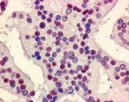
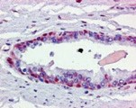
A Normal Cancer B
High JARDI1D

P < 0.001

IHC |  | JARID1D |  | Total
IHC |  | Low | High | Total
Tissue types | Normal | 2 | 19 (90%) | 21
Tissue types | Tumor | 28 | 40 (59%) | 68
Tissue types | Metastasis | 6 | 0 (0%) | 6
Total |  | 36 | 59 | 95

C
Low JARDI1D
Log2 median-centered ratio

2.0

1.5

1.0

0.5

0
Cancer Metastasis

D
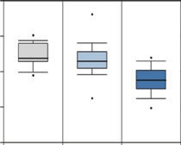
JARID1D mRNA levels

Normal Primary Metastasis

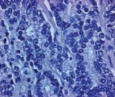
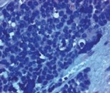
Exome sequencing

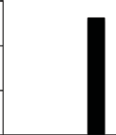
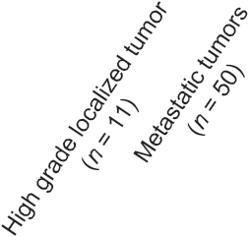
30

20

10

0

aCGH

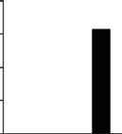
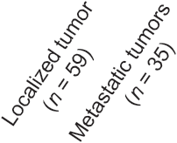
40

30

20

10

0

(n = 24) (n = 64)
Deletion of JARID1D gene (%)
(n = 24)

P = 0.024

E




30
P = 6.18E–8

Deletion Amplification Mutation

20
Percent change of total patients

10

0
D
D
D
D P
DM
D
7
M
5
M
5
M
1
M
B 5A
5
M
A B C D A
D
5
D
5
D/
5
8
/
5
M

Histone demethylases Histone methyltransferases

K K K K D/ /
D1 18
RI 17 M JAAA KD
KI
J

Figure 7.
Low JARID1D levels are correlated with high MMP1 and MMP3 levels in prostate tumors and with poor
survival in prostate cancer patients. A and B, correlation analysis of JARID1D mRNA levels with either MMP1 (A) or
A

400
MMP1 mRNA levels

300

200

100

0

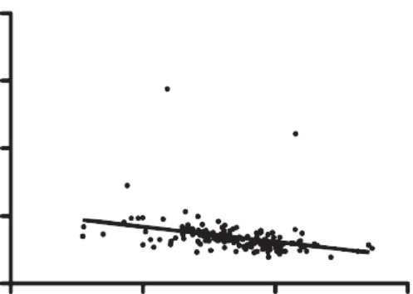
P < 0.0001 r = –0.3300 n = 150

0 200 400 600
JARID1D mRNA levels
B
200
MMP3 mRNA levels

150

100

50

0

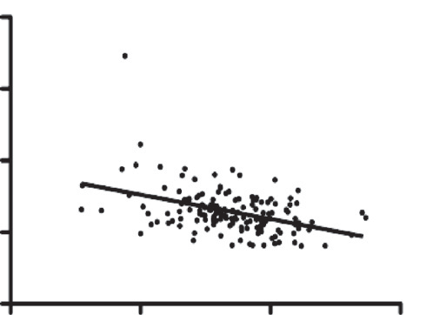
P < 0.0001 r = –0.4186 n = 150

0 200 400 600
JARID1D mRNA levels

MMP3 (B) mRNA levels in a dataset from the publicly available database cBioPortal (NCBI GEO Database
#GSE21032). C, Kaplan–Meier survival rate analysis of a set of prostate
cancer patients grouped by IHC– assessed JARID1D levels. Tumor samples in tissue microarrays were
analyzed by IHC. D, Kaplan–Meier
C

100
Percent survival
80

60

IHC

P = 0.041
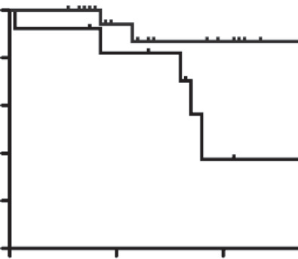
High JARID1D (n = 26)
D mRNA

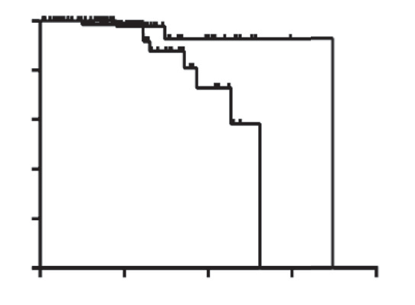
100
Percent survival
80

60
P = 0.0386
High JARID1D (n = 70)

survival rate analysis of a set of prostate cancer patients grouped by JARID1D mRNA levels. A prostate cancer patient dataset with follow-up history (NCBI GEO Database #:
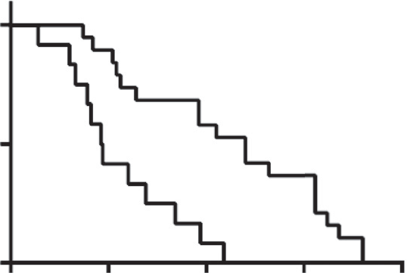
GSE21032) from cBioPortal was used; the mean JARID1D level for the entire group was used as the cutoff value. E, survival analysis of castration- resistant prostate cancer patients
E

40
Low JARID1D
20 (n = 13)
0
0 20 40 60
Months
40 Low JARID1D
20 (n = 70)

0
0 50 100 150 200
Months

grouped by JARID1D mRNA levels. Data with follow-up history in the Grasso prostate cancer dataset from

100
mRNA
P = 0.0003

the Oncomine database were used for this analysis.

50
Low
High JARID1D
(n = 19)

JARID1D (n = 12)
Percent survival
0
0 50 100 150 200
Months

levels (45). We also found that JARID1D represses the expression of multiple MMPs, such as MMP1, MMP2, MMP3, MMP7, MMP10, MMP13, and MMP14 (Fig. 2C). Interestingly, MMPs have been known to induce EMT. For example, the induced
expression of MMP3 drives the molecular and phenotypic con- version of normal epithelial cells to mesenchymal cells (46). Reciprocally, EMT induction results in increased levels of MMPs. For instance, the expression of Snail1 in cancer cells triggers an

Figure 6.
JARID1D expression is signiﬁcantly decreased in metastatic prostate cancer. A, representative images of immunohistochemical staining for JARID1D expression in human normal prostate tissues, primary prostate tumors, and metastatic prostate tumors. B, immunohistochemical analysis of JARID1D protein levels in
normal prostate tissues (n ¼ 21), primary prostate tumors (n ¼ 68), and metastatic prostate tumors (n ¼ 6). C, analysis of JARID1D mRNA levels using a dataset
called "Yu prostate cancer" from the publicly available database Oncomine. D, database analysis for the frequency of JARID1D gene deletion. Using exome sequencing data from the Grasso prostate cancer dataset from the Oncomine database, we analyzed the JARID1D gene's deletion in localized prostate tumors (n ¼ 11)
and metastatic prostate tumors (n ¼ 50; left). Tumors with -2 (a high-level copy loss) were considered to have gene deletion (37). Using array comparative
genomic hybridization (aCGH) data of the Grasso prostate cancer dataset from the Oncomine database, we analyzed the JARID1D gene's deletion (right).
Less than -1 in log 2 (tumor/normal tissue ratio) in gene copy numbers was considered to have gene deletion (37). E, analysis of the mutation and copy number
alteration of multiple histone lysine methyltransferases and demethylases in 50 metastatic prostate tumors using exome sequencing data from the Grasso prostate cancer dataset (cBio Portal). Tumors with -2 (a high-level copy loss) were considered to have gene deletion. Data in the bar graph in D are reused here
for direct comparison.

MMP-14– and MMP-15–dependent invasion program (47). Therefore, it is likely that JARID1D represses certain EMT path- ways in addition to several MMP genes to inhibit the invasiveness of prostate cancer cells.
Increased invasive abilities of cancer cells are essential for metastasis, and these abilities are in principle under epigenetic control. In fact, histone methylation modiﬁers, which epigenet- ically regulate gene expression, are positively or negatively asso- ciated with metastasis processes. There are multiple examples for metastasis-promoting histone methylation modiﬁers. Minutes and colleagues found that the H3K27 methyltransferase EZH2 may induce prostate tumorigenesis and metastasis by repressing expression of the tumor-suppressor protein DAB2IP (48). Ren and colleagues reported that EZH2 might enhance cancer cell invasion by downregulating expression of the metastasis suppressor RKIP (49). Cao and colleagues showed that JARID1A (also known as RBP2 and KDM5A) promotes breast cancer progression and metastasis (50). Similarly, Luo and colleagues demonstrated that the histone demethylase KDM4C might enhance breast tumor growth and metastasis (51). SMYD3 is upregulated in many cancer types, including pancreatic and lung tumors, and may promote cancer cell invasion by increasing expression of the matrix metalloproteinase 9 (52). In addition to overexpression of aforementioned metastasis-promoting histone modiﬁers, the losses of metastasis-inhibiting histone methylation modiﬁers may enhance cancer cell metastasis. As described in the present study, JARID1D is lost and downregulated in a substantial portion of metastatic prostate tumors. The H3K9 methyltransferase SETDB1, which appears to inhibit metastasis of lung cancer cells, is strongly downregulated in lung cancer cells (53).
In summary, we identify JARID1D as an anti-invasiveness histone methylation modiﬁer that acts against prostate cancer cell metastasis by repressing metastatic gene programs. Our work uncovers a previously unknown invasion-suppressive mechanism
by which a Y chromosome–speciﬁcally expressed histone demethylase epigenetically inhibits prostate cancer metastasis.

Disclosure of Potential Conﬂicts of Interest
No potential conﬂicts of interest were disclosed.

Authors' Contributions
Conception and design: N. Li, P.-Y. Kan, M.G. Lee
Development of methodology: N. Li, S.S. Dhar, P.-Y. Kan, C.-H. Chan Acquisition of data (provided animals, acquired and managed patients, provided facilities, etc.): N. Li, T.-Y. Chen
Analysis and interpretation of data (e.g., statistical analysis, biostatistics, computational analysis): N. Li, S.S. Dhar, T.-Y. Chen, M.G. Lee
Writing, review, and/or revision of the manuscript: N. Li, M.G. Lee
Administrative, technical, or material support (i.e., reporting or organizing data, constructing databases): N. Li, Y. Wei, J.-H. Kim, M.G. Lee
Study supervision: M.-C. Hung, M.G. Lee
Other (provided expertise and suggestions): H.-K. Lin

Acknowledgments
The authors thank Dr. Bingnan Gu, Dr. Amrish Sharma, Dr. Zhenbo Han, and Mr. Su Zhang for their technical assistance and Joan Ritho, Dr. Chunru Lin, and Dr. Liuqing Yang for supplying reagents. The authors also thank Joseph Munch for manuscript editing.

Grant Support
This study was supported by grants to M.G. Lee from the NIH (CA157919 and GM095659), the Cancer Prevention and Research Institute of Texas (CPRIT RP110183), and the Center for Cancer Epigenetics at MD Anderson (including Solexa allowance) and by a postdoctoral fellowship to N. Li from the Center for Cancer Epigenetics at MD Anderson.
The costs of publication of this article were defrayed in part by the payment of page charges. This article must therefore be hereby marked advertisement in accordance with 18 U.S.C. Section 1734 solely to indicate this fact.

References
1. Barski A, Cuddapah S, Cui K, Roh TY, Schones DE, Wang Z, et al. High- resolution proﬁling of histone methylations in the human genome. Cell 2007;129:823–37.
2. Mikkelsen TS, Ku M, Jaffe DB, Issac B, Lieberman E, Giannoukos G, et al.
Genome-wide maps of chromatin state in pluripotent and lineage-com- mitted cells. Nature 2007;448:553–60.
3. Gu B, Lee MG. Histone H3 lysine 4 methyltransferases and demethylases in self-renewal and differentiation of stem cells. Cell Biosci 2013;3:39.
4. Shi Y, Whetstine JR. Dynamic regulation of histone lysine methylation by demethylases. Mol Cell 2007;25:1–14.
5. Klose RJ, Zhang Y. Regulation of histone methylation by demethylimina- tion and demethylation. Nat Rev Mol Cell Biol 2007;8:307–18.
6. Ruthenburg AJ, Allis CD, Wysocka J. Methylation of lysine 4 on histone H3:
intricacy of writing and reading a single epigenetic mark. Mol Cell 2007;25:
15–30.
7. Lee MG, Norman J, Shilatifard A, Shiekhattar R. Physical and functional association of a trimethyl H3K4 demethylase and Ring6a/MBLR, a poly- comb-like protein. Cell 2007;128:877–87.
8. Yamane K, Tateishi K, Klose RJ, Fang J, Fabrizio LA, Erdjument-Bromage H, et al. PLU-1 is an H3K4 demethylase involved in transcriptional repression and breast cancer cell proliferation. Mol Cell 2007;25:801–12.
9. Christensen J, Agger K, Cloos PA, Pasini D, Rose S, Sennels L, et al. RBP2
Belongs to a family of demethylases, speciﬁc for tri-and dimethylated lysine
4 on histone 3. Cell 2007;128:1063–76.
10. Iwase S, Lan F, Bayliss P, de la Torre-Ubieta L, Huarte M, Qi HH, et al. The X- linked mental retardation gene SMCX/JARID1C deﬁnes a family of histone H3 lysine 4 demethylases. Cell 2007;128:1077–88.

11. Tahiliani M, Mei P, Fang R, Leonor T, Rutenberg M, Shimizu F, et al. The histone H3K4 demethylase SMCX links REST target genes to X-linked mental retardation. Nature 2007;447:601–5.
12. Lee MG, Wynder C, Cooch N, Shiekhattar R. An essential role for
CoREST in nucleosomal histone 3 lysine 4 demethylation. Nature 2005;
437:432–5.
13. Shi Y, Lan F, Matson C, Mulligan P, Whetstine JR, Cole PA, et al. Histone demethylation mediated by the nuclear amine oxidase homolog LSD1. Cell 2004;119:941–53.
14. Stahl PR, Kilgue A, Tennstedt P, Minner S, Krohn A, Simon R, et al. Y chromosome losses are exceedingly rare in prostate cancer and unrelated to patient age. Prostate 2012;72:898–903.
15. Perinchery G, Sasaki M, Angan A, Kumar V, Carroll P, Dahiya R. Deletion of
Y-chromosome speciﬁc genes in human prostate cancer. J Urol 2000;163:
1339–42.
16. Wallrapp C, Hahnel S, Boeck W, Soder A, Mincheva A, Lichter P, et al. Loss of the Y chromosome is a frequent chromosomal imbalance in pancreatic cancer and allows differentiation to chronic pancreatitis. Int J Cancer
2001;91:340–4.
17. Bianchi NO, Richard SM, Pavicic W. Y chromosome instability in testicular cancer. Mutat Res 2006;612:172–88.
18. Hunter S, Gramlich T, Abbott K, Varma V. Y chromosome loss in esoph- ageal carcinoma: An in situ hybridization study. Genes Chromosomes Cancer 1993;8:172–7.
19. Minner S, Kilgue A, Stahl P, Weikert S, Rink M, Dahlem R, et al. Y chromosome loss is a frequent early event in urothelial bladder cancer. Pathology 2010;42:356–9.

20. Vijayakumar S, Garcia D, Hensel CH, Banerjee M, Bracht T, Xiang R, et al.
The human Y chromosome suppresses the tumorigenicity of PC-3, a human prostate cancer cell line, in athymic nude mice. Genes Chromo- somes Cancer 2005;44:365–72.
21. Forsberg LA, Rasi C, Malmqvist N, Davies H, Pasupulati S, Pakalapati G, et al. Mosaic loss of chromosome Y in peripheral blood is associated with shorter survival and higher risk of cancer. Nat Genet 2014;46:624–8.
22. Wagner KW, Alam H, Dhar SS, Giri U, Li N, Wei Y, et al. KDM2A promotes lung tumorigenesis by epigenetically enhancing ERK1/2 signaling. J Clin Invest 2013;123:5231–46.
23. Dhar SS, Alam H, Li N, Wagner KW, Chung J, Ahn YW, et al. Transcriptional repression of histone deacetylase 3 by the histone demethylase KDM2A is coupled to tumorigenicity of lung cancer cells. J Biol Chem 2014;289:
7483–96.
24. Kim JH, Sharma A, Dhar SS, Lee SH, Gu B, Chan CH, et al. UTX and MLL4 coordinately regulate transcriptional programs for cell proliferation and invasiveness in breast cancer cells. Cancer Res 2014;74:1705–17.
25. Dhar SS, Lee SH, Kan PY, Voigt P, Ma L, Shi X, et al. Trans-tail regulation of MLL4-catalyzed H3K4 methylation by H4R3 symmetric dimethylation is mediated by a tandem PHD of MLL4. Genes Dev 2012;26:2749–62.
26. Langmead B, Trapnell C, Pop M, Salzberg SL. Ultrafast and memory- efﬁcient alignment of short DNA sequences to the human genome. Genome Biol 2009;10:R25.
27. Zhang Y, Liu T, Meyer CA, Eeckhoute J, Johnson DS, Bernstein BE, et al.
Model-based analysis of ChIP-Seq (MACS). Genome Biol 2008;9:R137.
28. Liu T, Ortiz JA, Taing L, Meyer CA, Lee B, Zhang Y, et al. Cistrome: an integrative platform for transcriptional regulation studies. Genome Biol
2011;12:R83.
29. Nemeth JA, Harb JF, Barroso U, Jr., He Z, Grignon DJ, Cher ML. Severe combined immunodeﬁcient-hu model of human prostate cancer metas- tasis to human bone. Cancer Res 1999;59:1987–93.
30. Abdulghani J, Gu L, Dagvadorj A, Lutz J, Leiby B, Bonuccelli G, et al. Stat3 promotes metastatic progression of prostate cancer. Am J Pathol 2008;172:
1717–28.
31. Kessenbrock K, Plaks V, Werb Z. Matrix metalloproteinases: regulators of the tumor microenvironment. Cell 2010;141:52–67.
32. Friedl P, Alexander S. Cancer invasion and the microenvironment: plas- ticity and reciprocity. Cell 2011;147:992–1009.
33. Yang J, Weinberg RA. Epithelial-mesenchymal transition: at the crossroads of development and tumor metastasis. Dev Cell 2008;14:818–29.
34. Miller SA, Mohn SE, Weinmann AS. Jmjd3 and UTX play a demethylase- independent role in chromatin remodeling to regulate T-box family member-dependent gene expression. Mol Cell 2010;40:594–605.
35. Wang C, Lee JE, Cho YW, Xiao Y, Jin Q, Liu C, et al. UTX regulates mesoderm differentiation of embryonic stem cells independent of H3K27 demethy- lase activity. Proc Natl Acad Sci U S A 2012;109:15324–9.
36. Shpargel KB, Sengoku T, Yokoyama S, Magnuson T. UTX and UTY dem- onstrate histone demethylase-independent function in mouse embryonic development. PLoS Genet 2012;8:e1002964.
37. Grasso CS, Wu YM, Robinson DR, Cao X, Dhanasekaran SM, Khan AP, et al.
The mutational landscape of lethal castration-resistant prostate cancer. Nature 2012;487:239–43.
38. Oram SW, Liu XX, Lee TL, Chan WY, Lau YF. TSPY potentiates cell proliferation and tumorigenesis by promoting cell cycle progression in HeLa and NIH3T3 cells. BMC Cancer 2006;6:154.
39. Murakami S, Chishima S, Uemoto H, Sakamoto E, Sato T, Kurabe N, et al.
The male-speciﬁc factor Sry harbors an oncogenic function. Oncogene
2014;33:2978–86.
40. Walport LJ, Hopkinson RJ, Vollmar M, Madden SK, Gileadi C, Oppermann U, et al. Human UTY(KDM6C) is a male-speciﬁc N-methyl lysyl demethy- lase. J Biol Chem 2014;289:18302–13.
41. Ellinger J, Kahl P, von der Gathen J, Rogenhofer S, Heukamp LC, Gutge- mann I, et al. Global levels of histone modiﬁcations predict prostate cancer recurrence. Prostate 2010;70:61–9.
42. Xiang Y, Zhu Z, Han G, Ye X, Xu B, Peng Z, et al. JARID1B is a histone H3 lysine 4 demethylase upregulated in prostate cancer. Proc Natl Acad Sci U S A 2007;104:19226–31.
43. Kahl P, Gullotti L, Heukamp LC, Wolf S, Friedrichs N, Vorreuther R, et al.
Androgen receptor coactivators lysine-speciﬁc histone demethylase 1 and four and a half LIM domain protein 2 predict risk of prostate cancer recurrence. Cancer Res 2006;66:11341–7.
44. Chaffer CL, Weinberg RA. A perspective on cancer cell metastasis.
Science 2011;331:1559–64.
45. Nieman MT, Prudoff RS, Johnson KR, Wheelock MJ. N-cadherin promotes motility in human breast cancer cells regardless of their E-cadherin expres- sion. J Cell Biol 1999;147:631–44.
46. Lochter A, Galosy S, Muschler J, Freedman N, Werb Z, Bissell MJ. Matrix metalloproteinase stromelysin-1 triggers a cascade of molecular alterations that leads to stable epithelial-to-mesenchymal conversion and a prema- lignant phenotype in mammary epithelial cells. J Cell Biol 1997;139:
1861–72.
47. Ota I, Li XY, Hu Y, Weiss SJ. Induction of a MT1-MMP and MT2-MMP- dependent basement membrane transmigration program in cancer cells by Snail1. Proc Natl Acad Sci U S A 2009;106:20318–23.
48. Min J, Zaslavsky A, Fedele G, McLaughlin SK, Reczek EE, De Raedt T, et al.
An oncogene-tumor suppressor cascade drives metastatic prostate cancer by coordinately activating Ras and nuclear factor-kappaB. Nat Med
2010;16:286–94.
49. Ren G, Baritaki S, Marathe H, Feng J, Park S, Beach S, et al. Polycomb protein EZH2 regulates tumor invasion via the transcriptional repression of the metastasis suppressor RKIP in breast and prostate cancer. Cancer Res
2012;72:3091–104.
50. Cao J, Liu Z, Cheung WK, Zhao M, Chen SY, Chan SW, et al. Histone demethylase RBP2 is critical for breast cancer progression and metastasis. Cell Rep 2014;6:868–77.
51. Luo W, Chang R, Zhong J, Pandey A, Semenza GL. Histone demethylase JMJD2C is a coactivator for hypoxia-inducible factor 1 that is required for breast cancer progression. Proc Natl Acad Sci U S A 2012;109:E3367–76.
52. Cock-Rada AM, Medjkane S, Janski N, Yousﬁ N, Perichon M, Chaussepied
M, et al. SMYD3 promotes cancer invasion by epigenetic upregulation of the metalloproteinase MMP-9. Cancer Res 2012;72:810–20.
53. Wu PC, Lu JW, Yang JY, Lin IH, Ou DL, Lin YH, et al. H3K9 histone methyltransferase, KMT1E/SETDB1, cooperates with the SMAD2/3 path- way to suppress lung cancer metastasis. Cancer Res 2014;74:7333–43.

