Oral Citrulline Mitigates Inflammation and Jejunal Damage via the Inactivation of Neuronal Nitric Oxide Synthase and Nuclear Factor–κB in Intestinal Ischemia and Reperfusion

Chun-Hong Lai, RD, MS1,*; Chien-Hsing Lee, MD, PhD2,3,*; Ching-Yi Hung, MS2; and Hui-Chen Lo, PhD4

Abstract
Background: Intestinal ischemia and reperfusion (I/R) is a life-threatening emergency accompanied by inflammation and organ damage. We compared the mechanisms and the effects of arginine, citrulline, and glutamine on inflammation and intestinal damage. Materials and Methods: Male Wistar rats underwent 60 minutes of superior mesenteric artery occlusion and either 3 (I/R3) or 24 (I/R24) hours of reperfusion and were orally administered vehicle, arginine, citrulline, or glutamine 15 minutes before reperfusion and at 3, 9, and 21 hours of reperfusion. Results: I/R3 rats experienced jejunal damage and apoptosis, and I/R24 rats had liver dysfunction compared with normal rats (one-way ANOVA, P
< .05). Arginine and citrulline administrations improved jejunal morphology, and citrulline and glutamine administrations alleviated the loss of jejunal mass in I/R3 rats. I/R3-increased circulating nitrate/nitrite (NOx), tumor necrosis factor–α, and interleukin-6 were significantly decreased by citrulline, glutamine and citrulline, and arginine, glutamine, and citrulline, respectively. These amino acids decreased plasma NOx and interferon-γ in I/R24, decreased jejunal neuronal nitric oxide synthase (NOS) protein in I/R3 rats, and alleviated jejunal apoptosis in I/R3 and I/R24 rats. In addition, the jejunal phosphorylated to total nuclear factor–κB (NF-κB) ratio was decreased by arginine and citrulline in I/R24 rats. Conclusion: Oral administration of arginine, citrulline, and glutamine may alleviate systemic inflammation, jejunal apoptosis, and neuronal NOS in intestinal I/R. Citrulline may further attenuate jejunal damage by preserving jejunal mass, partially via the inactivation of NOS and the NF-κB pathway. In conclusion, oral citrulline may have more benefits than arginine and glutamine in mitigating intestinal ischemia and reperfusion-induced adverse effects. (JPEN J Parenter Enteral Nutr. XXXX;xx:xx-xx)

Keywords
intestinal ischemia and reperfusion; arginine; citrulline; glutamine; inflammatory mediators; apoptosis; nitric oxide synthase; nuclear factor–κB

Clinical Relevancy Statement
Intestinal ischemia and reperfusion (I/R) is a life-threatening emergency accompanied by inflammation and organ damage. Using rats with intestinal ischemia followed by either 3 or 24 hours of reperfusion to mimic the intestinal I/R-induced acute injury in clinical situations, we found that oral citrulline may have more benefits than arginine and glutamine in mitigating intestinal I/R-induced systemic inflammation and jejunal atro- phy and apoptosis. Oral citrulline supplementation may be a useful adjuvant to alleviate intestinal I/R-induced damages.

Introduction
Intestinal ischemia and reperfusion (I/R) is a life-threatening abdominal emergency that commonly results in systemic inflammation, multiple organ failure (MOF), and death.1 Even with advanced clinical techniques, the in-hospital mortality rate of intestinal I/R remains as high as 55.1%.2 The nutritive perfusion failure and intestinal barrier dysfunction facilitate the translocation of bacteria and toxins and result in the local
and systemic inflammation in an intestinal I/R injury.1 It has been demonstrated that the excess production of inflammatory mediators, such as the proinflammatory cytokines and nitric oxide (NO), and the overactivation of the transcriptional factor

From the 1Department of Nutrition, Chi-Mei Medical Center, Tainan; 2Division of Pediatric Surgery, Department of Surgery, Children’s Hospital of China Medical University, Taiwan; 3Graduate Institute of Medical Sciences, Chang Jung Christian University, Tainan, Taiwan; and 4Department of Nutritional Science, Fu Jen Catholic University, New Taipei City, Taiwan.
*Chun-Hong Lai and Chien-Hsing Lee contributed equally to this article.
Financial disclosure:This work is supported by the National Science Council of the Republic of China (NSC 98-2320-B-030-003-MY3).
Received for publication January 27, 2015; accepted for publication May 18, 2015.
Corresponding Author:
Hui-Chen Lo, PhD, Department of Nutritional Science, Fu Jen Catholic University, #510 Zhongzheng Rd, Xinzhuang District, New Taipei City 24205, Taiwan.
Email: 041663@mail.fju.edu.tw

2

nuclear factor (NF)–κB in the jejunal mucosa play essential roles in the intestinal I/R-induced inflammation and MOF.3
Numerous strategies have been proposed to ameliorate intestinal I/R injury. The therapeutic effects of nutrition sup- port, especially the immunonutrients glutamine and arginine, on intestinal I/R-induced local and systemic inflammation have been investigated. Animal studies have shown that argi- nine, the sole source of NO in the human body, may enhance survival rates, improve intestinal integrity and function, sup- press the release of proinflammatory cytokines, and inhibit lung leakage and neutrophil infiltration in cases of intestinal I/R.4,5 Arginine-derived NO is considered the major mediator of minimizing mucosal cell injury during reperfusion.6 However, several studies have indicated that arginine adminis- tration soon after intestinal I/R may worsen the outcomes via excessive priming and the activation of circulating myeloid cells and inducible nitric oxide synthase (iNOS) expression.7,8 Via de novo arginine synthesis, citrulline has been proved
to be more effective in increasing plasma arginine than the oral administration of arginine. Citrulline may increase the levels of circulating NO and inactivate iNOS without causing excess NO-associated adverse effects, including hypotension and vas- cular hyporeactivity.9 Recently, circulating citrulline has been considered a biomarker for detecting renal dysfunction10 and the small intestine’s mass and function.11 The effects of citrul- line on I/R-induced injury have not been investigated in depth. According to our understanding of the amino acids’ interorgan metabolism, glutamine is a precursor for citrulline synthesis in the intestine10 and an essential component of the proliferative response for enterocytes.12 Evidence shows that parenteral and enteral glutamine supplementation may alleviate the mucosal injury and decrease the proinflammatory cytokines and entero- cyte apoptosis in animals with intestinal I/R.13–15 Contradictory results for the administration of intraluminal glutamine have been reported in mice with intestinal I/R, as evidenced by the reduced survival time, increased reactive oxygen intermediate, and activated circulating myeloid cells.16 These controversial results may be associated with the timing, dose, and route of supplementation.
The current medical treatments for intestinal I/R are focused on the prevention of the progression of the I/R injury and the attenuation of the complications. No study has yet compared the therapeutic effects and mechanisms of the argi- nine metabolism-associated amino acids on improving intes- tinal I/R-induced damages. Using rats with intestinal ischemia followed by either 3 or 24 hours of reperfusion to mimic the intestinal I/R-induced acute and continuing injury in clinical situations, we compared the effects of orogastric arginine, citrulline, and glutamine administration on the intestinal mor- phology and the systemic and intestinal inflammatory responses. The molecular mechanisms of these amino acids on the intestinal I/R-induced inflammation were also investigated.

Materials

Animals and Experimental Design
The animals’ facilities and protocols were approved by the Institutional Animal Care and Use Committee (IACUC) of Fu Jen Catholic University, New Taipei City, Taiwan, under approval number FJU-A9727. The rats were maintained in accordance with the Guidelines for the Care and Use of Laboratory Animals of Fu Jen Catholic University. Male Wistar rats (National Taiwan University, Taipei, Taiwan) ini- tially weighing 220 g (6–7 weeks old) were acclimated to the animal facility with free access to water and a chow diet (5001 Laboratory Rodent diet; LabDiet, Richmond, IN) in a room maintained at 22°C on a 12:12-hour light-dark cycle for 2 weeks until their body weights reached approximately 280 g.
After being fasted overnight, the animals were anesthe- tized by an intramuscular injection of 80 mg ketamine and 8 mg xylazine per kilogram of body weight. Then, the animals were divided into 9 groups: 1 normal control group (R group, n = 10) and 8 intestinal I/R groups. The rats in the 8 intestinal I/R groups underwent an occlusion of the superior mesen- teric artery (SMA) for 60 minutes using microvascular clamps to induce the intestinal ischemia and then underwent either 3 hours (I/R3, n = 6 per group) or 24 hours (I/R24, n = 12 per group) of reperfusion before being killed. During the course of the intestinal ischemia, the rats were kept uncon- scious with the peritoneal administration of pentobarbital up to 25 mg/kg, and their abdomens were covered by moist gauze that was kept moist by repeated irrigation with saline (prewarmed to 37°C). To confirm the severity of the intesti- nal ischemia, the intestine was checked at 5 minutes after the SMA occlusion to ensure that the bowel’s color had become dark red to black, with interstitial swelling. Forty-five min- utes after the ischemia, animals were orogastrically adminis- tered (gavaged) with 200 µL of starch pastes (5% w/v) that were supplemented with one-eighth of their daily dose of casein, arginine, citrulline, or glutamine. Each of these 4 dif- ferent starch pastes contained an equal amount of nitrogen (ie, 5.708 mmol of N/kg/d) according to the study of Osowska
et al,17 as well as an equal amount of protein obtained by
adding casein to control for the protein content. The study design was as follows:

The R group consisted of normal, healthy rats fed with a chow diet.
The IRS group of rats underwent 60 minutes of intestinal ischemia and 3 hours of reperfusion and were supple- mented with 1 g casein/kg/d.
The AGS group of rats underwent 60 minutes of intestinal ischemia and 3 hours of reperfusion and were supple- mented with 0.994 g arginine/kg/d and 0.006 g casein/ kg/d.

3

The CTS group of rats underwent 60 minutes of intestinal ischemia and 3 hours of reperfusion and were supple- mented with 1 g citrulline/kg/d.
The GNS group of rats underwent 60 minutes of intestinal ischemia and 3 hours of reperfusion and were supple- mented with 0.834 g glutamine/kg/d and 0.166 g casein/ kg/d.
The IRL group of rats underwent 60 minutes of intestinal ischemia and 24 hours of reperfusion and were supple- mented with 1 g casein/kg/d.
The AGL group of rats underwent 60 minutes of intestinal ischemia and 24 hours of reperfusion and were supple- mented with 0.994 g arginine/kg/d and 0.006 g casein/ kg/d.
The CTL group of rats underwent 60 minutes of intestinal ischemia and 24 hours of reperfusion and were supple- mented with 1 g citrulline/kg/d.
The GNL group of rats underwent 60 minutes of intestinal ischemia and 24 hours of reperfusion and were supple- mented with 0.834 g glutamine/kg/d and 0.166 g casein/ kg/d.

Sixty minutes after the ischemia was induced, the microvas- cular clamp was removed to allow the blood to reperfuse and the bowel color to return to normal within 10 to 15 seconds. Subsequently, the abdominal incision was closed using silk sutures, which was followed by an intraperitoneal injection of 3 mL sterilized saline at 37°C. After the surgery, the animals were individually housed in an animal facility with free access to water and a chow diet. For the I/R24 rats, the starch pastes with casein or amino acids were orogastrically administered at 3, 9, and 21 hours after the reperfusion, which provided one- eighth, six-eighths, and one-eighth of the daily dose, respec- tively, based on the length of the time intervals. The time intervals and the doses of the amino acid supplementation were selected to meet a pattern of food intake of 3 meals a day after adjustment for the time intervals.
The survival rate of the I/R3 and I/R24 rats was 100% and 93.75%, respectively. One hour before being killed, the animals were intraperitoneally injected with 250 µL 5-bromo-2-deoxy- uridine (5-BrdU, 100 mg/kg; Sigma-Aldrich, St Louis, MO)– labeled saline for the measurement of the crypt cell proliferation in the jejunum. In addition, immediately before being killed, the animals were weighed and anesthetized by an intraperitoneal injection of 75 mg pentobarbital/kg. Blood was collected by a cardiac puncture, after which the serum and whole blood were isolated for further assays. The lung, heart, liver, kidneys, spleen, and gastrocnemius muscles were dissected and weighed, and the results were recorded. The entire small intestine was carefully removed and placed on an ice-cold plate. The oral 10 cm from the stomach was taken as the duodenum, the distal 15 cm from the cecum end was taken as the ileum, and the remain- der of the small intestine represented the jejunum. The jejunum was divided into several segments for the different assays.

Hematology and Blood Biochemistry Profiles
The complete blood counts (CBCs), including the number of red blood cells (RBCs), white blood cells (WBCs), and plate- lets; the percentages of hematocrit; and the levels of hemoglo- bin in the whole blood were determined by a hematology analyzer (GEN-S System 2; Beckman Coulter, Brea, CA). The serum concentrations of glucose, serum albumin, triglycerides, cholesterol, blood urea nitrogen, glutamic pyruvic transami- nase (GPT), and glutamic oxaloacetic transaminase (GOT) were measured using an automatic analyzer (Hitachi 7150; Hitachi, Tokyo, Japan).

Plasma and Jejunal Profiles of Inflammatory Mediators and Amino Acids
The plasma concentrations and jejunal content of tumor necrosis factor (TNF)–α, interferon (IFN)–γ, and interleukin (IL)–6 were measured using commercially available enzyme- linked immunosorbent assays (ELISA; R&D Systems, Minneapolis, MN). The plasma and jejunal levels of nitrate/ nitrite (NOx), which indirectly represent NO, were deter- mined using a commercial colorimetric kit (Cayman Chemical, Ann Arbor, MI). The plasma and jejunal amino acid profiles, including glutamine, citrulline, arginine, and ornithine, were determined using high-performance liquid chromatography (HPLC, PICO-TAG method; Millipore, Merck KGaA, Darmstadt, Germany) with α–aminobutyric acid as a sample preparation internal standard. The samples were treated with perchloric acid, precipitated, and derivatized with phenyliso- thiocyanate followed by a series of drying and redrying proce- dures, as described by Bidlingmeyer et al.18

Jejunal Mass and Morphological Changes
A section of 1 cm of the jejunum from the central segment was fixed in 10% buffered formalin for routine paraffin embedding. The 4-µm paraffin-embedded sections were stained with hema- toxylin and eosin (H&E) and were morphometrically measured under a light microscope. The villus height, crypt depth, and muscularis thickness were determined. At least 5 villus-crypt axes were measured in each animal. One investigator was assigned to perform all of the measurements to prevent interob- server differences in the measuring technique. To determine the wet and dry mucosal weights, 3 cm of the jejunum segments was collected, and the mucosa was obtained by scraping the small intestine with a glass slide. The weights of the mucosa and mus- cularis were measured before (ie, the wet weight) and after a 48-hour drying process at 80°C in an oven (ie, the dry weight). The following 3 cm of the jejunum segments that separated into mucosa and muscularis was used for the protein analysis (Bioinchoninic acid protein assay; Pierce, Rockford, IL) and the
DNA content.19 Bovine serum albumin and calf thymus DNA
were used as the standards of protein and DNA, respectively.

4

Jejunal Apoptotic and Proliferation Status
To identify the apoptotic cells in the jejunum, the 4-µm paraf- fin-embedded sections of the jejunum were stained with the terminal deoxynucleotidyl transferase-mediated dUTP-biotin nick end labeling (TUNEL), that is, immunofluorescence staining, using a commercially available kit (Hoffmann-La Roche, Branford, CT). The jejunal sections were dewaxed, rehydrated with xylene and degraded alcohol, and incubated with proteinase K (20 µg/mL in 10 mM Tris/HCl, pH 8.0) at 37°C for 40 minutes. After blocking by 3% bovine serum albumin and 20% fetal bovine serum at room temperature for 30 minutes, the jejunal sections were washed with phosphate- buffered saline (PBS), incubated with the TUNEL reaction mixture in a humidified chamber at 37°C for 60 minutes in the dark, washed with PBS, and counterstained with 4′,6-diamid- ino-2-phenylindole (DAPI) for the nuclei. The total number of cells with a green fluorescent signal on the TUNEL and a blue fluorescent signal on the DAPI (excited by UV light) was determined using Image-Pro Plus 6.0 software (Media Cybernetics, Silver Spring, MD). To evaluate the objective apoptosis status, the apoptotic index was calculated as the number of TUNEL-positive cells per total number of cells in 5 villi.15
To identify the proliferation cells in the crypt cells of the jejunum, the 4-µm paraffin-embedded sections were prepared as previously described and stained with a mouse monoclonal anti–rat BrdU antibody (Santa Cruz Biotechnology, Santa Cruz, CA) at a dilution of 1:50 at 4°C overnight. For the nega- tive control, the primary antibody was replaced by 0.5% bovine serum albumin. The sections were subsequently incubated with goat anti–mouse immunoglobulin (Ig) G–fluorescein iso- thiocyanate (FITC; Santa Cruz Biotechnology) at a dilution of 1:50 and counterstained with DAPI for the nuclei. The total number of cells with a green fluorescent signal on the BrdU and the blue fluorescent signal on the DAPI was determined. To evaluate the objective proliferation status, the proliferation index was calculated as the number of BrdU-positive cells per the total number of cells in 5 crypts.

Protein Expression of NF-κB and NOS in the Jejunum
The cytosol and nuclear proteins were extracted from the jeju- num using a commercial kit (NE-PER Nuclear and Cytoplasmic Extraction Kit; Thermo Fisher Scientific, Rockford, IL). The jejunal protein (30 µg) was fractionated by 10% sodium dodecyl sulfate–polyacrylamide gel electrophoresis (SDS- PAGE) and transferred to a hydrophobic polyvinylidene diflu- oride (PVDF) membrane. The polyclonal anti–rat antibodies, including the total and phosphorylated NF-κB, I-κB, iNOS, endothelial nitric oxide synthase (eNOS), and neuronal nitric oxide synthase (nNOS) (Santa Cruz Biotechnology, Santa Cruz, CA), and monoclonal anti–rat β-actin (Millipore,
Bedford, MA) were used at dilutions of 1:1000 to 1:50,000. Horseradish peroxidase (HRP)–labeled anti–goat and anti– rabbit IgG antibodies (Santa Cruz Biotechnology) were used at dilutions of 1:5000 to 1:25,000. The signals were visualized by incubation in a chemiluminescent HRP substrate (ECL; Millipore) and exposure to an X-ray film. The band densities were determined using a BioSpectrum CCD Imaging System (Ultra-Violet Products, Upland, CA) with a normalization to the β-actin signal.

Statistical Analysis
The values are reported as the means ± the standard error of the mean (SEM). All groups were compared with a 1-way analysis of variance (ANOVA) using the SAS general linear models program (SAS Institute, Cary, NC). To compare the effects of intestinal I/R and amino acid treatment, we compared the IRS, AGS, CTS, and GNS groups and the IRL, AGL, CTL, and GNL groups with the R group individually. To compare the effects of reperfusion duration, we compared the IRL group with the IRS group. The group means were considered signifi- cantly different at P < .05. The protective least significant dif- ference (LSD) technique was used as the post hoc analysis to compare the differences among the groups when the ANOVA indicated an overall significant treatment effect.

Results

Body Weight and the Weights of the Organs and Tissues
There were no significant differences in the body weights or the weights of the lung, heart, kidneys, spleen, and gastrocne- mius muscle among the I/R3 rats, the I/R24 rats, or the IRS and IRL groups (data not shown). However, the weights of the liver were significantly greater in the IRL group (10.33 ± 0.32 g) than in the R group (8.05 ± 0.26 g). The supplementation of arginine, citrulline, and glutamine did not have a significant impact on the body weights or the weights of the organs and tissues in the I/R3 and I/R24 rats.

Hematology and Blood Biochemistry Profiles
Because the blood accumulated in the tissues and organs in shock status, the I/R3 rats had a decreased systemic blood vol- ume, which limited the collection of blood samples. Therefore, the CBC and blood biochemistry parameters were obtained for the R group and the I/R24 groups. The results showed that the IRL group had significantly decreased circulating numbers of RBCs (6.40 ± 0.15 ×106/µL) and platelets (998 ± 36 ×103/µL), percentages of hematocrit (38.21 ± 0.86%), and levels of hemoglobin (12.78 ± 0.30 g/100 mL) and had significantly increased circulating numbers of WBCs (4.508 ± 0.454 ×103/
µL) compared with the R group (RBCs, 7.13 ± 0.07 ×106/µL;

5
Table 1. Plasma and Jejunal Contents of Arginine Metabolism-Associated Amino Acids in Normal and Intestinal Ischemia/Reperfusion in Rats.
Plasma, µmol/L Jejunum, nmol/g

Group | Glutamine | Ornithine | Citrulline | Arginine |  | Glutamine | Ornithine | Citrulline | Arginine
R | 357 ± 17c,A | 97.9 ± 16.6b | 80.3 ± 1.8c,B | 113.2 ± 11.7b,AB |  | 316 ± 18 | 53.3 ± 10.6B | 38.2 ± 5.8c,B | 512 ± 27
3-hour reperfusion
IRS 512 ± 28a |  | 193.7 ± 24.7a | 166.5 ± 9.0b | 668.0 ± 48.9a | 321 ± 39 |  | 35.2 ± 5.0 | 59.9 ± 3.6b | 449 ± 56
AGS 485 ± 31ab |  | 257.4 ± 36.3a | 154.6 ± 15.7b | 719.5 ± 62.0a | 275 ± 42 |  | 60.6 ± 18.1 | 53.0 ± 4.6bc | 513 ± 50
CTS 395 ± 20bc |  | 199.6 ± 21.9a | 435.9 ± 59.3a | 591.8 ± 55.3a | 411 ± 50 |  | 33.1 ± 7.0 | 133.8 ± 8.8a | 632 ± 56
GNS 496 ± 56a |  | 185.1 ± 22.7a | 146.0 ± 16.7b | 712.5 ± 82.1a | 280 ± 33 |  | 38.9 ± 11.1 | 56.6 ± 2.7b | 513 ± 57
24-hour reperfusion
IRL 282 ± 12*,B |  | 114.0 ± 12.0* | 71.7 ± 4.2*,B | 101.9 ± 11.9*,AB | 394 ± 32 |  | 34.3 ± 4.9B | 47.3 ± 5.1AB | 493 ± 44
AGL 321 ± 23AB |  | 128.2 ± 17.6 | 74.2 ± 2.7B | 76.1 ± 9.5BC | 408 ± 35 |  | 55.7 ± 8.3B | 45.4 ± 5.0AB | 535 ± 28
CTL 303 ± 14B |  | 162.1 ± 14.8 | 189.7 ± 17.0A | 119.7 ± 21.4A | 398 ± 36 |  | 48.2 ± 4.7B | 59.9 ± 5.7A | 496 ± 43
GNL 276 ± 12B |  | 116.1 ± 9.0 | 67.1 ± 1.9B | 62.5 ± 6.1C | 474 ± 45 |  | 81.6 ± 11.0A | 35.4 ± 3.1B | 585 ± 62
Values are means ± SEM, n = 10 for the R group, n = 6 for the groups with 3 hours of reperfusion, and n = 11 for the groups with 24 hours of reperfusion. *P < .05, IRS vs IRL. Values with different lowercase letters in the R, IRS, AGS, CTS, and GNS groups and those with different uppercase letters in the R, IRL, AGL, CTL, and GNL groups represent a significant difference at P < .05 by 1-way analysis of variance with least significant difference. AGL, I/R24 rats with arginine; AGS, I/R3 rats with arginine; CTL, I/R24 rats with citrulline; CTS, I/R3 rats with citrulline; GNL, I/R24 rats with glutamine; GNS, I/R3 rats with glutamine; IRL, I/R24 rats with casein; IRS, I/R3 rats with casein; R, normal rats.

platelets, 1137 ± 75 ×103/µL; hematocrit, 42.66 ± 0.51%;
hemoglobin, 14.12 ± 0.18 g/100 mL; and WBCs, 3.330 ± 0.376
×103/µL). The supplementation with glutamine, but not with arginine or citrulline, further decreased the circulating num- bers of platelets (861 ± 60 ×103/µL) in the I/R24 rats.
There were no significant differences in the serum concentra- tions of glucose, triglycerides, cholesterol, or creatinine among the R, IRL, AGL, CTL, and GNL groups (data not shown). However, the serum concentrations of albumin (2.74 ± 0.08 g/100 mL) were significantly decreased and the serum concen- trations of blood urea nitrogen, GOT, and GPT (27.3 ± 4.8 g/100 mL, 454 ± 71 U/L, and 121 ± 28 U/L, respectively) were signifi- cantly increased in the IRL group compared with the R group (serum albumin, 3.12 ± 0.04 g/100 mL; blood urea nitrogen, 13.4 ± 1.4 g/100 mL; GOT, 111 ± 9 U/L; and GPT, 30 ± 3 U/L).
The oral administration of arginine, citrulline, and glutamine did not have a significant impact on the intestinal I/R-induced changes in the hematology and blood biochemistry parameters.

Amino Acid Profiles in the Plasma and Jejunum
To investigate the effects of the intestinal I/R and orogastri- cally administered arginine, citrulline, and glutamine on the arginine metabolism-associated amino acids, we measured the plasma and jejunal content of glutamine, ornithine, citrulline, and arginine using HPLC. The results showed that the plasma concentrations of glutamine, ornithine, citrulline, and arginine were significantly increased in the IRS group compared with the R group and were significantly decreased in the IRL group compared with the IRS group (Table 1). In the I/R3 rats, the orogastrically administered citrulline significantly decreased
the plasma glutamine and further increased the plasma citrul- line. In the I/R24 rats, the orogastrically administered citrulline significantly increased the plasma citrulline and the adminis- tered glutamine significantly decreased plasma arginine.
The jejunal content of citrulline was significantly increased in the IRS group compared with the R group and was further increased by the citrulline administration in the I/R3 rats. There were no sig- nificant differences in the jejunal content of the arginine metabo- lism-associated amino acids between the IRS and IRL groups or the IRL and R groups. However, the jejunal content of ornithine was significantly elevated by glutamine administration in the I/R24 rats.

Inflammatory Mediators in the Plasma and Jejunum
The systemic and local inflammatory responses were evalu- ated by measuring the levels of the NOx and cytokines in the plasma and jejunum (Table 2). The plasma NOx, TNF-α, IL-6, and IFN-γ were significantly increased by approximately 2-, 2.8-, 12-, and 2-fold, respectively, in the IRS group compared with the R group. In the I/R3 rats, the orogastric administra- tion of citrulline significantly attenuated the increase in the plasma NOx, the administration of citrulline and glutamine significantly alleviated the increases in the plasma TNF-α, and the administration of arginine, citrulline, and glutamine sig- nificantly alleviated the increases in the plasma IL-6. After 24 hours of reperfusion, the plasma NOx, IL-6, and IFN-γ were significantly increased and the plasma TNF-α was signifi- cantly decreased in the IRL group compared with the R group. In addition, the plasma TNF-α and IL-6 were significantly decreased in the IRL group compared with the IRS group. The orogastric administration of arginine, citrulline, and glutamine

6

Table 2. Plasma and Jejunal Contents of Nitrate/Nitrite and Cytokines in Normal and Intestinal Ischemia/Reperfusion in Rats.
Plasma Jejunum

Group NOx, µmol/L TNF-α, pg/mL IL-6, pg/mL IFN-γ, pg/mL NOx, ng/g TNF-α, pg/mg IL-6, pg/mg IFN-γ, pg/mg
R 30.88 ± 1.57c,C 75.6 ± 8.0b,A 104 ± 12c,B 6.1 ± 0.7b,C 89.65 ± 3.96A 16.60 ± 3.40a,A 40.29 ± 6.76a,A 215.0 ± 43.0a,A
3-hour reperfusion
IRS 69.17 ± 4.00a | 218.8 ± 47.2a | 1258 ± 316a | 12.4 ± 1.9a | 85.82 ± 4.74 | 15.58 ± 1.04a | 37.32 ± 6.07a | 64.0 ± 14.7bc
AGS 63.13 ± 4.24a | 180.9 ± 24.7a | 695 ± 87b | 15.0 ± 2.7a | 83.65 ± 3.74 | 10.98 ± 2.64ab | 26.42 ± 8.96ab | 35.3 ± 17.4bc
CTS 50.00 ± 2.02b | 86.2 ± 3.2b | 608 ± 177b | 13.5 ± 1.0a | 78.73 ± 5.34 | 6.61 ± 2.15b | 10.56 ± 5.03b | 13.3 ± 7.2c
GNS 64.58 ± 4.55a | 85.5 ± 9.3b | 505 ± 75bc | 12.9 ± 0.9a | 74.26 ± 3.78 | 13.97 ± 1.64ab | 26.47 ± 3.09ab | 110.7 ± 23.7b
24-hour reperfusion
IRL 63.52 ± 3.74A | 38.2 ± 5.0*,B | 188 ± 18*,A | 14.9 ± 1.7A | 82.97 ± 5.03A | 4.94 ± 1.10*,B | 19.43 ± 3.91*,B | 16.4 ± 6.7*,B
AGL 53.64 ± 2.53B | 29.2 ± 3.0B | 226 ± 24A | 10.1 ± 0.7B | 79.84 ± 3.61A | 4.43 ± 0.79B | 15.50 ± 3.70B | 10.3 ± 3.7B
CTL 50.23 ± 3.05B | 35.5 ± 4.2B | 211 ± 12A | 10.8 ± 1.0B | 78.96 ± 4.31AB | 4.89 ± 1.01B | 12.11 ± 2.31B | 14.3 ± 4.7B
GNL 50.25 ± 4.88B | 28.7 ± 2.8B | 197 ± 20A | 10.9 ± 1.0B | 66.95 ± 5.33B | 4.20 ± 1.05B | 10.88 ± 2.27B | 13.1 ± 6.4B
Values are means ± SEM, n = 10 for the R group, n = 6 for the groups with 3 hours of reperfusion, and n = 11 for the groups with 24 hours of reperfusion. *P < .05, IRS vs IRL. Values with different lowercase letters in the R, IRS, AGS, CTS, and GNS groups and those with different uppercase letters in the R, IRL, AGL, CTL, and GNL groups represent a significant difference at P < .05 by 1-way analysis of variance with least significant difference. AGL, I/R24 rats with arginine; AGS, I/R3 rats with arginine; CTL, I/R24 rats with citrulline; CTS, I/R3 rats with citrulline; GNL, I/R24 rats with glutamine; GNS, I/R3 rats with glutamine; IFN-γ, interferon-γ; IL-6, interleukin-6; IRL, I/R24 rats with casein; IRS, I/R3 rats with casein; NOx, nitric oxide; R, normal rats; TNF-α, tumor necrosis factor–α.

significantly alleviated the increases in the plasma NOx and IFN-γ in the I/R24 rats.
The amount of IFN-γ, not NOx, TNF-α, and IL-6, per gram of jejunum was significantly decreased in the IRS group com- pared with the R group. The citrulline administration signifi- cantly decreased the jejunal content of TNF-α and IL-6 in the I/R3 rats. The jejunal content of TNF-α, IL-6, and IFN-γ was significantly decreased in the IRL group compared with the IRS and R groups. The administration of glutamine signifi- cantly decreased the jejunal content of NOx, not TNF-α, IL-6, or IFN-γ, in the I/R24 rats.

Composition and Architecture of the Jejunum
The morphology of the jejunum in the I/R3 and I/R24 rats is shown in Figure 1A and 1B, respectively. The I/R3 rats had apparent mucosal destruction, with a thick layer of mucus on the surface of the villi, and the orogastric administration of argi- nine and citrulline, but not glutamine, attenuated the destruc- tion. In the I/R24 rats, the jejunal villi had detached lamina propria, and these detachments were alleviated by the adminis- tration of arginine, citrulline, and glutamine (Figure 1B).
To quantify the changes in the jejunal morphology, the vil- lus height, crypt depth, and muscularis thickness of the jeju- num were determined, and the results are shown in Figure 2. The IRS group had a significantly decreased villus height (Figure 2A), crypt depth (Figure 2B), and muscularis thickness (Figure 2C) in the jejunum compared with the R group. In the I/R3 rats, the orogastric administration of citrulline signifi- cantly attenuated the decrease in the villus height, and the administration of arginine significantly attenuated the decreases in the crypt depth and muscularis thickness.
The IRL group had a significantly decreased crypt depth, but not a decreased villus height or muscularis thickness, in the jejunum compared with the R group. However, the villus height and crypt depth were significantly increased in the IRL group compared with the IRS group. In the I/R24 rats, the administration of arginine and citrulline significantly allevi- ated the decrease in the jejunal crypt depth, and the administra- tion of glutamine significantly increased the jejunal muscularis thickness.
To assess the effects of the intestinal I/R and amino acid supplementation on the jejunal mass, we determined the wet and dry weights and the protein and DNA content in the jejunal mucosa and muscularis. For the jejunal mucosa, the IRS group had significantly decreased wet (data not shown) and dry weights (Figure 2D) and protein (Figure 2E) and DNA (Figure 2F) con- tent compared with the R group. In the I/R3 rats, the adminis- tration of citrulline significantly attenuated the decreases in the mucosal wet and dry weights and the protein and DNA content, and the administration of glutamine significantly attenuated the decrease in the mucosal DNA content.
The IRL group had a significantly decreased mucosal DNA in the jejunum compared with the R group. However, the muco- sal dry weight and protein content were significantly increased in the IRL group compared with the IRS group. In the I/R24 rats, the administration of arginine, citrulline, or glutamine did not have a significant impact on the jejunal mucosal mass.
For the jejunal muscularis, the wet and dry weights and the protein and DNA content were significantly lower in the IRS and IRL groups compared with the R group (data not shown). The citrulline, but not the arginine or glutamine, administration significantly alleviated the decreases in the wet and dry weights of the jejunal muscularis in the I/R24 rats. However, the admin-

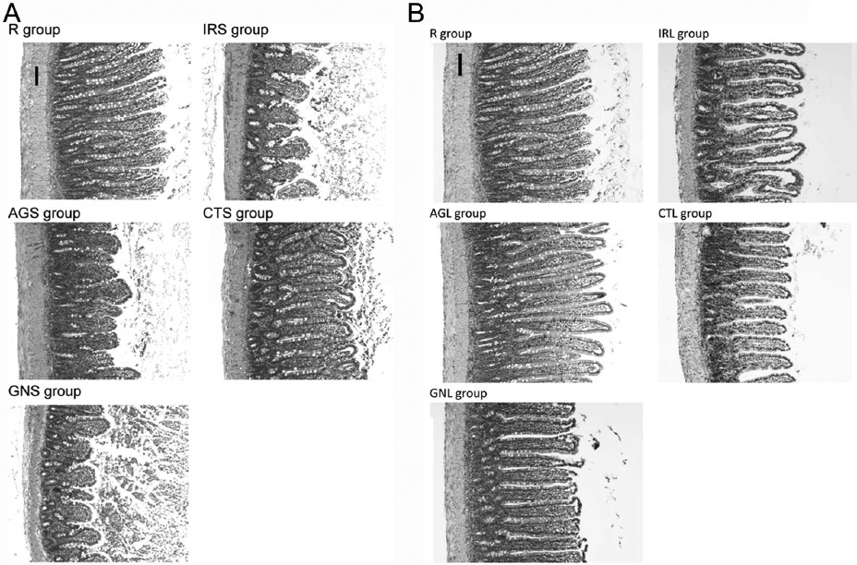
7

Figure 1. Light micrographs of the jejunum stained with hematoxylin and eosin (100×, bars = 100 µm) in the normal, I/R3 (A), and I/R24 (B) rats. AGL, I/R24 rats with arginine; AGS, I/R3 rats with arginine; CTL, I/R24 rats with citrulline; CTS, I/R3 rats with citrulline; GNL, I/R24 rats with glutamine; GNS, I/R3 rats with glutamine; I/R3, intestinal ischemia followed by 3 hours of reperfusion; I/R24, intestinal ischemia followed by 24 hours of reperfusion; IRL, I/R24 rats with casein; IRS, I/R3 rats with casein.

istration of arginine, citrulline, or glutamine did not have a sig- nificant impact on the jejunal muscularis mass in the I/R24 rats.

Jejunal Apoptosis and Proliferation Status
The in situ immunofluorescent TUNEL (Figure 3A,B) and BrdU (Figure 4A,B) analyses were used to determine the DNA damage in the jejunal villi and the cell proliferation in the jeju- nal crypt cells. The green fluorescence of the villi in the TUNEL analysis was greater in the IRS and IRL groups and was lower in the groups administered with amino acids. When the apop- totic index was calculated as the percentage of TUNEL-positive cells per 5 villi, we found that the IRS group had a significantly greater apoptotic index than did the R and IRL groups (Figure 3C). In addition, the orogastric administration of arginine, citrulline, and glutamine significantly decreased the apoptotic index of the jejunal villi in both the I/R3 and I/R24 rats.
Figure 4 shows the results of the cell proliferation in the jejunal crypt cells. When the proliferation index was calculated as the percentage of BrdU-positive cells per 5 crypts, the results indicated that the IRS group had a significantly decreased proliferation index compared with the R group. In addition, the AGS group had a further decreased proliferation index compared with the IRS group. In the I/R24 rats, the CTL
group had a significantly decreased proliferation index in the jejunal crypt cells compared with the IRL group.

Expression of NF-κB and NOS in the Jejunum
To assess the effects of the intestinal I/R and amino acid sup- plementation on the molecular mechanisms of the inflamma- tory response in the jejunum, we determined the protein expression of the nuclear total and phosphorylated NF-κB, cytosolic I-κB, iNOS, eNOS, and nNOS (Figure 5). There were no significant differences in the protein expression of cytosolic I-κB among the groups (data not shown). The protein expression of the nuclear total and phosphorylated NF-κB in the jejunum was not significantly different between the IRS and R or IRL and R groups. However, the protein expression of the nuclear total NF-κB in the IRL group was significantly decreased compared with the IRS group. When the ratio of the phosphorylated to the total NF-κB was calculated, we found that the IRS group had a significantly decreased ratio com- pared with the R and IRL groups (Figure 5C). In the I/R3 rats, the administration of arginine and citrulline significantly increased the total nuclear NF-κB but not the phosphorylated NF-κB, and the administration of citrulline significantly

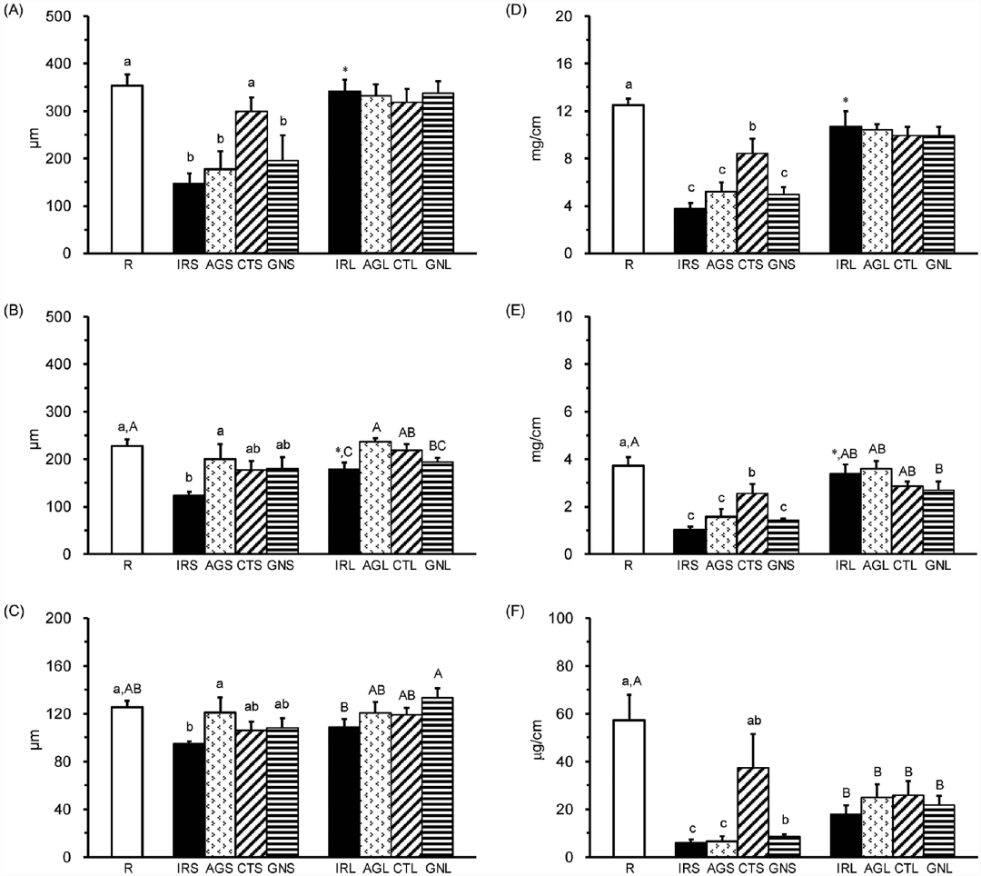
8

Figure 2. Jejunal histology and mass. Villus height (A), crypt depth (B), muscularis thickness (C), mucosal dry weight (D), protein content (E), and DNA content (F). *P < .05, IRS vs IRL. Values with different lowercase letters in the R, IRS, AGS, CTS, and GNS groups and those with different uppercase letters in the R, IRL, AGL, CTL, and GNL groups represent a significant difference at P < .05 by 1-way analysis of variance with least significant difference. AGL, I/R24 rats with arginine; AGS, I/R3 rats with arginine; CTL, I/R24 rats with citrulline; CTS, I/R3 rats with citrulline; GNL, I/R24 rats with glutamine; GNS, I/R3 rats with glutamine; IRL, I/R24 rats with casein; IRS, I/R3 rats with casein; R, normal rats.

decreased the ratio of the phosphorylated to the total NF-κB. In the I/R24 rats, both arginine and citrulline, not glutamine, administration significantly decreased the ratio of the phos- phorylated to the total NF-κB.
There were no significant differences in the protein expres- sion of eNOS (Figure 5E) in the jejunum among the groups. In the I/R3 rats, the protein expression of iNOS was not signifi- cantly different between the IRS and R groups and was signifi- cantly lower in the AGS and CTS groups than in the R group (Figure 5D). In the I/R24 rats, iNOS protein was significantly lower in the IRL group than in the R group. The amino acid administration did not have significant impact on iNOS
protein expression in both the I/R3 and I/R24 rats. The protein expression of nNOS was significantly greater in the IRS group than in the R and IRL groups (Figure 5F). In the I/R3 rats, the administration of arginine, citrulline, and glutamine signifi- cantly alleviated the increases in the nNOS protein expression. In the I/R24 rats, the administration of citrulline significantly attenuated the decrease in the nNOS protein expression.

Discussion
Intestinal I/R is a clinical condition that results in intestinal injury and systemic inflammation and has a high mortality

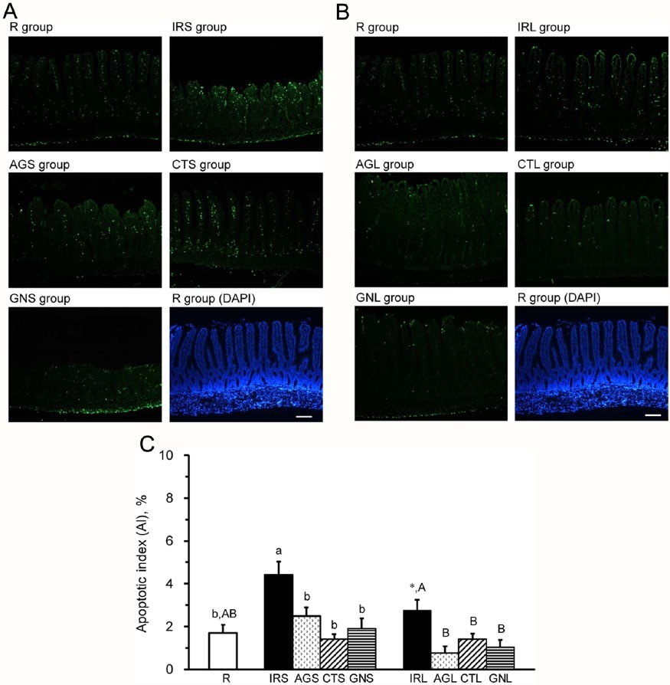
9

Figure 3. In situ detection of the apoptotic cells using a TUNEL assay with a green fluorescein label (100×, bars = 100 µm) in the jejunal villi in the normal, I/R3 (A), and I/R24 (B) rats. The total nuclei stained with DAPI are shown in the blue label. The apoptotic index (C) was calculated as the percentage of the TUNEL-positive apoptotic nuclei divided by the DAPI-staining nuclei per 5 villi. Values are mean
± SEM. *P < .05, IRS vs IRL. Values with different lowercase letters in the R, IRS, AGS, CTS, and GNS groups and those with different uppercase letters in the R, IRL, AGL, CTL, and GNL groups represent a significant difference at P < .05 by 1-way analysis of variance with least significant difference. AGL, I/R24 rats with arginine; AGS, I/R3 rats with arginine; CTL, I/R24 rats with citrulline; CTS, I/R3 rats with citrulline; DAPI, 4′,6-diamidino-2-phenylindole; GNL, I/R24 rats with glutamine; GNS, I/R3 rats with glutamine; I/R3, intestinal ischemia followed by 3 hours of reperfusion; I/R24, intestinal ischemia followed by 24 hours of reperfusion; IRL, I/R24 rats with casein; IRS, I/R3 rats with casein; R, normal rats; TUNEL, terminal deoxynucleotidyl transferase-mediated dUTP-biotin nick end labeling.

rate. It is conceivable that intestinal I/R-induced cellular necrosis and/or apoptosis are closely associated with the activation of the NOS and NF-κB pathways, which increase the production of inflammatory mediators in the organs/tis- sues and circulation.3,12,20 The gut plays a key role in barrier defense and nutrient digestion, absorption, and metabolism. Therefore, nutrition manipulation has become the most accept- able approach to overcome the damage to the gut in subjects with an intestinal injury. Evidence has shown that the enteral and parenteral administrations of arginine and glutamine have beneficial effects on intestinal I/R injuries.4,5,10,12 However, the clinical use of arginine is limited due to safety concerns. Using
an intestinal I/R rat model, we herein demonstrated that the oral administration of citrulline, an alternative source of argi- nine, may have more benefits than arginine or glutamine in preventing intestinal I/R-induced jejunal damage and systemic inflammation.
It has been demonstrated that intestinal ischemia progres- sively damages the enterocyte structures; however, the resto- ration of the blood flow may actually intensify the lesions. The damaged mucosal structure results in the translocation of bacteria and toxins into the blood circulation and provokes both local and systemic inflammation.21 For example, intesti- nal I/R causes an acute inflammatory response in the liver, as

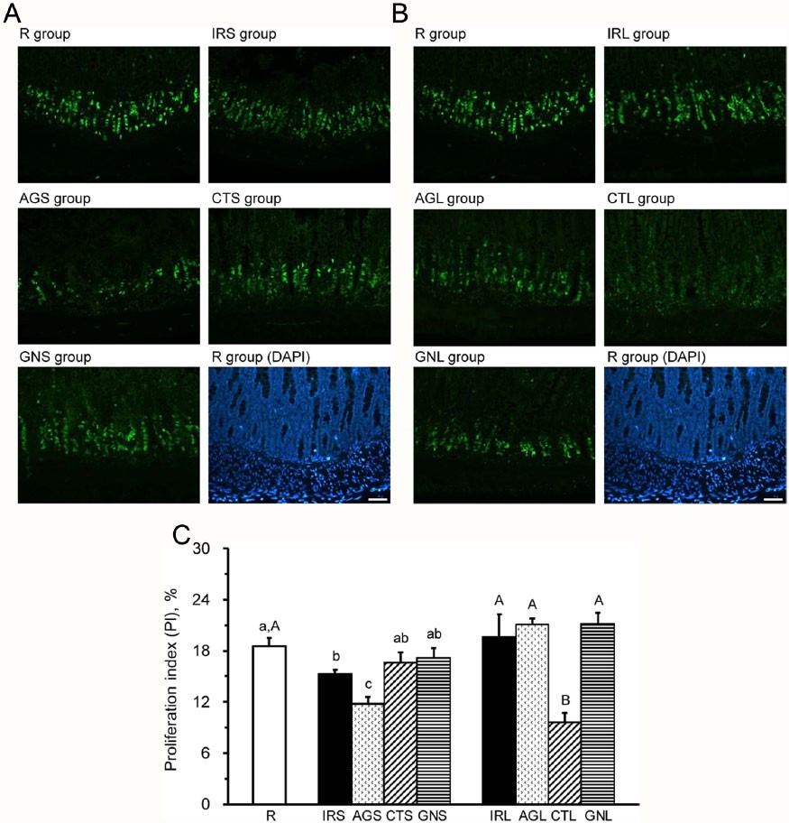
10

Figure 4. In situ detection of the proliferating cells using BrdU with a green fluorescein label (200×, bars = 50 µm) in the jejunal crypts in the normal, I/R3 (A), and I/R24 (B) rats. The total nuclei stained with DAPI are shown in the blue label. The proliferation index
(C) was calculated as the percentage of the BrdU-positive nuclei divided by the DAPI-staining nuclei per 5 crypts. Values are mean ± SEM. *P < .05, IRS vs IRL. Values with different lowercase letters in the R, IRS, AGS, CTS, and GNS groups and those with different uppercase letters in the R, IRL, AGL, CTL, and GNL groups represent a significant difference at P < .05 by 1-way analysis of variance with least significant difference. AGL, I/R24 rats with arginine; AGS, I/R3 rats with arginine; BrdU, bromo-2-deoxyuridine; CTL, I/ R24 rats with citrulline; CTS, I/R3 rats with citrulline; DAPI, 4′,6-diamidino-2-phenylindole; GNL, I/R24 rats with glutamine; GNS, I/ R3 rats with glutamine; I/R3, intestinal ischemia followed by 3 hours of reperfusion; I/R24, intestinal ischemia followed by 24 hours of reperfusion; IRL, I/R24 rats with casein; IRS, I/R3 rats with casein; R, normal rats.

evidenced by the histopathological injuries and elevated serum GOT, GPT, and TNF-α.22 In the present study, the I/R3 rats had significant histological damage (Figure 1), mucosal loss (Figure 2), and apoptosis (Figure 3) in the jejunum, and the I/R24 rats had increases in liver weight and in the serum levels of blood urea nitrogen, GOT, and GPT. The intestinal I/R-induced liver dysfunction is closely related to the sys- temic inflammation for the circulating WBCs, and inflamma- tory mediators, such as NOx, TNF-α, and IL-6 (Table 2), were significantly elevated.
The ischemic damage is caused primarily by the blockage of the oxygen and nutrient supply, leading to the depletion of ade- nosine triphosphate (ATP) and a homeostatic imbalance in the enterocytes.1 When the intestine has I/R, the activation of iNOS and transcription factor NF-κB in the immune cells may cause the extensive release of NO and proinflammatory cytokines.2,20 The establishment of new nutrition strategies at the early onset of intestinal I/R to maintain the gut’s integrity and immune function would have great advantages in clinical settings.6 Because the dietary amino acids are major fuels for the

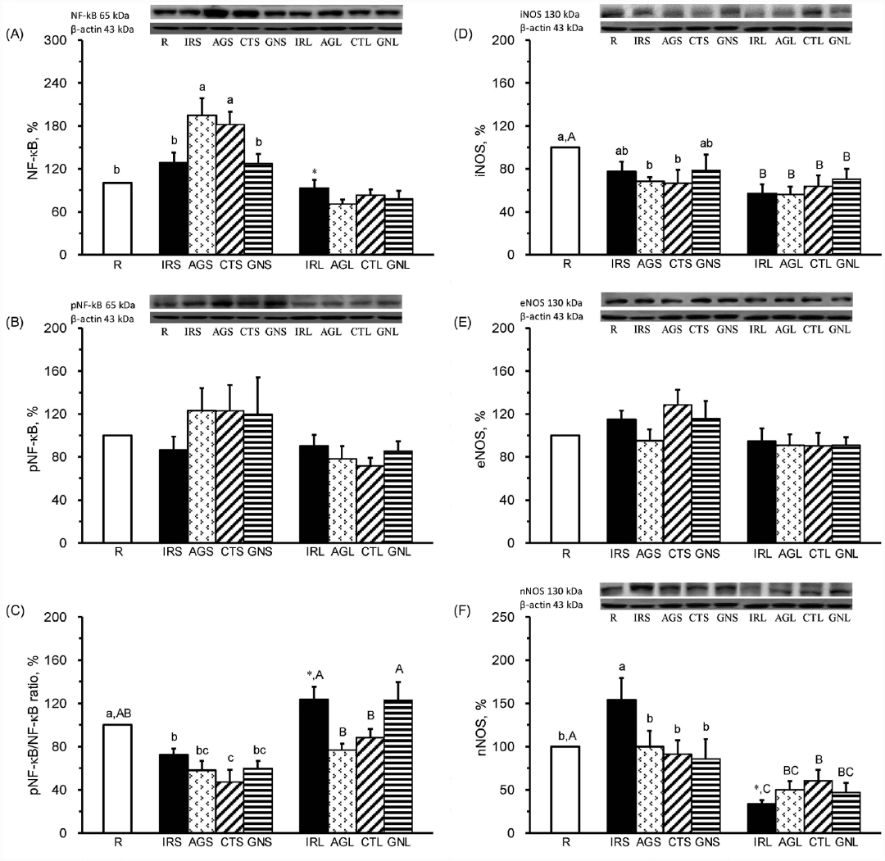
11

Figure 5. Nuclear factor (NF)–κB and nitric oxide synthases in the jejunum in the normal, I/R3 (A), and I/R24 (B) rats. A Western blot assay was used to detect the nuclear total (A) and phosphorylated NF-κB (B); the ratio of the phosphorylated-to-total NF-κB (C), iNOS (D), eNOS (E), and nNOS (F); and internal control β-actin. The protein quantification was calculated as the percentages of the R group. Values are mean ± SEM. *P < .05, IRS vs IRL. Values with different lowercase letters in the R, IRS, AGS, CTS, and GNS groups and those with different uppercase letters in the R, IRL, AGL, CTL, and GNL groups represent a significant difference at P < .05 by 1-way analysis of variance with least significant difference. AGL, I/R24 rats with arginine; AGS, I/R3 rats with arginine; CTL, I/R24 rats with citrulline; CTS, I/R3 rats with citrulline; eNOS, endothelial nitric oxide synthase; GNL, I/R24 rats with glutamine; GNS, I/R3 rats with glutamine; iNOS, inducible nitric oxide synthase; I/R3, intestinal ischemia followed by 3 hours of reperfusion; I/R24, intestinal ischemia followed by 24 hours of reperfusion; IRL, I/R24 rats with casein; IRS, I/R3 rats with casein; nNOS, neuronal nitric oxide synthase; R, normal rats.

enterocytes and the immune-modulatory amino acids play an important role in regulating the intestinal immune cells, we hypothesized that arginine, glutamine, and citrulline, the source of de novo arginine synthesis, may mitigate the intestinal I/R- induced jejunal damage and systemic inflammation. Circulating citrulline concentration has been regarded as a marker of enterocyte mass and function. Based on the significantly
increased plasma citrulline concentrations in the CTS and CTL groups compared with the IRS and IRL groups, respectively (Table 1), we confirmed that the intestine was functional, at least partially, during intestinal I/R. The unchanged plasma lev- els of arginine and glutamine may be associated with extensive metabolism of these amino acids by arginase and glutaminase in the enterocytes.9,12

12

Glutamine has been recognized as a major metabolic fuel and is an essential component of the proliferative response in enterocytes.12 Both parenteral and enteral glutamine may pro- tect the intestine from morphologic and functional injury, increase DNA synthesis and cell proliferation, decrease proin- flammatory cytokine production, and alleviate the apoptosis of enterocytes and lymphatic cells in an intestinal I/R injury.4,6,7,13 In the present study, the administration of glutamine after isch- emia and during reperfusion significantly increased jejunal ornithine content in the I/R24 rats (Table 1), which revealed that glutamine was catabolized to ornithine in the enterocytes of the jejunum. In addition, glutamine administration pre- served the jejunal DNA (Figure 2), at least partially, and decreased the plasma TNF-α and IL-6 in the I/R3 rats (Table 2) and increased the jejunal muscularis thickness and deceased the plasma and jejunal NOx in the I/R24 rats. The intestinal I/R-induced jejunal apoptosis was significantly attenuated by glutamine in both the I/R3 and I/R24 rats, as shown in the decreased apoptotic index obtained using the TUNEL method (Figure 3). These results confirm that enteral glutamine admin- istration may attenuate intestinal I/R-induced jejunal damage and systemic inflammation.
Arginine-derived NO is an important mediator in the recovery of intestinal mucosa during reperfusion. Animal studies have indicated that both parenteral and enteral arginine administration may maintain the intestinal integrity,4,23 attenu- ate the intestinal dysfunction,24 and suppress the release of proinflammatory cytokines5 after intestinal I/R. However, long-term (2% in the diet) or early enteral arginine administra- tion may not have observable benefits or even worsen the out- come via the excessive priming and activation of the circulating iNOS expression.25,26 It is possible that arginine may attenuate the ischemia-induced and not the reperfusion- induced intestinal dysfunction.24 The inconsistent results may also be related to the doses of the arginine. For example, a low-dose arginine supplementation (0.7% of the diet) had a beneficial effect on the microvascular development in pigs that were weaned early, whereas high doses of arginine (1.2% of the diet) caused adverse effects.27 In the present study, the dose of arginine (0.994 g/kg/d) we used was approximately 0.9%–1% of the diet. We found that arginine significantly alleviated the decrease in the crypt depth in both the I/R3 and I/R24 rats. The administration of arginine significantly attenu- ated the intestinal I/R-induced jejunal damage and systemic inflammation, as shown in the decreased jejunal apoptotic index and plasma NOx. In addition, the arginine administra- tion significantly decreased the ratio of the phosphorylated to the total NF-κB in the jejunum of the I/R24 rats (Figure 5). These results suggest that the oral administration of arginine may attenuate the intestinal I/R-induced jejunal damage via the inactivation of NF-κB.
Circulating citrulline, produced almost exclusively by the gut, is a useful biomarker in reflecting the length, mass, and function of the small intestine.11,28 In this study, the plasma
citrulline was significantly increased in the CTS and CTL groups, and the jejunal citrulline was significantly increased in the CTS group (Table 1). In addition, the citrulline administra- tion significantly attenuated the intestinal I/R-induced intesti- nal damages, such as the increases in jejunal dry weight, the villus height, and the mucosal protein and DNA content (Figure
- and the decreases in jejunal apoptosis (Figure 3C). Moreover, the citrulline administration significantly alleviated the local and systemic inflammatory responses, as shown in the decreases in the plasma NOx, TNF-α, and IL-6 and the jejunal TNF-α and IL-6 content (Table 2). These beneficial effects of citrulline administration may be closely associated with the decreased activation of the NF-κB (Figure 5). Compared with the arginine and glutamine administration, the oral citrulline administration may result in more benefits to the jejunal struc- ture and mass as well as may attenuate both the systemic and local inflammation in intestinal I/R.
The roles of the different NOS in affecting the development of intestinal I/R injury have been discussed. In rats with an intestinal transplantation, the decreased nNOS and increased iNOS activities contribute to the intestinal I/R injury and acute rejection, and the nNOS activity is closely related to the graft structure and function.20 In the present study, the protein expression of the nNOS was significantly increased in the I/R3 rats and decreased in the I/R24 rats (Figure 5), and the iNOS protein expression was not significantly affected in the I/R3 rats and was significantly decreased in the I/R24 rats. The increased nNOS protein may be an adaptive response to com- pensate for the inactivated constitutive NOS (ie, nNOS and
eNOS) to maintain normal physiology during the early phase of reperfusion.29 When administered with glutamine, arginine, and citrulline, the I/R3 rats had an attenuated inflammation, which decreased the adaptive response in increasing the nNOS expression. After 24 hours of reperfusion, this adaptive response disappeared and was replaced by a decrease in nNOS protein expression in I/R24 rats, and the citrulline administra- tion significantly alleviated this decrease. The effects of the intestinal I/R and these amino acids on the activities of iNOS and nNOS need to be further investigated.
This study has several limitations. First, the I/R rats that received the vehicle alone (ie, the starch paste) were not included in this study. It has been shown that the luminal glu- cose may preserve the epithelium and significantly attenuate the permeability and damage to the villi in the intestine.30 In addition, the effects of the luminal protein in an intestinal injury are still unclear. Therefore, we used starch paste and casein, a widely used, easily obtained protein source, to control for the effects of the energy, carbohydrate, and protein on the intestinal damage in the present study. Even though casein may not be the best choice for controlling amino acid intake, it is the
most common protein with a complete amino acid composition and is easily digested and absorbed. Second, the intestinal I/R- induced MOF was not evaluated. In the present study, the intestinal I/R-induced elevations in the plasma NOx and IFN-γ

13

were significantly decreased by arginine, citrulline, and gluta- mine administration in the I/R24 rats. These attenuated inflam- matory and/or immune responses imply that these amino acids have potential for preventing the intestinal I/R-induced MOF. Third, the 3- and 24-hour reperfusion may not be sufficiently long to show the nutrition effects of these amino acids in this model. Based on the results that citrulline may preserve the intestinal mass (Figure 2) and decrease the circulating levels of the inflammatory mediators (Table 2), we speculate that the long-term administration of citrulline may have beneficial effects on both the gut and the systemic immune function. Therefore, it is worthwhile to investigate the long-term effects of citrulline on the MOF and the inflammatory and immune response in intestinal I/R injury. Finally, the NOS and NF-κB pathway was the only signaling pathway tested in this study. Several other pathways that are involved in inflammation, such as peroxisome proliferator–activated receptor-γ, oxidative stress, and mitogen-activated protein kinase, may be altered.31,32 In addition, the ability of citrulline to preserve the jejunal mass may be associated with pathways that are responsible for cell proliferation. These pathways bear investigation in future studies.
In summary, the results of the present study revealed that intestinal I/R may result in jejunal damage, liver dysfunction, and activated inflammatory responses. In the I/R3 rats, the decreased plasma TNF-α and IL-6 levels and jejunal apoptotic index and the increased mucosal DNA content suggested that the oral glutamine administration may alleviate the intestinal I/R-induced systemic inflammation and jejunal damage. In addition, arginine administration significantly preserved the jejunal integrity, such as the increased crypt depth and muscu- laris thickness, and the citrulline administration significantly alleviated the jejunal mass loss, such as the mucosal dry weight, protein content, and DNA content, and significantly attenuated systemic inflammation, such as the decreased plasma NOx, TNF-α, and IL-6 in the I/R3 rats. In the I/R24 rats, administration of arginine, citrulline, and glutamine before and during the reperfusion may significantly decrease plasma NOx and IFN-γ and alleviate jejunal apoptosis. Administration of arginine and citrulline may alleviate the acti- vation of NF-κB, as shown in the decreased ratio of the phos- phorylated NF-κB to the total NF-κB. The citrulline administration further decreased jejunal TNF-α and IL-6 con- tent and attenuated the decrease in nNOS protein expression in the I/R24 rats. Taken together, the oral administration of argi- nine, citrulline, and glutamine may alleviate the systemic inflammation, jejunal apoptosis, and nNOS expression in intestinal I/R. However, the oral administration of citrulline may further preserve the jejunal mass and alleviate the produc- tion of inflammatory mediators in the jejunum. Our findings indicated that oral citrulline may be a better adjuvant than argi- nine and glutamine in preventing the intestinal I/R-induced adverse effects.

Acknowledgments
We thank Yu-Chang Huang and Ju-Fang Teng for their technical support, allowing for the completion of this study.

Statement of Authorship
C.-H. Lai, C.-H. Lee, C.-Y. Hung, and H.-C. Lo contributed to the conception or design of the research; C.-H. Lai, C.-H. Lee, C.-Y. Hung, and H.-C. Lo contributed to the acquisition, analysis, or inter- pretation of the data; C.-H. Lai, C.-Y. Hung, and H.-C. Lo drafted the manuscript; C.-H. Lee and H.-C. Lo critically revised the manu- script; and C.-H. Lai, C.-H. Lee, C.-Y. Hung, and H.-C. Lo agree to be fully accountable for ensuring the integrity and accuracy of the work. All authors read and approved the final manuscript.

References
  - Vollmar B, Menger MD. Intestinal ischemia/reperfusion: microcircula- tory pathology and functional consequences. Langenbecks Arch Surg. 2011;396:13-29.
  - Alhan E, Usta A, Cekic A, Saglam K, Turkyilmaz S, Cinel A. A study on 107 patients with acute mesenteric ischemia over 30 years. Int J Surg. 2012;10:510-513.
  - Siriussawakul A, Chen LI, Lang JD. Medical gases: a novel strategy for attenuating ischemia-reperfusion injury in organ transplantation? J Transplant. 2012;2012:819382.
  - Sukhotnik I, Helou H, Mogilner J, et al. Oral arginine improves intestinal recovery following ischemia-reperfusion injury in rat. Pediatr Surg Int. 2005;21:191-196.
  - Spanos CP, Papaconstantinou P, Spanos P, Karamouzis M, Lekkas G, Papaconstantinou C. The effect of L-arginine and aprotinin on intestinal ischemia-reperfusion injury. J Gastrointest Surg. 2007;11:247-255.
  - Wang WW, Qiao SY, Li DF. Amino acids and gut function. Amino Acids. 2009;37:105-110.
  - Fukatsu K, Ueno C, Maeshima Y, et al. Effects of L-arginine infusion during ischemia on gut blood perfusion, oxygen tension, and circulating myeloid cell activation in a murine gut ischemia/reperfusion model. JPEN J Parenter Enteral Nutr. 2004;28:224-231.
  - Sato N, Moore FA, Kone BC, et al. Differential induction of PPAR- gamma by luminal glutamine and iNOS by luminal arginine in the rodent postischemic small bowel. Am J Physiol Gastrointest Liver Physiol. 2006;290:G616-G623.
  - Schwedhelm E, Maas R, Freese R, et al. Pharmacokinetic and pharmaco- dynamic properties of oral L-citrulline and L-arginine: impact on nitric oxide metabolism. Br J Clin Pharmacol. 2008;65:51-59.
  - Moinard C, Cynober L. Citrulline: a new player in the control of nitrogen homeostasis. J Nutr. 2007;137:1621S-1625S.
  - Luo M, Fernández-Estívariz C, Manatunga AK, et al. Are plasma citrul- line and glutamine biomarkers of intestinal absorptive function in patients with short bowel syndrome? JPEN J Parenter Enteral Nutr. 2007;31:1-7.
  - Mondello S, Galuppo M, Mazzon E, et al. Glutamine treatment attenu- ates the development of ischaemia/reperfusion injury of the gut. Eur J Pharmacol. 2010;643:304-315.
  - Wu GH, Wang H, Zhang YW, Wu ZH, Wu ZG. Glutamine supplemented parenteral nutrition prevents intestinal ischemia- reperfusion injury in rats. World J Gastroenterol. 2004;10:2592-2594.
  - Kozar RA, Verner-Cole E, Schultz SG, et al. The immune-enhancing enteral agents arginine and glutamine differentially modulate gut bar- rier function following mesenteric ischemia/reperfusion. J Trauma. 2004;57:1150-1156.
  - Sukhotnik I, Khateeb K, Mogilner JG, et al. Dietary glutamine supple- mentation prevents mucosal injury and modulates intestinal epithelial

14

restitution following ischemia-reperfusion injury in the rat. Dig Dis Sci. 2007;52:1497-1504.
  - Omata J, Fukatsu K, Ueno C, Maeshima Y, Saitoh D, Mochizuki H. Intraluminal glutamine administration during ischemia worsens survival after gut ischemia-reperfusion. J Surg Res. 2007;143:260-264.
  - Osowska S, Moinard C, Neveux N, Loï C, Cynober L. Citrulline increases arginine pools and restores nitrogen balance after massive intestinal resec- tion. Gut. 2004;53:1781-1786.
  - Bidlingmeyer BA, Cohen SA, Tarvin TL, Frost B. A new, rapid, high- sensitivity analysis of amino acids in food type samples. J Assoc Off Anal Chem. 1987;70:241-247.
  - Labarca C, Paigen K. A simple, rapid, and sensitive DNA assay proce- dure. Anal Biochem. 1980;102:344-352.
  - Li XL, Zou XM, Nie G, Song ML, Li G. Roles of neuronal nitric oxide synthase and inducible nitric oxide synthase in intestinal transplantation of rats. Transplant Proc. 2013;45:2497-2501.
  - Ozkan OV, Yuzbasioglu MF, Ciralik H, et al. Resveratrol, a natural anti- oxidant, attenuates intestinal ischemia/reperfusion injury in rats. Tohoku J Exp Med. 2009;218:251-258.
  - Horie Y, Kajihara M, Mori S, et al. Japanese herbal medicine, Saiko- keishi-to, prevents gut ischemia/reperfusion-induced liver injury in rats via nitric oxide. World J Gastroenterol. 2004;10:2241-2244.
  - Fotiadis C, Adamis S, Misiakos EP, et al. The prophylactic effect of L-arginine in acute ischaemic colitis in a rat model of ischaemia/reperfu- sion injury. Acta Chir Belg. 2007;107:192-200.
  - Gomez JS, Miranda-Ferreira R, Taha NS, et al. Study of L-arginine in intestinal lesions caused by ischemia-reperfusion in rats. Transplant Proc. 2012;44:2309-2312.
  - Lee CH, Hsiao CC, Hung CY, Chang YJ, Lo HC. Long-term enteral argi- nine supplementation in rats with intestinal ischemia and reperfusion. J Surg Res. 2012;175:67-75.
  - Yanni AE, Margaritis E, Liarakos N, et al. Time-dependent alterations in serum NO concentration after oral administration of L-arginine, L-NAME, and allopurinol in intestinal ischemia/reperfusion. Vasc Health Risk Manag. 2008;4:437-441.
  - Zhan Z, Ou D, Piao X, Kim SW, Liu Y, Wang J. Dietary arginine sup- plementation affects microvascular development in the small intestine of early-weaned pigs. J Nutr. 2008;138:1304-1309.
  - Curis E, Crenn P, Cynober L. Citrulline and the gut. Curr Opin Clin Nutr Metab Care. 2007;10:620-626.
  - Sureda A, Cordova A, Ferrer MD, et al. Effects of L-citrulline oral supplementation on polymorphonuclear neutrophils oxidative burst and nitric oxide production after exercise. Free Radic Res. 2009;43: 828-835.
  - Altshuler AE, Lamadrid I, Li D, et al. Transmural intestinal wall perme- ability in severe ischemia after enteral protease inhibition. PLoS One. 2014;9:e96655.
  - Peng Z, Ban K, Wawrose RA, Gover AG, Kozar RA. Protection by enteral glutamine is mediated by intestinal epithelial cell peroxisome proliferator-activated receptor gamma during intestinal ischemia/reper- fusion PPARγ mediates protection by glutamine. Shock. 2015;43(4): 327-333.
  - Zabot GP, Carvalhal GF, Marroni NP, Hartmann RM, da Silva VD, Fillmann HS. Glutamine prevents oxidative stress in a model of mes- enteric ischemia and reperfusion. World J Gastroenterol. 2014;20: 11406-11414.

