Disabled-2 Is Required for Efficient Hemostasis and Platelet Activation by Thrombin in Mice

Hui-Ju Tsai,* Chien-Ling Huang,* Yao-Wen Chang, Ding-Yuan Huang, Chung-Ching Lin, Jonathan A. Cooper, Ju-Chien Cheng, Ching-Ping Tseng

Objective—The essential role of platelet activation in hemostasis and thrombotic diseases focuses attention on unveiling the underlying intracellular signals of platelet activation. Disabled-2 (Dab2) has been implicated in platelet aggregation and in the control of clotting responses. However, there is not yet any in vivo study to provide direct evidence for the role of Dab2 in hemostasis and platelet activation.
Approach and Results—Megakaryocyte lineage-restricted Dab2 knockout (Dab2−/−) mice were generated to delineate in vivo functions of Dab2 in platelets. Dab2−/− mice appeared normal in size with prolonged bleeding time and impaired thrombus formation. Although normal in platelet production and granule biogenesis, Dab2−/− platelets elicited a selective defect in platelet aggregation and spreading on fibrinogen in response to low concentrations of thrombin, but not other soluble agonists. Investigation of the role of Dab2 in thrombin signaling revealed that Dab2 has no effect on the expression of thrombin receptors and the outside-in signaling. Dab2−/− platelets stimulated by low concentrations of thrombin were

normal in G
-mediated calcium mobilization and protein kinase C activation, but were defective in G
-mediated RhoA-

αq

ROCKII activation. The attenuated G
α12/13
α12/13

signaling led to impaired ADP release, Akt-mammalian target of rapamycin and

integrin αIIbβ3 activation, fibrinogen binding, and clot retraction. The defective responses of Dab2−/− platelets to low concentrations of thrombin stimulation may contribute to the impaired hemostasis and thrombosis of Dab2−/− mice.
Conclusions—This study sheds new insight in platelet biology and represents the first report demonstrating that Dab2 is a key

regulator of hemostasis and thrombosis by functional interplay with G
-mediated thrombin signaling. (Arterioscler

Thromb Vasc Biol. 2014;34:2404-2412.)
α12/13

Key Words: Dab2 protein, mouse ◼ platelet activation ◼ thrombin

latelets are anucleated cells derived from megakaryocytes and represent the second most numerous blood cells in the peripheral blood.1 The essential role of platelet activa- tion in hemostasis, myocardial infarction, and other throm- botic diseases has prompted considerable focus on unveiling the underlying intracellular mechanisms of agonist-induced platelet activation.2,3 Thrombin binds to G-protein–linked pro-
P

Cytoskeleton remodeling occurs at different stages of plate- let activation.6 After adhesion to surfaces coated with fibrino- gen or collagen, platelets form broad, actin filament–containing lamellae and spread over an area of several micrometers squared. During platelet activation, the cytoplasmic domain of integrin αIIbβ3 associates with actin filaments and intra- cellular signaling molecules including talin, vinculin, zyxin,

tease-activated receptors (PARs) and causes G
-dependent
paxillin, filamin, and α-actinin.7–10 Integrin αIIbβ3–mediated

αq
increase in intracellular calcium and protein kinase C (PKC)
clot retraction then occurs through the action of nonmuscle

activity, G
-dependent Rho activation, G -dependent inhi-
myosin IIA and IIB that are attached to actin and contract the

α12/13
bition of adenylyl cyclase, and G
αi
-mediated phosphoinositide
βγ
actin filaments.11 Despite extensive studies, the underlying

3-kinase–Akt activation.4,5 Collagen interacts with glycopro- tein VI and recruits Syk to the plasma membrane followed by tyrosine phosphorylation of downstream substrates required for platelet activation.4 The agonist-induced inside-out signal- ing ultimately activates integrin αIIbβ3 and results in platelet activation, secretion, and aggregation.
mechanisms of agonist-induced inside-out signaling and cyto- skeleton reorganization still wait to be fully elucidated.
Disabled-2 (Dab2) is an adaptor protein with at least 2 isoforms p82 (p96) and p59 (p67) being generated through alternative splicing.12 p59-Dab2 lacks the ninth coding exon corresponding to the amino acids 230 to 445 of p82-Dab2,

Received on: September 7, 2013; final version accepted on: September 2, 2014.
From the Graduate Institute of Biomedical Sciences (H.-J.T., Y.-W.C., C.-P.T.), and Department of Medical Biotechnology and Laboratory Science (C.-L.H., D.-Y.H., C.-C.L., C.-P.T.), College of Medicine, Chang Gung University, Taoyuan, Taiwan; Division of Basic Sciences, Fred Hutchinson Cancer Research Center, Seattle, WA (J.A.C.); Department of Medical Laboratory Science and Biotechnology, China Medical University, Taichung, Taiwan (J.-C.C.); Molecular Medicine Research Center, Chang Gung University (C.-P.T.) and Department of Family Medicine (C.-P.T.), Chang Gung Memorial Hospital, Taoyuan, Taiwan.
*These authors contributed equally to this study.
The online-only Data Supplement is available with this article at http://atvb.ahajournals.org/lookup/suppl/doi:10.1161/ATVBAHA.114.302602/-/DC1.
Correspondence to Ching-Ping Tseng, PhD, Department of Medical Biotechnology and Laboratory Science, Chang Gung University, 259 Wen-Hwa First Rd, Kwei-Shen, Taoyuan 333, Taiwan. E-mail ctseng@mail.cgu.edu.tw
© 2014 American Heart Association, Inc.
Arterioscler Thromb Vasc Biol is available at http://atvb.ahajournals.org DOI: 10.1161/ATVBAHA.114.302602

2404

Nonstandard Abbreviations and Acronyms

Dab2 Disabled-2
mTOR mammalian target of rapamycin
PAR protease-activated receptor
PKC protein kinase C

resulting in the deletion of several binding sites for endocytic proteins.12 By interactions with other cellular factors through the N-terminal phosphotyrosine binding domain, the aspartic acid–proline–phenylalanine motif, and the C-terminal pro- line–rich region,7,13–16 Dab2 elicits functions in cytoskeleton reorganization, endocytosis, differentiation, and cell signal- ing.17–20 Dab2 is known to regulate the signaling pathways of Ras-mitogen-activated protein kinase, Wnt, transforming growth factor-β, and RhoA-ROCK14–16,21 and modulate cyto- skeleton reorganization by binding to actin, myosin VI, non- muscle myosin heavy chain IIA, and dynein.17,19,22
Dab2 is abundantly expressed in human platelets and is dis- tributed mainly in the cytoplasm and α-granules.23 It is upregu- lated during megakaryocytic differentiation of human CD34+ hematopoietic pluripotent stem cells, murine embryonic stem cells, and human leukemic K562 cells.13,20,24 In vitro studies have identified Dab2 as a regulator of platelet integrin activa- tion, cell adhesion, and fibrinogen uptake.13,25 Dab2 is released and binds to either integrin αIIb or phospholipid sulfatide in response to platelet activation, playing a role in platelet–fibrin- ogen and platelet–leukocyte adhesion and aggregation.23,26 The balance between sulfatide- and integrin receptor–bound states is involved in the control of the extent of clotting response.26,27 Nevertheless, there is not yet any in vivo study to provide direct evidence for the role of Dab2 in thrombosis and hemostasis.
In this study, megakaryocyte/platelet lineage–restricted Dab2 knockout (Dab2−/−) mice were generated by using the PF4-Cre transgenic system.28 We report here that PF4-Cre– driven Dab2−/− mice display a prolonged bleeding time and impaired thrombus formation. Dab2-deficient platelets are impaired in platelet aggregation, spreading on fibrinogen and clot retraction in response to low concentrations of thrombin. The functional defect of Dab2-deficient platelets is correlated with the lack of responsiveness to thrombin-induced RhoA- ROCKII and Akt-mammalian target of rapamycin (mTOR) activation, ADP release, and integrin αIIbβ3 activation. This study defines Dab2 as a key regulator of thrombosis and hemostasis by playing a selective role in thrombin-stimulated inside-out signaling in platelets.

Materials and Methods
Materials and Methods are available in the online-only Supplement.

Results

Generation of Megakaryocyte Lineage- Restricted Dab2−/− Mice
To determine the in vivo roles of Dab2 in platelet function, megakaryocyte lineage-restricted Dab2−/− mice were generated by cross-breeding Dab2fl/fl mice with PF4-Cre mice to ablate exon 2 of DAB2 gene. Genotyping of Dab2−/− tail genomic
DNA by polymerase chain reaction revealed the polymerase chain reaction products of 530 and 450 bp corresponding to the alleles of DAB2 and PF4-Cre, respectively (Figure 1A). Sequencing of the reverse transcriptase-polymerase chain reac- tion product from a single Dab2−/− megakaryocyte revealed the presence of a truncated DAB2 transcript, indicating successful ablation of DAB2 gene by Cre-recombinase (Figure 1B).
After BSA density gradient and cell sorting to enrich CD41+/Gr1− megakaryocytes for >85% purity, both p82 and p59 Dab2 proteins were detectable in Dab2fl/fl but not in Dab2−/− megakaryocytes (Figure 1C). Dab2 expression in the nonmegakaryocytic small cell population obtained from the upper layer of the BSA density gradient was not affected. Immunofluorescence staining using anti-Dab2 antibody fur- ther confirmed a lack of Dab2 expression in Dab2−/− mega- karyocytes (Figure 1D).
Western blot analysis was then performed to characterize Dab2 expression in Dab2−/− platelets. p59 was the sole Dab2 isoform in Dab2fl/fl platelets, and its expression was abrogated in Dab2−/− platelets (Figure 1E). These data confirm the genera- tion of megakaryocyte/platelet-restricted Dab2-deficient mice.

Dab2−/− Mice Display Impaired Hemostasis and Thrombosis With No Defect in Platelet Production and Granule Biogenesis
Dab2−/− mice were viable with no evidence of spontaneous bleeding or hemorrhage and no apparent differences in size and weight when compared with Dab2fl/fl mice. A bleeding time assay was performed to explore the primary hemostasis func- tion of Dab2 after injury. Dab2−/− mice had an average bleeding time of 308.4±56.4 seconds that was significantly increased when compared with 171.5±36.9 seconds for Dab2fl/fl mice (P=0.039 by log-rank test; Figure 2A). We noted that 29.2% of Dab2−/− mice had excessive bleeding (lasting >10 minutes) when compared with 11.8% of Dab2fl/fl mice. In contrast, the rebleeding rate is similar for Dab2−/− and Dab2fl/fl mice (58.8% versus 54.8%; Figure 2B).
Thrombus formation in Dab2−/− mice was evaluated using a FeCl -induced mesenteric venules/arterioles thrombosis model. In control mice, the thrombus was compact and occupied the entire injured surface, as judged by the uniform intensity of flu- orescence (Figure 2C). In contrast, the injured surface was not uniformly covered by thrombus in Dab2−/− mice, as observed by the lack of homogeneity of the fluorescence signal (Figure 2C; Movie I in the online-only Data Supplement). The occlu- sion time was much slower in Dab2−/− compared with control venules (36.6±1.7 and 14.8±2.4 minutes, respectively; P<0.001) and arterioles (38.3±1.8 and 12.2±1.2 minutes, respectively; P<0.001; Figure 2D). These data indicate that Dab2−/− mice elicit impaired primary hemostasis and thrombus formation.
3
To determine whether the changes in hemostasis and throm- bus formation of Dab2−/− mice are because of the defect in hematopoiesis and platelet production, hematological pro- files of Dab2−/− mice were determined. Blood counts were comparable between Dab2−/− and Dab2fl/fl mice (Table I in the online-only Data Supplement). In particular, the platelet numbers and mean volumes were not significantly different
(910±46/μL [×103] and 4.4±0.1 fl for Dab2fl/fl and 872±40/μL

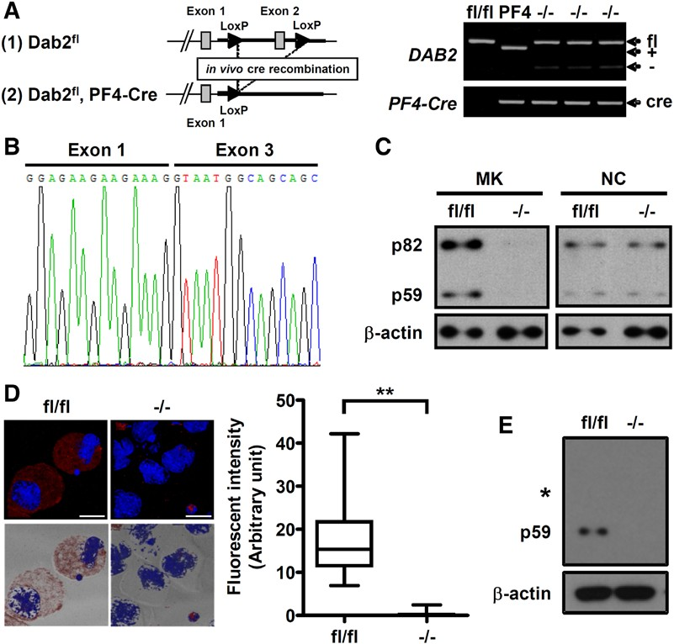
Figure 1. Generation of megakaryocyte lineage–restricted Disabled-2 (Dab2) knockout mice. A, Dab2 targeting strategy (left). The posi- tions of the PF4-Cre (450 bp) and the wild-type (460 bp; +), null (250 bp; −), and floxed (530 bp, fl) alleles for DAB2 were indicated (right). B, The polymerase chain reaction product was sequenced, and truncated DAB2 transcript was found to present in the −/− megakaryocyte. C, The lysates of the sorted megakaryocytes were collected to analyze Dab2 expression by Western blot using anti-Dab2 antibody. Cell lysates from the small cell fraction on the top of BSA gradient were also collected for the use as nonmegakaryocytic small cells (NC) to demonstrate lineage-specific knockout of Dab2 protein. D, Dab2 expression in the fl/fl and −/− megakaryocytes was analyzed by immuno- fluorescence staining using anti-Dab2 antibody followed by Alexa Fluor 546 goat anti-rabbit secondary antibody (red) and counterstained with DAPI (blue). The images were observed using fluorescence and differential interference contrast microscopy. Left: The upper images represent the fluorescent field of xy projection and the bottom images represent the fluorescent xy projection merged with its correspond- ing bright-field image (length of bar, 20 μm). The fluorescence intensity of fl/fl (n=40) and −/− (n=40) megakaryocytes was quantified by ImageJ software and was shown as box and whisker plot (right). The ends of the box are the upper and lower quartiles, and the median
is marked by a horizontal line inside the box. The whiskers are the 2 lines outside the box that extend to the highest and lowest values.
**P<0.01. E, The lysates of fl/fl and −/− platelets were analyzed by Western blot using anti-Dab2 antibody. The position of membrane cor- responding to the molecular weight of 82 kDa was marked. The expression of β-actin was used for the control of equal protein loading.

[×103] and 4.2±0.1 fl for Dab2−/−; Table I in the online-only Data Supplement). Transmission electron microscopy analy- sis revealed that Dab2fl/fl and Dab2−/− platelets displayed simi- lar morphology and granule biogenesis (Figure 2E and 2F). The number of α-granules per platelet in 1 single section was 3.1±0.2 and 3.6±0.2 for Dab2fl/fl and Dab2−/− platelets, respec- tively. The number of dense granules per platelet in 1 single section was 0.4±0.1 and 0.5±0.1 for Dab2fl/fl and Dab2−/− plate- lets, respectively. These data indicate that Dab2−/− mice are normal in blood cell production and platelet biogenesis.

Dab2−/− Platelets Are Selectively Defective in Thrombin-Induced Aggregation, Platelet
Spreading on Fibrinogen, and Clot Retraction Agonist-induced platelet aggregation assays were performed to elucidate the effects of Dab2 deficiency on platelet func- tion. Dab2−/− platelets responded normally to collagen, U46619, ADP, and high concentrations of thrombin and PAR4 peptide. However, the responsiveness of Dab2−/− platelets to low concentrations of thrombin (0.05 U/mL) and PAR4 pep- tide (0.15 mmol/L) was significantly decreased (Figure 3A). At the end of the assays, the percentage of light transmission
for thrombin (0.05 U/mL) treatment was 49.4±7.4% and 13.3±8.5% for Dab2fl/fl and Dab2−/− platelets, respectively (P<0.01; Figure 3B). The percentage of light transmission for PAR4 peptide (0.15 mmol/L) treatment was 51.6±3.5% and 29.5±7.7% for Dab2fl/fl and Dab2−/− platelets, respectively (P<0.05; Figure 3B). These data indicate that Dab2-deficient platelets are defective in response to low concentrations of thrombin and PAR4 peptide.
Platelet–fibrinogen interaction is important for the primary hemostatic plug and thrombus formation. The adhesion and spreading of Dab2−/− platelets on immobilized fibrinogen were analyzed (Figure 4A and 4B). The number of Dab2−/− platelet adhesions on fibrinogen was similar to the Dab2fl/fl platelets (Figure 4B, left panel). At the resting stage, Dab2fl/fl and Dab2−/− platelets did not spread well on fibrinogen, consistent with a previous report.29 On thrombin stimulation, a large portion of Dab2−/− platelets had rounded morphology with limited lamel- lipodia formation. The number of Dab2−/− platelets spread on fibrinogen (39.9±6.9) was decreased when compared with the Dab2fl/fl platelets (88.9±15.3; P<0.05; Figure 4B, middle panel). The increase in surface area of spread of Dab2−/− platelets was 56.7±13.7% of Dab2fl/fl platelets (P<0.05; Figure 4B, right

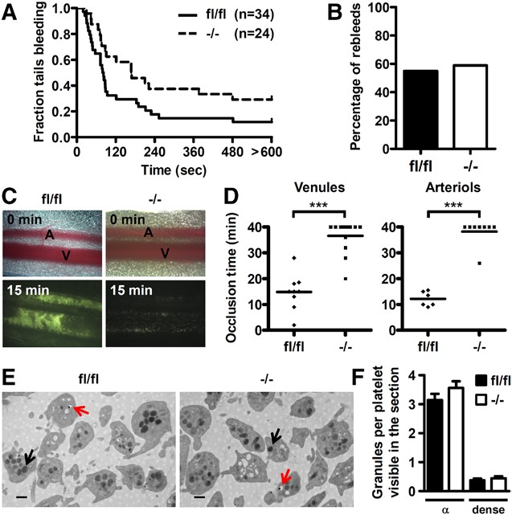

Figure 2. Disabled-2 (Dab2) knockout mice display impaired hemostasis and thrombosis but are normal for platelet morphol- ogy and granule formation. A, Time from the excision to cessation of bleeding was recorded. The fraction of tails that are bleeding as a function of time after tail transection was shown. Genotypes and the number of mice of each genotype are indicated. The effect of Dab2 knockout on bleeding time was statistically signifi- cant (log-rank test; P=0.039). B, The mice as described in A that were rebled <2 minutes after blood flow stop were considered as having the tendency of rebleeding. The percentage of fl/fl and −/− mice with rebleeding tendency were plotted. C and D, Thrombus formation in the mesenteric arterioles and venules was induced by FeCl . Mesentery was placed under a fluorescence micro- scope, and thrombus formation was video recorded. Representa- tive images for fl/fl and −/− mice at 0 and 15 min after injury were shown in C, and the complete video is shown in Movie I in the online-only Data Supplement. The dot plot shows occlusion time for venules and arterioles as a result of FeCl -induced thrombosis in fl/fl (n=9 for venules and n=6 for arterioles) and −/− mice (n=13 for venules and n=8 for arterioles). Means are indicated by hori- zontal lines. ***P<0.001. E, Representative transmission electron microscopy images (×30 000; length of bar, 500 nm) of fl/fl and
3
3
−/− platelets are shown. Black arrow indicates α-granule; and red arrow, dense granule. F, The number of α- and dense granules from a total of 12 fields of view in 2 independent experiments was counted. Data are shown as the mean±SEM for the number of α- and dense granules per platelet visible in the section (n=12).

panel). In contrast, spreading of Dab2−/− and Dab2fl/fl platelets on fibrinogen stimulated by ADP was similar (Figure 4A and 4B), indicating that Dab2 acts on the thrombin- but not ADP- stimulated inside-out signaling. Dab2−/− and Dab2fl/fl platelets also spread equally on fibrinogen when stimulated by MnCl (an exogenous activator of the integrin; Figure 4A and 4B), revealing that Dab2 deficiency does not affect the outside-in
2
signaling of integrin αIIbβ3.
Clot retraction is mediated by binding of fibrinogen to the activated integrin αIIbβ3 leading to contraction of platelets. Clot retraction assay revealed that Dab2fl/fl platelets started to retract at 30 minutes and were completely retracted by 2 hours, whereas Dab2−/− platelets showed only partial retraction by 2 hours (Figure 4C). After quantifying the clot area, the percent- age of clot retraction was 73.5±6.0% for Dab2fl/fl platelets, which
was significantly different than 49.2±6.3% for Dab2−/− platelets

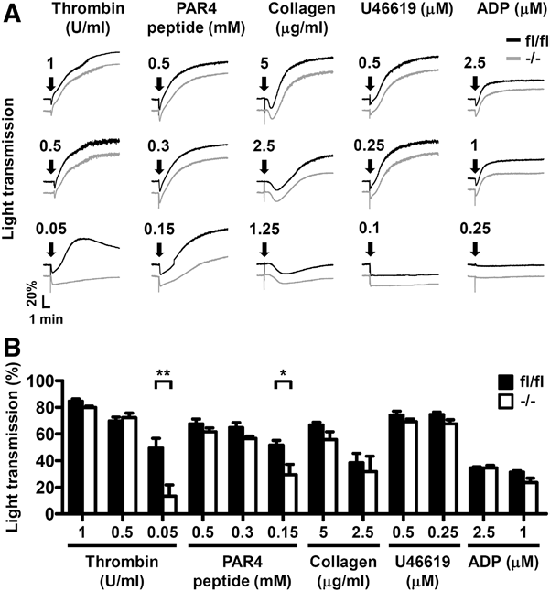
Figure 3. Selective defects in thrombin-induced aggregation of Disabled-2 knockout platelets. A and B, The washed platelets of fl/fl and −/− mice were stimulated by soluble agonists, and platelet aggregation was recorded by a platelet aggregometer (Chrono-Log). Representative aggregation curves in response to thrombin, protease-activated receptor 4 peptide (AYPGKF), collagen, U46619, and ADP at the indicated concentrations are shown in A. Arrows indicate the point of agonist addition. The
percentage of light transmission at the end of aggregation assay is shown in B. The data represent the mean±SEM of 3 to 9 inde- pendent experiments. *P<0.05; **P<0.01.

(P<0.05; Figure 4C). These data indicate that Dab2 deficiency results in a defect in thrombin signaling leading to impaired platelet spreading on fibrinogen and clot retraction.

Dab2 Deficiency Causes a Decrease in Platelet Fibrinogen Storage and Thrombin-Stimulated ADP Release and Integrin αIIbβ3 Activation
Dab2 has been shown to play a role in fibrinogen internaliza- tion in human K562 cells.25 The fibrinogen content in Dab2−/− platelets was analyzed to investigate whether Dab2 deficiency has any effect on fibrinogen storage in platelets. Western blot analysis revealed that Dab2fl/fl and Dab2−/− mice had similar amounts of plasma fibrinogen (Figure 5A). However, the
fibrinogen content in Dab2−/− platelets was ≈63% of the con-
trol (P<0.05; Figure 5B), implicating a selective defect of Dab2−/− platelets in fibrinogen storage. Adding exogenous fibrinogen in the reaction mixtures was not able to restore thrombin-induced aggregation response of Dab2−/− platelets (Figure 5C). These data imply that the decrease in fibrino- gen storage does not account for the attenuated response of Dab2−/− platelets to low concentrations of thrombin.
The effects of Dab2 deficiency on thrombin signaling was delineated further in the following experiments. Surface CD41 expression and thrombin-stimulated α-granule release as indicated by the surface expression of CD62P were nor- mal in Dab2−/− platelets (Figure 5D and 5E). In contrast, low concentrations of thrombin induced less release of ADP, less integrin αIIbβ3 activation, and less fibrinogen binding from

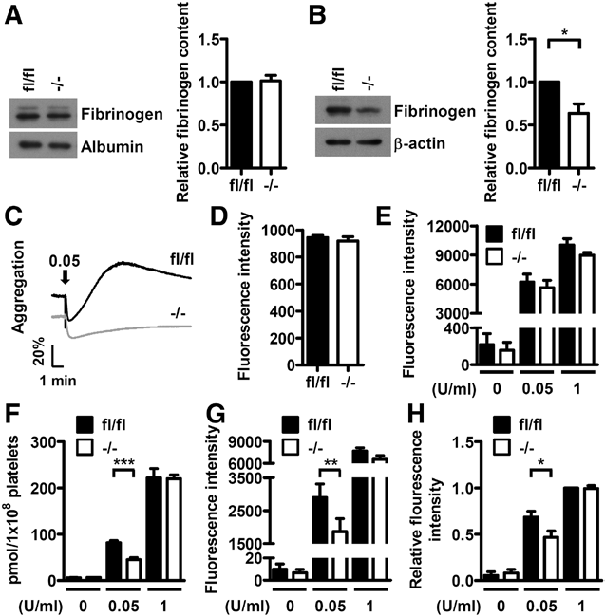

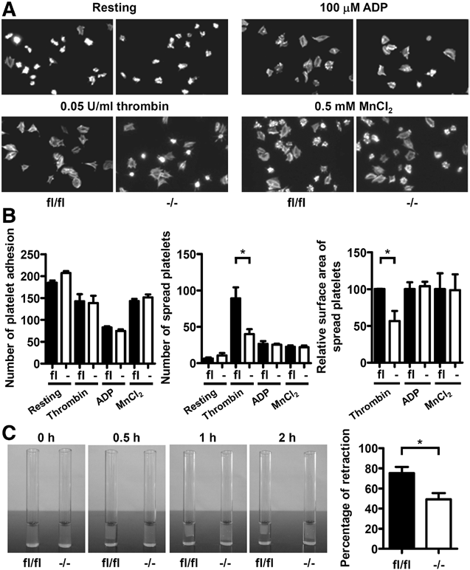
Figure 4. Reduced spreading on fibrinogen and impaired clot retraction of Disabled-2 knockout platelets in response to low concentrations of thrombin. A and B, Platelet adhesion and spreading were performed. The platelets were then labeled with FITC-conjugated phalloidin and recorded by fluorescence microscopy under high-power field (HPF) of ×1000 magnifica-
tion. The number of platelet adhesion/HPF was determined. The increase in surface area of spreading platelets by thrombin, ADP, or MnCl stimulation was determined by subtraction of the sur- face area of resting platelets. The relative surface area of spread- ing platelets is shown. The data represent the mean±SEM of 3 to 7 independent experiments. *P<0.05. C, The photographs corre- sponding to 0, 0.5, 1, and 2 h after initiation of thrombin-induced clot retraction are shown. The area of clot at 2 h after reaction was quantified by ImageJ, and the percentage of retraction ([original area−clot area]×100) was calculated. The data represent the mean±SEM of 5 independent experiments. *P<0.05.
2

Dab2−/− than from Dab2fl/fl platelets (Figure 5F–5H). These data indicate that Dab2−/− platelets are defective in thrombin- stimulated ADP release and integrin αIIbβ3 activation.

Dab2 Regulates Thrombin-Stimulated Inside-Out Signaling
To elucidate the molecular insight for Dab2 function in thrombin signaling, we first analyzed whether the expres- sion of thrombin receptors was altered in Dab2−/− platelets. Flow cytometry and Western blot analyses revealed that the expression levels of thrombin receptors GPIbα, PAR3, and PAR4 were comparable between Dab2fl/fl and Dab2−/− platelets (Figure 6A), ruling out aberrant thrombin receptor expression
as the cause of impaired thrombin signaling in Dab2−/− platelets. The inside-out signaling of thrombin is mainly transmit- ted through the G-protein–dependent pathways that cause
Figure 5. Deficiency of platelet Disabled-2 causes a decrease in fibrinogen content and thrombin-induced ADP release and inte- grin αIIbβ3 activation. A, Platelet-poor plasma (PPP) of fl/fl and
−/− mice was collected, and the fibrinogen content in PPP was determined by Western blotting using anti-fibrinogen antibody. The expression of albumin was used for the control of equal protein loading. The band intensity of fibrinogen normalized by albumin was quantified by ImageJ software. The data represent the mean±SEM of 6 independent experiments. B, The platelets of fl/fl and −/− mice were collected, and the fibrinogen contents were analyzed by Western blot using the anti-fibrinogen anti- body. The expression of β-actin was used for the control of equal protein loading. The band intensity of fibrinogen normalized by
β-actin was quantified by ImageJ software. The data represent the mean±SEM of 4 independent experiments. *P<0.05. C, One micro- gram of fibrinogen was added to the fl/fl or −/− washed platelets from fl/fl or −/− mice followed by thrombin (0.05 U/mL) stimulation. Platelet aggregation was then recorded by a platelet aggregometer (Chrono-Log). Arrows indicate the point of agonist added. Essen- tially similar results were obtained in 3 independent experiments. D, The washed platelets from fl/fl and −/− mice were incubated with the FITC-conjugated anti-CD41 antibody and analyzed by flow cytometry. The data represent the mean±SEM of 3 indepen- dent experiments E, Resting or thrombin-stimulated (0.05 and
1 U/mL) fl/fl and −/− platelets were incubated with the PE-conjugated anti-CD62P antibody and analyzed by flow cytometry. The cor- responding isotype control antibody was used to define the back- ground fluorescence signal. The data represent the mean±SEM of 3 to 6 independent experiments. F, Supernatants from thrombin- stimulated fl/fl and −/− platelets were collected. ADP release
assay was then performed and quantified using the GloMax 20/20 luminometer. The data represent the mean±SEM of 5 independent experiments. ***P<0.001. G and H, Resting or thrombin-stimulated
(0.05 and 1 U/mL) fl/fl and −/− platelets were incubated with the PE-conjugated JON/A antibody (G) or Alexa Fluor-488–conjugated fibrinogen (H) followed by flow cytometry. The corresponding isotype control antibody was used to define the background fluo- rescence signal. The data represent the mean±SEM of 5 to 10 independent experiments. **P<0.01; *P<0.05.

intracellular calcium concentration and the phosphorylation of PKC-pan, PKCδ-T505, and PDK1-Ser241 stimulated by low concentrations of thrombin were similar between Dab2fl/fl

an increase in intracellular calcium concentration and sig-
and Dab2−/− platelets (Figure 6B and 6C), whereas G

α12/13
-

naling proteins phosphorylation.5 Analyses of the molecular
events downstream of thrombin receptors revealed that the
dependent Rho activation as represented by the phosphor-
ylation of ROCKII (a downstream effector of RhoA) at

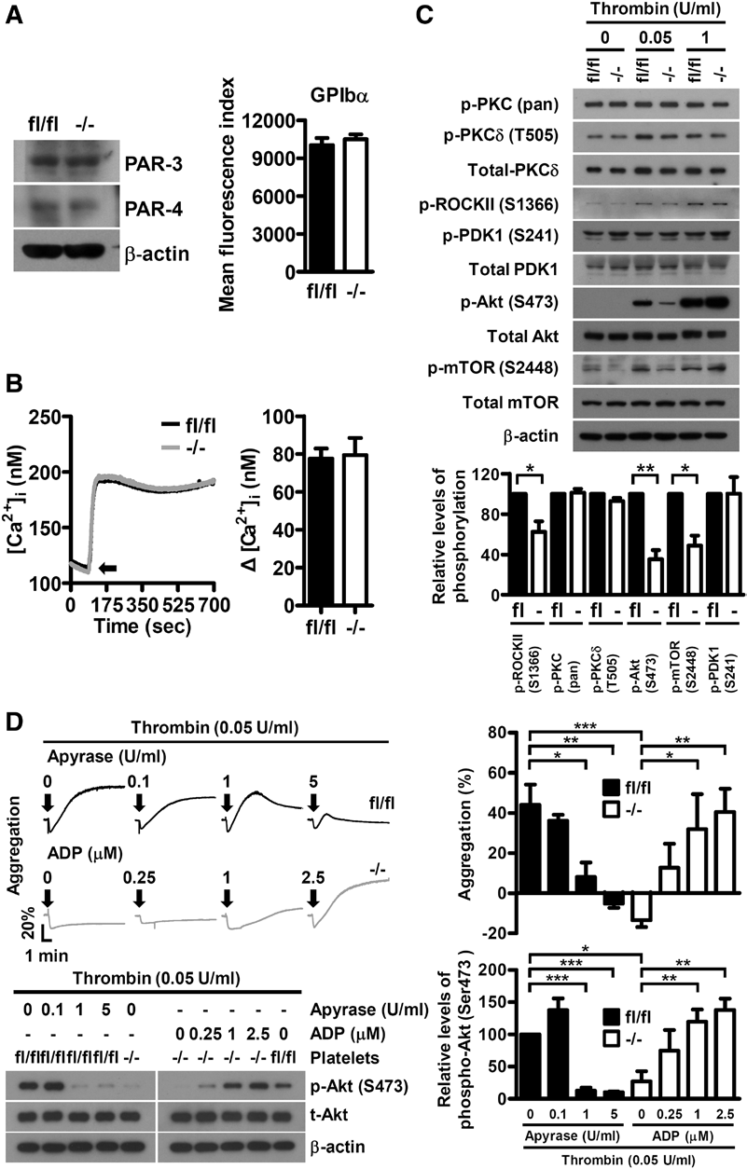
Figure 6. Disabled-2 is involved in the regulation of low concentrations of thrombin-stimulated ROCKII- Ser1366 and Akt-Ser473 phosphorylation. A, The expression of thrombin receptor GPIbα, protease- activated receptor (PAR) 3, and PAR4 in fl/fl and
−/− platelets was analyzed by flow cytometry or Western blot using FITC-conjugated anti-GPIbα, anti-PAR3, and anti-PAR4 antibodies, respectively. B, Fluo-3–loaded washed platelets from fl/fl and
−/− mice were stimulated with 0.05 U/mL thrombin, and the changes in intracellular Ca2+ concentra- tion ([Ca]2+ ) were calculated. Arrow indicates the starting point of thrombin stimulation (left). The data represent the mean±SEM of 3 independent experiments (right). C, The fl/fl and −/− platelets were stimulated with the indicated concentrations of thrombin and the platelet lysates were collected for Western blot analysis using the indicated anti- bodies. The expression of β-actin was used for the control of equal protein loading (top). The relative levels of phosphorylation for the indicated proteins stimulated with 0.05 U/mL thrombin were quantified by ImageJ software (bottom). The data represent the mean±SEM of 3 to 4 independent experiments.
i
**P<0.01; *P<0.05. D, The fl/fl platelets were prein- cubated with the indicated concentrations of apy- rase for 1 min and then stimulated with thrombin
(0.05 U/mL). The −/− platelets were stimulated with thrombin (0.05 U/mL) and the indicated concentra- tions of ADP simultaneously. Platelet aggregation was recorded by a platelet aggregometer (Chrono- Log). Representative traces for platelet aggregation are shown (top left). Arrows indicate the point of agonist addition. The lysates for the platelets with the indicated treatment were collected for West- ern blot analysis using the anti-Akt and anti-p-Akt (Ser473) antibodies. The expression of β-actin was used for the control of equal protein loading (bot- tom left). The percentage of light transmission at the end of the aggregation assay (top right) and the relative phosphorylation levels of p-Akt (Ser473) are shown (bottom right). The data represent the
mean±SEM of 4 independent experiments. *P<0.05;
**P<0.01; ***P<0.001.

Ser136630 in Dab2−/− platelets was 62.4±10.5% of the control (P<0.05; Figure 6C). The phosphorylation of Akt-Ser473 and mTOR-Ser2448 in Dab2−/− platelets were also sig- nificantly attenuated to 35.3±8.9% and 48.8±10.1% of the control, respectively (P<0.01 and <0.05; Figure 6C). These defects were not apparent if Dab2−/− platelets were stimu- lated with high concentrations of thrombin (0.5 or 1 U/mL) or other soluble agonists such as collagen, U46619, and ADP (Figure 6C; Figure I in the online-only Data Supplement). These data indicate that Dab2 mediates signaling by low doses of thrombin and acts upstream of RhoA-ROCK and Akt-mTOR. Platelet aggregation and Akt-Ser473 phos- phorylation stimulated by low thrombin concentrations were inhibited by apyrase in Dab2fl/fl platelets and were restored by ADP in the Dab2−/− platelets in a dose-dependent manner (Figure 6D). These data indicate that impaired ADP release contributes to the defective platelet aggregation and Akt phosphorylation of Dab2−/− platelets.

Discussion
Our results define a key in vivo function for Dab2 in regulating hemostasis, thrombosis, and platelet signaling in mice. Absence of Dab2 does not influence the process of platelet biogen- esis, but selectively inhibits the phosphorylation of ROCKII- Ser1366, Akt-Ser473, and mTOR-Ser2448 under conditions of low-dose thrombin stimulation. The impairment of the signal- ing response in Dab2−/− platelets causes functional changes in
ADP release, integrin αIIbβ3 activation, fibrinogen binding,
platelet aggregation, spreading on fibrinogen, and clot retrac- tion. In accord with the aforementioned functional defects of Dab2−/− platelets, Dab2−/− mice display a prolonged bleeding time and impaired thrombus formation. This study presents novel evidence demonstrating that Dab2 plays an important role in hemostasis, thrombosis, and platelet signaling in vivo.
Various signaling pathways are activated when platelets are stimulated with different types of agonists. Collagen induces clustering of glycoprotein VI and causes an increase in

glycoprotein VI–associated Src family kinase activity, leading to a rise in intracellular calcium and an increase in PKC activ- ity.31,32 The receptors of thrombin and thromboxane A2 couple
1
notion that the mTOR complex 2 complex is responsible for the phosphorylation of Akt-Ser473.40
Based on the findings in this study, a possible working

to both G
αq

α12/13
and G
pathways, whereas ADP binds to P2Y
model for the mechanisms of Dab2 action in thrombin-stim-

and P2Y
12
receptors that couple to G
and G , respectively,
ulated inside-out signaling is proposed. In response to low

for signal propagation.33 GPIbα is apparently another type of
αq
αi
α12/13
concentrations of thrombin, Dab2 regulates G
-mediated

thrombin receptor.34,35 Because the expression levels of PAR3,
RhoA-ROCK activation and potentiates ADP release. The

PAR4, and GPIbα are similar between Dab2−/− and wild-type
released ADP binds to its receptor P2Y
and activates G /G

12 αi βγ

platelets, the selective defects of Dab2−/− platelets in response
to low thrombin concentrations are not attributed to the altered expression of thrombin receptors. Instead, Dab2−/− platelets
signaling leading to Akt-mTOR phosphorylation/activation,
which potentiates integrin activation and platelet aggregation. This mode of Dab2 action is consistent with previous studies

are impaired in G
-mediated RhoA activation as shown by
showing that G
-mediated RhoA-ROCK activation regu-

α12/13
the decreased ROCKII-Ser1366 phosphorylation. This is con-
sistent with the previous study showing that Dab2 modulates RhoA activity and inhibits nerve growth factor–induced neu- rite outgrowth.21 Dab2−/− and RhoA−/− mice are abnormal in hemostasis and thrombus formation, whereas the correspond- ing platelets are defective in integrin activation, clot retrac- tion, and dense granule/ADP secretion in response to low concentrations of thrombin. In contrast, Dab2−/− and RhoA−/− platelets response normally to ADP and collagen-stimulated platelet aggregation.36 These results imply that Dab2 and RhoA-ROCKII are in the same signaling axis.
Discrepancies between Dab2−/− and RhoA−/− platelets are
also noted. For example, RhoA−/− but not Dab2−/− platelets are defective in P-selectin exposure in response to throm- bin.36 This is explainable by the broad spectrum of RhoA
α12/13
lates cytoskeleton reorganization, which is critical for degran-
ulation,41 whereas ADP release is essential to stabilize platelet aggregates stimulated by concentrations of thrombin <0.25 to 1 U/mL but is not required at high thrombin concentrations.42 Despite the fact that Dab2 elicits a restrictive function in response to low thrombin concentrations, but not other soluble agonists, Dab2 deficiency has profound effects on hemostasis and thrombosis in vivo, as evidenced by Dab2−/− mice having a prolonged bleeding time and impaired thrombus formation. Consistent with our findings, even a partial decrease in thrombin- induced platelet aggregation observed in PAR3-deficient mice impairs hemostasis and protects against thrombosis.43 Similarly, blocking thrombin receptor PAR4 on platelets extends bleed- ing time and protects against systemic platelet activation.44 This and other studies support the perception that thrombin signaling

function, which plays a central role in G

α12/13
signaling and
plays a pivotal role in hemostasis and thrombosis.

also contributes to G
-mediated platelet activation.37 Several
The defect in fibrinogen storage does not particularly con-

αq
indirect studies indicate that G
αq
may directly regulate RhoA
tribute to the defective response of Dab2−/− platelets to low

activity by activating the Rho-guanine nucleotide exchange factors.38 In contrast, Dab2 seems to restrict its function in G -associated RhoA-ROCK activation with no evidence
α12/13
concentrations of thrombin. Nevertheless, this and other stud- ies indicate that Dab2 positively regulates fibrinogen uptake. Fibrinogen uptake in K562 cells is a Dab2-dependent pro-

for cross-talk of Dab2 to G
; Dab2−/− platelets are normal in
cess.25 Expression of shDAB2 in rat megakaryocytes results

G -mediated calcium mobilization and PKC phosphorylation in response to thrombin. This study reveals for the first time
αq
αq
α12/13
in a moderate decrease in fibrinogen uptake (Figure II in the online-only Data Supplement). At the molecular level, Dab2

the functional interplay of Dab2 with G
ROCK activation in murine platelets.
-mediated RhoA-
is known to bind the β3-NITY motif of the fibrinogen recep-
tor integrin αIIbβ3 through the PTB domain7,13 and act as an

Because Src family kinase and G /G /G
are the major
NPXY sequence–specific clathrin adaptor protein in receptor

αi βγ αq

signaling pathways mediating platelet activation by collagen
and ADP, respectively, the restricted function of Dab2 in the
endocytosis.17,45,46 With two thirds of the normal fibrinogen
content still present in Dab2−/− platelets, a Dab2-dependent

α12/13
G
pathway also explains the normal aggregation patterns
and a Dab2-independent mechanism for fibrinogen internal-

of Dab2−/− platelets in response to collagen and ADP. Despite
ization could occur in platelets.

α12/13
G
coupling to the thromboxane A2 receptors, Dab2−/−
Not all the observations obtained from Dab2−/− mice are

platelets are not defective in platelet aggregation stimulated
by the thromboxane A2 mimetic U46619. Similar to our findings, Lyn-deficient platelets are defective in aggregation stimulated by low concentrations of thrombin and PAR4, but produce normal aggregation by U46619 and ADP.39 These studies highlight the presence of agonist-specific signaling
consistent with our previous analyses using human cell lines
and platelets. In K562 cells, Dab2 knockdown augments rather than weakens integrin αIIbβ3 activation and increases cell adhesion to fibrinogen.13 In human platelets, Dab2 negatively regulates platelet–fibrinogen interaction and platelet aggrega- tion.13,23,26,47 Dab2 is required for murine platelet aggregation

downstream of G
α12/13
pathway.
in response to low concentrations of thrombin. Several issues

Another important finding in this study is that Dab2−/− platelets are normal in PDK1-Ser241 phosphorylation, but are impaired in ADP release, platelet aggregation, and the phosphorylations of Akt-Ser473 and mTOR-Ser2448. The defective platelet aggregation and Akt-Ser473 phosphoryla- tion were rescued and restored by supplementation of ADP to the reaction. These data indicate that Akt-Ser473 phosphory- lation is independent of PDK1 signaling, consistent with the
could be argued for the discrepancy among these studies. First, different Dab2 isoforms are present in human and murine platelets. Human platelets mainly expressed p82, whereas p59 is the sole Dab2 isoform in murine platelets (Figure III in the online-only Data Supplement). Distinct functions of p82 and p59 have been reported. p82 has been shown to function in receptor-mediated endocytosis, whereas p59 can act as a tran- scriptional regulator during the differentiation of F9 cells.48–51

In Dab2−/− mice, expression of p59 only partially compensates for the absence of Dab2.12 Hence, species-specific expression of Dab2 isoforms may explain the distinct features of Dab2 in human and mouse megakaryocytes and platelets.
The discrepancy between this and previous studies could simply be because of the use of different experimental models. In the human platelet studies, the experiments were mainly performed in vitro using recombinant Dab2 protein as a tool to analyze Dab2 function and its effects on platelet response.23,26 No in vivo study was performed using Dab2 mutants or Dab2- deficient human platelets. In contrast, Dab2-deficient mouse platelets were used in the present study to analyze in vivo Dab2 function. Future study using an animal model system with expression of human platelet Dab2 protein may provide additional insight for the differential Dab2 function in human and mouse platelets.
In conclusion, the findings that Dab2 expression is required for (1) hemostasis and thrombosis, (2) fibrinogen storage, (3) thrombin-stimulated inside-out signaling, and (4) optimal ADP release, integrin αIIbβ3 activation, and fibrinogen binding leading to platelet aggregation, spreading on fibrinogen, and clot retraction stimulated by low thrombin concentrations are the first demonstration that Dab2 plays an important role in
efficient hemostasis and platelet activation by thrombin in vivo.

Acknowledgments
The PF4-Cre mouse was a kind gift from Dr Radek Skoda (University Hospital Basel, Basel, Switzerland). We acknowledge the editorial help from Dr Arnold Stern (New York University School of Medicine) and the technical advice from Drs Shu-Wha Lin and Chung-Yang Kao (National Taiwan University) for FeCl -induced thrombosis model.
3

Sources of Funding
This study was supported in part by the China Medical University Grant CMU97-153 to J.-C. Cheng, grant GM066257 from the US Public Health Service to J.A. Cooper, and National Science Council Grants NSC102-2628-B-182-009-MY3, and NSC102-2628-B-182-
- MY3, Chang Gung Memorial Hospital Grants CMRPD1C0552 and CMRPD1B0393, and Chang Gung Molecular Medicine Research Center Grant EMRPD1D1281 to C.-P. Tseng.

Disclosures
None.

References
  - George JN. Platelets. Lancet. 2000;355:1531–1539.
  - Chong AJ, Pohlman TH, Hampton CR, Shimamoto A, Mackman N, Verrier ED. Tissue factor and thrombin mediate myocardial ischemia- reperfusion injury. Ann Thorac Surg. 2003;75:S649–S655.
  - Schönberger T, Ziegler M, Borst O, Konrad I, Nieswandt B, Massberg S, Ochmann C, Jürgens T, Seizer P, Langer H, Münch G, Ungerer M, Preissner KT, Elvers M, Gawaz M. The dimeric platelet collagen receptor GPVI-Fc reduces platelet adhesion to activated endothelium and preserves myocardial function after transient ischemia in mice. Am J Physiol Cell Physiol. 2012;303:C757–C766.
  - Newman DK. PI3Kbeta goes to the head of its class. Blood.
2009;114:2011–2012.
  - Angiolillo DJ, Capodanno D, Goto S. Platelet thrombin receptor antago- nism and atherothrombosis. Eur Heart J. 2010;31:17–28.
  - Kamath S, Blann AD, Lip GY. Platelet activation: assessment and quanti- fication. Eur Heart J. 2001;22:1561–1571.
  - Calderwood DA, Fujioka Y, de Pereda JM, García-Alvarez B, Nakamoto T, Margolis B, McGlade CJ, Liddington RC, Ginsberg MH. Integrin beta cytoplasmic domain interactions with phosphotyrosine-binding domains:
a structural prototype for diversity in integrin signaling. Proc Natl Acad Sci U S A. 2003;100:2272–2277.
  - Wolfenson H, Lubelski A, Regev T, Klafter J, Henis YI, Geiger B. A role for the juxtamembrane cytoplasm in the molecular dynamics of focal adhesions. PLoS One. 2009;4:e4304.
  - Legate KR, Fässler R. Mechanisms that regulate adaptor binding to beta- integrin cytoplasmic tails. J Cell Sci. 2009;122(Pt 2):187–198.
  - Roca-Cusachs P, del Rio A, Puklin-Faucher E, Gauthier NC, Biais N, Sheetz MP. Integrin-dependent force transmission to the extracellular matrix by α-actinin triggers adhesion maturation. Proc Natl Acad Sci U S A. 2013;110:E1361–E1370.
  - Cohen I. The contractile system of blood platelets and its function.
Methods Achiev Exp Pathol. 1979;9:40–86.
  - Maurer ME, Cooper JA. Endocytosis of megalin by visceral endoderm cells requires the Dab2 adaptor protein. J Cell Sci. 2005;118:5345–5355.
  - Huang CL, Cheng JC, Liao CH, Stern A, Hsieh JT, Wang CH, Hsu HL, Tseng CP. Disabled-2 is a negative regulator of integrin alpha(IIb) beta(3)-mediated fibrinogen adhesion and cell signaling. J Biol Chem. 2004;279:42279–42289.
  - Wang Z, Tseng CP, Pong RC, Chen H, McConnell JD, Navone N, Hsieh JT. The mechanism of growth-inhibitory effect of DOC-2/DAB2 in prostate cancer. Characterization of a novel GTPase-activating pro- tein associated with N-terminal domain of DOC-2/DAB2. J Biol Chem. 2002;277:12622–12631.
  - Hocevar BA, Smine A, Xu XX, Howe PH. The adaptor molecule Disabled-2 links the transforming growth factor beta receptors to the Smad pathway. EMBO J. 2001;20:2789–2801.
  - Hocevar BA, Mou F, Rennolds JL, Morris SM, Cooper JA, Howe PH. Regulation of the Wnt signaling pathway by disabled-2 (Dab2). EMBO J. 2003;22:3084–3094.
  - Morris SM, Arden SD, Roberts RC, Kendrick-Jones J, Cooper JA, Luzio JP, Buss F. Myosin VI binds to and localises with Dab2, potentially link- ing receptor-mediated endocytosis and the actin cytoskeleton. Traffic. 2002;3:331–341.
  - Kowanetz K, Terzic J, Dikic I. Dab2 links CIN85 with clathrin-mediated receptor internalization. FEBS Lett. 2003;554:81–87.
  - Inoue A, Sato O, Homma K, Ikebe M. DOC-2/DAB2 is the binding part- ner of myosin VI. Biochem Biophys Res Commun. 2002;292:300–307.
  - Huang CL, Cheng JC, Kitajima K, Nakano T, Yeh CF, Chong KY, Tseng CP. Disabled-2 is required for mesoderm differentiation of murine embry- onic stem cells. J Cell Physiol. 2010;225:92–105.
  - Huang CH, Cheng JC, Chen JC, Tseng CP. Evaluation of the role of Disabled-2 in nerve growth factor-mediated neurite outgrowth and cel- lular signalling. Cell Signal. 2007;19:1339–1347.
  - Hosaka K, Takeda T, Iino N, Hosojima M, Sato H, Kaseda R, Yamamoto K, Kobayashi A, Gejyo F, Saito A. Megalin and nonmuscle myosin heavy chain IIA interact with the adaptor protein Disabled-2 in proximal tubule cells. Kidney Int. 2009;75:1308–1315.
  - Huang CL, Cheng JC, Stern A, Hsieh JT, Liao CH, Tseng CP. Disabled-2 is a novel alphaIIb-integrin-binding protein that negatively regulates platelet-fibrinogen interactions and platelet aggregation. J Cell Sci. 2006;119:4420–4430.
  - Tseng CP, Chang P, Huang CL, Cheng JC, Chang SS. Autocrine sig- naling of platelet-derived growth factor regulates disabled-2 expres- sion during megakaryocytic differentiation of K562 cells. FEBS Lett. 2005;579:4395–4401.
  - Hung WS, Huang CL, Fan JT, Huang DY, Yeh CF, Cheng JC, Tseng CP. The endocytic adaptor protein Disabled-2 is required for cellular uptake of fibrinogen. Biochim Biophys Acta. 2012;1823:1778–1788.
  - Welsh JD, Charonko JJ, Salmanzadeh A, Drahos KE, Shafiee H, Stremler MA, Davalos RV, Capelluto DG, Vlachos PP, Finkielstein CV. Disabled-2 modulates homotypic and heterotypic platelet interactions by binding to sulfatides. Br J Haematol. 2011;154:122–133.
  - Xiao S, Charonko JJ, Fu X, Salmanzadeh A, Davalos RV, Vlachos PP, Finkielstein CV, Capelluto DG. Structure, sulfatide binding properties, and inhibition of platelet aggregation by a disabled-2 protein-derived pep- tide. J Biol Chem. 2012;287:37691–37702.
  - Tiedt R, Schomber T, Hao-Shen H, Skoda RC. Pf4-Cre transgenic mice allow the generation of lineage-restricted gene knockouts for studying megakaryocyte and platelet function in vivo. Blood. 2007;109:1503–1506.
  - Goschnick MW, Lau LM, Wee JL, Liu YS, Hogarth PM, Robb LM, Hickey MJ, Wright MD, Jackson DE. Impaired “outside-in” integrin alphaIIbbeta3 signaling and thrombus stability in TSSC6-deficient mice. Blood. 2006;108:1911–1918.

  - Chuang HH, Yang CH, Tsay YG, Hsu CY, Tseng LM, Chang ZF, Lee HH. ROCKII Ser1366 phosphorylation reflects the activation status. Biochem J. 2012;443:145–151.
  - Varga-Szabo D, Pleines I, Nieswandt B. Cell adhesion mechanisms in platelets. Arterioscler Thromb Vasc Biol. 2008;28:403–412.
  - Yacoub D, Théorêt JF, Villeneuve L, Abou-Saleh H, Mourad W, Allen BG, Merhi Y. Essential role of protein kinase C delta in platelet signaling, alpha IIb beta 3 activation, and thromboxane A2 release. J Biol Chem. 2006;281:30024–30035.
  - Offermanns S. Activation of platelet function through G protein-coupled receptors. Circ Res. 2006;99:1293–1304.
  - Dubois C, Steiner B, Kieffer N, Reigner SC. Thrombin binding to GPIbalpha induces platelet aggregation and fibrin clot retraction supported by resting alphaIIbbeta3 interaction with polymerized fibrin. Thromb Haemost. 2003;89:853–865.
  - Dubois C, Steiner B, Meyer Reigner SC. Contribution of PAR-1, PAR-4 and GPIbalpha in intracellular signaling leading to the cleavage of the beta3 cytoplasmic domain during thrombin-induced platelet aggregation. Thromb Haemost. 2004;91:733–742.
  - Pleines I, Hagedorn I, Gupta S, May F, Chakarova L, van Hengel J, Offermanns S, Krohne G, Kleinschnitz C, Brakebusch C, Nieswandt B. Megakaryocyte-specific RhoA deficiency causes macrothrombocytope- nia and defective platelet activation in hemostasis and thrombosis. Blood. 2012;119:1054–1063.
  - Jin J, Mao Y, Thomas D, Kim S, Daniel JL, Kunapuli SP. RhoA down- stream of G(q) and G(12/13) pathways regulates protease-activated receptor-mediated dense granule release in platelets. Biochem Pharmacol. 2009;77:835–844.
  - Vogt S, Grosse R, Schultz G, Offermanns S. Receptor-dependent RhoA activation in G12/G13-deficient cells: genetic evidence for an involvement of Gq/G11. J Biol Chem. 2003;278:28743–28749.
  - Cho MJ, Pestina TI, Steward SA, Lowell CA, Jackson CW, Gartner TK. Role of the Src family kinase Lyn in TxA2 production, adenosine diphos- phate secretion, Akt phosphorylation, and irreversible aggregation in platelets stimulated with gamma-thrombin. Blood. 2002;99:2442–2447.
  - Sarbassov DD, Guertin DA, Ali SM, Sabatini DM. Phosphorylation and regulation of Akt/PKB by the rictor-mTOR complex. Science. 2005;307:1098–1101.
  - Huang JS, Dong L, Kozasa T, Le Breton GC. Signaling through G(alpha)13 switch region I is essential for protease-activated receptor 1-mediated human platelet shape change, aggregation, and secretion. J Biol Chem. 2007;282:10210–10222.
  - Cattaneo M, Canciani MT, Lecchi A, Kinlough-Rathbone RL, Packham MA, Mannucci PM, Mustard JF. Released adenosine diphosphate stabilizes thrombin-induced human platelet aggregates. Blood. 1990;75:1081–1086.
  - Weiss EJ, Hamilton JR, Lease KE, Coughlin SR. Protection against thrombosis in mice lacking PAR3. Blood. 2002;100:3240–3244.
  - Covic L, Misra M, Badar J, Singh C, Kuliopulos A. Pepducin-based inter- vention of thrombin-receptor signaling and systemic platelet activation. Nat Med. 2002;8:1161–1165.
  - Morris SM, Cooper JA. Disabled-2 colocalizes with the LDLR in clathrin- coated pits and interacts with AP-2. Traffic. 2001;2:111–123.
  - Spudich G, Chibalina MV, Au JS, Arden SD, Buss F, Kendrick-Jones
J. Myosin VI targeting to clathrin-coated structures and dimerization is mediated by binding to Disabled-2 and PtdIns(4,5)P2. Nat Cell Biol. 2007;9:176–183.
  - Drahos KE, Welsh JD, Finkielstein CV, Capelluto DG. Sulfatides partition disabled-2 in response to platelet activation. PLoS One. 2009;4:e8007.
  - Mishra SK, Keyel PA, Hawryluk MJ, Agostinelli NR, Watkins SC, Traub LM. Disabled-2 exhibits the properties of a cargo-selective endocytic clathrin adaptor. EMBO J. 2002;21:4915–4926.
  - Keyel PA, Mishra SK, Roth R, Heuser JE, Watkins SC, Traub LM. A single common portal for clathrin-mediated endocytosis of distinct cargo governed by cargo-selective adaptors. Mol Biol Cell. 2006;17:4300–4317.
  - Teckchandani A, Toida N, Goodchild J, Henderson C, Watts J, Wollscheid B, Cooper JA. Quantitative proteomics identifies a Dab2/integrin module regulating cell migration. J Cell Biol. 2009;186:99–111.
  - Cho SY, Jeon JW, Lee SH, Park SS. p67 isoform of mouse disabled 2 protein acts as a transcriptional activator during the differentiation of F9 cells. Biochem J. 2000;352 Pt 3:645–650.

Significance

The essential role of platelet activation in hemostasis and thrombotic diseases focuses attention on unveiling the underlying intracellular signals of platelet activation. Disabled-2 has been implicated in platelet aggregation and in the control of clotting responses. By analyzing the phenotype and platelet functions using the megakaryocyte lineage–restricted Disabled-2 knockout mouse, we demonstrate in this study that Disabled-2 is a key regulator of hemostasis and thrombosis by playing a selective role in thrombin-stimulated inside-out signaling. This study sheds new insight in platelet biology and represents the first report demonstrating that Disabled-2 has a functional interplay with thrombin signaling.

