█ Subject Heading
Preferential formation of Si-O-C over Si-C linkage upon thermal grafting on hydrogen−terminated Silicon (111)
[a] Dr. Yit Lung Khung and Professor Dario Narducci
University of Milan-Bicocca,
Department of Materials Science
Via R. Cozzi 55, I-20125 Milan (Italy)

[b] Dr Siti Hawa Ngalim
Regenerative Medicine Cluster
Advanced Medical and Dental Institute (AMDI)
Universiti Sains Malaysia, Penang (Malaysia)

[c ] Dr. Laura Meda
Eni S.p.A. - Istituto Eni Donegani,
Centro Ricerche per le Energie non Convenzionali,
Via G. Fauser, 4 I-28100 Novara (Italy)

*Corresponding Author:

Dr. Yit Lung Khung

yit.khung@unimib.it

phone: +39-02-6448-5143

fax +39-02-6448-5400
[

Yit Lung Khung^{a*}, Siti Hawa Ngalim^{b}, Laura Meda^{c} and Dario Narducciª

Introduction
1. Introduction
The understanding and control of surface grafting of organic layers onto silicon surfaces is an important research area towards the optimization of a good hybrid organic/silicon device. For the quality of the grafted organic layer, researchers often used ‘stacking density’, surface wettability and film stability as yardsticks of evaluation. In the past, a great deal of attention has been given towards the grafting of organic monolayers via the OH groups that typically dominates the SiO₂ surface. Silanes and phosphonates are popular approach taking this route for grafting organics on SiO₂ surfaces^{[1]}. However, in both situations, the activation energy required for a number of chemical species is extremely high especially for phosphonates, while the Si-O-Si linkage is highly susceptible to hydrolysis^{[2]}. Furthermore, with silanes, it was very difficult to produce a true monolayer due to their intrinsic crosslinking. Hydrogenated silicon surfaces (Si-H), on the other hand, are an excellent starting point to initiate covalent grafting of organic monolayers on the silicon surface. Produced from the removal of native oxide on silicon surface commonly via hydrofluoric acid etching, Si-H surface is a popular platform for creating a direct covalent linkage for monolayer formation.

Many modes of direct functionalization on Si-H surface has been reported in literature, ranging from indirect substitution such as hydrosilylation to halogen replacement of Si-H for direct substitution^{[3]}. As first proposed by Linford et al. in the mid 90s^{[4]}, a popular indirect substitution chemical grafting is hydrosilylation, , which forms a direct covalent Si-C bond on silicon hydrogenated surfaces to produce a highly stable monolayer. The process involves the activation of alkenes or any unsaturated hydrocarbon that in turn react with the Si-H surface. The reaction can be summarized as
Abstract: In a stringent and oxygen-free environment, Si-H surfaces were introduced to a trifluoroalkyne, an alcohol-derivatised alkyne, and an equal mixture of both alkynes at temperatures of 130°C.  . | Contact angle measurements (CA), high-resolution X-ray photoelectron spectroscopy (XPS) as well as Angle Resolved XPS (ARXPS) were performed to examine the system. Si-H surfaces were found to have a strong preference towards the formation of Si-O-C rather than Si-C bonds when alcohol and alkynes’ reactivity were compared.

$≡$S$i−$H $+$ H₂CCH$−$R $→≡$Si$−$CH₂$−$CH₂$−$R (1)

The reaction is often driven by surface radical intermediates and can occur via catalysts or Lewis acids^{[3, 5]}, intermediate halogenation and subsequent Grignard chemistry^{[6]}, UV irradiation^{[7]} or can be thermally driven^{[8]}. Catalyst-driven hydrosilylation gives good yields but is prone to surface contamination from the metallic catalyst as residues on the surface, while the intermediate halogenation method had a restricted portfolio of functional groups available for grafting^{[9]}. Instead, UV irradiation is very efficient in achieving good grafting yield but is highly susceptible towards water contamination that can result in subsequent surface oxidation. Thermally-driven hydrosilylation, on the other hand, is a straightforward method although this process is very slow and can be also prone to contamination. However, its high reaction temperature (>100°C) ensures that water traces are removed, thus minimizing the risk of surface oxidation. Also, reaction rates can be enhanced as it is currently accepted in literature that at high temperature (>100°C) alkyne species will react much faster to a hydrogen-terminated silicon surface compared to alkene-tethered chains ^{[8, 10]}. A range of different long aliphatic carbon chains can be thermally grafted onto Si-H surface with good surface coverages reported as well as promising hydrophobicity even on flat surfaces (contact angles ranging from 82 to 111°)^{[8, 11]}.

Another highly efficient approach to prepare highly packed covalent layers from Si-H is the direct reaction with alcohol to produce Si-OC linkage^{[12]}. This produces near-oxide-free silicon surfaces, although the reaction time may be slow. The general reaction process is thought to be a nucleophilic attack of the Si-H by a lone pair from the oxygen in the alcohol followed by the loss of the two hydrogen atoms to give an oxidative addition linkage (Si-OR) on the surface^{[12d]}. In 2003, Pei et al. published geometry optimization calculations providing evidence that Si-OC linkage leads to better stacking on the surface compared to Si-C, thus producing a denser layer^{[13]}. They argued that this could be attributed to the smaller van der Waals radii exhibited by –O- from the Si-O-C linkage as compared to the -CH₂- from Si-C bond. They also suggested that tilting of the Si-O bond (5-15°) is smaller compared to the Si-C case (28-39°) for similar sized hydrocarbon, a fact that may contribute to better stacking and densification. So far, several reports seemingly suggested that Si-O-C linkage leads to a very high coverage (up to 97%) on the silicon surface^{[14]}. There are two additional advantages with grafting the Si-H surface with the Si-O-C linkage strategy. Firstly, it has been shown that the conditions governing the reaction are very mild (as low as room temperature) and even long-chain alcohols can be grafted in situations where alkenes cannot succeed^{[15]}. Secondly, due to its mild conditions, the functional groups of the molecules are largely intact and not compromised. Nonetheless, the Si-O-C is often deemed in literature to be unstable compared to the Si-C due to the polarity of the Si-O bond. On the contrary, it had been shown to be relatively thermodynamically stable although it is still susceptible to hydrolysis in acidic conditions^{[12a]}.

One of the remaining questions is how the Si-H surface would respond when introduced simultaneously to both an alkyne and an alcohol molecule, namely whether there exists a certain preference for surface passivation between the two competing molecules or grafting occurs by equal chance is currently unclear. In this paper the Si-H surface preference and reaction efficiency in the presence of both an alkyne molecule and a difunctionalized molecule with alkynic and alcoholic groups will be examined in a thermal reaction setup similar to that used in thermal hydrosilylation. Two alkynes were selected, namely 4-Ethynyl-α,α,α-trifluorotoluene (trifluoroalkyne), whose trifluoride functional group serves both as an XPS marker and as a way to modify the surface hydrophobicity upon functionalization; and 4-ethynylbenzyl alcohol (enthylbenzylalcohol). As shown in figure 1, at least five outcomes are possible in a reaction involving a mix of both alkyne species. To the best of the authors’ knowledge, this is the first time that such a direct competition between Si-C and Si-O-C in a thermally driven environment is examined.

By clarifying the different reactivity of alkynes and alcoholic groups toward Si−H, this study may also support targeting a practical aim. Actually, a challenge with regards to surface modifications on flat silicon is to optimise surface coverage using shorter organic molecules. As shown in the past, aromatic species confer better packing density on the surface^{[16]}. Covalently grafting a short aromatic species may therefore aid in increasing the surface hydrophobicity as a result. Thus, the molecules chosen in this study all had aromatic rings conferring rigidity to the organic layer^{[17]}

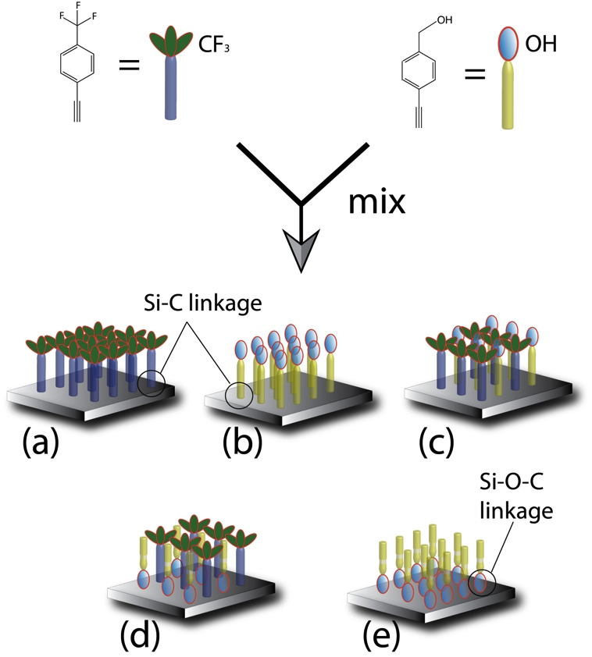

Figure 1. Some of the possibilities involving the trifluoroalkyne and the ethynylbenzylalcohol reacting to hydrogen terminated Si (111) surface. (a) Complete passivation of trifluoroalkyne via Si-C bond, (b) complete passivation of ethynylbenzylalcohol via Si-C, (c) a mix of both alkyne via Si-C bonding, (d) a mix of trifluroalkyne via Si-C and ethynylbenzylalcohol via Si-O-C and (e) a complete passivation of ethynylbenzylalcohol via the Si-O-C linkage.

Results and Discussion
Contact Angle studies

Sessile drop contact angle were measured on pristine silicon surface as well as for the three functionalized surfaces. Results are shown in Figure 2.

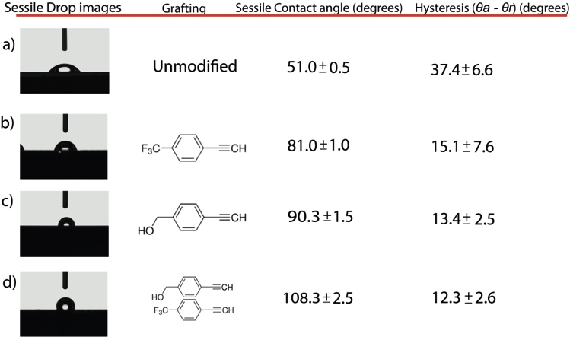
Figure 2. Static drop contact angle θ as well as the hysteresis measurement for a) pristine unmodified silicon surface, (b) trifluoro-terminated surfaces, c) ethynylbenzyl alcohol -terminated surfaces and d) mixed layer

After the 18 hours thermal reaction treatment, stringent rinsing procedures were undertaken to reduce the possibility of physisorption of the unreacted molecules. Subsequently, for the trifluoroalkyne sample, the sessile drop contact angle was found to be 81.0° ± 1.0°, This was within expectation for long aliphatic chains^{[8]}. In principle, longer alkyl chains were found to pack denser on the surface as compared to their shorter contemporaries^{[18]}. This means that achieving high hydrophobicity on silicon surface has often been confined to using longer alkyl chains. Considering however that the trifluroalkyne molecule used in this work is very short, attaining this value is not only extremely promising but also suggests a good degree of surface coverage for trifluoroalkyne.

When CA measurements were performed on ethynylbenzylalcohol-terminated surfaces (Figure 2c), average CAs of 90.3° ± 1.5° were obtained, a slightly higher value than that found with the trifluoroalkyne. One would expect instead a drop on CA if the alkyne end of the molecule were oriented towards the surface while exposing the OH functionality. This suggested that the most likely surface linkage occurred through the formation of a Si-O-C linkage, the functional group exposing from the surface being the unreacted alkyne. If this is the case, findings from Pei et al. previously proposing a higher packing of Si-OR compared to Si-C monolayers^{[13]} would make logical to expect a slight increment in contact angle due to the denser packing compared to the trifluoro-terminated surface – in agreement with our observations.

Surfaces functionalized with 1:1 mixed layer surface yielded CAs of up to 108°, an extremely high value considering the short hydrocarbon molecules that was used in the experiment. It is sensible that the aromatic ring in the molecule may have increased the rigidity of the layer via transitional bonding. Considering the high contact angle, one could safely eliminate the possibility of OH groups exposed to the surface. This, in turn, suggests that the reaction to Si-H was through the Si-C linkage for the trifluoroalkyne and highly preferentially through the Si-O-C for the ethynylbenzylalcohol.

Contact angle hysteresis derived from the advancing and the receding angle was also performed for the samples to evaluate the quality and the packing of the films. Interestingly, the trifluoroalkyne-modified silicon showed the highest hysteresis value (15.1 ± 7.6°) while the ethynylbenzylalcohol-modified surfaces showed a hysteresis value of 13.4 ± 2.5°. The 1:1 mixed reactant surface presented an even lower value of 12.3 ± 2.6°. The reduction in hysteresis between the trifluoroalkyne- and the ethynylbenzylalcohol -based samples suggests a better packing of the layer in the second case. Instead, as the confidence range of the second and the third sample overlap, one can consider the packing density on the surface for both samples to be comparable. However, considering the significant increment in sessile drop contact angle on the 1:1 mixed layer, one may suspect that the introduction of the trifluoroalkyne may have affected the layer composition of the film. XPS analysis will provide the needed insights on this matter.

It should be also noted that hysteresis of less than 10° was often considered as an indication of highly compact and defect free monolayers^{[19]}. Reported values in the present study seemingly fell short of this value. This is especially relevant as our initial reactant concentration was only 0.3 M in mesitylene while results in the literature usually refer to neat hydrocarbons. Furthermore, the Si(111) surface was not atomically flat, and intrinsic surface defects may have impeded optimal surface coverage. Finally, in our setup, we also realized that raising the molar concentration of initial reactants did not raise the surface coverage notably, as reflected by the hysteresis values across the different samples.

XPS Analysis of the Grafted Moieties

In order to better understand the composition of the organic layer, XPS spectra were examined for all four samples along the Si2p, C1s, O1s and the F1s spectral lines. The initial survey spectrum of the samples (Figure 3) showed at first glance that, differently from the trifluoroalkyne-modified surface, F1s was not detectable on the 1:1 mixed sample. This strongly suggests that the trifluoroalkyne did not graft to the surface.

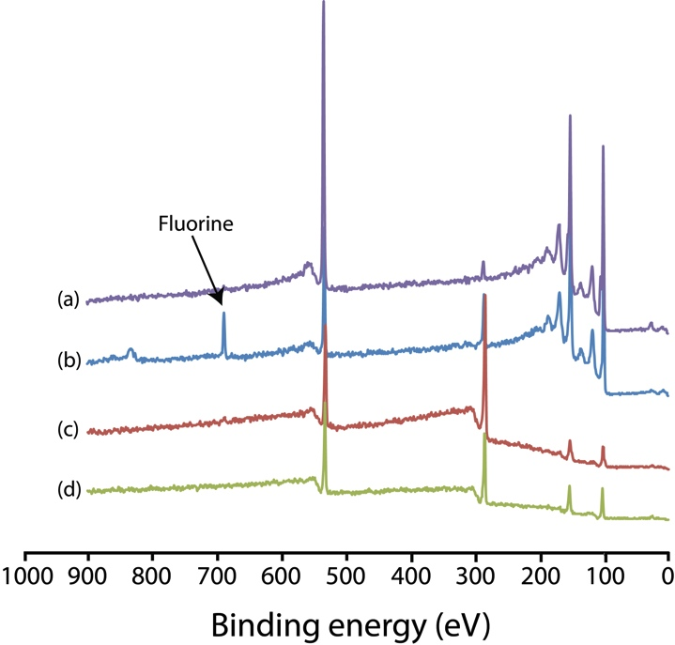

Figure 3. XPS survey spectrum of (a) pristine unmodified silicon surface, (b) trifluoroalkyne modified surface, (c) ethynylbenzylalcohol-modified surface and (d) 1:1 mixed modified surface. Note that the F1s was detectable only for trifluoroalkyne modified surface.

The C1s high-resolution spectra for the four samples revealed that Si-H reaction forming Si-C linkage occurred exclusively with the trifluoroalkyne functionalized samples. This is indicated by the broad peak at 293.3 eV as well as deconvoluted shoulder at 287.4 and 289.2 eV (Figure 4a) which were characteristics of the C-F_{x} bonds^{[20]}. The C-C, C-H species were assigned to the major peak centering at 285.3 eV. Instead, Si-C bonds expected around 283 eV could not be safely assigned although a gradual shouldering at 284-283 eV may suggest its presence, as reported previously^{[21]}.

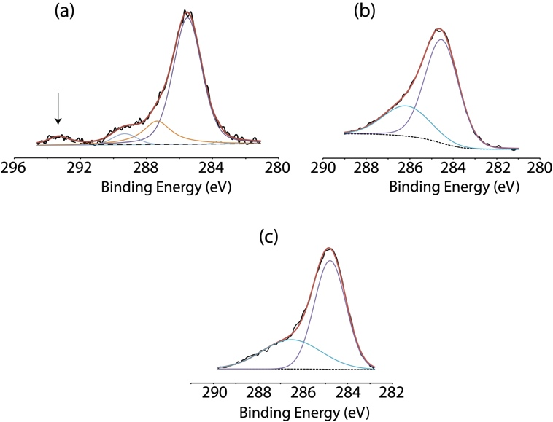

Figure 4. C1s spectra of (a) trifluoroalkyne-modified surface, (b) ethynylbenzylalcohol-modified surface and (c) 1:1 mixed-modified surface. Note that the CF₃ signal was noticeable only for trifluoroalkyne- modified surface but absence for the 1:1 mixed surface

On both the ethynylbenzylalcohol--modified and the 1:1 mixed samples, the C-C signal was shifted towards 284.6 eV and can be described as sp² C-C^{[22]} as well as sp² C-OR^{[23]}. This suggested that the interfacial aromatic carbon might be engaged in intermolecular interactions, which is not unperceivable if the layer is dense^{[13]}. Considering that Si-O-C was thought as the primary linkage to the surface and the carbon in this linkage is subsequently bonded to an aromatic ring, in principle substantial intermolecular interaction should occur due to the chain proximity^{[17]}. A broad peak at 286.3-286.7 eV was also deconvoluted in both samples and can be attributed to epoxy type linkage (C-O-R)^{[5, 24]}. This peak was attributed to sp² C-OR^{[23]} by Yamada et al. although we observed a slightly larger peak (FWHM = 2.3 eV for the alcohol modified surface, FWHM = 3.0 eV for the 1:1 mixed sample) compared to Yamada’s system (1.4 eV). At first glance, this might suggest that some unreacted alcohol may have physisorbed onto the surface. However the symmetry of the deconvoluted curve as well as the O1s analysis ruled out this hypothesis (see figure 6). An alternative explanation could be the various transition of C1s C-OR states derived from a close aromatic association and epoxides moieties^{[25]}.
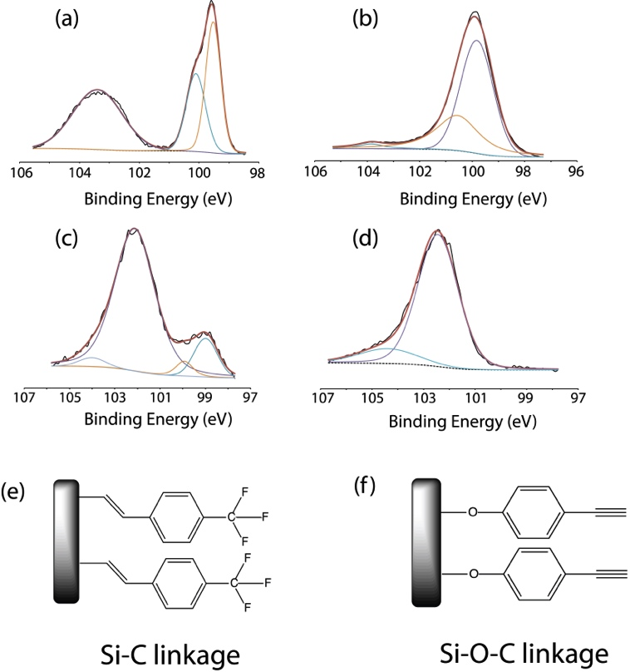
Figure 5. High-resolution Si2p spectra of (a) unmodified silicon (b) trifluoroalkynemodified surface, (c) ethynylbenzylalcohol-modified surface and (d) 1:1 mixed modified surface. (e) and (f) represent the respective chemical linkage on the surface

On the high-resolution Si2p spectra, for the unmodified silicon (Figure 5a), the elemental Si was observed at 99.5 eV (Si 2p_{3/2}) and 100.1 eV (Si 2p_{1/2}) respectively while a broad distribution observed at 103.7 eV was assigned to Si-O_{x} species^{[26]}. Upon thermal hydrosilylation, the Si-O_{x} band largely diminished on the trifluoroalkyne surfaces (Figure 5b) while we were able to deconvolute a broad peak at 100.5 eV, characteristic of the Si-C bond^{[27]}. The near absence of Si-O_{x} implies that most of the surfaces that were functionalized were relatively oxide-free. Subsequently, with the ethynylbenzylalcohol functionalization, both elemental Si peak intensities at 99.5 eV and 100 eV were reduced while an intense peak centered at 102.2 eV was observed (figure 5c). As Si-O_{x} was found to center at 103.7 eV. This shift to 102.2 eV was not attributed to the oxide and is instead the most important indicator for the formation of Si-O-C linkage^{[28]}. This confirmed that the Si-H reacted exclusively with the OH end of the ethynylbenzylalcohol rather than with the alkyne end. Interestingly, on the 1:1 mixed surface the elemental Si peaks were barely noticeable while the predominant peak centered at 102.3 eV was assigned to Si-O-C. This implies that the Si-H preferentially reacted with ethynylbenzylalcohol to form Si-O-C instead of the Si-C linkeage (absence of 100.5 eV) in the thermal setup.

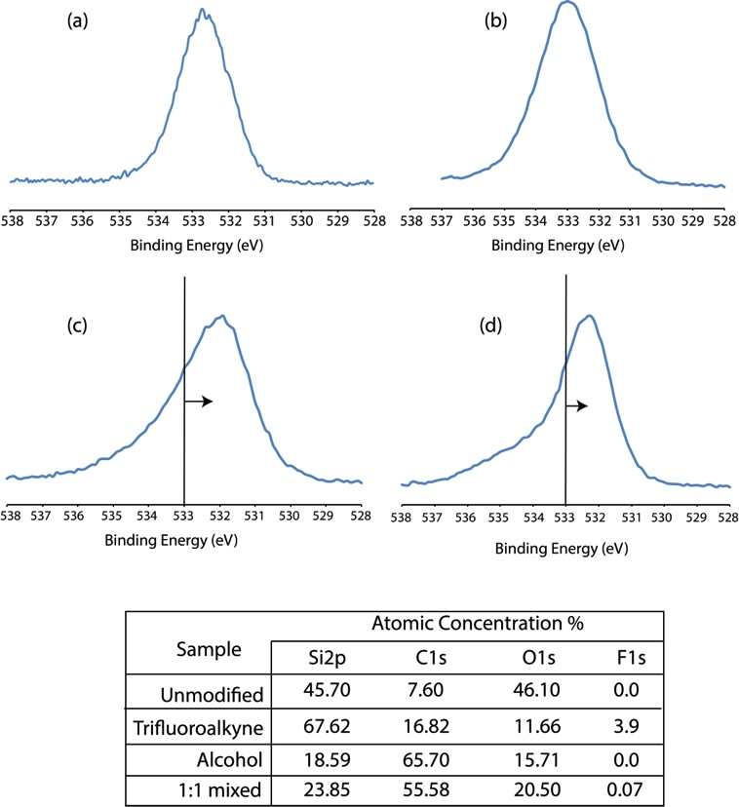

Figure 6. High-resolution O1s spectra of (a) unmodified silicon (b) trifluoroalkyne modified surface, (c) ethynylbenzylalcohol-modified surface and (d) 1:1 mixed modified surface. The vertical line displayed for (c) and (d) shows the shift from 533 eV. A table of the atomic concentration of the respective elements is also as shown.

High-resolution O1s XPS spectra were essential to determine the nature of the oxide on the surface and more significantly, to determine the nature of the interaction between the surface and the organic layer, i.e. whether the film was physisorbed or chemisorbed onto the surface. On the unmodified surface (Figure 6a), the primary peak was centered at 532.8 eV and this is indicative of the oxygen species in Si-O_{x}. In the trifluoroalkyne samples (Figure 6b), the similar peak at 532.8 eV revealed the subsequent oxidation of the unreacted Si-H surface. Instead, a shift of O1s to 532 eV and 532.3 eV was observed for the ethynylbenzylalcohol and the 1:1 mixed surface respectively (Figures 6c and 6d). These could be easily assigned to chemically bonded C-O species on the surface, as physisorbed C-O would give a higher O1s shift^{[29]}, corroborating the notion of the Si-O-C linkage on the surface.

Quantitative data were also considered, although it is difficult to derive useful information for the ethynylbenzylalcohol and 1:1 mixed sample due to the overlapping of oxygen XPS signals for both free oxide and Si-O_{x} moieties. In fact, the broad shouldering at 534 eV for both ethynylbenzylalcohol and 1:1 mixed samples may have arisen from the Si-O-Si back bonding. Nonetheless, important information that could be derived from the atomic concentration data was that, despite having overwhelming Si-O-C linkage in the mixed sample, trace amounts of fluorine (0.07%) on the surface could be detected. Interestingly, this indirectly helped to rule out physisorption as a higher amount of fluoride would be detected if this was the case. Although the 1:1 mixed sample showed less signs of reaction from the increment of the O1s, this little amount of trifluoroalkyne might be responsible for the higher sessile contact angle observed (108°). The mechanism by which trace amounts of trifluroalkyne on a surface mostly grafted by ethynylbenzylalcohol may lead to an increase of the hydrophobicity is not clear at this this time, and will be addressed in forthcoming investigations.

Modification of the first silicon layers

An issue deserving some additional analyses was the diminishing crystalline Si XPS signature. In principle, one cannot rule out the occurrence of physisorption on our surface, although the stringent cleaning process taken in place along with the previous quantitative analysis makes such an explanation quite fragile. Instead, silicon backbonding might be responsible for the thickening of the Si-O-Si layer at the interfacial area^{[30]}. Along the first oxidation steps is well recognized that oxygen insertion forms Si-O-Si linkages over a distance from the outer surface that may exceed 1 nm^{[30b, 31]}. From the observation of broad stretch that centered at 103.9 eV for both ethynylbenzylalcohol and the 1:1 sample, the possibility of oxygen-backbonded silicon atoms could be partially contemplated, considering that XPS sampling depth is ~1-3 nm in the setup. As the silicon oxidation rate (and the resulting thickness of the partially oxidized layer) increases with the polarization of the Si–Si bond induced by the oxygen atom covalently bonded to the surface, the oxidised layer is expected to be thicker upon Si-O-C bonding, as this would impart a greater polarity to the underlying Si–Si bonds than SiOH groups because of the mesomery enabled by the aromatic-linked carbon immediately adjacent to the oxygen atom.

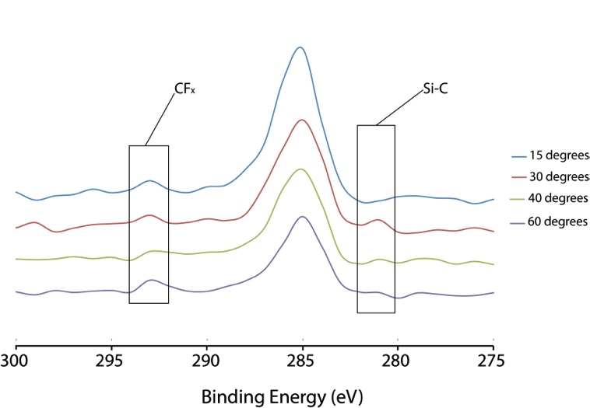
Figure 7. High-resolution ARXPS on trifluroalkyne surfaces showing the detectable Si-C linkage at 282.1 eV

To further address this issue, angle resolved XPS (ARXPS) were performed on the surfaces using angles between 15° and 60°. On the trifluoroalkyne samples, the upmost layer thickness was measured at ~1.5 nm, which was consistent to the modeled height of the molecule when grafted to the surface (figure 7). Furthermore, the Si-C signal at 282.1 eV could be easily resolved at 30° and 40° scan, as shown in figure 7. Instead, it was impossible to obtain any quantitative information for the ethynylbenzylalcohol grafting. ARXPS showed however that the thickness of the upmost layer exceeded the detection threshold of the instrument (~8 nm) and showed the co-presence of silicon in such a layer. Since we may now safely rule out that the ethynylbenzylalcohol had been physisorbed onto the surface, this leads to the conclusion that the pre-oxidation of the upmost silicon layer facilitated the roughening of the surface by easing its local etching.

4. Discussion

Based upon XPS and CA data, in the joint presences of both the alkyne and the alcohol functional groups, Si-H was found to preferentially react to the alcohol in our low temperature setup. A possible explanation for such preference is based on the kinetic model proposed by Horrocks et al. describing the reaction of Si-C formation as occurring via hydrogen abstraction by trace oxygen^{[32]}. In fact, based on the density functional calculations (DFT) simulations, the activation energy for the abstraction of hydrogen from Si-H by oxygen is 128-139 kJ mol⁻¹ while that from the cleavage of Si-H on its own is 330-350 kJ mol⁻¹. In the present case with trifluoroalkyne, it is reasonable to conjecture that the initiating oxygen atom could possibly come from trace oxygen, thus driving the alkyne ends from trifluoroalkyne towards the formation of the Si-C linkage. Hence trifluoroalkyne may rely only on residual oxygen species found in solution to accomplish the abstraction since at 130°C the probability of water reacting to the surface may be reasonably excluded. On the other hand, ethnylbenzylalcohol reactivity towards the Si-H surface is predominantly driven by nucleophilic attacks on the surface, resulting in the formation of the Si-O-C bonding. Furthermore, it is important to note that Mischki et al. examined the possibility of glass being a source of radicals for the initiation of thermal surface grafting and this may also be another contributing factor in both our grafting scenarios^{[33]}. This may be further examined in future undertaking of this work.
Conclusion
In summary, two different alkyne species were mixed and their reactivity onto the surface was compared. From this study, the presence of oxygen−containing species turns out to be the key factor in low temperature thermal setup to obtain high quality layers. Using a thermal reaction setup similar to hydrosilylation, we found that Si-H surface highly prefer to react with OH ends. Si-O-C linkage was found to be the preferential candidate for reaction and almost the entire surface was alkoxylated. Furthermore, we confirmed experimentally that Si-O-C linkage leads to denser layers. Considering the efficiency of Si-O-C on reacting to Si-H surface, this comparative study suggests how to obtain well-packed organic layers on silicon surfaces.

Surface grafting was initially intended for the formation of a mixed layer with different functionality that may exhibit interesting surface wettability properties. Although Si-H was found to preferentially react to the alcohol when compared to alkyne under low temperature conditions, we could observe that trace amounts of trifluoroalkyne in the mixed sample can remarkably raise the hydrophobicity of the film. Further analysis of such an effect will be the subject of future studies. Considering that bifunctional molecules are often required to generate functional monolayers, this study helps to describe further the underlying mechanism of thermal hydrosilylation.
Experimental Section
Materials
Boron-doped (111) silicon wafers, with resistivity of 0.01-0.018 Ω cm were used in this experiment. Sulfuric acid (Aldrich) and hydrogen peroxide (BDH Prolabo) were of semiconductor grade. 4-ethynylbenzyl alcohol and 4-Ethynyl-α,α,α-trifluorotoluene were purchased from Sigma-Aldrich. All other chemicals, unless differently stated, were used as received without further purification.

Thermal Reaction Protocol
Silicon wafers were cut into pieces (approximately 20 x 20 mm²) and cleaned for 30 min in hot Piranha solution (95°C, 1 vol 30% by mass aqueous hydrogen peroxide to 3 vol sulfuric acid). Surface was then transferred to an aqueous fluoride solution (2.5% hydrofluoric acid, 1.5 min). Subsequently, the samples were transferred to a solution of 4-Ethynyl-α,α,α-trifluorotoluene (0.3 M in Mesitylene) that was degassed through a minimum of 20 freeze-pump-thaw cycles. In doing this, extra care was taken to completely exclude air from the reaction vessel (a custom-made Schlenk flask). The sample was kept under a stream of nitrogen while the reaction vessel was immersed in an oil bath set to 140°C for 18 hours. The flask was then opened to the atmosphere and the functionalized surface sample was rinsed and sonicated in copious amounts of chloroform, ethyl acetate, and then ethanol before being analyzed.
For the 4-ethynylbenzyl alcohol-based layer, silicon surface was also functionalized in similar fashion and with the same molar concentration. Functionalized surface sample was rinsed consecutively with copious amounts of chloroform, ethyl acetate, and then ethanol before being analyzed.
Finally, in the third experiment a mixed solution of 0.3 M 4-ethynylbenzyl alcohol and 0.3 M 4-ethynyl-α,α,α-trifluorotoluene were co-solubilized in mesitylene and the solution underwent a minimum of 20 freeze-pump-thaw cycles to remove all oxygen. Subsequently, hydrogen-terminated surface was introduced quickly into the solution inside the reaction vessel and the reaction was set to 140 °C for 18 hours. Functionalized surface sample was rinsed consecutively with copious amounts of chloroform, ethyl acetate, and then ethanol before being analyzed.

Contact Angle Measurements
The water contact angle (CA) values were acquired on a Dataphysics OCA-20 goniometer setup at room temperature in ambient atmosphere. This instrument consists of a CCD video camera with a resolution of 768 × 576 pixel and could take up to 50 images per seconds. For each sessile droplet measurement three separate 5 μl droplets were dispensed onto the selected sample and the drop images were recorded. Advancing and receding contact angles (θ_{a} and θ_{r}) were also measured on both sides of the drop and on three different locations on the sample. All drop images were then processed by an image analysis that calculated both the left and right contact angles from the droplet shape with an accuracy of ± 0.1°.

X-ray photoelectron spectroscopy (XPS)

The XPS wide scan spectra were acquired using AXIS Ultra DLD, Kratos, equipped with an Al Kα X-ray source (1486.6 eV) at 10mA, 15kV, analyzing a 300 µm × 700 µm area under 3.9×10⁻⁹ Torr ultra vacuum environment inside sample analyze chamber. Analyses were performed in the hybrid lens mode with the slot aperture and the pass energy of the hemispherical analyzer was set at 160 eV for the survey scan. Spectra were also obtained for the C1s, F1s, Si2p and O1s in high resolution for all samples. The spectra were subsequently analyzed using vision software, which included with vision manager and vision processing.
Acknowledgements
Authors gratefully acknowledge the support given by Prof. Claudia Riccardi and Dr. Elisa Grimoldi through the PlasmaPrometeo Center, University of Milano Bicocca, for contact angle measurements.
Keywords: Hydrosilylation, silicon hydride, contact angle, alkynes
[1] a) M. H. Hu, S. Noda, T. Okubo, Y. Yamaguchi and H. Komiyama, Appl. Surf. Sci. 2001, 181, 307-316; b) R. P. Bagwe, L. R. Hilliard and W. H. Tan, Langmuir 2006, 22, 4357-4362; c) Y. L. Khung, G. Barritt and N. H. Voelcker, Exp. Cell. Res. 2008, 314, 789-800.
[2] E. L. Hanson, J. Schwartz, B. Nickel, N. Koch and M. F. Danisman, J. Am. Chem. Soc. 2003, 125, 16074-16080.
[3] A. Bansal, X. L. Li, I. Lauermann, N. S. Lewis, S. I. Yi and W. H. Weinberg, J. Am. Chem. Soc. 1996, 118, 7225-7226.
[4] M. R. Linford, P. Fenter, P. M. Eisenberger and C. E. D. Chidsey, J. Am. Chem. Soc. 1995, 117, 3145-3155.
[5] R. Boukherroub, S. Morin, F. Bensebaa and D. D. M. Wayner, Langmuir 1999, 15, 3831-3835.
[6] L. J. Webb, S. Rivillon, D. J. Michalak, Y. J. Chabal and N. S. Lewis, J. Phys. Chem. B 2006, 110, 7349-7356.
[7] X. Wang, R. E. Ruther, J. A. Streifer and R. J. Hamers, J. Am. Chem. Soc. 2010, 132, 4048-+.
[8] A. Ng, S. Ciampi, M. James, J. B. Harper and J. J. Gooding, Langmuir 2009, 25, 13934-13941.
[9] P. Thissen, O. Seitz and Y. J. Chabal, Prog. Surf. Sci. 2012, 87, 272-290.
[10] L. Scheres, M. Giesbers and H. Zuilhof, Langmuir 2010, 26, 4790-4795.
[11] a) Y. L. Zhong and S. L. Bernasek, J. Am. Chem. Soc. 2011, 133, 8118-8121; b) S. Ciampi, J. B. Harper and J. J. Gooding, Chem. Soc. Rev. 2010, 39, 2158-2183.
[12] a) G. Cleland, B. R. Horrocks and A. Houlton, J. Chem. Soc. Faraday Trans. 1995, 91, 4001-4003; b) D. J. Michalak, S. R. Amy, A. Esteve and Y. J. Chabal, J. Phys. Chem. C 2008, 112, 11907-11919; c) D. J. Michalak, S. R. Amy, D. Aureau, M. Dai, A. Esteve and Y. J. Chabal, Nat. Mater. 2010, 9, 266-271; d) R. Boukherroub, S. Morin, P. Sharpe, D. D. M. Wayner and P. Allongue, Langmuir 2000, 16, 7429-7434; e) C. A. Hacker, K. A. Anderson, L. J. Richter and C. A. Richter, Langmuir 2005, 21, 882-889.
[13] Y. Pei, J. Ma and Y. S. Jiang, Langmuir 2003, 19, 7652-7661.
[14] F. Effenberger, G. Gotz, B. Bidlingmaier and M. Wezstein, Angew. Chem. Int. Edit 1998, 37, 2462-2464.
[15] A. Hozumi, H. Taoda, T. Saito and N. Shirahata, J. Nanotech. Nanotech. 2009, 9, 455-460.
[16] a) J. P. Pillot, M. Birot, T. T. T. Tran, T. M. Dao, C. Belin, B. Desbat and S. Lazare, Langmuir 2005, 21, 3338-3343; b) A. Ulman, Chem. Rev. 1996, 96, 1533-1554.
[17] A. Ulman and R. P. Scaringe, Langmuir 1992, 8, 894-897.
[18] K. Tamada, T. Ishida, W. Knoll, H. Fukushima, R. Colorado, M. Graupe, O. E. Shmakova and T. R. Lee, Langmuir 2001, 17, 1913-1921.
[19] a) P. Gupta, A. Ulman, S. Fanfan, A. Korniakov and K. Loos, J. Am. Chem. Soc. 2005, 127, 4-5; b) A. B. Sieval, A. L. Demirel, J. W. M. Nissink, M. R. Linford, J. H. van der Maas, W. H. de Jeu, H. Zuilhof and E. J. R. Sudholter, Langmuir 1998, 14, 1759-1768.
[20] a) T. J. Chuang, H. F. Winters and J. W. Coburn, Appl. Surf. Sci. 1979, 2, 514-531; b) F. Pippig, S. Sarghini, A. Hollaender, S. Paulussen and H. Terryn, Surf. Interface Anal. 2009, 41, 421-429.
[21] A. Lavi, H. Cohen, T. Bendikov, A. Vilan and D. Cahen, Phys. Chem. Chem. Phys. 2011, 13, 1293-1296.
[22] a) S. Kwon, E.-S. Lee, H. Seo, K.-J. Jeon, C. C. Hwang, Y.-H. Kim and J. Y. Park, Surf. Sci. 2013, 612, 37-41; b) H. Yao, C.-C. Chu, H.-J. Sue and R. Nishimura, Carbon 2013, 53, 366-373.
[23] Y. Yamada, H. Yasuda, K. Murota, M. Nakamura, T. Sodesawa and S. Sato, J. Mater. Sci 2013, 48, 8171-8198.
[24] Y.-S. Wang, S.-Y. Yang, S.-M. Li, H.-W. Tien, S.-T. Hsiao, W.-H. Liao, C.-H. Liu, K.-H. Chang, C.-C. M. Ma and C.-C. Hu, Electrochim. Acta. 2013, 87, 261-269.
[25] V. Lee, L. Whittaker, C. Jaye, K. M. Baroudi, D. A. Fischer and S. Banerjee, Chem. Mater. 2009, 21, 3905-3916.
[26] a) F. J. Grunthaner, P. J. Grunthaner, R. P. Vasquez, B. F. Lewis, J. Maserjian and A. Madhukar, J. Vac. Sci. Technol., A 1979, 16, 1443-1453; b) C. H. deVilleneuve, J. Pinson, M. C. Bernard and P. Allongue, J. Phys. Chem. B 1997, 101, 2415-2420.
[27] a) F. J. Gomez, P. Prieto, E. Elizalde and J. Piqueras, Appl. Phys. Lett. 1996, 69, 773-775; b) Y. X. Wang, J. Wen, Z. Guo, Y. Q. Tang, H. G. Tang and J. X. Wu, Thin Solid Films 1999, 338, 93-99.
[28] a) A. Avila, I. Montero, L. Galan, J. M. Ripalda and R. Levy, J. Appl. Phys. 2001, 89, 212-216; b) N. Li, P. Hu, X. Zhang, Y. Liu and W. Han, Corros. Sci. 2013, 73, 44-53.
[29] a) C. Houtman and M. A. Barteau, Langmuir 1990, 6, 1558-1566; b) L. Kubler, E. K. Hlil, D. Bolmont and G. Gewinner, Surf. Sci. 1987, 183, 503-514.
[30] a) D. Graf, M. Grundner and R. Schulz, J. Vac. Sci. Technol., A 1989, 7, 808-813; b) H. N. Waltenburg and J. T. Yates, Chem. Rev. 1995, 95, 1589-1673.
[31] Y. Hijikata, H. Yaguchi, M. Yoshikawa and S. Yoshida, Appl. Surf. Sci. 2001, 184, 161-166.
[32] M. Woods, S. Carlsson, Q. Hong, S. N. Patole, L. H. Lie, A. Houlton and B. R. Horrocks, Journal of Physical Chemistry B 2005, 109, 24035-24045.
[33] T. K. Mischki, G. P. Lopinski and D. D. M. Wayner, Langmuir 2009, 25, 5626-5630.

Received: ((will be filled in by the editorial staff))
Revised: ((will be filled in by the editorial staff))
Published online: ((will be filled in by the editorial staff))

Entry for the Table of Contents (Please choose one layout only)

FULL PAPER
Text for Table of Contents, max. 450 characters.  ((The TOC Graphic should not exceed the size of this area)) |  | █ Subject Heading  Author(s), Corresponding Author(s)*  ■■ – ■■  Title

