Ethanol Extract of Hedyotis diffusa Willd affects immune responses in normal Blab/c mice in vivo

Yu-Yui Kuo¹, Jing-Pin Lin², Yung-Ting Hsiao³, Guan-Ling Chou³, Yu-Hsiang Tsai³, Su-Yin Chiang¹, Jaung-Geng Lin^{1,*}, and Jing-Gung Chung^{3,4,*}

¹Graduate Institute of Chinese Medicine, China Medical University, Taichung 413, Taiwan, R.O.C.
²School of Chinese Medicine, China Medical University, Taichung 413, Taiwan, R.O.C.
³Department of Biological Science and Technology, China Medical University, Taichung 413, Taiwan, R.O.C.
⁴Department of Biotechnology, Asia University, Taichung 413, Taiwan, R.O.C.

Running title: Ethanol extract of Hedyotis diffusa Willd affect immuno responses in normal mice

*Correspondence to:
Jing-Gung Chung, Department of Biological Science and Technology, China Medical University, No 91, Hsueh-Shih Road, Taichung 404, Taiwan. Tel: +886 4 2205 3366 ext 2531, Fax: +886 4 2205 3764, e-mail: jgchung@mail.cmu.edu.tw
Jaung-Geng Lin, Graduate Institute of Chinese Medicine, China Medical University, No 91, Hsueh-Shih Road, Taichung 40402, Taiwan. Tel: +886-4-22053366 ext 3113, Fax: +886-4-2205 3764, e-mail: jglin@mail.cmu.edu.tw

Key Words: Ethanol extract of Hedyotis diffusa Willd, normal Balb/c mice, phagocytosis, macrophage, Natural killer cells

Abstract. Numerous clinical anticancer drugs are obtained from natural plants and Hedyotis diffusa Willd has been used as a traditional Chinese medicine or as a major component in Traditional Chinese medicine formulas for a long time. Ethanol extract of Hedyotis diffusa Willd (EEHDW) have been shown possesses various biological activities including anticancer function in vitro. Our earlier studies have shown EEHDW affect immune responses in WEHI-3 generated leukemia mice, but EEHDW has not been reported affected on immune responses in a normal mouse model. Herein, we investigated if EEHDW could affect immune responses on normal murine cells in vivo. Normal BALB/c mice were treated by oral treatment with or without EEHDW at 0, 16, 32, and 64 mg/kg or 32 mg/kg by i.p. for 3 weeks then animals were weighted and blood, liver, spleen samples were collected for further experiments. Results indicated that EEHDW did not significantly affect body weight and liver weights (Fig. 1C and D) but significantly increased the spleen weight from i.p treatment when compared to control groups. Flow cytometric assay indicated that EEHDW promoted CD11b levels at 16, 32 and 64 mg/kg oral treatment, CD19 levels at 16, 32, 64 mg/kg oral treatment and i.p. treatment, and Mac-3 levels at 16, 32 and 64 mg/kg oral treatment, however, it did not significantly affected the levels of CD3. At 16 and 32 mg/kg of EEHDW by oral treatment were significantly decreased macrophage phagocytosis from PBMC but 32 mg/kg of EEHDW by i.p. treatment was significantly increased phagocytotic activity of macrophages which were obtain from peritoneal cavity. EEHDW at 32 mg/kg by i.p. treatment led to increase NK cell activities compared to oil control groups. EEHDW at 32 mg/kg of EEHDW by i.p. treatment increase B cell and T cell proliferation. Based on these observations, EEHDW seems to have promoted immune responses in this murine model.

Introduction

Cancer, one of the most serious clinical problems, is a major to cause major morbidity and mortality in worldwide. Most prevalent cancer such as melanoma, leukemia, hepatoma, lung carcinoma and breast cancer are the most challenging problems in clinical oncology. Leukemia derived from unregulated proliferation of immature blood cells such as mutant hematopoietic stem cell (1). Currently, the major treatment for patients with leukemia was chemotherapy; however, it is recognized to be a relatively low efficacy and high toxicity for the patient (2). Therefore, numerous studies focused on the natural products for treatment of human cancer including leukemia.

After antigen entry into human body then several white blood cells are involved to against these antigen through interact each other of these leukocytes (3). The major histocompatibility complex-1 (MHC-1) is also named as human leukocyte antigen-1 (HLA-1) that plays a central role in both adaptive and innate immunity (4). It was reported that some natural product can promoted immune responses (5). We also reported that some crude extract of natural plant can increased immune responses in normal or leukemia mice model (6-8). Herein, we also further investigation crude extract of natural plants for examining the effects of immune responses in vivo.
Traditional Chinese medicine (TCM) have been used to treat patients for long ago in Chinese population and now they have received attention based on low side effects as alternative remedies for several diseases (9-11). Hedyotis Diffusa Willd, a traditional Chinese folk medicine and widely distributed in northeast Asia, was used for heat-clearing, detoxification, promotion of blood circulation and removal of blood stasis (12). Some of TCM formulas prescriptions contain Hedyotis Diffusa Willd as a significant component to treat various types of cancer including breast and colon cancers (12-14). It was reported that Hedyotis Diffusa Willd induces apoptosis of human colon carcinoma cells and inhibit tumor angiogenesis in vitro (15, 16) and inhibits colorectal cancer growth in Vivo via inhibition of STAT3 signaling pathway (17). Furthermore, Hedyotis diffusa Willd inhibits colorectal cancer growth in vivo via inhibition of SHH-mediated tumor angiogenesis (18). WE found that ethanol extract of Hedyotis diffusa Willd upregulates G0/G1 phase arrest and induce apoptosis in human leukemia HL-60 cells by modulating caspase cascade signaling and altering associated genes expression (19).
Our primary studies, we also found that ethanol extract of Hedyotis diffusa Willd (EEHDW) affect immuno responses in leukemia mice in vivo (20), however, there is no available information to show the effect of EEHDW on the immune responses in normal mice. Therefore, in the present study, we investigated EEHDW affecting the immune responses of normal BALB/c mice in vivo and the results showed that EEHDW increases immune responses such as increased the macrophague phagocytosis and natural Killer cell activities in normal Balb/c mice.

Materials and Methods
Materials and reagents. Tissue culture plastic wares were obtained from BD Bioscience (San Jose, CA, USA). Isolated cells maintain were used RPMI-1640 medium, fetal bovine serum (FBS), L-glutamine and penicillin-streptomycin that were purchased from Gibco (Life Technologies, Carlsbad, CA, USA). Ethanol Extract of Hedyotis diffusa Willd (EEHDW) was kindly provided by Dr. Yu-Yui, Kuo (Department of Chinese Medicine, China Medical University, Taichung, Taiwan) and was dissolved in D.D. H₂O and kept at -20°C in a 50 ml tube covered with aluminum paper for avoiding light before use.

Male BALB/c mice. Sixty male Balb/c mice at an age of 4 week, weighing 22-25 g were obtained from the National Laboratory Animal Center (Taipei, Taiwan). All animals were housed in stainless steel mesh-bottomed cages which contained wooden chips and kept under specified pathogen-free conditions in the animal center of China Medical University (Taichung, Taiwan). Housing of the animals was standardized by 12 h : 12 h dark-light cycle (dark phase: 9.00 a.m.-9.00 p.m.) at a room temperature of 22 ± 2°C. Humidity was set at 50%. All mice were fed with clean water and normal nutrient food, the hygienic status which is monitored and international ethical guidelines according to the institutional guidelines (Affidavit of Approval of Animal Use Protocol) that have been reviewed and approved by the Institutional animal Care and Use Committee (IACUC) of China Medical University (Taichung, Taiwan) as described previously (20).

In vivo Treatment of animals with EEHDW. Sixty Balb/c mice were randomized into six groups (n=10). Group I mice received with normal diet as control. Group II was treated with olive oil by intra-gastric administration. Group III was treated with 16 mg/kg of EEHDW by intra-gastric administration. Group IV was treated with 32 mg/kg of EEHDW by intra-gastric administration. Group V was treated with 64 mg/kg of EEHDW by intra-gastric administration. Group VI was treated with 32 mg/kg of EEHDW by intraperitoneal (i.p.). All animals were treated for 27 days. After 27 days all mice were weighed and sacrificed by euthanasia with CO₂ as described previously (20).

Immunofluorescence staining of cell’s surface markers. After the treatment, all mice were individually weighed, and then blood, liver and spleen were individually collected. Splenocytes were isolated from each spleen of each mouse to measure cytotoxic activity of Natural killer cells as described previously (21). Leukocytes’ cell markers were measured from each blood sample from each mouse as described previously (21). In briefly, 1 ml blood sample was lysed with 1×Pharm Lyse™ lysing buffer (BD Biosciences Pharmingen Inc., San Diego, CA, USA) for destroying the red blood cells and then were centrifuged at 1500 ×g for 15 min at 4°C to collect white blood cells. Isolated leukocytes were stained by PE-labeled anti-mouse CD3 and CD19, FITC-labeled anti-mouse CD11b and Mac-3 antibodies (BD Biosciences Pharmingen Inc., San Diego, CA, USA) for 30 min and then were stained with secondary antibody then were analyzed by flow cytometry (Becton-Dickinson, San Jose, CA, USA) as previously described (20).

Measurements of macrophages’ phagocytosis. After treatment, the macrophages from each mouse of each group were isolated from PBMC and peritoneum as described previously (21, 22). Isolated cells were placed in the 96-well plates and added 50 μl of Escherichia coli-FITC based on the PHAGOTEST® kit manufacturer's instructions (Orpegen, Heidelberg, Germany) and then were analyzed by flow cytometery. The percentage of phagocytosis were further quantified by CellQuest software (BD Biosciences Pharmingen Inc., San Diego, CA, USA) as described previously (20, 21).

Measurements of Natural killer (NK) cell cytotoxic activity. Isolated splenocytes (1×10⁵ cells/well) were placed 15 ml tube containing 1 ml of RPMI-1640 medium. YAC-1 cells (2.5×10⁷ cells) in serum-free RPMI 1640 medium and the PKH-67/Dil.C buffer (Sigma-Aldrich Corp.) were added to the cells and then mixed thoroughly for 2 min at 25°C. And then 2 ml PBS was added to tube for 1 min, 4 ml medium was added to the well and incubation for 10 min and then cells were centrifuged at 1200 rpm for 2 min at 25°C. And then NK cell cytotoxic activity was assayed by flow cytometry as described elsewhere (20, 21).

Measurements of T and B cell proliferation. Isolated splenocytes (1×10⁵ cells/well) were placed in 96-well plated and 100μl of RPMI-1640 medium was added to the well. Concanavalin A (Con A, 5 μg/ml) and lipopolysaccharide (LPS, 5 μg/ml) were separately added to the cells to stimulate for 3 days for T and B cell proliferation assay, respectively. All samples were assayed by using CellTiter 96 AQueous One Solution Cell Proliferation Assay kit (Promega, Madison, WI, USA) as previously described (20, 21).

Statistical analysis. All data were presented as the means ± standard deviation (S.D.) of values of three independent experiments. Comparisons between control and EEHDW-treated groups were analyzed by Student’s t-test. A probability of 0.05 or less was considered statistically significant.

Results
EEHDW affected the body, liver and spleen weights of normal Balb/c mice. During experimental periods, mice each 2 days were individually weighted and monitored. The representative animal, liver and spleen pictures are present in Figure 1A and B. The body, liver and spleen weights are showing in Figure 1C, D and E. These results indicated that EEHDW did not significantly affect body weight and liver weights (Fig. 1C and D) but significantly increased the spleen weight from i.p treatment when compared with the without EEHDW-treated mice as shown in Figure 1E, however, all other does of EEHDW treated groups did not show significant affects.

EEHDW affected cells markers of white blood cells from normal Balb/c mice. At the end of incubation, blood samples were collected from each mouse and then to measure the levels of cell markers CD3, CD11b, CD19 and Mac-3 by using flow cytometer. The results are shown in Figure 2A, B, C and D. Results indicated that EEHDW promoted CD11b (Fig. 2B) levels at 16, 32 and 64 mg/kg oral treatment, CD19 (Fig. 2C) levels at 16, 32 and 64 mg/kg oral treatment and 32 mg/kg i.p. treatment, and Mac-3 (Fig. 2D) levels at 16, 32 and 64 mg/kg oral treatment, however, it did not significantly affected the levels of CD3 (Fig. 2A).

EEHDW affected macrophages phagocytosis from PBMC and peritoneal cavity of normal BALB/c mice. At the end of treatment, cells were isolated from PBMC and peritoneal cavity of each animal and then to measure the levels of phagocytosis by using flow cytometer. Results are showed in Figure 3. EEHDW treatment at all oral treatment group did not significantly affected macrophage phagocytosis from peritoneal cavity, but only significantly increased at 32 mg/kg of EEHDW by i.p. treatment. EEHDW treatment at all 16 and 32 mg/kg oral treatment group significantly increased macrophage phagocytosis from PBMC.

EEHDW affected the cytotoxic activity of natural killer cells from normal BALB/c mice. In order to investigate EEHDW affected the activities of NK cell activities, isolated splenocytes were incubated with YAC-1 targets cells and then were assayed by flow cytometer. Results are shown in Figure 4, which indicated that EEHDW by i.p. treated cells were higher NK cell activities compared to control groups.

EEHDW affected T and B cell proliferation from normal BALB/c mice. In order to investigate the effects of EEHDW on T and B cell proliferation, isolated splenocytes were pretreated with Con A or LPS then were assayed and results were shown in Figure 5A and B which indicated that EEHDW treatment decreased T (Fig. 5B) cell proliferation at oral treatment. However, B cell proliferation except at 16 mg/kg of oral treatment and 32 mg/kg of EEHDW i.p. treatment increase B cell proliferation and other doses did not significant affects (Fig. 5A).

Discussion
It is well documented that many clinical used anticancer drugs are obtained from natural plants such as paclitaxel from Taxus brevifolia, vinblastine (from Catharanthus roseus), and camptothectin from Camptotheca acuminata) (22). Recently, investigators are investigated more extract of natural plants based on traditional used in patients since lone ago for using as alternative and complementary medications for cancer therapy (23). EEHDW have been used as traditional Chinese herbal medicine since long ago and our earlier studies have been shown that EEHDW suppressed the cell proliferation of A549, H1355, HL-60, WEHI-3, and B16F10 cells as well as reduced cell viability in a concentration-dependent manner. We also found that EEHDW triggered an arrest of HL-60 cells at G0/G1 phase and induced sub-G1 population (apoptotic cells) in Hl-60 cells (19). Although, we have shown that EEHDW affect immune resposes on WEHI-3 induced leukemia mice in vivo (19), however, there is no available and reliable data literature regarding the effects of EEHDW on normal human patients or normal animal model in vivo. Thus, in the present study, we investigated the effects of EEHDW on immune responses from normal Blab/c mice in vivo.
Normal animals were treated with or without EEHDW at various doses for 27 days and results indicated that EEHDW at all doses was not significant affect the body, liver and spleen weights when compared to untreated groups of mice (Fig. 1). Thus, in this study in short time treatment indicated EEHDW did not induced cytotoxic effects on normal animals. This is in agreement with our earlier studies have shown that EEHDW extract no significant effect on body weight but it significantly reduced the weights of spleen and liver in WEHI-3 leukemic mice (19).
Results from Figure 2A, B, C and D indicated that EEHDW promoted CD19 (Fig. 2B) levels at oral treatment group, CD11b (Fig. 2C) levels at oral treatment group and i.p. treatment group, and Mac-3 (Fig. 2D) levels at oral treatment group, however, it did not significantly affected the levels of CD3 (Fig. 2A). These findings need further investigations. However, it is slightly difference from our earlier studies in WEHI-3 leukemia mice that indicated EEHDW increased the percentage of CD11b cell surface marker (monocytes) and it reduced the percentage of CD3 (T-cell) and CD19 (B-cell) markers, but did not affect the level of Mac-3 (19).
T cells also play an important for against foreign antigen such as T cytotoxic cells but T helper cells also can promote B cell for producing antibody to attached antigen (24). Furthermore, macrophage can inhibited intracellular bacterial growth and it also can through phagocytosis to destroy the infection in vivo (25). This is in agreement with our earlier studies indicated that EEHDW was not influence on phagocytosis by macrophages from peripheral blood mononuclear cells and the peritoneal cavity in leukemic mice (19).
For further confirm whether or not EEHDW affect the activities of NK cell activities, YAC-1 targets cells were added to the isolated splenocytes then were incubated and then were assayed by flow cytometer and results indicated that EEHDW treated cells were lower NK cell activities compared to control groups. Figure 5A and B which indicated that EEHDW treatment decreased T (Fig. 5B) and B (Fig. 5A) cell proliferation. However, our earlier studies indicated that isolated splenocytes from EEHDW extract-treated leukemic mice demonstrated an increase of T- and B-cell proliferation at i.p. treatment in vivo (19).
In conclusion, in the present study indicated that the ethanol extract of Hedyotis diffusa Willd (EEHDW) did not significant change the body, liver and spleen weights in normal Bla/c mice in vivo. Leukocytes populations assay indicated that EEHDW promoted cellular population CD19 (B cells), increased CD11b (monocytes) and Mac-3 (macrophague) but did not significant affect CD3 (T cells) population in normal mice. Furthermore, EEHDW did not increased macrophague phagocytosis and NK cell activies in BALB/c mice in vivo.

Acknowledgement
This work was supported by grant CMU102-ASIA-20 from China Medical University, Taichung, Taiwan.

References
1 Alabsi AM, Ali R, Ideris A, Omar AR, Bejo MH, Yusoff K and Ali AM: Anti-leukemic activity of Newcastle disease virus strains AF2240 and V4-UPM in murine myelomonocytic leukemia in vivo. Leuk Res 36: 634-645, 2012.
2 Lee SJ, Kim KH, Park JS, Jung JW, Kim YH, Kim SK, Kim WS, Goh HG, Kim SH, Yoo JS, Kim DW and Kim KP: Comparative analysis of cell surface proteins in chronic and acute leukemia cell lines. Biochem Biophys Res Commun 357: 620-626, 2007.
3 Li X, Chen W, Liu G, Lu W and Fu J: Continuous-flow microfluidic blood cell sorting for unprocessed whole blood using surface-micromachined microfiltration membranes. Lab Chip 14: 2565-2575, 2014.
4 Flanary S, Hoffman AS and Stayton PS: Antigen delivery with poly(propylacrylic acid) conjugation enhances MHC-1 presentation and T-cell activation. Bioconjug Chem 20: 241-248, 2009.
5 Rajput N, Naeem M, Ali S, Zhang JF, Zhang L and Wang T: The effect of dietary supplementation with the natural carotenoids curcumin and lutein on broiler pigmentation and immunity. Poult Sci 92: 1177-1185, 2013.
6 Huang AC, Cheng HY, Lin TS, Chen WH, Lin JH, Lin JJ, Lu CC, Chiang JH, Hsu SC, Wu PP, Huang YP and Chung JG: Epigallocatechin gallate (EGCG), influences a murine WEHI-3 leukemia model in vivo through enhancing phagocytosis of macrophages and populations of T- and B-cells. In Vivo 27: 627-634, 2013.
7 Chang YH, Yang JS, Yang JL, Wu CL, Chang SJ, Lu KW, Lin JJ, Hsia TC, Lin YT, Ho CC, Wood WG and Chung JG: Ganoderma lucidum extracts inhibited leukemia WEHI-3 cells in BALB/c mice and promoted an immune response in vivo. Biosci Biotechnol Biochem 73: 2589-2594, 2009.
8 Lin CC, Lin JJ, Wu PP, Lu CC, Chiang JH, Kuo CL, Ji BC, Lee MH, Huang AC and Chung JG: Wogonin, a natural and biologically-active flavonoid, influences a murine WEHI-3 leukemia model in vivo through enhancing populations of T- and B-cells. In Vivo 27: 733-738, 2013.
9 Zhao J, Jiang P and Zhang W: Molecular networks for the study of TCM pharmacology. Brief Bioinform 11: 417-430, 2010.
10 Ji HF, Li XJ and Zhang HY: Natural products and drug discovery. Can thousands of years of ancient medical knowledge lead us to new and powerful drug combinations in the fight against cancer and dementia? EMBO Rep 10: 194-200, 2009.
11 Gordaliza M: Natural products as leads to anticancer drugs. Clin Transl Oncol 9: 767-776, 2007.
12 Lin M, Lin J, Wei L, Xu W, Hong Z, Cai Q, Peng J and Zhu D: Hedyotis diffusa Willd extract inhibits HT-29 cell proliferation via cell cycle arrest. Exp Ther Med 4: 307-310, 2012.
13 Yang J-J, Hsu H-Y, Ho Y-H and Lin C-C: Comparative study on the immunocompetent activity of three different kinds of Peh-Hue-Juwa-Chi-Cao, Hedyotis diffusa, H. corymbosa and Mollugo pentaphylla after sublethal whole body x-irradiation. Phytother Res 11: 428-432, 1997.
14 Dong Q, Ling B, Gao B, Maley J, Sammynaiken R and Yang J: Hedyotis diffusa water extract diminished the cytotoxic effects of chemotherapy drugs against human breast cancer MCF7 cells. Nat Prod Commun 9: 699-700, 2014.
15 Lin J, Chen Y, Wei L, Chen X, Xu W, Hong Z, Sferra TJ and Peng J: Hedyotis Diffusa Willd extract induces apoptosis via activation of the mitochondrion-dependent pathway in human colon carcinoma cells. Int J Oncol 37: 1331-1338, 2010.
16 Lin J, Wei L, Xu W, Hong Z, Liu X and Peng J: Effect of Hedyotis Diffusa Willd extract on tumor angiogenesis. Mol Med Rep 4: 1283-1288, 2011.
17 Cai Q, Lin J, Wei L, Zhang L, Wang L, Zhan Y, Zeng J, Xu W, Shen A, Hong Z and Peng J: Hedyotis diffusa Willd Inhibits Colorectal Cancer Growth in Vivo via Inhibition of STAT3 Signaling Pathway. Int J Mol Sci 13: 6117-6128, 2012.
18 Lin J, Wei L, Shen A, Cai Q, Xu W, Li H, Zhan Y, Hong Z and Peng J: Hedyotis diffusa Willd extract suppresses Sonic hedgehog signaling leading to the inhibition of colorectal cancer angiogenesis. Int J Oncol 42: 651-656, 2013.
19 Kuo YJ, Yang JS, Lu CC, Chiang SY, Lin JG and Chung JG: Ethanol extract of Hedyotis diffusa willd upregulates G0/G1 phase arrest and induces apoptosis in human leukemia cells by modulating caspase cascade signaling and altering associated genes expression was assayed by cDNA microarray. Environ Toxicol 2014.
20 Lin CC, Kuo CL, Lee MH, Hsu SC, Huang AC, Tang NY, Lin JP, Yang JS, Lu CC, Chiang JH, Chueh FS and Chung JG: Extract of Hedyotis diffusa Willd influences murine leukemia WEHI-3 cells in vivo as well as promoting T- and B-cell proliferation in leukemic mice. In Vivo 25: 633-640, 2011.
21 Lin JJ, Lu KW, Ma YS, Tang NY, Wu PP, Wu CC, Lu HF, Lin JG and Chung JG: Alpha-phellandrene, a natural active monoterpene, influences a murine WEHI-3 leukemia model in vivo by enhancing macrophague phagocytosis and natural killer cell activity. In Vivo 28: 583-588, 2014.
22 Hsu HF, Huang KH, Lu KJ, Chiou SJ, Yen JH, Chang CC and Houng JY: Typhonium blumei extract inhibits proliferation of human lung adenocarcinoma A549 cells via induction of cell cycle arrest and apoptosis. J Ethnopharmacol 135: 492-500, 2011.
23 Cassileth BR: Alternative and Complementary Cancer Treatments. Oncologist 1: 173-179, 1996.
24 Kaye J, Gillis S, Mizel SB, Shevach EM, Malek TR, Dinarello CA, Lachman LB and Janeway CA, Jr.: Growth of a cloned helper T cell line induced by a monoclonal antibody specific for the antigen receptor: interleukin 1 is required for the expression of receptors for interleukin 2. J Immunol 133: 1339-1345, 1984.
25 Horwitz MA: Cell-mediated immunity in Legionnaires' disease. J Clin Invest 71: 1686-1697, 1983.

Figure legends

Figure 1. EEHDW affect the body, liver and spleen weights of normal Balb/c mice. All mice were randomly divided into 6 groups, Group I was treated with normal diet. Group II was treated with olive oil. Group III was treated with 16 mg/kg of EEHDW. Group IV was treated with 32 mg/kg of EEHDW. Group V was treated with 64 mg/kg of EEHDW. Group VI was treated with 32 mg/kg of EEHDW by i.p. All animals were treated for 27 days. The representative pictures of animal (A), liver and spleen (B), body (C), liver (D) and spleen (E) weights are presented. The total body weights were measured every 2 days.

Figure 2. EEHDW affected the levels of cell markers in white blood cells from normal Balb/c mice. EEHDW-treated and -untreated animal were sacrificed then were collected blood samples and then were analyzed for cell markers (A: CD3; B: CD11b; C: CD19; D: Mac-3) by flow cytometry as described in Materials and Methods. The data are expressed as the mean±S.D. of three experiments (n=10). *p<0.05 Significant difference between Group II and EEHDW-treated groups.

Figure 3. EEHDW affected macrophages’ phagocytosis from PBMC and peritoneal cavity of normal Balb/c mice. EEHDW-treated and -untreated animals were individually collected blood samples and then macrophages were isolated from PBMC and peritoneum of each mouse. Isolated macrophages were assayed phagocytosis by flow cytometery and quantified by CellQuest as described in Materials and Methods. *p<0.05 Significant difference between Group II and EEHDW-treated groups.

Figure 4. EEHDW affected the cytotoxic activity of natural killer cells in normal Balb/c mice. Isolated splenocytes (1×10⁵cells/well) from each animal were placed in 1 ml of RPMI-1640 medium in 96-well plates. Target YAC-1 cells (2.5×10⁷ cells) and the PKH-67/Dil.C buffer was added to the cells for the measurement of the NK cell cytotoxic activity by flow cytometry as described in Materials and Methods. *p<0.05 Significant difference between Group II and EEHDW-treated groups.

Figure 5. EEHDW affected T and B cell proliferation in normal Balb/c mice. Isolated B cells were pretreated with LPS and cell proliferation was analyzed by flow cytometer (A). T cells were pretreated with Con A then cell proliferation was analyzed by flow cytometer (B) as described in Materials and Methods. *p<0.05 Significant difference between Group II and EEHDW -treated groups.

Figure 1.
A
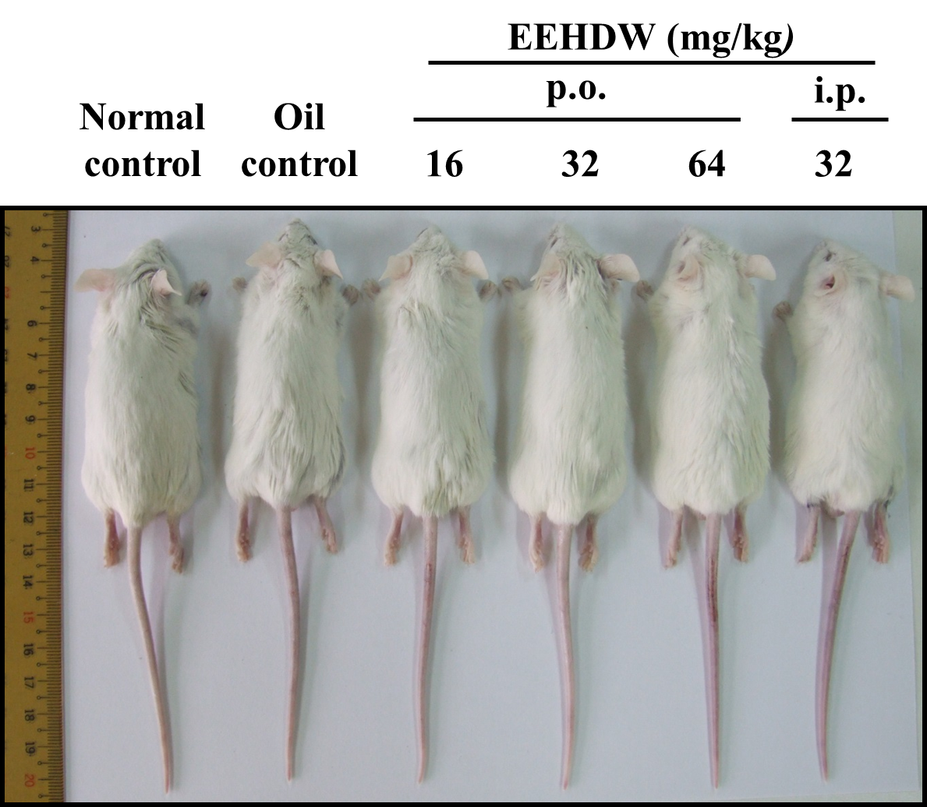
B
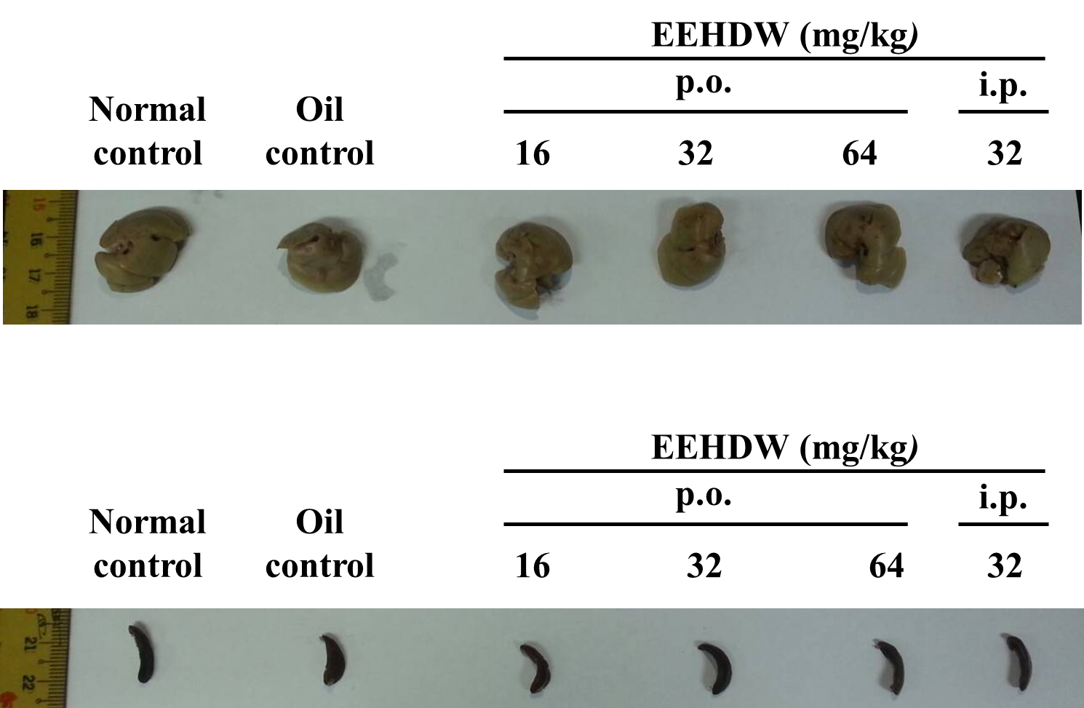
C
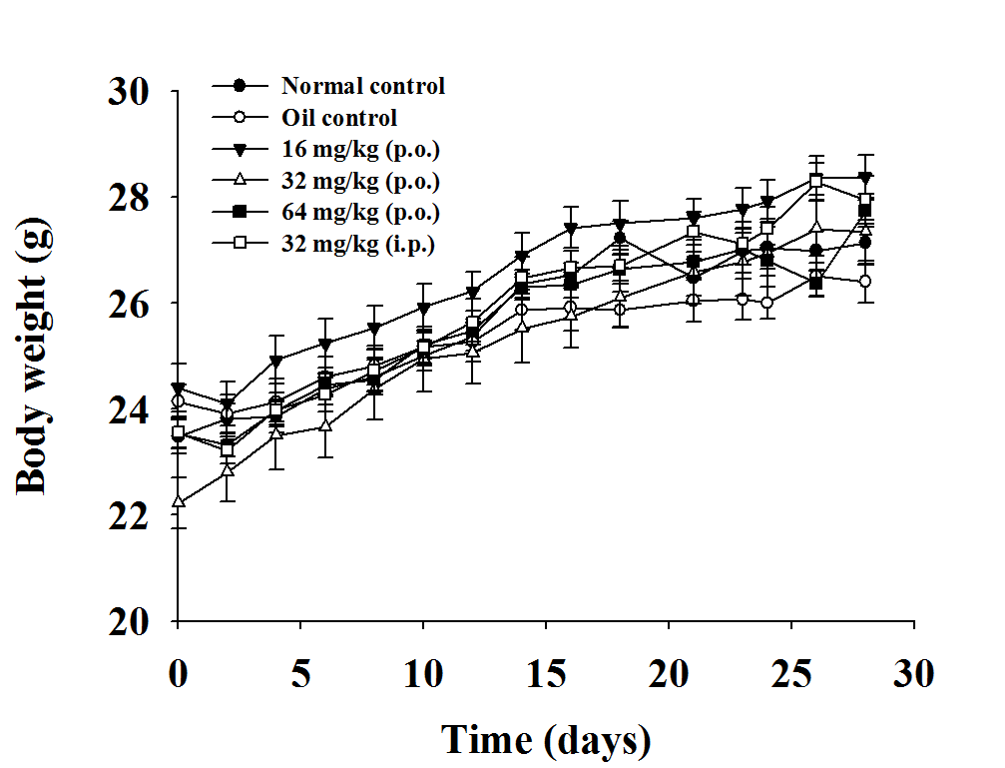
D
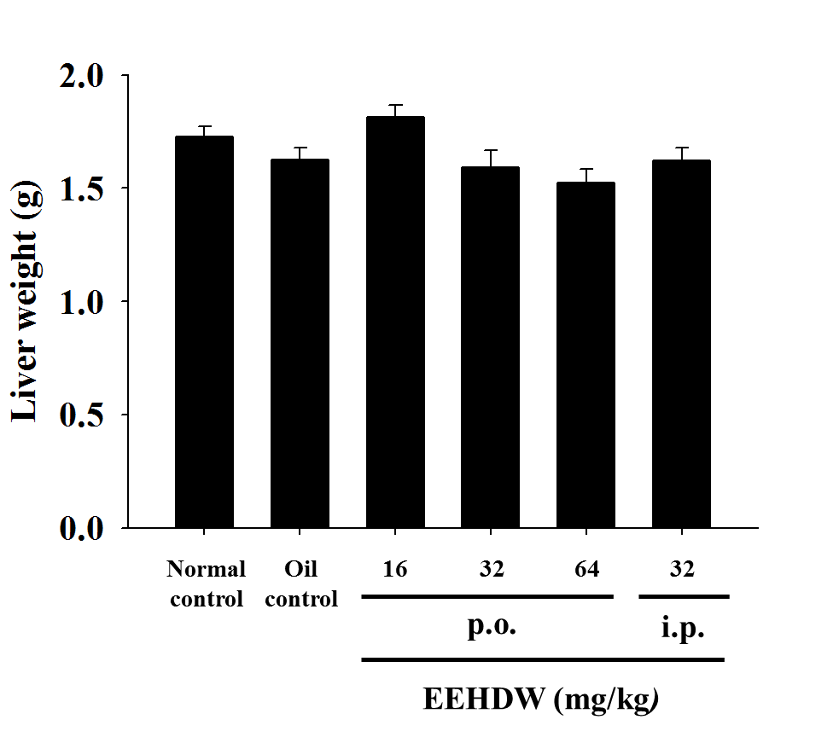
E
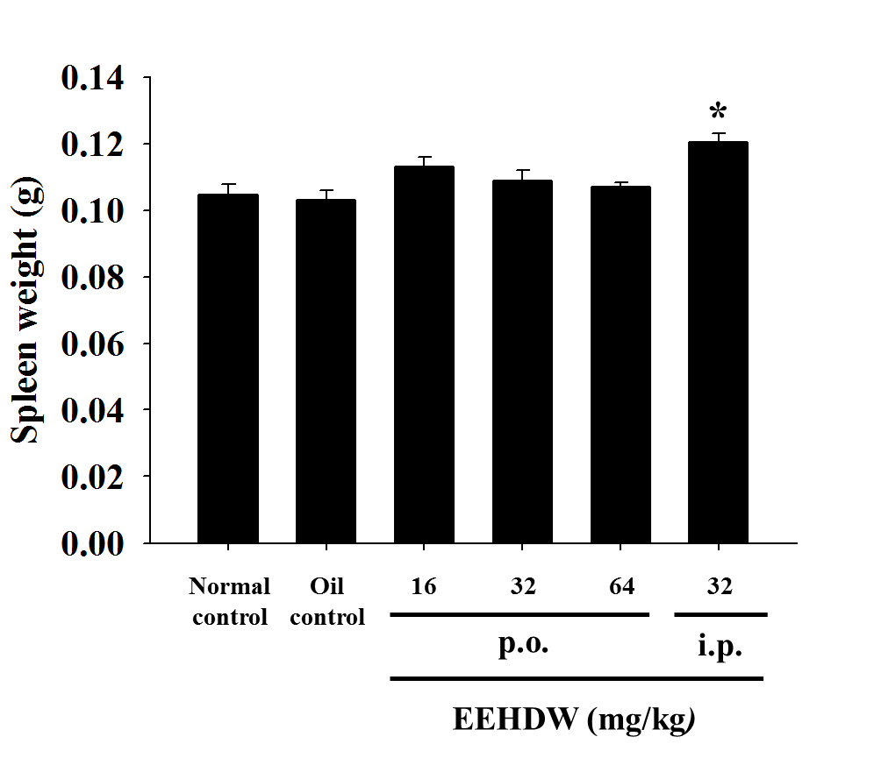
Figure 2.
A
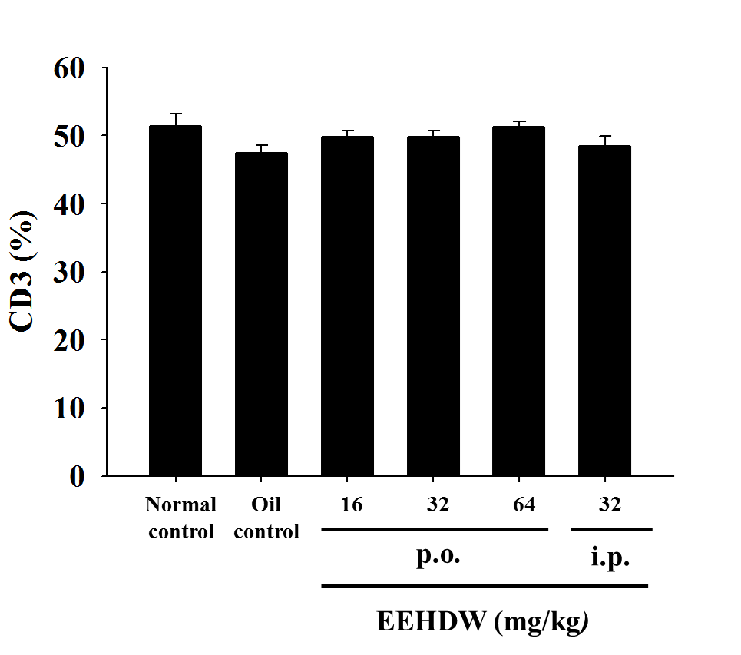
B
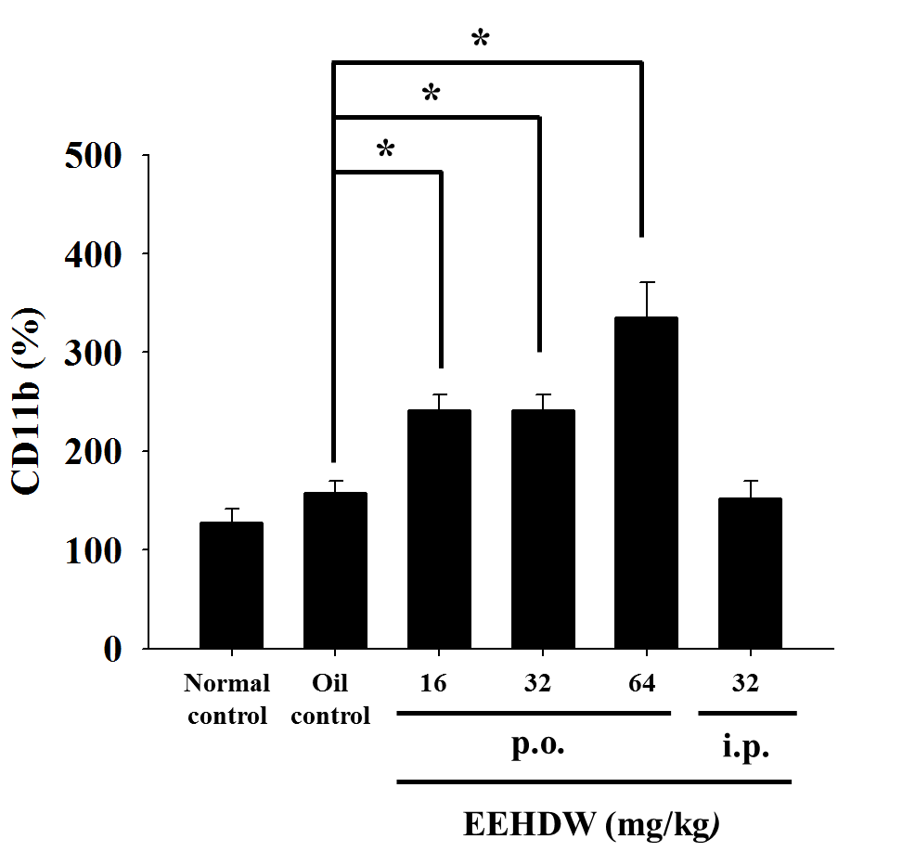
C
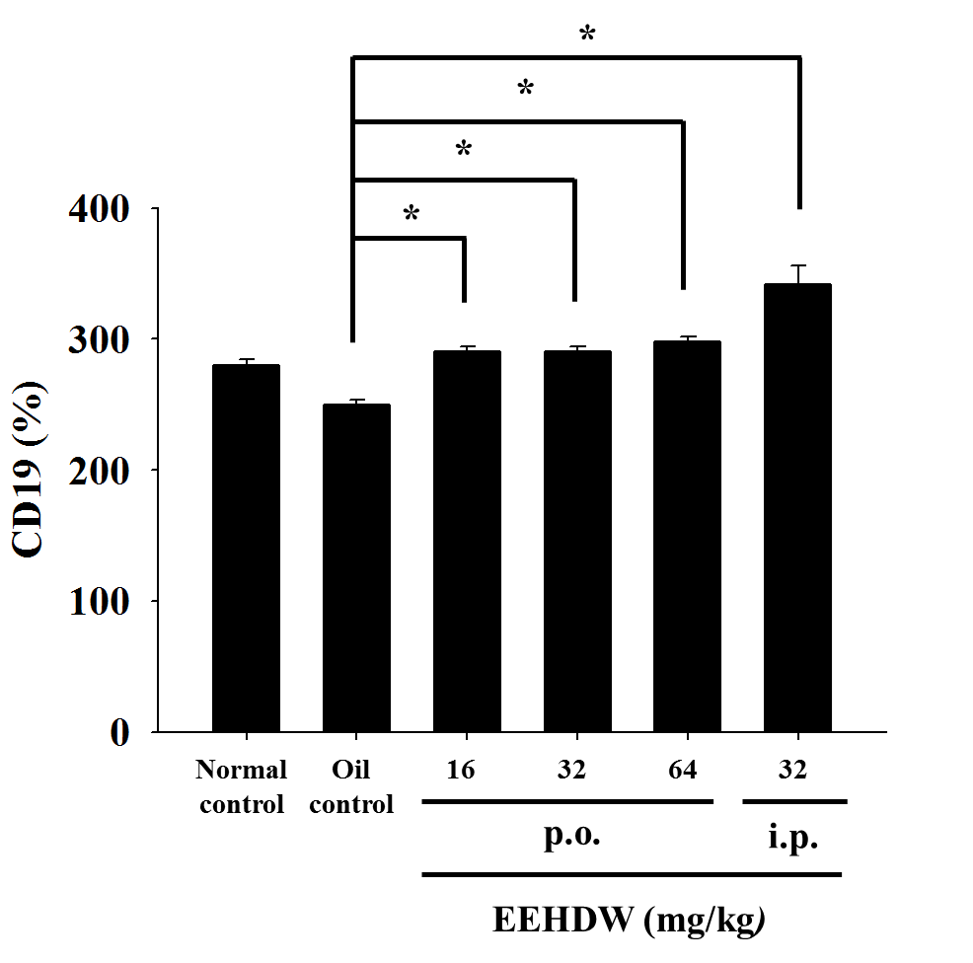
D
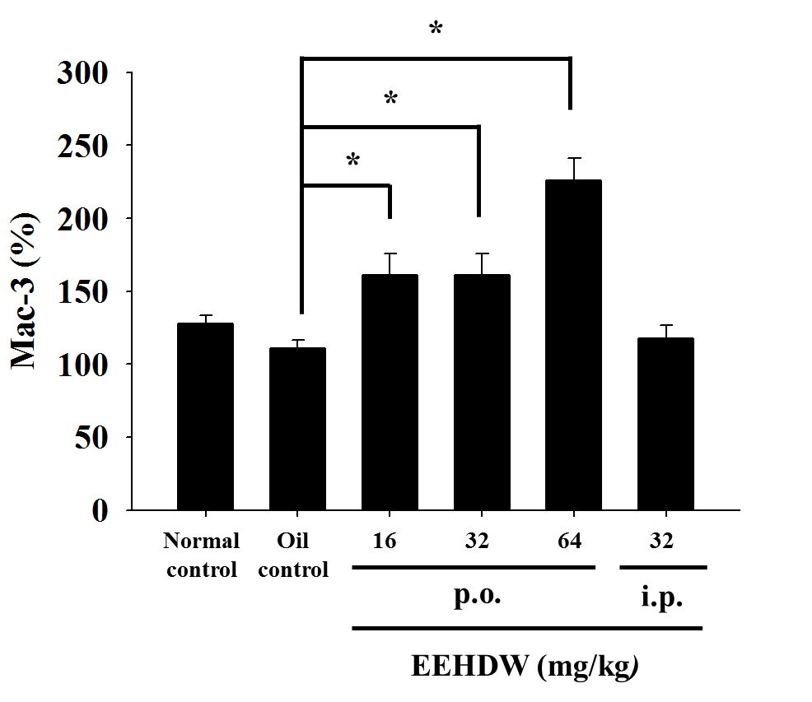
Figure 3
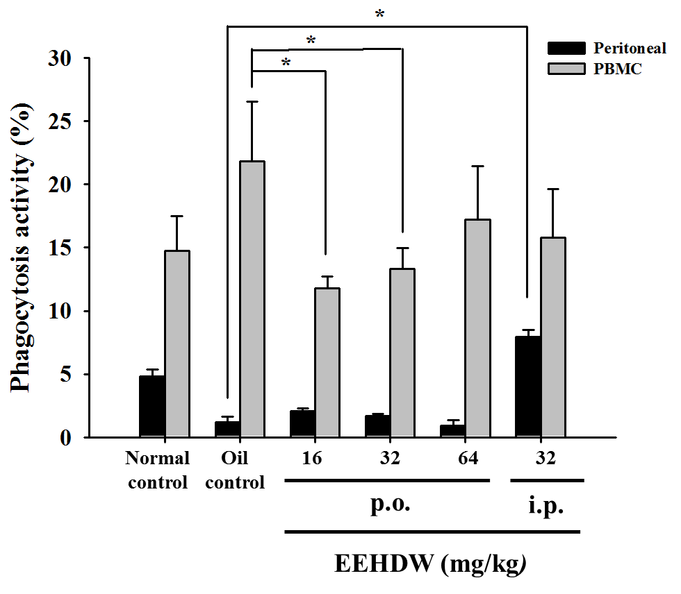

Figure 4
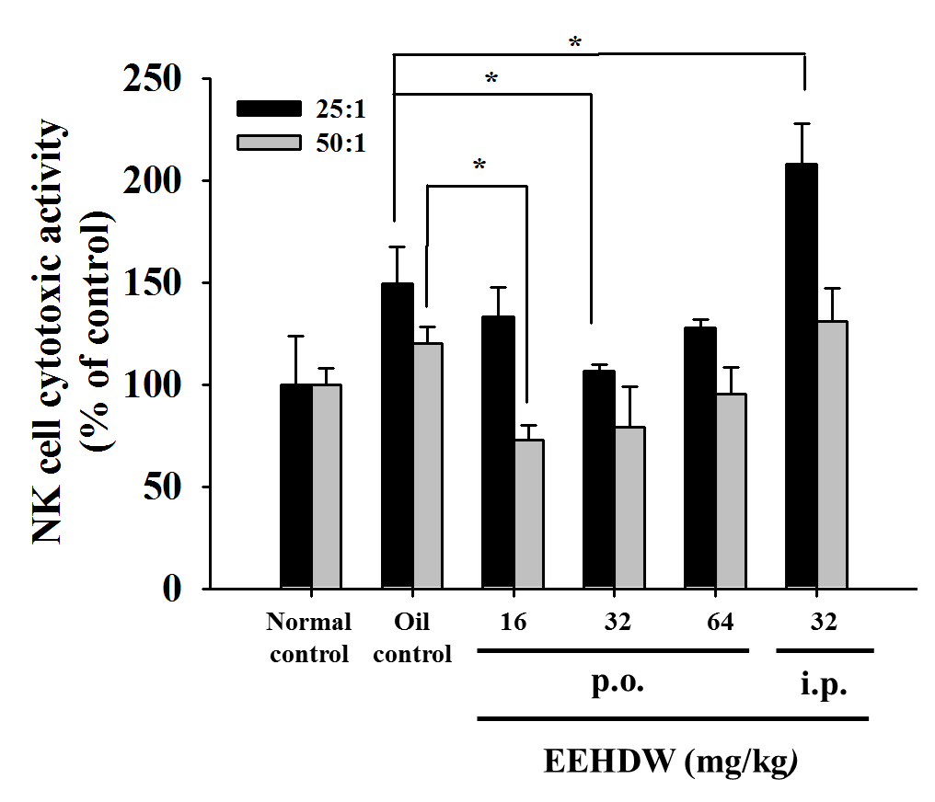
Figure 5
A
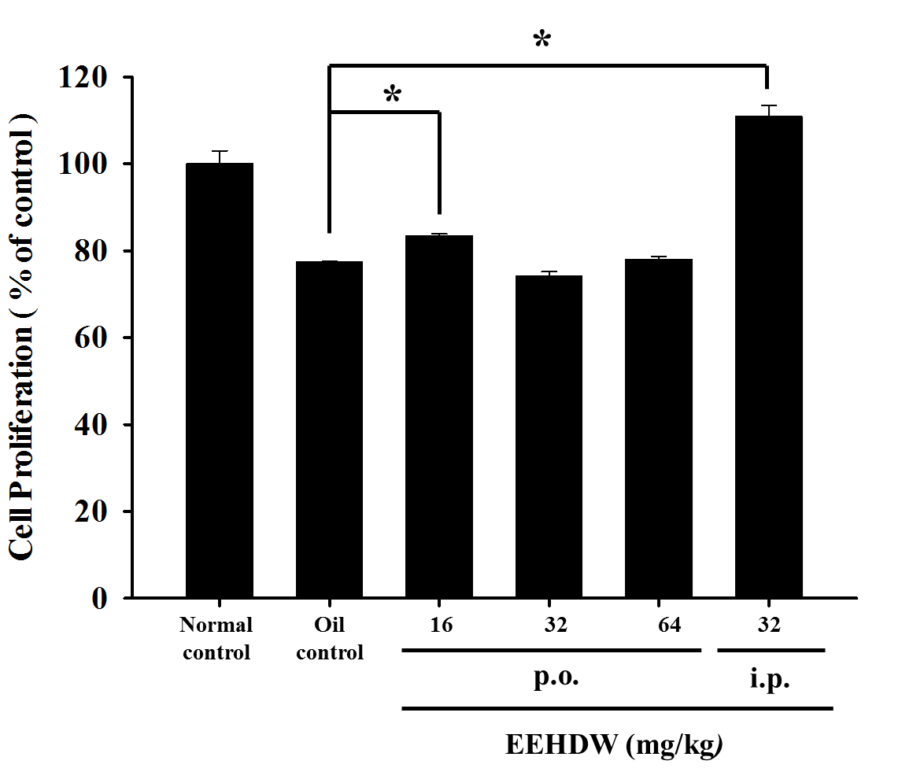
B
