Demethoxycurcumin induces DNA damage and inhibits DNA repair associated protein expressions in NCI-H460 human lung cancer cells

Yang-Ching Ko¹, Jin-Cherng Lien², Hsin-Chung Liu³, Shu-Chun Hsu³, Hui-Yi Lin⁴, Fu-Shin Chueh⁵, Bin-Chuan Ji⁶, Mei-Due Yang⁷, Wu-Huei Hsu^{1,8,*} and Jing-Gung Chung^{3,9,*}

¹Graduate Institute of Clinical Medical Science, China Medical University, Taichung, Taiwan
²Graduate Institute of Pharmaceutical Chemistry, China Medical University, Taichung, Taiwan
³Department of Biological Science and Technology, China Medical University, Taichung, Taiwan
⁴School of Health and Nutrition Biotechnology, Asia University, Taichung, Taiwan
⁵Department of Health and Nutrition Biotechnology, Asia University, Taichung, Taiwan
⁶Division of Chest Medicine, Department of Internal Medicine, Changhua Christian Hospital, Changhua, Taiwan
⁷Department of Surgery, China Medical University Hospital, Taichung, Taiwan
⁸Department of Internal Medicine, China Medical University Hospital, Taichung, Taiwan
⁹Department of Biotechnology, Asia University, Wu feng, Taichung, Taiwan

Running title: Demethoxycurcumin (DMC) induced DNA damage and repair in NCI-H460 cells

*Correspondence to:
Jing-Gung Chung, Ph. D., Department of Biological Science and Technology, China Medical University. No 91, Hsueh-Shih Road, Taichung 404, Taiwan. Tel.: +886-4-2205-3366 ext 2531; Fax: +886-4-2205-3764. E-mail: jgchung@mail.cmu.edu.tw
Wu-Huei Hsu, Department of Internal Medicine, China Medical University, Taichung,
No 91, Hsueh-Shih Road, Taichung 404, Taiwan. Taiwan. Tel: +886-422053366 ext. 3483, Fax: +886-422038883. E-mail: hsuwh@mail.cmuh.org.tw

Abstract. Demethoxycurcumin (DMC) is a key component of a Chinese medicine (Turmeric) and has been proven effective in killing various cancer cells. Its role in inducing cytotoxic effects in many cancer cells have been reported, but none have studied induced DNA damage action in lung cancer cells in detail. In this study, we demonstrated DMC-induced DNA damage and condensation in NCI-H460 cells by using Comet assay and DAPI staining examinations, respectively. Western blotting indicated that DMC suppressed the protein levels associated with DNA damage and repair, such as 14-3-3σ (an important checkpoint keeper of DDR), DNA repair proteins breast cancer 1, early onset (BRCA1), O6-methylguanine-DNA methyltransferase (MGMT), mediator of DNA damage checkpoint 1 (MDC1), and p53 (tumor suppressor protein). DMC could activate phosphorylated p53 and p-H2A.X (phospho Ser140) in NCI-H460 cells. Furthermore, we used confocal laser systems microscopy to examine the protein translocation. The results show that DMC promote the translocation of p-p53 and p-H2A.X (phospho Ser140) from cytosol to nuclei in NCI-H460 cells. Taken together, DMC induced DNA damage and affect DNA repair proteins in NCI-H460 cells in vitro.

Keywords: Demethoxycurcumin (DMC); DNA damage, comet assay, DAPI staining, human lung cancer NCI-H460 cells.
Introduction
Lung cancer has been recognized the second most common cancer in both genders and the leading cause of cancer death. Non-small cell lung carcinoma (NSCLC) is responsible for 80% of lung cancer cases and is the leading causes of cancer-related death worldwide with a 5-year survival rate of only 16% (1). NSCLC is relatively insensitive to chemotherapy, thus, the outcome of standard platinum-based chemotherapies remains disappointing (1, 2). Thus, it is important to develop and identify new strategies for NSCLC treatment.
Recently, natural herbals and phytochemicals are becoming aware of great interest as complementary and/or alternatives therapies in psychiatric medicine (3). Curcuminoids, the major natural phenolic compounds, are present in the rhizome of turmeric (Curcuma longa Linn.) (4), contains curcumin (Cur, 75−80%), demethoxycurcumin (DMC, 15−20%), and bisdemethoxycurcumin (BDMC, 3−5%), respectively (5, 6). It is well documented that curcumin have biological activities act as antioxidant, anti-inflammatory and anticancer properties (7-9). Currently, DMC also have similar biological functions such as anti-oxidative (10), anti-inflammatory (11), anti-cancer (12), and anti-angiogenesis (13) activities. DMC have been shown to induce cytotoxic effects in many cancer cells (14-16). Recently, curcumin have been shown clinical benefits in human chronic diseases including osteoarthritis, rheumatoid arthritis, and type II diabetes (17).
Induction of DNA damage and inhibition of DNA repair system by DMC in human lung cancer cells have not been reported, and also no available information to show associated molecular mechanisms of DMC. Thus, we selected the major types of non-small cell lung carcinoma such as NCI-H460 cells for examining the cytotoxic effects of DMC on NCI-H460 cells and we found that DMC induced DNA damage and inhibit DNA damage repair associated protein in vitro.

Materials and Methods
Chemicals and reagents. Demethoxycurcumin (DMC), dimethyl sulfoxide (DMSO), propidium iodide (PI), Trypsin-EDTA, anti-p-ATM, anti-p53, anti-p-p53, anti-DNA-PK and anti-MGMT were purchased from Sigma Chemical. (St. Louis, MO, USA). Anti-DNA-PK was purchased from Calbiochem (San Diego, CA, USA). Anti-14-3-3σ was purchased from Merck and anti-p-ATR was purchased from Cell Signaling (Danvers, MA, USA). Fetal bovine serum (FBS), culture medium RPMI-1640, L-glutamine and penicillin-streptomycin were purchased from GIBCO®/Invitrogen Life Technologies (Carlsbad, California, USA).

Cell culture. The human non-small lung cancer cell line (NCI-H460) was purchased from the Food Industry Research and Development Institute (Hsinchu, Taiwan). Cells were cultured in RPMI-1640 medium supplemented with 10% FBS, 100 U/ml penicillin, 100 μg/ml streptomycin, and 2 mM glutamines at 37°C in a 75 cm² tissue culture flask in a 5% CO₂ humidified incubators. Cells were passaged by 0.25% trypsin−EDTA when they reached ∼80% confluence.

Cellular viability. Cell viability was determined by flow cytometer assay as reported previously (18). NCI-H460 cells (1 × 10⁵ cells) were seeded on the 24 well cell culture cluster overnight. Cells (5x105 cells/well) were placed in 12 well plate for 24 h then treated with DMC different ranging from 0 to 35 μM for 48 h. Cells were collected, washed and stained with PI (5 μg/ml) in phosphate-buffered saline (PBS) and followed by flow cytometry (Becton-Dickinson, San Jose, CA, USA) performed to measure the total percentage of viable cells as described previously (18).

Comet assay (Single cell gel electrophoresis) for DNA damage measurement. NCI-H460 cells (2 x 10⁵ cells/well) were seeded on 12-well plates for 24 h and then were incubated with 0, 15, 25 and 35 μM of DMC or 0.5% H₂O₂ as a positive control for 48 h. After incubation, aliquots of 10⁵ cells were isolated to measure cell DNA damage by using Comet assay as described previously (19). Comets of cells on slides acquired DNA damage by the CometScoreTM Freeware analysis (TriTek Corporation, Sumerduck, VA, USA) (19) for Comet tail lengths, calculated and quantified.

4',6-diamidino-2-phenylindole dihydrochloride (DAPI) staining for DNA condension examination. NCI-H460 cells (2 x 10⁵ cells/well) were seeded on 12 well plate for 24 h then were incubated with DMC (0, 15, 20, 25, 30 and 35 μM) for 48 h. After incubation, cells were fixed with 3.7% formaldehyde in PBS for 10 min and then were followed by using DAPI staining. After staining, cells were examined and photographed by using a fluorescence microscope at 400 x as previously described (19).

Western blotting for examining protein expressions. NCI-H460 cells (1 x 10⁶ cells/well) were seeded onto a 100 mm tissue culture dish containing 10% FBS. Cells were then treated with 0, and 35 μM of DMC for 6, 24 and 48 h. After treatment, cells were harvested and suspended in sodium dodecyl sulfate (SDS) sample buffer, sonicated, and boiled for 10 min as described previously (19). After brief centrifugation, equivalent amounts of isolated proteins from the soluble fractions of cell lysates from each treatment were electrophoresed by 10% sodium dodecyl sulfate-polyacrylamide gel (SDS-PAGE) and were transferred to nitrocellulose membrane, and immunoblotted as described previously (19). The transfer membrane was stained by primary antibodies (anti-14-3-3σ, MGMT, BRCA1, MDC1, p53, p-p53, and p-H2A.X) at 4 °C then were washed and stained by secondary antibody. And then membranes were visualized with a chemiluminescent detection system and the protein expressions were measured as described by the manufacturer (19).

Confocal laser microscopy for examining protein translocation. NCI-H460 cells (5 × 10⁴ cells/well) were placed on 4-well chamber slides and were incubated with 35 μM of DMC for 48 h. Cells were rinsed and fixed in 4% formaldehyde in PBS for 15 min. A 0.3% Triton-X 100 in PBS was used to permeable cells. Cells were washed with PBS and blocking with 5% BSA in PBS for 20 min and were stained with primary anti-p-H2A.X and anti-p-p53 (green fluorescence) overnight. Cells were washed and stained with secondary antibody (FITC-conjugated goat anti-mouse IgG). Nuclein was stained by using PI (red fluorescence). All samples were mounted and photomicrograph by using a Leica TCS SP2 Confocal Spectral Microscope as described previously (20, 21).

Statistical analysis. The results are expressed as the mean ± standard deviation (S.D.) from 3 independent experiments. The comparisons between DMC-treated and untreated groups were performed by Student’s t-test. P values <0.05 were considered to be significant.

Results
Effects of DMC on the total viability of NCI-H460 cells. NCI-H460 cells were treated with DMC (0, 15, 20, 25, 30 and 35 μM) for 48 h. Cells were harvested for measuring the percentage of viable cells by flow cytometric assay and results are shown in Fig. 1. The results indicated that the percentages of viable cells were decreased significantly after treatment with DMC except the lode dose (15μM) and these effects are dose dependently (Fig. 1).

Effects of DMC on DNA damage of NCI-H460 cells. Cells were treated with DMC (0, 15, 25 and 35μM) and 0.5% H₂O₂ for 48 h and then were harvested for single cell electrophoresis (Comet assay) and results are presented in Figures 2A and B. Results indicate that DMC at 3 doses induced comet lengths increased when compared with control in NCI-H460 cells. Positive control (0.5% H₂O₂) treatment clearly induced comet tail production. These results indicated that DMC induced DNA damage in NCI-H460 cells.

Effects of DMC on DNA condension of NCI-H460 cells. We further confirmed the induction of cell death whether or not via DNA condension by DMC in NCI-H460 cells. DAPI staining was used for examining the formation of DNA condension and results are shown in Figures 3A and B. Results indicated that DMC induced DNA condension in NCI-H460 cells and these effects are dose-dependent manners.

Effects of DMC on DNA damage associated proteins of NCI-H460 cells. Cells were treated with 35μM of DMC for 0, 6, 24 and 48 h and then DNA damage associated protein such as 14-3-3σ, MGMT, BRCA1, MDC1, p53, p-p53 and p-H2A.X that were examined by Western blotting and results are shown in Fig. 4. The results indicated that DMC decreased the proteins levels of 14-3-3σ, MGMT, BRCA1, MDC1, and p53 but increased p-p53 and p-H2A.X in NCI-H460 cells. And these effects are time-dependently

DMC affect the translocation of p-p53 and p-H2A.X in NCI-H460 cells. In order to investigate whether or not DMC affect DNA damage associated protein translocation in NCI-H460 cells, cells were exposed to 35μM of DMC then were examined by confocal microscopy and results are shown in Figure 5. Which indicated that DMC promoted the p-p53 (Fig. 5A) and p-H2A.X (Fig. 5B) trans to nuclei when compared to control groups. These observations indicated that DMC induced DNA damage and repair that may also involve p-p53 (Fig. 5A) and p-H2A.X (Fig. 5B) translocation from cytoplasm into nuclei in NCI-H460 cells.

Discussion
Although numerous evidences have shown that DMC induced cytotoxic effects through induction of cell cycle arrest and apoptosis in many human cancer cells, but there is no report to show DMC induced DNA damage and affect associated protein expression in human cancer cells. Therefore, we selected NCI-H460 cells to exposed various doses of DMC then to investigate the effects of DMC on cell viability. We found that 1) DMC decreased the percentage of viable cells in a concentration-dependent manner (Fig. 1); 2) a concentration-dependent increase in DNA damage and condension was observed in NCI-H460 cells after exposed to DMC, which was assayed by Comet assay and DAPI staining, respectively (Figs. 2 and 3); 3) DMC decreased the proteins levels of 14-3-3σ, MGMT, BRCA1, MDC1, and p53 but increased p-p53 and p-H2A.X in NCI-H460 cells. And these effects are time-dependently; 4) DMC induced DNA damage and repair that may also involve p-p53 (Fig. 5A) and p-H2A.X (Fig. 5B) translocation from cytoplasm into nuclei in NCI-H460 cells.
Based on the results from Figures 2 and 3 indicated that DMC induced DNA damage and condension in NCI-H460 cells that were measured by Comet assay and DAPI staining, respectively. Comet assay (single cell gel electrophoresis) is a well-documented method for measuring DNA damage (21, 22) based on the comet tails were observed, and the longer the comet tail mean and the higher DNA damage (Fig. 2). Reports have been shown that during the process of excision repair of DNA, comet assay can be used to measure the trend-break formation (20, 23).
In normal or cancer cells, after exposed to agents or chemical that led to DNA damage in cells, cells can used their DNA repair system for the cells to survival via eliminating DNA lesions or added new DNA based (20, 23). Therefore, recently, a new type of anti-neoplastic therapy is to manipulation of DDR (24-26). Thus, DDR inhibition has been proven effective treatment for cancer. In the present study, our finding is the first one to provide the information regarding DMC induced DNA damage and affect repair system in NCI-H460 cells (Figures 2 and 3). Figure 4 indicated that DMC suppressed DNA damage and repair associated protein expression such as 14-3-3σ, O6-methylguanine-DNA methyltransferase (MGMT), breast cancer 1, and early onset (BRCA1), mediator of DNA damage checkpoint 1 (MDC1), and tumor suppressor protein p53 but promoted the levels of p-p53 and p-H2A.X in examined NCI-H460 cells.
Results from Figure 4 have shown that DMC decreased the protein levels of MDC1 and MGMT. It was reported that cells after affected by agent led to DNA damage then ATM will phosphorylates MDC1 and to oligomerize MDC1 (27). Oligomerized MDC1 accumulate can facilitate the activation of ATM and other DDR-related proteins at that special location. Thus, it was reported that MDC1 is defective then many downstream DDR functions of ATM are impaired (28). It was reported that DNA damage can be developed after cells were exposed to agents (environmental pollutants, carcinogens and anticancer drugs) to forming O6 methylguanine. MGMT is a DNA repair enzyme to eliminate O6 methylguanines (29). It was reported that MGMT inhibition as a mean of increasing tumor susceptibility to chemotherapy (30).
Results from Figure 4 also shown that DMC suppressed the protein levels of 14-3-3σ and BRCA1 in NCI-H460 cells. One of the cell cycle checkpoints is controlled by 14-3-3σ, which is activated after DNA damage and can led to G2 phase arrest (31). Several checkpoint inhibitors are currently under investigation for their anticancer potentials (32) and 14-3-3σ have been suggested as an effective therapeutic target (33). BRCA-1 plays an important role in DNA repair, cell cycle checkpoint control and maintenance of genomic stability in breast and ovarian cancer (34), furthermore, BRCA-1 promoter methylation was found to be positively associated with increased mortality in breast cancer patients (35). Result from western blotting (Fig. 4) also shown that DMC increased p-p53 and p-H2A.X in NCI-H460 cells. We also further confirm them by using confocal laser microscopy to show DMC promotes the translocation of p-p53 and p-H2A.X from cytoplasm to nuclei (Fig. 5). H2A.X play a critical for the efficient accumulation of DNA repair factors at the DNA break site and H2A.X deficient mice will have higher radiosensitivity (36, 37).
Based on these observations, we propose possible mechanisms underlying DMC-induced DNA damage and inhibited DNA repair proteins in NCI-H460 cells in Figure 6. In the present study, our finding regarding DMC induced DNA damage and affect associated protein expression were limited by its in vitro design. In the future, studies including animal model is needed to confirm DMC’s function in vivo.

Acknowledgement
This work was supported by grant CMU102-ASIA-20 from China Medical University, Taichung, Taiwan. Experiments and data analysis were performed in part through the use of the Medical Research Core Facilities Center, Office of Research & Development at China medical University, Taichung, Taiwan, R.O.C.

Author Contributions

Conceived and designed the experiments: Y.-C.K., W.-H.H., J.-G.C. Performed the experiments: J.-C.L., H.-C.L. Analyzed the data: H.-C.L., S.-C.H., F.-S.C. Contributed reagents/materials/analysis tools: B.-C.J, M.-D.Y. Wrote the paper: Y.-C.K., J.-G.C.

Conflicts of Interest
The authors declare no conflict of interest.
References
1 Chemotherapy in non-small cell lung cancer: a meta-analysis using updated data on individual patients from 52 randomised clinical trials. Non-small Cell Lung Cancer Collaborative Group. BMJ 311: 899-909, 1995.
2 Siegel R, Naishadham D and Jemal A: Cancer statistics, 2013. CA Cancer J Clin 63: 11-30, 2013.
3 Chiappedi M and Bejor M: Herbals and natural dietary supplements in psychiatric practice. Recent Pat CNS Drug Discov 5: 164-171, 2010.
4 Wright LE, Frye JB, Timmermann BN and Funk JL: Protection of trabecular bone in ovariectomized rats by turmeric (Curcuma longa L.) is dependent on extract composition. J Agric Food Chem 58: 9498-9504, 2010.
5 Jayaprakasha GK, Jagan Mohan Rao L and Sakariah KK: Improved HPLC method for the determination of curcumin, demethoxycurcumin, and bisdemethoxycurcumin. J Agric Food Chem 50: 3668-3672, 2002.
6 Shieh JM, Chen YC, Lin YC, Lin JN, Chen WC, Chen YY, Ho CT and Way TD: Demethoxycurcumin inhibits energy metabolic and oncogenic signaling pathways through AMPK activation in triple-negative breast cancer cells. J Agric Food Chem 61: 6366-6375, 2013.
7 Tizabi Y, Hurley LL, Qualls Z and Akinfiresoye L: Relevance of the Anti-Inflammatory Properties of Curcumin in Neurodegenerative Diseases and Depression. Molecules 19: 20864-20879, 2014.
8 Priyadarsini KI, Maity DK, Naik GH, Kumar MS, Unnikrishnan MK, Satav JG and Mohan H: Role of phenolic O-H and methylene hydrogen on the free radical reactions and antioxidant activity of curcumin. Free Radic Biol Med 35: 475-484, 2003.
9 Sreenivasan S and Krishnakumar S: Synergistic Effect of Curcumin in Combination with Anticancer Agents in Human Retinoblastoma Cancer Cells Lines. Curr Eye Res: 1-13, 2014.
10 Mohamad H, Lajis NH, Abas F, Ali AM, Sukari MA, Kikuzaki H and Nakatani N: Antioxidative constituents of Etlingera elatior. J Nat Prod 68: 285-288, 2005.
11 Somchit M, Changtam C, Kimseng R, Utaipan T, Lertcanawanichakul M, Suksamrarn A and Chunglok W: Demethoxycurcumin from Curcuma longa rhizome suppresses iNOS induction in an in vitro inflamed human intestinal mucosa model. Asian Pac J Cancer Prev 15: 1807-1810, 2014.
12 Parsai S, Keck R, Skrzypczak-Jankun E and Jankun J: Analysis of the anticancer activity of curcuminoids, thiotryptophan and 4-phenoxyphenol derivatives. Oncol Lett 7: 17-22, 2014.
13 Kim JH, Shim JS, Lee SK, Kim KW, Rha SY, Chung HC and Kwon HJ: Microarray-based analysis of anti-angiogenic activity of demethoxycurcumin on human umbilical vein endothelial cells: crucial involvement of the down-regulation of matrix metalloproteinase. Jpn J Cancer Res 93: 1378-1385, 2002.
14 Anuchapreeda S, Tima S, Duangrat C and Limtrakul P: Effect of pure curcumin, demethoxycurcumin, and bisdemethoxycurcumin on WT1 gene expression in leukemic cell lines. Cancer Chemother Pharmacol 62: 585-594, 2008.
15 Lee JW, Hong HM, Kwon DD, Pae HO and Jeong HJ: Dimethoxycurcumin, a structural analogue of curcumin, induces apoptosis in human renal carcinoma caki cells through the production of reactive oxygen species, the release of cytochrome C, and the activation of caspase-3. Korean J Urol 51: 870-878, 2010.
16 Luthra PM, Kumar R and Prakash A: Demethoxycurcumin induces Bcl-2 mediated G2/M arrest and apoptosis in human glioma U87 cells. Biochem Biophys Res Commun 384: 420-425, 2009.
17 Cao Y, Xu RX and Liu Z: A high-throughput quantification method of curcuminoids and curcumin metabolites in human plasma via high-performance liquid chromatography/tandem mass spectrometry. J Chromatogr B Analyt Technol Biomed Life Sci 949-950: 70-78, 2014.
18 Yu CS, Huang AC, Yang JS, Yu CC, Lin CC, Chung HK, Huang YP, Chueh FS and Chung JG: Safrole induces G0/G1 phase arrest via inhibition of cyclin E and provokes apoptosis through endoplasmic reticulum stress and mitochondrion-dependent pathways in human leukemia HL-60 cells. Anticancer Res 32: 1671-1679, 2012.
19 Chueh FS, Chen YL, Hsu SC, Yang JS, Hsueh SC, Ji BC, Lu HF and Chung JG: Triptolide induced DNA damage in A375.S2 human malignant melanoma cells is mediated via reduction of DNA repair genes. Oncol Rep 29: 613-618, 2013.
20 Tice RR, Andrews PW and Singh NP: The single cell gel assay: a sensitive technique for evaluating intercellular differences in DNA damage and repair. Basic Life Sci 53: 291-301, 1990.
21 Ashby J, Tinwell H, Lefevre PA and Browne MA: The single cell gel electrophoresis assay for induced DNA damage (comet assay): measurement of tail length and moment. Mutagenesis 10: 85-90, 1995.
22 Pool-Zobel BL, Lotzmann N, Knoll M, Kuchenmeister F, Lambertz R, Leucht U, Schroder HG and Schmezer P: Detection of genotoxic effects in human gastric and nasal mucosa cells isolated from biopsy samples. Environ Mol Mutagen 24: 23-45, 1994.
23 Olive PL, Banath JP and Durand RE: Detection of etoposide resistance by measuring DNA damage in individual Chinese hamster cells. J Natl Cancer Inst 82: 779-783, 1990.
24 Hsu YC, Weng HC, Lin S and Chien YW: Curcuminoids-cellular uptake by human primary colon cancer cells as quantitated by a sensitive HPLC assay and its relation with the inhibition of proliferation and apoptosis. J Agric Food Chem 55: 8213-8222, 2007.
25 Ireson C, Orr S, Jones DJ, Verschoyle R, Lim CK, Luo JL, Howells L, Plummer S, Jukes R, Williams M, Steward WP and Gescher A: Characterization of metabolites of the chemopreventive agent curcumin in human and rat hepatocytes and in the rat in vivo, and evaluation of their ability to inhibit phorbol ester-induced prostaglandin E2 production. Cancer Res 61: 1058-1064, 2001.
26 Ireson CR, Jones DJ, Orr S, Coughtrie MW, Boocock DJ, Williams ML, Farmer PB, Steward WP and Gescher AJ: Metabolism of the cancer chemopreventive agent curcumin in human and rat intestine. Cancer Epidemiol Biomarkers Prev 11: 105-111, 2002.
27 Luo K, Yuan J and Lou Z: Oligomerization of MDC1 protein is important for proper DNA damage response. J Biol Chem 286: 28192-28199, 2011.
28 Jungmichel S, Clapperton JA, Lloyd J, Hari FJ, Spycher C, Pavic L, Li J, Haire LF, Bonalli M, Larsen DH, Lukas C, Lukas J, MacMillan D, Nielsen ML, Stucki M and Smerdon SJ: The molecular basis of ATM-dependent dimerization of the Mdc1 DNA damage checkpoint mediator. Nucleic Acids Res 40: 3913-3928, 2012.
29 Christmann M, Verbeek B, Roos WP and Kaina B: O(6)-Methylguanine-DNA methyltransferase (MGMT) in normal tissues and tumors: enzyme activity, promoter methylation and immunohistochemistry. Biochim Biophys Acta 1816: 179-190, 2011.
30 Verbeek B, Southgate TD, Gilham DE and Margison GP: O6-Methylguanine-DNA methyltransferase inactivation and chemotherapy. Br Med Bull 85: 17-33, 2008.
31 Chan TA, Hermeking H, Lengauer C, Kinzler KW and Vogelstein B: 14-3-3Sigma is required to prevent mitotic catastrophe after DNA damage. Nature 401: 616-620, 1999.
32 Matthews TP, Jones AM and Collins I: Structure-based design, discovery and development of checkpoint kinase inhibitors as potential anticancer therapies. Expert Opin Drug Discov 8: 621-640, 2013.
33 Neal CL, Yao J, Yang W, Zhou X, Nguyen NT, Lu J, Danes CG, Guo H, Lan KH, Ensor J, Hittelman W, Hung MC and Yu D: 14-3-3zeta overexpression defines high risk for breast cancer recurrence and promotes cancer cell survival. Cancer Res 69: 3425-3432, 2009.
34 Venkitaraman AR: Cancer susceptibility and the functions of BRCA1 and BRCA2. Cell 108: 171-182, 2002.
35 Xu X, Gammon MD, Zhang Y, Bestor TH, Zeisel SH, Wetmur JG, Wallenstein S, Bradshaw PT, Garbowski G, Teitelbaum SL, Neugut AI, Santella RM and Chen J: BRCA1 promoter methylation is associated with increased mortality among women with breast cancer. Breast Cancer Res Treat 115: 397-404, 2009.
36 Bassing CH, Chua KF, Sekiguchi J, Suh H, Whitlow SR, Fleming JC, Monroe BC, Ciccone DN, Yan C, Vlasakova K, Livingston DM, Ferguson DO, Scully R and Alt FW: Increased ionizing radiation sensitivity and genomic instability in the absence of histone H2AX. Proc Natl Acad Sci U S A 99: 8173-8178, 2002.
37 Celeste A, Petersen S, Romanienko PJ, Fernandez-Capetillo O, Chen HT, Sedelnikova OA, Reina-San-Martin B, Coppola V, Meffre E, Difilippantonio MJ, Redon C, Pilch DR, Olaru A, Eckhaus M, Camerini-Otero RD, Tessarollo L, Livak F, Manova K, Bonner WM, Nussenzweig MC and Nussenzweig A: Genomic instability in mice lacking histone H2AX. Science 296: 922-927, 2002.

Legends to Figures
Fig. 1. DMC decreased the percentage of viable human lung cancer NCI-H460 cells. Cells (2x10⁵ cells/well) were maintained in 12-well plates and were incubated with DMC (0, 15, 20, 25, 30 and 35μM) for 48 h. Then all samples were harvested and stained with PI (5 μg/ml) and analyzed by flow cytometry (Becton-Dickinson, San Jose, CA, USA) for total viable cells as previously described. *P<0.05 was considered significant differences.

Fig. 2. DMC-induced DNA damage in NCI-H460 cells. Cells (2 x 10⁵ cells/well) were maintained in 12-well plate and were incubated with 0, 15, 25 and 35 μM of DMC for 48 h and DNA damage was determined by Comet assay as described in Materials and Methods. A: representative picture of Comet assay for dose-dependent effects; B: Comet length (folds of control). The 0.5% H₂O₂ was acted as positive control. *P<0.05 was considered significant differences.

Fig. 3. 4,6-diamidino-2-phenylindole dihydrochloride (DAPI) staining for DNA damage and condension in NCI-H460 cells. Cells (2 × 10⁵ cells/well) were maintained in 6-well plates for 24 h and were treated with 0, 15, 20, 25, 30 and 35μM of DMC for 48 h. Then cells in each treatment were DAPI stained and were examined and photographed using a fluorescence microscope at 400x as described in Materials and Methods. A: representative picture of DAPI staining; B: Mean of fluorescence (folds of control). *P<0.05 was considered significant differences.

Fig. 4. Western blotting assay for protein levels of associated with DNA damage and repair in NCI-H460 cells. Cells (2 x 10⁵ cells/well) were maintained in 12-well plate and then were incubated with 35μM of DMC for 0, 6, 24 and 48 h. The total proteins were collected and determined by Bio-Rad assay Kit. The amounts of proteins from each treatment were measured by sodium dodecyl sulfate - polyacrylamide gel electrophoresis (SDS-PAGE) and immunoblotting as in Materials and Methods.

Fig. 5. Confocal laser system microscopy was used for examining protein translocation in NCI-H460 cells. Cells (5 × 10⁴ cells/well) were kept on 4-well chamber slides and were incubated with 35 μM of DMC for 48 h and then were fixed in 4% formaldehyde in PBS for 15 min followed by using 0.3% Triton-X 100 in PBS for 1 h and then followed by immunostaining as described in Materials and Methods. A: p-p53; B: p-H2A.X. Both samples were examined and photo-micrographed under a Leica TCS SP2 Confocal Spectral Microscope.

Fig. 6. The possible flow chart for DMC-induced DNA damage and repair associated proteins in human lung cancer NCI-H460 cells.

Fig. 1
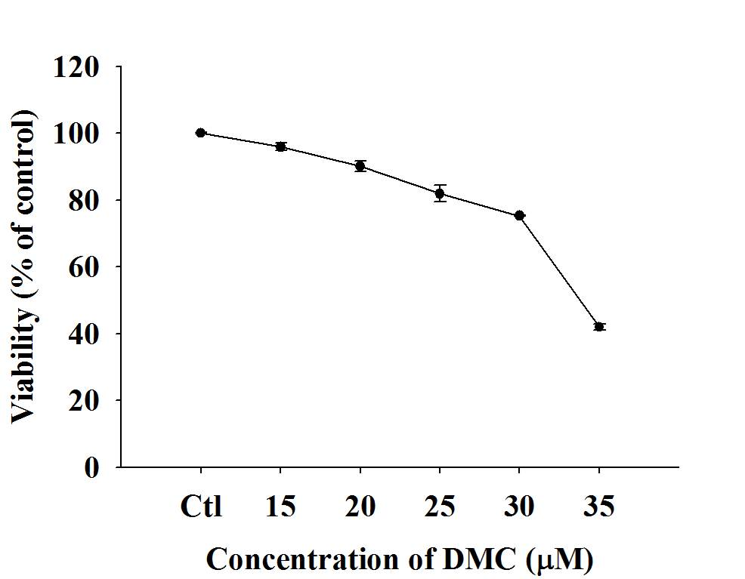

Fig. 2
(A)
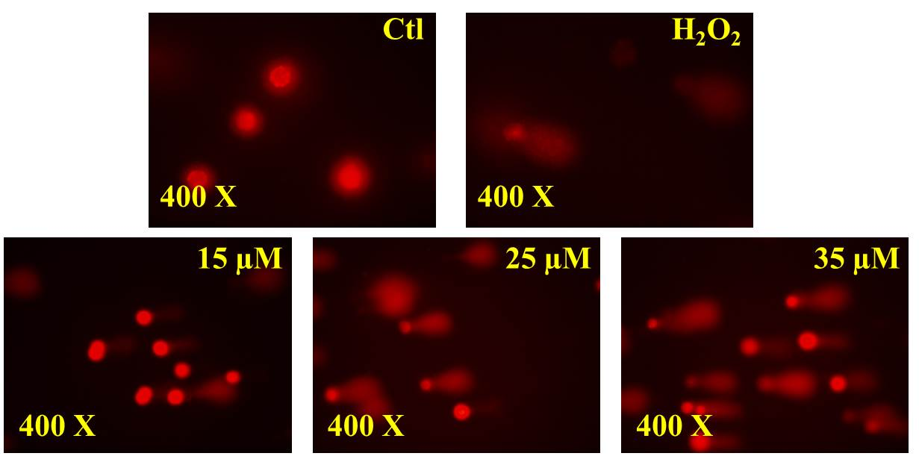
(B)
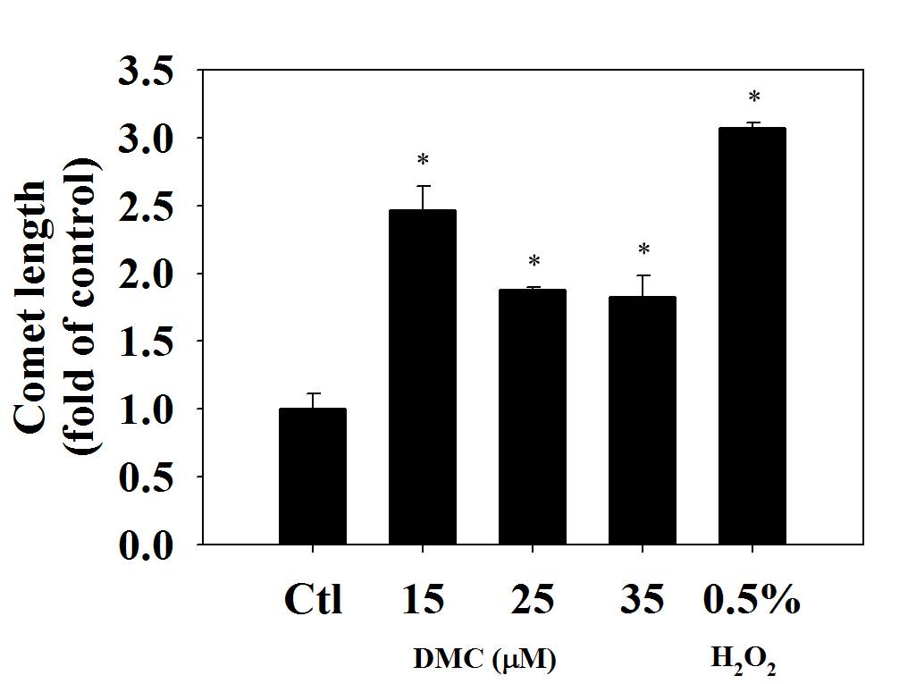

Fig. 3
(A)
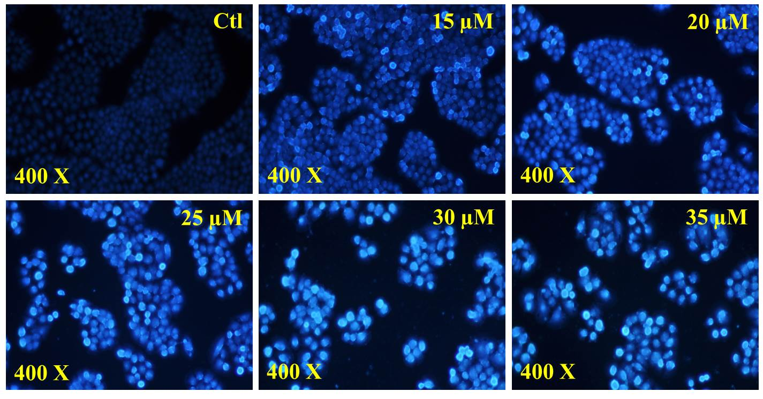
(B)
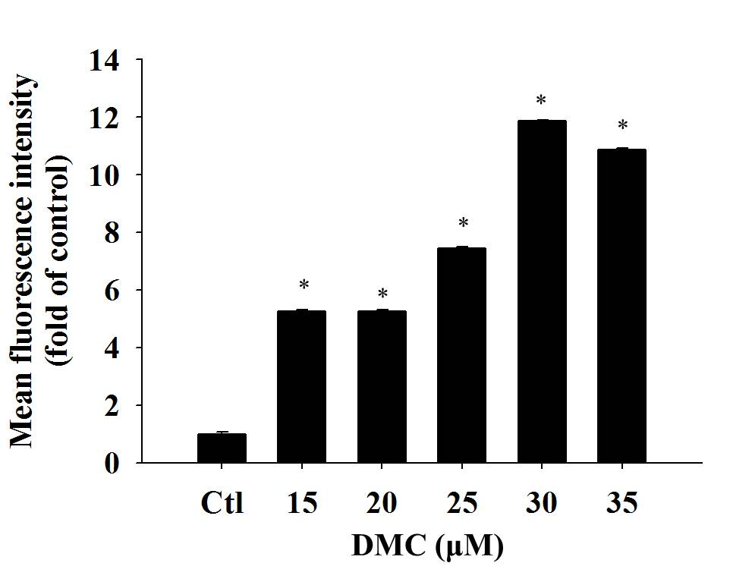

Fig. 4
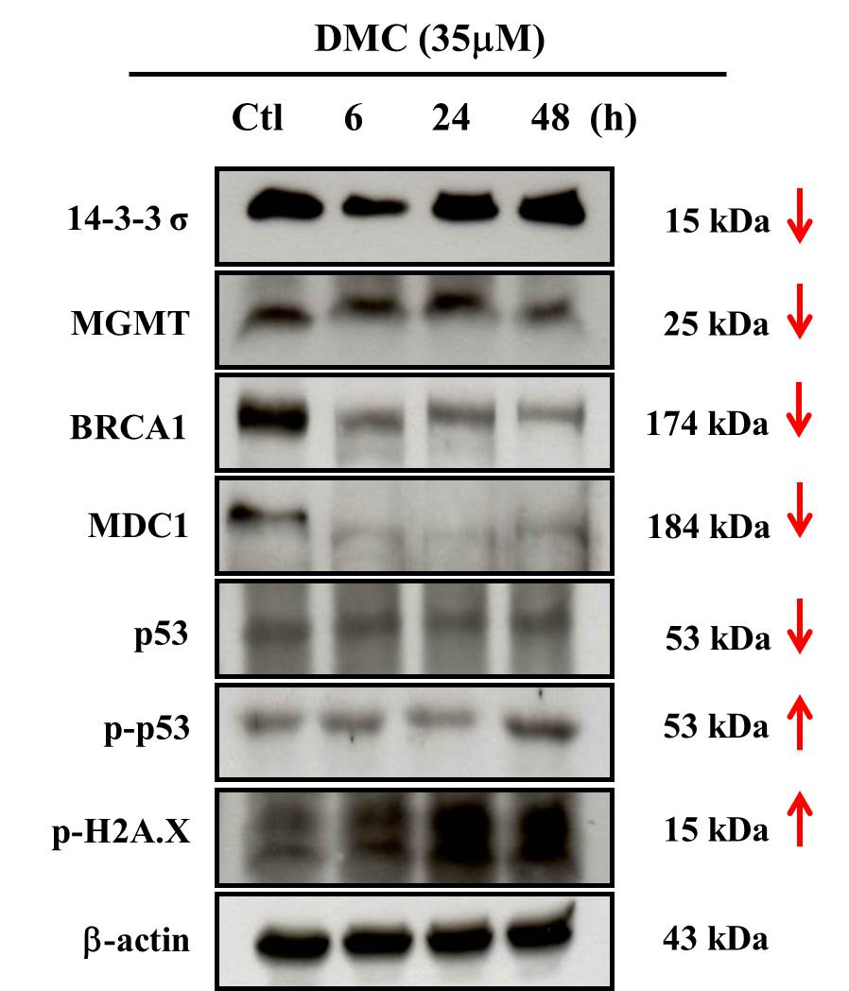

Fig. 5
(A)
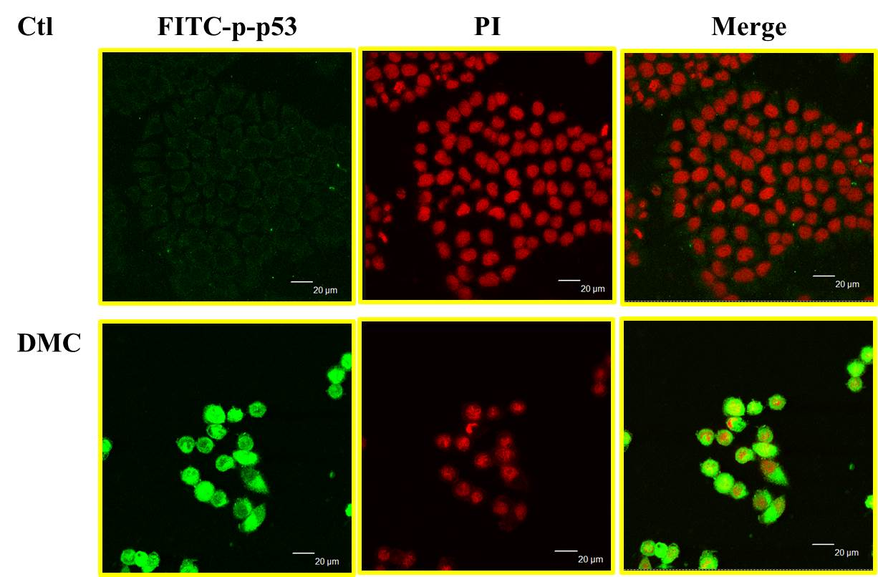
(B)
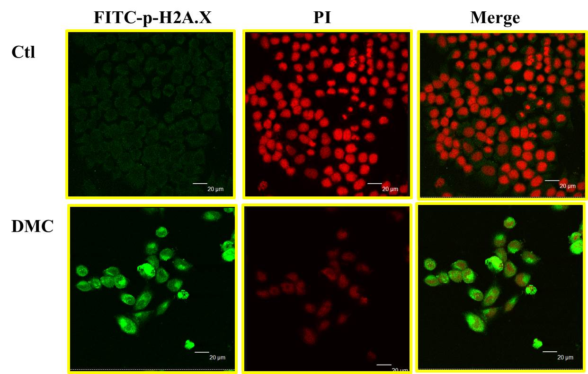

Fig. 6
