- 13-Year Nationwide Cohort Study of Chronic Kidney Disease
- Risk Among Treatment-naïve Patients With Chronic Hepatitis
- B in Taiwan
4
5 Yi-Chun Chen,1,2,7 Yu-Chieh Su,2,3 Chung-Yi Li,4,5 Shih-Kai Hung2,6,7 6
- 1Division of Nephrology, Department of Internal Medicine, Dalin Tzu Chi Hospital, Buddhist

- Tzu Chi Medical Foundation, Chiayi, Taiwan;

- 2School of Medicine, Tzu Chi University, Hualien, Taiwan;
- 3Division of Hematology-Oncology, Department of Internal Medicine, Dalin Tzu Chi Hospital,

- Buddhist Tzu Chi Medical Foundation, Chiayi, Taiwan;

- 4Department and Graduate Institute of Public Health, College of medicine, National Cheng Hung

- University, Tainan, Taiwan;

- 5Department of Public Health, College of Public Health, China Medical University, Taichung,

- Taiwan;

- 6Department of Radiation Oncology, Dalin Tzu Chi Hospital, Buddhist Tzu Chi Medical

- Foundation, Chiayi, Taiwan.

- 7Yi-Chun Chen and Shih-Kai Hung contributed equally to this work as corresponding authors 19
- Correspondence to Yi-Chen Chen, MD, Division of Nephrology, Department of Internal

- Medicine, Dalin Tzu Chi Hospital, Buddhist Tzu Chi Medical Foundation, Chiayi, No. 2,

- Minsheng Rd., Dalin Township, Chiayi County 622, Taiwan. E-mail:

23 chenyichun0320@yahoo.com.tw. Tel: +886-5-2648000-5665; Fax: +886-5-2648128.

1

- Yu-Chieh Su, MD Email: alineycc@gmail.com

- Chung-Yi Li, PhD Email: cyli99@mail.ncku.edu.tw

- Shih-Kai Hung, MD, PhD Email: df254246@tzuchi.com.tw 5
- Type: Research Article

- Running title: Untreated chronic HBV increases CKD risk

- Conflict of interest: None.

- Support: None. 10
11

12

13

14

15

16

17

18

19

20

21

22

- Abstract

- Background: Chronic hepatitis B virus (HBV) infection and chronic kidney disease (CKD) have

- high prevalences in Taiwan and worldwide. However, the association of untreated chronic

- hepatitis B virus (HBV) infection with chronic kidney disease (CKD) remains in conflict.

- Methods: This cohort study used claims data in the Taiwan National Health Insurance Research

- Database in 1996-2010, in which all diseases were classified by ICD-9-CM codes. We identified

- 17796 adults who had chronic HBV infection and did not take nucleos(t)ide analogues from

- 1998 to 2010 and also randomly selected 71184 matched controls without HBV in the same

- dataset. Cumulative incidences and adjusted hazard ratio (aHR) of incident CKD were evaluated

- through the end of 2010 after adjusting for competing mortality.

- Results: The risk of CKD was significantly higher in the HBV cohort (13-year cumulative

- incidence, 6.2%; 95% confidence interval [CI], 5.4%-7.1%) than in the non-HBV cohort (2.7%;

13 95% CI, 2.5%-3.0%) (p<0.001), and the aHR was 2.58 (95% CI, 1.95-3.42; p<0.001).

14 Multivariable stratified analysis further verified significant associations of CKD with HBV in

15 men of any age (aHR, 2.98; 95% CI, 2.32-3.83, p<0.001 for men aged <50 years; aHR, 1.58;

- 95% CI, 1.31-1.91, p<0.001 for men aged ≧50 years) and women under the age of 50 (aHR,

- 2.99; 95% CI, 2.04-4.42, p<0.001), but no significant association in women aged 50 or over.

- Conclusion: Untreated chronic HBV infection is associated with increased risk of CKD. Hence,

- high-risk HBV-infected subjects should have targeted monitoring for the development of CKD. 20
- Keywords: HBV infection, chronic kidney disease, cohort study, Taiwan National Health

- insurance Research Database, competing mortality. 23

- Background

- Chronic kidney disease (CKD) is a global public health burden because of its increasing

- incidence and prevalence and progressive nature to end-stage renal disease (ESRD) [1].

- Therefore, it is critical to identify risk factors for CKD to allow for effective surveillance.

- Beyond the traditional cardiovascular risk factors, infectious disease is an under-recognized risk

- factor for CKD [2].

- Hepatitis B affects approximately 350 million people worldwide [3], and is associated with

- high mortality and morbidity [4]. Apart from major liver complications, clinical evidence

- suggests that chronic HBV infection has a negative impact on renal function. HBV infection can

- lead to glomerulonephritis, even in the absence of cirrhosis [5]. A small controlled prospective

- study indicated that individual estimated glomerular filtration rate declined by approximately -2

- ml/min/y in 60 untreated HBV-infected patients without pre-existing renal disease, diabetes, or

- hypertension during the median follow-up of 24 months [6]. A 2-year cross-sectional HARPE

- study indicated that renal abnormalities were highly prevalent in treatment-naïve patients with

- chronic HBV infection [7]. A 2-year GLOBE study indicated that Telbivudine improved renal

- function in patients with chronic HBV infection [8]. Together, these findings provide the basis

- for a hypothesized negative impact of HBV infection on renal function.

- Chronic HBV infection is associated with increased insulin resistance [9] and intensification

- of oxidative stress [10], and these may contribute to renal injury [11]. Therefore, it seems

- biologically plausible that HBV-infected subjects have increased risk for CKD. Our prior

- nationwide cohort study has demonstrated that untreated chronic HBV infection is associated

- with increased risk of ESRD [12]. However, four cross-sectional studies [9,13-15] on the role of

- HBV in the development of CKD have had disparate results.

  - To date, there have been no cohort studies of the association of chronic HBV infection with

  - risk of incident CKD, and it is unclear which HBV-infected patients are more likely to develop

  - CKD. This is a crucial issue, because the management of patients with coexisting HBV infection

  - and CKD is a challenge [16] and the global burden of HBV infection and CKD is rising [17].

  - Taiwan has high prevalence of CKD and HBV infection, and thus provides an ideal setting for

  - study of the relationship of both diseases. In the present study, we conducted a 13-year

  - nationwide cohort study to examine whether untreated chronic HBV infection is associated with

  - increased risk of incident CKD using reimbursement claims data from the Taiwan National

  - Health Insurance Research Database (NHIRD). 10

- Methods

- Database

- This nationwide cohort study used outpatient and inpatient claims from the NHIRD from 1996 to

- 2010, which is released by the National Health Research Institutes (NHRI) for Taiwan’s National

- Health Insurance (NHI) Program. The NHI is a government-run, compulsory-enrolment,

- single-payer system that had a coverage rate of more than 99% by the end of 2010, and codes

- diagnoses according to ICD-9-CM (Supplemental Table 1). The NHIRD lacks information on

- laboratory and lifestyle data and severity of the disease condition. Our previous research

- provided details of the NHIRD [2,12,18-21]. In brief, the NHIRD has detailed healthcare data of

- 25.68 million enrollees (99.9% of the population) based on a random sample of all enrollees of

- the NHI program. There were no significant differences in age, sex, or healthcare costs between

- the sample group and all enrollees. The NHRI approved this study. Informed consent was not

- required because this is a secondary data analysis. 3
- Study Cohorts

- Here, we used methods substantially similar to those we used in our earlier paper regarding the

- association of HBV with ESRD [12]. In the present study, we identified all adults with chronic

- HBV infection between 1 January 1998 and 31 December 2010 from the NHIRD. The index date

- was defined on the date of chronic HBV infection claim during the entry period. We excluded

- subjects who had HCV infection from 1996 to 2010 and CKD/ESRD from 1996 to the index date,

- or took nucleoside analogues (lamivudine, adefovir, entecavir, telbivudine) [12] before CKD

- event occurred. The NHI program in Taiwan was initiated in 1995, so the dataset only allows

- tracking of medical services from 1996 to 2010. There were 17796 untreated subjects with

- chronic HBV infection.

- The non-HBV (control) cohort was extracted from the remaining subjects in the database. We

- first excluded subjects who had claim-based diagnoses of HCV or HBV infection from 1996 to

- 2010, or CKD/ESRD from 1996 to the index date. For each HBV case, we used a simple random

- sampling method to select 4 controls of the same sex and same age category (18-39, 40-49,

- 50-59, 60-69, or ≥70 years). We used age stratification because previous research indicated an

- age-dependent association of HBV infection and CKD [4,19]. For controls, the index date was

- within the same year of the index date of their matched cases. The control group ultimately

- included 71184 subjects. 22
23 Definition of CKD

- The claims-based diagnosis of CKD was defined by the presence of 1 inpatient or 2 outpatient

- ICD-9-CM code 585 [19] in the claims and without catastrophic illness registration cards for

- ESRD (indicating the need for renal replacement therapy). The Taiwan Society of Nephrology

- launched a nationwide CKD Preventive Project covering CKD stages 1-5 in 2004. The simplified

- Modification of Diet in Renal Disease equation along with proteinuria has been used to estimate

- the national prevalence of 5-stage CKD in Taiwan [1]. The ICD-9-CM code 585 is consistent

- with the National Kidney Foundation’s Kidney Disease Outcome Quality Initiative definition of

- CKD stages 1-5 [19], allowing for comparisons of the incidence and prevalence of CKD in

- Taiwan and the United States [22]. However, the CKD stage (severity) cannot be assessed in the

- NHIRD. 11
- Main Outcome Measurement

- Both cohorts were followed from the index date to the first diagnosis of CKD, death, or the end

- of 2010. Death is a competing event for any event of progression because patients who die

- during follow-up can no longer progress after death [23]. Therefore, death before reaching CKD,

- which could lead to informative censoring, was considered as a competing risk event in

- estimating the incidence of CKD. Death was defined by withdrawal from the NHI program [12]. 18
- Potential Confounders

- We considered several confounders associated with CKD [19], including major comorbidities

- between 1 January 1996 and the index date (diabetes, hypertension, coronary heart disease,

- hyperlipidemia, and cirrhosis), geographic regions (northern, central, southern, or eastern

- Taiwan), number of medical visits, urbanization level (urban, suburban, and rural) and enrollee

- category (EC), from EC1 (highest status) to EC4 (lowest status), as proxy measures of

- socioeconomic status. Although herbs containing aristolochic acids could be identified from the

- NHIRD only before November 2003, we also recorded use of herbs containing aristolochic acid

- including (Guan) Mu Tong and (Guang) Fangchi, which were associated with increased risk of

- CKD (24), greater than 30 days from 1996 to endpoint outcome. We also considered

- Deyo-Charlson Comorbidity Index (CCI) score and propensity score to control confounding and

- reduce bias in the background covariates between both cohorts in studies using healthcare

- administrative databases [25-27]. HBV status as the dependent variable and background

- covariates (including age, sex, major comorbidities, geographic region, urbanization level, EC,

- number of medial visits, and CCI score) as the independent variables were included in the

- calculation of propensity score using logistic regression. The propensity score model had a

- c-index of 0.66, indicating fair discrimination between the two cohorts [12]. 13
- Statistical Analyses

- We calculated and compared the cumulative incidence of CKD in data with competing risk by

- the modified Kaplan-Meier method and Gray’s method [28], and tested differences in the full

- time-to-event distributions between the study cohorts using modified log-rank test. We checked

- the interaction terms of HBV with sex, HBV with age, and HBV with age and sex, all of which

- were statistically significant. After confirming the assumption of proportional hazards, we

- applied the modified Cox proportional hazard model in the presence of competing mortality to

- examine the association of HBV with CKD [29], with adjustment for all covariates (age per year,

- sex, major comorbidities, use of herbs containing aristolochic acid, geographic region,

- urbanization level, EC, number of medical visits, CCI score, and propensity score) and three

- significant above-mentioned interaction terms. Next, we determined the influence of HBV on

- CKD according to sex and age in the presence of competing mortality. For this analysis, we

- classified patients as younger than 50 years or as 50 years and older, because previous research

- indicated that age of 50 years is an important factor associated with disease progression in

- patients with chronic hepatitis B [30]. We analyzed all data with SAS (version 9.2; SAS Institute,

- Inc., Cary, N.C.) and considered a two-sided p-value less than 0.05 as statistically significant. 7

- Results

- Baseline characteristics of the study cohorts

- The male-to-female ratio in the HBV cohort was 1.4. Compared with the non-HBV (control)

- cohort, the HBV cohort was more likely to have comorbidities including diabetes, hypertension,

- hyperlipidemia, and cirrhosis, as well as frequent use of herbs containing aristolochic acid,

- higher socioeconomic status (EC 1 and 2), more medical visits, higher propensity score and CCI

- score, and to reside in urban areas and northern, central, and eastern regions; all with

- considerable significance (Table 1). 16
- Cumulative incidences of CKD between the HBV and control cohorts in the presence of

- competing mortality

- The 1-, 3-, 5-, 7-, 9-, 11-, and 13-year cumulative incidences of CKD were 0.26% vs. 0.10%,

20 0.77% vs. 0.33%, 1.35% vs. 0.65%, 2.00% vs. 1.00%, 2.90% vs. 1.48%, 4.30% vs. 2.12%, and

- 6.20% vs. 2.74%, respectively, in the HBV cohort compared with the control cohort (all p<0.001,

- Table 2). Therefore, the risk of CKD was significantly higher in the HBV cohort (13-year

1 cumulative incidence, 6.2%; 95% CI, 5.4%-7.1%) than the control cohort (2.7%; 95% CI,

2 2.5%-3.0%) (p<0.001, Figure 1).

3

- Chronic HBV infection as an independent risk factor for CKD

- The mean duration of follow-up was 6.55 and 6.56 years for the HBV and control cohorts,

- respectively (Table 3). Among the 88980 subjects, 1247 subjects (1.4%) developed CKD during

- the study period, with 425 (2.4%) and 822 (1.2%) from the HBV and control cohorts,

- respectively. The modified multivariable-adjusted Cox proportional hazard model in the

- presence of competing mortality revealed that CKD was independently associated with HBV

- (adjusted hazard ratio [aHR], 2.58; 95% confidence interval [CI], 1.95-3.42; p<0.001), men (1.38;

11 1.11-1.73; p=0.004); age (1.06; 1.05-1.07; p<0.001), diabetes (2.41; 1.94-2.99; p<0.001),

12 hypertension (1.92; 1.64-2.24; p<0.001), residence in central (1.31; 1.12-1.53; p<0.001), eastern

13 (1.49; 1.06-2.09; p=0.023), southern (1.21; 1.04-1.42; p=0.016) Taiwan, and the number of

14 medical visits (1.01; 1.009-1.014; p<0.001) (Table 4).

- We further performed a sensitivity analysis to test the robustness of these results. We excluded

- diabetic or cirrhotic subjects from both cohorts at baseline, also indicating a positive association

- of HBV with CKD (2.61, 1.97-3.46; 2.58, 2.04-3.99; respectively) (data not shown). 18
- Association of CKD with HBV by Sex and Age

- After adjusting for competing mortality, multivariable stratified analysis further verified

- significant associations of CKD risk with HBV in men (adjusted HR, 3.05; 95% CI, 2.50-3.71;

22 p<0.001), women (2.56; 1.93-3.41; p<0.001), subjects younger than 50 years (2.86; 1.98-4.13;

23 p<0.001), men younger (2.98; 2.32-3.83; p<0.001) and older than 50 years (1.58; 1.31-1.91;

- p<0.001), and women younger than 50 years (2.99; 2.04-4.42; p<0.001), and no significant

- association in subjects older than 50 years (1.19; 0.90-1.56; p=0.22) and women older than 50

3 years (1.18; 0.90-1.55; p=0.24) (Table 5).

4

- Discussion

- To our knowledge, this is the first large nationwide cohort study to demonstrate an increased risk

- for CKD in untreated subjects with chronic HBV infection and simultaneously to determine the

- overall risk and age- and sex-specific risks of CKD. In this study, CKD was 2.58-fold more

- likely in HBV-infected subjects, relative to controls, after controlling for potential confounders

- and competing mortality. We also found that the risk of CKD in HBV-infected subjects was

- somewhat similar (range from 2 to 3) in men of any age and women under the age of 50.

- Noteworthily, HBV was not associated with CKD risk in women aged 50 or over. This

- information has important clinical implications for the design of surveillance programs that

- assess chronic HBV infection and CKD.

- The association between chronic HBV infection and the development of CKD remains

- controversial. Two cross-sectional studies [7,15] demonstrated a positive association of HBV

- with CKD. A 2-year multicentric cross-sectional French study reported that CKD was highly

- prevalent in 268 treatment-native patients with chronic HBV infection [7]. A cross-sectional

- Taiwanese study [15] reported that HBV was associated with CKD in 416 HBV-infected adults;

- however, another cross-sectional Taiwanese study by the same research group reported that HBV

- was not associated with CKD or proteinuria in 5424 HBV-infected adults [14]. Similarly, a

- cross-sectional study of 328 HBV-infected adults in Beijing [13] reported that HBV was not

- associated with CKD or albuminuria. On the other hand, a cross-sectional Japanese study of 130

- HBV-infected adults [9] showed that HBV was not associated with albuminuria, but was

- inversely associated with CKD. The discrepancies among these studies may be attributed to the

- cross-sectional nature of their design, use of small sample sizes, and differences among the

- specific populations. Moreover, cross-sectional analyses cannot establish whether HBV infection

- preceded development of CKD. The present study was cohort design and used a large dataset,

- which afforded considerable statistical power and allowed tracking of incident CKD events over

- 13 years. We demonstrated an increased risk of CKD in untreated patients with chronic HBV

- infection that was independent of the presence of diabetes or cirrhosis.

- Our HBV cohort tended to be younger and male, and to have a higher socioeconomic status,

- consistent with our prior research [12]. On stratified analysis, we found significant associations

- of HBV with CKD risk in men of any age (especially under the age of 50) and women under the

- age of 50, similar to our prior research [12]. Previous research reported that men have increased

- risk for development of CKD [19], and that men have a lower clearance rate than females, so are

- therefore more susceptible to development of chronic HBV infection [31]. Steatosis, a

- characteristic feature of chronic HBV infection, can increase lipid peroxidation and plasma

- inflammatory biomarkers [30], and these may contribute to endothelial dysfunction and renal

- injury [11]. The biggest sex difference in steatosis occurs in subjects younger than 50 years [30].

- Taken together, these results may explain our observations regarding the effect of age and gender

- on the risk for development of CKD following untreated chronic HBV infection.

- The pathogenesis of HBV-mediated renal injury probably depends on interactions of the virus

- with the host and various environmental factors [3]. Our results indicated that CKD ensued

- following untreated chronic HBV infection during the mean follow-up of 5.7 years, the interval

- of which was similar to 60 months in a case series [5]. HBV-related renal injury is believed to be

- due to the deposition of immune complexes of HBV antigens and host antibodies [3]. Other

- research also explored the possible effect of HBV on the development of nephropathy. HBV

- antigens (HBsAg, HBcAg, and HBeAg) and HBV DNA have been detected in glomeruli [32]

- and tubular epithelia [33], respectively. HBV DNA negative or positive sera of patients with

- chronic HBV infection promoted apoptotic damage in renal tubular cells via up-regulation of Fas

- gene expression, and these patients also had a higher circulating level of transforming growth

- factor-β, which is implicated in the potentiation of apoptosis and renal fibrosis [34]. HBV is

- associated with increased insulin resistance [9] and oxidative stress [10], and these are implicated

- in the progression of nephropathy [11]. However, only a small number of the 350 million HBV

- carriers develop glomerulonephritis [4]. This indicates that chronic HBV infection by itself is

- insufficient for development of nephropathy, and that additional socio-environmental conditions,

- alterations in cell-mediated immunity, genetic susceptibility, and other factors are also important

- [3]. This may explain the lower 13-year cumulative incidence rate (6.2%) of CKD following

- untreated chronic HBV infection in this study. However, the HBV-positive population is

- increasing by 50 million per year, despite a marked increase in vaccination rates [35]. Therefore,

- it is conceivable that the burden of CKD following chronic HBV infection is increasing.

- The major strength of our study is that it was designed to reduce selection bias (due to use of a

- large nationwide population-based and highly representative sample with random sampling),

- environmental effects (due to the availability of socioeconomic indicators for all subjects) [18],

- and detection bias (due to consideration of complete histories of the use of medical services) [19].

- In addition, the study population was well defined and follow-up was complete because our

- design relied on computerized registries that provided complete nationwide coverage. Therefore,

- our finding of increased risk of CKD in HBV-infected subjects is robust.

- Some potential limitations should be noted. First, misclassification of diseases may occur

- when an administration database is used. However, the NHI Administration established an audit

- and penalty system for quality monitoring to ensure accuracy of claims and minimize

- misclassification error [36]. Moreover, both CKD and viral hepatitis are important health

- problems in Taiwan, so the government has strict guidelines for diagnosis [37]. Second, some of

- our control subjects may have had sub-clinical HBV infection. However, if HBV is associated

- with CKD, this misclassification would lead to lower HRs, thus supporting the robustness of our

- findings. Third, the NHIRD lacks information on family history of kidney diseases, lifestyle,

- body weight, and laboratory data (e.g. levels of serum HBV DNA and HBV genotype), which

- may contribute to CKD risk. Thus, this may lead to the difference of propensity score between

- both cohorts. Nevertheless, we added CCI score into the propensity analysis in order to reach the

- comparability of both cohorts and included CCI score and propensity score in multivariable and

- stratified analyses to control confounding in healthcare administrative databases [12,25,26].

- Although unmeasured confounders my still exist as with any observational study, we believe the

- methodology used in the present study is solid and robust. 18

- Conclusions

- This large national cohort study indicates that untreated chronic HBV infection is associated with

- increased risk of CKD, especially males and younger age. High-risk HBV-infected subjects

- should have targeted monitoring for the development of CKD.

1

- List of abbreviations

- CKD = chronic kidney disease, HBV = hepatitis B virus, HR = hazard ratio, CI = confidence

- interval, ESRD = end-stage renal disease, NHIRD = National Health Insurance Research

- Database, NHRI = National Health Research Institutes, NHI = National Health Insurance, EC =

- enrollee category, CCI = Charlson Comorbidity Index. 7

- Competing interests

- All authors have no conflict of interests. 10

- Authors' contributions

- Conceived and designed the experiments: YCC. Contributed reagents/materials/analysis tools:

- SKH, YCS. Performed the experiments: YCC. Analyzed the data: YCC, SKH, YCS. Wrote the

- paper: YCC. Provided constructive opinions and suggestions: YCC, SKH, YCS, CYL. 15

- Acknowledgements

- This study is based partly on secondary data from the National Health Insurance Research

- Database provided by the National Health Insurance Administration, Ministry of Health and

- Welfare, Taiwan. The interpretations and conclusions herein do not represent the views of the

- National Health Insurance Administration, Ministry of Health and Welfare, or National Health

- Research Institutes. 3

- References

- 1. Wen CP, Cheng TY, Tsai MK, Chang YC, Chan HT, Tsai SP, et al. All-cause mortality

- attributable to chronic kidney disease: a prospective cohort study based on 462 293 adults in

7 Taiwan. Lancet. 2008;371:2173-2182.

- 2. Chen YC, Chiou WY, Hung SK, Su YC, Hwang SJ. Hepatitis C virus itself is a causal risk

- factor for chronic kidney disease beyond traditional risk factors: a 6-year nationwide cohort

- study across Taiwan. BMC Nephrol. 2013;14:187.

- 3. Bhimma R, Coovadia HM. Hepatitis B virus-associated nephropathy. Am J Nephrol.

12 2004;24:198-211.

- 4. Levy M, Chen N. Worldwide perspective of hepatitis B-associated glomerulonephritis in

- the 80s. Kidney Int. 1991;Suppl 35:S24-33.

- 5. Lai KN, Li PK, Lui SF, Au TC, Tam JS, Tong KL, et al. Membranous nephropathy related

- to hepatitis B virus in adults. N Engl J Med. 1991;324:1457-1463.

- 6. Mauss S, Berger F, Filmann N, Hueppe D, Henke J, Hegener P, et al. Effect of HBV

- polymerase inhibitors on renal function in patients with chronic hepatitis B. J Hepatol.

19 2011;55:1235-1240.

- 7. Amet S, Bronowicki JP, Thabut D, Zoulim F, Bourliere M, Mathurin P, et al. Prevalence of

- renal abnormalities in chronic HBV infection: The HARPE study. Liver Int. 2014. doi:

22 10.1111/liv.12480.

- 8. Gane EJ, Deray G, Liaw YF, Lim SG, Lai CL, Rasenack J, et al. Telbivudine improves

- renal function in patients with chronic hepatitis B. Gastroenterology. 2014;146:138-146.

- 9. Ishizaka N, Ishizaka Y, Seki G, Nagai R, Yamakado M, Koike K. Association between

- hepatitis B/C viral infection, chronic kidney disease and insulin resistance in individuals

- undergoing general health screening. Hepatol Res. 2008;38:775-783.

- 10. Pawlak K, Pawlak D, Mysliwiec M. Hepatitis intensified oxidative stress, MIP-1beta and

- RANTES plasma levels in uraemic patients. Cytokine. 2004;28:197-204.

- 11. Sarafidis PA, Ruilope LM. Insulin resistance, hyperinsulinemia, and renal injury:

- mechanisms and implications. Am J Nephrol. 2006;26:232-244.

- 12. Chen YC, Su YC, Li CY, Wu CP, Lee MS. A nationwide cohort study suggests chronic

- hepatitis B virus infection increases the risk of end-stage renal disease among patients in Taiwan.

12 Kidney Int. 2014. doi: 10.1038/ki.2014.363.

- 13. Cai J, Fan X, Mou L, Gao B, Liu X, Li J, et al. Association of reduced renal function with

- hepatitis B virus infection and elevated alanine aminotransferase. Clin J Am Soc Nephrol.

15 2012;7:1561-1566.

- 14. Lee JJ, Lin MY, Yang YH, Lu SN, Chen HC, Hwang SJ. Association of hepatitis C and B

- virus infection with CKD in an endemic area in Taiwan: a cross-sectional study. Am J Kidney

18 Dis. 2010;56:23-31.

- 15. Lin MY, Chiu YW, Lee CH, Yu HY, Chen HC, Wu MT, et al. Factors Associated with

- CKD in the Elderly and Nonelderly Population. Clin J Am Soc Nephrol. 2013;8:33-40.

- 16. Unger JK, Peters H. Hepatitis B in chronic kidney disease: moving toward effective

- prevention. Kidney Int. 2008;73:799-801.

- 17. Chacko EC, Surrun SK, Mubarack Sani TP, Pappachan JM. Chronic viral hepatitis and

- chronic kidney disease. Postgrad Med J. 2010;86:486-492.

- 18. Sun Y, Chang YH, Chen HF, Su YH, Su HF, Li CY. Risk of Parkinson disease onset in

- patients with diabetes: a 9-year population-based cohort study with age and sex stratifications.

5 Diabetes Care. 2012;35:1047-1049.

- 19. Chen YC, Lin HY, Li CY, Lee MS, Su YC. A nationwide cohort study suggests that

- hepatitis C virus infection is associated with increased risk of chronic kidney disease. Kidney Int.

8 2014;85:1200-1207.

- 20. Chen HF, Chen P, Li CY. Risk of malignant neoplasms of liver and biliary tract in diabetic

- patients with different age and sex stratifications. Hepatology. 2010;52:155-163.

- 21. Chen YC, Su YC, Lee CC, Huang YS, Hwang SJ. Chronic kidney disease itself is a causal

- risk factor for stroke beyond traditional cardiovascular risk factors: a nationwide cohort study in

13 Taiwan. PLoS One. 2012;7:e36332.

- 22. Collins AJ, Foley RN, Herzog C, Chavers B, Gilbertson D, Ishani A, et al. US Renal Data

- System 2010 Annual Data Report. Am J Kidney Dis. 2011;57:A8,e1-526.

- 23. Boucquemont J, Heinze G, Jager KJ, Oberbauer R, Leffondre K. Regression methods for

- investigating risk factors of chronic kidney disease outcomes: the state of the art. BMC Nephrol.

18 2014;15:45.

- 24. Lai MN, Lai JN, Chen PC, Tseng WL, Chen YY, Hwang JS, et al. Increased risks of

- chronic kidney disease associated with prescribed Chinese herbal products suspected to contain

- aristolochic acid. Nephrology (Carlton). 2009;14:227-234.

- 25. Patorno E, Grotta A, Bellocco R, Schneeweiss S. Propensity score methodology for

- confounding control in health care utilization databases. Epidemiol Biostat Public Health.

3 2013;10:e8940.

- 26. Schneeweiss S, Maclure M. Use of comorbidity scores for control of confounding in studies

- using administrative databases. Int J Epidemiol. 2000;29:891-898.

- 27. D'Agostino RB, Jr. Propensity scores in cardiovascular research. Circulation.

7 2007;115:2340-2343.

8 28. Gray RJ. A class of K-sample tests for comparing the cumulative incidence of a competing

9 risk. Ann Stat. 1988;16:1141-1154.

10 29. Fine JP, Gray RJ. A proportional hazards model for the subdistribution of a competing risk.

11 J Am Stat Assoc. 1999;94:496-509.

- 30. Shimizu I, Kohno N, Tamaki K, Shono M, Huang HW, He JH, et al. Female hepatology:

- favorable role of estrogen in chronic liver disease with hepatitis B virus infection. World J

14 Gastroenterol. 2007;13:4295-4305.

- 31. London WT, Drew JS. Sex differences in response to hepatitis B infection among patients

- receiving chronic dialysis treatment. Proc Natl Acad Sci U S A. 1997;74:2561-2563.

- 32. Lai KN, Lai FM. Clinical features and the natural course of hepatitis B virus-related

- glomerulopathy in adults. Kidney Int. 1991;Suppl 35:S40-4.

- 33. Lai KN, Ho RT, Tam JS, Lai FM. Detection of hepatitis B virus DNA and RNA in kidneys

- of HBV related glomerulonephritis. Kidney Int. 1996;50:1965-1977.

- 34. Deng CL, Song XW, Liang HJ, Feng C, Sheng YJ, Wang MY. Chronic hepatitis B serum

- promotes apoptotic damage in human renal tubular cells. World J Gastroenterol.

23 2006;12:1752-1756.

1 35. Patton H, Tran TT. Management of hepatitis B during pregnancy. Nat Rev Gastroenterol

2 Hepatol. 2014;11:402-409.

- 36. Sheu JJ, Kang JH, Lin HC. Hyperthyroidism and risk of ischemic stroke in young adults: a

- 5-year follow-up study. Stroke. 2010;41:961-966.

- 37. National Health Insurance Administration, Ministry of Health and Welfare, Taiwan.

- http://www.nhi.gov.tw. Accessed June 1, 2014. 7
8

9

10

11

12

13

14

15

16

17

18

19

20

21

- Figure Legends

- Figure 1. Cumulative incidence of CKD in the HBV and non-HBV cohorts. Data were compiled

- after adjustment for competing mortality. 4
5

6

7

8

9

10

11

12

13

14

15

16

17

18

19

20

21

22
1 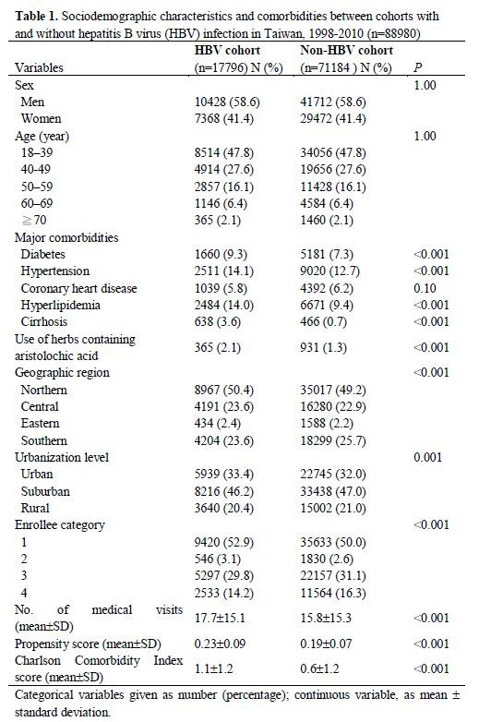
2

Table 2. Cumulative incidences of chronic kidney disease (CKD) between the HBV and non-HBV cohorts in the presence of competing mortality
 | HBV cohort, (95% CI) | Non-HBV cohort , (95% CI) | P*
CKD event
At 1 year | 0.26% (0.19%-0.35%) | 0.10% (0.08%-0.12%) | <0.001
At 3 years | 0.77% (0.64%-0.92%) | 0.33% (0.29%-0.38%) | <0.001
At 5 years | 1.35% (1.17%-1.55%) | 0.65% (0.59%-0.72%) | <0.001
At 7 years | 2.00% (1.76%-2.26%) | 1.00% (0.91%-1.09%) | <0.001
At 9 year | 2.90% (2.58%-3.24%) | 1.48% (1.37%-1.60%) | <0.001
At 11 year | 4.30% (3.85%-4.79%) | 2.12% (1.96%-2.29%) | <0.001
At 13 year | 6.20% (5.39%-7.08%) | 2.74% (2.49%-3.01%) | <0.001

*Two sample proportion test. Abbreviations: CI, confidence interval.
1

2

3

4

5

6

7
1 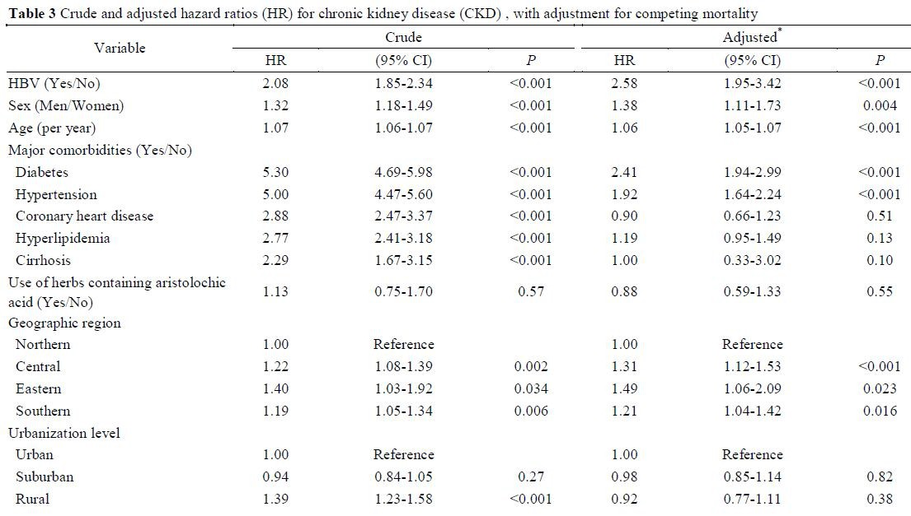
2
1 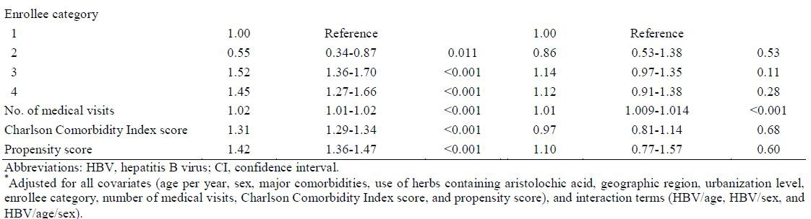
2

3

4

5

6

7

8

9

10

Table 4. Association of chronic kidney disease (CKD) with HBV, stratified by sex and age, with adjustment for competing mortality HBV cohort Non-HBV cohort Hazard ratio (95% CI)
 | n | PY | CKD  events | n | PY | CKD  events | Crude | P | Adjusted* | P
Sex  Men | 10428 | 68249 | 294 | 41712 | 274693 | 525 | 2.26 (1.96-2.61) | <0.001 | 3.05 (2.50-3.71)† | <0.001
Women | 7368 | 48243 | 131 | 29472 | 192357 | 297 | 1.77 (1.44-2.18) | <0.001 | 2.56 (1.93-3.41)† | <0.001
Age (year)
< 50 | 13428 | 84358 | 203 | 53712 | 337813 | 191 | 4.30 (3.53-5.24) | <0.001 | 2.86 (1.98-4.13 | <0.001
≧50 | 4368 | 32133 | 222 | 17472 | 129237 | 631 | 1.40 (1.20-1.63) | <0.001 | 1.19 (0.90-1.56) | 0.22
Men
< 50 years | 7888 | 49981 | 140 | 31552 | 200858 | 132 | 4.28 (3.38-5.43) | <0.001 | 2.98 (2.32-3.83) | <0.001
≧50 years | 2540 | 18268 | 154 | 10160 | 73835 | 393 | 1.57 (1.30-1.89) | <0.001 | 1.58 (1.31-1.91) | <0.001
Women
< 50 years | 5540 | 34378 | 63 | 22160 | 136955 | 59 | 4.34 (3.05-6.19) | <0.001 | 2.99 (2.04-4.42) | <0.001
≧50 years | 1828 | 13865 | 68 | 7312 | 55402 | 238 | 1.13 (0.86-1.48) | 0.37 | 1.18 (0.90-1.55) | 0.24

Abbreviations: HBV, hepatitis B virus; PY, person-year; CI, confidence interval.
*Adjusted for all covariates (age, sex, major comorbidities, use of herbs containing aristolochic acid, geographic region, urbanization level, enrollee category, number of medical visits, Charlson Comorbidity Index score, and propensity score) and interaction terms (HBV/age, HBV/sex, HBV/age/sex), minus the covariate and interaction terms on which stratified.
†Age was treated as a continuous variable in multivariate analysis.
1

