Note: This copy is for your personal non-commercial use only. To order presentation-ready copies for distribution to your colleagues or clients, contact us at www.rsna.org/rsnarights.

evaluation of the effect of cumulative Operator experience on hepatocellular carcinoma recurrence after Primary Treatment with radiofrequency ablation1

Teng-Yu Lee, MD, PhD, MBA Jaw-Town Lin, MD, PhD
Hsiu J. Ho, PhD
Ming-Shiang Wu, MD, PhD Chun-Ying Wu, MD, PhD, MPH

Purpose: To investigate the association between cumulative op- erator volume and the risk of hepatocellular carcinoma (HCC) recurrence after potentially curative radiofrequen- cy ablation (RFA).

Materials and
Methods:
This study was approved by the Research Ethics Com- mittee. By using the Taiwan National Health Insurance Research Database, 52 096 patients with HCC were iden- tified between July 1, 2004, and December 31, 2011. In total, 2827 patients were selected who underwent poten- tially curative RFA for newly diagnosed HCC. These pa- tients were grouped into quintiles according to the cu- mulative operator volumes. Patients in the lowest or the highest quintiles were 1:1 matched according to their propensity scores. Finally, two separate groups, each con- taining 406 patients, were recruited in the high- and low- volume groups (cumulative operator volume of 79 cases and 10 cases, respectively). Cumulative incidences of and hazard ratios for HCC recurrence were analyzed after adjusting for competing mortality.

1 From the Department of Medicine, Chung Shan Medical University, Taichung, Taiwan (T.Y.L.); Division of Gastro- enterology, Taichung Veterans General Hospital, No. 1650
Taiwan Boulevard, Sect. 4, Taichung, Taiwan 40705 (T.Y.L., C.Y.W.); School of Medicine, Fu Jen Catholic University, New Taipei City, Taiwan (J.T.L., H.J.H.); Department of Internal Medicine, E-Da Hospital and I-Shou University, Kaohsiung, Taiwan (J.T.L.); Center for Health Policy Research and Development, National Health Research Institutes, Miaoli, Taiwan (J.T.L.); Division of Gastroenterology, National
Taiwan University Hospital, Taipei, Taiwan (M.S.W.); Faculty of Medicine, School of Medicine, National Yang-Ming University, Taipei, Taiwan (C.Y.W.); Graduate Institute of Clinical Medical Science and Department of Public Health, China Medical University, Taichung, Taiwan (C.Y.W.); and Department of Life Sciences, National Chung-Hsing University, Taichung, Taiwan (C.Y.W.). Received August 23,
2014; revision requested October 28; revision received November 25; accepted December 7; final version accepted December 18. Supported by the National Health
Research Institutes, Taiwan (grants PH-101-PP-23 and PH-
102-PP-23). Address correspondence to C.Y.W. (e-mail:
chun@vghtc.gov.tw).

q RSNA, 2015
Results: The HCC recurrence rate of the high-volume group was significantly lower than that of the low-volume group (high-volume group 5-year recurrence rate of 65.8%,
95% confidence interval [CI]: 59.5%, 72.1%; low-volume group 5-year recurrence rate of 71.4%, 95% CI: 66.2%,
76.5%; P , .05). In modified Cox regression analysis, the highest cumulative operator volume was independently as- sociated with a decreased risk of HCC recurrence (hazard ratio, 0.80; 95% CI: 0.67, 0.97; P , .05). Multivariable stratified analyses verified the association between the highest cumulative operator volume and decreased HCC recurrence in almost all subgroups.

Conclusion: The risk of HCC recurrence could be significantly de- creased by experienced RFA operators. Further studies based on cumulative operator volume may be helpful in improving the quality of RFA for HCC.

q RSNA, 2015

Online supplemental material is available for this article.

Original research n Vascular and InterVentIonal radIology
Radiology: Volume 000: Number 0—   2015 n radiology.rsna.org 1

VASCULAR AND INTERVENTIONAL RADIOLOGY: Operator Experience in Radiofrequency Ablation for Hepatocellular Carcinoma Lee et al

epatocellular carcinoma (HCC) is the third leading cause of can- cer death worldwide (1), and
H
the incidence of HCC continues to in- crease in Europe and the United States (2–4). Owing to the progress in HCC surveillance programs in recent years, an increasing number of patients have received diagnoses of localized and re- gional HCC in developed countries, and curative treatments were considered in
30%–60% of new cases (2,5). Although regular screening of high-risk popula- tions and early treatment of localized HCC may contribute to a reduction in HCC-related mortality, further im- provement in the effectiveness of local treatment is imperative, owing to the unsatisfactory survival rates (2,6).
Highly effective therapies such as radiofrequency ablation (RFA) are al- ternative choices to surgical resection for localized HCC, and in current clin- ical practice guidelines, RFA is now considered a standard of care for early stage HCC (7,8). RFA provides the ad- vantages of effectiveness, safety, and wound recovery and has thus become a popular curative treatment for HCC in recent years. However, the use of RFA in place of surgical resection as a first- line treatment for early HCC remains controversial because of concerns about

Advances in Knowledge
n The hepatocellular carcinoma (HCC) recurrence rate after radiofrequency ablation (RFA) was significantly lower in the high-volume group than in the low-volume group (5-year recur- rence rate of 65.8% vs 71.4%, respectively; P , .05).
n The highest cumulative operator volume of RFA was indepen- dently associated with a decreased risk of HCC recur- rence (hazard ratio, 0.80; P ,
.05).
n In multivariable regression analyses, high annual hospital volume of RFA was not associ- ated with a decreased risk of HCC recurrence (hazard ratio,
0.87; P = .14).

the potential for a higher local recur- rence rate (9,10). Improvement in the effectiveness of RFA is therefore crucial for reducing tumor recurrence.
RFA is a highly operator-dependent procedure, and sufficient experience and technical skill are important com- ponents of the RFA procedure (11–13). Although several prognostic factors of RFA treatment have been identified (14–17), the influence of operator ex- perience on outcome has not been evaluated. Recent investigations, such as those of esophageal cancer surgery, have demonstrated that the operator volume is an independent prognostic factor, and the reduction in risk that appears to be associated with the ex- perience of the operator may play a central role in quality improvement (18,19). We hypothesized that cumu- lative operator volume could be an important prognostic indicator for pa- tients with HCC who are undergoing RFA treatment, so we conducted a co- hort study to investigate the association between cumulative operator volume and the risk of HCC recurrence after potentially curative RFA.

Materials and Methods

Study Design
In this retrospective cohort study, we retrieved the medical records of all patients who underwent RFA for HCC from the National Health Insurance Research Database (NHIRD) in Tai- wan. The NHIRD contains healthcare data from more than 99% of the entire population of 23.38 million in Taiwan. The NHIRD comprises comprehensive

Implications for Patient Care
n Cumulative experience of RFA operators could affect clinical outcomes, and further studies based on cumulative operator volume are warranted to improve the quality of RFA treatment.
n Operator volume may be a more precise indicator of RFA experi- ence than annual hospital volume.

information, such as demographic data, dates of clinical visits, diagnostic codes, operation codes, operator codes, hos- pital codes, and details of prescrip- tions, among others, as detailed in our previous studies (20–24). The authors declared no conflicts of interest. This study was approved by the Research Ethics Committee of the National Health Research Institutes in Taiwan.

Study Subjects
All hospitalized patients who were ad- mitted with a primary diagnosis of HCC between July 1, 2004, and December
31, 2011, were identified. The accuracy of HCC diagnosis was confirmed by the International Classification of Diseases, Ninth Revision (ICD-9), admission code (code 155.0) and the inclusion of pa- tients in the Registry for Catastrophic Illness Patient Database, or RCIPD. The RCIPD is an official system within the NHIRD in which histopathologic confirmation or typical image presen- tation is required for the diagnosis of HCC (20,24).
The flowchart of patient selection in the study is shown in Figure 1. In our

Published online before print
10.1148/radiol.15141864 Content codes: Radiology 2015; 000:1–8
Abbreviations:
CI = confidence interval
HBV = hepatitis B virus
HCC = hepatocellular carcinoma
HCV = hepatitis C virus
HR = hazard ratio
ICD-9 = International Classification of Diseases, Ninth
Revision
NHIRD = National Health Insurance Research Database
NSAID = nonsteroidal anti-inflammatory drug
RFA = radiofrequency ablation

Author contributions:
Guarantors of integrity of entire study, T.Y.L., J.T.L., C.Y.W.; study concepts/study design or data acquisition or data analysis/interpretation, all authors; manuscript drafting or manuscript revision for important intellectual content, all authors; approval of final version of submitted manuscript, all authors; agrees to ensure any questions related to the work are appropriately resolved, all authors; literature research, T.Y.L., J.T.L., M.S.W., C.Y.W.; clinical studies, M.S.W.; experimental studies, M.S.W.; statistical analysis, all authors; and manuscript editing, all authors

Conflicts of interest are listed at the end of this article.

Figure 1

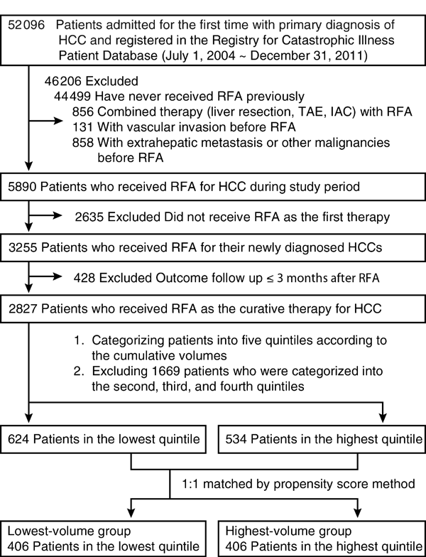
Figure 1: Flowchart of the selection of study patients. Data were compiled after adjustment for competing mortality. IAC = intra-arterial chemotherapy, TAE = transarterial embolization.
chronological number of patients who had undergone RFA by the responsible operator at the end of study period, and only one operator was responsible for each RFA procedure. In addition, hos- pital volume was considered another potential prognostic factor. Individual hospitals where RFA treatments were performed could be recognized, and annual hospital volume was defined as the median annual number of patients undergoing RFA treatments during the study period. Individual hospitals were further categorized into low- or high- volume hospitals according to the me- dian value of annual hospital volumes, and the influence of hospital volume was evaluated.

Measurement for Adverse Effects and
Outcomes
Potentially major RFA adverse effects were evaluated by means of red blood cell transfusion during hospitalization for the index RFA and a diagnosis of liver abscess (ICD-9 code 452.0) within
3 months after index RFA. HCC recur- rence was defined as any application of treatment modality for HCC recurrence (liver resection, percutaneous ethanol injection, RFA, transarterial emboliza- tion, or intra-arterial chemotherapy)

study, we only included patients who had undergone RFA as a primary treat- ment for HCC. Patients who underwent combination therapies (ie, combined with liver resection, transarterial em- bolization, or intra-arterial chemother- apy) with RFA were excluded. In addi- tion, we excluded patients with vascular invasion (ICD-9 codes 452, 453.0, and
453.2), extrahepatic metastasis, or other malignant tumor (ICD-9 codes
140–208).
Furthermore, patients who under- went RFA for newly diagnosed HCC were identified by excluding those who did not undergo RFA as the first ther- apy. By using the definition of curative RFA in our study (ie, no tumor recur- rence within 3 months after RFA), pa- tients who underwent RFA as a curative treatment were identified. Patients who underwent secondary RFA shortly after index RFA were also included, on the basis of the definition of curative RFA
applied in previous studies (25,26). For patients who underwent secondary RFA within 3 months after index RFA, curative RFA was defined as no tumor recurrence within 3 months after sec- ondary RFA.
According to cumulative operator volumes, patients were grouped into quintiles, and patients in the lowest or highest quintiles of cumulative opera- tor volumes were 1:1 matched accord- ing to the propensity score method as the lowest- or highest-volume groups, respectively. Propensity scores were measured by using a logistic model with age, sex, tumor sizes, underlying co- morbidities, and use of potentially che- moprotective drugs.

Measurement of RFA Volumes
Operator experience was evaluated by means of cumulative operator vol- ume. Cumulative operator volume for each operator was calculated as the
after the start date for outcome fol- low-up. In the definition of curative RFA in our study, the outcome was based on follow-up, which started from the date of curative RFA. The liver transplan- tation data were treated as censored. Patients in our cohort were followed up until the date of HCC recurrence, liver transplantation, death, or the date of December 31, 2011. Death was defined as withdrawal of the patient from the National Health Insurance program in Taiwan.

Prognostic Factor Assessment
Except for operator and hospital vol- umes, several important prognostic fac- tors were also evaluated. Tumor sizes were divided into three categories, as follows: smaller than 3 cm, 3–5 cm, and larger than 5 cm. Major coexisting dis- eases were evaluated according to ICD-
9 codes at or before index RFA, includ- ing hepatitis B virus (HBV) infection

VASCULAR AND INTERVENTIONAL RADIOLOGY: Operator Experience in Radiofrequency Ablation for Hepatocellular Carcinoma Lee et al

(codes 070.2, 070.3, and V02.61), hep- atitis C virus (HCV) infection (codes
070.41, 070.44, 070.51, 070.54, and
V02.62), alcoholic liver disease (codes
571.2 and 571.3), liver cirrhosis (code
571.5), liver decompensation (codes
789.5, 572.2, and 572.4), and diabetes mellitus (code 250).
Antiviral therapies, including any nucleos(t)ide analogue or interferon- based therapies for chronic hepatitis B or C infection, started during the observation period were analyzed to determine effects on outcomes. In ad- dition, certain potentially chemopre- ventive medications, including statins, nonsteroidal anti-inflammatory drugs (NSAIDs), aspirin, and metformin, were analyzed, and drug users were defined as patients who used more than one tab- let per month during the study period.

Statistical Analysis
Cumulative incidences for HCC re- currence after curative RFA were calculated, and death prior to HCC recurrence was considered to be a com- peting risk event. By using a modified Kaplan-Meier method and the Gray method (27), cumulative incidences in competing risk data ratios were com- pared. In addition, differences in the full time-to-event distributions between the lowest- and highest-volume groups were compared by using a modified log- rank test (20).
After adjusting for age, sex, tumor size, viral origins, cirrhosis, diabetes mellitus, and use of statins, NSAIDs, aspirin, or metformin, multivariable regression analyses were conducted to determine the independent prognostic factors for HCC recurrence, and haz- ard ratios (HRs) were also determined by means of modified Cox proportional hazard models in the presence of com- peting risk events. For the estima- tions of cumulative incidences within competing risk events, Cox models were conducted by using the “cmprsk” package for R (R Foundation, Vienna, Austria; http://cran.r-project.org/web/ packages/cmprsk/index.html). Other statistical analyses were performed by using SAS version 9.3 software (SAS In- stitute, Cary, NC).

Results

Baseline Demographic Characteristics of the Study Subjects

As shown in Figure 1, we initially iden- tified 52 096 potentially eligible patients with HCC who were admitted for the first time and registered in the Regis- try for Catastrophic Illness Patient Da- tabase between July 1, 2004, and De- cember 31, 2011. We further excluded
46 206 patients who never underwent RFA, who underwent combination ther- apy with RFA, and who were found to have vascular invasion, extrahepatic metastasis, or concurrent malignancies before or at the time of diagnosis of HCC. After these exclusions, 5890 pa- tients who underwent RFA for HCC were identified to calculate operator or hospital volumes.
Furthermore, after excluding 2635 patients for whom RFA was not the first therapy for HCC and 428 patients whose outcomes were followed up for less than
3 months, 2827 patients who underwent RFA as the curative therapy for newly di- agnosed HCC were identified. According to the cumulative operator volumes, pa- tients in the lowest or highest quintiles were matched for confounding factors. Finally, 406 patients were recruited in either the low-volume group or the high- volume group.
Baseline demographic characteris- tics, follow-up durations, comorbidities, and confounding drug use in the low- and high-volume groups are presented in Table 1. The cumulative operator volumes were 1–10 cases and 79–163 cases, respectively. The median value of annual hospital volumes was 22 cases, so hospitals with an annual hospital vol- ume of more than 22 cases were de- fined as high-volume hospitals. There were no differences in other prognostic factors between the two groups, includ- ing age, sex, levels of annual hospital volume, academic medical centers, tumor sizes, follow-up duration, un- derlying viral hepatitis, alcoholic liver disease, liver cirrhosis, liver decompen- sation, diabetes mellitus, renal failure, and use of antiviral therapy, metformin, statins, NSAIDs, or aspirin.
Potentially Major Adverse Effects, HCC Recurrence, and Overall Mortality
The red blood cell transfusion rate for the high-volume group was significantly lower than that of the low-volume group (8.4% vs 13.6%, P , .05), but the in- cidences of liver abscess formation within 3 months after RFA were similar in both groups (1.0% vs 0.5%, P = .68).
In total, 465 patients (57.3%) were found to have developed HCC recur- rence during the follow-up period: 251 (61.8%) and 214 (52.7%) in the low- and high-volume groups, respectively (P
, .01). Cumulative incidences of tumor recurrence in the low- and high-volume groups are shown in Figure 2. With a high percentage of patients with under- lying cirrhosis in this cohort study, 59 (14.5%) and 57 (14.0%) died before HCC recurrence in the low- and high- volume groups, respectively. After ad- justing for competing mortality, 5-year HCC recurrence rates for the low-vol- ume group were significantly higher than those of the high-volume group during the observation period (71.4% vs 65.8%, respectively; P , .05).
In total, 298 patients (36.7%) died during the follow-up period: 163 (40.1%) and 135 (33.2%) in the low- and high-volume groups, respectively (P
, .05). However, cumulative incidences of overall mortality in the low- and high- volume groups did not reach statistical significance (P = .15; Fig E1 [online]).

Multivariable Analysis of Prognostic
Factors
In the multivariable regression analysis for determining independent prognos- tic factors of HCC recurrence (Table 2), the highest cumulative operator volume (HR, 0.8; 95% confidence interval [CI]:
0.67, 0.97; P , .05), antiviral therapy (HR, 0.60; 95% CI: 0.47, 0.77; P , .01), and NSAIDs or aspirin use (HR, 0.80;
95% CI: 0.66, 0.97; P , .05) were as- sociated with a decreased risk of HCC recurrence. Meanwhile, HBV infection (HR, 1.64; 95% CI: 1.32, 2.04; P , .01) and HCV infection (HR, 1.35; 95% CI:
1.08, 1.70; P , .01) were associated with an increased risk of HCC recur- rence. However, high annual hospital

volume was not associated with a de- creased risk of HCC recurrence (HR,
0.87; 95% CI: 0.72, 1.05).

Multivariable Stratified Analyses in All
Subgroups of Patients
Multivariable stratified analysis was per- formed in all subgroups of patients, including age less than 70 years or at least 70 years, both sexes, low and high

annual hospital volume, tumor size less than 3 cm and at least 3 cm, HBV and HCV infections, antiviral therapy after RFA, alcohol liver disease, liver cirrho- sis, diabetes mellitus, and use of met- formin, statins, NSAIDs, or aspirin. The highest cumulative operator vol- ume was found to be associated with a reduced risk of HCC recurrence in almost all stratified analyses (Fig 3).
these limitations (13). Experience and technical skill of RFA may directly affect clinical outcomes.
Although hospital volume may also be an indicator of experience in oper- ation and has been reported to be in- versely associated with mortality rate in high-risk cancer surgeries, recent studies demonstrated that surgeon volume might be a more independent prognostic factor than hospital vol- ume (18,19). In a recent nationwide
These observations further confirmed the association between high cumula- tive operator volume and decreased risk of HCC recurrence in patients with HCC after curative RFA.

Discussion

In our study, tumor recurrence rates were significantly lower in the group of patients with the highest cumulative operator volume compared with rates in the group with the lowest cumulative operator volume, and cumulative oper- ator volume was an independent prog- nostic factor of HCC recurrence after curative RFA. The research to evaluate the influence of operator volume on the outcome of RFA treatment for HCC has been limited. The findings of our study support the hypothesis that cumulative experience of RFA operators could af- fect clinical outcomes. To improve the quality of RFA treatment, further stud- ies based on cumulative operator vol- ume are therefore warranted.
RFA is an energy-based heat abla- tion technique that produces cell co- agulation near the electrode, and sev- eral factors related to technique may be involved in the success of the RFA procedure. For example, complete tu- mor ablation may require RFA to be conducted by using overlapping abla- tion zones; therefore, good planning before performing RFA and a skilled technique in needle deployment are necessary (11,12). Additionally, per- forming RFA for tumors close to liver hilum or peripheral tumors adjacent to extrahepatic organs is especially chal- lenging (28,29), and experienced oper- ators may perform artificial ascites or artificial pleural effusion to overcome
Table 1
Baseline Characteristics of the Study Subjects Who Underwent RFA by Operators with
Low and High Cumulative RFA Volume

Low Operator Volume High Operator Volume
Characteristic (n = 406) (n = 406) P Value

RFA cumulative volume 1–10 79–163 … (cases)
Age (y)
Median* 67.4 (59.4–73.0) 67.4 (59.5–73.4) .72
Mean† 66.1 6 9.7 66.2 6 9.6 .84
Patient sex ..99
Men 241 (59.4) 242 (59.6) Women 165 (40.6) 164 (40.4)
High annual hospital volume 196 (48.3) 204 (50.2) .62 (.22 cases)
No. of patients in academic 232 (57.1) 215 (53.0) .26
medical centers
Follow-up duration (y)
Median* 2.6 (1.6–4.0) 2.5 (1.6–3.7) .62
Mean† 2.9 6 1.7 2.8 6 1.7 .67
Tumor size .98
,3 cm 256 (63.0) 254 (62.6)
3–5 cm 127 (31.3) 127 (31.3)
.5 cm 23 (5.7) 25 (6.2)
Viral origin .89
None 40 (9.8) 42 (10.3) HBV 138 (34.0) 128 (31.5) HCV 177 (43.6) 181 (44.6) HBV and HCV 51 (12.6) 55 (13.5)
Major coexisting diseases
Alcoholic liver disease 21 (5.2) 22 (5.4) ..99
Liver cirrhosis 287 (70.7) 285 (70.2) .94
Liver decompensation 48 (11.8) 48 (11.8) ..99
Diabetes mellitus 112 (27.6) 112 (27.6) ..99
Renal failure 16 (3.9) 15 (3.7) ..99
Drug users
Post-RFA antiviral therapy 72 (17.7) 69 (17.0) .75
Metformin 75 (18.5) 72 (17.7) .86
Statins 28 (6.9) 31 (7.6) .79
NSAIDs or aspirin 245 (60.3) 255 (62.8) .52

Note.—Unless indicated otherwise, data are number of patients, with percentages in parentheses.
* Numbers in parentheses are the 25%–75% interquartile range.
† Data are means 6 standard deviations.

VASCULAR AND INTERVENTIONAL RADIOLOGY: Operator Experience in Radiofrequency Ablation for Hepatocellular Carcinoma Lee et al

Table 2
Figure 2

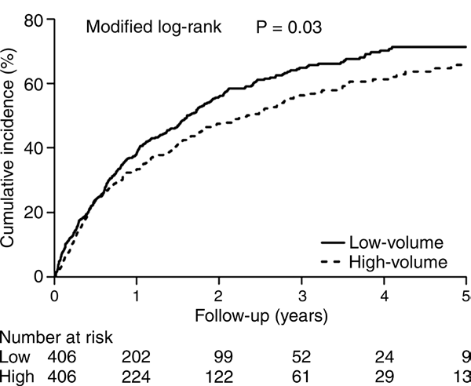
Figure 2: Graph of cumulative incidences of tumor recurrence according to cumulative operator volumes, based on follow-up from 3 months after RFA.
of esophagectomy for cancer, hospital volume was not associated with a de- creased mortality risk after adjustment for surgeon volume, but a survival ben- efit was found in favor of high-volume surgeons after adjustment for hospi- tal volume (18). In our study, we also found that annual hospital volume was not associated with HCC recurrence af- ter RFA, and operator volume may be a more precise indicator of operation experience.
It is important to note that opera- tor volume is not the only factor that affects outcomes. Compatible with the findings of previous studies, other in- dependent prognostic factors of RFA treatment were also observed in our study, such as HBV infection, HCV in- fection, post-RFA antiviral therapy, and use of NSAIDs or aspirin. For example, in our previous studies of patients with HCC who underwent liver resection,
HBV or HCV antiviral therapies and use

Multivariable Cox Proportional Hazards Model Analysis for Risk of HCC Recurrence
after Adjusting for Competing Mortality

Variable HR 95% CI P Value

Cumulative operator volume
Low volume 1 … … High volume 0.80 0.67, 0.97 ,.05
Age per year 1.01 1.00, 1.02 .26
Male sex 1.07 0.87, 1.31 .54
Annual hospital volume
Low volume (22 cases) 1
High volume (.22 cases) 0.87 0.72, 1.05 .14
Tumor size
,3 cm 1 … …
3–5 cm 1.05 0.85, 1.29 .65
.5 cm 1.15 0.74, 1.77 .54
Chronic viral infection
None 1 … … HBV 1.64 1.32, 2.04 ,.01
HCV 1.35 1.08, 1.70 ,.01
Alcoholic liver disease 1.11 0.69, 1.77 .67
Cirrhosis 1.01 0.83, 1.24 .91
Diabetes mellitus 1.24 0.96, 1.60 .10
Antiviral therapy 0.60 0.47, 0.77 ,.01
Metformin use 0.86 0.63, 1.16 .31
Statin use 0.72 0.49, 1.05 .08
NSAID or aspirin use 0.80 0.66, 0.97 ,.05
of NSAIDs or aspirin were associated with a lower risk of HCC recurrence (20,30). However, confounding fac- tors and bias might have existed in our study, such as immortal person-time bias that the treatment effect could be overestimated by selecting patients with shorter outcome follow-up dura- tion as the reference group. A causal relationship between drug use and clin- ical outcome cannot be inferred on the basis of the results of this observational study. However, the associations found in our study provide a basis for further studies, and well-controlled studies are mandatory for confirmation of our findings.
Some operators also performed RFA for other tumor types, such as metastatic tumors. Just as operator experience correlated with RFA perfor- mance for HCC, operators in the high- volume group also had more experience with performing RFA for other tumor types than those in the low-volume group during the study period (me- dian, 31.0 cases [25%–75% interquar- tile range, 24.0–47.0 cases] vs 1.0 case

Swedish cohort study of esophageal cancer surgery, surgeon volume rather than hospital volume independently influenced prognosis, and the results
indicated that hospital factors other than hospital volume itself, such as sur- geon volume, might influence the risk of mortality. In a recent meta-analysis
[25%–75% interquartile range, 0–2.0 cases]; P , .01). However, the origins of other tumor types varied, and the tu- mor characteristics could be different

Figure 3

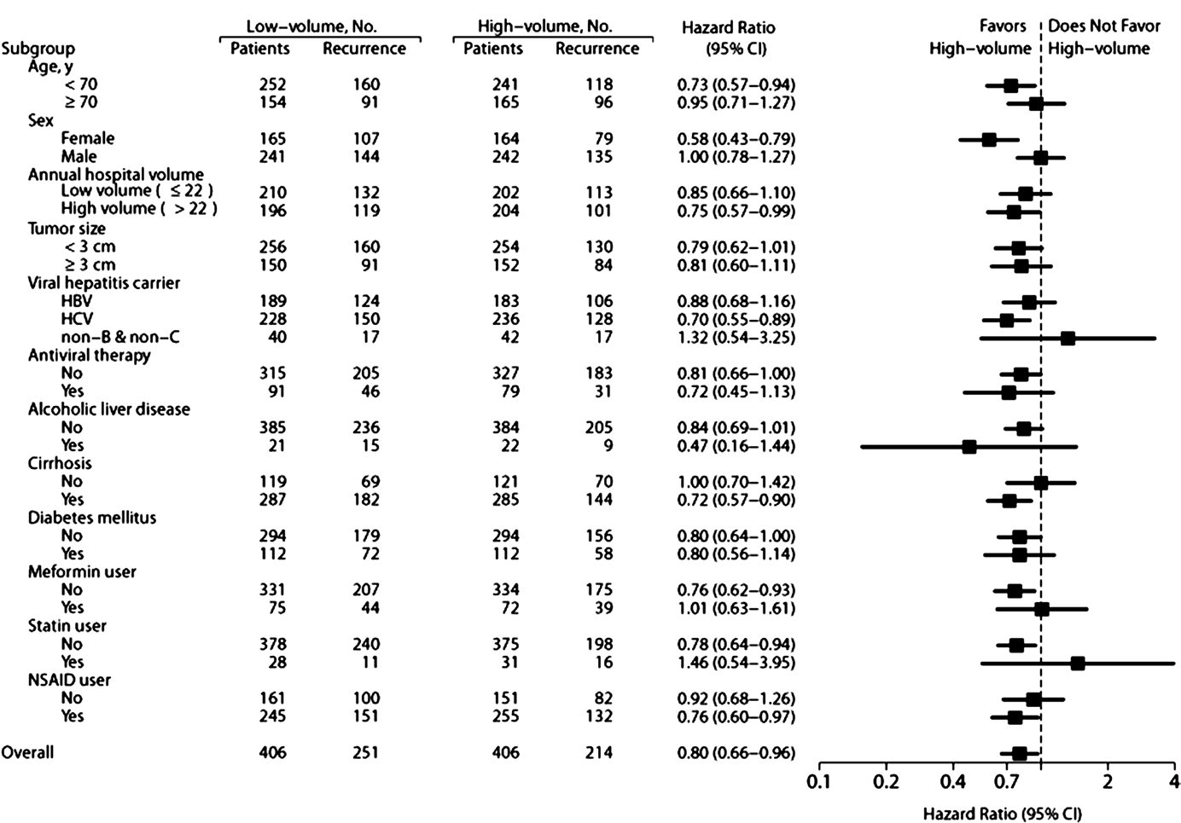
Figure 3: Multivariable stratified analyses for the association between cumulative operator volume and HCC recurrence.

from those of HCC. The main focus of our study was operator experience in performing potentially curative RFA for HCC, so we did not include the addi- tional experience of other tumor types in our study.
There were several limitations in our study. First, only one responsible operator could be verified for each RFA procedure in the NHIRD, but there were no available data on other supervisors or assistants. The high-volume operators might have supervised some procedures performed by low-volume operators, fel- lows, or residents, and the outcome dif- ferences between the two study groups could therefore have been underestimat- ed. Second, low-volume operators might have selected tumors that were easy to approach, and difficult-to-treat tumors
were usually treated by experienced operators. If difficult-to-treat tumors were treated by low-volume operators, the tumor recurrence rates might have been higher. The outcome differences between high- and low-volume operators may have been underestimated. Third, cumulative operator volumes were cal- culated at the end of the study period, and patients who underwent RFA in the early experience stage of high-volume operators were included in the high- volume group. The tumor recurrence rates of the high-volume group should have been underestimated, but the con- clusion of our study was not affected. Fourth, HCC recurrence was defined in our study as application of HCC therapy after curative RFA. It is possible that the HCC recurrence rates might have been
underestimated if, for example, a patient did not undergo further treatment for the tumor recurrence. However, the tu- mor burden in patients who underwent RFA as a curative treatment was likely limited; thus, the likelihood of rapid tu- mor progression to untreatable disease was probably minimal. Furthermore, patients in both groups were matched by the propensity score method, and the probability of this situation occurring should therefore be equal. Last, the min- imum requirement of cumulative opera- tor volume could not be interpreted in this retrospective association study, so further studies are warranted to address this important issue.
In conclusion, cumulative operator volume was significantly associated with decreased HCC recurrence after RFA,

VASCULAR AND INTERVENTIONAL RADIOLOGY: Operator Experience in Radiofrequency Ablation for Hepatocellular Carcinoma Lee et al

and the highest cumulative operator volume was an independent prognostic factor for tumor recurrence. Further studies based on cumulative operator volume would be helpful to improve RFA quality.

Disclosures of Conflicts of Interest: T.Y.L. dis- closed no relevant relationships. J.T.L. disclosed no relevant relationships. H.J.H. disclosed no relevant relationships. M.S.W. disclosed no rele- vant relationships. C.Y.W. disclosed no relevant relationships.

References
1. Ferlay J, Shin HR, Bray F, Forman D, Mathers C, Parkin DM. Estimates of world- wide burden of cancer in 2008: GLOBOCAN
2008. Int J Cancer 2010;127(12):2893–2917.

2. Altekruse SF, McGlynn KA, Reichman ME.
Hepatocellular carcinoma incidence, mortal- ity, and survival trends in the United States from 1975 to 2005. J Clin Oncol 2009;27(9):
1485–1491.

3. El-Serag HB, Mason AC. Rising incidence of hepatocellular carcinoma in the United States. N Engl J Med 1999;340(10):745–750.

4. El-Serag HB. Epidemiology of viral hepatitis and hepatocellular carcinoma. Gastroenter- ology 2012;142(6):1264–1273, e1.

5. Llovet JM, Bruix J. Novel advancements in the management of hepatocellular car- cinoma in 2008. J Hepatol 2008;48(Suppl
1):S20–S37.

6. Yeh YP, Hu TH, Cho PY, et al. Evaluation of abdominal ultrasonography mass screen- ing for hepatocellular carcinoma in Taiwan. Hepatology 2014;59(5):1840–1849.

7. European Association For The Study Of The Liver; European Organisation For Research And Treatment Of Cancer. EASL-EORTC clinical practice guidelines: management of hepatocellular carcinoma. J Hepatol
2012;56(4):908–943.

8. Bruix J, Sherman M; American Association for the Study of Liver Diseases. Manage- ment of hepatocellular carcinoma: an up- date. Hepatology 2011;53(3):1020–1022.

9. Feng K, Yan J, Li X, et al. A randomized con- trolled trial of radiofrequency ablation and surgical resection in the treatment of small hepatocellular carcinoma. J Hepatol 2012;
57(4):794–802.
10. Chen MS, Li JQ, Zheng Y, et al. A prospec- tive randomized trial comparing percutane- ous local ablative therapy and partial hepa- tectomy for small hepatocellular carcinoma. Ann Surg 2006;243(3):321–328.

11. Nishikawa H, Osaki Y, Iguchi E, et al. Ra- diofrequency ablation for hepatocellular carcinoma: the relationship between a new grading system for the ablative margin and clinical outcomes. J Gastroenterol 2013;
48(8):951–965.

12. Tombesi P, Di Vece F, Sartori S. Resection vs thermal ablation of small hepatocellular carcinoma: what’s the first choice? World J Radiol 2013;5(1):1–4.

13. Koda M, Murawaki Y, Hirooka Y, et al.
Complications of radiofrequency ablation for hepatocellular carcinoma in a multi- center study: an analysis of 16 346 treated nodules in 13 283 patients. Hepatol Res
2012;42(11):1058–1064.

14. N’Kontchou G, Mahamoudi A, Aout M, et al. Radiofrequency ablation of hepatocellular carcinoma: long-term results and prognostic factors in 235 Western patients with cirrho- sis. Hepatology 2009;50(5):1475–1483.

15. Shiina S, Tateishi R, Arano T, et al. Ra- diofrequency ablation for hepatocel- lular carcinoma: 10-year outcome and prognostic factors. Am J Gastroenterol
2012;107(4):569–577; quiz 578.

16. Lin SM, Lin CJ, Lin CC, Hsu CW, Chen YC.
Radiofrequency ablation improves prognosis compared with ethanol injection for hepa- tocellular carcinoma , or =4 cm. Gastroen- terology 2004;127(6):1714–1723.

17. Shau WY, Shao YY, Yeh YC, et al. Diabetes mellitus is associated with increased mor- tality in patients receiving curative therapy for hepatocellular carcinoma. Oncologist
2012;17(6):856–862.

18. Brusselaers N, Mattsson F, Lagergren J.
Hospital and surgeon volume in relation to long-term survival after oesophagectomy: systematic review and meta-analysis. Gut
2014;63(9):1393–1400.

19. Derogar M, Sadr-Azodi O, Johar A, Lager- gren P, Lagergren J. Hospital and surgeon volume in relation to survival after esoph- ageal cancer surgery in a population-based study. J Clin Oncol 2013;31(5):551–557.

20. Wu CY, Chen YJ, Ho HJ, et al. Association between nucleoside analogues and risk of hepatitis B virus–related hepatocellular car-
cinoma recurrence following liver resection. JAMA 2012;308(18):1906–1914.

21. Wu CY, Wu MS, Kuo KN, Wang CB, Chen YJ, Lin JT. Effective reduction of gastric cancer risk with regular use of nonste- roidal anti-inflammatory drugs in Helico- bacter pylori-infected patients. J Clin Oncol
2010;28(18):2952–2957.

22. Wu CY, Kuo KN, Wu MS, Chen YJ, Wang CB, Lin JT. Early Helicobacter pylori erad- ication decreases risk of gastric cancer in patients with peptic ulcer disease. Gastro- enterology 2009;137(5):1641–1648, e1–e2.

23. Wu CY, Chan FK, Wu MS, et al. Hista- mine2-receptor antagonists are an alterna- tive to proton pump inhibitor in patients receiving clopidogrel. Gastroenterology
2010;139(4):1165–1171.

24. Chen HP, Shieh JJ, Chang CC, et al. Met- formin decreases hepatocellular carci- noma risk in a dose-dependent manner: population-based and in vitro studies. Gut
2013;62(4):606–615.

25. Lin SM, Lin CJ, Lin CC, Hsu CW, Chen YC.
Randomised controlled trial comparing per- cutaneous radiofrequency thermal ablation, percutaneous ethanol injection, and percu- taneous acetic acid injection to treat hepa- tocellular carcinoma of 3 cm or less. Gut
2005;54(8):1151–1156.

26. Livraghi T, Goldberg SN, Lazzaroni S, Mel- oni F, Solbiati L, Gazelle GS. Small hepa- tocellular carcinoma: treatment with radio- frequency ablation versus ethanol injection. Radiology 1999;210(3):655–661.

27. Gray RJ. A class of K-sample tests for com- paring the cumulative incidence of a com- peting risk. Ann Stat 1988;16(3):1141–1154.

28. Teratani T, Yoshida H, Shiina S, et al. Ra- diofrequency ablation for hepatocellular carcinoma in so-called high-risk locations. Hepatology 2006;43(5):1101–1108.

29. Lu DS, Raman SS, Limanond P, et al. Influ- ence of large peritumoral vessels on outcome of radiofrequency ablation of liver tumors. J Vasc Interv Radiol 2003;14(10):1267–1274.

30. Hsu YC, Ho HJ, Wu MS, Lin JT, Wu CY.
Postoperative peg-interferon plus ribavirin is associated with reduced recurrence of hepatitis C virus-related hepatocellular car- cinoma. Hepatology 2013;58(1):150–157.

