Abstract: The diastereoselective synthesis of 4-hydroxy-3-keto-2,6-disubstituted-cyclohex-3-ene-1,1-dicarbonitriles has been developed through domino double Michael addition of 1-hydroxy-1,5-disubstituted-1,4-dien-3-ones to 2-alkylidene malononitriles catalyzed by triethylamine. This simple domino process affords a variety of highly functionalized 4-hydroxy-3-keto-cyclohex-3-enes, some of which are not easily accessible using other methodologies, in moderate to good yields and excellent diastereselectivities (dr > 95: 5). Thus, the generality of this process and feasibility of introducing bioactive moieties make the reaction highly valuable in the synthetic and medicinal chemistry.
Base-Catalyzed Domino Double Michael Reactions of 1-Hydroxy-1,4-dien-3-ones and 2-Alkylidene Malononitriles: A Diastereoselective Route to Polysubstituted 4-Hydroxy-3-keto-cyclohex-3-ene
Yeong-Jiunn Jang,^{[a,b]} Yu-Shan Chen,^{[a]} Chia-Jui Lee,^{[a]} Chi-Han Chen^{[a]} and Wenwei Lin*^{[a]}
ª Department of Chemistry, National Taiwan Normal University, No. 88, Sec. 4, Tingchow Road, Taipei, Taiwan 11677, R.O.C.
^{b} School of Pharmacy, College of Pharmacy, China Medical University, No.91 Hsueh-Shih Road, Taichung, Taiwan 40402, R.O.C., and Chinese Medicine Research and Development Center, China Medical University Hospital, No.2 Yuh-Der Road, Taichung, Taiwan 40447, R.O.C.
Fax: +886-2-2932-4249.
E-mail: wenweilin@ntnu.edu.tw.
Key words: Domino reaction, Michael addition, Diastereoselectivity, Cyclohexanone, Curcumin

The construction of suitably functionalized cyclohexanones and related cyclohexanol skeletons plays a central role in many natural product syntheses due to their significant biological and pharmaceutical importance.^{[1]} In literature reports, lots of methods for synthesizing substituted cyclohexanones have arisen from different approaches, such as [4+2]-cycloadditions,^{[2]} Rh(I)-catalyzed Pauson-Khand reactions,^{[3]} Pd-catalyzed intramolecular hydroalkylation,^{[4]} organocatalyzed domino annulations,^{[5]} and reductive tandem double Michael cascades,^{[6a]} highlighting the continued concern of these frameworks from the synthetic community. In particular, domino processes have been found as powerful strategies for the construction of complex molecular skeletons by simultaneous formation of two or more bonds from simple materials in a one-pot manner.^{[7]} These benefits are of particular interest in pharmaceutical research for the building of libraries of biologically active compounds. Therefore, developing novel domino reactions for preparation of structurally diverse chemical libraries of polyfunctional compounds remains the interest of synthetic chemists. In this field, the usefulness of sequential Michael additions has been demonstrated,^{[8]} and domino Michael reactions have especially emerged as one of the most potent tools for the synthesis of various important cyclic building blocks during recent decades.
It is well documented that Michael reactions of chalcones with active alkenes such as nitroolefins and 1,5-disubstituted-1,4-pentadien-3-ones with active methylene substrates such as malononitrile and 1,3-dicarbonyl compounds have long been employed to prepare highly substituted cyclohexanones, while chalcones serve both as the starting Michael donor and ending acceptor in domino double Michael reactions (Scheme 1, type 1) and bischalcones as the Michael acceptors twice in the reaction course (type 2). Recently, curcumin and its derivatives, also bischalcones, are reported to have chalcone-like behavior and used to build substituted cyclohexanones with nitroolefin and chalcone (type 3).^{[6b-c]} Although, there are several reports with β-keto-ester-chalcones,^{[9]} to the best of our knowledge, so far no results have been reported in literature for highly functionalized syntheses of 4-hydroxy-3-keto-cyclohex-3-enes with β-keto-chalcones (1-hydroxy-1,4-dien-3-ones) both as the starting Michael donor and ending acceptor in domino double Michael reactions (type 4).

Scheme 1 Domino Double Michael Reactions for Constructing Cyclohexanones
Herein, we disclose that only trans-isomers of 4-hydroxy-3-keto-2,6-disubstituted-cyclohex-3-ene-1,1-dicarbonitriles 3 could be efficiently synthesized in good yields with excellent diastereoselectivities through domino Michael additions of 1-hydroxy-1,4-dien-3-ones 1 with 2-alkylidene malononitriles 2 catalyzed by triethylamine in this context.
Starting materials, 1-hydroxy-1,4-dien-3-ones 1, were readily prepared by benzoylation of methyl vinyl ketones and acid chlorides with LDA.^{[10]} Initially, to identify the optimal reaction condition, a representative reaction affording 3aaa was investigated in the presence of different bases in CH₂Cl₂ (DCM) at 30 ºC. First of all, the reaction of 1aa with 1.2 equiv of 2-benzylidenemalononitrile (2a), in the presence of piperidine as base catalyst (20 mol %) in 2 d, afforded 85% NMR yield of 3aaa (Table 1, entry 1). The reaction was then performed in the presence of pyrrolidine and DMAP, which led to a noticeable decrease in the yield of 3aaa to 72% and 70% respectively and 11% remaining of 1aa (entries 2-3). The reaction completely failed to occur when pyridine was used as base (entry 4). The representative reaction was then carried out in the presence of triethylamine (TEA) which led to slight enhancement in the yield (91%) without any remains of 1aa within 22 h (entry 5). DABCO gave moderate yield (69%), whereas traced reaction was observed with 4-methylmorpholine (entries 6 and 7). From these results, TEA emerged as the best choice of base for the domino reaction. Having determined the optimal base for the reaction, investigating the choice of a suitable solvent was performed. From the results in Table 1, DCM was revealed as the best solvent which furnished maximum yield of the product (entries 8-15 vs. 5). Incidentally, higher temperature (60 ºC) in 1,2-dichloroethane (1,2-DCE) or toluene resulted in only somewhat faster reaction rate or higher yield and exhibited the low temperature dependence on the reactions (entries 10 vs. 9 or 14 vs. 13). The ideal conditions thus established above were then applied to the synthesis of a library of novel 4-hydroxy-3-keto-2,6-disubstituted-cyclohex-3-ene-1,1-dicarbonitriles 3 via the domino double Michael reactions of 1-hydroxy-1,4-dien-3-ones 1 and 2-alkylidene malononitriles 2 as follows.

Table 1 Condition Screening for the Formation of Cyclohexanone 3 via Domino Double Michael Reactions of 1aa and 2a^{[a]}

Entry | Cat. | Solv. | T (ºC) | Time (d) | 3aaa/1aa (%)^{[b]}
1 | Piperidine | DCM | 30 | 2 | 85/0
2 | Pyrrolidine | DCM | 30 | 2 | 72/11
3 | DMAP | DCM | 30 | 2 | 70/11
4 | Pyridine | DCM | 30 | 1 | nr
5 | TEA | DCM | 30 | 22 h | 91/0
6 | 4-Methylmorpholine | DCM | 30 | 2 | 8/82
7 | DABCO | DCM | 30 | 2 | 69/13
8 | TEA | CHCl₃ | 30 | 1 | 74/11
9 | TEA | DCE | 30 | 1 | 79/2
10 | TEA | DCE | 60 | 18 h | 79/2
11 | TEA | THF | 30 | 1 | 58/11
12 | TEA | CH₃CN | 30 | 1 | 80/0
13 | TEA | Toluene | 30 | 1 | 20/68
14 | TEA | Toluene | 60 | 1 | 26/51
15 | TEA | Xylenes | 30 | 1 | 21/66
[a] Unless stated otherwise, all the reaction were carried out using 1aa (0.25 mmol) and 2a (0.3 mmol, 1.2 equiv) in the presence of catalyst (20 mol%) in the corresponding ACS-grade solvent (2 mL) at 30 ºC. [b] NMR analysis: a known amount of Ph₃CH was added to the crude products and used as internal reference for determination of yields of products and remaining starting materials.

With the optimum conditions in hand, we explored the scope and limitation of this route to highly functionalized 4-hydroxy-3-keto-cyclohex-3-enes 3 by changing the substitution pattern of 2 to modify the nature of the double bond. The reactions proceeded with excellent diastereoselectivities, leading to the formation of the corresponding 3 in single diastereomer. The trans-conﬁguration of the 2,6-disubstitutions of 3aaa was conﬁrmed by X-ray crystallography.^{[11]} These results are depicted in the Table 2. Various electron-poor and -rich R¹ substituents of 2 were all well-tolerated when reacting with 1aa. In general, reactions with electron-withdrawing R¹ substituents no matter at ortho- or para-position of 2 (entries 4-7 vs. 8) or with steric hindered R¹ substituents (entries 2-3 vs. 8) uniformly proceeded to give similar results to that of phenyl substituent (entry 1), but it had large impact on the reaction time while electron-donating R¹ substituent was at para-position even stoichiometric 2h was forced to be consumed by excess 1aa (entry 8). Heteroaryl motifs such as 2i-k were successfully incorporated, and a similar trend was obtained in 60-79% yields within 9 h to 4 d as well (entries 9-11). Additionally, it should be noted that indole and coumarin are valuable building blocks found in numerous biologically active natural products and pharmacologically relevant therapeutic agents.^{[12-14]} Molecules containing these scaffolds exhibit a broad range of bioactivities. Therefore, in view of substrate scope, they were also introduced into our method for expanding the library of 3. Remarkably, they were successfully installed on the skeletons (entries 12-13 and 16), which provided a high possibility of generating interesting bioactivities of the corresponding 3. However, other attempts to react aliphatic R¹ substituent under the standard conditions gave unsatisfied results, even in a prolonged reaction time (entries 14 and 15). Furthermore, only keto-form product (entry 15)^{[15]} was surprisingly generated without any enol product when R¹ was tert-butyl group (2o) because the intramolecular hydrogen bonding of keto and enol residues was twisted and corrupted due to the steric hindrance between R¹ (tert-butyl) and R² (phenyl) groups in the product. Obviously, the substituents at R¹ and interactions between R¹ and R² have large influence not only on the yield and rate but also on the product distribution.

Table 2 Domino Double Michael Reactions of 1aa and R¹-Substituted 2^{[a]}

Entry | R¹ (2) | Time (h) | Yield of 3 (%)^{[c]}
1 | Ph (2a) | 22 | 3aaa, 87
2 | 1-Naphthyl (2b) | 24 | 3aab, 85
3 | 2-Naphthyl (2c) | 16 | 3aac, 77
4 | 4-ClC₆H₄ (2d) | 16 | 3aad, 80
5 | 4-BrC₆H₄ (2e) | 16 | 3aae, 77
6 | 2-ClC₆H₄ (2f) | 24 | 3aaf, 76
7 | 2-BrC₆H₄ (2g) | 9 | 3aag, 75
8^{[d]} | 4-MeOC₆H₄ (2h) | 96 | 3aah, 74
9 | 2-Thiophenyl (2i) | 96 | 3aai, 79
10 | 2-Furyl (2j) | 72 | 3aaj, 60
11 | 3-Pyridinyl (2k) | 9 | 3aak, 72
12 | 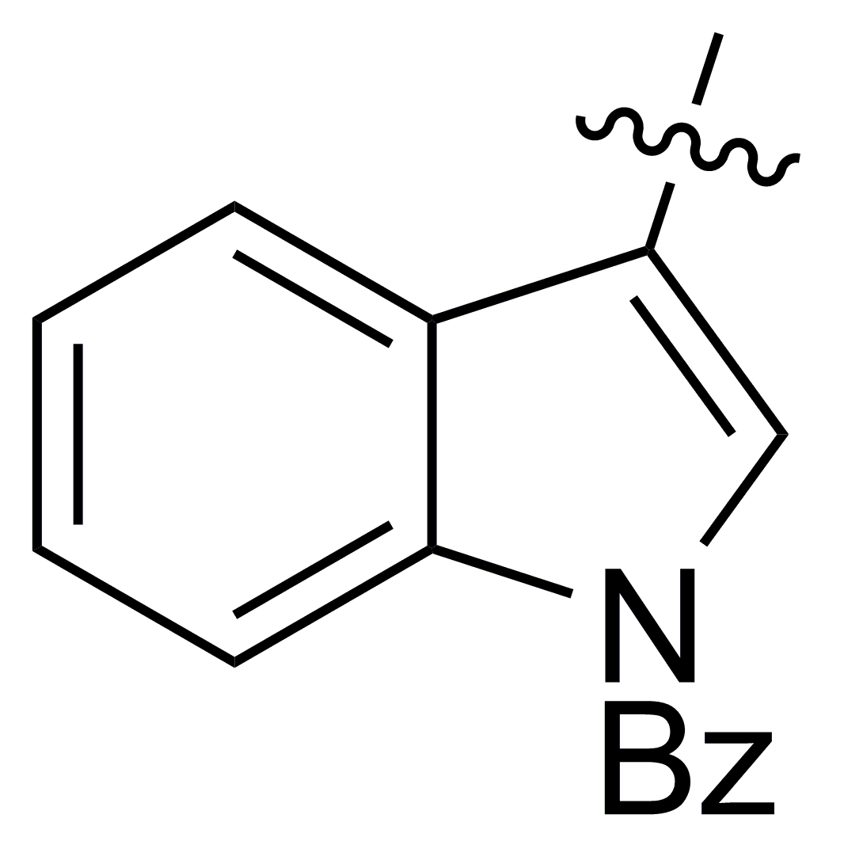  (2l) | 48 | 3aal, 62
13 | 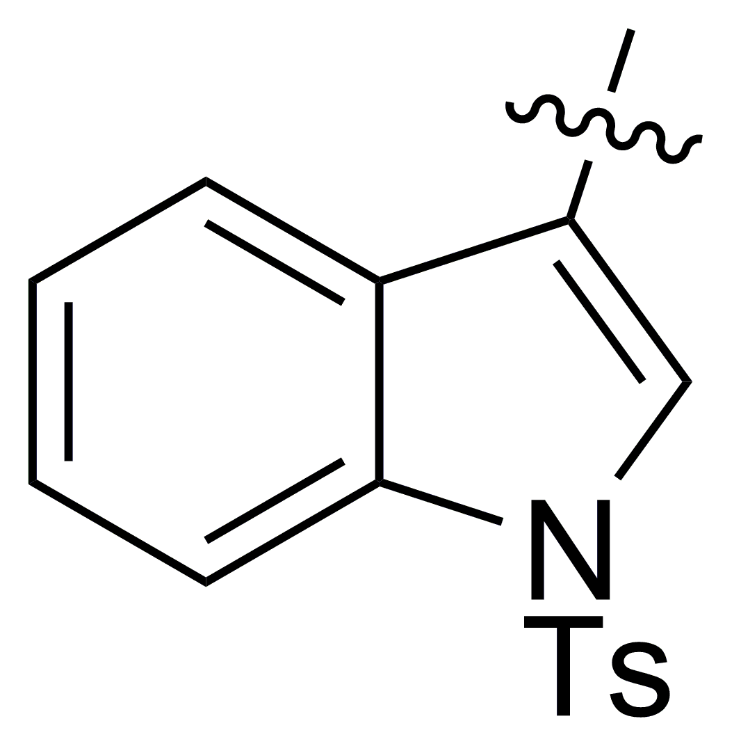  (2m) | 48 | 3aam, 60
14 | i-Propyl (2n) | 72 | 3aan, 20
15 | t-Butyl (2o) | 144 | 3aao-keto, 37
16 | 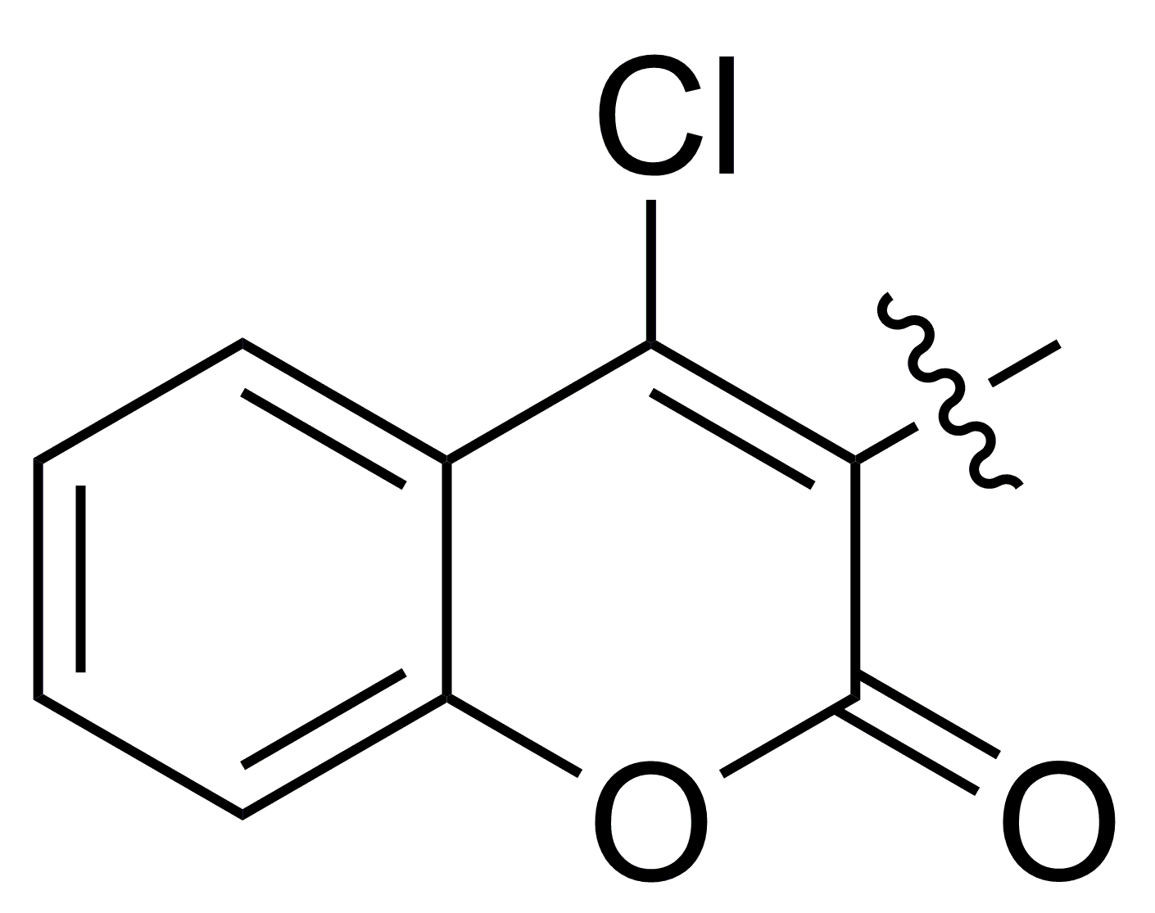  (2p) | 24 | 3aap, 66
[a] Unless stated otherwise, all the reaction were carried out using 1aa (0.25 mmol) and 2 (0.3 mmol, 1.2 equiv) in the presence of TEA (20 mol%) in DCM (2 mL) at 30 ºC. [b] Measured by ¹H NMR analysis of crude reaction mixture. [c] Isolated yield. [d] The reaction were carried out using 1aa (0.3 mmol, 1.2 equiv) and 2h (0.25 mmol) in the presence of TEA (20 mol%) in DCM (2 mL) at 30 ºC.

Under the optimized conditions, the scope of this new domino double Michael reaction was next examined using various 1-R²-5-phenyl-substituted 1 which were prepared from benzylideneacetone and various readily available acid chlorides (Table 3).^{[10]} It was pleasing to ﬁnd that most reactions afforded the corresponding products in good yields and with excellent diastereoselectivities. When the R² functionality contained an electron-withdrawing group (EWG), the desired product was achieved with good efﬁciency, relatively higher yields, while only medium yield was observed with an electron-donating group (EDG) which inactivated the production of nucleophilic enolate (Scheme 2, Intermediate Ⅰ) and therefore retarded the first addition step (entries 1-2 vs. 3). These results indicated that the electronic properties of R² played an important role in the whole process and was especially beneficial to the first Michael reaction. Furthermore, heteroaryl motifs such as 1ae-af were successfully incorporated, and similar results were obtained in 81-85 % yields as well (entries 4 and 5). The reactions of aliphatic R² were also examined (entries 6 and 7), and the corresponding products were produced smoothly with signiﬁcant increase both in yields and reaction rates while steric effects were not involved in. On the other hand, when steric hindered R² was investigated (entry 8), a noticeable decrease in reaction rate and yield was found in comparison with those of EWG (entries 8 vs. 1-2), but remarkably it was still better than that of EDG (entries 8 vs. 3). It is interesting that electronic effect at R² has a larger influence on the yield and rate than steric effect. Similarly, it was found that the keto-form product was once again in the majority when R² was tert-butyl group (entry 8),^{[16]} and it was resulted from the steric hindrance between R² (tert-butyl) and R¹ (phenyl) groups in the product which were just in the reversed roles of substituents compared with 3aao (Table 2, entry 15).
Table 3 Domino Double Michael Reactions of 2a and R²-Substituted 1^{[a]}

Entry | R² (1) | Time (h) | Yield of 3 (%)^{[c]}
1 | 4-ClC₆H₄ (1ab) | 24 | 3aba, 77
2 | 4-BrC₆H₄ (1ac) | 24 | 3aca, 78
3 | 4-MeOC₆H₄ (1ad) | 24 | 3ada, 39
4 | 2-Thiophenyl (1ae) | 12 | 3aea, 81
5 | 2-Furyl (1af) | 8 | 3afa, 85
6 | n-Ethyl (1ag) | 8 | 3aga, 88
7 | i-Propyl (1ah) | 13 | 3aha, 94
8 | t-Butyl (1ai) | 48 | 3aia-enol, 18  3aia-keto, 55
[a] Unless stated otherwise, all the reaction were carried out using 1 (0.25 mmol) and 2a (0.3 mmol, 1.2 equiv) in the presence of TEA (20 mol%) in DCM (2 mL) at 30 ºC. [b] Measured by ¹H NMR analysis of crude reaction mixture. [c] Isolated yield.

To thoroughly extend the generality of this method, many 1-phenyl-5-R³-substituted 1 which were synthesized from benzoyl chloride and several methyl vinyl ketones readily prepared through the Aldol condensation or the Wittig reaction were tested and the results were summarized in Table 4. To our delight, a wide variety of functionalized 3 were constructed in medium to good yields and with excellent diastereoselectivities. Similar yields and rates were afforded no matter electron-rich, -poor, or heteroaryl motifs were involved. It suggested that 5-R³-substitutes of 1 had less influence on the overall reactivity as compared with R¹ and R²-substitutes and the second addition step on the conjugated ketone was too fast to be retarded by R³-substitutes due to intramolecular addition. Inspired by ideas in Table 2, indolyl motifs were also successfully introduced and provided similar results to other heteroaryl motifs in this position (entries 7-8 vs. 4-6).

Table 4 Domino Double Michael Reactions of 2a and R³-Substituted 1^{[a]}

Entry | R³ (1) | Time (h) | Yield of 3 (%)^{[c]}
1 | 4-ClC₆H₄ (1ba) | 12 | 3baa, 68
2 | 4-BrC₆H₄ (1ca) | 12 | 3caa, 75
3 | 4-MeOC₆H₄ (1da) | 12 | 3daa, 72
4 | 2-Thiophenyl (1ea) | 14 | 3eaa, 66
5 | 2-Furyl (1fa) | 24 | 3faa, 65
6 | 3-Pyridinyl (1ga) | 12 | 3gaa, 59
7 | 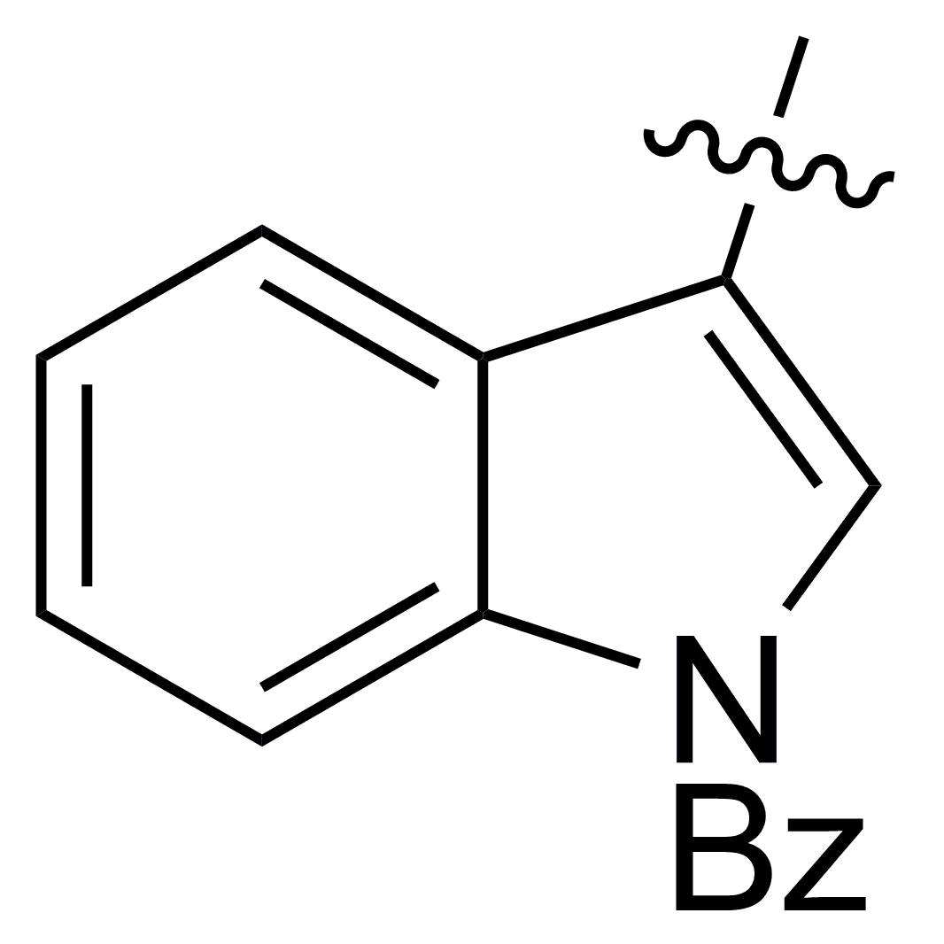  (1ha) | 24 | 3haa, 70
8 | 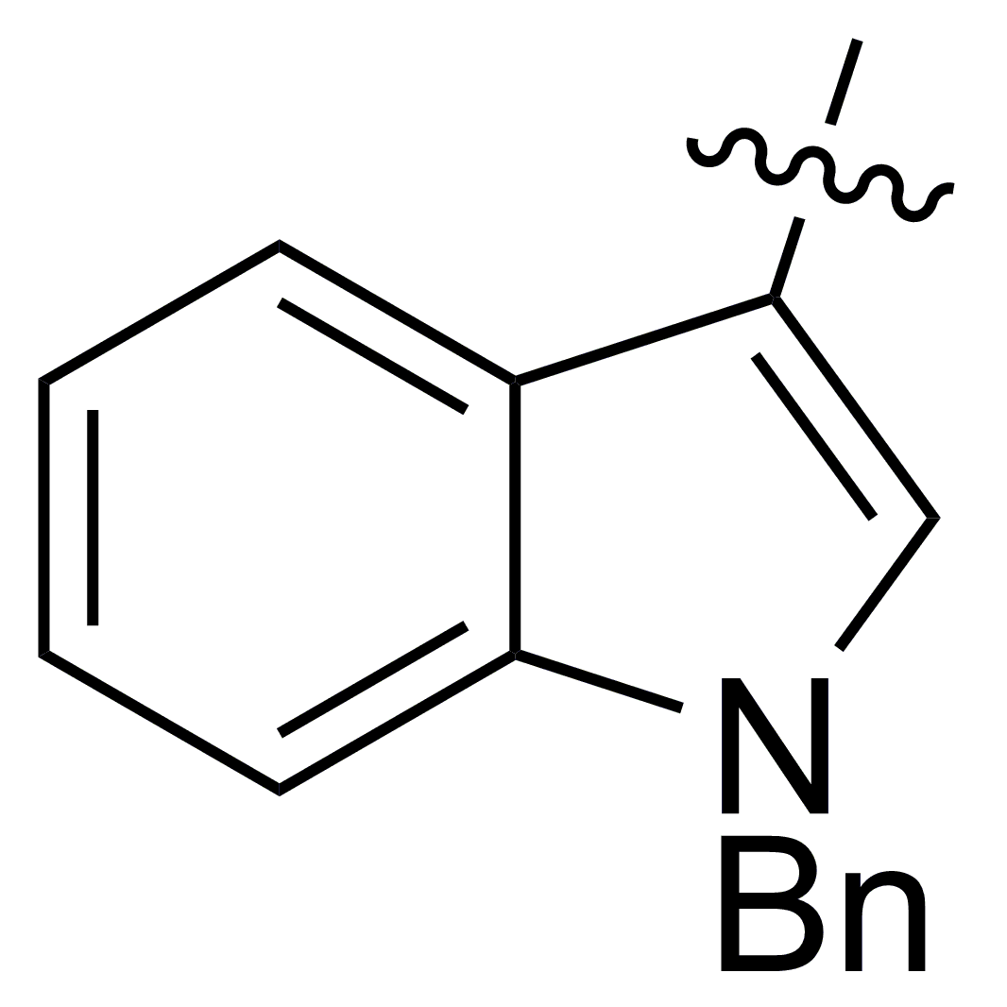  (1ia) | 24 | 3iaa, 66
[a] Unless stated otherwise, all the reaction were carried out using 1 (0.25 mmol) and 2a (0.3 mmol, 1.2 equiv) in the presence of TEA (20 mol %) in DCM (2 mL) at 30 ºC. [b] Measured by ¹H NMR analysis of crude reaction mixture. [c] Isolated yield.

Scheme 2. Proposed Mechanism for the Formation of 3 from 1

In addition, scope of the work was further extended to the one-pot manner due to the easy and mild preparation of 2. To study this proposal, 1aa was treated with benzaldehyde and malononitrile in the presence of TEA under similar conditions, and it’s delightful to ﬁnd that the corresponding product 3aaa as the only diastereomer was afforded in similar yield to that in a stepwise reaction though a prolonged reaction time was necessary (Scheme 3 vs. Table 2, entry 1). On the other hand, it was worth to mention that such highly functional products 3 were conveniently generated for the first time from commercially available materials in a one-pot and multicomponent reaction comparing to literature reports.^{[2-6]}

Scheme 3. Preparation of 3aaa from Benzaldehyde and Malononitrile in a One-pot Manner.^{[a]} ([a] The reaction was carried out using 1aa (0.25 mmol), benzaldehyde (1.2 equiv) and malononitrile (1.2 equiv) in the presence of TEA (20 mol%) in DCM (2 mL) at 30 ºC. [b] Isolated yield. [c] Measured by ¹H NMR analysis of crude reaction mixture.)

Pleased by results so far we turned our attention to the synthetic application related to the introduction of more functionalities on the carbocycles, and it would be definitely attractive to apply our method to compounds existing in nature or owning interesting bioactivities. For this purpose, curcumin related derivatives 4a and 4b were prepared to react with 2a under typical conditions. To our delight, our method can be used directly as expected and was straightforward to culminate in an excellent diastereoselective synthesis of very highly functionalized ortho-chalcony-cyclohexanones 5aa (65%) and 5ba (75%) in 12 h (Scheme 4). Moreover, chalcones represent a very important and enormous class of natural compounds which display interesting biological activities, and recent research suggests that the development of hybrid compounds through the combination of different pharmacophores may lead to molecules with interesting proﬁles. Based on these criterions, our methodology allowed practical and versatile functionalization indeed, which made it attractive from a medicinal chemistry point of view.

Scheme 4. Domino Double Michael Reactions on Curcumin Related Derivatives 4a and 4b

In summary, we have developed a novel domino method to construct highly functionalized cyclohexanone derivatives via a double Michael reaction of 1-hydroxy-1,4-dien-3-ones and 2-alkylidene malononitriles. The attractive features of this process are the practicability and the mild reaction conditions, which provide a series of cyclohexanone derivatives in moderate to good yields with extremely high diastereoselectivities. In addition, considering the high functional group tolerance of our method, this protocol should as well offer an efficient and stereoselective entry to structurally more diverse, bioactive and potentially pharmacological compounds. Current efforts are focused in two categories in order to: [1] broaden the substrate scopes and study substrates other than methylenemalononitrile such as α-cyanocinnamate, and [2] develop new applications to this versatile methodology especially for the asymmetric synthesis of valuable compounds. Further results under investigation in these areas will be reported in due course.
General Procedure for the Synthesis of 3 or 5. In an ordinary vial equipped with a magnetic stirring bar, compounds 1 or 4 (0.25 mmol), 2 (0.3 mmol, 1.2 equiv) and triethylamine (20 mol %, 0.05 mmol) were dissolved in 2.0 mL of CH₂Cl₂ and stirred at 30 ºC. After the completion of the reaction, the mixture was subjected directly to flash column chromatography on silica gel to purify the corresponding products 3 or 5.
3aaa: White solid, 87.9 mg, yield 87%, R_{f} 0.21 (DCM/hexanes: 2/3); 100% enol form; mp 248.3-249.2 °C; ¹H-NMR (400 MHz, CDCl₃) δ/ppm: 16.41 (s, 1H), 7.44-7.34 (m, 7H), 7.34-7.29 (m, 2H), 7.30 (t, 1H, J = 7.6 Hz), 7.16-7.09 (m, 2H), 7.01 (d, 2H, J = 7.9 Hz), 4.52 (s, 1H), 3.47 (dd, 1H, J = 11.7, 6.2 Hz), 3.32 (dd, 1H, J = 19.7, 11.7 Hz), 3.10 (dd, 1H, J = 19.6, 6.2 Hz). ¹³C-NMR (100 MHz, CDCl₃) δ/ppm: 196.7, 182.3, 136.5, 135.9, 135.0, 130.7, 130.2, 129.5, 129.3, 129.2, 128.9, 128.32, 128.3, 126.1, 114.4, 113.1, 105.4, 49.1, 44.4, 40.2, 34.7. MS (70 eV, EI) m/z (%): 404 [M]⁺ (10), 250 (30), 232 (15), 155 (18), 105 (100), 77 (70). IR (KBr) $\tilde{ν}$(cm⁻¹): 3448 (s), 3059 (w), 2374 (w), 1608 (s), 1458 (w), 1240 (m), 702 (s). HRMS (APCI-TOF) for C₂₇H₂₀N₂O₂Na, [M+Na]⁺ (427.1422) found: 427.1415.
3aab: White solid, 96.5 mg, yield 85%, R_{f} 0.18 (DCM/hexanes: 2/3); 100% enol form; mp 152.9-153.8 °C; ¹H-NMR (400 MHz, CDCl₃) δ/ppm: 16.21 (s, 1H), 7.88 (d, 1H, J = 8.2 Hz), 7.80 (d, 1H, J = 8.1 Hz), 7.60 (d, 1H, J = 8.6 Hz), 7.53 (t, 1H, J = 7.68 Hz), 7.46-7.37 (m, 2H), 7.37-7.29 (m, 6H), 7.09 (t, 1H, J = 7.5 Hz), 6.94 (t, 2H, J = 7.7 Hz), 6.83 (d, 2H, J = 7.4 Hz), 5.55 (s, 1H), 3.73 (dd, 1H, J = 11.8, 6.1 Hz), 3.39 (dd, 1H, J = 19.8, 11.9 Hz), 3.16 (dd, 1H, J = 19.8, 6.1 Hz). ¹³C-NMR (100 MHz, CDCl₃) δ/ppm: 198.0, 180.6, 136.6, 135.0, 133.7, 132.7, 131.7, 130.3, 130.0, 129.5, 129.1, 128.8, 128.7, 128.4, 128.2, 126.4, 126.3, 125.5, 124.5, 122.8, 114.8, 112.9, 106.8, 43.2, 43.1, 40.5, 34.2. MS (70 eV, EI) m/z (%): 454 [M]⁺ (45), 205 (40), 105 (100), 77 (50). IR (KBr) $\tilde{ν}$(cm⁻¹): 3448 (s), 3055 (w), 2369 (w), 1598 (s), 1406 (m), 1295 (m), 701 (s). HRMS (ESI-TOF) for C₃₁H₂₂N₂O₂Na, [M+Na]⁺ (477.1579) found: 477.1581.
3aac: Yellow solid, 87.5 mg, yield 77%, R_{f} 0.41 (DCM/hexanes: 1/1); 100% enol form; mp 193.6-194.4 °C; ¹H-NMR (500 MHz, CDCl₃) δ/ppm: 16.54 (s, 1H), 7.88 (d, 1H, J = 7.2 Hz), 7.85 (d, 2H, J = 8.5 Hz), 7.61 (s, 1H), 7.60-7.54 (m, 2H), 7.40-7.32 (m, 4H), 7.32-7.27 (m, 2H), 7.25-7.20 (m, 3H), 7.00 (t, 2H, J = 7.6 Hz), 4.87 (s, 1H), 3.54 (dd, 1H, J = 11.7, 6.4 Hz), 3.37 (dd, 1H, J = 19.9, 11.7 Hz), 3.18 (dd, 1H, J = 19.9, 6.4 Hz). ¹³C-NMR (125 MHz, CDCl₃) δ/ppm: 196.6, 182.6, 136.4, 134.9, 133.6, 133.4, 132.9, 130.8, 129.9, 129.5, 129.2, 128.8, 128.4, 128.33, 128.28, 127.8, 127.3, 127.2, 126.9, 126.2, 114.4, 113.2, 105.5, 49.2, 44.4, 40.4, 34.8. MS (70 eV, EI) m/z (%): 454 [M]⁺ (40), 205 (15), 105 (100), 77 (95). IR (KBr) $\tilde{ν}$(cm⁻¹): 3448 (s), 3055 (w), 2369 (w), 1612 (s), 1413 (w), 1241 (s), 700 (s). HRMS (ESI-TOF) for C₃₁H₂₁N₂O₂, [M-H]⁻ (453.1603) found: 453.1594.
3aad: White solid, 87.8 mg, yield 80%, R_{f} 0.43 (DCM/hexanes: 1/1); 100% enol form; mp 153.4-154.2 °C; ¹H-NMR (400 MHz, CDCl₃) δ/ppm: 16.35 (s, 1H), 7.45-7.37 (m, 4H), 7.37-7.28 (m, 6H), 7.04 (dd, 4H, J = 11.6, 8.6 Hz), 4.51 (s, 1H), 3.42-3.27 (m, 2H), 3.10 (dd, 1H, J = 18.4, 4.9 Hz). ¹³C-NMR (100 MHz, CDCl₃) δ/ppm: 196.9, 182.0, 136.4, 135.5, 134.7, 134.5, 131.4, 130.8, 129.6, 129.3, 129.1, 128.5, 128.3, 126.0, 114.2, 113.0, 105.2, 48.2, 44.3, 40.2, 34.5. MS (70 eV, EI) m/z (%): 438 [M]⁺ (50), 440 [M+2]⁺ (17), 249 (85), 189 (20), 105 (100), 77 (70). IR (KBr) $\tilde{ν}$(cm⁻¹): 3702 (w), 2923 (m), 2358 (m), 2328 (m), 1596 (s), 1489 (m), 1234 (m), 697 (s). HRMS (ESI-TOF) for C₂₇H₁₈N₂O₂Cl, [M-H]⁻ (437.1057) found: 437.1063.
3aae: White solid, 93.0 mg, yield 77%, R_{f} 0.56 (DCM/hexanes: 1/1); 100% enol form; mp 259.9-260.7 °C; ¹H-NMR (400 MHz, CDCl₃) δ/ppm: 16.35 (s, 1H), 7.50 (d, 2H, J = 8.4 Hz), 7.46-7.37 (m, 4H), 7.36-7.28 (m, 4H), 7.02 (d, 2H, J = 7.5 Hz), 6.99 (d, 2H, J = 8.4 Hz), 4.49 (s, 1H), 3.42-3.26 (m, 2H), 3.10 (dd, 1H, J = 18.2, 4.8 Hz). ¹³C-NMR (100 MHz, CDCl₃) δ/ppm: 196.8, 182.0, 136.4, 135.0, 134.7, 132.1, 131.6, 130.8, 129.6, 129.3, 128.5, 128.3, 126.0, 123.8, 114.1, 113.0, 105.1, 48.6, 44.2, 40.2, 34.5. MS (70 eV, EI) m/z (%): 484 [M]⁺ (10), 484 [M+2]⁺ (10), 249 (60), 105 (100), 77 (50). IR (KBr) $\tilde{ν}$(cm⁻¹): 3448 (s), 3063 (w), 2369 (w), 1618 (s), 1413 (s), 1239 (s), 702 (s).HRMS (ESI-TOF) for C₂₇H₁₈N₂O₂Br, [M-H]⁻ (481.0552) found: 481.0545.
3aaf: White solid, 83.4 mg, yield 76%, R_{f} 0.57 (DCM/hexanes: 1/1); 100% enol form; mp 213.9-214.7 °C; ¹H-NMR (400 MHz, CDCl₃) δ/ppm: 16.15 (s, 1H), 7.46-7.32 (m, 7H), 7.32-7.21 (m, 5H) , 6.96 (d, 2H, J = 7.4 Hz), 5.28 (s, 1H), 3.54 (dd, 1H, J = 12.0, 5.8 Hz), 3.36 (dd, 1H, J = 19.5, 12.0 Hz), 3.09 (dd, 1H, J = 19.6, 5.8Hz). ¹³C-NMR (100 MHz, CDCl₃) δ/ppm: 198.5, 180.5, 136.7, 136.3, 134.7, 134.1, 131.1, 130.44, 130.42, 129.6, 129.3, 128.6, 128.5, 127.0, 125.4, 114.3, 112.3, 105.8, 44.6, 42.8, 40.5, 34.1. MS (70 eV, EI) m/z (%): 438 [M]⁺ (18), 440 [M+2]⁺ (6), 403 (20), 249 (60), 105 (100), 77 (70). IR (KBr) $\tilde{ν}$(cm⁻¹): 3442 (w), 3059 (w), 2243 (w), 1618 (s), 1406 (w), 1268 (m), 702 (s). HRMS (ESI-TOF) for C₂₇H₁₈N₂O₂Cl, [M-H]⁻ (437.1057) found: 437.1055.
3aag: White solid, 90.6 mg, yield 75%, R_{f} 0.57 (DCM/hexanes: 1/1); 100% enol form; mp 208.1-209.0 °C; ¹H-NMR (400 MHz, CDCl₃) δ/ppm: 16.12 (s, 1H), 7.45 (d, 1H, J = 8.0 Hz), 7.42-7.32 (m, 7H), 7.30 (t, 2H, J = 7.6 Hz), 7.25-7.16 (m, 2H), 6.96 (d, 2H, J = 7.4 Hz), 5.26 (s, 1H), 3.54 (dd, 1H, J = 12.0, 5.8 Hz), 3.36 (dd, 1H, J = 19.6, 12.0 Hz), 3.09 (dd, 1H, J = 19.6, 5.8 Hz). ¹³C-NMR (100 MHz, CDCl₃) δ/ppm: 198.7, 180.3, 136.8, 135.6, 134.7, 133.9, 131.2, 130.5, 130.4, 129.6, 129.2, 128.7, 128.5, 127.6, 127.5, 125.5, 114.2, 112.3, 105.9, 47.0, 42.7, 40.4, 34.0. MS (70 eV, EI) m/z (%): 483 [M]⁺ (5), 485 [M+2]⁺ (5), 403 (50), 249 (70), 105 (100), 77 (70). IR (KBr) $\tilde{ν}$(cm⁻¹): 3435 (m), 3025 (w), 2369 (w), 1618 (s), 1405 (s), 1269 (s), 764 (s). HRMS (ESI-TOF) for C₂₇H₁₈N₂O₂Br, [M-H]⁻ (481.0552) found: 481.0555.
3aah: White solid, 80.4 mg, yield 74%, R_{f} 0.28 (DCM/hexanes: 1/1); 100% enol form; mp 209.0-209.3 °C; ¹H-NMR (400 MHz, CDCl₃) δ/ppm: 16.42 (s, 1H), 7.44-7.36 (m, 4H), 7.35-7.27 (m, 4H), 7.04 (t, 4H, J = 7.7 Hz), 6.89 (d, 2H, J = 8.6 Hz), 4.47 (s, 1H), 3.84 (s, 3H), 3.44 (dd, 1H, J = 11.8, 6.2 Hz), 3.30 (dd, 1H, J = 19.7, 11.9 Hz), 3.08 (dd, 1H, J = 19.8, 6.3 Hz). ¹³C-NMR (100 MHz, CDCl₃) δ/ppm: 196.8, 182.0, 160.2, 136.6, 135.1, 131.4, 130.7, 129.5, 129.2, 128.32, 128.30, 127.8, 126.1, 114.5, 114.2, 113.3, 105.7, 55.3, 48.5, 44.6, 40.1, 34.7. MS (70 eV, EI) m/z (%): 434 [M]⁺ (30), 262 (70), 249 (60), 105 (100), 77 (100). IR (KBr) $\tilde{ν}$(cm⁻¹): 3448 (s), 3059 (w), 2374 (w), 1608 (s), 1458 (w), 1240 (m), 702 (s). HRMS (ESI-TOF) for C₂₈H₂₁N₂O₃, [M-H]⁻ (433.1552) found: 433.1551.
3aai: Yellow solid, 81.1 mg, yield 79%, R_{f} 0.59 (DCM/hexanes: 1/1); 100% enol form; mp 231.7-232.6 °C; ¹H-NMR (400 MHz, CDCl₃) δ/ppm: 16.41 (s, 1H), 7.48-7.32 (m, 9H), 7.15 (d, 2H, J = 7.4 Hz), 7.05 (t, 1H, J = 4.3 Hz), 6.95 (d, 1H, J = 3.3 Hz), 4.83 (s, 1H), 3.59 (dd, 1H, J = 11.8, 6.4 Hz), 3.29 (dd, 1H, J = 19.7, 11.8 Hz), 3.07 (dd, 1H, J = 19.8, 6.4 Hz).¹³C-NMR (100 MHz, CDCl₃) δ/ppm: 196.4, 182.2, 140.5, 136.3, 135.0, 130.9, 129.6, 129.31, 129.29, 128.6, 128.3, 128.2, 127.7, 126.2, 114.0, 113.5, 107.0, 44.9, 44.5, 40.8, 34.6. MS (70 eV, EI) m/z (%): 410 [M]⁺ (10), 326 (25), 256 (30), 161 (18), 105 (100), 77 (90). IR (KBr) $\tilde{ν}$(cm⁻¹): 3424 (w), 2921 (m), 2369 (w), 1608 (s), 1411 (s), 1238 (s), 700 (s). HRMS (ESI-TOF) for C₂₅H₁₇N₂O₂S, [M-H]⁻ (409.1011) found: 409.1007.
3aaj: Yellow solid, 59.2 mg, yield 60%, R_{f} 0.45 (DCM/hexanes: 1/1); 100% enol form; mp 230.5.4-231.4 °C; ¹H-NMR (400 MHz, CDCl₃) δ/ppm: 16.44 (s, 1H), 7.48 (t, 2H, J = 6.9 Hz), 7.43-7.35 (m, 7H), 7.16 (t, 2H, J = 7.3 Hz), 6.41 (dd, 1H, J = 3.1, 1.8 Hz), 6.21 (d, 1H), 4.66 (s, 1H), 3.53 (dd, 1H, J = 11.7, 6.4 Hz), 3.27 (dd, 1H, J = 19.7, 11.8 Hz), 3.06 (dd, 1H, J = 19.7, 6.4 Hz). ¹³C-NMR (100 MHz, CDCl₃) δ/ppm: 195.3, 183.6, 149.3, 144.2, 136.1, 135.1, 131.0, 129.6, 129.3, 128.6, 128.3, 126.2, 113.7, 113.1, 112.4, 111.2, 103.7, 43.7, 43.5, 41.6, 34.9. MS (70 eV, EI) m/z (%): 394 [M]⁺ (10), 240 (40), 105 (100), 77 (90). IR (KBr) $\tilde{ν}$(cm⁻¹): 3448 (s), 3122 (w), 2374 (w), 1609 (s), 1414 (s), 1272 (s), 701 (s). HRMS (ESI-TOF) for C₂₅H₁₇N₂O₃, [M-H]⁻ (393.1239) found: 393.1239.
3aak: White solid, 73.0 mg, yield 72%, R_{f} 0.62 (ethyl acetate /hexanes: 1/1); 100% enol form; mp 251.0-251.9 °C; ¹H-NMR (400 MHz, CDCl₃) δ/ppm: 16.29 (s, 1H), 8.63 (s, 1H), 8.38 (s, 1H), 7.46-7.37 (m, 5H), 7.37-7.27 (m, 5H), 7.02 (d, 2H, J = 7.4 Hz), 4.57 (s, 1H), 3.44-3.30 (m, 2H), 3.21-3.08 (m, 1H). ¹³C-NMR (125 MHz, CDCl₃) δ/ppm: 197.0, 181.8, 150.9, 150.4, 137.7, 136.4, 134.4, 132.0, 130.9, 129.8, 129.4, 128.6, 128.3, 125.8, 123.5, 114.0, 112.9, 104.4, 47.1, 44.1, 40.4, 34.4. MS (70 eV, EI) m/z (%): 405 [M]⁺ (30), 251 (95), 105 (100), 77 (90). IR (KBr) $\tilde{ν}$(cm⁻¹): 3448 (m), 2922 (m), 2254 (w), 1576 (s), 1414 (s), 1272 (s), 698 (s). HRMS (ESI-TOF) for C₂₆H₁₈N₃O₂, [M-H]⁻ (404.1399) found: 404.1400.
3aal: Yellow solid, 84.9 mg, yield 62%, R_{f} 0.20 (DCM/hexanes: 1/1); 100% enol form; mp 227.1-228.0 °C; ¹H-NMR (400 MHz, CDCl₃) δ/ppm: 16.25 (s, 1H), 8.28 (d, 1H, J = 8.2 Hz), 7.71-7.67 (m, 3H), 7.49 (t, 2H, J = 7.4 Hz), 7.38-7.25 (m, 9H), 7.18 (t, 2H, J = 7.5 Hz), 7.09 (s, 1H), 7.03 (d, 2H, J = 7.4 Hz), 4.78 (s, 1H), 3.69 (dd, 1H, J = 11.2, 6.0 Hz), 3.35 (dd, 1H, J = 11.5, 19.7 Hz), 3.10 (dd, 1H, J = 19.8, 5.8 Hz). ¹³C-NMR (100 MHz, CDCl₃) δ/ppm: 196.9, 180.9, 168.1, 136.5, 136.3, 134.9, 133.5, 132.6, 130.5, 129.5, 129.2, 129.1, 128.9, 128.3, 128.1, 125.7, 124.3, 119.1, 117.3, 116.3, 114.1, 113.6, 105.4, 44.5, 41.9, 41.4, 34.4. MS (70 eV, EI) m/z (%): 547 [M]⁺ (6), 105 (100), 77 (70). IR (KBr) $\tilde{ν}$(cm⁻¹): 3725 (w), 3053 (w), 2947 (w), 2359 (w), 1695 (m), 1600 (m), 1448 (m), 1349 (s), 697 (s). HRMS (MALDI-TOF) for C₃₆H₂₅N₃O₃Na, [M+Na]⁺ (570.1794) found: 570.1812.
3aam: Yellow solid, 89.7 mg, yield 60%, R_{f} 0.45 (DCM/hexanes: 2/1); 100% enol form; mp 260.1-261.0 °C; ¹H-NMR (400 MHz, CDCl₃) δ/ppm: 16.15 (s, 1H), 7.99 (d, 1H, J = 8.4 Hz), 7.77 (d, 2H, J = 8.4 Hz), 7.45 (s, 1H), 7.39-7.28 (m, 4H), 7.25 (d, 4H, J = 8.5 Hz), 7.22-7.09 (m, 3H), 6.94 (t, 2H, J = 7.9 Hz), 6.76 (d, 2H, J = 7.2 Hz), 4.82 (s, 1H), 3.56 (dd, 1H, J = 11.8, 6.0 Hz), 3.34 (dd, 1H, J = 19.7, 11.9 Hz), 3.11 (dd, 1H, J = 19.7, 6.0 Hz), 2.34 (s, 3H). ¹³C-NMR (100 MHz, CDCl₃) δ/ppm: 197.5, 180.2, 145.6, 136.3, 135.0, 134.9, 134.7, 130.4, 129.5, 129.2, 129.0, 128.21, 128.17, 127.9, 126.8, 125.7, 125.6, 123.6, 120.1, 119.6, 114.1, 113.7, 113.2, 106.0, 43.3, 41.1, 40.8, 34.0, 21.5. IR (KBr) $\tilde{ν}$(cm⁻¹): 3688 (w), 3057 (w), 2920 (w), 2357 (w), 1595 (s), 1444 (s), 1172 (s), 672 (s). HRMS (MALDI-TOF) for C₃₆H₂₇N₃O₄SNa, [M+Na]⁺ (620.1620) found: 620.1641.
3aan: White solid, 18.5 mg, yield 20%, R_{f} 0.61 (DCM/hexanes: 1/1); 100% enol form; mp 211.8-212.5 °C; ¹H-NMR (400 MHz, CDCl₃) δ/ppm: 16.12 (s, 1H), 7.59-7.51 (m, 5H), 7.51-7.42 (m, 5H), 3.64 (d, 1H, J = 3.4 Hz), 3.52 (dd, 1H, J = 11.7, 6.7 Hz), 3.21 (dd, 1H, J = 19.7, 11.8 Hz), 2.94 (dd, 1H, J = 19.8, 6.7 Hz), 2.08 (m, 1H), 0.85 (d, 3H, J = 7.0 Hz), 0.62 (d, 3H, J = 6.9 Hz). ¹³C-NMR (100 MHz, CDCl₃) δ/ppm: 193.7, 184.3, 136.6, 135.4, 131.2, 129.6, 129.4, 128.9, 128.2, 127.6, 114.6, 114.2, 105.0, 47.7, 43.9, 40.8, 35.3, 32.4, 24.0, 21.8. MS (70 eV, EI) m/z (%): 370 [M]⁺ (6), 327 (40), 223 (85), 105 (100), 77 (65;). IR (CH₂Cl₂) $\tilde{ν}$(cm⁻¹): 3328 (m), 2962 (m), 2244 (w), 1589 (s), 1265 (s), 708 (s). HRMS (MALDI-TOF) for C₂₄H₂₂N₂O₂Na, [M+Na]⁺ (393.1579) found: 393.1596.
3aao-keto: Yellow solid, 35.6 mg, yield 37%, R_{f} 0.63 (DCM/hexanes: 1/1); 100% keto form; mp 214.2-215.1 °C; ¹H-NMR (400 MHz, CDCl₃) δ/ppm: 8.29-8.12 (m, 2H), 7.66 (t, 1H, J = 7.4 Hz), 7.48-7.60 (m, 4H), 7.48-7.36 (m, 3H), 4.98 (d, 1H, J = 3.5 Hz), 4.18 (dd, 1H, J = 12.3, 6.9 Hz), 3.51 (d, 1H, J = 4.2), 3.01 (ddd, 1H, J = 19.2, 12.4, 1.5 Hz), 2.79 (dd, 1H, J = 19.2, 6.9 Hz), 1.21 (s, 9H). ¹³C-NMR (100 MHz, CDCl₃) δ/ppm: 200.4, 192.9, 135.3, 134.7, 134.3, 129.9, 129.5, 129.09, 129.07, 128.8, 115.8, 113.8, 61.6, 53.8, 46.5, 41.2, 40.1, 36.2, 28.3. MS (70 eV, EI) m/z (%): 384 [M]⁺ (10), 250 (10), 105 (100), 77 (65). IR (KBr) $\tilde{ν}$(cm⁻¹): 2962 (m), 2359 (w), 1707 (s), 1672 (s), 1592 (w), 1486 (w), 1261 (m), 697 (m).HRMS (EI-magnetic sector) for C₂₅H₂₄N₂O₂, [M]⁺ (384.1838) found: 384.1841.
3aap: Yellow solid, 83.6 mg, yield 66%, R_{f} 0.24 (DCM/hexanes: 1/1); 100% enol form; mp 201.6-202.3 °C; ¹H-NMR (400 MHz, CDCl₃) δ/ppm: 16.51 (s, 1H), 7.73 (d, 1H, J = 8.0 Hz), 7.65 (t, 1H, J = 7.6 Hz), 7.48-7.32 (m, 8H), 7.28 (t, 2H, J = 7.4 Hz), 7.20 (d, 2H, J = 7.3 Hz), 5.26 (s, 1H), 4.00 (dd, 1H, J = 10.2, 7.3 Hz), 3.32-3.14 (m, 2H). ¹³C-NMR (100 MHz, CDCl₃) δ/ppm: 191.7, 188.5, 158.9, 152.7, 152.1, 135.4, 135.2, 134.0, 130.2, 129.4, 129.1, 128.9, 128.5, 126.8, 126.0, 125.3, 120.3, 117.2, 116.6, 113.9, 112.9, 102.0, 44.9, 43.4, 43.1, 36.8. MS (70 eV, EI) m/z (%): 506 [M]⁺ (30), 311 (30), 105 (100), 77 (70). IR (KBr) $\tilde{ν}$(cm⁻¹): 3710 (w), 3038 (m), 2916 (m), 2351 (m), 1714 (m), 1604 (m), 1482 (w), 1288 (m), 705 (m). HRMS (ESI-TOF) for C₃₀H₁₉N₂O₄ClNa, [M+Na]⁺ (529.0931) found: 529.0923.
3aba: White solid, 84.5 mg, yield 77%, R_{f} 0.59 (DCM/hexanes: 1/1); 100% enol form; mp 234.2-235.1 °C; ¹H-NMR (400 MHz, CDCl₃) δ/ppm: 16.39 (s, 1H), 7.46-7.36 (m, 6H), 7.34-7.29 (m, 4H), 7.28-7.24 (m, 2H), 7.16 (t, 2H, J = 3.7 Hz), 4.46 (s, 1H), 3.46 (dd, 1H, J = 11.6, 6.2 Hz), 3.32 (dd, 1H, J = 20.0, 11.4 Hz), 3.12 (dd, 1H, J = 19.6, 6.4 Hz). ¹³C-NMR (100 MHz, CDCl₃) δ/ppm: 195.4, 182.7, 137.1, 135.8, 134.9, 134.8, 130.2, 129.54, 129.48, 129.3, 129.0, 128.7, 128.3, 127.7, 114.3, 113.0, 105.4, 49.1, 44.4, 40.2, 34.7. MS (70 eV, EI) m/z (%): 438 [M]⁺ (15), 440 [M+2]⁺ (5), 284 (40), 139 (100), 77 (20). IR (KBr) $\tilde{ν}$(cm⁻¹): 3448 (m), 3060 (w), 2369 (w), 1608 (s), 1413 (s), 1274 (s), 703 (s). HRMS (ESI-TOF) for C₂₇H₁₈N₂O₂Cl, [M-H]⁻ (437.1057) found: 437.1057.
3aca: White solid, 94.3 mg, yield 78%, R_{f} 0.57 (DCM/hexanes: 1/1); 100% enol form; mp 242.4-243.2 °C; ¹H-NMR (400 MHz, CDCl₃) δ/ppm: 16.34 (s, 1H), 7.45-7.35 (m, 8H), 7.34-7.28 (m, 2H), 7.20-7.12 (m, 2H), 6.88 (d, 2H, J = 8.5 Hz), 4.46 (s, 1H), 3.45 (dd, 1H, J = 11.6, 6.2 Hz), 3.31 (dd, 1H, J = 19.7, 11.7 Hz), 3.11 (dd, 1H, J = 19.7, 6.3 Hz). ¹³C-NMR (100 MHz, CDCl₃) δ/ppm: 195.4, 182.7, 135.8, 135.2, 134.8, 131.6, 130.2, 129.52, 129.47, 129.2, 129.0, 128.3, 127.8, 125.4, 114.3, 113.0, 105.4, 49.0, 44.3, 40.2, 34.7. MS (70 eV, EI) m/z (%): 482 [M]⁺ (10), 484 [M+2]⁺ (10), 330 (55), 312 (30), 182 (100), 155 (100), 104 (70), 77 (50). IR (KBr) $\tilde{ν}$(cm⁻¹): 3448 (m), 3054 (w), 2374 (w), 1592 (s), 1414 (s), 1275 (s), 703 (s). HRMS (ESI-TOF) for C₂₇H₁₈N₂O₂Br, [M-H]⁻ (481.0552) found: 481.0558.
3ada: White solid, 42.4 mg, yield 39%, R_{f} 0.36 (DCM/hexanes: 1/1); 100% enol form; mp 205.4-206.4 °C; ¹H-NMR (400 MHz, CDCl₃) δ/ppm: 16.76 (s, 1H), 7.45-7.39 (m, 3H), 7.39-7.35 (m, 3H), 7.34-7.27 (m, 2H), 7.25-7.20 (m, 2H), 7.09 (d, 2H, J = 8.8 Hz), 6.79 (d, 2H, J = 8.8 Hz), 4.64 (s, 1H), 3.81 (s, 3H), 3.45 (dd, 1H, J = 11.6, 6.4 Hz), 3.30 (dd, 1H, J = 20.0, 11.2 Hz), 3.10 (dd, 1H, J = 19.8, 6.5 Hz). ¹³C-NMR (100 MHz, CDCl₃) δ/ppm: 195.0, 182.9, 161.8, 136.1, 135.1, 130.2, 129.4, 129.3, 129.2, 129.0, 128.8, 128.7, 128.3, 114.4, 113.7, 113.3, 105.2, 55.4, 49.1, 44.5, 40.4, 35.0. MS (70 eV, EI) m/z (%): 434 [M]⁺ (20), 280 (55), 172 (75), 134 (100), 104 (50), 77 (60). IR (CH₂Cl₂) $\tilde{ν}$(cm⁻¹): 3313 (w), 3038 (w), 2969 (w), 2351 (s), 1596 (s), 1413 (m), 1303 (s), 1259 (s), 701 (m). HRMS (MALDI-TOF) for C₂₈H₂₃N₂O₃, [M+H]⁺ (435.1708) found: 435.1717.
3aea: White solid, 83.1 mg, yield 81%, R_{f} 0.31 (DCM/hexanes: 1/1); 100% enol form; mp 243.5-244.2 °C; ¹H-NMR (400 MHz, CDCl₃) δ/ppm: 17.51 (s, 1H), 7.59 (d, 1H, J = 4.8 Hz), 7.54-7.42 (m, 5H), 7.42-7.34 (m, 3H), 7.33-7.24 (m, 3H), 7.00 (t, 1H, J = 4.4 Hz), 5.01 (s, 1H), 3.48-3.24 (m, 2H), 3.11 (dd, 1H, J = 19.2, 6.0 Hz). ¹³C-NMR (100 MHz, CDCl₃) δ/ppm: 184.8, 184.5, 139.6, 135.4, 135.1, 133.5, 132.2, 130.4, 129.7, 129.5, 129.2, 128.3, 128.1, 114.3, 113.4, 103.7, 48.5, 44.8, 40.1, 35.5. MS (70 eV, EI) m/z (%): 410 [M]⁺ (10), 256 (15), 172 (45), 111 (100), 105, 77 (20). IR (KBr) $\tilde{ν}$(cm⁻¹): 3448 (m), 2920 (w), 2375 (w), 1592 (s), 1413 (s), 1239 (s), 702 (s). HRMS (ESI-TOF) for C₂₅H₁₇N₂O₂S, [M-H]⁻ (409.1011) found: 409.1012.
3afa: Yellow solid, 83.8 mg, yield 85%, R_{f} 0.34 (DCM/hexanes: 1/1); 100% enol form; mp 241.8-242.6 °C; ¹H-NMR (400 MHz, CDCl₃) δ/ppm: 17.36 (s, 1H), 7.52 (s, 1H), 7.47-7.35 (m, 8H), 7.34-7.29 (m, 2H), 7.25 (d, 1H, J = 3.4 Hz), 6.48 (q, 1H, J = 1.6 Hz), 5.48 (s, 1H), 3.47 (dd, 1H, J = 12.0, 6.0 Hz), 3.33 (dd, 1H, J = 19.5, 12.0 Hz), 3.07 (dd, 1H, J = 19.6, 6.1 Hz). ¹³C-NMR (100 MHz, CDCl₃) δ/ppm: 184.2, 178.7, 150.4, 146.8, 136.4, 135.2, 130.3, 129.4, 129.2, 129.1, 128.6, 128.3, 120.5, 114.6, 113.5, 112.7, 103.4, 47.5, 44.6, 39.5, 35.3. MS (70 eV, EI) m/z (%): 394 [M]⁺ (35), 239 (25), 159 (30), 95 (100), 77 (40). IR (KBr) $\tilde{ν}$(cm⁻¹): 3436 (m), 2922 (m), 2244 (w), 1591 (s), 1411 (s), 1246 (m), 704 (s). HRMS (ESI-TOF) for C₂₅H₁₇N₂O₃, [M-H]⁻ (393.1239) found: 393.1238.
3aga: White solid, 78.4 mg, yield 88%, R_{f} 0.45 (DCM/hexanes: 1/1); 100% enol form; mp 171.5-172.0 °C; ¹H-NMR (400 MHz, CDCl₃) δ/ppm: 16.13 (s, 1H), 7.52-7.45 (m, 3H), 7.43-7.35 (m, 5H), 7.33-7.27 (m, 2H), 4.58 (s, 1H), 3.41 (dd, 1H, J = 12.3, 6.8 Hz), 3.25 (dd, 1H, J = 19.4, 12.3 Hz), 2.96 (dd, 1H, J = 19.4, 5.9 Hz), 2.47 (dq, 1H, J = 17.1, 5.9 Hz), 1.95 (dq, 1H, J = 17.1, 5.9 Hz), 0.95 (t, 3H, J =7.2 Hz). ¹³C-NMR (100 MHz, CDCl₃) δ/ppm: 203.8, 176.6, 135.3, 135.0, 130.2, 129.7, 129.5, 129.2, 129.1, 128.3, 114.5, 113.2, 104.9, 48.6, 44.4, 39.7, 33.5, 30.9, 7.6. MS (70 eV, EI) m/z (%): 356 [M]⁺ (70), 223 (30), 202 (60), 155 (100), 77 (70), 57 (80). IR (KBr) $\tilde{ν}$(cm⁻¹): 3448 (m), 2938 (m), 2374 (w), 1618 (s), 1414 (s), 1212 (s), 704 (s). HRMS (ESI-TOF) for C₂₃H₁₉N₂O₂, [M-H]⁻ (355.1447) found: 355.1448.
3aha: White solid, 87.1 mg, yield 94%, R_{f} 0.51 (DCM/hexanes: 1/1); 100% enol form; mp 224.5-225.1 °C; ¹H-NMR (400 MHz, CDCl₃) δ/ppm: 16.64 (s, 1H), 7.52-7.42 (m, 3H), 7.42-7.34 (m, 5H), 7.33-7.27 (m, 2H), 4.63 (s, 1H), 3.42 (dd, 1H, J = 12.3, 5.9 Hz), 3.25 (dd, 1H, J = 19.5, 12.3 Hz), 2.97 (dd, 1H, J = 19.5, 5.9 Hz), 2.57 (sept, 1H, J = 6.7 Hz), 1.60 (d, 3H, J = 6.8 Hz), 0.64 (d, 3H, J = 6.6 Hz). ¹³C-NMR (100 MHz, CDCl₃) δ/ppm: 206.9, 179.4, 135.7, 135.0, 130.2, 129.6, 129.4, 129.2, 129.0, 128.2, 114.4, 113.2, 104.1, 48.5, 44.5, 39.7, 34.0, 33.9, 19.7, 17.9. MS (70 eV, EI) m/z (%): 370 [M]⁺ (60), 327 (15), 223 (60), 216 (65), 155 (100), 105 (60), 77 (40). IR (KBr) $\tilde{ν}$(cm⁻¹): 3449 (m), 2962 (m), 2244 (w), 1618 (s), 1412 (s), 1213 (m), 704 (s). HRMS (ESI-TOF) for C₂₄H₂₁N₂O₂, [M-H]⁻ (369.1603) found: 369.1599.
3aia-enol: White solid, 17.3 mg, yield 18%, R_{f} 0.49 (DCM/hexanes: 1/1); 100% enol form; mp 182.6-183.6 °C; ¹H-NMR (400 MHz, CDCl₃) δ/ppm: 17.19 (s, 1H), 7.51-7.42 (m, 3H), 7.41-7.31 (m, 5H), 7.31-7.26 (m, 2H), 5.05 (s, 1H), 3.31-3.16 (m, 2H), 3.08-2.94 (m, 1H), 1.15 (s, 9H). ¹³C-NMR (100 MHz, CDCl₃) δ/ppm: 207.2, 181.0, 135.8, 135.2, 130.3, 129.4, 129.3, 129.2, 129.0, 128.3, 114.3, 113.8, 104.5, 47.7, 44.4, 43.1, 40.0, 34.7, 27.8. MS (70 eV, EI) m/z (%): 384 [M]⁺ (10), 327 (30), 223 (40), 83(100), 57 (15). IR (KBr) $\tilde{ν}$(cm⁻¹): 3443 (w), 2962 (m), 2252 (w), 1726 (s), 1699 (s), 1596 (w), 1478 (s), 1283 (m), 693 (s). HRMS (FAB-magnetic sector) for C₂₅H₂₅N₂O₂, [M+H]⁺ (385.1916) found: 385.1917.
3aia-keto: White solid, 52.9 mg, yield 55%, R_{f} 0.33 (DCM/hexanes: 1/1); 100% keto form; mp 201.1-202.0 °C; ¹H-NMR (400 MHz, CDCl₃) δ/ppm: 7.52-7.43 (m, 3H), 7.42-7.26 (m, 7H), 4.74 (d, 1H, J = 12.5 Hz), 4.18-4.02 (m, 2H), 3.41 (dd, 1H, J = 16.7, 7.1 Hz), 3.02 (d, 1H, J = 16.7 Hz), 0.89 (s, 9H). ¹³C-NMR (100 MHz, CDCl₃) δ/ppm: 210.6, 203.5, 134.7, 134.0, 129.7, 129.6, 129.2, 129.1, 128.9, 115.3, 112.8, 59.1, 48.1, 45.8, 44.9, 44.0, 42.3, 25.7. MS (70 eV, EI) m/z (%): 384 [M]⁺ (10), 146 (100), 131 (30), 57 (15). IR (KBr) $\tilde{ν}$(cm⁻¹): 3695 (m), 2962 (s), 2358 (s), 1585 (s), 1455 (s), 1166 (s), 705 (s). HRMS (FAB-magnetic sector) for C₂₅H₂₅N₂O₂, [M+H]⁺ (385.1916) found: 385.1915.
3baa: White solid, 74.6 mg, yield 68%, R_{f} 0.27 (DCM/hexanes: 1/1); 100% enol form; mp 204.5-205.3 °C; ¹H-NMR (400 MHz, CDCl₃) δ/ppm: 16.44 (s, 1H), 7.47-7.31 (m, 6H), 7.30-7.22 (m, 4H), 7.11 (d, 2H, J = 6.2 Hz), 7.00 (d, 2H, J = 7.6 Hz), 4.52 (s, 1H), 3.45 (dd, 1H, J = 11.7, 6.4 Hz), 3.26 (dd, 1H, J = 19.7, 11.7 Hz), 3.08 (dd, 1H, J = 19.7, 6.4 Hz). ¹³C-NMR (100 MHz, CDCl₃) δ/ppm: 196.6, 181.9, 136.3, 135.8, 135.6, 133.4, 130.7, 130.1, 129.6, 129.43, 129.35, 128.9, 128.3, 126.1, 114.1, 113.0, 105.3, 48.9, 44.2, 39.7, 34.5. MS (70 eV, EI) m/z (%): 438 [M]⁺ (40), 440 [M+2]⁺ (15), 250 (80), 232 (75), 155 (70), 145 (60), 105 (100), 77 (85). IR (KBr) $\tilde{ν}$(cm⁻¹): 3432 (m), 3063 (w), 2369 (w), 1610 (s), 1413 (w), 1237 (m), 702 (s). HRMS (EI-magnetic sector) for C₂₇H₁₉N₂O₂Cl, [M]⁺ (438.1135) found: 438.1137.
3caa: White solid, 90.6 mg, yield 75%, R_{f} 0.25 (DCM/hexanes: 1/1); 100% enol form; mp 227.3-228.2 °C; ¹H-NMR (400 MHz, CDCl₃) δ/ppm: 16.43 (s, 1H), 7.50 (d, 2H, J = 8.4 Hz), 7.44-7.34 (m, 4H), 7.27 (t, 2H, J = 7.5 Hz), 7.19 (d, 2H, J = 8.4 Hz), 7.14-7.08 (m, 2H), 7.00 (d, 2H, J = 7.8 Hz), 4.52 (s, 1H), 3.43 (dd, 1H, J = 11.7, 6.4 Hz), 3.25 (dd, 1H, J = 19.7, 11.7 Hz), 3.08 (dd, 1H, J = 19.7, 6.4 Hz). ¹³C-NMR (100 MHz, CDCl₃) δ/ppm: 196.6, 181.9, 136.3, 135.8, 134.0, 132.4, 130.7, 130.1, 129.9, 129.4, 128.9, 128.4, 126.1, 123.8, 114.1, 113.0, 105.3, 49.0, 44.2, 39.8, 34.5. MS (70 eV, EI) m/z (%): 482 [M]⁺ (10), 484 [M+2]⁺ (10), 250 (55), 155 (25), 145 (20), 105 (100), 77 (75). IR (KBr $\tilde{ν}$(cm⁻¹): 3435 (m), 3062 (w), 2369 (w), 1611 (s), 1414 (s), 1236 (s), 702 (s). HRMS (ESI-TOF) for C₂₇H₁₈N₂O₂Br, [M-H]⁻ (481.0552) found: 481.0546.
3daa: White solid, 78.2 mg, yield 72%, R_{f} 0.47 (DCM/hexanes: 1/1); 100% enol form; mp 207.8-208.4 °C; ¹H-NMR (400 MHz, CDCl₃) δ/ppm: 16.42 (s, 1H), 7.46-7.32 (m, 4H), 7.25 (dd, 4H, J = 17.5, 8.3 Hz), 7.14-7.08 (m, 2H), 7.00 (d, 2H, J = 7.5 Hz), 6.88 (d, 2H, J = 8.6 Hz), 4.50 (s, 1H), 3.78 (s, 3H), 3.43 (dd, 1H, J = 11.6, 6.3 Hz), 3.28 (dd, 1H, J = 19.7, 11.7 Hz), 3.07 (dd, 1H, J = 19.6, 6.2 Hz). ¹³C-NMR (100 MHz, CDCl₃) δ/ppm: 196.6, 182.4, 160.3, 136.5, 136.0, 130.6, 130.2, 129.5, 129.2, 128.8, 128.3, 126.8, 126.1, 114.53, 114.46, 113.3, 105.4, 55.3, 49.0, 44.8, 39.5, 34.8. MS (70 eV, EI) m/z (%): 434 [M]⁺ (50), 250 (60), 155 (35), 104 (100), 77 (80). IR (KBr) $\tilde{ν}$(cm⁻¹): 3439 (m), 2836 (w), 2244 (w), 1616 (s), 1406 (s), 1258 (s), 700 (s). HRMS (ESI-TOF) for C₂₈H₂₁N₂O₃, [M-H]⁻ (433.1552) found: 433.1556.
3eaa: White solid, 67.7 mg, yield 66%, R_{f} 0.32 (DCM/hexanes: 1/1); 100% enol form; mp 220.1-221.0 °C; ¹H-NMR (400 MHz, CDCl₃) δ/ppm: 16.34 (s, 1H), 7.44-7.30 (m, 5H), 7.29-7.22 (m, 2H), 7.14-7.06 (m, 3H), 7.04-6.96 (m, 3H), 4.52 (s, 1H), 3.82 (t, 1H, J = 8.8 Hz), 3.26 (d, 2H, J = 8.8 Hz). ¹³C-NMR (100 MHz, CDCl₃) δ/ppm: 196.7, 181.2, 137.5, 136.5, 135.8, 130.7, 130.1, 129.3, 128.9, 128.3, 127.8, 127.4, 126.3, 126.0, 114.1, 113.1, 105.4, 48.7, 45.3, 36.5, 36.4. MS (70 eV, EI) m/z (%): 410 [M]⁺ (15), 250 (35), 105 (100), 77 (90). IR (KBr) $\tilde{ν}$(cm⁻¹): 3448 (m), 3055 (w), 2375 (w), 1602 (s), 1416 (s), 1256 (s), 747 (s). HRMS (ESI-TOF) for C₂₅H₁₇N₂O₂S, [M-H]⁻ (409.1011) found: 409.1017.
3faa: Yellow solid, 64.1 mg, yield 65%, R_{f} 0.36 (DCM/hexanes: 1/1); 100% enol form; mp 215.7-216.6 °C; ¹H-NMR (400 MHz, CDCl₃) δ/ppm: 16.41 (s, 1H), 7.50-7.32 (m, 5H), 7.27 (t, 2H, J = 7.2 Hz), 7.16-7.06 (m, 2H), 7.00 (d, 2H, J = 7.5 Hz), 6.34 (d, 2H, J = 14.2 Hz), 4.49 (s, 1H), 3.67 (dd, 1H, J = 11.3, 6.5 Hz), 3.31 (dd, 1H, J = 19.8, 11.4 Hz), 3.12 (dd, 1H, J = 19.8, 6.5 Hz). ¹³C-NMR (100 MHz, CDCl₃) δ/ppm: 196.5, 181.7, 148.5, 143.7, 136.4, 135.8, 130.8, 130.1, 129.4, 129.0, 128.4, 126.2, 113.9, 113.2, 110.9, 109.7, 105.4, 48.6, 43.1, 34.9, 33.2. MS (70 eV, EI) m/z (%): 394 [M]⁺ (15), 250 (70), 155 (20), 145 (15), 105 (100), 77 (60). IR (KBr) $\tilde{ν}$(cm⁻¹): 3449 (m), 3056 (m), 2236 (w), 1603 (s), 1412 (s), 1251 (s), 702 (s). HRMS (ESI-TOF) for C₂₅H₁₇N₂O₃, [M-H]⁻ (393.1239) found: 393.1244.
3gaa: Yellow solid, 59.8 mg, yield 59%, R_{f} 0.24 (DCM/ethyl acetate/hexanes: 1/2/3); 100% enol form; mp 231.7-232.5 °C; ¹H-NMR (400 MHz, CDCl₃) δ/ppm: 16.44 (s, 1H), 8.64 (s, 1H), 8.47 (s, 1H), 7.79 (d, 1H, J = 8.0 Hz), 7.45-7.35 (m, 5H), 7.28 (t, 2H, J = 7.6 Hz), 7.17-7.08 (m, 2H), 7.01 (d, 2H, J = 7.4 Hz), 4.56 (s, 1H), 3.51 (dd, 1H, J = 11.7, 6.5 Hz), 3.29 (dd, 1H, J = 19.7, 11.7 Hz), 3.11 (dd, 1H, J = 19.7, 6.5 Hz). ¹³C-NMR (100 MHz, CDCl₃) δ/ppm: 196.5, 181.6, 150.9, 150.0, 136.2, 135.6, 135.2, 130.9, 130.8, 130.1, 129.5, 129.0, 128.3, 126.1, 123.9, 114.0, 112.8, 105.3, 48.8, 44.0, 38.0, 34.3. MS (70 eV, EI) m/z (%): 405 [M]⁺ (10), 300 (100), 156 (40), 105 (80), 77 (60). IR (KBr) $\tilde{ν}$(cm⁻¹): 3448 (m), 3060 (w), 2246 (w), 1604 (s), 1412 (s), 1254 (s), 704 (s). HRMS (EI-magnetic sector) for C₂₆H₁₉N₃O₂, [M]⁺ (405.1477) found: 405.1469.
3haa: Yellow solid, 95.8 mg, yield 70%, R_{f} 0.27 (DCM/hexanes: 1/1); 100% enol form; mp 258.9-259.8 °C; ¹H-NMR (400 MHz, CDCl₃) δ/ppm: 16.44 (s, 1H), 8.35 (d, 1H, J = 8.3 Hz), 7.77 (d, 2H, J = 7.4 Hz), 7.63 (t, 1H, J = 7.4 Hz), 7.57 (s, 1H), 7.54 (t, 2H, J = 7.6 Hz), 7.46-7.32 (m, 5H), 7.28 (t, 2H, J = 7.7 Hz), 7.22-7.16 (m, 3H), 7.07 (d, 1H, J = 7.9 Hz), 7.02 (d, 2H, J = 7.6 Hz), 4.55 (s, 1H), 3.96 (dd, 1H, J = 11.1, 7.1 Hz), 3.24-3.06 (m, 2H). ¹³C-NMR (100 MHz, CDCl₃) δ/ppm: 196.5, 182.0, 168.3, 136.3, 136.0, 133.7, 132.5, 130.8, 130.7, 129.5, 129.0, 128.8, 128.4, 126.1, 126.04, 125.95, 124.0, 118.3, 116.7, 116.5, 114.5, 113.5, 105.3, 48.7, 44.2, 35.1, 31.4 MS (70 eV, EI) m/z (%): 547 [M]⁺ (10), 105 (100), 77 (30). IR (KBr) $\tilde{ν}$(cm⁻¹): 3664 (s), 3092 (w), 2359 (w), 1684 (w), 1600 (w), 1455 (w), 1082 (s), 700 (s). HRMS (MALDI-TOF) for C₃₆H₂₅N₃O₃Na, [M+Na]⁺ (570.1794) found: 570.1814.
3iaa: Yellow solid, 88.0 mg, yield 66%, R_{f} 0.49 (DCM/hexanes: 1/1); 100% enol form; mp 222.4-223.2 °C; ¹H-NMR (400 MHz, CDCl₃) δ/ppm: 16.46 (s, 1H), 7.47-7.37 (m, 4H), 7.34 (s, 1H), 7.32-7.21 (m, 6H), 7.21-7.16 (m, 3H), 7.14 (t, 1H, J = 7.4 Hz), 7.07 (d, 2H, J = 6.9 Hz), 7.02 (t, 3H, J = 8.0 Hz), 5.31 (d, 2H, J = 4.2 Hz), 4.54 (s, 1H), 4.02 (dd, 1H, J = 11.1, 6.9 Hz), 3.29 (dd, 1H, J = 20.0, 11.2 Hz), 3.21 (dd, 1H, J = 20.0, 6.9 Hz). ¹³C-NMR (100 MHz, CDCl₃) δ/ppm: 196.7, 182.6, 136.7, 136.6, 136.3, 136.2, 130.6, 130.2, 129.2, 128.9, 128.3, 127.8, 127.0, 126.73, 126.66, 126.1, 122.7, 120.0, 118.5, 115.0, 113.8, 110.2, 110.1, 105.6, 50.3, 48.8, 45.1, 35.9, 32.1. MS (70 eV, EI) m/z (%): 534 [M]⁺ (15), 207 (10), 115 (5), 105 (40), 92 (100), 77 (25). IR (KBr) $\tilde{ν}$(cm⁻¹): 3748 (w), 3031 (w), 2916 (w), 2359 (w), 1726 (w), 1592 (s), 1474 (m), 1467 (m), 1230 (m), 697 (s). HRMS (EI-magnetic sector) for C₃₆H₂₇N₃O₂, [M]⁺ (533.2103) found: 533.2099.
5aa: Yellow solid, 70.0 mg, yield 65%, R_{f} 0.50 (DCM/hexanes: 1/1)； 100% enol form; mp 235.5-236.3 °C; ¹H-NMR (400 MHz, CDCl₃) δ/ppm: 17.19 (s, 1H), 7.74 (d, 1H, J = 15.4 Hz), 7.52-7.41 (m, 5H), 7.40-7.29 (m, 10H), 6.59 (d, 1H, J = 15.4 Hz), 4.79 (s, 1H), 3.50 (dd, 1H, J = 12.3, 5.8 Hz), 3.30 (dd, 1H, J = 19.5, 12.3 Hz), 3.03 (dd, 1H, J = 19.5, 5.9 Hz). ¹³C-NMR (100 MHz, CDCl₃) δ/ppm: 186.8, 183.7, 145.0, 136.3, 135.1, 134.3, 130.9, 130.1, 129.7, 129.4, 129.25, 129.21, 129.0, 128.5, 128.2, 119.0, 114.4, 113.2, 104.8, 48.5, 44.6, 39.9, 35.2. MS (70 eV, EI) m/z (%): 430 [M]⁺ (40), 276 (20), 172 (20), 154 (25), 131 (70), 105 (70), 103 (100), 77 (90). IR (KBr) $\tilde{ν}$(cm⁻¹): 3702 (w), 3030 (m), 2358 (w), 1733 (w), 1627 (s), 1451 (s), 1204 (m), 701 (s). HRMS (EI-magnetic sector) for C₂₉H₂₂N₂O₂, [M]⁺ (430.1684) found: 430.1681.
5ba: Yellow solid, 135.3 mg, yield 75%, R_{f} 0.39 (ethyl acetate/DCM/hexanes: 1/1/4)； 100% enol form; mp 153.9-154.3 °C; ¹H-NMR (400 MHz, CDCl₃) δ/ppm: 17.11 (s, 1H), 7.66 (d, 1H, J = 15.3 Hz), 7.55-7.40 (m, 5H), 7.10 (t, 2H, J = 8.3 Hz), 6.98-6.90 (m, 2H), 6.88-6.80 (m, 2H), 6.48 (d, 1H, J = 15.3 Hz), 4.77 (s, 1H), 3.83 (s, 6H), 3.48 (dd, 1H, J = 12.0, 5.9 Hz), 3.25 (dd, 1H, J = 19.5, 12.1 Hz), 3.04 (dd, 1H, J = 19.5, 5.9 Hz), 1.54 (d, 18 H, J = 3.0 Hz). ¹³C-NMR (100 MHz, CDCl₃) δ/ppm: 186.7, 183.1, 151.7, 151.5, 151.1, 150.9, 144.1, 142.3, 141.0, 136.3, 133.7, 133.1, 130.1, 129.7, 129.3, 123.1, 123.0, 121.7, 120.7, 119.3, 114.4, 113.0, 112.0, 111.4, 104.8, 83.8, 83.6, 56.1, 55.8, 48.4, 44.4, 39.8, 35.3, 27.5. MS (70 eV, EI) m/z (%): 522 [M-200]⁺ (100), 177 (60), 150 (100), 135 (60), 77 (20). IR (KBr) $\tilde{ν}$(cm⁻¹): 3336 (w), 2977 (w), 2351 (w), 1764 (s), 1600 (m), 1512 (m), 1253 (s), 1145 (s), 743 (w). HRMS (ESI-TOF) for C₄₁H₄₂N₂O₁₀Na, [M+Na]⁺ (745.2737) found: 745.2728.
6: Yellow solid, 52.3 mg, yield 100%, R_{f} 0.35 (DCM/hexanes: 2/1)； 100% enol form; mp 147.9-148.8 °C; ¹H-NMR (400 MHz, CDCl₃) δ/ppm: 17.24 (s, 1H), 7.67 (d, 1H, J = 15.2 Hz), 7.52-7.41 (m, 5H), 6.93 (dd, 1H, J = 8.2, 2.2 Hz), 6.87 (dd, 3H, J = 8.2, 2.2 Hz), 6.80-6.74 (m, 2H), 6.39 (d, 1H, J = 15.2 Hz), 5.94 (bs, 1H), 5.71 (bs, 1H), 4.76 (s, 1H), 3.88 (d, 6H, J = 2.8 H), 3.43 (dd, 1H, J = 12.1, 5.9 Hz), 3.24 (dd, 1H, J = 19.4, 12.2 Hz), 3.02 (dd, 1H, J = 19.4, 5.9 Hz). ¹³C-NMR (100 MHz, CDCl₃) δ/ppm: 187.0, 182.9, 148.8, 146.9, 146.8, 146.6, 145.2, 136.6, 130.2, 129.6, 129.2, 127.0, 129.9, 123.9, 121.8, 116.7, 114.9, 114.8, 114.7, 113.4, 110.1, 109.6, 104.5, 56.1, 55.8, 48.5, 45.0, 39.8, 35.4. MS (70 eV, EI) m/z (%): 522 [M]⁺ (40), 367 (25), 190 (30), 177 (100), 150 (60), 77 (30). IR (KBr) $\tilde{ν}$(cm⁻¹): 3466 (s), 3382 (m), 3191 (w), 2962 (w), 2200 (w), 1581 (s), 1451 (m), 1272 (s), 777 (w). HRMS (MALDI) for C₃₁H₂₇N₂O₆, [M+H]⁺ (523.1869) found: 523.1888.

Acknowledgments
We thank the Ministry of Science and Technology of the Republic of China (NSC 101-2113-M-003-001-MY3) for financial support.

References
- a) Jiang, J.; Bunda, J. L.; Doss, G. A.; Chicchi, G. G.; Kurtz, M. M.; Tsao, K.-L. C.; Tong, X.; Zheng, S.; Upthagrove, A. K.; Samuel, K.; Tschirret-Guth, R.; Kumar, S.; Wheeldon, A.; Carlson, E. J.; Hargreaves, R.; Burns, D.; Ryan, T. Hamill, C.; Krause, S. M.; Eng, W.; DeVita, R. J.; Mills, S. G. J. Med. Chem. 2009, 52, 3039.; b) Bui, T.; Barbas, C. F. Tetrahedron Lett. 2000, 41, 6951; c) Ciochina, R.; Grossman, R. B. Chem. Rev. 2006, 106, 3963.
- a) Kim, W. H.; Lee, J. H.; Danishefsky, S. J. J. Am. Chem. Soc. 2009, 131, 12576; b) Nakashima, D.; Yamamoto, H. J. Am. Chem. Soc. 2006, 128, 9626.
- a) Jiao, L.; Lin, M.; Zhuo, L.-G.; Yu, Z.-X. Org. Lett. 2010, 12, 2528; b) Taber, D. F.; Paquette, C. M.; Gu, P.; Tian, W. The J. Org. Chem. 2013, 78, 9772.
- Wang, X.; Pei, T.; Han, X.; Widenhoefer, R. A. Org. Lett. 2003, 5, 2699.
- a) Pulkkinen, J.; Aburel, P. S.; Halland, N.; Jørgensen, K. A. Adv. Synth. Catal. 2004, 346, 1077; b) Wang, J.; Ma, A.; Ma, D. Org. Lett. 2008, 10, 5425; c) Hayashi, Y.; Toyoshima, M.; Gotoh, H.; Ishikawa, H. Org. Lett. 2009, 11, 45; d) Cui, H.-F.; Yang, Y.-Q.; Chai, Z.; Li, P.; Zheng, C.-W.; Zhu, S.-Z.; Zhao, G. J. Org. Chem. 2009, 75, 117; e) He, P.; Liu, X.; Shi, J.; Lin, L.; Feng, X. Org. Lett. 2011, 13, 936; f) Wang, L.-L.; Peng, L.; Bai, J.-F.; Jia, L.-N.; Luo, X.-Y.; Huang, Q.-C.; Xu, X.-Y.; Wang, L.-X. Chem. Commun. 2011, 47, 5593.
- Kamenecka, T. M.; Overman, L. E.; Sakata, S. K. Ly; Org. Lett. 2002, 4, 79.
- Reviews on domino reaction, see: a) Tietze, L. F. Chem. Rev. 1996, 96, 115; b) Pellissier, H. Chem. Rev. 2013, 113, 442; Reviews on domino reactions in total synthesis, see: c) Nicolaou, K. C.; Edmonds, D. J.; Bulger, P. G. Angew. Chem., Int. Ed. 2006, 45, 7134; d) Tietze, L. F.; Brasche, G.; Gericke, K.; Domino Reactions in Organic Synthesis, Wiley-VCH, Weinheim, 2006. 160. e) Volla, C. M. R.; Atodiresei, I.; Rueping, M. Chem. Rev. 2014, 114, 2390.
- a) Yin, G.; Ren, T.; Rao, Y.; Zhou, Y.; Li, Z.; Shu, W.; Wu, A. J. Org. Chem. 2013, 78, 3132; b) Chittiboyina, A. G.; Peddikotla, P.; Avery, M. A.; Khan, I. A. J. Org. Chem. 2013, 78, 9223; c) Wzorek, J. S.; Knöpfel, T. F.; Sapountzis, I.; Evans, D. A. Org. Lett. 2012, 14, 5840.
- a) Hoashi, Y.; Yabuta, T.; Takemoto, Y. Tetrahedron Lett. 2004, 45, 9185. b) Hoashi, Y.; Yabuta, T.; Yuan, P.; Miyabe, H.; Takemoto, Y. Tetrahedron 2006, 62, 365. c) Wei, Q.; Gong, L.-Z. Org. Lett. 2010, 12, 1008.
- MacDonald, F. K.; Burnell, D. J. J. Org. Chem. 2009, 74, 6973.
- The structure of 3aaa was determined by X-ray analysis (CCDC number: 940043), and more information was provided in the supporting information.
- For selected reviews and monographs on indole related compounds, see: a) Ishikura, M.; Yamada, K. Nat. Prod. Rep. 2009, 26, 803; b) Walker, S. R.; Carter, E. J.; Huff, B. C.; Morris, J. C. Chem. Rev. 2009, 109, 3080; c) Higuchi, K.; Kawasaki, T. Nat. Prod. Rep. 2007, 24, 843. and the previous reports of the series cited therein.
- For representative reports detailing the biological importance of indoles, see: a) Patil, S. A.; Patil, R.; Miller, D. D. Curr. Med. Chem. 2009, 16, 2531; b) Alves, F. R. de Sa; Barreiro, E. J.; Fraga, C. A. M. Mini-Rev. Med. Chem. 2009, 9, 782; c) Sarkar, F. H.; Li, Y. Cancer Treat. Rev. 2009, 35, 597.
- For selected reviews on coumarin related compounds, see: a) Riveiro, M. E.; Kimpe, N. De.; Moglioni, A.; Vázquez, R.; Monczor, F.; Shayo, C.; Davio, C. Curr. Med. Chem. 2010, 17, 1325; b) Wu, L.; Wang, X.; Xu, W.; Farzaneh, F.; Xu, R. Curr. Med. Chem. 2009, 16, 4236; c) O’Kennedy, R.; Thornes, R. D.; Coumarins: Biology, Applications, and Mode of Action, J. Wiley & Sons, Chichester, 1997, 1.
- The structure of 3aao-keto was determined by NMR analysis, and more information was provided in the supporting information.
- The structures of 3aia were determined by X-ray analysis (CCDC number for 3aia-enol: 940045; for 3aia-keto: 940044), and more information was provided in the supporting information

