Basic and Translational Science

The Expression and Evaluation of Androgen Receptor in Human Renal Cell Carcinoma
Guodong Zhu, Liang Liang, Lei Li, Qiang Dang, Wenbin Song, Shuyuan Yeh, Dalin He, and Chawnshang Chang

OBJECTIVE To investigate the expression of androgen receptor (AR) with clinical and pathologic features in patients with renal cell carcinoma (RCC) and to explore the function of AR using human RCC cells.

MATERIALS AND METHODS
The expression of AR was detected by immunohistochemistry in 44 adjacent normal kidney tissues of 120 RCC patients and also in 16 metastatic RCC patients with their respective primary and metastatic tissue samples. The expression of AR was examined by western blot in commonly used human RCC cell lines and normal kidney epithelial cells, and the luciferase assay was performed in those AR-positive RCC cells.

RESULTS The expression rate of AR was higher in adjacent normal kidney (90.9%) than in RCC tissues (30.0%, P <.001), and it was negatively associated with pT stage and Fuhrman’s grade. Specif- ically, there were 40.7% AR-positive cases in pT1 compared with 8.0% in pT3 (P ¼ .013), and
50.0% of grade I cases were found to be AR positive compared with 12.9% in grade III (P ¼
.008). AR expression was slightly higher in primary RCC tissues (12.5%) than their respective metastases (0%, P ¼ .484). AR strongly expressed in CAKI-2 and OSRC-2 cells with little transactivation, which might indicate that AR in those 2 RCC cells has little function.
CONCLUSION Our results suggest that any attempt to investigate the roles of AR in RCC progression might need to combine the detection of AR expression in tissue samples with examining its function to make a correct correlation between AR and RCC progression. UROLOGY 83: 510.e19e510.e24,
2014. © 2014 Elsevier Inc.

enal cell carcinoma (RCC) accounts for 3% of all adult malignancies.1 Surgery remains the only effective treatment for RCC because metastatic
R
disease is usually resistant to radiotherapy and chemo- therapy, and immunotherapy shows limited response rates of 15%-20%.2 Although the development of targeted therapy opens a new door for advanced RCC patients, its effect is still limited for patients with selective pathologic type.3

Guodong Zhu, Liang Liang, and Lei Li contributed equally.
Financial Disclosure: The authors declare that they have no relevant ﬁnancial interests. Funding Support: This study was supported in part by the grant from National Natural Science Foundation of China (NSFC: 30901501 to Guodong Zhu), the National High Technology Research and Development Program of China (863 Program, No. SS2014AA020607 to Lei Li), US National Cancer Institute grants (CA122840 and CA127300), and George H. Whipple Professorship Endowment and National Science Council and Taiwan Department of Health Clinical Trial and Research Center of Excellence grant DOH99-TD-B-111-004 (China Medical University, Taichung, Taiwan).
From the Sex Hormone Research Center, Department of Urology, The First Afﬁliated Hospital of Medical College of Xi’an Jiaotong University, Xi’an, China; George H. Whipple Lab for Cancer Research, Departments of Pathology and Urology, Wilmot Cancer Center, University of Rochester Medical Center, Rochester, NY; and the Sex Hormone Research Center, China Medical University/Hospital, Taichung, Taiwan
Reprint requests: Dalin He, M.D., and Lei Li, M.D., Ph.D., Sex Hormone Research Center, Department of Urology, The First Afﬁliated Hospital of Medical College of Xi’an Jiaotong University, 277 West Yanta Road, Xi’an 710061, China. E-mail: hedlxjtu@yahoo.com.cn (Dalin He); lilydr@hotmail.com (Lei Li)
Submitted: April 4, 2013, accepted (with revisions): October 6, 2013
The epidemiology study indicates that RCC has a gender difference in tumor incidence (male-to-female ratio 1.6:1),4 and early studies suggested that many types of diseases with incidence of gender difference might be linked to steroid hormone receptor expression and func- tion, such as hematologic malignancies with the higher incidence in men5 and autoimmunity diseases more commonly found in women.6 Importantly, the gender difference in cancer susceptibility is one of the most consistent ﬁndings in cancer epidemiology.7 However, previous studies on the linkage between AR expression and RCC progression remain unclear and controversial.8-12
In this study, we systematically examined the expres- sion of androgen receptor (AR) in RCC tissue samples by immunohistochemistry (IHC) and its potential linkage to various clinical stages and pathologic grades, focusing on the type of clear cell carcinoma, which is the most commonly seen histologic subtype of RCC. In addition, we explored the expression of AR and its function in commonly used human RCC cell lines.

MATERIALS AND METHODS
Tissue Samples
One hundred twenty parafﬁn embedded RCC specimens from 73 male and 47 female patients, 44 adjacent normal kidney

510.e19 ª 2014 Elsevier Inc. 0090-4295/14/$36.00
All Rights Reserved http://dx.doi.org/10.1016/j.urology.2013.10.022

tissue specimens from 24 male and 20 female patients, and 16 primary RCC tissue specimens with their respective metastatic tissue specimens from 12 male and 4 female patients who received radical or partial nephrectomy and cytoreductive nephron-sparing surgery, respectively, between January 2000 and March 2012 were retrieved from the ﬁles of the Department of Urology, the First Afﬁliated Hospital of Medical College of Xi’an Jiaotong University for analysis. All patients provided written informed consent of using their tissue specimens in this study. The mean patient age at operation was 63 years (range, 35-82). All specimens were re-evaluated with respect to pT stage, Fuhrman’s grade, and histologic subtypes by 2 patholo- gists. pT stages were adjusted according to the 2009 edition of the TNM system, and nuclear grading was performed according to the World Health Organization guidelines. Stage pT1, pT2, and pT3 disease was present in 54 (45.0%), 41 (34.2%), and 25 (20.8%) tumors, respectively. Tumor grade was G-I, G-II, and G-III in 28 (23.3%), 61 (50.9%), and 31 (25.8%) cases,
respectively. Histologic subtypes of the main component were clear cell in 96 (80.0%), papillary in 12 (10.0%), chromophobe
in 6 (5.0%), collecting duct carcinoma in 4 (3.3%), and sar-
comatoid cell in 2 (1.7%) cases.

Immunohistochemistry
IHC was conducted using the Dako EnVision System (Dako Corporation, Carpinteria, CA). Rabbit polyclonal antibody against AR (N-20, SC-816, 1:500 diluted) was from Santa Cruz Biotech- nology (Santa Cruz, Dallas, TX). Tissues were deparafﬁnized, rehydrated, and subjected to 5 minutes pressure-cooking antigen retrieval in citrate buffer (10 mM, pH 6.0), 10 minutes Double Endogenous Enzyme Block, 90 minutes primary antibody incuba- tion, and 30 minutes Dako Cytomation EnVision þ HRP reagent incubation. Signals were detected by adding the substrate hydrogen peroxide using diaminobenzidine as a chromogen followed by 1 minute hematoxylin counterstaining. Specimens were dehydrated, mounted, and analyzed using an E800 microscope (Nikon, Mel- ville, NY) and a SPOT camera (Diagnostic Instruments, Arnold, MD). All reagents except those speciﬁed were obtained from Dako Corporation (Carpinteria, CA). The speciﬁcity of IHC staining for all studied protein expressions was conﬁrmed using negative and positive controls. For negative controls, the adjacent sections of each specimen were stained with normal rabbit serum at appro- priate dilutions. For positive controls, one slide of human prostate cancer tissue specimen was used. The expression of AR was investigated in semiquantitative fashion independently by 2 pa- thologists blinded to the clinicopathologic data. Tissue samples were considered AR positive even when only a few cells showed
distinct nuclear and or cytoplasm staining. Immunoreactivity was analyzed as previously described,13 which was semiquantiﬁed in categories as 0—no reactivity, 1—<10%, 2—10% to 25% positive,
3—25% to 50% positive, 4—50% to 75% positive, 5—75% to
90% positive, and 6—>90% of normal kidney epithelial cells or RCC cells positive for AR staining.

Cell Lines and Cell Culture
Human RCC cell lines, including CAKI-2, OSRC-2, ACHN, 786-O, and 769-P were purchased from ATCC, the normal human kidney proximal tubular cell line HKC-8 were kindly provided by Dr. Syed Khundmiri from the University of Louisville (Louisville, KY), and all cells were maintained in Dulbecco’s modiﬁed Eagle’s medium (DMEM, Gibco, San Diego, CA) supplemented with 10% fetal bovine serum (FBS) at 37oC with 5% CO2 in a humidiﬁed incubator.
Protein Extraction and Western Blot
Total cellular protein lysates from human RCC cell lines, including CAKI-2, OSRC-2, ACHN, 786-O and 769-P, normal human kidney proximal tubular cell line HKC-8, and LNCaP and PC-3 prostate cancer cells were prepared with radio- immunoprecipitation assay (RIPA) buffer (50 mM Tris/pH 8.0, 150 mM NaCl, 0.1% SDS, 1% NP40, and 0.5% sodium deoxy- cholate) containing proteinase inhibitors, 1% cocktail and 1 mmol/L PMSF (Sigma, St Louis, MO). A total of 20 mg (LNCaP cell lysates) or 80 mg (RCC, HKC-8 cell and PC-3 ly- sates) of protein was separated by 10% SDS-PAGE and trans- ferred to nitrocellulose membranes. After blocking with 5% skim milk in Tris-buffered saline with 0.1% Tween 20/pH 7.6 (TBST), the membranes were incubated with a rabbit polyclonal primary antibody against AR (SC-816, 1:1000 diluted) from Santa Cruz Biotechnology (Santa Cruz, Dallas, TX) at room temperature for
1.5 hours. After being washed with TBST, membranes were incubated with goat antirabbit secondary antibody coupled to horseradish peroxidase (65-6120, 1:5000 diluted) from Invi- trogen Life Technology (Invitrogen, Grand Island, NY) at room temperature for 1 hour and visualized with an ECL chemilumi- nescent detection system (Thermo Scientiﬁc, Rockford, IL).
Loading differences were normalized using a monoclonal mouse against human b-Tubulin antibody (SC-5274, 1:3000 diluted) from Santa Cruz Biotechnology (Santa Cruz, Dallas, TX). The
cell lysate from LNCaP and PC-3 prostate cancer cells was used as the positive and negative controls, respectively.

Plasmids
The plasmids used were pSG5-AR, full-length complementary deoxyribonucleic acid of wild-type human AR, MMTV-Luc (MMTV) a luciferase reporter plasmid, and pRL-TK-Luc as internal control, all of which were constructed as described previously.14-17

Luciferase Assay
Luciferase activity, transfection, and reporter assays were per- formed using Lipofectamin 2000 (Invitrogen, Grand Island, NY) according to the manufacturer’s protocol. Human RCC cell lines, OSRC-2 and CAKI-2, which have endogenous AR expression demonstrated by western blot, were transfected with MMTV-Luc. Cells transfected with pSG5-AR were used as positive controls, and all cells were cotransfected with pRL-TK-Luc as the internal
control. The assay was performed as described previously.18
Brieﬂy, OSRC-2 and CAKI-2 cells at 5 x 104 were plated respectively into 24-well dishes with 10% charcoal strippedeFBS DMEM medium for 24 hours, medium was refreshed, cells in testing group were transfected with MMTV-Luc and pRL-TK- Luc, whereas cells in positive group were transfected with MMTV-Luc, pRL-TK-Luc, and pSG5-AR for 24 hours, and all wells repeated in triplicate. After transfection, the medium of all the aforementioned cells was refreshed to 10% charcoal strip- pedeFBS medium in the presence of dihydrotestosterone (DHT) at different concentration (1 nM and 10 nM, ethanol was used as control) for 24 hours. These cells were then harvested and assayed for luciferase activity using the Dual-Luciferase Reporter Assay System (Promega Corporation, Madison, WI). Data were expressed as relative luciferase activity normalized to the internal Renilla luciferase control.

Statistic Analysis
Subgroups with respect to tissue types (normal kidney or RCC tissue specimens), gender, pT stages, and grades were compared

with respect to possible differences in AR expression using the Chi-square test or Fisher exact test (if the total number of the samples was below 40). The statistical signiﬁcance of differences
between groups of the luciferase data was analyzed by t-test, and all
Table 1. The androgen receptor expression rate in adja- cent normal vs cancerous kidney tissue specimens from 120 renal cell carcinoma patients

P values <.05 were considered to reach a signiﬁcant difference.
Total No.
Variables of Patients
No. of AR-positive Patients (%)
P
Value

RESULTS
AR Expression Rate Is Higher in Adjacent Normal Kidney Tissues Than in RCC Tissues
The IHC staining demonstrated that the adjacent normal kidney tissue specimens (40 of 44, 90.9%) had higher AR expression rate than RCC tissue specimens (36 of 120, 30.0%, P <.001; Table 1, Supplementary Fig. 1). In
addition, the positive AR staining could mainly be found
in the cytoplasm of renal tubular epithelial cells; however, RCC tissue samples showed majority nuclear AR staining (arrows in Supplementary Fig. 1). There was no signiﬁ- cant difference in AR-positive rate between male (24 of
Tissue type
Normal kidney 44 40 (90.9) <.001
RCC 120 36 (30.0)
Normal kidney Male Female
24 | 22 (91.7) | .848
20 | 18 (90.0)

RCC

Male | 73 | 24 (32.9) | .391
Female | 47 | 12 (25.5)
AR, androgen receptor; RCC, renal cell carcinoma.

Table 2. The comparison of androgen receptor expression rate in 120 renal cell carcinoma patients with different pathologic T stage and Fuhrman’s grade

73, 32.9%) and female (12 of 47, 25.5%) RCC patients
(P ¼ .391; Table 1).
Stage/Grade pT stage
Total No. of Patients
No. of AR-positive Patients (%)
P
Value

AR Expression Rate Was Negatively Associated With pT Stage and Fuhrman’s Grade in RCC Patients Of 54 stage pT1 RCC tumors, 22 (40.7%) were AR pos- itive compared with 2 of 25 (8.0%) stage pT3 RCC tumors (P ¼ .013; Table 2, Supplementary Fig. 2). Of the 28 Fuhrman’s grade I RCC tumors, 14 (50.0%) were AR positive compared with 4 (12.9%) of 31 grade III RCC tumors (P ¼ .008; Table 2, Supplementary Fig. 2). The
T1 54 22 (40.7) .013
T2 41 12 (29.3)
T3 25 2 (8.0)
pT1
Male Female
32 | 15 (46.9) | .269
22 | 7 (31.8)
24 | 8 (33.3) | .497
17 | 4 (23.5)

pT2
Male Female
pT3

Table 2 lists details regarding pT stage and Fuhrman’s | Male | 17 | 1 (5.9) | .569
grade with AR expression. The IHC staining of AR | Female 8  Fuhrman’s grade |  | 1 (12.5)
expression with different pT stage and Fuhrman’s grade G-I 28 |  |  | 14 (50.0) | .008
showed clearly that the AR expression was negatively G-II 61 |  |  | 18 (29.5)
associated with the increase of pT stage and Fuhrman’s G-III 31 |  |  | 4 (12.9)
grade. However, there was no signiﬁcant difference in AR- | Grade-I
positive rate between male and female RCC patients in the Male |  | 12 | 9 (75.0) | .054
subgroups with the same pT stage or Fuhrman’s grade. Female |  | 16 | 5 (31.3)

AR Expression Rate Was Relatively Higher in Primary RCC Tissue Specimens Than in Metastatic RCC Tissue Samples From the Same Individual Patients Of the limited 16 paired primary and metastatic RCC tumors, only 2 primary RCC tissue specimens were AR positive (Fig. 1, patient #2), compared with negative AR expression in all the 16 metastatic RCC tumors (P ¼
.484; Supplementary Table 1, Fig. 1). Those 2 primary RCC patients were men with lymph node metastases. The 16 metastatic RCC tissues involved metastases from 10 lymph nodes, 1 adrenal gland (Fig. 1, patient #4), 1
bone, 1 lung (Fig. 1, patient #15), 1 thyroid gland, 1 intestine, and 1 spleen. However, more paired tissue samples may be needed to make further analysis before we can conclude the role of AR in RCC metastasis.

AR Expression and Function in RCC Cell Lines
The expression of AR was detected by western blot in commonly used human RCC cell lines, including
Grade-II
Male 43 13 (30.2) .848
Female 18 5 (27.8)

Grade-III
Male | 18 | 2 (5.6) | .726
Female | 13 | 2 (15.4)
pT, pathologic T; other abbreviation as in Table 1.

CAKI-2, OSRC-2, ACHN, 786-O, and 769-P, and in
normal human kidney proximal tubular cell line HKC-8. As shown in Figure 2, AR could be examined both in CAKI-2 and OSRC-2 cells, but its expression was not detected in ACHN, 786-O, or 769-P cells. In addition, the expression of AR could also be detected in HKC-8 cells, but its expression level was lower than those found in CAKI-2 and OSRC-2 cells. We further exam- ined the AR transactivation in those AR-positive RCC cell lines (OSRC-2 and CAKI-2) using ARE luciferase assay. Unexpectedly, the results demonstrated that although those OSRC-2 and CAKI-2 cells were AR- positive, the ARE luciferase assay from these 2 cell lines

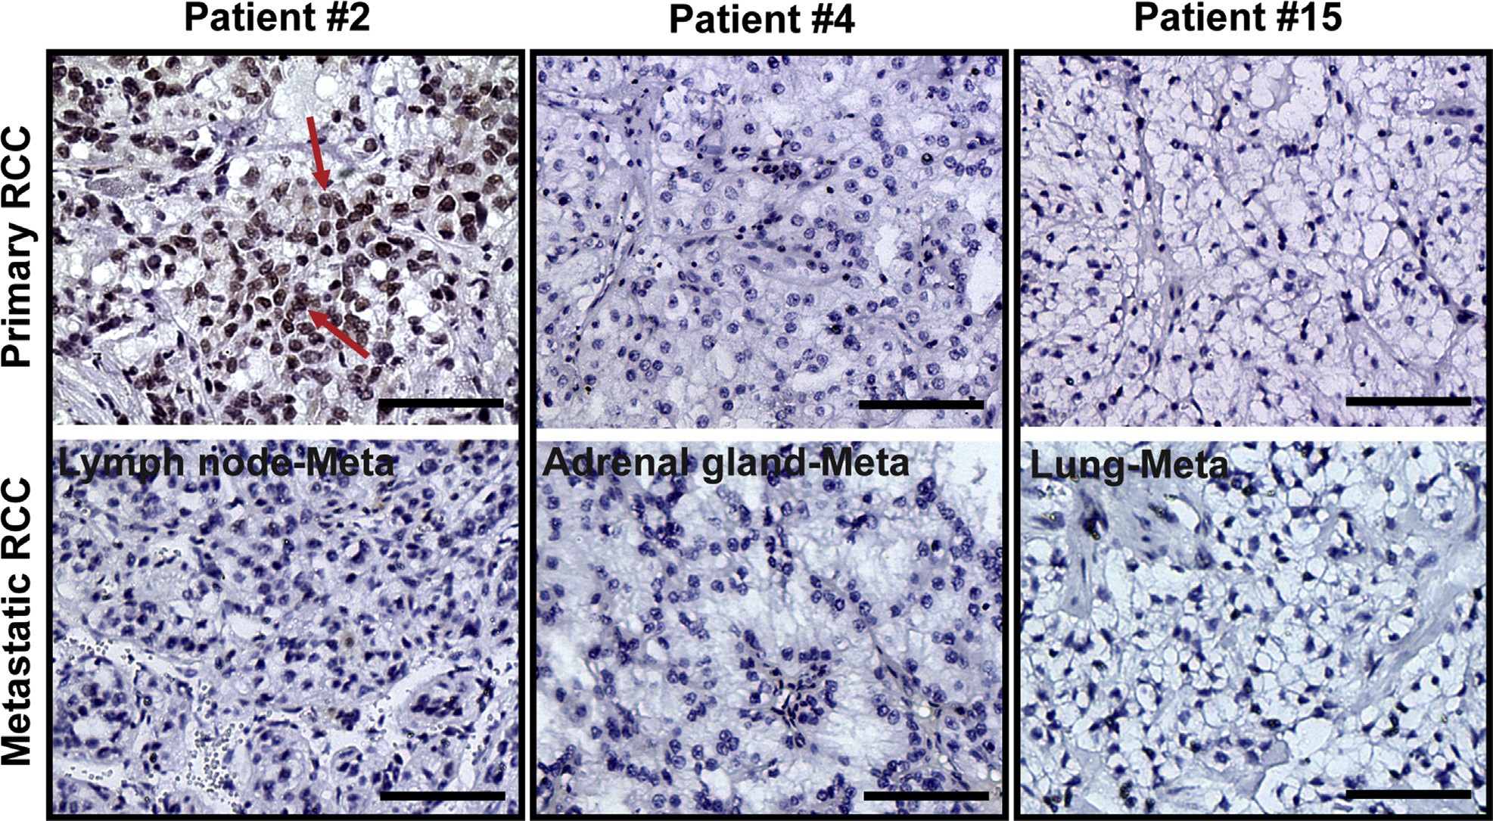
Figure 1. The expression of androgen receptor (AR) in primary vs metastatic tissues from the same renal cell carcinoma patients. The expression of AR could be detected in the primary renal cell carcinoma tissue in patient #2 (arrows), but when cancer cells metastasized to lymph nodes, the expression of AR was lost, and the other 2 cases (patient # 4 and 15) with adrenal gland and lung metastasis, respectively, had no detectable AR expression both in their primary and metastatic tissue
specimens. Scale bar ¼ 100 mm. RCC, renal cell carcinoma.

showed little transactivation, indicating the AR in these 2 RCC cell lines has little function.

COMMENT
The disappointing results of radiotherapy, chemotherapy, and immunotherapy in metastatic RCC and the gender difference in tumor incidence have raised the interest to explore the role of hormone receptors in clinical RCC tissue samples and investigate the potential of antihor- mone therapy to battle RCC. However, results from previous studies remained controversial, and RCC tumor samples used in these studies were also limited.8-12 Loda et al8 analyzed AR expression with negative results with only 1 AR-positive case of RCC as compared with the AR expression in prostate cancer. In contrast, Brown et al9 found a relatively high rate of AR expression, with 5 positive in 12 primary and 1 positive in 5 metastatic RCC patients. Furthermore, Klotzl et al10 also found AR expression in 3 of 21 RCC tissue samples, and Nakano et al11 reported AR expression in 13 of 41 RCC cases. These studies suggested that AR could be detected in some RCC patients.
The most systematic study performed by Langner et al13 demonstrated that AR expression could be immunohis- tochemically detect in almost 27 of 182 of RCC cases (15%) of the tumors, and it was signiﬁcantly associated
with low stage, well or moderately differentiated tumors, and a favorable outcome, decreasing with tumor growth

and dedifferentiation. Although it provided some impor- tant information about the linkage of AR with RCC progression, it did not show the AR expression proﬁle difference between normal kidney and RCC, between primary RCC and metastasis, and between male and fe- male RCC patients. Most importantly, based on the ARE luciferase results obtained from AR-positive RCC cells in our study, those AR detected in human RCC tissue specimens might not directly link to its real function in RCC progression, although it was negatively correlated with the increasing clinical stage and pathologic grade.
In our study, with the available 120 primary RCC tissue samples with different clinical stages and pathologic grades, we found that the expression of AR could be detected in almost 30% of RCC cases. Interestingly, compared with RCC, we found the AR-positive cells were much higher in the adjacent normal kidney tubule epithelial cells (44 of 120 RCC patients samples), with nearly 90.9% cells having positive AR staining mainly located in cytoplasm of the renal epithelial cells. How- ever, there is no signiﬁcant difference of AR-positive rate between male and female patients in RCC or adjacent normal kidney tissue samples. These results indicated that when those normal kidney epithelial cells transformed into cancerous cells under the stimulation from some complicated hereditary or environmental exposure, the expression rate of AR in those cells decreased but more localized to cell nuclei. Hence, it will be very interesting to study how AR expression level and cellular

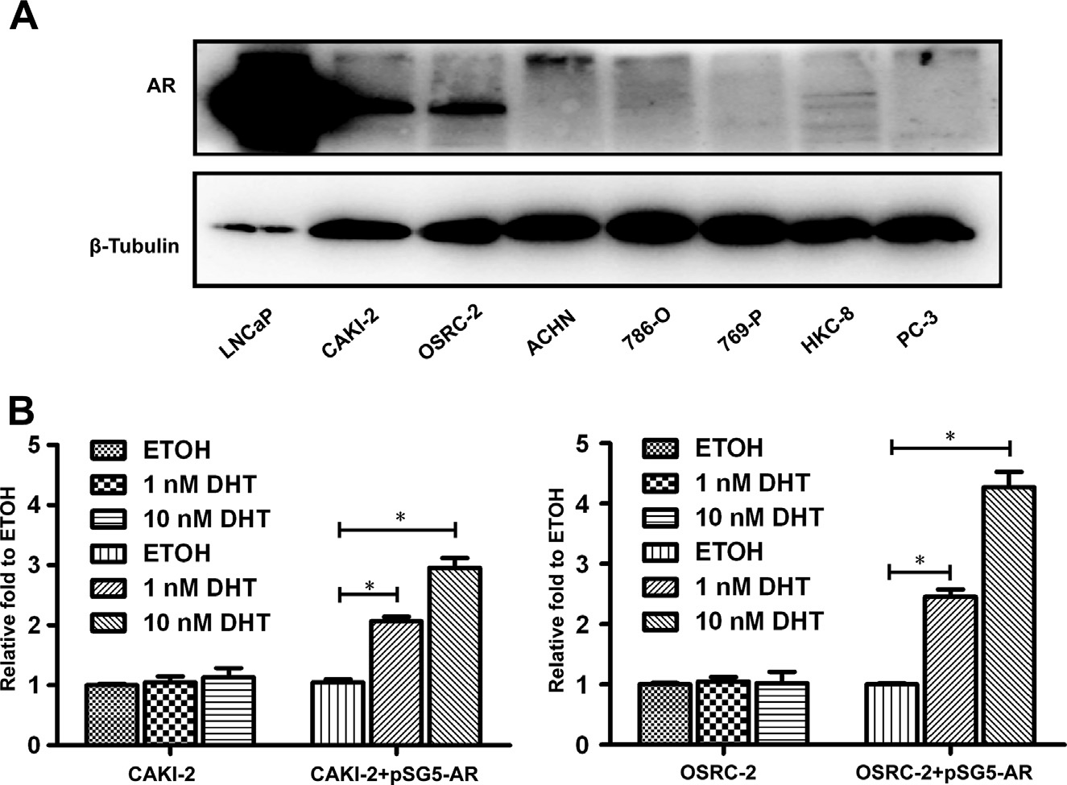
Figure 2. The expression of androgen receptor (AR) in commonly used renal cell carcinoma (RCC) cell lines with little AR transactivation in AR-positive cells. The expression of AR was detected by western blot in human RCC cell lines with clear cell carcinoma origin, including CAKI-2, OSRC-2, ACHN, 786-O, and 769-P, and also in the normal human kidney proximal tubular HKC-8 cells. The expression of AR could be detected in CAKI-2, OSRC-2, and HKC-8 cells, but was not detected in ACHN, 786-O, and 769-P cells. The prostate cancer LNCaP and PC-3 cells were used as positive and negative controls, respectively (A). The ARE luciferase assay from these 2 AR-positive cell lines showed little transactivation (B), indicating the AR in these 2 RCC cell lines has little function (P <.05, each experiment was triplicate).

distribution pattern changing might inﬂuence the initia- tion of RCC.
We also found that AR expression was associated with known favorable prognostic factors, such as low pT stage and low histologic Fuhrman’s grade. Furthermore, we also noticed that AR expression was relatively rare in RCC patients with high pT stage or high Fuhrman’s grade compared with patients who had low pT stage or low histologic grade. These data were very similar to those reported by Langner et al; however, our results did not show any signiﬁcant difference of AR-positive rate be- tween male and female RCC patients in the subgroups with the same pT stages or Fuhrman’s grades. In addition, in all the 16 metastatic RCC patients, we found 2 AR- positive cases in their primary tumor samples, and those 2 male patients had lymph nodes metastases. In contrast, we did not detect any AR-positive cases in those 16 metastatic counterparts of the tumor samples. Although it did not reach to the statistic difference (P ¼ .484), it might still indicate that once the RCC metastasize from their primary site, their AR expression level will become even lower. Similar result was also be reported by Fleischmann et al19 in prostate cancer patients, and it was found that the AR expression level was statically signif- icant down-regulated in matched lymph node metastases compared with their primary site.
These contrasting results of AR expression in different stages or grades of RCC raised the question whether AR expression is indeed linked to AR-mediated RCC pro- gression, as in early prostate cancer studies had indicated
that AR might have various mutations, and therefore AR expression alone might not directly link to prostate cancer stages.20-22 We then detected the AR expression status in some commonly used human RCC cell lines that originated from clear cell carcinoma of the kidney, and also we compared the AR expression difference between RCC cells and normal kidney epithelial cells. As ex- pected, we did ﬁnd that some RCC cells, such as OSRC-2 and CAKI-2 cells had positive AR immunoreactivity, but some other RCC cells, including ACHN, 786-O, and 769-P did not express AR. This in vitro cell line data were quite similar to those found in RCC patients, which also include both AR positive and negative cases. In addition, the expression of AR could also be detected in normal human kidney proximal tubular HKC-8 cells, which also coincided with those found in normal human kidney tissue specimens. However, ARE luciferase assay in these 2 AR-positive RCC cells showed little AR
transactivation, indicating AR in these 2 AR-positive RCC cells has little or no function. These results sug- gested that assays for expression of AR, at messenger ribonucleic acid level via quantitative polymerase chain reaction (qPCR) or at protein level via western blot analysis or IHC staining, might not equally reﬂect the function of AR in clinical RCC patients.

CONCLUSION
Our clinical and cell line data demonstrated that the expression of AR might negatively correlate with the

progression of RCC by IHC staining using clinical RCC tissue samples, but transactivation assays found AR expression might not directly link to AR function in RCC cell lines. This ﬁnding might raise the conclusion of any attempt of using the status of AR expression to link with RCC progression might need to combine the detection of AR expression in clinical tissue samples with examining its function to make a correct correlation be- tween AR and the RCC progression.

References
- Murphy WM, Beckwith JB, Farrow GM. Atlas of Tumor Pathology. Tumors of the Kidney, Bladder, and Related Urinary Structures. Washington, D.C. Armed Forces Institute of Pathology. 3rd Series, Fasc. 1994;11:92-132.
- Motzer RJ, Russo P. Systemic therapy for renal cell carcinoma.
J Urol. 2000;163:408-417.
- Escudier B, Osanto S, Ljungberg B, et al. Multidisciplinary man- agement of metastatic renal cell carcinoma in the era of targeted therapies. Cancer Treat Rev. 2012;38:127-132.
- Chow WH, Dong LM, Devesa SS. Epidemiology and risk factors for
kidney cancer. Nat Rev Urol. 2010;7:245-257.
- Pearce MS, Parker L. Childhood cancer registrations in the devel- oping world: still more boys than girls. Int J Cancer. 2001;91: 402-406.
- Palaszynski KM, Smith DL, Kam-rava S, et al. A yin-yang effect between sex chromosome complement and sex hormones on the immune response. Endocrinology. 2005;146:3280-3285.
- Dorak MT, Karpuzoglu E. Gender differences in cancer suscepti-
bility: an inadequately addressed issue. Front Genet. 2012;3:1-11.
- Loda M, Fogt F, French FS, et al. Androgen receptor immunohis- tochemistry on parafﬁn-embedded tissue. Mod Pathol. 1994;7: 388-391.
- Brown DF, Dababo MA, Hladik CL, et al. Hormone receptor immunoreactivity in hemangioblastomas and clear cell renal cell carcinomas. Mod Pathol. 1998;11:55-59.
- Klotzl G, Otto U, Becker H, et al. Determination of androgen,
progestin and estrogen receptors with two different assays in renal cell carcinoma. Urol Int. 1987;42:100-104.
- Nakano E, Tada Y, Fujioka H, et al. Hormone receptor in renal cell
carcinoma and correlation with clinical response to endocrine therapy. J Urol. 1984;132:240-245.

Nolan LP, Heatley MK. The value of immunohistochemistry in distinguishing between clear cell carcinoma of the kidney and ovary. Int J Gynecol Pathol. 2001;20:155-159.
- Langner C, Ratschek M, Rehak P, et al. Steroid hormone receptor
expression in renal cell carcinoma: an immunohistochemical anal- ysis of 182 tumors. J Urol. 2004;171:611-614.
- Yeh S, Lin HK, Kang HY, et al. From HER2/Neu signal cascade to
androgen receptor and its coactivators: a novel pathway by induc- tion of androgen target genes through MAP kinase in prostate cancer cells. Proc Natl Acad Sci USA. 1999;96:5458-5463.
- Yeh S, Hu YC, Rahman M, et al. Increase of androgen-induced cell
death and androgen receptor transactivation by BRCA1 in prostate cancer cells. Proc Natl Acad Sci USA. 2000;97:11256-11261.
- Chen M, Ni J, Zhang Y, et al. ERAP75 functions as a coactivator to
enhance estrogen receptor a transactivation in prostate stromal cells. Prostate. 2008;68:1273-1282.
- Chen M, Ni J, Chang HC, et al. CCDC62/ERAP75 functions as a
coactivator to enhance estrogen receptor beta-mediated trans- activation and target gene expression in prostate cancer cells. Carcinogenesis. 2009;30:841-850.
- Xu D, Lin TH, Zhang C, et al. The selective inhibitory effect of a
synthetic tanshinone derivative on prostate cancer cells. Prostate. 2012;72:803-816.
- Fleischmann A, Rocha C, Schobinger S, et al. Androgen receptors are differentially expressed in Gleason patterns of prostate cancer and down-regulated in matched lymph node metastases. Prostate. 2011;71:453-460.
- Newmark JR, Hardy DO, Tonb DC, et al. Androgen receptor gene mutations in human prostate cancer. Proc Natl Acad Sci USA. 1992; 89:6319-6323.
- Culig Z, Hobisch A, Cronauer MV, et al. Mutant androgen receptor detected in an advanced-stage prostatic carcinoma is activated by adrenal androgens and progesterone. Mol Endocrinol. 1993;7:1541- 1550.
- Montgomery JS, Price DK, Figg WD. The androgen receptor gene and its inﬂuence on the development and progression of prostate cancer. J Pathol. 2001;195:138-146.

APPENDIX
SUPPLEMENTARY DATA
Supplementary data associated with this article can be found,
in the online version, at http://dx.doi.org/10.1016/j.urology. 2013.10.022.

