The iNOS/Src/FAK axis contributes to lithium chloride-mediated macrophage migration
Hui-Chen Chen^{1,2}, Wan-Chu Chien¹, Miao Ying Chang³, Ming-Chei Maa^{1,2}*, and Tzeng-Horng Leu^{4,5}*
¹Graduate Institute of Basic Medical Science and ²Ph.D. Program for Aging, China Medical University, Taichung 40402, Taiwan
³Department of Medical Research, China Medical University Hospital, Taichung 40402, Taiwan
⁴Institute of Basic Medical Sciences and ⁵Department of Pharmacology, College of Medicine, National Cheng Kung University, Tainan 70101, Taiwan
Running Title: Effect of LiCl on macrophage migration
*Corresponding author: Tzeng-Horng Leu, Dept. of Pharmacology, College of Medicine, National Cheng Kung University, Tainan 70101, Taiwan. Tel: +886-6-235-3535 (ext. 5468); Fax: +886-6-274-9269; E-mail: tzengleu@mail.ncku.edu.tw; Ming-Chei Maa, Graduate Institute of Basic Medical Science, China Medical University. 91 Hsueh-Shih Road, Taichung 40402, Taiwan. Tel: +886-4-2205-2121 (ext. 7720); Fax: +886-4-2205-3764; E-mail: mcmaa@mail.cmu.edu.tw
Keywords: LiCl, Src, FAK, iNOS, GSK3β, Macrophage migration
Abbreviations:
Ctrl, control; FAK, Focal adhesion kinase; iNOS, inducible nitric-oxide synthase; GSK3β, glycogen synthase kinase 3β; LiCl, lithium chloride; PEM, peritoneal macrophages; pTyr, phosphorylated tyrosine; SFK, Src family kinases; TLRs, Toll-like receptors; WT, wild type.

Author contributions
M.-C. Maa and T.-H. Leu designed the experiments, analyzed the data, and wrote the manuscript; H.-C. Chen analyzed the data and wrote the manuscript; W.-C. Chien and M.Y. Chang performed experiments and prepared the figures.

Summary

Lithium chloride (LiCl) has long been used as a mood stabilizer for bipolar mood depression patients. However, its biological effects on immune cells are unclear yet. In this study, we observed that upon LiCl stimulation, the motility and the content of total protein tyrosine phosphorylation in RAW264.7 macrophages and murine peritoneal macrophages (PEMs) were significantly increased. The inhibition of LiCl-induced macrophage migration by PP2 (an inhibitor for Src family kinases (SFKs)) suggested the involvement of SFKs in this process. Interestingly, while Src was greatly induced, the expression of its myeloid relatives (i.e. Lyn, Fgr, Hck) was almost unaltered in RAW264.7 cells exposed to LiCl. Knockdown of Src suppressed LiCl-elicited movement and the level of FAK Pi-Tyr861, which could be reversed by siRNA-resistant Src. Consistent with Src and migration increment was iNOS-dependent in macrophages, markedly reduced Src expression, activity and cell migration was observed in iNOS-null PEMs treated with LiCl. Moreover, FAK knockdown suppressed LiCl-stimulated macrophage motility, suggesting the involvement of FAK in this process. Remarkably, similar increment of Src, FAK Pi-Tyr861 and migration ability could also be detected in RAW264.7 treated with other GSK3β inhibitors (i.e. SB216763 and Kenpaullone). These results corroborate that through inhibition of GSK3β, iNOS/Src axis occupies a critical role in macrophage locomotion in response to LiCl.
Introduction

Being general phagocytic cells, some macrophages reside in tissues, while the remaining motile ones are coming from monocytes during inflammation. Once recruited to inflamed tissues, the macrophages not only continuously scavenge dead cells and cell debris, but also ingest invading microbes to prevent them from entering the blood. In addition, macrophages also play a crucial role in orchestrating immune responses by inducing inflammation, which regulates the mobilization and activation of various immune effector cells to promote the innate and adaptive immune responses. Thus, the migration of macrophages into tissues is an essential step in the host response to infection.
Src is a nonreceptor tyrosine kinase and the prototype of a family of highly conserved proteins, including Fyn, Yes, Lck, Lyn, Fgr, Hck, and Blk. Members of Src family kinases (SFKs) have been implicated in a spectrum of signaling pathways and cellular responses [1]. Unlike the highly expressed myeloid SFKs (i.e. Fgr, Hck, and Lyn), Src is barely detectable in resting macrophages, which results in its importance being underestimated. Previously, our study demonstrated that Src, but not its myeloid relatives, was up-regulated in macrophages exposed to various Toll-like receptor (TLR) ligands. Upon induction and activation, Src promoted FAK phosphorylation, ultimately leading to the increase of macrophage migration. Notably, all these events were inducible nitric-oxide synthase (iNOS)-dependent [2; 3; 4]. Moreover, Src is also essential in phagocytosis and interferon-beta (IFN-β) production in activated macrophages [5; 6].
In searching of chemicals that might influence the expression of Src in macrophages, we accidentally identified lithium chloride (LiCl) could induce Src expression. LiCl is a glycogen synthase kinase 3β (GSK3β) inhibitor [7; 8] and the classic drug in treating bipolar mood depression patients [9]. Although the detailed mechanism remains unclear, evidences indicated that the therapeutic effect of LiCl might be resided in its inhibition of GSK3β activity by competing the binding of magnesium (Mg²⁺) or increasing the inhibitory phosphorylation of GSK3β [7; 10; 11]. Despite LiCl exerts its effect on nerve cells and have therapeutic potential in central nervous system-related diseases [12], it also still its influence on other cell types such as macrophage is unclear has been shown to increase the production of TNF-α and CCL2 in monocytes/macrophages [1; 2; 3]. In contrast to the inducing effects, LiCl pretreatment, however, was shown to inhibit TLR-induced secretion of TNF-α, IL-1β, CCL2, CCL5, PGE2, NO and IFN-β production and this effect was shown to be GSK3β-independent [4; 5; 6]. The mechanisms underlying the differential effects of LiCl-treated macrophages are still needed to be clarified. Though several studies have examined the effects of LiCl on regulating the production of cytokines and chemokines in macrophages, little is known about its role in other aspects of macrophage biology such as migration. In this report, we demonstrated that LiCl could increase macrophage motility by inducing iNOS and upregulating the expression and activity of Src.

Materials and Methods

Reagents and Antibodies
Lithium chloride (LiCl), 3-(2,4-Dichlorophenyl)-4-(1-methyl-1H-indol-3-yl)-1H-
pyrrole-2,5-dione (SB216763), and 9-Bromo-7,12-dihydroindolo[3,2-d][1]benzazepin
-6(5H)-one (Kenpaullone) were obtained from Sigma-Aldrich (St. Louis, MO). (4-Amino-5-(4-chlorophenyl)-7-(t-butyl) pyrazolo-[3,4-d] pyrimidine (PP2) was purchased from Merck (Darmstadt, Germany). The primary antibodies used were NF-κB p65 Pi-S468 (Abcam, UK); actin, iNOS, and FAK (Upstate); FAK Pi-Y861 (BIOSOURCE International); Src Pi-Y416 (Cell Signaling Technology); Lyn, Fgr, Hck, NF-κB p65, GSK3β Pi-S9, GSK3β, and HRP-conjugated anti-phosphotyrosine antibody (PY20) (Santa Cruz Biotechnology Inc.). The mouse ascites containing monoclonal anti-Src (peptide 2-17) antibody were produced by the hybridoma (CRL-2651) obtained from the American Type Culture Collection.

Animals
C57BL/6 mice were purchased from the National Animal Center and were utilized to prepare peritoneal macrophages (PEMs). C56BL/6 inducible nitric-oxide synthase knock-out (C57BL/6-Nos^{tm1Lau}) (iNOS^{-/-}) [13] and wild type (WT) mice of the same age and sex were used to assess the role of iNOS in LiCl-induced macrophage migration). All of the mice were maintained and bred in an animal facility at the China Medical University. All experiments using laboratory animals were carried out in accordance with guidelines of the China Medical University.

Cell culture and collection of peritoneal macrophages (PEMs)
The murine macrophage cell line, RAW264.7 (American Type Culture Collection) was cultured and propagated in RPMI 1640 medium supplemented with 10% fetal calf serum (HyClone, Logan, UT) and 2mM l-glutamine at 37°C in humidified atmosphere of 5% CO₂ and air. PEMs were collected by peritoneal lavage from C57BL/6 mice given an intraperitoneal injection of 1 ml of thioglycollate broth 4 days before harvest. The PEMs were washed with Ca²⁺- and Mg²⁺- free phosphate-buffered saline and plated in fetal calf serum-containing RPMI medium for 6 h. Then the cells were washed with medium to remove non-adherent cells. The resultant macrophage monolayer with greater than 98% purity, evaluated by morphology and phagocytosis property, was used for experiments.

Generation of macrophages expressing nonspecific siRNA, src siRNA, lyn siRNA or fak siRNA
The generation of RAW264.7-based control cells (Ctrl; expressing nonspecific siRNA), Src-deficient cells (siSrc-1) and Src-deficient cells expressing ectopic Src (siSrc-1/Src15), Lyn-deficient cells (siLyn-1), or FAK-deficient cells (siFAK-1, -2) was described previously [3; 4].

Lysate preparation and immunoblot analysis
Cells were lysed with modified radioimmune precipitation assay buffers and protein concentration was determined by protein assay kit (Bio-Rad) [14]. The cell lysates were resolved in an 8% sodium dodecyl sulfate (SDS)-polyacrylamide gel, transferred to nitrocellulose membranes, and probed with the respective antibodies followed by HRP-conjugated protein A or HRP-conjugated secondary antibodies and detected by the Enhanced Chemiluminescence method (Amersham Biosciences) (Rockford, IL, USA).

Cell migration assay

The migration of macrophages exposed to LiCl was determined by a modify Boyden chamber as described before.[3] Briefly, cells with or without LiCl exposure were added to the upper wells (48-multiwell Boyden microchambers) at 2×10⁴ cells/well. The migrated cells will traverse a polycarbonate filter (8 μm) from the upper chamber to the lower chamber, which contains 10% fetal calf serum as a chemoattractant. After 6 hours at 37 ºC in 5% CO₂, non-migratory cells on the upper membrane surface were removed, and the cells that traversed and spread on the lower membrane surface were fixed with methanol and stained with Giemsa stain (Modified solution, Sigma). By utilizing a microscope with a 40× objective, the number of migratory cells per membrane was enumerated. Four random fields in each filter were examined. Each experiment was performed in triplicate, and migration was expressed as the mean ± S.D. of total cells counted per field.

Statistical analysis
Each experiment was performed at least three times. Unless indicated, the results were presented as means ± S.D. from a representative triplicate experiment. The significance of difference was assessed by Student’s t test. Bonferroni correction was used for controlling type I error in multiple comparisons.
Results

Src family kinases are involved in LiCl-induced macrophage migration
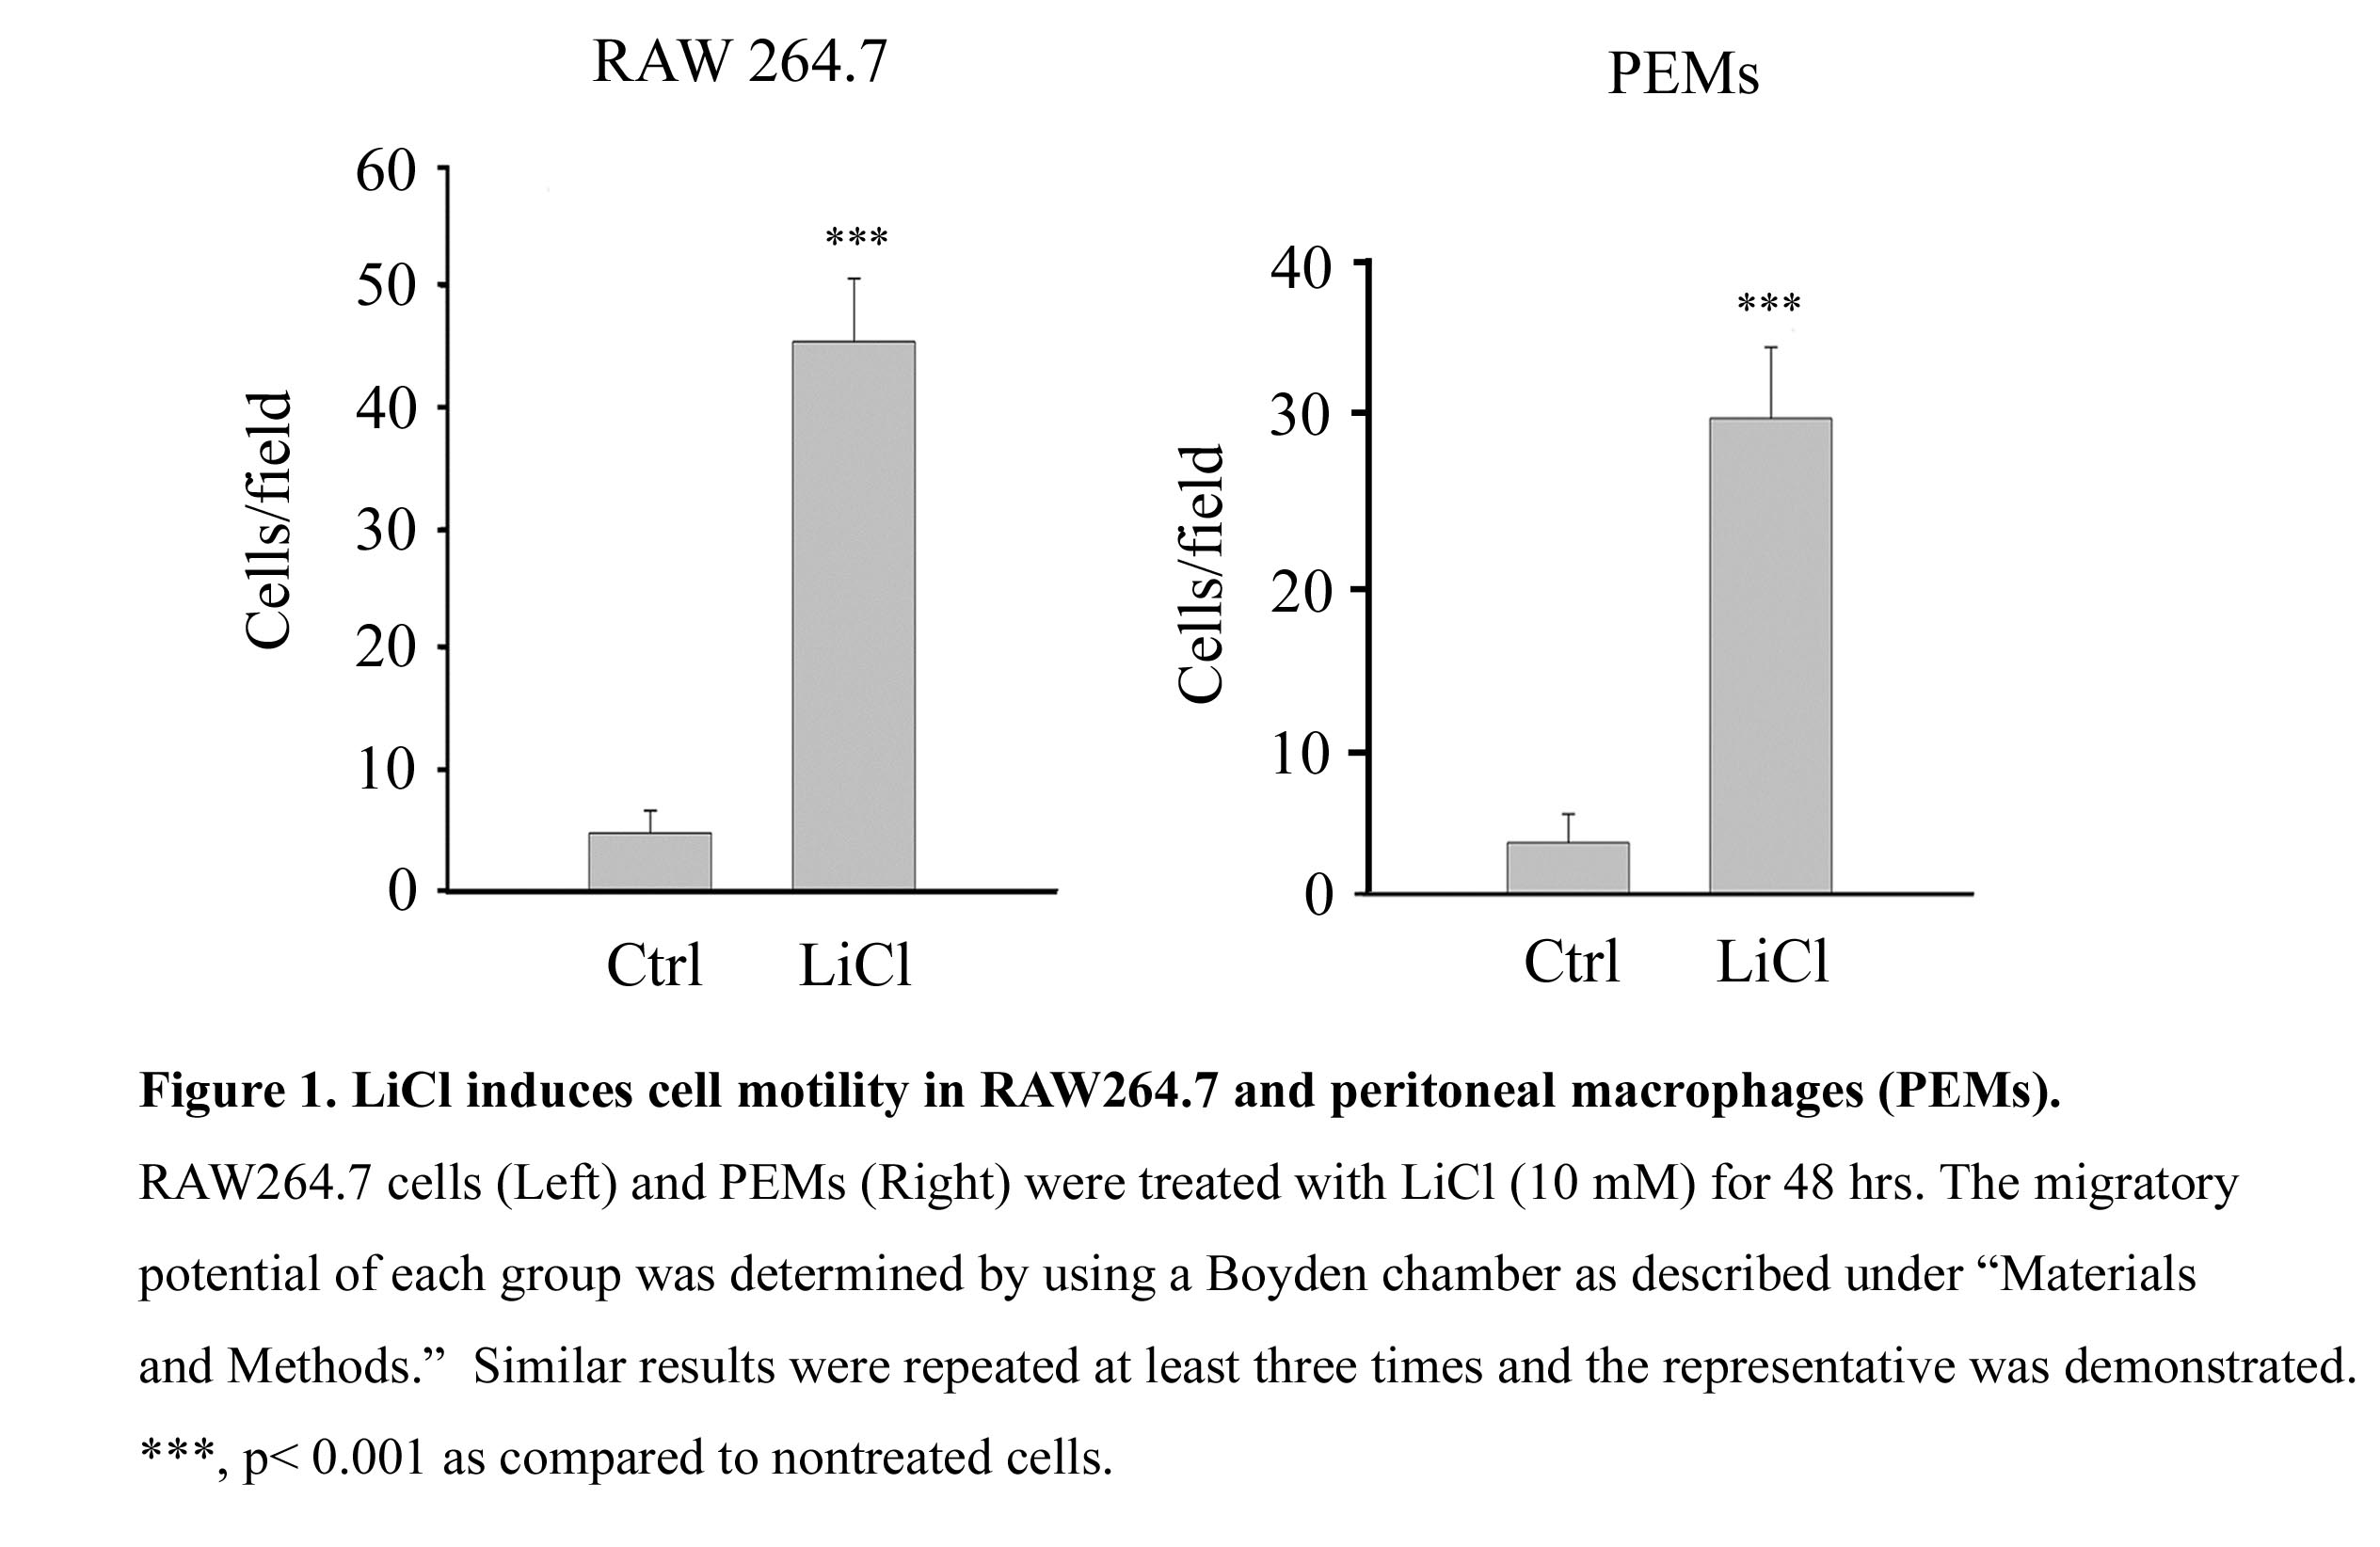
Given LiCl is the drug in treating bipolar mood depression patients, its effect on macrophage migration was attempted. As shown in Figure 1, LiCl elevated the level of GSK3β Pi-S9 which negatively regulated GSK3β activity. Compared to control, significant increase in cell migration was observed in murine RAW264.7 macrophages as well as in PEMs treated with LiCl. Through the regulation of actin cytoskeleton rearrangement, the protein tyrosyl phosphorylation plays a pivotal role in cell adhesion and motility [15; 16]. Consistently, LiCl exposure increased the protein tyrosyl phosphorylation in macrophages (Figure 2A). Of note, the LiCl-induced migration was significantly suppressed following PP2 (the inhibitor of SFKs) (Figure 2B), indicating the participation of the SFKs in this process. 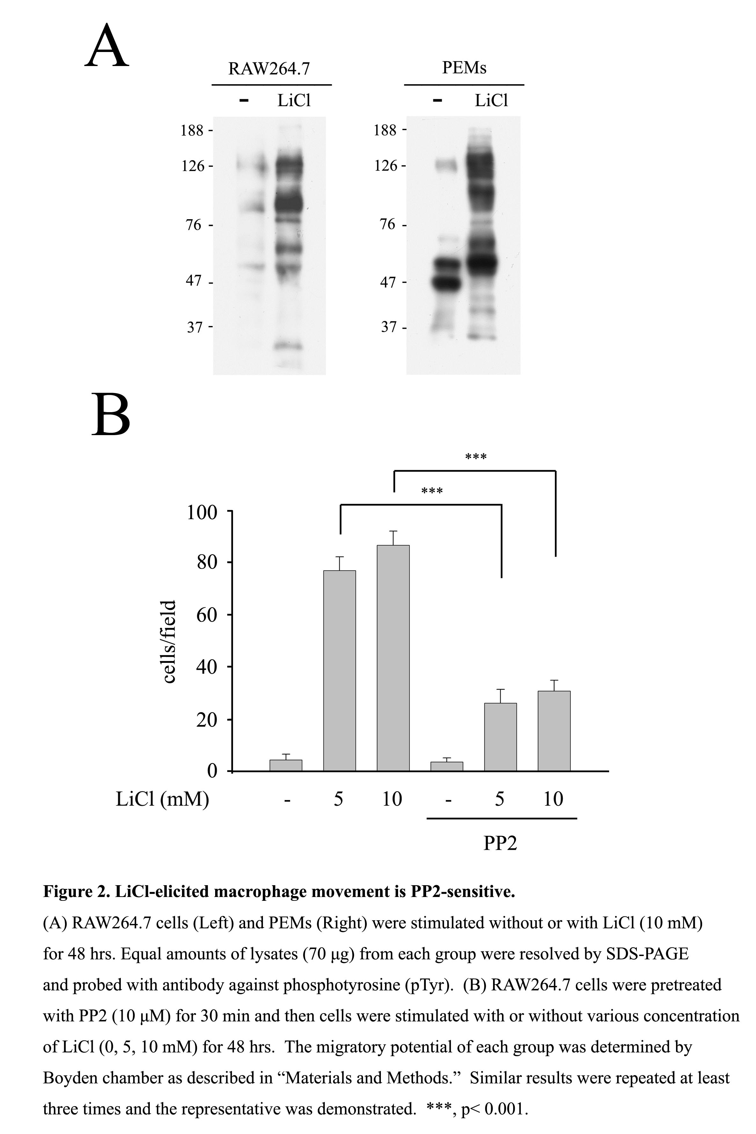.
Src plays an important role in LiCl-mediated macrophage migration
In order to identify the responsible SFKs in LiCl-elicited macrophage migration, RAW264.7 cells were treated with various concentrations of LiCl, and the expression of Src and one of the myeloid SFK (i.e. Lyn) was examined. As shown in Figure 3A, Src was induced by 2 mM LiCl and a dose-dependent induction of Src, but not Lyn, was observed. Furthermore, the expression of Src exhibited a time-dependent manner as its expression peaked at around 48 hrs. In contrast, the amount of Lyn, Fgr, and Hck was almost unaltered before and after LiCl exposure (Figure 3B). 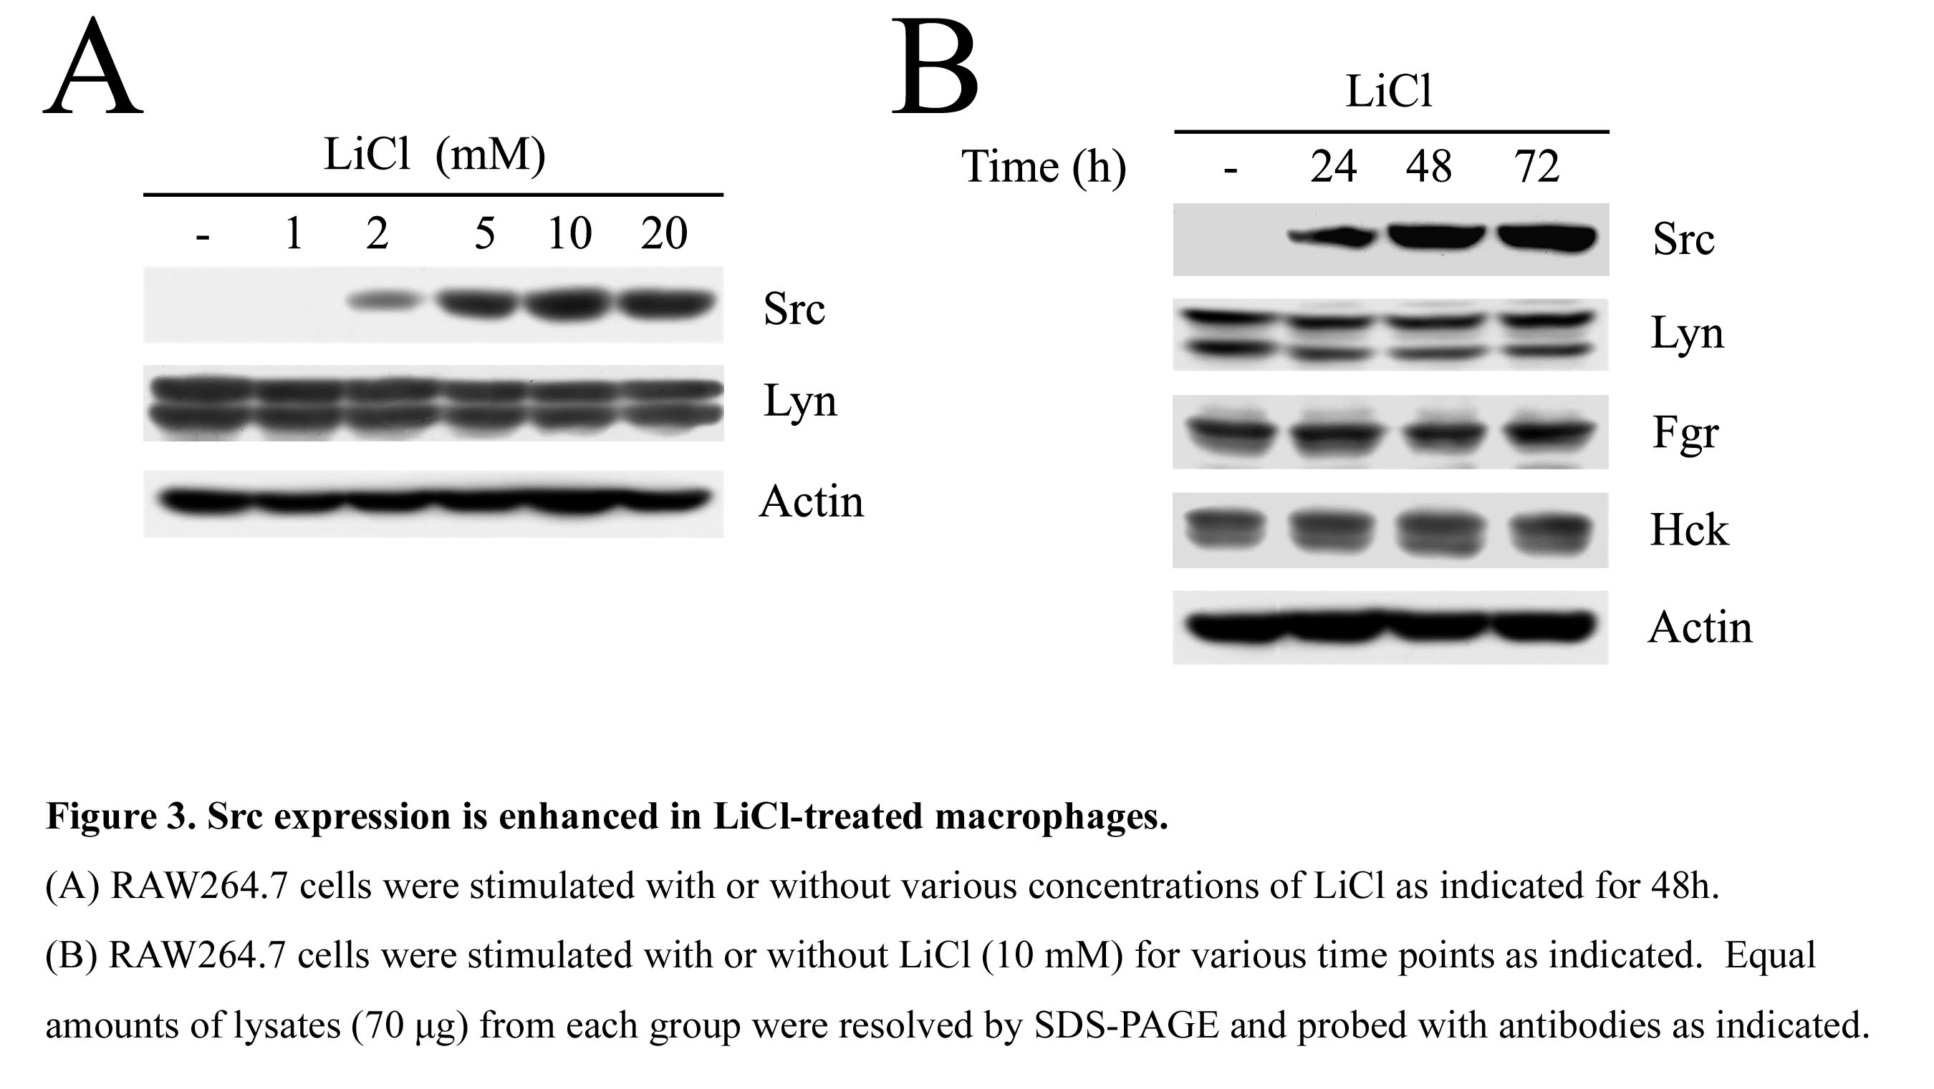These results indicated Src might be critical in LiCl-stimulated macrophage mobility. To prove this point, RAW264.7 (RAW) cells and their derived control (Ctrl), Src-deficient cells (siSrc-1) and Src-deficient cells with ectopic Src (siSrc-1/Src15) were stimulated with LiCl, and their migratory ability as well as Src activation were analyzed. While LiCl-elicited cell mobilization (Figure 4A) and Src activation (as reflected by FAK Pi-Tyr861) (Figure 4B) were suppressed in Src-deficient RAW264.7, ectopic Src reverted these defects. Notably, in agreement to reduced mobility, PP2 significantly decreased the level of Src and FAK Pi-Y861 in LiCl-treated macrophages (Figure 2B). Thus, Src was pivotal in cell mobility in macrophages exposed to LiCl.
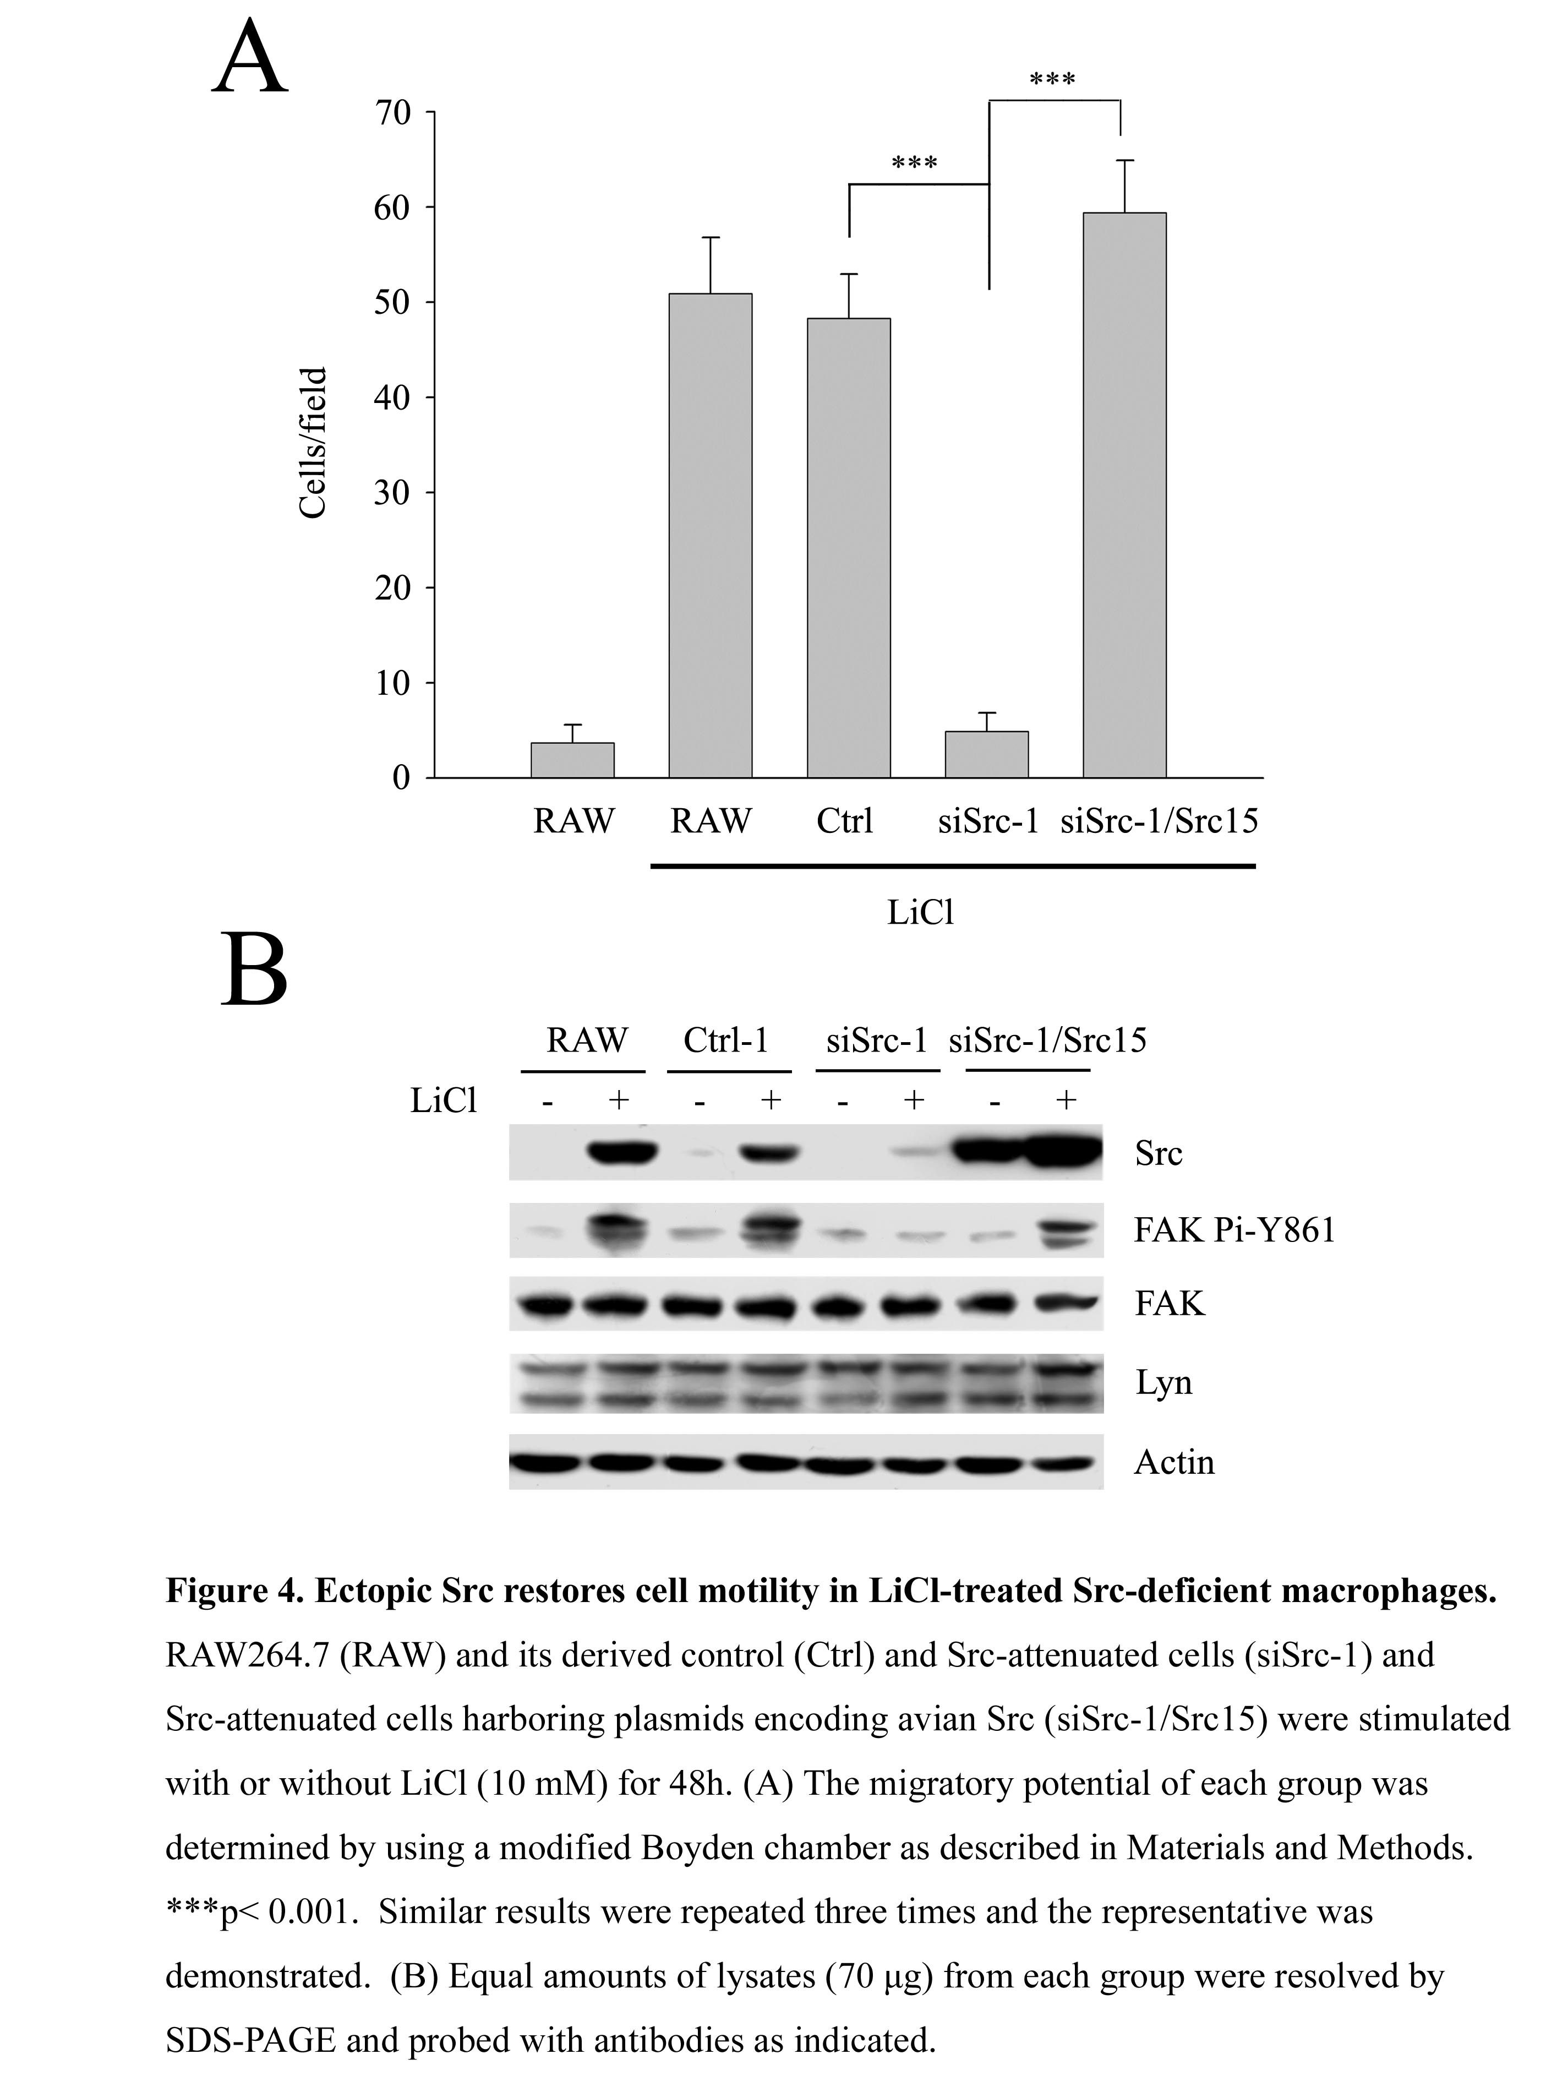

iNOS is required for LiCl-induced Src expression and macrophage migration
Previously, we have demonstrated that inducible nitric-oxide synthase was required for TLR-mediated Src induction and macrophage migration [3; 4]. Intriguingly, like TLR engagement [6], the expression of iNOS also appeared ahead of Src in macrophages exposed to LiCl (Figure 5A). 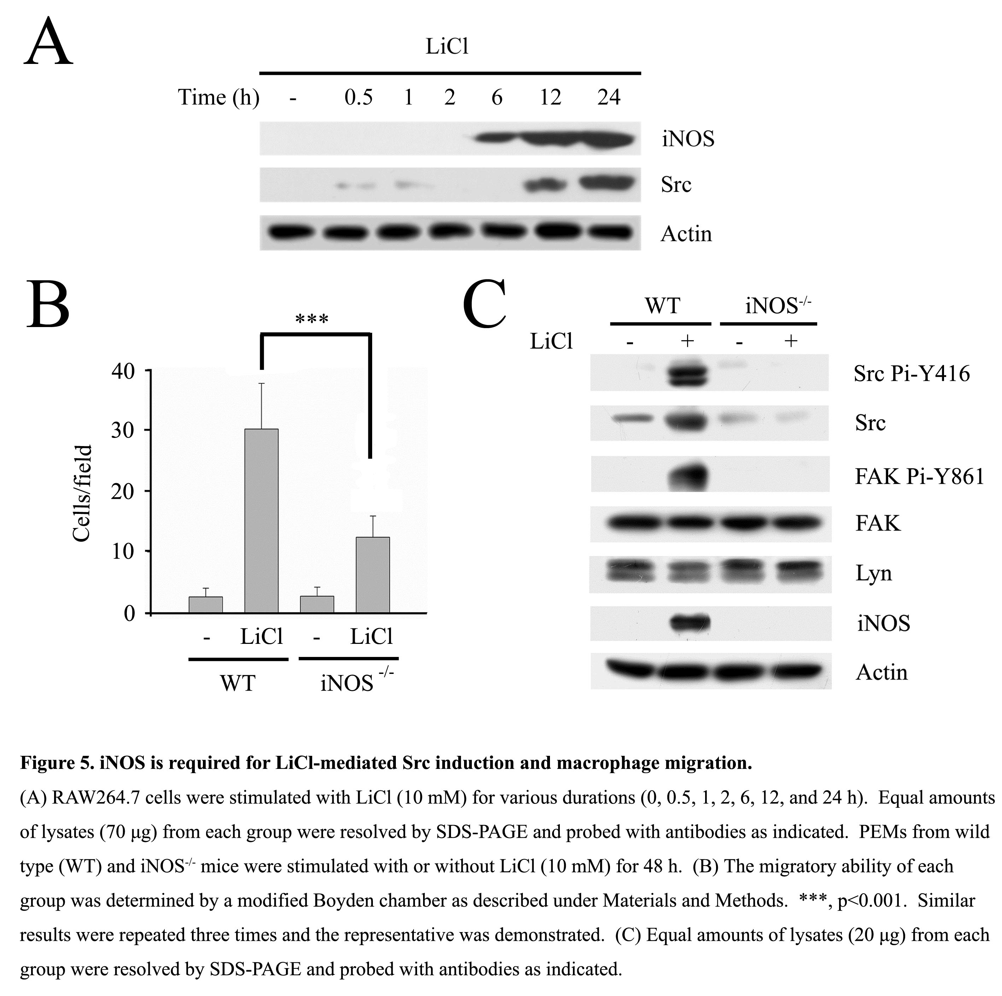To study the role of iNOS in LiCl-mediated Src induction and macrophage motility, the migratory ability of PEMs derived from WT and iNOS^{-/-} mice treated with or without LiCl were analyzed. As shown in Figure 5B, LiCl-stimulated macrophage mobility was impaired in the iNOS-null PEMs. Remarkably, the reduced macrophage motility was correlated with the diminished level of Src and FAK Pi-Tyr861 in LiCl-treated PEMs devoid of iNOS (Figure 5C). Of note, the expression of Lyn was unaltered in iNOS-null PEMs regardless of LiCl treatment (Fig. 5C). These data indicated that iNOS participated in LiCl-induced Src expression and macrophage migration.

FAK participates in LiCl-elicited macrophage motility
Our prior study indicated knockdown of FAK, but not Lyn, reduced the mobility in TLR engaged macrophages [4]. To ascertain the role of FAK and Lyn in LiCl-evoked mobility, RAW264.7 derived control (Ctrl-1), Lyn-deficient (siLyn-1) and FAK-deficient (siFAK-1, -2) cells were stimulated with or without LiCl for 24 hrs. 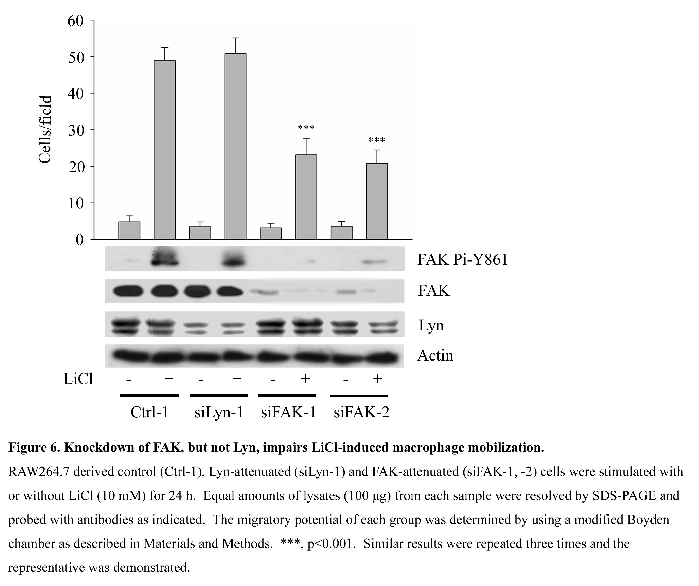As shown in Figure 6, knockdown of FAK, but not Lyn impaired macrophage motility in response to LiCl. These results confirmed that FAK, as a substrate of Src, played a pivotal role in LiCl-evoked macrophage movement.

LiCl-induced macrophage migration is mediated through inactivating GSK3β activity
To verify LiCl-mediated migration was through GSK3β-dependent pathway, other GSK3β specific inhibitors such as SB216763 and Kenpaullone were used to address this issue. 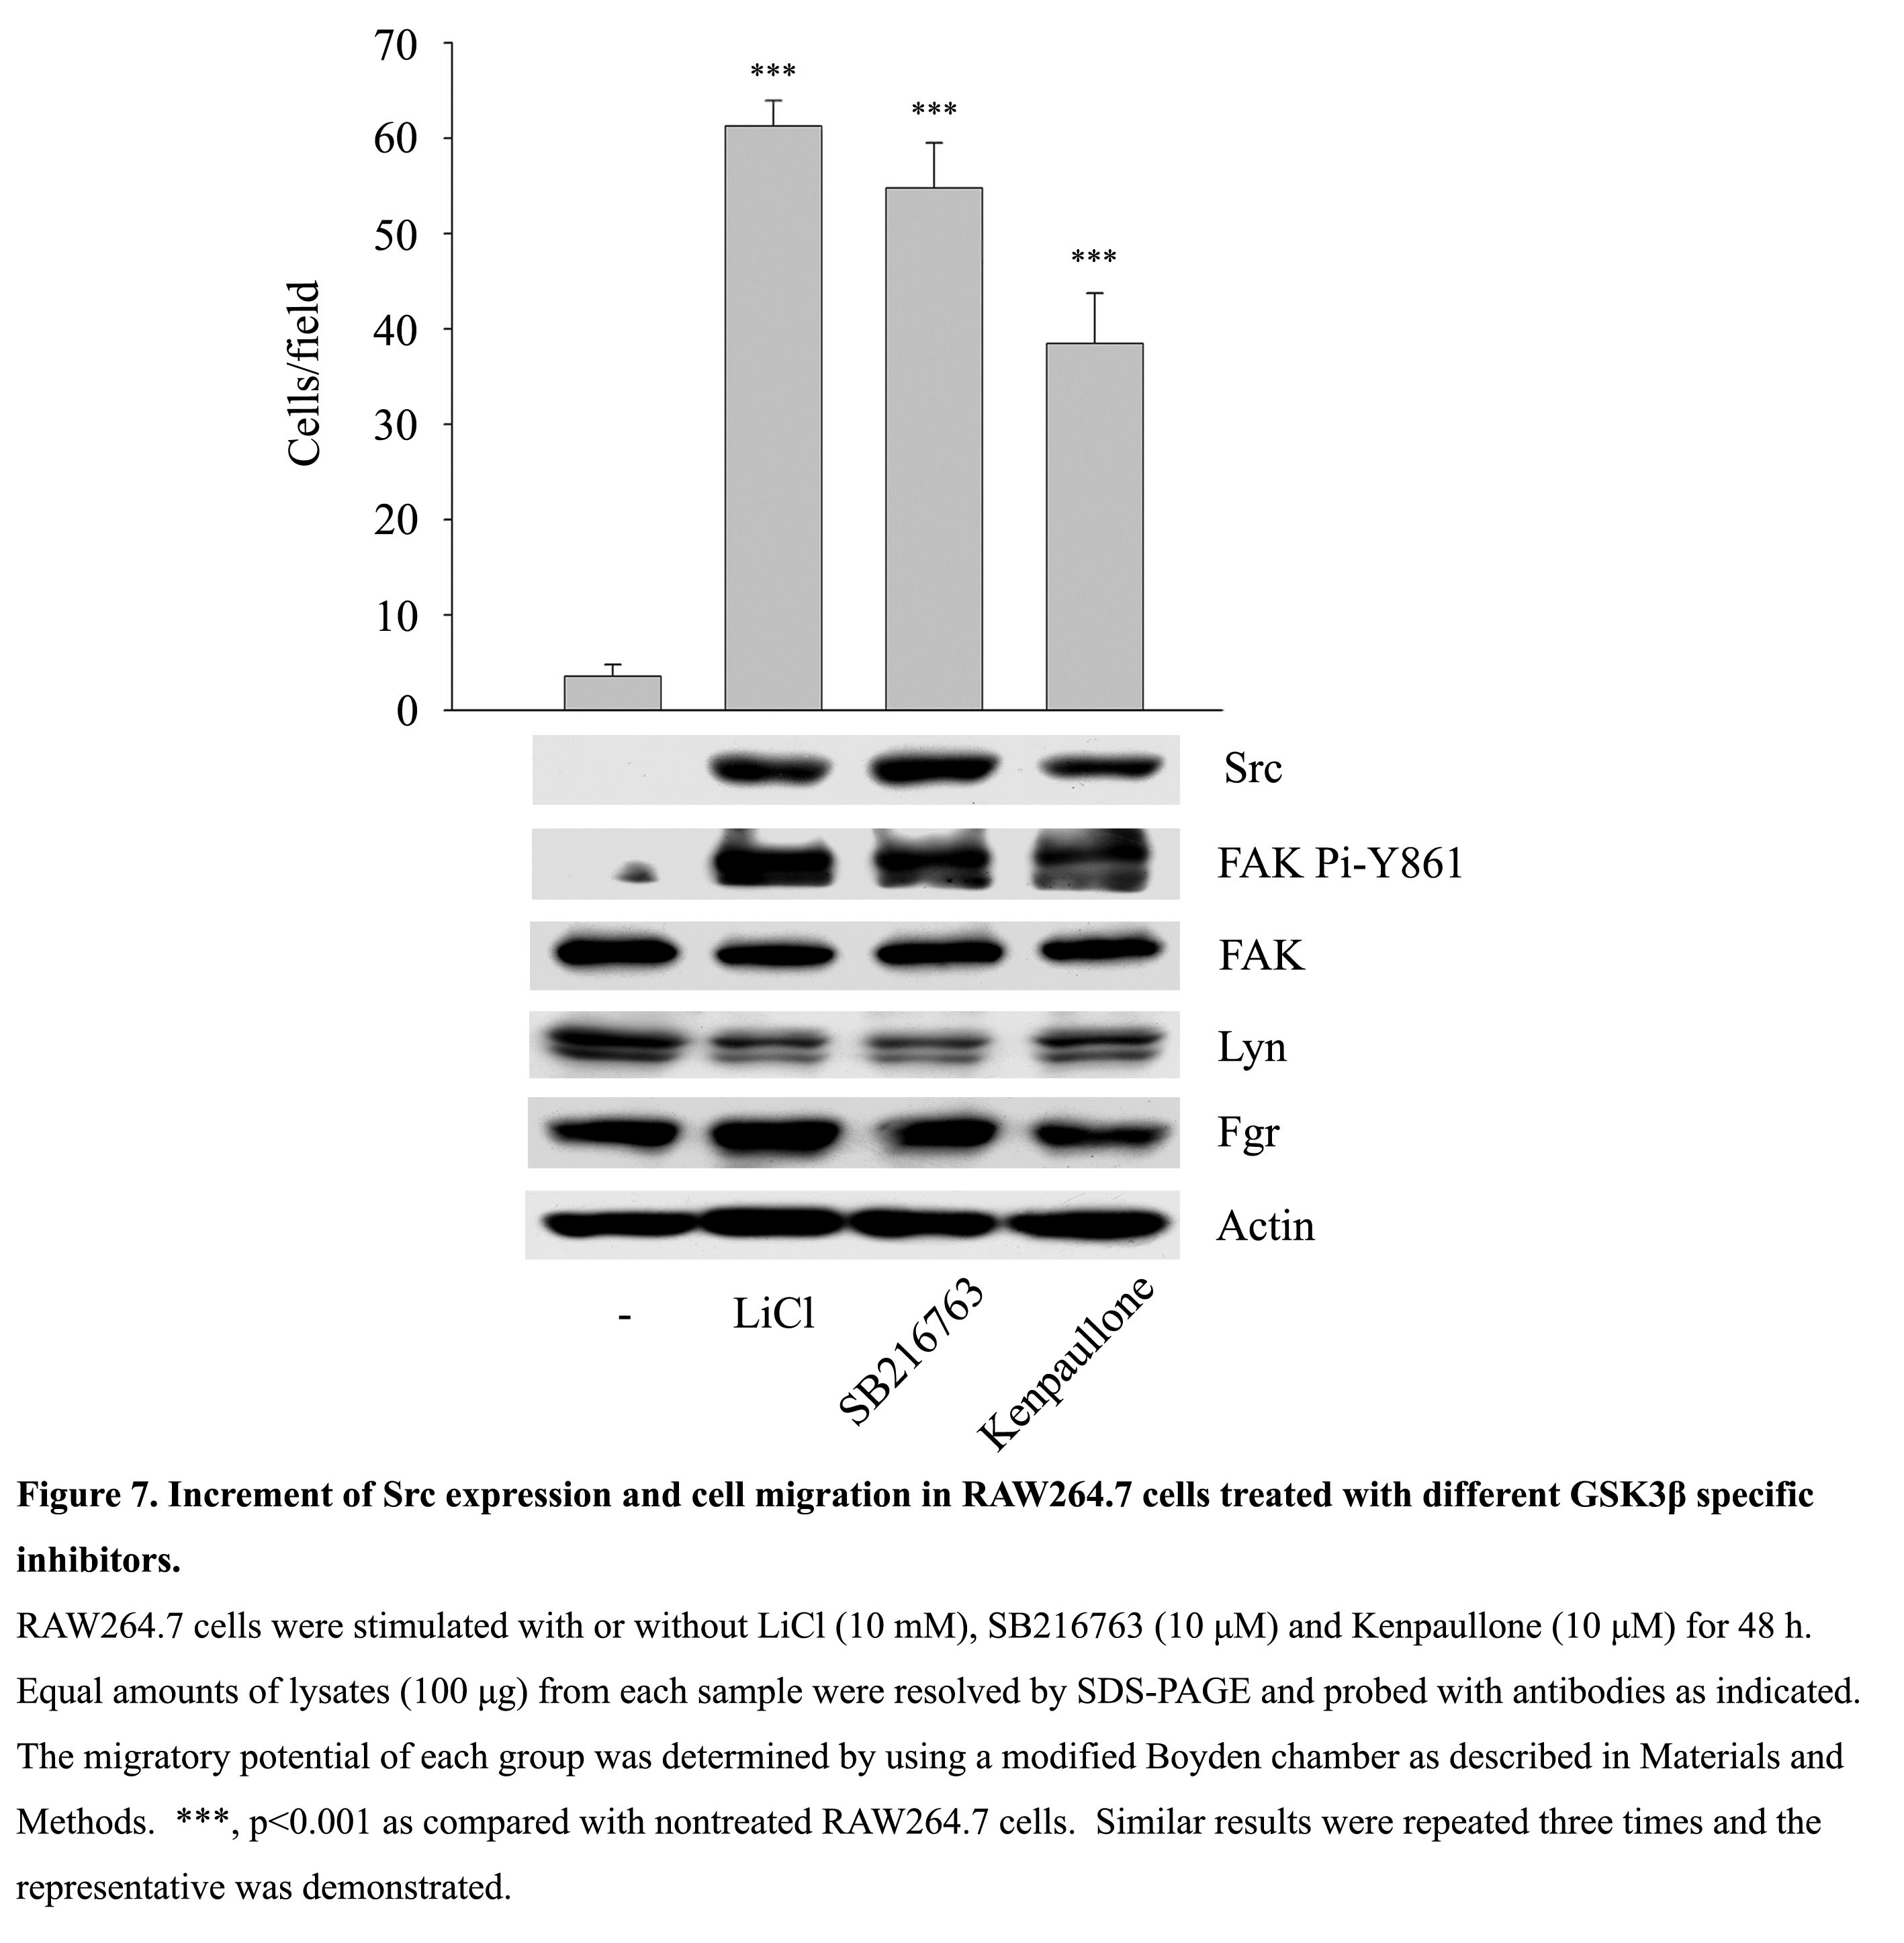As shown in Figure 7, SB216763 and Kenpaullone inhibited the activity of GSK3β. Both compounds, like LiCl could increase the expression of iNOS, Src as well as the activity of Src and FAK that ultimately led to macrophage migration. Markedly, these GSK3β inhibitors augmented NF-κB activation (as reflected by NF-κB p65 Pi-S468). Thus, Src induction and activation could be achieved by GSK3β blockade in macrophages.

Discussions

Our data indicated that LiCl induced macrophage migration by upregulating the activity of NF-κB, the expression of iNOS and Src as well as the activity of Src and FAK (Figure 8). 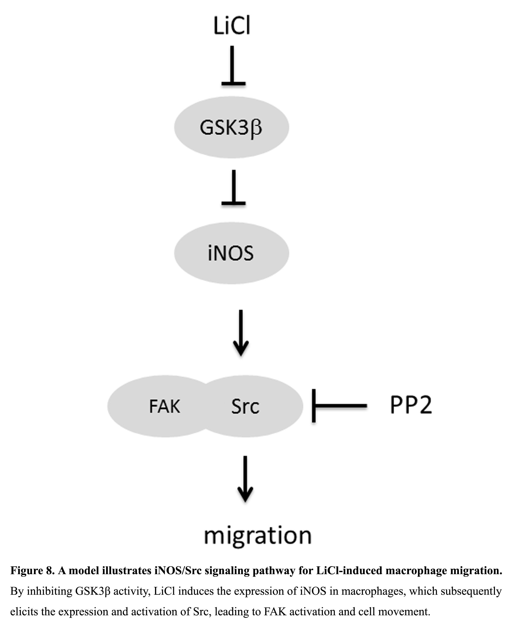In our studies, the content of tyrosyl-phosphorylated proteins increased after LiCl stimulation, and this phenomenon together with their migratory ability was inhibited by an SFK inhibitor PP2, suggesting the role of SFKs in this process. Interestingly, while the expression of the myeloid Src relatives (i.e. Lyn, Fgr and Hck) was not altered, the expression and activity of Src was greatly elevated when macrophages were treated with LiCl, indicating the importance of Src in LiCl-induced macrophage activation. The enhanced Src activity was associated with the increased activity of FAK, which was a substrate of Src and was a critical molecule in regulating cell spreading and migration [17]. These results implied the involvement of the Src/FAK axis in LiCl-induced migration. The importance of Src was further confirmed by RAW264.7 cells bearing plasmid encoding src-specific siRNA, in which the activity of Src and FAK and macrophage migration were suppressed upon LiCl treatment. However, reintroduction of Src to Src-deficient macrophages could totally recover these defects. These results are reminiscent of TLR-activated macrophage mobility, indicating the importance of Src/FAK axis in regulating cell movement in LiCl-stimulated macrophages [3; 4].
Our prior study indicated the enhanced expression and activity of Src was iNOS-dependent in macrophages in response to TLR engagement [3; 4]. Intriguingly, the time course study revealed the induction of iNOS appeared ahead of Src in LiCl-treated macrophages, indicating the indispensability of iNOS in this process. Indeed, LiCl-mediated Src induction as well as macrophage motility was impaired in iNOS-null macrophages. Transcription factor NF-κB plays an important role in the activation of inos transcription. Although GSK3β can positively [18; 19; 20; 21] or negatively [22] regulate the activity of NF-κB in macrophages treated with various stimuli, it can directly phosphorylate p65 on Ser468 leading to decreased basal transcriptional activity [23]. Thereby, LiCl might activate NF-κB via reducing its p65 Ser468 phosphorylation and up-regulate the expression and activity of iNOS/Src in our study.
In addition to GSK3β, LiCl could also exert its negative effect on other enzymes, including ADP-ribosyl transferase, phosphomonoesterases, and inositol monophosphatase [24; 25; 26]. Therefore, the involvement of the aforementioned enzymes in LiCl-activated iNOS/Src axis and macrophage movement could not be excluded. Nevertheless, other GSK3β inhibitors, SB216763 and Kenpaullone which act as ATP-competitive inhibitors could also stimulate Src expression and macrophage motility corroborated that GSK3β blockade resulted in Src induction and activation.
GSK3β is a multi-tasking serine/threonine kinase and is involved in the Wnt/β-catenin signing pathway. The engagement of Wnt/Frizzled inhibits GSK3β-mediated phosphorylation of β-catenin and prevents the later protein from polyubiquitination/proteasome-mediated protein degradation, leading to the complex formation between β-catenin and transcription factor TCF/LEF (lymphoid enhancer factor) that triggers the transcription of their target genes in the nucleus. It has been demonstrated that TLR2-mediated iNOS induction led to the upregulation of Wnt/β-catenin signaling [27; 28]. In addition, via ERK/AKT-mediated GSK3β suppression, β-catenin-mediated gene expression is required for LPS-stimulated macrophage motility [29]. Given that iNOS/Src/FAK axis is involved in TLR-mediated cell motility in macrophages [4], the mutual regulation between iNOS and β-catenin seems to be important in regulating macrophage mobilization as well as other immune functions, which deserve further investigation. Given LiCl was the classic drug in treating bipolar mood depression patients, we noticed that the therapeutic concentration of LiCl (0.8-1.0 mM) [30] was very close to the effective concentration (i.e. 2 mM) to induce Src expression in macrophages. Thus, carefully dosing of LiCl might be important for avoiding inappropriate macrophage activation.
In conclusion, we demonstrated that the iNOS induction achieved by GSK3β inhibition was crucial for LiCl-mediated macrophage migration and Src and FAK were downstream targets for this event. Our findings extended our understanding in the impact of LiCl on immune cell functions.
Acknowledgements

This work is supported in part by National Health Research Institute Grant NHRI-EX103-10131BI (to T.-H.L.); National Science Council Grants NSC102-2325-B-006-010 (to T.-H.L.) and NSC101-2311-B-039-002-MY3 (to M.-C.M.); Taiwan Department of Health Clinical Trial and Research Center of Excellence Grant DOH103-TD-B-111-004 (to M.-C.M.); and China Medical University Grant CMU101-S-02.

Conflict of Interests
All authors declare no conflict of interest.

References

[1] R. Ishizawar, S.J. Parsons, c-Src and cooperating partners in human cancer, Cancer Cell 6 (2004) 209-14.
[2] T.H. Leu, S. Charoenfuprasert, C.K. Yen, C.W. Fan, M.C. Maa, Lipopolysaccharide-induced c-Src expression plays a role in nitric oxide and TNFalpha secretion in macrophages, Mol Immunol 43 (2006) 308-16.
[3] M.C. Maa, M.Y. Chang, Y.J. Chen, C.H. Lin, C.J. Yu, Y.L. Yang, J. Li, P.R. Chen, C.H. Tang, H.Y. Lei, T.H. Leu, Requirement of inducible nitric-oxide synthase in lipopolysaccharide-mediated Src induction and macrophage migration, J Biol Chem 283 (2008) 31408-16.
[4] M.C. Maa, M.Y. Chang, J. Li, Y.Y. Li, M.Y. Hsieh, C.J. Yang, Y.J. Chen, Y. Li, H.C. Chen, W.E. Cheng, C.Y. Hsieh, C.W. Cheng, T.H. Leu, The iNOS/Src/FAK axis is critical in Toll-like receptor-mediated cell motility in macrophages, Biochim Biophys Acta 1813 (2011) 136-47.
[5] Y.J. Chen, M.Y. Hsieh, M.Y. Chang, H.C. Chen, M.S. Jan, M.C. Maa, T.H. Leu, Eps8 protein facilitates phagocytosis by increasing TLR4-MyD88 protein interaction in lipopolysaccharide-stimulated macrophages, J Biol Chem 287 (2012) 18806-19.
[6] M.Y. Hsieh, M.Y. Chang, Y.J. Chen, Y.K. Li, T.H. Chuang, G.Y. Yu, C.H. Cheung, H.C. Chen, M.C. Maa, T.H. Leu, The inducible nitric-oxide synthase (iNOS)/Src axis mediates Toll-like receptor 3 tyrosine 759 phosphorylation and enhances its signal transduction, leading to interferon-beta synthesis in macrophages, J Biol Chem 289 (2014) 9208-20.
[7] P.S. Klein, D.A. Melton, A molecular mechanism for the effect of lithium on development, Proc Natl Acad Sci U S A 93 (1996) 8455-9.
[8] V. Stambolic, L. Ruel, J.R. Woodgett, Lithium inhibits glycogen synthase kinase-3 activity and mimics wingless signalling in intact cells, Curr Biol 6 (1996) 1664-8.
[9] T.D. Gould, H.K. Manji, Glycogen synthase kinase-3: a putative molecular target for lithium mimetic drugs, Neuropsychopharmacology 30 (2005) 1223-37.
[10] R.S. Jope, Lithium and GSK-3: one inhibitor, two inhibitory actions, multiple outcomes, Trends Pharmacol Sci 24 (2003) 441-3.
[11] F. Zhang, C.J. Phiel, L. Spece, N. Gurvich, P.S. Klein, Inhibitory phosphorylation of glycogen synthase kinase-3 (GSK-3) in response to lithium. Evidence for autoregulation of GSK-3, J Biol Chem 278 (2003) 33067-77.
[12] C.T. Chiu, Z. Wang, J.G. Hunsberger, D.M. Chuang, Therapeutic potential of mood stabilizers lithium and valproic acid: beyond bipolar disorder, Pharmacol Rev 65 (2013) 105-42.
[13] V.E. Laubach, E.G. Shesely, O. Smithies, P.A. Sherman, Mice lacking inducible nitric oxide synthase are not resistant to lipopolysaccharide-induced death, Proc Natl Acad Sci U S A 92 (1995) 10688-92.
[14] M.C. Maa, T.H. Leu, Vanadate-dependent FAK activation is accomplished by the sustained FAK Tyr-576/577 phosphorylation, Biochem Biophys Res Commun 251 (1998) 344-9.
[15] S.L. Weinstein, C.H. June, A.L. DeFranco, Lipopolysaccharide-induced protein tyrosine phosphorylation in human macrophages is mediated by CD14, J Immunol 151 (1993) 3829-38.
[16] L.M. Williams, A.J. Ridley, Lipopolysaccharide induces actin reorganization and tyrosine phosphorylation of Pyk2 and paxillin in monocytes and macrophages, J Immunol 164 (2000) 2028-36.
[17] K.A. Owen, F.J. Pixley, K.S. Thomas, M. Vicente-Manzanares, B.J. Ray, A.F. Horwitz, J.T. Parsons, H.E. Beggs, E.R. Stanley, A.H. Bouton, Regulation of lamellipodial persistence, adhesion turnover, and motility in macrophages by focal adhesion kinase, J Cell Biol 179 (2007) 1275-87.
[18] K.P. Hoeflich, J. Luo, E.A. Rubie, M.S. Tsao, O. Jin, J.R. Woodgett, Requirement for glycogen synthase kinase-3beta in cell survival and NF-kappaB activation, Nature 406 (2000) 86-90.
[19] M. Martin, K. Rehani, R.S. Jope, S.M. Michalek, Toll-like receptor-mediated cytokine production is differentially regulated by glycogen synthase kinase 3, Nat Immunol 6 (2005) 777-84.
[20] Y.T. Chang, C.L. Chen, C.F. Lin, S.L. Lu, M.H. Cheng, C.F. Kuo, Y.S. Lin, Regulatory role of GSK-3 beta on NF- kappa B, nitric oxide, and TNF- alpha in group A streptococcal infection, Mediators Inflamm 2013 (2013) 720689.
[21] C.F. Lin, C.C. Tsai, W.C. Huang, C.Y. Wang, H.C. Tseng, Y. Wang, J.I. Kai, S.W. Wang, Y.L. Cheng, IFN-gamma synergizes with LPS to induce nitric oxide biosynthesis through glycogen synthase kinase-3-inhibited IL-10, J Cell Biochem 105 (2008) 746-55.
[22] K. Saijo, B. Winner, C.T. Carson, J.G. Collier, L. Boyer, M.G. Rosenfeld, F.H. Gage, C.K. Glass, A Nurr1/CoREST pathway in microglia and astrocytes protects dopaminergic neurons from inflammation-induced death, Cell 137 (2009) 47-59.
[23] H. Buss, A. Dorrie, M.L. Schmitz, R. Frank, M. Livingstone, K. Resch, M. Kracht, Phosphorylation of serine 468 by GSK-3beta negatively regulates basal p65 NF-kappaB activity, J Biol Chem 279 (2004) 49571-4.
[24] M.J. Berridge, C.P. Downes, M.R. Hanley, Neural and developmental actions of lithium: a unifying hypothesis, Cell 59 (1989) 411-9.
[25] E.J. Nestler, R.Z. Terwilliger, R.S. Duman, Regulation of endogenous ADP-ribosylation by acute and chronic lithium in rat brain, J Neurochem 64 (1995) 2319-24.
[26] C.J. Phiel, P.S. Klein, Molecular targets of lithium action, Annu Rev Pharmacol Toxicol 41 (2001) 789-813.
[27] K. Bansal, J. Trinath, D. Chakravortty, S.A. Patil, K.N. Balaji, Pathogen-specific TLR2 Protein Activation Programs Macrophages to Induce Wnt-β-Catenin Signaling, Journal of Biological Chemistry 286 (2011) 37032-37044.
[28] Q. Du, X. Zhang, Q. Liu, X. Zhang, C.E. Bartels, D.A. Geller, Nitric oxide production upregulates Wnt/beta-catenin signaling by inhibiting Dickkopf-1, Cancer Res 73 (2013) 6526-37.
[29] K. Gong, F. Zhou, H. Huang, Y. Gong, L. Zhang, Suppression of GSK3beta by ERK mediates lipopolysaccharide induced cell migration in macrophage through beta-catenin signaling, Protein Cell 3 (2012) 762-8.
[30] R. Eilers, Therapeutic drug monitoring for the treatment of psychiatric disorders. Clinical use and cost effectiveness, Clin Pharmacokinet 29 (1995) 442-50.

[1] M. Hull, E. Lee, T. Lee, N. Anand, V. LaLone, N. Parameswaran, Lithium chloride induces TNFalpha in mouse macrophages via MEK-ERK-dependent pathway, J Cell Biochem 115 (2014) 71-80.
[2] E.S. Kleinerman, R.D. Knowles, M.B. Blick, L.A. Zwelling, Lithium chloride stimulates human monocytes to secrete tumor necrosis factor/cachectin, J Leukoc Biol 46 (1989) 484-92.
[3] P.B. Raghavendra, E. Lee, N. Parameswaran, Regulation of macrophage biology by lithium: a new look at an old drug, J Neuroimmune Pharmacol 9 (2014) 277-84.
[4] L. Wang, L. Zhang, X. Zhao, M. Zhang, W. Zhao, C. Gao, Lithium attenuates IFN-beta production and antiviral response via inhibition of TANK-binding kinase 1 kinase activity, J Immunol 191 (2013) 4392-8.
[5] M. Zhang, W. Jin, X. Zhou, J. Yu, A.J. Lee, S.C. Sun, Deregulation of Tpl2 and NF-kappaB signaling and induction of macrophage apoptosis by the anti-depressant drug lithium, Cell Signal 21 (2009) 559-66.
[6] S. Nahman, R.H. Belmaker, A.N. Azab, Effects of lithium on lipopolysaccharide-induced inflammation in rat primary glia cells, Innate Immun 18 (2012) 447-58.

