NFIL3 Suppresses Hypoxia-induced Apoptotic Cell Death by Targeting the Insulin-like Growth Factor 2 Receptor

Kuan-Ho Lin^{1,2,3}, Chia-Hua Kuo⁴, Wei-Wen Kuo⁵, Tsung-Jung Ho^{6,7}, Peiying Pai⁸, Wei-Kung Chen³, Lung-Fa Pan^{9,10}, Chien-Cheng Wang¹, V. Vijaya Padma ¹¹, Chih-Yang Huang^{12,13,14}

¹Graduate Institute of Clinical Medical Science, China Medical University, Taichung, Taiwan

²College of Medicine, China Medical University, Taichung, 40402, Taiwan
³Department of Emergency Medicine, China Medical University Hospital, Taichung, Taiwan
⁴Department of Sports Sciences, University of Taipei, Taipei, Taiwan
⁵Department of Biological Science and Technology, China Medical University, Taichung
⁶School of Chinese Medicine, College of Chinese Medicine, China Medical University

⁷Chinese Medicine Department, China Medical University Beigang Hospital, Taiwan
⁸Division of Cardiology, China Medical University Hospital, Taichung, Taiwan

⁹Cardiology Department of Taichung Armed Forces General Hospital
¹⁰Department of Medical Imaging and Radiological Sciences of Central Taiwan University of Science and Technology
¹¹ Department of Biotechnology, Bharathiar University, Coimbatore-641 046, India
¹²Graduate Institute of Chinese Medical Science, China Medical University, Taichung, Taiwan ¹³Graduate Institute of Basic Medical Science, China Medical University, Taichung, Taiwan
¹⁴Department of Health and Nutrition Biotechnology, Asia University, Taichung, Taiwan

Corresponding author: Chih-Yang Huang Ph.D., Graduate Institute of Basic Medical Science, Graduate Institute of Chinese Medical Science, China Medical University and Hospital, No. 91, Hsueh-Shih Road, Taichung, 404, Taiwan. Tel: +886-4-22053366 ext 3313. E-mail address: cyhuang@mail.cmu.edu.tw

Abstract
The insulin-like growth factor-II/mannose 6-phosphate receptor (IGF2R) over-expression correlates with heart disease progression. The IGF2R is not only an IGF2 clearance receptor, but it also triggers signal transduction, resulting in cardiac hypertrophy, apoptosis and fibrosis. The present study investigated the nuclear factor IL-3 (NFIL3), a transcription factor of the basic leucine zipper superfamily, and its potential pro-survival effects in cardiomyocytes. NFIL3 might play a key role in heart development and act as a survival factor in the heart, but the regulatory mechanisms are still unclear. IGF2 and IGF2R protein expression were highly increased in rat hearts subjected to hemorrhagic shock. IGF2R protein expression was also up-regulated in H9c2 cells exposed to hypoxia. Over-expression of NFIL3 in H9c2 cardiomyoblast cells inhibited the induction of hypoxia-induced apoptosis and down-regulated IGF2R expression levels. Gel shift assay, double-stranded DNA pull-down assay and chromatin immune-precipitation analyses indicated that NFIL3 binds directly to the IGF2R promoter region. Using a luciferase assay, we further observed NFIL3 repress IGF2R gene promoter activity. Our results demonstrate that NFIL3 is an important negative transcription factor, which through binding to the promoter of IGF2R, suppresses the apoptosis induced by IGF2R signaling in H9c2 cardiomyoblast cells under hypoxic conditions.

Keywords: NFIL3, EBPRE, hypoxia, apoptosis, IGF2R signaling,

- Introduction
The cation-independent mannose 6-phosphate receptor/insulin-like growth factor II receptor (CI-MPR/IGF2R) is a multifunctional protein that is able to interact with intracellular and extracellular ligands, some of which are important growth regulatory factors [Ghosh et al., 2003]. The IGF2R mediates insulin-like growth factor II (IGF2) through internalization and lysosomal degradation and is considered an IGF2 clearance receptor [Boker et al., 1997]. However, much evidence has shown that in spite of the degradation of IGF2 in the lysosome, IGF2R may direct intracellular signal transduction in the regulation of cell behavior [Harris and Westwood, 2012; Hawkes et al., 2006; McKinnon et al., 2001; Okamoto and Nishimoto, 1991]. In a transgenic mice model, the lack of imprinted IGF2R results in ventricular hyperplasia, which is characterized by increased proliferation of fetal myocardial cells [Lau et al., 1994]. It has been shown that disruption of IGF2R protein levels promotes cell proliferation and diminished hypoxia- and tumor necrosis factor (TNF)-induced apoptosis in neonatal rat cardiac myocytes [Chen et al., 2004]. Ligation of the abdominal aorta in rats induced expression of IGF2R and cardiac myocyte apoptosis in the heart. Moreover, IGF2 and the IGF2R play a critical role in angiotensin II (Ang II)-induced apoptosis in cardiomyoblast cells by increasing the IGF2Rexpression at both the transcription and translation levels [Lee et al., 2006]. IGF2 or Leu27IGF2 (an IGF2 analog) activated the IGF2R, which interacted with Gαq and induced hypertrophy and apoptosis in H9c2 and neonatal rat ventricular myocyte cells [Chen et al., 2009; Chu et al., 2008; Chu et al., 2009]. These findings indicate that IGF2, acting through the IGF2R, can promote cardiomyocyte death. Histone acetylation also plays an essential role in the up-regulation of IGF2R during heart disease exacerbation [Chu et al., 2012]. It is possible that the IGF2R gene expression program requires strict transcriptional regulation; however, the mechanisms regulating its transcription remain poorly understood.
The nuclear factor interleukin 3 regulated (NFIL3) protein, also known as the E4 binding protein 4 (E4BP4), is a member of the mammalian basic leucine zipper (bZIP) family and acts as a transcriptional repressor or activator [Cowell, 2002; Cowell et al., 1992]. It was demonstrated that NFIL3 binds to the promoter of the IL-3 gene and that IL-3 treatment induced NFIL3 expression and prevented apoptosis of pro-B lymphocytes [Ikushima et al., 1997; Zhang et al., 1995]. The consensus NFIL3-binding site sequence (EBPRE) is homologous to the cAMP-responsive DNA element (CRE) and the consensus CCAAT enhancer binding protein beta (C/EBPβ) [Haas et al., 1995]. NFIL3 has also been reported to control T cell cytokine expression and neuronal regeneration-associated gene expression by forming a transcriptional feed forward loop with the CREB [Kashiwada et al., 2011; MacGillavry et al., 2009]. NFIL3 is expressed in the heart, lung and skeletal muscle and is highly expressed in the liver of the rat [Nishimura and Tanaka, 2001]. NFIL3 has been identified as an anti-apoptosis effector in pro-B lymphocytes [Ikushima et al., 1997; Kuribara et al., 1999] and as a promoter of neuronal survival and axonal growth [Junghans et al., 2004]. In our lab, previous studies have shown that NFIL3 is essential for heart development and acts as a cardiac survival factor [Weng et al., 2010]; however, the role of NFIL3 in the genetic regulatory mechanisms of the mammalian heart remains unclear. Thus, the aim of the present study was to investigate whether NFIL3 protected against hypoxia-induced IGF2R signaling and apoptosis in H9c2 cardiomyoblast cells and its probable mechanisms.

- Materials and methods

  - Cell culture and transfection
H9c2 cardiomyoblast cells were obtained from American Type Culture Collection (ATCC) and cultured in Dulbecco’s modiﬁed essential medium supplemented with 10% cosmic calf serum (CCS), 2 mM glutamine, 100 U/ml penicillin, 100 mg/ml streptomycin and 1 mM pyruvate in humidiﬁed air (5% CO₂) at 37 °C. Experiments were performed at a cell population density up to 70%. Before being placed in the hypoxic condition, the cells were incubated in minimal essential medium for 24 h. After hypoxia treatment, the cells were harvested and extracted for analysis. NFIL3 plasmids were purchased from OriGene and cells were transfected for 24 h using PureFection reagents (System Biosciences, Mountain View, CA, USA)

  - Hemorrhagic Shock induction and Hypoxia Treatment
Animals were subjected to hemorrhagic shock as previously described[Chang et al., 2005]. For normoxia experiments, the H9c2 cardiomyoblast cells (ATCC) were cultured in humidified 5% CO2/95% air at 37°C. For hypoxia experiments, the H9c2 cardiomyoblast cells (ATCC) were cultured with 5% CO2, 94% N2, and 1% O2 at37°C. The cells were incubated for 6, 12, 24 or 48 hr under hypoxic conditions. To evaluate hypoxic effects in culture of H9c2 cells (ATCC), protein level were detected by Western blot. Each experimental condition was performed in triplicate

2.3. Cell viability assay
Cell viability was using a 3- (4, 5-dimethylthiazol-2-yl)-2,5-diphenyltetrazolium bromide (MTT) assay kit. The H9c2 ells were incubated in 12-well plates in 10%CCS medium with hypoxia treatment for 3, 6, 12, 24 hr. Subsequently, the medium was removed and the cells were washed with phosphate-buffered saline (PBS). 1 mL of MTT/phenol-red free DMEM (v/v=1:9) was added to each well and the cells were incubated for 4 h at 37 °C. The medium was removed carefully and 1 mL of dimethyl sulfoxide (DMSO) was added to each well, for 5 min, 200 μL of supernatant of each sample was transferred to 96-well plates, and absorbance 570 nm was measured by spectrophotometer (U-2001, Hitachi). The absorbance in the control group was regarded as 100% cell viability.

2.3. Western blot
Cultured H9c2 cells were scraped and washed twice with PBS. The cell suspensions were collected, lysed using a lysis buffer (50 mM Tris, pH 7.5; 0.5 M NaCl; 1.0 mM EDTA, pH 7.5; 10% glycerol; 1 mM basal medium Eagle; 1% Igepal-630; and a proteinase inhibitor cocktail tablet (Roche, Mannheim, Germany)) and spun at 12,000 g for 30 min. The supernatants were subjected to SDS–PAGE and transferred onto an ImmobilonTM PVDF membrane (Millipore, Bedford, MA, USA). The membranes were blocked with 5% low-fat milk and 1% Tween 20 in PBS and probed with the indicated antibodies. Protein expression was detected with the ECL detection system (Millipore). The antibodies used are as follows: anti-NFIL3, anti-Bax, anti-Bak, anti-Cyt C, anti-cleaved caspase-3, α-tubulin, β-actin (Santa Cruz Biotechnology, Santa Cruz, CA, USA), anti-IGF2, anti-IGF2R (Abcam, Cambridge, MA, USA), anti-IGF1R, anti-phospho-IGF1R, anti-PI3K, anti-phospho-Akt, and anti-phospho-PLCβ (Cell Signaling Technology, Beverly, MA).

2.3. TUNEL assay
DNA strand breaks were demonstrated by TUNEL with the In Situ Cell Death Detection kit, fluorescein (Roche). H9c2 cells were ﬁxed with a 4% paraformaldehyde solution for 30 min at room temperature, washed three times with phosphate-buffered saline (PBS), permeabilized with 0.1% Triton X-100 (TEDIA, Fairfield, OH, USA) for 5 min, rinsed with PBS, and then stained with the TUNEL reaction mixture for 2 h. After rinsing again with PBS, the cells were stained with 1 µg/ml DAPI for 5 min. TUNEL-positive cardiomyoblasts were detected in the 515-565 nm (green) range with fluorescence microscopy (Olympus, Tokyo, Japan).
  - RNA extraction and Semi-quantitative RT-PCR
Total RNA was extracted from cultured H9c2 cell using the Quick-RNATM Miniprep Kit (R1055, Zymo Research) following the manufacturers’ instructions. The concentration and purity of the total RNA were calculated based on the absorbance at 260 and 280 nm. Complementary DNA (cDNA) was synthesized with 1 µg of total RNA and 1 µM oligo dT (dT15) primer using Moloney Murine Leukemia Virus Reverse Transcriptase (Promega, Madison, WI). cDNA was amplified using the following primer sets: IGF2R forward primer 5′-CACCGCATCCAAGATGAGAGA-3′, IGF2R reverse primer 5′-GCTGTTGATTCCAAAAATAATGCA-3′, GAPDH forward primer 5′-CCACACCTGGGATTATCCACAT-3′, GAPDH reverse primer 5′-GCCCCCAACACTGAGCAT-3′, PCR products were electrophoresed by using 1% agarose gels and visualized by staining with ethidium bromide. The gel was illuminated on a UV trans-illuminator and photographed using the UVP GDS-7900 imaging system (UVP Inc., Upland, CA, USA).

2.4. Nuclear extracts and the electrophoretic mobility shift assay (EMSA)
The nuclear extracts of H9c2 cells were prepared using Nuclear and Cytoplasmic Extraction Reagents (Thermo, NY, USA). Probes to the EBPRE sequence in the IGF2R promoter were used to detect sequence-specific NFIL3 binding in vitro. The probes used were as follows: 5'--TTTTTCTTACATAATATGGCTTACATAATATGGCTTACATAATTTTTT-3' and competitor 5'-CACCGCCTTACATAATATGGGT-3'. Nucleotides were biotin labeled by Sigma Aldrich. The binding reaction was performed using the LightShift kit (Thermo). Briefly, nuclear extracts, binding mixtures (2.5% Glycerol, 5 mM MgCl_{2,} 50 ng/μl, 0.05% NP-40 and 10 mM EDTA), the competitor (4 pmol) and the anti-NFIL3 antibody (1 μg, Santa Cruz) were incubated on ice for 5 min. The labeled probe (40 fmol) was then added in a volume of 20 μl, and the mixture was incubated for an additional 25 min. The reaction products were separated via electrophoresis (100 V, 6% non-denaturing polyacrylamide gel) until the bromophenol blue dye had migrated approximately 2/3 to 3/4 down the length of the gel, and they were then transferred to a Biodyne B Nylon Membrane (Thermo) in 0.5X TBE buffer at 100 V. The DNA crosslinked products were detected using chemiluminescence (Thermo).

2.5. Biotin-DNA pull-down assay
The 5'-biotinylated double-stranded oligonucleotides (5'- TTTTTCTTACATAATATG GCTTACATAATATGGCTTACATAATTTTTT-3') corresponded to positions -899 to -890 of the IGF2R promoter and included three repeats. The competitor (5'-CACCGCCTTACATA ATATGGGT-3') corresponded to positions -905 to -885 of the IGF2R promoter. Nuclear protein extracts were prepared from H9c2 cells that were transfected with NFIL3. A total of 25μg of the nuclear extract was incubated at 4℃ for 1 h with each pair of the oligonucleotides and Qbeads-Streptavidin (MagQu, TPE, Taiwan). The protein-DNA complexes were denatured in SDS sample buffer, subjected to SDS-PAGE and detected by Western blot.

2.6. Chromatin immunoprecipitation assay
A ChIP assay was performed as described previously [Chu et al., 2012]. Brieﬂy, cells were crosslinked with formaldehyde, and chromatin was fragmented by sonication. Chromatin was immunoprecipitated with anti-NFIL3 (Santa Cruz) or control IgG, and puriﬁed co-precipitated DNA was quantiﬁed by PCR with Ex Taq™ Polymerase (TaKaRa, Otsu, Japan). The PCR products were then analyzed using agarose gel electrophoresis and stained with EtBr for visualization. The primers used to amplify the DNA fragments were as follows: forward 5'-AGCACATTACAGACGGAGCCATT-3' and reverse 5'-TC AGACAGGACTGGAGTTCGGAT-3'.

2.7. Luciferase assay
The IGF2R-luciferase constructs were created by inserting an ~ 1.3 and an ~ 0.7 kb fragment encompassing the predicted EBPRE into the pGL4-BASIC-luciferase plasmid (Promega, Tokyo, Japan). The primers used to amplify the DNA fragments were as follows: IGF2R_P1 (forward 5'-TCTCATCTCGAGCAATGACTAGTCTTCATGTAACAGC -3' and reverse 5'-GCCGC-AAAGCTTGAGTCGAAGCTGCAACGG-3') and IGF2R_P2 (forward 5'- CATTCGCTCGAGTCCGAACTCCAGTCCTGTCT-3' and reverse 5'-GCC GCAAAGCTTGAGTCGAAGCTGCAACGG-3'). A commercial plasmid containing a CMV-driven Renilla reporter system was used as an internal control (Promega). H9c2 cells were plated in 6-well plates at 50-70% confluence and were co-transfected with the pCMV-NFIL3 construct or with an equimolar amount of the pCMV empty vector and the pGL4-IGF2R_P1 or pGL4-IGF2R_P2 construct utilizing PureFection™ reagents (System Biosciences). The media was changed 2 h prior to transfection. After the media was changed, the cells were incubated in 10% DMEM for 24 h. The luciferase assays were performed using the Dual-Luciferase Reporter Assay System according to the manufacturer’s instructions (Promega). Briefly, 100 μl of luciferase substrate was added to 20 μl of lysate, and luciferase activity was measured using a LB940 Multilabel Reader (Berthold Technologies, Bad Wildbad, Germany). Each luciferase assay was performed in triplicate.
- Results

  - Hypoxia-induced IGF2R expression in H9c2 cardiomyoblasts correlated with expression in hearts subjected to hemorrhagic shock rat.
IGF2 and the IGF2R play an important role in the heart. IGF2 and IGF2R protein expression levels were increased in the hearts of rats with an abdominal aorta ligation. Under an Ang II-induced cardiomyoblast apoptotic condition, blocking IGF2 or the IGF2R attenuated Ang II-induced DNA fragmentation [Lee et al., 2006]. Therefore, we decided to further characterize the IGF2 and IGF2R expression in rats subjected to hemorrhagic shock. The levels of IGF2 and IGF2R protein expression were significantly increased in the hearts of rats subjected to hemorrhagic shock compared with the control rat hearts (Fig. 1A). We also investigated whether hypoxia induced IGF2R protein expression in H9c2 cells. Western blot analysis confirmed a time-dependent up-regulation of IGF2R protein expression when cells were treated with hypoxia (Fig. 1B). Due to the IGF2R protein expressed most after 24 hr hypoxia treatment, H9c2 cell viability under hypoxic conditions was detected by MTT assay. There were significant difference between control (normoxia) and 24hr hypoxia treated groups (Fig. 1C). This result indicated that 24hr hypoxia treatment had harmful effect on growth of H9c2 cells.

  - NFIL3 overexpression repressed hypoxia-induced apoptosis of H9c2 cardiomyoblast cells.
Previous studies have shown that overexpression of NFIL3 attenuates caspase-3 activation and that NFIL3 plays an important role in heart development [Weng et al., 2010]. To investigate whether NFIL3 can inhibit hypoxia-induced apoptosis, we first overexpressed NFIL3 alone. We observed a significant increase in the phosphorylation of IGF1R and Akt and a decline in the IGF2R protein expression level (Fig. 2A). Next, we transfected H9c2 cells with the NFIL3 plasmid and then exposed the cells to hypoxia. The hypoxia-induced reduction in PI3K/Akt signaling was reversed by transfection with NFIL3 in a dose-dependent manner. In addition, the increase in the expression of hypoxia-induced apoptotic proteins Bax, Bak, Cyt C and caspase-3 was decreased with transfection of a different dose of NFIL3 (Fig. 2B). After 24 h of hypoxia treatment, we observed a significant increase in DNA fragmentation using the TUNEL assay. However, there was a significant attenuation of hypoxia-induced TUNEL positive staining when the cells were transfected with NFIL3 (Fig. 2C). Taken together, these results suggest that the up-regulation of NFIL3 inhibits hypoxia-induced H9c2 cell apoptosis.

  - Overexpression of NFIL3 inhibited IGF2R transcription.
To determine the possible mechanisms for IGF2R suppression, we performed semi-quantitative PCR to measure the IGF2R transcription. We observed an increase in the expression of the IGF2R gene in H9c2 cells exposed to hypoxia (Fig. 3A). However, hypoxia-induced IGF2R gene up-regulation was diminished by transfection of a different dose of NFIL3 (Fig. 3B). The findings illustrated in Fig. 3 suggest that NFIL3 repressed IGF2R transcription levels in a direct or an indirect way.

  - NFIL3 suppressed IGF2R gene expression by directly targeting the promoter region of the IGF2R
The NFIL3 binding element is called the E4BP4 response element (EBPRE). We found a conserved consensus sequence for NFIL3 binding -0.8 to -1.2 kb upstream of the IGF2R gene promoter (Fig. 4A). Interestingly, this putative NFIL3 binding sequence is conserved between the rat and mouse, whereas a similar sequence is conserved between humans and orangutans (pongo). We hypothesized that NFIL3 suppressed IGF2R gene expression through direct interaction with the EBPRE. To investigate whether NFIL3 binds to the EBPRE, an electrophoretic mobility-shift assay (EMSA) and a double-stranded DNA pull-down assay were performed with biotin-labeled double-stranded DNA (Fig. 4B). As illustrated in Fig. 4C, overexpression of NFIL3 in H9c2 cells resulted in the binding of protein to the probe with the three repeats of the EBPRE sequence (3xEBPRE). This band shift was diminished by the addition of the biotin-free double-stranded DNA containing the EBPRE sequence or an antibody to NFIL3. NFIL3 was pulled down with the biotin-labeled double-stranded DNA comprising the 3xEBPRE probe (Fig. 4D). The interaction between NFIL3 and the biotin-labeled 3xEBPRE probe was competitively inhibited by the addition of the biotin-free double-stranded DNA containing the EBPRE sequence. A chromatin immunoprecipitation assay (ChIP) also showed specific binding of NFIL3 to the -781 to -965 kb region of the IGF2R promoter, which contains the EBPRE sequence (Fig. 4E). These data indicate that NFIL3 interacts with the EBPRE sequence of the IGF2R promoter in H9c2 cells. We also used a luciferase reporter construct containing the IGF2R promoter including the -890 to -899 EBPRE-containing region to monitor IGF2R transcription. Overexpression of NFIL3 caused a statistically significant attenuation (60%) of the IGF2R promoter activity compared with the empty vector control. In contrast, overexpression of NFIL3 had no statistical effect on the pGL4-0.7k-luc construct, which did not contain the EBPRE sequence (Fig. 4F). Taken this together, NFIL3 overexpression could translocation to nuclear inhibit hypoxia induced IGF2R expression triggered cell apoptosis by binding IGF2R promoter region, and it is able to repress IGF2R gene transcription (Fig. 5).

- Discussion
IGF2R, a ~300-kDa cation-independent mannose 6-phosphate (M6P) receptor, interacts with many different classes of ligands, including IGF2, retinoic acid, uPAR, plasminogen and other M6P containing ligands to regulate various cellular functions [Bohnsack et al., 2010; Ghosh et al., 2003]. H9c2 cells treated with tumor necrosis factor-alpha (TNF-α), lipopolysaccharide (LPS), angiotensin II (Ang II) and inomycin, as well as the spontaneously hypertensive rat (SHR) heart respond with increased IGF2R gene activation [Chu et al., 2012]. Previously study indicate that down-regulation of IGF2R gene expression reduced hypoxia- and TNFα-induced apoptosis [Chen et al., 2004]. Up-regulation of IGF2R, by treatment with Leu27IGF2 and through interactions with Gαq, induced apoptosis and hypertrophy [Chu et al., 2008; Chu et al., 2009]. Our ﬁndings demonstrated that the IGF2R protein expression was up-regulated in H9c2 cells exposed to hypoxia and in the hearts of hemorrhagic shock rats (Fig. 1A). The data reveal that the expression of IGF2R in H9c2 cardiomyoblasts after 36 and 48 hr of hypoxia decreases respect to 24hr of hypoxia (Fig. 1B). The majorly reason of this decrease is the H9c2 cell viability was decreased from 24hr and the IGF2R protein level was also decrease accompany. We also found that the cells viability during the hypoxia of H9c2 cardiomyoblast cells has significant decreaseceafter 24hr hypoxia treated. These evidence suggests that IGF2R protein expression correlates with hypoxia.
NFIL3 is a mammalian basic leucine zipper transcription factor, and it acts as a transcriptional activator or repressor [Cowell et al., 1992; Zhang et al., 1995]. The latent functions of NFIL3, its ability to regulate motor neuron growth and survival [Junghans et al., 2004], hematopoietic cell survival [Yu et al., 2002], macrophage differentiation and activation [Baek et al., 2009], cardiac survival and embryonic heart development [Weng et al., 2010], have been reported by many studies. Thus, we investigated whether the overexpression of NFIL3 promotes survival of cardiomyoblasts subjected to hypoxic conditions. Hypoxia-induced IGF2R expression and cellular apoptosis were both blocked by overexpression of NFIL3 (Fig. 2). The C-terminal region of NFIL3 has transcriptional repressing activity [Cowell et al., 1992]. Furthermore, we determined that the IGF2R gene expression was regulated by NFIL3. As shown in Figure 3B, IGF2R gene transcription was influenced by NFIL3. In this study, we found that the NFIL3 protein bound to the EBPRE site in the IGF2R promoter region in vitro using a gel shift assay and a double-stranded DNA pull-down assay (Fig. 4C, D). We also noted a strong binding affinity between NFIL3 and the IGF2R promoter in vivo using a chromatin immuno-precipitation assay (Fig. 4E). Moreover, a luciferase assay showed the deflection of the EBPRE sequence in the IGF2R promoter region, which reduced suppression of IGF2R gene expression. These results imply that the transcription of the IGF2R gene was negatively regulated by NFIL3 acting on the EBPRE site, which might suppress the IGF2R protein expression and H9c2 cell apoptosis under hypoxic conditions.
Previously study indicate that IGF2R plays a critical role in regulation of myocardium cell apoptosis by interaction with Gαq to phosphorylation of PLCβ and activate calcineurin signaling result in mitochondria-dependent apoptosis [Chu et al., 2009]. In conclusion, the present study shows that NFIL3 binding to the EBPRE site in the IGF2R promoter region is critical for negative regulation of IGF2R gene expression and attenuation of the hypoxia-induced H9c2 cell apoptosis (Fig. 5). Thus, our data provides new insight into the mechanisms of NFIL3-regulated cardiomyoblast survival and may further protect against hypoxia-induced heart diseases.

Acknowledgements
This study is supported by the China Medical University, Taichung, Republic of China (CMU100-NTU-04), (DMR-98-048), (DMR-103-048) and (DMR-104-046) also in part by the Taiwan Department of Health Clinical Trial and Research Center of Excellence (DOH102-TD-B-111-004). This study is supported in part by Taiwan Ministry of Health and Welfare Clinical Trial and Research Center of Excellence (MOHW103-TDU-B-212-113002).

On behalf of all authors, the corresponding author states that there is no conflict of interest.

References

Baek YS, Haas S, Hackstein H, Bein G, Hernandez-Santana M, Lehrach H, Sauer S, Seitz H. 2009. Identification of novel transcriptional regulators involved in macrophage differentiation and activation in U937 cells. BMC Immunol 10:18.
Bohnsack RN, Patel M, Olson LJ, Twining SS, Dahms NM. 2010. Residues essential for plasminogen binding by the cation-independent mannose 6-phosphate receptor. Biochemistry 49:635-44.
Boker C, von Figura K, Hille-Rehfeld A. 1997. The carboxy-terminal peptides of 46 kDa and 300 kDa mannose 6-phosphate receptors share partial sequence homology and contain information for sorting in the early endosomal pathway. J Cell Sci 110 ( Pt 8):1023-32.
Chang JX, Chen S, Ma LP, Jiang LY, Chen JW, Chang RM, Wen LQ, Wu W, Jiang ZP, Huang ZT. 2005. Functional and morphological changes of the gut barrier during the restitution process after hemorrhagic shock. World J Gastroenterol 11:5485-91.
Chen RJ, Wu HC, Chang MH, Lai CH, Tien YC, Hwang JM, Kuo WH, Tsai FJ, Tsai CH, Chen LM, Huang CY, Chu CH. 2009. Leu27IGF2 plays an opposite role to IGF1 to induce H9c2 cardiomyoblast cell apoptosis via Galphaq signaling. J Mol Endocrinol 43:221-30.
Chen Z, Ge Y, Kang JX. 2004. Down-regulation of the M6P/IGF-II receptor increases cell proliferation and reduces apoptosis in neonatal rat cardiac myocytes. BMC Cell Biol 5:15.
Chu CH, Lo JF, Hu WS, Lu RB, Chang MH, Tsai FJ, Tsai CH, Weng YS, Tzang BS, Huang CY. 2012. Histone acetylation is essential for ANG-II-induced IGF-IIR gene expression in H9c2 cardiomyoblast cells and pathologically hypertensive rat heart. J Cell Physiol 227:259-68.
Chu CH, Tzang BS, Chen LM, Kuo CH, Cheng YC, Chen LY, Tsai FJ, Tsai CH, Kuo WW, Huang CY. 2008. IGF-II/mannose-6-phosphate receptor signaling induced cell hypertrophy and atrial natriuretic peptide/BNP expression via Galphaq interaction and protein kinase C-alpha/CaMKII activation in H9c2 cardiomyoblast cells. J Endocrinol 197:381-90.
Chu CH, Tzang BS, Chen LM, Liu CJ, Tsai FJ, Tsai CH, Lin JA, Kuo WW, Bau DT, Yao CH, Huang CY. 2009. Activation of insulin-like growth factor II receptor induces mitochondrial-dependent apoptosis through G(alpha)q and downstream calcineurin signaling in myocardial cells. Endocrinology 150:2723-31.
Cowell IG. 2002. E4BP4/NFIL3, a PAR-related bZIP factor with many roles. Bioessays 24:1023-9.
Cowell IG, Skinner A, Hurst HC. 1992. Transcriptional repression by a novel member of the bZIP family of transcription factors. Mol Cell Biol 12:3070-7.
Ghosh P, Dahms NM, Kornfeld S. 2003. Mannose 6-phosphate receptors: new twists in the tale. Nat Rev Mol Cell Biol 4:202-12.
Haas NB, Cantwell CA, Johnson PF, Burch JB. 1995. DNA-binding specificity of the PAR basic leucine zipper protein VBP partially overlaps those of the C/EBP and CREB/ATF families and is influenced by domains that flank the core basic region. Mol Cell Biol 15:1923-32.
Harris LK, Westwood M. 2012. Biology and significance of signalling pathways activated by IGF-II. Growth Factors 30:1-12.
Hawkes C, Jhamandas JH, Harris KH, Fu W, MacDonald RG, Kar S. 2006. Single transmembrane domain insulin-like growth factor-II/mannose-6-phosphate receptor regulates central cholinergic function by activating a G-protein-sensitive, protein kinase C-dependent pathway. J Neurosci 26:585-96.
Ikushima S, Inukai T, Inaba T, Nimer SD, Cleveland JL, Look AT. 1997. Pivotal role for the NFIL3/E4BP4 transcription factor in interleukin 3-mediated survival of pro-B lymphocytes. Proc Natl Acad Sci U S A 94:2609-14.
Junghans D, Chauvet S, Buhler E, Dudley K, Sykes T, Henderson CE. 2004. The CES-2-related transcription factor E4BP4 is an intrinsic regulator of motoneuron growth and survival. Development 131:4425-34.
Kashiwada M, Cassel SL, Colgan JD, Rothman PB. 2011. NFIL3/E4BP4 controls type 2 T helper cell cytokine expression. EMBO J 30:2071-82.
Kuribara R, Kinoshita T, Miyajima A, Shinjyo T, Yoshihara T, Inukai T, Ozawa K, Look AT, Inaba T. 1999. Two distinct interleukin-3-mediated signal pathways, Ras-NFIL3 (E4BP4) and Bcl-xL, regulate the survival of murine pro-B lymphocytes. Mol Cell Biol 19:2754-62.
Lau MM, Stewart CE, Liu Z, Bhatt H, Rotwein P, Stewart CL. 1994. Loss of the imprinted IGF2/cation-independent mannose 6-phosphate receptor results in fetal overgrowth and perinatal lethality. Genes Dev 8:2953-63.
Lee SD, Chu CH, Huang EJ, Lu MC, Liu JY, Liu CJ, Hsu HH, Lin JA, Kuo WW, Huang CY. 2006. Roles of insulin-like growth factor II in cardiomyoblast apoptosis and in hypertensive rat heart with abdominal aorta ligation. Am J Physiol Endocrinol Metab 291:E306-14.
MacGillavry HD, Stam FJ, Sassen MM, Kegel L, Hendriks WT, Verhaagen J, Smit AB, van Kesteren RE. 2009. NFIL3 and cAMP response element-binding protein form a transcriptional feedforward loop that controls neuronal regeneration-associated gene expression. J Neurosci 29:15542-50.
McKinnon T, Chakraborty C, Gleeson LM, Chidiac P, Lala PK. 2001. Stimulation of human extravillous trophoblast migration by IGF-II is mediated by IGF type 2 receptor involving inhibitory G protein(s) and phosphorylation of MAPK. J Clin Endocrinol Metab 86:3665-74.
Nishimura Y, Tanaka T. 2001. Calcium-dependent activation of nuclear factor regulated by interleukin 3/adenovirus E4 promoter-binding protein gene expression by calcineurin/nuclear factor of activated T cells and calcium/calmodulin-dependent protein kinase signaling. J Biol Chem 276:19921-8.
Okamoto T, Nishimoto I. 1991. Analysis of stimulation-G protein subunit coupling by using active insulin-like growth factor II receptor peptide. Proc Natl Acad Sci U S A 88:8020-3.
Weng YJ, Hsieh DJ, Kuo WW, Lai TY, Hsu HH, Tsai CH, Tsai FJ, Lin DY, Lin JA, Huang CY, Tung KC. 2010. E4BP4 is a cardiac survival factor and essential for embryonic heart development. Mol Cell Biochem 340:187-94.
Yu YL, Chiang YJ, Yen JJ. 2002. GATA factors are essential for transcription of the survival gene E4bp4 and the viability response of interleukin-3 in Ba/F3 hematopoietic cells. J Biol Chem 277:27144-53.
Zhang W, Zhang J, Kornuc M, Kwan K, Frank R, Nimer SD. 1995. Molecular cloning and characterization of NF-IL3A, a transcriptional activator of the human interleukin-3 promoter. Mol Cell Biol 15:6055-63.

Figure Legend
Figure 1. Hypoxia-induced IGF2R expression in H9c2 cardiomyoblasts correlated with expression in the hearts of hemorrhagic shock rats.
- The IGF2 and IGF2R protein expression levels of normal (Con) and hemorrhagic shock (HS) rat hearts were measured by western blot. The quantitative analysis of IGF2 and IGF2R protein expression levels was represented as a bar graph below the western blot. (B) The IGF2R expression in H9c2 cells under hypoxic conditions was detected by western blot. Three independent western blot experiments were quantified by densitometry and normalized to α-tubulin. The data are presented as the mean ± SD. *p < 0.05 and **p < 0.01 vs. normal (normoxia). (C) Cells were exposed to nomoxia or hypoxia for a variable period of time (1, 3, 6, 12, 24 h), and then cell viability was determined by the MTT assay. The data are presented as the mean ± SD. *p < 0.05 vs. normal (normoxia).

Figure 2. Hypoxia-induced apoptosis was blocked by transfection with NFIL3 in H9c2 cells.
(A) H9c2 cells were transfected with 0.5, 1 or 1.5 (μg/ml) NFIL3 for 24 h. Cell lysates were collected and analyzed for NFIL3, phospho-IGF1R, phospho-Akt and IGF2R protein expression using western blot. (B) NFIL3 transfected H9c2 cells were exposed to hypoxia for 24 h and then analyzed for survival- and apoptosis-related proteins by western blot using the following antibodies: NFIL3, phospho-PI3K, phospho-Akt, IGF2R, phospho-PLCβ, Bax, Bak, Cytochrome C (Cyt C) and cleaved caspase-3. (C) Apoptosis was detected by the TUNEL assay. All experiments were performed in triplicate. **p < 0.01 vs. normoxia-treated cells. ##p < 0.01 vs. hypoxia-treated cells.

Figure 3. Overexpression of NFIL3 inhibited IGF2R gene transcription.
(A) IGF2R mRNA was analyzed by semi-quantitative PCR after exposure to hypoxia. Data points represent the mean ± SD. *p < 0.05 and **p < 0.01 vs. normoxia-treated cells. (B) Cells were transfected with NFIL3 for 24 h and exposed to hypoxia for another 24 h. All experiments were performed in triplicate. *p < 0.05 vs. normoxia-treated cells. #p < 0.05 and ##p < 0.01 vs. hypoxia-treated cells.
Figure 4. NFIL3 suppressed IGF2R gene expression by directly targeting to the promoter region of the IGF2R.
(A) Alignment of the EBPRE sequence in the IGF2R promoter for 4 species. (B) The sequences of the gel-shift oligonucleotides used. Nuclear protein extracts were prepared from H9c2 cells transfected with or without NFIL3. (C) The EMSA was performed in triplicate. (D) A total of 25 μg of nuclear extract was incubated with 5’-biotinylated double-stranded oligonucleotides previously coupled to Qbeads-Streptavidin. The protein-DNA complexes were separated with a magnet, and then denatured in SDS sample buffer and subjected to SDS-PAGE. NFIL3 was detected by western blot. (E) Cells transfected with or without NFIL3 were prepared for the ChIP assay. (F) Schematic diagrams of the IGF2R gene indicating predicted EBPRE sites. H9c2 cells were transiently co-transfected with empty or NFIL3 overexpression vectors and with luciferase-reporter constructs containing ~ 1.2 and ~ 0.7 kb of the IGF2R promoter containing or not containing the predicted EBPRE site. Luciferase activity compared with the control. The data are presented as the mean ± SD. *p < 0.01 vs. control.
Figure 5. A hypothetical model of NFIL3 suppression of hypoxia-induced IGF2R expression and cell apoptosis in H9c2 cardiomyoblast cells.
Hypoxia induces IGF2R activation, which leads to IGF2R interaction with Gαq and phosphorylation of PLCβ leading to cell apoptosis. NFIL3, through binding to the promoter of the IGF2R, suppresses IGF2R gene expression, blocking hypoxia-induced cell apoptosis.

Figure1.

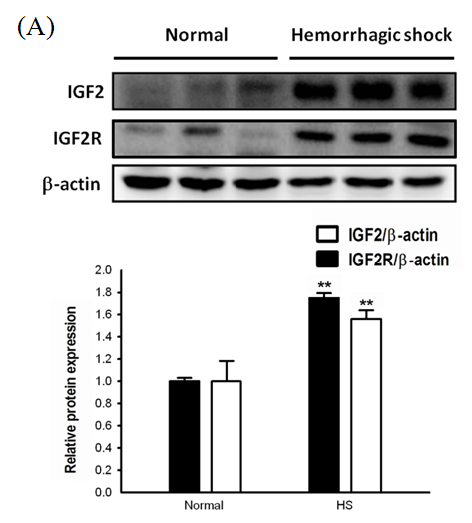
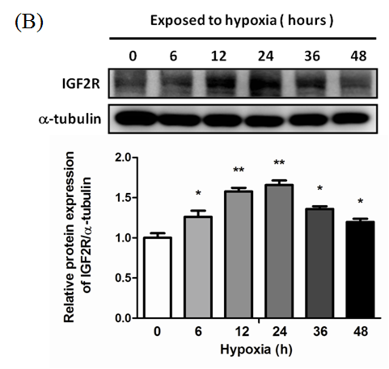
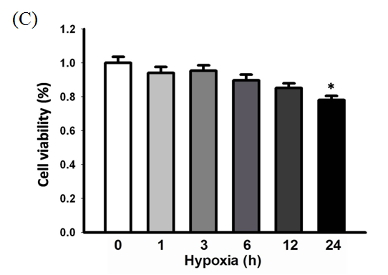

Figure2.
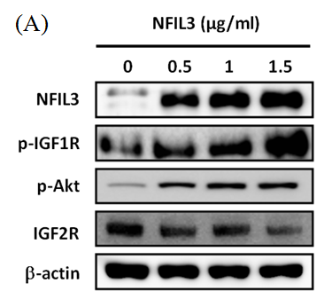
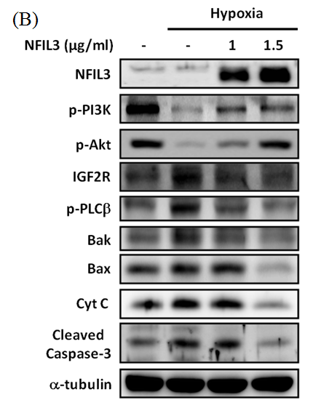
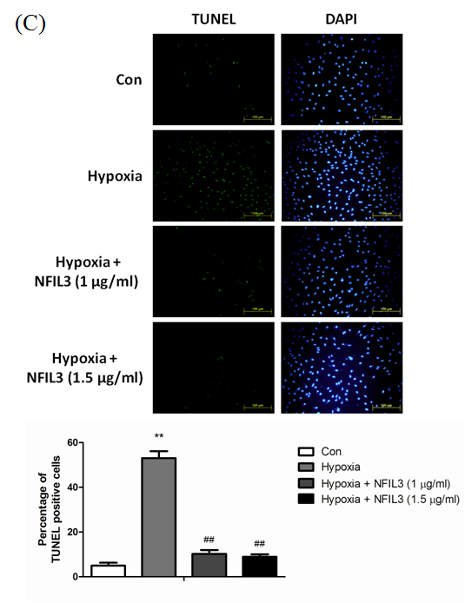

Figure3.

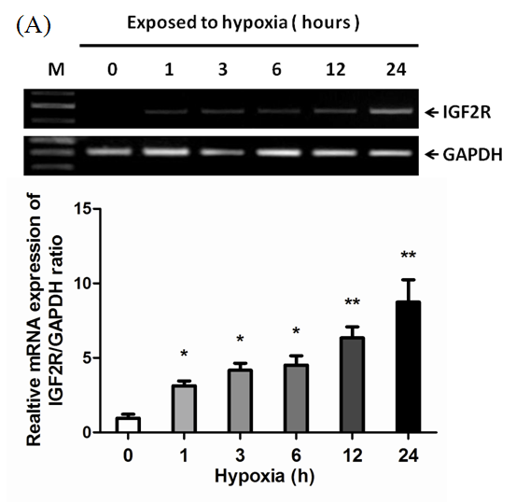
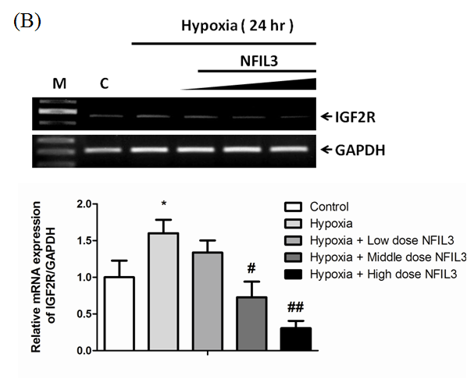

Figure4.
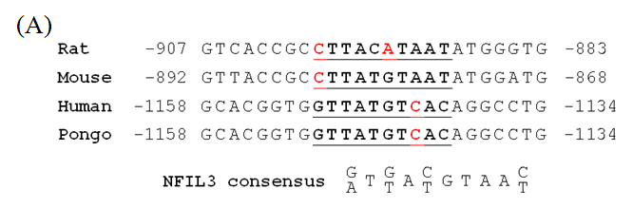

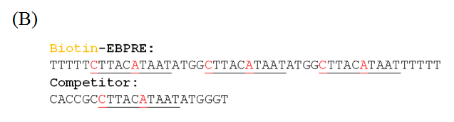

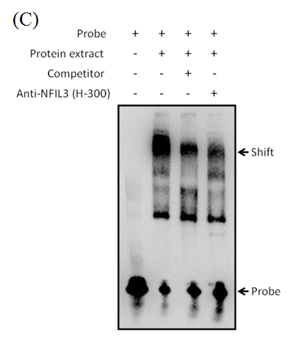

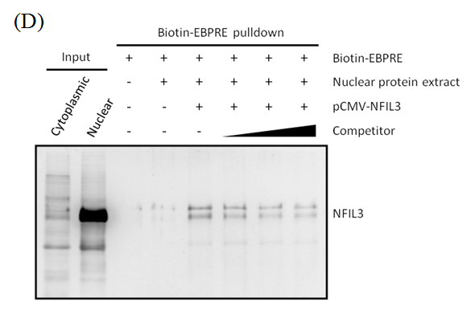
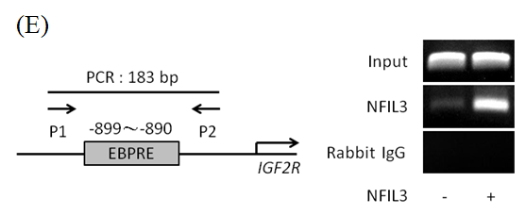
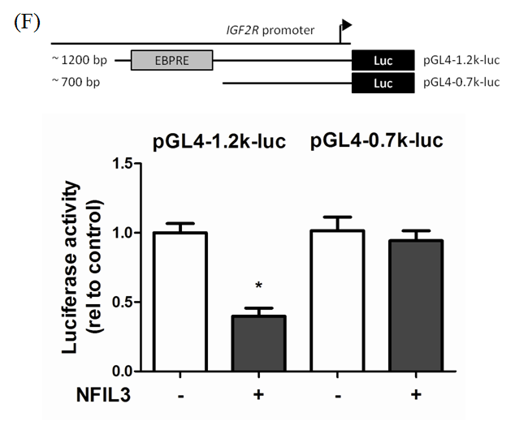

Figure5.

