Title: Long-term potentiation decay and memory loss are mediated by AMPAR endocytosis
Authors and affiliations:
Zhifang Dong^{1*}, Huili Han¹, Hongjie Li¹, Yanrui Bai¹, Wei Wang¹, Man Tu¹, Yan Peng¹, Limin Zhou¹, Wenting He¹, Xiaobin Wu¹, Tao Tan¹, Mingjing Liu¹, Xiaoyan Wu¹, Weihui Zhou¹, Wuyang Jin², Shu Zhang^{2,3}, Todd Charlton Sacktor⁴, Tingyu Li^{1*}, Weihong Song^{1,2*}, Yu Tian Wang^{1,2,3*}
¹Ministry of Education Key Laboratory of Child Development and Disorders, and Chongqing Key Laboratory of Translational Medical Research in Cognitive Development and Learning and Memory Disorders, Children’s Hospital of Chongqing Medical University, Chongqing 400014, PR China;
² Brain Research Centre and Department of Medicine, University of British Columbia, Vancouver, BC V6T 2B5, Canada;
³Graduate Institute of Immunology, China Medical University and Translational Medicine Research Center, China Medical University Hospital, Taichung;
⁴Departments of Physiology and Pharmacology, and of Neurology, The Robert Furchgott Center for Neural and Behavioral Science, SUNY Downstate Medical Center, Brooklyn, New York, USA.
Conflict of interest: We declare that there are no competing financial interests.

* Corresponding authors：
Zhifang Dong, PhD
136 Zhongshan Er Road
Yuzhong District, Chongqing 400014, PR China
Tel.: 0086-23-63637857
Email: zfdong@cqmu.edu.cn
Or
Tingyu Li, MD
136 Zhongshan Er Road
Yuzhong District, Chongqing 400014, PR China
Tel.: 0086-23-63630913
Email: tyli@vip.sina.com
Or
Weihong Song, MD/PhD
2255 Wesbrook Mall
Vancouver, British Columbia V6T 1Z3, Canada
Phone: 1-604-822-8019
E-mail: weihong@exchange.ubc.ca
Or
Yu Tian Wang, MD/PhD, FRSC
F117-2211 Wesbrook Mall
Vancouver, BC V6T 2B5, Canada
Phone: 1-604-822-0398
E-mail: ytwang@brain.ubc.ca

Abstract
Long-term potentiation (LTP) of synaptic strength between hippocampal neurons is associated with learning and memory, and LTP dysfunction is thought to underlie memory loss. LTP can be temporally and mechanistically classified into decaying (early phase) LTP and non-decaying (late phase) LTP. While the non-decaying nature of LTP is thought to depend on protein synthesis and contribute to memory maintenance, little is known about the mechanisms and roles of the decaying LTP. Here, we demonstrated that inhibiting endocytosis of postsynaptic α-amino-3-hydroxy-5-methyl-isoxazole-4-propionic acid receptors (AMPARs) prevents LTP decay, thereby converting it into non-decaying LTP. Conversely, restoration of AMPAR endocytosis by inhibiting protein_kinase_Mζ (PKMζ) converted non-decaying LTP into decaying LTP. Similarly, inhibition of AMPAR endocytosis prolonged memory retention in normal animals, and reduced memory loss in a murine model of Alzheimer’s disease. These results strongly suggest that an active process that involves AMPAR endocytosis mediates the decay of LTP and that inhibition of this process can prolong the longevity of LTP as well as memory under both physiological and pathological conditions.

Key words: long-term potentiation; long-term memory; AMPA receptor endocytosis; Alzheimer's disease
Introduction
Activity-dependent long-term potentiation (LTP) of synaptic efficacy at the glutamatergic synapses in the hippocampus is the most well characterized form of synaptic plasticity, and has long been considered as a cellular mechanism underlying learning and memory (1-4). In support of the putative role of LTP in learning and memory, extensive work in in vivo animals has revealed a strong correlation between the maintenance of LTP and the maintenance of memory (5-7). Therefore, understanding the processes underlying LTP maintenance may in turn provide important information about the mechanisms of memory storage. LTP maintenance is often temporally and mechanistically divided into two phases, the decaying (or early) phase of LTP and the non-decaying (or late) phase of LTP (8, 9). The decaying LTP is often induced experimentally in brain slices and in vivo animals with a weaker induction protocol (such as a single tetanic burst), can decay within hours, and does not depend on the synthesis of new protein(s); Conversely, non-decaying LTP can be induced with stronger stimulation protocols (such as multiple tetani in quick succession), lasts hours and days, and may require new protein synthesis (10-13). Decaying LTP may be converted into non-decaying LTP, with such a conversion thought to be a critical process for the conversion of a short-term memory (STM) to a long-term memory (LTM) (14, 15). However, how and why decaying LTP decays in comparison with non-decaying LTP, and how it can be converted into non-decaying LTP remains poorly understood.
Evidence accumulated in recent years supports a conjecture that the decay of LTP could be mediated by an active activity-dependent process, rather than a passive decay of processes required for maintaining LTP (16, 17). This leads us to hypothesize that this active process could be a feedback synaptic scaling mechanism. We speculate that during decaying LTP, the increased synaptic efficacy may trigger an activity-dependent feedback synaptic down-scaling mechanism that becomes functional, actively reducing the synaptic efficacy until LTP decays back to the basal level. We further reasoned that during the production of non-decaying LTP, such a synaptic scaling mechanism becomes constantly inhibited by the newly synthesized molecule(s), so that the increased synaptic efficacy during non-decaying LTP was not scaled down. Thus, the tonic inhibition of such a putative negative feedback mechanism developed during decaying LTP by one or more newly synthesized proteins during the non-decaying LTP is one of the critical steps for conversion of the decaying LTP into the non-decaying LTP.
Although the molecular substrate of such a putative synaptic scaling process remains unknown, Hou et al. has recently revealed that in cultured hippocampal neurons, persistent enhancement of synaptic efficacy can trigger a synaptic input-specific homeostatic scaling mechanism that reduces the synaptic efficacy by endocytic removal of postsynaptic α-amino-3-hydroxy-5-methyl-isoxazole-4-propionic acid glutamate receptors (AMPARs) at these potentiated synapses (18, 19). Since decaying LTP is also a process involving persistent increase in synaptic efficacy in a synaptic input-specific manner, we tested if a similar activity-dependent AMPAR endocytosis process may function as a putative negative-feedback synaptic scaling mechanism responsible for the decay of LTP, and if so, whether pharmacological blockade of this process can convert decaying LTP into non-decaying LTP, thereby converting STM into LTM.

Results
Inhibition of AMPARs endocytosis converts decaying LTP into non-decaying LTP
In order to make the correlation of electrophysiological characterizations more relevant to behavioural analyses of memory maintenance, we studied both decaying LTP and non-decaying LTP using an in vivo model of hippocampal synaptic plasticity in freely-moving adult rats (20, 21). Schaffer-Collateral stimulation-induced field excitatory postsynaptic potentials (fEPSPs) were recorded from the CA1 region. As shown in Figure 1a, electrical stimulation with a strong protocol of high-frequency-stimulation (sHFS, 4-train of 30 pulses at 100 Hz with an inter-train interval of 5 min) reliably induced a characteristic non-decaying LTP of fEPSPs that lasted for at least over 24 hrs in vehicle control animals (sHFS+Vel; n = 5; 138.0 ± 3.1% at 25 hrs after the induction; p = 0.001 vs. baseline; Fig. 1a); whereas a weak HFS protocol (wHFS; 2-train of 30 pulses at 100 Hz with an inter-train interval of 5 min) was only able to induce a typical decaying LTP that decayed back to baseline level within 2 hrs after the induction in vehicle control animals (wHFS+Vel; n = 5; 100.9 ± 1.8% at 25 hrs after the induction; p = 0.337 vs. baseline, p < 0.001 vs. sHFS+Vel; Fig. 1a).
To determine if AMPAR endocytosis plays an essential role in mediating the decay of LTP, we employed a well-characterized membrane-permeable GluA2-derived Tat-GluA2_{3Y} peptide that has previously been shown to prevent activity-dependent AMPAR endocytosis, without affecting the constitutive AMPAR endocytosis and hence basal synaptic transmission in both brain slices in vitro (22-24) and freely-moving animals in vivo (24-26).
As expected, immediately following the induction of decaying LTP with wHFS, intracerebroventricular (i.c.v.) injections of Tat-GluA2_{3Y} (GluA2_{3Y}; 500 pmol in 5µl), but not its scrambled peptide (scr-GluA2_{3Y}) or saline vehicle control (Vel), significantly prolonged the maintenance of LTP that remained at the potentiated level 24 hrs after the induction (wHFS+scr-GluA2_{3Y}: n = 5, 101.0 ± 5.5 %, p = 0.911 vs. baseline, p = 0.992 vs. wHFS+Vel; wHFS+GluA2_{3Y}: n = 7, 133.0 ± 10.9 %, p = 0.020 vs. baseline, p = 0.016 vs. wHFS+Vel, p = 0.017 vs. wHFS+scr-GluA2_{3Y}, p = 0.337 Vs. sHFS+Vel; Fig. 1a). Thus, inhibition of AMPAR endocytosis is sufficient to convert decaying LTP into non-decaying LTP. These results suggest that GluA2-dependent AMPAR endocytosis is a key process mediating the decay of LTP.
Next, we examined if non-decaying LTP induced by sHFS is maintained by an active inhibition of this secondary (activity-dependent) AMPAR endocytosis. We reasoned that a process capable of producing non-decaying LTP (such as the sHFS utilized here), while producing LTP, can also trigger the translation-dependent synthesis of protein(s) that can actively suppress the secondary AMPAR endocytosis, thereby preventing LTP from decaying. Among many potential candidate molecules, we focused on the atypical PKC isoform, protein kinase Mζ (PKMζ), because its rapid translation has been suggested to have a critical role not only in the maintenance of LTP and memory (7), but also in regulating AMPAR trafficking (7, 26-28). We therefore tested if sHFS-induced non-decaying LTP is maintained by the inhibition of AMPAR endocytosis by PKMζ with i.c.v. applications of PKMζ inhibitor ZIP (7) or its scrambled peptide (scr-ZIP), each at 25 nmol/5μl in the absence or presence of GluA2_{3Y} or its scrambled control peptide (500 pmol/5μl), 1 hr prior to the induction of non-decaying LTP with sHFS (Fig. 1b). Fluorescence imaging of hippocampal sections demonstrated a co-localization of FITC-ZIP and PSD-95 (a postsynaptic marker protein of excitatory synapses) ensured the successful diffusion of ZIP to hippocampal excitatory synapses, the action side of the peptide 2 h after i.c.v. administration of the peptide (supplemental Fig. 1). We reasoned that if PKMζ maintains non-decaying LTP by inhibiting the putative secondary AMPAR endocytosis, then inhibition of PKMζ with ZIP should release this active endocytosis process, and thereby impair the maintenance of non-decaying LTP, converting it into a decaying LTP. We further predicted that this ZIP effect should be prevented in the presence of GluA2_{3Y}. Supporting our reasoning, we found that while sHFS reliably induced non-decaying LTP in the vehicle control group receiving the same volume of saline (Vel: n = 5, 129.9 ± 9.4 %, p = 0.027 vs. baseline; Fig. 1b), it only produced a decaying synaptic potentiation similar to that of decaying LTP in animals receiving a co-application of ZIP and control scr-GluA2_{3Y} (ZIP+scr-GluA2_{3Y}: n = 5, 99.1 ± 5.2 %, p = 0.945 vs. baseline, p = 0.004 vs. Vel; Fig. 1b), suggesting that ZIP is sufficient to prevent sHFS from inducing non-decaying LTP by converting it into decaying LTP. In contrast, application of GluA2_{3Y} has little effect on the sHFS-induced non-decaying LTP on its own (scr-ZIP+GluA2_{3Y}: n = 5, 138.4 ± 6.6 %, p = 0.006 vs. baseline, p = 0.376 vs. Vel; Fig. 1b); this is not surprising as AMPAR endocytosis may have been inhibited by PKMζ. However, when co-applied with ZIP, GluA2_{3Y} prevented ZIP’s ability to convert non-decaying LTP into decaying LTP (ZIP+GluA2_{3Y}: n =6, 128.8 ± 3.4 %, p = 0.001 vs. baseline, p = 0.897 vs. Vel, p = 0.003 vs. ZIP+scr-GluA2_{3Y}; Fig. 1b). As a control, we found that neither scr-ZIP nor scr-GluA2_{3Y} affected sHFS-induced non-decaying LTP (scr-ZIP+scr-GluA2_{3Y}: n = 4, 138.7 ± 5.5 %, p = 0.005 vs. baseline, p = 0.386 vs. Vel; Fig. 1b). These results demonstrate that application of ZIP prior to the induction of non-decaying LTP was sufficient to prevent the maintenance phase of LTP, and does so by releasing the inhibition on AMPAR endocytosis.
If non-decaying LTP is maintained by persistently inhibiting an active AMPAR endocytic process, we predict that ZIP should cause non-decaying LTP to decay even when applied after the establishment of non-decaying LTP, and this effect should still be prevented by GluA2_{3Y} application. As shown in Figure 1c, when applied 1 hr after sHFS, ZIP (but not its control scr-ZIP) was still capable of causing the sHFS-induced non-decaying LTP to gradually reduce to baseline within 2 hrs of drug application (ZIP+scr-GluA2_{3Y}: n = 5, 102.1 ± 1.4 %, p = 0.573 vs. baseline; Vel: n = 4, 134.3 ± 5.2 %, p = 0.019 vs. baseline; scr-ZIP+scr-GluA2_{3Y}: n = 5, 135.4 ± 6.6 %, p = 0.008 vs. baseline; scr-ZIP+GluA2_{3Y}: n = 5, 140.3 ± 3.2 %, p < 0.001 vs. baseline; Fig. 1c). Again, this effect of ZIP was prevented by the co-application of GluA2_{3Y} (ZIP+GluA2_{3Y}: n = 6, 132.1 ± 6.3 %, p = 0.004 vs. baseline; Fig. 1c).
The ability of ZIP to convert the non-decaying LTP to a decaying LTP and its prevention by GluA2_{3Y} are all in a good agreement with our prediction that PKMζ is likely the newly translated molecule that inhibits the active AMPAR endocytosis during the maintenance of non-decaying LTP. However, the selectivity of ZIP as a PKMζ inhibitor has recently been challenged (29-31). To further confirm the involvement of PKMζ in this process, we employed a lentivirus-mediated PKMζ shRNA to reduce PKMζ expression in the hippocampus (Fig. 2). Western blots performed 7 days after a bilateral intra-hippocampal infusion of viral particles showed that PKMζ shRNA (LV_{PKMζ shRNA}, 1.5μl per side) selectively reduced the level of PKMζ (LV_{PKMζ shRNA}, 64.4 ± 8.4% of LV_{eGFP}, p = 0.013, n = 5 in each group; Fig. 2b), but not PKCλ/ι (LV_{PKMζ shRNA}, 105.1 ± 12.0% of LV_{eGFP}, p = 0.690, n = 5 in each group; Fig. 2b) in the hippocampus. Consistent with the critical involvement of PKMζ in the inhibition of active AMPAR endocytosis, and hence the maintenance of non-decaying LTP, we found that 7 days after intra-hippocampal infusion of PKMζ shRNA viral particles, shRNA-mediated PKMζ knockdown prevented sHFS from inducing the non-decaying LTP; with the LTP being decayed back to baseline less than 2 hrs after sHFS. This effect was prevented by GluA2_{3Y}, but not its control scr-GluA2_{3Y} (500 pmol/5μl, i.c.v) delivered immediately after sHFS (LV_{PKMζ shRNA}+scr-GluA2_{3Y}: n = 5, 108.7 ± 9.3 % at 25 hrs after the induction, p = 0.456 vs. baseline, p = 0.006 vs. LV_{eGFP}+scr-GluA2_{3Y}, p = 0.002 vs. LV_{eGFP}+GluA2_{3Y}; LV_{PKMζ shRNA}+GluA2_{3Y}: n = 5, 136.6 ± 2.0 % at 25 hrs after the induction, p < 0.001 vs. baseline, p = 0.774 vs. LV_{eGFP}+scr-GluA2_{3Y}, p = 0.358 vs. LV_{eGFP}+GluA2_{3Y}, p = 0.004 vs. LV_{PKMζ shRNA}+scr-GluA2_{3Y}; Fig. 2c). In contrast, a bilateral infusion of control viral particles had no obvious effect on the ability of sHFS to induce a non-decaying LTP in the presence of either GluA2_{3Y} or its control scr-GluA2_{3Y} (LV_{eGFP}+scr-GluA2_{3Y}: n = 3, 139.2 ± 1.4 % at 25 hrs after the induction, p = 0.002 vs. baseline; LV_{eGFP}+GluA2_{3Y}: n = 3, 145.3 ± 2.3 % at 25 hrs after the induction, p = 0.003 vs. baseline, p = 0.564 vs. LV_{eGFP}+scr-GluA2_{3Y}, Fig. 2c).
Together, these results strongly suggest that PKMζ is likely the ZIP-sensitive molecule responsible for tonically inhibiting the secondary, activity-dependent AMPAR endocytosis, and thereby preventing LTP from decaying following sHFS.
Inhibition of AMPARs endocytosis converts STM into LTM
If maintenance of LTP is a critical cellular mechanism mediating memory storage, then converting decaying LTP into non-decaying LTP by inhibition of AMPAR endocytosis with GluA2_{3Y} would be expected to convert STM into LTM. We first tested the physiological role of this decaying LTP to non-decaying LTP conversion in a well-characterized hippocampus-dependent learning task, inhibitory avoidance training (IA), using a weak (wIA; 0.2 mA, 2 s) or strong footshock IA (sIA; 0.4 mA, 2 s). Consistent with our recent report (20), wIA training could only produce STM that could be retrieved within 1 hr (wIA-1h: n = 8, 59.8 ± 17.3 s for test, p = 0.014 vs. training), but not 24 hrs (wIA-24h: n = 8, 23.3 ± 3.3 s for test, p = 0.084 vs. training; Fig. 3a) following the training. As expected, bilateral intra-hippocampal infusions of GluA2_{3Y} (100 pmol per side in 1μl) immediately after wIA training reliably and significantly promoted LTM formation so that the memory could be retrieved 24 hrs after training (GluA2_{3Y}: n = 12, 89.7 ± 29.7s for test, p = 0.014 vs. training, p = 0.043 vs. Vel, p = 0.020 vs. scr-GluA2_{3Y}; Fig. 3a). As a control, application of scr-GluA2_{3Y} peptide failed to prolong the memory retention (scr-GluA2_{3Y}: n = 11, 19.2 ± 5.5 s for test, p = 0.094 vs. training; Fig. 3a). In contrast to wIA, sIA training reliably produced LTM that could be recalled 24 hrs after training. However, bilateral applications of either GluA2_{3Y} or scr-GluA2_{3Y} peptide did not produce any notable effect on LTM formation induced by sIA training (Vel: n = 12, 315.9 ± 59.8 s for test, p = 0.001 vs. training; scr-GluA2_{3Y}: n = 7, 270.3 ± 69.4 s for test, p = 0.007 vs. training, p = 0.626 vs. Vel; GluA2_{3Y}: n = 7, 316.0 ± 53.0 s for test, p = 0.001 vs. training, p = 0.999 vs. Vel, p = 0.636 vs. scr-GluA2_{3Y}; Fig. 3b).
These results strongly suggest that as demonstrated in decaying LTP and non-decaying LTP, activity-dependent AMPAR endocytosis plays a critical role in constraining the ability of wIA to produce LTM. Conversely, during formation of LTM by sIA, as with the induction of non-decaying LTP with sHFS, AMPAR endocytosis may be inhibited by the increased amount and activity of a ZIP-sensitive molecule (such as PKMζ), and therefore application of endocytosis inhibitor GluA2_{3Y} has no effect on the LTM. We next investigated these predictions by directly measuring AMPAR synaptic localization and PKMζ expression in the hippocampus of animals subjected to either wIA or sIA. We examined the expression levels of AMPAR subunits, along with PKMζ, in postsynaptic densities and total tissue lysates obtained 24 hrs after training. Based on the above electrophysiological and behavioural results, we expect that wIA training may produce decaying LTP (as a result of increased function and/or numbers of synaptic AMPARs), but this would be gradually counteracted by a secondary activity-dependent increase in AMPAR endocytosis at these potentiated synapses, leading to no net change in the total amount of synaptic AMPARs at the time point when LTM was recalled. In contrast, sIA would result in an up-regulation of ZIP-sensitive molecules, such as PKMζ, which in turn persistently inhibit the decaying LTP-associated secondary AMPAR endocytosis, resulting in a persistent increase in the amount of synaptic AMPARs at the time of LTM recall. As shown in Figure 3c (n = 5 in each group), we found that a specific increase in the synaptic amount of GluA2 was only observed following sIA, but not wIA training, and more importantly, application of GluA2_{3Y} (but not its control scr-GluA2_{3Y}) was able to increase the synaptic GluA2 amount of wIA to that similar to sIA (Fig. 3c). However, GluA1 (Fig. 3c), GluA3 (supplemental Fig. 2a) and GluA4 (supplemental Fig. 2b) localization were not affected by wIA or sIA training-induced memory formation, suggesting that alteration of trafficking and expression of AMPARs containing these subunits may not play a critical role in IA tasks. These findings are consistent with a critical role of endocytosis of GluA2-containing AMPARs in constraining wIA to produce only STM. In agreement with our prediction that PKMζ is a ZIP-sensitive molecule, which inhibits the secondary AMPAR endocytosis and thereby maintains the LTM, we found that only sIA (but not wIA) training resulted in a significant increase in the level of PKMζ in synaptosomes, regardless of the presence or absence of GluA2_{3Y} or scr-GluA2_{3Y} (Fig. 3c).
To test the causal role of PKMζ in inhibiting AMPAR endocytosis and hence, prolonging memory maintenance directly, we then examined if inhibition of PKMζ by ZIP peptide applied 2 hrs before LTM retrieval can disrupt sIA-induced LTM, and if blockade of GluA2 endocytosis with GluA2_{3Y} peptide at the same time can mimic PKMζ’s function to inhibit AMPAR endocytosis, thereby preventing ZIP disruption of the sIA-induced LTM (Fig. 4a). As shown in Figure 4b, in animals receiving bilateral intra-hippocampal infusions of control peptides, sIA reliably induced LTM, which could be retrieved at 24 hrs after the training (scr-ZIP+scr-GluA2_{3Y}: n = 8, 228.1 ± 67.6 s for test, p = 0.011 vs. training; scr-ZIP+ GluA2_{3Y}: n = 8, 252.3 ± 68.5 s for test, p = 0.007 vs. training; Fig. 4b). However, this sIA-induced LTM was significantly impaired by bilateral hippocampal administrations of ZIP (ZIP+scr-GluA2_{3Y}: n = 8, 25.1 ± 13.6 s for test, p = 0.179 vs. training; Fig. 4b). As expected, the ZIP-induced impairment was prevented by co-application of GluA2_{3Y} (ZIP+ GluA2_{3Y}: n = 8, 227.0 ± 54.0 s for test, p = 0.003 vs. training; Fig. 4b). These results support our prediction that PKMζ maintains memory retention by inhibition of GluA2 AMPAR endocytosis, while ZIP impairs memory retention by disrupting this mechanism.
Consistent with these behavioural results, 24 hrs after training immunoblot analysis of synaptosomal (synaptic) and lysate (total) amounts of PKMζ and AMPARs in hippocampal tissues (n = 5 in each group) revealed a significant increase in postsynaptic expression of PKMζ in all groups of animals, which received sIA training relative to levels seen in untrained control groups. In comparison, the amount of synaptic GluA2 (but not GluA1) was also increased in all training groups except for the ZIP treated group (ZIP+scr-GluA2_{3Y}; Fig. 4c). It is important to point out that the ZIP treated group is also the only group in which LTM was impaired (Fig. 4b). Moreover, this inhibition of sIA-induced increase in synaptic GluA2 AMPARs by ZIP was prevented by co-application of GluA2_{3Y} (Zip+GluA2_{3Y}; Fig. 4c). Notably, there was no difference in the total levels of PKMζ, GluA2 and GluA1 among all these groups (Fig. 4c). Thus, similar to the mechanisms involved in the conversion of decaying LTP to non-decaying LTP, our results strongly support the notion that GluA2 endocytosis is a critical determinant for constraining memory retention, with a ZIP-sensitive molecule, likely PKMζ maintaining memory retention by constantly inhibiting this memory-constraining mechanism.
To further confirm that it is sIA-induced increase in synaptic PKMζ that inhibits a secondary AMPAR endocytosis, thereby ensuring the formation of inhibition, we next compared the longevity of sIA-induced memory between animals received bilateral intra-hippocampal infusions of control or PKMζ-shRNA viral particles (1.5μl per side) 7 days prior to the training (Fig. 5a). As shown in Figure 5b, sIA reliably induced LTM that could be retrieved by 24 hrs in animals receiving control viral particles and this was not affected by an immediate intra-hippocampal infusion (100 pmol per side in 1μl) of either GluA2_{3Y} or scr-GluA2_{3Y} peptide after sIA training (LV_{eGFP}+scr-GluA2_{3Y}: n = 10, 203.5 ± 44.0 s for retrieval test, p = 0.001 vs. training; LV_{eGFP}+GluA2_{3Y}: n = 13, 274.7 ± 53.8 s for test, p < 0.001 vs. training, p = 0.312 vs. LV_{eGFP}+scr-GluA2_{3Y}, Fig. 5b). However, the ability of sIA to induce LTM was significantly impaired in animals receiving PKMζ-shRNA viral particles (LV_{PKMζ shRNA}+scr-GluA2_{3Y}: n = 10, 54.1 ± 16.8 s for test, p = 0.031 vs. training, p = 0.046 vs. LV_{eGFP}+scr-GluA2_{3Y}, p = 0.003 vs. LV_{eGFP}+GluA2_{3Y}; Fig. 5b). As expected, the impairment induced by shRNA-mediated PKMζ knockdown was prevented by the bilateral intrahippocampal infusion of GluA2_{3Y} immediately after sIA training (LV_{PKMζ shRNA}+GluA2_{3Y}: n = 12, 279.6 ± 57.7 s for test, p = 0.001 vs. training, p = 0.289 vs. LV_{eGFP}+scr-GluA2_{3Y}, p = 0.941 vs. LV_{eGFP}+GluA2_{3Y}, p = 0.002 vs. LV_{PKMζ shRNA}+scr-GluA2_{3Y}; Fig. 5b). These results are in full agreement with the aforementioned results with ZIP, and thereby further confirm that PKMζ maintains LTM by inhibition of the secondary GluA2-dependent AMPAR endocytosis.
Inhibition of AMPARs endocytosis reduces memory loss in a transgenic mouse model of Alzheimer's disease
Alzheimer's disease (AD), one of the most common neurodegenerative diseases leading to dementia, is characterized by progressive memory loss and other cognitive dysfunctions due, at least in part, to the impairment of synaptic plasticity (32, 33). Indeed, recent work has reported evidence for postsynaptic degeneration and mislocalization of PKMζ to neurofibrillary tangles in AD patients’ brain structures important for memory formation, including the hippocampus (34, 35). Given the important role of PKMζ-mediated inhibition of GluA2 AMPAR endocytosis in maintaining LTP and memory retention, we hypothesize that dysfunction of PKMζ-mediated inhibition of GluA2 AMPAR endocytosis due to mislocalization or failure to increase PKMζ expression in AD may prevent the increase in synaptic GluA2 levels during the maintenance of LTP and memory, thereby contributing to the impairment of LTP and memory dysfunction observed in AD. If so, we further reasoned that inhibition of AMPAR endocytosis using the GluA2_{3Y} peptide may reduce the impairment of non-decaying LTP and LTM in AD. We tested this hypothesis using a well characterized AD model of APP23/PS45 double transgenic mice (36, 37). As shown in Figure 6a, fEPSP recordings in vivo revealed that sHFS could only induce a decaying LTP that lasted for less than 1 hr in APP23/PS45 double transgenic AD mice (aged 2.5 months) receiving control peptide infusion (scr-GluA2_{3Y}, 3μmol/kg, i.p.) 1 hr prior to sHFS (scr-GluA2_{3Y}: 95.5 ± 7.4 % at 4 hrs after sHFS; n=4, p = 0.754 vs. baseline before sHFS; Fig. 6a). This suggests a severe impairment in LTP maintenance in these mice. However, application of GluA2_{3Y} (3 μmol/kg, i.p.) prevented the rundown of LTP, converting this decaying LTP into non-decaying LTP (GluA2_{3Y}: 134.4 ± 5.9 % at 4 hrs after sHFS; n = 4, p = 0.016 vs. baseline, p = 0.013 vs. scr-GluA2_{3Y}; Fig. 6a). Next, we examined the ability of GluA2_{3Y} to reduce memory impairment in these AD mice. As shown in the top panel of Figure 6b, we first trained the animals (aged 1.5 months) using an IA task with a strong intensity footshock (1.5 mA, 2 s) in order to establish a stable IA memory trace for the task in these mice. After a single IA training, animals were subjected to systemic injection of GluA2_{3Y} or scr-GluA2_{3Y} (3 μmol/kg, i.p.) daily for 30 days. Two retrieval tests were performed at day 15 and day 30 after IA training to determine LTM retention. As shown in the bottom panel of Figure 6b, the retrieval test at day 15 (Fig. 6b, Bottom panel; Test 1, red bars) revealed that regardless of the treatments, all animals showed stable memory retention for the IA tasks, as evidenced by the similar avoidance latency (scr-GluA2_{3Y}: n = 18, 298.1 ± 44.3 s for test, p = 0.001 vs. training; GluA2_{3Y}: n = 20, 327.8 ± 45.9 s for test, p = 0.001 vs. training, p = 0.332 vs. scr-GluA2_{3Y}; Test 1, red bar, Fig. 6b). This suggests that the LTM was established by the training protocol in these animals and that at this point in time, the cognitive ability in these animals was not significantly affected. In contrast, by day 30 animals receiving the control scr-GluA2_{3Y} peptide treatment showed a significantly shortened avoidance latency when compared to that observed from animals treated with GluA2_{3Y} (scr-GluA2_{3Y}: n = 18, 111.7 ± 27.9 s for test, p = 0.003 vs. training; GluA2_{3Y}: n = 20, 261.5 ± 40.9 s for test, p = 0.001 vs. training, p = 0.004 vs. scr-GluA2_{3Y}; Test 2, blue bar, Fig. 6b). These results strongly suggest that there is a significantly impaired cognitive function in these animals (as exemplified by the reduced memory retention), and that this memory decay process can be significantly inhibited by treatment with GluA2_{3Y}.
In order to further evaluate the effect of GluA2_{3Y} on amelioration of memory deficits in these AD mice, we performed another hippocampus-dependent learning and memory task, the Morris water maze task. After daily GluA2_{3Y} (n = 7, 3μmol/kg, i.p.) or scr-GluA2_{3Y} (n = 6, 3μmol/kg, i.p.) treatment for 3 weeks, mice (aged 1.5 months) were subjected to water maze training for 5 days and a probe test on day 6. The results showed that GluA2_{3Y} treatment dramatically shortened the escape latency in searching the hidden platform on training day 4 (scr-GluA2_{3Y}: 78.2 ± 11.2 s; vs GluA2_{3Y}: 42.8 ± 10.3 s; p = 0.046; Fig. 6c) and 5 (scr-GluA2_{3Y}: 59.2 ± 16.2 s; vs GluA2_{3Y}: 18.6 ± 4.2 s; p = 0.033; Fig. 6c) relative to scr-GluA2_{3Y} controls. Furthermore, the probe test data also showed that mice treated with GluA2_{3Y} spent much more time in the hidden platform quadrant on day 6 compared to mice treated with scr-GluA2_{3Y} controls (scr-GluA2_{3Y}: 319.2 ± 6.2 s; vs GluA2_{3Y}: 43.2 ± 3.0 s; p = 0.025; Fig. 6d). These results further suggest that the inhibition of AMPAR endocytosis by GluA2_{3Y} treatment significantly slows down the memory decline in AD mice.
To correlate electrophysiological and behavioural cognitive changes with biochemical alterations of synaptic GluA2 and PKMζ, we then performed immunoblotting of hippocampal synaptosomal fractionations and total tissue lysates from these animals immediately after the second IA retrieval test. As shown in Figure 6e (n = 5 in each group), we found that these AD mice treated with GluA2_{3Y} showed a significant increase in synaptic GluA2, but not synaptic GluA1 or PKMζ when compared to those treated with control peptide (scr-GluA2_{3Y}). Neither treatment affected the total levels of GluA1, GluA2 or PKMζ (Fig. 6e). Our results are consistent with the notion that under non-treated conditions, sHFS or sIA training in AD fails to cause a translocation of PKMζ to the synapse, possibly due to its mislocalization into neurofibrillary tangles (34, 35). This in turn results in uninhibited secondary AMPAR endocytosis, leading to the failure to increase synaptic GluA2. These conjectures can further explain why the application of GluA2_{3Y} alone is able to rescue the LTP maintenance and reduce memory impairment in AD, as it can prevent this secondary AMPAR endocytosis without the need for an increase in synaptic PKMζ.
Neuritic plaques represent one of the main histopathological hallmarks in AD brains and are thought to play a critical role in mediating the excitotoxicity responsible for AD neuronal damage, including the loss of both synapses and neurons (38-40). In turn, this excitotoxicity further facilitates the formation of neuritic plaques (41). It is interesting to note that in one of our previous studies, we observed that facilitated GluA2-dependent AMPAR endocytosis is associated with neuronal apoptosis produced by excitotoxicity, and more importantly, that blocking this AMPAR endocytosis with GluA2_{3Y} can prevent this excitotoxicity-induced neuronal apoptosis (42). Others have also reported that facilitated GluA2 endocytosis is in fact sufficient and necessary to mediate Aβ-mediated neuronal injuries (43). Therefore, we suspect that our chronic applications of GluA2_{3Y} peptide in AD mice, through reducing excitotoxicity, may also decrease neuritic plaque formation in these animals. To test this prediction, brains from these GluA2_{3Y} and scr-GluA2_{3Y}-treated AD mice were processed and examined for Aβ-containing neuritic plaques using 4G8 immunostaining. As shown in Figure 6f, neuritic plaque formation was significantly decreased in AD mice treated with GluA2_{3Y} in comparison with those treated with control peptide (scr-GluA2_{3Y}: 23.4 ± 1.6; GluA2_{3Y}: 17.5 ± 1.4; n=12 in each groups; p = 0.011; Fig. 6f).

Discussion
Previous studies have suggested that the decay of LTP is not mediated by a passively gradual rundown of a LTP-maintaining mechanism, but as a result of active inhibition. Here, we present results that not only further support this view, but also strongly indicate that this tonic inhibition of LTP maintenance is at least in part mediated by a mechanism involving GluA2-dependent AMPAR endocytosis. As blockade of this AMPAR endocytosis has no effect on either basal synaptic transmission or the induction of LTP, our results support the notion that this AMPAR endocytosis may represent a feedback mechanism secondary to the increased synaptic efficacy during LTP. Although the mechanisms by which increased synaptic efficacy activates such a secondary AMPAR endocytosis are still unclear, Hou et al. has recently reported a novel input-specific homeostatic down-regulation of synaptic efficacy mediated by increased endocytosis and consequent degradation of postsynaptic AMPARs (18, 19). This may suggest that the activity-dependent homeostasis revealed by Hou et al. and the feedback GluA2-dependent AMPAR endocytosis demonstrated in the present work may share certain common mechanistic steps.
In addition to the active contribution of the GluA2-dependent AMPAR endocytosis to the decay of LTP, its inhibition also appears critical for the maintenance of non-decaying LTP; this was supported by our observations that ZIP is capable of causing decay of LTP and by the evidence that this ZIP effect can be prevented by blocking AMPAR endocytosis. Thus, this novel AMPAR endocytosis feedback mechanism appears active not only during decaying LTP, but throughout the maintenance phase of non-decaying LTP. The non-decaying characteristic of LTP seems to be due to an active inhibition of such a tonically active process by a ZIP-sensitive molecular mechanism. Among the potential candidates as the ZIP target(s) that inhibits GluA2-dependent endocytosis, we favor PKMζ for several reasons. First, PKMζ can be rapidly and persistently induced during, and required for, the maintenance of LTP and memory (7, 26-28). Second, existing evidence strongly suggests that PKMζ maintains non-decaying LTP in slice preparations, at least in part, by altering GluA2 trafficking (28). Third, in the present study we were able to demonstrate that the increase in synaptic PKMζ is specifically associated with the sHFS-induced non-decaying LTP and sIA-induced LTM formation, but not wHSF-induced decaying LTP or wIA-induced STM. Fourth, we showed that shRNA-mediated PKMζ knockdown mimicked ZIP, thereby impairing the maintenance of both non-decaying LTP and LTM. Finally, and most significantly, we directly demonstrated that the impairment by PKMζ knockdown was indeed mediated by its action of inhibiting GluA2-dependent endocytosis, as this effect was fully prevented (or occluded) by GluA2_{3Y}. However, it should also be pointed out that the absolute requirement of PKMζ in the maintenance of LTP as well as LTM has recently been challenged (29-31), and that ZIP appears to also inhibit protein kinase isoforms other than PKMζ (44). Thus, it may remain possible for the involvement of a ZIP-sensitive molecule other than PKMζ in mediating the inhibition of this secondary GluA2-dependent AMPAR endocytosis, thereby maintaining both non-decaying LTP and LTM.
Although the role of activity-dependent synaptic plasticity such as LTP in memory maintenance remains to be established, this notion is supported by a large body of correlative evidence (1-4). Our results demonstrating that the blockade of AMPAR endocytosis is similarly capable of converting decaying LTP to non-decaying LTP, and STM into LTM, reflect the critical role of decaying LTP and non-decaying LTP in mediating STM and LTM, respectively. In addition, our study identifies the endocytosis of GluA2-containing AMPARs as the common and critical step in constraining the conversion of decaying LTP to non-decaying LTP and of STM to LTM. Thus, our work provides strong evidence for a critical role of GluA2-dependent endocytosis, and hence the synaptic density of GluA2 subunits, in determining the longevity of LTP and memory. It is interesting to note that the increased synaptic GluA2 subunits observed during either non-decaying LTP or LTM was not associated with any notable change in other AMPAR subunits including GluA1 subunit. This is somewhat surprising given that an increased synaptic insertion of GluA1 homomeric AMPARs has previously been suggested to be important for both LTP expression (2, 45) and learning/memory (46, 47). However, as the increased synaptic insertion of GluA1 homomeric AMPARs is likely a transient phenomenon, only occurring within minutes after the induction of LTP (45, 48), such an increase in synaptic insertion of GluA1 homomeric AMPARs would have been replaced by an increase in GluA2-containing and GluA1-lacking (likely GluA2 homomeric) AMPARs during the non-decaying LTP and LTM when these subunits were analyzed in Western blots.
If endocytosis of AMPARs has a critical role in causing LTP decay, an abnormal increase in this process could contribute to the impairment of LTP maintenance and memory retention associated with some cognitive disorders. The fact that GluA2_{3Y} can rescue LTP impairment and slow the progressive memory loss in the transgenic AD mice described here supports this view. However, it is somewhat surprising that in the present work we also observed a significant effect of GluA2_{3Y} in reducing excitotoxic neuritic plaques in these AD mice. Since no increased GluA1 homomeric AMPARs was observed following sIA-training induced memory under either physiological or pathological conditions, a critical contribution to this excitotoxic AD pathology from an increase in Ca²⁺ permeable GluA1 homomeric AMPARs is unlikely. In this regard, it is interesting to note that in one of our previous studies we observed that facilitated GluA2-dependent AMPAR endocytosis is associated with neuronal apoptosis produced by NMDA and ischemia-induced excitotoxicity, and more importantly, that blocking this AMPAR endocytosis with the GluA2_{3Y} peptide can prevent this excitotoxicity-induced neuronal apoptosis (42). Others have also reported that facilitated GluA2 endocytosis is in fact sufficient and necessary to mediate Aβ-mediated neuronal injuries (43). Thus, our results obtained in the present work, along with that from these recent studies, strongly suggest that GluA2-dependent AMPAR endocytosis may represent an essential step in mediating certain forms of neuronal excitotoxicity. While how AMPAR endocytosis mediates excitotoxic neuronal death remains unclear, we have recently demonstrated that AMPAR endocytosis-induced neuronal death appears to be mediated by both enhancing the caspase-3 death-signaling pathway and inhibiting the PI3K survival-signaling pathway (42). Interestingly enough, Li and colleagues (49) have also recently reported that caspase-3 activation via mitochondria is actually required for AMPAR endocytosis, and hence the expression of long-term depression. Together, these studies suggest that there may be a positive feedback interplay between AMPAR endocytosis and caspase-3 in mediating excitotoxic neuronal death. In this scenario, by preventing GluA2-dependent endocytosis, the GluA2_{3Y} peptide can be expected to disrupt this self-amplified excitotoxic death signaling, thereby reducing excitotoxic neuritic plaques in AD mice. Thus, our results that GluA2_{3Y} not only rescues LTP impairment and slows memory loss, but also reduces excitotoxic neuritic plaques in the transgenic AD mice demonstrated in the present work provide scientific bases for the development of AMPAR endocytosis blockers, such as GluA2_{3Y}, as potential therapeutics for treating the learning and memory deficits associated with both Alzheimer’s patients and aged populations.

Methods
Animals
Adult male Sprague–Dawley rats (300-350 g, aged 8-10 weeks) and transgenic mice (aged 1.5 months) were housed in plastic cages in a temperature-controlled (21°C) colony room on a 12/12 h light/dark cycle, and all electrophysiological and behavioral experiments were conducted during light cycle. Food and water were available ad libitum. APP23 transgenic mice carry human APP751 cDNA with the Swedish double mutation at positions 670/671 (KM → NL) under control of the murine Thy-1.2 expression cassette. PS45 transgenic mice carry human presenilin-1 cDNA with the M146V mutation. The genotype of the mice was confirmed by PCR using DNA from tail tissues.
Peptides and antibodies
The AMPAR endocytosis inhibitor Tat-GluA2_{3Y} (YGRKKRRQRRR-YKEGYNVYG) and scrambled Tat-GluA2_{3Y} (YGRKKRRQRRR-VYKYGGYNE), the PKMζ inhibitor ZIP (myr-SIYRRGARRWRKL-OH), scrambled ZIP (myr-RLYRKRIWRSAGR-OH) and FITC-ZIP peptides were synthesized by GL Biochem Ltd. (Shanghai, China). All peptides were dissolved in 0.9% sterile saline at required concentrations.
Mouse anti-Aβ monoclonal antibody was obtained from Signet Laboratories (SIG-39240). Mouse anti- GluA2 (MAB397) and anti-PSD-95 (MAB1598) monoclonal antibodies were obtained from Millipore. Rabbit anti-GluA1 (AB312320, anti-PKMζ (AB59364) and anti-β-actin (AB8227) polyclonal antibodies were purchased from Abcam. Rabbit anti-PKCλ/ι (#2998) monoclonal antibody was from cell signaling.
Lentiviral shRNA-mediated knockdown of hippocampal PKMζ
To reduce the expression of PKMζ, we used a lentivirus-mediated PKMζ small interfering RNA (shRNA), which was constructed by Genomeditech Ltd. (Shanghai, China). The siRNA sequence targeting rat PKMζ, 5'-GCAAGCTGCTTGTCCATAAAC-3', has been shown previously to efficiently down-regulate rat PKMζ expression (50). Pairs of complementary oligonucleotides containing these sequences were synthesized and cloned into the pGMLV-SB1 lentivector. The pGMLV-SB1 lentivectors containing the shRNA sequences were transfected into 293T producer cells. Viral supernatants were harvested after 48 h, and the titers were determined with serial dilutions of concentrated lentivirus. Titers were 3×10⁹ TU/ml.

Bilateral hippocampal microinjection
Surgery: One hundred and fifty rats were chronically implanted with cannulas above dorsal hippocampi as previously described (20), and 8 animals were excluded from the experiment due to nonfunctional cannulas or postoperative complications. Briefly, rats were anaesthetized with sodium pentobarbital (60 mg/kg, i.p.). Atropine (0.4 mg/kg, i.p.) was also given to help relieve respiratory congestion. Scalp skin was shaved with clippers and disinfected using iodine before the rat was mounted on a stereotaxic instrument. After opening the scalp skin and exposing the skull, two 22-gauge stainless steel guide cannulas (10 mm; Plastics One Inc.) were implanted above the dorsal hippocampi (3.5 mm posterior to bregma, 2.5 mm lateral to the midline and 2.5 mm below the surface of the dura) and fixed to the skull with four jeweler’s screws and dental cement. Sterile dummy cannula (30-gauge stainless steel rod, 10 mm in length, Plastics One Inc.) were inserted into guide cannula to avoid bacterial infection and cerebral spinal fluid leakage through the cannula. All rats were allowed to recover for 7 to 10 days before experiments.
Habituation: On the day prior to experiments, the animals were placed in the experiment room and given a sham intra-hippocampal injection to become acclimatized to the injection procedure. Dummy cannulas were removed and the rats were placed into a Plexiglas injection box (25×45×25 cm, same as home cage) with 30-gauge injection cannulas in their guide cannulas. Injection cannulas (11 mm, Plastics One Inc.) were connected to a microsyringe pump (Harvard Apparatus) by PE-50 tubing, which are 1 mm beyond the tip of the guide cannulas.
Intra-hippocampal microinjection: Drugs were injected with 10 µl Hamilton syringes and a microsyringe pump at 0.5 µl/min for 2 min. After injection, the injection cannulas were left in place for an additional minute to allow for the diffusion of the drug away from the cannula tips. The rats were then removed from the injection box, their dummy cannulas replaced, and they were placed back in their home cages.

Inhibitory avoidance task

Apparatus: The inhibitory avoidance (IA) apparatus is a two-chambered Perspex box consisting of a lighted safe compartment and a dark shock compartment separated by an automatic trap door (25×20×20 cm for each compartment, San Diego Instruments, Inc., San Diego, CA).

Procedures: One day before training, animals were allowed to freely explore both chambers for 3 min. On the training day, animals were placed in the safe compartment facing a corner opposite the door. Ten seconds later, the trap door was opened to allow the animals to enter the dark compartment. After the animals entered the dark compartment, the door was closed and they received a footshock via electrified steel grids on the box floor (28 grids at the inter-grid interval of 1.8 cm for rats, 62 grids at the inter-grid interval of 0.8 cm for mice). In the present study, two intensity-footshocks for rat experiments were used: (i) a weak footshock IA training (wIA, 0.2 mA, 2 s) and (ii) a strong footshock IA training (sIA, 0.4 mA, 2 s) to produce short-term memory (STM, 1 hr after training) and long-term memory (STM, 24 hr after training), respectively. For transgenic mice experiments, a stronger footshock (1.5 mA, 2 s) was used to produce a solid LTM that could last for over 15 days. After IA training, the animals were given 15 s to recover in the dark compartment before being returned to their home cages. The animals were submitted to a test session to measure STM or LTM. Memory was assessed by placing trained animals back in the lighted compartment of the box and measuring latencies for the animals to reenter the dark compartment. Reentry was counted when all of the animal’s four paws were back in the dark compartment of the box. No footshock was administered during retention assays, and measurements were terminated at a ceiling test latency of 540 s.

Water maze task

The Morris water maze consisted of a circular stainless steel pool (150 cm in diameter) filled with water (25±1℃) made opaque with non-toxic white paint. The pool was surrounded by light blue curtains, and three distal visual cues were fixed to the curtains. A CCD camera suspended above the pool center recorded the swim paths of the animals and video output was digitized by an Any-maze tracking system (Stoelting, USA). The pool was artificially divided into four quadrants, including NE, NW, SW and SE. The Morris water maze test includes spatial training and probe test. Twenty-four hours before spatial training, the animals were allowed to adapt to the maze for a 120 s free swim. The animals were then trained in spatial learning task for 6 trials per day for 5 consecutive days. In each trial, mice were placed into water from four starting positions (NE, NW, SW, and SE), facing to the pool wall. They were then required to swim to find the hidden platform (13 cm in diameter, located in SW) which was submerged 1 cm under water. During each trial, mice were allowed to swim until they found the hidden platform where they remained for 20 s before being returned to a holding cage. Mice that failed to find the hidden platform in 120 s were guided to the platform where they remained for 20 s. Twenty four hours after the final training trial, mice were returned to the pool from a novel drop point with the hidden platform absent for 120 s and their swim path was recorded.
Electrophysiological recordings in freely moving rat
Electrodes implantation: One hundred rats were chronically implanted with electrodes as described previously (20, 21), and 12 animals were exclude from the experiment due to nonfunctional electrodes or postoperative complications. Briefly, rats were deeply anesthetized with sodium pentobarbital (60 mg/kg, i.p.) and pretreated with atropine (0.4 mg/kg, i.p.) to prevent excessive salivation. The core temperature of anesthetized rats was maintained at 36.5±0.5ºC. Three stainless-steel bone anchor screws (Stoelting Co., USA) were inserted into the skull through drilled holes without piercing the dura. One screw served as a ground electrode (7 mm posterior to bregma and 5 mm left of the midline), another screw acted as an anchor (opposite the ground screw, 7 mm posterior to bregma and 5 mm right of the midline) and the third screw served as a reference electrode (8 mm anterior to bregma and 1 mm left of the midline). The stimulating electrode was made by gluing together a pair of twisted Teflon-coated 90% platinum/10% iridium wires (50 μm inner diameter, 100 μm outer diameter, A-M Systems Inc., USA). The recording electrode was a single Teflon-coated platinum iridium wire (75 μm inner diameter, 140 μm outer diameter, A-M Systems Inc., USA). The recording electrode was lowered into the CA1 pyramidal cell dendritic layer (AP, -3.5 mm; ML, 2.5 mm; DV, ~2.5 mm from skull surface of the dura), and the stimulating electrode was placed in the Schaffer collateral/commissural pathways of the dorsal hippocampus (AP, -4.5 mm; ML, 3.5 mm; DV, ~2.8 mm from skull surface of the dura) via holes drilled through the skull. The electrode socket assembly was fixed onto the skull with dental cement. The correct placement of the electrodes in the CA1 region of the dorsal hippocampus was verified by electrophysiological criteria and postmortem examination.
Electrophysiological recordings in freely moving rats: All rats were allowed to recover for at least 7 days before freely moving recordings were performed. During this recovery period, rats were allowed to acclimatize to the recording chamber (40×40×60 cm), which was made of black Plexiglas and open at the top, for at least 1 hr each day. To allow rats to move around freely in the chamber during recording, implanted electrodes were connected by a flexible cable and a swivel commutator (Crist Instrument Co. Inc., USA) to the stimulation and recording equipment. Field excitatory postsynaptic potentials (fEPSPs) were evoked by square-wave stimulations (pulse width = 0.12 ms). Test fEPSPs were evoked at a frequency of 0.033 Hz and at a stimulus intensity adjusted to around 50% of the maximal response size. After a 30-min stable baseline, LTP was induced. In the present experiment, two high-frequency stimulation (HFS) protocols were used to induce LTP. To induce an unsaturated form of LTP that contains only decaying LTP (last for less than 1.5 hrs), a weak HFS (wHFS) that contains two trains of 30 pulses at 100 Hz were given with an inter-train interval of 5 min. To induce the stable (non-decaying LTP (over 24 hrs), a strong HFS (sHFS) that contains 4 trains of 30 pulses at 100 Hz, with an inter-train interval of 5 min, were given.
Electrophysiological recordings in anesthetized transgenic mice
Mice were deeply anesthetized with sodium pentobarbital at a dose of 60 mg/kg (i.p.) within its home cage, and then mounted to a stereotaxic frame (Stoelting Co., USA). The core temperature was monitored and kept at 36.5±0.5ºC. Two electrodes (a pair of 100 μm outer diameter Teflon-coated wires; A-M Systems Inc., USA) were slowly inserted into the brain through drilled holes. A stimulating electrode was placed at Schaffer collaterals of dorsal hippocampus (AP, -1.7–1.9 mm; ML, 1.7–1.9 mm; DV, 1.6 –2.0 mm from skull surface of the dura), and a recording electrode was placed at the ipsilateral striatum radiatum of hippocampal CA1 area (AP, -1.7–1.9 mm; ML, 1.2–1.3 mm; DV, 1.5–1.9 mm from skull surface of the dura). Placements of the two electrodes were slowly adjusted to obtain the optimal response of EPSP. Electrophysiological signals were recorded with an extracellular amplifier (Model 3600) and SciWorks data acquisition system provided by A-M Systems. Stimulating pulses (100 μs duration) with an intensity that evoked one-half of maximum amplitude were delivered at 0.033 Hz to obtain a stable baseline for at least 30 min. Once a stable baseline was established, a sHFS that contains 4 trains of 30 pulses at 100 Hz, with an inter-train interval of 5 min, was delivered to induce LTP. The correct placement of the electrodes in the CA1 region of the dorsal hippocampus was verified by electrophysiological criteria and postmortem examination.
Immunohistochemistry
Mice were euthanized after behavioral testing, and one half of the brains immediately frozen for protein extraction. The other half of the brains were fixed in freshly depolymerized 4% paraformaldehyde and sectioned with a Cryostat (Leica) to 30 μm thickness for immunocytochemical staining as previously described (36, 37). Every sixth slice with the same reference position was mounted onto slides for staining. Immunocytochemical staining was performed on floating sections. The slices were immunostained with biotinylated monoclonal 4G8 antibody in 1:500 dilution. Plaques were visualized by the ABC and DAB method and counted under microscopy at 40X magnification. Plaques were quantitated, and the mean plaque count per slice was recorded for each mouse.
Western blotting
Subcellular fractionation: After behavioural testing, the hippocampal tissue from rats and transgenic mice was collected for Western blotting. The tissue was homogenized in ice-cold Tris-HCl buffer (30 mM, pH 7.4) containing 4 mM EDTA, 1 mM EGTA, 100 μM (NH4)₆Mo₇O₂₄, 5mM Na₄P₂O₇, 25 mM NaF, 1 mM Na₃VO₄ and a cocktail of protease inhibitors (Complete, Roche). Subcellular fractions were prepared as previously described (26). Briefly, the hippocampal homogenates were centrifuged twice at 4 °C at 700g for 7 min to remove nuclei and other debris. The two supernatants were pooled and centrifuged at 100,000g at 4°C for 60 min. Pellets were resuspended in the same buffer containing 0.5% Triton X-100 and incubated at 4°C for 20 min, layered over 1 M sucrose and centrifuged at 100,000g for 60 min. Finally, the Triton-insoluble material that sedimented through the sucrose layer, which is highly enriched in postsynaptic densities, was resuspended in the same buffer containing 1% SDS and stored at −80°C. Total protein concentration was determined by the BCA protein assay kit (Pierce).

Immunoblotting: Samples were aliquoted into the same amount (30 µg for total protein and 10 µg for subcellular fraction), and boiled with 4X sample buffer at 95°C for 5 min. The samples were then separated on 10% SDS-PAGE gels and transferred onto polyvinylidenedifluoride (PVDF) membranes. To block non-specific background, the membranes were incubated with 5% fat-free milk for 1 hr at room temperature. The target proteins were immunoblotted with primary antibody overnight at 4°C to GluA1 (1:3000), GluA2 (1:1000) or PKMζ (1:4000), followed by incubation with HRP-conjugated secondary antibody (1:3000, 1 hr at room temperature). For sequential blotting, the membranes were stripped with stripping buffer, and probed with a second antibody. The blots were developed by enhanced chemiluminescence detection system (Amersham ECL), and imaged by Bio-Rad ChemiDocTM XRS+ system. The intensities of interested bands (raw data) were quantified using Bio-Rad Quantity One® software. The relative level of target protein is expressed as the percentage between intensity of target protein and that of marker protein, such as postsynaptic marker PSD-95 (1:500) and cytoplasmic marker β-actin (1:5000).

Statistical Analysis

All results were presented as mean ± SEM and analyzed by ANOVA or 2-tailed Student’s t-test. Statistical significance is accepted when P < 0.05.

Study approval
All experimental protocols were approved by the University of British Columbia Animal Care Committee and the Chongqing Medical University Animal Care Committee. All efforts were made to minimize animal suffering and to reduce the number of animals used.

Acknowledgments
This work was supported by 973 Program of the Ministry of Science and Technology of China (2012CB517903 and 2014CB548100 to Z.D.), the National Natural Science Foundation of China (31040085 and 81271221 to Z.D., 81161120498 to T.L., 81070269 to W.Z.), the Taiwan Department of Health and Welfare Clinical Trial and Research Center of Excellence (MOHW103-TDU-B-212-113002 to Y.T.W), the Canadian Institutes of Health Research (TAD-117948 to W.S. and Y.T.W), Brain Canada (Y.TW.), and NIH grants (R37 MH057068, R01 MH53576, and R01 DA034970 to T.C.S.). Y.T.W. is the holder of the HSFBC/Y chair in stroke research. We thank Dr. Loren W. Oschipok and Ms. Agnes Kwok for their excellent editorial assistance.

References
1. Bliss, T.V., and Collingridge, G.L. 1993. A synaptic model of memory: long-term potentiation in the hippocampus. Nature 361:31-39.
2. Collingridge, G.L., Isaac, J.T., and Wang, Y.T. 2004. Receptor trafficking and synaptic plasticity. Nat Rev Neurosci 5:952-962.
3. Frey, U., and Morris, R.G. 1998. Synaptic tagging: implications for late maintenance of hippocampal long-term potentiation. Trends Neurosci 21:181-188.
4. Malenka, R.C., and Nicoll, R.A. 1999. Long-term potentiation--a decade of progress? Science 285:1870-1874.
5. Sacktor, T.C. 2008. PKMzeta, LTP maintenance, and the dynamic molecular biology of memory storage. Prog Brain Res 169:27-40.
6. Abel, T., Nguyen, P.V., Barad, M., Deuel, T.A., Kandel, E.R., and Bourtchouladze, R. 1997. Genetic demonstration of a role for PKA in the late phase of LTP and in hippocampus-based long-term memory. Cell 88:615-626.
7. Pastalkova, E., Serrano, P., Pinkhasova, D., Wallace, E., Fenton, A.A., and Sacktor, T.C. 2006. Storage of spatial information by the maintenance mechanism of LTP. Science 313:1141-1144.
8. Frey, U., Huang, Y.Y., and Kandel, E.R. 1993. Effects of cAMP simulate a late stage of LTP in hippocampal CA1 neurons. Science 260:1661-1664.
9. Huang, E.P. 1998. Synaptic plasticity: going through phases with LTP. Curr Biol 8:R350-352.
10. Frey, U., Krug, M., Reymann, K.G., and Matthies, H. 1988. Anisomycin, an inhibitor of protein synthesis, blocks late phases of LTP phenomena in the hippocampal CA1 region in vitro. Brain Res 452:57-65.
11. Krug, M., Lossner, B., and Ott, T. 1984. Anisomycin blocks the late phase of long-term potentiation in the dentate gyrus of freely moving rats. Brain Res Bull 13:39-42.
12. Muller, D., Nikonenko, I., Jourdain, P., and Alberi, S. 2002. LTP, memory and structural plasticity. Curr Mol Med 2:605-611.
13. Nguyen, P.V., Abel, T., and Kandel, E.R. 1994. Requirement of a critical period of transcription for induction of a late phase of LTP. Science 265:1104-1107.
14. Davis, H.P., and Squire, L.R. 1984. Protein synthesis and memory: a review. Psychol Bull 96:518-559.
15. Lu, Y., Ji, Y., Ganesan, S., Schloesser, R., Martinowich, K., Sun, M., Mei, F., Chao, M.V., and Lu, B. 2011. TrkB as a potential synaptic and behavioral tag. J Neurosci 31:11762-11771.
16. Villarreal, D.M., Do, V., Haddad, E., and Derrick, B.E. 2002. NMDA receptor antagonists sustain LTP and spatial memory: active processes mediate LTP decay. Nat Neurosci 5:48-52.
17. Xiao, M.Y., Niu, Y.P., and Wigstrom, H. 1996. Activity-dependent decay of early LTP revealed by dual EPSP recording in hippocampal slices from young rats. Eur J Neurosci 8:1916-1923.
18. Bartlett, T.E., and Wang, Y.T. 2011. Illuminating synapse-specific homeostatic plasticity. Neuron 72:682-685.
19. Hou, Q., Gilbert, J., and Man, H.Y. 2011. Homeostatic regulation of AMPA receptor trafficking and degradation by light-controlled single-synaptic activation. Neuron 72:806-818.
20. Dong, Z., Gong, B., Li, H., Bai, Y., Wu, X., Huang, Y., He, W., Li, T., and Wang, Y.T. 2012. Mechanisms of hippocampal long-term depression are required for memory enhancement by novelty exploration. J Neurosci 32:11980-11990.
21. Ge, Y., Dong, Z., Bagot, R.C., Howland, J.G., Phillips, A.G., Wong, T.P., and Wang, Y.T. 2010. Hippocampal long-term depression is required for the consolidation of spatial memory. Proc Natl Acad Sci U S A 107:16697-16702.
22. Yang, K., Xiong, W., Yang, G., Kojic, L., Wang, Y.T., and Cynader, M. 2012. The regulatory role of long-term depression in juvenile and adult mouse ocular dominance plasticity. Sci Rep 1:203.
23. Ahmadian, G., Ju, W., Liu, L., Wyszynski, M., Lee, S.H., Dunah, A.W., Taghibiglou, C., Wang, Y., Lu, J., Wong, T.P., et al. 2004. Tyrosine phosphorylation of GluR2 is required for insulin-stimulated AMPA receptor endocytosis and LTD. EMBO J 23:1040-1050.
24. Brebner, K., Wong, T.P., Liu, L., Liu, Y., Campsall, P., Gray, S., Phelps, L., Phillips, A.G., and Wang, Y.T. 2005. Nucleus accumbens long-term depression and the expression of behavioral sensitization. Science 310:1340-1343.
25. Van den Oever, M.C., Goriounova, N.A., Li, K.W., Van der Schors, R.C., Binnekade, R., Schoffelmeer, A.N., Mansvelder, H.D., Smit, A.B., Spijker, S., and De Vries, T.J. 2008. Prefrontal cortex AMPA receptor plasticity is crucial for cue-induced relapse to heroin-seeking. Nat Neurosci 11:1053-1058.
26. Migues, P.V., Hardt, O., Wu, D.C., Gamache, K., Sacktor, T.C., Wang, Y.T., and Nader, K. 2010. PKMzeta maintains memories by regulating GluR2-dependent AMPA receptor trafficking. Nat Neurosci 13:630-634.
27. Yao, Y., Kelly, M.T., Sajikumar, S., Serrano, P., Tian, D., Bergold, P.J., Frey, J.U., and Sacktor, T.C. 2008. PKM zeta maintains late long-term potentiation by N-ethylmaleimide-sensitive factor/GluR2-dependent trafficking of postsynaptic AMPA receptors. J Neurosci 28:7820-7827.
28. Sacktor, T.C. 2011. How does PKMzeta maintain long-term memory? Nat Rev Neurosci 12:9-15.
29. Frankland, P.W., and Josselyn, S.A. 2013. Neuroscience: Memory and the single molecule. Nature 493:312-313.
30. Lee, A.M., Kanter, B.R., Wang, D., Lim, J.P., Zou, M.E., Qiu, C., McMahon, T., Dadgar, J., Fischbach-Weiss, S.C., and Messing, R.O. 2013. Prkcz null mice show normal learning and memory. Nature 493:416-419.
31. Volk, L.J., Bachman, J.L., Johnson, R., Yu, Y., and Huganir, R.L. 2013. PKM-zeta is not required for hippocampal synaptic plasticity, learning and memory. Nature 493:420-423.
32. Marchetti, C., and Marie, H. 2011. Hippocampal synaptic plasticity in Alzheimer's disease: what have we learned so far from transgenic models? Rev Neurosci 22:373-402.
33. Rowan, M.J., Klyubin, I., Cullen, W.K., and Anwyl, R. 2003. Synaptic plasticity in animal models of early Alzheimer's disease. Philos Trans R Soc Lond B Biol Sci 358:821-828.
34. Crary, J.F., Shao, C.Y., Mirra, S.S., Hernandez, A.I., and Sacktor, T.C. 2006. Atypical protein kinase C in neurodegenerative disease I: PKMzeta aggregates with limbic neurofibrillary tangles and AMPA receptors in Alzheimer disease. J Neuropathol Exp Neurol 65:319-326.
35. Shao, C.Y., Mirra, S.S., Sait, H.B., Sacktor, T.C., and Sigurdsson, E.M. 2011. Postsynaptic degeneration as revealed by PSD-95 reduction occurs after advanced Abeta and tau pathology in transgenic mouse models of Alzheimer's disease. Acta Neuropathol 122:285-292.
36. Qing, H., He, G., Ly, P.T., Fox, C.J., Staufenbiel, M., Cai, F., Zhang, Z., Wei, S., Sun, X., Chen, C.H., et al. 2008. Valproic acid inhibits Abeta production, neuritic plaque formation, and behavioral deficits in Alzheimer's disease mouse models. J Exp Med 205:2781-2789.
37. Ly, P.T., Wu, Y., Zou, H., Wang, R., Zhou, W., Kinoshita, A., Zhang, M., Yang, Y., Cai, F., Woodgett, J., et al. 2013. Inhibition of GSK3beta-mediated BACE1 expression reduces Alzheimer-associated phenotypes. J Clin Invest 123:224-235.
38. Harris, M.E., Hensley, K., Butterfield, D.A., Leedle, R.A., and Carney, J.M. 1995. Direct evidence of oxidative injury produced by the Alzheimer's beta-amyloid peptide (1-40) in cultured hippocampal neurons. Exp Neurol 131:193-202.
39. Markesbery, W.R. 1999. The role of oxidative stress in Alzheimer disease. Arch Neurol 56:1449-1452.
40. Mattson, M.P., Cheng, B., Davis, D., Bryant, K., Lieberburg, I., and Rydel, R.E. 1992. beta-Amyloid peptides destabilize calcium homeostasis and render human cortical neurons vulnerable to excitotoxicity. J Neurosci 12:376-389.
41. Gu, X., Sun, J., Li, S., Wu, X., and Li, L. 2013. Oxidative stress induces DNA demethylation and histone acetylation in SH-SY5Y cells: potential epigenetic mechanisms in gene transcription in Abeta production. Neurobiol Aging 34:1069-1079.
42. Wang, Y., Ju, W., Liu, L., Fam, S., D'Souza, S., Taghibiglou, C., Salter, M., and Wang, Y.T. 2004. alpha-Amino-3-hydroxy-5-methylisoxazole-4-propionic acid subtype glutamate receptor (AMPAR) endocytosis is essential for N-methyl-D-aspartate-induced neuronal apoptosis. J Biol Chem 279:41267-41270.
43. Hsieh, H., Boehm, J., Sato, C., Iwatsubo, T., Tomita, T., Sisodia, S., and Malinow, R. 2006. AMPAR removal underlies Abeta-induced synaptic depression and dendritic spine loss. Neuron 52:831-843.
44. Ren, S.Q., Yan, J.Z., Zhang, X.Y., Bu, Y.F., Pan, W.W., Yao, W., Tian, T., and Lu, W. 2013. PKClambda is critical in AMPA receptor phosphorylation and synaptic incorporation during LTP. EMBO J 32:1365-1380.
45. Malinow, R., and Malenka, R.C. 2002. AMPA receptor trafficking and synaptic plasticity. Annu Rev Neurosci 25:103-126.
46. Mitsushima, D., Ishihara, K., Sano, A., Kessels, H.W., and Takahashi, T. 2011. Contextual learning requires synaptic AMPA receptor delivery in the hippocampus. Proc Natl Acad Sci U S A 108:12503-12508.
47. Whitlock, J.R., Heynen, A.J., Shuler, M.G., and Bear, M.F. 2006. Learning induces long-term potentiation in the hippocampus. Science 313:1093-1097.
48. Plant, K., Pelkey, K.A., Bortolotto, Z.A., Morita, D., Terashima, A., McBain, C.J., Collingridge, G.L., and Isaac, J.T. 2006. Transient incorporation of native GluR2-lacking AMPA receptors during hippocampal long-term potentiation. Nat Neurosci 9:602-604.
49. Li, Z., Jo, J., Jia, J.M., Lo, S.C., Whitcomb, D.J., Jiao, S., Cho, K., and Sheng, M. 2010. Caspase-3 activation via mitochondria is required for long-term depression and AMPA receptor internalization. Cell 141:859-871.
50. Zhang, Y.H., Kays, J., Hodgdon, K.E., Sacktor, T.C., and Nicol, G.D. 2012. Nerve growth factor enhances the excitability of rat sensory neurons through activation of the atypical protein kinase C isoform, PKMzeta. J Neurophysiol 107:315-335.

Figure Legends
Figure 1. Active GluA2-dependent AMPAR endocytosis prevents the development of hippocampal CA1 decaying LTP into non-decaying LTP in freely-moving rats. (a) Inhibition of GluA2-dependent AMPAR endocytosis converts decaying LTP into non-decaying LTP. The plot (left) presents normalized slopes of fEPSPs; bar graph on the right summarizes the average percentage change of fEPSP slope immediately before (1) and 25 hrs (2) after the induction, and corresponding representative traces are shown on top of the plot and graph. Weak high-frequency stimulation (wHFS+Veh; n = 5) and strong high-frequency stimulation (sHFS+Veh; n = 5) protocols reliably produce decaying LTP and non-decaying LTP, respectively. Application of Tat-GluA2_{3Y} (wHSF+GluA2_{3Y}; n = 7), but not its control scr-GluA2_{3Y} (wHFS+scr-GluA2_{3Y}; n = 5) prevented the decay of wHFS-induced LTP. (b and c) ZIP, applied either 1 hr before (b) or after (c) the induction stimulation, causes decay of sHFS-induced non-decaying LTP via GluA2-AMPAR endocytosis-dependent mechanism. Plot on the left and bar graph on the right show that ZIP peptide (ZIP+scr-GluA2_{3Y}; n = 5 for application either before or after sHFS) causes sHFS-induced non-decaying LTP to decay and this is prevented by co-application of GluA2_{3Y} (ZIP+ GluA2_{3Y}; n = 6 for application either before or after sHFS). The control scrambled ZIP has no observable effect in the presence of either GluA2_{3Y} (scr-ZIP+GluA2_{3Y}; n = 5 for application either before or after sHFS) or its control (scr-ZIP+scr-GluA2_{3Y}; n = 4 and n = 5 for application before and after sHFS, respectively). **p < 0.01, Tukey’s post hoc analysis.
Figure 2. Inhibition of AMPAR endocytosis rescues PKMζ knockdown-induced impairment of non-decaying LTP in freely-moving rats. (a) Diagram illustrating the experimental protocols for the electrophysiological recordings in animals receiving bilateral intrahippocampal infusions of lentiviral shRNA (1.5 μl/hippocampus) and i.c.v infusion of GluA2_{3Y} or scr-GluA2_{3Y} peptide (500 pmol). (b) Representative images and immunoblots illustrating the injection site and efficiency of lentiviral shRNA-mediated PKMζ knockdown. PKMζ-shRNA selectively reduced the level of PKMζ, but not PKCλ/ι expression. LV_{eGFP} – lentiviral control; LV_{PKMζ shRNA} – lentiviral PKMζ-shRNA. Bars: 2 mm for the left graph and 50 μm for the right graph. n = 5, *p < 0.05, Student’s t-test. (c) shRNA-mediated knockdown of PKMζ causes decay of sHFS-induced non-decaying LTP via GluA2-AMPAR endocytosis-dependent mechanism. Plot at the top and bar graph at the bottom show that lentiviral shRNA knockdown of PKMζ (LV_{PKMζ shRNA}+scr-GluA2_{3Y}; n = 3) causes sHFS-induced non-decaying LTP to decay and this is prevented by application of GluA2_{3Y} (LV_{PKMζ shRNA}+GluA2_{3Y}; n = 5) immediately after sHFS delivery. The control viral GFP has no observable effect in the presence of either GluA2_{3Y} (LV_{eGFP}+ GluA2_{3Y}; n = 5) or its control (LV_{eGFP}+scr-GluA2_{3Y}; n = 3). **p < 0.01, Tukey’s post hoc analysis.
Figure 3. Blocking GluA2-dependent AMPAR endocytosis promotes LTM formation. (a) Inhibition of GluA2-dependent AMPAR endocytosis converts STM into LTM. wIA training produces only a STM that could be retrieved within 1 hr, but not at 24 hrs, in control animals receiving bilateral intra-hippocampal infusions of vehicle (Vel; n = 8 for either 1 hr or 24 hrs test) immediately after training, however this wIA-induced STM is converted into a LTM that could be retrieved at 24 hrs by bilateral intra-hippocampal infusions of GluA2_{3Y} (n = 12), but not its control (n = 11). (b) Inhibition of GluA2-dependent AMPAR endocytosis does not affect LTM formation. Neither GluA2_{3Y} (n = 7) nor scr-GluA2_{3Y} (n = 7) applied via bilateral intra-hippocampal infusions shows any effect on LTM formation induced by sIA training, compared to vehicle (n = 12). (c) sIA training specifically increases synaptic GluA2 and PKMζ. Sequential immunoblotting of synaptosomal fraction (Top panels) and total tissue lysates (Bottom panels) of hippocampal tissues collected from animals in a and b immediately after memory tested at 24 hrs. wIA and sIA differentially affect the levels of GluA2 and PKMζ in the synaptic fraction, but not in total lysates. Note wIA training does not affect PKMζ and only increases synaptic GluA2 level in rats treated with GluA2_{3Y}, whereas sIA training increases the levels of both PKMζ and GluA2 in the synaptic fraction. Neither wIA nor sIA has any effect on GluA1. N = 5, *p < 0.05, **p < 0.01, Tukey’s post hoc analysis.
Figure 4. GluA2-dependent AMPAR endocytosis produced by PKMζ inactivation negatively regulates the memory retention. (a) Diagram illustrating the experimental protocols for sIA training and test (retrieval), and the times for bilateral intra-hippocampal infusions of peptides. (b) Inhibition of GluA2-dependent AMPAR endocytosis rescues memory impairment induced by ZIP. ZIP (ZIP+scr-GluA2_{3Y}), but not its control scr-ZIP (scr-ZIP+scr-GluA2_{3Y} or scr-ZIP+GluA2_{3Y}), impairs the sIA-induced LTM and this impairment is prevented by GluA2_{3Y} (ZIP+GluA2_{3Y}). n = 8 for each group, **p < 0.01, Tukey’s post hoc analysis. (c) ZIP-induced memory impairment is associated with a specific reduction in synaptic GluA2 in the hippocampus. Sequential immunoblotting of synaptosomal fraction (Top panels) and total tissue lysates (Bottom panels) of hippocampal tissues collected from animals in B immediately after the memory tests. ZIP treatment specifically reduced synaptic GluA2 without affecting either GluA1 or PKMζ (ZIP+scr-GluA2_{3Y}). Co-application of GluA2_{3Y} prevented ZIP-induced reduction of GluA2 without affecting either GluA1 or PKMζ (ZIP+GluA2_{3Y}). n = 5, *p < 0.05, **p < 0.01, Tukey’s post hoc analysis.
Figure 5. GluA2-dependent AMPAR endocytosis caused by PKMζ knock-down negatively regulates memory maintenance. (a) Diagram illustrating the experimental protocols for sIA training and test (retrieval), and the times for bilateral intra-hippocampal infusions of lentivirus-mediated PKMζ shRNA (1.5μl/side) and peptides. (b) Inhibition of GluA2-dependent AMPAR endocytosis rescues memory impairment induced by PKMζ knock-down. PKMζ shRNA (LV_{PKMζ shRNA}+scr-GluA2_{3Y}; n = 10), but not its control (n = 10 for LV_{eGFP}+scr-GluA2_{3Y} and n = 13 for LV_{eGFP}+GluA2_{3Y}), impairs the sIA-induced LTM and this impairment is prevented by GluA2_{3Y} (LV_{PKMζ shRNA}+GluA2_{3Y}, n = 12). *p < 0.05, **p < 0.01, Tukey’s post hoc analysis.
Figure 6. GluA2-dependent AMPA receptor endocytosis contributes to memory impairment in AD mice. (a) Inhibition of AMPAR endocytosis prevents the impairment of LTP maintenance in AD mice. Plot of slope of fEPSPs shows that sHFS is capable of inducing the non-decaying LTP in mice receiving GluA2_{3Y}, but not control peptide. n = 4 for each group; *p < 0.05; Student’s t-test. (b) Inhibition of AMPAR endocytosis reduces impairment of memory maintenance in AD mice. Inhibitory avoidance tests show that LTM gradually decayed between 15-30 days and this memory impairment is fully rescued by chronic application of GluA2_{3Y} (n = 20), but not its control (n = 20). **p < 0.01; Tukey’s post hoc analysis. (c-d) Inhibition of AMPAR endocytosis improves spatial learning and memory in water maze tests. Mice treated with GluA2_{3Y} (n = 7) spent less time finding the hidden platform on training day 4 and 5 (c), and spent much more time in platform-located quadrant during probe testing (d), compared to mice receiving scr-GluA2 ( n = 6). *p < 0.05; Tukey’s post hoc analysis. (e) The increase in synaptic GluA2 is critical for the improved memory maintenance in AD mice. GluA2_{3Y}, but not scr-GluA2_{3Y}, rescues the sIA-induced increase in synaptic GluA2_{3Y} without affecting the deficit in sIA-induced synaptic localization of PKMζ. n = 5; *p < 0.05; Student’s t-test. (f) Chronic application of GluA2_{3Y}, but not scr-GluA_{2Y}, decreases neuritic plaque formation. Bar: 500 μm. n = 12 for each group; *p < 0.05, Student’s t-test.
Figure 1

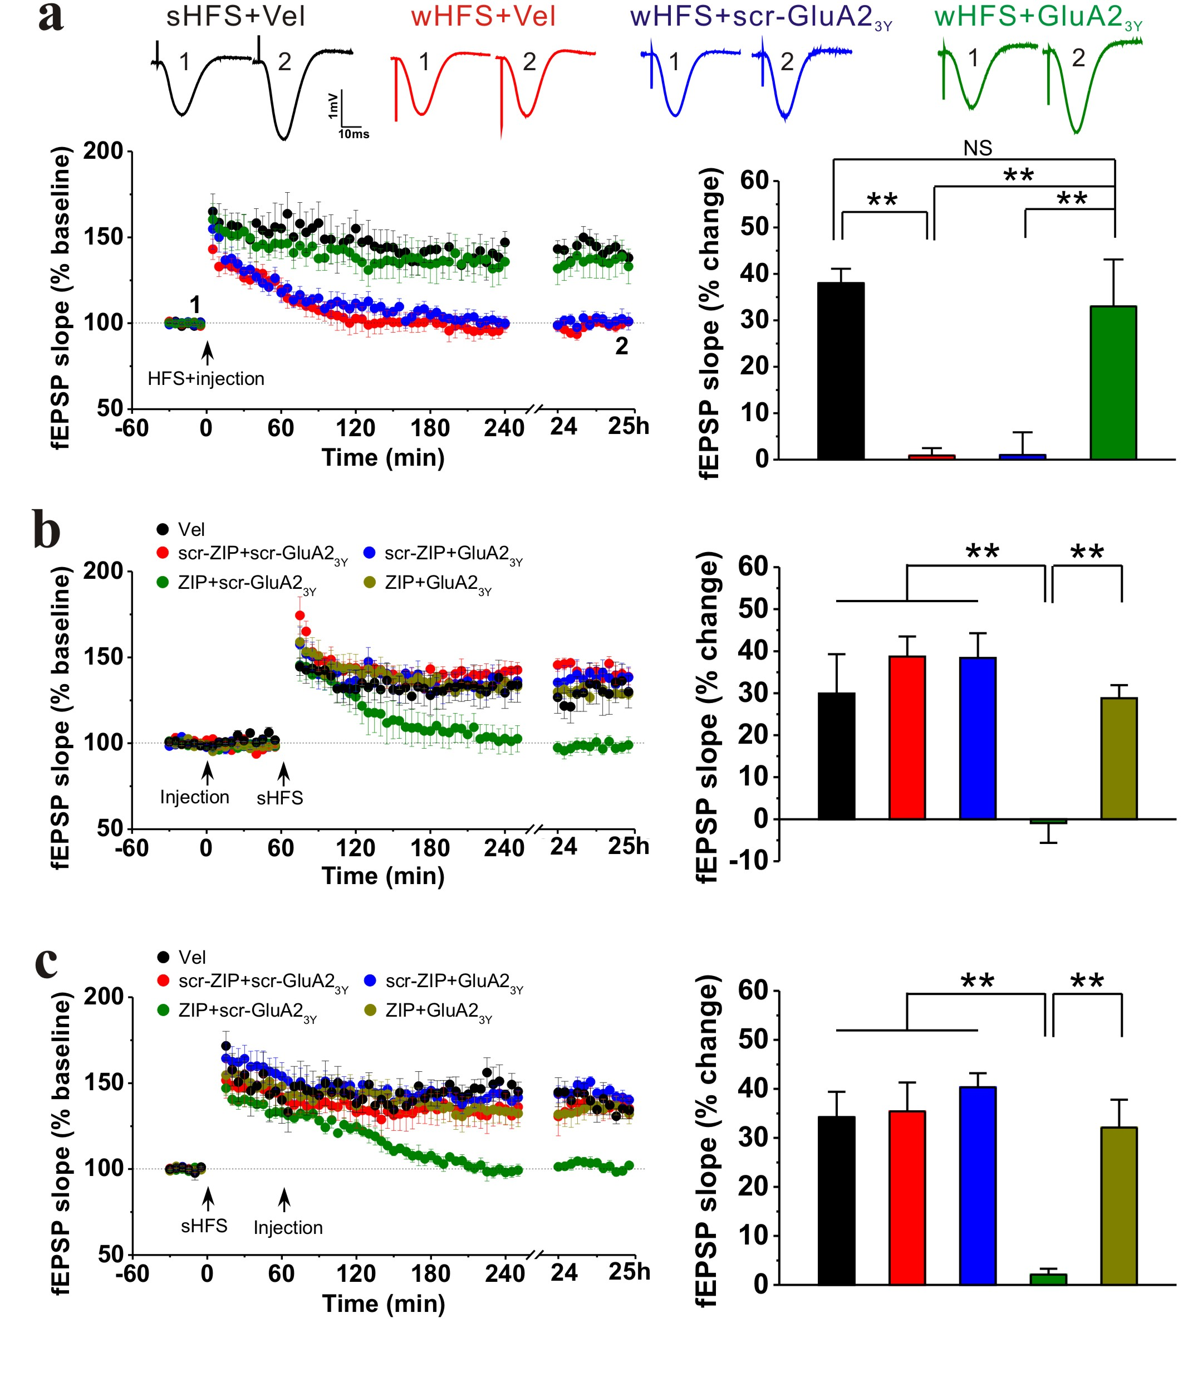

Figure 2
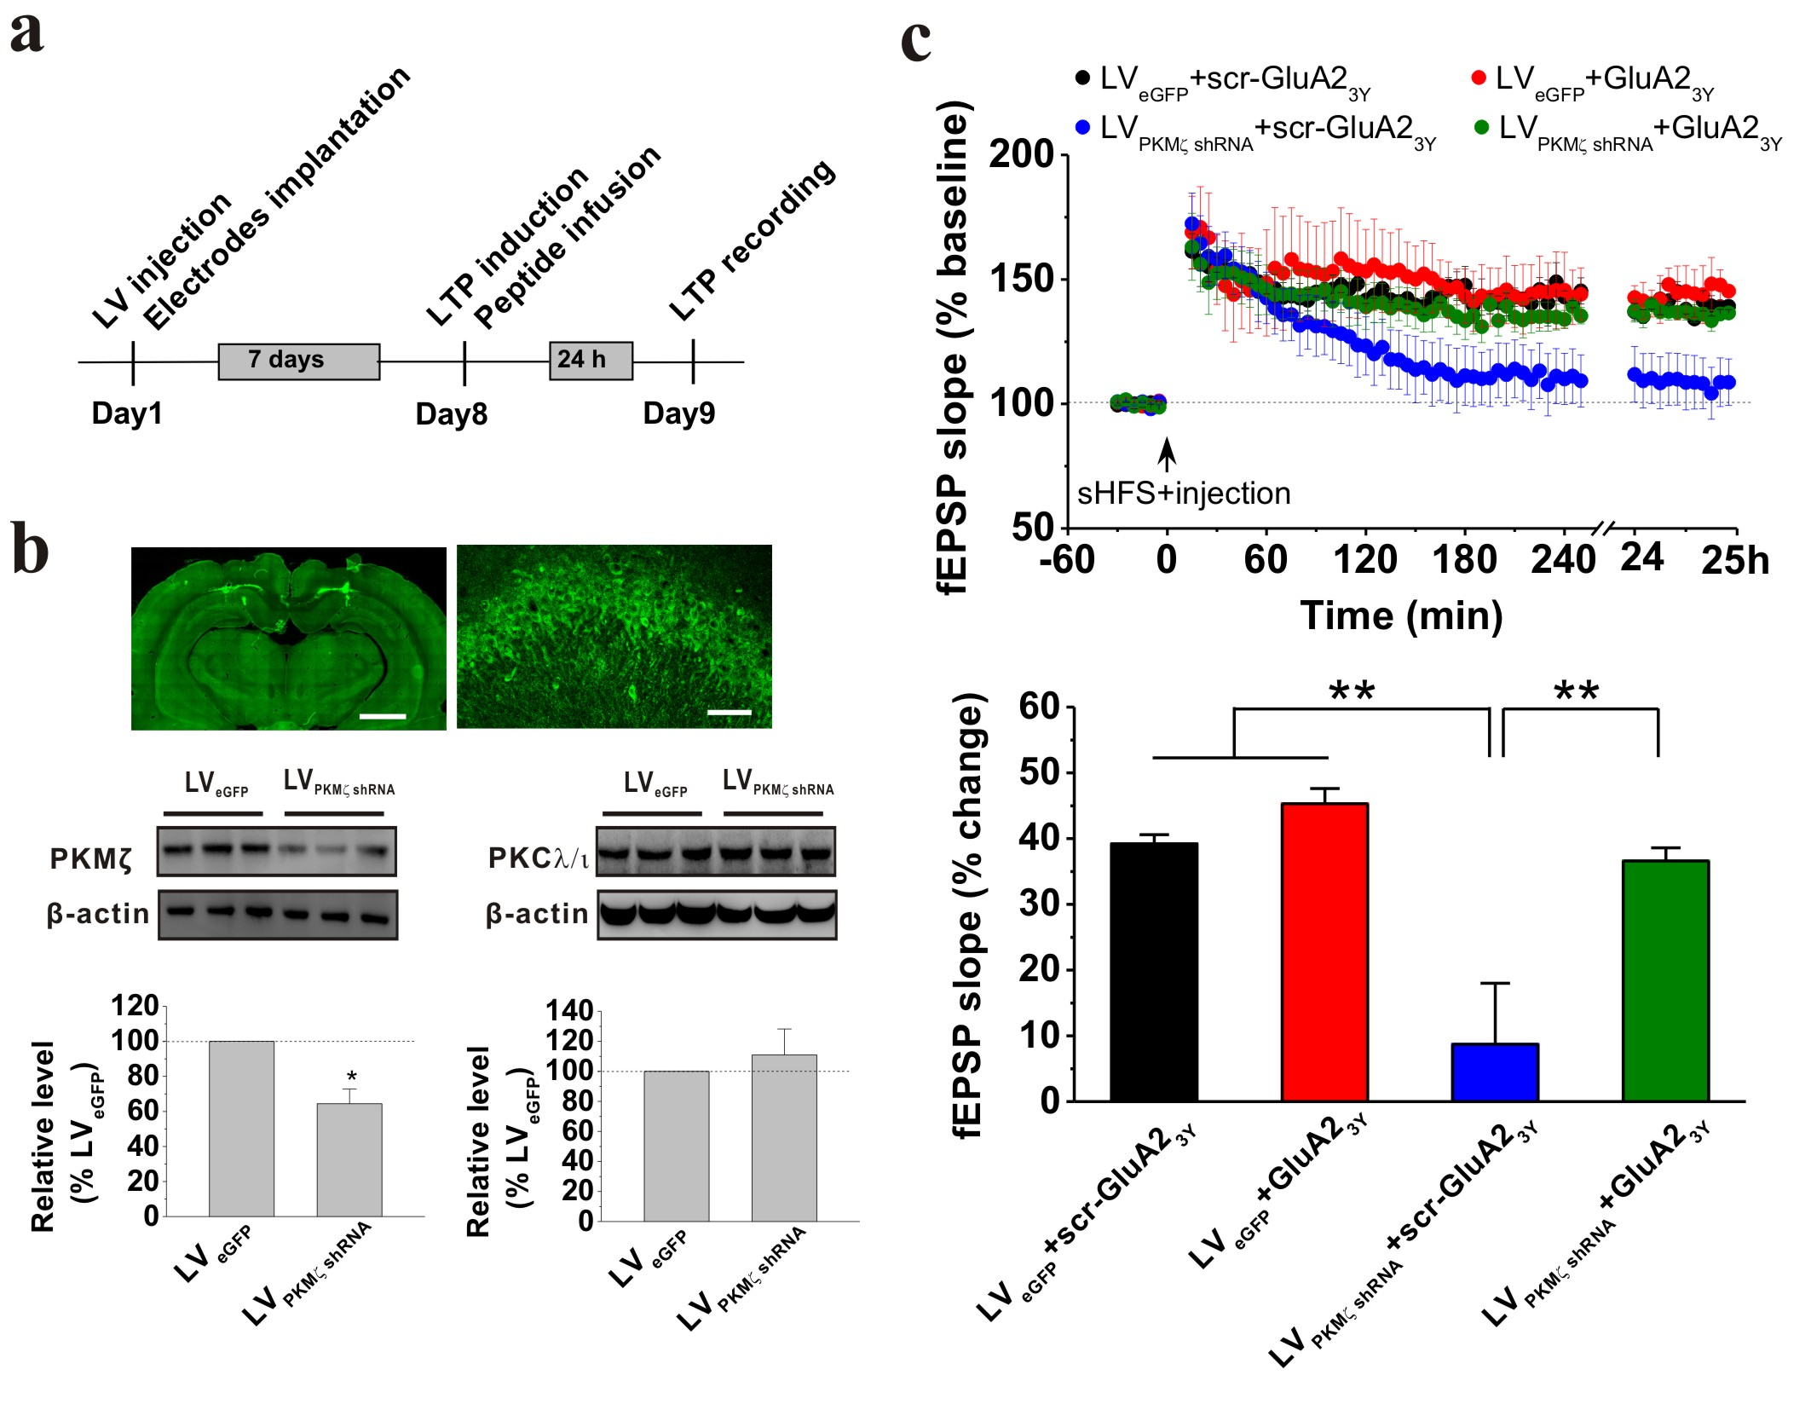

Figure 3
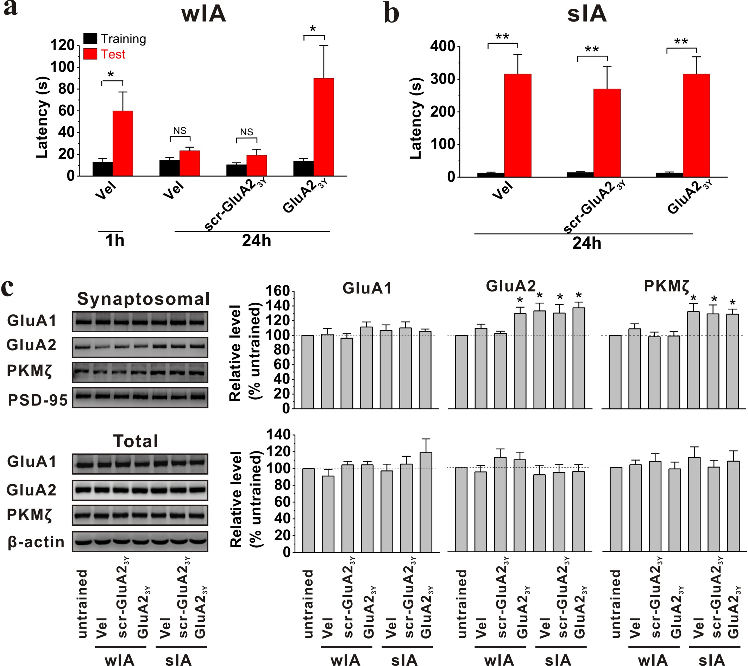

Figure 4
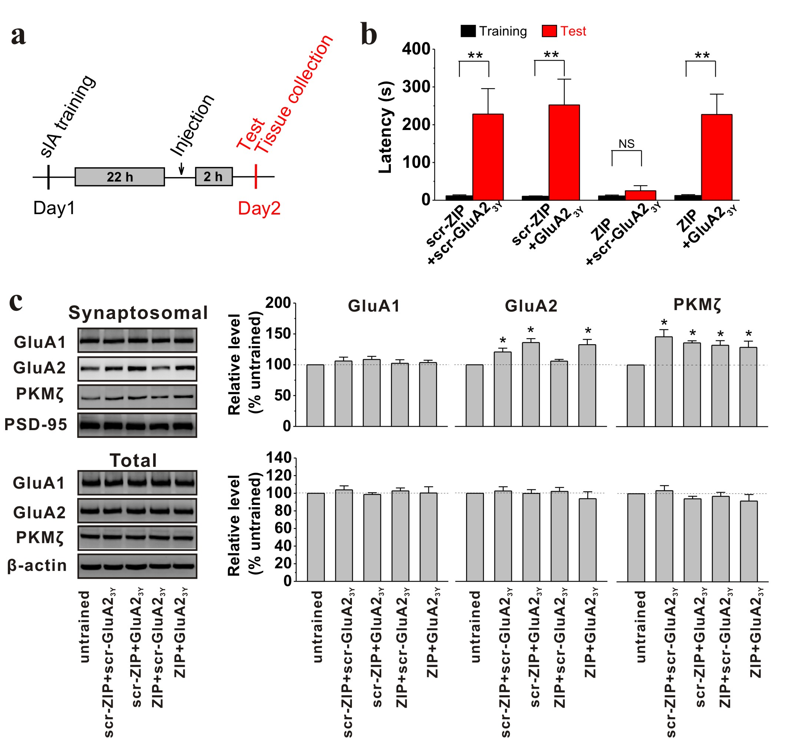

Figure 5
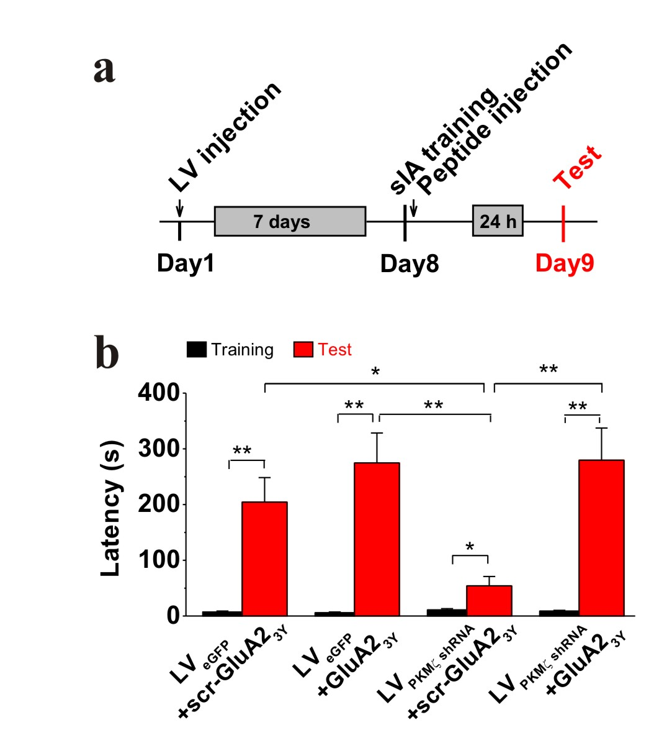

Figure 6
