J Mater Sci: Mater Med (2015) 26:49 DOI 10.1007/s10856-014-5357-3

DELIVE RY SYST EMS

Enhanced anti-cancer activity by curcumin-loaded hydrogel nanoparticle derived aggregates on A549 lung adenocarcinoma cells

Benjamin Teong • Chia-Yun Lin • Shwu-Jen Chang •
Gregory Cheng-Chie Niu • Chun-Hsu Yao •
I-Fen Chen • Shyh-Ming Kuo

Received: 2 March 2014 / Accepted: 12 September 2014
! Springer Science+Business Media New York 2015

Abstract To investigate the anti-cancer activity of curcu- min-loaded hydrogel nanoparticle derived aggregates on A549 lung adenocarcinoma cells. Curcumin was incorpo- rated with biopolymeric chitosan, gelatin, and hyaluronan nanoparticles using an electrostatic field system. Charac- teristics of curcumin-loaded aggregates were examined including size and morphology, incorporation efficiency, stability and in vitro release. Treatment effect on A549 cells were assessed with cell viability assay, apoptosis assay, cell cycle analysis, reactive oxygen species detection, and Western blot. Observation from transmission electron microscopy show that the prepared biopolymeric nanopar- ticles were approximately 3–4 nm in diameter and that the size of the aggregates increased to approximately 26–55 nm after the incorporation of curcumin with the nanoparticles. The incorporation efficiency of curcumin into the chitosan, gelatin, and hyaluronan nanoparticles was 81, 67, and 78 % respectively. The formation of hyaluronan/curcumin and gelatin/curcumin aggregates seems to improve the stability of curcumin drug. The chitosan/curcumin aggregate has a faster release of curcumin than gelatin/curcumin and
hyaluronan/curcumin aggregates. Treatment with chitosan/ curcumin, gelatin/curcumin and hyaluronan/curcumin aggregates resulted in higher apoptosis rates of 45, 40 and 32 %, respectively, as compared to pure curcumin (less than 20 %) via Annexin V-FITC/PI analysis. Chitosan/curcumin aggregates induce the highest apoptosis effect (indicated by sub-G1 phase). In summary, chitosan/curcumin, gelatin/ curcumin, and hyaluronan/curcumin aggregates represent higher anticancer proliferation properties in A549 cells than curcumin alone that exhibit great potential enhancement by either using fewer drugs or a decreased duration.

- Introduction

Curcumin (Cur), which is chemically known as difer- uloylmethane (C21H20O6), is the major natural phenolic compound extracted from turmeric (Curcuma longa) and is commonly used as a spice or yellow coloring agent in food. It is also used in traditional medicine and is known to be an anti-inflammatory, anti-oxidant, anti-tumor, anti-virus, and

low toxicity agent with promising clinical applications.

Benjamin Teong and Chun-Hsu Yao have contributed equally to the present work.

B. Teong ! C.-Y. Lin ! S.-J. Chang ! G. C.-C. Niu !
I.-F. Chen (&) ! S.-M. Kuo (&)
Department of Biomedical Engineering, I-Shou University,
Kaohsiung, Taiwan
e-mail: ifen@isu.edu.tw
S.-M. Kuo
e-mail: smkuo@isu.edu.tw

C.-H. Yao
Department of Biomedical Imaging and Radiological Science, China Medical University, Taichung, Taiwan
Importantly, Cur can suppress cancer cell proliferation and promote apoptosis and has been proven to have potent therapeutic value [1–3]. Over the past few decades, the potential cancer chemotherapeutic properties of Cur in var- ious cancer cell lines, such as the breast cancer cell lines MTA-MB-231 and MCF-7 and the lung cancer cell line A549, have been the subjects for study [4–6]. Although Cur has demonstrated anticancer activity, it still has limitations, such as low bioavailability and poor pharmacokinetics, due to its poor solubility in water solutions and the blood stream, an initial burst release effect, and a high peak plasma con- centration as a result of its rapid metabolism [7, 8].

Consequently, a number of injections are necessary to achieve the above-mentioned therapeutic or anticancer effects. Therefore, we propose that these difficulties can be overcome by encapsulating Cur within a hydrophilic mate- rial to form Cur conjugates in order to enhance its solubility and bioavailability to the targeted cells.
Drug carriers and drug delivery systems using carriers such as liposomes, micelles, nanotubes, and polymeric micro- and nanoparticles have been widely developed and used in bio- medical research for decades [9–12]. Among these carriers, nanoparticles show unique physical and chemical properties compared with the other forms of drug carriers due to their ultra-fine size and sub-cellular functions. The nano-encapsu- lation technique helps increase the stability of a drug and its usefulness when applied to controlled and targeted delivery. In a previous research study, we developed a new method for the production of biopolymeric nanoparticles using an electrostatic field system (EFS) method in an aqueous-phase environment [13]. This EFS technology provides a simple yet powerful technique for fabricating biopolymeric nanoparticles.
In recent years, the utilization of polymeric nanoparticles as a carrier system for cell-specific targeting and the delivery of drugs has gained increased interest due to their excellent endocytosis efficiency, passive tumor-targeting, high encap- sulation efficiency, and ability to deliver a wide range of therapeutic agents [14–17]. The dose and bioactivity of drugs released by nanoparticles are affected by the kinetics of cel- lular attachment and internalization, intracellular pathways, and the final location of the nanoparticles. The size, shape, charge, and surface chemistry of nanoparticles also play important roles in the desired bioactivity of encapsulated drugs. In this study, we employed the EFS method to incor- porate Cur within polymer with three different types of ionic charge, such as positive-charged chitosan (Chi), neutral- charged gelatin (Gel), and negatively-charged hyaluronan (HA) nanoparticles to fabricate Cur-loaded aggregates and evaluate the anti-proliferative effects of Cur or Cur-loaded aggregate on A549 cells. In order to discern the related mechanisms of Cur-loaded aggregates on the A549 cell apoptosis, the absence of adverse effect levels of nanoparticles (5 % v/v of fresh medium: nanoparticles) or Cur concentra- tion (5 lg/mL) were determined prior to the experimental runs. Also, a relatively short 6 and 12 h incubation period were performed to evaluate the ability of Cur-loaded aggre- gate exerting on the A549 cells apoptosis.

- Materials and methods

  - Materials

Chi (MW: 3 9 105 Da), Gel (type A from porcine skin), Cur (MW: 368.38 Da), 3-(4,5-dimethylthiazol-2-yl)-2,5-
diphenyltetrazo-lium bromide (MTT), dimethyl sulfoxide (DMSO), sodium chloride, potassium chloride, phen- ylmethanesulfonyl fluoride (PMSF) and Nonidet P-40 (NP-
40) were purchased from Sigma-Aldrich (St. Louis, MO, USA). Triton X-100 and potassium dihydrogen phosphate was purchased from MERCK (New Jersey, USA). Sodium phosphate dibasic and tween-20 was purchased from J.T. Baker (Pennsylvania, USA). HA, with a molecular weight of 9 9 105 Da (from Streptococcus zooepidemicus) and sodium fluoride (NaF) was purchased from Fluka (Swit- zerland). Tris was purchased from AMRESCO (Ohio, USA). Annexin V-FITC/PI detection kit, mitochondrial membrane potential detection (JC-1) kit and PI/RNase staining buffer were purchased from BD Bioscience (Cal- ifornia, USA). Hydrogen peroxide colorimetric assay kit was purchased from Biovision (California, USA). 40,6-di- amidino- 2-phenylindole (DAPI) and 1,10-dioctadecyl- 3,3,30,30-tetramethylindodicarbocyanine perchlorate (Did oil) was purchased from Invitrogen (California, USA). The A549 lung adenocarcinoma cell line and HFL-1 lung cell was obtained from the Bioresource Collection and Research Center (Hsinchu, Taiwan). A high-voltage power supply was supplied by Bertan (series 230, USA).

  - Production of Cur-loaded nanoparticle aggregate

Cur-loaded nanoparticle aggregates were produced using a protocol described in our previous study [13]. Briefly, an electrostatic field system was constructed using two par- allel copper plates connected with a direct current power supply. Cur was first dissolved in DMSO to prepare a stock solution (5 mg/mL). Then, 1 mL of a Chi, Gel, or HA solution (0.2 mg/mL) was vigorously mixed with Cur (final concentration of Cur was set at 5 lg/mL), and this mixture was poured into a plastic petri dish and placed in the center of the two plate electrodes. Various parameters, such as
temperature (Chi = 17 "C, Gel and HA = 25 "C), applied
electrostatic field strength (5 kV), concentration of bio- polymeric solution (0.2 mg/mL), reaction time (Chi: 5 h, Gel: 3 h, HA: 1 h), and cross-linking reagents, were maintained constant during the study. A schematic repre- sentation of the preparation of nanoparticles and aggregates is shown in Fig. 1. The produced Cur-loaded aggregates (Chi/Cur5, Gel/Cur5 and HA/Cur5 denoted the Cur con- centration of 5 lg/mL) were examined and the size was analyzed using a Tecnai G2 20 S-Twin transmission elec- tron microscopy (TEM; FEI, USA).

  - Incorporation efficiency (IE), Chemical stability and in vitro release study

The percentage of Cur incorporated during the preparation of Chi, Gel, or HA nanoparticles was determined as

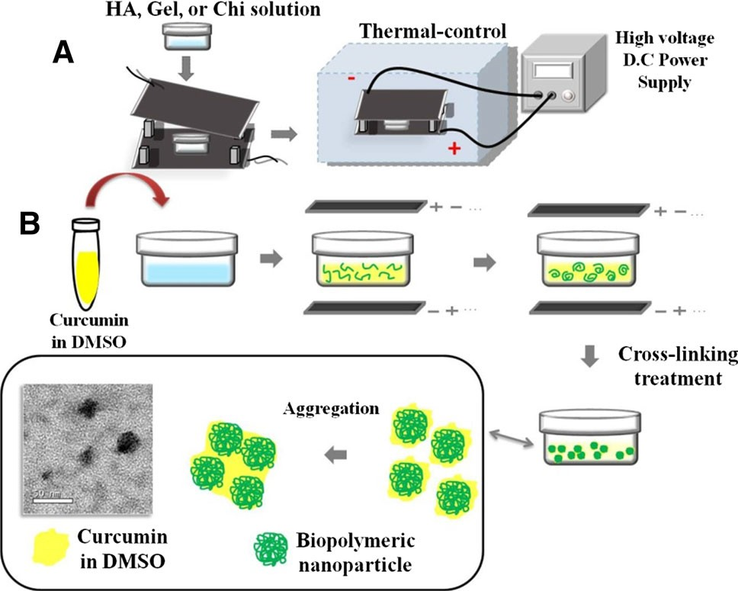
Fig. 1 Schematic representation of nanoparticle preparation. a The setup of the devices; b the procedures used to produce the nanoparticles and aggregates. Cur (yellow) was dissolved in DMSO solution and then combined with HA, Gel, or Chi solution. An electrostatic field provides energy that enables the self-assembly of
the polymer into nanoparticles (green), and Cur would be incorpo- rated at this stage. A cross-linking solution was added at the end of the nanoparticle production. The nanoparticles aggregated to produce raspberry-like aggregates that were approximately 50 nm in size (Color figure online)

follows: 1 mL of Cur-loaded aggregates solution was centrifuged at 15,0009g for 60 min, and the amount of Cur in the supernatant was measured by high-performance liquid chromatography (HPLC, Agilent 1100 series, USA). The HPLC analysis was performed using a C-18 column (4.6 mm 9 150 mm, 5 lm), a mobile phase of 80 % (v/v) methanol, a flow rate of 1 mL/min, and a detection wavelength of 428 nm. A standard concentration curve of Cur was generated for the estimation of the Cur content in the aggregates. The IE was calculated using the following formula:
IEð%Þ ¼ ½ðTotal amount of Cur & Free amount of CurÞ= Total amount of Cur’( 100 %
The chemical stability of Cur in Cur-loaded aggregates was examined using a modified method presented by Sun et al. [18]. Briefly, Cur and the prepared aggregates were diluted with phosphate buffered saline (PBS) to a final concentration of 5 lg/mL in a volume of 500 lL, and the
samples were then incubated in a shaking-water bath at 37 "C and 40 rpm for 0 min, 30 min, 1 h, 2 h, 3 h, 4 h,
8 h, and 12 h. At each time interval, the samples were removed, centrifuged at 15,0009g for 5 min (less duration due to diluted amount of aggregate), and subjected to HPLC analysis. The release of Cur from the Chi/Cur, Gel/ Cur, and HA/Cur aggregates was investigated using a method similar to that mentioned earlier, and each
measurement was repeated three times. The release of Cur from the aggregates was calculated using the follow- ing formula. In vitro releaseð%Þ ¼ ½ðTotal amount of Cur
&Residue of CurÞ=Total amount of Cur’( 100 %

  - Cell culture and Cur-loaded aggregates treatment

A carcinoma cell line A549 and a normal cell line HFL1 was employed in this study. Both cell lines were cultured with DMEM high glucose supplemented with 10 % fetal bovine serum (FBS). Cells were grown in 75 cm2 culture flasks and harvested in a solution of trypsin–EDTA at 70 % confluence. The cells were seeded at a density of 3 9 104
cells/mL in 96-well plate and grown at 37 "C under a
humidified atmosphere of 5 % CO2 for 24 h to allow adherence of cells. The media was removed, then 190 lL fresh media and 10 lL of Cur-loaded aggregates were added to the plate and grown for a designated 6 h, 12 h period of time. Cells grown in a medium containing an equivalent amount of DMSO was served as control. Operators were blinded with respect to treatment groups.

  - Cell viability assay

The cell viability was determined using a MTT assay. After pre-determined period of incubation, 20 lL of MTT solu- tion (5 mg/mL) was added, and the cells were incubated for an additional 3 h. The formazan precipitate was dissolved in 200 lL of DMSO, and the solution was vigorously mixed to dissolve the reacted dye. The absorbance of each well was read on a multi-plate reader at 570 nm. The spectrophotometer (Multiskan Co., Thermo Scientific, USA) was calibrated to zero absorbance using culture medium without cells. The cell viability was also examined with a live/dead cell assay (Invitrogen, UK). Briefly, 1 mL of PBS containing 2.5 lL/mL of 4 lM ethidium homodi- mer-1 (EthD-1) assay solution and 1 lL/mL of 2 lM cal- cein AM solution was prepared. Then, 100 lL of the live/
dead assay solution was added to each culture for 15 min, and the mixture was placed in an incubator at 37 "C with a
humidified atmosphere and 5 % CO2. The staining solution was removed, and the samples were viewed under a fluo- rescence microscope with 494-nm (green, calcein) and 528-nm (red, EthD-1) excitation filters (Olympus IX71, Japan).

  - Measurement of apoptosis: annexin V-FITC/PI

The A549 cells (2 9 105 cells) were seeded in 25 T culture flasks and incubated for 24 h at 37 "C under a humidified
atmosphere of 5 % CO2. The media was removed, then
2.85 mL fresh media and 0.15 mL of biopolymeric nano- particles (Chi, Gel, HA) and Cur-loaded aggregates were

added to the flask and grown for 6 h. The cells were then treated with DMSO (control group). The apoptosis assay was performed by staining with an annexin-V-FITC/PI kit (BD Bioscience) using the manufacturer’s protocol. Briefly, the cells were trypsinized from the culture flask and washed several times with PBS. The cell pellets were suspended in 19 binding buffer and stained with 5 lL of annexin V-FITC and 5 lL of PI for 10 min. The cells were subjected to fluorescence activated cell sorting (FACS) analysis using a flow cytometer (BD Accuri C6, CA, USA).

  - Measurement of mitochondrial membrane potential (DW)—JC-1

Changes in the DW associated with apoptosis were also analyzed with the cationic lipophilic fluorescent probe 5,50,6,60-Tetrachloro1,10,3,30-tetraethyl-benzimidazo- lylcarbocyanine iodide (JC-1; BD Biosciences, USA). The A549 cells were treated with the same experimental groups as mentioned earlier. The DW measurement was performed according to the manufacturer’s protocol. Briefly, lyophi- lized JC-1 powder was dissolved in DMSO and added into 19 binding buffer to produce working solution; 0.5 mL of working solution was added into each sample for 10 min
37 "C and wash twice with 19 binding buffer. The DW
measurement was performed using flow cytometry (BD Accuri C6, CA, USA).

  - Measurement of reactive oxygen species (ROS) levels

Hydrogen peroxide (H2O2) is a reactive oxygen metabolic byproduct that serves as a regulator of oxidative stress- related states. In the present study, we measured the H2O2 concentrations to indicate the levels of ROS after A549 cells (3 9 104 cells/mL) treated with Cur-loaded aggregates for 30 min. According to the H2O2 colorimetric assay kit (Bio- vision, USA) manufacturer’s instruction, briefly, the cell culture medium was collected and centrifuged for 5 min at 1,0009g to remove particulate pellet. And then, 50 lL of supernatant was incubated with a reaction mixture consist of 46 lL assay buffer, 2 lL OxiRedTM Probe solution and 2 lL horseradish peroxidase-conjugated solution at room tem- perature for 10 min. The optical density (OD) value was read on a multiplate reader (Thermo Scientific) at 570 nm. A H2O2 standard curve was built with an R2 value of 0.9917 and the concentration of H2O2 was then calculated.

  - Cell cycle analysis

Cell cycle analysis was carried out at 6 h post treatment.
A549 cells were harvested, fixed with 70 % cold ethanol and stored at -20 "C for over 1 h time period. Cells were
washed twice with PBS and incubated with phosphate–
citrate buffer and 0.1 % triton X-100 at shaking water bath (37 "C, 40 rpm) for 30 min. Cells were again washed with
PBS and stained with 0.5 mL PI/RNase staining buffer (BD Bioscience, USA) for 15 min at room temperature and analyzed by flow cytometry. Cell cycle distribution was calculated from 10,000 cells with ModFit LT software.

  - Morphological assessment by DAPI staining

The A549 cells were incubated with Cur-loaded nano- aggregate for 6 h. After the treatment, cells were washed with PBS and fixed in 4 % formaldehyde. The cells then treated with 0.1 % triton X-100 incubated for 20 min. After washed with PBS, the cells were stained with a DAPI solution and incubated in the dark for 5 min. Nuclei images were examined under a fluorescence microscope at 4009 magnification (Olympus IX-71, Japan).

  - Sodium dodecyl sulfate–polyacrylamide gel electrophoresis (SDS–PAGE) and western blot analysis

To evaluate the expression levels of various intracellular proteins related to apoptosis, A549 cells were treated with Cur or Cur-loaded nanospheres for 6 h. Cells were pre- pared by washing twice with cold-PBS buffer and lysed using cell lysis buffer (50 mM Tris pH 8.0, 120 mM NaCl,
50 mM NaF, 0.5 % NP-40, 1 mM PMSF).The lysates were collected and centrifuged at 13,000 rpm at 4 "C for
10 min. The protein concentration was determined using the Bio-Rad protein assay kit. Equal amount of proteins (100 lg) was loaded and separated by SDS-PAGE and then transferred to nitrocellulose membrane. After blocking with 5 % skim milk, membranes were incubated for
overnight at 4 "C with primary antibodies to Bcl-xL, Bcl-2
(Cell Signaling, Danvers, MA), a-tubulin and b-actin (GeneTex, Inc.). After washing three times in Tris buffered saline (TBS) with 0.1 % tween-20, membranes were incubated with horseradish peroxidase-conjugated second- ary antibodies (Santa Cruz Biotechnology) for 1 h at room temperature and visualized with the enhanced chemilumi- nescence detection system (Thermo Scientific Pierce Pro- tein Research Products, Illinois, USA).

  - Cell interaction assay with Did oil

In order to investigate the interaction between nanospheres and cells, a lipophilic tracker, Did oil was employed in this study. A549 cells (2 9 103 cells) was seeded onto cover slide and incubate for 24 h. 5 lL of Did Oil was mixed with 995 lL water (W), Chi, Gel and HA solution to produce W/Did, Chi/Did nanospheres, Gel/Did

nanospheres and HA/Did nanospheres by EFS system, respectively. These prepared nanospheres were diluted with culture medium to the final concentration of 40 lg/ mL and then added to the well and incubated for prede- termined time intervals. The cover slide was retrieved at 10 min, 30 min, 1 h and 2 h time intervals, and thereafter fixing the cells in 3.7 % paraformaldehyde and stained with DAPI counter staining agent. The slides were viewed under the confocal laser scanning microscope (Olympus Fluo- View 1000).

  - Statistical analysis

The data are presented as the mean ± standard deviation. Each result was statistically analyzed through an indepen-
dent-samples t test using the SPSS program (version 17.0). Values of P \ 0.05 were considered statistically signifi- cant. The significant differences compared to the DMSO
control group and to the Cur group are indicated with an asterisk (*) and a number sign (#), respectively.

3 Results

3.1 Characteristics of Cur-loaded aggregates

The EFS has been well studied in our lab for the preparation of biopolymeric nanoparticles [19, 20]. The EFS provides an electrostatic force for controlling molecules (Chi, Gel and HA) to undergo a self-assembly process to form into nano- particle. The nanoparticles prepared using this method are equally well dispersed and exhibit a narrow range of particle size. Figure 2 shows TEM images of biopolymeric nano- particles and aggregates prepared by the EFS method. The Chi, Gel, and HA nanoparticles were well dispersed in solution and exhibited a spherical shape with a mean diam- eter ranging from approximately 3–4 nm. When
hydrophobic drug, such as Cur, was incorporated into the nanoparticles production process, the nanoparticles would be ‘‘glued’’ together by the Cur which was dissolved in DMSO (a bipolar solvent) that brought Cur molecules onto the surface and the matrices of Chi, Gel and HA nanoparti- cles. Subsequently, the DMSO would have been dispersed into the aqueous media and left Cur behind. Consequently, the hydrophilic domain on Cur molecule would bind itself onto the hydrophilic sites or region of the biopolymer. At the same time, the hydrophobic region on Cur would be bound, in form of thin layer yet in continuous phase, to the hydro- phobic regions on the nanoparticles. Thus, the Cur compo- nent would bring the individual nanoparticle together to form aggregates, and yielded clusters with increasing in size of Cur-loaded nanoparticle aggregates at gross diameters approximately in 30–60 nm (Fig. 1).
The IE of Cur within the Chi, Gel, and HA nanoparticles with Cur concentrations of 5 lg/mL was determined, as described in Table 1. The IE of Cur within Chi, Gel, and HA nanoparticles was found to be 81, 67, and 78 %, respectively. As shown in the TEM images, the positively charged Chi produced loosely packed aggregates, and the acidic condition helped the retention of stability of Cur. These features led to the production of aggregates of a relatively larger size with high incorporation ratio of Cur. Negatively charged HA enhanced the aqueous solubility and stability of Cur, as reported by Manju and Sreenivasan [1], which might have contributed to the stable incorpo- ration of Cur. On the other hand, Gel/Cur exhibited a densely packed morphology, which might be due to the firm binding to the hydrophobic sites on Gel by Cur. Overall, these results demonstrated that Cur could be well incorporated within these biopolymeric nanoparticles (Table 1) in substantially aggregated mode.
Cur is chemically unstable in aqueous solutions and undergoes rapid hydrolysis followed by molecular frag- mentation to form byproducts such as trans-6-(4-hydroxy-

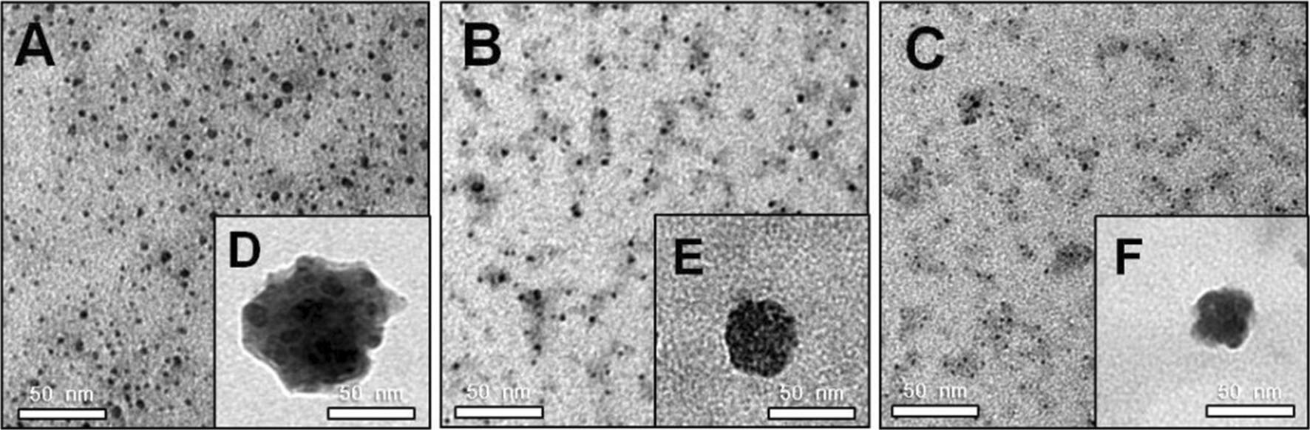

Fig. 2 TEM images of a Chi nanoparticles, b Gel nanoparticles, c HA nanoparticles, d Chi/Cur5 aggregate, e Gel/Cur5 aggregate, f HA/Cur5 aggregate

Table 1 Characteristics of the prepared nanoparticles and aggregates Size (nm) IE (%) Sphericitya
Chi | 4.0 ± 0.7 | n.d. | ???
Chi/Cur5 | 54.7 ± 4.8 | 81.3 ± 2.2 | ??
Gel | 3.2 ± 1.2 | n.d. | ???
Gel/Cur5 | 28.2 ± 4.2 | 66.9 ± 4.4 | ??
HA | 2.8 ± 0.9 | n.d. | ???
HA/Cur5 | 31.2 ± 4.7 | 77.6 ± 5.4 | ?
n.d. not determined, IE incorporation efficiency
a Sphericity: good (???), moderate (??), poor (?)

3-methoxyphenyl)-2,4-dioxo-5-hexenal, vanillin, vanillic acid, ferulic aldehyde, and ferulic acid at physiological conditions [21, 22]. Additionally, these degradation pro- ducts have shown higher aqueous solubility compared to Cur itself and contribute negligibly to the detection of Cur by HPLC [23]. The chemical stability of free Cur, Chi/ Cur5, Gel/Cur5, and HA/Cur5 aggregates was examined in
0.01 M PBS (pH 7.4) over a 12 h incubation period. As natural polymer degrade eventually, the unfolding of HA, GEL and CHI nanoparticles during the incubation period would subsequently release the curcumin into the aqueous. As shown in Fig. 3a, free Cur 5 lg/mL exhibited approx- imately 90 % degradation within 12 h. The HA/Cur5 and Gel/Cur5 aggregates enhanced the stability of the incor- porated Cur by protecting Cur against hydrolysis. In con- trast, the Chi/Cur5 aggregates revealed a rapid degradation of Cur. This result might be attributed to Chi/Cur5 being ionic-cross-linked and incorporated with pH sensitive groups that would exhibit significant changes in structure and composition that would reflect on the various physio- logical levels [24]. For instance, when the pH is adjusted from acidic to neutral conditions, the Chi structure under- goes a volume phase transition from swollen to either a shrunken or collapsed state, which increases the chances that the proton of incorporated Cur being removed from the phenolic group, and leads to the destruction of this struc- ture [25]. This could explain why the stability of Chi/Cur5 was lower than that of the free Cur. The results are pre- sented as the percentage of Cur residue in the samples at each time interval. As shown in Fig. 3b, the release profile of Cur from the Chi/Cur5, Gel/Cur5, and HA/Cur5 aggregates with an initial burst release (approximately 30 %) during the 1 h of incubation was presented. Approximately, 90 % Cur was released from the Chi/Cur5 aggregates, whereas about 50–60 % Cur release was observed from the Gel/Cur5 and HA/Cur5 aggregates after 12 h, which indicated that the Chi/Cur5 aggregates would produce a more rapid release of Cur most likely due to their larger size and looser structure in general.

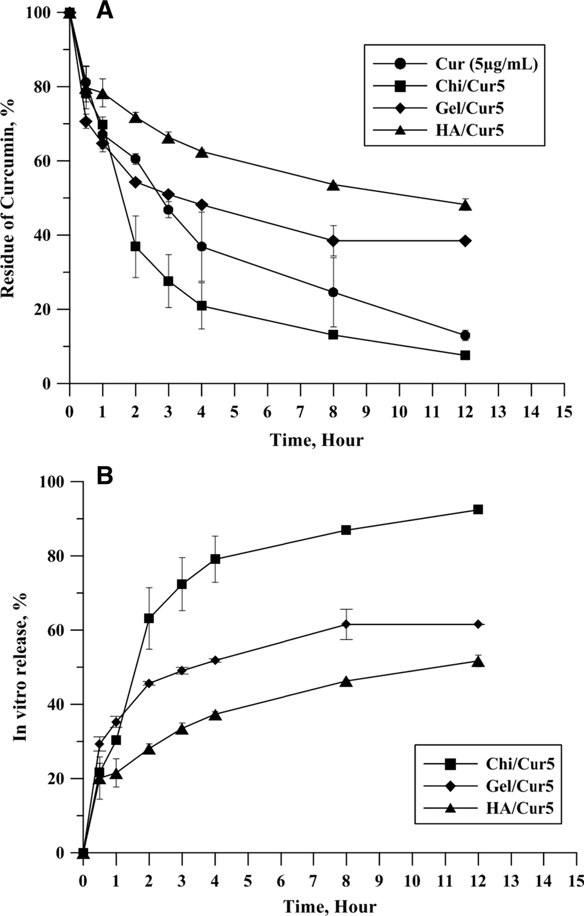
Fig. 3 a Chemical stability of free Cur, Chi/Cur5, Gel/Cur5, and HA/ Cur5 aggregates in PBS (pH 7.4). b In vitro release profiles of Chi/ Cur5, Gel/Cur5, and HA/Cur5 aggregates in PBS (pH 7.4)

  - In vitro cell viability test

It is known that nanoparticles may cause undesired cyto- toxicity depending on their types and concentrations. Therefore, prior to the experimental run, an optimal con- centration of the nanoparticles that exhibit a harmless effect on the cultured cells was determined through a cell viability test. As shown in Fig. 4a, an obvious decrease in cell via- bility was observed after the addition of more than 20 lg/mL Chi nanoparticles, 20 lg/mL Gel nanoparticles, or 30 lg/ mL HA nanoparticles compared with the tissue culture flask (control). No obvious decrease in cell viability was observed after the addition of 10 lg/mL Chi nanoparticles, Gel nanoparticles, or HA nanoparticles. Therefore, a nanoparti- cle or Cur-loaded aggregate concentration of 10 lg/mL was used as the final concentration in the subsequent apoptotic assays. Furthermore, the effects of various loading concen- trations of Cur (0.5, 1.0, 2.5, 5.0 and 10 lg/mL) on A549 cells over 48 h incubation periods were also tested. As shown

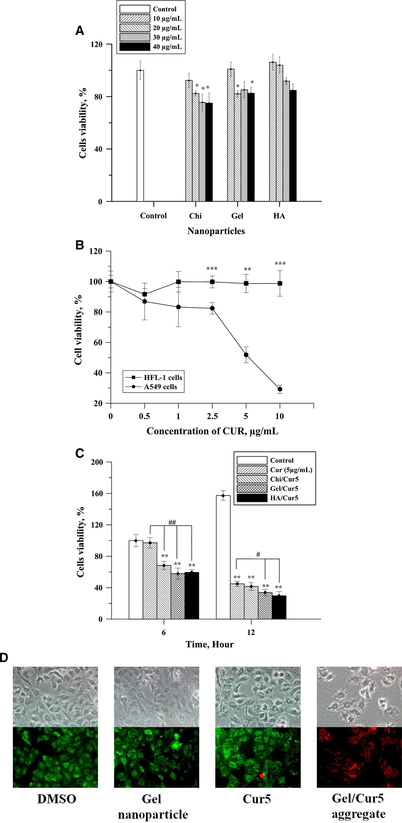
Fig. 4 a Effect of Chi, Gel, and HA nanoparticles on the A549 cells viability. b Cell viability dose–response curves for human
lung normal (HFL1) and cancerous (A549) cells treated with Cur over 48 h. IC50 was approximately at 5 lg/mL.
c Effect of Cur, Chi/Cur
aggregates, Gel/Cur aggregates, and HA/Cur aggregates on the A549 cells viability. d Live/ dead assay of A549 cells treated
with Cur at a concentration of 5 lg/mL for 6 h. The fluorescence micrographs show the live (green) and dead (red) A549 cells after treatment with Gel/Cur5 aggregates (as an example) (9200). The significant differences are based on comparisons with the control group (*) or with the Cur group
(#): **P \ 0.01, ***P \ 0.001,
#P \ 0.05, ##P \ 0.01, and
###P \ 0.001 (Color figure online)

in Fig. 4b, the cytotoxicity of Cur in A549 cells showed a dose-dependent inhibitory effect. The half maximal inhibi- tory concentration (IC50) of Cur toward A549 cells was approximately 5 lg/mL for 48 h incubation. Our primary objective at this stage was to evaluate the potential enhancement of the apoptotic effect of Chi/Cur5, Gel/Cur5, and HA/Cur5 aggregates attributed to the incorporation of Cur within the nanoparticles. Figure 4c shows the viability of A549 cells cultured with Cur5, Chi/Cur5, Gel/Cur5, or HA/Cur5 aggregates. As shown, cells treatment with DMSO (as control) did not inhibit cell proliferation in which this group archived a 60 % growth after 6 h of incubation, but a significant decrease in cell viability was observed in the Chi/ Cur5, Gel/Cur5, and HA/Cur5 groups after a relatively short 6 and 12 h incubation period compared with the Cur5 group. These results showed that Cur-loaded aggregates could exert an enhanced apoptotic effect toward A549 cells, most likely by improving the hydrophobicity of Cur and facilitating the cellular uptake of these aggregates [1, 7, 26].
The live/dead stained cell images which representing a local observation on morphology has provided further information on the cell viability after treatment with Cur and Cur-loaded aggregates. The images shown in Fig. 4d illustrated the viable A549 cells (in green) and the dead A549 cells (in red) after 6 h of incubation with Cur5 or Gel/Cur5 aggregates. The images also show that the dead A549 cells exhibited shrinkage, incurred frilled membranes and were detached from the plate. These observations are typical morphological apoptosis changes.

  - Apoptosis assay by flow cytometry

To further examine the apoptotic effect of Cur-loaded aggregate on the A549 cells, the annexin V-FITC/PI staining and DWm were evaluated by flow cytometry. As shown in Fig. 5a, the apoptotic profile of Cur-loaded aggregates on the A549 cells, more percentage of apoptotic cells was observed after treated with Chi/Cur5 aggregate: 44.7 %, Gel/Cur5 aggregate: 40.7 % and HA/Cur5 aggregate: 30.9 %, respectively, as compared to pure Cur5 (induced 18.1 % apoptosis). Loss of DWm had also been utilized to confirm an early apoptosis event caused by these aggregates. Similarly, A549 cells exposure to Chi/Cur5, Gel/Cur5 and HA/Cur5 aggregates resulted in higher decline in DWm as compared to the pure nanoparticles and Cur5 (Fig. 5b), which indicated that a higher ratio of apoptosis after treated with the aggre- gates. A statistical difference was observed between the aggregates groups and pure Cur5 group.

  - Cell cycle analysis

In order to identify the anti-proliferative effect of Cur- loaded aggregates treatment on A549 cells, the cell cycle
progression was analyzed by using flow cytometry. As shown in Fig. 6a, b, the proportion of G2/M phase increases from 7.39 % (Cur5) to a higher percentage of 18.56 % (Chi/Cur5 aggregate), 11.8 % (Gel/Cur5 aggregate) and
13.6 % (HA/Cur5 aggregate), respectively, at 6 h treat- ment, indicated that Cur-aggregate treatment lead to an increased accumulation of A549 cells in G2/M phase (arrested in G2/M phase in cell cycle). Furthermore, a higher proportion of sub-G1 phase was observed in Chi/ Cur5 (6.34 %), Gel/Cur5 (3.46 %) and HA/Cur5 (3 %) aggregates as compared to pure Cur5 (1.18 %) indicating that enhanced apoptosis was occurred. However, no apoptosis was observed in other groups (Table 2). Induc- tion of apoptosis in A549 cells after treatment with Cur5- loaded aggregates was further examined by DAPI staining method. The A549 cells treated with DMSO showed round and homogeneous nuclei, whereas aggregate-treated cells exhibited condensed and fragmented nuclei (Fig. 6c). This DNA fragmentation can lead cells to apoptosis.

  - Detection of ROS

ROS have been reported to play a key role in early stage of apoptosis detection as in evidence of high level of intra- cellular production of ROS in the targeted apoptotic cells. In order to measure the capacity of Cur-loaded aggregate that caused by intracellular oxidation, we detected the reactive oxygen metabolic byproduct H2O2, which would indicate the levels of intracellular ROS produced by aggregate-treated cells. When A549 cells were treated with Cur-loaded aggregate, the cells exhibited significant increase of ROS at 30 min as compared to the DMSO and pure Cur5 groups. An approximate 1.2- to 1.3-fold increase was observed in aggregate-treated groups as shown in Fig. 7. Interestingly, a mild increase in ROS level was also demonstrated on the pure nanoparticle groups, probably due to the stimulus by cellular endocytosis of these nano- particles that would respond by generating oxidative stress.

  - Western blotting analysis

In order to identify the specific regulatory proteins asso- ciated with the A549 cell apoptosis due to Cur-loaded aggregate, the apoptosis-related protein expression levels of Bcl-xL and Bcl-2 were detected by Western blotting analysis. Our results demonstrated that cells treated with Cur-loaded aggregates lead to an obvious down-regulation of Bcl-2 as compared to other groups (Fig. 8). This result suggests that suppression of Bcl-2 could contribute to Cur- loaded aggregate induced apoptosis. Meanwhile, there was no obvious suppression of Bcl-2 protein levels in other groups that demonstrated the concentrations of Cur5 or nanoparticles used in this present study is in nontoxic

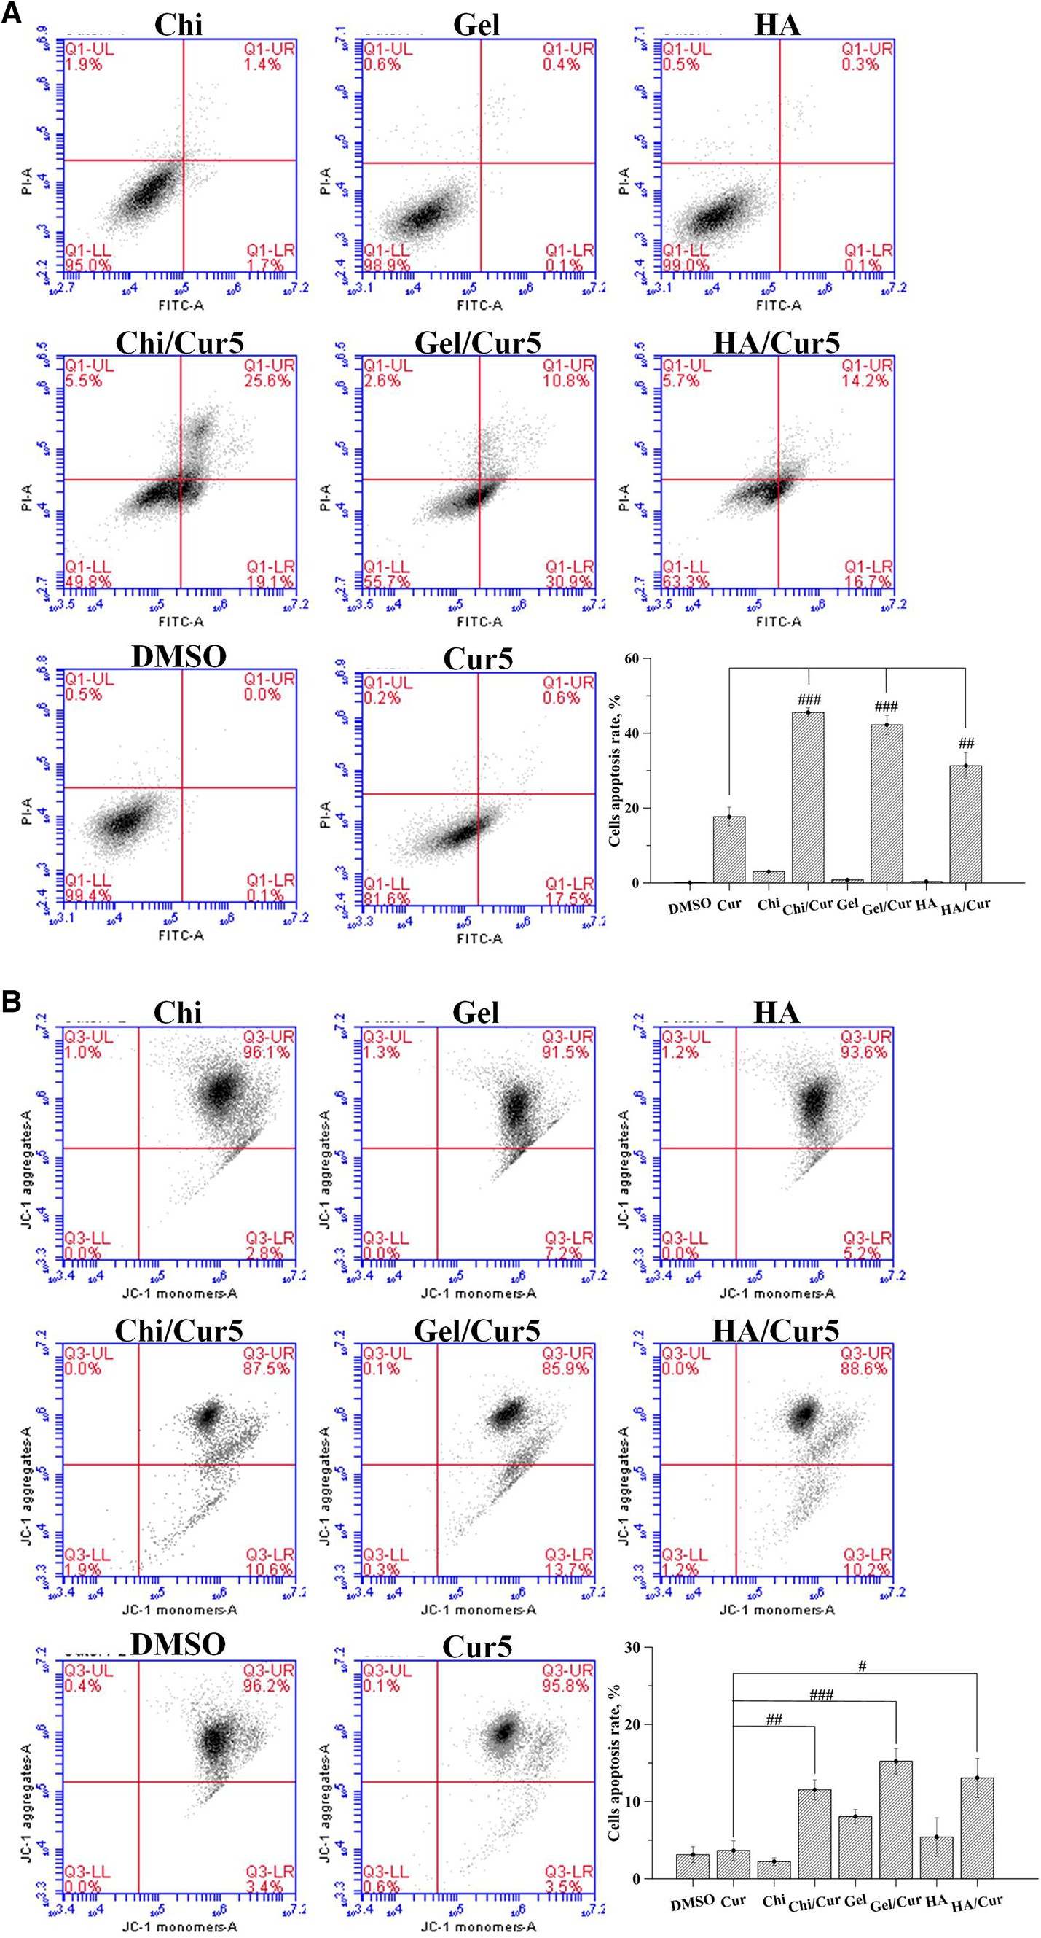
Fig. 5 a FACS-based apoptosis profile for the nanoparticles, aggregates and pure Cur5 on A549 cells. The apoptosis rate of A549 was significantly
different between Cur5 only and Cur5-loaded aggregates. b Flow cytometry analysis of mitochondrial membrane
potential (DWm) in each treatment group was performed by JC-1 staining. Loss of DWm was demonstrated by the change in JC-1 fluorescence from JC-1 aggregates (UR quadrant) to JC- 1 monomers (LR quadrant).
Cells treated with Cur5 only have similar percentages of JC- 1 monomers as control group, whereas cells treated with Cur5- loaded aggregates show high percentages of JC-1 monomers, indicating there is a loss in DWm

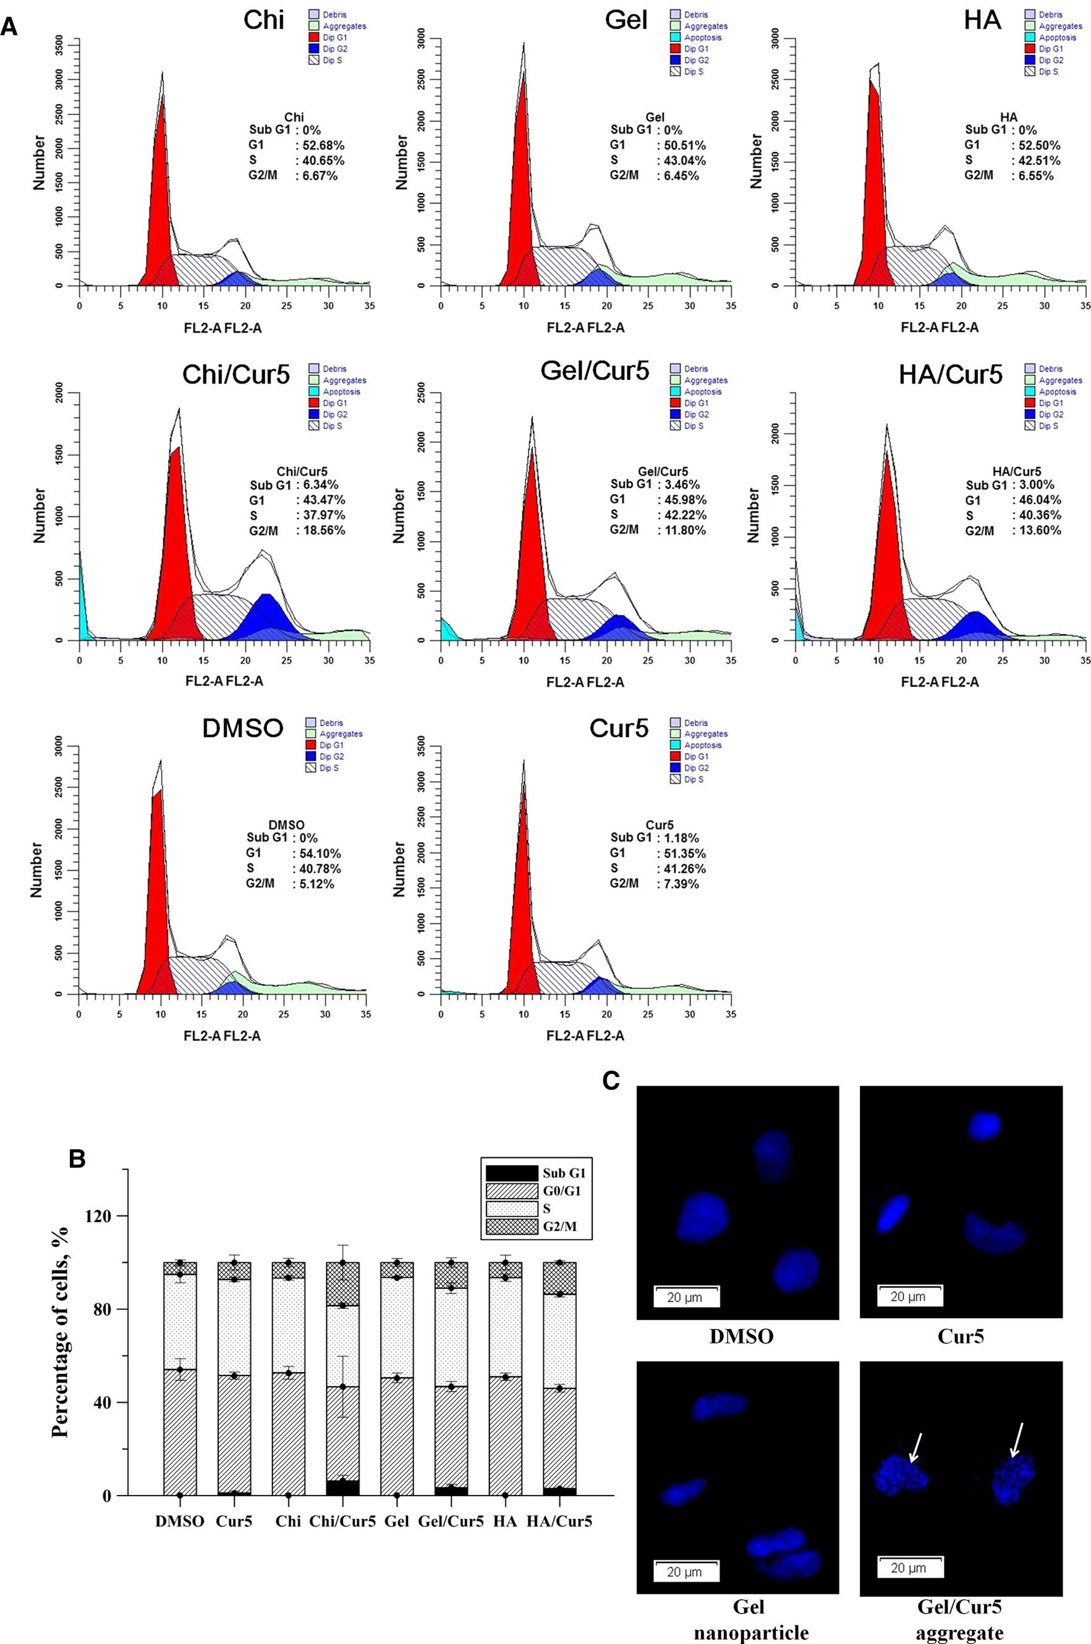

b Fig. 6 A549 cells were treated with various nanoparticles and Cur5- loaded aggregates for 6 h and the cells were harvested and analyzed for cell cycle. a The percent of cells in each phase. Flow cytometry analysis showing DNA distribution profiles in different phases of cell cycle (Sub-G1, G1, S and G2/M) in A549 after PI staining. b The cell distribution which have been summarized and present as mean ± SE (values shown in Table 2). c A549 cells stained with DAPI and visualized under a fluorescence microscope (magnification 9400). White arrow indicates the fragmented nuclei

Table 2 The percentages of cells present in each phase of cell cycle (%)

 | Sub-G1 | G1 | S | G2/M
DMSO | 0 | 54.1 | 40.78 | 5.12
Cur5 | 1.18 | 51.35 | 41.26 | 7.39
Chi | 0 | 52.68 | 40.65 | 6.67
Chi/Cur5 | 6.34 | 43.47 | 37.97 | 18.56
Gel | 0 | 50.51 | 43.04 | 6.45
Gel/Cur5 | 3.46 | 45.98 | 42.22 | 11.8
HA | 0 | 52.50 | 42.51 | 6.55
HA/Cur5 | 3 | 46.04 | 40.36 | 13.6

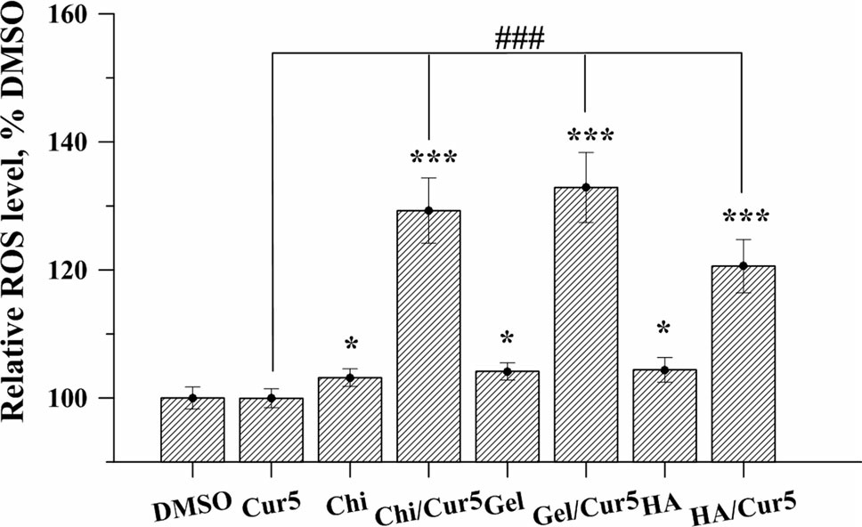
Fig. 7 Effect of nanoparticles and Cur5-loaded aggregates treatment on ROS generation. A549 cells (3 9 104 cells/mL) were seeded in 96 well plates and incubated with various nanoparticles and Cur5-loaded aggregates (described in Sect. 2) for 30 min, and the generation of ROS was then determined by hydrogen peroxide colorimetric assay
kit. Significant differences are based on comparison with DMSO group. *P \ 0.05, ***P \ 0.001

range. However, a mild increased Bcl-xL protein level was detected and this contradictory result was probable asso- ciated with cell cycle arrest [27].

  - Interaction of nanoparticles with cells

The lipophilic fluorescent probe Did oil was utilized and mixed with the Chi and Gel materials to prepare Gel/Did
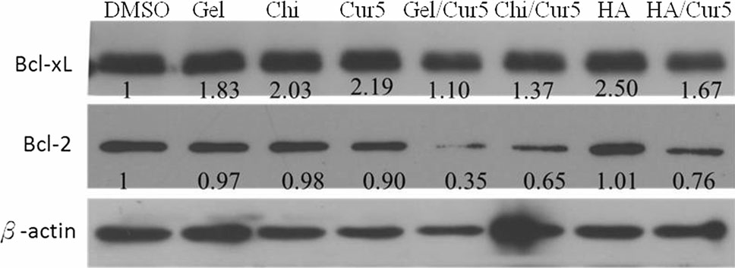

Fig. 8 Western blot analysis of apoptosis-related proteins in A549 cells. Cells were treated with Cur5 or Cur5-loaded aggregates for 6 h. Whole-cell lysates were analyzed by SDS-PAGE and immunoblotted with antibodies against Bcl-xL and Bcl-2

and Chi/Did nanoparticles through the EFS method. Because Did oil has specific affinity toward cell mem- branes, we can utilize this fluorescent dye to observe the speed at which the nanoparticles approach the cultured cells and the amount of nanoparticles that approach the cultured cells. In this experiment, we were unable to pre- pare particulates and well-dispersed HA/Did nanoparticles due to the positive-charge of the Did oil, which aggregated severely with the HA molecules (negatively charged) during the nanoparticle preparation. As shown in Fig. 9, the fluorescent microscopy results for the A549 cells that cultured with W/Did, Gel/Did, and Chi/Did nanoparticles for 10 min to 2 h were presented. As observed, more red fluorescence is observed around the cells when they were cultured with the Gel/Did or Chi/Did nanoparticles for 2 h compared with W/Did. This observation demonstrated that these nanoparticles could approach and interact with the cells more quickly and would thus yield more apoptosis of A549 cells when incorporated with the Cur drug [28].

- Discussion

Many reports have demonstrated that Cur shows anticancer activity against many cancer cells. Sun et al. indicated that Cur could repress cell proliferation, induces G1 arrest at a lower concentration of 30 lM in a time- and dose-depen- dent manner and higher doses of Cur produce a dose- dependent apoptotic death (50 lM) in MDA-MB-231/Her2 cells [29]. Rejinold et al. also indicated that the apoptosis is Cur concentration dependent and differential sensitivity to normal and cancer cells [7]. Our primary objective at this stage was to evaluate the potential enhancement of the apoptotic effect (with either less drug or a decreased duration) of Chi/Cur5, Gel/Cur5, and HA/Cur5 aggregates attributed to the incorporation of Cur to the nanoparticles. In order to evaluate the potential enhancement of apoptosis on A549 cells by Cur-loaded aggregate, the IC50 is deter- mined prior to each experimental run. As shown in Fig. 4b, the IC50 value for the A549 cells was 5 lg/mL (about
13.6 lM) and a non-toxic effect was exhibited on the

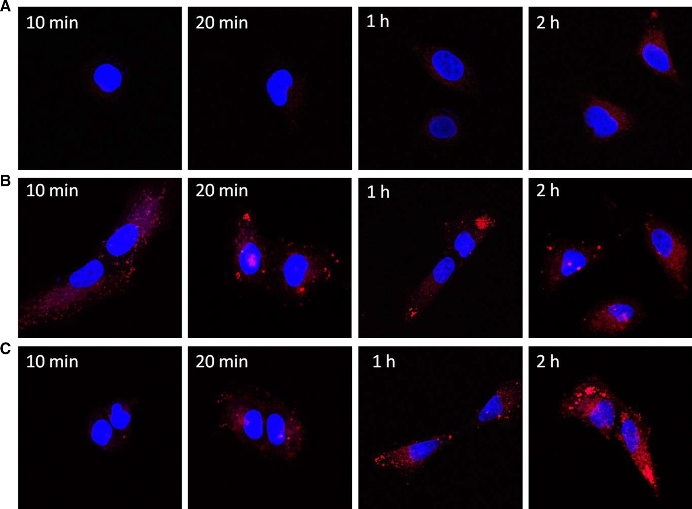

Fig. 9 Confocal images of A549 cells treated with a Did oil with water (W/Did), b Did oil in Gel nanoparticles (Gel/Did), and c Did oil in Chi nanoparticles (Chi/Did) for 10 min, 30 min, 1 h, and 2 h. The
red fluorescence represents the binding of Did oil to the cellular and intra-organelles membranes, and the blue fluorescence shows the DAPI staining of the cell nucleus (Color figure online)

normal HFL-1 cells, so that we adopted this concentration as the final concentration during the Cur-loaded aggregate preparation. Notably, this concentration was much less than the concentration used in previous mentioned study. Cur, being a lipophilic molecule, might have some short- falls such as low solubility and inability to achieve homogeneous dispersion in solution, all of which has impaired its use as a therapeutic anticancer drug directly. Based on our results and experiences, we intended to use the EFS method to produce Cur-incorporated biopolymeric nanoparticles and to evaluate their potential use as a Cur anticancer drug carrier. Our results demonstrated that Cur- loaded aggregate could enhance the apoptosis of A549 cells by the following evidences: the induced ROS pro- duction followed by DNA damage which then leading to the decreased levels of Bcl-2, that followed by decreased levels of DWm in mitochondria. These results suggested that Cur-loaded aggregate exhibited functional aqueous dispersion after hydrophilic Chi, Gel, or HA nanoparticle aggregation of Cur and improved the Cur bioavailability, and eventually led to enhanced cellular apoptosis. The A549 cells treated with Chi/Cur5 aggregate, Gel/Cur5 aggregate and HA/Cur5 aggregate exhibited a higher ratio
of apoptosis compared to those treated with pure Cur5 in the Annexin V-FITC and PI fluorescence flow cytometry analyses. Similarly, A549 cells exposure to Chi/Cur5, Gel/ Cur5 and HA/Cur5 aggregates results in higher decline in DWm. The most significant contribution of this study is the developed Cur-loaded aggregate could enhance the apop- totic effect on A549 cells as compared to the pure Cur even at the relatively low concentration level by similar apop- tosis mechanisms and pathways. As we mentioned earlier, our primary objective was to enhance the apoptotic effect of Cur by either using less drug or short duration of treatment. Figure 10 shows the viability of A549 treatment with lesser concentration of Cur (2.5 lg/mL) than IC50(5 lg/mL), which showed similarly decreased viability after 48 h of incubation, whereas if in usage of Cur con- centration at 5 lg/mL, only a shorter incubation (6 h) was required to reduce the viability of A549.
Punja et al. reported that the therapeutic effect of drug- loaded nanoparticles depended on the internalization of nanoparticles and sustained retention of the nanoparticles [30]. It has been known that nanoparticles are similar in size to typical cellular components and can efficiently intrude into living cells by exploiting the cellular

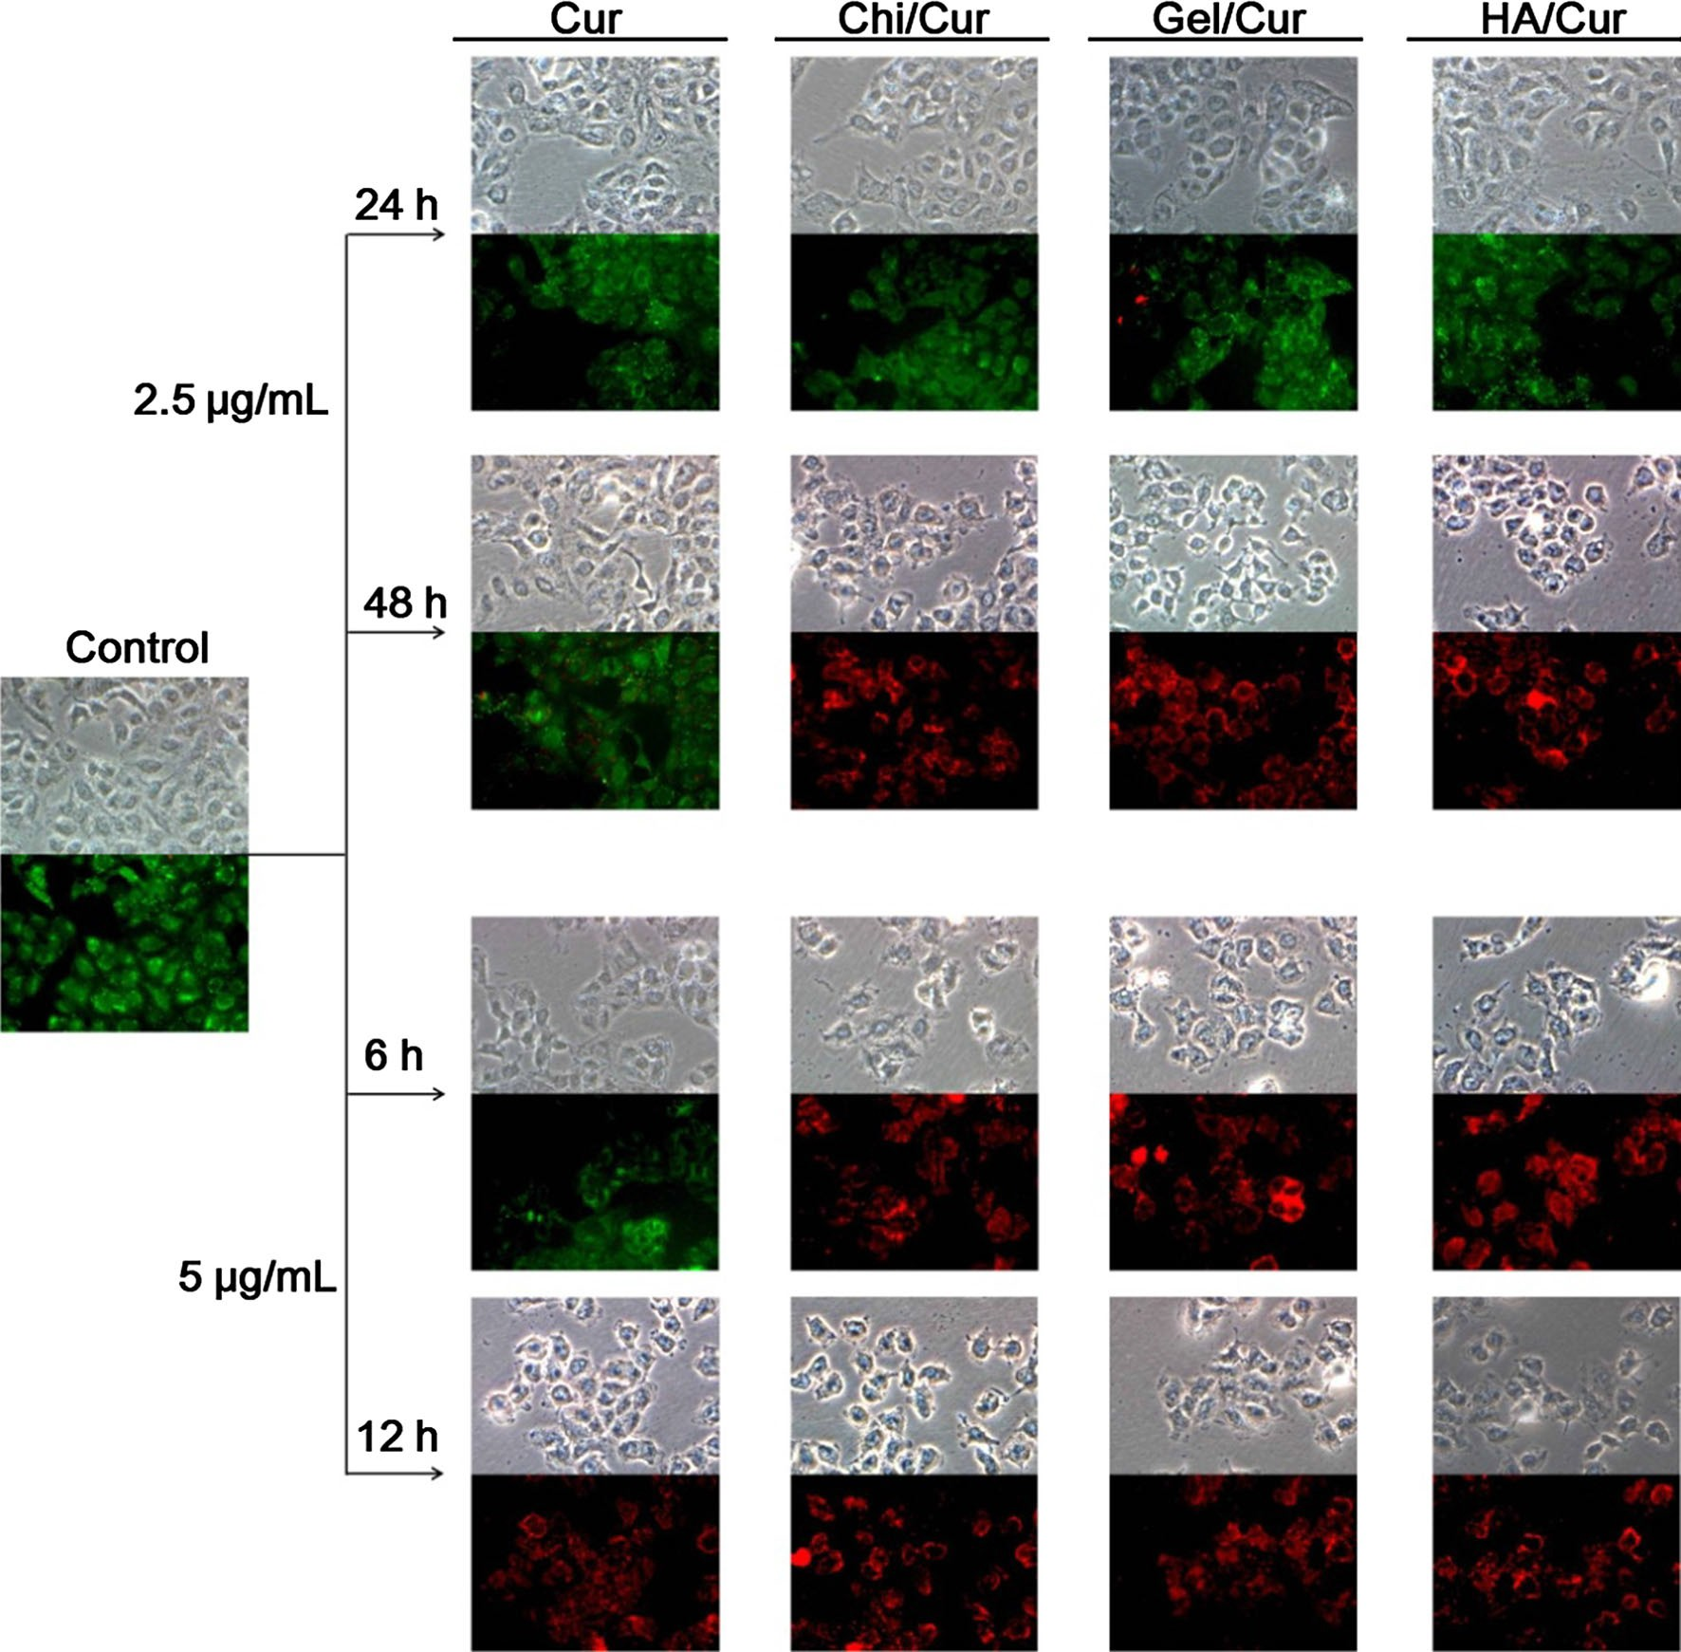

Fig. 10 Live/dead assay of A549 cells treated with Cur at a concentration of 2.5 lg/mL for 24 h or at a concentration of 5 lg/ mL for 6 h. The optical micrographs compare the morphology
changes, and fluorescence micrographs show the living (green) and dead (red) A549 cells after treatment. The images were obtained at 9200 magnification (Color figure online)

endocytosis machinery, such as clathrin-mediated uptake, caveolae-mediated uptake, macropinocytosis, or phagocy- tosis. The efficiency of the cellular uptake of nanoparticles is strongly affected by many factors, such as the nanopar- ticle size, shape, composition, and surface chemistry and the charge of the materials [31]. In the present study, we propose a simplified schematic representation of the interfacial phenomenon responsible for the delivery of Cur in form of Cur-loaded aggregates into the cells (as observed in Fig. 11). At low dosage of Cur given to the cells, poorly dissolved Cur targeted the receptor on the surface membrane of cancer cell, and then entering into cytoplasm to trigger and initiate a series of apoptosis pro- cesses. For Cur-loaded aggregates, Cur molecules were riding on clusters of hydrogel polymer nanoparticle that
possess large mass, high local density, and some cases with electric charges. These aggregates were to be endocytosed into cells more easily and readily. Sahay et al. [32] noted that the majority of positively charged nanomaterials enter a cell through clathrin-mediated endocytosis, whereas most negatively charged nanomaterials utilize caveolae-medi- ated endocytosis. However, it is unclear from the literature whether neutral nanomaterials employ any specific cellular entry routes. Generally, Cur being sparsely soluble to aqueous medium, requires hydrophobic pockets for endo- cytosis. By examining the molecular structure, we might assumed that Chi possess the highest hydrophobicity, with Gel rank the second and HA the third. It seemed that the higher the hydrophobicity of hydrogel employed, the greater the size of the aggregates as shown in Fig. 2d–f.

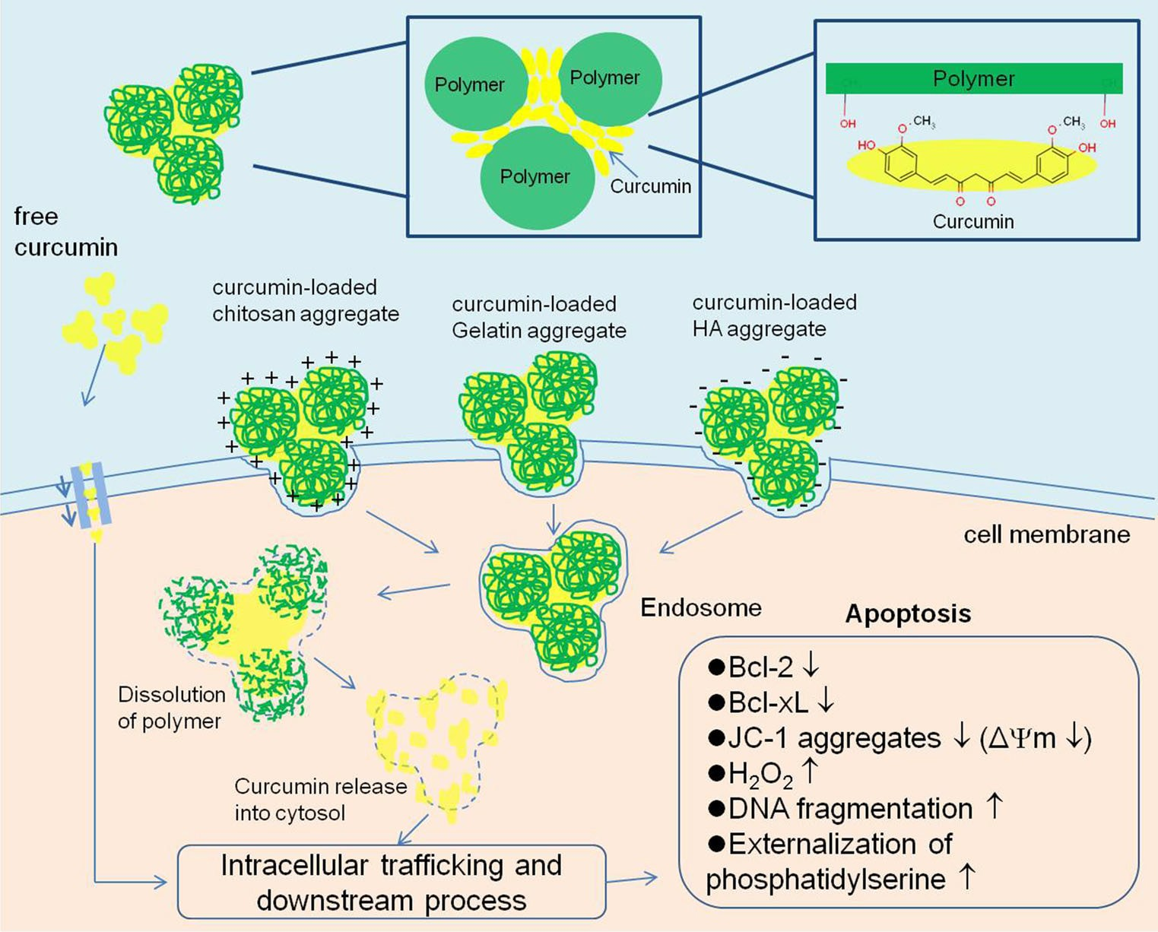
Fig. 11 Schematic representation of the probable delivery and uptake pathways through which Cur and the Cur- loaded nanoparticles enter cells. A few interfacial phenomena were hypothesized, including free-floating Cur binds to a surface receptor (i.e., cytokine receptor, epidermal growth factor receptor, etc.) or a transmembrane protein (i.e., cadherin), and Cur-loaded nanoparticles are uptaken by one or multiple endocytosis pathways

Once Cur-loaded nanoparticles were engulfed into the cytoplasm, and the dissolution of Chi, Gel or HA polymer nanoparticles provides energy to emulsify the Cur com- ponent to form Cur sub-nanoparticles, which were then readily dispersed into cytoplasm and initiate the apoptosis process. In other words, the synergy expressed by the Cur- loaded aggregates to the apoptosis process could be enhanced by the naturally occurred hydrogel molecules that might lead the ways to receptors and channels on the cancer cell surface and thus facilitate means for endocy- tosis of Cur. Nevertheless, the details in delivery of Cur that bundling on the Chi, Gel or HA nanoparticles to the ‘‘target area’’ of cell surface membrane is still yet to be defined.

- Conclusion

Cur has been successfully incorporated with biopolymeric nanoparticles to form nanoparticles derived Cur aggre- gates. An enhanced apoptotic effect on human lung cancer A549 cells has been demonstrated by the Chi/Cur5, Gel/ Cur5, and HA/Cur5 aggregates compared with Cur alone. Specifically, at a low curcumin concentration of 5 lg/mL (13.6 lM), these aggregates significantly decrease the viability of A549 cells after 6 h of incubation. These results suggest that the Chi/Cur5, Gel/Cur5, and HA/Cur5
aggregates exhibit higher anticancer proliferation activities in A549 cells than does Cur alone, and this result is most likely due to the greater aqueous dispersion of Cur upon aggregation with the hydrophilic nanoparticles. Addition- ally, the Cur-loaded nanoparticles have advantages, such as facilitating the ease of uptake of Cur into cells, enhancing the apoptotic effect with reduced dosage compared with treatment with pure Cur. Specifically, these Cur-loaded aggregates are nano-sized, with high polarity in charac- teristics and dispersed well in the extra- and intra-cellular matrices that resulting in enhanced cellular bioavailability. The studies with A549 cells show that these aggregates could be used as an efficient delivery vehicle of curcumin into cells and thus enhance apoptosis.

Acknowledgments This study was supported by a Grant from the National Science Council, Taiwan (101-2221-E-214-007-MY3).

References

  - Manju S, Sreenivasan K. Conjugation of curcumin onto hyalu- ronic acid enhances its aqueous solubility and stability. J Colloid Interface Sci. 2011;359:318–25.
  - Sa G, Das T. Anti cancer effects of curcumin: cycle of life and death. Cell Div. 2008;3:14. doi:10.1186/1747-1028-3-14.
  - Datta R, Halder S, Zhang B. Role of TGF-b signaling in curcu- min-mediated inhibition of tumorigenicity of human lung cancer cells. J Cancer Res Clin Oncol. 2013;139:563–72.

  - Radhakrishna Pillai G, Srivastava AS, Hassanein TI, Chauhan DP, Carrier E. Induction of apoptosis in human lung cancer cells by curcumin. Cancer Lett. 2004;208:163–70.
  - Kizhakkayil J, Thayyullathil F, Chathoth S, Hago A, Patel M, Galadari S. Modulation of curcumin-induced Akt phosphoryla- tion and apoptosis by PI3K inhibitor in MCF-7 cells. Biochem Biophys Res Commun. 2010;394:476–81.
  - Tang H, Murphy CJ, Zhang B, Shen Y, Van Kirk EA, Murdoch WJ, Radosz M. Curcumin polymers as anticancer conjugates. Biomaterials. 2010;31:7139–49.
  - Sanoj Rejinold N, Muthunarayanan M, Divyarani VV, Sreerekha PR, Chennazhi KP, Nair SV, Tamura H, Jayakumar R. Curcumin- loaded biocompatible thermoresponsive polymeric nanoparticles for cancer drug delivery. J Colloid Interface Sci. 2011;360:39–51.
  - Yallapu MM, Gupta BK, Jaggi M, Chauhan SC. Fabrication of curcumin encapsulated PLGA nanoparticles for improved thera- peutic effects in metastatic cancer cells. J Colloid Interface Sci. 2010;351:19–29.
  - Dhule SS, Penfornis P, Frazier T, Walker R, Feldman J, Tan G, He J, Alb A, John V, Pochampally R. Curcumin-loaded c- cyclodextrin liposomal nanoparticles as delivery vehicles for osteosarcoma. Nanomed-Nanotechnol. 2012;8:440–51.
  - Zhou N, Zan X, Wang Z, Wu H, Yin D, Liao C, Wan Y. Ga- lactosylated chitosan–polycaprolactone nanoparticles for hepa- tocyte-targeted delivery of curcumin. Carbohydr Polym. 2013;94:420–9.
  - Ahmed K, Li Y, McClements DJ, Xiao H. Nanoemulsion- and emulsion-based delivery systems for curcumin: encapsulation and release properties. Food Chem. 2012;132:799–807.
  - Song L, Shen Y, Hou J, Lei L, Guo S, Qian C. Polymeric micelles for parenteral delivery of curcumin: preparation, characterization and in vitro evaluation. Colloids Surf A. 2011;390:25–32.
  - Yu-Hsien K, Shwu-Jen C, Chin Wen C, Shyh-Ming K, Shu-Ying C, Ru-Ting L. Preparation of bio-polymeric nanoparticles by electrostatic field system. Micro Nano Lett. 2012;7:997–1000.
  - Gupta AK, Gupta M, Yarwood SJ, Curtis ASG. Effect of cellular uptake of gelatin nanoparticles on adhesion, morphology and cytoskeleton organisation of human fibroblasts. J Control Release. 2004;95:197–207.
  - Yoshikawa T, Okada N, Oda A, Matsuo K, Matsuo K, Mukai Y, Yoshioka Y, Akagi T, Akashi M, Nakagawa S. Development of amphiphilic c-PGA-nanoparticle based tumor vaccine: potential of the nanoparticulate cytosolic protein delivery carrier. Biochem Biophys Res Commun. 2008;366:408–13.
  - Tang J, Slowing II, Huang Y, Trewyn BG, Hu J, Liu H, et al. Poly(lactic acid)-coated mesoporous silica nanosphere for con- trolled release of venlafaxine. J Colloid Interface Sci. 2011;360:488–96.
  - Liu J, Xu L, Liu C, Zhang D, Wang S, Deng Z, Lou W, Xu H, Bai Q, Ma J. Preparation and characterization of cationic curcumin nanoparticles for improvement of cellular uptake. Carbohydr Polym. 2012;90:16–22.
  - Sun J, Bi C, Chan HM, Sun S, Zhang Q, Zheng Y. Curcumin- loaded solid lipid nanoparticles have prolonged in vitro antitu- mour activity, cellular uptake and improved in vivo bioavail- ability. Colloids Surf B. 2013;111:367–75.
  - Kuo SM, Chiang MY, Lan CW, Niu GC-C, Chang SJ. Evaluation of nanoarchitectured collagen type II molecules on cartilage engineering. J Biomed Mater Res A. 2013;101A:368–77.
  - Kang PL, Chen CH, Chen SY, Wu YJ, Lin CY, Lin FH, Kuo SM. Nano-sized collagen I molecules enhanced the differentiation of rat mesenchymal stem cells into cardiomyocytes. J Biomed Mater Res A. 2013;101:2808–16.
  - Wang YJ, Pan MH, Cheng AL, Lin LI, Ho YS, Hsieh CY, Lin JK. Stability of curcumin in buffer solutions and characterization of its degradation products. J Pharm Biomed Anal. 1997;15:1867–76.
  - Priyadarsini KI. Photophysics, photochemistry and photobiology of curcumin: studies from organic solutions, bio-mimetics and living cells. J Photochem Photobiol C. 2009;10:81–95.
  - Shen L, Ji H-F. The pharmacology of curcumin: is it the degra- dation products? Trends mol med. 2012;18:138–44.
  - Weitai W, Shuiqin Z. Hybrid micro-/nanogels for optical sensing and intracellular imaging. Nano Rev. 2010;1:5730. doi:10.3402/ nano.v1i0.5730.
  - Lo´ pez-Leo´n T, Carvalho ELS, Seijo B, Ortega-Vinuesa JL, Bastos-Gonza´lez D. Physicochemical characterization of chitosan nanoparticles: electrokinetic and stability behavior. J Colloid Interface Sci. 2005;283:344–51.
  - Sun J, Bi C, Chan HM, Sun S, Zhang Q, Zheng Y. Curcumin- loaded solid lipid nanoparticles have prolonged in vitro antitu- mour activity, cellular uptake and improved in vivo bioavail- ability. Colloids Surf B. 2013;111:367–75.
  - Huang ZW, Laurent V, Chetouani G, Ljubimova JY, Holler E, Benvegnu T, Loyer P, Cammas-Marion S. New functional degradable and bio-compatible nanoparticles based on poly(malic acid) derivatives for site-specific anti-cancer drug delivery. Int J Pharm. 2012;423:84–92.
  - Janumyan YM, Sansam CG, Chattopadhyay A, Cheng N, Soucie EL, Penn LZ, Andrews D, Knudson CM, Yang E. Bcl-xL/Bcl-2 coordinately regulates apoptosis, cell cycle arrest and cell cycle entry. EMBO J. 2003;22:5459–70.
  - Sun S-H, Huang H-C, Huang C, Lin JK. Cycle arrest and apop- tosis in MDA-MB-231/Her2 cells induced by curcumin. Eur J Pharm Sci. 2012;690:22–30.
  - Punfa W, Yodkeeree S, Pitchakarn P, Ampasavate C, Limtrakul
P. Enhancement of cellular uptake and cytotoxicity of curcumin- loaded PLGA nanoparticles by conjugation with anti-P-glyco- protein in drug resistance cancer cells. Acta Pharmacol Sin. 2012;33:823–31.
  - Treuel L, Jiang X, Nienhaus GU. New views on cellular uptake and trafficking of manufactured nanoparticles. J R Soc Interface. 2013;10:20120939. doi:10.1098/rsif.2012.0939.
  - Sahay G, Alakhova DY, Kabanov AV. Endocytosis of nan- omedicines. J Control Release. 2010;145:182–95.

