Neurocomputing 152 (2015) 127–138

Contents lists available at ScienceDirect


Neurocomputing

journal homepage: www.elsevier.com/locate/neucom

Efficient block-wise temporally consistent contour extraction in image sequences

Zhengwang Wu ª, Xiaoyi Jiang ^{b,c,n}, Nanning Zheng ª, Dachuan Cheng ^{d}

- Institute of Artificial Intelligence and Robotics, Xi'an Jiaotong University, China

- Department of Mathematics and Computer Science, University of Münster, Germany

- Cluster of Excellence EXC 1003, Cells in Motion, CiM, Münster, Germany

- Department of Biomedical Imaging, China Medical University, Taiwan

a r t i c l e i n f o

Article history:

Received 25 July 2014 Received in revised form 18 October 2014

Accepted 3 November 2014 Communicated by Huiyu Zhou Available online 14 November 2014

Keywords:

Contour extraction

Temporal consistency

Graph search

Block-wise approximation

a b s t r a c t

In this paper we investigate the problem of temporally consistent consecutive contour extraction in image sequences, including both single and multiple boundaries. By formulating this problem in the form of an optimal surface detection in 3D volume, we are able to resort to a graph-theoretic approach for exact solution. In order to cope with the high computational complexity caused by the potential unboundedness in time (i.e., an image sequence can be arbitrarily long) and heavy noise, we propose three approximate block-wise variants to accelerate the solution process. The effectiveness and efficiency of our approach is exemplarily demonstrated on simulated data and real ultrasound data for arterial wall detection. It is shown that the approximate variants dramatically reduce the computation time without loss of solution quality.

& 2014 Elsevier B.V. All rights reserved.

1. Introduction

Contour extraction plays an important role in (biomedical) image analysis. Classical approaches include dynamic programming [1], snakes (active contours) [2], level set techniques [3], and minimum path approaches [4]. These and their improved variants [5–10], just to name a few, provide the foundation for many practical applications.

Recently, many improved contour detection algorithms have been proposed in the literature. For instance, dynamic program-ming is extended in [11] to a non-gradient based variant. In [12], local image feature is proposed to be embedded in the active contour model, which accelerates the convergence speed and avoids being trapped in the local minimum. An active contour model is introduced in [13], which is driven by local intensity and gradient energies. A further variant of energy can be found in [14] with local Gaussian distribution fitting energy. In [15], a decoupled active contour model is proposed, which decouples the traditional energy into two steps in order to incorporate a dynamic prior estimation. A new deformable model based approach is presented in [16], which can integrate constraints from multiple sources (edges, region information, statistical priors, and geometric/spatial priors). In [17], the minimum path method is extended towards more general dynamic propagation speed functions. Another extension is given in [18] to deal with unknown endpoints. An

- Corresponding author.

E-mail address: xjiang@uni-muenster.de (X. Jiang).

http://dx.doi.org/10.1016/j.neucom.2014.11.011 0925-2312/& 2014 Elsevier B.V. All rights reserved.

edge following technique is proposed in [19], which combines the information of edge vector field and edge map. Since contour detection in single images is not the focus of this work, we do not present a more detailed literature review, but refer the reader to these recent works and the references therein.

When segmenting contours in image sequences, the general method consists in applying some contour detection algorithms to each image separately, e.g. [20,21]. But this independent handling of temporally correlated images may result in temporally incon-sistent segmentation results. As an illustration, Fig. 1 shows the arteria extraction results of using dynamic programming [6] in adjacent images. The extraction result in (a) is correct, while the result in (b) is obviously drifted, caused by the noisy pixels marked in the red ellipse in (c).

Sequence data generally require temporal consistency of seg-mentation results. In medical image analysis, for example, experi-enced physicians subconsciously follow the temporal consistency when they are asked to provide an expert ground truth segmenta-tion of single images. In practice temporal consistency typically exists in sequence data. As an illustration, Fig. 2 shows the statistics of frame-to-frame differences in the y-direction of ground truth contours between two adjacent frames in an ultra-sound sequence of 78 images. The vast majority of these differ-ences is no more than two pixels. It is the temporal consistency that eases the manual segmentation of individual frames and should thus be expected from image sequence segmentation algorithms as well.

128 Z. Wu et al. / Neurocomputing 152 (2015) 127–138

A rather straightforward way of achieving temporally consis-tent segmentation is given by stacking all images from a sequence together to form a 3D volume, where the third dimension is time. Then, the original 2D consecutive contour segmentation problem is reformulated as the optimal surface segmentation problem (in terms of minimum cost) with temporal consistency constraints in 3D volume. Conceptually, this approach is equivalent to extending the minimum-cost 2D contour detection by highly efficient dynamic programming [1,5] to the 3D case. Unfortunately, there does not exist easy algorithmic extension of dynamic program-ming to 3D. The solution from [22] is a concatenation of two steps of 2-D dynamic programming. Dynamic programming is applied to each individual image first and then to virtual image planes spanned by the y-axis and the time axis (based on the result matrix from the first round). It is important to note that this efficient approach does not exactly solve the optimal surface detection problem, but delivers an approximate solution only. In addition, it cannot guarantee the temporal consistency. Fortu-nately, the graph-theoretic approach [23] provides an exact solu-tion to this optimization problem and can thus be applied to solve
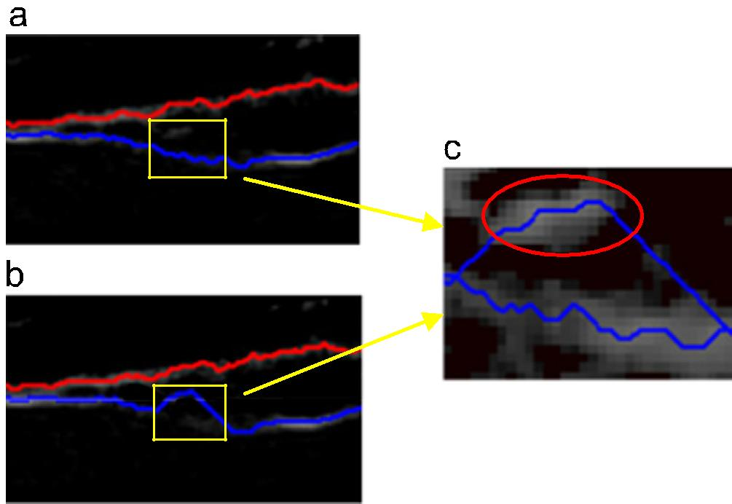

Fig. 1. (a) and (b) Contour extraction results in two adjacent frames. The noisy pixels marked in the red ellipse of (c), which is part of frame i þ 1, causes the inconsistent extraction along the time axis. (For interpretation of the references to color in this figure caption, the reader is referred to the web version of this article.)
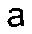
the problem of temporally consistent contour extraction in an image sequence.

The need of detecting temporally consistent contours in a global manner has also be recognized in [24]. However, the authors stated “Detecting boundaries in an image sequence can be viewed as detecting a surface in 3D-space. The problem is that, for dynamic programming, there exists no general extension to 3D that is guaranteed to find the optimal surface”. Obviously, they were not aware of the fact that the optimal surface detection algorithm from [23] is exactly a 3D extension of the 2D dynamic programming for contour detection (although being based on two different algorithmic paradigms).

In addition to the temporal consistency, the optimal surface search approach has another advantage of being able to deal with individual strongly distorted images within a sequence. Applying some contour detection algorithm to each frame separately will certainly have trouble with these images. The optimization scheme within the 3D volume will help “smooth out” such discontinuous data. This idea has been adopted, for instance in [22]. But the method based on dynamic programming in that paper can only deliver a suboptimal solution.

However, the graph search algorithm becomes computationally demanding for long image sequences. In particular, simultaneously detecting multiple contours leads to the problem of simulta-neously detecting multiple surfaces in a 3D volume, which has a substantially increased computational complexity (see Section 3 for a complexity discussion). In practice, this algorithmic variant is highly required because of the numerous instances of multi-contour, or more specifically, multi-coupled contours (to be defined in Section 2) [5,25,26].

In this paper we study approximation schemes for the optimal surface detection algorithm from [23] in the context of temporally consistent contour extraction in image sequences in order to reduce the computation cost. Instead of processing all images in a 3D volume, the sequence is partitioned into blocks, each being processed by the algorithm from [23]. Three strategies are pro-posed to ensure smooth transition from one block to another to preserve the temporary consistency. The effectiveness and effi-ciency of our approach is demonstrated on two sources of data: simulated data and ultrasound image sequences (for arterial wall detection).

 | 8000 |  |  |  |  |  |  | 8000
numbers | 6000 |  |  |  |  |  | numbers | 6000
numbers | 4000 |  |  |  |  |  | numbers | 4000
Pixel | 2000 |  |  |  |  |  | Pixel | 2000
 | 0 | 2 | 3 | 4 | 5 | 6 |  | 0 | 2 | 3 | 4 | 5 | 6
 | 1 |  |  |  |  |  |  | 1
 | Adjacent Step Value (Unit: pixels) |  |  |  |  |  |  | Adjacent Step Value (Unit: pixels)
 | 8000 |  |  |  |  |  |  | 8000
numbers | 6000 |  |  |  |  |  | numbers | 6000
numbers | 4000 |  |  |  |  |  | numbers | 4000
Pixel | 2000 |  |  |  |  |  | Pixel | 2000
 | 0 | 2 | 3 | 4 | 5 | 6 |  | 0 | 2 | 3 | 4 | 5 | 6
 | 1 |  |  |  |  |  |  | 1
 | Adjacent Step Value (Unit: pixels) |  |  |  |  |  |  | Adjacent Step Value (Unit: pixels)
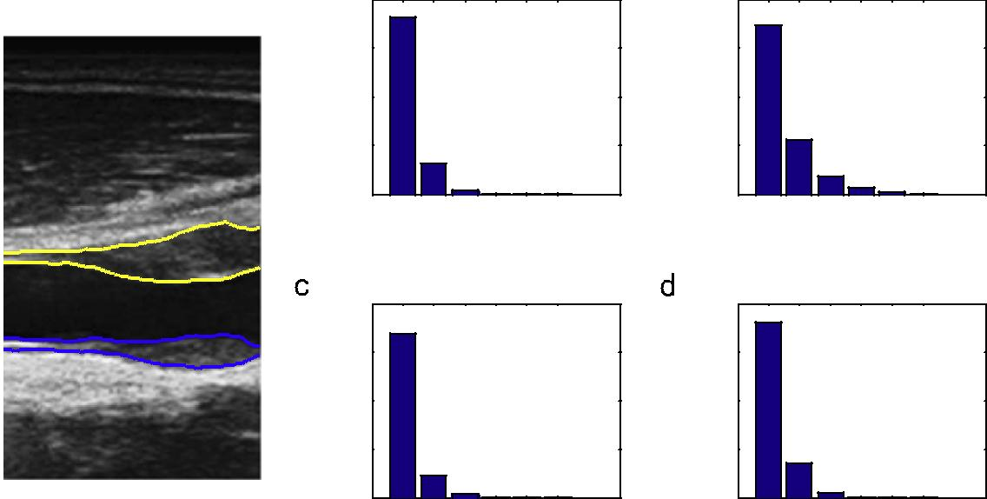

Fig. 2. Arterial walls labeled by experienced physician; statistics of frame-to-frame differences in y.

Z. Wu et al. / Neurocomputing 152 (2015) 127–138 | 129

The remainder of this paper is structured as follows. Section 2 formally defines the task considered in this work. Its direct exact solution is described in Section 3, followed by the block-wise variants in Section 4. Our experimental results are reported in Section 5. Finally, Section 6 concludes this paper.

2. Problem formulation

The general class of 2D contours under consideration is defined as follows.

Definition 1. For a given X _ Y image, a consecutive contour p₀p₁; …; p_{X} _ ₁ is a sequence of points drawn from left to right, where p_{i}, i ¼ 0; …; X _ 1, is a point in the i-th column. The points p_{i} and p_{i} _{þ} ₁, i ¼ 0; …; X _ 2, in two adjacent columns are continuous, i.e., their difference in y is bounded by some predefined δ_{x}.

This class of contours, directly or indirectly, is often met in practice. In medical image analysis, for example, the artery boundary, the spinal contour, etc. belong to this class. Such contours build the basis of seam carving for content-aware image resizing [27]. In addition, Definition 1 can be extended to deal with closed contours based on a polar transformation [5].

In practice many problem instances appear as that of multi-coupled consecutive contours. The example shown in Fig. 2 is such a contour corresponding to the artery wall in ultrasound images. For both the near wall and the far wall (as illustrated in Fig. 8), the intima and adventitia are coupled. The following definition for-malizes this contour category. For the sake of simplicity, we define the two-coupled consecutive contour only. More than two coupled consecutive contours can be defined in a similar way.

Definition 2. For a given X _ Y image, a two-coupled consecutive contour consists of two consecutive contours C₁ ¼ p₀p₁; …; p_{X} _ ₁ and C₂ ¼ q₀q₁; …; q_{X} _ ₁ (Definition 1). The term coupled means that the distance between any two points in the same column satisfies 0oδ_{l} rjy_{pi} _y_{qi} j rδ_{u}, see Fig. 3.

Given T frames from a sequence, a 3D image volume can be formed by stacking them together along the time dimension, see Fig. 4(a). Then, the task considered in this work is to extract either a consecutive or a multi-coupled consecutive contour in each frame subject to Definition 2 so that all contours satisfy a temporal continuity constraint, i.e. in each column the frame-to-frame difference in y is bounded by some predefined δ_{t}.

More specifically, each pixel at position ðx ¼ i; y ¼ jÞ in frame t is associated with a weight (cost) w_{i;j;t} , representing some measure of preference that the corresponding pixel belongs to the contour of interest. Then, contour detection in a single frame is a problem of finding a contour based on Definition 1 which minimizes the sum of weights. Accordingly, the temporal contour extraction problem is to find T2D contours subject to the continuity con-straint along the time axis such that the overall sum of weights is minimized. Formally, this problem can be stated as follows:

min | X _ 1 Y _ 1 T _ 1
min | ∑ ∑ ∑ | w | i;j;t _ | x | i;j;t
^{x}i;j;t | ∑ ∑ ∑ |  | i;j;t _ |  | i;j;t
 | i ¼ 0 j ¼ 0 t ¼ 0
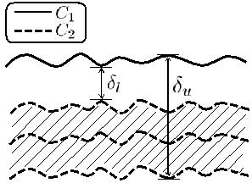

Fig. 3. Illustration of two-coupled consecutive contour.

y

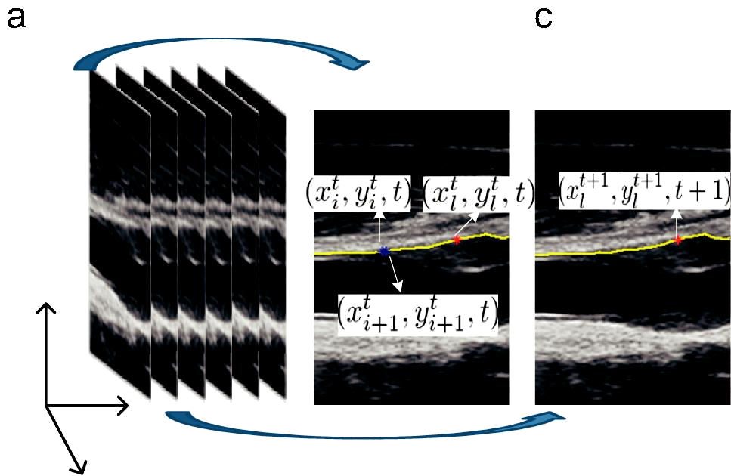

t

x

Fig. 4. (a) 3D volume formed by an image sequence. (b) and (c) are two adjacent frames at time t and t þ 1. Spatial smoothness constraint: jy^{t}_{iþ} ₁ _ y^{t}_{i} jrδ_{x} . Temporal consistency constraint: jy^{t}_{l} ^{þ} ¹ _ y^{t}_{l} jrδ_{t} .

⁸x_{i;j;t} ¼ 0; 1
>
>
Y _ 1
 | > | ∑ ^{x}i;j;t ¹
 | > |  |  |  | ¼
 | > |  | 0 |  | ¼
 | > j |  | 0
 | > | ¼
 | > | ¼
 | > |  |  |  | δ_{x}
 | > |  |  |  | δ_{x}
 | >
s:t: | > |  |  |  | ∏ x_{i} |  |  |  |  |  |  | 1 | 0 | 1
 | <x_{i;j;t} |  |  |  |  |  |  | 1 j |  | k t |  | 1 | 0 | ð Þ
 | > |  |  | _ k ¼ _ δ_{x} ^{ð} |  |  | þ |  | ; | þ ; | _ Þ ¼
 | > |  |  |  | δ _{t}
 | > |  |  |  | δ _{t}
 | >
 | >
 | > |  |  |  | ∏ ^{x}i;j |  |  |  | l;t | ₁ 1 0
 | >x_{i;j;t} |  |  |  |  |  |  |  | l;t
 | > |  |  | _ |  | ð |  | þ |  | þ _ |  | Þ ¼
 | > |  |  | _ |  | ð |  | þ |  |  |  | Þ ¼
>
>
>
- l ¼ _ δ_{t}

The first constraint labels a pixel to be on the contour or not. The second one guarantees one single contour pixel in each column. Finally, the last two constraints express the spatial smoothness and temporal consistency constraint, respectively. Note that the index j þ k and j þl in these constraints must be bounded to the range of valid index values. But for notational simplicity we do not present the formally more rigorous formulation.

Multi-coupled consecutive contour detection in a single frame is the problem of finding a contour based on Definition 2 which minimizes the sum of weights. Consequently, the temporal con-sistent contour extraction problem is to find multi-coupled con-secutive surfaces from the 3D volume subject to the continuity constraint along the time axis which minimize the sum of weights. Formally, this problem for the special case M¼ 2 can be stated as follows:

min | M ¼ 2 X _ 1 Y _ 1 T _ 1
min | ∑ ∑ ∑ ∑ |  |  |  |  |  |  |  |  |  |  | w |  |  | i;j;t _ | x | i;j;t;m
^{x}i;j;t |  |  |  |  |  |  |  |  |  |  |  |  |  |  | i;j;t _ |  | i;j;t;m
 | m ¼ 1 i ¼ 0 j ¼ 0 t ¼ 0
 | ⁸x_{i;j;t;m} ¼ 0; 1; |  |  |  |  |  |  |  |  |  |  |  |  |  |  |  |  |  |  |  | m ¼ 1; 2
 | >Y _ 1
 | >
 | > | ∑ x |  |  |  |  |  |  |  |  | 1; |  |  |  |  |  |  |  |  |  | m |  |  | 1; 2
 | > |  |  |  | i;j;t;m
 | > |  |  | 0 |  |  |  |  | ¼ |  |  |  |  |  |  |  |  |  |  |  |  | ¼
 | > _{j} |  |  | 0
 | > | ¼
 | >
 | >
 | >
 | >_{δ} |  | l r |  |  | j |  |  | j | 2 | r |  | δ |  | u; |  |  |  |  |  | x |  | ;t | ;1 |  | x | i;j₂ | ;t;2 |  | 1
 | > |  |  |  |  | 1 |  |  |  | 2 |  |  |  |  | u; |  |  |  |  |  | i;j₁ |  | ;t | ;1 |  |  | i;j₂ | ;t;2
 | > |  |  |  | j |  | _ |  |  | j |  |  |  |  |  |  |  |  |  |  |  |  |  |  | _ |  |  |  | ¼
 | > |  |  |  | j |  |  |  |  | j |  |  |  |  |  |  |  |  |  |  |  |  |  |  | _ |  |  |  | ¼
s:t: | > |  |  |  |  |  |  |  | δ_{x} |  |  |  |  |  |  |  |  |  |  |  |  |  |  |  |  |  |  |  |  | 2
 | < |  |  |  |  |  |  |  |  |  |  |  |  |  |  |  |  |  |  |  |  |  |  |  |  |  |  |  |  | ð Þ
 | ^{>x}i;j;t;m _ ∏ ^{ðx}i þ 1;j þ k;t;m _ ^{1Þ ¼} ⁰
 | > |  |  |  |  |  | k | ¼ _ |  |  | δ_{x}
 | >
 | >
 | > |  |  |  |  |  |  |  | δ _{t}
 | >
 | >
 | >
 | >x |  |  |  |  |  |  | ∏ |  |  |  | x |  | i;j l;t 1;m |  |  |  | 1 |  |  | 0
 | > i;j;t;m
 | > |  |  |  |  | _ |  |  |  |  | ð |  |  |  | þ | þ_ |  |  |  | Þ ¼
 | > |  |  |  |  | _ |  |  |  |  | ð |  |  |  | þ |  |  |  |  | Þ ¼
 | >
 | >
 | > |  |  |  |  |  | l ¼ _ δ_{t}
 | :

The third constraints means the coupled constraint from Definition 2. The other constraints have the same meaning as for the case of single contour detection.

Designing appropriate cost functions is of paramount impor-tance and must be carefully considered for particular applications. Some general discussions about this issue can be found in [6,23].

130 Z. Wu et al. / Neurocomputing 152 (2015) 127–138

3. Exact optimal solution

Without the constraints, both the problems in (1) and in (2) are actually a zero-order MRF [28]:

EðXÞ ¼ ∑ Gðv; X_{v}Þ ð3Þ

v AV

where X is a labeling function. The constrained problems (1) and

(2) considered in this work can be solved by the algorithm from [29]. Later, [23] presents the full details of this method (e.g. how to embed the constraints into the procedure of graph construction) and also extends the method for the case of multi-surface extrac-tion. The optimal surface extraction algorithm [23] has been successfully applied to solve a variety of problems, for instance, medical image segmentation [30], video/image resizing [31], and median surface computation [32]. In this work we use it to solve our optimal surface extraction problem.

Given this observation, a straightforward solution to temporally consistent contour detection is to apply the graph-theoretic algorithm there. In the following we only give a brief overview of this algorithm and the interested readers are referred to [23] for more details. Given a 3D volume w_{i;j;t} with associated weights, it non-trivially constructs a graph, which transforms the surface segmentation problem into computing a maximum or minimum closure in a node-weighed digraph. A maximum closure C in a digraph is a subset of nodes such that all successors of any nodes in C are also contained in C. The cost of C is the total cost of the nodes C. The maximum closure problem is then to search for a closure with the maximum weight, which can be solved in polynomial time by computing a minimum s _ t cut in a derived arc-weighted digraph [33,34]. Through a modification of the graph construction, the method can be used to extract coupled surfaces [23].

The computational complexity of this exact solution depends on the size of the search graph (n: number of vertices ¼ X _ Y _ T, m: number of edges). The popular minimum-cut algorithm from [33] has a worst-case time complexity of Oðmn²jC jÞ, where jCj represents the cost of the minimum cut solution. Theoretically speaking, this bound in [33] is worse than the complexity of other standard algorithms [34,35]. For instance, the algorithm from [34] has a time complexity Oðmn log nÞ. Although being theoretically advantageous, its practical performance remains unclear. An experimental comparison shows that on typical problem instances in computer vision, the algorithm from [33] significantly outper-forms standard algorithms. Thus, we resort to this algorithm in our work.
When handling multiple (K) surfaces, the number of vertices, n, of the graph is duplicated K times and the number of edges, m, is duplicated accordingly, see [23] for more details. Then, the overall complexity becomes OðK³ _ mn² jCjÞ. This causes a severe growth of the complexity with increasing number of surfaces to be extracted simultaneously.

The number of edges, m, is linear to n by a small factor because each pixel has a few spatial and temporal neighbors only. There-fore, the two versions of optimal graph search algorithm (single or

multiple surfaces) have the computational complexity of Oðn³jCjÞ ¼ OðX³Y³T³jCjÞ and OðK³ _ n³jCjÞ ¼ OðK³ _ X³Y³T³jCjÞ, which cubi-
cally increases with the number of frames, T.

4. Block-wise approximate solution strategies

Although the global optimal solution can be determined by the above method, its direct use to solve the tasks described in the last section is not feasible in practice for large data and multiple surface extraction due to the severely increasing complexity. The following two reasons make the situation even worse. First, for a sequence with T frames the computational complexity signifi-cantly increases with T, causing both space and time problem. For typical image sizes in medical image analysis, for instance, a large number of images may cause memory overflow. Even if sufficient memory can be allocated, the computation time may become too long to be useful for real applications. Fig. 5(a) shows how the computation time increases with the number of frames (additional related experimental results can be found in Section 5. Secondly, the searching strategy during the maximum flow needs all the possible path flows to be determined from the source to the sink node [36]. If the image has many noise pixels, it will cause a potentially increasing number of paths and thus make the search-ing time increasing. Fig. 5(b) is such an example, where we fixed 20 frames to search for the contour. Then, we added different levels of noise to these frames. The searching time increased severely as the noise becomes severe.

To reduce the complexity, we can partition the sequence into blocks and perform a block-by-block contour detection. A (rela-tively small) block size will dramatically decrease the computation cost. This block-based approach, however, poses two important issues to be considered: (1) how to preserve the temporal consistency among blocks? (2) how to ensure an approximately optimal solution? Therefore, suitable strategies for consecutive transition from one block to another need to be developed. In the following three strategies are proposed: Block Average (BA), Block

 | 14000 |  |  |  |  |  |  |  | 8
 | 12000 |  |  |  |  |  |  |  | 7
 | 10000 |  |  |  |  |  |  | (20 frames; unit: second) | 6
Time (unit: second) | 10000 |  |  |  |  |  |  | (20 frames; unit: second)
Time (unit: second) |  |  |  |  |  |  |  | (20 frames; unit: second) | 5
Time (unit: second) | 8000 |  |  |  |  |  |  | (20 frames; unit: second)
Time (unit: second) |  |  |  |  |  |  |  | (20 frames; unit: second) | 4
Time (unit: second) | 6000 |  |  |  |  |  |  | (20 frames; unit: second) | 3
Time (unit: second) | 4000 |  |  |  |  |  |  | (20 frames; unit: second)
 | 4000 |  |  |  |  |  |  | Time | 2
 | 2000 |  |  |  |  |  |  |  | 1
 | 0 | 45 | 85 | 125 | 165 | 205 | 251 |  | 0 | 8.5 | 7.8 | 7.2 | 6.7 | 6.2
 | 5 |  |  |  |  |  |  |  | 16.9 13.4 11.6 10.3 9.3
 |  |  | Frame Number |  |  |  |  |  | Image Noise Level - PSNR
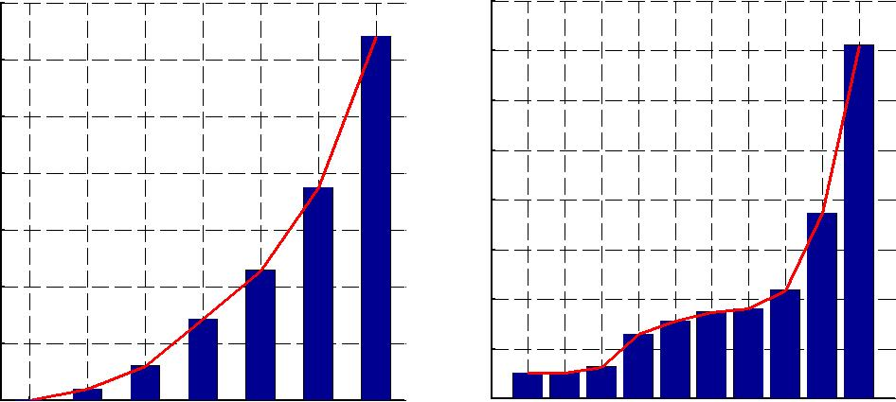

Fig. 5. Computation time dependent of (a) number of frames and (b) noise level (20 frames).

Z. Wu et al. / Neurocomputing 152 (2015) 127–138 | 131

Initialization (BI), and Block Consecutive (BC), as demonstrated in Fig. 6.

Block Average (BA): The first idea is to overlap several frames between two adjacent blocks and to combine the solutions for each overlapping parts, see Fig. 6(a). It consists of three steps:

- Partition the image sequence into blocks with k ðkZ1Þ over-lapping frames between adjacent blocks.
- Apply the optimal surface extraction algorithm [23] to each block and get the optimal solution of each block.

- Combine the solutions of the overlapping frames from two adjacent blocks. This can be simply done for example by taking the average of two contour pixels.

The advantage of this strategy is that the solution is optimal for each separated block. However, the temporal consistency may be weakly violated in some transition areas.

Block Initialization (BI): In order to strongly preserve the temporal consistency, we can use the following strategy. Only one frame from adjacent blocks is overlapping, i.e., the last frame of block B_{i} is the first frame of the next block B_{i} _{þ} ₁. At the very beginning, the optimal surface extraction algorithm [23] is applied
to the first block B₁. Then, using the extracted contour result in the last frame of B₁ as a fix start point for the optimization of the second block B₂. In this case only those pixels on this contour are needed for constructing the first layer (corresponding to the first frame) of the search graph when searching for the optimal solution in B₂. The enforced initialization of B₂ complexity sub-stantially reduces the search complexity. This step is repeated for all subsequent blocks, see Fig. 6(b).

Using this strategy, the temporal consistency is obviously fully guaranteed. However, this strategy also has one potential draw-back. The extracted contour for B_{i} is guaranteed to be optimal for this single block (subject to the initialization), but not necessarily with respect to the whole sequence of all T images. Enforcing the extracted contour from the last frame of B_{i} to be the solution of the first frame of B_{i} _{þ} ₁ will propagate any potential inaccuracy to this and the following frames.

Block Consecutive (BC): The third strategy combines the pre-vious two strategy. Here, several frames are overlapping between adjacent blocks. First, the optimal surface extraction algorithm [23] is applied to each block. Then, we pick the extraction results of two frames, i.e., the first frame of the overlapping part from the first block and the last frame of the overlapping part from the

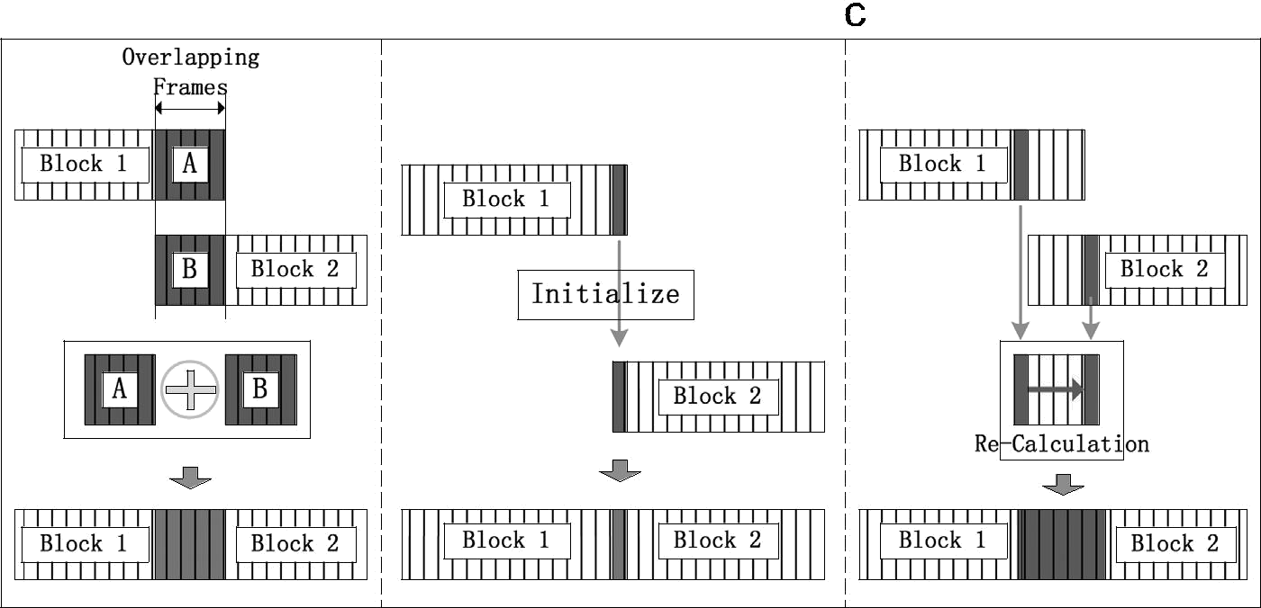

Fig. 6. Three strategies of block partition for approximate solution (a) Block Average, (b) Block Initialization and (c) Block Conseutive.
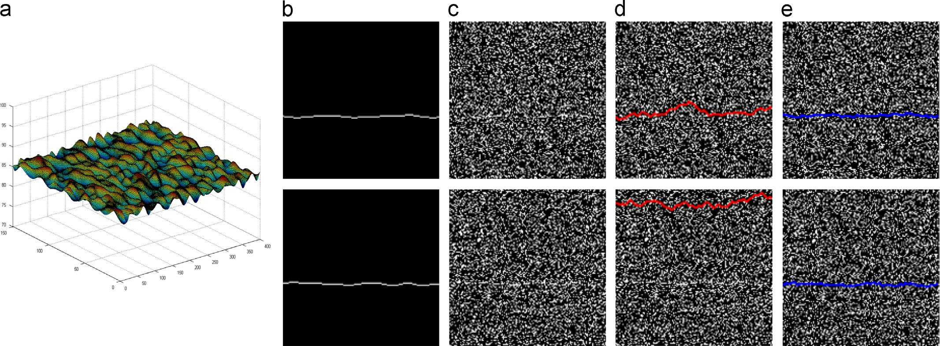

Fig. 7. Simulated data generated to test our approach. (a) The generated consecutive surface, each slice is a contour according to Definition 1. (b) The contour in one frame (slice) from the surface in (a) along the x-axis. (c) The image after adding noise (top: PSNR¼ 6.11 db; bottom: PSNR¼ 5.94 db). (d) 2D dynamic programming [6] extraction result. (e) Our result.

132 Z. Wu et al. / Neurocomputing 152 (2015) 127–138

second block, and recalculate the overlapping part by enforcing the surface passing the selected two frames' results. See Fig. 6(c) for an illustration.

This strategy also fully guarantees the temporary consistency. Thus, it reduces the risk of accumulating error, at the price of slightly higher computation cost because of the recalculation for the overlapping part.

In summary, the BI and BC strategies fully guarantee the temporary consistency, while BA may slightly violate the consis-tency in some block transition areas. In the experiment section, we will compare the three strategies in various aspects and try to make a recommendation for the choice of the approximation strategy.

When working with the three strategies we partition a sequence of

T frames into N_{b} ¼ T=B blocks of B frames each. Then, the computa-tional complexity amounts to OðX³Y³B³ _ jC_{b}j _ ðT=BÞÞ ¼ OðX ³Y³B²T _ jC_{b}jÞ for single surface detection, where jC_{b}j represents the average

cost of the minimum cut solution for each block. For multiple surface detection the same consideration results in the computational com-plexity Oð K³ _ X³Y³B²T _ jC_{b}jÞ. As discussed in Section 3, the complex-ity of the global graph search algorithm cubically increases with the number of frames, T. In our block-wise approximation strategies the increase rate is linear to T only (the block size B is considered as a constant). Specially for long sequences the global graph search thus becomes soon no more practicable. As will be demonstrated in the next section, our approximation solution provides a detection accuracy that is very much comparable with that obtained from the global graph search. Given the high throughput of today's devices, one is often faced with sequences of hundreds (and even larger number) of frames. In practice our approach thus can serve as a good alternative to the global graph search.

If only considering the computational complexity, the smaller the block the better, i.e. lower the complexity, is. However, a too small block size will decrease the overall robustness of our approximation approach because the temporary consistency con-straint needs some minimal size of context to be satisfied. A good balance of efficiency and accuracy thus must be realized by selecting suitable block size. We will explore this parameter in Section 5.3.

The block-wise approximate strategies presented above may have another benefit. It may be quite awkward for a user to obtain the segmentation results until all the data become available. Our approach is of progressive nature and can provide instant detec-tion solutions with a quality, which is virtually equal to that of global optimization over the entire image sequence as demon-strated in the next section.

As a final remark it is important to emphasize that the intention of this work is not to present an improved algorithm for surface detection in 3D volumes (contour detection in image sequences). Instead, given any such algorithm (the optimal graph search algorithm from [23] used in this work is one example only), our approach gives a practical approach to dealing with long sequences with high accuracy and computational efficiency. Let
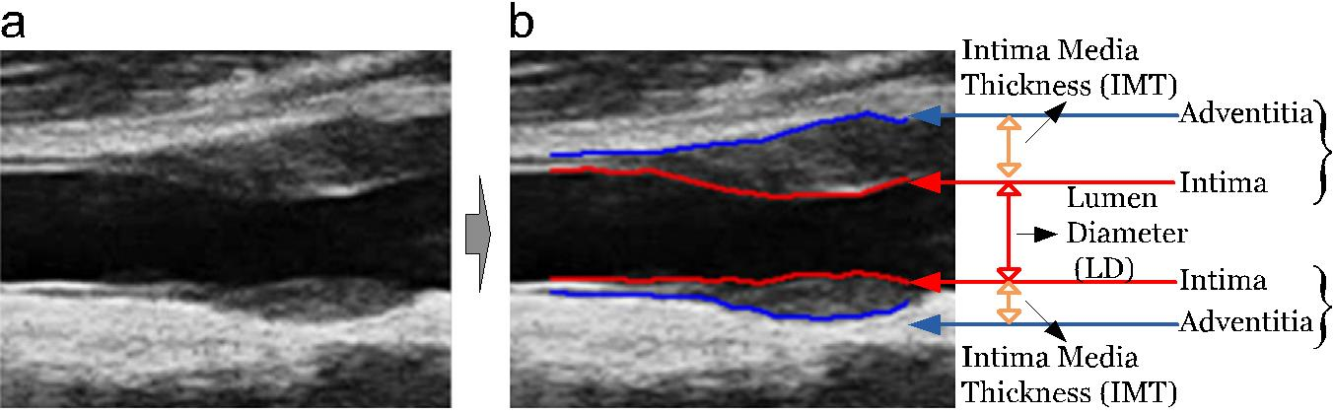
the computational complexity of such an algorithm for surface detection in 3D volumes be Oðf ðXYÞ _ gðTÞÞ. For example, in the case of the algorithm from [23] f ðXYÞ ¼ X³Y³ and f ðTÞ ¼ T³. For the sake of discussion simplicity the complexity function is assumed to be decomposable into two terms f(XY) and g(T). In addition, other terms like jCj in [23] are ignored. Our block-wise approximation approach is applicable to any such algorithm for surface detection in 3D volumes and has the complexity Oðf ðXYÞ _ gðBÞ _ ðT=BÞÞ. Requiring this term smaller than Oðf ðXYÞ _ gðTÞÞ leads to

gð_{B}BÞ _{o}gð_{T}TÞ

This requirement is clearly satisfied if gðÞ is asymptotically larger than the linear function, e.g. gðÞ is cubic for the global graph search algorithm [23]. In all such situations our approach is beneficial in practice.

5. Experimental results

In this section we present a series of experimental results to demonstrate the usefulness of the block-wise approximation solution strategies. Section 5.1 describes the simulated and real data used in our experiments. The experiment design is presented in Section 5.2. We study the parameters of our approach in Section 5.3. Based on the optimized parameter values we then explore the performance of the block-wise approximation strategies in terms of optimality (Section 5.4), robustness in case of weak and broken consistency (Section 5.5), and efficiency (Section 5.6). Finally, we compare the performance of our approach with a recent related method (Section 5.7) and conclude with some discussions (Section 5.8).

5.1. Experiment scenarios

The effectiveness and efficiency of our approach is exemplarily demonstrated in two scenarios:

- Simulated data with heavy added noise.

- Ultrasound image sequences (arterial wall detection).
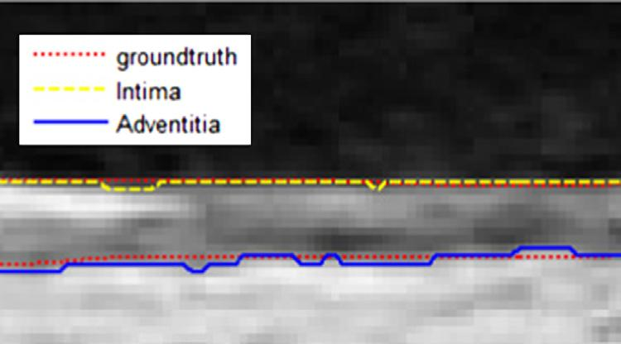

Fig. 9. Example of far wall with ground truth and extracted artery.

Fig. 8. Illustration of the intima (Int.) and adventitia (Adv.) for near wall and far wall in artery wall ultrasound image. (For interpretation of the references to color in this figure caption, the reader is referred to the web version of this article.)

 |  |  |  |  |  | Z. Wu et al. / Neurocomputing 152 (2015) 127–138 |  |  |  |  |  |  |  |  |  |  | 133
(unit:pixel) | 0.02 | N_{B}=15 |  |  |  | (unit:pixel) | 0.01 | N_{B}=15 |  |  |  | (unit:pixel) |  | N_{B}=15
(unit:pixel) |  | N_{B}=15 |  |  |  | (unit:pixel) |  | N_{B}=15 |  |  |  | (unit:pixel) | 0.08 | N_{B}=15
(unit:pixel) |  | N_{B}=20 |  |  |  | (unit:pixel) | 0.008 | N_{B}=20 |  |  |  | (unit:pixel) | 0.07 | N_{B}=20
Difference | 0.015 | N_{B}=20 |  |  |  | Difference | 0.008 | N_{B}=20 |  |  |  | Difference | 0.07 | N_{B}=20
Difference | 0.015 | N_{B}=30 |  |  |  | Difference |  | N_{B}=30 |  |  |  | Difference |  | N_{B}=30
Difference |  | N_{B}=30 |  |  |  | Difference |  | N_{B}=30 |  |  |  | Difference | 0.06 | N_{B}=30
Difference | 0.01 | N_{B}=50 |  |  |  | Difference | 0.006 | N_{B}=50 |  |  |  | Difference | 0.05 | N_{B}=50
blockwise | 0.01 |  |  |  |  | blockwise |  |  |  |  |  | blockwise | 0.04
blockwise |  |  |  |  |  | blockwise | 0.004 |  |  |  |  | blockwise | 0.04
blockwise |  |  |  |  |  | blockwise | 0.004 |  |  |  |  | blockwise | 0.03
blockwise | 0.005 |  |  |  |  | blockwise | 0.002 |  |  |  |  | blockwise | 0.02
and |  |  |  |  |  | and | 0.002 |  |  |  |  | and | 0.02
and |  |  |  |  |  | and |  |  |  |  |  | and | 0.01
Global |  |  |  |  |  | Global |  |  |  |  |  | Global | 0.01
Global | 0 |  |  |  |  | Global | 0 |  |  |  |  | Global | 0
Global | 0 | 100 | 200 | 300 | 400 | Global | 0 | 100 | 200 | 300 | 400 | Global | 0 | 100 | 200 | 300 | 400
 |  | Sequence Index |  |  |  |  |  | Sequence Index |  |  |  |  |  | Sequence Index
 | 120 | N_{B}=15 |  |  |  |  | 500 | N_{B}=15 |  |  |  |  | 500 | N_{B}=15
 | 100 | N_{B}=15 |  |  |  |  |  | N_{B}=15 |  |  |  |  |  | N_{B}=15
(unit:second) | 100 | N_{B}=20 |  |  |  | (unit:second) | 400 | N_{B}=20 |  |  |  | (unit:second) | 400 | N_{B}=20
(unit:second) | 80 | N_{B}=30 |  |  |  | (unit:second) |  | N_{B}=30 |  |  |  | (unit:second) |  | N_{B}=30
(unit:second) |  | N_{B}=50 |  |  |  | (unit:second) | 300 | N_{B}=50 |  |  |  | (unit:second) | 300 | N_{B}=50
(unit:second) | 60 |  |  |  |  | (unit:second) |  |  |  |  |  | (unit:second)
(unit:second) |  |  |  |  |  | (unit:second) | 200 |  |  |  |  | (unit:second) | 200
Time | 40 |  |  |  |  | Time | 200 |  |  |  |  | Time | 200
Time |  |  |  |  |  | Time | 100 |  |  |  |  | Time | 100
 | 20 |  |  |  |  |  | 100 |  |  |  |  |  | 100
 | 0 | 100 | 200 | 300 | 400 |  | 0 | 100 | 200 | 300 | 400 |  | 0 | 100 | 200 | 300 | 400
 | 0 |  |  |  |  |  | 0 |  |  |  |  |  | 0
 |  | Sequence Index |  |  |  |  |  | Sequence Index |  |  |  |  |  | Sequence Index
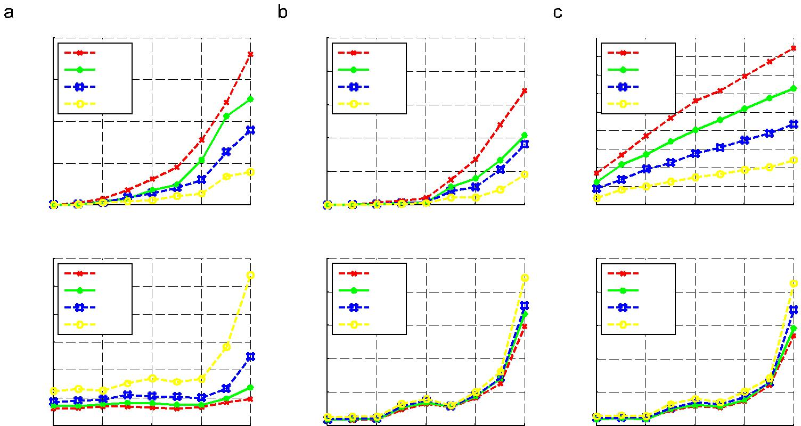
Fig. 10. Effect of block size N_{B} for all three strategies (a1) BI deviation with different block size, (a2) BI time cost with different block size, (b1) BA deviation with different block size, (b2) BA time cost with different block size, (c1) BC deviation with different block size, (c2) BC time cost with different block size.
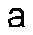
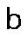

(unit:pixel) | 0.01 | N_{O}=5 |  |  |  | (unit:pixel)
(unit:pixel) |  | N_{O}=5 |  |  |  | (unit:pixel) | 0.08
Difference | 0.008 | N_{O}=10 |  |  |  | Difference | 0.06
Difference | 0.006 |  |  |  |  | Difference | 0.06
blockwise | 0.004 |  |  |  |  | blockwise | 0.04
blockwise | 0.002 |  |  |  |  | blockwise | 0.02
and | 0 |  |  |  |  | and | 0
Global | 0 | 100 | 200 | 300 | 400 | Global | 0
Global | 0
Global |  | Sequence Index |  |  |  | Global
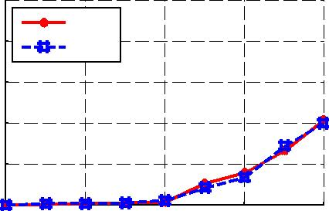

 | N_{O}=5
 | N_{O}=10
0 | 100 | 200 | 300 | 400
 |  | Sequence Index
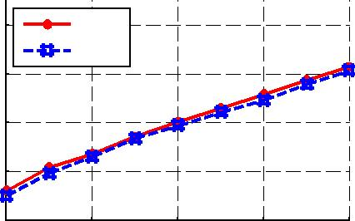

Time (unit:second)

500
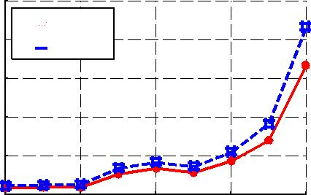
N_{O}=5 400 N_{O}=10

300

200

100

0

0 | 100 | 200 | 300 | 400
 |  | Sequence Index

 | 500 | N_{O}=5
 | 400 | N_{O}=5
(unit:second) | 400 | N_{O}=10
(unit:second) | 300
(unit:second) | 200
Time | 200
Time | 100
 | 0 | 100 | 200 | 300 | 400
 | 0
 |  |  | Sequence Index
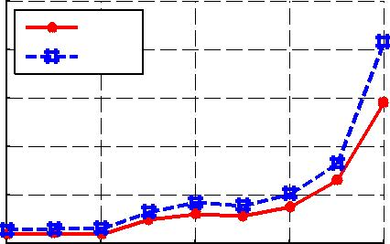

Fig. 11. Effect of overlapping size N_{O} for strategies BA and BC. (a1) BA deviation with different overlapped size, (a2) BA time cost with different overlapped size, (b1) BC deviation with different overlapped size and (b2) BC time cost with different overlapped size.

Two reasons motivate us to include simulated data for testing. It is hardly possible to obtain massive real data with ground truth manually specified by experienced experts (physicians). Simulated data help us overcome this problem. Moreover, different noise levels can be generated in order to thoroughly characterize the noise effect.

In our two experiment scenarios, the simulated data are related to single surface detection while the arterial wall detection is a task of two-coupled surface (after sticking along the time axes) detection.

Simulated data: We generated 400 sequences, each with 400 images. Each image has one single contour. In order to satisfy the

f1-N_{B} þ N_{O}g; fN_{B} þ 1-2 _ N_{B} þN_{O}g; f2 _ N_{B} þN_{O}-3 _ N_{B} þ 2_
134 Z. Wu et al. / Neurocomputing 152 (2015) 127–138

temporal consistency along the time axis, we first generated the data in the form of continuous 3D surfaces, see Fig. 7. We then added noise of different levels to simulate practical images.

Ultrasound image sequences: An arteria has a near wall and a far wall, as illustrated in Fig. 2 (left) in yellow and blue, respectively, and Fig. 8. Each wall is characterized by two layers called intima (Int.) and adventitia (Adven.). Quantitative measures based on these features have showed a strong relationship with some diseases [37,38], which motivates to precisely extract the intima and adventitia. Six ultrasound arteria image sequences were used in our experiments and they all have ground truth contours labeled by experienced physicians, see an example in Fig. 9.

The images were preprocessed for denoising and cost compu-tation. The details are not important for our discussion here and it suffices to say that the cost measures the preference that the corresponding pixel belongs to the contour of interest; interested readers are referred to [6]. We demonstrate the experimental results of detecting the intima and adventitia of both near wall and far wall. The processing of the near and far wall was performed in two separate steps, but the intima and the adventitia were simultaneously extracted.

5.2. Experiment design

For both the simulated and real ultrasound data, we considered the following four evaluation scenarios. The block size is denoted by N_{B} and the number of overlapping frames by N_{O}.

- Each image sequence is globally processed using the optimal surface extraction algorithm [23] sketched in Section 3. This method will deliver the globally optimal solution.

- Using the Block Average (BA) strategy: The partitioning scheme is f1-N_{B} þN_{O}g; fN_{B} þ 1-2 _ N_{B} þ N_{O}g; f2 _ N_{B} þN_{O}-3 _ N_{B} þ2 _ N_{O}g, etc.
- Using the Block Initialization (BI) strategy: The partitioning scheme
is f1-N_{B} þ1g; fN_{B} þ1-2 _ N_{B} þ1g; f2 _ N_{B} þ 1-3 _ N_{B} þ 2g, etc., with only one overlapping frame for adjacent blocks.

4. Using the Block Consecutive (BC) strategy: The partitioning

scheme is N_{O}g, etc.

Based on the simulated data with ground truth, we tested the influence of the two parameters (block size N_{B} and number of overlapping frames N_{O}) on the final extraction result. This study allows us to fix the parameter values for the actual performance evaluation. For both simulated and real data, we conducted a comparison between the globally optimal and the block-wise

pixel) | 0.08
pixel) |  | BI
pixel) | 0.07 | BA
(unit: | 0.07 | BC
(unit: | 0.06
and blockwise | 0.06
and blockwise | 0.05
and blockwise | 0.04
global | 0.04
global | 0.03
between | 0.03
between | 0.02
Difference | 0.01
Difference | 0
 | 0 | 50 | 100 | 150 | 200 | 250 | 300 | 350 | 400
 | 0
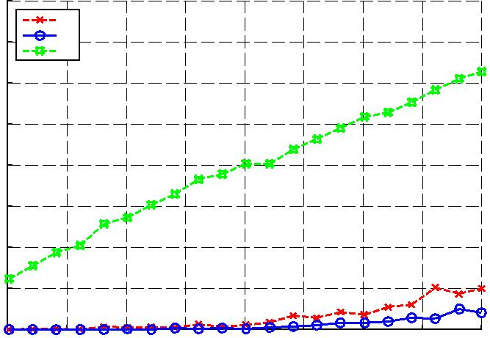
Sequence Index (noise level increases as the index increases)

Fig. 12. Simulated data: comparison between global method and approximate strategies.

result in terms of optimality (deviation between the globally optimal and the block-wise result) and efficiency (difference in computation time). The results are reported in the following subsections.

5.3. Block size and overlapping size

The extraction performance certainly depends on the two parameters block size N_{B} and overlapping size N_{O}. We

Table 1

Real ultrasound data: comparison between global method and approximate strategies (unit: pixels).

Sequence | # |  | Near wall |  |  |  |  | Far wall
no. | frames
no. | frames |  | Int. |  | Adven. |  |  | Int. |  | Adven.
1 | 86 | BA | 0.0070.06 |  | 0.0070.00 |  | 0.00 |  | 70.01 | 0.0070.00
 |  | BI | 0.0070.00 |  | 0.0070.09 |  | 0.00 |  | 70.00 | 0.0070.00
 |  | BC | 0.02 | 70.15 | 0.02 | 70.16 | 0.03 |  | 70.19 | 0.03 | 70.17
2 | 86 | BA | 0.0070.00 |  | 0.0070.00 |  | 0.00 |  | 70.00 | 0.0070.00
 |  | BI | 0.0070.00 |  | 0.0070.02 |  | 0.00 |  | 70.00 | 0.0070.00
 |  | BC | 0.05 | 70.21 | 0.05 | 70.23 | 0.02 |  | 70.14 | 0.03 | 70.16
3 | 73 | BA | 0.0070.03 |  | 0.0070.00 |  | 0.00 |  | 70.00 | 0.0070.00
 |  | BI | 0.0070.00 |  | 0.0070.02 |  | 0.00 |  | 70.00 | 0.0070.00
 |  | BC | 0.02 | 70.15 | 0.0170.12 |  | 0.0170.12 |  |  | 0.0170.10
4 | 78 | BA | 0.0170.22 |  | 0.0070.00 |  | 0.00 |  | 70.00 | 0.0070.00
 |  | BI | 0.0070.00 |  | 0.02 | 70.33 | 0.00 |  | 70.00 | 0.0070.00
 |  | BC | 0.03 | 70.22 | 0.03 | 70.24 | 0.0170.12 |  |  | 0.02 | 70.17
5 | 111 | BA | 0.08 | 70.40 | 0.2471.05 |  | 0.0170.14 |  |  | 0.0170.14
 |  | BI | 0.0670.48 |  | 0.1070.73 |  | 0.02 |  | 70.25 | 0.02 | 70.26
 |  | BC | 0.28 | 70.85 | 0.36 | 71.23 | 0.1470.56 |  |  | 0.1470.54
6 | 251 | BA | 0.0070.02 |  | 0.0070.09 |  | 0.00 |  | 70.01 | 0.0070.00
 |  | BI | 0.0070.04 |  | 0.0070.01 |  | 0.00 |  | 70.00 | 0.0070.06
 |  | BC | 0.1270.50 |  | 0.1170.47 |  | 0.09 |  | 70.39 | 0.08 | 70.38

Table 2

Real ultrasound data: comparison with ground truth (unit: pixels).

Sequence | # |  | Near wall |  |  |  |  | Far wall
no. | frames
no. | frames |  | Int. |  | Adven. |  |  | Int. |  |  | Adven.
1 | 86 | Global | 0.5770.41 |  | 1.0070.70 |  |  | 0.55 | 70.41 | 0.67 |  | 70.47
 |  | BA | 0.5770.41 |  | 1.0070.70 |  |  | 0.55 | 70.41 |  | 0.67 | 70.47
 |  | BI | 0.5770.41 |  | 0.9970.70 |  |  | 0.55 | 70.41 |  | 0.67 | 70.47
 |  | BC | 0.5770.41 |  | 1.0070.71 |  |  | 0.5770.43 |  |  | 0.68 | 70.48
2 | 86 | Global | 0.4170.33 |  | 0.5770.54 |  |  | 0.58 | 70.41 | 0.43 |  | 70.32
 |  | BA | 0.4170.33 |  | 0.5770.54 |  |  | 0.58 | 70.41 |  | 0.43 | 70.32
 |  | BI | 0.4170.33 |  | 0.5770.54 |  |  | 0.58 | 70.41 |  | 0.43 | 70.32
 |  | BC | 0.4470.36 |  | 0.5970.57 |  |  | 0.59 | 70.42 |  | 0.45 | 70.35
3 | 73 | Global | 0.60 | 70.53 | 0.6070.41 |  |  | 0.53 | 70.38 |  | 0.42 | 70.29
 |  | BA | 0.60 | 70.53 | 0.6070.41 |  |  | 0.53 | 70.38 |  | 0.42 | 70.29
 |  | BI | 0.60 | 70.53 | 0.6070.41 |  |  | 0.53 | 70.38 |  | 0.42 | 70.29
 |  | BC | 0.60 | 70.52 | 0.6070.41 |  |  | 0.53 | 70.38 |  | 0.42 | 70.29
4 | 78 | Global | 1.30 72.31 |  | 1.59 | 71.41 |  | 0.7070.72 |  |  | 0.80 | 70.73
 |  | BA | 1.3172.32 |  | 1.59 | 71.41 |  | 0.7070.72 |  |  | 0.80 | 70.73
 |  | BI | 1.30 72.31 |  | 1.56 | 71.38 |  | 0.7070.72 |  |  | 0.80 | 70.73
 |  | BC | 1.29 72.29 |  | 1.58 | 71.41 |  | 0.7170.72 |  |  | 0.81 | 70.74
5 | 111 | Global | 0.87 | 70.93 | 1.36 | 71.35 |  | 0.79 | 70.82 |  | 0.83 | 70.75
 |  | BA | 0.88 | 70.95 | 1.36 | 71.28 |  | 0.80 | 70.84 |  | 0.84 | 70.77
 |  | BI | 0.92 | 71.03 | 1.43 | 71.48 |  | 0.80 | 70.85 |  | 0.85 | 70.79
 |  | BC | 0:89 70:89 |  | 1.30 | 71.18 |  | 0.83 | 70.83 |  | 0.87 | 70.79
6 | 251 | Global | 1.53 71.01 |  | — |  |  | 0.86 | 70.54 |  | —
 |  | BA | 1.53 71.01 |  | — |  |  | 0.86 | 70.54 |  | —
 |  | BI | 1.54 71.01 |  | — |  |  | 0.86 | 70.54 |  | —
 |  | BC | 1.56 71.05 |  | — |  |  | 0.88 | 70.57 |  | —

Z. Wu et al. / Neurocomputing 152 (2015) 127–138 | 135

experimented with various values on the simulated data. The results, the average deviation between the globally optimal and block-wise result over all 400 images of a sequence, for a fixed N_{O} ¼ 5 are presented in Fig. 10 (other N_{O} values show similar behavior). It can be observed that with decreasing block size, the deviation becomes consistently larger for all three strategies. But even for the rather small value N_{B} ¼15, the deviation is still very small, indicating the quality of the block-wise solution.

The number of overlapping frames, N_{O}, is another factor, which may have influences on BA and BC, but not on BI, because BI has the fixed N_{O} ¼1. By fixing N_{B} ¼20 we also conducted experiments to evaluate the influence of N_{O}. The results, again the average deviation between the globally optimal and block-wise result over all 400 images of a sequence, shown in Fig. 11 reveal that the solution quality has nearly no difference as the overlapping size

Table 3

increases, although the computation time is slightly influenced N_{O}, especially when the noise level is high. Based on these experi-ments and observations we fix N_{B} ¼ 20 and N_{O} ¼5 for the subse-quent experimental studies.

5.4. Optimality

One essential question to be clarified is the optimality of the block-wise approximate solution. The average deviation between the globally optimal contours and the approximate solution from the three block strategies over all 160,000 (400 sequences with 400 images each) is shown in Fig. 12 (simulated data) and Table 1 (real ultrasound data; standard deviation in addition to the average). There is nearly no noticeable difference between the global and block-wise solutions.

Consistency violated inside blocks. The mean value of deviation between the optimal surface detection [23] and our block-wise strategies (unit: pixels). Each column stands for different numbers of inserted blank frames.

Sequence no. |  | Near wall |  |  |  |  |  |  |  | Far wall
 |  | Int. |  |  |  | Adven. |  |  |  | Int. |  |  |  | Adven.
 |  | 2 | 4 | 6 | 2 |  | 4 | 6 | 2 |  | 4 | 6 | 2 |  | 4 | 6
1 | BA | 0.00 | 0.00 | 0.00 | 0.00 |  | 0.00 | 0.00 | 0.00 |  | 0.00 | 0.00 | 0.00 |  | 0.00 | 0.00
 | BI | 0.00 | 0.00 | 0.00 | 0.00 |  | 0.00 | 0.01 | 0.00 |  | 0.00 | 0.00 | 0.00 |  | 0.00 | 0.00
 | BC | 0.02 | 0.06 | 0.09 | 0.03 |  | 0.06 | 0.10 | 0.03 |  | 0.03 | 0.09 | 0.03 |  | 0.04 | 0.09
2 | BA | 0.00 | 0.00 | 0.00 | 0.00 |  | 0.00 | 0.00 | 0.00 |  | 0.00 | 0.00 | 0.00 |  | 0.00 | 0.00
 | BI | 0.00 | 0.00 | 0.00 | 0.00 |  | 0.00 | 0.00 | 0.00 |  | 0.00 | 0.00 | 0.00 |  | 0.00 | 0.00
 | BC | 0.05 | 0.06 | 0.06 | 0.05 |  | 0.06 | 0.06 | 0.02 |  | 0.03 | 0.03 | 0.03 |  | 0.03 | 0.03
3 | BA | 0.00 | 0.00 | 0.00 | 0.00 |  | 0.00 | 0.00 | 0.00 |  | 0.00 | 0.00 | 0.00 |  | 0.00 | 0.00
 | BI | 0.00 | 0.00 | 0.00 | 0.00 |  | 0.00 | 0.00 | 0.00 |  | 0.00 | 0.00 | 0.00 |  | 0.00 | 0.00
 | BC | 0.02 | 0.05 | 0.05 | 0.02 |  | 0.04 | 0.05 | 0.02 |  | 0.05 | 0.05 | 0.01 |  | 0.04 | 0.05
4 | BA | 0.02 | 0.02 | 0.02 | 0.00 |  | 0.00 | 0.00 | 0.00 |  | 0.00 | 0.00 | 0.00 |  | 0.00 | 0.00
 | BI | 0.00 | 0.00 | 0.00 | 0.00 |  | 0.00 | 0.00 | 0.00 |  | 0.00 | 0.00 | 0.00 |  | 0.00 | 0.00
 | BC | 0.03 | 0.10 | 0.03 | 0.03 |  | 0.10 | 0.04 | 0.01 |  | 0.09 | 0.02 | 0.02 |  | 0.09 | 0.02
5 | BA | 0.02 | 0.11 | 0.09 | 0.07 |  | 0.32 | 0.28 | 0.01 |  | 0.01 | 0.00 | 0.01 |  | 0.01 | 0.00
 | BI | 0.07 | 0.15 | 0.07 | 0.11 |  | 0.48 | 0.13 | 0.02 |  | 0.02 | 0.01 | 0.01 |  | 0.02 | 0.02
 | BC | 0.27 | 0.31 | 0.27 | 0.13 |  | 0.48 | 0.13 | 0.16 |  | 0.28 | 0.23 | 0.15 |  | 0.28 | 0.23
6 | BA | 0.00 | 0.00 | 0.00 | 0.00 |  | 0.00 | 0.00 | 0.00 |  | 0.00 | 0.00 | 0.00 |  | 0.00 | 0.00
 | BI | 0.00 | 0.00 | 0.00 | 0.00 |  | 0.00 | 0.00 | 0.00 |  | 0.00 | 0.00 | 0.00 |  | 0.00 | 0.00
 | BC | 0.12 | 0.18 | 0.19 | 0.12 |  | 0.18 | 0.19 | 0.11 |  | 0.15 | 0.15 | 0.10 |  | 0.15 | 0.15

Table 4

Consistency violated between blocks. The mean value of deviation between the optimal surface detection [23] and our block-wise strategies (unit: pixels). Each column stands for different numbers of inserted blank frames.

Sequence no. |  | Near wall |  |  |  |  |  |  |  | Far wall
 |  | Int. |  |  |  | Adven. |  |  |  | Int. |  |  |  | Adven.
 |  | 1 | 2 | 3 | 1 |  | 2 | 3 | 1 |  | 2 | 3 | 1 |  | 2 | 3
1 | BA | 0.00 | 0.00 | 0.00 | 0.00 |  | 0.00 | 0.00 | 0.00 |  | 0.00 | 0.00 | 0.00 |  | 0.00 | 0.00
 | BC | 0.02 | 0.04 | 0.04 | 0.02 |  | 0.05 | 0.04 | 0.02 |  | 0.06 | 0.05 | 0.02 |  | 0.05 | 0.04
2 | BA | 0.00 | 0.00 | 0.00 | 0.00 |  | 0.00 | 0.00 | 0.00 |  | 0.00 | 0.00 | 0.00 |  | 0.00 | 0.00
 | BC | 0.04 | 0.05 | 0.06 | 0.04 |  | 0.05 | 0.06 | 0.02 |  | 0.02 | 0.04 | 0.02 |  | 0.03 | 0.05
3 | BA | 0.00 | 0.00 | 0.00 | 0.00 |  | 0.00 | 0.00 | 0.00 |  | 0.00 | 0.00 | 0.00 |  | 0.00 | 0.00
 | BC | 0.04 | 0.05 | 0.06 | 0.04 |  | 0.04 | 0.06 | 0.04 |  | 0.04 | 0.07 | 0.04 |  | 0.04 | 0.06
4 | BA | 0.00 | 0.00 | 0.00 | 0.00 |  | 0.00 | 0.00 | 0.00 |  | 0.00 | 0.00 | 0.00 |  | 0.00 | 0.00
 | BC | 0.04 | 0.07 | 0.14 | 0.02 |  | 0.09 | 0.16 | 0.01 |  | 0.08 | 0.15 | 0.01 |  | 0.08 | 0.15
5 | BA | 0.30 | 0.06 | 0.11 | 0.09 |  | 0.18 | 0.27 | 0.00 |  | 0.00 | 0.01 | 0.00 |  | 0.00 | 0.01
 | BC | 0.14 | 0.16 | 0.18 | 0.16 |  | 0.24 | 0.31 | 0.09 |  | 0.11 | 0.11 | 0.08 |  | 0.11 | 0.11
6 | BA | 0.00 | 0.00 | 0.00 | 0.00 |  | 0.00 | 0.00 | 0.00 |  | 0.00 | 0.00 | 0.00 |  | 0.00 | 0.00
 | BC | 0.09 | 0.12 | 0.14 | 0.19 |  | 0.11 | 0.14 | 0.06 |  | 0.09 | 0.13 | 0.06 |  | 0.10 | 0.12

136 Z. Wu et al. / Neurocomputing 152 (2015) 127–138

In addition to the differences between the different solutions, the absolute extraction quality compared to the ground truth is presented in Table 2 for the real ultrasound data (average and standard deviation over all images). Note that the sixth sequence only has ground truth for the intima. Not surprisingly, the block-wise solution is nearly the same as the global optimum.

From Tables 1 and 2 and Fig. 12, it can be seen that global solution quality is well preserved under all three block-wise strategies. The deviation δ between the globally optimal and block-wise solution is very small. Generally, δ_{BA} oδ_{BI} oδ_{BC} 51 pixel, most of them being equal to 0. For the simulated data, the deviation values are approxi-mately equal to zero. Since the temporal consistency supports to suppress noise, good final results can be achieved even in the case of high noise level (low PSNR; the highest noise level of sequence 400 reaches PSNR¼ 5.88 db).

In all experiments BC is slightly worse than BA and BI. BC pays more attention to the block consecutive property, so the result in the overlapping part is re-calculated. Because of the relatively small overlapping size this re-calculation tends more likely to be influenced by noise. Among all three block-wise strategies, the blocks in BA are relatively independent and there is no extra hard constraint on consecutive between blocks. For this reason the temporal consistency might be broken at the boundary of blocks. In contrast, blocks in BI and BC are correlated because they use the neighboring blocks' results to initialize the current block. This way the temporal consistency is fully guaranteed.

5.5. Robustness in case of weak and broken consistency

Since the method is based on the temporal consistency, we tested the performance when the consistency is violated. Two experiments are designed:

 | 700
 |  | Global
second) | 600 | BA
second) |  | BI
second) | 500 | BC
Frames(unit: | 500
Frames(unit: | 400
of 400 | 300
Time Cost | 200
Time Cost | 100
 | 0 | 50 | 100 | 150 | 200 | 250 | 300 | 350 | 400
 | 0
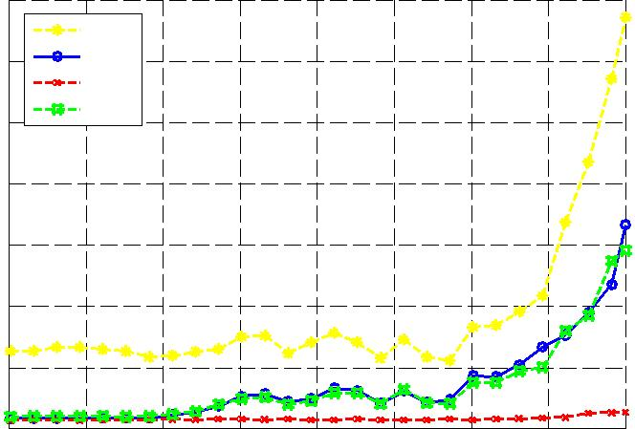
Sequence Index (noise level increases as the index increases)

Fig. 13. Simulated data: computation time.

- Consistency violated inside blocks. Using totally blank frames to replace the original frames inside the block. For each block, f2; 4; 6g frames at randomly selected positions are replaced, here the block size is fixed to 20 frames.

- Consistency violated between blocks. Using totally blank frames to replace the original frames inside the overlapping part. For each overlapping part, f1; 2; 3g frames are replaced, and the overlapping size is fixed to 5 frames.

By adding totally blank frames, weak and broken consistency can be simulated.

On these data we ran the optimal surface detection [23] and our block-wise strategies and computed the deviation of the two results, see Tables 3 and 4. Note that the way of simulating consistency violated between blocks cannot be applied to the approximation strategy BI. Thus, this option is not listed in Table 4. In both tables most of the values are equal to or near zero which shows the robustness of our approximation approach, i.e. despite of the broken consistency, it does achieve similar results as the optimal search.

5.6. Efficiency

The run time on an Intel Core i7 920 CPU with 8 G memory is presented in Fig. 13 for the simulated data and Table 5 for the six ultrasound sequences. The block-wise methods are dramatically faster than the global graph search optimization (with nearly equal extraction quality).

To further investigate the computation time behavior we artificially established a sequence of 502 images by concatenating the sequence 6 with 251 images and itself in reversed order. Then, surface extraction was performed on the first k frames, k Af40; 80; 120; 160; 200; 240; 280; 320; 360; 400; 440; 480; 502g, to extract the far wall surfaces.

The computation time for the different strategies is given in Fig. 14. The rapidly increasing computation time for the optimal graph search can be explained as follows. Since the number of edges, m, is linear to the number of vertices, n, the computational complexity amounts to Oðn³Þ ¼ OðX³Y³T³Þ if ignoring the constant term K³ and jCj, thus cubically increasing with the number of frames, T. In contrast, the three block-wise approximation schemes linearly depend on T. Table 5 shows that already a sequence length of 251 leads to hours of computation. Therefore, the global optimization using graph search is not practical for long sequences and the block-wise approaches can provide high-quality extraction within reasonable time.

Among the three block-wise strategies, BI is much faster than BA and BC. This is because BC and BA need to calculate without inhering the previous block's result. Considering the optimality study above, BI can be a sufficiently good choice for real applica-tions. The experiments on the simulated data also support this conclusion. Overall, using any of the thee block-wise strategies

Table 5

Real ultrasound data: computation time.

Sequence no. | # frames | near wall |  |  |  |  | far wall
 |  | Global | BA | BI | BC |  | Global | BA | BI | BC
1 | 86 | 279.72 | 33.93 | 10.05 | 31.61 |  | 179.40 | 23.77 | 8.67 | 22.34
2 | 86 | 130.11 | 15.51 | 5.67 | 15.94 |  | 144.31 | 15.71 | 5.99 | 14.23
3 | 73 | 298.90 | 21.76 | 7.78 | 18.99 |  | 133.70 | 13.84 | 5.80 | 12.08
4 | 78 | 232.76 | 13.23 | 9.14 | 11.61 |  | 198.60 | 8.79 | 5.33 | 6.83
5 | 111 | 1197.70 | 146.03 | 42.15 | 139.34 |  | 263.76 | 36.27 | 15.56 | 33.18
6 | 251 | 12,824.78 | 256.03 | 56.57 | 246.08 |  | 11,168.01 | 369.64 | 83.47 | 349.36

Z. Wu et al. / Neurocomputing 152 (2015) 127–138 | 137

 | 8000
 | 7000 | Global
 | 7000 | BA
 |  | BI
 | 6000 | BC
Time (unit:second) | 5000
Time (unit:second) | 4000
Time (unit:second) | 3000
 | 2000
 | 1000
 | 0 | 100 | 150 | 200 | 250 | 300 | 350 | 400 | 450 | 500
 | 50
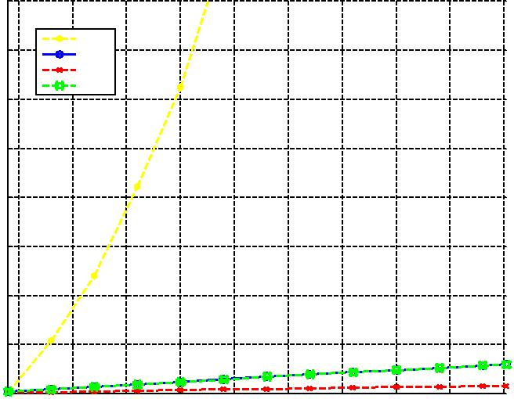
Frame number

Fig. 14. Simulated data (concatenated sequence of 502 images): computation time.

 | 0.7
pixel) |  | BI
pixel) | 0.6 | BA
pixel) |  | BC
(Unit: |  | BC
(Unit: |  | 3D DP
(Unit: | 0.5
blockwise | 0.5
blockwise | 0.4
and | 0.4
global | 0.3
between | 0.2
Difference | 0.1
 | 0 | 50 | 100 | 150 | 200 | 250 | 300 | 350 | 400
 | 0
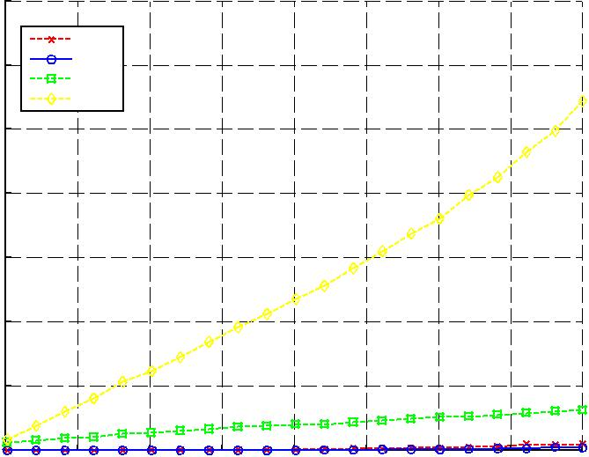
Sequence Index (noise level increase as the index increase)

Fig. 15. Comparison of our method with the double dynamic programming approach [22] (marked by “3D DP”).

instead of global optimization, the computation time is dramati-cally reduced with little loss of extraction quality, if any.

5.7. Comparison with double dynamic programming approach

As discussed in the introduction section, the solution from [22] is based on a concatenation of two steps of 2-D dynamic programming. In contrast to the optimal graph search [23] it does not exactly solve the optimal surface detection problem, but delivers an approximate solution only. In addition, it cannot guarantee the temporal consis-tency. We also compared the result of our block-wise approximation strategies with this method using the same protocol as in Fig. 12 and the comparison result is presented in Fig. 15. While there is nearly no noticeable difference between the optimal graph search and block-wise solutions, the double dynamic programming approach is much less robust to the increasing levels of noise and produces much larger deviation from the global graph search.

5.8. Discussions

Based on the above observations and discussions we can make the following suggestions. Generally, we prefer BI because it is effective

and fast. If the image sequence is highly noisy, then BI cannot always promise the solution quality. Then, we have two circumstances. If the precision of the solution is emphasized, BA should be considered. But if the consecutive constraint is emphasized, then BC should be selected.

Looking at Table 2, we can see that for the sequences 4/5/6 the extraction error compared to the ground truth is larger than for the first three sequences. In these cases the achieved extraction perfor-mance indicates further room for improvement. Graph search based extraction, independent of using the exact solution from [23] or the block-wise approximation, makes the strong basic assumption that the expected surface must be the minimum-cost surface. Generally, this assumption poses substantial challenges to feature computation in the preprocessing step. The current preprocessing used in our experiments may not be optimal yet to achieve higher performance for the sequences 4/5/6. This issue will be studied in future. However, it should be emphasized that the aim of this work is to achieve temporal consistency by means of 3D graph search and to study the block-wise approximation strategies. Even the results for the sequences 4/5/6 confirm the achievement of these two goals.

Currently, our approximation approach assumes a constant block size. In principle it is possible to consider using multiple block sizes that adaptively takes the local properties of an image sequence into account. A concrete realization of this idea needs to tackle several technical issues. Given a (possibly preset) range of block sizes, a whole sequence is to be partitioned into blocks of varying lengths in an optimal manner. Both the definition of a suitable optimality criterion and its optimization pose substantial challenges. We will consider this issue of multiple block sizes in future.

6. Conclusion

In this paper we have investigated the problem of temporally consistent extraction of single or multiple coupled contours in image sequences. By formulating this problem in the form of an optimal surface detection in 3D volume, we are able to resort to a recent graph-theoretic approach for exact solution. However, getting the exact solution is computationally costly. In order to cope with the high computational complexity caused by the potential unboundedness in time (i.e., an image sequence can be arbitrarily long), we proposed three approximate variants, which partition the whole sequences into blocks and then combine these blocks' extraction result to form a final result. The effectiveness and efficiency of the strategies are exemplarily demonstrated on both simulated data and real ultrasound data for arterial wall detection. It is shown that the approximate variants dramatically reduce the computation time without loss of solution quality.

In addition to those extensions discussed in Section 5.8 we will extend the experimental testing to additional domains in future. In addition, the algorithm from [23] has an augmented version for optimal detection of tubular surfaces, which enables us to further develop our approach towards handing closed contours.

Acknowledgments

This work is supported by the State Key Program of National Nature Science Foundation of China (Grant no. 61231018) and by the Deutsche Forschungsgemeinschaft (DFG), SFB 656 MoBil, Münster, Germany (Project B3).

References

- C. Sun, S. Pallottino, Circular shortest path in images, Pattern Recognit. 36 (3) (2003) 709–719.
- M. Kass, A. Witkin, D. Terzopoulos, Snakes: active contour models, Int. J. Comput. Vis. 1 (4) (1988) 321–331.

138 Z. Wu et al. / Neurocomputing 152 (2015) 127–138

- R. Malladi, J. Sethian, B. Vemuri, Shape modeling with front propagation: a level set approach, IEEE Trans. Pattern Anal. Mach. Intell. 17 (2) (1995) 158–175.

- L.D. Cohen, R. Kimmel, Global minimum for active contour models: a minimal path approach, Int. J. Comput. Vis. 24 (1) (1997) 57–78.
- C. Sun, A. Ben, Multiple paths extraction in images using a constrained expanded trellis, IEEE Trans. Pattern Anal. Mach. Intell. 27 (12) (2005) 1923–1933.

- D. Cheng, X. Jiang, Detections of arterial wall in sonographic artery images using dual dynamic programming, IEEE Trans. Inf. Technol. Biomed. 12 (6) (2008) 792–799.

- X. Jiang, A. Große, K. Rothaus, Interactive segmentation of non-star-shaped contours by dynamic programming, Pattern Recognit. 44 (9) (2011) 2008–2016.

- C. Xu, J.L. Prince, Snakes, shapes, and gradient vector flow, IEEE Trans. Image Process. 7 (3) (1998) 359–369.
- T. McInerney, D. Terzopoulos, T-snakes: topology adaptive snakes, Med. Image Anal. 4 (2) (2000) 73–91.
- T. Chan, L. Vese, Active contours without edges, IEEE Trans. Image Process. 10 (2) (2001) 266–277.
- X. Jiang, D. Tenbrinck, Region based contour detection by dynamic program-ming, in: Proceedings of 14th International Conference on Computer Analysis of Images and Patterns, York, UK, Part II, 2013, pp. 152–159.

- K. Zhang, H. Song, L. Zhang, Active contours driven by local image fitting energy, Pattern Recognit. 43 (4) (2010) 1199–1206.
- J. Yuan, J. Wang, L. Liu, Active contours driven by local intensity and local gradient fitting energies, Int. J. Pattern Recognit. Artif. Intell. 28 (3) (2014) 1455006.

- H.-J. Wang, M. Liu, Active contours driven by local gaussian distribution fitting energy based on local entropy, Int. J. Pattern Recognit. Artif. Intell. 27 (6) (2013) 1355008.

- A.K. Mishra, P.W. Fieguth, D.A. Clausi, Decoupled active contour (DAC) for boundary detection, IEEE Trans. Pattern Anal. Mach. Intell. 33 (2) (2011) 310–324.

- T. Shen, H. Li, X. Huang, Active volume models for medical image segmenta-tion, IEEE Trans. Med. Imaging 30 (3) (2011) 774–791.
- W. Liao, S. Wörz, K. Rohr, Globally minimal path method using dynamic speed functions based on progressive wave propagation, in: Proceedings of the Asian Conference on Computer Vision (ACCV 2012), Springer, Berlin, Heidelberg, 2013, pp. 25–37.

- V. Kaul, A.J. Yezzi, Y.J. Tsai, Detecting curves with unknown endpoints and arbitrary topology using minimal paths, IEEE Trans. Pattern Anal. Mach. Intell. 34 (10) (2012) 1952–1965.

- K. Somkantha, N. Theera-Umpon, S. Auephanwiriyakul, Boundary detection in medical images using edge following algorithm based on intensity gradient and texture gradient features, IEEE Trans. Biomed. Eng. 58 (3) (2011) 567–573.
- T.-C. Huang, D.-C. Cheng, A. Schmidt-Trucksäss, U.H. Schütz, Automated localisation and boundary identification of superficial femoral artery on MRI sequences, Comput. Methods Biomech. Biomed. Eng. 16 (8) (2013) 873–884.
- A.M.F. Santos, R.M. Dos Santos, P.M.A. Castro, E. Azevedo, L. Sousa, J.M. R. Tavares, A novel automatic algorithm for the segmentation of the lumen of the carotid artery in ultrasound b-mode images, Expert Syst. Appl. 40 (16) (2013) 6570–6579.

- D. Cheng, J. Lin, Three-dimensional expansion of a dynamic programming method for boundary detection and its application to sequential magnetic resonance imaging (MRI), Sensors 12 (5) (2012) 5195–5211.
- K. Li, X. Wu, D. Chen, M. Sonka, Optimal surface segmentation in volumetric images-a graph-theoretic approach, IEEE Trans. Pattern Anal. Mach. Intell. 28 (1) (2006) 119–134.

- P. Holdfeldt, M. Viberg, T. Gustavsson, A new method based on dynamic programming for boundary detection in ultrasound image sequences, in: Proceedings of the IEEE Engineering in Medicine and Biology Society, 2008,
    - 3072–3074.

- S. Lee, C. Wu, A k-best paths algorithm for highly reliable communication networks, IEICE Trans. Commun. E82B (4) (1999) 586–590.
- D. Castanon, Efficient algorithms for finding the k best paths through a trellis, IEEE Trans. Aerosp. Electron. Syst. 26 (2) (1990) 405–410.
- S. Avidan, A. Shamir, Seam carving for content-aware image resizing, ACM Trans. Graph. 26 (3) (2007) 10.
- M.A. Abidi, R.C. Gonzalez, Data Fusion in Robotics and Machine Intelligence, Academic Press Professional, Inc., San Diego, CA, USA, 1992.
- X. Wu, D.Z. Chen, Optimal net surface problems with applications, in: Automata, Languages and Programming, Springer, Berlin, Heidelberg, 2002,
    - 1029–1042.

- M. Abramoff, M. Garvin, M. Sonka, Retinal imaging and image analysis, IEEE Rev. Biomed. Eng. 3 (2010) 169–208.
- D. Han, X. Wu, M. Sonka, Optimal multiple surfaces searching for video/image resizing—a graph-theoretic approach, in: Proceedings of the International Conference on Computer Vision, 2009, pp. 1026–1033.
- Z. Wu, X. Jiang, N. Zheng, Y. Liu, D. Cheng, Exact solution to median surface problem using 3D graph search and application to parameter space explora-tion, Pattern Recognit. 48 (2), February 2015, 380–390.
- Y. Boykov, V. Kolmogorov, An experimental comparison of min-cut/max-flow algorithms for energy minimization in vision, IEEE Trans. Pattern Anal. Mach. Intell. 26 (9) (2004) 1124–1137.

- D. Hochbaum, A newold algorithm for minimum-cut and maximum-flow in closure graphs, Networks 37 (4) (2001) 171–193.
- A.V. Goldberg, R.E. Tarjan, A new approach to the maximum-flow problem, J. ACM 35 (4) (1988) 921–940.
- R. Ahuja, T. Magnanti, J. Orlin, Network Flows: Theory, Algorithms, and Applications, Prentice-Hall, Inc., New Jersey, 1993.
- M.W. Lorenz, H.S. Markus, M.L. Bots, M. Rosvall, M. Sitzer, Prediction of clinical cardiovascular events with carotid intima-media thickness a systematic review and meta-analysis, Circulation 115 (4) (2007) 459–467.

- S.H. Johnsen, E.B. Mathiesen, Carotid plaque compared with intima-media thickness as a predictor of coronary and cerebrovascular disease, Curr. Cardiol. Rep. 11 (1) (2009) 21–27.

Zhengwang Wu received the B.S. degree in Computer Science from Xi'an Jiaotong University, Xi'an, China, in 2006. He is currently a Ph.D. student in Institute of Artificial Intelligence and Robotics, major in computer vision and pattern recognition, Xi'an Jiaotong Univer-sity. His research interests include Medical Image processing, Structural Pattern Recognition and Combi-natory Optimization.


Xiaoyi Jiang studied Computer Science at Peking Uni-versity and received his Ph.D. and Venia Docendi (Habilitation) degree from University of Bern, Switzer-land. He was an associate professor at Technical Uni-versity of Berlin. Since 2002 he is a full professor of Computer Science at University of Münster, Germany. Currently, he is an Editor-in-Chief of the International Journal of Pattern Recognition and Artificial Intelligence and also serves on the advisory board and editorial board of several journals including Pattern Recognition, IEEE Transactions on Cybernetics, and Chinese Science Bulletin. He is senior member of IEEE and fellow of IAPR.


Nanning Zheng graduated in 1975 from the Depart-ment of Electrical Engineering, Xi’an Jiaotong Univer-sity, Xi'an, China, received the M.E. degree in information and control engineering from Xi'an Jiao-tong University in 1981, and the Ph.D. degree in electrical engineering from Keio University, Japan, in 1985. He is currently a full professor and the director of the Institute of Artificial Intelligence and Robotics in Xi’an Jiaotong University. His research interests include computer vision, pattern recognition, computational intelligence, image processing, and hardware imple-mentation of intelligent systems. Since 2000, he has been the Chinese representative on the Governing

Board of the International Association for Pattern Recognition. He presently serves as executive editor of the Chinese Science Bulletin. He became a member of the Chinese Academy Engineering in 1999. He is a fellow of the IEEE.

Dachuan Cheng studied Electrical Engineering (B.S.) at Chinese Culture University, Taiwan, Biomedical Engi-neering (M.S. and Ph.D.) at National Cheng Kung Uni-versity, Taiwan. He is an associate professor at the Department of Biomedical Imaging and Radiological Science of the China Medical University, Taiwan. His research interests include medical image processing and optimisation.


