Effect of concomitant administration of nifedipine and tacrolimus on the development of gingival overgrowth in rats

Sheng-Yi Chen , DDS, MS
Graduate Institute of Medical Sciences, National Defense Medical Center, Taipei, Taiwan
Department of Periodontology, School of Dentistry, National Defense Medical Center and Tri-Service General Hospital, Taipei, Taiwan
Division of Periodontics, Dentistry Department, Taipei Medical University-Shuang Ho Hospital, Taipei, Taiwan

Cheng-Yang Chiang, DDS, MS,
Chairman and Associate Professor, Department of Periodontology, School of Dentistry, National Defense Medical Center and Tri-Service General Hospital, Taipei, Taiwan

Yu-Wen Yeh, MD
Department of Internal Medicine, Tri-Service General Hospital Songshan Branch
Department of Dermatology, National Defense Medical Center and Tri-Service General Hospital, Taipei, Taiwan

Hsiao-Pei Tu, PhD
Assistant Professor of Department of Dental Hygiene, China Medical University
Department of Periodontology, School of Dentistry, National Defense Medical Center and Tri-Service General Hospital, Taipei, Taiwan

Hsien-Chung Chiu, DDS, PhD
Assistant Professor, Department of Periodontology, School of Dentistry
National Defense Medical Center and Tri-Service General Hospital, Taipei, Taiwan

Shin Nieh, DDS, DSc
Professor, Department of Pathology, National Defense Medical Center and Tri-Service General Hospital, Taipei, Taiwan

Earl Fu, DDS, DSc
Professor, Department of Periodontology, School of Dentistry
National Defense Medical Center and Tri-Service General Hospital, Taipei, Taiwan

Correspondence to:
Earl Fu, DDS, DSc
Professor, Department of Periodontology, School of Dentistry
National Defense Medical Center and Tri-Service General Hospital
PO Box 90048-507, Taipei, Taiwan
Tel: +886-2-87927150; Fax: +886-2-87927145
E-mail: ndmcearl@ndmctsgh.edu.tw
Running title:Nifedipine /tacrolimus on gingival overgrowth
Abstract
Background/purpuse: Gingival overgrowth is the main oral manifestation in transplant recipients who use calcineurin inhibitors. This study was to evaluate effect of concomitant administration of nifedipine with tacrolimus on rat gingival overgrowth.

Materials and methods:Thirty-six Sprague-Dawley rats were assigned into four groups, including control group. In drug groups, either tacrolimus (1.5 mg/kg) or nifedipine (30mg/kg), or both drugs together was administrated daily for 6 weeks. The gingival morphology was macroscopically examined on the mandibular central papilla from cast models biweekly and analyzed by measuring the sulcular probing depth and the keratinized gingival width around first mandibular molars immediately after sacrificing. By histology, the changes of papillae, including the connective tissue, the epithelial and the total tissue areas, were measured at two different tissue levels.

Results: Significantly increased papillary dimensions, including depth, width and height, were observed across all groups after first week, with control group showing less changes than experimental drug groups. Among drug groups, significantly increased papillary dimensions were noted in nifedipine group when compared with groups treated with tacrolimus and both drugs. Changes in keratinized gingival width were found to be similar in tacrolimus and combined-drug groups but greater in nifedipine group. For probing depth, experimental groups showed greater changes than control group but no difference among experimental groups. Similar trends were presented for the total and the connective tissue areas; however, the epithelial tissue areas did not show any difference among the four treatment groups.

Conclusion: Gingival overgrowth could be induced either by nifedipine or by tacrolimus, although a less extent gingival overgrowth could be induced by tacrolimus if compared with that by nifedipine. However, the concomitant administration of nifedipine with tacrolimus did not aggravate the induced of gingival overgrowth.

KEY WORDS: gingival; overgrowth; tacrolimus; nifedipine; rat
Introduction
Gingival overgrowth is one of the adverse effects among various groups of drugs, including cyclosporin A, nifedipine and phenytoin. tacrolimus (FK506), an immunosuppressant introduced in 1984 from Streptomyces tsukubaensis. Tacrolimus has been used successfully as an alternative to cyclosporin A for preventing graft rejection and treating autoimmune diseases.¹ Tacrolimus shares similar pharmacodynamics, but has nephrotoxicity, neurotoxicity, and disturbances in glucose metabolism. On the other hand, tacrolimus has advantages over cyclosporin A with respect to hyperlipidemia, hypertension, and hirsutism.¹ Many clinical researches have demonstrated the benefit of tacrolimus in terms of reduced gingival overgrowth,²⁻⁵ and preferred the use of tacrolimus over cyclosporin A to lower the risk of developing gingival overgrowth in conclusion.⁴⁻⁸
To attenuate such side effects, nephrotoxicity and hypertension, it is common practices to administer nifedipine, which may also induce gingival overgrowth,⁹ with tacrolimus.¹⁰ Several clinical studies have evaluated the development of gingival overgrowth after concomitant administration of nifedipine with tacrolimus and have postulated a synergistic relationship between calcium-channel blockers and tacrolimus in producing gingival overgrowth. Despite former attempts to prove the existence of such relationship, the effects of co-administration of nifedipine and tacrolimus on gingival overgrowth remain elusive due to lack of organized experimental design and randomized control. Most previous studies were based on single case reports or case-series reports without using different drugs during treatment as a control variable. Therefore, the present study aims to evaluate the hypothesis that concomitant treatment of nifedipine with tacrolimus can aggravate the gingival overgrowth in an animal model through an experimental design using different drug combination as variable.

Materials and methods
Experimental design
Thirty-six male Sprague Dawley rats, five week-old weighting 150–200 g, were randomly assigned into four groups treated with different drug combinations: control, tacrolimus, nifedipine, and combined-drug (tacrolimus+nifedipine) group. Animals in the tacrolimus group received tacrolimus dissolved in mineral oil at daily dose of 1.5 mg/kg body weight via gastric feeding, whereas the control group received the mineral oil solvent alone. Animals in the nifedipine group received daily dose of nifedipine of 30 mg/kg body weight (Sigma, St. Louis, MO, USA) dissolved in dimethyl sulfoxide (Sigma-Aldrich, St. Louis, MO, USA), whereas the animals in the tacrolimus+nifedipine group received both tacrolimus and nifedipine, as mentioned above. All of the drugs and oil solvent were delivered daily for 6 weeks. The protocol was approved by the Institutional Animal Care Committee of the National Defense Medical Center, Taipei, Taiwan, prior to the commencement of the study.

Macroscopic evaluation of gingival morphology

From the cast models obtained from dental impressions (Coltène/Whaledent, Altstätten, Switzerland), the morphological changes of the central mandibular papilla, including the mesiodistal width (MD), buccolingual depth (BL), and vertical height (VH), were measured and evaluated biweekly (Figure 1.A), as described previously. ¹³ In addition, the depths of the gingival sulci at the distobuccal sites of the maxillary and first mandibular molars were recorded using a stereomicroscope (Olympus®-SZH, Olympus, Tokyo, Japan) via the insertion of a specially designed plastic gingival probe after sacrificing by carbon dioxide inhalation at the end of experiment.¹⁴ The widths of keratinized gingiva at the mesio-, mid-, and disto-buccal sites of the right and left first mandibular molars were also measured directly by using methods modified in our previous study.¹⁵

Microscopic evaluation of gingival morphology

In this study, the gingival tissue specimens (including teeth, gingiva, and surrounding soft and hard tissues) around the mandibular incisors were selected for the histological evaluation of gingival morphological changes. After fixation in 10% formalin and decalcification with 5% HCl, the specimens were serially sectioned at intervals 6 μm apart from the base of the central incisal papilla. Routine hematoxylin and eosin stain method was used for microscopic examination. As modified from our previous study, two tissue levels were selected for histometric analysis based on the characteristics of the lingual gingiva between the roots.¹⁶ Briefly, the junctional epithelia and the crest of the dental alveoli were used as landmarks for tissue level 1 and 2 (Figure 1B), respectively. At these two levels, the tissue dimension, including tissue mesiodistal width (tMD) and tissue buccolingual thickness (tBL), as well as connective tissue, epithelial tissue and total tissue areas, were measured. In this study, five consecutive sections at each level were selected for histometric measurements.

Statistical analysis

One- or two-way analysis of variance (ANOVA) was used to evaluate the differences of the morphological and tissue dimensions of the mandibular central papilla between different treatment groups and between different intervals. Repeated measures ANOVA with Duncan post hoc analysis was used to evaluate whether any dependent variables (probing depth or keratinized gingival width) are correlated with the inter-subject factor (the drug treatments) and the intra-subject factor(s) (e.g. the right and left sides examined and the upper and lower jaws evaluated). Duncan post hoc test was further used if any significance was noted. Significance was set at P < 0.05.

Results
The mandibular central papillae appeared to be larger in the animals receiving nifedipine and/or tacrolimus when compared with those in control rat receiving no drug (Figure 2I to 2 VI). The papillary morphology, measured from the stone models, was summarized (Figure 2A to 2D). The papillary BL thickness increased significantly from week 0 to week 6, its increase was under the influence of the drug delivered (Figure 2A and 2D). Significantly greater papillary BL thickness was found in animal groups treated with drug/drugs than in the control group. Among the drug groups, the greatest thickness was found in the nifedipine group, while the thicknesses were similar in the tacrolimus group and the tacrolimus+nifedipine group (Figure 2 A and D). Similar trends were observed in the MD width (Figure 2B and D) and VH (Figure 2C and D).

The results of analyses of the probing depth and keratinized gingival width around the molars were summarized in the Figures 3. For probing depth, significantly greater depth was observed in each of the three drug groups than that in control group although no difference in depth was found between the right and left sides, as well as between the upper and lower jaws (Figure 3.I). The keratinized gingival widths were significantly different between the treatment groups but not between the right and left sides, regardless the examining sites of mesio-buccal, mid-buccal and disto-buccal sites (Figure 3.II). Among the four treatment groups, the greatest keratinized gingival width was recorded in the nifedipine group and no statistical difference was found between the tacrolimus group and the tacrolimus+nifedipine group; however, the keratinized gingival width in each of the three drug groups was all greater than that in the control group.

The histological presentation of the papillae for the four animal groups was summarized in the Figures 4. Again, the total tissue areas were significantly different among the four treatment groups, regardless of tissue levels. At each tissue level, significantly greater tissue areas were found in all drug groups when compared to the control group. The greatest one was found in the nifedipine group. Similar trends were observed in the connective tissue areas, at each tissue level (except no statistical difference was found at the level 2 tissue area between the tacrolimus+nifedipine group and the nifedipine group); however, the epithelial tissue areas did not show any difference among the four treatment groups at both tissue levels (Figure 4).

Discussion
Whether the concomitant intake of nifedipine can aggravate the morphological changes of gingival during the administration of tacrolimus was evaluated in vivo in this study. However, whether tacrolimus induces gingival overgrowth is still inconclusive. Some published human studies suggest that tacrolimus does not induce gingival overgrowth; while others disapprove this hypothesis, or suggest that the severity of gingival overgrowth is less than that observed during cyclosporin A administration. The confusion in defining this phenomenon may possibly stem in the difficulty to assess a three-dimensional changes of gingival morphology in a quantitative manner and the absence of a standardized way to record gingival overgrowth. In human studies, several have been used to measure the overgrown gingival.¹⁹⁻²¹ Moreover, gingival overgrowth is not evenly distributed around the tooth, as gingival overgrowth occurs more frequently and/or severe on the labial than on the lingual side and around the anterior than around the posterior teeth. Similar difficulties appear in animal studies, hence this study adopted varied measurements to macroscopically record gingival overgrowth (including three-dimensional stone model, two-dimensional tissue section, and one-dimensional probing depth and keratinized gingival width) at different locations of gingivae. A time-dependent increase of gingival dimension in the mandibular central papillae was observed in all animal groups (Figure 2D), which may in part be due to the natural growth of the animals.¹³ Although our results showed that there were general increases in all dimensions over the 6 weeks, significantly increased gingival overgrowth was consistently seen in the animals treated with drugs when compared with the animals treated without drug. Significantly increased gingival dimensions were consistently noted in the animals fed with tacrolimus group when compared with the control animals, which indicated that gingival overgrowth could be induced by tacrolimus in this animal model, although to a lesser extent than gingival overgrowth induced by nifedipine. Moreover, concomitant treatment of nifedipine did not aggravate tacrolimus-induced gingival overgrowth because the morphology in the combined-drug group was either similar to that in the tacrolimus group or not greater than that in the nifedipine group (Figure 2A~D). Histological analysis showed similar findings, regardless of the tissue level examined (Figures 4). In clinical studies reported that both long term nifedipine and tacrolimus administration increased the severity of gingival enlargement. In present study, the combination usage of tacrolimus and nifedipine did not cause more gingival overgrowth compare to the administration of these drugs alone. These Previous studies reported that short term (60 and 120 days) tacrolimus administration did not induce gingival change in rats whereas gingival overgrowth occurred after 180 and 240 days. These discrepant results might be related to the drug duration or the alterations in the sensitivity of the animals to these immunosuppressive drugs.
In this study, the gingival probing depth and the keratinized gingival width on the buccal surface of the first molar were also measured to evaluate the dimensions of gingival overgrowth on the posterior teeth. However, these two methods have limitations. Gingival probing depth was added as one of the methods to evaluate gingival overgrowth as it has been used in a previous study.²³ Despite the widespread use of the periodontal probe as a measurement tool for pocket depth, a certain degree of error exists in the technique of measuring the root surface at the level of the greatest penetration of the probe tip. Listgarten et al.²⁴ suggested that the tip of the periodontal probe would be located at the demarcation line between the junction epithelium and the site of connective tissue attachment, and possibly within the connective tissue. Moreover, the recorded depth can be influenced by many other factors (including force, angulation, and tissue inflammation). On the other hand, the width of the keratinized gingiva may represent the true gingival overgrowth, as it is presented in the gingiva, not in the mucosa. However, the widths may vary at different sites, which make it difficult to compare the minor changes of the overgrowth.
By microscopy, our histological measurements used a two-dimensional measurement, including the tBL and tMD, in the incisal papilla; however, three-dimensional results could still be inferred from the two-dimensional data because they were taken at two different tissue levels recording. Similar findings of significantly increased total and connective tissue areas of central papilla were found in all drug groups when compared to that in the control group, and the greatest total and connective tissue areas observed in nifedipine group were observed. However, the epithelial tissue areas were similar among the treatment groups, regardless at level 1 and 2.These findings imply that the connective tissue may be the target tissue for the induced gingival overgrowth related to nifedipine or Trc. Under a different mechanism from cyclosporine-A, the epithelial cells and the stroma cells are both the target cells during the development of gingival overgrowth.
In conclusion, the macro- and micro-scopic changes of mandibular central papillary morphology and the gingival measurements around first mandibular molars, including the gingival width and probing depth, all showed that gingival overgrowth could be induced in the animals receiving tacrolimus, although in a less extent than that having nifedipine. Moreover, the concomitant administration of nifedipine with tacrolimus did not aggravate the gingival overgrowth induced by single drug of nifedipine or tacrolimus.

ACKNOWLEDGEMENTS

This study was partially supported by grants from the Department of National Defense, Taipei, Taiwan, ROC (DOD-100-I35) and from the C.Y. Foundation for Advancement of Education, Sciences, and Medicine, Republic of China.
References
1. Spencer CM, Goa KL, Gillis JC. Tacrolimus. An update of its pharmacology and clinical efficacy in the management of organ transplantation. Drugs 1997;54:925-75.
2. James JA, Jamal S, Hull PS, et al. Tacrolimus is not associated with gingival overgrowth in renal transplant patients. J Clin Periodontol 2001;28:848-52.
3. McKaig SJ, Kelly D, Shaw L. Investigation of the effect of FK506 (tacrolimus) and cyclosporin on gingival overgrowth following paediatric liver transplantation. Int J Paediatr Dent 2002;12:398-403.
4. Ellis JS, Seymour RA, Taylor JJ, Thomason JM. Prevalence of gingival overgrowth in transplant patients immunosuppressed with tacrolimus. J Clin Periodontol 2004;31:126-31.
5. de Oliveira Costa F, Diniz Ferreira S, de Miranda Cota LO, da Costa JE, Aguiar MA. Prevalence, severity, and risk variables associated with gingival overgrowth in renal transplant subjects treated under tacrolimus or cyclosporin regimens. J Periodontol 2006;77:969-75.
6. Busque S, Demers P, St-Louis G, et al. Conversion from Neoral (cyclosporine) to tacrolimus of kidney transplant recipients for gingival hyperplasia or hypertrichosis. Transplant Proc 1998;30:1247-8.
7. Hernandez G, Arriba L, Frias MC, et al. Conversion from cyclosporin A to tacrolimus as a non-surgical alternative to reduce gingival enlargement: a preliminary case series. J Periodontol 2003;74:1816-23.
8. Shiboski CH, Krishnan S, Besten PD, et al. Gingival enlargement in pediatric organ transplant recipients in relation to tacrolimus-based immunosuppressive regimens. Pediatr Dent 2009;31:38-46.
9. Nery EB, Edson RG, Lee KK, Pruthi VK, Watson J. Prevalence of nifedipine-induced gingival hyperplasia. J Periodontol 1995;66:572-8.
10. Seifeldin RA, Marcos-Alvarez A, Gordon FD, Lewis WD, Jenkins RL. Nifedipine interaction with tacrolimus in liver transplant recipients. The Annals of pharmacotherapy 1997;31:571-5.
11. Spolidorio LC, Spolidorio DM, Massucato EM, Neppelenbroek KH, Campanha NH, Sanches MH. Oral health in renal transplant recipients administered cyclosporin A or tacrolimus. Oral Dis 2006;12:309-14.
12. Greenberg KV, Armitage GC, Shiboski CH. Gingival enlargement among renal transplant recipients in the era of new-generation immunosuppressants. J Periodontol 2008;79:453-60.
13. Fu E, Nieh S, Chang HL, Wang SL. Cyclosporin A-induced gingival overgrowth in rats: macroscopic and microscopic observations. Int J Periodontics Restorative Dent 1996;16:278-91.
14. Kitamura K, Morisaki I, Adachi C, et al. Gingival overgrowth induced by cyclosporin A in rats. Arch Oral Biol 1990;35:483-6.
15. Ayanoglou CM, Lesty C. Cyclosporin A-induced gingival overgrowth in the rat: a histological, ultrastructural and histomorphometric evaluation. J Periodontal Res 1999;34:7-15.
16. Fu E, Nieh S, Hsiao CT, Hsieh YD, Wikesjo UM, Shen EC. Nifedipine-induced gingival overgrowth in rats: brief review and experimental study. J Periodontol 1998;69:765-71.
17. Sekiguchi RT, Paixao CG, Saraiva L, Romito GA, Pannuti CM, Lotufo RF. Incidence of tacrolimus-induced gingival overgrowth in the absence of calcium channel blockers: a short-term study. J Clin Periodontol 2007;34:545-50.
18. Cezario ES, Cota LO, Ferreira SD, et al. Gingival overgrowth in renal transplant subjects medicated with tacrolimus in the absence of calcium channel blockers. Transplantation 2008;85:232-6.
19. Seymour RA, Smith DG, Turnbull DN. The effects of phenytoin and sodium valproate on the periodontal health of adult epileptic patients. J Clin Periodontol 1985;12:413-9.
20. Daley TD, Wysocki GP, Day C. Clinical and pharmacologic correlations in cyclosporine-induced gingival hyperplasia. Oral Surg Oral Med Oral Pathol 1986;62:417-21.
21. McGaw T, Lam S, Coates J. Cyclosporin-induced gingival overgrowth: correlation with dental plaque scores, gingivitis scores, and cyclosporin levels in serum and saliva. Oral Surg Oral Med Oral Pathol 1987;64:293-7.
22. Prabhu A, Mehta DS. A morphologic comparison of gingival changes influenced by cyclosporin and tacrolimus in rats: an experimental study. J Periodontol 2006;77:265-70.
23. Armitage GC, Svanberg GK, Loe H. Microscopic evaluation of clinical measurements of connective tissue attachment levels. J Clin Periodontol 1977;4:173-90.
24. Listgarten MA, Mao R, Robinson PJ. Periodontal probing and the relationship of the probe tip to periodontal tissues. J Periodontol 1976;47:511-3.
25. Tu HP, Chen YT, Shieh YS, et al. Cyclosporin-induced downregulation of the expression of E-cadherin during proliferation of edentulous gingival epithelium in rats. J Periodontol 2006;77:832-9.
26. Spoildorio LC, Spolidorio DM, Neves KA, Gonzaga HF, Almeida OP. Morphological evaluation of combined effects of cyclosporin and nifedipine on gingival overgrowth in rats. J Periodontal Res 2002;37:192-5.

Figures
Figure 1 Macro-scopic and micro-scopic analysis for morphological changes in the gingivae examined in this study. (A) The macroscopic analysis: the photo I presents the lingual appearance of central mandibular papilla on a stone model. The papillary dimensions, including the mesiodistal width (MD) and vertical height (VH), are measured. The photo II shows the depth of probing after inserting a plastic probe into the gingival sulcus at the distobuccal site of the left mandibular first molar. The photo III indicates the three widths of keratinized gingiva measured at the mesio-, mid-, and disto-buccal sites of the right first mandibular molar (three lines indicate the widths). (B) The microscopic analysis: the histograms present the two tissue levels (levels 1 and 2) of the mandibular central papilla. On the tissue sections, the central interdental papillae and the adjacent roots were clear observed. At the transverse plane section of level 1, the junctional epithelia are observed, whereas the most coronal level of alveolar bone crests are noted at the section of level 2. (The arrows indicate the epithelia, whereas the arrowheads point to the alveolar bone crests, original magnification, 20 ×).

- Macroscopic analysis
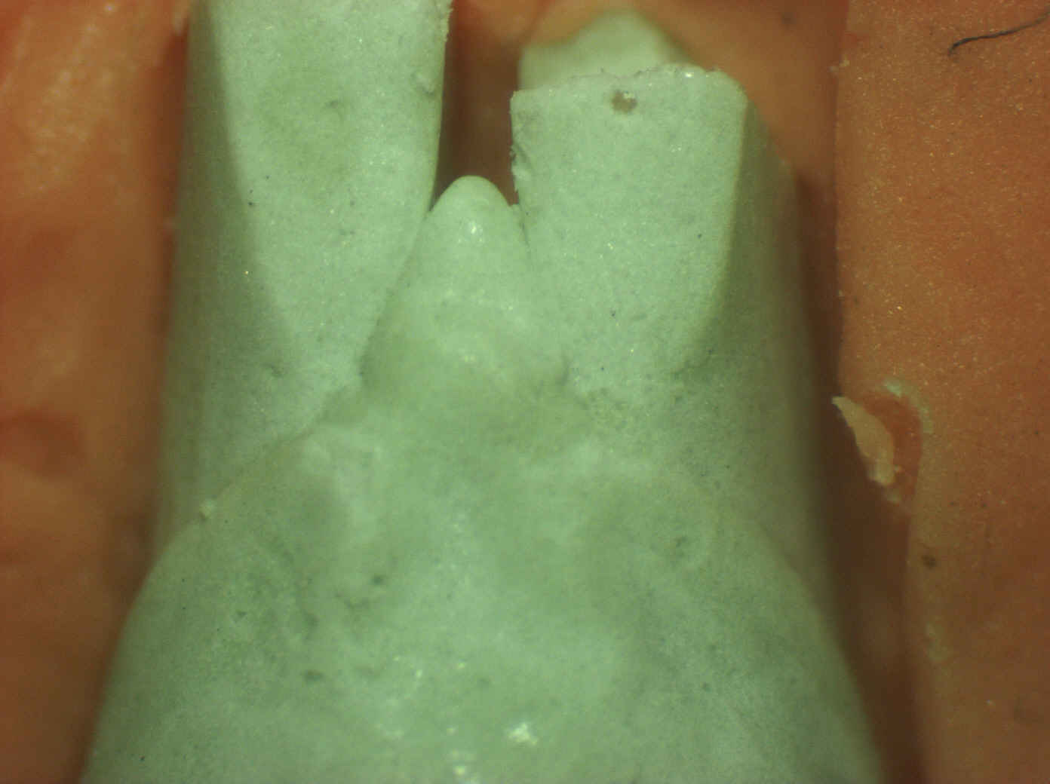  VH  MD  I | 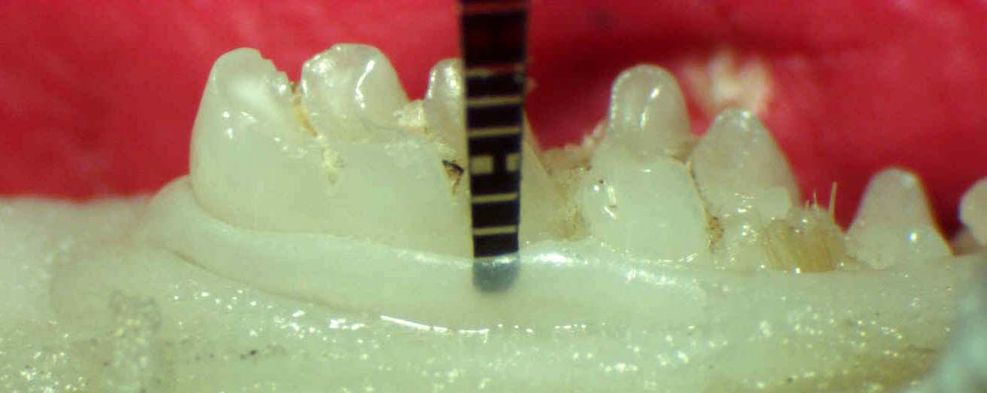  II |  | 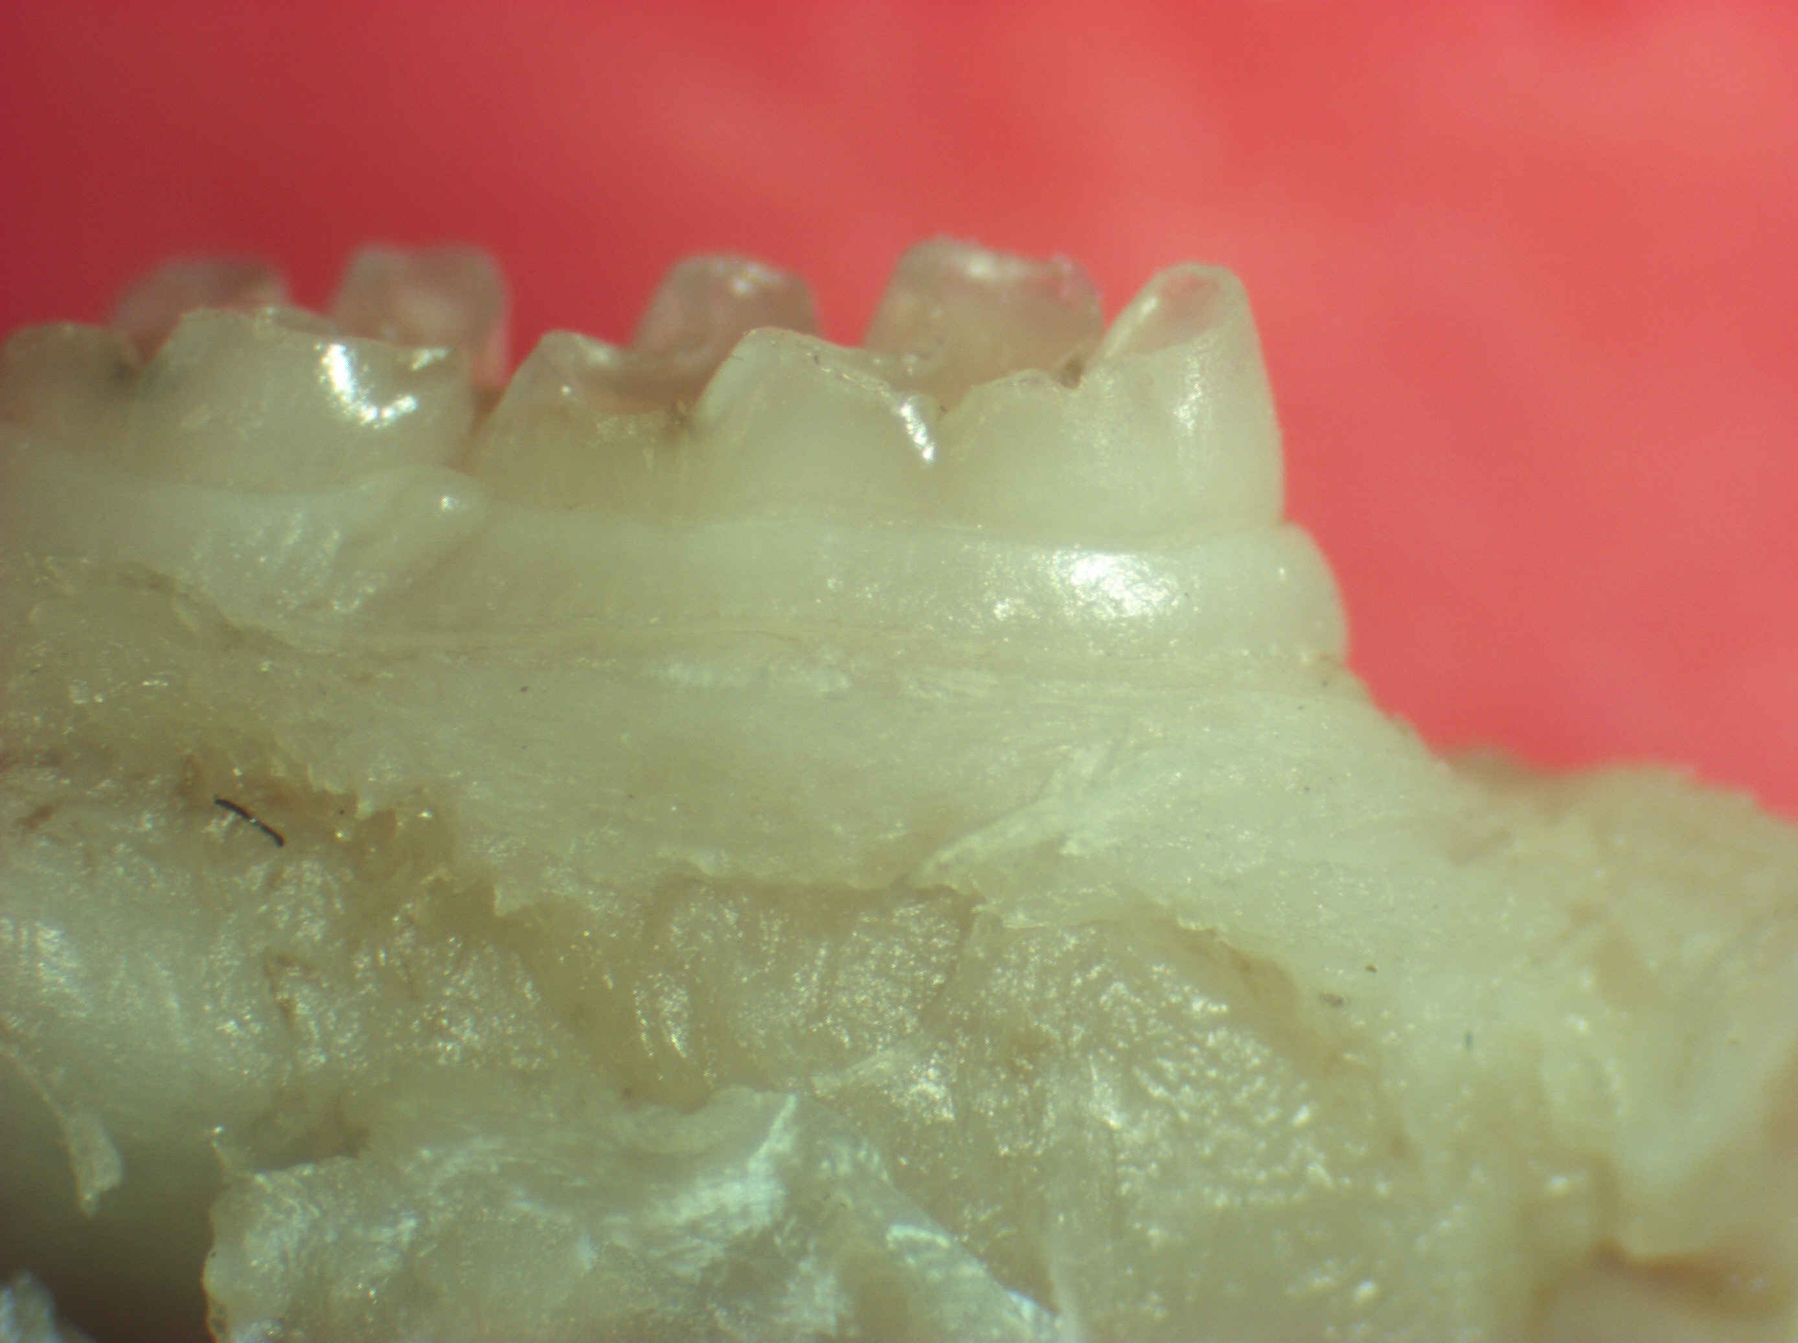  III
- Microscopic analysis
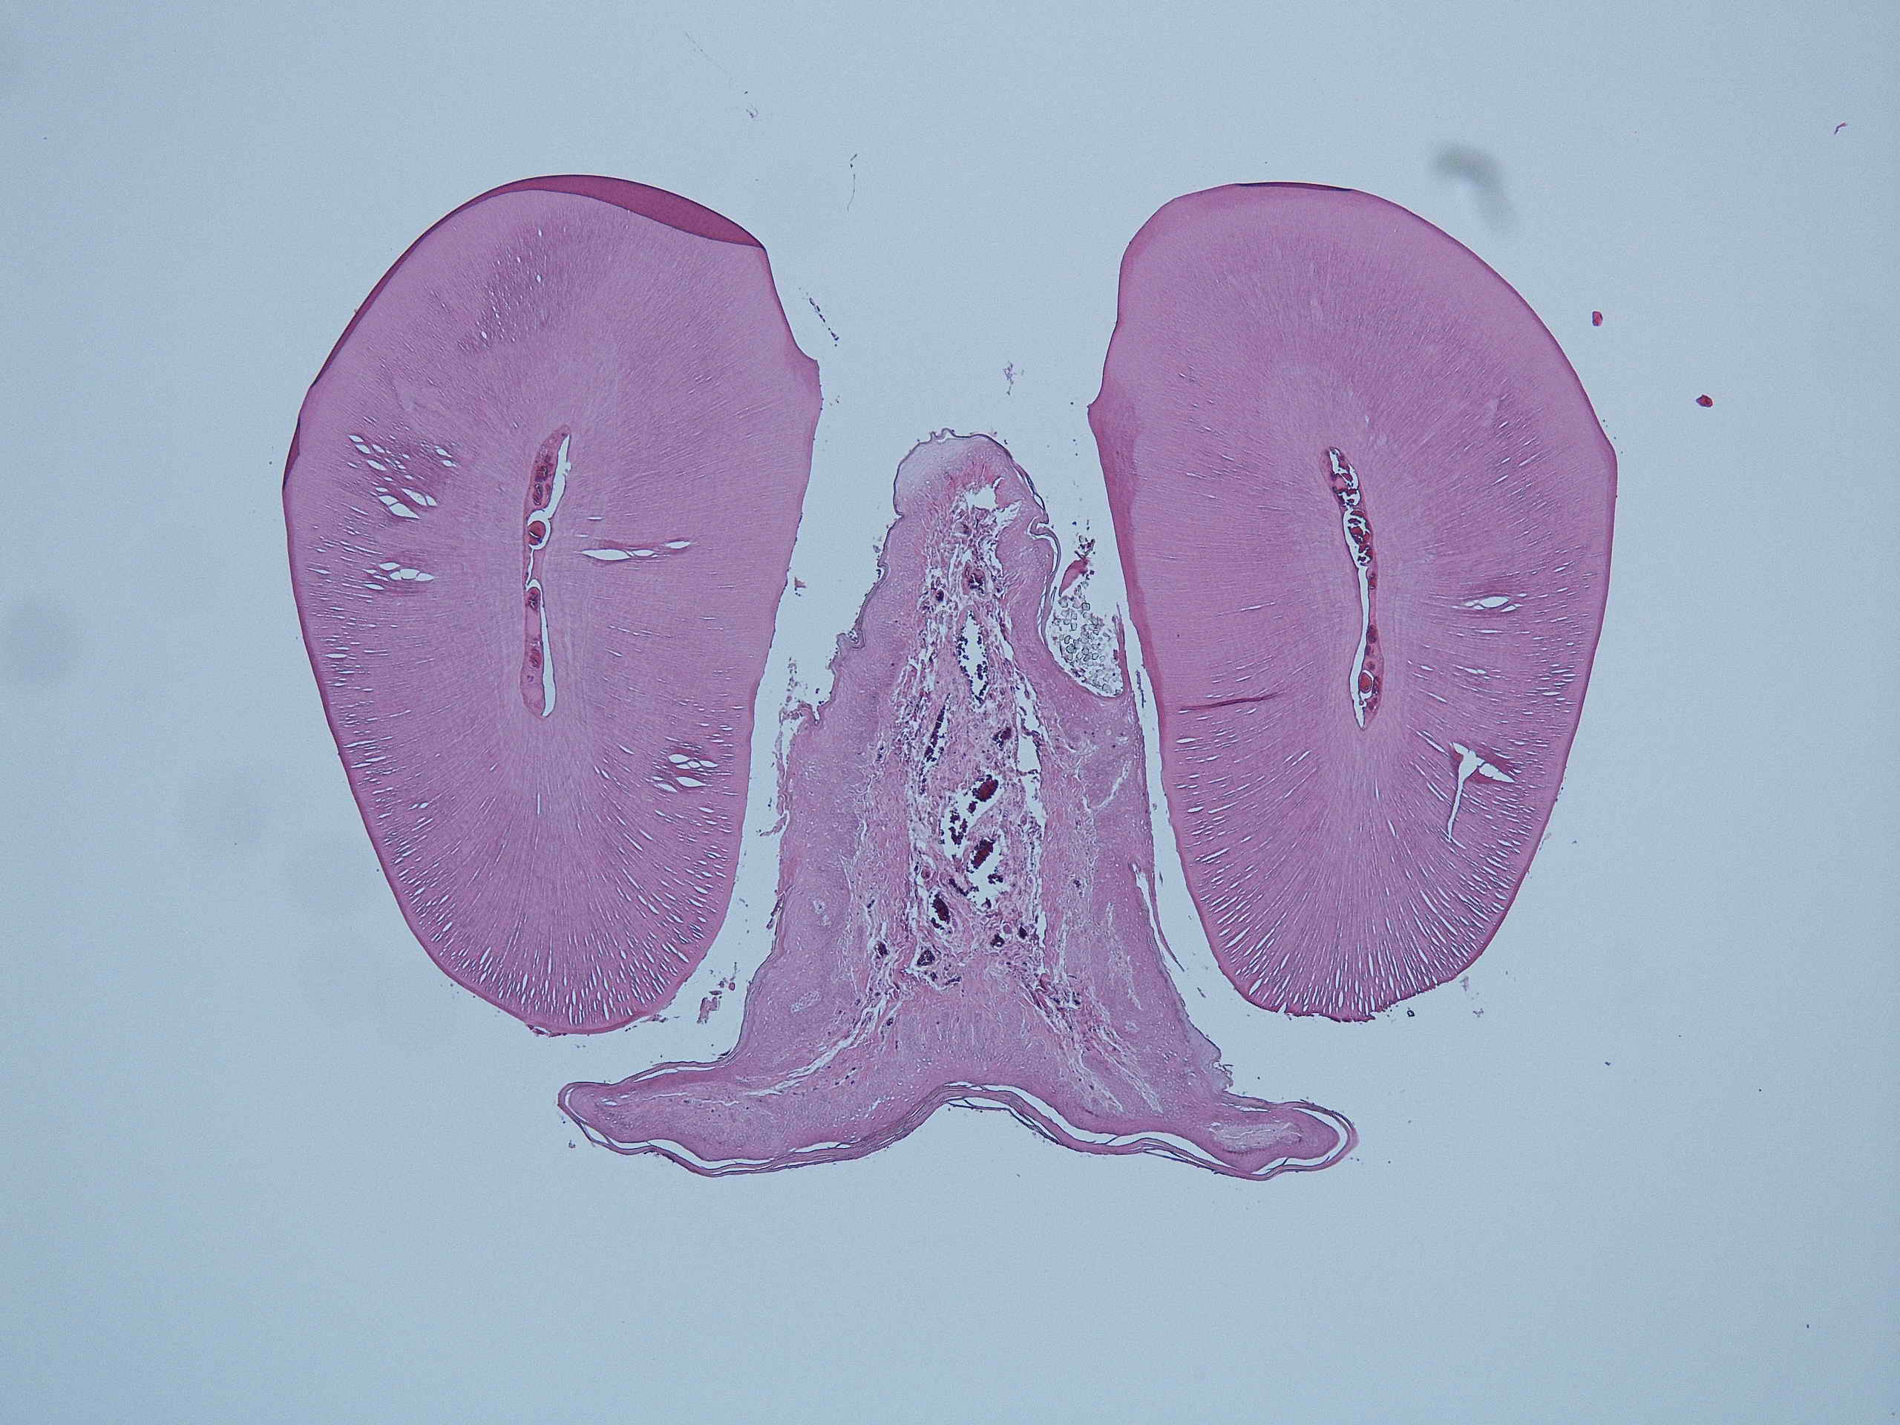  Level 1 |  | 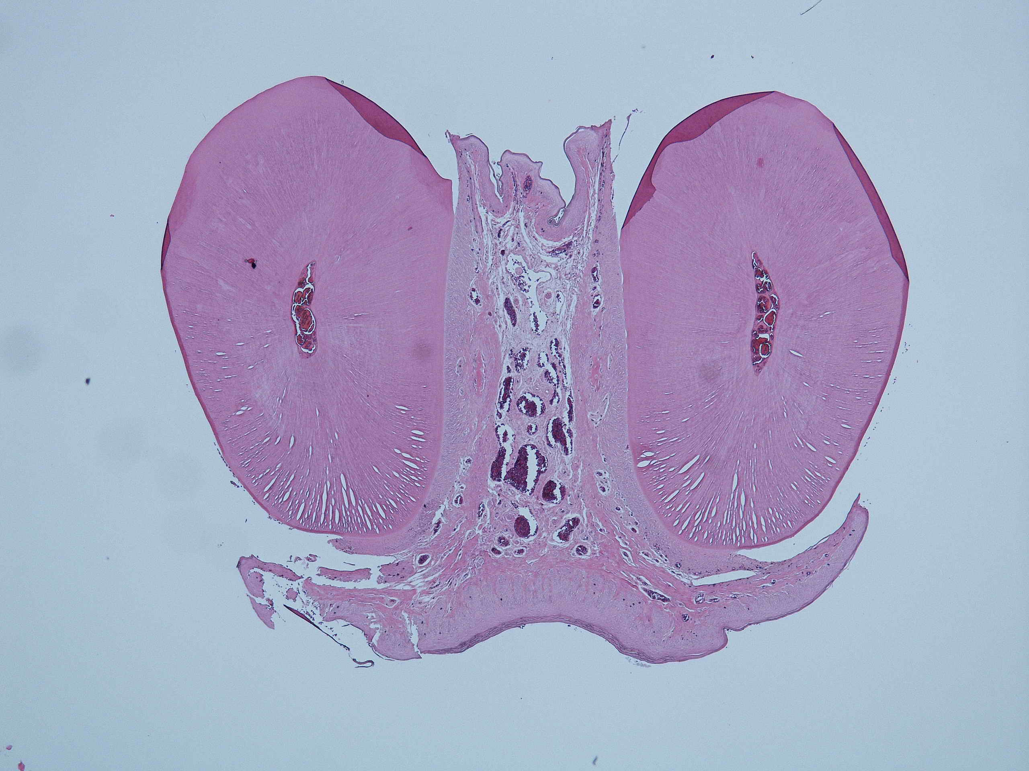  Level 2

Figure 2 The gingival morphology of mandibular central papillae in the four animal groups depending on the treatment of tacrolimus and nifedipine. The top photographs show the lingual aspect of central mandibular papillae and surrounding gingivae from a rat in control group (I), nifedipine group (II), tacrolimus group (III) and combined drug group (VI) at the end of week 6. (Original magnification, 15 ×). The plots A to C show the gingival morphological changes of central mandibular papillae recorded on stone models in four animal groups during six weeks (mean ± standard deviations, the buccolingual depth, mesiodistal width, and vertical height). The plot D represents the statistical analyses of plot A to C. (Bars: means and standard deviations; *: significant difference among the observation intervals or the treatment groups using two-way ANOVA; A to C or a to c: significant difference in the observation intervals or the treatment groups were achieved; significant difference at p < 0.001) (Cont: control group, nifedipine: nifedipine group, tacrolimus: tacrolimus group and Comb: the tacrolimus+nifedipine group).

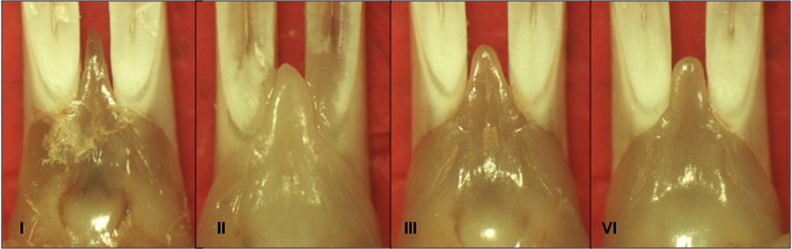
Figure 3 The gingival probing depth and the keratinized gingiva width around the molars in the four animal groups depending on the tacrolimus and nifedipine treatment. The plot I shows the probing depth (I) at the distobuccal sites of the right and left first mandibular molars at the end of study. The plot II presents the width of keratinized gingiva at mesio-, mid-, and disto-buccal sites of the right and left first mandibular molars. (Bars: means and standard deviations; *: significant difference for the within-subjects factor or for the between-subjects factor using repeated-measures ANOVA; A,B: the subsets obtained after post hoc analysis if significant differences achieved for the between-subject or within-subjects factors; significance was set at P < 0.05) (Cont: control group, NIF: nifedipine group, Tcr: tacrolimus group, Comb: the tacrolimus+nifedipine group, Max: maxilla, Mand: mandible, and KGW: keratinized gingiva width).
Figure 4 The tissue areas of the central mandibular papilla in the four animal groups depending on the tacrolimus and nifedipine treatment. The histograms present the connective tissue areas (CT) and the epithelial areas (Epi.), as well as the total tissue area, on the histological sections selected at papillary level 1 and 2. (Bars: means and standard deviations; *: significant difference among the groups examined at each tissue level using one-way ANOVA; A to C: significant difference achieved; significant difference at p < 0.001) (Cont: control group, NIF: nifedipine group, Tcr: tacrolimus group and Comb: the tacrolimus+nifedipine group).

