Suppression of the TNF-alpha level is mediated by Gan-Luh-Yin (Traditional Chinese Medicine) in human oral cancer cells through the NF-kappaB, AKT and ERK-dependent pathways

Jai-Sing Yang¹, Chia-Chun Wu², Hong-Zin Lee³, Wen-Tsong Hsieh¹, Feng-Yao Tang⁴, Da-Tian Bau^{5,6}, Kuang-Chi Lai^{7,8}, Jin-Cherng Lein^{9,*}, and Jing-Gung Chung^{2,10,*}

¹Department of Pharmacology, , China Medical University, Taichung 404, Taiwan; ²Department of Biological Science and Technology, China Medical University, Taichung 404, Taiwan; ³School of Pharmacy, China Medical University, Taichung 404, Taiwan; ⁴Department of Nutrition, China Medical University, Taichung 404, Taiwan; ⁵Institute of Clinical Medical Science, China Medical University, Taichung 404, Taiwan; ⁶Terry Fox Cancer Research laboratory, China Medical University Hospital, Taichung 404, Taiwan; ⁷Department of Surgery, China Medical University Beigang Hospital, Yunlin 651, Taiwan; ⁸School of Medicine, China Medical University Hospital, Taichung 404, Taiwan; ⁹Graduate Institute of Pharmaceutical Chemistry, China Medical University, Taichung 404, Taiwan; ¹⁰Department of Biotechnology, Asia University, Taichung 413, Taiwan.

Running title: Gan-Luh-Yin reduces the TNF-α level in an oral cancer cell line

*Both have equal contributions

*Address correspondence to Prof. Jing-Gung Chung, Department of Biological Science and Technology, China Medical University, No 91, Hsueh-Shih Road, Taichung 40402, Taiwan. Tel: +886-4-2205 3366 ext 2161, fax: +886-4-2205 3764. E-mail address: jgchung@mail.cmu.edu.tw
Jin-Cherng Lein, Graduate Institute of Pharmaceutical Chemistry, China Medical University, Taichung 404, Taiwan, No 91, Hsueh-Shih Road, Taichung 40402, Taiwan. Tel: +886-4-2205 3366 ext 5607, fax: +886-4-2205 3764. E-mail address: jclein@mail.cmu.edu.tw
Abstract. Oral cancer is one of the major causes of deaths in the male population of Taiwan. Gan-Luh-Yin (GLY) is used for an adjuvant treatment of Traditional Chinese Medicine in clinical patients. In this study, we investigated the molecular mechanisms in oral cancer cell lines after exposure to GLY. The cytometric bead-based array (CBA) method was used for the examining and analyzing of tumor necrosis factor-alpha (TNF-α) secretion level. TNF-α mRNA expression was determined by real-time PCR analysis. Nuclear factor-kappaB (NF-κB) activity and other relative proteins were determined by NF-κB promoter assay, Western blotting, electrophoretic mobility shift assay (EMSA) and immuno-staining analyses. GLY decreased the secretion of TNF–α from the oral cancer CAL 27 cells. Furthermore, two thousand μg/ml of GLY significantly suppressed TNF-α mRNA expression of CAL 27 cells in a time-dependent manner. GLY reduced the levels of proteins, including nuclear NF-κB (p65 and p50), p-IKK (ser176), p-IκB, p-AKT, p-ERK and nuclear Egr-1 in a time and dose-dependent manner. GLY also suppressed the NF-κB activity and translocation in CAL 27 cells. We suggest that GLY might promote the cure of oral cancer through decreasing the level of TNF-α cytokine, and these actions were mediated partially through the NF-κB, AKT and ERK-dependent pathways in vitro.

Keywords: Gan-Luh-Yin; Traditional Chinese Medicine; Cytokines; TNF-α; NF-κB; AKT and ERK-dependent pathways
Introduction
Globally there is an estimated 300,000 cases of oral or pharyngeal per year and males contain higher incidences than that of females . The important factors for causing oral cancer include tobacco smoking . betel quid , heavy alcohol drinking and micronutrient deficiency . It was reported that a person whether exposure to two or more of these factors could develop increased oral cancer risk . However, in Taiwan, betel quid chewing is one of the important factors for oral cancer development. The Department of Health, R.O.C. (Taiwan) has demonstrated that about 9.7 persons per 100 thousand die annually by oral cancer in 2009 . The clinical therapies for oral cancer patients include surgery, radiotherapy and chemotherapy but the cure rates so far are unsatisfactory. Therefore, the investigators are focused on new agents and novel targets for oral cancer treatment.
Gan-Luh-Yin (GLY) has been used as a traditional Chinese medicine (TCM) in the Chinese population. Clinically, stomatitis, aphthous ulcer, cancer of the tongue and nasopharyngeal carcinoma are treated with GLY. Currently, it is still used for oral cancer patients after surgery and radiation therapy. GLY was prepared by extracting a mixture of Glycyrrhilza uralensis, Liriope spicata, Citrus sinensis, Rehmannia glutinose, Artemisia capillaris, Eriobotrya japonica, Dendrobium nobile, Scutellaria baicalensis and Asparagus cochinchinensis. Many studies have reported that all mixtures have anti-allergic, anti-cancer, anti-inflammatory effects and immuno-modulation responses . In this study, we investigated the effects of immune responses of oral cancer cell lines after GLY treatment. Our results indicated that GLY is able to regulate the level of TNF-α cytokine, and the inhibition of TNF-α cytokine secretion via the NF-κB, AKT and ERK-dependent pathways in human oral cancer CAL 27 cells.

Materials and Methods
Chemicals and reagents. GLY had been used for oral cancer patients since long time ago in Taiwan. GLY was prepared by extracting a mixture including 125 g of Glycyrrhilza uralensis, Liriope spicata, Citrus sinensis, Rehmannia glutinose, Artemisia capillaries, Eriobotrya japonica, Dendrobium nobile, Scutellaria baicalensis and Asparagus cochinchinensis with boiling in 5000 ml of distilled water under reflux for 2.5 h. The pooled extract was filtered and concentrated by evaporation with stirring and heating to dry. Dimethyl sulfoxide (DMSO) was purchased from Sigma-Aldrich Co. (St. Louis, MO, USA).

Cell cultures. The human tongue cancer line SCC-4 was purchased from the Food Industry Research and Development Institute (Hsinchu, Taiwan). The human oral carcinoma cell lines (CAL 27, HSC-3 and TW 206) were obtained from Dr. Pei-Jung Lu (Graduate Institute of Clinical Medicine, National Cheng Kung University, Tainan, Taiwan). Cells were grown at 37 °C, in a humidified 5% CO₂ and 95% air, in RPMI-1640 medium supplemented with 10% fetal bovine serum, 2 mM L-glutamine, 100 Units/ml penicillin and 100 μg/ml streptomycin (Invitrogen Life Technologies, Carlsbad, CA, USA) .

TNF-α determination by cytometric bead array (CBA) method and flow cytometric analysis. About 2.5 ×10⁵ cells seeded onto 24-well culture plate were treated with various concentrations (0, 200, 1000 and 2000 μg/ml) of GLY in RPMI-1640 medium for 48 h. Collected media were centrifuged, and supernatants were subjected to assays for levels of cytokines as described previously . Analysis of TNF-α. cytokine from the supernatants was conducted using the human Th1/Th2 cytometric bead array kit (BD Biosciences, San Diego, CA, USA) and was analyzed by flow cytometry .

TNF-α mRNA determination by real-time PCR. The total RNA was extracted from CAL 27 cells (5 × 10⁵ cells) after treatment with 2000 μg/ml of GLY for 6, 12 and 24 h by using the Qiagen RNeasy Mini Kit (Qiagen, inc., Valencia, CA, USA) as described previously . RNA samples were reverse-transcribed for cDNA at 42°C for 30 min by using High Capacity cDNA Reverse Transcription Kit according to the standard protocol of the supplier (Applied Biosystems, Carlsbad, CA, USA). Then the quantitative PCR was performed using the following condition: 50°C for 2 min, 95°C for 10 min, and at 95°C for 40 cycles of 15 sec, at 60°C for 1 min using 1 μl of the cDNA reverse-transcribed as described above, 2X SYBR Green PCR Master Mix (Applied Biosystems) and 200 nM of forward (F) and reverse (R) primers (Actin: F-ATTGGCAATGAGCGGTTC, R-GGATGCCACAGGACTCCAT; TNF-α: F-TAGCAGATGCTGGTCATGTG, R-TTGCACCACAGGTCAAAAG). Each assay was run on an Applied Biosystems 7300 Real-Time PCR system in triplicates and expression fold-changes were derived using the comparative C_{T} method .

Western blotting analyses. CAL 27 cells (1 × 10⁶ cells) were treated with 2000 μg/ml of GLY for different intervals of time (0, 2, 4 and 6 h) and at various concentrations (0, 200, 1000 and 2000 μg/ml) for 24 h-exposure to determine the alteration of protein levels. The cells were harvested and the nuclear proteins and total proteins were collected for detection as described previously . Briefly, proteins were resolved over 12% SDS-PAGE and blot was incubated with individual monoclonal primary antibodies such as NF-κB p65, NF-κB p50, phospho-IKK (Ser176), phospho-IκB, phospho-AKT, AKT, phospho-ERK (p44/42), ERK (p44/42), Egr-1, PCNA and α-tubulin (Santa Cruz Biotechnology, Inc., Santa Cruz, CA, USA). Each blot was stained by a horseradish peroxidase-conjugated secondary antibody (Santa Cruz Biotechnology, Inc.) and detected by ECL kit (Millipore, Billerica, MA, USA) and autoradiography using X-ray film . The band density on film from Western blotting was determined and performed by NIH ImageJ software .

Immuno-staining and fluorescence microscopy. CAL 27 cells (2 × 10⁵ cells) were then treated with 2000 μg/ml GLY for 24 h, and then fixed in 4% formaldehyde (Sigma-Aldrich Corp.) for 15 min. The cells were permeabilized with 0.1% Triton-X 100 in PBS with blocking using 2% BSA. The fixed cells were incubated with anti-human NF-κB p65 antibody (1:100 dilution) overnight followed by exposure to the secondary antibody (FITC-conjugated goat anti-mouse IgG at 1:100 dilution; Santa Cruz Biotechnology, Inc.), and then nuclei were stained with PI. Finally, the cells were photographed under a Leica fluorescence Microscope .

NF-κB activity determination by NF-κB promoter assay. CAL 27 cells (5 × 10⁵ cells) were co-transfected with 0.5 μg NF-κB promoter plasmid and 0.5 μg β-galactosidase expression vectors and grown to 60% confluence onto 12-well plates before being transfected by Lipofectamine 2000 (Invitrogen) for 5 min. The mixture was incubated for 25 min at room temperature and added to each well and after the 24 h transfection was complete, the cells were incubated with the GLY. For preparing lysates, 100 μL of reporter lysis buffer (Promega, Madison, WI, USA) was added to each group, and cells were scraped from dishes and supernatant was collected from each well by centrifugation at 13,000 rpm for 30 s. Equal amounts of protein (10–20 μg) were placed into wells of an opaque black 96-well microplate. Then an equal volume of luciferase substrate was added to all wells, and luminescence was measured in a microplate luminometer as described previously .

Electrophoretic mobility shift assay (EMSA). The nuclear extracts were preformed from GLY-treated CAL 27 cells (5 × 10⁵ cells) by using the NE-PER Nuclear and Cytoplasmic Extraction kit (Pierce, Rockford, Illinois, USA). The protein concentrations were determined and the biotin end-labeled oligonucleotide sequences 5’-Biotin-GATCCAGGGGACTTTCCCTAGC-3’corresponding to the consensus of NF-κB was developed. The isolated 5 μg nuclear extract proteins were used for EMSA with a LightShift Chemiluminescent EMSA Kit (Pierce) based on the protocol of the manufacturer. After the biotin end-labeled duplex DNA was obtained, it then was incubated with a nuclear extract or purified factor and underwent electrophoresis on 6% polyacrylamide native gel. Then a 100-fold excess of unlabeled double stranded oligonucleotide was added to the reaction for competition experiments and the DNA was then rapidly transferred to a positive nylon membrane, UV cross-linked, probed with biotin-HRP conjugate and incubated with the substrate of ECL kit (Millipore) .

Data statistics analyses. Experiments were repeated at a minimum of three times with consistent results. Data is expressed as the mean ± S.D. One-way ANOVA was used to examine the significance of differences in measured variables between control and treated groups followed by Bonferroni’s test for multiple comparisons. Significance was declared at p < 0.05.

Results
The effects of GLY on the release of cytokines from oral cancer cell lines. The results from CBA analysis in Figure 1 showed that GLY significantly decreased TNF-α release in CAL 27 cells. Besides, the levels of IL-2, IL-4, IL-6 IL-10 and IFN-γ cytokines were determined by CBA analyses. Results indicated that GLY increased the levels of IL-2 in SCC-4 and TW 206 cells, increased IL-4 and IFN-γ levels in all examined cells, increased IL-6 in SCC-4 cells, increased IL-10 in SCC-4 and CAL 27 cells, decreased IL-6 in SCC-4 cells, decreased IL-10 in HSC-3 cells (data not shown). These results suggest that GLY regulated the effects of cytokines in oral cancer cell lines.

GLY inhibited the gene transcription of TNF-α mRNA in CAL 27 cells. To determine the effects of GLY on the transcription of TNF-α mRNA that were investigated and determined by real-time PCR analysis. The results are shown in Figure 2. Expression of mRNA for TNF-α was suppressed in a time-dependent manner when the CAL 27 cells were incubated with 2000 μg/ml of GLY. Our results suggest that GLY might regulate TNF-α cytokine production at gene levels.

GLY decreased NF-κB signaling pathway-associated protein levels, NF-κB translocation, and NF-κB activity in CAL 27 cells. To determine NF-κB signaling pathway was involved in the TNF-α cytokine secretion in CAL 27 cells, the effects of GLY on NF-κB were investigated. As shown in Figure 3, GLY inhibited the proteins levels of nuclear NF-κB (p65 and p50) in time- (Fig.3A) and concentration-dependent manners (Fig.3B) by Western blotting analysis. GLY also decreased the proteins levels of p-IKK and p-IκB in time- (Fig.3C) and dose-dependent manners (Fig.3D) by Western blotting analysis. In Figure 4A, GLY attenuated the NF-κB (p65) translocation to nuclear by immuno-staining analysis. Based on the promoter activity assay of NF-κB, GLY inhibited the expression of NF-κB at transcriptional level in a time-dependent manner (Fig. 4B). In Figure 4C, results from EMSA also showed that GLY reduced the level of NF-κB binding to the DNA and this effect is a time-dependent response. Our results suggest that GLY inhibited TNF-α cytokine production through the inhibition of NF-κB-dependent pathway in oral cancer CAL 27 cells.

GLY suppressed AKT and ERK associated proteins expression in CAL 27 cells. To confirm the mitogen-activated protein kinases (MAPKs) and AKT pathways were involved in TNF-α cytokine secretion in CAL 27 cells, the effects of GLY on MAPKs and AKT were investigated . As shown in Figure 5A, GLY inhibited the proteins levels of p-AKT and p-ERK in time- (Fig.5A) and concentration-dependent manners (Fig.5B) by Western blotting analysis. Moreover, GLY also inhibited the ERK downstream transcription factor protein level of nuclear Egr-1 on CAL 27 cells in time- (Fig.5C) and concentration-dependent manners (Fig.5D) by Western blotting analysis. However, GLY did not affect the protein levels of p-JNK, JNK, p-p38 and p38 of CAL 27 cells (data not shown). Our results suggest that GLY inhibited TNF-α cytokine production through inhibiting the AKT and ERK-dependent pathways in CAL 27 cells.

Discussion
It was reported that tumor cells can destruct the balance of the immune system via releasing elevated levels of inhibitory cytokines . Therefore, the investigation and observation of the regulatory effects of cell types on the immune system is important and may lead to understanding whether the host survives or dies after cancer development. In the present study, we first investigated the effects of GLY on cytokines among different oral cancer cell lines and to find out the possible signal pathway. Oral cancer patients have lower T and B cells , but tumor cells secreted substances which can suppress local immunity and affect the phenotype of infiltrating T cells and macrophages then lead to the active inhibition of the proliferation of antigen-specific T cells and depression of a local inflammatory response . In our study, we showed that GLY significantly inhibited the secretion of TNF-α from CAL 27 cells (Fig. 1). Furthermore, GLY promoted the secretion of IL-2 from SCC-4 and TW 206 oral cancer cells, and the secretion of IL-4 from SCC-4, CAL 27, HSC-3 and TW 206 oral cancer cells. However, GLY inhibited IL-6 secretion of SCC-4 cells and it promoted the secretion of IFN-γ from CAL 27, SCC-4, HSC-3 and TW 206 cells (data not shown). The reports from other investigators demonstrated that patients with head and neck squamous cell carcinoma (HNSCC) are biased toward the Th2 phenotype as they have increased levels of the Th2 cytokines IL-4, IL-6 and IL-10 and diminished levels of the Th1 cytokine IFN-γ . Myers et al. demonstrated that specific growth stimulatory effects of IL-4 on the proliferation of head and neck squamous cell carcinoma (HNSCC) in vitro and HNSCC cell lines can be stimulated to proliferate in the presence of exogenous recombinant human IL-4 . Sung et al. demonstrated that protective effects of IFN-γ on target cell sensitivity to lysis were blocked by pre-treatment of target cells with actinomycin-D or cycloheximide . We suggest that IL-4 has an important role in the promotion of cancer cell proliferation, and IFN-γ also inhibits the toxic effect for anti-cancer drugs in HNSCC.
In our results from CBA analysis, GLY increased the levels of IL-4 and IFN-γ in all examined oral cancer cells, but it exhibited only slight changes in these concentrations (IL-4: Control: 1 pg/ml; GLY: 1-2.5 pg/ml. IFN-gamma: Control: 1-2 pg/ml; GLY: 2-3 pg/ml.) (data not shown). In Taiwan, patients with tongue cancer were treated with GLY which has anti-inflammatory effects and immuno-modulation responses. TNF-α is a major cytokine involved in inflammatory human head and neck squamous cell carcinoma. In our results from CBA analysis, GLY decreased the level of TNF-α in examined cells, especially in CAL 27 cells (Control: 27 pg/ml; GLY: 13.8 pg/ml) (Fig. 1). Therefore, our study just focuses on GLY-regulated the level of TNF-α, and inhibited the TNF-α cytokine secretion via the NF-κB, AKT and ERK-dependent pathways in CAL 27 cells.
Previous studies of human oral cancer cell lines have demonstrated that the concentration of certain pro-inflammatory, pro-angiogenic cytokines such as up-regulation of TNF-α, IL-1, IL-6, and IL-8 . There is much evidence that these cytokines are produced in oral cancer cell lines and that is involved in cell growth, invasion of tumor suppression, immune status and even survival. It was reported that TCM can modulate the pro-inflammatory cytokines and the ability of TCM to modulate pro-inflammatory cytokines coincides with its proposed cancer suppressing activities. GLY has been used as a TCM for complementary therapy in Taiwan for a long time in oral cancer patients. Our results from CBA analysis demonstrated that GLY significantly decreased TNF-α in CAL 27 cells (Fig. 1). In Figure 2, the expression of mRNA for TNF-α was suppressed in a time-dependent manner on CAL 27 cells after GLY exposure. Our data indicated that TNF-α may be an important target in GLY-treated CAL 27 cells. TCM has been reported to regulate the activity of the transcription factor NF-κB in a number of different cell types . NF-κB is a central mediator of the immune-regulation and inflammatory response. Figures 3 and 4 indicated that GLY inhibited the protein levels of nuclear NF-κB, p-IKK, p-IκB, p-AKT and p-ERK in time- and concentration-dependent manners by Western blotting analysis. Our results also showed that GLY decreased the translocation of NF-κB to nuclei (Fig. 4A) and it decreased NF-κB activity by promoter activity assay (Fig. 4B) and EMSA (Fig. 4C). GLY inhibited TNF-α cytokine production through inhibition of the NF-κB, AKT and ERK-dependent pathways in human oral cancer CAL 27 cells.
We demonstrated that GLY is able to modulate the secretion of cytokines and significantly suppressed spontaneous the level of TNF-α mRNA. Also, GLY decreased protein levels of NF-κB, AKT and ERK relative signaling, and it attenuated the NF-κB activity and translocation in CAL 27 cells.
The GLY-inhibited TNF-α secretion in CAL 27 cells was mediated partially through suppressing the NF-κB, AKT and ERK-dependent pathways, and the proposed signal model as can be seen in Figure 6.

Acknowledgments
This work was supported by grant CMU99-ASIA-23 from China Medical University, Taichung, Taiwan. Experiments and data analysis were performed in part through the use of the Medical Research Core Facilities Center, Office of Research & Development at China medical University, Taichung, Taiwan, R.O.C.

References
Applebaum KM, Furniss CS, Zeka A, Posner MR, Smith JF, Bryan J, Eisen EA, Peters ES, McClean MD, Kelsey KT. 2007. Lack of association of alcohol and tobacco with HPV16-associated head and neck cancer. J Natl Cancer Inst 99:1801-1810.
Baan R, Straif K, Grosse Y, Secretan B, El Ghissassi F, Bouvard V, Altieri A, Cogliano V. 2007. Carcinogenicity of alcoholic beverages. Lancet Oncol 8:292-293.
Balaram P, Sridhar H, Rajkumar T, Vaccarella S, Herrero R, Nandakumar A, Ravichandran K, Ramdas K, Sankaranarayanan R, Gajalakshmi V and others. 2002. Oral cancer in southern India: the influence of smoking, drinking, paan-chewing and oral hygiene. Int J Cancer 98:440-445.
Banno N, Akihisa T, Tokuda H, Yasukawa K, Taguchi Y, Akazawa H, Ukiya M, Kimura Y, Suzuki T, Nishino H. 2005. Anti-inflammatory and antitumor-promoting effects of the triterpene acids from the leaves of Eriobotrya japonica. Biol Pharm Bull 28:1995-1999.
Bhat NR, Zhang P, Lee JC, Hogan EL. 1998. Extracellular signal-regulated kinase and p38 subgroups of mitogen-activated protein kinases regulate inducible nitric oxide synthase and tumor necrosis factor-alpha gene expression in endotoxin-stimulated primary glial cultures. J Neurosci 18:1633-1641.
Boccia S, Cadoni G, Sayed-Tabatabaei FA, Volante M, Arzani D, De Lauretis A, Cattel C, Almadori G, van Duijn CM, Paludetti G and others. 2008. CYP1A1, CYP2E1, GSTM1, GSTT1, EPHX1 exons 3 and 4, and NAT2 polymorphisms, smoking, consumption of alcohol and fruit and vegetables and risk of head and neck cancer. J Cancer Res Clin Oncol 134:93-100.
Chang MC, Chiang CP, Lin CL, Lee JJ, Hahn LJ, Jeng JH. 2005. Cell-mediated immunity and head and neck cancer: with special emphasis on betel quid chewing habit. Oral Oncol 41:757-775.
Chang Y-M, Velmurugan BK, Kuo W-W, Chen Y-S, Ho T-J, Tsai C-T, Ye C-X, Tsai C-H, Tsai F-J, Huang C-Y. 2013. Inhibitory effect of alpinate Oxyphyllae fructus extracts on Ang II-induced cardiac pathological remodeling-related pathways in H9c2 cardiomyoblast cells. BioMedicine 3:148-152.
Chiang JH, Yang JS, Ma CY, Yang MD, Huang HY, Hsia TC, Kuo HM, Wu PP, Lee TH, Chung JG. 2011. Danthron, an anthraquinone derivative, induces DNA damage and caspase cascades-mediated apoptosis in SNU-1 human gastric cancer cells through mitochondrial permeability transition pores and Bax-triggered pathways. Chem Res Toxicol 24:20-29.
Elgert KD, Alleva DG, Mullins DW. 1998. Tumor-induced immune dysfunction: the macrophage connection. J Leukoc Biol 64:275-290.
Fong YC, Maa MC, Tsai FJ, Chen WC, Lin JG, Jeng LB, Yang RS, Fu WM, Tang CH. 2008. Osteoblast-derived TGF-beta1 stimulates IL-8 release through AP-1 and NF-kappaB in human cancer cells. J Bone Miner Res 23:961-970.
Hashibe M, Brennan P, Benhamou S, Castellsague X, Chen C, Curado MP, Dal Maso L, Daudt AW, Fabianova E, Fernandez L and others. 2007. Alcohol drinking in never users of tobacco, cigarette smoking in never drinkers, and the risk of head and neck cancer: pooled analysis in the International Head and Neck Cancer Epidemiology Consortium. J Natl Cancer Inst 99:777-789.
Hsiang CY, Lai IL, Chao DC, Ho TY. 2002. Differential regulation of activator protein 1 activity by glycyrrhizin. Life Sci 70:1643-1656.
Hsu YL, Kuo PL, Tzeng TF, Sung SC, Yen MH, Lin LT, Lin CC. 2008. Huang-lian-jie-du-tang, a traditional Chinese medicine prescription, induces cell-cycle arrest and apoptosis in human liver cancer cells in vitro and in vivo. J Gastroenterol Hepatol 23:e290-299.
Ibanez MD, Sastre J, San Ireneo MM, Laso MT, Barber D, Lombardero M. 2004. Different patterns of allergen recognition in children allergic to orange. J Allergy Clin Immunol 113:175-177.
Jang SI, Kim YJ, Kim HJ, Lee JC, Kim HY, Kim YC, Yun YG, Yu HH, You YO. 2006. Scoparone inhibits PMA-induced IL-8 and MCP-1 production through suppression of NF-kappaB activation in U937 cells. Life Sci 78:2937-2943.
Jo EH, Kim SH, Ra JC, Kim SR, Cho SD, Jung JW, Yang SR, Park JS, Hwang JW, Aruoma OI and others. 2005. Chemopreventive properties of the ethanol extract of chinese licorice (Glycyrrhiza uralensis) root: induction of apoptosis and G1 cell cycle arrest in MCF-7 human breast cancer cells. Cancer Lett 230:239-247.
Kim HM, An CS, Jung KY, Choo YK, Park JK, Nam SY. 1999. Rehmannia glutinosa inhibits tumour necrosis factor-alpha and interleukin-1 secretion from mouse astrocytes. Pharmacol Res 40:171-176.
Koo HN, Jeong HJ, Choi JY, Choi SD, Choi TJ, Cheon YS, Kim KS, Kang BK, Park ST, Chang CH and others. 2000. Inhibition of tumor necrosis factor-alpha-induced apoptosis by Asparagus cochinchinensis in Hep G2 cells. J Ethnopharmacol 73:137-143.
Lathers DM, Achille NJ, Young MR. 2003. Incomplete Th2 skewing of cytokines in plasma of patients with squamous cell carcinoma of the head and neck. Hum Immunol 64:1160-1166.
Lee do Y, Choo BK, Yoon T, Cheon MS, Lee HW, Lee AY, Kim HK. 2009. Anti-inflammatory effects of Asparagus cochinchinensis extract in acute and chronic cutaneous inflammation. J Ethnopharmacol 121:28-34.
Lee JH, Li YC, Ip SW, Hsu SC, Chang NW, Tang NY, Yu CS, Chou ST, Lin SS, Lino CC and others. 2008. The role of Ca2+ in baicalein-induced apoptosis in human breast MDA-MB-231 cancer cells through mitochondria- and caspase-3-dependent pathway. Anticancer Res 28:1701-1711.
Lee YC, Lee JC, Seo YB, Kook YB. 2005. Liriopis tuber inhibit OVA-induced airway inflammation and bronchial hyperresponsiveness in murine model of asthma. J Ethnopharmacol 101:144-152.
Lin CC, Yang JS, Chen JT, Fan S, Yu FS, Yang JL, Lu CC, Kao MC, Huang AC, Lu HF and others. 2007a. Berberine induces apoptosis in human HSC-3 oral cancer cells via simultaneous activation of the death receptor-mediated and mitochondrial pathway. Anticancer Res 27:3371-3378.
Lin M-C, Tsai S-Y, Wang F-Y, Liu F-H, Syu J-N, Tang F-Y. 2013. Leptin induces cell invasion and the upregulation of matrilysin in human colon cancer cells. BioMedicine 3:174-180.
Lin MW, Tsao LT, Chang LC, Chen YL, Huang LJ, Kuo SC, Tzeng CC, Lee MR, Wang JP. 2007b. Inhibition of lipopolysaccharide-stimulated NO production by a novel synthetic compound CYL-4d in RAW 264.7 macrophages involving the blockade of MEK4/JNK/AP-1 pathway. Biochem Pharmacol 73:1796-1806.
Lu CC, Yang JS, Huang AC, Hsia TC, Chou ST, Kuo CL, Lu HF, Lee TH, Wood WG, Chung JG. 2010. Chrysophanol induces necrosis through the production of ROS and alteration of ATP levels in J5 human liver cancer cells. Mol Nutr Food Res 54:967-976.
Lu KW, Tsai ML, Chen JC, Hsu SC, Hsia TC, Lin MW, Huang AC, Chang YH, Ip SW, Lu HF and others. 2008. Gypenosides inhibited invasion and migration of human tongue cancer SCC4 cells through down-regulation of NFkappaB and matrix metalloproteinase-9. Anticancer Res 28:1093-1099.
Myers JN, Yasumura S, Suminami Y, Hirabayashi H, Lin W, Johnson JT, Lotze MT, Whiteside TL. 1996. Growth stimulation of human head and neck squamous cell carcinoma cell lines by interleukin 4. Clin Cancer Res 2:127-135.
Ozes ON, Mayo LD, Gustin JA, Pfeffer SR, Pfeffer LM, Donner DB. 1999. NF-kappaB activation by tumour necrosis factor requires the Akt serine-threonine kinase. Nature 401:82-85.
Parkin DM, Pisani P, Ferlay J. 1999. Estimates of the worldwide incidence of 25 major cancers in 1990. Int J Cancer 80:827-841.
Rahman M, Sakamoto J, Fukui T. 2005. Calculation of population attributable risk for bidi smoking and oral cancer in south Asia. Prev Med 40:510-514.
Rhodus NL, Ho V, Miller CS, Myers S, Ondrey F. 2005. NF-kappaB dependent cytokine levels in saliva of patients with oral preneoplastic lesions and oral squamous cell carcinoma. Cancer Detect Prev 29:42-45.
Room R, Babor T, Rehm J. 2005. Alcohol and public health. Lancet 365:519-530.
Shin EM, Zhou HY, Guo LY, Kim JA, Lee SH, Merfort I, Kang SS, Kim HS, Kim S, Kim YS. 2008. Anti-inflammatory effects of glycyrol isolated from Glycyrrhiza uralensis in LPS-stimulated RAW264.7 macrophages. Int Immunopharmacol 8:1524-1532.
Sung MW, Johnson JT, Van Dongen G, Whiteside TL. 1996. Protective effects of interferon-gamma on squamous-cell carcinoma of head and neck targets in antibody-dependent cellular cytotoxicity mediated by human natural killer cells. Int J Cancer 66:393-399.
Tang NY, Yang JS, Chang YH, Lu HF, Hsia TC, Lin WC, Chung JG. 2006. Effects of wogonin on the levels of cytokines and functions of leukocytes associated with NF-kappa B expression in Sprague-Dawley rats. In Vivo 20:527-532.
Wang HW, Lin CP, Chiu JH, Chow KC, Kuo KT, Lin CS, Wang LS. 2007. Reversal of inflammation-associated dihydrodiol dehydrogenases (AKR1C1 and AKR1C2) overexpression and drug resistance in nonsmall cell lung cancer cells by wogonin and chrysin. Int J Cancer 120:2019-2027.
Wang J, Yu Y, Hashimoto F, Sakata Y, Fujii M, Hou DX. 2004. Baicalein induces apoptosis through ROS-mediated mitochondrial dysfunction pathway in HL-60 cells. Int J Mol Med 14:627-632.
Young SH, Antonini JM, Roberts JR, Erdely AD, Zeidler-Erdely PC. 2008. Performance evaluation of cytometric bead assays for the measurement of lung cytokines in two rodent models. J Immunol Methods 331:59-68.
Yu CS, Yu FS, Chan JK, Li TM, Lin SS, Chen SC, Hsia TC, Chang YH, Chung JG. 2006. Aloe-emodin affects the levels of cytokines and functions of leukocytes from Sprague-Dawley rats. In Vivo 20:505-509.
Yu FS, Yang JS, Yu CS, Lu CC, Chiang JH, Lin CW, Chung JG. 2011. Safrole induces apoptosis in human oral cancer HSC-3 cells. J Dent Res 90:168-174.
Zhang H, Yan D, Shi X, Liang H, Pang Y, Qin N, Chen H, Wang J, Yin B, Jiang X and others. 2008. Transmembrane TNF-alpha mediates "forward" and "reverse" signaling, inducing cell death or survival via the NF-kappaB pathway in Raji Burkitt lymphoma cells. J Leukoc Biol 84:789-797.
Zhao W, Ye Q, Tan X, Jiang H, Li X, Chen K, Kinghorn AD. 2001. Three new sesquiterpene glycosides from Dendrobium nobile with immunomodulatory activity. J Nat Prod 64:1196-1200.

Figure legends
Figure 1. GLY affected the release of TNF-α on CAL 27 human oral cancer cell line. About 2.5×10⁵ cells/well in culture medium were treated with 0, 200, 1000 and 2000 μg/ml of GLY for 48 h. The collected media were subjected to assays for the level of TNF-α cytokine as described in Materials and Methods. The level of TNF-α was determined and quantified by CBA assay and flow cytomerty. Each point is the mean ± S.D. of three experiments: a, p < 0.05, significantly different compared with control (0 μg/ml); b, p < 0.05, significantly different compared with 200 μg/ml of GLY treatment by one-way ANOVA followed by Bonferroni’s multiple-comparison test.

Figure 2. GLY inhibited gene expression of TNF-α in CAL 27 cells. The total RNA was extracted from the CAL 27 cells after treatment with 2000 μg/ml of GLY for 0, 12 and 24 h. Then cDNA was produced and TNF-α was developed by using an Applied Biosystems 7300 Real-Time PCR system in triplicates and expression fold-changes were derived using the comparative C_{T} method as described in Materials and Methods. Each point is the mean ± S.D. of three experiments: a, p < 0.05, significantly different compared with control (0 h); b, p < 0.05, significantly different compared with GLY treatment for 12 h by one-way ANOVA followed by Bonferroni’s multiple-comparison test.

Figure 3. The effects of GLY on the protein levels of NF-κB p65, NF-κB p50 (panel A and B), p-IKK, and p-IκB (panel C and D) in CAL 27 cells. Cells were treated with 2000 μg/ml of GLY for 0, 2, 4 and 6 h (panel A and C) or exposed to 0, 200, 1000 and 2000 μg/ml of GLY for 24 h before cells were isolated for Western blotting assay as described in Materials and Methods. Each point is the mean ± S.D. of three experiments: a, p < 0.05, significantly different compared with control (0 h); b, p < 0.05, significantly different compared with GLY treatment for 2 h; d, p < 0.05, significantly different compared with 0 μg/ml of GLY treatment; e and f, p < 0.05, significantly different compared with 200 and 1000 μg/ml of GLY treatment, respectively, by one-way ANOVA followed by Bonferroni’s multiple-comparison test.

Figure 4. The effects of GLY on the levels of NF-κB p65 translocation (A), promoter activity (B) and DNA binding activity (C) of NF-κB on CAL 27 cells. The cells were treated with GLY for various periods of time before cells were isolated for immuno-staining, NF-κB promoter activity and EMSA assay as described in Materials and Methods. Each point is the mean ± S.D. of three experiments: a, p < 0.05, significantly different compared with control (0 h); b and c, p < 0.05, significantly different compared with GLY treatment for 6 and 12 h, respectively, by one-way ANOVA followed by Bonferroni’s multiple-comparison test.

Figure 5. The effects of GLY on the levels of p-AKT, AKT, p-ERK (p44/42), ERK (p44/42) (panel A and B) and ERK downstream transcription factor Egr-1 protein level (panel C and D) in CAL 27 cells. The cells were treated with GLY for various time periods and various concentrations before isolation for Western blotting analysis as described in Materials and Methods. Each point is the mean ± S.D. of three experiments. a, p < 0.05, significantly different compared with control (0 h); b and c, p < 0.05, significantly different compared with GLY treatment for 2 and 4 h, respectively; d, p < 0.05, significantly different compared with 0 μg/ml of GLY treatment; e and f, p < 0.05, significantly different compared with 200 and 1000 μg/ml of GLY treatment, respectively, by one-way ANOVA followed by Bonferroni’s multiple-comparison test.

Figure 6. The proposed model of GLY-suppressed TNF-α release in CAL 27 human oral cancer cells.
Figure 1
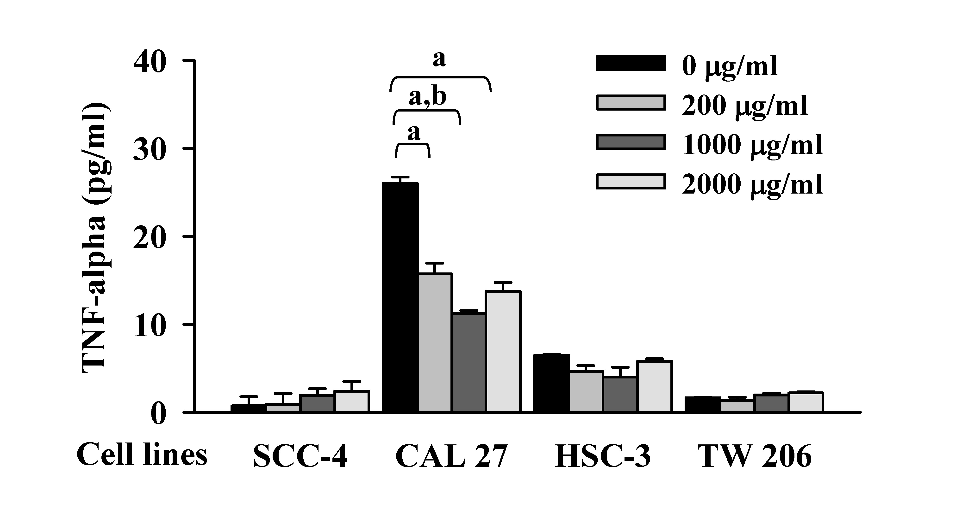
Figure 2
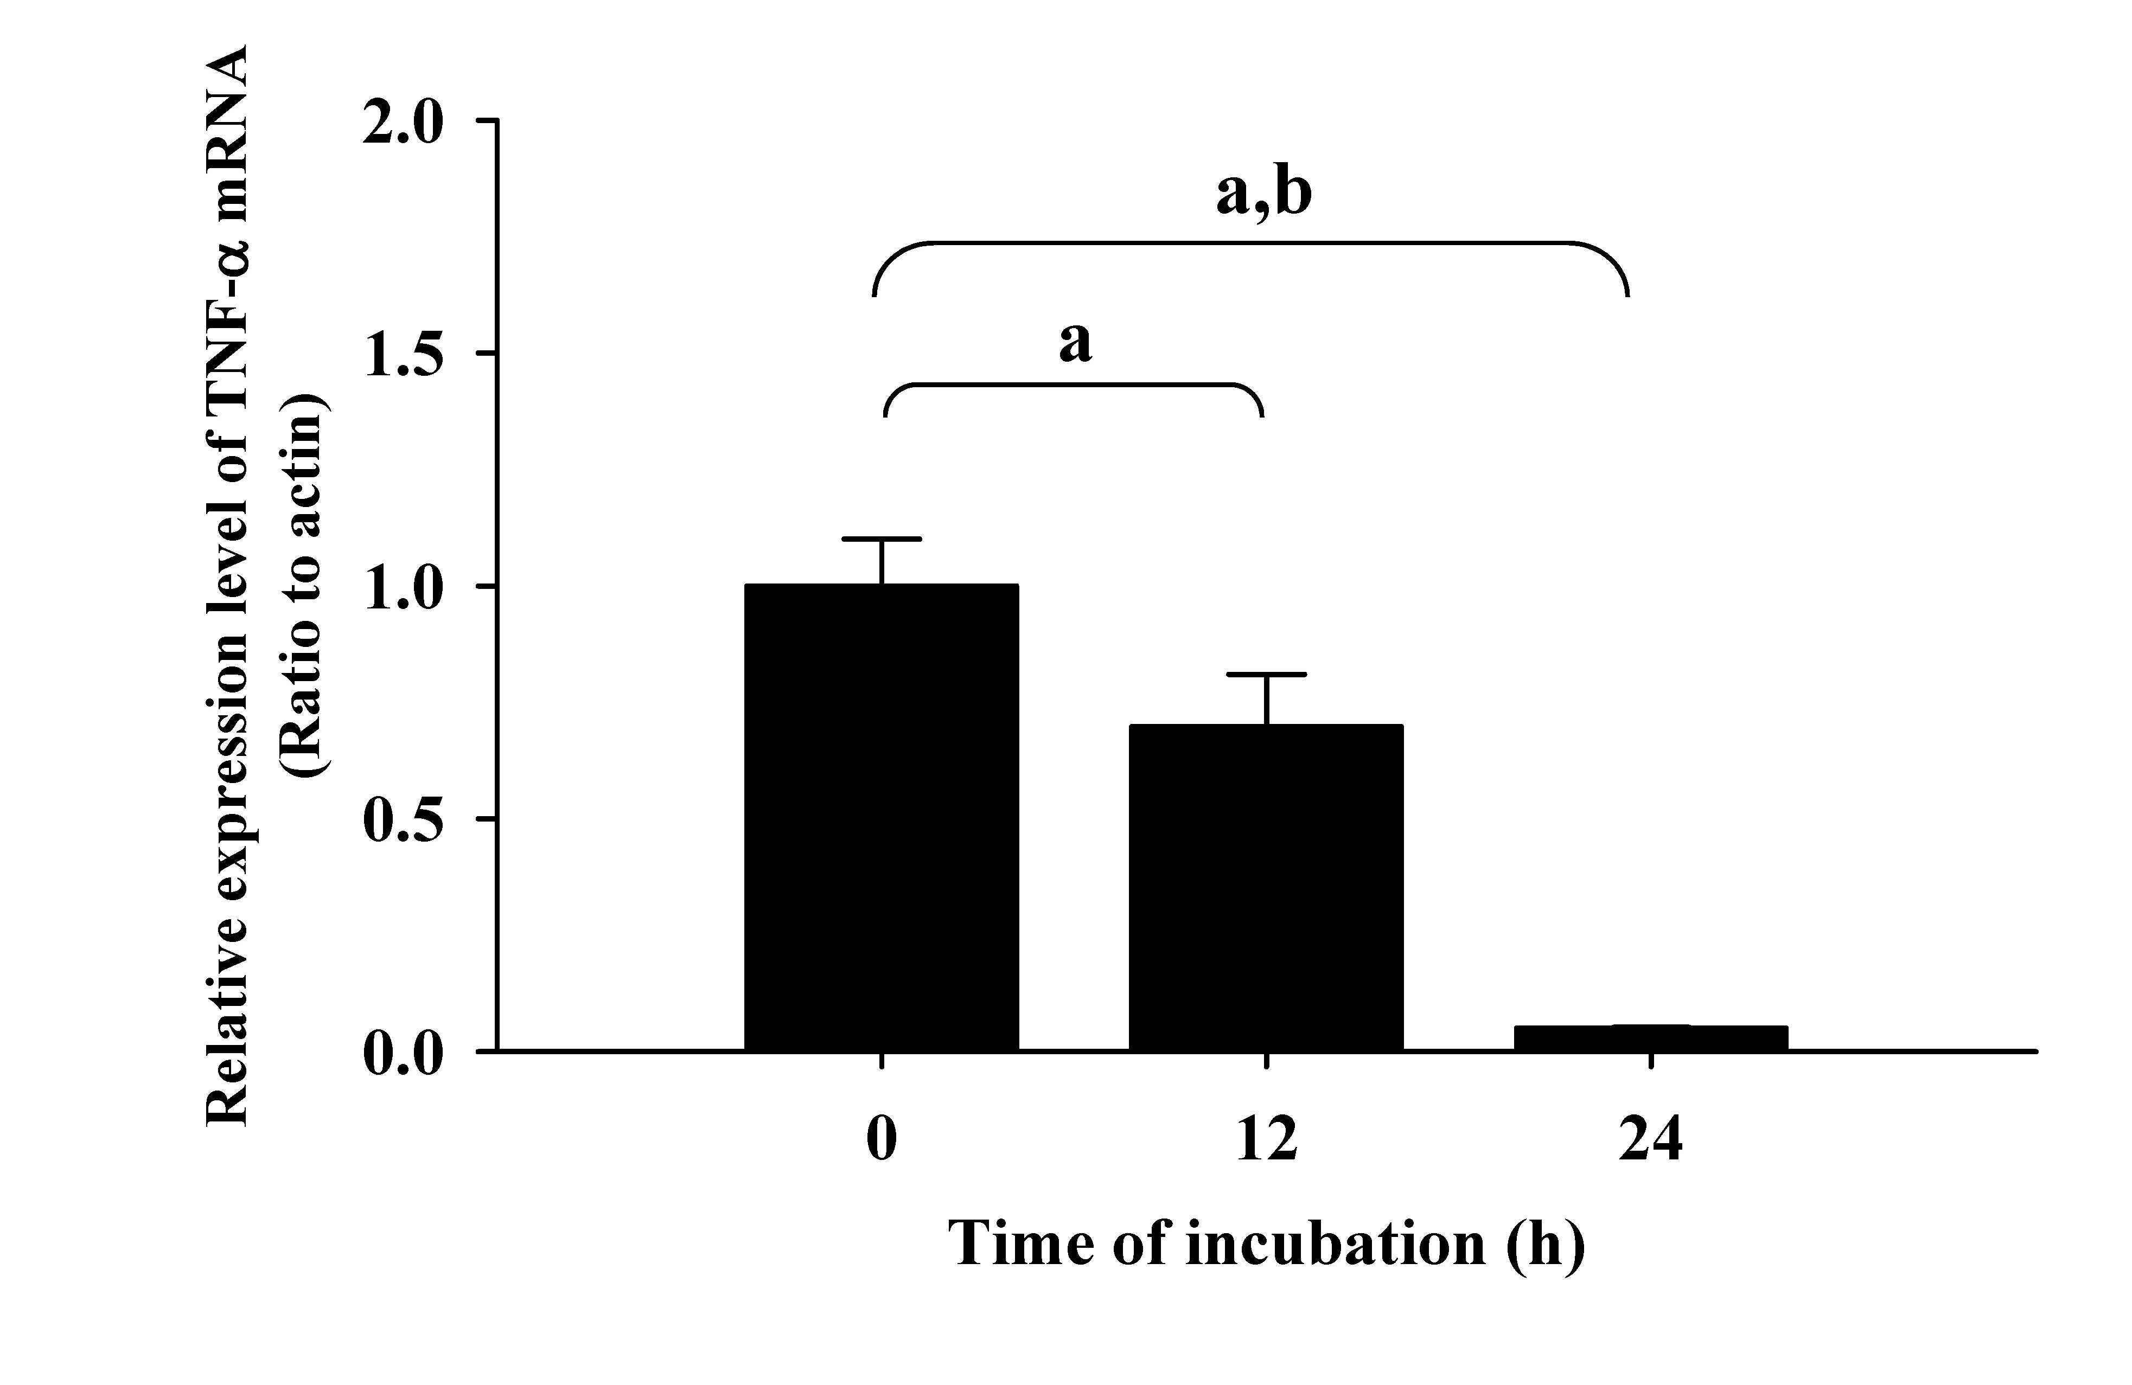
Figure 3
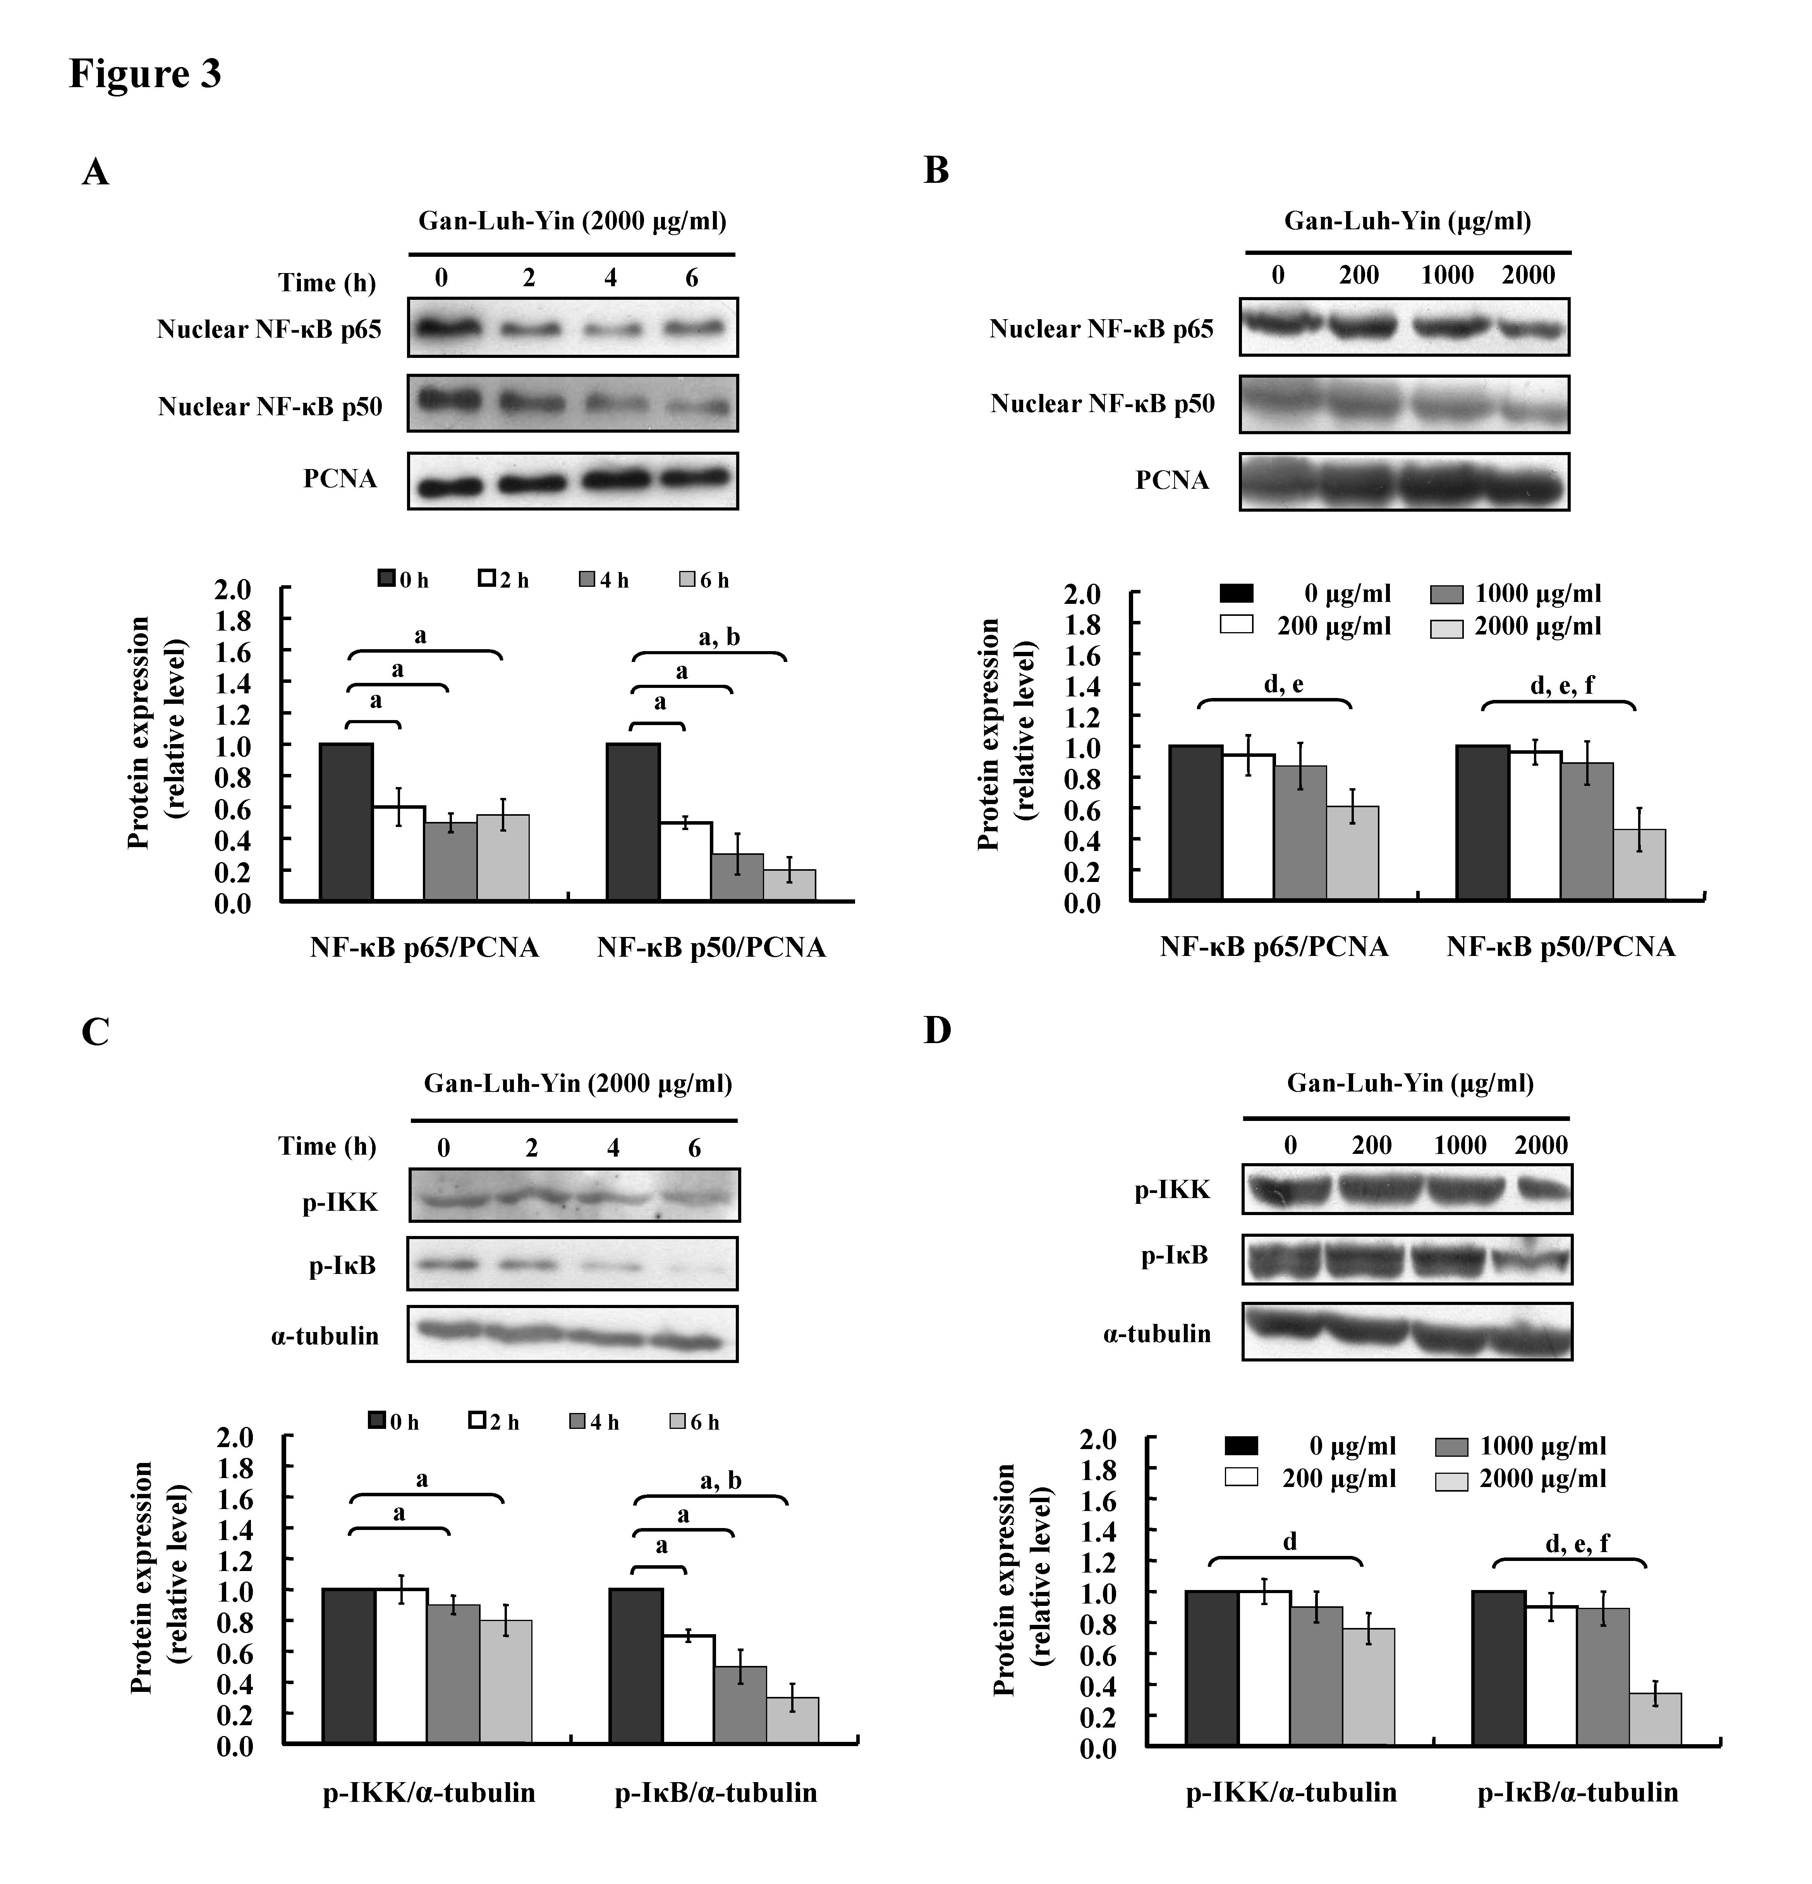
Figure 4
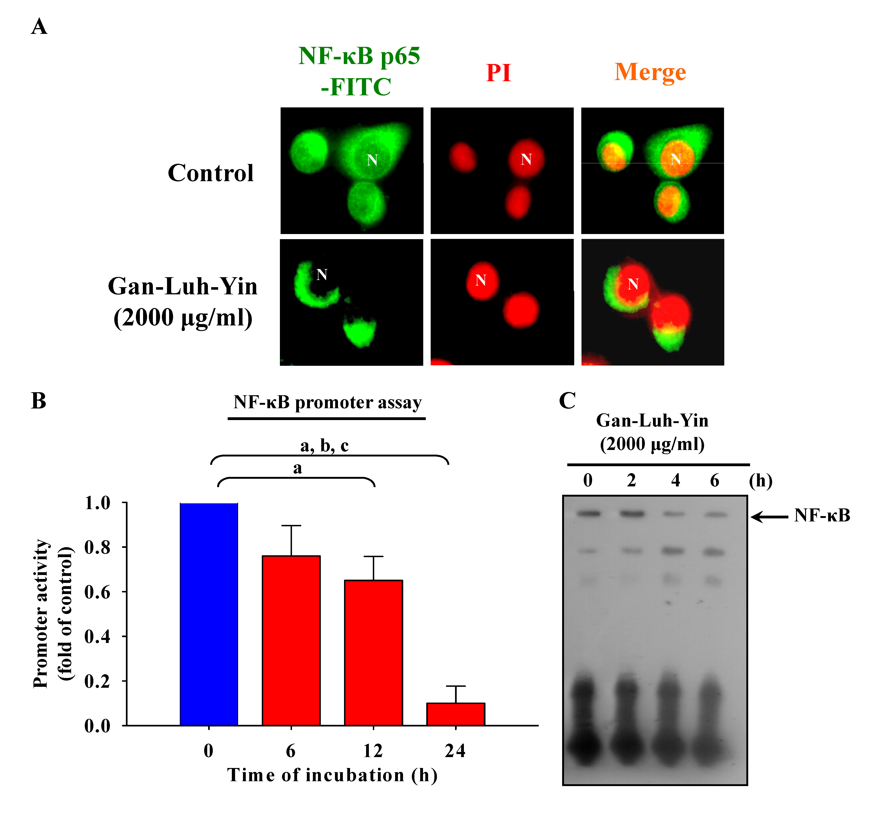
Figure 5
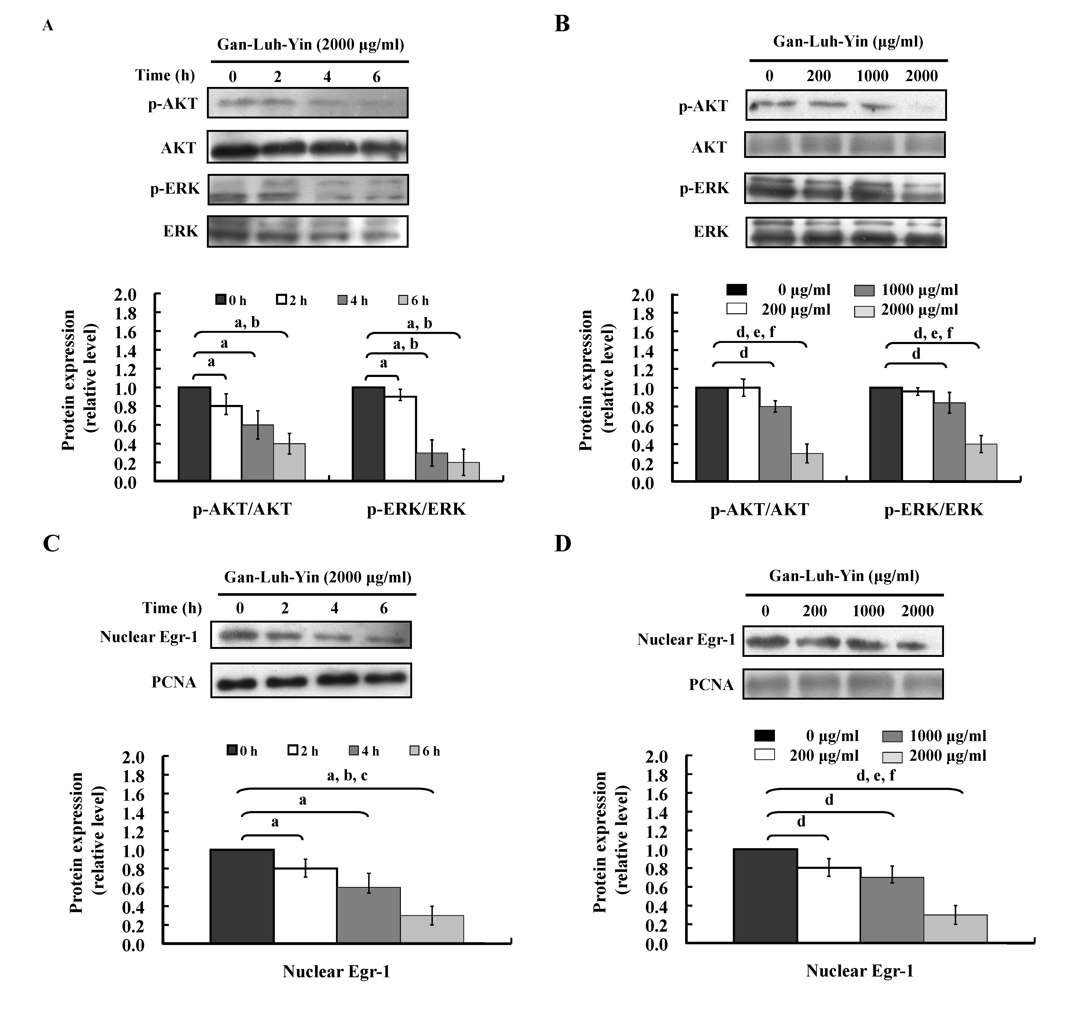
Figure 6
