


Short communication1. IntroductionAurantii Fructus Immaturus (AFI) is mainly comprised of twodifferent species: the immature fruits of Citrus aurantium L. (AFICA)and Citrus sinensis Osbeck (AFICS). They are usually collected fromMay to June. After removal of pollutants, they are cut in half throughthe middle and are dried in the shade. Clinically, they are usedmainly for gastro-intestinal food retention, fullness and pain fromdistention of the stomach, and prolapse of the rectum and uterus[1]. Polymethoxylated ﬂavones, coumarins, ﬂavonoid glycosidesand alkaloids were identiﬁed as the main chemical compoundswhich showed anticarcinogenic [2–4], antioxidant, antimicro-bial [5], gastric mucosal protective [6], and neuroprotective [7]efﬁcacies.Another herbal medicine, Poniciri Trifoliatae Fructus Immatu-rus (PTFI), is the fruits of Poncirus trifolata Raf., which is usuallymisused as AFI in clinics. Before the Song dynasty of China, bothAFI and PTFI were used interchangeably in folk medicine. Later,physicians realized that AFI and PTFI had different medical effectsand stopped using the latter gradually [8]. By the Ming and Qing∗Corresponding author. Tel.: +1 301 504 8144; fax: +1 301 504 8314.E-mail address: pei.chen@ars.usda.gov (P. Chen).dynasties of China, PTFI was deﬁned clearly as the counterfeit ofAFI [8]. However, even today, PTFI is still often misused as AFI,either mistakenly or intentionally, due to their similar morpho-logical appearances and their confusing Chinese names as PTFI iscalled “Lvyi Zhishi” that is similar in Chinese pronunciation with AFI(“Zhishi”).Metabolic ﬁngerprinting can be deﬁned as high-throughputqualitative screening of the metabolic compositions of an organ-ism or tissue with the primary aim of sample comparison anddiscrimination analysis. Generally, no attempt is initially made toidentify the metabolites present. All steps from sample prepara-tion, separation, and detection should be rapid and as simple as isfeasible [9]. Flow-injection mass spectrometry (FIMS) is one of theeasiest and fastest analytical tool for obtaining metabolic ﬁnger-prints of samples. It has been applied in quite a few researchesinvolving diverse sample matrices including TCMs, plant mate-rials, dietary supplements, and fruits [10–13]. The method incombination with chemometric methods was demonstrated to besuccessful in assessing the similarities and differences in chemicalproﬁles from different samples. Furthermore, when combined withultra high-performance liquid chromatography high-resolution MSmethod (UHPLC/HRMS), putative identiﬁcation of the chemicalcompounds responsible for the differentiation of the samples couldbe obtained [14].The present study aimed to differentiate AFI from its coun-terfeit PTFI using FIMS method combined with chemometrics.UHPLC/HRMS was used to provide complementary data for identi-ﬁcation of the characteristic chemical compounds.2. Experimental2.1. MaterialsNine samples of AFICA (AFICA-01 ∼ AFICA-09) and twelve sam-ples of PTFI (PTFI-01 ∼ PTFI-12) were gifted and authenticatedby Professor Yuan-Shiun Chang from the College of Pharmacy atChina Medical University. The authentication of the herbs was con-ﬁrmed using DNA-sequence-based methods (Authen Technologies,Richmond, CA). Acetonitrile and methanol were Optima* grade(Fisher Scientiﬁc, Pittsburgh, PA, USA). Formic acid is MS grade(Sigma/Aldrich, St. Louis, MO, USA). Puriﬁed water was producedby Thermo Barnstead Nanopure Life Science UV/UF Water Puriﬁca-tion System. Reference compounds including naringin, hesperidinand neohesperidin were from Chengdu Must Bio-technology Co.,LTD (Chengdu, China, purity >95%).2.2. Sample preparationFive-hundred milligrams of each dried ground sample wasmixed with 10.0 mL of methanol:water (5:5, v/v) in a 15-mLcentrifuge tube. All samples were sonicated for 60 min at roomtemperature. The extracts were centrifuged at 4000 rpm for 15 min(IEC Clinical Centrifuge, Damon/IEC Division, Needham Heights,MA, USA). The supernatant of each sample was diluted 100 timesand then ﬁltered through a 17-mm (0.45 m) PVDF syringe ﬁl-ter (VWR Scientiﬁc, Seattle, WA, USA) for analysis. To avoid errorsarising from unexpected degradation of the chemical compounds,the sample analyses were completed within 24 h after the extrac-tion. The injection volume for each sample was 5 L. Each samplewas analyzed ﬁve times for the FIMS experiment, three times forthe quantiﬁcation experiment and one time for the UHPLC/HRMSexperiment.2.3. Ultra high-performance liquidchromatography–high-resolution mass spectrometry systemThe UHPLC–HRMS system consisted of a Thermo LTQ OrbitrapXL mass spectrometer with an Accela 1250 binary pump, a PAL-HTC-Accela autosampler, an Accela 1250 PDA detector, and anAgilent column compartment (G1316A).For FIMS, a guard column was used to minimize potentialcontamination for MS system, but it did not provide meaningfulseparation. Mobile phases consisted of 0.1% formic acid in H2O (A)and 0.1% formic acid in acetonitrile (B) with isocratic elution at50:50 (v:v) and a ﬂow rate at 0.5 mL/min for 2.0 min. Electrosprayionization (ESI) was performed in the negative ion mode from m/z100 to 1000 to obtain the FIMS ﬁngerprints. The parameters of themass spectrometer were optimized with hesperidin by auto-tuneusing the Xcalibur software through infusion of the reference com-pound. The following conditions were used: sheath gas ﬂow rate,80 (arbitrary units); aux gas ﬂow rate, 15 (arbitrary units); sprayvoltage, −4.5 kV; heated capillary temperature, 300◦C; capillaryvoltage, −40.0 V; tube lens offset, −150 V. Spectra were averagedover retention time between 0.2 and 1.2 min. Five repeat analysesof the 21 different samples provided 105 spectra.The chromatographic separation was carried out on a ThermoHypersil GOLDTMaQ analytical HPLC column (200 mm × 2.1 mm,1.9 m) with a ﬂow rate of 0.30 mL/min. The column heater waskept at 60◦C. Mobile phase A consisted of 0.1% formic acid inwater and B consisted of 0.1% formic acid in acetonitrile. The elu-tion gradient was 10% B (v/v) over 0–2 min, 10% to 95% B over2–25 min. Quantiﬁcation of naringin, hesperidin and neohesperidinwas carried out using a detection wavelength at 280 nm. ESI wasperformed in the negative ion mode to obtain the HRMS data usingFourier transform MS (FTMS). The conditions for FTMS were as fol-lows: sheath gas ﬂow rate, 80 AU; aux and sweep gas, 15 AU; sprayvoltage, −4.5 kV; capillary temperature, 300◦C; capillary voltage,−40 V; and tube lens offset, −150 V. The mass range was fromm/z 100 to 1000 m/z with a resolution of 30,000, isolation widthof 1.5 amu, and maximum ion injection time of 500 ms. The mostintense ions were selected for the data-dependent scan with colli-sion energy at 30–35%.2.4. Data processing for FIMS ﬁngerprintsThe mass spectrum for each sample consisted of a vector (countsversus mass for m/z 100–1000). The spectra were exported to Excel(Microsoft, Inc., Belleview, WA, USA) for data pre-processing andthen to Solo (Eigenvector Research, Inc. Wenatchee, WA, USA) forprincipal component analysis (PCA) and soft independent model-ing of class analogy (SIMCA). The preprocessing in Microsoft Excelinvolved combining the 105 spectra, sorting the data according tosample names, and ﬁlling the mass matrix (each spectrum had adifferent number of masses since any count of the ion below thedetection threshold would not be exported into the mass list fromthe spectrum). A zero was inserted for each missing m/z in a masslist so that the number of data points of the mass list of each sam-ple was 901. The resulting two-dimensional matrix (105 samplesversus 901 masses) was then exported to Solo for PCA and SIMCA.Preprocessing in Solo, prior to PCA and SIMCA, consisted of normal-ization (normalized to unit vector) and mean centering.3. Results and discussion3.1. PCA of the FIMS ﬁngerprints of AFICA and PTFI samplesPCA mathematically transforms a number of possibly correlatedvariables into a smaller number of uncorrelated variables calledprincipal components (PCs). PCA score plots obtained from the gen-erated PCs provides visual patterns that can be easily understoodand avoids subjective decisions.The variables used in the present study were the intensity val-ues of the ions between m/z 100 and 1000 (901 variables), andthe observations were the samples (21 × 5 = 105). The dataset wasexported to Solo for PCA. According to the PCA scores plot (Fig. 1),the two groups of samples were clearly separated from each otherwith the ﬁrst two principal components cumulatively accountingfor 97.13% of the total variance. All the AFICA samples are clusteredon the left of the plot, with PC1 scores below zero. All the PTFIsamples are clustered on the right, with PC1 scores above zero.Generally, the loadings plots clarify not only how much a vari-able contributes to the PC but also how well that PC takes thatvariable into account over the data points. Moreover, loadings plotsindicate the relationship between variables. The PC1 loadings plot(Supplementary Fig. A) indicates that the ions at m/z 191, 285, 301,341, 579, 593, and 609 are responsible for the separation of sampleson PC1. The samples with positive intensity values for ions at m/z191, 285, 341 and 593 get positive PC1 scores, whereas, the sam-ples with positive intensity values for ions at m/z 301, 579, and 609get negative PC1 scores. The position of each sample in PCA scoresplot depends on the combined effects of intensity values of theseions. All the PTFI samples have positive intensity values for ions atm/z 285, 341 and 593, leading to their right positions on the scoresplot; and all the AFICA samples have positive intensity values for
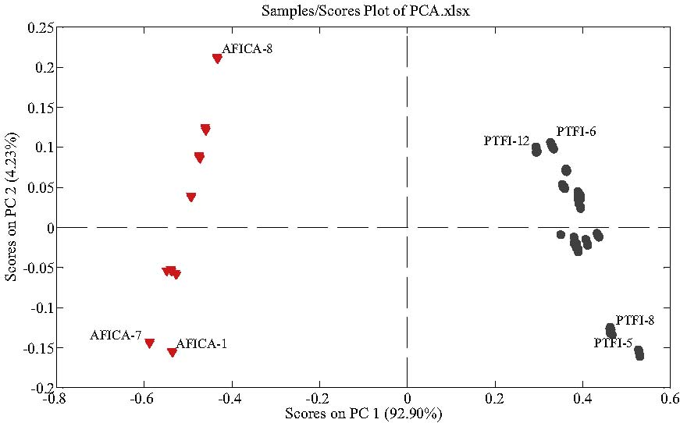
Fig. 1. PCA scores plot of AFICA and PTFI using the intensities of the 901 ions as variables.ions at m/z 301, 579, and 609, leading to their positions to the leftin the scores plot.According to PC2 loadings plot (Supplementary Fig. B), the ionat m/z 579 contributes to PC2 scores of the samples positively,whereas, the ions at m/z 191, 301, 593 and 609 contribute to PC2scores of the samples negatively. In the present study, PC2 didn’tplay critical role in scores plot in grouping two kinds of herbs.In summary, the seven ions were found to be the characteristicmarkers which played the most important role in differentiationbetween AFICA and PTFI samples in the present study.3.2. Soft independent modeling of class analogy (SIMCA)SIMCA is one of the supervised pattern recognition techniquesusing training set to conduct a model in order to predict unknownsamples [15]. In order to conﬁrm the statistical signiﬁcance of thePCA results, SIMCA was performed in the present study. The recog-nition ability (Fig. 2) proved to be highly satisfactory and suggesteda 100% correct classiﬁcation for samples from each group. Theresults further conﬁrmed the PCA grouping results.3.3. Identiﬁcation of the seven characteristic ionsThe retention time (tR, min), UV max(nm), [M−H]−wt, [M−H]−formula, error (ppm) between theoretical and measured values,MS2and MS3ions of each characteristic peak as well as its assign-ment are summarized in Table 1. The ESI-MSnspectra of these peaksare shown in supplementary document (Supplemental Fig. C to Fig.I).Representative UHPLC/HRMS total ion chromatograms (TICs) ofAFICA-5 and PTFI-5 are shown in Fig. 3. Discrepancies in chemi-cal proﬁles between AFICA and PTFI samples suggest that the twogroups of samples probably have different pharmacological effects.Combined extracted ion chromatograms (EICs) for AFICA-5 andPTFI-5 for the seven characteristic ions are displayed in Fig. 4. Theions at m/z 191 and 341 were from peak 1 (1a and 1b, Table 1)with retention time at 1.62 min, of which the HRMS measurementswere 191.0555 (C7H11O6, 0.485 ppm) and 341.1073 (C12H21O11,−1.577 ppm), respectively. The ion at m/z 683 was also found inMS spectrum which was tentatively identiﬁed as the [2M−H]−ionof the ion at m/z 341. In MS2spectrum, the deprotonated ion at m/z191 yielded characteristic ions at m/z 173 and 147, correspondingto losses of neutral fragments of H2O and CO2, respectively. Thiscompound was tentatively identiﬁed as quinic acid according tothe literature [16,17]. The ion at m/z 341 produced a base peakat m/z 179 [M−H-hexosyl]−as well as the ion at m/z 161 [M−H-hexosyl-H2O]−in MS2spectrum, which was tentatively identiﬁedas dihexose [16].Two peaks (peak 2 and peak 3), retention times at 8.65 (UVmax: 222, 283 nm) and 9.01 (UV max: 230, 282, 327 nm) min,had ions at m/z 579. HRMS measurement of the deprotonatedion [M−H]−of peak 2 was 579.1707, suggesting the chemi-cal composition of C27H31O14(−0.228 ppm). The ion at m/z 271[M−H-308]−was observed as the predominant product ion inthe MS2spectra, suggesting the neutral loss of a rutinosyl. Inthe MS3experiment, the ion at m/z 151 [M−H-rutinosyl-120]−was found to be the base peak, resulting from the Retro-Diels–Alder (RDA) reactions, which further lost a neutral CO2,leading to a fragment ion at m/z 107 [M−H-rutinosyl-120-CO2]−.Other fragment ions at m/z 165, 177 and 227 [M−H-rutinosyl-CO2]−were also observed. This peak was tentatively identiﬁedas narirutin according to the MS behaviors reported in liter-atures [18–21]. HRMS measurement of the deprotonated ion[M−H]−of peak 3 was 579.1703, also suggesting the chemi-cal composition of C27H31O14(−0.918 ppm). Its major fragmentions in MS2spectrum were 561 [M−H-H2O]−, 459 [M−H-120]−,313 [M−H-120-rhamnosyl]−, 295 [M−H-120-rhamnosyl-H2O]−,271 [M−H-neohesperidosyl]−, and 235 [M−H-neohesperidosyl-2H2O]−. It is worth noting here the loss of 120 Da may be causedby either the glycan [22] or ring C [23]. In the MS3experi-ment, the ion at m/z 459 [M−H-120]−yielded the base peakat m/z 357 [M−H-120-C7H2O]−as well as a series of fragmentions at m/z 441 [M−H-120-H2O]−, 339 [M−H-240]−, 313 [M−H-120-rhamnosyl]−, 271 [M−H-neohesperidosyl]−, 235 [M−H-neohesperidosyl-2H2O]−and 151 [M−H-120-neohesperidosyl]−.The ion at m/z 271 [M−H-neohesperidosyl]−yielded the base peakat m/z 151 [M−H-neohesperidosyl-120]−and another predomi-nant ion at m/z 177 in MS3experiment. Finally, the peak wasidentiﬁed as naringin and conﬁrmed by the reference compound.The ion at m/z 609 was from peak 4 and peak 5 with reten-tion times at 9.31 (UV max: 284, 328 nm) and 9.65 (UV max:284, 328 nm) min, respectively. They are identiﬁed as hesperidinand neohesperidin, respectively. HRMS measurement of peak 4gave a [M−H]−ion at m/z 609.1808 (C28H33O15, −0.547 ppm) aswell as the ion at m/z 301, resulting from a cleavage of rutinosyl.In the MS2spectrum, the deprotonated ion produced a predomi-nant base peak at m/z 301 [M−H-rutinosyl]−. Peak 5 showed theHRMS measurement of [M−H]−at m/z 609.1810 also with the
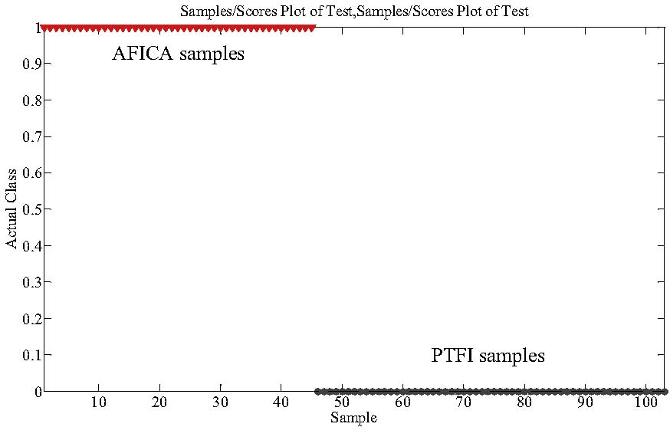
Fig. 2. SIMCA modeling and prediction results.formula of C28H33O15(−0.397 ppm). Interestingly, due to the dif-ference of the chemical structures between neohesperidin andhesperidin, a series of fragment ions at m/z 489 [M−H-120]−,343 [M−H-120-rhamnosyl]−, 325 [M−H-120-rhamnosyl-H2O]−and 301 [M−H-neohesperidosyl]−were observed in MS2spec-trum of neohesperidin. The MS behaviors were consistent with thatreported in literatures [19–21].The ion at m/z 593 was from peak 6 and peak 7 with reten-tion times at 11.35 (UV max: 225, 283 nm) and 11.63 (UV max:226, 282 nm) min, respectively. HRMS measurement of peak 6gave a [M−H]−ion at m/z 593.1855 (C28H33O14, −1.655 ppm) aswell as the ion at m/z 285, resulting from a cleavage of ruti-nosyl. In the MS2experiment, the deprotonated ion produceda predominant base peak at m/z 285 [M−H-rutinosyl]−, whichfurther yielded a series of fragment ions at m/z 270 [M−H-rutinosyl-CH3]−, 243 [M−H-rutinosyl-C2H2O]−, 164, and 151 inMS3experiment. According to the literature [20,24], it was tenta-tively identiﬁed as neoponcirin (isosakuranetin-7-rutinoside). Peak7 is an isomer of neoponcirin. The structural difference betweenthe two compounds was the position of the linkage to rham-nosyl and glucosyl, which leads to different MS behaviors. Peak7 showed the HRMS measurement of [M−H]−at m/z 593.1845(C28H33O14, −3.341 ppm) along with its formic acid adduct ionat m/z 639 [M+HCOOH-H]−. In the MS2experiment, the depro-tonated ion yielded a series of fragmentation ions at m/z 575[M−H-H2O]−, 473 [M−H-120]−, 431 [M−H-162]−, 327 [M−H-120-rhamnosyl]−and 309 [M−H-120-rhamnosyl-H2O]−and a basepeak at 285 [M−H-neohesperidosyl]−. It can be seen that thisglycoside with neohesperidose favored eliminating of rhamnosyland a fragment with molecular weight of 120 Da. In MS3exper-iment, the ion at m/z 285 produced fragmentation ions at m/z270 [M−H-neohesperidosyl-CH3]−, 243 [M−H-neohesperidosyl-C2H2O]−, 164, and 151. This peak was tentatively identiﬁed asponcirin (isosakuranetin-7-neohesperidose) according to litera-tures [20,21,24].3.4. Contents of naringin, hesperidin and neohesperidin in all thetested samplesAs described above, the seven characteristic ions were foundin eight peaks. Naringin, hesperidin and neohesperidin were thenquantiﬁed using reference compounds. The results are shown
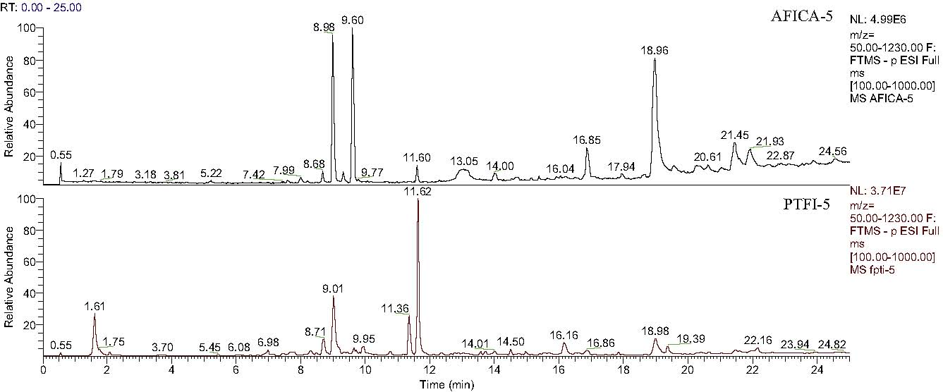
Fig. 3. UHPLC/HRMS total ion chromatograms of AFICA-5 and PTFI-5.in Table 2. First, naringin was found to be the main chemicalcompound in all the samples. The concentrations ranged from64.63 ± 1.87 to 189.12 ± 6.82 mg/g in AFICA samples, which wereclose to the values reported in literatures [25–27]. However, thevalues were between 10.36 ± 0.47 to 22.03 ± 1.40 mg/g in PTFI sam-ples, which were much lower than that in AFICA samples. Second,hesperidin and neohesperidin were not detected in any of thePTFI samples, but they were detected in all the AFICA samples(1.95 ± 0.13 to 5.16 ± 0.18 mg/g for hesperidin and 56.85 ± 0.82 to105.99 ± 1.25 mg/g for neohesperidin, respectively). Finally but themost importantly, synephrine is the chemical marker for qualitycontrol of AFI samples speciﬁed in the Chinese Pharmacopoeia (edi-tion 2010), the concentration of which should not be less than3 mg/g. However, due to the high polarity of synephrine, sodium
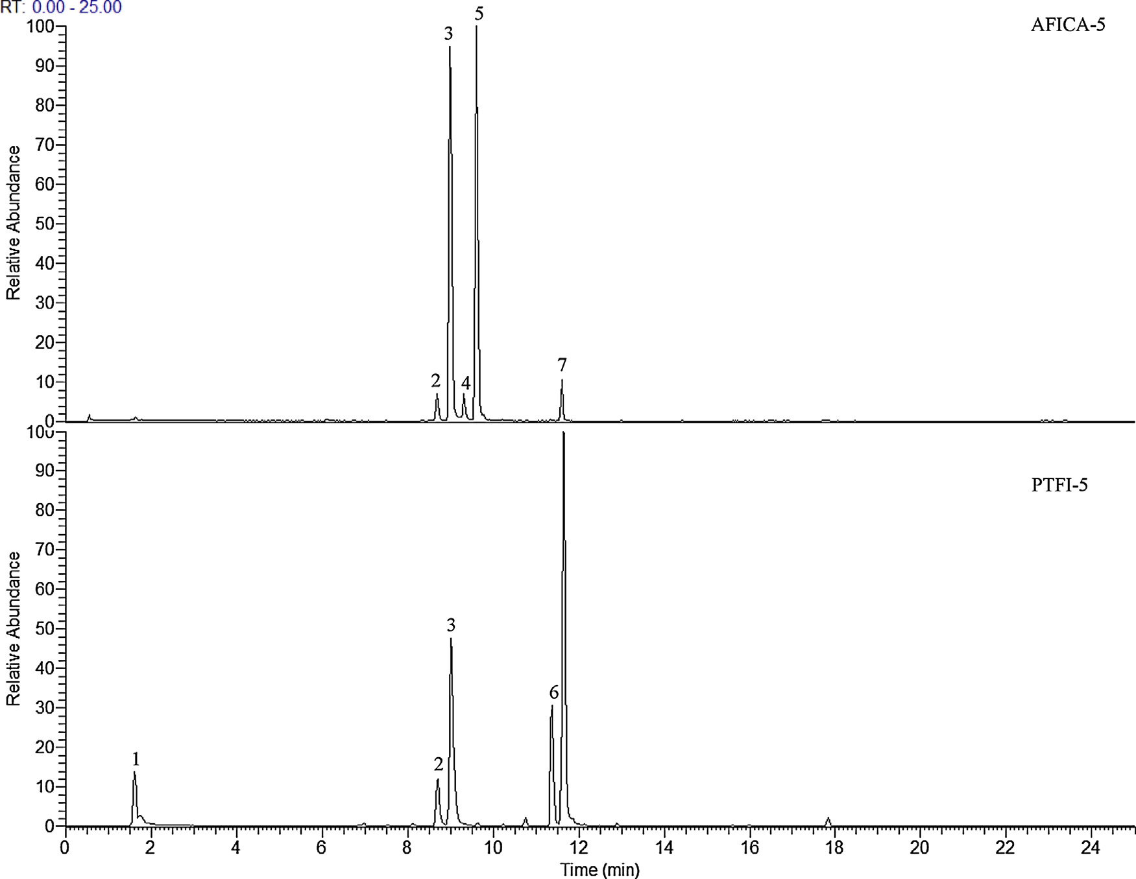
Fig. 4. Extracted ion chromatogram at m/z 191, 285, 301, 341, 579, 593 and 609 of AFICA-5 and PTFI-5.dodecyl sulfate is needed for good retention of the marker on thechromatographic column. This is not compatible with MS detec-tion. The results obtained in the present study show that AFICA havehigh concentrations of naringin, hesperidin and neohesperidin, allof which can be quantiﬁed using both UV detector and mass spec-trometer. Therefore, these three compounds can be considered asalternatives for assessment on the herb besides synephrine.4. ConclusionTwo previous reports on the identiﬁcation of AFI are of interests.Both of them were HPLC based. One used multivariate analysis justas that described in this study, however, it did not use loadings plotnor the SIMCA model [28]. The other used a targeted approach thatis not a comprehensive approach as the one described in this study[29]. Compared with the FIMS metabolic ﬁngerprinting method,both methods were time-consuming and labor-intensive. The FIMSmetabolic ﬁngerprinting method was demonstrated to be a simple,fast, and reliable for differentiating AFICA from its counterfeit PTFI.Furthermore, the characteristic ions observed from the PCA load-ings plots were identiﬁed with the aid of UHPLC-HRMS. Naringin,hesperidin and neohesperidin were quantiﬁed using UV detectorat 280 nm. The results conﬁrmed the authenticity of AFICA samplesand also indicated that naringin and neohesperidin were the mainchemical compounds in AFICA, both with concentrations greaterthan 50 mg/g. It is worth noting that the two compounds might bemore acceptable for quality assessment on AFICA compared withsynephrine.Appendix A. Supplementary dataSupplementary data associated with this article can be found, inthe online version, at http://dx.doi.org/10.1016/j.jpba.2014.12.035.References[1] State Pharmacopoeia Commission, Pharmacopoeia of the People’s Republic ofChina, vol. 1, Chinese Medical Science and Technology Press, Beijing, 2010, pp.230–231.[2] S. Li, P.M. Pan, C.S. Lai, C.Y. Lo, S. Dushenkov, C.T. Ho, Isolation and syntheses ofpolymethoxy ﬂavones and hydroxylated polymethoxy ﬂavones as inhibitors ofHL-60 cell lines, Bioorg. Med. Chem. 15 (2007) 3381–3389.[3] J.A. Manthey, N. Guthrie, Antiproliferative activities of citrus ﬂavonoids againstsix human cancer cell lines, J. Agric. Food Chem. 50 (2002) 5837–5843.[4] T. Tanaka, K. Kawabata, M. Kakumoto, H. Makita, A. Hara, H. Mori, K. Satoh, A.Hara, A. Murakami, W. Kuki, Y. Takahashi, H. Yonei, K. Koshimizu, H. Ohigashi,Citrus auraptene inhibits chemically induced colonic aberrant crypt foci in maleF344 rats, Carcinogenesis 18 (1997) 2155–2161.[5] M.S. Mokbel, Y. Watanabe, F. Hashinaga, T. Suganuma, Puriﬁcation of theantioxidant and antimicrobial substance of ethyl acetate extracts from Buntan(Citrus grandis Osbeck) fruit peel, Pak. J. Biol. Sci. 9 (2006) 145–150.[6] H. Takase, K. Yamamoto, H. Hirano, Y. Saito, A. Yamashita, Pharmacologicalproﬁle of gastric mucosal protection by marmin and nobiletin from a tra-ditional herbal medicine, Aurantii Fructus Immaturus, Jpn. J. Pharmacol. 66(1994) 139–147.[7] A. Nakajima, T. Yamakuni, M. Haraguchi, N. Omae, S.Y. Song, C. Kato, O. Naka-gawasai, T. Tadano, A. Yokosuka, Y. Mimaki, Y. Sashida, Y. Ohizumi, Nobiletin,a citrus ﬂavonoid that improves memory impairment, rescues bulbectomy-induced cholinergic neurodegeneration in mice, J. Pharmacol. Sci. 105 (2007)122–126.[8] Z.W. Xie, Research on duration and changes of Zhi Shi and Zhi Qiao as ancientand present drugs, Res. Tradit. Chin. Med. 1 (1991) 19–22.[9] R.D. Hall, Plant metabolomics: from holistic hope, to hype, to hot topic, NewPhytol. 169 (2006) 453–468.[10] P. Chen, L.Z. Lin, J.M. Harnly, Mass spectroscopic ﬁngerprinting methodfor differentiation between Scutellaria lateriﬂora and the Germander (Teu-crium canadense and T. chamaedrys) species, J. AOAC Int. 93 (2010)1148–1154.[11] Y. Zhao, Y.G. Niu, Z.H. Xie, H.M. Shi, P. Chen, L.L. Yu, Differentiating leaf andwhole-plant samples of di- and tetraploid Gynostemma pentaphyllum (Thunb.)Makino using ﬂow-injection mass spectrometric ﬁngerprinting method, J.Funct. Foods 5 (2013) 1288–1297.[12] Y. Zhao, J.H. Sun, L.L. Yu, P. Chen, Chromatographic and mass spectrometricﬁngerprinting analyses of Angelica sinensis (Oliv.) Diels-derived dietary sup-plements, Anal. Bioanal. Chem. 405 (2013) 4477–4485.[13] P. Chen, J.M. Harnly, G.E. Lester, Flow injection mass spectral ﬁngerprintsdemonstrate chemical differences in Rio Red grapefruit with respect to year,harvest time, and conventional versus organic farming, J. Agric. Food Chem. 58(2010) 4545–4553.[14] J.H. Sun, P. Chen, A ﬂow-injection mass spectrometry ﬁngerprinting method forauthentication and quality assessment of Scutellaria lateriﬂora-based dietarysupplements, Anal. Bioanal. Chem. 401 (2011) 1577–1584.[15] L.A. Berrueta, R.M. Alonso-Salces, K. Heberger, Supervised pattern recognitionin food analysis, J. Chromatogr. A 1158 (2007) 196–214.[16] P. Chen, J.M. Harnly, Pde B. Harrington, Flow injection mass spectroscopic ﬁn-gerprinting and multivariate analysis for differentiation of three Panax species,J. AOAC Int. 94 (2011) 90–99.[17] N. Fang, S. Yu, R.L. Prior, LC/MS/MS characterization of phenolic constituents indried plums, J. Agric. Food Chem. 50 (2002) 3579–3585.[18] F. Xu, Y. Liu, Z. Zhang, C. Yang, Y. Tian, Quasi-MSn identiﬁcation of ﬂa-vanone 7-glycoside isomers in Da Chengqi Tang by high performance liquidchromatography–tandem mass spectrometry, Chin. Med. 4 (2009) 15.[19] H.Y. Zhao, M.X. Fan, X. Wu, H.J. Wang, J. Yang, N. Si, B.L. Bian, Chemical proﬁlingof the Chinese herb formula Xiao-Cheng-Qi decoction using liquid chromatog-raphy coupled with electrospray ionization mass spectrometry, J. Chromatogr.Sci. 51 (2013) 273–285.[20] H.E. Cho, S.Y. Ahn, S.C. Kim, M.H. Woo, J.T. Hong, D.C. Moon, Deter-mination of ﬂavonoid glycosides, polymethoxyﬂavones, and coumarins inherbal drugs of Citrus and Poncirus fruits by high performance liquidchromatography–electrospray ionization/tandem mass spectrometry, Anal.Lett. 47 (2014) 1299–1323.[21] W.Y. Liu, C. Zhou, C.M. Yan, S.L. Xie, F. Feng, C.Y. Wu, N. Xie, Characterizationand simultaneous quantiﬁcation of multiple constituents in Aurantii FructusImmaturus extracts by HPLC–DAD–ESI-MS/MS, Chin. J. Nat. Med. 10 (2012)456–463.[22] F. Cuyckens, R. Rozenberg, E. de Hoffmann, M. Claeys, Structure characteri-zation of ﬂavonoid O-diglycosides by positive and negative nano-electrosprayionization ion trap mass spectrometry, J. Mass Spectrom. 36 (2001) 1203–1210.[23] P. Shi, Q. He, Y. Song, H. Qu, Y. Cheng, Characterization and identiﬁcation ofisomeric ﬂavonoid O-diglycosides from genus Citrus in negative electrosprayionization by ion trap mass spectrometry and time-of-ﬂight mass spectrome-try, Anal. Chim. Acta 598 (2007) 110–118.[24] H. Wang, F. Feng, Identiﬁcation of components in Zhi-Zi-Da-Huang decoc-tion by HPLC coupled with electrospray ionization tandem mass spectrometry,photodiode array and ﬂuorescence detectors, J. Pharm. Biomed. Anal. 49 (2009)1157–1165.[25] Z.X. Zhang, Y.Z. Zheng, L.J. Liang, T.X. Dong, H.Q. Zhan, K.J. Zhao, Analysis ofHPLC ﬁngerprints of Citrus aurantium and Citrus sinensis and the contents ofnaringin and synephrine, Zhongguo Yao Fang 22 (2011) 3711–3714.[26] H. Jiang, J. Li, R.B. Shi, Determination of three ﬂavanones in the effective fractionof ﬂavones in Fructus Aurantii Immaturus by HPLC, Zhongguo Yao Fang 19(2008) 2127–2128.[27] Q. Wang, D. Yuan, Determination of ﬂavonoids in Fructus Aurantii Immaturusand Fructus Aurantii from different habitat by HPLC, Heilongjiang Yi Yao 21(2008) 1–3.[28] C.C. Chuang, W.C. Wen, S.J. Sheu, Classiﬁcation of Aurantii Fructus samples bymultivariate analysis, J. Sep. Sci. 30 (2007) 1827–1832.[29] C.C. Chuang, W.C. Wen, S.J. Sheu, Original identiﬁcation on the commercialsamples of Aurantii Fructus, J. Sep. Sci. 30 (2007) 1235–1241.

