Iterative Methods for Triple Hierarchical Variational Inequalities with Mixed Equilibrium Problems, Variational Inclusions and Variational Inequalities Constraints
Lu-Chuan Ceng¹, Yen-Cherng Lin^{∗2}, and Ching-Feng Wen³
¹Department of Mathematics, Shanghai Normal University, Shanghai 200234, China; and Scientific Computing Key Laboratory of Shanghai Universities, Shanghai 200234, China.
²Department of Occupational Safety and Health, College of Public Health, China Medical University, Taichung 40421, Taiwan. ³Center for Fundamental Science, Kaohsiung Medical University, Kaohsiung 807, Taiwan.
Email: L.-C. Ceng - zenglc@hotmail.com; Y.-C. Lin∗- yclin@mail.cmu.edu.tw; C.-F. Wen - cfwen@kmu.edu.tw; ∗Corresponding author

Abstract
In this paper, we introduce and analyze a multi-step hybrid steepest-descent extragradient algorithm and multi-step composite Mann-type viscosity iterative algorithm for finding a solution of triple hierarchical variational inequalities defined over the common set of solutions of mixed equilibrium problems, variational inclusions, variational inequalities and fixed point problems. Under appropriate assumptions, we prove that the proposed algorithms converges strongly to a common element of the fixed point set of a strict pseudocontractive mapping, solution set of finitely many generalized mixed equilibrium problems, solution set of finitely many variational inclusions and solution set of general system of variational inequalities. Such element is a unique solution of a triple hierarchical variational inequality problem. In addition, we also consider as an application the proposed algorithm to solve a hierarchical variational inequality problem defined over the set of common solutions of finitely many generalized mixed equilibrium problems, finitely many variational inclusions and general system of variational inequalities. The results obtained in this paper improve and extend the corresponding results announced by many others.
Keywords: Triple hierarchical variational inequalities; Generalized mixed equilibrium problems; Variational inclusions; General system of variational inequalities; Hybrid steepest-descent extragradient algorithm; Composite Mann-type viscosity algorithm; Fixed points.
AMS subject classifications. 49J30; 47H09; 47J20; 49M05

Introduction and Formulations
Let C be a nonempty closed convex subset of a real Hilbert space H and A : C → H be a nonlinear mapping on C. The variational inequality problem (VIP) defined by C and A is to find x ∈ C such that
hAx,y − xi ≥ 0, ∀y ∈ C. (1.1)
The solution set of VIP (1.1) is denoted by VI(C,A). The theory of variational inequalities is well established area in nonlinear analysis and optimization. For further details on this topic, we refer to [25,38,34,31,47] and the references therein.
It is well known that if A is a strongly monotone and Lipschitz-continuous mapping on C, then VIP (1.1) has a unique solution. Several iterative methods have been proposed in the literature to compute the approximate solutions of a VIP. Korpelevich’s extragradient method is one of them which was proposed by Korpelevich [30]. During the last two decades, this method received a great attention given by many authors, who improved and generalized it in different directions and ways, see, for example, [29,49,35,8,43, 7,33,22,19,18,11,16] and the references therein.
Let ϕ : C → R be a real-valued function, A : C → H be a nonlinear mapping and Θ : C × C → R be a bifunction. The generalized mixed equilibrium problem (GMEP) is to find x ∈ C such that
Θ(x,y) + ϕ(y) − ϕ(x) + hAx,y − xi ≥ 0, ∀y ∈ C. (1.2)
We denote the set of solutions of GMEP (1.2) by GMEP(Θ,ϕ,A). The GMEP (1.2) is very general in the sense that it includes many problems as special cases, namely, optimization problems, variational inequalities, minimax problems, Nash equilibrium problems in noncooperative games, etc. For different aspects and solution methods, we refer to [29,13,15,35,8,22,16] and the references therein.
If ϕ = 0, then GMEP (1.2) reduces to the generalized equilibrium problem (GEP) of finding x ∈ C such that
Θ(x,y) + hAx,y − xi ≥ 0, ∀y ∈ C.
It was considered and studied in [4,27] and further studied in [39]. The set of solutions of GEP is denoted by GEP(Θ,A).
If A ≡ 0, then GMEP (1.2) reduces to the mixed equilibrium problem (MEP) which is to find x ∈ C such that
Θ(x,y) + ϕ(y) − ϕ(x) ≥ 0, ∀y ∈ C.
It was considered and studied in [21]. The set of solutions of MEP is denoted by MEP(Θ,ϕ).
If ϕ ≡ 0, A ≡ 0, then GMEP reduces to the equilibrium problem (EP) which is to find x ∈ C such that
Θ(x,y) ≥ 0, ∀y ∈ C.
The set of solutions of EP is denoted by EP(Θ). It is worth to mention that the EP is an unified model of several problems, namely, variational inequality problems, optimization problems, saddle point problems, complementarity problems, fixed point problems, Nash equilibrium problems, etc.
The common assumptions on bifunction Θ : C × C → R are the following:
(A1) Θ(x,x) = 0 for all x ∈ C;
(A2) Θ is monotone, i.e., Θ(x,y) + Θ(y,x) ≤ 0 for any x,y ∈ C;
(A3) Θ is upper-hemicontinuous, i.e., for each x,y,z ∈ C,
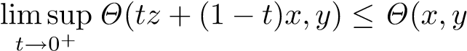);
(A4) Θ(x,·) is convex and lower semicontinuous for each x ∈ C.
We also consider the following assumptions (B0) and (B1) or (B2) on the function ϕ : C → R:
(B0) ϕ is lower semicontinuous and convex;
(B1) For each x ∈ H and r > 0, there exists a bounded subset D_{x} ⊂ C and y_{x} ∈ C such that for any
z ∈ C \ D_{x},
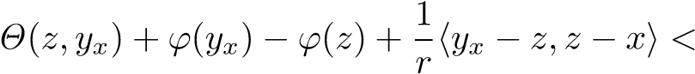0;
or
(B2) C is a bounded set.
On the other hand, let B : C → H be a single-valued mapping and R be a multivalued mapping with D(R) = C. Consider the following variational inclusion: find x ∈ C such that
0 ∈ Bx + Rx. (1.3)
We denote by I(B,R) the solution set of the variational inclusion (1.3). In particular, if B ≡ R ≡ 0, then I(B,R) = C. If B ≡ 0, then problem (1.3) becomes the inclusion problem introduced by Rockafellar [36]. It is known that problem (1.3) provides a convenient framework for the unified study of optimal solutions in many optimization related areas including mathematical programming, complementarity problems, variational inequalities, optimal control, mathematical economics, equilibria and game theory, etc. Let a set-valued

mapping R : D(R) ⊂ H → 2^{H} be maximal monotone. We define the resolvent operator J_{R,λ} : H → D(R) associated with R and λ by
J_{R,λ} = (I + λR)⁻¹, ∀x ∈ H,
where λ is a positive number.
Huang [28] studied problem (1.3) in the case where R is maximal monotone and B is strongly monotone and Lipschitz continuous with D(R) = C = H. Subsequently, Zeng et al. [48] further studied this problem in a more general setting than in [28]. Moreover, Ceng et al. [48] obtained the same strong convergence result as in [28]. In addition, Ceng et al. [48] also gave the geometric convergence rate estimate for approximate solutions. Also, various types of iterative algorithms for solving variational inclusions have been further studied and developed; for more details, we refer to [23,7,50] and the references therein.
Let F₁,F₂ : C → H be two mappings. Consider the following general system of variational inequalities
(GSVI) of finding (x∗,y∗) ∈ C × C such that ½
hν₁F₁y∗ + x∗ − y∗,x − x∗i ≥ 0, hν₂F₂x∗ + y∗ − x∗,x − y∗i ≥ 0, | ∀x ∈ C,  ∀x ∈ C, | (1.4)
where ν₁ > 0 and ν₂ > 0 are two constants. It was considered and studied in [14,43,19,18,11]. In particular, if F₁ ≡ F₂ ≡ A, then the GSVI (1.4) reduces to the following problem of finding (x∗,y∗) ∈ C × C such that ½
hν₁Ay∗∗ ++xy∗∗ −− yx∗∗,x,x−−xy∗∗i ≥i ≥ 00,, ∀∀xx ∈∈ C,C, (1.5) hν₂Ax
which is studied by Verma [40] and it is called a new system of variational inequalities (NSVI). Further, if x∗ = y∗ additionally, then the NSVI reduces to the classical VIP (1.1). By considering G := P_{C}(I − ν₁F₁)P_{C}(I − ν₂F₂) and y∗ = P_{C}(I − ν₂F₂)x∗, where P_{C} denote the metric projection of H onto C, Ceng et al. [18] transformed GSVI (1.4) into the following fixed point equation:
Gx∗ = x∗. (1.6)
A variational inequality problem defined over the set of fixed points of a mapping is called hierarchical variational inequality problem.
Let S and T be two nonexpansive mappings. Yao et al. [44] considered the following hierarchical variational inequality problem (HVIP): find hierarchically a fixed point of T which is a solution to the VIP for monotone mapping I − S, namely, find ˜x ∈ Fix(T) such that
h(I − S)x,p˜ − x˜i ≥ 0, ∀p ∈ Fix(T). (1.7)
The solution set of HVIP (1.7) is denoted by Λ. It is easy to check that solving the HVIP (1.7) is equivalent to solving the fixed point problem of the composite mapping P_{Fix(T)}S, that is, find ˜x ∈ C such that x˜ = P_{Fix(T)}Sx˜. Ceng et al. [44] introduced and analyzed an iterative algorithm for solving HVIP (1.7). They also studied the strong convergence of the sequences generated by their algorithm.
A variational inequality problem defined over the set of solutions of a hierarchical variational inequality problem is called a triple hierarchical variational inequality problem. For for further detail on triple hierarchical variational inequalities, we refer [2,9,10,12,8] and the references therein. Very recently, Kong et al. [29] introduced and studied the following triple hierarchical variational inequality problem (THVIP) (over the fixed point set of a strictly pseudocontractive mapping) with a variational inequality constraint.
Problem 1.1. [29, Problem II] Let F : C → H be κ-Lipschitzian and η-strongly monotone on the nonempty closed convex subset C of H, where κ and η are positive constants. Let A : C → H be a monotone and LLipschitzian mapping, V : C → H be a ρ-contraction with coefficient ρ ∈ [0,1), S : C → C be a nonexpansive
mapping, and T : C → C be a ξ-strictly pseudocontractive mapping with Fix(T) ∩ VI(C,A) 6= ∅. Let p
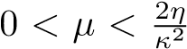 and 0 < γ ≤ τ, where τ = 1 − 1 − µ(2η − µκ²). Then, the objective is to find x∗ ∈ Ξ such
that
h(µF − γV )x∗,x − x∗i ≥ 0, ∀x ∈ Ξ, (1.8)
where Ξ denotes the solution set of the following hierarchical variational inequality problem (HVIP) of finding z∗ ∈ Fix(T) ∩ VI(C,A) such that
h(µF − γS)z∗,z − z∗i ≥ 0, ∀z ∈ Fix(T) ∩ VI(C,A). (1.9)
They proposed an algorithm for solving Problem 1.1 and studied the convergence analysis for the sequences generated by the proposed algorithm.
In this paper, we introduce and study the following triple hierarchical variational inequality problem (THVIP) (defined over the fixed point set of a strictly pseudocontractive mapping) with constraints of finitely many GMEPs, finitely many variational inclusions and general system of variational inequalities:
Throughout the paper, M and N are assumed to be positive integers.
Problem 1.2. Assume that
- for each j = 1,2, F_{j} : C → H is ζ_{j}-inverse-strongly monotone and F : H → H is κ-Lipschitzian and
η-strongly monotone with positive constants κ,η > 0 such that 0 < γ ≤ τ and 0 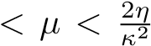 where p
τ = 1 − 1 − µ(2η − µκ²);
- for each k ∈ {1,2,...,M}, Θ_{k} : C × C → R is a bifunction satisfying conditions (A1)–(A4) and ϕ_{k} : C → R ∪ {+∞} is a proper lower semicontinuous and convex function with restriction (B1) or
(B2);
- for k ∈ {1,2,...,M} and i ∈ {1,2,...,N}, R_{i} : C → 2^{H} is a maximal monotone mapping, and A_{k} : H → H and B_{i} : C → H are µ_{k}-inverse strongly monotone and η_{i}-inverse strongly monotone, respectively;
- T : H → H is a ξ-strictly pseudocontractive mapping, S : H → H is a nonexpansive mapping and
V : H → H is a ρ-contraction with coefficient ρ ∈ [0,1);
T
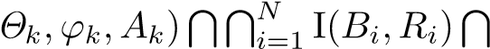
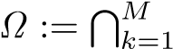
- VI(Ω,µF − γS) =6 ∅ whereGMEP(GSVI(G) Fix(T).
Then, the objective is to find x∗ ∈ Ξ such that
h(µF − γV )x∗,x − x∗i ≥ 0, ∀x ∈ Ξ, (1.10)
where Ξ := VI(Ω,µF − γS), that is, the solution set of the following hierarchical variational inequality problem (HVIP) of finding z∗ ∈ Ω such that
h(µF − γS)z∗,z − z∗i ≥ 0, ∀z ∈ Ω. (1.11)
Motivated and inspired by the above facts, we introduce and analyze two iterative methods for solving Problem 1.2. By combining Korpelevich’s extragradient method, viscosity approximation method, hybrid steepest-descent method and Mann’s iteration method, we first propose a multi-step hybrid steepestdescent extragradient method. However, by combining Mann’s iteration method, Korpelevich’s extragradient method, viscosity approximation method, hybrid steepest-descent method and projection method, we propose a multistep composite Mann-type viscosity iterative algorithm. We prove the strong convergence results for these methods. In particular, we prove that the proposed algorithms converge strongly to a common el-
T
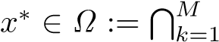
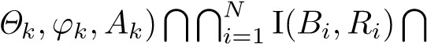
ementGMEP(GSVI(G) Fix(T) which is a unique solution of the THVIP 1.2. In addition, we also consider the application of the proposed algorithm for solving a hierarchical variational inequality problem with constraints of finitely many GMEPs, finitely many variational inclusions and GSVI (1.4). The results obtained in this paper improve and extend the corresponding results announced by many others.

Preliminaries
Throughout this paper, we assume that H is a real Hilbert space whose inner product and norm are denoted by h·,·i and k·k, respectively. Let C be a nonempty closed convex subset of H. We write x_{n} * x to indicate that the sequence {x_{n}} converges weakly to x and x_{n} → x to indicate that the sequence {x_{n}} converges strongly to x. Moreover, we use ω_{w}(x_{n}) to denote the weak ω-limit set of the sequence {x_{n}}, that is,
ω_{w}(x_{n}) := {x ∈ H : x_{ni} * x for some subsequence {x_{ni}} of {x_{n}}}.
Definition 2.1. A mapping A : C → H is called
- monotone if
hAx − Ay,x − yi ≥ 0, ∀x,y ∈ C;
- η-strongly monotone if there exists a constant η > 0 such that
hAx − Ay,x − yi ≥ ηkx − yk², ∀x,y ∈ C;
- ζ-inverse-strongly monotone if there exists a constant ζ > 0 such that
It is easy to see that the projection P_{C} is 1-inverse-strongly monotone. Inverse strongly monotone (also referred to as co-coercive) operators have been applied widely in solving practical problems in various fields. It is obvious that if A is ζ-inverse-strongly monotone, then A is monotone and -Lipschitz continuous.
Moreover, we also have that, for all u,v ∈ C and λ > 0,
k(I − λA)u − (I − λA)vk² = k(u − v) − λ(Au − Av)k²
= ku − vk² − 2λhAu − Av,u − vi + λ²kAu − Avk² (2.12) ≤ ku − vk² + λ(λ − 2ζ)kAu − Avk².
So, if λ ≤ 2ζ, then I − λA is a nonexpansive mapping from C to H.
The metric (or nearest point) projection from H onto C is the mapping P_{C} : H → C which assigns to each point x ∈ H the unique point P_{C}x ∈ C satisfying the property
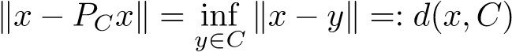.
Some important properties of projections are gathered in the following proposition.
Proposition 2.1. For given x ∈ H and z ∈ C:
- z = P_{C}x ⇔ hx − z,y − zi ≤ 0, ∀y ∈ C;
- z = P_{C}x ⇔ kx − zk² ≤ kx − yk² − ky − zk², ∀y ∈ C;
- hP_{C}x − P_{C}y,x − yi ≥ kP_{C}x − P_{C}yk², ∀y ∈ H. Consequently, P_{C} is nonexpansive and monotone.
Definition 2.2. A mapping T : H → H is said to be:
- nonexpansive if
kTx − Tyk ≤ kx − yk, ∀x,y ∈ H;
- firmly nonexpansive if 2T − I is nonexpansive, or equivalently, if T is 1-inverse strongly monotone
(1-ism),
hx − y,Tx − Tyi ≥ kTx − Tyk², ∀x,y ∈ H;
alternatively, T is firmly nonexpansive if and only if T can be expressed as
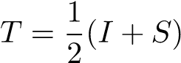,
where S : H → H is nonexpansive; projections are firmly nonexpansive.
It can be easily seen that if T is nonexpansive, then I − T is monotone.
Next we list some elementary conclusions for the MEP.
Proposition 2.2. [21] Assume that Θ : C × C → R satisfies (A1)-(A4) and let ϕ : C → R be a proper lower semicontinuous and convex function. Assume that either (B1) or (B2) holds. For r > 0 and x ∈ H, define a mapping T_{r}^{(Θ,ϕ)} : H → C as follows:
for all x ∈ H. Then the following statements hold:
- For each x ∈ H, T_{r}^{(Θ,ϕ)}(x) is nonempty and single-valued;
- T_{r}^{(Θ,ϕ)} is firmly nonexpansive, that is, for any x,y ∈ H,
;
- Fix(T_{r}^{(Θ,ϕ)}) = MEP(Θ,ϕ);
- MEP(Θ,ϕ) is closed and convex;
for all s,t > 0 and x ∈ H.
Ceng et al. [18] transformed the GSVI (1.4) into a fixed point problem in the following way:
Proposition 2.3. [18] For given x,¯ y¯ ∈ C, (¯x,y¯) is a solution of the GSVI (1.4) if and only if x¯ is a fixed point of the mapping G : C → C defined by
Gx = P_{C}(I − ν₁F₁)P_{C}(I − ν₂F₂)x, ∀x ∈ C,
where y¯ = P_{C}(I − ν₂F₂)¯x.
In particular, if the mapping F_{j} : C → H is ζ_{j}-inverse-strongly monotone for j = 1,2, then the mapping G is nonexpansive provided ν_{j} ∈ (0,2ζ_{j}] for j = 1,2. We denote by GSVI(G) denote the fixed point set of the mapping G.
We need some facts and tools in a real Hilbert space H which are listed as lemmas below. Lemma 2.1. Let X be a real inner product space. Then there holds the following inequality
kx + yk² ≤ kxk² + 2hy,x + yi, ∀x,y ∈ X.
Lemma 2.2. Let H be a real Hilbert space. Then the following hold:
- kx − yk² = kxk² − kyk² − 2hx − y,yi for all x,y ∈ H;
- kλx + µyk² = λkxk² + µkyk² − λµkx − yk² for all x,y ∈ H and λ,µ ∈ [0,1] with λ + µ = 1;
- If {x_{n}} is a sequence in H such that x_{n} * x, it follows that
It is clear that, in a real Hilbert space H, T : C → C is ξ-strictly pseudocontractive if and only if the following inequality holds:
This immediately implies that if T is a ξ-strictly pseudocontractive mapping, then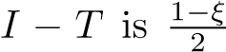-inverse strongly monotone; for further detail, we refer to [32] and the references therein. It is well known that the class of strict pseudocontractions strictly includes the class of nonexpansive mappings and that the class of pseudocontractions strictly includes the class of strict pseudocontractions.
Lemma 2.3. [32, Proposition 2.1] Let C be a nonempty closed convex subset of a real Hilbert space H and T : C → C be a mapping.
- If T is a ξ-strictly pseudocontractive mapping, then T satisfies the Lipschitzian condition
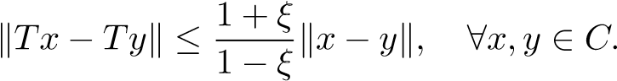
- If T is a ξ-strictly pseudocontractive mapping, then the mapping I − T is semiclosed at 0, that is, if {x_{n}} is a sequence in C such that x_{n} * x˜ and (I − T)x_{n} → 0, then (I − T)x˜ = 0.
- If T is ξ-(quasi-)strict pseudocontraction, then the fixed-point set Fix(T) of T is closed and convex so
that the projection P_{Fix(T)} is well defined.
Lemma 2.4. [43] Let C be a nonempty closed convex subset of a real Hilbert space H. Let T : C → C be a ξ-strictly pseudocontractive mapping. Let γ and δ be two nonnegative real numbers such that (γ + δ)ξ ≤ γ. Then
kγ(x − y) + δ(Tx − Ty)k ≤ (γ + δ)kx − yk, ∀x,y ∈ C.
Lemma 2.5. [26, Demiclosedness principle]] Let C be a nonempty closed convex subset of a real Hilbert space H. Let S be a nonexpansive self-mapping on C with Fix(S) 6= ∅. Then I − S is demiclosed. That is, whenever {x_{n}} is a sequence in C weakly converging to some x ∈ C and the sequence {(I − S)x_{n}} strongly converges to some y, it follows that (I − S)x = y. Here I is the identity operator of H.
Lemma 2.6. Let A : C → H be a monotone mapping. In the context of the variational inequality problem the characterization of the projection (see Proposition 2.1 (i)) implies
u ∈ VI(C,A) ⇔ u = P_{C}(u − λAu), ∀λ > 0.
Let C be a nonempty closed convex subset of a real Hilbert space H. Let λ be a number in (0,1] and let
µ > 0. Associating with a nonexpansive mapping T : C → H, we define the mapping T^{λ} : C → H by
T^{λ}x := Tx − λµF(Tx), ∀x ∈ C,
where F : H → H is an operator such that, for some positive constants κ,η > 0, F is κ-Lipschitzian and η-strongly monotone on H; that is, F satisfies the conditions:
kFx − Fyk ≤ κkx − yk and hFx − Fy,x − yi ≥ ηkx − yk²
for all x,y ∈ H.
Lemma 2.7. [41, Lemma 3.1] T^{λ} is a contraction provided 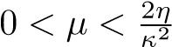; that is,
kT^{λ}x − T^{λ}yk ≤ (1 − λτ)kx − yk, ∀x,y ∈ C,
p where τ = 1 − 1 − µ(2η − µκ²) ∈ (0,1].
Remark 2.1. (i) Since F is κ-Lipschitzian and η-strongly monotone on H, we get 0 < η ≤ κ. Hence, whenever 0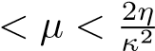, we have
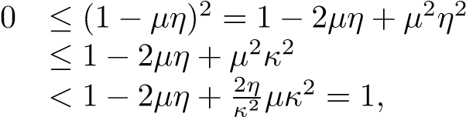
which implies
p
0 < 1 − 1 − 2µη + µ²κ² ≤ 1.
p
So, τ = 1 − 1 − µ(2η − µκ²) ∈ (0,1].
(ii) In Lemma 2.7, put 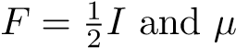= 2. Then we know that 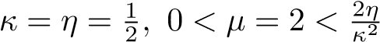= 4 and
.
Lemma 2.8. [41] Let {s_{n}} be a sequence of nonnegative numbers satisfying the conditions
s_{n+1} ≤ (1 − α_{n})s_{n} + α_{n}β_{n}, ∀n ≥ 1,
where {α_{n}} and {β_{n}} are sequences of real numbers such that
(i) {α_{n}} ⊂ [0,1] and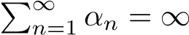, or equivalently,
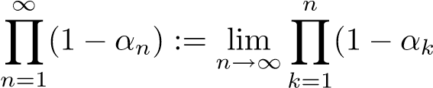) = 0;
.
Then, lim_{n→∞} s_{n} = 0.
Finally, recall that a set-valued mapping T : D(T) ⊂ H → 2^{H} is called monotone if for all x,y ∈ D(T), f ∈ Tx and g ∈ Ty imply
hf − g,x − yi ≥ 0.
A set-valued mapping T is called maximal monotone if T is monotone and (I+λT)D(T) = H for each λ > 0, where I is the identity mapping of H. We denote by G(T) the graph of T. It is known that a monotone mapping T is maximal if and only if, for (x,f) ∈ H × H, hf − g,x − yi ≥ 0 for every (y,g) ∈ G(T) implies f ∈ Tx.
Next we provide an example to illustrate the concept of maximal monotone mapping.
Let A : C → H be a monotone, k-Lipschitz-continuous mapping and let N_{C}v be the normal cone to C at v ∈ C, that is,
N_{C}v = {u ∈ H : hv − p,ui ≥ 0, ∀p ∈ C}.
Define
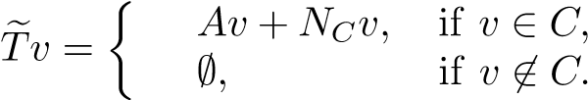
Then, Te is maximal monotone (see [36]) such that
0 ∈ Tve ⇐⇒ v ∈ VI(C,A). (2.13)
Let R : D(R) ⊂ H → 2^{H} be a maximal monotone mapping. Let λ,µ > 0 be two positive numbers.
Lemma 2.9. [6] There holds the resolvent identity
Remark 2.2. For λ,µ > 0, there holds the following relation
(2.14)
Indeed, whenever λ ≥ µ, utilizing Lemma 2.9 we deduce that
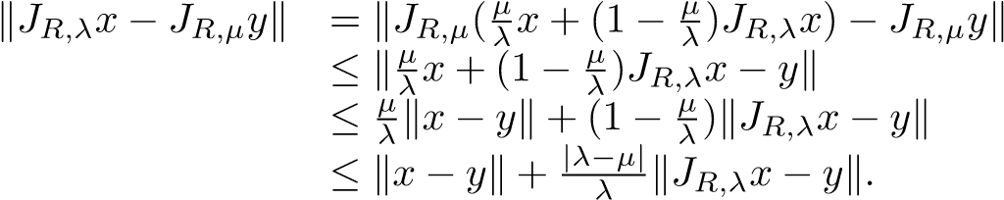
Similarly, whenever λ < µ, we get
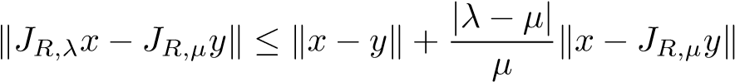.
Combining the above two cases we conclude that (2.14) holds.
In terms of Huang [28] (see also [48]), there holds the following property for the resolvent operator

J_{R,λ} : H → D(R).
Lemma 2.10. J_{R,λ} is single-valued and firmly nonexpansive, that is,
hJ_{R,λ}x − J_{R,λ}y,x − yi ≥ kJ_{R,λ}x − J_{R,λ}yk², ∀x,y ∈ H.
Consequently, J_{R,λ} is nonexpansive and monotone.
Lemma 2.11. [7] Let R be a maximal monotone mapping with D(R) = C. Then for any given λ > 0, u ∈ C is a solution of problem (1.5) if and only if u ∈ C satisfies
u = J_{R,λ}(u − λBu).
Lemma 2.12. [48] Let R be a maximal monotone mapping with D(R) = C and let B : C → H be a strongly monotone, continuous and single-valued mapping. Then for each z ∈ H, the equation z ∈ (B + λR)x has a unique solution x_{λ} for λ > 0.
Lemma 2.13. [7] Let R be a maximal monotone mapping with D(R) = C and B : C → H be a monotone, continuous and single-valued mapping. Then (I + λ(R + B))C = H for each λ > 0. In this case, R + B is maximal monotone.

Hybrid Steepest-Descent Extragradient Method and Convergence Results
In this section, we introduce and analyze a multi-step hybrid steepest-descent extragradient algorithm for finding a solution of THVIP 1.2. This algorithm is based on Korpelevich’s extragradient method, viscosity approximation method, hybrid steepest-descent method and Mann’s iteration method. We prove the strong convergence of the proposed algorithm to a unique solution of THVIP 1.2 under suitable conditions. In addition, we also consider the application of the proposed algorithm for solving a hierarchical variational inequality problem (HVIP).
Rest of the paper, unless otherwise specified, we assume that M and N are positive integers, and C is a nonempty closed convex subset of a real Hilbert space H.
Assumption 3.1. (a) For each k ∈ {1,2,...,M}, let Θ_{k} : C × C → R be a bifunction satisfying (A1)(A4) and ϕ_{k} : C → R ∪ {+∞} be a proper lower semicontinuous and convex function with restriction (B1) or (B2).
- For each k ∈ {1,2,...,M} and each i ∈ {1,2,...,N}, let R_{i} : C → 2^{H} be a maximal monotone mapping, and A_{k} : H → H and B_{i} : C → H be µ_{k}-inverse strongly monotone and η_{i}-inverse strongly monotone, respectively,
- Let T : H → H be a ξ-strictly pseudocontractive mapping, S : H → H be a nonexpansive mapping and V : H → H be a ρ-contraction with coefficient ρ ∈ [0,1).
- For j = 1,2, let F_{j} : C → H be ζ_{j}-inverse-strongly monotone, and F : H → H be κ-Lipschitzian and
η-strongly monotone with positive constants κ,η > 0 such that 0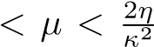 and 0 < γ ≤ τ, where p τ = 1 − 1 − µ(2η − µκ²).
T
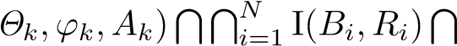
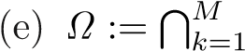
GMEP(GSVI(G) Fix(T).
- The solution set Ξ of HVIP (1.11) is nonempty.
- Let {α_{n}}, {λ_{n}} ⊂ (0,1], {β_{n}}, {γ_{n}}, {δ_{n}} ⊂ [0,1], {λ_{i,n}} ⊂ [a_{i},b_{i}] ⊂ (0,2η_{i}) and {r_{k,n}} ⊂ [c_{k},d_{k}] ⊂ (0,2µ_{k}), where i ∈ {1,2,...,N} and k ∈ {1,2,...,M}.
We propose the following multi-step hybrid steepest-descent extragradient algorithm for finding a solution of THVIP 1.2.
Algorithm 3.1. For given arbitrarily x₀ ∈ H, let {x_{n}} be the sequence generated by
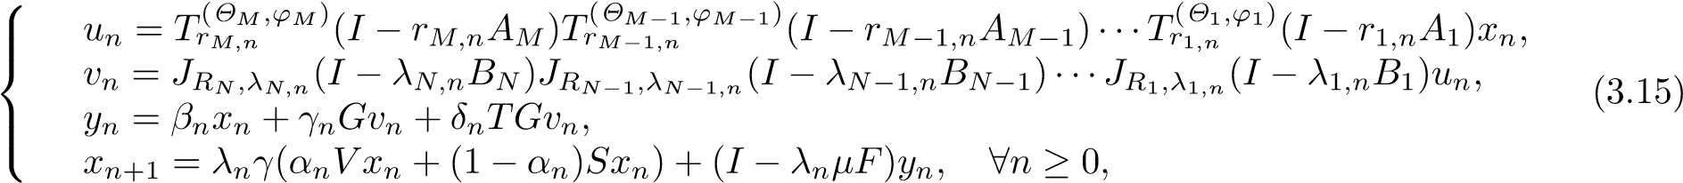
where G := P_{C}(I − ν₁F₁)P_{C}(I − ν₂F₂) with ν_{j} ∈ (0,2ζ_{j}) for j = 1,2.
If V ≡ 0, then Algorithm 3.1 reduces to the following algorithm.
Algorithm 3.2. For given arbitrarily x₀ ∈ H, let {x_{n}} be the sequence generated by
     | un = Tr(M,nΘM,ϕM)(I − rM,nAM)Tr(MΘ−M1−,n1,ϕM−1)(I − rM−1,nAM−1)···Tr(1Θ,n1,ϕ1)(I − r1,nA1)xn, vn = JR_{N},λ_{N,n}(I − λN,nBN)JR_{N−1},λ_{N−1,n}(I − λN−1,nBN−1)···JR₁,λ_{1,n}(I − λ1,nB1)un, y_{n} = β_{n}x_{n} + γ_{n}Gv_{n} + δ_{n}TGv_{n}, | (3.16)
x_{n+1} = λ_{n}(1 − α_{n})γSx_{n} + (I − λ_{n}µF)y_{n}, ∀n ≥ 0,
The following result provides the convergence of the sequences generated by the above algorithm. Theorem 3.1. In addition to Assumption 3.1, suppose that
and 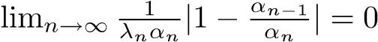; and 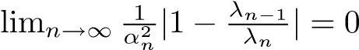; 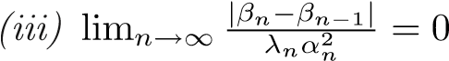 and 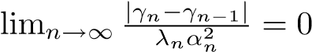;
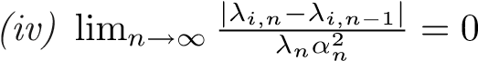 and
- β_{n} + γ_{n} + δ_{n} = 1, (γ_{n} + δ_{n})ξ ≤ γ_{n} (∀n ≥ 0), {β_{n}} ⊂ [a,b] ⊂ (0,1) and liminf_{n→∞} δ_{n} > 0;
- kx − Txk ≥ k¯[d(x,Ω)]^{θ} (∀x ∈ C) and lim_{n→∞}(λ¹_{n}^{/θ}/α_{n}) = 0 for some k,θ >¯ 0.
Then, the following conclusions hold.
- If {Sx_{n}} is bounded, then {x_{n}} converges strongly to a point x∗ ∈ Ω which is a unique solution of Problem 1.2 provided that ky_{n} − Tx_{n}k = o(α_{n}).
- If {Sx_{n}} is bounded, where {x_{n}} is the sequence generated by (3.16), then {x_{n}} converges strongly to a unique solution x∗ ∈ Ξ of the following VIP provided that ky_{n} − Tx_{n}k = o(α_{n}):
hFx∗,x − x∗i ≥ 0, ∀x ∈ Ξ.
Proof. Put
for all k ∈ {1,2,...,M} and n ≥ 1,
for all and 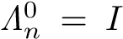, where I is the identity mapping on H. Then, we have
un = ∆Mn xn and vn = ΛNn un.
We divide rest of the proof into several steps.
Step 1. We prove that {x_{n}} is bounded.
Indeed, take a fixed p ∈ Ω arbitrarily. Utilizing (2.12) and Proposition 2.2 (ii), we have
kun − pk = kTr(M,nΘM,ϕM)(I − rM,nBM)∆Mn −1xn − Tr(M,nΘM,ϕM)(I − rM,nBM)∆Mn −1pk
≤ k(I − rM,nBM)∆Mn −1xn − (I − rM,nBM)∆Mn −1pk ≤ k∆Mn −1xn − ∆Mn −1pk
...
≤ k∆0nxn − ∆0npk = kx_{n} − pk.
Utilizing (2.12) and Lemma 2.10, we have
kvn − pk = kJRN,λN,n(I − λN,nAN)ΛNn −1un − JRN,λN,n(I − λN,nAN)ΛNn −1pk
≤ k(I − λN,nAN)ΛNn −1un − (I − λN,nAN)ΛNn −1pk ≤ kΛNn −1un − ΛNn −1pk
...  ≤ kΛ0nun − Λ0npk = ku_{n} − pk,  which together with the last inequality implies that | (3.17)
kv_{n} − pk ≤ kx_{n} − pk. | (3.18)
Since p = Gp = P_{C}(I−ν₁F₁)P_{C}(I−ν₂F₂)p, F_{j} is ζ_{j}-inverse-strongly monotone for j = 1,2, and 0 < ν_{j} ≤ 2ζ_{j} for j = 1,2, we deduce that, for any n ≥ 0,
kGv_{n} − pk²
= kP_{C}(I − ν₁F₁)P_{C}(I − ν₂F₂)v_{n} − P_{C}(I − ν₁F₁)P_{C}(I − ν₂F₂)pk²
≤ k(I − ν₁F₁)P_{C}(I − ν₂F₂)v_{n} − (I − ν₁F₁)P_{C}(I − ν₂F₂)pk²
= k[P_{C}(I − ν₂F₂)v_{n} − P_{C}(I − ν₂F₂)p] − ν₁[F₁P_{C}(I − ν₂F₂)v_{n} − F₁P_{C}(I − ν₂F₂)p]k²
≤ kP_{C}(I − ν₂F₂)v_{n} − P_{C}(I − ν₂F₂)pk²
+ ν₁(ν₁ − 2ζ₁)kF₁P_{C}(I − ν₂F₂)v_{n} − F₁P_{C}(I − ν₂F₂)pk² (3.19)
≤ kP_{C}(I − ν₂F₂)v_{n} − P_{C}(I − ν₂F₂)pk²
≤ k(I − ν₂F₂)v_{n} − (I − ν₂F₂)pk²
= k(v_{n} − p) − ν₂(F₂v_{n} − F₂p)k² ≤ kv_{n} − pk² + ν₂(ν₂ − 2ζ₂)kF₂v_{n} − F₂pk² ≤ kv_{n} − pk².
(This shows that G : C → C is a nonexpansive mapping). Since (γ_{n} + δ_{n})ξ ≤ γ_{n} for all n ≥ 0 and T is ξ-strictly pseudocontractive, utilizing Lemma 2.4, we obtain from (3.15), (3.18) and (3.19) that
ky_{n} − pk = kβ_{n}x_{n} + γ_{n}Gv_{n} + δ_{n}TGv_{n} − pk
= kβ_{n}(x_{n} − p) + γ_{n}(Gv_{n} − p) + δ_{n}(TGv_{n} − p)k
≤ β_{n}kx_{n} − pk + kγ_{n}(Gv_{n} − p) + δ_{n}(TGv_{n} − p)k
≤ β_{n}kx_{n} − pk + (γ_{n} + δ_{n})kGv_{n} − pk (3.20)
≤ β_{n}kx_{n} − pk + (γ_{n} + δ_{n})kv_{n} − pk
≤ β_{n}kx_{n} − pk + (γ_{n} + δ_{n})kx_{n} − pk
= kx_{n} − pk,
Noticing the boundedness of {Sx_{n}}, we get sup_{n≥0} kγSx_{n} −µFpk ≤ Mc for some M >c 0. Moreover, utilizing
Lemma 2.7, we deduce from (3.15), (3.20) and 0 < γ ≤ τ that for all n ≥ 0
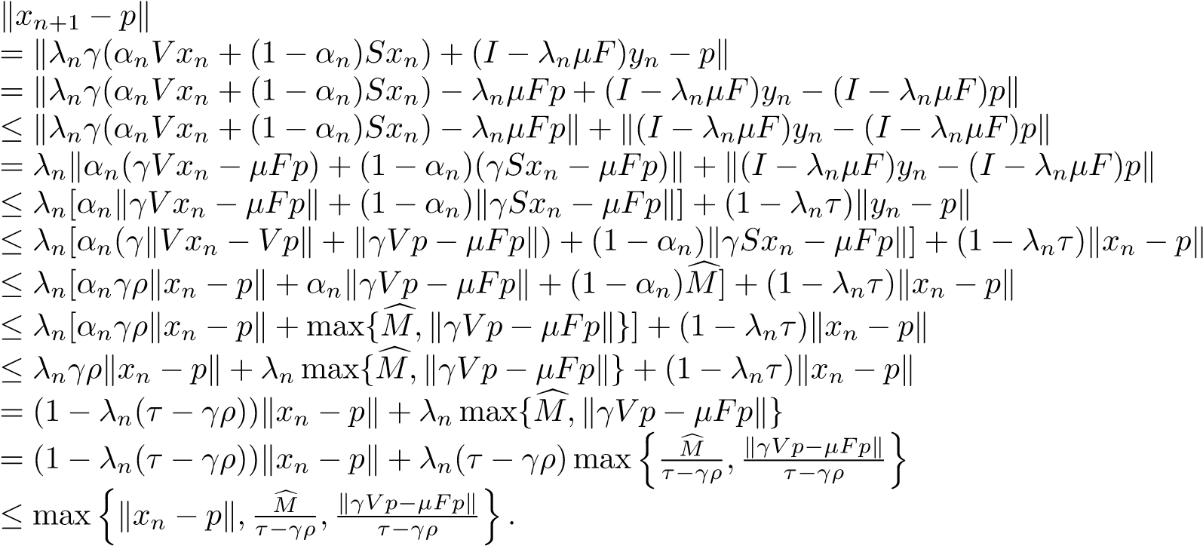
By induction, we obtain
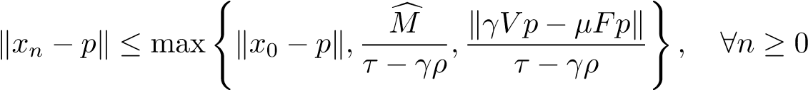.
Thus, {x_{n}} is bounded and so are the sequences {u_{n}}, {v_{n}} and {y_{n}}.
Step 2. We prove that lim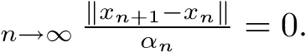
Indeed, utilizing (2.12) and (2.14), we obtain
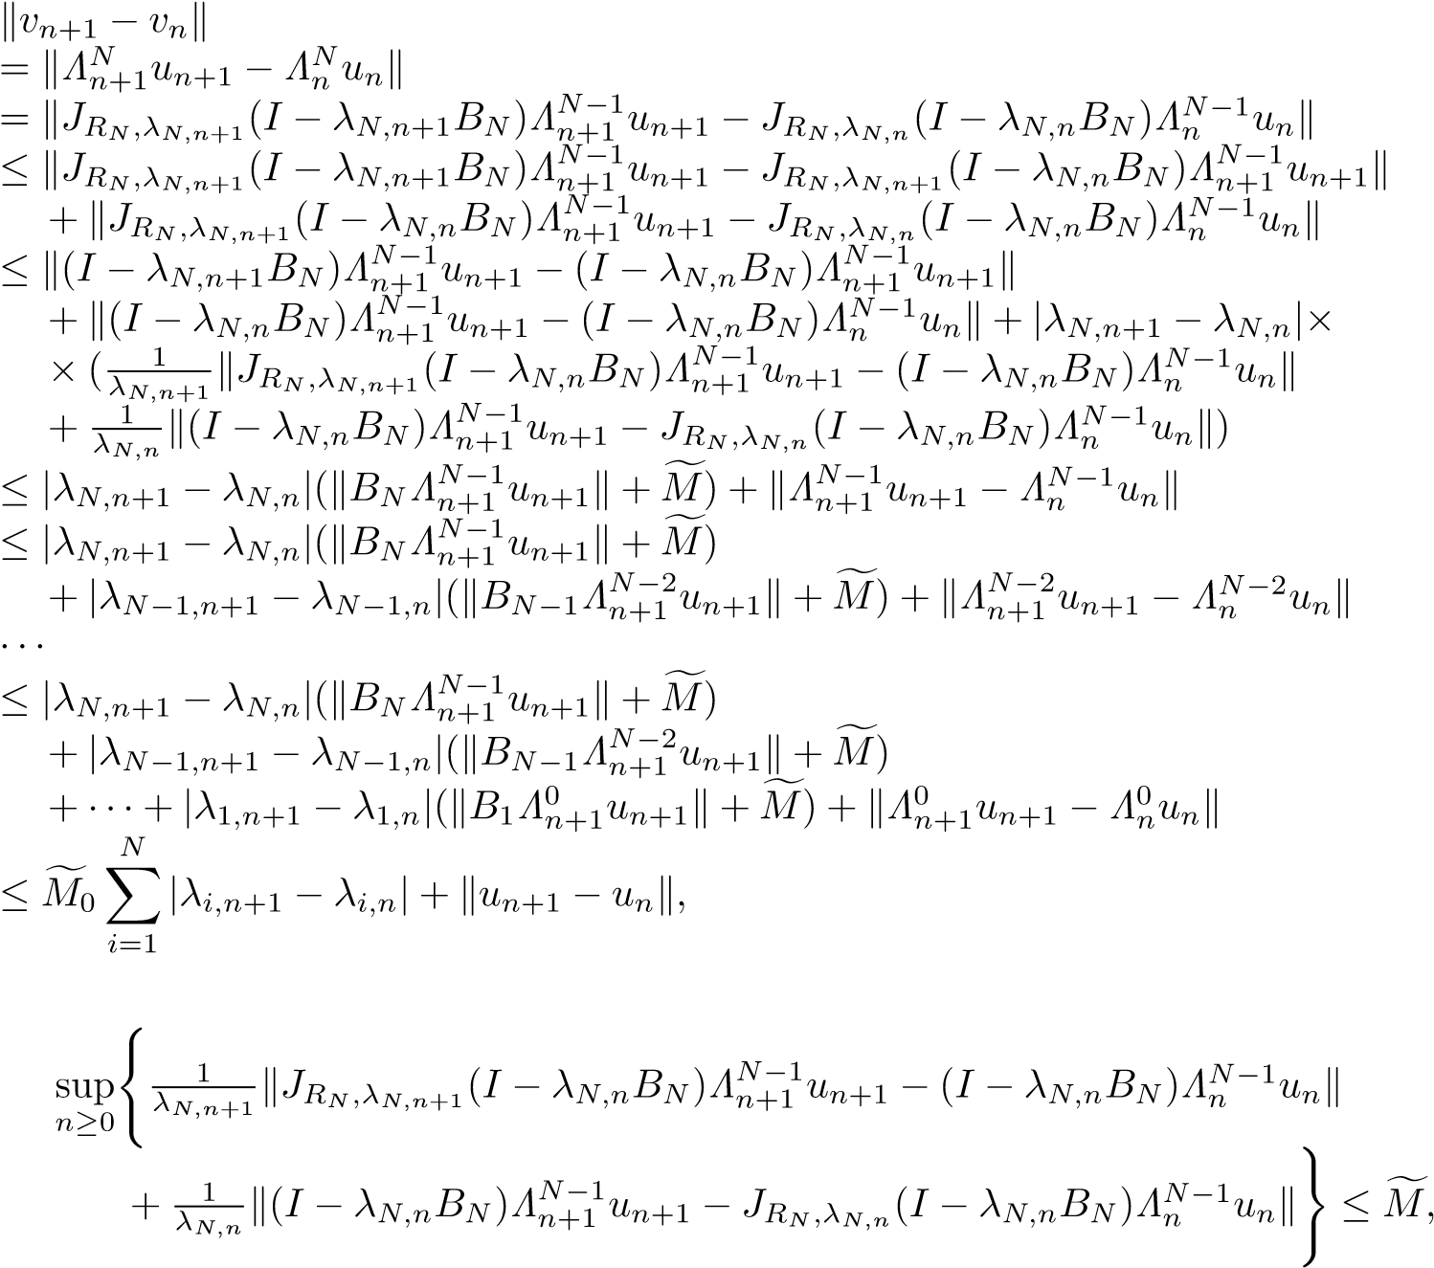
(3.21)
where
for some M >f 0 and sup for some Mf₀ > 0. Utilizing Proposition 2.2
(ii), (v), we have
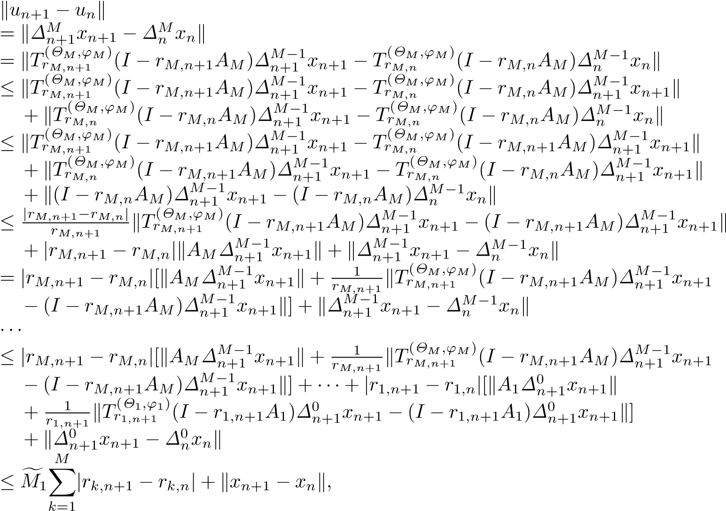 (3.22)
where 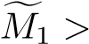0 is a constant such that for each n ≥ 0
.
Furthermore, define y_{n} = β_{n}x_{n} + (1 − β_{n})w_{n} for all n ≥ 0. It follows that
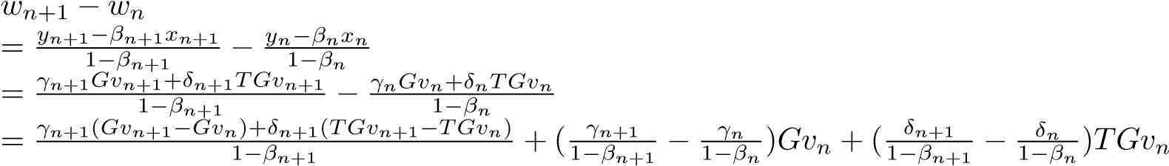
(3.23)
.
Since (γ_{n} + δ_{n})ξ ≤ γ_{n} for all n ≥ 0, utilizing Lemma 2.4, we have
kγn+1(Gvn+1 − Gvn) + δn+1(TGvn+1 − TGvn)k ≤ (γn+1 + δn+1)kGvn+1 − Gvnk. (3.24)
Hence, it follows from (3.21) – (3.24) that
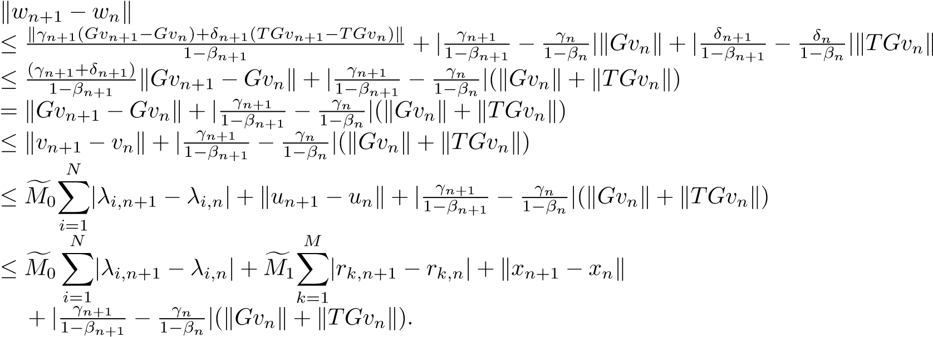 (3.25)
In the meantime, simple calculation shows that
yn+1 − yn = βn(xn+1 − xn) + (1 − βn)(wn+1 − wn) + (βn+1 − βn)(xn+1 − wn+1). So, it follows from (3.25) that
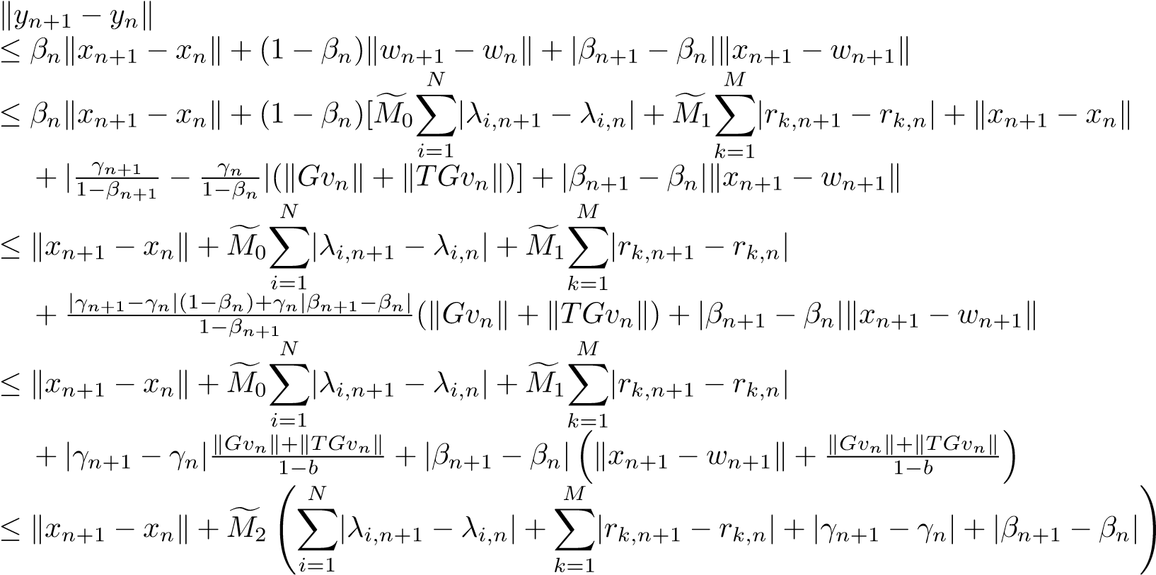
(3.26)
,
where sup for some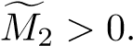
On the other hand, define z_{n} := α_{n}V x_{n} + (1 − α_{n})Sx_{n} for all n ≥ 0. Then, it is known that x_{n+1} =
λ_{n}γz_{n} + (I − λ_{n}µF)y_{n} for all n ≥ 0. Simple calculations show that

   | zn+1 − zn = (αn+1 − αn)(V xn − Sxn) + αn+1(V xn+1 − V xn)  +(1 − α_{n+1})(Sx_{n+1} − Sx_{n}),  xn+2 − xn+1 = (λn+1 − λn)(γzn − µFyn) + λn+1γ(zn+1 − zn)
+ (I − λn+1µF)yn+1 − (I − λn+1µF)yn.
Since V is a ρ-contraction with coefficient ρ ∈ [0,1) and S is a nonexpansive mapping, we conclude that
kzn+1 − znk ≤ |αn+1 − αn|kV xn − Sxnk + αn+1kV xn+1 − V xnk + (1 − αn+1)kSxn+1 − Sxnk
≤ |αn+1 − αn|kV xn − Sxnk + αn+1ρkxn+1 − xnk + (1 − αn+1)kxn+1 − xnk = (1 − α_{n+1}(1 − ρ))kx_{n+1} − x_{n}k + |α_{n+1} − α_{n}|kV x_{n} − Sx_{n}k,
which together with (3.12) and 0 < γ ≤ τ, implies that
kxn+2 − xn+1k
≤ |λn+1 − λn|kγzn − µFynk + λn+1γkzn+1 − znk + k(I − λn+1µF)yn+1 − (I − λn+1µF)ynk
≤ |λn+1 − λn|kγzn − µFynk + λn+1γkzn+1 − znk + (1 − λn+1τ)kyn+1 − ynk
≤ |λ_{n+1} − λ_{n}|kγz_{n} − µFy_{n}k + λ_{n+1}γ[(1 − α_{n+1}(1 − ρ))kx_{n+1} − x_{n}k
XN
+ |αn+1 − αn|kV xn − Sxnk] + (1 − λn+1τ)[kxn+1 − xnk + Mf2( |λi,n+1 − λi,n|
i=1
XM
+ |rk,n+1 − rk,n| + |γn+1 − γn| + |βn+1 − βn|)]
k=1
≤ (1 − λ_{n+1}(τ − γ) − λ_{n+1}α_{n+1}γ(1 − ρ))kx_{n+1} − x_{n}k + |λ_{n+1} − λ_{n}|kγz_{n} − µFy_{n}k
XN
+ |αn+1 − αn|kV xn − Sxnk + Mf2( |λi,n+1 − λi,n|
i=1
XM
+ |rk,n+1 − rk,n| + |γn+1 − γn| + |βn+1 − βn|)
k=1
XN XM
≤ (1 − λn+1αn+1γ(1 − ρ))kxn+1 − xnk + Mf3{ |λi,n+1 − λi,n| + |rk,n+1 − rk,n|
i=1 k=1
+ |λn+1 − λn| + |αn+1 − αn| + |βn+1 − βn| + |γn+1 − γn|},
where sup_{n≥0}{kγz_{n} − µFy_{n}k + kV x_{n} − Sx_{n}k + Mf₂} ≤ Mf₃ for some Mf₃ > 0. Consequently,
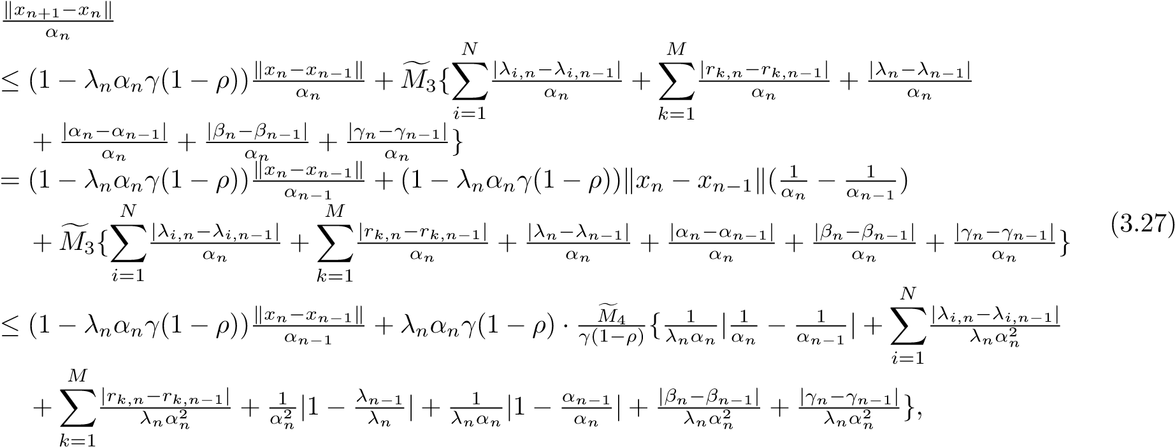
where sup_{n≥1}{kx_{n} − x_{n−1}k + Mf₃} ≤ Mf₄ for some Mf₄ > 0. From conditions (i)–(iv), it follows that
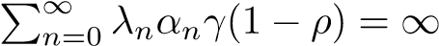and
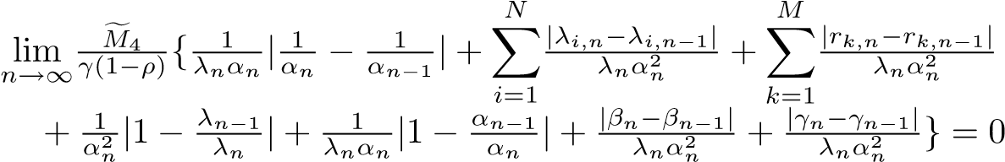.
Thus, utilizing Lemma 2.8, we immediately conclude that
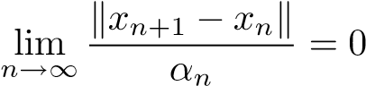.
So, from α_{n} → 0, it follows that
lim kx_{n+1} − x_{n}k = 0.
n→∞
Step 3. We prove that lim_{n→∞} kx_{n} − u_{n}k = 0, lim_{n→∞} kx_{n} − v_{n}k = 0, lim_{n→∞} kv_{n} − Gv_{n}k = 0 and lim_{n→∞} kv_{n} − Tv_{n}k = 0.
Indeed, utilizing Lemmas 2.1 and 2.2 (b), from (3.15), (3.18) – (3.19) and 0 < γ ≤ τ, we deduce that
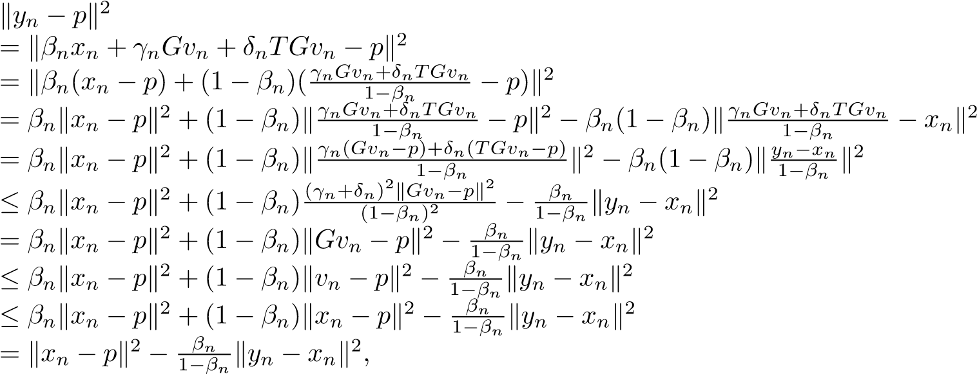 (3.28)
and hence,
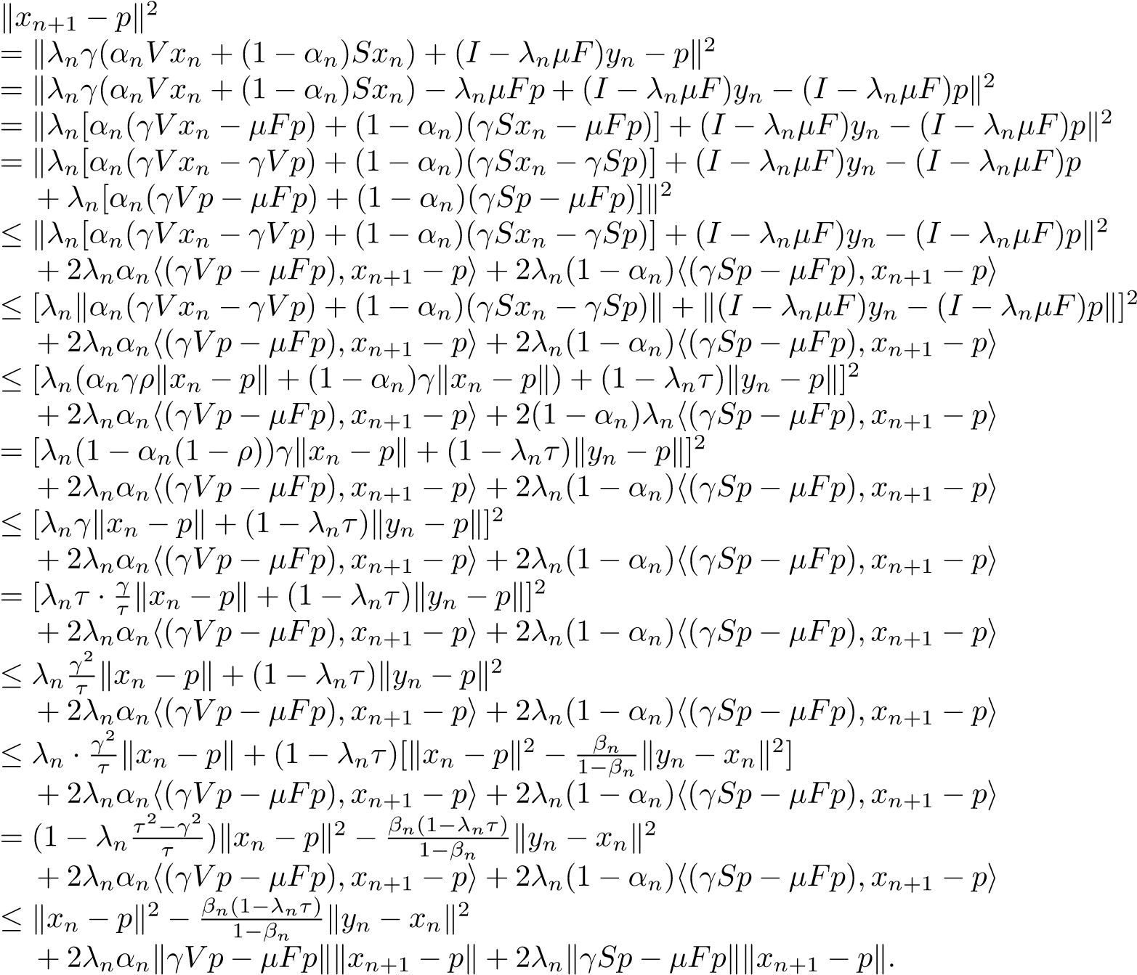 (3.29)
which together with {β_{n}} ⊂ [a,b] ⊂ (0,1), immediately yields
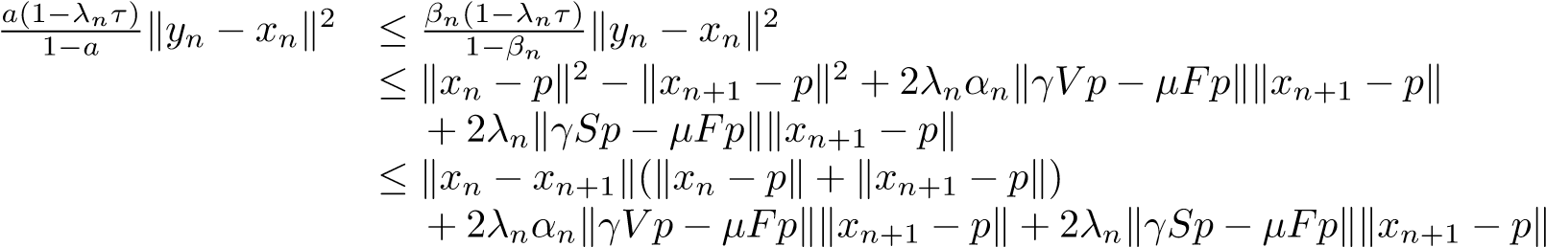.
Since λ_{n} → 0, α_{n} → 0, kx_{n+1} − x_{n}k → 0 and {x_{n}} is bounded, we have
lim ky_{n} − x_{n}k = 0. (3.30) n→∞
Observe that
 | 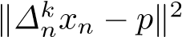
 |  | ≤ k(I − rk,nAk)∆kn−1xn − (I − rk,nAk)pk2  ≤ k∆kn−1xn − pk2 + rk,n(rk,n − 2µk)kAk∆kn−1xn − Akpk2  ≤ kxn − pk2 + rk,n(rk,n − 2µk)kAk∆kn−1xn − Akpk2, | (3.31)
and | 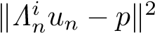
 |  | ≤ kΛin−1un − pk2 + λi,n(λi,n − 2ηi)kBiΛin−1un − Bipk2  ≤ kun − pk2 + λi,n(λi,n − 2ηi)kBiΛin−1un − Bipk2  ≤ kxn − pk2 + λi,n(λi,n − 2ηi)kBiΛin−1un − Bipk2, | (3.32)
for i ∈ {1,2,...,N} and k ∈ {1,2,...,M}. Combining (3.28), (3.31) and (3.32), we get |  |  | (3.32)
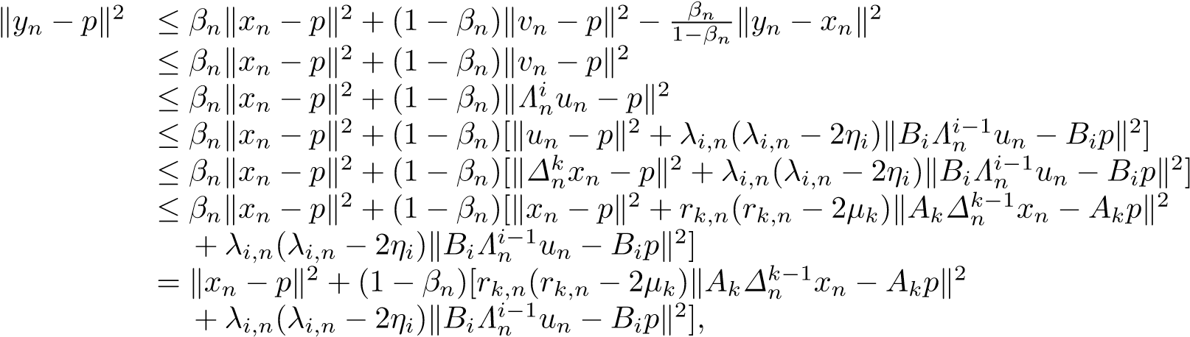
which immediately leads to
(1 − βn)[rk,n(2µk − rk,n)kAk∆kn−1xn − Akpk2 + λi,n(2ηi − λi,n)kBiΛin−1un − Bipk2]
≤ kx_{n} − pk² − ky_{n} − pk²
≤ kx_{n} − y_{n}k(kx_{n} − pk + ky_{n} − pk).
Since kx_{n} − y_{n}k → 0, {β_{n}} ⊂ [a,b] ⊂ (0,1), {λ_{i,n}} ⊂ [a_{i},b_{i}] ⊂ (0,2η_{i}), {r_{k,n}} ⊂ [c_{k},d_{k}] ⊂ (0,2µ_{k}), i ∈ {1,2,...,N},k ∈ {1,2,...,M} and {x_{n}},{y_{n}} are bounded sequences, we have
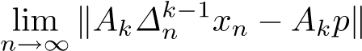= 0 and 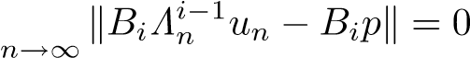lim , (3.33)
for all k ∈ {1,2,...,M} and i ∈ {1,2,...,N}.
Furthermore, by Proposition 2.2 (ii) and Lemma 2.2 (a), we have
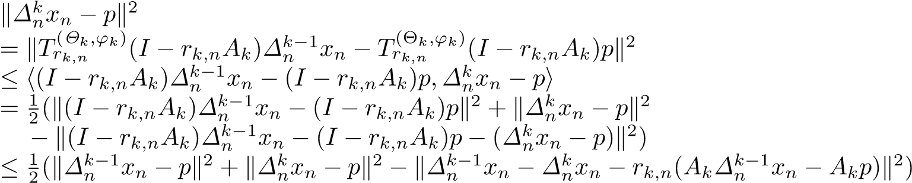,
which implies that
k∆knxn − pk2
≤ k∆kn−1xn − pk2 − k∆nk−1xn − ∆knxn − rk,n(Ak∆kn−1xn − Akp)k2
= k∆kn−1xn − pk2 − k∆nk−1xn − ∆knxnk2 − rk,n2 kAk∆kn−1xn − Akpk2  + 2rk,nh∆kn−1xn − ∆knxn,Ak∆nk−1xn − Akpi  ≤ k∆kn−1xn − pk2 − k∆nk−1xn − ∆knxnk2 + 2rk,nk∆kn−1xn − ∆knxnkkAk∆kn−1xn − Akpk ≤ kxn − pk2 − k∆kn−1xn − ∆knxnk2 + 2rk,nk∆nk−1xn − ∆knxnkkAk∆kn−1xn − Akpk. | (3.34)
By Lemma 2.2 (a) and Lemma 2.10, we obtain
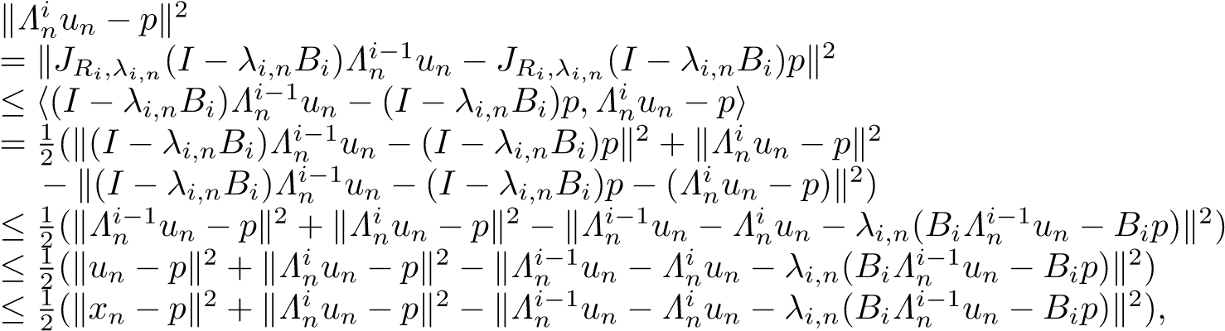
which immediately leads to
kΛinun − pk2
≤ kxn − pk2 − kΛin−1un − Λinun − λi,n(BiΛin−1un − Bip)k2
= kxn − pk2 − kΛin−1un − Λnkunk2 − λi,n2kBiΛin−1un − Bipk2 (3.35)
+ 2λi,nhΛni−1un − Λinun,BiΛin−1un − Bipi
≤ kxn − pk2 − kΛin−1un − Λinunk2 + 2λi,nkΛin−1un − ΛinunkkBiΛin−1un − Bipk.
Combining (3.28) and (3.35), we conclude that
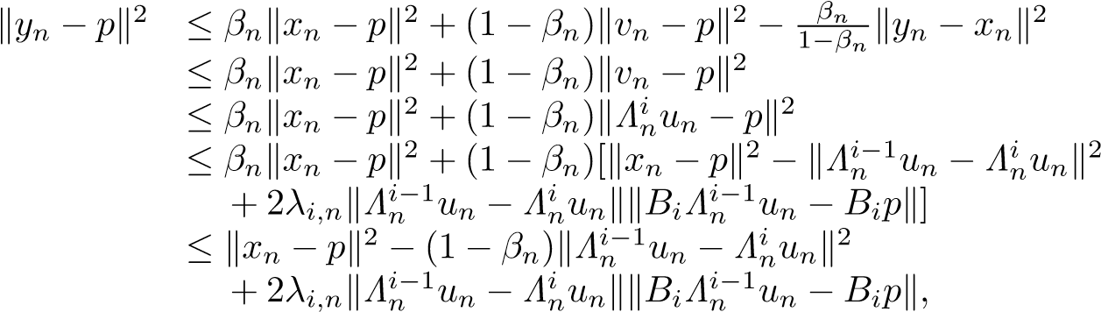
which yields
(1 − βn)kΛin−1un − Λinunk2
≤ kxn − pk2 − kyn − pk2 + 2λi,nkΛin−1un − ΛniunkkBiΛin−1un − Bipk ≤ kxn − ynk(kxn − pk + kyn − pk) + 2λi,nkΛin−1un − ΛinunkkBiΛin−1un − Bipk.
Since {β_{n}} ⊂ [a,b] ⊂ (0,1), {λ_{i,n}} ⊂ [a_{i},b_{i}] ⊂ (0,2η_{i}), i = 1,2,...,N, and {u_{n}},{x_{n}} and {y_{n}} are bounded sequences, we deduce from (3.33) and kx_{n} − y_{n}k → 0 that
. (3.36)
Also, combining (3.17), (3.28) and (3.34), we deduce that
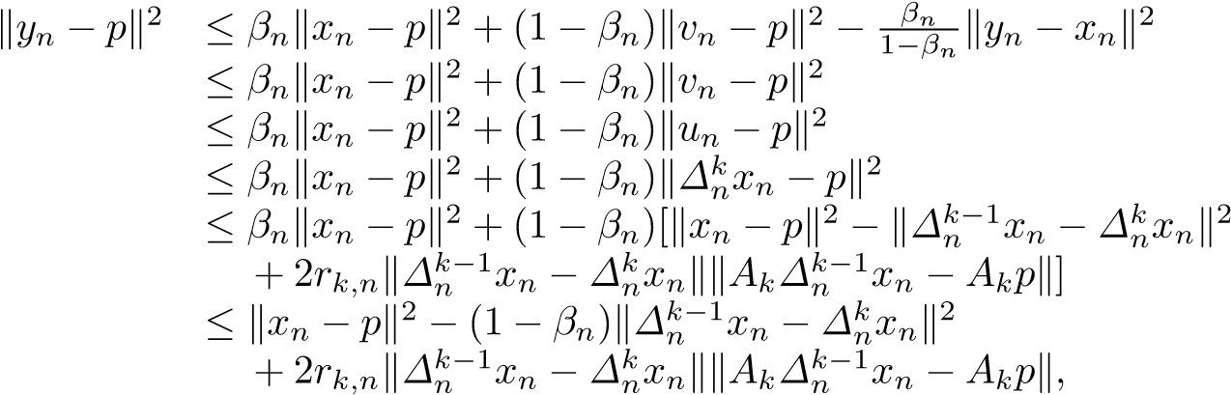
which yields
(1 − βn)k∆kn−1xn − ∆knxnk2
≤ kxn − pk2 − kyn − pk2 + 2rk,nk∆kn−1xn − ∆nkxnkkAk∆kn−1xn − Akpk ≤ kxn − ynk(kxn − pk + kyn − pk) + 2rk,nk∆kn−1xn − ∆knxnkkAk∆kn−1xn − Akpk. Since {β_{n}} ⊂ [a,b] ⊂ (0,1), {r_{k,n}} ⊂ [c_{k},d_{k}] ⊂ (0,2µ_{k}) for k = 1,2,...,M, and {x_{n}},{y_{n}} are bounded sequences, we deduce from (3.19) and kx_{n} − y_{n}k → 0 that
. (3.37)
Hence, from (3.36) and (3.37), we get
kxn − unk = k∆0nxn − ∆Mn xnk
≤ k∆0nxn − ∆1nxnk + k∆1nxn − ∆2nxnk + ··· + k∆Mn −1xn − ∆Mn xnk  → 0 as n → ∞,  and | (3.38)
≤ kΛ0nun − Λ1nunk + kΛ1nun − Λ2nunk + ··· + kΛNn −1un − ΛNn unk  → 0 as n → ∞,  respectively. Thus, from (3.38) and (3.39), we obtain | (3.39)
kx_{n} − v_{n}k ≤ kx_{n} − u_{n}k + ku_{n} − v_{n}k | (3.40)
→ 0 as n → ∞.
On the other hand, for simplicity, we write ˜p = P_{C}(I − ν₂F₂)p, ˜v_{n} = P_{C}(I − ν₂F₂)v_{n} and k_{n} = Gv_{n} =
P_{C}(I − ν₁F₁)v˜_{n} for all n ≥ 1. Then,
p = Gp = P_{C}(I − ν₁F₁)p˜ = P_{C}(I − ν₁F₁)P_{C}(I − ν₂F₂)p.
We now show that lim_{n→∞} kGv_{n} − v_{n}k = 0, that is, lim_{n→∞} kk_{n} − v_{n}k = 0. As a matter of fact, for p ∈ Ω, it follows from (3.18), (3.19) and (3.28) that
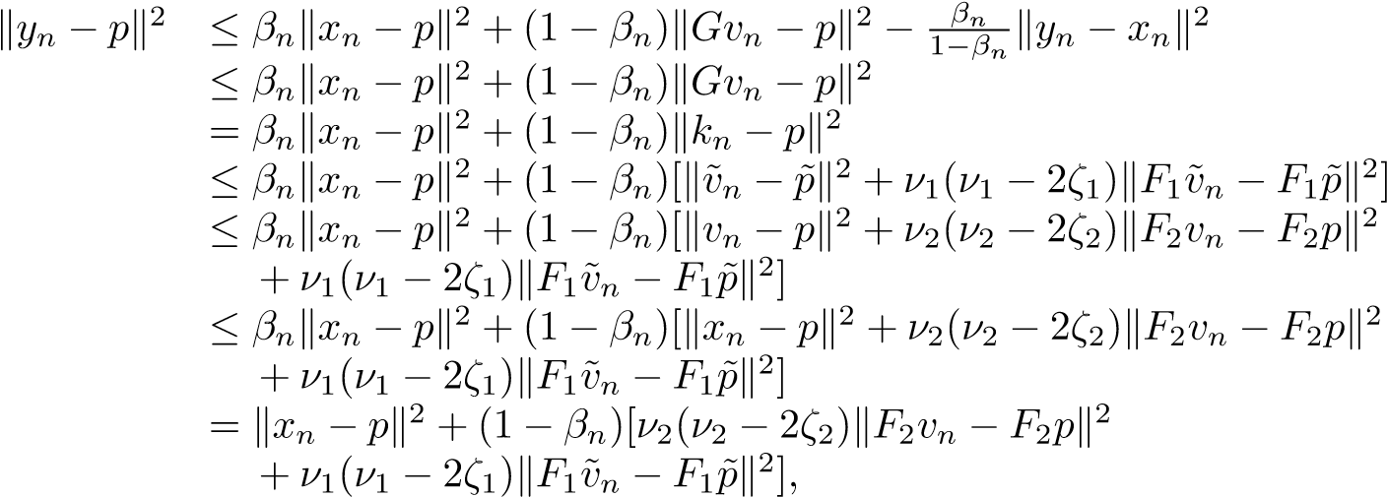 (3.41)
which immediately yields
(1 − β_{n})[ν₂(2ζ₂ − ν₂)kF₂v_{n} − F₂pk² + ν₁(2ζ₁ − ν₁)kF₁v˜_{n} − F₁p˜k²]
≤ kx_{n} − pk² − ky_{n} − pk² ≤ kx_{n} − y_{n}k(kx_{n} − pk + ky_{n} − pk).
Since kx_{n} − y_{n}k → 0, {β_{n}} ⊂ [a,b] ⊂ (0,1), ν_{j} ∈ (0,2ζ_{j}),j = 1,2, and {x_{n}},{y_{n}} are bounded sequences, we have
lim kF₂v_{n} − F₂pk = 0 and lim kF₁v˜_{n} − F₁p˜k = 0. (3.42) n→∞ n→∞
Also, in terms of the firm nonexpansivity of P_{C} and the ζ_{j}-inverse strong monotonicity of F_{j} for j = 1,2, we obtain from ν_{j} ∈ (0,2ζ_{j}), j = 1,2 and (3.19) that
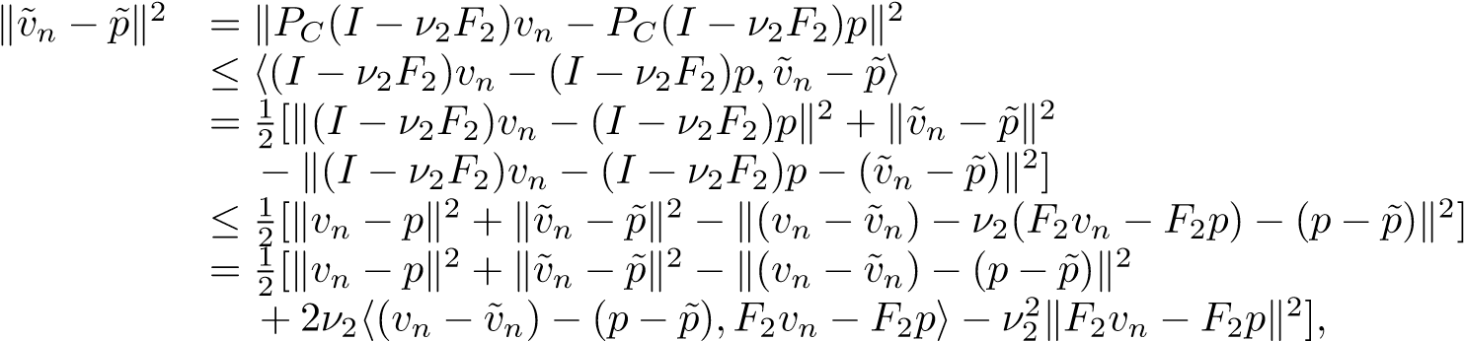
and
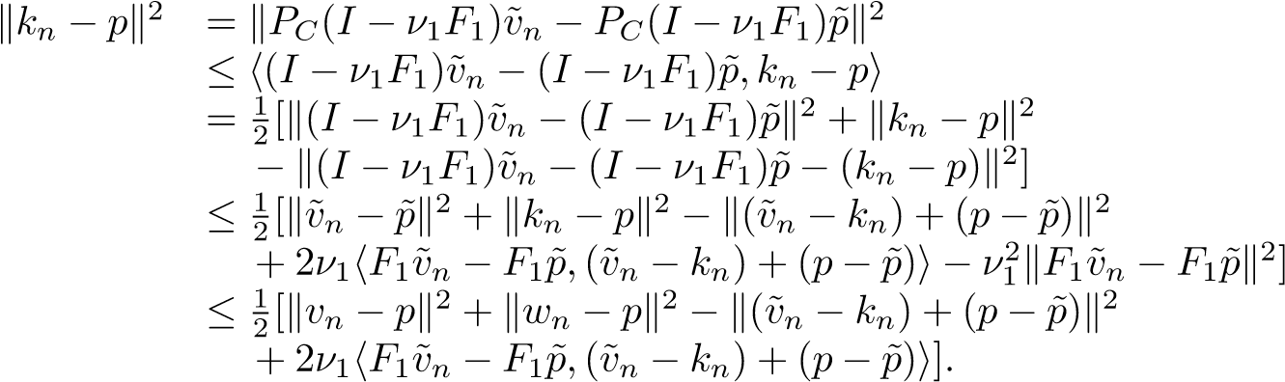
Thus, we have kv˜_{n}−p˜k² ≤ kv_{n}−pk²−k(v_{n}−v˜_{n})−(p−p˜)k²+2ν₂h(v_{n}−v˜_{n})−(p−p˜),F₂v_{n}−F₂pi−ν₂²kF₂v_{n}−F₂pk², (3.43) and kk_{n} − pk² ≤ kv_{n} − pk² − k(v˜_{n} − k_{n}) + (p − p˜)k² + 2ν₁kF₁v˜_{n} − F₁p˜kk(v˜_{n} − k_{n}) + (p − p˜)k. (3.44)
Consequently, from (3.18), (3.41) and (3.43), it follows that
ky_{n} − pk² ≤ β_{n}kx_{n} − pk² + (1 − β_{n})[kv˜_{n} − p˜k² + ν₁(ν₁ − 2ζ₁)kF₁v˜_{n} − F₁p˜k²]
≤ β_{n}kx_{n} − pk² + (1 − β_{n})kv˜_{n} − p˜k²
≤ β_{n}kx_{n} − pk² + (1 − β_{n})[kv_{n} − pk² − k(v_{n} − v˜_{n}) − (p − p˜)k²
+ 2ν₂h(v_{n} − v˜_{n}) − (p − p˜),F₂v_{n} − F₂pi − ν₂²kF₂v_{n} − F₂pk²]
≤ β_{n}kx_{n} − pk² + (1 − β_{n})[kx_{n} − pk² − k(v_{n} − v˜_{n}) − (p − p˜)k²
+ 2ν₂k(v_{n} − v˜_{n}) − (p − p˜)kkF₂v_{n} − F₂pk]
≤ kx_{n} − pk² − (1 − β_{n})k(v_{n} − v˜_{n}) − (p − p˜)k² + 2ν₂k(v_{n} − v˜_{n}) − (p − p˜)kkF₂v_{n} − F₂pk,
which hence leads to
(1 − β_{n})k(v_{n} − v˜_{n}) − (p − p˜)k²
≤ kx_{n} − pk² − ky_{n} − pk² + 2ν₂k(v_{n} − v˜_{n}) − (p − p˜)kkF₂v_{n} − F₂pk ≤ kx_{n} − y_{n}k(kx_{n} − pk + ky_{n} − pk) + 2ν₂k(v_{n} − v˜_{n}) − (p − p˜)kkF₂v_{n} − F₂pk.
Since kx_{n} −y_{n}k → 0, {β_{n}} ⊂ [a,b] ⊂ (0,1), ν₂ ∈ (0,2ζ₂), and {x_{n}}, {y_{n}}, {v_{n}}, {v˜_{n}} are bounded sequences, we obtain from (3.42) that
lim k(v_{n} − v˜_{n}) − (p − p˜)k = 0. (3.45) n→∞
Furthermore, from (3.18), (3.41) and (3.44), it follows that
ky_{n} − pk² ≤ β_{n}kx_{n} − pk² + (1 − β_{n})kk_{n} − pk²
≤ β_{n}kx_{n} − pk² + (1 − β_{n})[kv_{n} − pk² − k(v˜_{n} − k_{n}) + (p − p˜)k² + 2ν₁kF₁v˜_{n} − F₁p˜kk(v˜_{n} − k_{n}) + (p − p˜)k]
≤ β_{n}kx_{n} − pk² + (1 − β_{n})[kx_{n} − pk² − k(v˜_{n} − k_{n}) + (p − p˜)k²
+ 2ν₁kF₁v˜_{n} − F₁p˜kk(v˜_{n} − k_{n}) + (p − p˜)k]
= kx_{n} − pk² − (1 − β_{n})k(v˜_{n} − k_{n}) + (p − p˜)k² + 2ν₁kF₁v˜_{n} − F₁p˜kk(v˜_{n} − k_{n}) + (p − p˜)k,
which hence yields
(1 − β_{n})k(v˜_{n} − k_{n}) + (p − p˜)k²
≤ kx_{n} − pk² − ky_{n} − pk² + 2ν₁kF₁v˜_{n} − F₁p˜kk(v˜_{n} − k_{n}) + (p − p˜)k ≤ kx_{n} − y_{n}k(kx_{n} − pk + ky_{n} − pk) + 2ν₁kF₁v˜_{n} − F₁p˜kk(v˜_{n} − k_{n}) + (p − p˜)k.
Since kx_{n}−y_{n}k → 0, {β_{n}} ⊂ [a,b] ⊂ (0,1), ν₁ ∈ (0,2ζ₁), and {x_{n}}, {y_{n}}, {k_{n}}, {v˜_{n}} are bounded sequences, we obtain from (3.42) that
lim k(v˜_{n} − k_{n}) + (p − p˜)k = 0. (3.46) n→∞
Note that
kv_{n} − k_{n}k ≤ k(v_{n} − v˜_{n}) − (p − p˜)k + k(v˜_{n} − k_{n}) + (p − p˜)k.
Hence, from (3.45) and (3.46), we get
lim kv_{n} − Gv_{n}k = lim kv_{n} − k_{n}k = 0. (3.47) n→∞ n→∞
Also, observe that
y_{n} − x_{n} = γ_{n}(Gv_{n} − x_{n}) + δ_{n}(TGv_{n} − x_{n}), ∀n ≥ 0.
Hence, we obtain
δ_{n}kTGv_{n} − v_{n}k | ≤ δ_{n}kTGv_{n} − x_{n}k + δ_{n}kx_{n} − v_{n}k  = ky_{n} − x_{n} − γ_{n}(Gv_{n} − x_{n})k + δ_{n}kx_{n} − v_{n}k
≤ ky_{n} − x_{n}k + γ_{n}kGv_{n} − x_{n}k + δ_{n}kx_{n} − v_{n}k
≤ ky_{n} − x_{n}k + γ_{n}kGv_{n} − v_{n}k + γ_{n}kv_{n} − x_{n}k + δ_{n}kx_{n} − v_{n}k = ky_{n} − x_{n}k + γ_{n}kGv_{n} − v_{n}k + (γ_{n} + δ_{n})kx_{n} − v_{n}k ≤ ky_{n} − x_{n}k + kGv_{n} − v_{n}k + kx_{n} − v_{n}k.
So, from liminf_{n→∞} δ_{n} > 0, (3.30), (3.40) and (3.47), it follows that
lim kTGv_{n} − v_{n}k = 0. (3.48)
n→∞
In addition, noticing that
kTv_{n} − v_{n}k ≤ kTv_{n} − TGv_{n}k + kTGv_{n} − v_{n}k ≤ kv_{n} − Gv_{n}k + kTGv_{n} − v_{n}k,
we know from (3.47) and (3.48) that
lim kTv_{n} − v_{n}k = 0. | (3.49)
n→∞ Step 4. We prove that ω_{w}(x_{n}) ⊂ Ω.
Indeed, since H is reflexive and {x_{n}} is bounded, there exists at least a weak convergence subsequence of {x_{n}}. Hence it is known that ω_{w}(x_{n}) 6= ∅. Now, take an arbitrary w ∈ ω_{w}(x_{n}). Then there exists a subsequence {x_{ni}} of {x_{n}} such that x_{ni} * w. From (3.36) – (3.38) and (3.40) we have that u_{ni} * w,
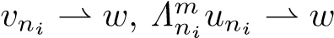 and 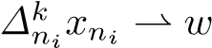, where m ∈ {1,2,...,N} and k ∈ {1,2,...,M}. Utilizing Lemma 2.3 (ii), we deduce from v_{ni} * w and (3.49) that w ∈ Fix(T). In the meantime, utilizing Lemma 2.5, we obtain from v_{ni} * w and (3.47) that w ∈ GSVI(G). Next, we prove that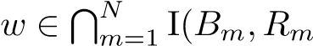). As a matter of fact,
since B_{m} is η_{m}-inverse strongly monotone, B_{m} is a monotone and Lipschitz continuous mapping. It follows
from Lemma 2.13 that R_{m} +B_{m} is maximal monotone. Let (v,g) ∈ G(R_{m} +B_{m}), that is, g −B_{m}v ∈ R_{m}v. Again, since Λ^{m}_{n} u_{n} = J_{Rm,λm,n}(I − λ_{m,n}B_{m})Λ^{m}_{n} ⁻¹u_{n}, n ≥ 1 , m ∈ {1,2,...,N}, we have
,
that is,
.
In terms of the monotonicity of R_{m}, we get
,
and hence,
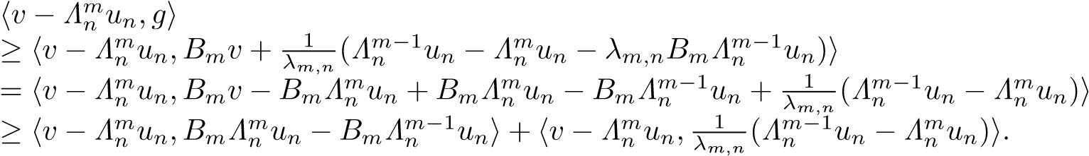
In particular,
.
Since kΛ^{m}_{n} u_{n} − Λ^{m}_{n} ⁻¹u_{n}k → 0 (due to (3.36)) and kB_{m}Λ_{n}^{m} u_{n} − B_{m}Λ^{m}_{n} ⁻¹u_{n}k → 0 (due to the Lipschitz continuity of B_{m}), we conclude from 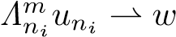 and {λ_{i,n}} ⊂ [a_{i},b_{i}] ⊂ (0,2η_{i}) that
.
It follows from the maximal monotonicity of B_{m} + R_{m} that 0 ∈ (R_{m} + B_{m})w, that is, w ∈ I(B_{m},R_{m}).
Therefore, 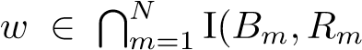). Next we prove that 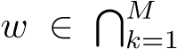 GMEP(Θ_{k},ϕ_{k},A_{k}). Since 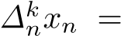
, we have
.
By (A2), we have
.
Let z_{t} = ty + (1 − t)w for all t ∈ (0,1] and y ∈ C. This implies that z_{t} ∈ C. Then, we have
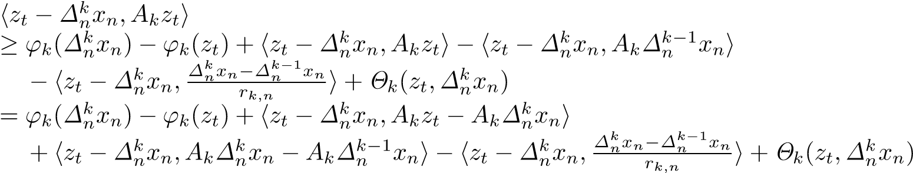
(3.50)
.
By (3.37), we have . Furthermore, by the monotonicity of A_{k}, we obtain 0. Then, by (A4), we obtain
hz_{t} − w,A_{k}z_{t}i ≥ ϕ_{k}(w) − ϕ_{k}(z_{t}) + Θ_{k}(z_{t},w). (3.51)
Utilizing (A1), (A4) and (3.51), we have
0 = Θ_{k}(z_{t},z_{t}) + ϕ_{k}(z_{t}) − ϕ_{k}(z_{t})
≤ tΘ_{k}(z_{t},y) + (1 − t)Θ_{k}(z_{t},w) + tϕ_{k}(y) + (1 − t)ϕ_{k}(w) − ϕ_{k}(z_{t})
≤ t[Θ_{k}(z_{t},y) + ϕ_{k}(y) − ϕ_{k}(z_{t})] + (1 − t)hz_{t} − w,A_{k}z_{t}i
= t[Θ_{k}(z_{t},y) + ϕ_{k}(y) − ϕ_{k}(z_{t})] + (1 − t)thy − w,A_{k}z_{t}i,
and hence,
0 ≤ Θ_{k}(z_{t},y) + ϕ_{k}(y) − ϕ_{k}(z_{t}) + (1 − t)hy − w,A_{k}z_{t}i.
Letting t → 0, we have, for each y ∈ C,
0 ≤ Θ_{k}(w,y) + ϕ_{k}(y) − ϕ_{k}(w) + hy − w,A_{k}wi.
This implies that w ∈ GMEP(Θ_{k},ϕ_{k},A_{k}), and hence, 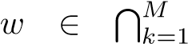 GMEP(Θ_{k},ϕ_{k},A_{k}). Thus,
GMEP( 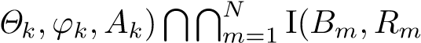). Consequently, w ∈
T
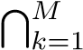
GMEP(GSVI(G) Fix(T) =: Ω. This shows that ω_{w}(x_{n}) ⊂ Ω.
Step 5. We prove that ω_{w}(x_{n}) ⊂ Ξ.
Indeed, take an arbitrary w ∈ ω_{w}(x_{n}). Then, there exists a subsequence {x_{ni}} of {x_{n}} such that x_{ni} * w. Utilizing (3.29), we obtain that for all p ∈ Ω
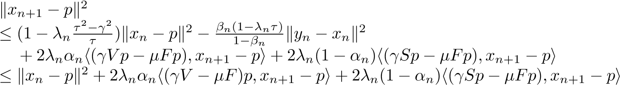,
which implies that
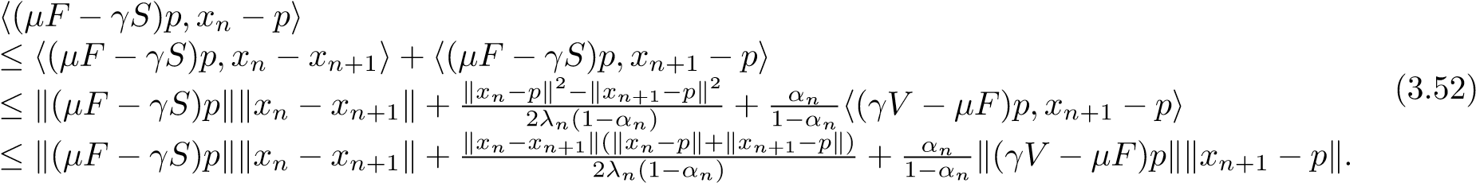
Since α_{n} → 0, kx_{n} − x_{n+1}k → 0 and
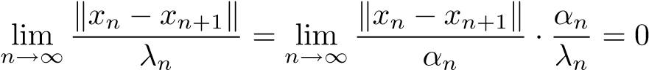,
from (3.52), we conclude that
h(µF − γS)p,w − pi = lim h(µF − γS)p,x_{ni} − pi
i→∞
≤ limsuph(µF − γS)p,x_{n} − pi n→∞
≤ 0, ∀p ∈ Ω,
that is,
h(µF − γS)p,w − pi ≤ 0, ∀p ∈ Ω. (3.53)
In addition, observe that
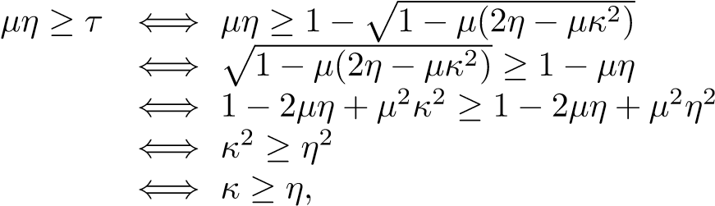 (3.54)
and h(µF − γS)x − (µF − γS)y,x − yi = µhFx − Fy,x − yi − γhSx − Sy,x − yi
≥ µηkx − yk² − γkx − yk²
= (µη − γ)kx − yk², ∀x,y ∈ H.
Since 0 < γ ≤ τ and κ ≥ η, we know that µη ≥ τ ≥ γ and hence the mapping µF − γS is monotone. Moreover, it is clear that the mapping µF − γS is (µκ + γ)-Lipschitzian. So, by Minty’s Lemma [26], we know that (3.53) is equivalent to the VIP
h(µF − γS)w,p − wi ≥ 0, ∀p ∈ Ω. (3.55)
This shows that w ∈ VI(Ω,µF − γS) =: Ξ. Thus, we derive ω_{w}(x_{n}) ⊂ Ξ according to the arbitrariness of w.
Step 6. We prove that lim_{n→∞} kx_{n} −x∗k = 0 provided ky_{n} −Tx_{n}k = o(α_{n}), where {x∗} = VI(Ξ,µF − γV ).
Indeed, it is clear that µF − γV is (µη − γρ)-strongly monotone and (µκ + γρ)-Lipschitzian. Then it is known that VI(Ξ,µF − γV ) is a singleton and hence we write VI(Ξ,µF − γV ) = {x∗}, that is, VI(VI(Ω,µF − γS),µF − γV ) = {x∗}.
Utilizing (3.20) and (3.29) with p = x∗, we get
kxn+1 − x∗k2
≤ [λ_{n}(α_{n}γρkx_{n} − x∗k + (1 − α_{n})γkx_{n} − x∗k) + (1 − λ_{n}τ)ky_{n} − x∗k]²
+ 2λ_{n}α_{n}h(γV x∗ − µFx∗),x_{n+1} − x∗i + 2(1 − α_{n})λ_{n}h(γSx∗ − µFx∗),x_{n+1} − x∗i
≤ [λ_{n}γ(1 − α_{n}(1 − ρ))kx_{n} − x∗k + (1 − λ_{n}τ)kx_{n} − x∗k]²
+ 2λ_{n}α_{n}h(γV x∗ − µFx∗),x_{n+1} − x∗i + 2(1 − α_{n})λ_{n}h(γSx∗ − µFx∗),x_{n+1} − x∗i
= [(1 − λ_{n}(τ − γ) − λ_{n}α_{n}γ(1 − ρ))kx_{n} − x∗k]² + 2λ_{n}α_{n}h(γV − µF)x∗,x_{n+1} − x∗i (3.56) + 2(1 − α_{n})λ_{n}h(γS − µF)x∗,x_{n+1} − x∗i
≤ (1 − λ_{n}(τ − γ) − λ_{n}α_{n}γ(1 − ρ))kx_{n} − x∗k² + 2λ_{n}α_{n}h(γV − µF)x∗,x_{n+1} − x∗i
+ 2(1 − α_{n})λ_{n}h(γSx∗ − µFx∗),x_{n+1} − x∗i
≤ (1 − λ_{n}α_{n}γ(1 − ρ))kx_{n} − x∗k² + 2λ_{n}α_{n}h(γV − µF)x∗,x_{n+1} − x∗i + 2(1 − α_{n})λ_{n}h(γS − µF)x∗,x_{n+1} − x∗i.
Now let us show that
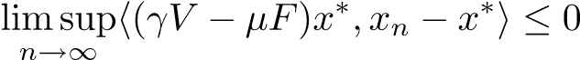. (3.57)
In fact, we may assume, without loss of generality, that there exists a subsequence {x_{nj}} of {x_{n}} such that x_{nj} * xˆ and
. (3.58)
In terms of the fact that ω_{w}(x_{n}) ⊂ Ξ, we get ˆx ∈ Ξ. Since VI(Ξ,µF − γV ) = {x∗}, it is easy from (3.58) to see that
limsuph(γV − µF)x∗,x_{n} − x∗i = h(γV − µF)x∗,xˆ − x∗i ≤ 0, n→∞
that is, (3.57) holds.
In addition, from x∗ ∈ Ξ and condition (vi) we obtain that
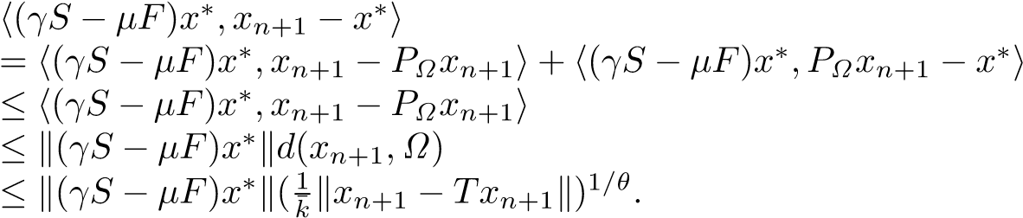 (3.59)
Utilizing Lemma 2.3 (i) we have
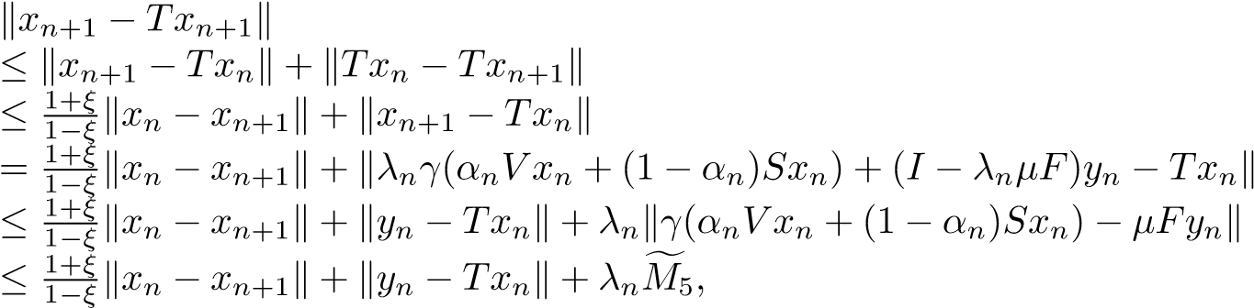 (3.60)
where sup for some 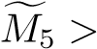0. Hence, for a big enough constant
k¯₁ > 0, from (3.59), we have
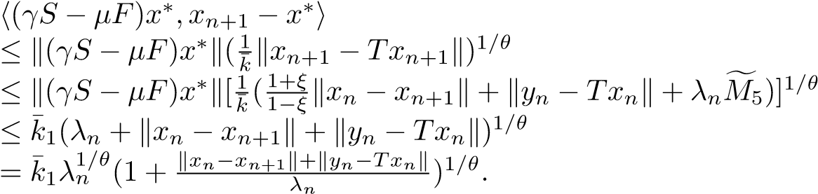 (3.61)
Combining (3.56) and (3.61), we get
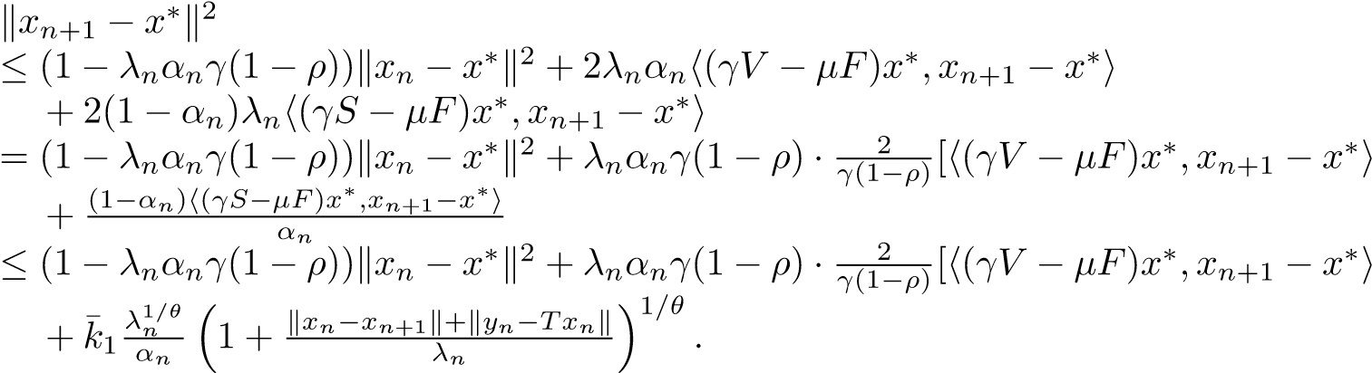 (3.62)
Since ) and 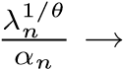0, we conclude from (3.57)
and the assumption ky_{n} − Tx_{n}k = o(α_{n}) that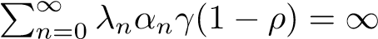,
,
and
.
Therefore, applying Lemma 2.8 to (3.62) we infer that lim_{n→∞} kx_{n} − x∗k = 0. The proof of part (a) is complete.
It is easy to see that part (b) now becomes a straightforward consequence of part (a) since, if V ≡ 0, THVIP (1.10) reduces to the VIP in part (b). This completes the proof.
Remark 3.1. It is clear that the iterative scheme (3.15) is different from the one considered in
[44, 29]. We extend three-step iterative scheme in [29, Algorithm I] to four-step iterative scheme for THVIP (1.10) by combining Korpelevich’s extragradient method, viscosity approximation method, hybrid steepest-descent method [42] and Mann’s iteration method. It is worth pointing out that under the lack of the assumptions similar to those in [44, Theorem 3.2], for example, {x_{n}} is bounded and Fix(T) ∩ intC 6= ∅, the sequence {x_{n}} generated by (3.15) converges strongly to a point x∗ ∈
T ∗ ∈ Ξ of
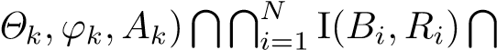
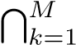
GMEP(GSVI(G) Fix(T) =: Ω, which is a unique solution x
THVIP (1.10) (over the fixed point set of strictly pseudocontractive mapping T), that is, h(µF −γV )x∗,p− x∗i ≥ 0,∀p ∈ Ξ. We note that the nonexpansive mapping T in [44] is extended to strictly pseudocontractive mapping T in (3.15).
Remark 3.2. Theorem 3.1 improves and extends Theorems 3.1 and 3.2 in [44] and Theorem 14 in [29] in the following aspects:
- THVIP (1.10) with the unique solution x∗ ∈ Ω satisfying
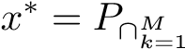GMEP( GSVI(G)∩Fix(T)(I − (µF − γS))x∗
is more general than the problem of finding a point ˜x ∈ C satisfying ˜x = P_{Fix(T)}Sx˜ in [44] and than the problem of finding a point x∗ ∈ Fix(T)∩VI(C,A) satisfying x∗ = P_{Fix(T)∩VI(C,A)}(I−(µF −γS))x∗ in [29, Theorem 14]. It is worth to point out that S is nonexpansive if and only if the complement 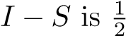-inverse strongly monotone; see [19].
- Four-step iterative scheme (3.15) for THVIP (1.10) is more flexible and subtle than three-step iterative scheme considered in [29, Algorithm I] and than two-step iterative scheme studied in [44] because it can be used to solve several kinds of problems, for example, THVIP, HVIP and problem of finding a common point of four sets: 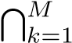 GMEP(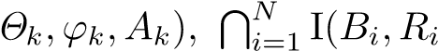 ), GSVI(G) and Fix(T). In addition, Theorem 3.1 drops the crucial requirements in [44, Theorem 3.2] that lim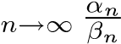 = 0,
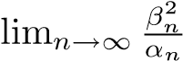= 0, Fix(T) ∩ intC 6= ∅ and {x_{n}} is bounded, and also removes the crucial ones in [29,
Theorem 14] that ) = 0 and kx_{n+1} − x_{n}k + kx_{n} − z_{n}k = o(λ²_{n}). In the meantime, Problem 1.1 (that is, Problem II in [29]) is extended and generalized to the setting of GSVI (1.4), finitely many GMEPs and finitely many variational inclusions in Problem 1.2.
- The technique used in Theorem 3.1 is different from the one used in [44, Theorems 3.1 and 3.2] and in [29, Theorem 14] because we used the properties of strictly pseudocontractive mappings (see Lemmas
2.3 and 2.4), the properties of resolvent operators and maximal monotone mappings (see Proposition 2.2, Remark 2.2 and Lemmas 2.9 – 2.13, the fixed point equation x∗ = P_{C}(I − ν₁F₁)P_{C}(I − ν₂F₂)x∗ equivalent to GSVI (1.4) (see Proposition 2.3 and contractive coefficient estimates for contractions associating with nonexpansive mappings (see Lemma 2.7).
- Compared with the restrictions on the parameter sequences in [44, Theorem 3.2] and [29, Theorem 14], respectively, the hypotheses (iii)–(iv) in Theorem 3.1 are additionally added because Theorem 3.1 involves the quite complex problem, that is, THVIP (1.10) (over the fixed point set Fix(T) of strictly pseudocontractive mapping T) with constraints of several problems: GSVI (1.4), finitely many GMEPs and finitely many variational inclusions.
We prove the strong convergence of the proposed algorithm to a unique solution of THVI Problem 1.2.
Theorem 3.2. In addition to Assumption 3.1, suppose that
- lim_{n→∞} λ_{n} = 0, lim_{n→∞} α_{n} = 0 and 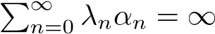;
- β_{n} + γ_{n} + δ_{n} = 1 and (γ_{n} + δ_{n})ξ ≤ γ_{n} for all n ≥ 0;
- liminf_{n→∞} δ_{n} > 0 and {β_{n}} ⊂ [a,b] ⊂ (0,1);
- lim_{n→∞}(λ_{n}/α_{n}²) = 0 and kx − Txk ≥ k¯ · d(x,Ω),∀x ∈ C, for some k¯.
If {Sx_{n}} is bounded, then
- ω_{w}(x_{n}) ⊂ Ω provided kx_{n} − x_{n+1}k → 0 (n → ∞);
- ω_{w}(x_{n}) ⊂ Ξ provided kx_{n} − x_{n+1}k = o(λ_{n});
- {x_{n}} converges strongly to a unique solution of Problem 1.2 provided kx_{n} − x_{n+1}k + kx_{n} − Tx_{n}k =
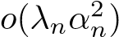.
Proof. Since the solution set Ξ of the HVIP (1.11) is nonempty, it is known that Ω 6= ∅. As in the proof of Theorem 3.1, put
for all k ∈ {1,2,...,M} and n ≥ 1,
for all i ∈ {1,2,...,N}, ∆⁰_{n} = I and Λ⁰_{n} = I, where I is the identity mapping on H. Then, we have that un = ∆Mn xn and vn = ΛNn un.
Rest of the proof is divided into several steps.
Step 1. As in the proof (Step 1) of Theorem 3.1, {x_{n}} is bounded.
Step 2. We prove that ω_{w}(x_{n}) ⊂ Ω provided kx_{n} − x_{n+1}k → 0 (n → ∞);.
Indeed, we first show that lim_{n→∞} kx_{n} − u_{n}k = 0, lim_{n→∞} kx_{n} − v_{n}k = 0, lim_{n→∞} kv_{n} − Gv_{n}k = 0 and lim_{n→∞} kv_{n} − Tv_{n}k = 0.
As a matter of fact, utilizing Lemmas 2.1 and 2.2 (b), from (3.15), (3.18), (3.19) and 0 < γ ≤ τ, we deduce
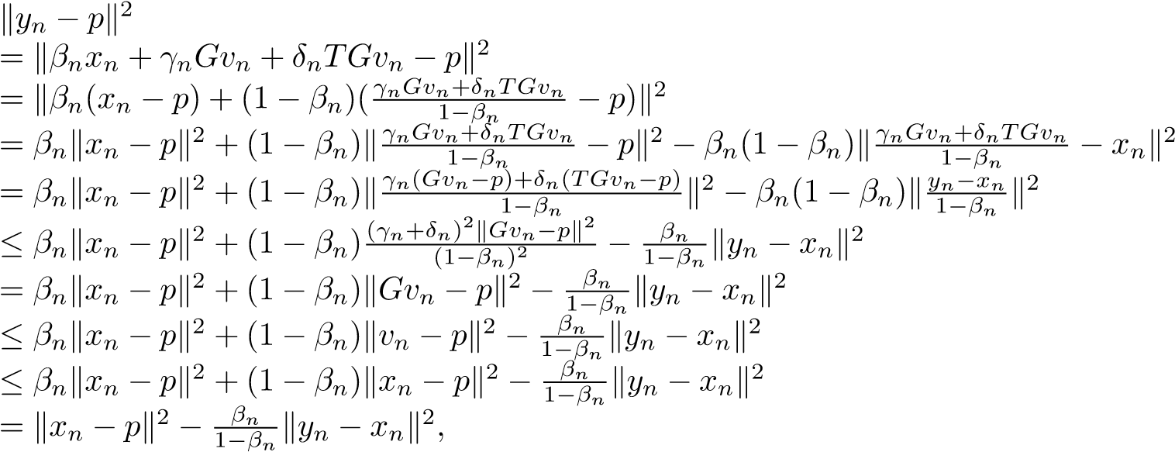 (3.63)
and hence,
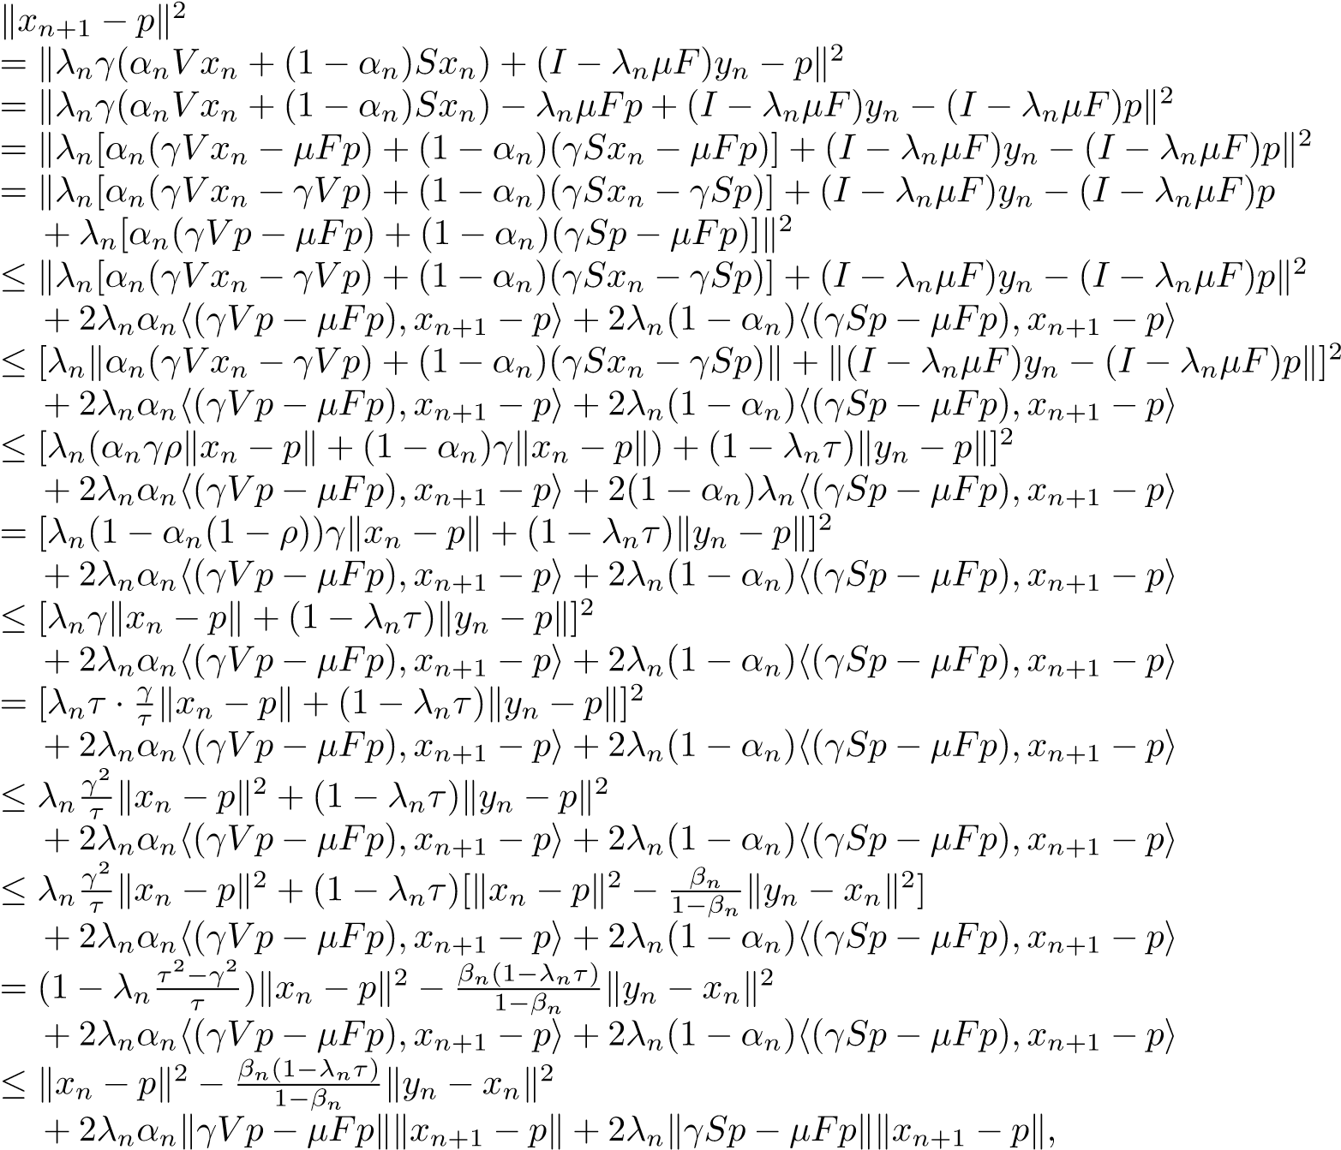 (3.64)
which together with {β_{n}} ⊂ [a,b] ⊂ (0,1) yields
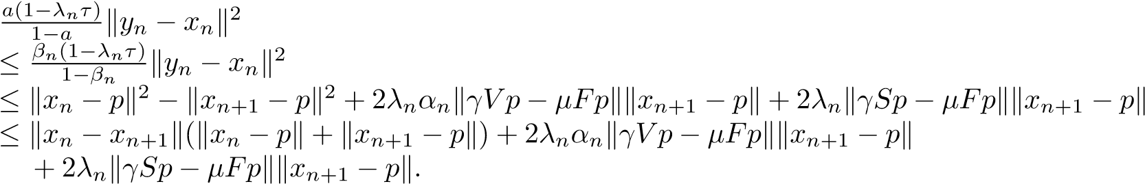
Since α_{n} → 0, λ_{n} → 0, kx_{n+1} − x_{n}k → 0 and {x_{n}} is bounded, we have
Observe that |  | lim ky_{n} − x_{n}k = 0. n→∞ | (3.65)
 | 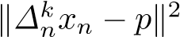
 |  | ≤ k(I − rk,nAk)∆kn−1xn − (I − rk,nAk)pk2  ≤ k∆kn−1xn − pk2 + rk,n(rk,n − 2µk)kAk∆kn−1xn − Akpk2  ≤ kxn − pk2 + rk,n(rk,n − 2µk)kAk∆kn−1xn − Akpk2, | (3.66)
and | 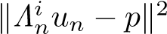 | = kJRi,λi,n(I − λi,nBi)Λin−1un − JRi,λi,n(I − λi,nBi)pk2  ≤ k(I − λi,nBi)Λin−1un − (I − λi,nBi)pk2
 |  | ≤ kΛin−1un − pk2 + λi,n(λi,n − 2ηi)kBiΛin−1un − Bipk2  ≤ kun − pk2 + λi,n(λi,n − 2ηi)kBiΛin−1un − Bipk2  ≤ kxn − pk2 + λi,n(λi,n − 2ηi)kBiΛin−1un − Bipk2, | (3.67)
for i ∈ {1,2,...,N} and k ∈ {1,2,...,M}. Combining (3.63), (3.66) and (3.25), we get
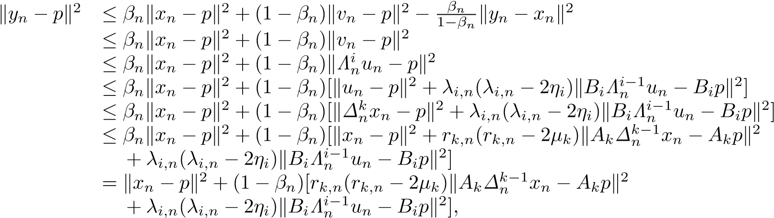
which immediately leads to
(1 − βn)[rk,n(2µk − rk,n)kAk∆kn−1xn − Akpk2 + λi,n(2ηi − λi,n)kBiΛin−1un − Bipk2]
≤ kx_{n} − pk² − ky_{n} − pk²
≤ kx_{n} − y_{n}k(kx_{n} − pk + ky_{n} − pk).
Since kx_{n} − y_{n}k → 0, {β_{n}} ⊂ [a,b] ⊂ (0,1), {λ_{i,n}} ⊂ [a_{i},b_{i}] ⊂ (0,2η_{i}), {r_{k,n}} ⊂ [c_{k},d_{k}] ⊂ (0,2µ_{k}), i ∈ {1,2,...,N}, k ∈ {1,2,...,M} and {x_{n}}, {y_{n}} are bounded sequences, we have
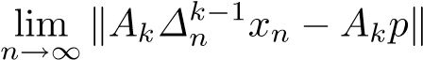= 0 and 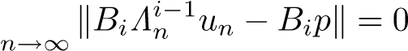lim , (3.68)
for all k ∈ {1,2,...,M} and i ∈ {1,2,...,N}.
Furthermore, by Proposition 2.2 (ii) and Lemma 2.2 (a), we have
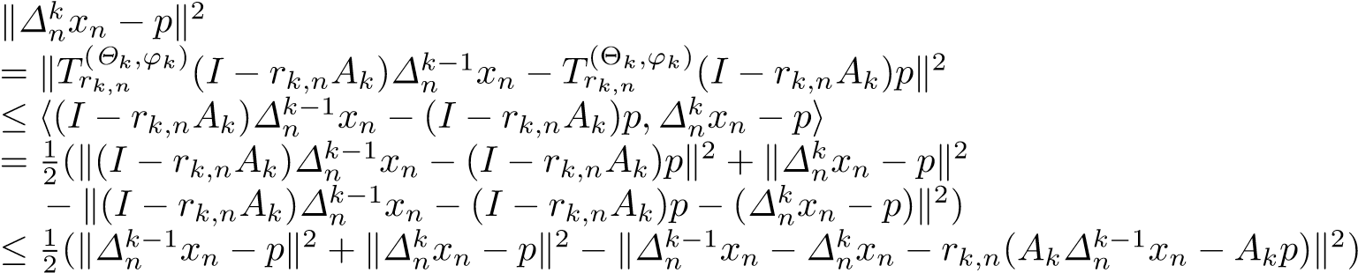,
which implies that
k∆knxn − pk2
≤ k∆kn−1xn − pk2 − k∆nk−1xn − ∆knxn − rk,n(Ak∆kn−1xn − Akp)k2
= k∆kn−1xn − pk2 − k∆nk−1xn − ∆knxnk2 − rk,n2 kAk∆kn−1xn − Akpk2  + 2rk,nh∆kn−1xn − ∆knxn,Ak∆nk−1xn − Akpi  ≤ k∆kn−1xn − pk2 − k∆nk−1xn − ∆knxnk2 + 2rk,nk∆nk−1xn − ∆knxnkkAk∆kn−1xn − Akpk ≤ kxn − pk2 − k∆kn−1xn − ∆knxnk2 + 2rk,nk∆nk−1xn − ∆knxnkkAk∆kn−1xn − Akpk.  By Lemma 2.2 (a) and Lemma 2.10, we obtain | (3.69)
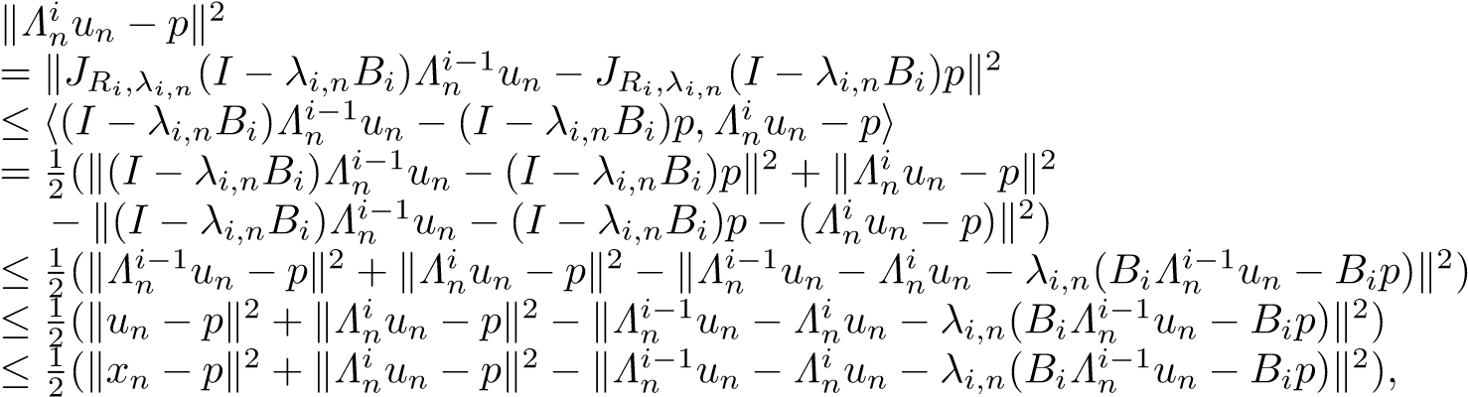
which immediately leads to
kΛinun − pk2
≤ kxn − pk2 − kΛin−1un − Λinun − λi,n(BiΛin−1un − Bip)k2
= kxn − pk2 − kΛin−1un − Λknunk2 − λi,n2kBiΛin−1un − Bipk2  + 2λi,nhΛni−1un − Λinun,BiΛin−1un − Bipi  ≤ kxn − pk2 − kΛin−1un − Λinunk2 + 2λi,nkΛin−1un − ΛinunkkBiΛin−1un − Bipk. | (3.70)
Combining (3.63) and (3.70), we have
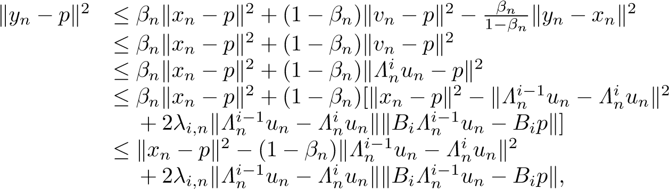
which yields
(1 − βn)kΛin−1un − Λinunk2
≤ kxn − pk2 − kyn − pk2 + 2λi,nkΛin−1un − ΛniunkkBiΛin−1un − Bipk ≤ kxn − ynk(kxn − pk + kyn − pk) + 2λi,nkΛin−1un − ΛinunkkBiΛin−1un − Bipk.
Since {β_{n}} ⊂ [a,b] ⊂ (0,1), {λ_{i,n}} ⊂ [a_{i},b_{i}] ⊂ (0,2η_{i}),i = 1,2,...,N, and {u_{n}}, {x_{n}} and {y_{n}} are bounded sequences, we deduce from (3.68) and kx_{n} − y_{n}k → 0 that
. (3.71)
Also, combining (3.17), (3.70) and (3.34)?, we deduce that
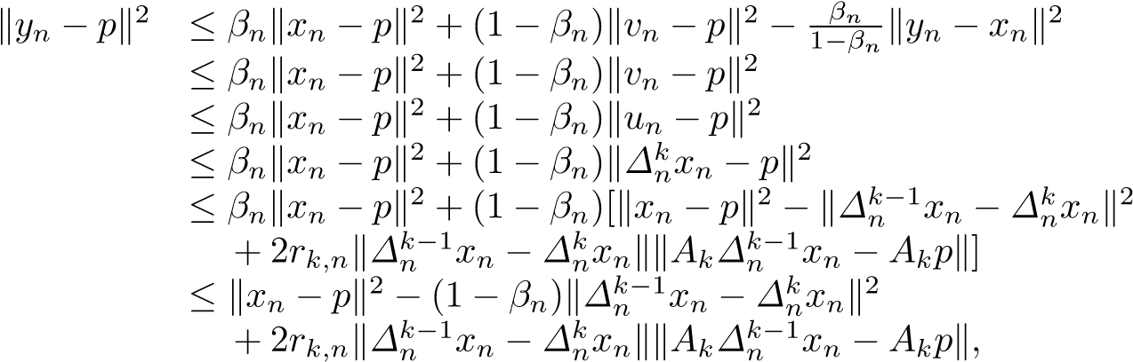
which yields
(1 − βn)k∆kn−1xn − ∆knxnk2
≤ kxn − pk2 − kyn − pk2 + 2rk,nk∆kn−1xn − ∆nkxnkkAk∆kn−1xn − Akpk ≤ kxn − ynk(kxn − pk + kyn − pk) + 2rk,nk∆kn−1xn − ∆knxnkkAk∆kn−1xn − Akpk.
Since {β_{n}} ⊂ [a,b] ⊂ (0,1), {r_{k,n}} ⊂ [c_{k},d_{k}] ⊂ (0,2µ_{k}) for k = 1,2,...,M, and {x_{n}}, {y_{n}} are bounded sequences, we deduce from (3.68) and kx_{n} − y_{n}k → 0 that
. (3.72)
Hence, from (3.71) and (3.30), we get
≤ k∆0nxn − ∆1nxnk + k∆1nxn − ∆2nxnk + ··· + k∆Mn −1xn − ∆Mn xnk  → 0 as n → ∞,  and | (3.73)
≤ kΛ0nun − Λ1nunk + kΛ1nun − Λ2nunk + ··· + kΛNn −1un − ΛNn unk  → 0 as n → ∞,  respectively. Thus, from (3.73) and (3.32), we obtain | (3.74)
kx_{n} − v_{n}k ≤ kx_{n} − u_{n}k + ku_{n} − v_{n}k | (3.75)
→ 0 as n → ∞.
On the other hand, for simplicity, we write ˜p = P_{C}(I − ν₂F₂)p, ˜v_{n} = P_{C}(I − ν₂F₂)v_{n} and k_{n} = Gv_{n} =
P_{C}(I − ν₁F₁)v˜_{n} for all n ≥ 1. Then,
p = Gp = P_{C}(I − ν₁F₁)p˜ = P_{C}(I − ν₁F₁)P_{C}(I − ν₂F₂)p.
We now show that lim_{n→∞} kGv_{n} − v_{n}k = 0, that is, lim_{n→∞} kk_{n} − v_{n}k = 0.
As a matter of fact, for p ∈ Ω, it follows from (3.18), (3.19) and (3.63) that
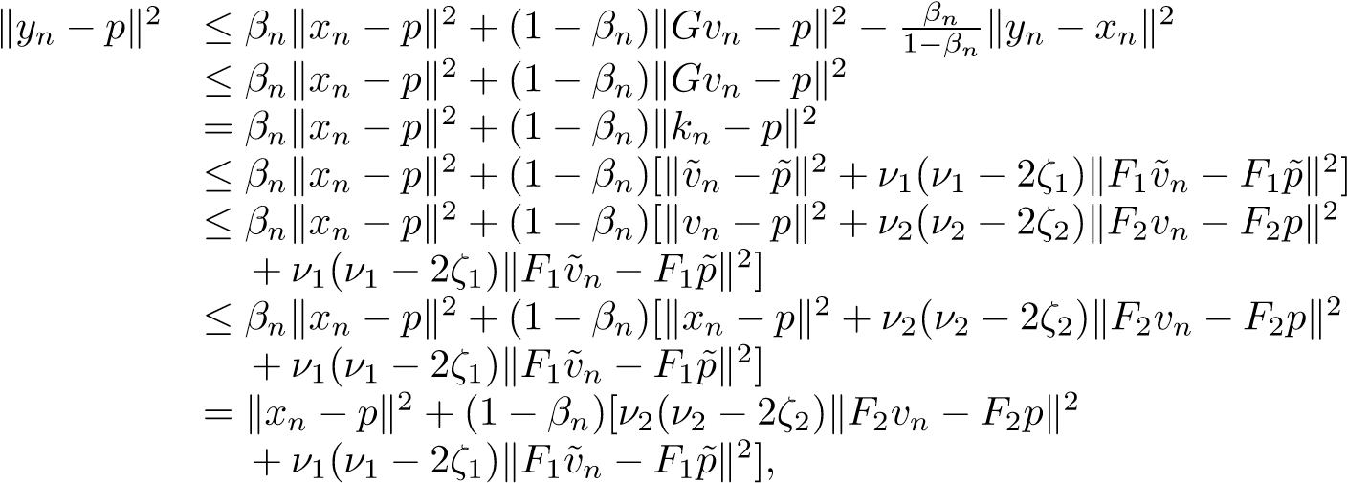 (3.76)
which immediately yields
(1 − β_{n})[ν₂(2ζ₂ − ν₂)kF₂v_{n} − F₂pk² + ν₁(2ζ₁ − ν₁)kF₁v˜_{n} − F₁p˜k²]
≤ kx_{n} − pk² − ky_{n} − pk² ≤ kx_{n} − y_{n}k(kx_{n} − pk + ky_{n} − pk).
Since kx_{n} − y_{n}k → 0, {β_{n}} ⊂ [a,b] ⊂ (0,1), ν_{j} ∈ (0,2ζ_{j}),j = 1,2, and {x_{n}},{y_{n}} are bounded sequences, we have
lim kF₂v_{n} − F₂pk = 0 and lim kF₁v˜_{n} − F₁p˜k = 0. (3.77) n→∞ n→∞
Also, in terms of the firm nonexpansivity of P_{C} and the ζ_{j}-inverse strong monotonicity of F_{j} for j = 1,2, we obtain from ν_{j} ∈ (0,2ζ_{j}),j = 1,2 and (3.19) that
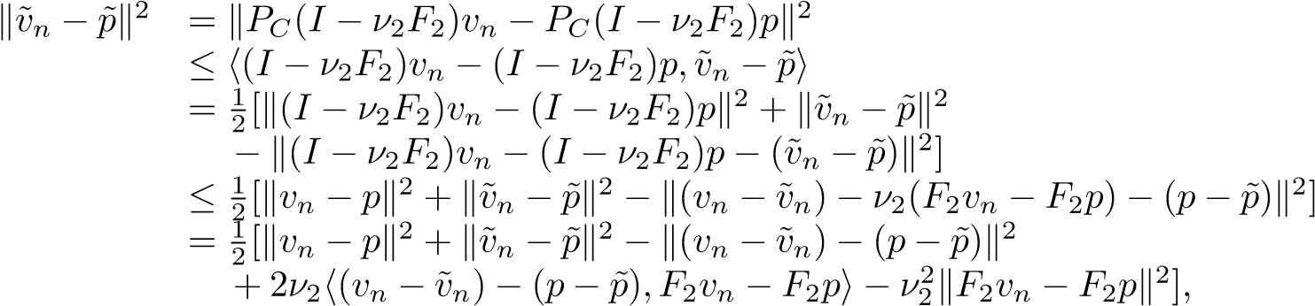
and
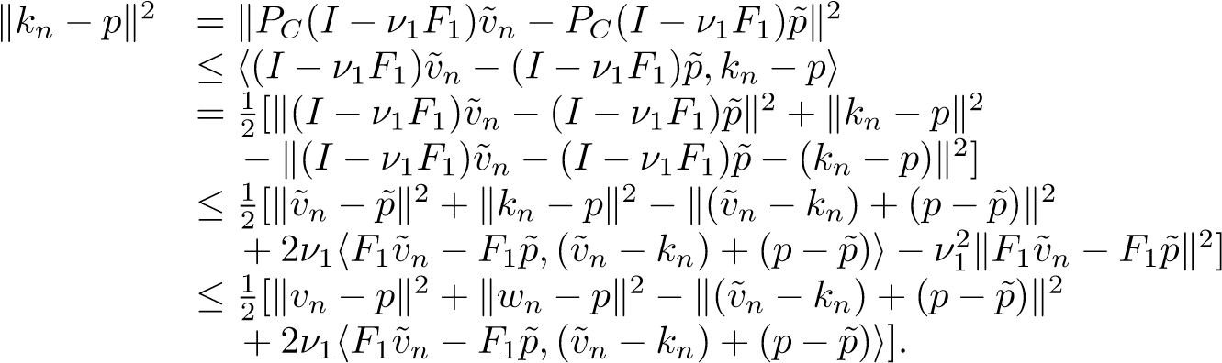
Thus, we have kv˜_{n}−p˜k² ≤ kv_{n}−pk²−k(v_{n}−v˜_{n})−(p−p˜)k²+2ν₂h(v_{n}−v˜_{n})−(p−p˜),F₂v_{n}−F₂pi−ν₂²kF₂v_{n}−F₂pk², (3.78) and kk_{n} − pk² ≤ kv_{n} − pk² − k(v˜_{n} − k_{n}) + (p − p˜)k² + 2ν₁kF₁v˜_{n} − F₁p˜kk(v˜_{n} − k_{n}) + (p − p˜)k. (3.79) Consequently, from (3.18), (3.76) and (3.78) it follows that
ky_{n} − pk² ≤ β_{n}kx_{n} − pk² + (1 − β_{n})[kv˜_{n} − p˜k² + ν₁(ν₁ − 2ζ₁)kF₁v˜_{n} − F₁p˜k²]
≤ β_{n}kx_{n} − pk² + (1 − β_{n})kv˜_{n} − p˜k²
≤ β_{n}kx_{n} − pk² + (1 − β_{n})[kv_{n} − pk² − k(v_{n} − v˜_{n}) − (p − p˜)k²
+ 2ν₂h(v_{n} − v˜_{n}) − (p − p˜),F₂v_{n} − F₂pi − ν₂²kF₂v_{n} − F₂pk²]
≤ β_{n}kx_{n} − pk² + (1 − β_{n})[kx_{n} − pk² − k(v_{n} − v˜_{n}) − (p − p˜)k²
+ 2ν₂k(v_{n} − v˜_{n}) − (p − p˜)kkF₂v_{n} − F₂pk]
≤ kx_{n} − pk² − (1 − β_{n})k(v_{n} − v˜_{n}) − (p − p˜)k² + 2ν₂k(v_{n} − v˜_{n}) − (p − p˜)kkF₂v_{n} − F₂pk,
which hence leads to
(1 − β_{n})k(v_{n} − v˜_{n}) − (p − p˜)k²
≤ kx_{n} − pk² − ky_{n} − pk² + 2ν₂k(v_{n} − v˜_{n}) − (p − p˜)kkF₂v_{n} − F₂pk ≤ kx_{n} − y_{n}k(kx_{n} − pk + ky_{n} − pk) + 2ν₂k(v_{n} − v˜_{n}) − (p − p˜)kkF₂v_{n} − F₂pk.
Since kx_{n}−y_{n}k → 0, {β_{n}} ⊂ [a,b] ⊂ (0,1), ν₂ ∈ (0,2ζ₂), and {x_{n}}, {y_{n}}, {v_{n}}, {v˜_{n}} are bounded sequences, we obtain from (3.77) that
lim k(v_{n} − v˜_{n}) − (p − p˜)k = 0. (3.80) n→∞
Furthermore, from (3.18), (3.76) and (3.79), it follows that
ky_{n} − pk² ≤ β_{n}kx_{n} − pk² + (1 − β_{n})kk_{n} − pk²
≤ β_{n}kx_{n} − pk² + (1 − β_{n})[kv_{n} − pk² − k(v˜_{n} − k_{n}) + (p − p˜)k² + 2ν₁kF₁v˜_{n} − F₁p˜kk(v˜_{n} − k_{n}) + (p − p˜)k]
≤ β_{n}kx_{n} − pk² + (1 − β_{n})[kx_{n} − pk² − k(v˜_{n} − k_{n}) + (p − p˜)k²
+ 2ν₁kF₁v˜_{n} − F₁p˜kk(v˜_{n} − k_{n}) + (p − p˜)k]
= kx_{n} − pk² − (1 − β_{n})k(v˜_{n} − k_{n}) + (p − p˜)k² + 2ν₁kF₁v˜_{n} − F₁p˜kk(v˜_{n} − k_{n}) + (p − p˜)k,
which hence yields
(1 − β_{n})k(v˜_{n} − k_{n}) + (p − p˜)k²
≤ kx_{n} − pk² − ky_{n} − pk² + 2ν₁kF₁v˜_{n} − F₁p˜kk(v˜_{n} − k_{n}) + (p − p˜)k ≤ kx_{n} − y_{n}k(kx_{n} − pk + ky_{n} − pk) + 2ν₁kF₁v˜_{n} − F₁p˜kk(v˜_{n} − k_{n}) + (p − p˜)k.
Since kx_{n}−y_{n}k → 0, {β_{n}} ⊂ [a,b] ⊂ (0,1), ν₁ ∈ (0,2ζ₁), and {x_{n}}, {y_{n}}, {k_{n}}, {v˜_{n}} are bounded sequences, we obtain from (3.77) that
lim k(v˜_{n} − k_{n}) + (p − p˜)k = 0. (3.81) n→∞
Note that
kv_{n} − k_{n}k ≤ k(v_{n} − v˜_{n}) − (p − p˜)k + k(v˜_{n} − k_{n}) + (p − p˜)k.
Hence, from (3.80) and (3.81), we get
lim kv_{n} − Gv_{n}k = lim kv_{n} − k_{n}k = 0. (3.82) n→∞ n→∞
Also, observe that
y_{n} − x_{n} = γ_{n}(Gv_{n} − x_{n}) + δ_{n}(TGv_{n} − x_{n}), ∀n ≥ 0.
Hence, we find
δ_{n}kTGv_{n} − v_{n}k | ≤ δ_{n}kTGv_{n} − x_{n}k + δ_{n}kx_{n} − v_{n}k  = ky_{n} − x_{n} − γ_{n}(Gv_{n} − x_{n})k + δ_{n}kx_{n} − v_{n}k
≤ ky_{n} − x_{n}k + γ_{n}kGv_{n} − x_{n}k + δ_{n}kx_{n} − v_{n}k
≤ ky_{n} − x_{n}k + γ_{n}kGv_{n} − v_{n}k + γ_{n}kv_{n} − x_{n}k + δ_{n}kx_{n} − v_{n}k = ky_{n} − x_{n}k + γ_{n}kGv_{n} − v_{n}k + (γ_{n} + δ_{n})kx_{n} − v_{n}k ≤ ky_{n} − x_{n}k + kGv_{n} − v_{n}k + kx_{n} − v_{n}k.
So, from liminf_{n→∞} δ_{n} > 0, (3.65), (3.75) and (3.82), it follows that
lim kTGv_{n} − v_{n}k = 0. (3.83) n→∞
In addition, noticing that
kTv_{n} − v_{n}k ≤ kTv_{n} − TGv_{n}k + kTGv_{n} − v_{n}k ≤ kv_{n} − Gv_{n}k + kTGv_{n} − v_{n}k,
we know from (3.82) and (3.83) that
lim kTv_{n} − v_{n}k = 0. (3.84) n→∞ Secondly, we show that ω_{w}(x_{n}) ⊂ Ω.
In fact, since H is reflexive and {x_{n}} is bounded, there exists at least a weak convergence subsequence of {x_{n}}. Hence, it is known that ω_{w}(x_{n}) =6 ∅. Now, take an arbitrary w ∈ ω_{w}(x_{n}). Then there exists a subsequence {x_{ni}} of {x_{n}} such that x_{ni} * w. From (3.71) – (3.73) and (3.75), we have u_{ni} * w, v_{ni} * w,
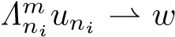and 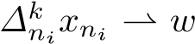, where m ∈ {1,2,...,N} and k ∈ {1,2,...,M}. Utilizing Lemma 2.3 (ii), we
deduce from v_{ni} * w and (3.84) that w ∈ Fix(T). In the meantime, utilizing Lemma 2.5, we obtain from v_{ni} * w and (3.82) that w ∈ GSVI(G).
Next, we prove that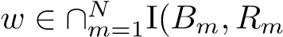). As a matter of fact, since B_{m} is η_{m}-inverse strongly monotone, B_{m} is a monotone and Lipschitz continuous mapping. It follows from Lemma 2.13 that R_{m} +B_{m} is maximal
monotone. Let (v,g) ∈ G(R_{m} + B_{m}), that is, g − B_{m}v ∈ R_{m}v. Again, since 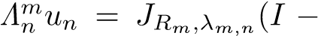
, we have
,
that is,
.
In terms of the monotonicity of R_{m}, we get
,
and hence,
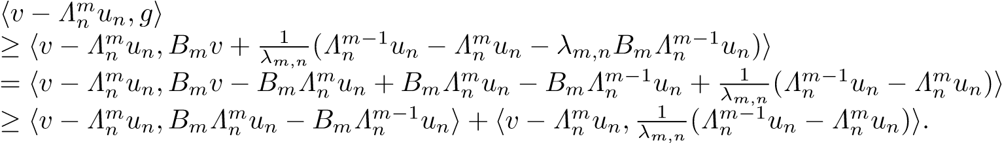
In particular,
.
Since 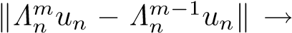0 (due to (3.71)) and 0 (due to the Lipschitz
continuity of B_{m}), we conclude from 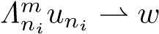 and {λ_{i,n}} ⊂ [a_{i},b_{i}] ⊂ (0,2η_{i}) that
.
It follows from the maximal monotonicity of B_{m} + R_{m} that 0 ∈ (R_{m} + B_{m})w, that is, w ∈ I(B_{m},R_{m}).
Therefore, 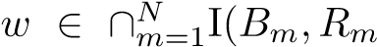). Next we prove that 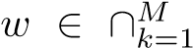GMEP(Θ_{k},ϕ_{k},A_{k}). Since 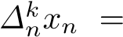
, we have
.
By (A2), we have
.
Let z_{t} = ty + (1 − t)w for all t ∈ (0,1] and y ∈ C. This implies that z_{t} ∈ C. Then, we have
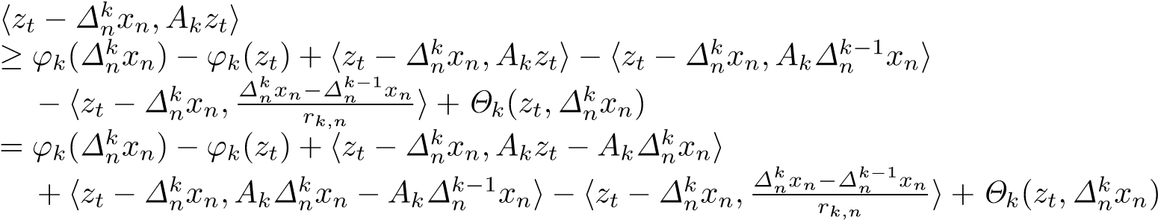
(3.85)
.
By (3.72), we have . Furthermore, by the monotonicity of A_{k}, we obtain 0. Then, by (A4), we get
hz_{t} − w,A_{k}z_{t}i ≥ ϕ_{k}(w) − ϕ_{k}(z_{t}) + Θ_{k}(z_{t},w). (3.86)
Utilizing (A1), (A4) and (3.86), we obtain
0 = Θ_{k}(z_{t},z_{t}) + ϕ_{k}(z_{t}) − ϕ_{k}(z_{t})
≤ tΘ_{k}(z_{t},y) + (1 − t)Θ_{k}(z_{t},w) + tϕ_{k}(y) + (1 − t)ϕ_{k}(w) − ϕ_{k}(z_{t})
≤ t[Θ_{k}(z_{t},y) + ϕ_{k}(y) − ϕ_{k}(z_{t})] + (1 − t)hz_{t} − w,A_{k}z_{t}i
= t[Θ_{k}(z_{t},y) + ϕ_{k}(y) − ϕ_{k}(z_{t})] + (1 − t)thy − w,A_{k}z_{t}i,
and hence,
0 ≤ Θ_{k}(z_{t},y) + ϕ_{k}(y) − ϕ_{k}(z_{t}) + (1 − t)hy − w,A_{k}z_{t}i.
Letting t → 0, we have, for each y ∈ C,
0 ≤ Θ_{k}(w,y) + ϕ_{k}(y) − ϕ_{k}(w) + hy − w,A_{k}wi.
This implies that w ∈ GMEP(Θ_{k},ϕ_{k},A_{k}), and hence, w ∈ ∩^{M}_{k=1}GMEP(Θ_{k},ϕ_{k},A_{k}). Thus, w ∈ Ω =
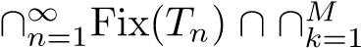GMEP( ). Consequently, 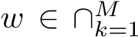GMEP(Θ_{k},ϕ_{k},A_{k}) ∩
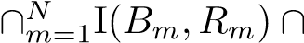GSVI(G) ∩ Fix(T) =: Ω. This shows that ω_{w}(x_{n}) ⊂ Ω.
Step 3. We prove that ω_{w}(x_{n}) ⊂ Ξ provided kx_{n} − x_{n+1}k = o(λ_{n}).
Indeed, we first note that 0 < γ ≤ τ and µη ≥ τ ⇐⇒ κ ≥ η by (3.54). It is clear that
h(µF − γS)x − (µF − γS)y,x − yi ≥ (µη − γ)kx − yk², ∀x,y ∈ C.
Hence, it follows from 0 < γ ≤ τ ≤ µη that µF −γS is monotone. Moreover, it is also obvious that µF −γS is (µκ + γ)-Lipschitzian.
Now, take an arbitrary w ∈ ω_{w}(x_{n}). Then, there exists a subsequence {x_{ni}} of {x_{n}} such that x_{ni} * w. Utilizing (3.64), we obtain that for each fixed p ∈ Ω,
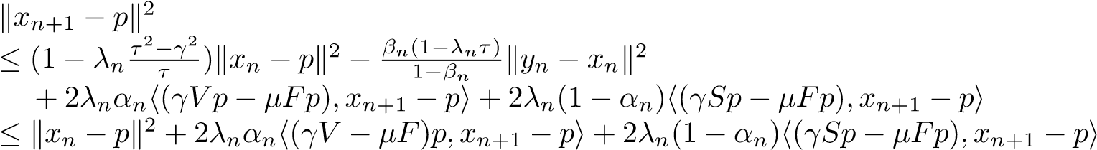,
which implies that
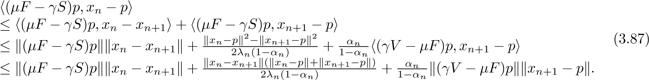
Since α_{n} → 0 and kx_{n} − x_{n+1}k = o(λ_{n}), from (3.87), we conclude that
h(µF − γS)p,w − pi = lim h(µF − γS)p,x_{ni} − pi
i→∞
≤ limsuph(µF − γS)p,x_{n} − pi n→∞
≤ 0, ∀p ∈ Ω,
that is,
h(µF − γS)p,w − pi ≤ 0, ∀p ∈ Ω. (3.88)
Since µF − γS is monotone and (µκ + γ)-Lipschitzian, by Minty’s Lemma [26], we know that (3.88) is equivalent to the VIP
h(µF − γS)w,p − wi ≥ 0, ∀p ∈ Ω.
This shows that w ∈ VI(Ω,µF − γS) =: Ξ, and hence, Ω ⊂ Ξ.
Step 4. We prove that {x_{n}} converges strongly to a unique solution of Problem II provided kx_{n} − x_{n+1}k + kx_{n} − Tx_{n}k = o(λ_{n}α_{n}²).
Indeed, it is easy from (3.64) to see that for each fixed p ∈ Ω,
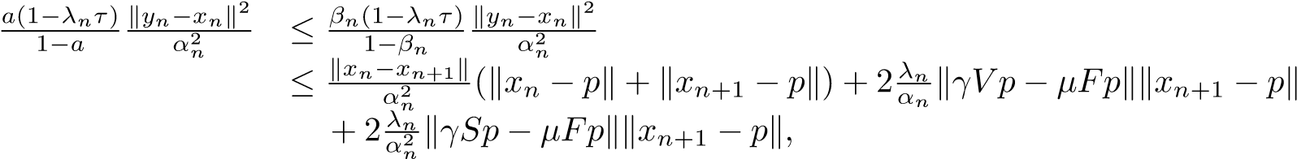
which together with kx_{n} − x_{n+1}k = o(α_{n}²) and λ_{n} = o(α_{n}²), implies that
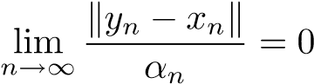. (3.89)
In the meantime, it is clear that
h(µF − γV )x − (µF − γV )y,x − yi ≥ (µη − γρ)kx − yk², ∀x,y ∈ C.
Hence, it follows from 0 < γ ≤ τ ≤ µη and ρ < 1 that µF − γV is (µη − γρ)-strongly monotone. Moreover, it is also obvious that µF −γV is (µκ+γρ)-Lipschitzian. So, we can write VI(µF −γV,Ξ) = {x∗}. We now
take a subsequence {x_{ni}} of {x_{n}} satisfying
. (3.90)
Without loss of generality, we may further assume that x_{ni} * x˜; then ˜x ∈ Ξ as we just proved. Since x∗ is a solution of the THVIP (1.10), we get
limsuph(γV − µF)x∗,x_{n} − x∗i = h(γV − µF)x∗,x˜ − x∗i ≤ 0. (3.91)
n→∞
From (3.15), (3.20) and (3.64) with p = x∗, it follows that
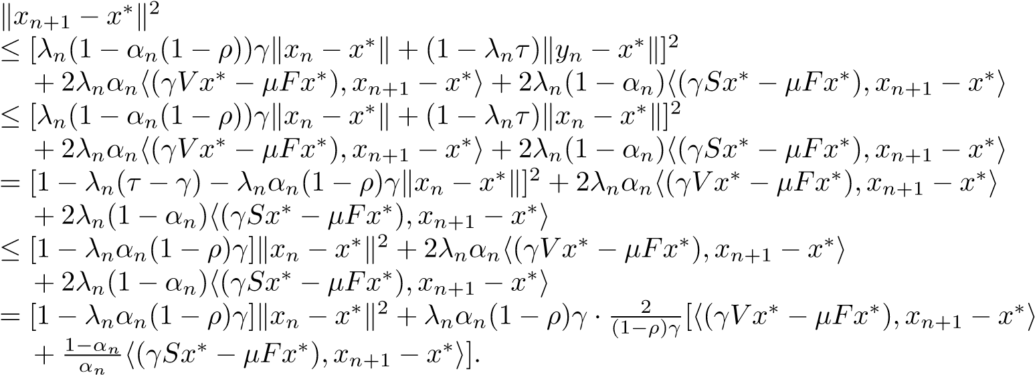
So, it follows from x∗ ∈ Ξ and condition (iv) that
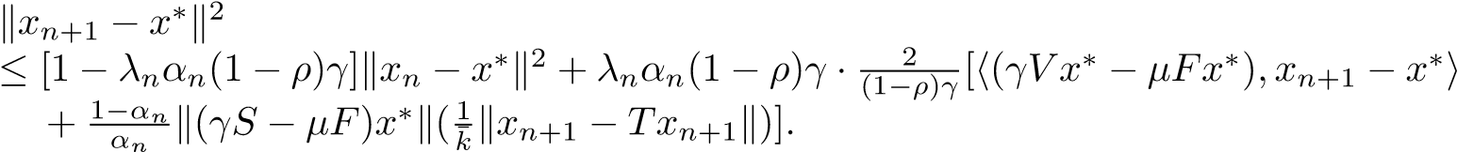 (3.92)
In addition, utilizing Lemma 2.3 (i), we have
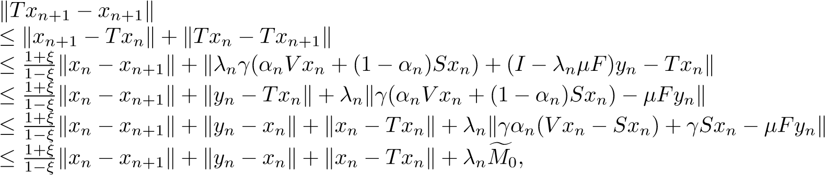
where sup_{n≥0} kγα_{n}(V x_{n} −Sx_{n})+γSx_{n} −µFy_{n}k ≤ Mf₀ for some Mf₀ > 0. Hence, for a big enough constant k¯₁ > 0, from (3.92), we have
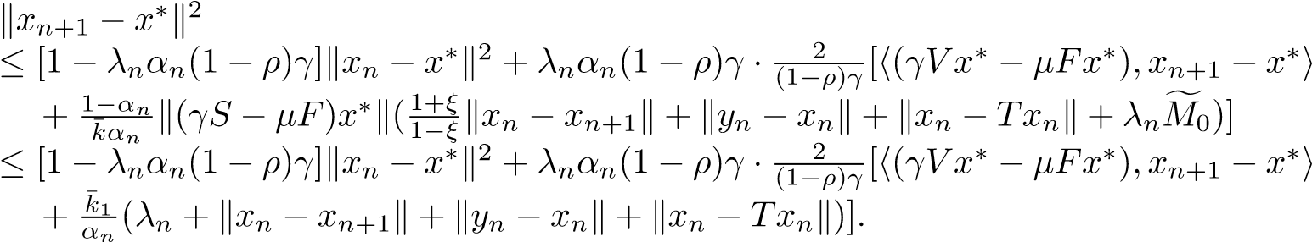 (3.93)
Since), we deduce from (3.89) and
(3.91) that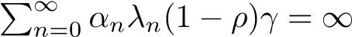and
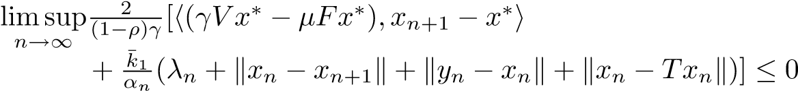.
Applying Lemma 2.8 to (3.93), we conclude that x_{n} → x∗ as n → ∞. This completes the proof.
Remark 3.3. It is obvious that iterative scheme (3.15) is different from iterative schemes considered in [44,29] We extended three-step iterative scheme in [29, Algorithm I] to our four-step iterative scheme (3.15) for the THVIP (1.10) by combining Korpelevich’s extragradient method, viscosity approximation method, hybrid steepest-descent method [42] and Mann’s iteration method. It is worth pointing out that under the lack of the assumptions similar to those in [44, Theorem 3.2], for example, {x_{n}} is
T
bounded and Fix(T) intC =6 ∅, the sequence {x_{n}} generated by (3.15) converges strongly to a point
T
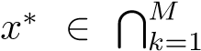
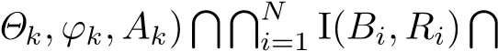
GMEP(GSVI(G) Fix(T) =: Ω, which is a unique solution
x∗ ∈ Ξ of THVIP (1.10) (over the fixed point set of strictly pseudocontractive mapping T), that is, h(µF − γV )x∗,p − x∗i ≥ 0,∀p ∈ Ξ.
Remark 3.4. Theorem 3.2 improves and extends [44, Theorems 3.1 and 3.2] and [29, Theorem 14] in the following aspects:
- THVIP (1.10) with the unique solution x∗ ∈ Ω satisfying
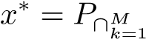GMEP( GSVI(G)∩Fix(T)(I − (µF − γS))x∗,
is more general than the problem of finding a point ˜x ∈ C satisfying ˜x = P_{Fix(T)}Sx˜ in [44] and than the problem of finding a point x∗ ∈ Fix(T)∩VI(C,A) satisfying x∗ = P_{Fix(T)∩VI(C,A)}(I−(µF −γS))x∗ in [29, Theorem 14]. It is worth pointing out that S is nonexpansive if and only if the complement -inverse strongly monotone.
- Four-step iterative scheme (3.15) for THVIP (1.10) is flexible, and subtle than those considered in [29, Algorithm I] and [44] because it can be used to solve several kinds of problems, for example, the
THVIP, the HVIP and the problem of finding a common point of four sets: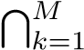 GMEP(Θ_{k},ϕ_{k},A_{k}),
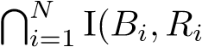), GSVI(G) and Fix(T). In addition, Theorem 3.2 drops the crucial requirements in [44,
Theorem 3.2] that lim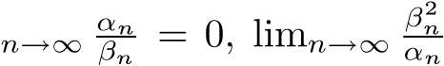 = 0, Fix(T) ∩ intC 6= ∅ and {x_{n}} is bounded, and also removes the crucial ones in [29, Theorem 14] that ) = 0. In the meantime, Problem 1.1 (that is, [29, Problem II]) is extended and generalized to the setting of the GSVI (1.4), finitely many GMEPs and finitely many variational inclusions in our Problem 1.2.
- The argument and technique in Theorem 3.2 are different from [44, Theorems 3.1 and 3.2] and [29, Theorem 14] because we make use of the properties of strictly pseudocontractive mappings (see Lemmas
2.3 and 2.4), the properties of resolvent operators and maximal monotone mappings (see Proposition 2.2, Remark 2.2 and Lemmas 2.9–2.13, the fixed point equation x∗ = P_{C}(I − ν₁F₁)P_{C}(I − ν₂F₂)x∗ equivalent to the GSVI (1.4) (see Proposition 2.3 and the contractive coefficient estimates for the contractions associating with nonexpansive mappings (see Lemma 2.7).
- Compared with the requirement kx_{n} − x_{n+1}k + kx_{n} − z_{n}k = o(λ²_{n}) in [29, Theorem 14], the one kx_{n} − x_{n+1}k + kx_{n} − Tx_{n}k = o(λ_{n}α_{n}²) in conclusion (c) of Theorem 3.2 is additionally added because Theorem 3.2 involves the quite complex problem, that is, the THVIP (1.10) (over the fixed point set Fix(T) of strictly pseudocontractive mapping T) with constraints of several problems: GSVI (1.4), finitely many GMEPs and finitely many variational inclusions.

Composite Mann-Type Viscosity Approximation Method and Convergence Results
In this section, we introduce and analyze a multi-step composite Mann-type viscosity iterative algorithm for finding a solution of the THVIP (1.10) (over the fixed point set of a strictly pseudocontractive mapping) with constraints of several problems: finitely many GMEPs, finitely many variational inclusions and GSVI (1.4) in a real Hilbert space. This algorithm is based on Mann’s iteration method, Korpelevich’s extragradient method, viscosity approximation method, hybrid steepest-descent method and projection method. We prove the strong convergence of the proposed algorithm to a unique solution of THVIP (1.10) under suitable conditions. In addition, we also consider the application of the proposed algorithm to solving a hierarchical VIP with the same constraints.
Algorithm 4.1. Let C be a nonempty closed convex subset of a real Hilbert space H. For each k ∈ {1,2,...,M}, let Θ_{k} : C × C → R be a bifunction satisfying (A1)–(A4) and ϕ_{k} : C → R ∪ {+∞} be a proper lower semicontinuous convex function with restriction (B1) or (B2). For each k ∈ {1,2,...,M}, i ∈ {1,2,...,N}, let R_{i} : C → 2^{H} be a maximal monotone mapping, and A_{k} : H → H and B_{i} : C → H be
µ_{k}-inverse strongly monotone and η_{i}-inverse strongly monotone, respectively. Let T : C → C be a ξ-strictly pseudocontractive mapping, S : C → C be a nonexpansive mapping and V : C → H be a ρ-contraction with coefficient ρ ∈ [0,1). Let F_{j} : C → H be ζ_{j}-inverse-strongly monotone for j = 1,2, and F : C → H
be κ-Lipschitzian and η-strongly monotone with positive constants κ, η > 0 such that 0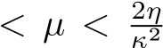 and p
0 < γ ≤ τ where τ = 1 − 1 − µ(2η − µκ²). Assume that the solution set Ξ of HVIP (1.11) is nonempty,
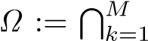
T ^{N} I(B_{i},R_{i})TGSVI(G) ∩ Fix(T). Let {λ_{n}}, {σ_{n}}, {α_{n}} ⊂ (0,1], whereGMEP(Θ_{k},ϕ_{k},A_{k}) ∩_{i=1}
{β_{n}}, {γ_{n}}, {δ_{n}} ⊂ [0,1], {λ_{i,n}} ⊂ [a_{i},b_{i}] ⊂ (0,2η_{i}) and {r_{k,n}} ⊂ [c_{k},d_{k}] ⊂ (0,2µ_{k}), where i ∈ {1,2,...,N} and k ∈ {1,2,...,M}. For given arbitrarily x₀ ∈ H, let {x_{n}} be the sequence generated by
     | un = Tr(M,nΘM,ϕM)(I − rM,nAM)Tr(MΘ−M1−,n1,ϕM−1)(I − rM−1,nAM−1)···Tr(1Θ,n1,ϕ1)(I − r1,nA1)xn, vn = JR_{N},λ_{N,n}(I − λN,nBN)JR_{N−1},λ_{N−1,n}(I − λN−1,nBN−1)···JR₁,λ_{1,n}(I − λ1,nB1)un, z_{n} = (1 − σ_{n})x_{n} + σ_{n}Gv_{n}, yn = βnxn + γnzn + δnTzn, | (4.94)
x_{n+1} = P_{C}[λ_{n}γ(α_{n}V x_{n} + (1 − α_{n})Sx_{n}) + (I − λ_{n}µF)y_{n}], ∀n ≥ 0, where G := P_{C}(I − ν₁F₁)P_{C}(I − ν₂F₂) with ν_{j} ∈ (0,2ζ_{j}) for j = 1,2.
Theorem 4.1. In addition to assumptions of Algorithm 4.1, suppose that
- lim_{n→∞} λ_{n} = 0, lim_{n→∞} α_{n} = 0 and 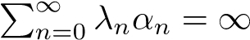;
- β_{n} + γ_{n} + δ_{n} = 1 and (γ_{n} + δ_{n})ξ ≤ γ_{n} for all n ≥ 0; (iii) liminf_{n→∞} δ_{n} > 0, liminf_{n→∞} σ_{n} > 0 and {β_{n}} ⊂ [a,b] ⊂ (0,1);
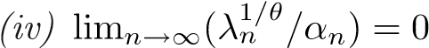 and kx − Txk ≥ k¯[d(x,Ω)]^{θ}, ∀x ∈ C, for some k,θ >¯ 0.
If {Sx_{n}} is bounded, then
- ω_{w}(x_{n}) ⊂ Ω provided kx_{n} − x_{n+1}k → 0 (n → ∞);
- ω_{w}(x_{n}) ⊂ Ξ provided kx_{n} − x_{n+1}k + kx_{n} − y_{n}k = o(λ_{n});
- {x_{n}} converges strongly to a unique solution of Problem II provided kx_{n}−x_{n+1}k+kx_{n}−y_{n}k+kx_{n}−z_{n}k =
o(λ_{n}).
Proof. Since the solution set Ξ of the HVIP (1.11) is nonempty, it is known that Ω 6= ∅. AS in the proof of Theorem 3.1, we put
for all k ∈ {1,2,...,M} and n ≥ 1,
,
for all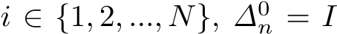 and 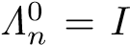, where I is the identity mapping on H. Then, we have that 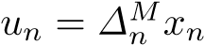 and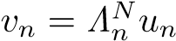.
We divide the rest of the proof into several steps.
Step 1. As in the proof of Theorem 3.1, {x_{n}} is bounded. Thus, {x_{n}} is bounded and so are the
sequences {u_{n}}, {v_{n}}, {y_{n}} and {z_{n}}.
Step 2. We prove that ω_{w}(x_{n}) ⊂ Ω provided kx_{n} − x_{n+1}k → 0 (n → ∞);.
As in the proof of Step 2 in Theorem 3.2, we have
(1 − βn)σn[rk,n(2µk − rk,n)kAk∆kn−1xn − Akpk2 + λi,n(2ηi − λi,n)kBiΛin−1un − Bipk2]
≤ kx_{n} − pk² − ky_{n} − pk²
≤ kx_{n} − y_{n}k(kx_{n} − pk + ky_{n} − pk).
Since liminf_{n→∞} σ_{n} > 0, kx_{n}−y_{n}k → 0, {β_{n}} ⊂ [a,b] ⊂ (0,1), {λ_{i,n}} ⊂ [a_{i},b_{i}] ⊂ (0,2η_{i}), {r_{k,n}} ⊂ [c_{k},d_{k}] ⊂ (0,2µ_{k}), i ∈ {1,2,...,N}, k ∈ {1,2,...,M} and {x_{n}}, {y_{n}} are bounded sequences, we have
= 0 and lim , (4.95)
for all k ∈ {1,2,...,M} and i ∈ {1,2,...,N}.
As in the proof of Step 2 in Theorem 3.2, we have
(1 − β_{n})σ_{n}k(v˜_{n} − k_{n}) + (p − p˜)k²
≤ kx_{n} − pk² − ky_{n} − pk² + 2ν₁kF₁v˜_{n} − F₁p˜kk(v˜_{n} − k_{n}) + (p − p˜)k ≤ kx_{n} − y_{n}k(kx_{n} − pk + ky_{n} − pk) + 2ν₁kF₁v˜_{n} − F₁p˜kk(v˜_{n} − k_{n}) + (p − p˜)k.
Since liminf_{n→∞} σ_{n} > 0, kx_{n} − y_{n}k → 0, {β_{n}} ⊂ [a,b] ⊂ (0,1), ν₁ ∈ (0,2ζ₁) and {x_{n}},{y_{n}}, {k_{n}}, {v˜_{n}} are bounded sequences, we obtain from (3.36) that
lim k(v˜_{n} − k_{n}) + (p − p˜)k = 0. (4.96) n→∞
Note that
kv_{n} − k_{n}k ≤ k(v_{n} − v˜_{n}) − (p − p˜)k + k(v˜_{n} − k_{n}) + (p − p˜)k.
Hence from (3.80) and (4.96), we get
lim kv_{n} − Gv_{n}k = lim kv_{n} − k_{n}k = 0. (4.97)
n→∞ n→∞
Also, observe that z_{n} − x_{n} = σ_{n}(Gv_{n} − x_{n}) and
y_{n} − x_{n} = γ_{n}(z_{n} − x_{n}) + δ_{n}(Tz_{n} − x_{n}), ∀n ≥ 0.
Hence we find that
kz_{n} − x_{n}k ≤ kGv_{n} − x_{n}k ≤ kGv_{n} − v_{n}k + kv_{n} − x_{n}k,
and δ_{n}kTz_{n} − z_{n}k ≤ δ_{n}kTz_{n} − x_{n}k + δ_{n}kx_{n} − z_{n}k
= ky_{n} − x_{n} − γ_{n}(z_{n} − x_{n})k + δ_{n}kx_{n} − z_{n}k
≤ ky_{n} − x_{n}k + γ_{n}kz_{n} − x_{n}k + δ_{n}kx_{n} − z_{n}k = ky_{n} − x_{n}k + (γ_{n} + δ_{n})kx_{n} − z_{n}k = ky_{n} − x_{n}k + kx_{n} − z_{n}k.
So, from liminf_{n→∞} δ_{n} > 0, (3.65), (3.75) and (4.97) it follows that
lim kx_{n} − z_{n}k = 0 and lim kTz_{n} − z_{n}k = 0. | (4.98)
n→∞ n→∞
Secondly, let us show that ω_{w}(x_{n}) ⊂ Ω.
In fact, since H is reflexive and {x_{n}} is bounded, there exists at least a weak convergence subsequence
of {x_{n}}. Hence it is known that ω_{w}(x_{n}) =6 ∅. Now, take an arbitrary w ∈ ω_{w}(x_{n}). Then there exists a subsequence {x_{ni}} of {x_{n}} such that x_{ni} * w. ¿From (3.71)–(3.73), (3.75) and (4.98), we have that
and 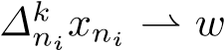, where m ∈ {1,2,...,N} and k ∈ {1,2,...,M}.
Utilizing Lemma 2.3 (ii), we deduce from z_{ni} * w and (4.98) that w ∈ Fix(T). In the meantime, utilizing Lemma 2.5, we obtain from v_{ni} * w and (4.97) that w ∈ GSVI(G).
As in the proof of Step 2 in Theorem 3.2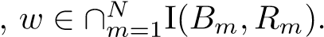
Step 3. We prove that ω_{w}(x_{n}) ⊂ Ξ provided kx_{n} − x_{n+1}k + kx_{n} − y_{n}k = o(λ_{n}).
Indeed, as in the proof of Step 3 in Theorem 3.2, we have 0 < γ ≤ τ and µη ≥ τ ⇐⇒ κ ≥ η. It is clear
that
Hence, it follows from 0 < γ ≤ τ ≤ µη that µF −γS is monotone. Moreover, it is also obvious that µF −γS is (µκ + γ)-Lipschitzian. Noticing
x_{n+1} = P_{C}w_{n} − w_{n} + λ_{n}γ(α_{n}V x_{n} + (1 − α_{n})Sx_{n}) + (I − λ_{n}µF)y_{n},
we obtain
n n+1  Set | n C n n n n n n n  + (I − λ_{n}µF)x_{n} − (I − λ_{n}µF)y_{n}. | (4.99)
x − x = w − P w + α λ (µF − γV )x + λ (1 − α )(µF − γS)x
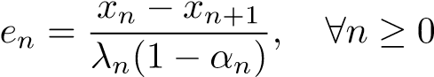. (4.100)
It can be easily seen from (3.45) that
This yields that, for all p ∈ Ω (noticing x_{n} = P_{C}w_{n−1}),
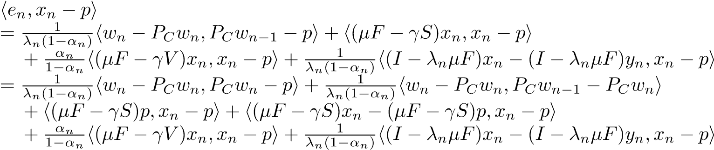
(4.102)
.
In (4.102), the first term is nonnegative due to Proposition 2.1 (i), and the fourth term is also nonnegative
due to the monotonicity of µF −γS. We, therefore, deduce from (4.102) that (noticing again x_{n+1} = P_{C}w_{n})
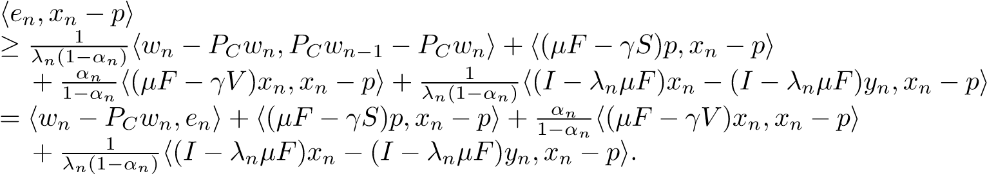 (4.103)
Note that
k(I − λ_{n}µF)x_{n} − (I − λ_{n}µF)y_{n}k ≤ (1 − λ_{n}τ)kx_{n} − y_{n}k.  Hence, it follows from kx_{n} − y_{n}k = o(λ_{n}) that | (4.104)
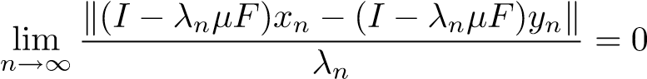. (4.105)
Also, since e_{n} → 0 (due to kx_{n+1} − x_{n}k = o(λ_{n})), α_{n} → 0 and {x_{n}} is bounded by Step 1 which implies that {w_{n}} is bounded, we obtain from (4.103) that
. (4.106)
This suffices to guarantee that ω_{w}(x_{n}) ⊂ Ξ; namely, every weak limit point of {x_{n}} solves the HVIP (1.11). As a matter of fact, if x_{ni} * x˜ ∈ ω_{w}(x_{n}) for some subsequence {x_{ni}} of {x_{n}}, then we deduce from (3.38) that for all p ∈ Ω
,
that is,
h(µF − γS)p,p − x˜i ≥ 0, ∀p ∈ Ω. (4.107)
In addition, note that ω_{w}(x_{n}) ⊂ Ω by Step 2. Since µF −γS is monotone and Lipschitz continuous and Ω is nonempty, closed and convex, by Minty’s Lemma [26] the last inequality is equivalent to (1.11). Consequently, we get ˜x ∈ Ξ.
Step 4. We prove that {x_{n}} converges strongly to a unique solution of Problem II provided kx_{n} − x_{n+1}k + kx_{n} − y_{n}k + kx_{n} − z_{n}k = o(λ_{n}).
Indeed, it is clear that
h(µF − γV )x − (µF − γV )y,x − yi ≥ (µη − γρ)kx − yk², ∀x,y ∈ C.
Hence, it follows from 0 < γ ≤ τ ≤ µη and ρ < 1 that µF − γV is (µη − γρ)-strongly monotone. Moreover, it is also obvious that µF −γV is (µκ+γρ)-Lipschitzian. So, we can write VI(µF −γV,Ξ) = {x∗}. We now
take a subsequence {x_{ni}} of {x_{n}} satisfying
. (4.108)
Without loss of generality, we may further assume that x_{ni} * x˜; then ˜x ∈ Ξ as we just proved. Since x∗ is a solution of the THVIP (1.10), we get
limsuph(γV − µF)x∗,x_{n} − x∗i = h(γV − µF)x∗,x˜ − x∗i ≤ 0. (4.109)
n→∞
¿From (4.94) and (3.63), it follows that (noticing that x_{n+1} = P_{C}w_{n} and 0 < γ ≤ τ)
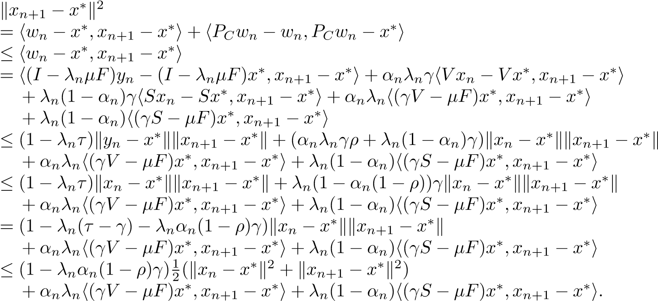
It turns out that
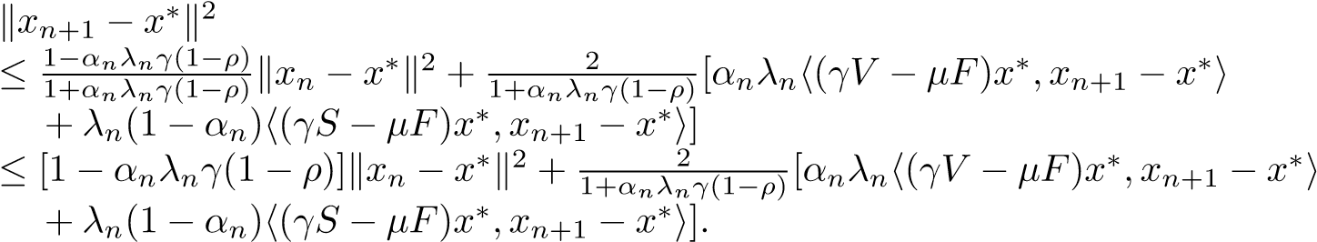 (4.110)
However, from x∗ ∈ Ξ and condition (iv) we obtain that
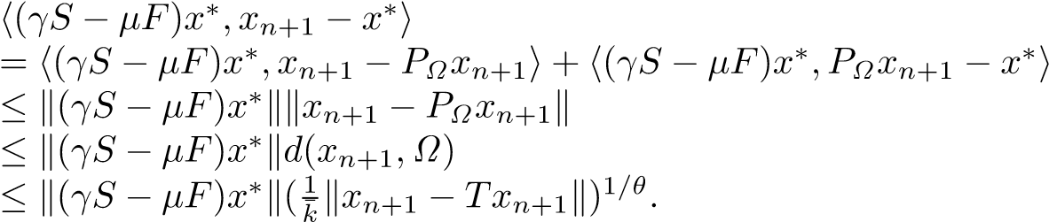 (4.111)
Since (γ_{n} + δ_{n})ξ ≤ γ_{n}, utilizing Lemmas 2.3 (i) and 2.4, we get
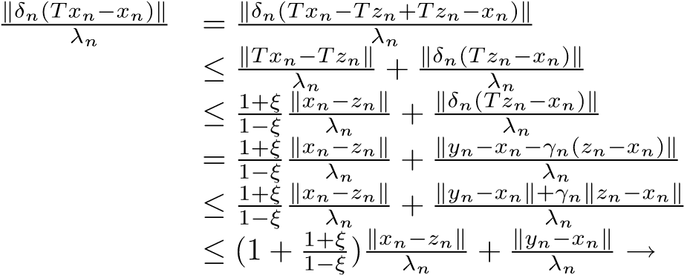0 as n → ∞.
That is, kδ_{n}(Tx_{n} − x_{n})k = o(λ_{n}). Taking into account liminf_{n→∞} δ_{n} > 0, we have kx_{n} − Tx_{n}k = o(λ_{n}).
Furthermore, utilizing Lemma 2.3 (i), we have
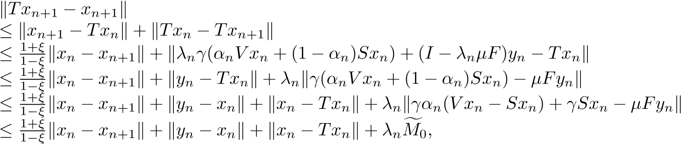
where sup_{n≥0} kγα_{n}(V x_{n} −Sx_{n})+γSx_{n} −µFy_{n}k ≤ Mf₀ for some Mf₀ > 0. Hence, for a big enough constant k¯₁ > 0, from (4.111), we have
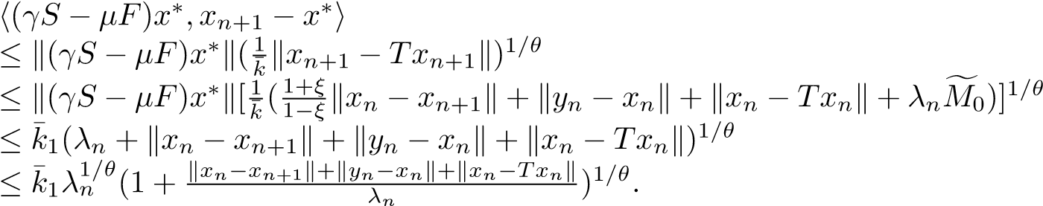 (4.112) Combining (4.110)–(4.112), we get
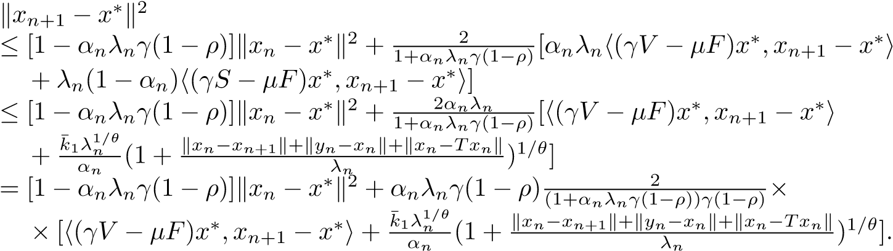
Since), we deduce from
(4.109) that 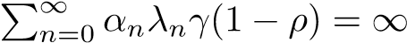 and
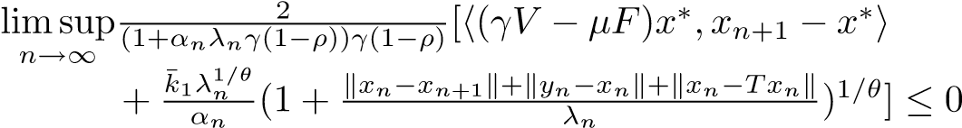.
Applying Lemma 2.8 to (4.112), we conclude that x_{n} → x∗ as n → ∞. This completes the proof.
Remark 4.1. It is obvious that iterative scheme (4.94) is different from from the iterative schemes in [44,29] The three-step iterative scheme in [29, Algorithm I] is extended to five-step iterative scheme (4.94) for the THVIP (1.10) by combining Mann’s iteration method, Korpelevich’s extragradient method, viscosity approximation method, hybrid steepest-descent method [42] and projection method. It is worth pointing out that under the lack of the assumptions similar to those in [44, Theorem 3.2], for example, {x_{n}} is
T ∗ ∈ bounded and Fix(T) intC 6= ∅, the sequence {x_{n}} generated by (3.1) converges strongly to a point x
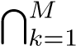
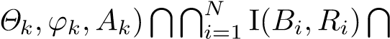
T ∗ ∈ Ξ GMEP(GSVI(G) Fix(T) =: Ω, which is a unique solution x
of the THVIP (1.10) (over the fixed point set of strictly pseudocontractive mapping T), that is, h(µF − γV )x∗,p − x∗i ≥ 0,∀p ∈ Ξ.
Remark 4.2. Theorem 4.1 improves and extends [44, Theorems 3.1 and 3.2] and [29, Theorem 14] in the following aspects:
- THVIP (1.10) with the unique solution x∗ ∈ Ω satisfying
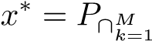GMEP(Θ_{k},ϕ_{k},A_{k})∩∩iN=1I(Bi,R_{i})∩GSVI(G)∩Fix(T)(I − (µF − γS))x∗
is more general than the problem of finding a point ˜x ∈ C satisfying ˜x = P_{Fix(T)}Sx˜ in [44] and the problem of finding a point x∗ ∈ Fix(T) ∩ VI(C,A) satisfying x∗ = P_{Fix(T)∩VI(C,A)}(I − (µF − γS))x∗ in [29, Theorem 14].
- Five-step iterative scheme (4.94) for THVIP (1.10) is flexible and advantageous than three-step iterative scheme in [29, Algorithm I] and two-step iterative scheme in because it can be used to solve several kinds of problems, for example, the THVIP, the HVIP and the problem of finding a common point of four sets: 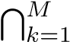 GMEP( 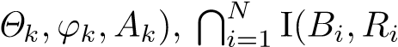), GSVI(G) and Fix(T). In addition, Theorem 4.1 drops the crucial requirements in [44, Theorem 3.2] that lim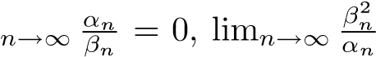 = 0, Fix(T) ∩
intC 6= ∅ and {x_{n}} is bounded, and also removes the crucial ones [29, Theorem 14] that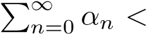
∞, lim_{n→∞}(α_{n}/λ²_{n}) = 0 and kx_{n+1} − x_{n}k + kx_{n} − z_{n}k = o(λ²_{n}).
- The argument and techniques in Theorem 4.1 are different from the ones in [44, Theorems 3.1 and 3.2] and in [29, Theorem 14] because we make use of the properties of strictly pseudocontractive mappings (see Lemmas 2.3 and 2.4), the properties of resolvent operators and maximal monotone mappings (see Proposition 2.2, Remark 2.2 and Lemmas 2.9–2.13, the fixed point equation x∗ = P_{C}(I − ν₁F₁)P_{C}(I − ν₂F₂)x∗ equivalent to the GSVI (1.4) (see Proposition 2.3) and the contractive coefficient estimates for the contractions associating with nonexpansive mappings (see Lemma 2.7).
- Compared with the requirement kx_{n} − x_{n+1}k + kx_{n} − z_{n}k = o(λ²_{n}) in [29, Theorem 14], the one kx_{n} − x_{n+1}k + kx_{n} − y_{n}k + kx_{n} − z_{n}k = o(λ_{n}) in conclusion (c) of Theorem 4.1 is additionally added because Theorem 4.1 involves the quite complex problem, that is, the THVIP 1.10 (over the fixed point set Fix(T) of strictly pseudocontractive mapping T) with constraints of several problems: GSVI (1.4), finitely many GMEPs and finitely many variational inclusions.

Acknowledgements
In this research, first was partially supported by the National Science Foundation of China (11071169), Innovation Program of Shanghai Municipal Education Commission (09ZZ133) and Ph.D. Program Foundation of Ministry of Education of China (20123127110002). In this research, second and third author were partially supported by a grant from National Science Council of Taiwan.
Competing Interest
The authors declare that they have no competing interests.

References
- Q.H. Ansari (Editor), Topics in Nonlinear Analysis and Optimization, World Education, Delhi, 2012.
- Q.H. Ansari, L.-C. Ceng, H. Gupta, Triple Hierarchical Variational Inequalities, In Nonlinear Analysis: Approximation Theory, Optimization and Applications, Edited by Q.H. Ansari, Birkh¨auser, Springer, New Delhi, Heidelberg, New York, Dordrecht, London, pp. 231–280, 2014. 1
- Q.H. Ansari, C.S., Lalitha, M. Mehta, Generalized Convexity, Nonsmooth Variational Inequalities and Nonsmooth Optimization, Taylor and Francis, CRC Press, England, 2013.
- Q.H. Ansari, N.-C. Wong, J.-C. Yao, The existence of nonlinear inequalities, Appl. Math. Lett. 12(5) (1999) 89–92. 1
- Q.H. Ansari, J.C. Yao, Systems of generalized variational inequalities and their applications, Appl. Anal.
76 (2000) 203–217.
- V. Barbu, Nonlinear Semigroups and Differential Equations in Banach Spaces, Noordhoff, 1976. 2.9
- L.C. Ceng, Q.H. Ansari, M.M. Wong, J.C. Yao, Mann type hybrid extragradient method for variational inequalities, variational inclusions and fixed point problems, Fixed Point Theory 13 (2) (2012) 403–422. 1, 1, 2.11, 2.13
- L.C. Ceng, Q.H. Ansari, S. Schaible, Hybrid extragradient-like methods for generalized mixed equilibrium problems, system of generalized equilibrium problems and optimization problems, J. Global Optim. 53 (2012) 69–96. 1, 1, 1
- L.C. Ceng, Q.H. Ansari, C.-F. Wen, Hybrid steepest-descent viscosity method for triple hierarchical variational inequalities, Appl. Abstract Anal., Volume 2012, (2012) Article ID 907105, 19 pages, 1
- L.C. Ceng, Q.H. Ansari, J.C. Yao, Iterative methods for triple hierarchical variational inequalities in Hilbert spaces, J. Optim. Theory Appl. 151(3) (2011), 489–512 1
- L.C. Ceng, Q.H. Ansari, J.C. Yao, Relaxed extragradient iterative methods for variational inequalities, Appl. Math. Comput. 218 (2011) 1112–1123. 1, 1
- L.C. Ceng, Q.H. Ansari, J.C. Yao, Relaxed hybrid steepest-descent methods with variable parameters for triple-hierarchical variational inequalities, Appl. Anal. 91 (10) (2012) 1793-–1810. 1
- L.C. Ceng, S.M. Guu, J.C. Yao, Hybrid iterative method for finding common solutions of generalized mixed equilibrium and fixed point problems, Fixed Point Theory Appl. 2012, 2012:92, 19pp. 1
- L.C. Ceng, S.M. Guu, J.C. Yao, Hybrid viscosity CQ method for finding a common solution of a variational inequality, a general system of variational inequalities, and a fixed point problem, Fixed Point
Theory Appl. 2013, 2013:313, 25pp. 1
- L.C. Ceng, H.Y. Hu, M.M. Wong, Strong and weak convergence theorems for generalized mixed equilibrium problem with perturbation and fixed point problem of infinitely many nonexpansive mappings, Taiwanese J. Math. 15 (2011) 1341–1367. 1
- L.C. Ceng, A. Petrusel, Relaxed extragradient-like method for general system of generalized mixed equilibria and fixed point problem, Taiwanese J. Math. 16 (2) (2012) 445–478. 1, 1
- L.C. Ceng, A. Petrusel, J.C. Yao, Iterative approaches to solving equilibrium problems and fixed point problems of infinitely many nonexpansive mappings, J. Optim. Theory Appl. 143 (2009) 37–58.
- L.C. Ceng, C.Y. Wang, J.C. Yao, Strong convergence theorems by a relaxed extragradient method for a general system of variational inequalities, Math. Methods Oper. Res. 67(3) (2008) 375–390. 1, 1, 1, 2,
2.3
- L.C. Ceng, M.M. Wong, Relaxed extragradient method for finding a common element of systems of variational inequalities and fixed point problems, Taiwanese J. Math. 17(2) (2013) 701–724. 1, 1, 3.2
- L.C. Ceng, J.C. Yao, Hybrid viscosity approximation schemes for equilibrium problems and fixed point problems of infinitely many nonexpansive mappings, Appl. Math. Comput. 198 (2008) 729–741.
- L.C. Ceng, J.C. Yao, A hybrid iterative scheme for mixed equilibrium problems and fixed point problems, J. Comput. Appl. Math. 214 (2008) 186–201. 1, 2.2
- L.C. Ceng, J.C. Yao, A relaxed extragradient-like method for a generalized mixed equilibrium problem, a general system of generalized equilibria and a fixed point problem, Nonlinear Anal. 72 (2010) 1922–1937. 1, 1
- L.C. Ceng, J.C. Yao, On the triple hierarchical variational inequalities with constraints of mixed equilibria, variational inclusions and systems of generalized equilibria, Tamkang J. Mathematics, 45 (3), September 2014, to appear 1
- V. Colao, G. Marino, H.K. Xu, An iterative method for finding common solutions of equilibrium and fixed point problems, J. Math. Anal. Appl. 344 (2008) 340–352.
- R. Glowinski, Numerical Methods for Nonlinear Variational Problems, Springer-Verlag, New York, 1984. 1
- K. Goebel, W.A. Kirk, Topics on Metric Fixed-Point Theory, Cambridge University Press, Cambridge, England, 1990. 2.5, 3, 3, 4
- J. Gwinner, Stability of monotone variational inequalities with various applications, In: Variational Inequalities and Network Equilibrium Problems, F. Giannessi and A. Maugeri (Eds.), pp. 123–142,
Plenum Press, (1995). 1
- N.J. Huang, A new completely general class of variational inclusions with noncompact valued mappings, Comput. Math. Appl. 35(10) (1998) 9–14. 1, 2
- Z.R. Kong, L.C. Ceng, Q.H. Ansari, C.T. Pang, Multistep hybrid extragradient method for triple hierarchical variational inequalities, Abstr. Appl. Anal. 2013, Article ID 718624, 17 pp. 1, 1, 1, 1.1, 3.1, 3.2, 3.3, 3.4, 4.1, 4.2
- G.M. Korpelevich, The extragradient method for finding saddle points and other problems, Matecon. 12 (1976) 747–756. 1
- J.L. Lions, Quelques M´ethodes de R´esolution des Probl`emes aux Limites Non Lin´eaires, Dunod, Paris, 1969. 1
- G. Marino, H.K. Xu, Weak and strong convergence theorems for strict pseudo-contractions in Hilbert spaces, J. Math. Anal. Appl. 329 (2007) 336–346. 2, 2.3
- N. Nadezhkina, W. Takahashi, Weak convergence theorem by an extragradient method for nonexpansive mappings and monotone mappings, J. Optim. Theory Appl. 128 (2006) 191–201. 1
- J.T. Oden, Quantitative Methods on Nonlinear Mechanics, Prentice-Hall, Englewood Cliffs, NJ 1986. 1
- J.W. Peng, J.C. Yao, A new hybrid-extragradient method for generalized mixed equilibrium problems, fixed point problems and variational inequality problems, Taiwanese J. Math. 12 (2008) 1401–1432. 1, 1
- R.T. Rockafellar, Monotone operators and the proximal point algorithms, SIAM J. Control Optim. 14 (1976) 877–898. 1, 2
- D.R. Sahu, H.K. Xu, J.C. Yao, Asymptotically strict pseudocontractive mappings in the intermediate sense, Nonlinear Anal. 70 (2009) 3502–3511.
- W. Takahashi, Nonlinear Functional Analysis, Yokohama Publishers, Yokohama, Japan, 2000. 1
- S. Takahashi, W. Takahashi, Strong convergence theorem for a generalized equilibrium problem and a nonexpansive mapping in a Hilbert space, Nonlinear Anal. 69 (2008) 1025–1033. 1
- R.U. Verma, On a new system of nonlinear variational inequalities and associated iterative algorithms,
Math. Sci. Res. Hot-Line 3 (8) (1999) 65–68. 1
- H.K. Xu, T.H. Kim, Convergence of hybrid steepest-descent methods for variational inequalities, J. Optim. Theory. Appl. 119 (2003) 185–201. 2.7, 2.8
- I. Yamada, The hybrid steepest-descent method for the variational inequality problems over the intersection of the fixed-point sets of nonexpansive mappings, in: Inherently Parallel Algorithms in Feasibility and Optimization and Their Applications, D. Batnariu, Y. Censor, and S. Reich, eds., Amsterdam,
North-Holland, Holland, 2001, pp. 473–504. 3.1, 3.3, 4.1
- Y. Yao, Y.C. Liou, S.M. Kang, Approach to common elements of variational inequality problems and fixed point problems via a relaxed extragradient method, Comput. Math. Appl. 59 (2010) 3472–3480. 1, 1, 2.4
- Y. Yao, Y.C. Liou, G. Marino, Two-step iterative algorithms for hierarchical fixed point problems and variational inequality problems, J. Appl. Math. Comput. 31 (2009) 433–445. 1, 1, 3.1, 3.2, 3.3, 3.4, 4.1,
4.2
- Y. Yao, Y.C. Liou, J.C. Yao, Convergence theorem for equilibrium problems and fixed point problems of infinite family of nonexpansive mappings, Fixed Point Theory Appl. 2007 (2007) Article ID 64363, 12pp.
- Y. Yao, H. Zhou, Y.C. Liou, Weak and strong convergence theorems for an asymptotically k-strict pseudocontraction and a mixed equilibrium problem, J. Korean Math. Soc. 46 (2009), 561–576.
- E. Zeidler, Nonlinear Functional Analysis and Its Applications, Springer-Verlag, New York, 1985. 1
- L.C. Zeng, S.M. Guu, J.C. Yao, Characterization of H-monotone operators with applications to variational inclusions, Comput. Math. Appl. 50 (2005) 329–337. 1, 2, 2.12
- L.C. Zeng, J.C. Yao, Strong convergence theorem by an extragradient method for fixed point problems and variational inequality problems, Taiwanese J. Math. 10 (2006) 1293–1303. 1
- S.S. Zhang, H.W. Lee Joseph, C.K. Chan, Algorithms of common solutions for quasi variational inclusions and fixed point problems, Appl. Math. Mech. (English Edition) 29 (2008) 571–581. 1

