Electromagnetic Shielding Effectiveness of Physical Property PET/Stainless Steel Composite Fabrics
Jia-Horng Lin^{1, 2, 3, b}, Ting-An Lin¹, An-Pang Chen¹ and Ching-Wen Lou^{4, a}
¹Laboratory of Fiber Application and Manufacturing, Department of Fiber and Composite Materials, Feng Chia University, Taichung City 40724, Taiwan, R.O.C.
²School of Chinese Medicine, China Medical University, Taichung 40402, Taiwan, R.O.C.
³Department of Fashion Design, Asia University, Taichung 41354, Taiwan, R.O.C.
⁴Institute of Biomedical Engineering and Materials Science, Central Taiwan University of Science and Technology, Taichung 40601, Taiwan, R.O.C.
ªcwlou@ctust.edu.tw, ^{b}jhlin@fcu.edu.tw
Keywords: composite fabrics, electromagnetic shielding effectiveness, conductivity composite yarn, air permeability.
Abstract. The electronic appliance is capable of emitting electromagnetic waves that will cause the damage of electrical equipment and influence people’s health. In this study, stain steel filament (SS filament) and 75D PET filament were used to manufacture SS/PET composite yarn The SS/PET composite yarn were made by the wrapping machine, which the core yarn is stain steel filament, wrapped yarn is 75D PET filament and the wrapping layers is varied as one and two. After that, the composite yarn is fabricated by the automatic sampling loom into composite woven fabrics. The composite SS/PET woven fabrics were under the tests of electromagnetic shielding effectiveness (EMSE) and air permeability. The test results revealed that the EMSE of the one-layer composite woven fabric is 9.5 dB at 900 MHz, but the EMSE decreases as test frequency increases. When laminating layer added to three layers, the EMSE raise up to 12.6 dB. The EMSE of composite woven fabric reached at 29.9 when the laminated angle is 45°. And the air permeability decreases as the laminate layer increases, which the thickness of sample affect air to pass through the sample.
Introduction
People enjoy the convenience of novel electrical products due to the progress of science and technology. But at the same time they are also exposed to the radiation of electromagnetic wave, which emits from the electronic appliances. Over the past few decades, as the use of electronic devices has rapidly grown, the electromagnetic interferences (EMI) problems have drastically increased.
Electromagnetic shielding effectiveness (EMSE) is a process by which a material is able to reduce the transmission of electromagnetic radiation. Various materials have been used such as conductive metal powders, ferrites, carbon products, chiral materials, synthetic organic fibers, and conjugated polymers to enhance the EMSE [1–2]. There are three mechanisms to attenuate electromagnetic waves such as absorption loss, reflection loss and internal multiple reflection loss [3]. Conductive materials such as metals reflect electromagnetic wave to prevent them from penetrating the shield. Electromagnetic wave energy transforms into thermal energy by absorption in electromagnetic field.
Thus, a number of investigations have been carried out on this subject in recent years. Gnidakouong et al. [4] exhibited their research results that the EMSE enhances with coating MWCNT (multi-walled carbon nano tube) on the PET substrate that contain glass fiber or carbon fiber. Brzeziński et al. [5] exploited that multiple structure could provide higher EMSE, which the structure enhanced the absorption loss and internal multiple reflection loss in the fabric.
The conductivity of polymer material is worse than the metallic material. In order to obviously decrease the electromagnetic shielding effectiveness. There are many research attention in metallic fabric to shielding radiation. [6-8]. In the present study, electromagnetic shielding fabrics can be applied on civil and electrical industries, for blocking electromagnetic radiation that can protect the health of people.
Experimental
Material and processing
PET filament and stain steel filament are selected as materials in the research. The tensile strength and tensile elongation of PET filament are 304.62 cN and 18.31%, respectively. 316L stain steel filament is supplied by King's Metal Fiber Technology Co., Ltd.
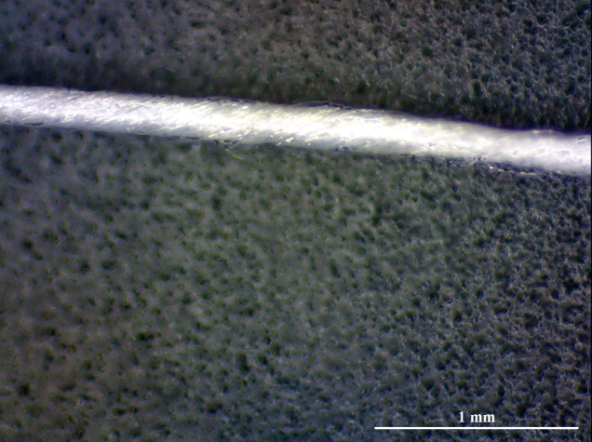
Figure 1. The schematic of PET/stainless steel double wrapped composites yarns.
EMSE
Electromagnetic shielding effectiveness is estimated by Shielding Effectiveness Test System (Shielding Effectiveness Test Sample Holder, EM-2107A) with plane wave based far-field, which the test frequency range is 300 kHz to 3 GHz.
Air permeability
Air permeability is estimated by Air Permeability Test Machine with ASTM D0730 standard. The size of sample is 25 cm × 25cm. In order to estimate the air permeability of composite woven fabric, the machine will adjust the mount of air jet nozzles.
Results and Discussion
Electromagnetic shielding is a barrier formed in a space by conductive or magnetic materials to attenuate the energy of electromagnetic shield. Identical shield has different shielding efficiency to different kinds of electromagnetic wave.
Fig. 2 showed that the EMSE decreased as the test frequency increased. The high-frequency electromagnetic wave has relative short wavelength, which raises the chance of electromagnetic wave to pass through the shield.

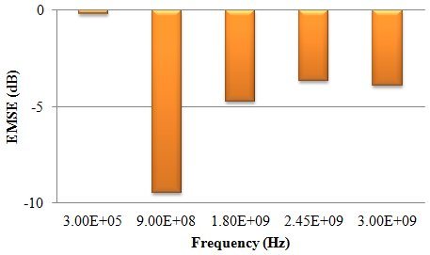
Figure 2. The EMSE of PET/stainless steel composites fabrics with various frequency.
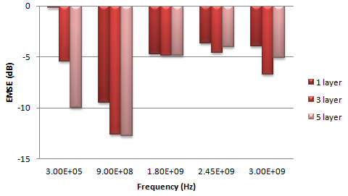
Figure 3. The EMSE of PET/stainless steel composites fabrics with various frequency and laminated layer.

Fig. 3. reveals that the laminated layer number of SS/PET increases as the EMSE enhances slightly. The phenomenon causes by the arrangement of SS/PET composite woven fabric with same direction, which the unit area has less loops to shield electromagnetic waves. The EMSE shows tiny enhancement in the right segment of Fig. 3. From Fig. 4, the EMSE increases as laminated layer number increases, which the laminated angle is 45°. With different arrangement of composite woven fabrics, the EMSE increase as layer number increase. A complete conductive network is formed to shield electromagnetic waves.

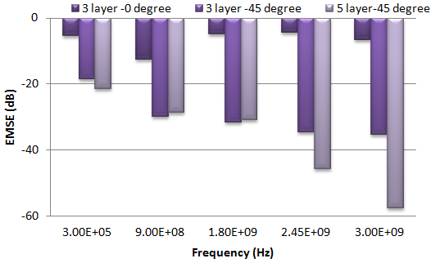
Figure 4. The EMSE of PET/stainless steel composites fabrics with various frequency and laminated layer.
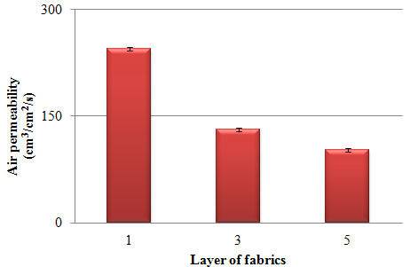
Figure 5. The air permeability of PET/stainless steel composites fabrics with various laminated layer.

Fig. 5. shows the air permeability decreases as the laminated layer number increases, which the thickness of SS/PET woven fabric affects air to penetrate from the mesh. The result shows that optimum value occurs with one-layer composite woven fabric, which can apply on costumes to obtain the quality of comfort.

Summery
In the research, the 0.08 mm stain steel filament and 75D PET filament were selected as core yarn and wrapped yarn to manufacture the SS/PET composite yarn with wrapping machine at 8000 rpm. And the SS/PET composite woven fabric was fabricated by the automatic sampling loom. According to the results, the EMSE performances better at the relative low frequency when the laminated layer number is fixed and decreases as the test frequency and layer number increases.
The test results revealed that the EMSE of the one-layer composite woven fabric is 9.5 dB at 900 MHz, but the EMSE decreases to 3.9 dB as the test frequency increases to 3 GHz. When laminated layer number added to three layers, the EMSE can reach at 12.6 dB. The EMSE raised up to 29.9 dB and 28.7 dB when the laminated layer number is 3 and 5 with laminated angle is 45°. The air permeability of SS/PET composite woven fabric decreased as the laminated layer number increased, which the thickness of sample affected the opportunity for air to pass through the sample. The optimum air permeability is 200 cm³/cm²/s which occurs at the single layer. The SS/PET composite woven fabric is expected to apply on civilian protective textiles.
Acknowledgement
The authors would especially like to thank National Science Council of the Taiwan, for financially supporting this research under Contract NSC 102-2622-E-468-001-CC3.
Reference
- J. Cao, W. Y. Fu, H. B. Yang, Q. J. Yu and Y. Y. Zhang: J. Phys. Chem. B. Vol. 113(2009), p. 4642.
- N. J. Tang, W. Zhong, C. Au, Y. Yang, M. G. Han, K. J. Lin and Y. W. Du: J Phys. Chem. B. Vol. 112 (2008), p. 19316.
- B.W. Li, Y. Shen, Z.X. Yue and C.W. Nan: Appl. Phys. Lett. Vol. 89 (2006), p. 132504.
- K. Rajendrakumar and G. Thilagavathi: Indian. J. Fibre. Text. Res. Vol. 37 (2012), p. 133.
- T. Brzeziński, T. Rybicki, G. Malinowska, I. Karbownik, E. Rybicki and L. Lech Szugajew: Fibres Text. East. Eur. Vol. (72) (2009), p. 60.
- J.H. Lin, A.P. Chen, C.M. Lin, C.W. Lin, C.T. Hsieh and C.W. Lou: Fiber. Polym. Vol. 11 (2010), p. 856.
- C.M. Lin, C.C. Huang, C.W. Lou, A.P. Chen, S.E. Liou and J.H. Lin: Fibres Text. East. Eur. Vol. 19 (2011), p. 28.
- C.W. Lou, C.M. Lin, A.P. Chen and J.H. Lin: Text. Res. J. Vol. 81(2011), p. 1331.

