The Influence of Hot Pressing Temperatures in Needle Punching Nonwoven
Ching-Wen Lou¹, Ya-Lan Hsing², Wen-Hao Hsing^{3, b} and Jia-Horng Lin^{2, 4, 5, a}
¹Institute of Biomedical Engineering and Materials Science, Central Taiwan University of Science and Technology, Taichung 40601, Taiwan, R.O.C.
²Laboratory of Fiber Application and Manufacturing, Department of Fiber and Composite Materials, Feng Chia University, Taichung City 40724, Taiwan, R.O.C.
³The Department of Textile Engineering, Chinese Culture University, Taipei 11114, Taiwan, R.O.C.
⁴School of Chinese Medicine, China Medical University, Taichung 40402, Taiwan, R.O.C.
⁵Department of Fashion Design, Asia University, Taichung 41354, Taiwan, R.O.C.
ªjhlin@fcu.edu.tw, ^{b}hsing@staff.pccu.edu.tw
Keywords: Recycle; Nonwoven; Low melting temperature polyethylene terephthalate
Abstract. Non-woven textile industry in an emerging field, with the process short, high yield, low cost and wide source of raw materials, but also has excellent performance of many functions on, making non-woven over the past half century gained textiles attention and consumers of all ages. The proportion of the world of non-woven fiber material used in the product, 85% in rayon ,and the other 15% in natural fibers, polyester fibers which accounted for the largest proportion of use. The experiment uses a low melting point polyester fiber(LPET) 20%, three-dimensional hollow curly polyester fiber(TPET) and recycled far infrared fiber(REPET) 40% each as the basic conditions change pressing temperature 100 ℃ -140 ℃, in order to observe and compare the effects of temperature on the non-woven fabric, this experiment tests including air permeability, tensile strength testing, infrared testing and SEM, respectively in different hot pressing temperature, each of the non-woven hot pressing temperatures sample go through microscopic to analysis for non-woven with the hot temperatures strong reason to improve or decline with hot temperature of air permeability.
Introduction
With concepts of environmental protection awareness rising, the 3R department of Reduce, Reuse, Recycle composed, which Recycle constantly being society attention. Because according to the United Nations statistics in global, minimum to produce 600 million tons per year ton wasted. [1] Therefore, we use recycled PET as a substrate, with far infrared and low melting point PET non-woven go through hot pressing, not only environmentally friendly but also avoid the use of chemicals to prevent environmental pollution caused by the overall deterioration or fiber.
Low-melting point polyester fiber having a special skin-core structure, and the melting temperature is 110 ℃, generally the core of polyester fibers having a melting point of 260 ℃. When the temperature is above 110 ℃, the cortex of the low melting point polyester will start to melt. Low melting polyester fiber fabric is usually used in the consolidation of thermal processing, and using recyclable.
Water molecule which are used in this experiment recovered far infrared far infrared fiber powder can be activated the organism, within the body temperature is increased in order to achieve thermal insulation effect, far infrared may also promote circulation and metabolism, and therefore it is good for human health care[2-4].
Experimental
Materials
low melting temperature polyethylene terephthalate fiber (LPET), 4 denier fiber fineness, 51 mm length, skin melting temperature 120℃, from Far Eastern New Century Corporation.
The three-dimensional hollow Polyethylene Terephthalate fibers (TPET), 7 denier fiber fineness, 51 mm length, and a melting point of 265 ℃, from Far Eastern New Century Corporation, Taiwan, R.O.C.) .Recycling far infrared PET (RFPET), 6 denier fiber fineness, 64 mm length, far infrared powder concentration 1.5 %, FROM True Young Co., Ltd.
Tests
Air permeability
This test follows ASTM D737-04(2012) air permeability standard, air permeability testing by Textest FX3300, revision the machine to adjust the air volume stalls, in order to achieve the correct porosity, sample sized 25 x 25 cm², number of samples tested N=10.
Tensile strength
This test follows ASTM D5035-11, sample sized 180 mm × 25.4 mm, fixture spacing 76 mm, stretch rate 305 ± 13 mm/min, number of samples tested N=10, this specification in dry and wet conditions of the test method, usually tested in a dry state, by analyzing changes in process conditions a single sample of test data in order to obtain better conditions for the process.
Far-Infrared Emissivity
This test follows FTTS-FA-010 and uses a far infrared emissivity tester (TSS-5X, Japan Sensor Corporation, Japan). The detection head randomly detects the quality of far infrared emissivity of the samples, and compares the value with the blackbody radiation (0.94). Twenty samples of each specification are evaluated for the mean.
Stereomicroscopic Observation
Scanning Electron Microscope (SEM): HITACHI S3000N, Japan.
Results and Discussion
Air permeability of REPET/TPET/LPET nonwoven as related to various hot pressing temperature
Because of the materials adding low melting point fibers relations, the outer structure of the fiber will start melting when temperature is raised to 110℃, melting makes nonwoven structure enables more careful, but also improved intensity. In Figure 1 as can be seen in the laboratory as an interval of every 20 degrees, with the upgrading of air permeability with decreasing temperature, it is because of the low melting point fibers after hot roller’s heat melting, the pore in nonwoven filled up, so when the temperature rises, the more the pore is filled, air permeability decline.
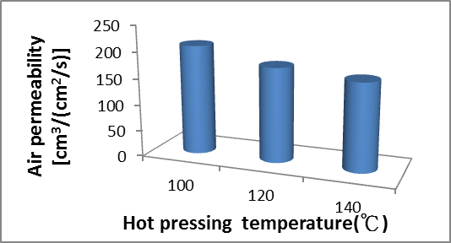
Figure 1 Influence of hot pressing temperature on the Air permeability of REPET/TPET/LPET nonwoven
Tensile strength of REPET/TPET/LPET nonwoven as related to various hot pressing temperature
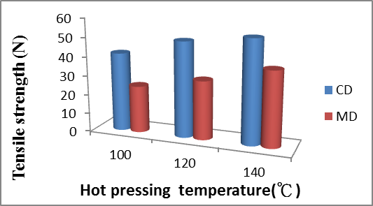
Figure 2 Influence of hot pressing temperature on the tensile strength of REPET/TPET/LPET nonwoven.
In the tensile strength test of the experiments enhance, most of the nonwoven fabric improved in strength after go through the hot pressing, especially since the melting of low-melting point fiber reinforcement nonwoven fabric as filled in the pores, low melting point fiber as would otherwise relatively flat fiber arrangement, bond into a network structure in 3D, so when the hot pressing temperature rises, nonwoven will increase in tensile strength, and can be learned from Figure 2 CD tensile strength and direction overall one third higher than the MD direction.
Far-infrared emissivity of REPET/TPET/LPET nonwoven as related to various hot pressing temperature
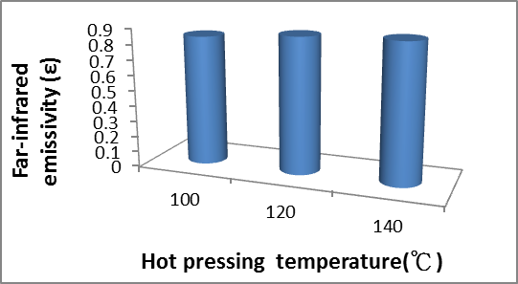
Figure 3 Influence of hot pressing temperature on the Far-infrared emissivity of REPET/TPET/LPET nonwoven.
Figure 3 can be seen, in the scope of the laboratory test, the far-infrared emissivity were above 0.8, all of them have reached a basic standard, and in this range, the higher the hot pressing temperature is, far infrared radiation rate will be improve slightly, because that the hot pressing will also cause nonwoven hardened and thin, the more fiber far-infrared particle distribution more closely, the far-infrared emissivity of the test will be improved.
SEM of REPET/TPET/LPET nonwoven as related to various hot pressing temperature
In Figure 4, from left to right in the order of 100 ℃, 120 ℃ and 140 ℃, and the magnification of the upper row 500 are used to observe the surface of the molten state, the surface can be seen that there is not too much melting in 100 ℃, but when the fibers together again, deal would becoming overlapping point, because of the hot and bonding together again, when 120 ℃ can see more integration points, and when 140 ℃ is worth mentioning that the low melting point fibers began a large-scale surface melting point around the fibers, and bonding will produce not only a point, when the parallel fiber to fiber bonding will be together again. Figure 4 is a magnification of the lower row of the image 1000 as the end of the fiber or fiber breakage London observation, it can be seen at higher temperatures because the surface layer is melted when the more serious, and produce so produced coated shaped condition, this can also explain the reason why the permeability decreased.
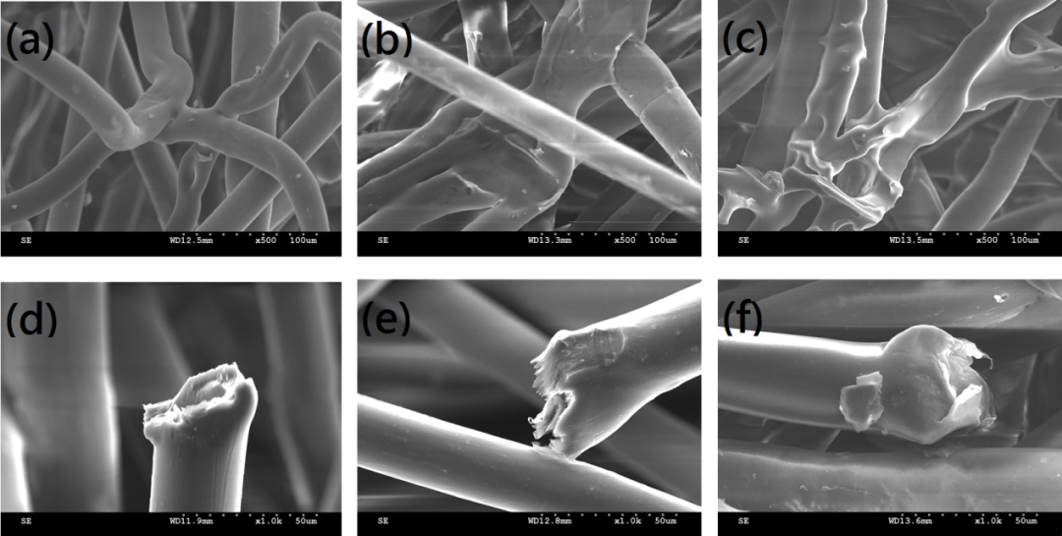
Figure 4 SEM of REPET/TPET/LPET nonwoven in 100 ℃, 120 ℃ and 140 ℃.
Conclusion
This study successfully creates REPET/TPET/LPET nonwoven fabrics with good mechanical properties. When REPET and TPET each fiber content of 40%, the hot pressing temperature rise in the tensile strength of nonwoven MD, CD direction have increased by 20 %, far infrared radiation rate is also enhanced. The air permeability was reduced by 15 %, while in the study also found that when the temperature increases after each message between the fibers and the extent have improved dramatically.
Acknowledgements
The authors would especially like to thank National Science Council of the Taiwan, for financially supporting this research under Contract NSC 102-2621-M-034-001.
References
- Municipal waste collected, Waste, Environment Statistics Database, UNdata, 2009.
- C.W. Lou, C.M. Lin, A.P. Chen and J.H. Lin: Text. Res. J. Vol. 81 (2011), p. 1331.
- H. Toyokawa, Y. Matsui, J. Uhara, H. Tsuchiya, S. Teshima, H. Nakanishi, A. H. Kwon, Y. Azuma, T. Nagaoka, T. Ogawa and Y. Kamiyama: Exp. Biol. MeD. Vol. 228 (2003), p. 724.
- N. Ise, T. Kaysuura, Y. Kikuchi and E. Miwa: Annals. Physiol. Vol. 1 (1987), p. 31.

