Fiber Formation of the Biocompatible Polymer Nanofiber Membrane by Electrospinning
Ching-Wen Lou¹, Chien-Lin Huang², Jin-Jia Hu^{3a}, Chao-Tsang Lu⁴, Zong-Han Wu⁵ and Jia-Horng Lin^{5,6b}
¹Institute of Biomedical Engineering and Material Science, Central Taiwan University of Science and Technology, Taichung 40601, Taiwan, R.O.C.
²Department of Fiber and Composite Materials, Feng Chia University, Taichung City 407, Taiwan, R.O.C
³Department of Biomedical Engineering National Cheng Kung University Taiwan, R.O.C.
⁴Institute of Life Sciences, Central Taiwan University of Science and Technology, Taichung 406, Taiwan, R.O.C.
⁵Laboratory of Fiber Application and Manufacturing, Department of Fiber and Composite Materials, Feng Chia University, Taichung City 407, Taiwan, R.O.C.
⁶School of Chinese Medicine, China Medical University, Taichung 40402, Taiwan, R.O.C.
Corresoonding email: ªjjhu@mail.ncku.edu.tw, ^{b}jhlin@fcu.edu.tw

ABSTRACT
Electrospinning has been attributed to be one of the most effective method to prepare nano-fibers, and widely applied in assorted fields. The nanofiber membranes made by electrospinning feature high porosity and surface area, and are qualified for vascular grafts, biological scaffolds, and wound dressings. Chitosan is non-toxic and biodegradable, making it a good biocompatible material; in addition, it is also proved to be anti-bacterial and help cell growth in wounds. This research produced nanofiber membrane with polyethylene oxide (PEO) by electrospinning; the influence of the three parameters —mixture ratio of solution, electric field, and distance between the capillary tip and the collecting plate, on electrospinning was then explored. According to the results of the experiment, electrospinning formed the optimum nanofibers when the volume mixing ratio of PEO/chitosan was 60:40.

Keywords: electrospinning; nanofiber, PEO, chitoston,
Introduction
Electrospinning was initiated in 1930, and Formhals got the patent for this technique in 1934. It can fabricate nanometer fibers, which are thinner than the micrometer fiber made by the traditional spinning technology, and have high specific surface area, high porosity and more delicate voids. Additionally, comparing with methods like self-assembly [1], phase separation [2], template-directed synthesis [3], electrospinning features low cost, cheaper facilities, and simple manufacturing process [4, 5], which has been drawing attention in recent years. Furthermore, electrospun nanofiber membranes can be used as filtration materials, and used in biomedical fileds, such as wound dressings, vascular grafts, drug delivery platforms [6] and so on. It was also proved by former studies that electrospinning is capable of making polymer like polylactic acid or natural polymer like silk fibroin and collagen into nanofiber successfully.
In recent years, people have made constant progress on different technologies and explore about the human body further; as a result, biomaterials have gradually gained popularity, too. This research mixed non-toxic polymer, PEO and chitosan (CS), and made them into nano-nonwoven fabrics by means of electrospinning. During the electrospinning process, the good fiber formation of PEO was used to improve the worse fiber formation of CS, fabricating nanofibers successfully. After the fabrication, the resulting PEO/CS composite dressings were observed with a SEM, determining the optimum parameters for PEO and CS.

Experimental
Preparation for Electrospinning
PEO powder (molecular weight: 3×105 - 5×10⁵ Da) were provided by Welsum Technology Corporation, Taiwan. The concentration of PEO solution was 1, 2, 3, 4, 5, 6, 7, and 8 wt%.Acetic acid (99% - 100%) was obtained from Long Island Pharmaceutical Co., Ltd, Osaka, Japan while chitosan powder (degree of de-acetylation: 85%) was offered by VA&G Bioscience Company, Taiwan. The acetic acid was made into 1 wt% acetic acid solution, into which 4g of chitosan (CS) powder was dissolved by the stirrer (Corning Laboratory Stirrer/Hot Plate, USA), forming the 4 wt% CS solution.
Afterwards, 6g of PEO powder was dissolved in the mixture of deionized water and methyl alcohol (MEOH) (Long Island Pharmaceutical Co., Ltd., Osaka, Japan) with a ratio of 1:1, creating the 6 wt% PEO/MEOH solution.
Observation of Morphology and Structure
PEO solution with different concentrations was measured with viscosity by a viscometer (Fungilab, S.A.) first. Afterwards, PEO nanofiber membrane and PEO/CS nanofiber membrane which were made with different concentration and volume mixing ratio

Results and Discussion
The Influence of Different Concentrations of PEO/Water Solution and Different Solvents on the Fiber Formation
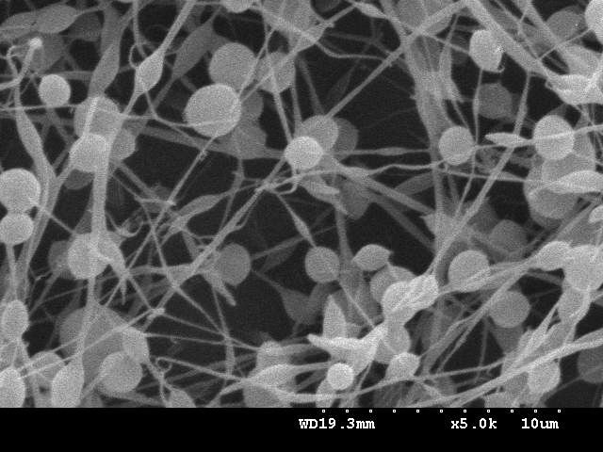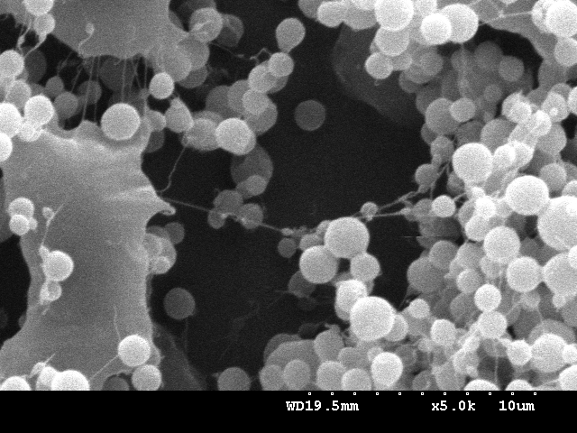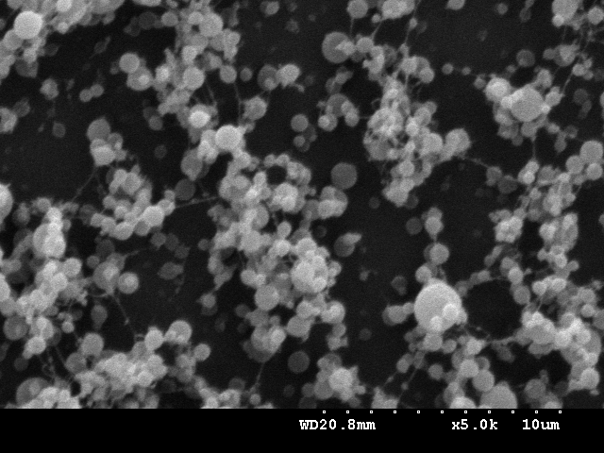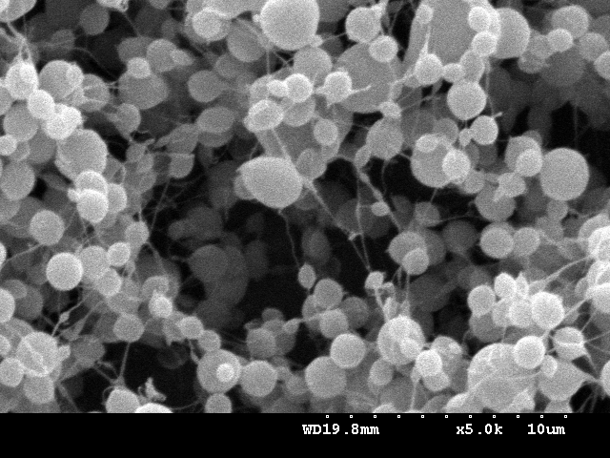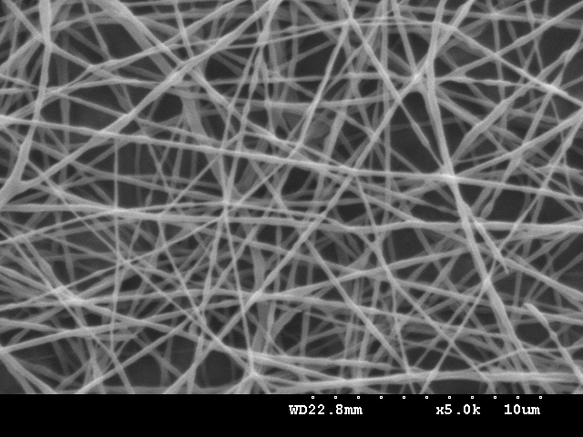
A
B
C
D
E
Figure 1. The SEM images of electrospun PEO/water solution of (A) 3 wt%, (B) 4 wt%, (C) 5 wt% and (D) 6 wt% (5000×). (E) is the SEM image of electrospun 6 wt% PEO/MEOH solution. The electrospinning voltage is 10 kV; the distance between the capillary and the collecting plate is 12 cm.
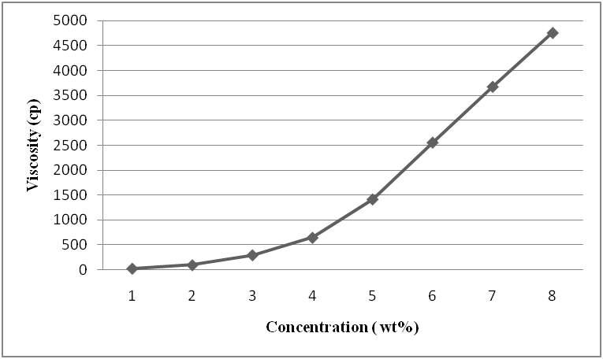
Figure 2. The viscosity of the PEO/water solution as related to different concentrations.
Figure 1 shows the SEM images of the nanofibers formed with PEO/water solution with different concentrations and 6 wt% PEO/MEOH solution. According to the observation, the electrospun fibers became better with the increase in concentration of the PEO/water solution. When the PEO/water solution had a concentration below 3 wt%, the membrane on the collecting plate were beads, as seen in Figure 1(A). This was because low concentration of the water solution equaled to low viscosity of the PEO/water solution, making the jet of PEO/water solution rupture easily. When the ruptured PEO/water solution was drawn onto the collecting plate, they became beads instead of fibers. When the concentration of the PEO/water solution was increased to 4 wt%, the membrane that was formed onto the collecting plate contained a few amount of fibers, which could be seen in Figure 1 (B). With the increase in the concentration of PEO/water solution, the beads decreased with the viscosity, indicating that the increase in viscosity contributed to the fiber formation of the PEO/water solution. When the concentration was 6 wt%, most PEO/water solution could be electrospun into fibers and there were only a few beads. When the concentration of the PEO/ water solution was in excess of 6 wt%, the viscosity was too high, giving insufficient tensile strength of the electrospinning under the same electric field, and thus electrospinning failed in spinning the PEO/water solution into fibers. The optimum fiber formation for PEO/water solution occurred when the PEO/water had a concentration of 6 wt%, electrospinning voltage was 10kV, and the distance between the capillary and the collecting plate was 12 cm.
However, such electrospinning result was not satisfactory; hence, we remained the electrospinning parameters but changed the solvent of pure deionized water to deionized water and methyl alcohol (MEOH) with a volume mixing ratio of 1:1. After the solvent was changed, the jet of the PEO/MEOH solution displayed a better fiber formation than PEO/water solution. Because volatility of the solvent was heightened, when the PEO/MEOH solution was electrospun and collected onto the collecting plate, it was solidified and became nanofiber successfully. Figure 1(D) and (E) offer the clear comparison between the fiber formation of polymer solution with and without methyl alcohol as solvent.
Figure 2 shows that the viscosity of PEO solution increases with its concentration. When the addition of PEO was 6 wt%, the PEO solution had a viscosity of 2500 CP and the optimum fiber formation.
The Influence of Different Volume Mixing Ratio of PEO/ CS Solution on the Fiber Formation of PEO/ CS Solution
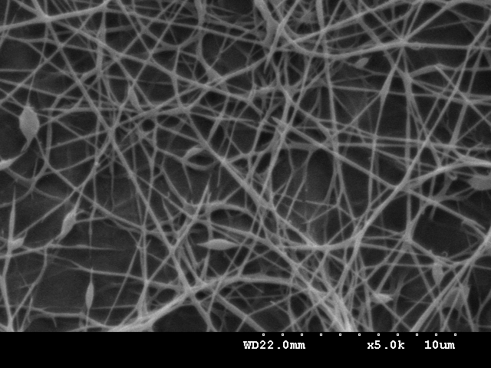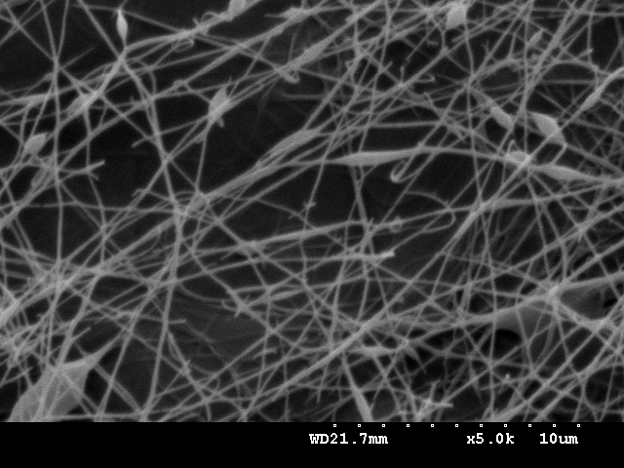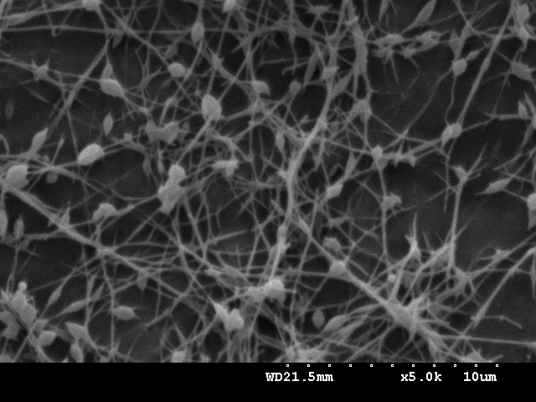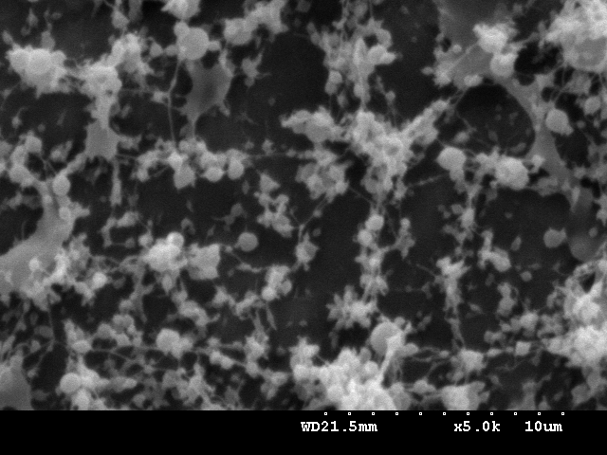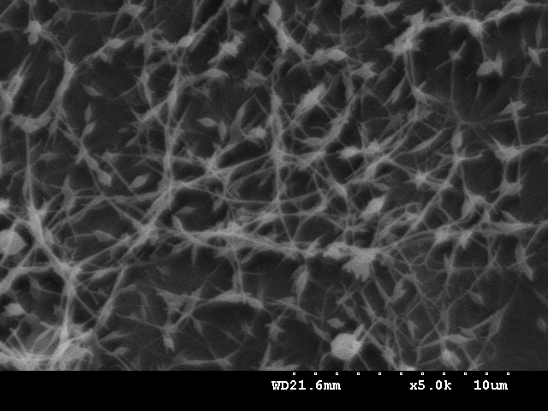
A
B
C
E
D
Figure 3. The SEM images of fibers electrospun with PEO/CS solution at different volume mixing ratios (A) 80:20, (B) 60:40, (C) 50:50, (D) 40:60, and (E) 20:80 (5000×). The voltage of electrospinning is 7.5 kV/cm and the distance between the capillary to the collecting plate is 15 cm.
Figure 3 displays the SEM images of the fibers electrospun with PEO/CS solution at different volume mixing ratios. The increase in the concentration of chitosan contributes to the smaller diameter of the prepared nanofibers. However, with the increase in the concentration of chitosan, the visocisoty of PEO/CS solution decreased rapidly, preventing the jet of PEO/CS solution from forming the continual nanofibers, and subsequently giving the amount of beads on the increase substantially. PEO/CS solution exhibited the optimum fiber formation when it volume mixing ratio was 60:40, as seen in Figure 3 (B). When the volume mixing ratio of PEO/CS solution was 50:50 as Figure 3 (C), the PEO/CS solution did not have sufficient viscosity, resulting in a low fiber formation. This study planed to make wound dressings; in order to accelerate the cells’ growth which demanded greater chitosan content, the volume mixing ratio of PEO/CS solution was set as 50:50.

Conclusion
According to the result, when the concentration of PEO/water solution increased, the fiber formation of electrospinning also increased. When the concentration was 6 wt%, the formed fibers were with less beads; furthermore, the addition of methyl alchohol which was with great volatility heightened the fiber formation massively and decreased beads rapidly.
Based on the result of electrospinning, when there was greater amount of chitosan in PEO/CS solution, the diameter of electrospun fiber was on the decrease. However, with the increase in chitosan, there were more beads in the electrospun fibers. When PEO/CS solution had a volume mixing ratio of 60:40, the thinnest fibers without beads could be obtained; the average diameter of the fibers was around 120-150 nm. When the volume mixing ratio was increased to 50:50, the fiber formation decreased a bit, increasing the beads’ amount slightly, the average diameter of electrospun fibers was around 80-110 nm.

Acknowledgement
This work would especially like to thank National Science Council of the Taiwan, for financially supporting this research under Contract NSC 99-2622-E-166-004-cc3.

REFERENCES
- J.D. Hartgerink, E. Beniash and S.I. Stupp: P Natl Acad Sci Usa, Vol. 99, No. 8 (2002), p. 5133-5138.
- P.X. Ma and R.Y. Zhang: J Biomed Mater Res A, Vol. 46, No. 1 (1999), p. 60-72.
- J.C. Hulteen, H.X. Chen, C.K. Chambliss and C.R. Martin: Nanostructured Materials, Vol. 9, No. 1-8 (1997), p. 133-136.
- D.H. Reneker, A.L. Yarin, H. Fong and S. Koombhongse: J Appl Phys, Vol. 87, No. 9 (2000), p. 4531-4547.
- G. Srinivasan and D.H. Reneker: Polym Int, Vol. 36, No. 2 (1995), p. 195-201.
- E.R. Kenawy, G.L. Bowlin, K. MansWeld, J. Layman, D.G. Simpson and E.H. Sanders and G.E. Wnek: J Control Release, Vol. 81, No. 1-2 (2002), p. 57-64.

