Glycyrrhizin, silymarin, and ursodeoxycholic acid regulate a common hepatoprotective pathway in HepG2 cells

Chien-Yun Hsiang^{a,1}, Li-Jen Lin^{b,1}, , Shung-Te Kao^{b}, Hsin-Yi Lo^{c}, Shun-Ting Chou^{c}, and Tin-Yun Ho^{c,d,}*

ªDepartment of Microbiology, China Medical University, Taichung 40402, Taiwan
^{b}School of Chinese Medicine, College of Chinese Medicine, China Medical University, Taichung 40402, Taiwan
^{c}School of Chinese Medicine, Graduate Institute of Chinese Medicine, China Medical University, Taichung 40402, Taiwan
^{d}Department of Health and Nutrition Biotechnology, Asia University, Taichung 41354, Taiwan

Correspondence to: Prof. Tin-Yun Ho, School of Chinese Medicine, Graduate Institute of Chinese Medicine, China Medical University, 91 Hsueh-Shih Road, Taichung 40402, Taiwan. Tel.: (+886) 4-2205-3366x3302; Fax: (+886) 4-2203-2295, E-mail: cyhsiang@mail.cmu.edu.tw

¹ These authors contributed equally to this work.
Abstract
Background: Glycyrrhizin, silymarin, and ursodeoxycholic acid are widely used hepatoprotectants for the treatment of liver disorders, such as hepatitis C virus infection, primary biliary cirrhosis, and hepatocellular carcinoma.
Purpose: The gene expression profiles of HepG2 cells responsive to glycyrrhizin, silymarin, and ursodeoxycholic acid were analyzed in this study.
Methods: HepG2 cells were treated with 25 μM hepatoprotectants for 24 h. Gene expression profiles of hepatoprotectants-treated cells were analyzed by oligonucleotide microarray in triplicates. Nuclear factor-κB (NF-κB) activities were assessed by luciferase assay.
Results: Among a total of 30,968 genes, 252 genes were commonly regulated by glycyrrhizin, silymarin, and ursodeoxycholic acid. These compounds affected the expression of genes relevant various biological pathways, such as neurotransmission, and glucose and lipid metabolism. Genes involved in hepatocarcinogenesis, apoptosis, and anti-oxidative pathways were differentially regulated by all compounds. Moreover, interaction networks showed that NF-κB might play a central role in the regulation of gene expression. Further analysis revealed that these hepatoprotectants inhibited NF-κB activities in a dose-dependent manner.
Conclusion: Our data suggested that glycyrrhizin, silymarin, and ursodeoxycholic acid regulated the expression of genes relevant to apoptosis and oxidative stress in HepG2 cells. Moreover, the regulation by these hepatoprotectants might be relevant to the suppression of NF-κB activities.

Keywords: glycyrrhizin, silymarin, ursodeoxycholic acid, hepatoprotectants, microarray
Introduction
Liver cancer is the second most common cause of cancer death worldwide, causing about 746,000 deaths in 2012. The prognosis of liver cancer is very poor and the estimated incidence of new cases is 782,000 in the less developed regions in 2012 (Ferlay et al., 2015). Several studies illustrate that constitutive nuclear factor-κB (NF-κB) activity plays a central role in the hepatic neoplastic progression through the upregulation of anti-apoptotic genes (Kucharczak et al., 2003). Moreover, the inhibition of NF-κB activation in hepatocytes retards and reduces the development of hepatocellular carcinoma in mice (DiDonato et al., 2012). Therefore, the inhibition of NF-κB activation might be an effective strategy to treat liver cancers.
Glycyrrhizin, the triterpenoid saponin from Glycyrrhiza glabra L. roots (licorice), consists of one molecule of glycyrrhetinic acid and two molecules of glucuronic acid. Glycyrrhizin exhibits various pharmacological effects, such as anti-inflammatory and protective effects in liver (Li et al., 2014). Therefore, glycyrrhizin analogs, such as magnesium isoglycyrrhizinate and stronger neo-minophagen C, are effective and safe for the treatment of patients with chronic liver disease and liver dysfunction (Mori et al., 1990; Mao et al., 2009).
Silymarin is a flavonolignan complex from Silybum marianum (L.) Gaertn. fruits. Silymarin comprises a number of flavonolignans, including silibinin (silybin A and silybin B), isosilybin A and B, silychristin A and B, silydianin, and other phenolic compounds (Wu et al., 2009). Silymarin exhibits anti-inflammatory and immunomodulatory effects and thus promotes the health of livers (Polyak et al., 2013). In addition, silymarin-type drugs like legalon have been used for the treatment of acute hepatitis and nonalcoholic fatty liver disease in patients (El-Kamary et al., 2009; Loguercio et al., 2012).
Ursodeoxycholic acid, a hydrophilic stereoisomer of chenodeoxycholic acid, is a major component of Chinese black bear’s bile (Ohtsuki et al., 1992). Ursodeoxycholic acid is used to treat chronic cholestatic liver diseases, such as primary biliary cirrhosis and primary sclerosing cholangitis (Chapman 2009; Lindor et al., 2009). Moreover, some evidences indicate that ursodeoxycholic acid decreases the levels of alanine aminotransferase, aspartate aminotransferase, and gamma-glutamyl transpeptidase in patients with chronic hepatitis C and protects livers from against methotrexate-induced toxicity (Omata et al., 2007; Uraz et al., 2008).
Few reports have evaluated the genomic alterations elicited by glycyrrhizin, silymarin, and ursodeoxycholic acid. For examples, Glycyrrhiza glabra root extract induces the proliferation of MCF-7 cells by activating extracellular signal-regulated kinases 1/2 and Akt pathways (Dong et al., 2007). Treating hepatocytes with ursodeoxycholic acid shows that ursodeoxycholic acid affects the expression of genes directly involved in cell cycle and apoptotic events, and the E2F-1/p53/apoptotic protease activating factor-1 pathway seems to be the target of ursodeoxycholic acid (Castro et al., 2005). In this study, we treated hepatocytes with non-cytotoxic concentrations of glycyrrhizin, silymarin, and ursodeoxycholic acid, and analyzed the gene expression profiles by microarray. The gene expression profiles were further compared to evaluate the different and the common pathways regulated by these compounds.

Materials and methods
Cell culture
The human hepatoma cell line (HepG2) was obtained from Bioresource Collection and Research Center (Hsinchu, Taiwan). Recombinant HepG2/NF-κB cell, which carried the NF-κB-driven luciferase genes, was constructed as described previously (Hsiang et al., 2009). HepG2 cells and HepG2/NF-κB cells were cultured in Dulbecco’s modified Eagle’s medium (DMEM) (Life Technologies, Gaithersburg, MD, USA) supplemented with 10% heat-inactivated fetal bovine serum (HyClone, Logan, Utah, USA), 100 μg/ml streptomycin, and 100 unit/ml penicillin in a humidified incubator at 37ºC with 5% CO₂.

Chemicals
Glycyrrhizin (purity ≥ 95%), silymarin, and ursodeoxycholic acid (purity ≥ 99%) were purchased from Sigma (St. Louis, MO, USA), dissolved in dimethyl sulfoxide (DMSO) to a final concentration of 200 mM, and stored at -30ºC. Silymarin (product number 254924) is a mixture of toxifolin (4%), silichristin (27.9%), silidianin (2.9%), silybin A (19.3%), silybin B (31.3%), isosilybin A (8.2%), and isosilybin B (2.3%). MG-132, a NF-κB inhibitor, was purchased from Santa Cruz (Dallas, TX, USA) and dissolved in DMSO to a final concentration of 50 mM. 3-(4,5-Dimethylthiazol-2-yl)-2,5-diphenyltetrazolium bromide (MTT) was purchased from Sigma (St. Louis, MO, USA) and dissolved in phosphate-buffered saline (PBS) (137 mM NaCl, 1.4 mM KH2PO4, 4.3 mM Na2HPO4, 2.7 mM KCl, pH 7.2).

Total RNA isolation
HepG2 cells (2×10⁶ cells, passage number 38) were seeded in a 25-cm² flask and incubated at 37ºC for 24 h. Cells were then treated with 5 ml of culture medium containing 0.125‰ DMSO (solvent control) or 25 μM hepatoprotectants, and incubated at 37ºC for another 24 h. Total RNA was extracted from cells treated with or without compounds by RNeasy Mini kit (Qiagen, Valencia, CA, USA). Total RNA was quantified using the spectrophotometer (Beckman Coulter, Fullerton, CA, USA) and further evaluated using an Agilent 2100 bioanalyzer (Agilent Technologies, Santa Clara, CA, USA). RNA sample with an RNA integrity number greater than 8.0 was accepted for microarray analysis.

Microarray analysis
Microarray analysis was performed as described previously (Lo et al., 2013; Ho et al., 2014). Briefly, fluorescent RNA targets were prepared from 5 μg of total RNA samples using the MessageAmpTM aRNA kit (Ambion, Austin, TX, USA) and Cy5 dye (Amersham Pharmacia, Piscataway, NJ, USA). Fluorescent targets were hybridized to the Human Whole Genome OneArrayTM (Phalanx Biotech Group, Hsinchu, Taiwan). Number of replicates was three. After an overnight hybridization at 50ºC, non-specific targets were washed away and the array was scanned by an Axon 4000 scanner (Molecular Devices, Sunnyvale, CA, USA). Spots with a signal-to-noise ratio > 0 or control probes were selected and normalized by the R program of the limma package (Smyth and Speed, 2003). We used surrogate variable analysis (sva) to capture the heterogeneity of expression caused by any variation and to improve the accuracy and reproducibility in analyzing gene expression levels (Leek and Storey, 2007). Normalized data were tested by a standard paired t-test. The p-values were then adjusted for a false discovery rate (FDR) (Benjamini and Hochberg, 1995). A value of FDR < 0.5 was considered statistically significant. The fold changes of genes were calculated by dividing the normalized signal intensities of genes in compound-treated cells by those in solvent-treated cells. Genes with fold changes ≥ 2.0 or ≤ -2.0 and FDR values < 0.5 were selected as differentially expressed genes and further analyzed by Kyoto Encyclopedia of Genes and Genomes (KEGG) pathway (www.genome.ad.jp/kegg/). We used the Web-based gene set analysis toolkit (bioinfo.vanderbilt.edu/webgestalt/) to test the enriched pathways. Microarray data are Minimum Information about Microarray Experiments compliant, and raw data have been deposited in the Gene Expression Omnibus (Accession number: GSE67504).

Quantitative real-time polymerase chain reaction (qPCR)
Total RNA was reverse-transcribed for 2 h at 37ºC using High Capacity cDNA Reverse Transcription kit (Applied Biosystems, Foster City, CA, USA). qPCR was performed by mixing cDNA, 2× Power SYBR Green PCR Master kit and 200 nM of forward and reverse primers. The reaction condition was followed: 10 min at 95ºC; 40 cycles of 15 sec at 95ºC and 1 min at 60ºC. Each assay was run on an Applied Biosystems 7300 Real-Time PCR system in triplicates. Relative Quantitation (RQ) was calculated using the comparative C_{T} method (ΔΔC_{T}) which determines the change in expression of a nucleic acid sequence in a test sample (treated group) relative to the same sequence in a calibrator sample (mock group) (Livak and Schmittgen, 2001). The ΔC_{T} value is determined by subtracting the average C_{T} value of glyceraldehyde-3-phosphate dehydrogenase (GAPDH) gene from the average C_{T} value of target gene. The ΔΔC_{T} value is determined by subtracting the ΔC_{T} value of mock group from the ΔC_{T} value of treated group. RQ is calculated as 2^{-ΔΔCT}. Fold changes were further presented as RQ if the RQ value was ≥ 1, or as -1/RQ if the RQ value is <1. The primer ser for each gene was followed: histone deacetylase 9 (HDAC9) forward, 5'-GCAAGAGGAGACAGAGACCG-3'; HDAC9 reverse, 5'-ACTTGGCACTTCACAAGGCT-3'; minichromosome maintenance deficient 3 associated protein (MCM3AP) forward, 5'-CGCTTCCTCTGGTGGTTCTT-3'; MCM3AP reverse, 5'-CTGCACTGCTTGCAAAACCT-3'; GAPDH forward, 5'-TCACCCACACTGTGCCCATCTATGA-3'; GAPDH reverse, 5'-GAGGAAGAGGATGCGGCAGTGG-3'.

Gene interaction network analysis
We constructed three interaction networks of genes with fold changes ≥ 2.0 or ≤ -2.0 in each treatment group using Genomatix Applications software. Then, we merged genes and their interactions in either network into a union network and finally classified this network by GOlorize, a cytoscape plug-in (Garcia et al., 2007). GOlorize first highlighted the nodes that belonged to the same class using color-coding and then constructed an enhanced visualization of the network using a class-directed layout algorithm. Finally, we used Cell Region-Based Rendering and Layout (Cerebral), a cytoscape plug-in, to generate a pathway-like representation of a network. Cerebral uses subcellular localization annotation to create a layered view of a cell, placing nodes in the region corresponding to the appropriate localization (Barsky et al., 2007).

Cell viability assay
HepG2 cells (5×10⁶ cells) were cultivated in a 96-well culture plate. After a 24-h incubation at 37 ºC, various amounts of glycyrrhizin, silymarin, or ursodeoxycholic acid were added to confluent cell monolayer and incubated for another 24 h. MG-132 (25 μM), a NF-κB inhibitor, was added to HepG2/NF-κB cells to evaluate the cytotoxicity. Cell viability was monitored by the MTT colorimetric assay as described previously (Cheng et al., 2009). Cell viability (%) was calculated by the equation: (OD of compound-treated cells/OD of solvent-treated cells)×100.

Luciferase assay
HepG2/NF-κB cells (5×10⁶ cells) were cultured in a 96-well culture plate at 37 ºC for 24 h, washed with DMEM, and treated with 25 μM of MG-132 or various amounts of glycyrrhizin, silymarin, or ursodeoxycholic acid for another 24 h. Cells were then washed with ice-cold PBS, lysed with 30 μl Triton lysis buffer (50 mM Tris-HCl, 1% Triton X-100, 1 mM dithiothreitol, pH 7.8), and collected with a cell scraper. Luciferase activity was measured as described previously (Cheng et al., 2009). Relative luciferase activity was calculated by dividing the relative luciferase unit (RLU) of compound-treated cells by the RLU of solvent-treated cells.

Statistical analysis
Data were presented as mean ± standard error. Data were analyzed by one-way ANOVA and post hoc Bonferroni test using SPSS Statistics version 20 (IBM, Armonk, NY, USA). A p value less than 0.05 was considered as statistically significant.

Results
Microarray analysis of hepatoprotectant-regulated gene expression
In this study, we chose HepG2 cell, hepatocytes derived from hepatocellular carcinoma, as a cell model to study the gene expression profiles of hepatoprotectants. Cytotoxic studies were first performed. Fig. 1 shows that glycyrrhizin, silymarin, and ursodeoxycholic acid displayed no visible cytotoxic effects at a broad range of concentration (0.5-500 μM). Previous studies indicated that silymarin at 25 μM achieves the highest hepatoprotective effect in FL83B mouse liver cells and at a concentration exceeding 25 μM abruptly increases cell damage in rat hepatocytes (Sainz-Pardo et al., 1994; Lo et al., 2014). In addition, up to 25 μM of glycyrrhizin dose not induce cell death in human epithelial ovarian carcinoma cells (Lee et al., 2010). Therefore, we treated HepG2 cells with 25 μM compounds to analyze novel or common biological pathways regulated by glycyrrhizin, silymarin, and ursodeoxycholic acid in this study.
Microarray data were analyzed by limma and sva packages to examine the differentially expressed genes in cells treated with various hepatoprotectants. We selected genes with fold changes ≥ 2.0 or ≤ -2.0 and FDR values < 0.5 as differentially expressed genes for further analysis. Among a total of 30,968 genes, glycyrrhizin, silymarin, and ursodeoxycholic acid downregulated the expression of 777, 684, and 797 genes, respectively. In addition, the expression of 497, 604, and 710 genes, was upregulated by glycyrrhizin, silymarin, and ursodeoxycholic acid, respectively. A Venn diagram was used to classify genes those were specific or common in the comparisons. Fig. 1 shows that glycyrrhizin and silymarin affected 145 genes, silymarin and ursodeoxycholic acid affected 196 genes, and glycyrrhizin and ursodeoxycholic acid affected 227 genes. Furthermore, a total of 252 genes was commonly affected by glycyrrhizin, silymarin, and ursodeoxycholic acid.

KEGG pathway analysis of differentially expressed genes altered by three hepatoprotectants
We further analyzed the enriched pathways altered by three hepatoprotectants. Table 1 shows that various KEGG pathways were significantly regulated by glycyrrhizin, silymarin, and ursodeoxycholic acid. No common KEGG pathway was affected by these hepatoprotectants. Glycyrrhizin regulated calcium signaling and T cell receptor signaling pathways, silymarin affected the insulin signaling pathway, and ursodeoxycholic acid affected neuroactive ligand-receptor interaction, tight junction, long-term depression, and extracellular matrix-receptor interaction. Expression levels of genes with p values < 0.05 in these pathways are displayed in Table 2.

Interaction network of hepatoprotectant-regulated genes
The relationship between differentially expressed genes affected by each compound was further analyzed by Genomatix Applications software. Genes were correlated based on a review of published data, the Genomatix Knowledge Base, and promoter DNA sequence analysis. Three interaction networks, corresponding to three hepatoprotectants-regulated genes, were constructed. Then, we merged three gene interaction networks using Cytoscape. As shown in Fig. 2, NF-κB was the node in the gene interaction network. A total of 127 genes was affected by all three compounds and associated with NF-κB in this network. The expression profiles of 127 NF-κB-connected genes were then clustered by hierarchical clustering analysis. Fig. 3 shows that genes upregulated by one compound had tendencies of upregulation by other compounds, and vice versa. Among 127 genes, 12 genes with fold changes ≥ 2.0 or ≤ -2.0 were commonly regulated by glycyrrhizin, silymarin, and ursodeoxycholic acid. The gene expression levels of these genes are shown in Table 3. Furthermore, we used Cerebral to generate pathway-like representations of networks for glycyrrhizin, silymarin, and ursodeoxycholic acid treatments. As shown in Fig. 4, these hepatoprotectants affected NF-κB via regulating the same or distinct genes. For example, in the extracellular space, glycyrrhizin modulated NF-κB activity by regulating interleukin 4 (IL4), IL23A, and fibroblast growth factor 10 (FGF10) genes, silymarin modulated NF-κB by regulating IL6, IL9, and collagen type 2 alpha 1 (COL2A1) genes, and ursodeoxycholic acid affected NF-κB by regulating IL4, IL11, and FGF10 genes. In addition, all compounds affected NF-κB by regulating HDAC9, MCM3AP, Wilms' tumor 1 (WT1), and Spi-B transcription factor (SPIB) genes in the nucleus.
We further verified microarray data by qPCR. We quantified the expression levels of HDAC9 and MCM3AP genes because these genes are associated with hepatocarcinogenesis and are directly interacted with NF-κB (Wang et al., 2010; Ding et al., 2013). In comparison with mock, the expression of HDAC9 genes was downregulated by glycyrrhizin, silymarin, and ursodeoxycholic acid, with fold changes of -2.08, -11.11, and -3.23, respectively (Table 4). The expression levels of MCM3AP genes were also decreased by glycyrrhizin, silymarin, and ursodeoxycholic acid, with fold changes of -2.56, -1.75, and -2.17, respectively. These findings indicated that the expression of HDAC9 and MCM3AP genes was downregulated by these hepatoprotectants, which were consistent with the findings of microarray data.

Effects of hepatoprotectants on NF-κB activities in HepG2 cells
Because NF-κB may play a central role in the glycyrrhizin-, silymarin- and ursodeoxycholic acid-regulated gene network, we wondered whether these compounds were able to affect NF-κB activities. HepG2/NF-κB cells were then treated with various amounts of glycyrrhizin, silymarin, or ursodeoxycholic acid, and the luciferase activity was determined 24 h later. As shown in Fig. 5, MG-132, a well-known proteasome inhibitor that inhibits NF-κB activity by inhibiting IκB degradation, suppressed significantly the NF-κB activity in HepG2 cells. Glycyrrhizin, silymarin, and ursodeoxycholic acid suppressed NF-κB activities in a dose-dependent manner. The EC₅₀ value of silymarin on the inhibition of NF-κB activity was 64±9.17 μM, while EC₅₀ values of glycyrrhizin and ursodeoxycholic acid were >500 μM. No visible cytotoxic effects were observed. These findings indicate that glycyrrhizin, silymarin, and ursodeoxycholic acid inhibited NF-κB activities in HepG2 cells.

Discussion
In this study, we investigated the gene expression profiles of HepG2 cells in response to glycyrrhizin, silymarin, and ursodeoxycholic acid treatments. Differentially expressed genes were categorized according to KEGG pathways, and we found that hepatoprotectant-regulated genes were associated with various biological pathways. For example, adrenoceptor alpha 1A, glutamate receptor ionotropic N-methyl D-aspartate 2A, and purinergic receptor P2X ligand-gated ion channel 4 in calcium signaling pathway, and glycine receptor alpha 1 and leptin receptor in neuroactive ligand-receptor interaction mediate actions in the nervous system through the binding of different neurotransmitters (Betz et al., 1999; Koshimizu et al., 2003; Vial et al., 2004; Ryan et al., 2008). Neuroblastoma RAS viral oncogene homolog and phosphoinositide-3-kinase regulatory subunit 1 in T cell receptor signaling pathway are also involved in insulin signaling pathway (Saltiel and Kahn, 2001). Protein kinase AMP-activated beta 1 (PRKAB1) and PRKAG3 are known to be associated with lipogenesis (Bailey, 2007). Based on these results, we suggested that these hepatoprotectants might regulate pathways involved in neurotransmission, and glucose and lipid metabolism in liver.
We further investigated differentially expressed genes by gene interaction network analysis. We found that NF-κB seemed to be in the central part of the network and 127 genes were connected directly to NF-κB. Furthermore, we found that 12 NF-κB-connected genes were differentially expressed in all three compound treatments. Among them, HDAC9, MCM3AP, SPIB, WT1, ethylmalonic encephalopathy 1 (ETHE1), BH3 interacting domain death agonist (BID), superoxide dismutase 2 (SOD2), and mitogen-activated protein kinase kinase kinase 7 (MAP3K7) genes are known to be involved in hepatocarcinogenesis, apoptosis, and anti-oxidative pathways, and their expressions are directly regulated by NF-κB. For examples, HDAC9 is a transcriptional regulator of the histone deacetylase family, which is regulated by Sp1 and NF-κB (Ma et al., 2011). Recent study indicated that HDAC9 promotes hepatocellular carcinoma progression by inhibiting p53 transcriptional activity (Ding et al., 2013). MCM3AP is an acetyltransferase that acetylases MCM3, and plays a role in DNA replication (Takei et al., 2001). It is also a novel hepatitis B virus integration site, and upregulation of MCM3AP promotes the hepatocarcinogenesis by affecting flanking sequences (Wang et al., 2010). SPIB is a transcription factor that binds to a purine-rich sequence of promoters (Bonadies et al., 2010). Using a random-walk-based community detection algorithm, Petrochilo et al. (2013) have identified that SPIB is functionally related to cancer and shows a promise as a therapeutic target. WT1 encodes a transcription factor involved in cell growth and development. The presence of NF-κB-responsive elements in the promoter of WT1 gene suggests that the transcription of WT1 gene is regulated by NF-κB pathway (Dehbi et al., 1998). WT1 is expressed in a substantial proportion of hepatocellular carcinoma contributing to tumor progression and resistance to chemotherapy, suggesting that WT1 may be an important target for liver cancer treatment (Perugorria et al., 2009). ETHE1 gene accelerates the export of NF-κB from nucleus and inhibits p53-dependent apoptosis, thus contributing to hepatocarcinogenesis (Higashitsuji et al., 2002). In our study, all three compounds reduced the expressions of HDAC9, MCM3AP, SPIB, WT1, and ETHE1 genes at non-toxic concentrations in hepatocytes, suggesting the anticancer potentials of these compounds.
In addition to ETHE1, BID gene product is a specific proximal substrate of caspase-8 in the Fas apoptotic signaling pathway (Li et al., 1998). While full-length BID is localized in cytosol, truncated BID (tBID) translocates to mitochondria and thus transduces apoptotic signals from cytoplasmic membrane to mitochondria. The SOD2 gene encodes an intramitochondrial free radical scavenging enzyme, the first line of defense against superoxide produced by oxidative phosphorylation. SOD2 maintains the integrity of mitochondrial enzymes that are inactivated by superoxide (Li et al., 1995). SOD2 and tBID are known to be associated with apoptosis via a mitochondrial pathway (Yin, 2000; Pardo et al., 2006). The ability of glycyrrhizin, silymarin, and ursodeoxycholic acid to reduce BID or induce SOD2 may protect HepG2 cells from damage by suppressing apoptosis via the mitochondrial pathway.
MAP3K7, is linked to IL1 receptor and tumor necrosis factor (TNF) receptor signalings (Sato et al., 2005). MAP3K7 is activated by chemical and physical stresses and regulates stress-induced activation of activator protein-1 and NF-κB (Ishitani et al., 2003; Takaesu et al., 2003; Shim et al., 2005). Hypoxia-activated MAP3K7 results in the activation of c-Jun-dependent transcription in response to oxidative stress (Blanco et al., 2007). In addition, BID is also able to induce the generation of reactive oxygen species (ROS) following death receptor activation (Ding et al., 2004). However, SOD2 plays a critical cytoprotective role against oxidative stress (Delhalle et al., 2002). In this study, the up-regulation of SOD2 and the down-regulation of BID and TAK1 by glycyrrhizin, silymarin, and ursodeoxycholic acid suggested the anti-oxidative properties of these compounds.
Hepatocytes exposed to BID siRNA are resistant to Fas and TNF-α-induced cell death (Yin et al., 1999; Guicciardi et al., 2005). Treatment of lymph-proliferative mice with BID antisense also ameliorates liver injury following bile duct ligation (Higuchi et al., 2001). Additionally, overexpression of SOD2 is effective against mitochondrial oxidative stress in hepatocytes and is protective against alcohol-induced liver injury in an enteral feeding rat model (Wheeler et al., 2001). The up-regulation of SOD2 in hepatocytes is associated with a reduction of ROS-induced injury after ischemia-reperfusion (Chen et al., 2006). Dominant-negative MAP3K7 induces G0 exit in the quiescent liver and accelerates hepatic cell cycle progression during regeneration (Bradham et al., 2001). Moreover, the inhibition of MAP3K7/c-Jun N-terminal kinase decreases the proliferation of hepatic stellate cells, a critical effector in hepatic fibrogenesis (Schnabl et al., 2001). Therefore, the differential expression of BID, SOD2, and TAK1 genes by glycyrrhizin, silymarin, and ursodeoxycholic acid suggested the hepatoprotective effects in livers.
NF-κB signaling pathways have a central function in the regulation of inflammation-fibrosis-cancer axis. NF-κB activation is crucially involved both in the fibrogenesis and in the initiation and promotion of liver cancers (Sun and Karin, 2008; Luedde and Schwabe, 2011). However, the dual role of NF-κB activation in hepatocarcinogenesis indicates that activation of NF-κB not only displays beneficial effects but also suppresses the viability of hepatocytes. For examples, in the early stages of tumorigenesis, NF-κB activation prevents the death of hepatocytes and thus avoids the release of proinflammatory cytokines by necrotic hepatocytes. However, in the late stages of tumorigenesis, NF-κB activation promotes the survival of transformed hepatocytes and elicits the malignancy of liver cancers (Sun and Karin, 2008; Luedde and Schwabe, 2011). Glycyrrhizin, silymarin, and ursodeoxycholic acid inhibited NF-κB activities in HepG2 cells, a human hepatoblastoma cell line, suggesting that glycyrrhizin, silymarin, and ursodeoxycholic acid might exhibit hepatoprotective effects by altering the survival of hepatoblastoma cells. Moreover, this finding was also consistent with previous reports that indicate glycyrrhizin, silymarin, and ursodeoxycholic acid play important roles in the treatment of hepatocellular carcinoma by reducing tumor cell proliferation or reducing the angiogenesis of liver (Kuiper et al., 2010; Li et al., 2014; Mastron et al., 2015).
In conclusions, this study demonstrated that different hepatoprotectants regulated different biological pathways. However, these hepatoprotectants also regulated the expression of common genes through a central molecule, NF-κB. Moreover, non-toxic dosages of hepatoprotectants inhibited NF-κB activities. Because the genes regulated by hepatoprotectants are relevant to antioxidant or anti-apoptotic pathways, we proposed that these compounds exerted their hepatoprotective effects by regulating apoptosis and oxidative stress in hepatocarcinoma cells.

Acknowledgments
This work was supported by grants from National Research Program for Biopharmaceuticals (MOST103-2325-B-039-002), Ministry of Science and Technology (NSC101-2320-B-039-034-MY3 and NSC102-2632-B-039-001-MY3), China Medical University (CMU102-NSC-04 and CMU103-SR-44), and CMU under the Aim for Top University Plan of the Ministry of Education, Taiwan.

Conflict of interest
There was no conflict of interest.

Abbreviations
NF-κB, nuclear factor-κB; DMEM, Dulbecco’s modified Eagle’s medium; DMSO, dimethyl sulfoxide; MTT, 3-(4,5-dimethylthiazol-2-yl)-2,5-diphenyltetrazolium bromide; PBS, phosphate-buffered saline; sva, surrogate variable analysis; FDR, false discovery rate; KEGG, Kyoto Encyclopedia of Genes and Genomes; qPCR, quantitative real-time polymerase chain reaction; RQ, Relative Quantitation; GAPDH, glyceraldehyde-3-phosphate dehydrogenase; HDAC9, histone deacetylase 9; MCM3AP, minichromosome maintenance deficient 3 associated protein; Cerebral, Cell Region-Based Rendering and Layout; RLU, relative luciferase unit; IL, interleukin; FGF10, fibroblast growth factor 10; COL2A1, collagen type 2 alpha 1; SPIB, Spi-B transcription factor; PRKAB1, protein kinase AMP-activated beta 1; ETHE1, ethylmalonic encephalopathy 1; BID, BH3 interacting domain death agonist; SOD2, superoxide dismutase 2; MAP3K7, and mitogen-activated protein kinase kinase kinase 7; tBID, truncated BID; TNF, tumor necrosis factor; ROS, reactive oxygen species.
References
Bailey, C.J., 2007. Treating insulin resistance: future prospects. Diabetes and Vascular Disease Research 4, 20-31.
Barsky, A., Gardy, J.L., Hancock, R.E.W., Munzner, T. C., 2007. Cerebral: a Cytoscape plugin for layout of and interaction with biological networks using subcellular localization annotation. Bioinformatics 23, 1040-1042.
Benjamini, Y., Hochberg, Y., 1995. Controlling the false discovery rate: a practical and powerful approach to multiple testing. Journal of the Royal Statistical Society. Series B (Methodological) 57, 289-300.
Betz, H., Kuhse, J., Schmieden, V., Laube, B., Kirsch, J., Harvey, R.J., 1999. Structure and functions of inhibitory and excitatory glycine receptors. Annals of the New York Academy of Sciences 868, 667-676.
Blanco, S., Santos, C., Lazo, P.A., 2007. Vaccinia-related kinase 2 modulates the stress response to hypoxia mediated by TAK1. Molecular and Cellular Biology 27, 7273-7282.
Bonadies, N., Neururer, C., Steege, A., Vallabhapurapu, S., Pabst, T., Mueller, B.U., 2010. PU.1 is regulated by NF-κB through a novel binding site in a 17 kb upstream enhancer element. Oncogene 29, 1062-1072.
Bradham, C.A., Hatano, E., Brenner, D.A., 2001. Dominant-negative TAK1 induces c-Myc and G(0) exit in liver. American Journal of Physiology. Gastrointestinal and Liver Physiology 281, G1279-1289.
Castro, R.E., Solá, S., Ma, X., Ramalho, R.M., Kren, B.T., Steer, C.J., Rodrigues, C.M., 2005. A distinct microarray gene expression profile in primary rat hepatocytes incubated with ursodeoxycholic acid. Journal of Hepatology 42, 897-906.
Chapman, R.W., 2009. High-dose ursodeoxycholic acid in the treatment of primary sclerosing cholangitis: throwing the urso out with the bathwater? Hepatology 50, 671-673.
Chen, W., Qiu, J.F., Zhang, Z.Q., Luo, H.F., Rosello-Catafau, J., Wu, Z.Y., 2006. Gene expression changes after hypoxic preconditioning in rat hepatocytes. Hepatobiliary & Pancreatic Diseases International 5, 416-421.
Cheng, W.Y., Lien, J.C., Hsiang, C.Y., Wu, S.L., Li, C.C., Lo, H.Y., Chen, J.C., Chiang, S.Y., Liang, J.A., Ho, T.Y., 2009. Comprehensive evaluation of a novel nuclear factor-κB inhibitor, quinoclamine, by transcriptomic analysis. British Journal of Pharmacology 157, 746-756.
Dehbi, M., Hiscott, J., Pelletier, J., 1998. Activation of the wt1 Wilms' tumor suppressor gene by NF-κB. Oncogene 16, 2033-2039.
Delhalle, S., Deregowski, V., Benoit, V., Merville, M.P., Bours, V., 2002. NF-κB-dependent MnSOD expression protects adenocarcinoma cells from TNF-α-induced apoptosis. Oncogene 21, 3917-3924.
DiDonato, J.A., Mercurio, F., Karin, M., 2012. NF-κB and the link between inflammation and cancer. Immunological Reviews 246, 379-400.
Ding, G., Liu, H.D., Huang, Q., Liang, H.X., Ding, Z.H., Liao, Z.J., Huang, G., 2013. HDAC6 promotes hepatocellular carcinoma progression by inhibiting P53 transcriptional activity. FEBS Letters 587, 880-886.
Ding, W.X., Ni, H.M., DiFrancesca, D., Stolz, D.B., Yin, X.M., 2004. Bid-dependent generation of oxygen radicals promotes death receptor activation-induced apoptosis in murine hepatocytes. Hepatology 40, 403-413.
Dong, S., Inoue, A., Zhu, Y., Tanji, M., Kiyama, R., 2007. Activation of rapid signaling pathways and the subsequent transcriptional regulation for the proliferation of breast cancer MCF-7 cells by the treatment with an extract of Glycyrrhiza glabra root. Food and Chemical Toxicology 45, 2470-2478.
El-Kamary, S.S., Shardell, M.D., Abdel-Hamid, M., Ismail, S., El-Ateek, M., Metwally, M., Mikhail, N., Hashem, M., Mousa, A., Aboul-Fotouh, A., El-Kassas, M., Esmat, G., Strickland, GT., 2009. A randomized controlled trial to assess the safety and efficacy of silymarin on symptoms, signs and biomarkers of acute hepatitis. Phytomedicine 16, 391-400.
Ferlay, J., Soerjomataram, I., Dikshit, R., Eser, S., Mathers, C., Rebelo, M., Parkin, D.M., Forman, D., Bray, F., 2015. Cancer incidence and mortality worldwide: sources, methods and major patterns in GLOBOCAN 2012. International Journal of Cancer 136, E359-386.
Garcia, O., Saveanu, C., Cline, M., Fromont-Racine, M., Jacquier, A., Schwikowski, B., Aittokallio, T., 2007. GOIorize: a Cytoscape plug-in for network visualization with Gene Ontology-based layout and coloring. Bioinformatics 23, 394-396.
Guicciardi, M.E., Bronk, S.F., Werneburg, N.W., Yin, X.M., Gores, G.J., 2005. Bid is upstream of lysosome-mediated caspase 2 activation in tumor necrosis factor α-induced hepatocyte apoptosis. Gastroenterology 129, 269-284.
Higashitsuji, H., Higashitsuji, H., Nagao, T., Nonoguchi, K., Fujii, S., Itoh, K., Fujita, J., 2002. A novel protein overexpressed in hepatoma accelerates export of NF-κB from the nucleus and inhibits p53-dependent apoptosis. Cancer Cell 2, 335-346.
Higuchi, H., Miyoshi, H., Bronk, S.F., Zhang, H., Dean, N., Gores, G.J., 2001. Bid antisense attenuates bile acid-induced apoptosis and cholestatic liver injury. The Journal of Pharmacology and Experimental Therapeutics 299, 866-873.
Ho, T.Y., Tang, N.Y., Hsiang, C.Y., Hsieh, C.L., 2014. Uncaria rhynchophylla and rhynchophylline improved kainic acid-induced epileptic seizures via IL-1β and brain-derived neurotrophic factor. Phytomedicine 21, 893-900.
Hsiang, C.Y., Chen, Y.S., Ho, T.Y., 2009. Nuclear factor-κB bioluminescence imaging-guided transcriptomic analysis for the assessment of hoist-biomaterial interaction in vivo. Biomaterials 30, 3042-3049.
Ishitani, T., Takaesu, G., Ninomiya-Tsuji, J., Shibuya, H., Gaynor, R.B., Matsumoto, K., 2003. Role of the TAB2-related protein TAB3 in IL-1 and TNF signaling. The EMBO Journal 22, 6277-6288.
Koshimizu, T.A., Tanoue, A., Hirasawa, A., Yamauchi, J., Tsujimoto, G., 2003. Recent advances in alpha1-adrenoceptor pharmacology. Pharmacology & Therapeutics 98, 235-244.
Kucharczak, J., Simmons, M.J., Fan, Y., Gélinas, C., 2003. To be, or not to be: NF-κB is the answer--role of Rel/NF-κB in the regulation of apoptosis. Oncogene 22, 8961-8982.
Kuiper, E.M., Hansen, B.E., Adang, R.P., van Nieuwkerk, C.M., Timmer, R., Drenth, J.P., Spoelstra, P., Brouwer, H.T., Kuyvenhoven, J.P., van Buuren H,R., Dutch PBC Study Group, 2010. Relatively high risk for hepatocellular carcinoma in patients with primary biliary cirrhosis not responding to ursodeoxycholic acid. European Journal of Gastroenterology and Hepatology 22, 1495-1502.
Lee, C.S., Yang, J.C., Kim, Y.J., Jang, E.R., Kim, W., Myung, S.C., 2010. 18β-Glycyrrhetinic acid potentiates apoptotic effect of trichostatin A on human epithelial ovarian carcinoma cell lines. European Journal of Pharmacology 649, 354-361.
Leek, J.T., Storey, J.D., 2007. Capturing heterogeneity in gene expression studies by surrogate variable analysis. PLoS Genetetics 3, 1724-1735.
Li, H., Zhu, H., Xu, C., Yuan, J., 1998. Cleavage of BID by caspase 8 mediates the mitochondrial damage in the Fas pathway of apoptosis. Cell 94, 491-501.
Li, J.Y., Cao, H.Y., Liu, P., Cheng, G.H., Sun, M.Y., 2014. Glycyrrhizic acid in the treatment of liver diseases: literature review. BioMed Research International 2014, 872139.
Li, J.Y., Cao, H.Y., Liu, P., Cheng, G.H., Sun, M.Y., 2014. Glycyrrhizic acid in the treatment of liver diseases: literature review. BioMed Reseach International 2014, 872139.
Li, Y., Huang, T.T., Carlson, E. J., Melov, S., Ursell, P.C., Olson, J.L., Noble, L.J., Yoshimura, M.P., Berger, C., Chan, P.H., Wallace, D.C., Epstein, C.J., 1995. Dilated cardiomyopathy and neonatal lethality in mutant mice lacking manganese superoxide dismutase. Nature Genetics 11, 376-381.
Lindor, K.D., Gershwin, M. E., Poupon, R., Kaplan, M., Bergasa, N.V., Heathcote, E.J., 2009. Primary biliary cirrhosis. Hepatology 50, 291-308.
Livak, K.J., Schmittgen, T.D., 2001. Analysis of relative gene expression data using real-time quantitative PCR and the 2–ΔΔCT method. Methods 25, 402-408.
Lo, D., Wang, Y.T., Wu, M.C., 2014. Hepatoprotective effect of silymarin on di(2-ethylhexyl)phthalate (DEHP) induced injury in liver FL83B cells. Environmental Toxicology and Pharmacology 38, 112-118.
Lo, H.Y., Ho, T.Y., Lin, C., Li, C.C., Hsiang, C.Y., 2013. Momordica charantia and its novel polypeptide regulate glucose homeostasis in mice via binding to insulin receptor. Journal of Agricultural and Food Chemistry 61, 2461-2468.
Loguercio, C., Andreone, P., Brisc, C., Brisc, M.C., Bugianesi, E. Chiaramonte, M., Cursaro, C., Danila, M., de Sio, I., Floreani, A., Freni, M.A., Grieco, A., Groppo, M., Lazzari, R., Lobello, S., Lorefice, E., Margotti, M., Miele, L., Milani, S., Okolicsanyi, L., Palasciano, G., Portincasa, P., Saltarelli, P., Smedile, A., Somalvico, F., Spadaro, A., Sporea, I., Sorrentino, P., Vecchione, R., Tuccillo, C., Del Vecchio Blanco, C., Federico, A., 2012. Silybin combined with phosphatidylcholine and vitamin E in patients with nonalcoholic fatty liver disease: a randomized controlled trial. Free Radical Biology and Medicine 52, 1658-1665.
Luedde, T., Schwabe, R.F., 2011. NF-κB in the liver--linking injury, fibrosis and hepatocellular carcinoma. Nature Reviews. Gastroenterology & Hepatology 8, 108-118.
Ma, X., Becker Buscaglia, L.E., Barker, J.R., Li, Y., 2011. MicroRNAs in NF-κB signaling. Journal of Molecular Cell Biology 3, 159-166.
Mao, Y.M., Zeng, M.D., Chen, Y., Chen, C.W., Fu Q.C., Cai, X., Wu, S.M., Chen, Y.G., Sun, Y., Li, J., Sui, Y.H., Zhao, W., Lu, L.G., Cao, A.P., Chen, H.Z., 2009. Magnesium isoglycyrrhizinate in the treatment of chronic liver diseases: a randomized, double-blind, multi-doses, active drug controlled, multi-center study. Zhonghua Gan Zang Bing Za Zhi 17, 847-851.
Mastron, J.K., Siveen, K.S., Sethi, G., Bishayee, A., 2015. Silymarin and hepatocellular carcinoma: a systematic, comprehensive, and critical review. Anticancer Drugs 26, 475-486.
Mori, K., Sakai, H., Suzuki, S., Akutsu, Y., Ishikawa M., Imaizumi, M., Tada, K., Aihara, M., Sawada, Y., Yokoyama, M., 1990. Effects of glycyrrhizin (SNMC: stronger neo-minophagen C) in hemophilia patients with HIV-1 infection. Tohoku Journal of Experimental Medicine 162, 183-193.
Ohtsuki, K., Oh-Ishi, M., Nagata, N., 1992. The stimulatory and inhibitory effects of glycyrrhizin and a glycyrrhetinic acid derivative on phosphorylation of lipocortin I by A-kinase in vitro. Biochemistry International 28, 1045-1053.
Omata, M., Yoshida, H., Toyota, J., Tomita, E., Nishiguchi, S., Hayashi, N., Iino, S., Makino, I., Okita, K., Toda, G., Tanikawa, K., Kumada, H., 2007. A large-scale, multicentre, double-blind trial of ursodeoxycholic acid in patients with chronic hepatitis C. Gut 56, 1747-1753.
Pardo, M., Melendez, J.A., Tirosh, O., 2006. Manganese superoxide dismutase inactivation during Fas (CD95)-mediated apoptosis in Jurkat T cells. Free Radical Biology and Medicine 41, 1795-1806.
Perugorria, M.J., Castillo, J., Latasa, M.U., Goñi, S., Segura, V., Sangro, B., Prieto, J., Avila, M.A., Berasain, C., 2009. Wilms' tumor 1 gene expression in hepatocellular carcinoma promotes cell dedifferentiation and resistance to chemotherapy. Cancer Research 69, 1358-1367.
Petrochilos, D., Shojaie, A., Gennari, J., Abernethy, N., 2013. Using random walks to identify cancer-associated modules in expression data. BioData Mining 6, 17.
Polyak, S.J., Ferenci, P., Pawlotsky, J.M., 2013. Hepatoprotective and antiviral functions of silymarin components in hepatitis C virus infection. Hepatology 57, 1262-1271.
Ryan, T.J., Emes, R.D., Grant, S.G., Komiyama, N.H., 2008. Evolution of NMDA receptor cytoplasmic interaction domains: implications for organisation of synaptic signalling complexes. BMC Neuroscience 9, 6.
Sainz-Pardo, L.A., Anundi, I., Miguez, M.P., Lindros, K.O., 1994. The effects of silymarin on the attachment and viability of primary cultures of rat hepatocytes. Toxicology In Vitro : An International Journal Published in Association with BIBRA 8, 577-579.
Saltiel, A.R., Kahn, C.R., 2001. Insulin signalling and the regulation of glucose and lipid metabolism. Nature 414, 799-806.
Sato, S., Sanjo, H., Takeda, K., Ninomiya-Tsuji, J., Yamamoto, M., Kawai, T., Matsumoto, K., Takeuchi, O., Akira, S., 2005. Essential function for the kinase TAK1 in innate and adaptive immune responses. Nature Immunology 6, 1087-1095.
Schnabl, B., Bradham, C.A., Bennett, B.L., Manning, A.M., Stefanovic, B., Brenner, DA., 2001. TAK1/JNK and p38 have opposite effects on rat hepatic stellate cells. Hepatology 34, 953-963.
Shim, J.H., Xiao, C., Paschal, A.E., Bailey, S.T., Rao, P., Hayden, M.S., Lee, K.Y., Bussey, C., Steckel ,M., Tanaka, N., Yamada, G., Akira, S., Matsumoto, K., Ghosh, S., 2005. TAK1, but not TAB1 or TAB2, plays an essential role in multiple signaling pathways in vivo. Genes & Development 19, 2668-2681.
Smyth, G.K., Speed, T., 2003. Normalization of cDNA microarray data. Methods 31, 265-273.
Sun, B., Karin, M., 2008. NF-κB signaling, liver disease and hepatoprotective agents. Oncogene 27, 6228-6244.
Takaesu, G., Surabhi, R.M., Park, K.J., Ninomiya-Tsuji, J., Matsumoto, K., Gaynor, RB., 2003. TAK1 is critical for IkappaB kinase-mediated activation of the NF-κB pathway. Journal of Molecular Biology 326, 105-115.
Takei, Y., Swietlik, M., Tanoue, A., Tsujimoto, G., Kouzarides, T., Laskey, R., 2001. MCM3AP, a novel acetyltransferase that acetylates replication protein MCM3. EMBO Reports 2, 119-123.
Uraz, S., Tahan, V., Aygun, C., Eren, F., Unluguzel, G., Yuksel, M., Senturk, O., Avsar, E., Haklar, G., Celikel, C., Hulagu, S., Tozun, N., 2008. Role of ursodeoxycholic acid in prevention of methotrexate-induced liver toxicity. Digestive Diseases and Sciences 53, 1071-1077.
Vial, C., Roberts, J.A., Evans, R.J., 2004. Molecular properties of ATP-gated P2X receptor ion channels. Trends in Pharmacological Sciences 25, 487-493.
Wang, J., Lin, J., Chang, Y., Li, P., Yang, Y., 2010. MCM3AP, a novel HBV integration site in hepatocellular carcinoma and its implication in hepatocarcinogenesis. Journal of Huazhong University of Science and Technology. Medical Science 30, 425-429.
Wheeler, M.D., Nakagami, M., Bradford, B.U., Uesugi, T., Mason, R.P., Connor, H.D., Dikalova, A., Kadiiska, M., Thurman, R.G., 2001. Overexpression of manganese superoxide dismutase prevents alcohol-induced liver injury in the rat. Journal of Biological Chemistry 276, 36664-36672.
Wu, J.W., Lin, L.C., Tsai, T.H., 2009. Drug-drug interactions of silymarin on the perspective of pharmacokinetics. Journal of Ethnopharmacology 121, 185-193.
Yin, X.M., 2000. Signal transduction mediated by Bid, a pro-death Bcl-2 family proteins, connects the death receptor and mitochondria apoptosis pathways. Cell Research 10, 161-167.
Yin, X.M., Wang, K., Gross, A., Zhao, Y., Zinkel, S., Klocke, B., Roth, K.A., Korsmeyer, S.J., 1999. Bid-deficient mice are resistant to Fas-induced hepatocellular apoptosis. Nature 400, 886-891.
Figure Legends
Fig. 1. Venn diagram of differentially expressed genes in HepG2 cells treated with 25 μM glycyrrhizin, silymarin, or ursodeoxycholic acid. The number of genes differentially regulated by glycyrrhizin, silymarin, or ursodeoxycholic acid is shown. Line graphs represent the cell viability of glycyrrhizin-, silymarin-, or ursodeoxycholic acid-treated cells. Values are mean ± standard error of three independent assays.

Fig. 2. Network analysis of glycyrrhizin-, silymarin-, and ursodeoxycholic acid-regulated genes in HepG2 cells. Differentially expressed genes, which were affected by either compound, were analyzed by BiblioSphere Pathway Edition software. Then, the network was visualized and classified by cytoscape software. Glycyrrhizin-, silymarin-, and ursodeoxycholic acid-regulated genes are colored in blue, red, and green, respectively.

Fig. 3. Hierarchical clustering analysis of 127 NF-κB-connected genes affected by either glycyrrhizin (Gly), silymarin (Sil), or ursodeoxycholic acid (Urso). Normalized log₂ expression values are color-coded according to the legend on the top. Increased levels are colored red and decreased levels are colored green.

Fig. 4. Cerebral layouts generated by cytoscape plug-in illustrate the pathway-like representations of networks for glycyrrhizin(A), silymarin (B), and ursodeoxycholic acid (C) treatments in HepG2 cells.

Fig. 5. Inhibitory effects of glycyrrhizin, silymarin, and ursodeoxycholic acid on NF-κB activities in HepG2 cells. HepG2/ NF-κB cells were seeded into 96-well plates and treated with 25 μM of MG-132 or various amounts of glycyrrhizin, silymarin and ursodeoxycholic acid. Luciferase activity and cell viability were determined at 24 h. The bars represent the relative luciferase activity, which is presented as comparison with the RLU relative to solvent-treated cells. The spots represent the cell viability during treatment. Values are mean ± standard error of three independent assays. *p< 0.05, **p< 0.01, ***p<0.001, compared with mock.
Table 1
Classification of genes altered by glycyrrhizin, silymarin, or ursodeoxycholic acid in HepG2 cells by KEGG pathways
Compound | Pathway | Observed (Total) | p-value
Glycyrrhizin | Calcium signaling pathway | 13 (176) | 0.00098
 | T cell receptor signaling pathway | 8 (93) | 0.00416
Silymarin | Insulin signaling pathway | 10 (135) | 0.00392
Ursodeoxycholic acid | Neuroactive ligand-receptor interaction | 22 (254) | 0.00037
 | Tight junction | 10 (136) | 0.00496
 | Long-term depression | 8 (76) | 0.00429
 | ECM-receptor interaction | 8 (87) | 0.00679

Table 2
Expression levels of genes which belong to glycyrrhizin-, silymarin-, or ursodeoxycholic acid-altered KEGG pathways in HepG2 cells
Compound | Gene name | Gene description | Change (folds) | p-value
Glycyrrhizin | Calcium signaling pathway
 | ADRA1A | Adrenoceptor alpha 1A | -4.00±1.36 | 0.0264
 | SLC25A4 | Solute carrier family 25, member 4 | -2.23±0.54 | 0.0456
 | CACNA1E | Calcium channel, voltage-dependent, alpha 1E subunit | 2.87±0.72 | 0.0248
 | GRIN2A | Glutamate receptor, ionotropic, N-methyl D-aspartate 2A | 2.64±0.44 | 0.0101
 | P2RX4 | Purinergic receptor P2X, ligand-gated ion channel 4 | -3.47±1.25 | 0.0410
 | PPID | Peptidylprolyl isomerase D | -2.22±0.34 | 0.0144
 | T cell receptor signaling pathway
 | CD3Z | CD3Z antigen, zeta polypeptide | -2.17±0.48 | 0.0384
 | IL4 | Interleukin 4 | 2.10±0.36 | 0.0229
 | NRAS | Neuroblastoma RAS viral (v-ras) oncogene homolog | -2.43±0.20 | 0.0017
 | PIK3R1 | Phosphoinositide-3-kinase, regulatory subunit 1 | -2.36±0.40 | 0.0151
Silymarin | Insulin signaling pathway
 | PDE3A | Phosphodiesterase 3A, cGMP-inhibited | -2.45±0.34 | 0.0076
 | PRKAB1 | Protein kinase, AMP-activated, beta 1 non-catalytic subunit | -4.91±0.56 | 0.0008
 | RPS6 | Ribosomal protein S6 | 2.33±0.45 | 0.0225
 | PRKAG3 | Protein kinase, AMP-activated, gamma 3 non-catalytic subunit | -2.22±0.32 | 0.0112
Ursodeoxycholic acid | Neuroactive ligand-receptor interaction
 | GLRA1 | Glycine receptor, alpha 1 | 3.72±0.75 | 0.0230
 | LEPR | Leptin receptor | 2.19±0.30 | 0.0284
 | Long-term depression
 | PPP2CB | Protein phosphatase 2, catalytic subunit, beta isoform | -2.75±0.34 | 0.0147
Table 3
Expression levels of 12 common NF-κB-connected genes in HepG2 cells responsive to glycyrrhizin, silymarin, and ursodeoxycholic acid treatments
Gene name | Gene description | Glycyrrhizin |  |  | Silymarin |  |  | Ursodeoxycholic acid
Gene name | Gene description | Change (folds) | FDR |  | Change (folds) | FDR |  | Change (folds) | FDR
MAP3K7 | Mitogen-activated protein kinase kinase kinase 7 | -5.98±3.61 | 0.06 |  | -5.71±3.21 | 0.05 |  | -4.59±1.83 | 0.06
HDAC9 | Histone deacetylase 9 | -3.93±1.24 | 0.02 |  | -4.92±3.68 | 0.12 |  | -3.81±0.65 | 0.02
CFTR | Cystic fibrosis transmembrane conductance regulator | -3.64±1.06 | 0.02 |  | -2.43±0.91 | 0.10 |  | -7.41±7.75 | 0.20
ETHE1 | Ethylmalonic encephalopathy 1 | -3.07±0.83 | 0.03 |  | -2.73±0.87 | 0.05 |  | -3.11±1.47 | 0.14
MCM3AP | Minichromosome maintenance deficient 3 associated protein | -2.92±1.56 | 0.14 |  | -2.17±1.02 | 0.20 |  | -2.74±1.85 | 0.27
SPIB | Spi-B transcription factor | -2.78±0.88 | 0.05 |  | -3.34±2.65 | 0.23 |  | -2.33±0.58 | 0.08
WT1 | Wilms' tumor 1 | -2.43±1.39 | 0.22 |  | -2.09±1.44 | 0.36 |  | -2.10±1.01 | 0.26
BID | BH3 interacting domain death agonist | -2.20±1.48 | 0.33 |  | -2.58±2.52 | 0.40 |  | -7.37±5.26 | 0.11
C1QTNF3 | C1q and tumor necrosis factor related protein 3 | 2.02±0.75 | 0.15 |  | 2.74±2.29 | 0.31 |  | 2.76±1.86 | 0.27
SOD2 | Superoxide dismutase 2 | 2.43±1.27 | 0.19 |  | 3.01±2.22 | 0.23 |  | 3.02±2.46 | 0.31
SFRS1 | Splicing factor, arginine/serine-rich 1 | 2.97±2.36 | 0.26 |  | 2.38±2.59 | 0.48 |  | 3.50±2.68 | 0.24
UBE2N | Ubiquitin-conjugating enzyme E2N | 4.24±1.79 | 0.04 |  | 2.55±1.23 | 0.15 |  | 4.71±0.98 | 0.02

Table 4
Expression levels of HDAC9 and MCM3AP genes in glycyrrhizin-, silymarin-, and ursodeoxycholic acid-treated HepG2 cells by qPCR
Gene | Sample | Avg C_{T} | Average C_{T} of GAPDH | ΔC_{T}ª | ΔΔC_{T}^{b} | Change (folds)
HDAC9 | Glycyrrhizin | 26.47±0.06 | 30.04±0.01 | -3.41±0.17 | 1.05±0.17 | -2.08
 | Silymarin | 37.07±1.07 | 30.13±0.03 | 6.94±1.07 | 3.48±1.07 | -11.11
 | Ursodeoxycholic acid | 27.37±0.13 | 30.13±0.03 | -2.76±0.13 | 1.70±0.13 | -3.23
MCM3AP | Glycyrrhizin | 33.89±1.06 | 30.04±0.01 | 4.00±1.07 | 1.36±1.07 | -2.56
 | Silymarin | 33.52±1.19 | 30.07±0.01 | 3.44±1.19 | 0.81±1.19 | -1.75
 | Ursodeoxycholic acid | 33.90±1.06 | 30.13±0.03 | 3.77±1.06 | 1.13±1.06 | -2.17
ª The ΔC_{T} value is determined by subtracting the average C_{T} value of GAPDH gene from the average C_{T} value of target gene. The standard deviation of the difference is calculated from the standard deviations of the target gene and GAPDH gene.
^{b} The ΔΔC_{T} value is determined by subtracting the ΔC_{T} value of mock group from the ΔC_{T} value of treated group. This is a subtraction of an arbitrary constant, so the standard deviation of ΔΔCT is the same as the standard deviation of ΔC_{T} value.
^{c} RQ is calculated as 2^{-ΔΔCT}. Fold changes were presented as RQ if the RQ value was ≥ 1, and as -1/RQ if the RQ value is <1.

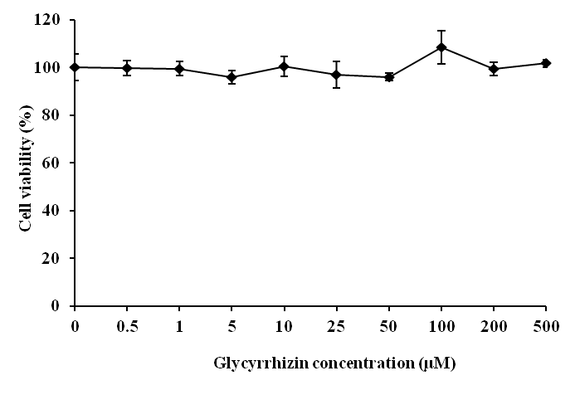
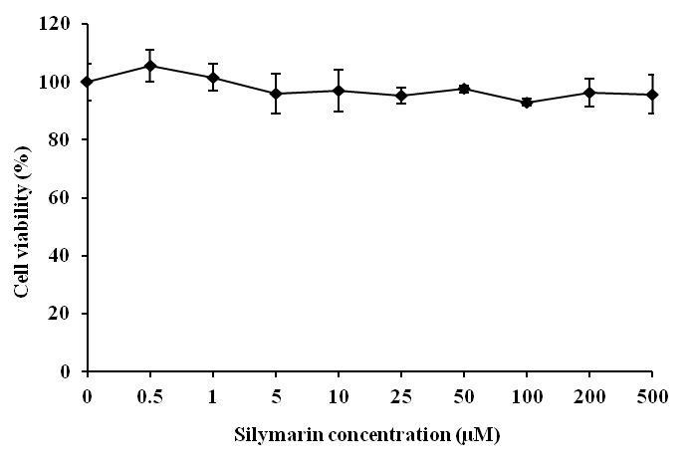
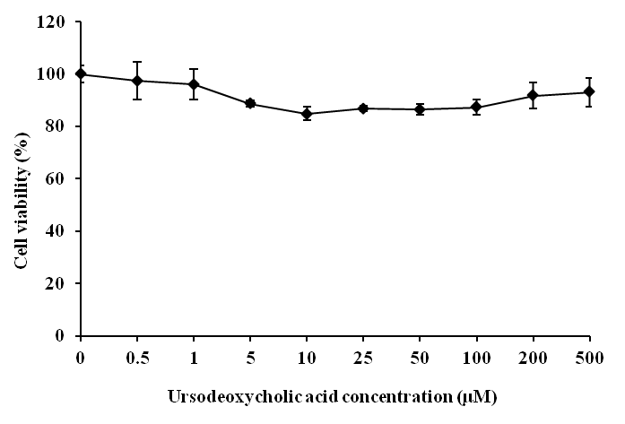
Figure 1
Glycyrrhizin
Silymarin
Ursodeoxycholic acid
650
145
227479
252
196448
832
695
1507
1288
1274

Figure 2

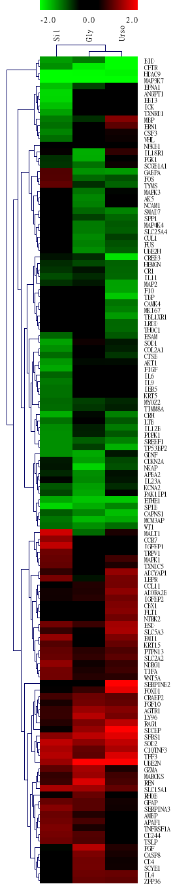
Figure 3
ZFP36
IL4
SCYE1
CD4
CASP8
PGF
TSLP
CD244
TNFRSF1A
APAF1
AMBP
SERINA3
GAFP
RHOB
SLC15A1
REN
MARCKS
GZMA
UBE2N
TFF3
C1QTNF3
SOD2
SFRS-1
SDCBP
RAG1
LY96
AGTR1
FGF10
CRABP2
FOXD1
SERPINB2
WNT5A
TIFA
NDRG1
SLC2A2
PTPN13
KRT15
EMI1
SLC5A3
ESD
NTRK2
FLT1
CBX1
IRFBP2
ADORA2B
OCL11
LEPR
ADCYAP1
TXNDC5
MAPK1
TRPV1
IGFRP1
CCR7
MALT1
WT1
MCM3AP
CAPNS1
SPIB
ETHE1
PAK1IP1
KCNA2
IL23A
APBA2
NKAP
CLKN2
GINF
TP23BP2
SREBF1
PDPK1
IL12B
LTB
CRH
TIMM8A
NYOZ2
KRT5
IER5
IL9
IL6
FIGF
AKT1
CTSB
COL2A1
SOD1
ESAM
THOC1
LRDD
TBL1XR1
MKI67
CAMK4
TBP
F10
MAP2
IL11
CR1
HEMGN
CREB3
UBE2H
FUS
CUL1
SLC25A4
MAP4K4
SPP1
SMAD7
NCAM1
AK5
MAPK3
TYMS
FOS
GABPA
SOGB1A1
PGK1
IL18R1
NFKB1
VHL
CSF3
ERN1
MBP
TXNRD1
ICK
EBI3
ANGPT1
EFNA1
MAP3K7
HDAC9
CFTR
BID
Urso
-2.0 0 2.0
Gly
Sil

Figure 4

- Glycyrrhizin

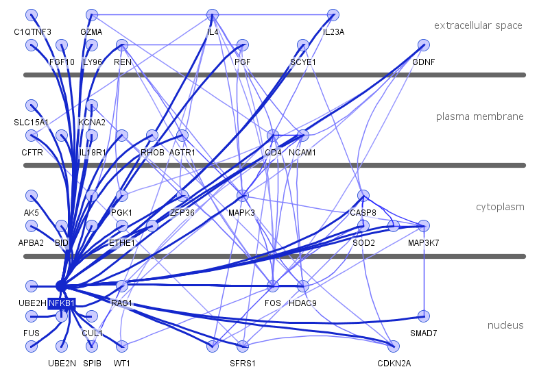

- Silymarin

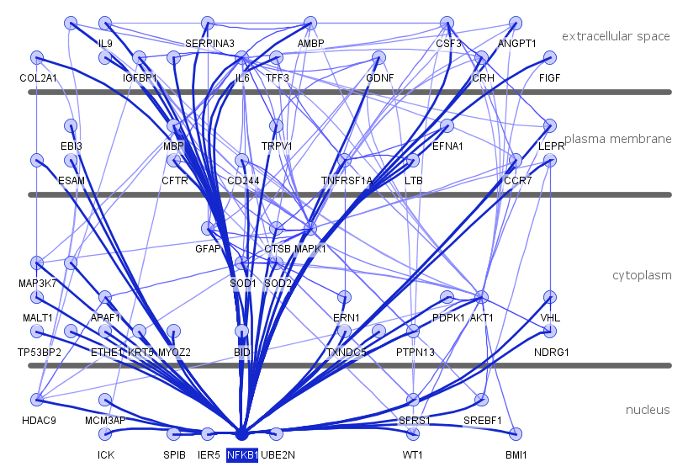
- Ursodeoxycholic acid

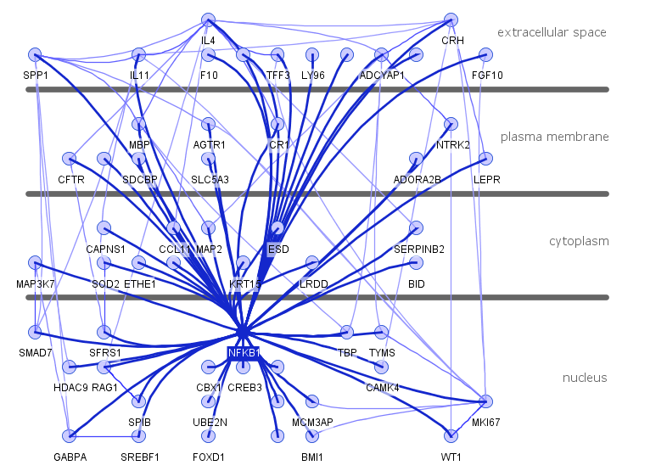
Figure 5





