Property Evaluation of Polyester/Cotton Woven Fabrics Made with Stainless Steel Weft Yarns
Ching-Wen Lou¹, Yuan-Jen Chang^{2, b}, Bing-Chiuan Shiu³, Ming-Chun Sie¹ and Jia-Horng Lin^{3, 4, 5, a}
¹Institute of Biomedical Engineering and Materials Science, Central Taiwan University of Science and Technology, Taichung 40601, Taiwan, R.O.C.
²Department of Management Information Systems, Central Taiwan University of Science and Technology, Taichung 40601, Taiwan, R.O.C.
³Laboratory of Fiber Application and Manufacturing, Department of Fiber and Composite Materials, Feng Chia University, Taichung City 40724, Taiwan, R.O.C.
⁴School of Chinese Medicine, China Medical University, Taichung 40402, Taiwan, R.O.C.
⁵Department of Fashion Design, Asia University, Taichung 41354, Taiwan, R.O.C.
ªjhlin@fcu.edu.tw, ^{b}ronchang@ctust.edu.tw
Keyword: smart textiles, wearable technique, cotton fibers, stainless steel fiber, woven fabric.
Abstract. Smart textiles have been widely discussed as a result of a fact that wearable technique has been used in healthcare, sports, tele-rehabilitation, and military fields. Textiles are characterized as comfortable, and thus suitable for long-term wearing, and therefore this study proposes to prepare humidity-sensitive textiles with electrical conductivity. Woven manufacturing is used in order to provide the textiles with desired mechanical properties of the woven fabrics that use high strength polyester (PET) fibers as the warp yarn, and cotton fibers and stainless steel fibers as two weft yarn types. Cotton fibers are water absorbent, while stainless steel fibers are electrically conductive and thus are able to provide sensing function. The humidity-sensitivity of the textiles relies on electrical conductivity; this study observe the fabric structure, water contact angle, and electrical conductivity of the fabrics in order to fabricate mechanically strong and humidity sensitive smart textiles.
Introduction
Wearable technique has been fast developed and gained increased attention from clinical staff and researchers [1]. In the wake of well-developed internet accesses, communication technology, and sensing technology, miniature sensing circuits have been massively produced and in turn accelerate the development of wearable technique. For example, patients, who stay home and community and require long-term monitoring, can take advantage of wearable technique for their electrocardiography (ECG) and breathing condition [2]. In case patients need any medical rescue, the wearable technique can provide immediate helps in time and decrease to waste medical resources, by sending alarm to ambulance staff, family members through sensing device and remote connection. A previous study shows that long-term monitoring data can significantly improve the treatment and diagnosis for cardiovascular disease [3]. To implement wearable technique, textiles are rendered with electrical conductivity for sensors to transmit signals. Smart textiles can be used for a long-term basis, provide the wearers comfort, and meanwhile, monitor users’ physical condition [4]. Moisture in blood, sweat, and urine can reflect the physical conditions of the human body. In the past, some studies detected the presence of moisture through the electrical conductive nonwoven fabrics coated with silver nanoparticles [5], while some studies spied perspiration by telling variation in the power of hydrogen ions [6]. However, these devices are created by extra manufacturing, and are not rendered with electrical conductivity during their original manufacturing. This study crisscross weaves the warp yarns and the weft yarns to form woven fabrics, the dense structure of which subsequently creates good mechanical property [7]. To attain conductive woven fabrics to sense moisture, two stainless steel fibers serve as the second weft yarn type and arranged parallel with a 6-cm space. Such weaving process can simply achieve electrical conductivity without additional processing. The distance between two metallic fibers allows moisture to cause short-circuit and then to be detected. High-strength PET multifilaments serve as the warp yarns; and water-absorbent cotton fibers and stainless steel fibers serve as two weft yarn types, all of which provide the resulting woven fabric with good mechanical strength, water absorption, and electrical conductivity. Hydrophilic and hydrophobic properties of the fabrics have been conducted by previous study [8]; therefore, this study observes the structure and measures water contact for analysis and discussion.
Experimental
Preparation of Samples
PET multifilaments (Universal Textile Co., Ltd., Taiwan, R.O.C.) is 500 Denier (D), which is defined as D=g/L*9000, where g refers to the fiber weight in grams and L refers to fiber length in meter. Stainless steel fiber (King's Metal Fiber Technology Co., Ltd., Taiwan, R.O.C.) has a diameter of 0.012 mm. Cotton fiber has a diameter of 0.012 mm and finenesses of 20 and 40 counts. In metric system, counts is defined as (N):N=L/G, where G refers to the fiber weight (gram) and L refers to fiber length (m). In Imperial units, counts refers to (S):S=L/(G*840), where G is the fiber weight (pound) and L refers fiber length (yard). Metric system is used in this study. The warp yarns is 500 D PET fibers and the weft yarns are cotton fibers with finenesses of 20 and 40 counts. Stainless steel fiber has a diameter of 0.012 mm, two stainless steel fibers are parallel arranged with a 6-cm distance, and the size of samples is 38 cm  12 cm.
Test
The woven fabrics are evaluated for structure observation with a stereomicroscope (SMZ-10A, Nikon Instruments Inc., Japan) and Motic Images Plus 2.0 software (Motic Group Co., Ltd., United States), resistance with Digital Multimeter (Agilent M3500A, 6½ Digit, Agilent, United States), and water contact angle with an optical contact angle measuring instruments (OCA-15, DataPhysics Instruments Inc., Germany). The solid surface is dripped with a drop of deionized water, and the level of its surface force on the liquid determines if the solid material is hydrophilic (with a water contact angle below 90 degrees) and hydrophobic (with a water contact angle above 90 degrees). Water contact angle measurement is performed in order to determine if the interstice caused by the warp and weft yarns have an influence on the water absorption of the woven fabrics. Water weight percentage of 100 % is obtained by subtracting the dry weight of woven fabrics from woven fabrics that are immersed in water for three minutes. Then, the 20, 40, 60, and 80 % of water weight can be yielded accordingly.
Results and Discussion
The structural observation of the woven fabrics should be conducted first in order to examine their humidity sensitive conductivity. Figure 1 shows the stereomicroscopic images of the woven fabrics made of cotton fiber of 20 counts and 40 counts. The morphology of the woven fabrics indicates that the fabrics is well but not compactly crisscross woven, which causes interstice between the warp yarns and the weft yarns. Woven fabrics are made of cotton fibers of 20 counts and 40 counts as the weft yarns, and the use of the former results in a smaller interstice in the woven fabrics. Next, an optical contact angle measuring instrument is used to determine if the interstices in the woven fabrics cause moisture loss.

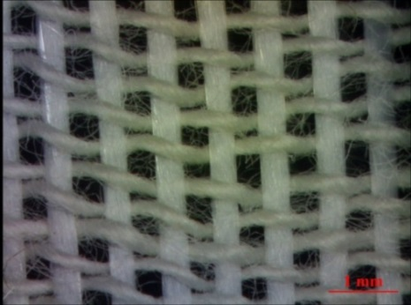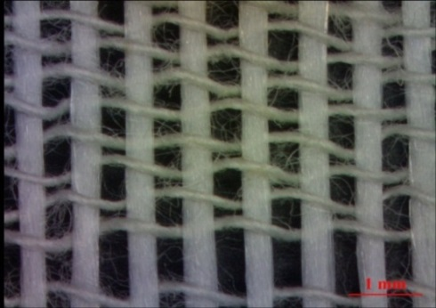
(a)
(b)
Figure 1. Stereomicroscopic images (15 ) of the woven fabrics composed of cotton fibers at a) 20 counts, and b) 40 counts.
Figure 2. Optical images of contact angles (15) of the woven fabrics made of cotton fibers with a) 20 counts and b) 40 counts.
Figure 2 shows the images of contact angles of the woven fabrics, and the results of optical contact angle measurement show that the contact angle of woven fabrics containing cotton fiber of 20 counts and 40 counts is 66.2° and 16.8°, respectively. Due to their small interstices, the woven fabrics with 20-count cotton fibers can keep water in the cotton fibers; however, the woven fabrics with 40-count cotton fibers have large interstices, which drain the water without holding it in the cotton fibers and thus lacks suction efficacy. Interstices also influence humidity sensitive conductivity, for which the resistance between the two metallic fibers is examined. The size of interstices in woven fabrics with 40-count cotton fibers is too large to retain water, thus even cotton fibers absorb water and the poor contact between cotton fibers makes the woven fabrics electronic undeliverable. Therefore, only woven fabrics with 20-count cotton fibers will be discussed in next discussion.
Figure 3 shows that resistance between two stainless steel fibers that are 6 cm apart measured by a multimeter. When the water weight percent is 20%, the resistance of the woven fabrics is 1.45MΩ. Such a result is due to the hygroscopic effect of cotton fibers, the absorbed water results in electron transport and thus the presence of resistance. Resistance decreases as a result of a decreasing water weight percentage, and a 100 % of water weight generates a resistance of 1.28 MΩ. The electron transport depends on and thus changes with the variations in water weight. In the future, this study plans to combine sensors to detect the water weight percentage according to the variations in resistance.
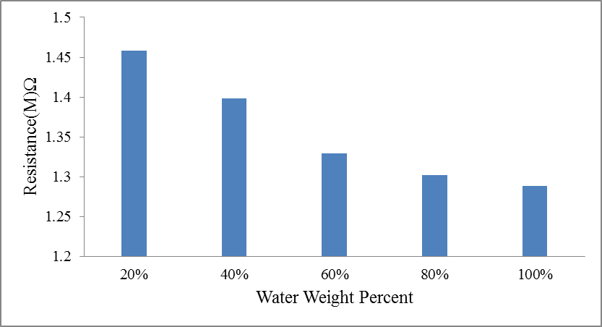
Figure 3. Water weight percent and resistance of woven fabrics made of 20-count cotton fibers.
Conclusion
This study prepares the woven fabrics with high-strength PET fibers (the warp yarns) to fortify the mechanical strength, and 20- and 40-count cotton fiber (the weft yarns) to absorb water. Two stainless steel fibers, which have a diameter of 0.012 cm and are parallel arranged with a distance of 6 cm, are combined increase the humidity-sensitive conductivity of the resulting woven fabrics. The results of stereomicroscopic observation and water contact angle measurement show that 40-count cotton fibers are too fine to compose a compact structure and to absorb water. The 20-count cotton fibers have a greater fineness and thus can form a compact structure to retain water inside cotton fibers, which eventually causes conductivity between stainless steel fibers. The results of resistance test show that the resistance of woven fabrics containing 20 % and 100 % water weight is 1.45 MΩ and 1.28 MΩ, respectively. In the future, this study will develop sensors according to the above features, and the resistance and corresponding water weight percent can thus be used for applications.
Acknowledgement
The authors would especially like to thank National Science Council of the Taiwan, for financially supporting this research under Contract NSC 101-2221-E-468-006.
References
- M. Chana, D. Estèvea, J.Y. Fourniolsa, C. Escribaa and E.Campo: Artif. Intell. MeD. Vol. 56 (2012), p. 137.
- M.Zh. Poh, N.C. Swenson, and R.W. Picard: IEEE. T. Bio-Med. Eng. Vol. 57 (2000), p. 1243.
- T. Kinkeldei, C. Zysset,N. Münzenrieder and G. Tröster: Sensor. Actuat. B-Chem. 174 (2012), p. 81.
- V. Marozas, A. Petrenas, S. Daukantas and A. Lukosevicius: J. Electrocardiol. Vol. 44 (2011), p. 189.
- J. Weremczuka, G. Tarapata and R. Jachowicz: Procedia Engineering Vol. 47 (2012), p. 1366.
- F. Benito-Lopez, S. Coyle, R. Byrne, Alan Smeaton, Noel E. O'Connor, D. Diamond: Procedia Chemistry Vol. 1 (2009), p. 1103.
- D.D. Cerovic, K.A. Asanovic, S.B. Maletic, J.R. Dojcilovic: Compos. Part B-Eng. Vol. 49 (2013), p. 65.

