Preliminary Study of Manufacturing Technique Using Three Dimensions Stain Steel Braid for Bone Scaffold
Jia-Horng Lin^{1,2}, Ching-Wen Lin^{3,a}, Yueh-Sheng Chen⁴, Chien-Lin Huang⁵, Wen-Cheng Chen⁶ and Ching-Wen Lou^{7,b}
¹Laboratory of Fiber Application and Manufacturing, Department of Fiber and Composite Materials, Feng Chia University, Taichung City 407, Taiwan, R.O.C.
²School of Chinese Medicine, China Medical University, Taichung 40402, Taiwan, R.O.C.
3Department of Fashion Design, Asia University, Taichung 41354, Taiwan, R.O.C.
⁴Department of Biomedical Imaging and Radiological Science, China Medical University, Taichung 40402, Taiwan, R.O.C.
⁵Department of Fiber and Composite Materials, Feng Chia University, Taichung City 407, Taiwan, R.O.C.
⁶Advanced Medical Devices and Composite Laboratory, Department of Fiber and Composite Materials, Feng Chia University, Taichung City 407, Taiwan, R.O.C.
⁷Institute of Biomedical Engineering and Material Science, Central Taiwan University of Science and Technology, Taichung 406, Taiwan, R.O.C.
ªchingwen@asia.edu.tw, ^{b}cwlou@ctust.edu.tw (corresponding author)
Keywords: stainless steel, braid, artificial bone scaffold
Abstract. Nowadays, as rising research on biomaterials, the artificial bone scaffold has become the most important part of the study. Moreover, metallic materials have been applied on the artificial bone scaffold; but its high rigidity causes the stress shielding effect in bones. To improve the disadvantages of metallic materials and pursue their better mechanical properties, 304 stainless steel fibers have multi-layer braided into the 3D stainless-steel braid with porous structure and better mechanical properties, using braiding machine. In multi-layer braiding process, with the constant number of take-up gear and varying number of braid gear, the 3D stainless-steel braid was manufactured. Afterwards, its braiding structure and angle were observed by stereo microscope. Also, the optimal braiding parameters can be acquired from tensile strength test.
- Introduction
The basic requirements that biomaterials can be applied on the clinical practice are bio-compatibility, non-toxicity and non-carcinogenicity [1]. After placed high-rigidity material in the damage parts, the bone tissue becomes gradually atrophic. In contrast, when placed metallic or ceramic materials, the bone damage parts can bear bigger stress, and thus the surrounding parts endure decreasing stress, which generates secondary damage once stimulating from the loading. Because the metallic materials have better strength than the bone, intended for suitable application on human bone, metallic materials’ structure needs to change to decrease their rigidity [2]. Once small damage produces, bone tissue has ability to repair. But when damage part exceeds the critical, bone tissue is difficult to repair by itself [3]. Therefore, artificial bone scaffolds applying on the bone tissue repairs become more and more important [4]. In this research, the porous artificial bone scaffolds were expected to prepare. By changes of metallic materials structure, their rigidity decreases. The result is promising to apply in bone tissue engineering repairs.
2. Experimental
2.1 Experimental Apparatus
16-spindle Braiding Machine: NL-601-C 16, Nan Hsing Machinery & Co., Ltd. Automatic Winding Machine: SY-01, Nan Hsing Machinery & Co., Ltd. Universal Strength Testing Machine: HT-9101, Hung Ta Instrument Co., Ltd. Microscope: Olympus B061, Japan.
2.2 Experiment Process
304 stainless steel fiber (diameter 0.08 mm, Yuen Neng Co., Ltd.) firstly was shifted to bobbin using automatic winding machine, and then multi-layer braided by braiding machine. In multi-layer braiding process, the number of take-up gear was set at 60, and the number of braid gear was varied as 60, 70 and 80. Therefore, the gear ratios of braiding gear and take-up gear were 60:60, 70:60 and 80:60. Afterwards, braiding structure and braiding angle of 3 D stainless-steel braid were observed by the microscope. In addition, the tensile strength was also evaluated based on ASTM STP 893. By the final evaluations, the optimal manufacturing parameters were acquired from the tests.
2.3 Testing
2.3.1 Braiding Structure Observation
The braiding structure was observed by microscope. Meanwhile, the braiding angle was calculated by 3D Motic Images Multi-Focus Software.
2.3.2 Tensile Strength Test
Based on ASTM STP 893, the tensile strength was tested by Universal Strength Testing Machine. The sample size was 80 mm ×4 mm ×4 mm. The samples were clamped in distance of 30 mm and then drawn at rate of 10 mm/min. Each sample was tested 5 times, and its average tensile strength was evaluated at the end.
- Results and Discussion
By microscope observations, the braiding structure of 3 D stainless-steel braid was shown in Figure 1. Depending on the braiding technique, the braid has 3D structure and porous configuration. However, it also presents that 3 D stainless-steel braid has different entangled degree, because the gear ratio of braiding gear and take-up gear changes in the braiding process.
As shown in Figure 2, the braiding angle of the braid increases with the number of take-up gear. This is attributed to braiding machine mandrel advances slowly with increase the number of braiding gear, more vertical to the axial braid machine [5].
As seen in Figure 3, when the gear ratio of braid gear and take-up gear is 60:60, the 3 D stain-steel braid has the highest tensile strength compared to gear ratios of 70:60 and 80:60. As increase of braiding angle, the tensile strength decreases (refer Figure 2). The reason is that, axial tensile force that stainless steel fibers suffer together decreases in the testing [6].
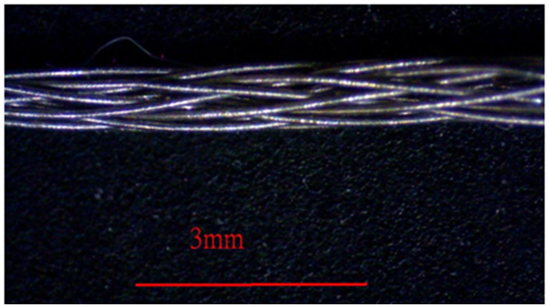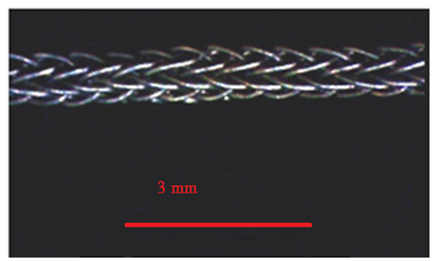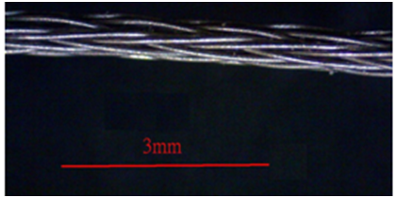
a
b
c
stainless-steel
stainless-steel
stainless-steel
Figure 1. The microscope observations of stainless-steel multi-layer braid with different gear ratios of braid gear and take-up gear (a)60:60 (b)70:60 (c)80:60.
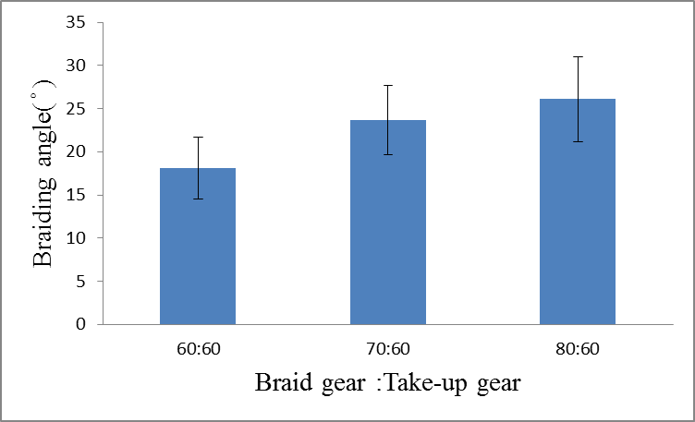
Figure 2. The influence of gear ratios of braid gear and take-up gear on braiding angle of stainless-steel multi-layer braid (60:60, 70:60 and 80:60)
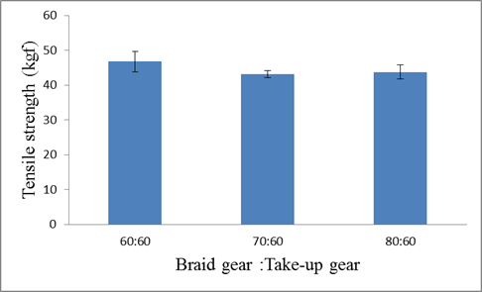
Figure 3. The influence of gear ratios of braid gear and take-up gear on tensile strength of stainless-steel multi-layer braid (60:60, 70:60 and 80:60)
- Conclusion
In braiding process, the braiding angle of 3 D stainless-steel braid increases with the number of take-up gear. The maximum tensile strength occurs when the gear ratio of braid gear and take-up gear is 60:60, simultaneously possessing the most stable braiding structure. In the following study, we will discuss on mechanical properties of 3 D stainless-steel braid, such as compression strength etc, in expectation to fabricate the artificial bone scaffolds that suitable apply on human body.
Acknowledgment
This work would especially like to thank National Science Council of the Taiwan, for financially supporting this research under Contract NSC 99-2622-E-039-004-CC3.
Reference
- T. Kokubo, H.M. Kim , M. Kawashita, Biomaterials. 24(2003) 2161-2175.
- J.H. Lin, W.C. Chen, J.J. Hu, Y.S. Chen, S.P. Wen and C. W. Lou. Processing Technology and Characteristic Evaluation of Polylactic Acid/316L Stainless Steel Composite Braids with Hydroxylapatite Deposition, Advanced Materials Research. 332-334 (2011) 1951-1954.
- T. Jiang, S. P. Nukavarapu, M. Deng, E. Jabbarzadeh, M.D. Kofron, S. B. Doty, W. I. Abdel-Fattah, C.T. Laurencin, Chitosan-poly(lactide-co-glycolide) microsphere-based scaffolds for bone tissue engineering: In vitro degradation and in vivo bone regeneration studies, Acta Biomater. 6 (2010) 3457-3470.
- T.Jiang, W. I. Abdel-Fattah, C. T. Laurencin, In vitro evaluation of chitosan/poly(lactic acid-glycolic acid) sintered microsphere scaffolds for bone tissue engineering, Biomaterial. 27 (2006) 4894-4903.
- C.W.Lou, W.C.Chen, Y.S. Chen, S.P. Wen, C.W. Chang and J.H. Lin, Process Technology and Mechanical Properties of Polylactic Acid Ply Yarns and 316L Stainless Steel Braids, Advanced Materials Research. 287-290 (2011) 2656-2659.
- C.W.Lou, J.J.Hu, Y.S. Chen, S.P. Wen, K.C. Lin and J.H. Lin. Manufacturing Technology of 316L Stainless Steel/Poly(Lactic Acid) Composite Braids and the Induction of Hydroxyapatite Formation on the Braid, Advanced Materials Research. 287-290 (2011) 2669-2672.

