Tencel®/Low-Melting-Point Polylactic Acid Composite Nonwoven Fabrics: Manufacturing Technique and Property Evaluations
Ching-Wen Lou^{1, b}, Meng-Chen Lin² and Jia-Horng Lin^{2, 3, 4,a}
¹Institute of Biomedical Engineering and Materials Science, Central Taiwan University of Science and Technology, Taichung 40601, Taiwan, R.O.C.
²Laboratory of Fiber Application and Manufacturing, Department of Fiber and Composite Materials, Feng Chia University, Taichung City 40724, Taiwan, R.O.C.
³School of Chinese Medicine, China Medical University, Taichung 40402, Taiwan, R.O.C.
⁴Department of Fashion Design, Asia University, Taichung 41354, Taiwan, R.O.C.
ªjhlin@fcu.edu.tw, ^{b} cwlou@ctust.edu.tw
Keyword: nonwoven fabric, Tencel® fiber, low-melting-point polylactic acid (LMPLA), hot pressing, water retention.
Abstract. This study combines hydrophilic and soft Tencel® fibers and low-melting-point polylactic acid (LMPLA) fibers by needle-punching and hot press processes to form moisture-retentive and comfortable Tencel®/LMPLA composite nonwoven fabrics. Air permeability, water vapor transmission rate, softness, water content rate, and water loss rate tests are performed on the composite nonwoven fabrics. The experiment results show that when hot pressed at 130 and 150 ˚C, the Tencel®/LMPLA composite nonwoven fabrics have good water absorption, water retention, and softness, which can be concluded as successfully moisture-retentive and comfortable Tencel®/LMPLA composite nonwoven fabrics.
Introduction
Nonwoven fabrics are highly commercially available in medical and health products because they have good air permeability, a porous structure, ease of processing, low production cost, and a short manufacturing process. The wide variety of raw material options, such as filaments, staples, natural fibers, synthetic fibers, and regenerated fibers, also make nonwoven fabrics versatile [1].
Tencel® fibers are cellulose fibers that are made of wood pulp with a solvent and fiber-spinning process, and the solvent of N-methylmorpholine-N-oxide (NMMO) can be reclaimed and recycled, which is an environmental friendly, power saving feature. The waste of Tencel® fibers can be decomposed by microscopic organisms into carbon dioxide and water, which thereby qualifies them as being eco-friendly. When made into medical products, ready-made clothes, printing cloth, and filter materials, Tencel® fibers can provide the products with good air permeability, water absorption, draping property, and a fluffy texture, all of which result in comfort for users [2-3].
Polylactic acid (PLA) is the polymerization of lactic acid which itself is a byproduct of fermented starch-rich crops by microscopic organisms. Thus, PLA can be obtained from a variety of sources. The waste of PLA can be disposed in a natural environment to allow degradation into carbon dioxide and water through microscopic organisms or acid-based reactions, and as a result, PLA is characterized as an ideal, eco-friendly polymer. PLA can be used for tissue engineering scaffolds, suture lines, and wound dressings due to its biocompatibility, bioabsorbable property, avirulence, and biodegradability, and therefore has been much valued in biomedical field [4-5].
This study synthesizes and hot presses Tencel® fibers and low-melting-point polylactic acid (LMPLA) fibers with various temperatures to form the composite nonwoven fabrics. The influence of the hot pressing temperature on the air permeability, water vapor transmission rate, softness, water retention, and water loss rate of Tencel®/LMPLA composite nonwoven fabrics are finally examined with the aim of yielding highly moisture-retentive and snug composite nonwoven fabrics.
Experimental
Materials
Tencel® fibers (Web-Pro Co., Ltd, Taiwan, R.O.C) have a length of 51 mm and a fineness of 1.7 D. LMPLA fibers (Far Eastern New Century, Taiwan, R.O.C.) have a fineness of 4 D and a length of 51 mm.
Procedure
Tencel® fibers and low-melting-point polylactic acid (LMPLA) fibers are blended at an 80/20 ratio, and undergo opening, mixing, carding, lapping, needle-punching processes, and hot pressing at 110 ˚C, 130 ˚C, and 150 ˚C within a spacing of 1 mm for 1 minute to form Tencel®/LMPLA composite nonwoven fabrics. The control group is Tencel®/LMPLA composite nonwoven fabrics that are not hot pressed.
Test
Air Permeability Test
An air permeability tester (TEXTEST FX3300, Switzerland) measures the air permeability of the samples, as specified in ASTM D373-04. Ten samples of each specification are used for this test.
Water Vapor Transmission Rate Test
This test is performed on three samples of each specification at 25 ˚C and relative humidity of 30 %, as specified in ASTM E96-90. The sample bottle containing water has a plastic cover with a hole, and samples are placed on top of it. The weight of the water is measured every hour for a total of 24 hours to calculate the water vapor transmission rate.
Softness Test
The draping length of Tencel®/LMPLA composite nonwoven fabrics is measured with a Flexometer (Hung Ta Instrument Co., Ltd , Taiwan, R.O.C), as specified in CNS12915 (cantilever test). The longer the draping length of samples, the harder the samples are. The number of samples is 5.
Water Content Rate Test
Samples are weighed (W₀) when dry, and then are immersed in 300 ml of water in a plastic container measuring 30 cm × 24 cm × 3 cm for 10 seconds, after which samples are removed from water, kept for 1 minute in order to remove unnecessary water, and weighed again (W₁). The water absorption of samples is calculated by the following equation (1).
Water Absorption (%)=(W₁-W₀) / W₀× 100 %…………………………… (1).
Water Loss Rate Test
Five samples of each specification are used for this test. The dry weight (W₀) and the first wet weight (W₁) of samples are obtained as the steps depicted in 2.3.4. Next, samples are kept in an enclosed space at 25 ˚C and relative humidity of 40 % for 15 minutes and weighed to have the second wet weight (W₂). The water retention of samples is computed by the following equation (2).
Water Retention (%)=[(W₁-W₀)- (W₂-W₀)] / (W₁-W₀)× 100 %……………… (2).
Results and Discussion
Effects of Hot Pressing Temperatures on Air Permeability of Tencel®/LMPLA Composite Nonwoven Fabrics
Figure 1 shows that the air permeability of the control group is greater than that of the Tencel®/LMPLA composite nonwoven fabrics that are hot pressed at 130 ˚C and 150 ˚C, both of which are above the melting point temperature of LMPLA (120 ˚C). The surface of fibers starts to melt and creates thermal bonding points between fibers, and such a result obstructs the air from flowing and thus decreases the air permeability.
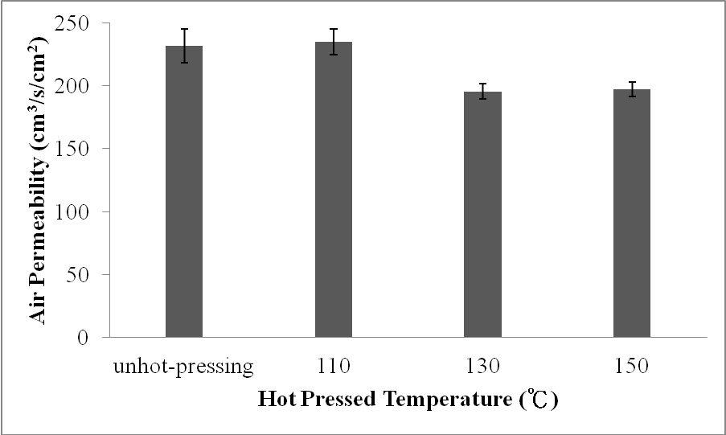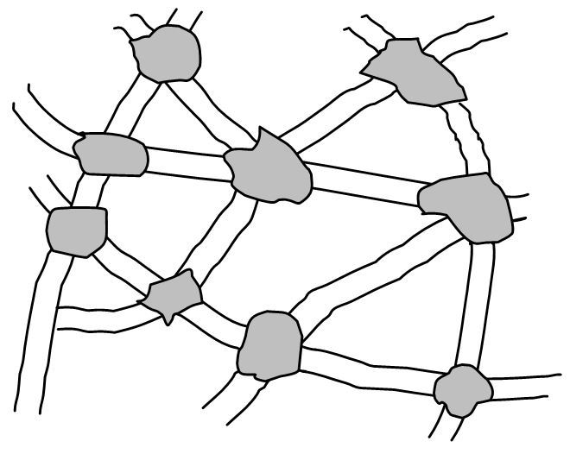
(a)
(b)
thermal
bonding points
fiber
Figure 1. a) Air permeability tests of Tencel®/LMPLA composite nonwoven fabrics as related to various hot pressing temperatures. b) Schematic diagram of thermal bonding points.
Effects of Hot Pressing Temperatures on Water Vapor Transmission Rate of Tencel®/LMPLA Composite Nonwoven Fabrics
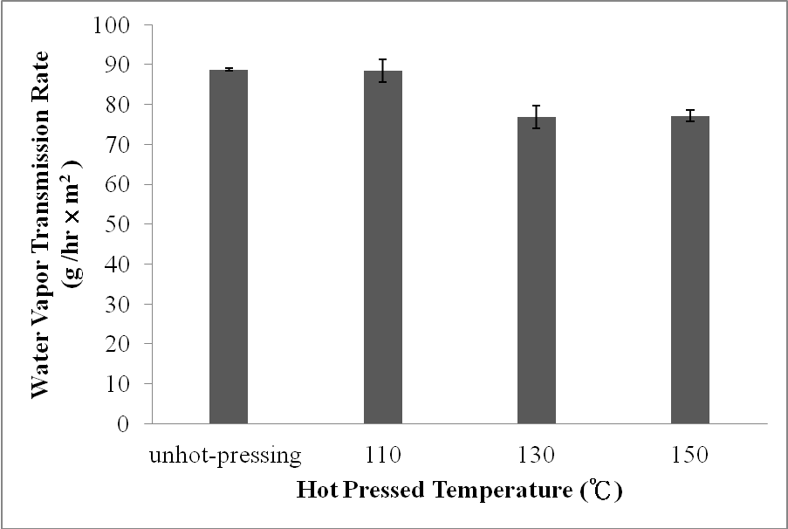
Figure 2. Water vapor transmission rate of Tencel®/LMPLA composite nonwoven fabrics as related to various hot pressing temperatures.
Figure 2 shows that Tencel®/LMPLA composite nonwoven fabrics that have been hot pressed at 130 ˚C and 150 ˚C demonstrate lower water vapor transmission rate than those hot pressed at 110 ˚C and the control group. A hot pressing temperature that exceeds the melting point of LMPLA fibers (120 ˚C) melts the surface of fibers and causes thermal bonding points between fibers, which obstructs the water vapor. However, water vapor transmission rate of the former group does not significantly decrease. This is because Tencel® fibers are hydrophilic and inclined to adsorb water molecules, and water can also be emitted through the pores in the fabrics, the water vapor transmission remains good.
Effects of Hot Pressing Temperatures on Softness of Tencel®/LMPLA Composite Nonwoven Fabrics
Figure 3 shows that when the Tencel®/LMPLA composite nonwoven fabrics are hot pressed at 130 ˚C and 150 ˚C, their draping length is longer, indicating a lower softness. The reason is the same as that provided in 3.1 and 3.2; furthermore, thermal bonding points limit the displacement of fibers that comprise the composite nonwoven fabrics, the result of which causes a longer draping length.
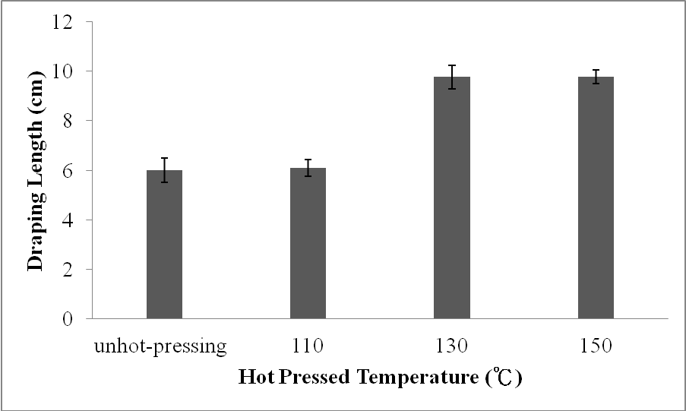
Figure 3. Softness of Tencel®/LMPLA composite nonwoven fabrics as related to various hot pressing temperatures.
Effects of Hot Pressing Temperatures on Water Absorption of Tencel®/LMPLA Composite Nonwoven Fabrics
Figure 4 shows that including the control group, all Tencel®/LMPLA composite nonwoven fabrics exhibit good water absorption. Such a result is due to Tencel® fibers, which have good water absorption. Compared to the control group, the Tencel®/LMPLA composite nonwoven fabrics that have been pressed at 130 ˚C and 150 ˚C have greater water absorption. Due to a compact reticular structure that is caused by thermal bonding point of fibers, water is able to enter the pores, resulting in higher water absorption.
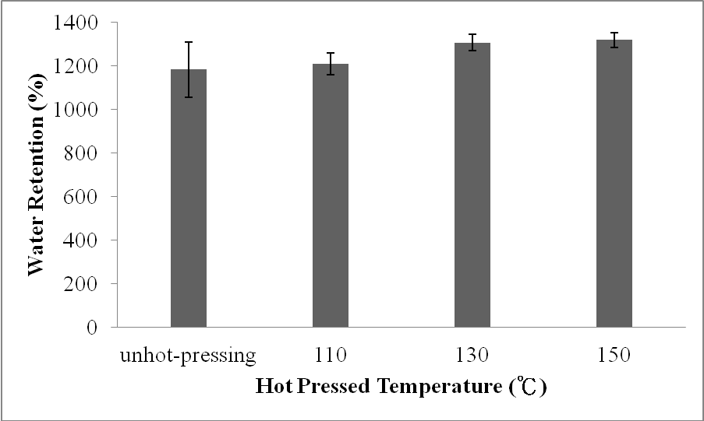
Figure 4. Water absorption of Tencel®/LMPLA composite nonwoven fabrics as related to various hot pressing temperatures.
Effects of Hot Pressing Temperatures on Water Loss Rate of Tencel®/LMPLA Composite Nonwoven Fabrics
Figure 5 shows that hot pressing at 130 ˚C and 150 ˚C results in a low water loss rate of Tencel®/LMPLA composite nonwoven fabrics, the water retention of which is greater than that of the control group. Such a result is due to the compact structure between the fibers caused by thermal bonding points, which preserve water in the pores and prevents water from escaping.
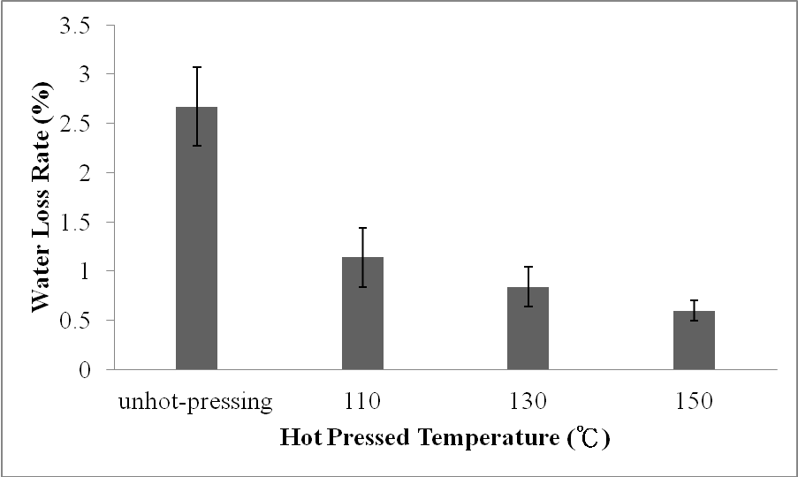
Figure 5. Water loss rate of Tencel®/LMPLA composite nonwoven fabrics as related to various hot pressing temperatures.
Conclusion
This study successfully prepares hot-pressed Tencel®/LMPLA composite nonwoven fabrics, which possess water absorption of 1306.9 % (130 ˚C) and 1318.8 (150 ˚C), a water retention rate of 0.84 % (130 ˚C) and 0.61 % (150 ˚C), and good softness, though the value of which is lower than that of composite nonwoven fabrics hot pressed at 110 ˚C and the control group.
Acknowledgement
The authors would especially like to thank National Science Council of the Taiwan, Central Taiwan Science Park, for financially supporting this research under Contract 102RB07.
References
- A. Abou-Okeila, A.M. Sheta, A. Amr and A. Ali. Marwa: Carbohyd. Polym. Vol. 90 (2012), p. 658.
- P.L. Nostro, D. Corrieri, M. Ceccato and P. Baglioni: J. Colloid. Interf. Sci. Vol. 236 (2001), p.270.
- S. Li, Ernst Worrell, Martin K. Patel: Resour. Conserv. Recy. Vol. 55 (2010), p. 260.
- R. Auras, B. Harte, S. Selke: Macromol. Biosci. Vol. 4 (2004), p. 835.
- V. Guarino, F. Causa, P. Taddei, di Foggia M., G. Ciapetti, D. Martini, C. Fagnano, N. Baldini and L. Ambrosio: Biomaterials. Vol. 29 (2008), p. 3662.

