Wicking Behavior and physical property of the Environment-Protective of Nonwoven Fabrics
Jia-Horng Lin^{1, 2, 3, b}, Mei-Chen Lin¹, An-Pang Chen¹ and Ching-Wen Lou^{4, a}
¹Laboratory of Fiber Application and Manufacturing, Department of Fiber and Composite Materials, Feng Chia University, Taichung City 40724, Taiwan, R.O.C.
²School of Chinese Medicine, China Medical University, Taichung 40402, Taiwan, R.O.C.
³Department of Fashion Design, Asia University, Taichung 41354, Taiwan, R.O.C.
⁴Institute of Biomedical Engineering and Materials Science, Central Taiwan University of Science and Technology, Taichung 40601, Taiwan, R.O.C.
ªcwlou@ctust.edu.tw, ^{b}jhlin@fcu.edu.tw
Keywords: wicking behavior, stiffness, environment-protective fabrics, high absorption fiber.
Abstract. Excessive bleeding becomes a primary cause for war wound death, accident death and operative death. Therefore, decreasing the bleeding time and operation time were play an important role in the preoperative period. In this study, the Tencel® fiber and high absorbent fiber were used to produce high absorption composite nonwoven fabrics. As the result of experiment, the higher high absorption fiber that will create the high stiffness, in addition, the nonwoven has upper stiffness at cross direction. In wicking behavior, the composite nonwoven has about absorption water reach 14 g when the high absorption fiber was 50 wt%. The assessment of application for this study anticipated the resulted high absorption composite nonwoven fabrics to be used as hemostasis material to decrease the ratio of dead person on bleeding.
Introduction
As technology development of wound healing materials in medical field, in recent years, medical absorbable hemostatic materials are caused highly attention by medical and industry fields for every country. A well hemostatic materials need possess good wicking behavior and drying capability, for them to be considered in the manufacture of medical fabrics. Because the Blood has 55 % adtevak, which contains 92 % water.
Thus hemostatic material must have ability of high hygroscopicity for absorbing plenty of bleedings and tissue fluid in trauma position. Lyocell fibers were produced with the cellulose solution as spinning dope by solvent spinning. N-Mehtyl-Morpholine-N-Oxide is good solvent to dissolve the cellulose. The dissolve foundation was related to the hydrogen bond with the -OH of cellulose. Lyocell fiber has a high crystallization structure composed of cellulose, hence it possesses high strength, high orientation, and high purity, retaining its original chemical properties [1-3]. There are many researches were focus on high water absorption and wicking behavior [4-7]. In this study, in order to manufacturing the high absorption fabrics applied in hemostatic field. The Tencel® fiber and high absorbent fiber were used to produce high absorption composite nonwoven fabrics. And the ratio of high absorbent fiber and punch were changed to evaluate the physical properties.
Experimental
Materials
Tencel® short fiber, previously known as Lyocell, (Taiwan Web-Pro Co., Ltd., Taiwan Web-Pro Co., Ltd., Taiwan, R.O.C.) has a fiber length of 51 mm and fineness of 1.7 D. Highly absorbent fiber, polymerized by acrylic acid, is purchased from Asiatic fiber corporation, Taiwan, R.O.C.
Processing
Tencel® fibers and highly absorbent fibers are mixed with ratios of from 10-50 wt% and undergo the nonwoven manufacturing consisting of opening, mixing, carding, laying, and needle-punching to form nonwoven. The nonwoven was change the punched density from 150 to 300 punch/min. And the nonwoven fabrics were evaluation the wicking behavior and physical properties. Figure 1 was shown the nonwoven before and after the water absorption. The highly absorbent fibers could be create a huge swelling.
Figure 1 The highly absorbent nonwoven. (a: dry nonwoven, b: swelling nonwoven)
Measurement
Horizontal wicking testing and Stiffness
Before testing, the water in liquid reservoir should be controlled having the same height with the base glass plate. Firstly, a sample (100 mm×100 mm) was placed on the base glass plate. Furthermore, a drop of water was placed on the sample surface, and then the sample was covered by a glass sheet at once. The water would diffuse alone the fabric by capillary force. The water is supplied continuously from a reservoir by siphoning on the electronic balance. The testing environment under 20 ± 2 °C and 65 ± 5% relative humidity. Stiffness test was according to cantilever method as regulated in CNS 12915.
Result and Discussion
Figure 2 shows the influence of highly absorbent fiber content on the stiffness of the composite nonwoven fabrics. Increasing the highly absorbent fiber content, the stiffness was accelerated. The reason is the composite nonwoven fabric had high moisture absorption ratio, the fiber was easy swelling slightly and drying. When the fabrics was dried the nonwoven has higher stiffness than the before. On the other hand, composite nonwoven fabrics also exhibited a higher stiffness in CD than that in MD. As in nonwoven manufacturing process, the carding direction was perpendicular to the net discharging direction, so the fibers were arranged in a tendency toward CD. The direction with a greater amount of fiber alignment promoted the stiffness of nonwoven fabric and prohibited the fabrics from deforming, subsequently resulting in a higher stiffness in CD than in MD.
Figure 3 present the influence of punch density on stiffness of the composite nonwoven fabrics. An promoted in needle-punching density was responsible for an accelerated in stiffness. In nonwoven processing, the barbed needle plate pushed the fibers down and caught the fibers through the nets repeatedly, making the fibers between webs intertwined and entangled. This heightened the frictions between fibers and prevented bending deformation, leading to the slight increase in the stiffness.

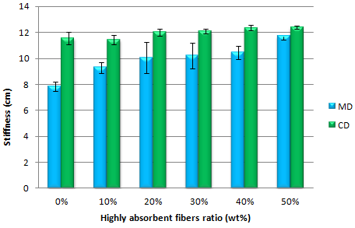
Figure 2. The Stiffness of the high absorption composite nonwoven fabrics with various ratio of high absorption fiber.
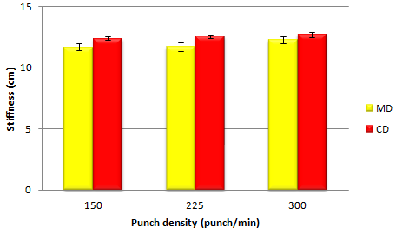
Figure 3. The Stiffness of the high absorption composite nonwoven fabrics with various ratio of punch density.

Horizontal wicking rate represents the water absorption and diffuse ability by capillary effect of the fabric in the horizontal direction. Figure 4 indicates that fabric horizontal wicking behavior from 0 second to 600 second. Moreover, the horizontal wicking rate may also relate to the total pore volume of the fabrics. The rate was increased obviously within 270 second. Because of the high absorption composite nonwoven fabrics has high ratio of hydrophilic group. The absorption waster could be fast to dispersive in the fabrics. When the time was over 270 second, the absorption ratio was stable. The reason maybe the fiber was swelling and saturated. Figure 5 was shown the Horizontal wicking rate of high absorption composite nonwoven fabrics with various punch density. The high absorption composite nonwoven fabrics have higher water absorption weight with the punch density was promoted. Because the higher punch density that will create the well friction between the absorption fiber. Therefore, the water develop the capillarity to promoted the water expanded.

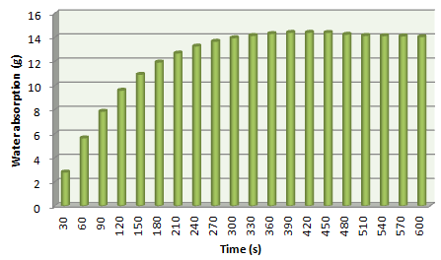
Figure 4. The water absorption weight of the high absorption composite nonwoven fabrics with various time (s).
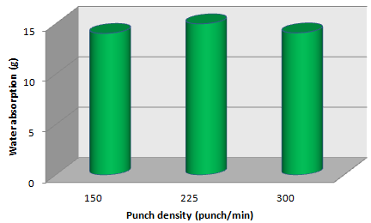
Figure 5. The water absorption weight of the high absorption composite nonwoven fabrics with punch density. The testing time was

Conclusion
In this study, the high absorption composite nonwoven fabrics with Tencel® fibers and high absorption fibers were successfully to manufacture. The higher high absorption fibers that will create the high stiffness when the high absorption fibers reach 50 wt%, the stiffness was 12.4 cm. When the high absorption fibers was zero, the composite nonwoven fabrics has 8 cm of stiffness at mechanical direction. In addition, the nonwoven has upper stiffness at cross direction.
In wicking behavior, the composite nonwoven has about absorption water reach 14 g when the high absorption fiber was 50 wt%. When the absorption time was over 270 second, the absorption ratio is become stable. The high absorption composite nonwoven fabrics have higher water absorption weight with the punch density was promoted. When the punch density was 225 (punch/min), the high absorption composite nonwoven has optimum horizontal wicking.
The assessment of application for this study anticipated the resulted high absorption composite nonwoven fabrics to be used as hemostasis material as well as to decrease bleeding and to shorten the operation duration in assorted surgeries clinically.
Acknowledgement
The authors would especially like to thank National Science Council of the Taiwan, for financially supporting this research under Contract NSC 102-2622-E-035-002-CC2..
Reference
- P. Bartsch, G. Kling: Lenzinger Berichte. Vol. 80 (2001), p. 40.
- R. N. Ibbett, Y.L. Hsieh: Text. Res. J. Vol. 71 (2001), p. 164.
- R. Campos, T. Bechtold: Text. Res. J. Vol. 73 (2003), p. 721.
- R. Fangueiro, A. Filgueiras, F. Soutinho and X. Meidi: Text. Res. J. Vol. 80 (2010), p.1522.
- A. Mukhopadhyay, S.M. Ishtiaque, D. Uttam: J. Text. Inst. Vol. 102 (2011), p. 700.
- M. J. Coplan: Text. Res. J. Vol. 23 (1953), p. 897.
- M.X. Yang, Y. Zhang, H.W. Liu and Q.T. Zheng: Advanced Materials Research Vol. 332–334 (2011), p. 808.

