A Study of the Effect of Forcipomyia Taiwana Repellents Made of Plant Extracts
Ching-Wen Lou¹, Ming-Chun Sie¹, Chao-Tsang Lu^{2, b}, Huey-Liang Kuo^{3, 4} and Jia-Horng Lin^{5, 6, 7, a}
¹Institute of Biomedical Engineering and Material Science, Central Taiwan University of Science and Technology, Taichung 406, Taiwan, R.O.C.
²Graduate Institue of Biotechnology, Central Taiwan University of Science and Technology, Taichung 406, Taiwan, R.O.C.
³Division of Nephrology, China Medical University Hospital, Taiwan.
⁴Graduate Institute of Clinical Medical Science, College of Medicine, China Medical University, Taiwan.
⁵Laboratory of Fiber Application and Manufacturing, Department of Fiber and Composite Materials, Feng Chia University, Taichung City 407, Taiwan, R.O.C.
⁶School of Chinese Medicine, China Medical University, Taichung 40402, Taiwan, R.O.C.
⁷Department of Biotechnology, Asia University, Taichung 41354, Taiwan, R.O.C.
Corresponding email: ªjhlin@fcu.edu.tw, ^{b}ctlu@ctust.edu.tw
Keywords: Forcipomyia taiwana (F. taiwana), repellent, Cinnamomum osmophloeum Kaneh., Cymbopogon excavates, Y-tube test

Abstract The bite of Forcipomyia taiwana (F. taiwana) causes intense pruritus and swelling in sensitive skin. Most commercially available F. taiwana repellents are made of N, N-diethyl-3-methylbenzamide synthetic repellents [1]; however, using them for a long time influences skins, and the nervous and immune system. This study uses the water extracted Cinnamomum osmophloeum Kaneh and Cymbopogon excavates for the Y-tube test, determining the repellent effect of these two extracts and the influence of water extract time on the difference in their repellent effect.
Introduction
F. taiwana (Diptera, Ceratopogonidae, Forcipomyia, Lasiohelea), a blood-sucking tiny midge, was found by Japanese researcher Shiraki in 1913. The bite of F. taiwana causes inflame and intense pruritus in sensitive skin, making it a type of pest. It lives in dark and moist places, and its major inhabitations are in east, middle, and south of Taiwan.
Most the insecticides nowadays are composed of N, N-diethyl-3-methylbenzamide, This particular ingredient is limited to a safe amount range, however, a long term use of it still negatively influences skins and nervous and immune systems [1]. Due to this reason, people prefer to use natural insecticides, which may contain one or more than one ingredients of Cinnamomum osmophloeum Kaneh., Cymbopogon excavates, Cedrus deodara, Eucalyptus maculate, Pelargonium reniforme, Mentha piperita, and Melia azedarach Linn [2, 3].
According to the result of a previous study, the extracts of Cinnamomum osmophloeum Kaneh. Cymbopogon excavates are significantly repellent to Aedes aegypti [4]. Therefore, this study explores whether these two plant extracts are able to repel F. taiwana and whether the water extract time influences their repellent effects.
Experimental
Materials
Cinnamomum osmophloeum Kaneh. and Cymbopogon excavates are provide d by Feng Chiuun Chinese Herbal Medicine Store, Taiwan, R.O.C. Y-tubes are provided by Fantan Acrylic Company, Taiwan, R.O.C.

Procedure
The 15 g of Cinnamomum osmophloeum Kaneh. and 15 g of Cymbopogo excavates are respectively cut to have a 3-5 cm length, placed into an Erlenmeyer flash that contains 300 ml of deionized water, and then in a horizontal shaking bath at 40 rpm at 40 ℃for 6, 12, and 24 hours. After filtration, two extracts are tested for repellent effect by using a Y-tube, and the influence of water extract time on their repellent effect is then evaluated.

Test
Figure 1 shows the illustration of the Y-tube. One extract and deionized water are absorbed by pieces of filter paper separately, and placed at two upper ends of the Y-tube, the odor end (B) and control end (C). After the odors are given enough time to diffuse naturally inside the Y-tube with the valve open for five minutes, the F. taiwana are released from the container and enter the odor mixture end (A). After the F. taiwana fly freely in the Y-tube for ten minutes, their distribution is observed to determine whether the two extracts are repellent to them and the influence of the extract time on extracts’ repellent effect.
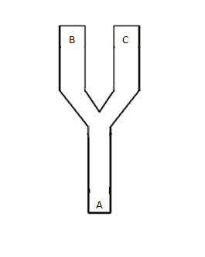
Figure 1. The illustration of the Y-tube.

Results and Discussion
Repellent Effect of Cinnamomum osmophloeum Kaneh and Cymbopogo excavates
Figure 2 shows the repellent effect of Cinnamomum osmophloeum Kaneh. and Cymbopogo excavates. Both plant extracts demonstrated to be repellent to F. taiwana.
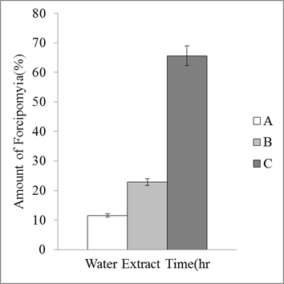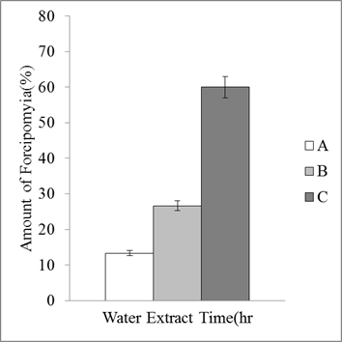
Figure 2. The repellent effect of a) Cinnamomum osmophloeum Kaneh. and b) Cymbopogo excavates. A is the odor mixture end, B is odor end, and C is control end of the Y-tube.

Influence of Water Extract Time on the Repellent Effect of Cinnamomum osmophloeum Kaneh. and Cymbopogo excavates
Figure 3 shows that an extract time of 6 hours does not have a significant influence on the repellent effect of either Cinnamomum osmophloeum Kaneh. or Cymbopogo excavates. This may be due to the fact that the effective material of the plants is not extracted yet. However, with an increase in extract time, there is a greater amount of effective material extracted, resulting in an increase in the repellent effect.

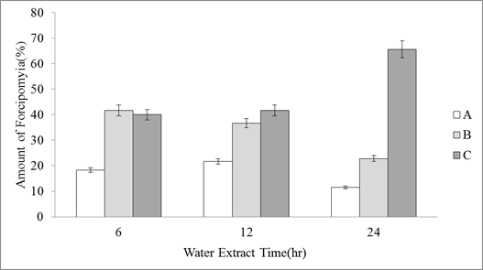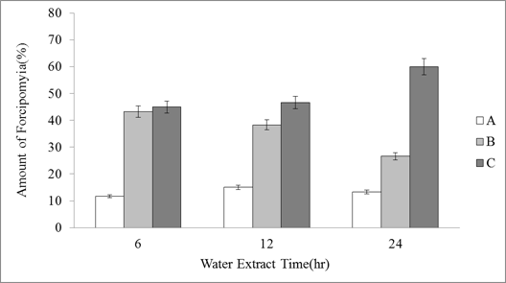
Figure 3. The repellent effect of a) Cinnamomum osmophloeum Kaneh. and b) Cymbopogo excavates as related to water extract time. A is the odor mixture end, B is odor end, and C is control end of the Y-tube.
Conclusion
This study successfully develops natural insecticide. ccording to the experimental results, both Cinnamomum osmophloeum Kaneh and Cymbopogo excavates extracts are repellent to F. taiawana. When extracted for 6 hours, their repellent effect is not very significantly; however, it increases with an increase in water extract time.
Acknowledgements
This work would especially like to thank National Science Council of the Republic of China, Taiwan, for financially supporting this research under Contract NSC 101-2221-E-166-002.
References
- W. Choochote, U. Chaithong, K. Kamsuk, A. Jitpakdi, P. Tippawangkosol, B. Tuetun, D. Champakaew, B. Pitasawat, Repellent activity of selected essential oils against Aedes aegypti, Fitoterapia. 78 (2007) 359-364.
- S.S. Cheng, J.Y. Liu, C.G. Huang, Y.R. Hsui, W.J. Chen, S.T. Chang, Insecticidal activities of leaf essential oils from Cinnamomum osmophloeum against three mosquito species, Bioresour Technol. 100 ( 2009) 457-464.
- S.T. Chang, S.S.Cheng, Antitermitic activity of leaf essential oils and components from Cinnamomum osmophleum, J. Agric. Food Chem. 13 (2002) 1389-1392.
- M.M. Specos, J.J. García, J. Tornesello, P. Marino, M.D. Vecchia, M.V. Tesoriero, L.G. Hermida, Microencapsulated citronella oil for mosquito repellent finishing of cotton textiles, Trans R. Soc. Trop. Med. Hyg. 104 (2010) 653-658.

