Taiwanese Journal of Obstetrics & Gynecology 53 (2014) 542e546
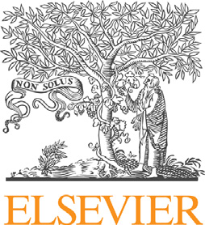
Contents lists available at ScienceDirect

Taiwanese Journal of Obstetrics & Gynecology
journal homepage: www.tjog-online.com
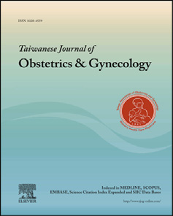
Original Article
Sexual orientations of women with polycystic ovary syndrome: Clinical observation in Taiwan
Ching-Hui Chen a, b, c, Peng-Hui Wang d, e, f, g, Meng-Ti Hsieh h, Chii-Ruey Tzeng a, b, Yi-Hsuan Wu a, Chin-San Lee c, Yuan-Hsiang Chu c, Heng-Yu Chang a, i, *
a Department of Obstetrics and Gynecology, College of Medicine, Taipei Medical University, Taipei, Taiwan b Department of Obstetrics and Gynecology, Taipei Medical University and Hospital, Taipei, Taiwan c Graduate School of Human Sexuality, Shu-Te University, Kaohsiung, Taiwan d Division of Gynecology, Department of Obstetrics and Gynecology, Taipei Veterans General Hospital, Taipei, Taiwan e Department of Obstetrics and Gynecology, National Yang-Ming University, School of Medicine, Taipei, Taiwan f Department of Medical Research, China Medical University Hospital, Taichung, Taiwan g Department of Nursing, National Yang-Ming University, School of Nursing, Taipei, Taiwan h Taipei Cancer Center, Taipei Medical University, Taipei, Taiwan i Department of Biochemistry and Molecular Cell Biology, Taipei Medical University, Taipei, Taiwan

article info abstract

Article history:
Accepted 12 September 2014
Keywords:
heterosexual lesbian polycystic ovary syndrome sexual orientation Taiwan
Objective: This study was conducted to explore the association between sexual orientations and poly-cystic ovary syndrome (PCOS)-related parameters. Materials and methods: A cross-sectional study with participants recruited from the regular outpatient clinic at the Department of Obstetrics and Gynecology at Taipei Medical University Hospital, Taipei, Taiwan between July 2012 and December 2013 was carried out. A total of 97 women met the criterion of having been diagnosed with PCOS. Among these 97 women, 89 were heterosexuals and eight were self-identiﬁed as lesbians. At the same time, 78 women without PCOS were enrolled to serve as the control group. Participants were given a standard questionnaire and had blood withdrawn for biochemical analysis of androgen parametersdincluding total testosterone, androstenedione, sex hormone binding globulin, free androgen index, 17b-estradiol (E2), luteinizing hormone, and follicular-stimulating hormone. The biochemical data were measured to compare the PCOS clinical parameters present in people of different sexual orientations (lesbians and heterosexuals). Results: The women with PCOS, regardless of sexual orientation, had higher percentages and serum levels of hyperandrogenism-related clinical parameters than the women without PCOS [acne (87.5% and
60.7% vs. 23.1%), p < 0.001]; hirsutism (62.5% and 57.3% vs. 15.4%, p三 0.001)]; and biochemical parameters (total T, p < 0.05 or p < 0.001, and luteinizing hormone/follicular-stimulating hormone ratio, p三 0.001]. The sexual orientation of women with PCOS affected their body mass index (BMI), because lesbians with PCOS possessed higher BMI than heterosexual women with PCOS (26.5 ± 1.9 vs.
22.5 ± 0.55; p < 0.05). However, hyperandrogenism-related clinical and biochemical parameters were not signiﬁcantly different statistically between women with PCOS but of different sexual orientations. Conclusion: Our preliminary data showed that sexual orientation inﬂuenced the BMI of women with PCOS, but did not affect hyperandrogenism-related clinical or biochemical characteristics. This observation requires further conﬁrmation. Copyright © 2014, Taiwan Association of Obstetrics & Gynecology. Published by Elsevier Taiwan LLC. All
rights reserved.
Introduction

Polycystic ovary syndrome (PCOS) is a common endocrine disorder that causes substantial psychological, social, and economic
* Corresponding author. Department of Biochemistry and Molecular Cell Biology,
burden for women of various ages [1e5]. The prevalence of PCOS in
College of Medicine, Taipei Medical University, 250 Wuxing Street, Taipei, Taiwan. E-mail address: hychang@tmu.edu.tw (H.-Y. Chang). childbearing aged women is approximately 5e20% [6e8], and
http://dx.doi.org/10.1016/j.tjog.2014.09.002
1028-4559/Copyright © 2014, Taiwan Association of Obstetrics & Gynecology. Published by Elsevier Taiwan LLC. All rights reserved.
accounts for anovulatory infertility [9,10]. Based on the Rotterdam 2003 criteria for the diagnosis of PCOS, the clinical expressions of this disease include chronic anovulation, clinical or biochemical signs of hyperandrogenism, and polycystic ovaries [11], which contribute to the following clinical symptoms: irregular or absent menstrual periods, infertility, excessive growth of body and facial hair, adult acne, high blood pressure, and elevated cholesterol levels. These clinical expressions are thought to result from the imbalance of hormones and insulin resistance of the body. Approximately 50e70% of women with PCOS were found to have symptoms of insulin resistance [12], which contributes to the clinical expression of prediabetes in women with PCOS [13]. Currently, PCOS is considered a genetic disease associated with various conditions including infertility, type 2 diabetes, cardiovascular disease, and ovarian cancer [14]. However, the exact pathophysiology of this complex disease is still unclear.
As discussed above, PCOS is associated with psychological, social, and metabolic problems, as well as issues regarding infertility. However, the relationship between sexual function and PCOS is rarely discussed. Recently, only a few studies have indicated that PCOS is also associated with particular sexual responses and sexual dysfunction [15e17]. Based on the homosexual cases studies, Ferraresi and his colleagues [15] showed that women with PCOS had higher levels of serum androgen and a lower sexual function index, but no signiﬁcant association was found between body mass index (BMI), serum androgen level, and sexual function. Another study conducted by Stovall et al [17] demonstrated that an elevated BMI was associated with a reduction in the orgasm/completion phase during the sexual response cycle, but not associated with acne or hirsutism. Mansson et al [16] further suggested that high BMI had only a minor effect on sexual function, and the total serum testosterone (T) level was positively associated with sexual satisfaction. These homosexual cases studies results imply that BMI and serum androgen levels might be independent factors that contribute to the clinical expression of PCOS. As to the impact of these PCOS-related physiological factors on sexual orientation, a pilot study [18] also suggested that the prevalence of PCOS and its related symptoms might not differ between lesbians and heterosexual women. However, studies on different sexual orientations are still under debate, and physiological factors may still vary between the two groups. For example, it was considered that lesbians have higher T levels than heterosexual women [19]. However, the evidence is still under debate, and very few studies have been done on the relationship between sexual orientation and PCOS. Moreover, the majority of the previous studies were conducted on Caucasians, so the association of PCOS with race, sexual orientation, and hormonal factors is still poorly understood [20].
Thus, in the current study, we took advantage of being based in Asia, because sexual dysfunction is an embarrassing issue and seldom discussed in Asia [21]. We aimed to evaluate the association between sexual orientation and PCOS-related physiological parameters, and to clarify the hormonal factors that may differ between different groups among Taiwanese people. Through the quantitative analysis of questionnaires, patient history, and hormone assays, we evaluated the physical activity, medical history, ultrasound data, and various hormone levels of the patients including 17b-estradiol (E2), luteinizing hormone (LH), follicularstimulating hormone (FSH), prolactin, total T, androstenedione (A4), and sex hormone binding globulin (SHBG). The conventional therapeutic targets of PCOS were aimed at the exhibited symptoms relating to insulin resistance, such as overweight issues and hirsutism. The outcomes of this study advanced our understanding of the relationship between PCOS and sexual orientation in Taiwanese women and provided additional information about the features of PCOS in people of different ethnic backgrounds. The study may also contribute to the improvement of future care for women with PCOS from various cultural backgrounds.
Methods
The study was carried out by using a cross section of participants recruited from the regular outpatient clinic at the Department of Obstetrics and Gynecology at Taipei Medical University Hospital, Taipei, Taiwan between July 2012 and December 2013.
A medical history questionnaire was used to recruit participants. Participants had to meet the following criteria: (1) be between the ages of 20 years and 35 years (this was done to avoid including those who were experiencing the hormonal effects of puberty and premature menopause), (2) have at least one functional ovary, (3) not taking oral contraceptives at the time when blood was drawn,
(4) display no menopausal symptoms (deﬁned by no period in the past 12 months accompanied by hot ﬂashes, vaginal dryness, and dizziness) at the time of participation, and (5) report to have never been diagnosed with Cushing's syndrome, androgen-secreting tumors, or congenital adrenal hyperplasia on the medical history questionnaire that was used for this study. Of the 97 women who met the criteria and were diagnosed with of PCOS, 89 were heterosexuals and eight were lesbians. At the same time, 75 women without PCOS were recruited to serve as the non-PCOS control group. An unpaired t test and two-sided p value were used.
Data collection and laboratory analysis
Upon meeting the eligibility criteria, participants were scheduled to visit our university-afﬁliated hospital. During the ﬁrst clinic visit, participants consented to participate in the study and completed the questionnaires. They were then interviewed regarding their physical activity and medical history. At the second visit, participants underwent a transvaginal or transabdominal ultrasound, and a fasting venipuncture of hormone assays, including, E2, FSH, LH, prolactin, total T, A4, and SHBG. The entire hormone assay was done at a laboratory at Taipei Medical University Hospital using the electrochemiluminescence immune assay. All study instruments and protocols were approved by the University Institutional Review Board (TMU 201202017). The participants completed a lengthy questionnaire about their sexual life history to determine their sexual orientation.
Measurement and observation
Demographic information (race, age, sexual orientation, and education) was obtained from the screening/recruitment forms and questionnaires. Sexual orientation was based primarily on self-identiﬁcation with conﬁrmatory questions regarding sexual behavior, attraction, and sexual history over the past 2 years.
PCOS diagnoses were made by a reproductive endocrinologist, who was blind to the sexual orientation of each participant, using a modiﬁed version of the 2004 and 2009 Rotterdam diagnostic criteria for PCOS [8,11]. In brief, a case of PCOS was identiﬁed when at least two of the following three criteria were met: (1) biochemical and/or clinical hyperandrogenism, (2) oligomenorrhea, and (3) polycystic ovaries on ultrasound, after exclusion of known disorders.
Clinical hyperandrogenism was based on current adult acne and excessive hair growth (hirsutism). Hirsutism was determined by using the modiﬁed FerrimaneGallway scale in which women marked seven body areas (0e4) according to their hair density; a score of 8 or higher indicates excessive hair growth. Biochemical hyperandrogenism was deﬁned by elevated total T and A4 (>2.4 ng/ mL) concentrations [22]. Oligomenorrhea was deﬁned as menstrual cycles at least 40 days apart within the past year or <6e9 menstrual cycles per year (at the time that blood was drawn), and was veriﬁed by a reproductive endocrinologist who reviewed participants' ﬁles.
BMI was used to create the following categories: <25 (underweight/normal); 25.0e29.0 (overweight), and這30.0 (obesity). In addition, blood assays were conducted to obtain related hormone assays. Overall, the PCOS diagnosis was conﬁrmed via a thorough review of participant ﬁles and blood results as well as ultrasound.
Results
Clinical characteristics of PCOS in those with different sexual orientations and controls
The clinical and biochemical features of PCOS are shown in Table 1. The PCOS group was subdivided into two groups based on different sexual orientations (heterosexuals and lesbians), and compared with the non-PCOS group (control groups). In terms of age, women in the control groups were older than those in both of the PCOS groups. As expected, acne and hirsutismdclinical characteristics of hyperandrogenismdoccurred more frequently in the PCOS groups. The group that comprised lesbians had a higher BMI than the group made up of heterosexuals (p ¼ 0.04) and the control group (p ¼ 0.04). The BMI of the heterosexuals was similar to that of the non-PCOS group (p ¼ 0.92; Fig. 1).
PCOS patients are associated with higher serum levels of testosterone
Consistent with the above ﬁndings regarding clinical hyperandrogenism, both the lesbian and heterosexual groups with PCOS displayed signiﬁcant increase in the levels of total T (0.34 ± 0.13 ng/ mL and 0.41 ± 0.24 ng/mL vs. 0.25 ± 0.12 ng/mL, respectively, both p < 0.05) and an abnormally higher ratio of LH and FSH (2.20 ± 0.65 and 2.90 ± 1.80 vs. 0.88 ± 0.34, respectively, both p < 0.05). However, there was no difference in terms of total T and A4 between heterosexuals and lesbians in the PCOS group (Fig. 2A and B). The level of SHBG, a surrogate marker of insulin resistance, seemed to be reduced in lesbians of the PCOS group, contributing to the higher levels of free androgen index, which was calculated using the formula: Testosterone/SHBG x 100, compared with those in the heterosexuals of the PCOS group; however, both did not reach statistical signiﬁcance (Fig. 3A and B).
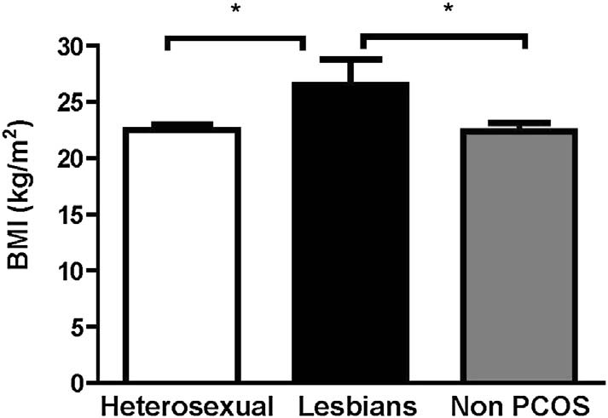
Figure 1. Comparison of body mass index (BMI) in heterosexuals, lesbians, and nonpolycystic ovary syndrome (non-PCOS) groups. BMI in the PCOS lesbian group was signiﬁcantly higher than that in the PCOS heterosexual and non-PCOS groups. *p < 0.05.
Taken together, the sexual orientation of PCOS patients might be different between high and normal BMI groups; however, androgen-related clinical or biochemical characteristics might not be strongly associated with sex orientation in these PCOS patients.
Discussion
One of the important ﬁndings of the current study is that a high rate of lesbians (9%) was found among the PCOS patients, demonstrated by the fact that PCOS patients were recruited from the regular gynecology and obstetrics clinic rather than the infertility clinic. This is important given that the vast majority of PCOS studies have been done on patients in infertility clinics [23e25]. No lesbians would have attended fertility clinics in Taiwan as it is not approved by law. Thus, we evaluated the clinical and biochemical indications of the PCOS patients in the regular clinics, and found that an important parameter of PCOS, BMI, was greater in the lesbian group and had a positive association with PCOS.
This observation suggested that high BMI in lesbians could be a risk factor that subsequently causes severe insulin resistance. Complications regarding a metabolic disorder could be a challenge for PCOS progression. This is a reasonable conclusion because lesbians are reported to be at high risk of obesity and cardiovascular disease [25]. It was then not a surprising result that reduced SHBG in the lesbian group was observed, although it did not reach
Table 1
The clinical and biochemical baseline characteristics of PCOS in women of different sexual orientations.
PCOS |  |  | Controls | L vs. H | L vs. C | H vs. C
L(n ¼ 8) |  | H (n ¼ 89) | C (n ¼ 78) | p | p | p
Age (y) | 25.0 ± 5.1 | 26.5 ± 5.6 | 30.7 ± 6.5 | 0.469 | 0.019 | <0.001
BMI (kg/m2) | 26.5 ± 6.5 | 22.5 ± 5.2 | 22.4 ± 5.0 | 0.042 | 0.043 | 0.922
Acne | 87.5 | 60.7 | 23.1 | 0.132 | <0.001 | <0.001
Hirsutism | 62.5 | 57.3 | 15.4 | 0.542 | 0.001 | <0.001
Oligomenorrhea | 50.0 | 59.6 | 30.8 | 0.433 | 0.234 | <0.001
E2 (pmol/L) | 59.1 ± 13.4 | 129.7 ± 151.2 | 79.8 ± 69.0 | <0.001 | 0.027 | 0.006
LH (IU/L) | 12.7 ± 5.1 | 15.1 ± 8.1 | 5.2 ± 2.4 | 0.422 | 0.004 | <0.001
FSH (IU/L) | 5.7 ± 1.3 | 5.6 ± 2.1 | 6.4 ± 2.6 | 0.874 | 0.475 | 0.034
LH/FSH ratio | 2.20 ± 0.65 | 2.90 ± 1.80 | 0.88 ± 0.34 | 0.242 | 0.001 | <0.001
Prolactin (ng/mL) | 21.2 ± 13.3 | 13.3 ± 6.3 | 15.6 ± 6.8 | 0.141 | 0.049 | 0.027
T (ng/mL) | 0.34 ± 0.13 | 0.41 ± 0.24 | 0.25 ± 0.12 | 0.432 | 0.047 | <0.001
A4 (ng/mL) | 2.4 ± 1.0 | 2.4 ± 1.5 | N.A. | 0.936
SHBG (nmol/L) | 38.6 ± 29.3 | 59.3 ± 36.7 | N.A. | 0.125
FAI | 0.08 ± 0.04 | 0.07 ± 0.11 | N.A. | 0.790

Data are presented as % or mean ± SD. The p values were derived from unpaired Student t test. A4 ¼ androstenedione; BMI ¼ body mass index; C ¼ non-PCOS controls; E2 ¼ 17b-estradiol; FAI ¼ free androgen index; FSH ¼ follicle-stimulating hormone; H ¼ heterosexual with PCOS; L ¼ Lesbian with PCOS; LH ¼ luteinizing hormone; N.A. ¼ not applicable; PCOS ¼ polycystic ovary syndrome; SHBG ¼ sex hormone binding globulin; T ¼ total testosterone.
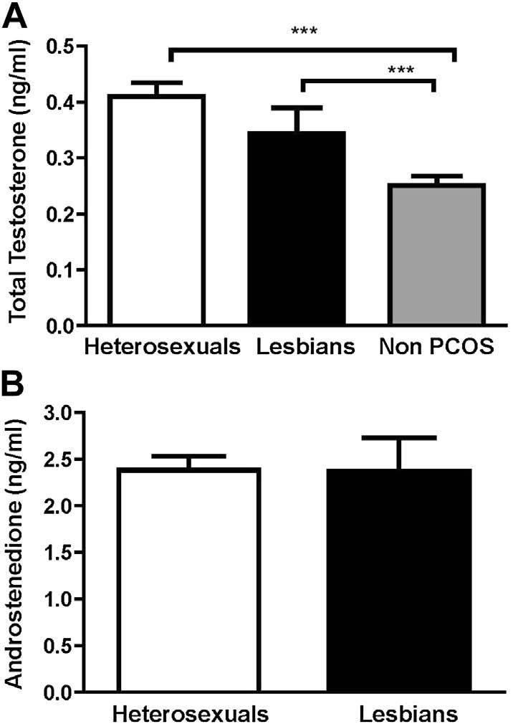

Figure 2. Serum concentrations of total testosterone (ng/mL) and androstenedione (ng/mL) in women with polycystic ovary syndrome (PCOS) of different sexual orientations (heterosexuals and lesbians), compared with women with non-PCOS. (A) PCOS patients had higher levels of total testosterone in both the heterosexual and lesbian groups than non-PCOS patients, where there was no signiﬁcant difference between heterosexuals and lesbians. (B) There were no considerable differences in androstenedione between the heterosexual and lesbian groups. ***p < 0.0001.
Figure3.Serumconcentrationsofsexhormonebindingglobulin(SHBG)andfreeandrogenindex(FAI)inwomenwithpolycysticovarysyndrome(PCOS)ofdifferentsexualorientations(heterosexualsandlesbians).(A)ThetrendoflowerlevelsofSHBGwasobservedinthelesbiangroup.(B)FAIincreasedinthelesbiangroup;however,theywerenotstatisticallysigniﬁcantlydifferent.
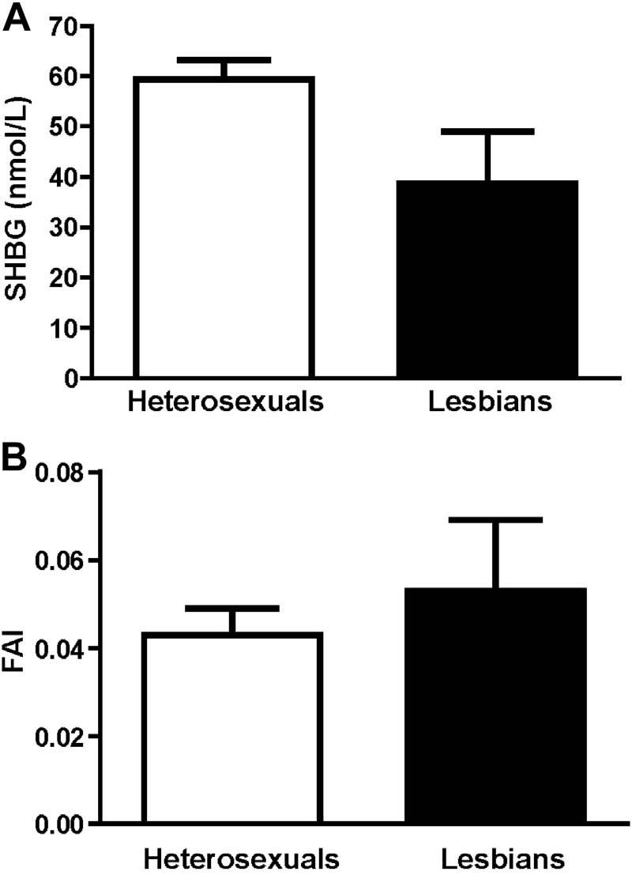
statistical signiﬁcance, given that lower SHBG is a known indication of insulin resistance. This hypothesis, however, requires further investigation. Most notably, we did not observe statistically increased levels of androgen-related hormones, such as total T and A4, in lesbians with PCOS, when compared with heterosexual women with PCOS. In fact, although PCOS patients had statistically higher total T serum levels than controls did, our data showed that total T in young Taiwanese women was not as high as in advanced-aged women as reported previously [26e28]. This is logical in view of the fact that natural total T levels rise with age in women [26]. This, however, could be noted as the age effect in PCOS patients. Furthermore, data on advanced-aged women are usually obtained from infertility clinics where patients often have received various hormonal treatments from fertility treatments they have sought in the past. Although the sample size was relatively small, the data presented in this manuscript provide a preliminary observation of the association between sexual orientation and PCOS in Taiwan. Herein, we have concluded that a high level of BMI in lesbians may be a risk factor for severe insulin resistance and consequently cause a metabolic disorder or symptoms such as Diabetes Mellitus (DM) or PCOS. Sexual orientation might not inﬂuence the level of androgen-related clinical or biochemical characteristics of women with PCOS in Taiwan.
Conﬂicts of interest
The authors have no conﬂicts of interest relevant to this article.
Acknowledgments
The authors thank Dr Ming-I Hsu at Wan-Fang Hospital, Taipei, Taiwan for generous discussions during the manuscript preparation. This work was supported in part by a joint grant from Taipei Medical University and Taipei Medical University Hospital (TMU100-AE3-Y10 and TMU101-AE3-Y10 to H.-Y.C. and C.-H.C.), and also by the Ministry of Science and Technology, Executive Yuan (MOST 103-2314-B-010 -043 -MY3 to P.-H.W.), and Taipei Veterans General Hospital (V102E4-003; V103A-016; V103C-112; and V103E4-003 to P.-H.W.), Taipei, Taiwan.
References
[1] Azziz R, Marin C, Hoq L, Badamgarav E, Song P. Health care-related economic burden of the polycystic ovary syndrome during the reproductive life span. J Clin Endocrinol Metab 2005;90:4650e8.
[2] Tzeng CR, Chang YC, Chang YC, Wang CW, Chen CH, Hsu MI. Cluster analysis of cardiovascular and metabolic risk factors in women of reproductive age. Fertil Steril 2014;101(5):1404e10.
[3] Chang CY, Chen MJ, Yang WS, Yeh CY, Ho HN, Chen SU, et al. Hypoadiponectinemia: a useful marker of dyslipidemia in women with polycystic ovary syndrome. Taiwan J Obstet Gynecol 2012;51:583e90.
[4] Lin MW, Tsai SJ, Chou PY, Huang MF, Sun HS, Wu MH. Vitamin D receptor 1a promotor e1521 G/C and e1012 A/G polymorphisms in polycystic ovary syndrome. Taiwan J Obstet Gynecol 2012;51:565e71.
[5] Chen MJ, Yang WS, Yang JH, Chen CL, Ho HN, Yang YS. Relationship between androgen levels and blood pressure in young women with polycystic ovary syndrome. Hypertension 2007;49:1442e7.
[6] Hung JH, Hu LY, Tsai SJ, Yang AC, Huang MW, Chen PM, et al. Risk of psychiatric disorders following polycystic ovary syndrome: a nationwide population-based cohort study. PLoS One 2014;9:e97041.
[7] March WA, Moore VM, Willson KJ, Phillips DI, Norman RJ, Davies MJ. The prevalence of polycystic ovary syndrome in a community sample assessed under contrasting diagnostic criteria. Hum Reprod 2010;25:544e51.
[8] Lauritsen MP, Bentzen JG, Pinborg A, Loft A, Forman JL, Thuesen LL, et al. The prevalence of polycystic ovary syndrome in a normal population according to the Rotterdam criteria versus revised criteria including anti-Mullerian hormone. Hum Reprod 2014;29:791e801.
[9] Petraglia F, Serour GI, Chapron C. The changing prevalence of infertility. Int J Gynaecol Obstet 2013;123:S4e8.
[10] Thessaloniki ESHRE/ASRM-Sponsored PCOS Consensus Workshop Group. Consensus on infertility treatment related to polycystic ovary syndrome. Fertil Steril 2008;89:505e22.
[11] Rotterdam ESHRE/ASRM-Sponsored PCOS Consensus Workshop Group. Revised 2003 consensus on diagnostic criteria and long-term health risks related to polycystic ovary syndrome. Fertil Steril 2004;81:19e25.
[12] Dunaif A. Insulin resistance and the polycystic ovary syndrome: mechanism and implications for pathogenesis. Endocr Rev 1997;18:774e800.
[13] Veltman-Verhulst SM, Goverde AJ, van Haeften TW, Fauser BC. Fasting glucose measurement as a potential ﬁrst step screening for glucose metabolism abnormalities in women with anovulatory polycystic ovary syndrome. Hum Reprod 2013;28:2228e34.
[14] Welt CK, Duran JM. Genetics of polycystic ovary syndrome. Semin Reprod Med 2014;32:177e82.
[15] Ferraresi SR, Lara LA, Reis RM. Rosa e Silva AC. Changes in sexual function among women with polycystic ovary syndrome: a pilot study. J Sex Med 2013;10:467e73.
[16] Mansson M, Norstrom K, Holte J, Landin-Wilhelmsen K, Dahlgren E, Landen M. Sexuality and psychological wellbeing in women with polycystic ovary syndrome compared with healthy controls. Eur J Obstet Gynecol Reprod Biol 2011;155:161e5.
[17] Stovall DW, Scriver JL, Clayton AH, Williams CD, Pastore LM. Sexual function in women with polycystic ovary syndrome. J Sex Med 2012;9:224e30.
[18] Smith HA, Markovic N, Matthews AK, Danielson ME, Kalro BN, Youk AO, et al. A comparison of polycystic ovary syndrome and related factors between lesbian and heterosexual women. Womens Health Issues 2011;21:191e8.
[19] Gartrell NK, Loriaux DL, Chase TN. Plasma testosterone in homosexual and heterosexual women. Am J Psychiatry 1977;134:1117e8.
[20] Agrawal R, Sharma S, Bekir J, Conway G, Bailey J, Balen AH, et al. Prevalence of polycystic ovaries and polycystic ovary syndrome in lesbian women compared with heterosexual women. Fertil Steril 2004;82:1352e7.
[21] Chen CH, Lin YC, Chiu LH, Chu YH, Ruan FF, Liu WM, et al. Female sexual dysfunction: the deﬁnition, classiﬁcation and debates. Taiwan J Obstet Gynecol 2013;52:3e7.
[22] Ferriman D, Gallwey JD. Clinical assessment of body hair growth in women. J Clin Endocrinol Metab 1961;21:1440e7.
[23] Liang SJ, Hsu CS, Tzeng CR, Chen CH, Hsu MI. Clinical and biochemical presentation of polycystic ovary syndrome in women between the ages of 20 and
40. Hum Reprod 2011 Dec;26(12):3443e9.
[24] Seow KM, Wang PH. Anti-Mullerian hormone: a marker for prediction of ovarian function and polycystic ovary syndrome. J Chin Med Assoc 2012;75: 93e4.
[25] Fredriksen-Goldsen KI, Kim HJ, Barkan SE, Muraco A, Hoy-Ellis CP. Health disparities among lesbian, gay, and bisexual older Adults: results from a population-based study. Am J Public Health 2013;103:1802e9.
[26] Hsu MI. Changes in the PCOS phenotype with age. Steroids 2013;78:761e6.
[27] Liou TH, Yang JH, Hsieh CH, Lee CY, Hsu CS, Hsu MI. Clinical and biochemical presentations of polycystic ovary syndrome among obese and nonobese women. Fertil Steril 2009;92:1960e5.
[28] Seow KM, Lin YH, Wang PH, Hwang JL, Ho LT, Juan CC. Aquaglyceroporin-7 overexpression in women with the polycystic ovary syndrome. Gynecol Obstet Invest 2013;75:126e31.
䘀椀最甀爀攀㌀⸀匀攀爀甀洀挀漀渀挀攀渀琀爀愀琀椀漀渀猀漀昀猀攀砀栀漀爀洀漀渀攀戀椀渀搀椀渀最最氀漀戀甀氀椀渀⠀匀䠀䈀䜀⤀愀渀搀昀爀攀攀愀渀搀爀漀最攀渀椀渀搀攀砀⠀䘀䄀䤀⤀椀渀眀漀洀攀渀眀椀琀栀瀀漀氀礀挀礀猀琀椀挀漀瘀愀爀礀猀礀渀搀爀漀洀攀⠀倀䌀伀匀⤀漀昀搀椀昀昀攀爀攀渀琀猀攀砀甀愀氀漀爀椀攀渀琀愀琀椀漀渀猀⠀栀攀琀攀爀漀猀攀砀甀愀氀猀愀渀搀氀攀猀戀椀愀渀猀⤀⸀⠀䄀⤀吀栀攀琀爀攀渀搀漀昀氀漀眀攀爀氀攀瘀攀氀猀漀昀匀䠀䈀䜀眀愀猀漀戀猀攀爀瘀攀搀椀渀琀栀攀氀攀猀戀椀愀渀最爀漀甀瀀⸀⠀䈀⤀䘀䄀䤀椀渀挀爀攀愀猀攀搀椀渀琀栀攀氀攀猀戀椀愀渀最爀漀甀瀀㬀栀漀眀攀瘀攀爀Ⰰ琀栀攀礀眀攀爀攀渀漀琀猀琀愀琀椀猀琀椀挀愀氀氀礀猀椀最渀椀ǻ挀愀渀琀氀礀搀椀昀昀攀爀攀渀琀⸀

