Taiwanese Journal of Obstetrics & Gynecology 53 (2014) 523e529

Contents lists available at ScienceDirect

Taiwanese Journal of Obstetrics & Gynecology
journal homepage: www.tjog-online.com
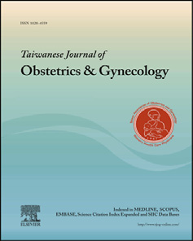
Original Article
Single-port compared with conventional laparoscopic cystectomy for ovarian dermoid cysts
Ben-Shian Huang a, b, c, d, Peng-Hui Wang a, b, c, d, e, f, Hsiao-Wen Tsai a, c, d, Teh-Fu Hsu d, g, Ming-Shyen Yen a, c, Yi-Jen Chen a, c, d, *
a Department of Obstetrics and Gynecology, Taipei Veterans General Hospital, Taipei, Taiwan b Department of Obstetrics and Gynecology, National Yang-Ming University Hospital, Ilan, Taiwan c Department of Obstetrics and Gynecology, National Yang-Ming University, Taipei, Taiwan d Institute of Clinical Medicine, National Yang-Ming University, Taipei, Taiwan e Immunology Center, Taipei Veterans General Hospital, Taipei, Taiwan f Department of Medical Research, China Medical University, Taichung, Taiwan g Department of Emergency Medicine, Taipei Veterans General Hospital, Taipei, Taiwan

article info abstract

Article history:
Accepted 5 May 2014
Keywords:
conventional laparoscopic surgery ovarian dermoid cyst single-port laparoscopic surgery
Objective: We compared the immediate surgical outcomes of single-port laparoscopic cystectomy (SLC) and conventional laparoscopic cystectomy (CLC) for managing ovarian dermoid cysts. Materials and methods: A retrospective case-control study was conducted to enroll 71 patients with dermoid cysts, including 34 patients in the SLC group and 37 patients in the CLC group. The outcome measures included operative time, blood loss, postoperative pain, analgesic use, and serum levels of hormones, including estrogen (E2), follicle-stimulating hormone, luteinizing hormone, and anti-Mullerian hormone. Results: SLC was associated with less time required for specimen retrieval (1.3 ± 0.8 vs. 12.0 ± 3.4 minutes, p < 0.001), fewer ruptured bags (0% vs. 10.8%, p ¼ 0.049), and less need of additional wound elongation (0% vs. 27.0%, p ¼ 0.001) when respectively compared with CLC. Additionally, patients who underwent SLC reported lower postoperative lower abdominal pain and less accumulated postoperative analgesics when respectively compared with patients who underwent CLC. There was no signiﬁcant difference of hormones between two groups. Conclusion: Our study demonstrated the feasibility of using the single-port method in place of CLC in the management of ovarian dermoid without increased difﬁculty of techniques or risk of ovarian damage. Copyright © 2014, Taiwan Association of Obstetrics & Gynecology. Published by Elsevier Taiwan LLC. All
rights reserved.

Introduction
The advantages of laparoscopy include less intraoperative blood loss, a reduced need for postoperative analgesic, shorter hospital stays, and better cosmetic results compared with laparotomic surgery [1e3]. A recent advancement in the ﬁeld of minimally invasive gynecology is transumbilical single-port laparoscopy (SPL) or transvaginal natural oriﬁce transluminal endoscopic surgery, which is an attempt to enhance the cosmetic beneﬁts and minimize the morbidity associated with abdominal incisions [4e6]. Although
* Corresponding author. Department of Obstetrics and Gynecology, Taipei Veterans General Hospital, and National Yang-Ming University, 201, Section 2, Shih-Pai Road, Taipei 112, Taiwan.
E-mail address: chenyj@vghtpe.gov.tw (Y.-J. Chen).
http://dx.doi.org/10.1016/j.tjog.2014.05.003
gynecologic surgeons pioneered pelvic laparoscopy to conduct tubal ligation through a single umbilical incision in the 1970s [7], more advanced procedures were reported years later, with the ﬁrst single-port hysterectomy reported by Pelosi and Pelosi [8] in 1991 and the ﬁrst single-port ovarian cystectomy reported by Kosumi et al in 2001 [4].
Through technological innovations, single-port adnexal surgeries have increasingly been conducted with comparable results to conventional multiple-port laparoscopy [9e27]. However, ovarian reservation is still a challenge and requires the preservation of as much normal tissue as possible during single-port laparoscopic cystectomy (SLC) [28,29]. Through a single subumbilical single-port incision, the limited range of instrument motion makes enucleation and suturing difﬁcult and increases the operation time [21,30]. Although several studies on SPL have addressed how to
1028-4559/Copyright © 2014, Taiwan Association of Obstetrics & Gynecology. Published by Elsevier Taiwan LLC. All rights reserved.
manage adnexal lesions, including patients with dermoid cysts, specimen retrieval and spillage of cyst content have not been elucidated [15,21,22,24,30].
Laparoscopic cystectomy for managing ovarian dermoid cysts has been well documented and has several advantages, such as less intraoperative blood loss, less postoperative pain, less postoperative analgesic requirement, shorter hospital stay, and better cosmetic results [1e3]. However, there are still some problems during conventional laparoscopic cystectomy (CLC) for ovarian dermoid cyst. The fascia must be torn and stretched when retrieving a dermoid cyst through one 10-mm or less trocar incision during CLC, and spillage sometimes occurs [31e34]. Although the malignancy rate of ovarian dermoid cysts is low, the cancer cells can still spread [35]. Therefore, the wound must be elongated to avoid spillage during retrieval of dense specimens or specimens with calciﬁed contents [33,36].
Although the aforementioned studies reveal that SPL can provide results that are comparable to conventional laparoscopy, SLC and CLC have not been directly compared for managing ovarian dermoid cysts. In this article, we describe single-port compared with conventional multiport laparoscopic cystectomy for the management of ovarian dermoid cysts.
Materials and methods
Study population
This study was designed as a retrospective case-control study, and port placement was one of the differences in operative procedures between the two groups. Patients who opted for the use of the Alexis small wound retractor (Applied Medical, Rancho Santa Margarita, CA, USA) at their own expense were enrolled in the SLC group, and those who did not were enrolled in the CLC group. Patients with ovarian dermoid cysts were evaluated at Taipei Veterans General Hospital from June 13, 2011 through June 12, 2013. Approval for the study was obtained from the hospital's ethics committee, and informed consent was obtained from all patients (VGHIRB 2011-06-004IA; NCT02009228). Inclusion criteria were as follows: the patient received cystectomy for ovarian dermoid cysts (even while pregnant), an American Society of Anesthesiologists physical status classiﬁcation of I or II, and the patient provided signed informed consent.
Patients who received an oophorectomy for dermoid cyst or had a dermoid ovarian cyst with malignant potential and concomitant surgeries for uterine lesion, pelvic organ prolapse, or urodynamic urinary incontinence were excluded (Fig. 1).
Surgical technique
The following procedures were followed to establish the three-channel single port: a 1.5-cm horizontal intraumbilical skin incision, a 1.5e2-cm rectus fasciotomy to open the peritoneal cavity, and the insertion of an Alexis small wound retractor (Applied Medical). The wrist portion of a size 6.5 surgical glove was ﬁxed to the outer ring of the wound retractor [37]. A 12-mm trocar was inserted through a small hole made in one of the ﬁngertips of the glove and advanced into the abdominal cavity. Two additional holes for the accessory channels were made in another ﬁngertip of the glove, and two conventional 5-mm trocars were inserted through the holes (Fig. 2).
Laparoscopic enucleation was performed after placing the ovary in a LiNA Easy Bag (Endobag) (125 x 200 mm for a 10-mm trocar; LiNA Medical, Glostrup, Denmark) to prevent intraperitoneal spillage. After enucleation of the ovarian dermoid cysts, the ovarian cortical strips were closed with 2e0 V-Loc sutures (Covidien, Mansﬁeld, MA, USA) in all patients. Electric cauterization for hemostasis was not used during enucleation and closure of ovary. The specimen was thoroughly removed through the Endobag.
After hemostasis, the single-port was removed, and the umbilical fascia and subcutaneous tissue were closed with size 2e0 Polysorb sutures. After the procedure was completed, Dermabond skin adhesive (Ethicon, Raleigh, NC, USA) was used to close the skin. Patients were discharged when they were fully ambulatory and apyrexial.
All procedures were performed by a single surgeon (Y.J.C.), assisted by another two surgeons (B.S.H. or H.W.T.), at a single institute (Taipei Veterans General Hospital) during the study period.
Outcome measurements
Patient data including demographic information, ﬁnal pathology, operative time, blood loss, low abdominal pain, shoulder tip pain, postoperative hospital stay, serum levels of estrogen (E2), follicle-stimulating hormone (FSH), luteinizing hormone (LH), and anti-Mullerian hormone (AMH) were collected. A visual analog pain scale (VAS) applicable to the patients was used to evaluate postoperative pain at 12, 24, and 48 hours after the surgery. The VAS consisted of a nongraduated 10-cm line ranging from “no pain” to “pain as bad as it could be”. In addition, the postoperative use of analgesics (meperidine prescribed as a 50-mg intramuscular injection every 4 hours and tenoxicam prescribed as a 20-mg intramuscular injection every 24 hours) was administered when requested by the patient, which was recorded. The accumulated dose was calculated as the summation of all used meperidine or tenoxicam per patient during the postoperative 48 hours.
Serum E2, FSH, LH, and AMH levels were assessed before the operation and 4 weeks after operation. Serum AMH concentrations were assayed using the ACTIVE MIS/AMH ELISA kit (reference DSL10-14400; Diagnostic Systems Laboratories, Inc., Webster, TX, USA) according to the manufacturer's instructions.
Statistical analysis
Statistical analysis was performed using SPSS 18.0.0 software (SPSS, Chicago, IL, USA). Descriptive statistics are presented as the means and standard deviation or percentages. Discrete variables were analyzed by the Chi-square or Fisher exact test; continuous variables were analyzed with the Student t test. A two-tailed p < 0.05 was considered signiﬁcant.
Results
A total of 90 patients scheduled for laparotic cystectomy were screened in this study; 19 patients were excluded for various reasons including oophorectomy for dermoid cyst (n ¼ 6), additional gynecologic surgery (n ¼ 8), and declining to participate (n ¼ 5) (Fig. 1). Overall, 34 patients in the SLC group and 37 patients in the CLC group were included for analysis, including two pregnant patients who received SLC during the second trimester without an additional accessory port (Table 1).
Demographic parameters, including age, parity, body mass index, location of ovarian dermoid cysts, history of abdominal surgery, adhesion, and size of ovarian dermoid cysts, were comparable between the two groups (Table 2).
The surgical outcomes of the two groups are shown in Table 2. There were no signiﬁcant differences for the total operative time
(92.35 ± 17.13 minutes for the SLC group compared with
83.38 ± 20.70 minutes for the CLC group, p ¼ 0.052), the time required to set the port (7.56 ± 1.88 minutes for the SLC group
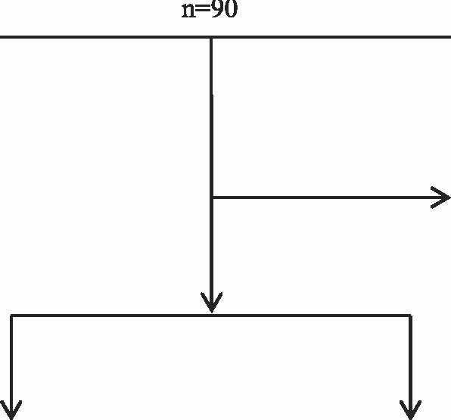
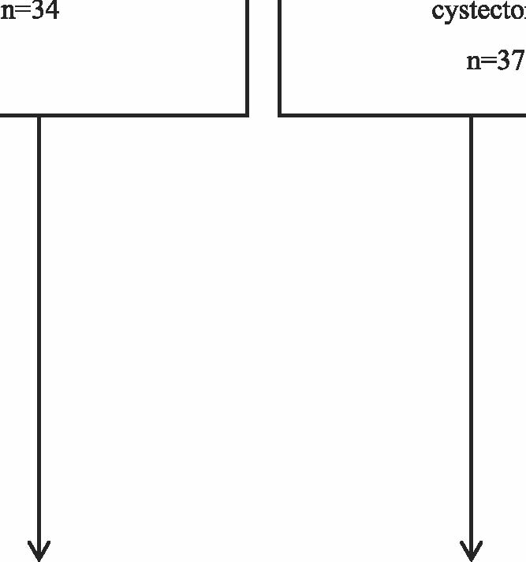
Fig.2.Portplacementforthesingle-portthree-channelsystem.
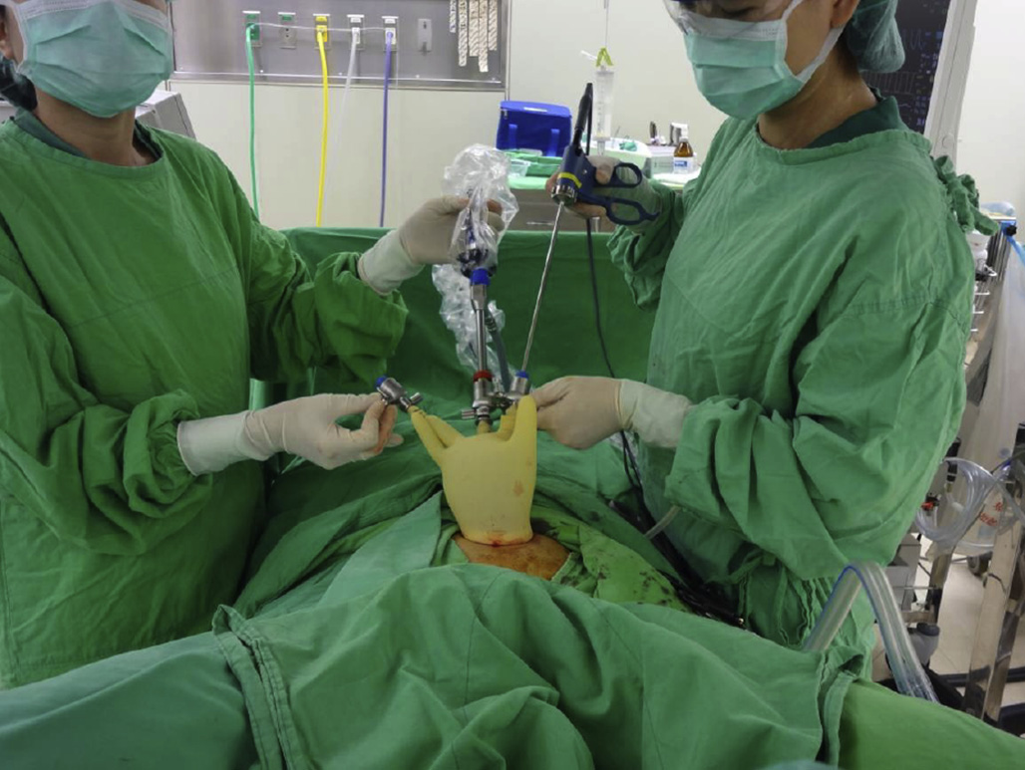
Fig. 1. Flowchart of group allocation.

compared with 8.09 ± 2.09 minutes for the CLC group, p ¼ 0.187), or the time to close the skin wound (10.24 ± 1.89 minutes for the SLC group compared with 10.05 ± 2.25 minutes for the CLC group, p ¼ 0.716) (Table 3).
The SLC required longer time to enucleate the ovarian cyst
(59.32 ± 15.54 minutes for the SLC group compared with
46.05 ± 18.48 minutes for the CLC group, p ¼ 0.002) and to suture the ovary (13.85 ± 4.51 minutes for the SLC group compared with
Table 1
Characteristics of the two pregnant patients who underwent single-port laparoscopic cystectomy.
GA (wk) Size OP BL PS PS PS Stay Outcome (mm) (min) (mL) (12 h) (24 h) (48 h) (d)
115 þ 210013920 8 2 2 5NSD
214 68 10620 10 3 2 12C/S
BL ¼ blood loss; C/S ¼ cesarean section; GA ¼ gestational age; NSD ¼ normal spontaneous delivery; OP ¼ operation time; Outcome ¼ pregnancy outcomedboth babies are healthy in term; PS ¼ pain score; Stay ¼ hospital stay.
526 | B.-S. Huang et al. / Taiwanese Journal of Obstetrics & Gynecology 53 (2014) 523e529
Table 2
Patient characteristics.
 | SLC groupa (n ¼ 34) | CLC group (n ¼ 37) | p | Mean difference (95% CI)
Age Para BMI (kg/m2) Location | 34.59 ± 10.18 0.79 ± 1.15 21.29 ± 2.52 | 34.73 ± 9.68 0.59 ± 0.95 21.14 ± 2.61 | 0.952 0.428 0.813 0.118 | -0.14 (-4.85 to 4.56) 0.20 (-0.30 to 0.70) 0.14 (-1.07 to 1.36)
Left Right Bilateral Previous surgery Adhesion Size (largest size in cm) Follow-up period (mo) | 12 (35.3) 21 (61.8) 1 (2.9) 7 (20.6) 9 (26.5) 7.05 ± 2.37 5.79 ± 3.34 | 20 (54.1) 14 (37.8) 3 (8.1) 4 (10.8) 10 (27.0) 6.39 ± 2.27 4.35 ± 3.31 | 0.255 0.958 0.236 0.065 | 0.66 (-0.44 to 1.76) 1.44 (-0.09 to 2.98)

Data are presented as mean ± standard deviation or n (%) unless otherwise speciﬁed. BMI ¼ body mass index; CI ¼ conﬁdence interval; CLC ¼ conventional laparoscopic cystectomy; SLC ¼ single-port laparoscopic cystectomy.
a
Two patients underwent single-port LC at 15 and 14 weeks of pregnancy.

7.14 ± 2.76 minutes for the CLC group, p < 0.001), but less time to retrieve the specimen (1.32 ± 0.84 minutes for the SLC group compared with 11.95 ± 3.43 minutes for the CLC group, p < 0.001). The spillage rate was similar between the two groups (14.7% vs. 16.2%, p ¼ 0.861), whereas there were signiﬁcantly more ruptured Endobags (0% in the SLC group vs. 10.8% in the CLC group, p ¼ 0.049) and additional umbilical wound elongation (0% in the SLC group vs. 27.0% in the CLC group, p ¼ 0.001) in the CLC group (Table 3).
There was no difference between the two groups in terms of the need for an additional trocar owing to severe adhesion associated with previous abdominal surgeries (5.9% vs. 0%, p ¼ 0.255), drainage (5.9% vs. 8.1%, p ¼ 0.714), blood loss (108.68 ± 32.58 mL for the SLC group compared with 98.43 ± 30.92 mL for the CLC group, p ¼ 0.880), or hospital stay (4.03 ± 1.60 days for the SLC group compared with 3.78 ± 0.78 days for the CLC group, p ¼ 0.401). The two groups presented no signiﬁcant difference in the rate of wound infections (2.9% vs. 5.4%, p ¼ 0.606), whereas no injury to adjacent organs, postoperative ileus, pelvic hematoma formation, urinary tract infection, or trocar site hernia was noted in either group (Table 3).
Table 3
Surgical outcomes.
SLC was associated with reductions in postoperative pain and the use of analgesics, with signiﬁcantly lower postoperative pain scores after 12 and 24 hours (5.68 ± 1.43 compared with 6.49 ± 1.63 in the CLC group at 12 hours, p ¼ 0.030, and 2.50 ± 0.79 compared with 3.65 ± 1.06 in the CLC group at 24 hours, p < 0.001) and lower accumulated doses of meperidine hydrochloride (34.85 ± 9.41 mg compared with 64.19 ± 20.12 mg in the CLC group, p < 0.001) and tenoxicam (14.41 ± 9.11 mg compared with 28.78 ± 10.30 mg in the CLC group, p < 0.001). By comparison, the postoperative pain scores after 48 hours were similar between the two groups (1.47 ± 0.93 compared with 2.03 ± 0.96, p ¼ 0.160) (Table 3).
Moreover, an analysis of the laparoscopy-induced shoulder tip pain scores showed no difference between the two groups
(3.26 ± 1.02 compared with 3.35 ± 0.98 at 12 hours, p ¼ 0.717;
2.26 ± 0.90 compared with 2.24 ± 0.86 at 24 hours, p ¼ 0.919; and
0.88 ± 0.81 compared with 0.84 ± 0.83 at 48 hours, p ¼ 0.820) (Table 3).
The ovarian reserve markers, including preoperative and postoperative E2, FSH, LH, FSH/LH ratio, and AMH levels, were analyzed and showed no signiﬁcant differences between the two groups
SLC group |  | CLC group | p | Mean difference
(n ¼ 34) |  | (n ¼ 37) |  | (95% CI)
Operative time (min)
Total time | 92.35 ± 17.13 | 83.38 ± 20.70 | 0.052 | 8.69 (2.59 e 22.80)
Set the port | 7.56 ± 1.88 | 8.09 ± 2.09 | 0.187 | -0.63 (-1.55 to 0.31)
Enucleate the dermoid cyst | 59.32 ± 15.54 | 46.05 ± 18.48 | 0.002 | 13.27 (5.15 to 21.39)
Suture the ovary | 13.85 ± 4.51 | 7.14 ± 2.76 | <0.001 | 0.88 (4.92 to 8.52)
Remove the specimen | 1.32 ± 0.84 | 11.95 ± 3.43 | <0.001 | 0.61 (-11.83 toe 9.42)
Close the skin wound | 10.24 ± 1.89 | 10.05 ± 2.25 | 0.716 | 0.49 (-0.81 to 1.17)
Spillage of the ovarian cyst during enucleation | 5 (14.7) | 6 (16.2) | 0.861
Rupture of the Endobag | 0 (0) | 4 (10.8) | 0.049
Additional umbilical wound elongation | 0 (0) | 10 (27.0) | 0.001
Need for an additional trocar | 2 (5.9) | 0 (0) | 0.135
Drainage | 2 (5.9) | 3 (8.1) | 0.714
Blood loss (mL) | 108.68 ± 32.58 | 98.43 ± 30.92 | 0.880 | 1.35 (-16.37 to 19.07)
Wound infection | 1 (2.9) | 2 (5.4) | 0.606
Hospital stay (d) | 4.03 ± 1.60 | 3.78 ± 0.78 | 0.410 | 0.24 (-0.35 to 0.84)
Lower abdominal pain score (time after operation in h)
12 | 5.68 ± 1.43 | 6.49 ± 1.63 | 0.030 | -0.81 (-1.54 to -0.08)
24 | 2.50 ± 0.79 | 3.65 ± 1.06 | <0.001 | -1.15 (-1.59 to -0.70)
48 | 1.47 ± 0.93 | 2.03 ± 0.96 | 0.160 | -0.56 (-1.00 to 0.11)
Shoulder tip pain score (time after operation in h)
12 | 3.26 ± 1.02 | 3.35 ± 0.98 | 0.717 | -0.09 (-0.56 to 0.39)
24 | 2.26 ± 0.90 | 2.24 ± 0.86 | 0.919 | 0.21 (-0.40 to 0.44)
48 | 0.88 ± 0.81 | 0.84 ± 0.83 | 0.820 | 0.05 (-0.35 to 0.43)
Total meperidine HCl dosage (mg) | 34.85 ± 9.41 | 64.19 ± 20.12 | <0.001 | -29.34 (-36.88 to -21.79)
Total nonsteroidal anti-inﬂammatory drug (tenoxicam) dosage (mg) | 14.41 ± 9.11 | 28.78 ± 10.30 | <0.001 | -14.37 (-18.99 to -9.75)

CI ¼ conﬁdence interval; CLC ¼ conventional laparoscopic cystectomy; SLC ¼ single-port laparoscopic cystectomy.
(Table 4). The time for sampling the serum hormone level between the two groups revealed no statistically signiﬁcant difference (Table 4). The serum AMH levels were similar between the two groups (3.94 ± 1.53 ng/mL compared with 3.99 ± 1.75 ng/mL before the operation, p ¼ 0.884; 3.37 ± 1.24 ng/mL compared with 3.43 ± 1.52 ng/mL 4 weeks after the operation, p ¼ 0.856). Moreover, the change in AMH levels revealed no statistically different between the two groups (0.60 ± 0.47 ng/mL in the SLC group compared with 0.54 ± 0.37 ng/mL in the CLC group, p ¼ 0.563). The other ovarian reserve markers, such as E2, FSH, and LH, revealed no signiﬁcant difference between the two groups (Table 4).
Discussion
This retrospective case-control study was conducted to compare the immediate results of the three-channel SLC and CLC for managing dermoid cysts. SLC signiﬁcantly decreased the time required to retrieve specimens, the rates of Endobag rupture and elongation of the umbilical wound, and the level of postoperative lower abdominal pain. Moreover, SLC provided similar ovarian reserve to CLC, as assessed by the preoperative and postoperative AMH levels.
In this study, the total operation time was similar between the two groups, and this result is compatible with the 2012 study by Kim et al [24]. However, several studies determined that using SPL for adnexal tumors was associated with longer operation times [27,38,39]. This inconclusive argument about total operation time may be associated with the patients, who received diverse diagnoses and underwent different surgeries. The techniques for salpingectomy, oophorectomy, and salpingo-oophorectomy are coagulation and cutting; by comparison, ovarian cyst enucleation requires the tissue to be dissected by traction and countertraction from various angles to remove only the cyst and leave as much normal tissue as possible to preserve ovarian function [5,28,39].
When analyzing the components of the operation, the time required to set the port and close the skin wound was similar between the two groups, which is compatible with our previous study [37]. If the surgeon routinely performs open laparoscopy, it is safe and simple to introduce the single-port system [40]. Moreover, a single 1.5e2-cm transumbilical incision makes the fascial layer easier to close and improves cosmetics, with the incision hidden in the umbilicus [15,41]; by contrast, it is sometimes difﬁcult to close the fascial level at a 10-mm trocar site owing to obesity [42,43].
The Endobag rupture (0% in the SLC group vs. 10.8% in the CLC group, p ¼ 0.049) and additional umbilical wound elongation rates were signiﬁcant higher in the CLC group compared with the SLC group (0% in the SLC group vs. 27.0% in the CLC group, p ¼ 0.001) (Table 3). Interestingly, the single 1.5e2-cm transumbilical incision SLC was associated with a shorter time for retrieving specimen. For CLC, extensive manipulation and elongation of 10-mm sub-umbilical incision are sometimes required to remove the contents of dermoid cysts because of dense or calciﬁed inner contents. We suggested that by making a single 1.5e2.0-cm transumbilical wound, SLC could provide an advantage for retrieving specimens without rupturing the Endobag or needing to elongate the wound. Moreover, with less manipulation for retrieving the specimen from the umbilical wound, SLC might be associated with less lower abdominal pain at 12 and 24 hours postoperatively.
Kim et al [5] reported that using SPL to enucleate an ovarian cyst required a longer time, and our study conﬁrmed this result. Moreover, patients with ovarian dermoid cysts usually present at younger age, and leaving as much normal tissue as possible to preserve ovarian function is desirable [28,44]. It is still a challenge to overcome the reduced instrument movement freedom to conduct cyst enucleation and suture via the single-port system [40]. In this study, the time for enucleation and suture in the SLC group was longer than in the CLS group, but the advantage for retrieving the specimen in the SLC group might explain the similar total operation time between the two groups. Spillage of cyst content during laparoscopy occurred in 18% of cases, and this rate increased to 62% for trocar removal without an Endobag [33,34].In our study, enucleation of dermoid cysts was performed within an Endobag, and spillage rates were 14.7% and 16.2% in the SLC and CLC groups, respectively. No Endobag rupture was noted in the SLC group, but four cases in the CLC group experienced an Endobag rupture during specimen retrieval. Kavallaris et al [45] determined that the Endobag ruptures during removal of dermoid cysts in 2.5% of cases by LC. Although the incidence of chemical peritonitis
Table 4
Mean levels of ovarian reserve markers before and after single-port and conventional laparoscopic cystectomy.
SLC group (n ¼ 34) |  | CLC group (n ¼ 37) | p | Mean difference (95% CI)
Preoperation serum hormone sampling |  |  | 0.733
Proliferative phase | 17 | 20
Secretary phase | 17 | 17
Postoperation serum hormone sampling |  |  | 0.893
Proliferative phase | 16 | 18
Secretary phase | 18 | 19
AMH Level (ng/ml)
Before the operation | 3.94 ± 1.53 | 3.99 ± 1.75 | 0.884 | -0.06 (-0.84 to 0.72)
After the operation (4 wk) | 3.37 ± 1.24 | 3.43 ± 1.52 | 0.856 | -0.06 (-0.71 to 0.60)
Change in AMH level (ng/ml) | 0.60 ± 0.47 | 0.54 ± 0.37 | 0.563 | -0.59 (-0.14 to 0.26)
E2 (pg/ml)
Before the operation | 73.18 ± 25.13 | 67.58 ± 30.95 | 0.404 | 5.60 (-7.71 to 18.91)
After the operation (4 wk) | 71.82 ± 39.34 | 58.50 ± 23.67 | 0.093 | 13.33 (-2.30 to 28.95)
FSH (mIU/ml)
Before the operation | 11.45 ± 11.64 | 9.82 ± 8.03 | 0.498 | 1.63 (-3.16 to 6.42)
After the operation (4 wk) | 7.89 ± 4.85 | 10.06 ± 7.20 | 0.140 | -2.16 (-5.05 to 0.73)
LH (mIU/ml)
Before the operation | 14.76 ± 13.51 | 10.28 ± 9.36 | 0.113 | 4.48 (-1.09 to 10.04)
After the operation (4 wk) | 10.13 ± 7.16 | 13.64 ± 10.89 | 0.111 | -3.51 (-7.85 to 0.82)
FSH/LH ratio
Before the operation | 1.50 ± 2.45 | 2.00 ± 2.82 | 0.429 | -0.50 (-1.75 to 0.75)
After the operation (4 wk) | 1.37 ± 1.74 | 1.41 ± 2.02 | 0.918 | -0.05 (-0.94 to 084)

AMH ¼ anti-Mullerian hormone; CI ¼ conﬁdence interval; CLC ¼ conventional laparoscopic cystectomy; E2 ¼ estradiol; FSH ¼ follicle-stimulating hormone; LH ¼ luteinizing hormone; SLC ¼ single-port laparoscopic cystectomy.
following LC for dermoid cysts is 0.2% [33], malignant transformation in an ovarian dermoid cyst occurs in 1e2% of cases [35]. Using an Endobag through the 1.5-to 2.5-cm transumbilical incision, we suggest that this method has the advantage of lowering the incidence of Endobag rupture. However, studies that evaluate SLC for managing ovarian dermoid cysts have few cases with long-term follow-up.
Not all procedures could be ﬁnished by three-channel SLC. Two patients (5.9%) required an additional ancillary port in the supra-pubic area to complete the single-port procedure owing to extensive pelvic adhesion associated with previous abdominal surgeries, although a signiﬁcant difference in the failure rate between the two groups was not detected in this study (as deﬁned by any additional port wound or conversion to laparotomy).
The hospital stay length was similar between the two groups and was based on the recommendations of the National Health Insurance System. All patients who received LC had a 4-day hospital stay if they did not have complications.
SLC signiﬁcantly decreased postoperative lower abdominal wound pain and parental analgesic use, which resulted from avoiding muscle injury by ancillary trocars and less manipulation of the transumbilical incision while retrieving the specimen. Ghezzi et al [46] suggested that downsizing the ancillary working port size was associated with lower immediate postoperative pain. In recent studies, single access laparoscopic adnexal surgery provided less postoperative pain [11,47,48], and our result is consistent with this ﬁnding. Moreover, it is interesting that pain scores were similar at 48 hours after surgery. A possible explanation for this point is that the fascia is less likely to have been stretched or torn for retrieving the specimen in SLC. A second possible reason is that SLC results in fewer abdominal wounds compared with CLC, resulting in less muscle injury [46].
In this study, the shoulder tip pain scores were similar after the operation between the two groups, and this ﬁnding is consistent with our previous study on prospective single-port laparoscopicassisted vaginal hysterectomy [37]. However, the study by Hoyer-Sorensen et al [27] indicated that single-port surgery is associated with more shoulder pain owing to the longer operation time. The possible reasons for shoulder tip pain after laparoscopy include the retention of operative gases [49], a high level of intraabdominal pressure [50], and a slow absorption rate of smoke generated through diathermy [27]. We suggest that the similar postoperative shoulder tip pain results from the similar total operation time.
There were no signiﬁcant differences of ovarian reserve markers between the two groups. Our study revealed that the preoperative and postoperative AMH levels and change in AMH levels showed no signiﬁcant differences between the two groups. No previous study has directly compared ovarian reserve after SLC and CLC for managing ovarian dermoid cysts. LC may accidentally remove healthy ovarian tissues with neoplasm, and preserving as much healthy tissue as possible is suggested [51,52]. Several studies revealed that the ovarian reserve after LC could be assessed with serial serum AMH level changes [52e57]. Our study revealed similar preoperative and postoperative AMH levels, change in AMH levels, and postoperative residual treated ovarian volume, suggesting that using SLC for managing ovarian dermoid cysts leads to a comparable ovarian reserve as using CLC. However, the changes in the other ovarian reserve markers (FSH, LH, or the ratio of FSH and LH) in our study were not remarkable, and this might be related to their low sensitivity in detecting the early decrease in the ovarian reserve [58].
This study has certain limitations, including the short follow-up period (1e12 months), lack of fertility outcome, recurrence rate, and the ﬁxed national health insurance payment per case for LC.
Furthermore, we focused on ovarian dermoid cysts although other adnexal tumors (e.g., endometrioma and functional cysts) also need validation. Moreover, the use of analgesics may have inﬂuenced the immediate or subsequent recording of VAS data because the use of analgesics was not continuous. Although this study revealed comparable AMH levels between the two groups, there has been no comparison between SLC and laparotomic cystectomy for ovarian dermoid cysts. Mohamed et al [59] suggested that LC is associated with a signiﬁcant reduction in ovarian reserve compared with laparotomic cystectomy because of damage to the ovarian vascularity and the accidental removal of healthy tissue [59].
In conclusion, our study demonstrated that SLC has advantages compared with CLC, including reduced time for specimen retrieval, reduced chance of Endobag rupture and elongation of wound, less postoperative pain, and less postoperative analgesic use. Moreover, SLC provides similar ovarian reserve to conventional CLC. A prospective randomized comparison is needed to conﬁrm and deﬁne the role of SPL in gynecologic adnexal surgeries.
Conﬂicts of interest
The authors have no conﬂicts of interest relevant to this article.
Acknowledgments
This work was supported by three sponsors, including the National Science Council Taiwan (NSC 101-2314-B-075-028-MY3 and NSC-102-2314-B-010-032), Taipei Veterans General Hospital (V102B-051, V102C-051, V102C-141, V102E4-003, VGH-102-EA009, V103E4-003 and VGH-103EA-20), and the Yen-Tjing-Ling Medical Foundation (CI-97-6 and CI-100-12).
References
[1] Wu MP, Wu CJ, Long CY, Ho CH, Huang KH, Chu CC, et al. Surgical trends for benign ovarian tumors among hospitals of different accreditation levels: an 11-year nationwide population-based descriptive study in Taiwan. Taiwan J Obstet Gynecol 2013;52:498e504.
[2] Yuen PM, Yu KM, Yip SK, Lau WC, Rogers MS, Chang A. A randomized prospective study of laparoscopy and laparotomy in the management of benign ovarian masses. Am J Obstet Gynecol 1997;177:109e14.
[3] Chang CC. A comparison of the costs of laparoscopic myomectomy and open myomectomy at a teaching hospital in southern Taiwan. Taiwan J Obstet Gynecol 2013;52:227e32.
[4] Kosumi T, Kubota A, Usui N, Yamauchi K, Yamasaki M, Oyanagi H. Laparoscopic ovarian cystectomy using a single umbilical puncture method. Surg Laparosc Endosc Percutaneous Tech 2001;11:63e5.
[5] Koo YJ, Im KS, Jung HJ, Kwon YS. Mature cystic teratoma of the uterosacral ligament successfully treated with laparoendoscopic single-site surgery. Taiwan J Obstet Gynecol 2012;51:86e8.
[6] Su H, Yen CF, Wu KY, Han CM, Lee CL. Hysterectomy via transvaginal natural oriﬁce transluminal endoscopic surgery (NOTES): feasibility of an innovative approach. Taiwan J Obstet Gynecol 2012;51:217e21.
[7] Wheeless Jr CR, Thompson BH. Laparoscopic sterilization. Review of 3600 cases. Obstet Gynecol 1973;42:751e8.
[8] Pelosi MA, Pelosi 3rd MA. Laparoscopic hysterectomy with bilateral salpingooophorectomy using a single umbilical puncture. New Jersey Med 1991;88: 721e6.
[9] Ghezzi F, Cromi A, Fasola M, Bolis P. One-trocar salpingectomy for the treatment of tubal pregnancy: a 'marionette-like' technique. BJOG 2005;112: 1417e9.
[10] Lim MC, Kim TJ, Kang S, Bae DS, Park SY, Seo SS. Embryonic natural oriﬁce transumbilical endoscopic surgery (E-NOTES) for adnexal tumors. Surgical Endosc 2009;23:2445e9.
[11] Mereu L, Angioni S, Melis GB, Mencaglia L. Single access laparoscopy for adnexal pathologies using a novel reusable port and curved instruments. Int J Gynaecol Obstet 2010;109:78e80.
[12] Lee YY, Kim TJ, Kim CJ, Park HS, Choi CH, Lee JW, et al. Single port access laparoscopic adnexal surgery versus conventional laparoscopic adnexal surgery: a comparison of peri-operative outcomes. Eur J Obstet Gynecol Reprod Biol 2010;151:181e4.
[13] Surico D, Gentilli S, Vigone A, Paulli E, Leo L, Surico N. Laparoendoscopic single-site surgery for treatment of concomitant ovarian cystectomy and cholecystectomy. J Minimally Invasive Gynecol 2010;17:656e9.
[14] Kumakiri J, Kikuchi I, Kitade M, Matsuoka S, Tokita S, Takeda S. Linear salpingotomy with suturing by single incision laparoscopic surgery for tubal ectopic pregnancy. Acta Obstet Gynecol Scand 2010;89:1604e7.
[15] Fagotti A, Rossitto C, Marocco F, Gallotta V, Bottoni C, Scambia G, et al. Laparoendoscopic single-site surgery for the treatment of benign adnexal diseases: a pilot study. Surgical Endosc 2011;25:1215e21.
[16] Kim WC, Kwon YS. Laparoendoscopic single-site surgery for exteriorization and cystectomy of an ovarian tumor during pregnancy. J Minimally Invasive Gynecol 2010;17:386e9.
[17] Jung YW, Choi YM, Chung CK, Yim GW, Lee M, Lee SH, et al. Single port transumbilical laparoscopic surgery for adnexal lesions: a single center experience in Korea. Eur J Obstet Gynecol Reprod Biol 2011;155:221e4.
[18] Kavallaris A, Chalvatzas N, Hornemann A, Luedders D, Diedrich K, Bohlmann MK. Laparoendoscopic single-site surgery (LESS) d is it feasible in gynecological surgery? Acta Obstet Gynecol Scand 2011;90:195e7.
[19] Bedaiwy MA, Escobar PF, Pinkerton J, Hurd W. Laparoendoscopic single-site salpingectomy in isthmic and ampullary ectopic pregnancy: preliminary report and technique. J Minimal Invasive Gynecol 2011;18:230e3.
[20] Chua YD, Ng YW, Fong YF. Laparoendoscopic single-site surgery (LESS) for a large ovarian tumor: ﬁrst clinical case report. Minimally Invasive Surg 2011;2011:105643.
[21] Kim WC, Lee JE, Kwon YS, Koo YJ, Lee IH, Lim KT. Laparoendoscopic single-site surgery (LESS) for adnexal tumors: one surgeon's initial experience over a one-year period. Eur J Obstet Gynecol Reprod Biol 2011;158:265e8.
[22] Im KS, Koo YJ, Kim JB, Kwon YS. Laparoendoscopic single-site surgery versus conventional laparoscopic surgery for adnexal tumors: a comparison of surgical outcomes and postoperative pain outcomes. Kaohsiung J Med Sci 2011;27:91e5.
[23] Lazard A, Poizac S, Courbiere B, Cravello L, Gamerre M, Agostini A. Cornual resection for interstitial pregnancy by laparoendoscopic single-site surgery. Fertil Steril 2011;95:2432. e2435e8.
[24] Kim TJ, Lee YY, An JJ, Choi CH, Lee JW, Kim BG, et al. Does single-port access (SPA) laparoscopy mean reduced pain? A retrospective cohort analysis between SPA and conventional laparoscopy. Eur J Obstet Gynecol Reprod Biol 2012;162:71e4.
[25] Escobar PF, Bedaiwy MA, Fader AN, Falcone T. Laparoendoscopic single-site (LESS) surgery in patients with benign adnexal disease. Fertil Steril 2010;93:2074. e2077e80.
[26] Song T, Kim TJ, Lee YY, Choi CH, Lee JW, Kim BG, et al. What is the learning curve for single-port access laparoscopic-assisted vaginal hysterectomy? Eur J Obstet Gynecol Reprod Biol 2011;158:93e6.
[27] Hoyer-Sorensen C, Vistad I, Ballard K. Is single-port laparoscopy for benign adnexal disease less painful than conventional laparoscopy? A single-center randomized controlled trial. Fertil Steril 2012;98:973e9.
[28] Morelli M, Mocciaro R, Venturella R, Imperatore A, Lico D, Zullo F. Mesial side ovarian incision for laparoscopic dermoid cystectomy: a safe and ovarian tissue-preserving technique. Fertil Steril 2012;98:1336e40. e1331.
[29] Dilek U, Pata O, Tataroglu C, Aban M, Dilek S. Excision of endometriotic cyst wall may cause loss of functional ovarian tissue. Fertil Steril 2006;85:758e60.
[30] Takeda A, Imoto S, Mori M, Nakano T, Nakamura H. Isobaric laparoendoscopic single-site surgery with wound retractor for adnexal tumors: a single center experience with the initial 100 cases. Eur J Obstet Gynecol Reprod Biol 2011;157:190e6.
[31] Miller CE. Methods of tissue extraction in advanced laparoscopy. Curr Opin Obstet Gynecol 2001;13:399e405.
[32] Sunoo CS. Laparoscopic removal of a large adnexal mass. Obstet Gynecol 2004;103:1087e9.
[33] Nezhat CR, Kalyoncu S, Nezhat CH, Johnson E, Berlanda N, Nezhat F. Laparoscopic management of ovarian dermoid cysts: ten years' experience. JSLS 1999;3:179e84.
[34] Laberge PY, Levesque S. Short-term morbidity and long-term recurrence rate of ovarian dermoid cysts treated by laparoscopy versus laparotomy. J Obstet Gynaecol Can 2006;28:789e93.
[35] Chen P, Yeh CC, Lee FK, Teng SW, Chang WH, Wang KC, et al. Squamous cell carcinoma occurring in the pelvis after total hysterectomy and bilateral salpingo-oophorectomy for an ovarian mature teratoma with malignant transformation. Taiwan J Obstet Gynecol 2012;51:446e8.
[36] Wang PH, Lee WL, Juang CM, Tsai WY, Chao HT, Yuan CC. Excision of mature teratoma using culdotomy, with and without laparoscopy: a prospective randomised trial. BJOG 2001;108:91e4.
[37] Chen YJ, Wang PH, Ocampo EJ, Twu NF, Yen MS, Chao KC. Single-port compared with conventional laparoscopic-assisted vaginal hysterectomy: a randomized controlled trial. Obstet Gynecol 2011;117:906e12.
[38] Ichikawa M, Akira S, Hamano E, Ono S, Mine K, Takeshita T. Evaluation of laparoendoscopic single-site gynecologic surgery with a multitrocar access system. J Nippon Med Sch 2011;78:235e40.
[39] Bedaiwy MA, Starks D, Hurd W, Escobar PF. Laparoendoscopic single-site surgery in patients with benign adnexal disease: a comparative study. Gynecol Obstet Invest 2012;73:294e8.
[40] Fagotti A, Fanfani F, Marocco F, Rossitto C, Gallotta V, Scambia G. Laparoendoscopic single-site surgery (LESS) for ovarian cyst enucleation: report of ﬁrst 3 cases. Fertil Steril 2009;92:1168. e1113e6.
[41] Jackson T, Einarsson J. Single-port gynecologic surgery. Rev Obstet Gynecol 2010;3:133e9.
[42] Huang BS, Lee FK, Wang PH. Trocar site hernia after laparoscopy, including robotic-assisted laparoscopy. J Chin Med Assoc 2014;77:59e60.
[43] Swank HA, Mulder IM, la Chapelle CF, Reitsma JB, Lange JF, Bemelman WA. Systematic review of trocar-site hernia. Br J Surg 2012;99:315e23.
[44] Li CZ, Liu B, Wen ZQ, Sun Q. The impact of electrocoagulation on ovarian reserve after laparoscopic excision of ovarian cysts: a prospective clinical study of 191 patients. Fertil Steril 2009;92:1428e35.
[45] Kavallaris A, Mytas S, Chalvatzas N, Nikolettos N, Diedrich K, Bohlmann MK, et al. Seven years' experience in laparoscopic dissection of intact ovarian dermoid cysts. Acta Obstet Gynecol Scand 2010;89:390e2.
[46] Ghezzi F, Cromi A, Colombo G, Uccella S, Bergamini V, Serati M, et al. Minimizing ancillary ports size in gynecologic laparoscopy: a randomized trial. J Minim Invasive Gynecol 2005;12:480e5.
[47] Kim TJ, Lee YY, Kim MJ, Kim CJ, Kang H, Choi CH, et al. Single port access laparoscopic adnexal surgery. J Minim Invasive Gynecol 2009;16:612e5.
[48] Kim WC, Im KS, Kwon YS. Single-port transumbilical laparoscopic-assisted adnexal surgery. JSLS 2011;15:222e7.
[49] Tsai HW, Chen YJ, Ho CM, Hseu SS, Chao KC, Tsai SK, et al. Maneuvers to decrease laparoscopy-induced shoulder and upper abdominal pain: a randomized controlled study. Arch Surg 2011;146:1360e6.
[50] Tsai HW, Wang PH, Yen MS, Chao KC, Hsu TF, Cheng YJ. Prevention of postlaparoscopic shoulder and upper abdominal pain: a randomized controlled study. Obstet Gynecol 2013;121:526e31.
[51] Maneschi F, Marasa L, Incandela S, Mazzarese M, Zupi E. Ovarian cortex surrounding benign neoplasms: a histologic study. Am J Obstet Gynecol 1993;169:388e93.
[52] Chang HJ, Han SH, Lee JR, Jee BC, Lee BI, Suh CS, et al. Impact of laparoscopic cystectomy on ovarian reserve: serial changes of serum anti-Mullerian hormone levels. Fertil Steril 2010;94:343e9.
[53] Iwase A, Hirokawa W, Goto M, Takikawa S, Nagatomo Y, Nakahara T, et al. Serum anti-Mullerian hormone level is a useful marker for evaluating the impact of laparoscopic cystectomy on ovarian reserve. Fertil Steril 2010;94: 2846e9.
[54] Lee WL, Liu WM, Fuh JL, Tsai YC, Shih CC, Wang PH. Basal FSH level changes after different types of uterine vessel occlusion in the management of uterine ﬁbroids. Fertil Steril 2010;94:2286e90.
[55] Seow KM, Wang PH. Anti-Mullerian hormone: a marker for prediction of ovarian function and polycystic ovary syndrome. J Chin Med Assoc 2012;75: 93e4.
[56] Chao KC, Ho CH, Shyong WY, et al. Anti-Mullerian hormone serum level as a predictive marker of ovarian function in Taiwanese women. J Chin Med Assoc 2012;75:70e4.
[57] Fanchin R, Schonauer LM, Righini C, Guibourdenche J, Frydman R, Taieb J. Serum anti-Mullerian hormone is more strongly related to ovarian follicular status than serum inhibin B, estradiol, FSH and LH on day 3. Human Reprod 2003;18:323e7.
[58] Celik HG, Dogan E, Okyay E, Ulukus C, Saatli B, Uysal S, et al. Effect of laparoscopic excision of endometriomas on ovarian reserve: serial changes in the serum antimullerian hormone levels. Fertil Steril 2012;97:1472e8.
[59] Mohamed ML, Nouh AA, El-Behery MM, Mansour SA. Effect on ovarian reserve of laparoscopic bipolar electrocoagulation versus laparotomic hemostatic sutures during unilateral ovarian cystectomy. Int J Gynaecol Obstet 2011;114: 69e72.
䘀椀最⸀㈀⸀倀漀爀琀瀀氀愀挀攀洀攀渀琀昀漀爀琀栀攀猀椀渀最氀攀ⴀ瀀漀爀琀琀栀爀攀攀ⴀ挀栀愀渀渀攀氀猀礀猀琀攀洀⸀

