international journal of hydrogen energy 39 (2014) 4788e4793
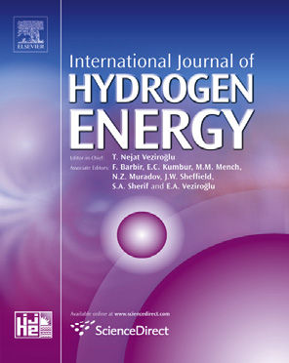

Available online at www.sciencedirect.com

ScienceDirect
journal homepage: www.elsevier.com/locate/he
Enhancing the electrocatalytic water splitting efﬁciency for amorphous MoSx
Chang-Lung Hsu a,b, Yung-Huang Chang b, Tzu-Yin Chen b, Chien-Chih Tseng b, Kung-Hwa Wei a,**, Lain-Jong Li b,c,*
a Department of Materials Science and Engineering, National Chiao Tung University, HsinChu 300, Taiwan b Institute of Atomic and Molecular Sciences, Academia Sinica, Taipei 10617, Taiwan c Department of Medical Research, China Medical University Hospital, Taichung, Taiwan

article info abstract

Article history:
Received 18 November 2013 Received in revised form 7 January 2014 Accepted 13 January 2014 Available online 15 February 2014
Keywords:
Hydrogen evolution reaction Electrocatalytic reaction Molybdenum disulﬁde Niobium chloride Amorphous molybdenum sulﬁde (MoSx) materials have been considered as cheap and promising catalysts for hydrogen evolution reaction (HER). In this contribution, we report that the amorphous MoSx catalysts prepared by the low temperature thermolysis of the (NH4)2MoS4 precursors on carbon clothes (catalyst loading: 3.2 mg/cm2) exhibit a Tefal slope of 50.5 mV/dec and a high exchange current density of 1.5 x 10-3 mA/cm2 in 0.5 M H2SO4 solutions. Spectroscopic studies of the amorphous MoSx catalysts show that the increase of HER efﬁciency is positively correlated to the concentration of S 22-species, providing strong evidence to support the argument that S22-is an active species for electrocatalytic HER. Additionally, the method for preparing catalysts is simple, scalable and applicable for large-scale production. Copyright ª 2014, Hydrogen Energy Publications, LLC. Published by Elsevier Ltd. All rights
reserved.

1. Introduction
The clean energy source such as hydrogen is an ideal energy carrier because there is no carbon dioxide emitted during the combustion process. The production of hydrogen from electrolytic water splitting has gained greater attention than before. Platinum is one of the most efﬁcient catalysts for electrocatalytic hydrogen evolution reaction (HER). However, its high cost and rareness on earth retard the wide applications for HER. Replacing Pt by earth abundant catalysts is critically important for the realization of large-scale HER applications. Among many potential candidates, low cost and earth abundant transition metal dichalcogenides [1e5] such as molybdenum disulﬁde (MoS2) and WS2 have been demonstrated as promising HER catalysts.
Molybdenum disulﬁde has been used as a solid-state lubricant [6] and the catalysts for hydrodesulfurization (HDS) [7,8], oxygen reduction reaction (ORR) [9] and hydrogen evolution reaction (HER) [10,11]. It has been reported that the high HER activity for the crystalline MoS2 structures is related to the unsaturated sulfur appearing at the crystal edges [11,12].It also exhibits relatively good stability in acidic environments [13e19]. However, previous synthetic methods involving ultra-high vacuum processing [11], high-temperature treatment [15,16] or using toxic H2S for sulfurization [11,15],may not be preferred in large-scale production of catalysts. Recent efforts have been focused on synthesizing highly efﬁcient

* Corresponding author. Institute of Atomic and Molecular Sciences, Academia Sinica, Taipei 10617, Taiwan. Tel.: þ886 2 23668205. ** Corresponding author. Department of Materials Science and Engineering, National Chiao Tung University, HsinChu 300, Taiwan. Tel.: þ886 3 57131771.
E-mail addresses: khwei@mail.nctu.edu.tw (K.-H. Wei), lanceli@gate.sinica.edu.tw (L.-J. Li). 0360-3199/$ e see front matter Copyright ª 2014, Hydrogen Energy Publications, LLC. Published by Elsevier Ltd. All rights reserved.
http://dx.doi.org/10.1016/j.ijhydene.2014.01.090
international journal of hydrogen energy 39 (2014) 4788e4793
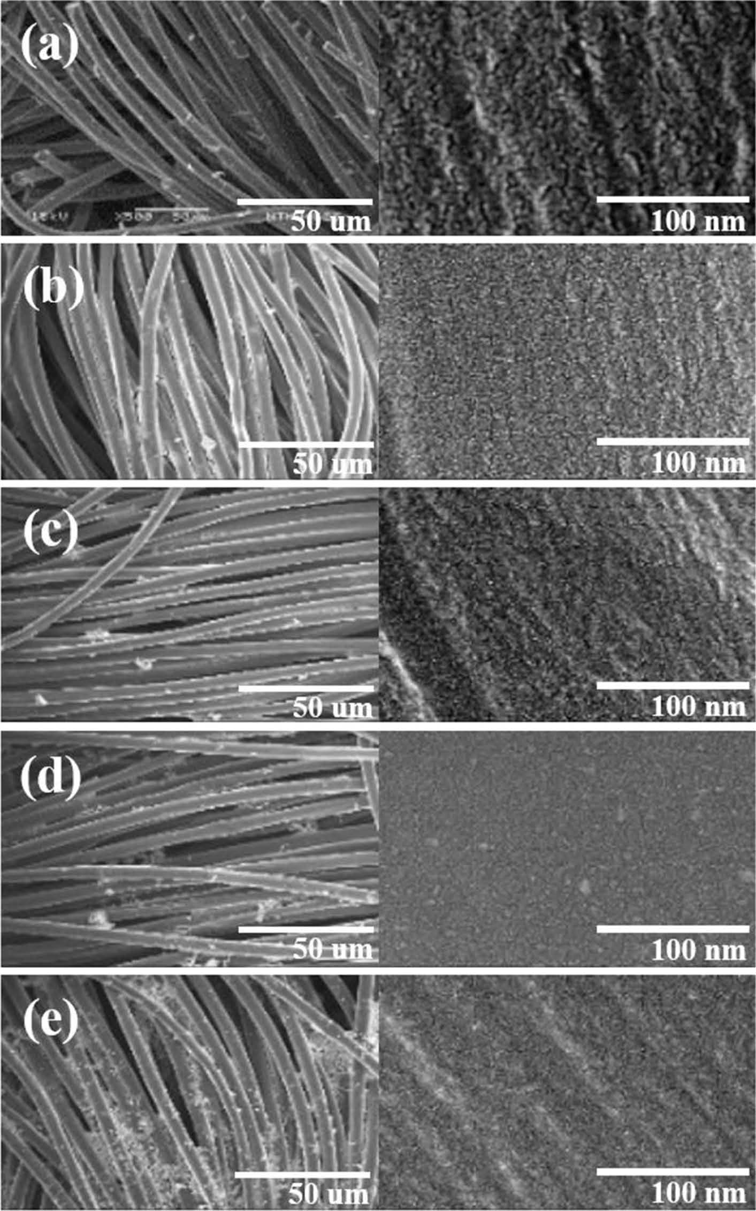
Fig. 1 e SEM images of the amorphous MoSx catalysts prepared with various NbCl5 solid weight percentages (a) 0 wt% (b)
0.1 wt% (c) 1 wt% (d) 10 wt% (e) 20 wt% Nb.
amorphous molybdenum sulﬁde catalysts [16,20e22]. Hu et al. have reported the electrochemical method to prepare the amorphous molybdenum sulﬁde catalysts with impressive HER efﬁciency [17,22]. The inclusion of Fe, Co, and Ni ions in the amorphous molybdenum sulﬁde structures further improves the apparent HER activity in acidic environments [21], where the enhancement of HER efﬁciency has been mainly attributed to the increase in catalyst loading caused by the higher electrochemical growth rate with the presence of Fe, Co, and Ni ions or the enhancement in reactivity of the defect sites [21e25]. The catalytic species in the amorphous MoSx and the mechanism of the HER efﬁciency increase in ternary metal sulﬁde materials still remain as a highly interesting topic.
international journal of hydrogen energy 39 (2014) 4788e4793

To further explore study the factors controlling the HER efﬁciency of ion MoSx catalysts and to avoid the complication of possible morphological change from electrochemical deposition, we use a simple thermolysis process at 120 oCto prepare the amorphous MoSx catalysts with the inclusion of various concentrations of NbCl5 (0e20 wt %). It is observed that the incorporation of NbCl5 in the precursor solution results in the enhancement of HER efﬁciency, and only 1 wt% of NbCl5 is needed to achieve the optimal HER efﬁciency enhancement (>100%) for MoSx catalysts. The X-ray photoelectron spectroscopy (XPS) analysis of these catalytic materials reveals that Nb does not bind to MoSx matrix, suggesting the enhancement is not related to the Nb-doping or Nb-inclusion. Instead, the enhancement in HER efﬁciency is closely related to structural changes of the MoSx catalysts, eg. the differences in the content of the S22-,Mo4þ and Mo5þ species in the resulting MoSx catalysts, caused by the presence of Nb5þ in the matrix.
2. Material and method
2.1. Synthesis of catalysts
Ammonium thiomolybdate ((NH4)2MoS4, abcr, 99.99%), Niobium chloride (NbCl5, Alfa, 99.95%) and N,N-dimethylformamide (DMF, SigmaeAldrich) were used without further puriﬁcation. A DMF solution was added with desired amount of (NH4)2MoS4 and NbCl5 (0.1 wt% w 20 wt%), followed by stirring at room temperature for overnight. The carbon clothes were immersed in the solution, baked on a hot-plate at 100 oC for 10 min and annealed at 120 oC in the H2/Ar environment (H2:Ar ¼ 20:80; 500 torr) in a CVD furnace to form amorphous MoSx and Nb-added MoSx catalysts. We measured the weight of each blank carbon clothes before and after the deposition of different catalysts, where the catalyst loading was obtained as the weight difference divided by the area of each sample.
2.2. Characterization
Chemical bonding structures of the catalysts were determined by X-ray photoelectron spectroscopy (XPS) (Phi 5000) with Mg Ka X-ray source. The energy calibrations were made against to the C 1s peak to eliminate the charging of the sample during analysis. The surface morphology was examined by a ﬁeld-emission scanning electron microscope (FESEM) (JSM-6500F). Polarization curves were recorded by an AUTOLAB pontentiostat (PGSTAT 302N) with a scan rate of 5 mV/s in a 0.5 M H2SO4 solution. A three-electrode conﬁguration using an Ag/AgCl (saturated KCl) electrode as the reference electrode, a graphite rod as the counter electrode, and the MoSx and Nb-added MoSx on carbon clothes as working electrodes were adopted for polarization and electrolysis measurements. Electrochemical surface analysis (ESA) was also performed on an AUTOLAB pontentiostat (PGSTAT 302N) at different scan rate of 5, 6, 7, 8, 9, 10 mV/s in a 0.035 M K3[Fe(CN)6] solution. A three-electrode conﬁguration is using an Ag/AgCl (saturated KCl) electrode as the reference electrode, Pt as the counter electrode, and the MoSx/carbon clothes samples as working electrode.
3. Results and discussion
In this contribution, Niobium is selected as the HER promoter since the Niobium-derivatives in the bulk state has been shown to exhibit high activity in hydroedesulfurization reactions [26,27]. The MoSx-based HER catalysts were prepared by the thermolysis of the (NH4)2MoS4 precursors at 120 oC, where the carbon clothes were dipped into a 5 wt% of (NH4)2MoS4 in DMF. To tailor the HER efﬁciency of the MoSx catalysts, various percentages of NbCl5 from 0.1 wt% to 20 wt % (solid content) were added in the precursor solution. Note that our previous report [28] has shown that the HER performance of the pristine and amorphous MoSx catalysts synthesized by the thermolysis method is optimal with the synthetic temperature at around 120 oC. Fig. 1(a)e(e) show the scanning electron microscopy (SEM) images of the MoSx catalysts prepared with the addition of with various percentages of NbCl5 (0 wt%, 0.1 wt% 1 wt%, 10 wt% and 20 wt% of solid weight) on carbon clothes. The carbon ﬁber diameter is w10 mm and the surface of the intrinsic MoSx seems slightly a little bit rougher than NbCl5 added MoSx systems. The morphology of these samples revealed in SEM looks quite similar. Consistently, the measured electrochemical surface area (ESA) for all these samples does not vary much (in between 1.86 and 1.92 cm2 as shown in Table 1), which makes the direct comparison of the catalyst HER efﬁciency easier. Fig. 2(a) shows the polarization curves of these amorphous MoSx catalysts, where the current is normalized by the geometrical area of the carbon clothes and the HER is performed in a 0.5 M H2SO4 solution. At the applied voltage of -0.3 V, it is observed that the HER efﬁciency increases from the 66.0 mA/cm2 for pristine MoSx to the 89.6 mA/cm2 for the MoSx incorporating 1 wt% NbCl5. However, the further increase in NbCl5 wt% results in a lower HER efﬁciency. For better comparison, the current density at the applied

NbCl5 solid content Catalyst loading Mo5þ/(Mo4þþ Mo5þ)S-2 2/% Current density Current Tafel J0 ESA in precursor (mg/cm2) (%) (mA/cm2) density slope (mA/cm2) (cm2) (A/g) (mV/dec)
0 wt % 3.2 16.7 31.7 66.0 20.6 50.5 1.5 x 10-3 1.912
0.1 wt % 2.9 26.9 51.2 81.1 28.1 48.0 1.7 x 10-3 1.888 1 wt% 3.0 29.1 56.6 89.6 30.1 46.0 3.3 x 10-3 1.921 10 wt% 2.9 27.1 51.6 84.9 29.1 51.9 2.5 x 10-3 1.871 20 wt% 3.3 22.0 41.8 81.0 22.6 45.5 2.4 x 10-3 1.863
international journal of hydrogen energy 39 (2014) 4788e4793
Fig.2eThepolarizationcurvesoftheamorphousMoSxcatalysts.(a)Thecurrentisnormalizedbythegeometricalareaofthecarbonclothes(b)Thecurrentisnormalizedbytheloadingweight(c)TheHERstabilityof0wt%and1wt%ofNbCl5-addition.
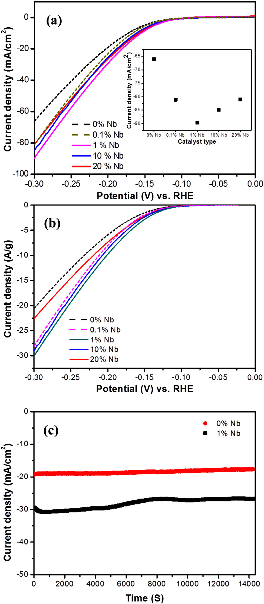potential of -0.3 V is plotted as a function of NbCl5 wt % in inset of Fig. 2(a). Fig. 2(b) shows the polarization curves normalized by the loading weight of each catalyst and the observed trend is similar to that normalized by the geometrical area (Fig. 2(a)). Consistently, the best HER efﬁciency is observed for the sample MoSx with 1 wt% of NbCl5 addition, which value is 30.1 A/g at the applied potential of -0.3 V.
According to classical HER theory, the catalytic performance of electrodes for HER can be described by Tafel relationship (Eq. (1)),
吋)
i
h ¼b ln(1)
i0
where h is the overpotential, i is the current density, and i0 is the exchange current density. The Tafel slope b is the measurement of the potential increase required to enhance the resulting current density one order of magnitude, normally used to evaluate the efﬁciency of the catalytic reaction. The electrical curves (ln i vs. h) for the MoSx catalysts show good linear relation when the overpotential is between -0.109 V and -0.141 V. The Tafel slope of the intrinsic MoSx is extracted as 50.5 mV/dec and the exchange current density is
0.15 x 10-2 mA/cm2. For the 1 wt% NbCl5-added MoSx, the Tafel slope is improved to 46.0 mV/dec and the exchange current density is as high as 0.33 x 10-2 mA/cm2. Moreover, the comparison of the catalytic stability between the intrinsic MoSx and the 1 wt% NbCl5-added MoSx is shown in Fig. 2(c). At an overpotential of V ¼-0.2 V, the current density of MoSx and 1 wt% NbCl5-added MoSx is 18.9 mA/cm2 and 27.1 mA/cm2, respectively, over a period of 3 h. The hydrogen production durability of the 1 wt% Nb-added MoSx is comparable to that of pristine MoSx. It is noted that several recent reports have hypothesized that the edges of MoS2 crystals might be related to the HER reactivity in MoSx materials [11,12,22]. In this report, all the catalysts are prepared at a low temperature and exhibit no Raman or X-ray diffraction features, suggesting all these materials are amorphous. Hence, alternative explanation is required to interpret our experimental observation. To understand the differences between the pristine and NbCl5added MoSx catalysts, XPS was adopted to characterize the chemical bonding structures. Fig. 3 displays the detailed XPS scans for the Mo and S binding energies for these catalysts. The binding energies of 229.2 eV and 232.4 eV are attributed to Mo 3d5/2 and 3d3/2 electrons for the Mo4þ state in MoS2 [21,29,30]. The binding energies of Mo 3d5/2 and 3d3/2 orbitals observed at 230.0 eV and 233.1 eV are originated from the Mo5þ state of Mo2S5 [21,29,30]. Note that the peak at 226.7 eV is assigned to S 2s [21,29,30]. The two peaks at 161.7 eV and
162.8 eV are the signature of the S 2p1/2 and 2p3/2 electrons of S2-[21,29,30]. The 163.2 eV and 164.3 eV peaks correspond to theS2p1/2 and 2p3/2 orbital of S22-[21,29,30]. Surprisingly, the binding energies of Nb are hardly detectable for all samples. Only very weak 3d5/2 and 3d3/2 peaks for the Nb5þ state are observed at 207.7 eV and 210.5 eV [31] for the sample added with 20 wt% NbCl5 (see Supporting Figure S1). These results point out that the Nb ions do not chemically bind to the MoSx matrix although the Nb and the HER efﬁciency enhancement is related to the structural difference of the MoSx catalysts. Table 1 summarizes the characterization results for these catalysts, including catalyst loading, XPS, surface area and electrical performance.
Several recent reports have speculated that the unsaturated sulfur atoms such as S22-could be related to the HER activity [28,32]. We can estimate the relative content of S22and S2-by comparing the area sum of the S22-doublet peaks
international journal of hydrogen energy 39 (2014) 4788e4793
Fig.3eXPSspectraoftheamorphousMoSxcatalysts.
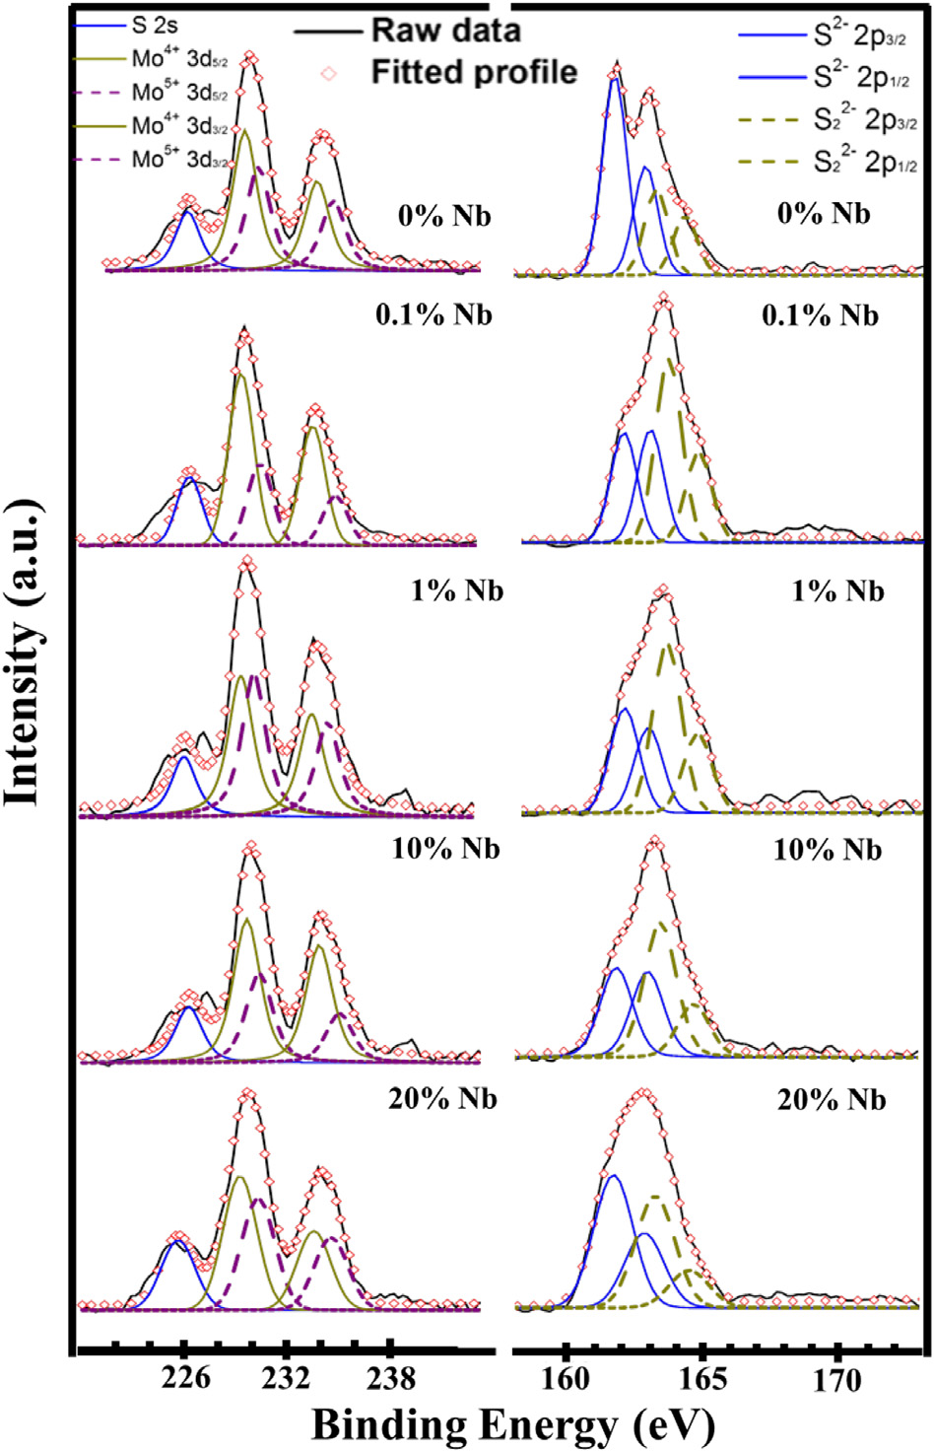

(163.2 eV and 164.3 eV) and that of the S2-doublet peaks (161.7 eV and 162.8 eV). The content of the S22-, estimated from the ratio S22-/(S22-þ S2-), for each catalyst is shown in Table 1. Note that the MoSx catalyst with 1 wt% of NbCl5 addition contains the highest S22-ratio (56.6%). Fig. 4 shows that the measured HER performance of these catalysts exhibits nice exhibits nice correlation to the S22-content, where the catalyst with a higher S22-content displays a larger HER current density. It is also noted that the content of Mo5þ (estimated by Mo5þ/(Mo4þþ Mo5þ) in XPS) is positively correlated to the S22content (Table 1). These observations provide strong evidence to support the argument that S 22-is the active species for electrocatalytic HER in MoSx systems. The XPS results suggest that the Nb atoms do not chemically bind to the MoSx matrix. However, the observed enhancement in HER with the NbCl5 addition is reproducible. Although it is not clear how the NbCl5 inclusion affects the formation of various MoSx structures at this stage, the formation of various MoSx structures could involve the dynamic competition between the reaction of Nb5þ with S2-and its decomposition which warrants more future studies.
Fig.4eHERperformanceofthesecatalystsispositivelycorrelatedtotheS22Lcontentinthechemicalcomposition.
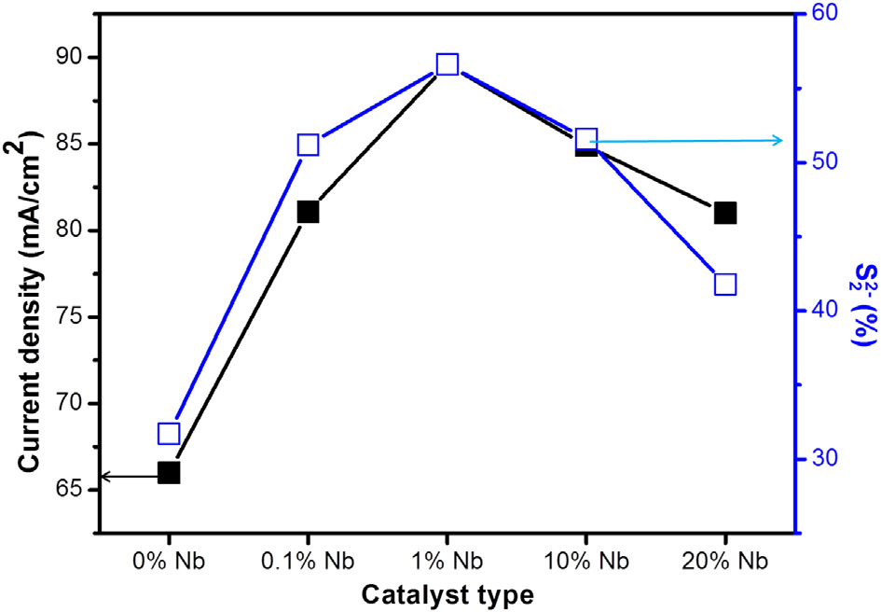
4. Conclusions
A fast, low-temperature and scalable thermolysis process is used to produce amorphous MoSx catalysts for HER. The addition of NbCl5 in the precursor solution is able to enhance the HER efﬁciency of obtained MoSx catalysts. Noticeably, the inclusion of only 1 wt% NbCl5 in the MoSx catalysts results in a 100% enhancement in exchange current density and a lowering of the Tafel slope to 46 mV/dec. The positive correlation between the HER performance and S22-quantities strongly suggests that S22-is the active species for electrocatalytic HER in MoSx systems.
Acknowledgments
This research was mainly supported by Academia Sinica (IAMS and Nano program) and National Science Council Taiwan (102-2119-M-001-005-MY3 and 99-2738-M-001-001).
Appendix A. Supplementary data
Supplementary data related to this article can be found at
http://dx.doi.org/10.1016/j.ijhydene.2014.01.090
references
[1] Coleman JN, Lotya M, O’Neill A, Bergin SD, King PJ, Khan U, et al. Two-Dimensional nanosheets produced by liquid exfoliation of layered materials. Science 2011;331:568e71.
[2] Chhowalla M, Shin HS, Eda G, Li LJ, Loh KP, Zhang H. The chemistry of two-dimensional layered transition metal dichalcogenide nanosheets. Nat Chem 2013;5:263e75.
[3] Song X, Hu J, Zeng H. Two-dimensional semiconductors: recent progress and future perspectives. J Mater Chem C 2013;1:2952e69.
[4] Li H, Lu G, Wang YL, Yin ZY, Cong CX, He QY, et al. Mechanical exfoliation and characterization of single-and few-layer nanosheets of WSe2, TaS2, and TaSe2. Small 2013;9:1974e81.
[5] Komsa HP, Kotakoski J, Kurasch S, Lehtinen O, Kaiser U, Krasheninnikov AV. Two-Dimensional transition metal
international journal of hydrogen energy 39 (2014) 4788e4793

dichalcogenides under electron irradiation: defect production and doping. Phys Rev Lett 2012;109:035503.
[6] Chhowalla M, Amaratunga GAJ. Thin ﬁlms of fullerene-like MoS2 nanoparticles with ultra-low friction and wear. Nature 2000;407:164e7.
[7] Prins R, Debeer VHJ, Somorjai GA. Structure and function of the catalyst and the promoter in CodMo hydrodesulfurization. Catal Catal Rev Sci Eng 1989;31:1e41.
[8] Salmeron M, Somorjai GA, Wold A, Chianelli R, Liang KS. The adsorption and binding of thiophene, butene and H2S on the basal plane of MoS2 single crystals. Chem Phys Lett 1982;90:105e7.
[9] Ahmed SM, Gerischer H. Inﬂuence of crystal surface orientation on redox reactions at semiconducting MoS2. Electrochim Acta 1979;24:705e11.
[10] Hinnemann B, Moses PG, Bonde J, Jørgensen KP, Nielsen JH, Horch S, et al. Biomimetic hydrogen evolution: MoS2 nanoparticles as catalyst for hydrogen evolution. J Am Chem Soc 2005;127:5308e9.
[11] Jaramillo TF, Jørgensen KP, Bonde J, Nielsen JH, Horch S, Chorkendorff I. Identiﬁcation of active edge sites for electrochemical H2 evolution from MoS2 nanocatalysts. Science 2007;317:100e2.
[12] Xie JF, Zhang H, Li S, Wang RX, Sun X, Zhou M, et al. Defect-rich MoS2 ultrathin nanosheets with additional active edge sites for enhanced electrocatalytic hydrogen evolution. Adv Mater; 2013. http://dx.doi.org/10.1002/adma.201302685.
[13] Jaramillo TF, Bonde J, Zhang JD, Ooi BL, Andersson K, Ulstrup J, et al. Hydrogen evolution on supported incomplete cubane-type [Mo3S4]4 þelectrocatalysts. J Phys Chem C 2008;112:17492e8.
[14] Bonde J, Moses PG, Jaramillo TF, Norskov JK, Chorkendorff I. Hydrogen evolution on nano-particulate transition metal sulphides. Faraday Discuss 2008;140:219e31.
[15] Chen ZB, Cummins D, Reinecke BN, Clark E, Sunkara MK, Jaramillo TF. Coreeshell MoO3eMoS2 nanowires for hydrogen evolution: a functional design for electrocatalytic materials. Nano Lett 2011;11:4168e75.
[16] Li YG, Wang HL, Xie LM, Liang YY, Hong GS, Dai HJ. MoS2 nanoparticles grown on graphene: an advanced catalyst for the hydrogen evolution reaction. J Am Chem Soc 2011;133:7296e9.
[17] Merki D, Fierro S, Vrubel H, Hu XL. Amorphous molybdenum sulﬁde ﬁlms as catalysts for electrochemical hydrogen production in water. Chem Sci 2011;2:1262e7.
[18] Merki D, Hu XL. Recent developments of molybdenum and tungsten sulﬁdes as hydrogenevolution catalysts. Energy Environ Sci 2011;4:3878e88.
[19] Laursen AB, Kegnaes S, Dahl S, Chorkendorff I. Molybdenum sulﬁdes defﬁcient and viable materials for electro e and photoelectrocatalytic hydrogen evolution. Energy Environ Sci 2012;5:5577 e91.
[20] Tang ML, Grauer DC, Lassalle-Kaiser B, Yachandra VK, Amirav L, Long JR, et al. Structural and electronic study of an amorphous MoS3 hydrogen-generation catalyst on a quantum-controlled photosensitizer. Angew Chem Int Ed 2011;50:10203e7.
[21] Merki D, Vrubel H, Rovelli L, Fierro S, Hu XL. Fe, Co, and Ni ions promote the catalytic activity of amorphous molybdenum sulﬁde ﬁlms for hydrogen evolution. Chem Sci 2012;3:2515e25.
[22] Vrubel H, Merki D, Hu XL. Hydrogen evolution catalyzed by MoS3 and MoS2 particles. Energy Environ Sci 2012;5:6136e44.
[23] Lauritsen JV, Helveg S, Lægsgaard E, Stensgaard I, Clausen BS, Topsøe H, et al. Atomic-scale structure of CoeMoeS nanoclusters in hydrotreating catalysts. J Catal 2001;197:1e5.
[24] Sun MY, Nelson AE, Adjaye J. On the incorporation of nickel and cobalt into MoS2-edge structures. J Catal 2004;226:32e40.
[25] Raybaud P, Hafner J, Kresse G, Kasztelany S, Toulhoat H. Structure, energetics, and electronic properties of the surface of a promoted MoS2 catalyst: an ab initio local density functional study. J Catal 2000;190:128e43.
[26] Geantet C, Afonso J, Breysse M, Allali N, Danot M. Niobium sulﬁdes as catalysts for hydrotreating reactions. Catal Today 1996;28:23e30.
[27] Allali N, Leblanc A, Danot M, Geantet C, Vrinat M, Breysse M. Catalytic properties of pure and Ni doped niobium sulﬁde catalysts for hydrodesulfurization. Catal Today 1996;27:137e44.
[28] Chang YH, Lin CT, Chen TY, Hsu CL, Zhang W, Wei KH, et al. Highly efﬁcient electrocatalytic hydrogen production by MoSx grown on graphene-protected 3-dimentional Ni foams. Adv Mater 2013;25:756e60.
[29] Weber Th, Muijsers JC, van Wolput JHMC, Verhagen CPJ, Niemantsverdriet JW. Facile synthesis of low crystalline MoS2 nanosheet-coated CNTs for enhanced hydrogen evolution reaction. J Phys Chem 1996;100:14144e50.
[30] Wang HW, Skeldon P, Thompson GE. XPS studies of MoS2 formation from ammonium tetrathiomolybdate solutions. Surf Coat Technol 1997;91:200e7.
[31] Izawa K, Ida S, Unal U, Yamaguchi T, Kang JH, Choy JH, et al. A new approach for the synthesis of layered niobium sulﬁde and restacking route of NbS2 nanosheet. J Solid State Chem 2008;181:319e24.
[32] Chen TY, Chang YH, Hsu CL, Wei KH, Chiang CY, Li LJ. Comparative study on MoS2 and WS2 for electrocatalytic water splitting. Int J Hydrogen Energy 2013;38:12302e9.
䘀椀最⸀㈀

