Journal of Alloys and Compounds 615 (2014) S660–S665

Contents lists available at ScienceDirect

Journal of Alloys and Compounds
journal homepage: www.elsevier.com/locate/jalcom
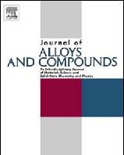
Enhancing the bio-corrosion resistance of Ni-free ZrCuFeAl bulk metallic glass through nitrogen plasma immersion ion implantation
Her-Hsiung Huang a,b,c,d,e,⇑, Hsun-Miao Huang e, Mau-Chin Lin f, Wei Zhang g, Ying-Sui Sun a, Wu Kai h, Peter K. Liaw i
a Department of Dentistry, National Yang-Ming University, Taipei, Taiwan b Graduate Institute of Basic Medical Science, China Medical University, Taichung, Taiwan c Department of Biomedical Informatics, Asia University, Taichung, Taiwan d Department of Stomatology, Taipei Veterans General Hospital, Taipei, Taiwan e Institute of Oral Biology, National Yang-Ming University, Taipei, Taiwan f Department of Dental Technology and Materials Science, Central Taiwan University of Science and Technology, Taichung, Taiwan g School of Materials Science & Engineering, Dalian University of Technology, Dalian, China h Institute of Materials Engineering, National Taiwan Ocean University, Keelung, Taiwan i Department of Materials Science & Engineering, University of Tennessee, Knoxville, USA

article info abstract

Article history:
Available online 24 January 2014
Keywords:
Bio-corrosion resistance Ni-free Zr-based bulk metallic glass Nitrogen plasma immersion ion implantation Pitting corrosion
Improving the resistance of bulk metallic glass (BMG) to corrosion, particularly pitting, is crucial to the further development of this material. This study employed surface treatment based on nitrogen plasma immersion ion implantation (N-PIII) to enhance the bio-corrosion resistance of Ni-free Zr62.5Cu22.5Fe5Al10 BMG for application in bone implants. Resistance to bio-corrosion was evaluated by establishing potentiodynamic polarization curves in artiﬁcial saliva (AS) and simulated body ﬂuid (SBF). Commercial pure Ti was used as the control. Results demonstrate that N-PIII treatment did not alter the bulk amorphous structure of Zr62.5Cu22.5Fe5Al10 BMG. Following N-PIII treatment, a nitride-containing 15 nm thick oxide ﬁlm was formed on the BMG. This ﬁlm signiﬁcantly improved resistance to bio-corrosion in both AS and SBF solutions. The N-PIII-treated BMG presented lower corrosion rates (50–67% less) and higher corrosion potential (800–1100 mV more) than that observed in untreated BMG and Ti. The N-PIII treatment also signiﬁcantly improved resistance of the BMG to pitting (increased pitting potential by 500–700 mV). This is the ﬁrst report of the outstanding resistance of Ni-free Zr-based BMG to bio-corrosion (i.e. corrosion rate 0.01 lA/cm2; pitting potential >1200 mV; corrosion potential >270 mV) in simulated biological environments.
。 2014 Elsevier B.V. All rights reserved.

1. Introduction
The elastic modulus of commercial biomedical Ti and its alloys is generally over 100 GPa, which is much higher than that of natural human bone [1]. The dissimilarity in elastic moduli often results in a stress shielding effect, which can result in bone resorption and diminish the likelihood of long-term success [2–4]. Thus, developing metallic implants with an elastic modulus closer to that of natural bone could prove highly beneﬁcial in the further development of bone implants.
Zr-based bulk metallic glass (BMG) with a lower elastic modulus has demonstrated outstanding potential for biomedical
⇑ Corresponding author. Address: Department of Dentistry, National Yang-Ming University, No. 155, Sec. 2, Li-Nong Street, Taipei 112, Taiwan. Tel.: +886 2 2826 7068; fax: +886 2 2826 4053.
E-mail address: hhhuang@ym.edu.tw (H.-H. Huang).
applications [5,6]; unfortunately, the Zr-based BMGs investigated in recent studies may contain Ni [7–11], which can produce negative biological side effects [12,13]. Therefore, Ni-free Zr-based BMG has been considered for biomedical applications [14–18]; however, the resistance of this material to bio-corrosion, particularly pitting, must be dealt with before it can be used in long-term clinical applications. Resistance to bio-corrosion extends the lifespan of the implant material by decreasing or even preventing the release of metallic ions due to the destruction of surface protectiveness of implant [19].
Biomedical applications often incorporate surface coatings to enhance the resistance of metals to bio-corrosion. Due to good biocompatibility, wear resistance, and bio-corrosion resistance, nitride is widely used to coat the surfaces of medical devices and implants [20–22]. The most common methods used to apply nitride thin ﬁlms include physical vapor deposition, chemical vapor deposition, and annealing in a nitrogen atmosphere [23,24].
http://dx.doi.org/10.1016/j.jallcom.2014.01.098
0925-8388/。 2014 Elsevier B.V. All rights reserved.
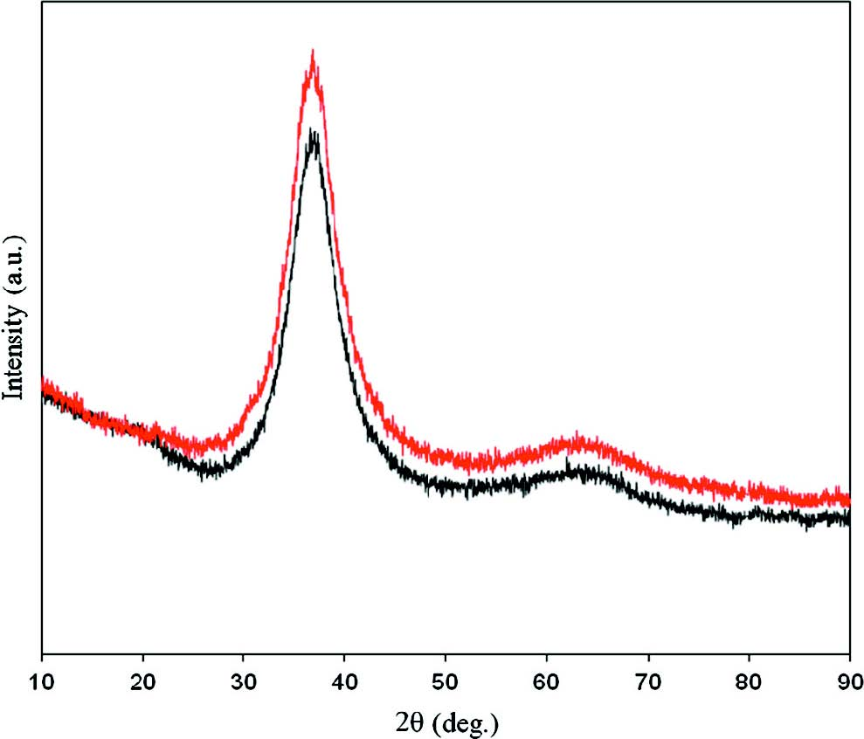
H.-H. Huang et al. / Journal of Alloys and Compounds 615 (2014) S660–S665 S661
Nitrogen atomic percentage (%)
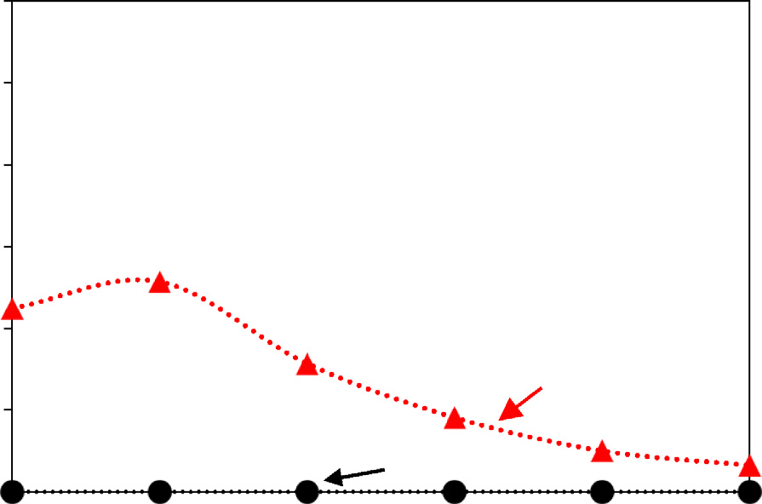
20
2.2. Bio-corrosion resistance analysis
15
A potentiostat was used to measure potentiodynamic polarization curves.
Acidic (pH 5.0) AS [34] and neutral (pH 7.4) SBF [35] were used as electrolytes in
10
the bio-corrosion test, and the specimens were used as working electrodes. A plat
inum sheet and saturated calomel electrode (SCE) were used as the counter elec-

However, these methods can be time-consuming and are not necessarily suitable for irregularly shaped implants. This study proposes plasma immersion ion implantation (PIII) as an alternative to these methods. PIII is a technique for surface modiﬁcation that is capable of enhancing the surface characterizations of the material without altering the original topography and bulk property [25]. PIII produces a uniformly implanted layer with superior adhesion capacity. This method is particularly well suited to irregularly shaped objects, such as surfaces of biomedical implants with complex geometry [26,27]. Previous studies evaluated the biocorrosion of PIII-treated commercial Ti implants in Hank’s solution, Ringer’s solution, or simulated body ﬂuid (SBF) [28–31]. However, the bio-corrosion resistance of PIII-treated BMG alloys in simulated biological environments had not been previously explored.
A type of Ni-free Zr-based Zr62.5Cu22.5Fe5Al10 BMG with reduced modulus of elasticity (approx. 50 GPa) has recently been developed [32]. This BMG alloy has extremely high glass-forming ability and is expected to broaden the range of applications in the biomedical ﬁeld [33]. However, this applicability has not been widely evaluated in speciﬁc biomedical applications. In our previous study, we investigated the response of bone cells to Ni-free Zr62.5Cu22.5Fe5Al10 BMG. This BMG was shown to have superior cell adhesion and protein adsorption than commercial biomedical Ti [32]. However, the resistance of Ni-free Zr62.5Cu22.5Fe5Al10 BMG to bio-corrosion (particularly pitting) is of considerable concern in long-term clinical applications. Our hypothesis was that N-PIII surface treatment could enhance the bio-corrosion resistance of Ni-free Zr62.5Cu22.5Fe5Al10 BMG. Thus, this study investigated the biocorrosionresistanceofNi-free Zr62.5Cu22.5Fe5Al10 BMG using potentiodynamic polarization curve measurementsinbothartiﬁcial saliva (AS) and SBF.
2. Materials and methods
2.1. Material preparation and surface characteristics
Ni-free Zr-based BMG rods (10 mm diameter) were prepared by arc melting, as previously described [33]. Electron probe X-ray microanalysis determined the chemical composition (in at.%) of the BMG rods as follows: Zr (62.5%), Cu (22.5%), Fe (5%), and Al (10%). BMG discs (10 mm diameter; 2 mm thickness) were polished using a series of silicon carbide papers; #1200 was the ﬁnest grit used. This resulted in a surface roughness (Ra) of approximately 0.1 lm. Commercial biomedical grade 2 Ti discs, also with an Ra of approximately 0.1 lm, were used as the control group.
N-PIII treatment (pulse rate 200 Hz; pulse duration 10 ls; time 30 min) was performed in a high vacuum chamber with a radio-frequency (RF) plasma source to implant nitrogen ions (1016 ions/cm2) into the polished BMG surfaces. The corresponding N-PIII-treated specimens of BMG were designated as N-PIII BMG. The NPIII treatment did not alter the surface roughness of the BMG at the microscale. The untreated BMG specimens (control group) were designated as BMG.
The crystal structure and outermost surface chemistry of the BMG discs were analyzed using an X-ray diffractometer (XRD) with a Cu Ka source (wavelength 1.5406 Å) and X-ray photoelectron spectrometer (XPS), respectively. The depth proﬁle of nitrogen concentration (in at.%) of the BMG discs was analyzed using XPS with Ar ion-beam etching rate 0.1 nm/s. Focused ion beam (FIB) milling was used to prepare the N-PIII BMG specimen for cross-sectional analysis by a transmission electron microscope (TEM).
3. Results and discussion
3.1. Surface characterizations
Fig. 1 presents the XRD patterns of Zr62.5Cu22.5Fe5Al10 alloys with and without N-PIII treatment. The patterns consisted of a broad diffraction maximum near 2h =370 without a detectable Bragg peak, indicating that both Zr62.5Cu22.5Fe5Al10 alloys with and without N-PIII treatment were amorphous (noncrystalline).
Fig. 2 presents the depth proﬁles of nitrogen concentration (in at.%) on Zr62.5Cu22.5Fe5Al10 BMGs with and without N-PIII treatment. Results indicate that the nitrogen concentration on N-PIII BMG initially increased with increasing the depth and then decreased, similar to the Gaussian distribution. The nitrogen peak concentration on N-PIII BMG was approximately 12.8%, corresponding to the etching depth about 3 nm. No nitrogen atoms could be detected on BMG without N-PIII treatment.
Fig. 3 presents XPS spectra analysis of Zr62.5Cu22.5Fe5Al10 BMGs with and without N-PIII treatment. Results indicate that the oxide ﬁlm on the outermost surface of the BMG without N-PIII treatment was composed as follows (in at.%): O (29.0%), Zr (53.5%), Cu (3.5%),
N-PIII BMG
BMG
Fig. 1. XRD patterns of the cast Zr62.5Cu22.5Fe5Al10 alloys with and without N-PIII treatment.
30
25
trode and reference electrode, respectively. The potentiodynamic polarization curves of the test specimens were measured from -0.5 V (vs open-circuit potential)
5
in the anodic direction at a scanning rate of 1 mV/s. Measurements were halted
when the anodic current density reached 1 mA/cm2. The electrolyte was deaerated
0 3 6
using nitrogen gas for 20 min prior to initiation of the bio-corrosion test. The major
9 12
corrosion parameters, including corrosion potential (Ecorr), pitting potential (Epit), Depth (nm) corrosion rate (Icorr), and anodic current (Ianod), were obtained from potentiodynamic polarization curves as a means to evaluate the resistance of the test specimens to Fig. 2. Depth proﬁles of nitrogen concentration (in at.%) on Zr62.5Cu22.5Fe5Al10 bio-corrosion. At least ﬁve samples were used under each set of test conditions. BMGs with and without N-PIII treatment.
Zr
ZrOx
S662 H.-H. Huang et al. / Journal of Alloys and Compounds 615 (2014) S660–S665
BMG N-PIII BMG Zr3d
Zr3d ZrO2
Intensity (a.u.)
Intensity (a.u.) Intensity (a.u.)
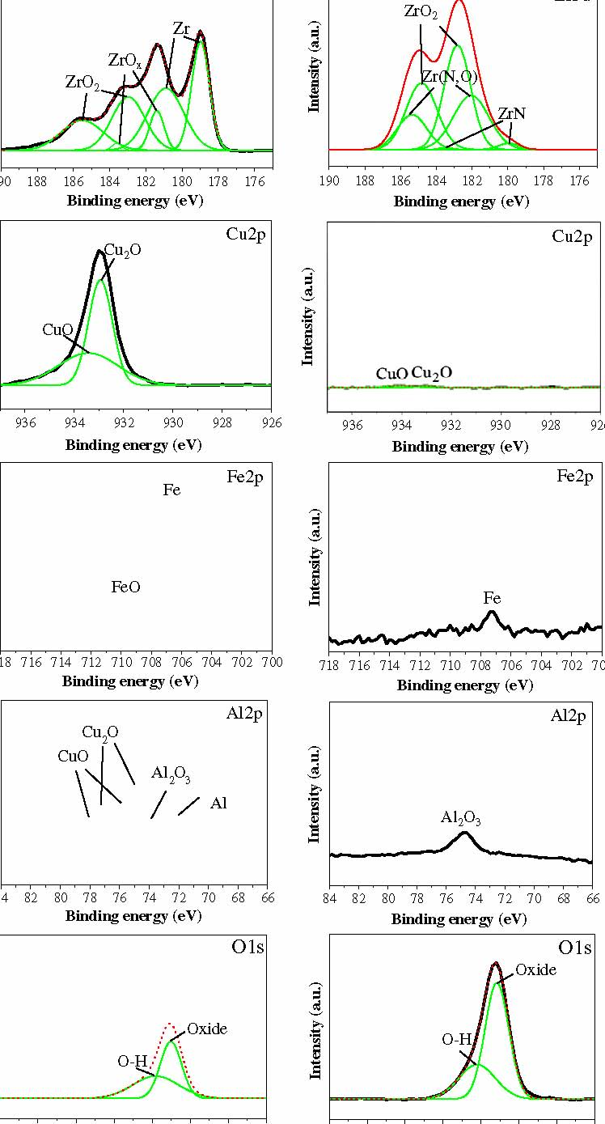
ZrO2 Zr(N,O) ZrN
190 188 186 184 182 180 178 176 190 188 186 184 182 180 178 176
Binding energy (eV) Binding energy (eV)
Cu2p
Cu2p
Cu2O
CuO
936 934 932 930 928 926
936
934
932 930
928
Binding energy (eV) Binding energy (eV)
Fe2p
Fe2p
Fe
FeO Fe

718 716 714 712 710 708 706 704 702 700
718 716 714 712 710 708 706 704 702 700
Binding energy (eV)
Binding energy (eV)
Al2p
Al2p
Cu2O
CuO
Al2O3
Al
Al2O3

84828078767472706866 84828078767472706866
Binding energy (eV)
Binding energy (eV)
O1s
O1s
Oxide
Oxide O-H
O-H
540 |  | 538 |  | 536 | 534 | 532 | 530 | 528 |  | 526 |  | 540 |  | 538 |  | 536 | 534 | 532 | 530 |  | 528 | 526
 |  |  | Binding energy (eV) |  |  |  |  |  |  |  |  |  |  |  | Binding energy (eV)
 |  |  |  |  |  |  |  |  | N1s |  |  |  |  |  |  |  |  |  |  | N1s

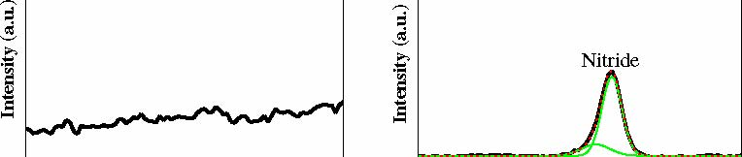
Nitride
Intensity (a.u.) Intensity (a.u.)
406 404 402 400 398 396 394 392 390
406 404 402 400 398 396 394 392 390
Binding energy (eV)
Binding energy (eV)
Fig. 3. XPS spectra analysis of Zr62.5Cu22.5Fe5Al10 BMGs with and without N-PIII treatment.
H.-H. Huang et al. / Journal of Alloys and Compounds 615 (2014) S660–S665 S663
Al (12.9%), and Fe (1.1%). This indicates that the surface oxide ﬁlm 1.5 of Zr62.5Cu22.5Fe5Al10 BMG without N-PIII treatment primarily contained Zr oxide (as ZrO2) with small quantities of Al, Cu, and Fe oxi-1.0 des. The outermost surface of N-PIII BMG contained the following
(in at.%): O (34.5%), Zr (49.6%), Cu (0.5%), Al (3.8%), Fe (0.4%), and N (11.2%). This indicates that the surface oxide ﬁlm of N-PIII
Zr62.5Cu22.5Fe5Al10 BMG was primarily comprised of a nitride-containing oxide ﬁlm, ZrO2/ZrN/Zr(N,O). The very limited quantities of Cu and Al on the outermost surface of the N-PIII BMG should promote biocompatibility because excessive Cu or Al ions may lead to biological side effects [36,37].
Fig. 4 presents a TEM micrograph showing a cross-section of the N-PIII BMG specimen. The micrograph primarily shows the nitride-containing oxide ﬁlm (as identiﬁed by XPS) of approximately 15 nm in thickness. We expected this nitride-containing oxide thin ﬁlm on the surface of the N-PIII BMG to provide good resistance to bio-corrosion in simulated biological environments, as discussed below.
Voltage (V) Voltage (V)
-0.5 -1.0 -1.5 10-9 10-8 10-7 10-6 10-5 10-4 10-3 10-2
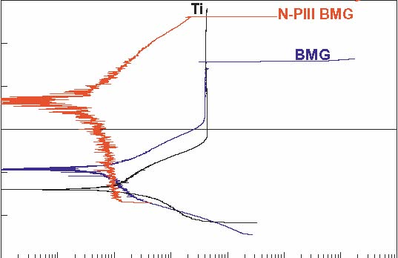
Current density (A/cm2)
(a)
0.5
0
1.5
1.0
3.2. Bio-corrosion resistance
Fig. 5 presents the potentiodynamic polarization curves of Ti and BMGs with and without N-PIII treatment in (a) AS and (b) SBF. All BMG samples (with and without N-PIII treatment) presented higher Ecorr and lower Ianod than commercial biomedical
Ti, regardless of the type of test solution. Nonetheless, only the BMG presented signs of pitting. The results also indicate that N-PIII treatment signiﬁcantly increased the Ecorr and Epit while decreasing the Ianod of BMG both in SA and SBF.
The corrosion parameters obtained from the potentiodynamic polarization curves are detailed in Table 1. Table 1 also compares the corrosion parameters obtained in this study with those of other studies. In our study, the Icorr values of Zr62.5Cu22.5Fe5Al10 BMG with N-PIII treatment were 50–67% lower, the Ecorr values were 800–1100 mV higher (or nobler), and the Epit values were 500– 700 mV higher than those of the untreated Zr62.5Cu22.5Fe5Al10 BMG. According to the XPS analysis results (Fig. 3), the outermost surface ﬁlm of Zr62.5Cu22.5Fe5Al10 BMG mainly contained ZrO2, while that of N-PIII treated Zr62.5Cu22.5Fe5Al10 BMG mainly contained ZrN/Zr(N,O) along with ZrO2. It is well known that the outermost surface ﬁlm of metals is responsible for the corrosion resistance. This indicates that the presence of nitrides, ZrN/Zr(N,O), in the ZrO2 surface ﬁlm of Zr62.5Cu22.5Fe5Al10 BMG signiﬁcantly increased the resistance of to bio-corrosion, especially pitting.
Furthermore, comparing the corrosion parameters obtained in this study with those of other studies (Table 1), the Icorr values
(0.01 lA/cm2) of the N-PIII Zr62.5Cu22.5Fe5Al10 BMG used in our
Fig.4.TEMmicrographshowingacross-sectionoftheN-PIIItreatedZr62.5Cu22.5-Fe5Al10BMGspecimen.
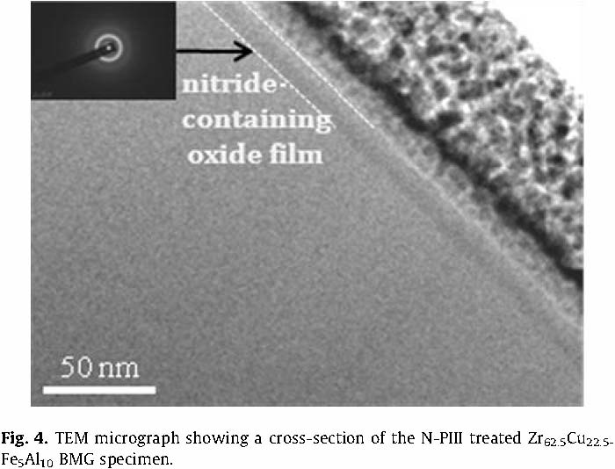
-0.5
-1.0
-1.5 10-9 10-8 10-7 10-6 10-5 10-4 10-3 10-2
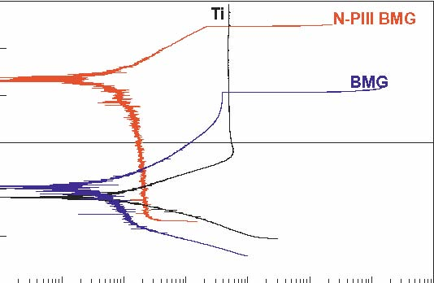
Current density (A/cm2)
(b)
Fig. 5. Potentiodynamic polarization curves of Ti and Zr62.5Cu22.5Fe5Al10 BMGs with and without N-PIII treatment in (a) AS and (b) SBF.
study were far lower than those of other Ni-free Zr-based BMGs (0.055–0.264 lA/cm2) [14,15,17,38] as well as other Ni-containing Zr-based BMGs (0.014–5430 lA/cm2) in simulated human body environments [7–10]. The Epit values (787 mV in AS; 531 mV in SBF) of Zr62.5Cu22.5Fe5Al10 BMG without N-PIII treatment were higher than those found for other Ni-free and Ni-containing Zr-based BMGs, as tested in the same simulated body environments [7– 10,14,15,17,38]. It should be noted that following N-PIII treatment, the Zr62.5Cu22.5Fe5Al10 BMG used in this study was found to have much higher Epit values (>1200 mV) than those obtained from any other Zr-based BMGs, tested in either AS or SBF. This indicates that the N-PIII treatment signiﬁcantly increased the bio-corrosion resistance of Zr62.5Cu22.5Fe5Al10 BMG. This was attributed to the presence of a protective nitride (ZrN/Zr(N,O))-containing ZrO2 thin ﬁlm on the surface of the N-PIII treated Zr62.5Cu22.5Fe5Al10 BMG.
Previous studies have demonstrated that elemental Cu is prone to the formation of nanocrystals on Cu-containing Zr-based BMGs. Cu nanocrystals promote the dissolution of BMGs through localized corrosion caused by the formation of a galvanic corrosion cell [39]. Furthermore, inhomogeneity within the cast of BMG alloys may result in localized imperfections on the surface of the ﬁlm leading to localized corrosion (e.g., pitting corrosion) [40]. If BMG alloys are to be incorporated into long-term biomedical applications, resistance to pitting corrosion must be improved. The N-PIII treatment in this study produced a uniform ZrN/Zr(N,O)-containing oxide ﬁlm (approximately 15 nm in thickness) on the surface of the Ni-free Zr-based BMG which contained 22.5% Cu (in at.%) in the bulk composition. Previous studies have shown that ZrN is known for its excellent corrosion resistance, good biocompatibility,
0.5
0
S664 H.-H. Huang et al. / Journal of Alloys and Compounds 615 (2014) S660–S665
Table 1
Comparison of the corrosion parameters of different Zr-based BMGs in simulated biological environments.
Zr-BMG | Ecorr (mV, SCE) | Icorr (lA/cm2) | Epit (mV, SCE) | Environment | Reference
Ni-containing
Zr53Cu30Ni9Al8 | -214 | 0.06 | 35 | SBF | [7]
Zr41.25Ti13.75Ni10Cu12.5Be22.5 | -194 | NA | <-120 | 3.5%NaCl | [8]
Zr55Al10Cu30Ni5 | -231 | 5430 | 118 | PBS | [9]
(Zr55Al10Cu30Ni5)99Y1 | -302 | 430 | 185 | PBS | [9]
Zr57Nb5Cu15.4Ni12.6Al10 | -382 | 0.014 | 291 | SBF | [10]
 | -263 | 0.038 | 786 | AS
Ni-free
Zr62.3Cu22.5Fe4.9Al6.8Ag3.5 | -290 | 0.055 | -22 | PBS | [14]
Zr60Cu22.5Fe7.5Al10 | -370 | 0.201 | -50 | PBS | [15]
Zr60Cu20Fe10Al10 | -390 | 0.264 | 70 | PBS | [15]
Zr60Ti6Cu19Fe5Al10 | -420 | 0.234 | 280 | PBS | [15]
Zr53Al15(Co1-xAgx)31 (x = 0, 0.1, 0.25) | -530 to -400 | NA | 30 to 225 | PBS | [17]
Zr50Cu35Al7Nb5Pb3 | <-300 | NA | <350 | PBS | [38]
Zr55Cu30Al7Nb5Pb3 | <-300 | NA | <600 | PBS | [38]
Zr62.5Cu22.5Fe5Al10 | -532 | 0.03 | 787 | AS | This study
 | -537 | 0.02 | 531 | SBF
N-PIII treated Zr62.5Cu22.5Fe5Al10 | 279 | 0.01 | 1311 | AS | This study
 | 649 | 0.01 | 1236 | SBF

NA: not available; PBS: phosphate buffered saline
and good mechanical property, which could make this compound highly useful in biomedical applications [41–43]. The formation of ZrN on the Zr-based alloy drastically increases the pitting corrosion resistance in chloride solution [44]. The presence of thin ZrN surface ﬁlm with oxide species (ZrNxOy and ZrO2) increases the pitting corrosion of Ti in artiﬁcial saliva solution [45]. In this study, the surface of the BMG contained ZrO2 with small amounts of Al, Cu, and Fe oxides. After N-PIII treatment, the surface of the BMG mainly comprised a nitride-containing oxide ﬁlm, ZrO2/ZrN/ Zr(N,O). We believed that the signiﬁcantly increased pitting potential of the BMG after N-III treatment was strongly related to the formation of ZrN/Zr(N,O) in the ZrO2 surface ﬁlm. However, the individual effect of ZrN, Zr(N,O), and ZrO2 on the pitting corrosion resistance of the BMG is an important issue but needs further investigation. The pitting potentials (1311 mV in AS and 1236 mV in SBF) obtained for the N-PIII treated BMG are probably the highest values ever achieved for Ni-free Zr-based BMG. As a result, the proposed N-PIII BMG has considerable potential for long-term clinical applications, such as medical implants, in which resistance to bio-corrosion is crucial.
4. Conclusions
After N-PIII treatment, a protective nitride-containing oxide ﬁlm, ZrO2/ZrN/Zr(N,O), of approximately 15 nm in thickness is formed on the Ni-free Zr62.5Cu22.5Fe5Al10 BMG. Polarization curves in artiﬁcial saliva and simulated body ﬂuid demonstrate that the proposed N-PIII treated Zr62.5Cu22.5Fe5Al10 BMG alloy has a signiﬁcantly lower corrosion rate, higher corrosion potential, and higher pitting potential than untreated Zr62.5Cu22.5Fe5Al10 BMG and other published Zr-based BMGs, regardless of whether they contain Ni. The pitting potentials (1311 mV in AS and 1236 mV in SBF) obtained for the N-PIII treated Zr62.5Cu22.5Fe5Al10 BMG are probably the highest values ever achieved for Ni-free Zr-based BMG. Thus, the Ni-free Zr62.5Cu22.5Fe5Al10 BMG alloy used in this study shows considerable potential in the ﬁeld of biomedical implants, and the proposed N-PIII treatment further enhances resistance to bio-corrosion, especially pitting.
Acknowledgements
Taoyuan, Taiwan, for their assistance in N-PIII treatment. Thanks are also due to Prof. Jyh-Wei Lee and Miss Mei-Chen Chiang, Ming Chi University of Technology, Taiwan, for their assistance in TEM analysis.
References
[1] M. Navarro, A. Michiardi, O. Castaño, J.A. Planell, J. R. Soc. Interface 5 (2008) 1137–1158.
[2] Q.G. Fu, X.W. Liu, S.G. Xu, M. Li, C.C. Zhang, J. Mater. Eng. Perform. 18 (2009) 797–804.
[3] M.T. Manley, K. Sutton, J. Arthroplasty 23 (2008) 47–50.
[4] M. Driscoll, L. Blyum, J. Bodyw Mov. Ther. 15 (2011) 335–342.
[5] M.D. Demetriou, A. Wiest, D.C. Hofmann, W.L. Johnson, B. Han, N. Wolfson, G. Wang, P.K. Liaw, JOM 62 (2010) 83–91.
[6] L. Liu, C.L. Qiu, C.Y. Huang, Y. Yu, H. Huang, S.M. Zhang, Intermetallics 17 (2009) 235–240.
[7] C.H. Huang, J.C. Huang, J.B. Li, J.S. Jang, Mater. Sci. Eng. C. 7 (2013) 4183–4187.
[8] H.C. Kou, Y. Li, T.B. Zhang, J. Li, J.S. Li, T. Nonferr. Metal. Soc. 21 (2011) 552–557.
[9] L. Huang, D. Qiao, B.A. Green, P.K. Liaw, J. Wang, S. Pang, T. Zhang, Intermetallics 17 (2009) 195–199.
[10] Y.B. Wang, Y.F. Zhang, S.C. Wei, M. Li, J. Biomed. Mater. Res. B Appl. Biomater. 96 (2011) 34–46.
[11] A. Dhawan, K. Sachdev, S. Roychowdhury, P.K. De, S.K. Sharma, J. Non-Cryst. Solids 353 (2007) 2619–2623.
[12] International Agency for Research on Cancer (IARC) Monographs on the Evaluation of Carcinogenic Risks to Humans, vol. 74, IARC Press, Lyon, 1999.
[13] J.C. Wataha, P.E. Lockwood, A. Schedle, J. Biomed. Mater. Res. 52 (2000) 360–
364.
[14] S.F. Guo, Z. Liu, K.C. Chan, W. Chen, H.J. Zhang, J.F. Wang, P. Yu, Mater. Lett. 84 (2012) 81–84.
[15] A. Monfared, S. Faghihi, H. Karami, Int. J. Electrochem. Sci. 8 (2013) 7744– 7752.
[16] J. Li, L.L. Shi, Z.D. Zhu, Q. He, H.J. Ai, J. Xu, Mater. Sci. Eng. C 33 (2013) 2113– 2121.
[17] N. Hua, L. Huang, J. Wang, Y. Cao, W. He, S. Pang, T. Zhang, J. Non-Cryst. Solids 358 (2012) 1599–1604.
[18] H. Jia, C.I. Muntele, L. Huanga, X. Li, G. Li, T. Zhang, W. Hea, P.K. Liaw, Intermetallics 41 (2013) 35–43.
[19] T.P. Chaturvedi, Indian J. Dent. Res. 20 (2009) 91–98.
[20] M. Birkholz, K.E. Ehwald, D. Wolansky, I. Costina, C. Baristyran-Kaynak, M. Fröhlich, H. Beyer, A. Kapp, F. Lisdat, Surf. Coat. Technol. 204 (2010) 2055– 2059.
[21] H. Hämmerle, K. Kobuch, K. Kohler, W. Nisch, H. Sachs, M. Stelzle, Biomaterials 23 (2002) 797–804.
[22] M. Birkholz, K.-E. Ehwald, P. Kulse, J. Drews, M. Fröhlich, U. Haak, M. Kaynak, E. Matthus, K. Schulz, D. Wolansky, Adv. Funct. Mat. 21 (2011) 1652–1656.
[23] H.O. Pierson, Handbook of Refractory Carbides and Nitrides: Properties, Characteristics, Processing, and Applications, Noyes Publications, New Jersey, 1996.
[24] G. Abadias, Surf. Coat. Technol. 202 (2008) 2223–2235.
[25] K.W.K. Yeung, R.W.Y. Poon, X.Y. Liu, J.P.Y. Ho, C.Y. Chung, P.K. Chu, W.W. Lu, D.
The authors would thank Mr. Y.C. Li, Dr. W.F. Tsai, and Dr. C.F.
Chan, K.M.C. Cheung, J. Biomed. Mater. Res. A 75 (2005) 256–267. Ai, Institute of Nuclear Energy Research, Atomic Energy Council, [26] S. Mändl, B. Rauschenbach, Surf. Coat. Technol. 156 (2002) 276–283.
H.-H. Huang et al. / Journal of Alloys and Compounds 615 (2014) S660–S665 S665

[27] X.B. Tian, P.K. Chu, R. Fu, S.Q. Yang, Surf. Coat. Technol. 186 (2004) 190–195.
[28] L. Tan, R.A. Dodd, W.C. Crone, Biomaterials 24 (2003) 3931–3939.
[29] R.W.Y. Poon, J.P.Y. Ho, X. Liu, C.Y. Chung, P.K. Chu, K.W.K. Yeung, W.W. Lu,
K.M.C. Cheung, Nucl. Instrum. Methods B 237 (2005) 411–416.
[30] R.A. Yankov, N. Shevchenko, A. Rogozin, M.F. Maitz, E. Richter, W. Moller, A. Donchev, M. Schutze, Surf. Coat. Technol. 201 (2007) 6752–6758.
[31] A.E. Muñoz-Castro, R. López-Callejas, E.E. Granda-Gutiérrez, R. Valencia-Alvarado, S.R. Barocio, R. Peña-Eguiluz, A. Mercado-Cabrera, A. de la Piedad Beneitez, Prog. Org. Coat. 64 (2009) 259–263.
[32] Y.S. Sun, W. Zhang, W. Kai, P.K. Liaw, H.H. Huang, J. Alloys Comp. 586 (2014) S539–S543.
[33] Q.S. Zhang, W. Zhang, A. Inoue, Scripta Mater. 61 (2009) 241–244.
[34] H.H. Huang, Y.H. Chiu, T.H. Lee, S.C. Wu, H.Y. Yang, K.H. Su, C.C. Hsu, Biomaterials 24 (2003) 3585–3592.
[35] T. Kokubo, S. Ito, Z.T. Huang, J. Biomed. Mater. Res. 24 (1990) 331–343.
[36] J.A. Lee, I.D. Marsden, C.N. Glover, Aquat. Toxicol. 99 (2010) 65–72.
[37] J.P. Landsberg, B. McDonald, F. Watt, Nature 360 (1992) 65–68.
[38] L. Huang, Y. Yokoyama, W. Wu, P.K. Liaw, S. Pang, A. Inoue, T. Zhang, W. He, J. Biomed. Mater. Res. B Appl. Biomater. 100 (2012) 1472–1482.
[39] J. Paillier, C. Mickel, P.F. Gostin, A. Gebert, Mater. Charact. 61 (2010) 1000– 1008.
[40] M.L. Morrison, R.A. Buchanan, A. Peker, W.H. Peter, J.A. Horton, P.K. Liaw, Intermetallics 12 (2004) 1177–1181.
[41] C.-M. Cotrut, V. Braic, M. Balaceanu, I. Titorencu, M. Braic, A.C. Parau, Thin Solid Films 538 (2013) 48–55.
[42] A.J. Nathanael, J.H. Lee, S.I. Hong, Appl. Mech. Mater. 248 (2013) 37–42.
[43] D.V. Shtansky, M. Roy, Surface engineering for biotribological application, in:
M. Roy (Ed.), Surface Engineering for Enhanced Performance against Wear, Springer-Verlag, Wien, 2013, pp. 277–310.
[44] S.J. Lee, H.S. Kwon, W. Kim, B.H. Choi, Mater. Sci. Eng. A 263 (1999) 23–31.
[45] D. Roman, J. Bernardi, C.L.G. de Amorim, F.S. de Souza, A. Spinelli, C. Giacomelli,
C.A. Figueroa, I.J.R. Baumvol, R.L.O. Basso, Mater. Chem. Phys. 130 (2011) 147–
153.
䘀椀最⸀㐀⸀

