Journal of Alloys and Compounds 615 (2014) S648–S654

Contents lists available at ScienceDirect

Journal of Alloys andCompounds
journal homepage: www.elsevier.com/locate/jalcom

Surface nanotopography of an anodized Ti–6Al–7Nb alloy enhances cell growth
Her-Hsiung Huang a,b,c,d, Chia-PingWue, Ying-Sui Suna, Wei-En Yange, Tzu-Hsin Leef,g,⇑
a Department of Dentistry, National Yang-Ming University, Taipei 112, Taiwan bGraduate Institute of Basic Medical Science, China Medical University, Taichung 404, Taiwan c Department of Biomedical Informatics, Asia University, Taichung 413, Taiwan dDepartment of Stomatology, Taipei Veterans General Hospital, Taipei 112, Taiwan e Institute of Oral Biology, National Yang-Ming University, Taipei 112, Taiwan fSchool of Dentistry, Chung Shan Medical University, Taichung 402, Taiwan gOral Medicine Center, Chung Shan Medical University Hospital, Taichung 402, Taiwan

article info abstract

Article history:
Available online7January 2014
Keywords:
Ti–6Al–7Nb alloy Electrochemical anodization Surface nanotopography Cell growth
The a/b-type Ti–6Al–7Nb alloy is a potential replacement for a/b-type Ti–6Al–4V alloy, which is widely used in biomedical implant applications. The biological response to implant material is dependent on the surface characteristics of the material. In the present study, a simple and fast process was developed to perform an electrochemical anodization treatment on Ti–6Al–7Nb alloy. The proposed process yielded a thin surface nanotopography, which enhanced cell growth on the Ti–6Al–7Nb alloy. The surface characteristics, including the morphology, wettability, and protein adsorption, were investigated, and the cytotoxicity was evaluated according to International Organization for Standardization 10993-5 speciﬁcations. Cell adhesion of human bone marrow mesenchymal stem cells on the test specimens was observed via ﬂuorescence microscopy and scanning electron microscopy. The anodization process produced a surface nanotopography (pore size <100nm) on anodized Ti–6Al–7Nb alloy, which enhanced the wettability, protein adsorption, cell adhesion, cell migration, and cell mineralization. The results showed that the surface nanotopography produced using the proposed electrochemical anodization process enhanced cell growth on anodized Ti–6Al–7Nb alloy for implant applications.
。 2014 Elsevier B.V. All rights reserved.

1. Introduction
Biomedical orthopaedic implant designs typically employ an alpha/beta (a/b)phase titanium–6aluminum–4vanadium (Ti–6Al–4V) alloy because of its good mechanical properties and satisfactory biocompatibility. Nevertheless, the possible negative biological effects of V have been indicated in previous studies [1–5]. The existence of V ions may enhance the expression of proinﬂammatory factors and osteolytic mediators, resulting in orthopaedic implant failures [1]. The existence ofV2O5 on an alloy surface is capable of cytotoxicity [2]. Moreover,Vions may reduce fertility. Namely, animals may experience embryo lethality, fetotoxicity, and teratogenicity afterVions exposure [3–5].
Ti alloys containing no V have obtained increasing attention, particularly those with Nb which does not have adverse tissue reaction [6]. To decrease the potential negative biological effects ascribed to V ions, V, a b phase stabilizer of Ti–6Al–4V alloy, can
⇑ Corresponding author. Address: School of Dentistry, Chung Shan Medical University, No.110, Sec. 1, Jianguo N. Rd., Taichung City 402, Taiwan. Tel.: +886 4 24718668x55011.
E-mail address: biomaterials@hotmail.com (T.-H. Lee).
be substituted by a different b phase stabilizer, such as niobium (Nb), to create Ti–6Al–7Nb alloy for implant applications. Similar to Ti–6Al–4Valloy, Ti–6Al–7Nb alloy presents excellent mechanical properties with less possible biological negative effects [7]. However, information on the cell growth of Ti–6Al–7Nb alloy is limited.
Creating porous topography on the surface of Ti-based implants is crucial for biocompatibility. Therefore, several studies have focused on developing techniques that produce and amend porous Ti-based implant surfaces to offer an ideal biological response [8–12]. Nevertheless, these techniques are often complicated and/or time-consuming for potential biomedical applications. Conversely, investigators have utilized easy electrochemical processes to generate ordered TiO2 nanotubes on pure Ti surfaces in ﬂuoride containing solutions [13,14]. Previous studies have employed a rapid electrochemical process to create a nanonetworked TiO2 layer on pure Ti surfaces to improve blood coagulation and cell growth [15–17]. Recently, an electrochemical anodization treatment was used to produce a nanoporous oxide layer on a Ti–6Al–7Nb alloy, which increases biocorrosion resistance in simulated blood plasma [18]. However, further information on cell growth on the nanoscale surfaces of Ti–6Al–7Nb alloy is currently unavailable.
0925-8388/$ -see front matter。 2014 Elsevier B.V. All rights reserved.
http://dx.doi.org/10.1016/j.jallcom.2013.12.235
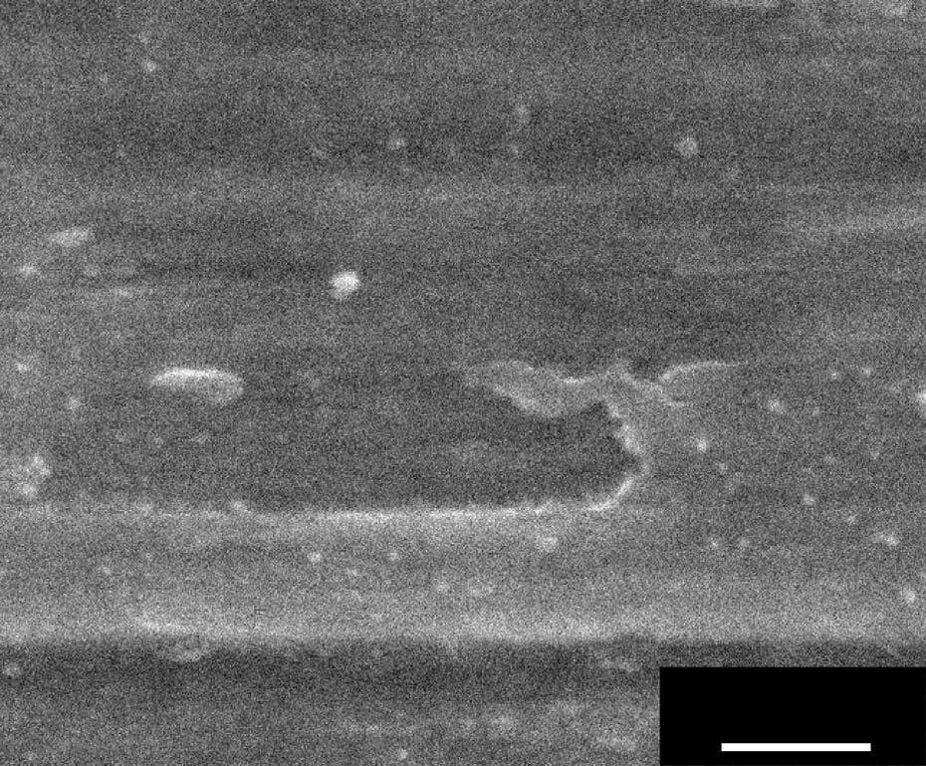
H.-H. Huang et al. / Journal of Alloys and Compounds 615 (2014) S648–S654 S649

(a) Ti6Al7Nb-P
200 nm
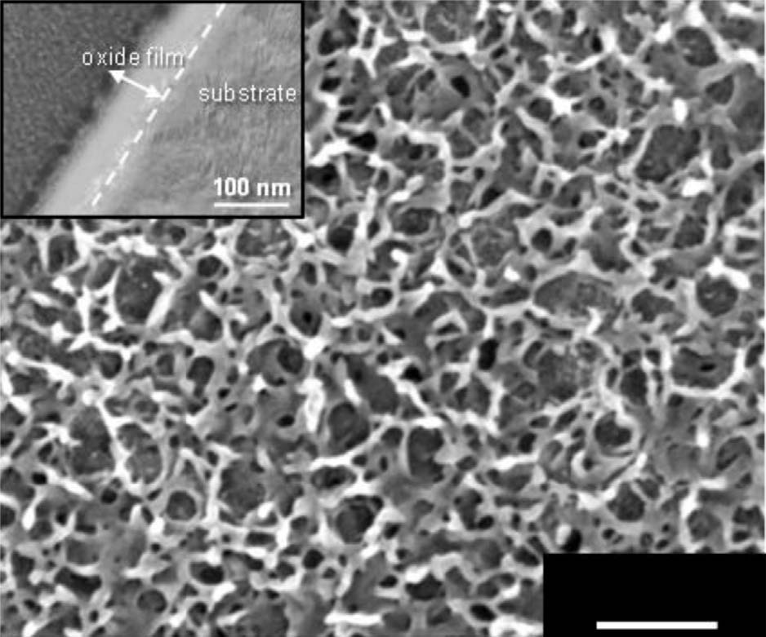
200 nm
(b) Ti6Al7Nb-A
Fig. 1. FE-SEM micrographs of (a) Ti6Al7Nb-P and (b) Ti6Al7Nb-A. The cross-sectional TEM micrograph of Ti6Al7Nb-A is shown in the upper-left inset of (b).
We hypothesisedthatasurfacenanotopographyonaTi–6Al–7Nb alloywouldimprove cell growth.Afast andsimpleelectrochemical anodization process, as used in our previous study [18], was used to produce a nanoporous surface on Ti–6Al–7Nb alloy for implant applications.Westudiedthewettability, protein adsorption,andcell growth(includingadhesion,migration,andmineralization)of anodized Ti–6Al–7Nb alloy with surface nanotopography.
2. Materials and methods
2.1. Material preparation
Biomedical Ti–6Al–7Nb discs (diameter: 15 mm; thickness: 1mm) were used as test substrates. The surfaces of the substrates were consecutively polished using SiCpaper#240–#1200.Ananodic current(<0.5A)wasappliedtopolished Ti–6Al– 7Nb specimensin 10-min incrementsusinga galvanostatin5MNaOHat25 oC. The anodized specimens were designated as Ti6Al7Nb-A, while the non-anodized polished specimens were designated as Ti6Al7Nb-P.
2.2. Surface characterization
The surface topography and chemistry of the Ti–6Al–7Nb specimens were analyzed using ﬁeld emission-scanning electron microscopy (FE-SEM) and X-ray photoelectron spectroscopy (XPS), respectively. The morphological dimensions of the surface conﬁgurations on the Ti6Al7Nb-A specimens were calculated according to three FE-SEM micrographs using Image-Pro@ Plus image analysis software (Version 4.5.1). Focused ion beam (FIB) milling was performedto preparea Ti6Al7Nb-A specimen for cross-sectional analysis using a transmission electron microscope (TEM). The surface roughness(Ra)was analyzed using atomic force microscopy (AFM) with a scanning area of 50 x50 lm. The surface wettability was analyzed by measuring the contact angle of a droplet of deionized water on the specimens using a contact-angle goniometer. The measurements were performed in triplicate.
2.3. Biological responses
2.3.1. Protein adsorption
Albumin and ﬁbronectin were used as the model proteins used in this study. The protein-containing (5mg/ml) phosphate-buffered saline (PBS) was added to all of the surfaces of the Ti–6Al–7Nb specimens. After 5min of immersion, the Ti–6Al–7N specimens were washed with deionized water. Adsorbed protein on the Ti–6Al–7Nb surfaces was qualitatively analyzed using XPS spectra, in terms of N1s intensity. The measurements were performed in triplicate.
2.3.2. Cytotoxicity
The NIH 3T3 cells, mouse ﬁbroblast cell line, were used to assess the cytotoxicity of the extracts from the Ti–6Al–7Nb specimens. The specimens were extracted for1din Dulbecco’s modiﬁed Eagle’s medium (DMEM)at37 oCin a 5% CO2 incubator. The extracts were subsequently used to treat cell monolayers for1d, after which the cells were examined for morphological changes to verify the toxicity scores. The cell viability was investigated using a 3-(4,5-dimethylthiazol-2-yl)2,5-diphenyl tetrazolium bromide (MTT) assay and a microplate photometer (wavelength = 570 nm) to measure the optical density (OD). Higher OD values indicated greater cell viability. DMEM without extracts was used as a reagent control. Treatment with 10% dimethyl sulfoxide in DMEM served as a positive control, while zirconia disc served as negative control. Additional experimental details are described in ISO 10993-5 speciﬁcations.
2.3.3. Cell adhesion
Human bone marrow mesenchymal stem cells (hMSCs) were transduced using the gene for green ﬂuorescent proteins (GFP) via retroviral delivery. The GFP-labeled hMSCs were seededonthe test specimensata densityof5 x104 cells/specimen. The culture medium consisted of a Roswell Park Memorial Institute-1640 (RPMI-1640) medium supplemented with 5% fetal bovine serum (FBS) and 10% horse serum. During cell incubation, which was performed for1d, adherent cells on the specimens were observed in situ usinga ﬂuorescence microscope. Sequentially, adherent cells on the specimens were ﬁxed with 2.5% glutaraldehyde for 2hat room temperature. The specimens were subsequently washed with deionized water and dehydrated using a series of ethanol solutions (30–100%) followed by a critical point dryer. The specimens were coated with a thin platinum ﬁlm, and the cell adhesion morphology was observed using FE-SEM.
For immunoﬂuorescent staining, which was conducted to characterize cell adhesion, the hMSCs were cultured on the specimens (5 x104 cells/cm2)for6h. The culture medium consisted of low glucose Dulbecco’s modiﬁed Eagle medium (DMEM) supplemented with 10% FBS. Adherent cells were subsequently ﬁxed with 4% paraformaldehyde and were permeabilized with 0.2% Triton X-100 in PBS. The cells were then incubated with mouse monoclonal anti-vinculin at4 oC overnight, and the secondary antibody was conjugated with ﬂuorescein isothiocyanate. The nuclei and F-actin were stained with 40,6-diamidino-2-phenylindole (DAPI) and rhodamine phalloidin, respectively. Cell images were obtained using a multi-purpose zoom microscope with image analysis software (Image-Pro@ Express 6.0).
2.3.4. Cell migration
A wound-healing assay was used to evaluate the migration of GFP-labeled hMSCs on the specimens. Cells (5 x104 cells/specimen) were seeded on the specimensandwere cultureduntil conﬂuency.Apipettetipwasusedtocreateastraight scratch on the specimens to simulate a surface wound with a width of approximately 250 lm.Aﬂuorescence microscope was used to capture the images during cell migrationat0,2,and4h.The measurements were performedin triplicatefor each time point.
2.3.5. Cell mineralization
The capacity for cell mineralization was examined using Alizarin RedSstaining to detect calcium components. AlizarinRedSisadye that binds selectivelyto calcium salts and is widely used to determine the calcium mineral histochemistry. The hMSCs were incubated in a normal culture medium for 24h before changing the medium to an osteogenic medium consisting of DMEM supplemented with 300 lM of ascorbic acid, 10 mM of b-glycerophosphate, and 10 nM of dexamethasone. After 7, 14, or 21d of osteogenic culture, the cells were ﬁxed with ice-cold 70% ethanol for1h, washed with PBS, and stained with1% Alizarin RedSin distilled water (pH 4.2) for5min at room temperature. The cells were subsequently washed with distilled water until the colour disappeared. Quantiﬁcation of stained cells was performed using a quantitative destaining procedure with 10% (w/v) cetylpyridinium chloridein10mMof sodium phosphate(pH7.0)for1hwith shakingat room
S650 H.-H. Huang et al. / Journal of Alloys and Compounds 615 (2014) S648–S654
Ti6Al7Nb-P Ti6Al7Nb-A
Ra 0.059 µm
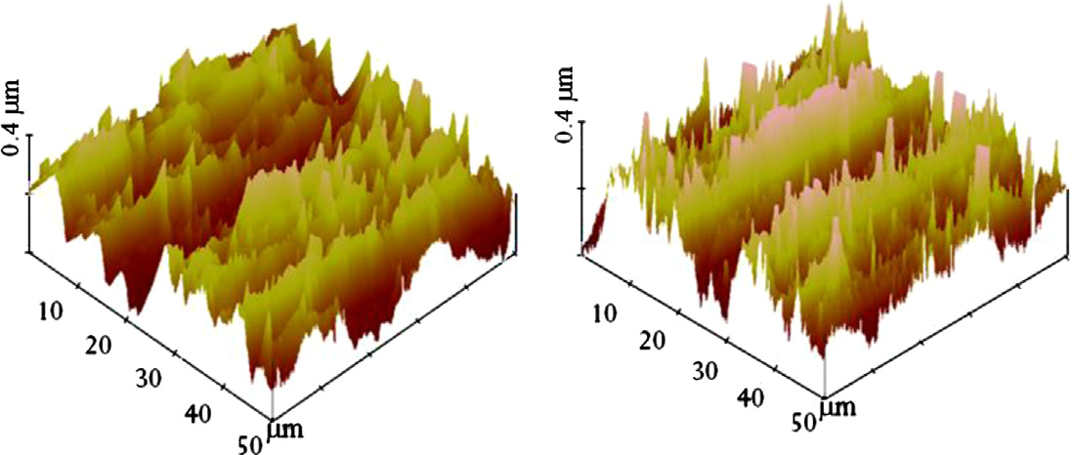Ra 0.064 µm
(a)

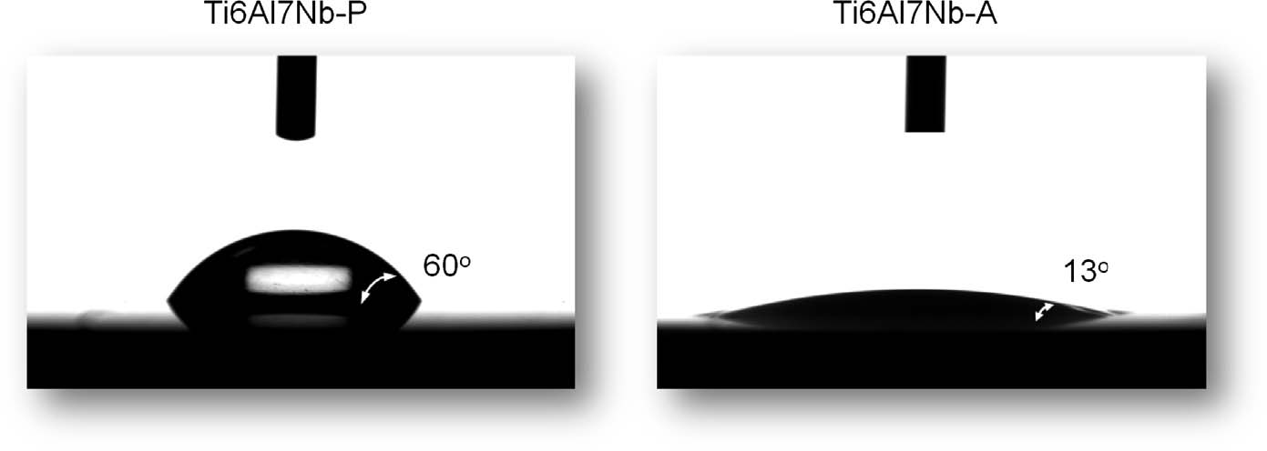
(b)

Fig. 2. (a) Surface topography, in terms of the AFM micrograph, and (b) surface wettability, in terms of the water contact angle, of Ti6Al7Nb-P and Ti6Al7Nb-A specimens.
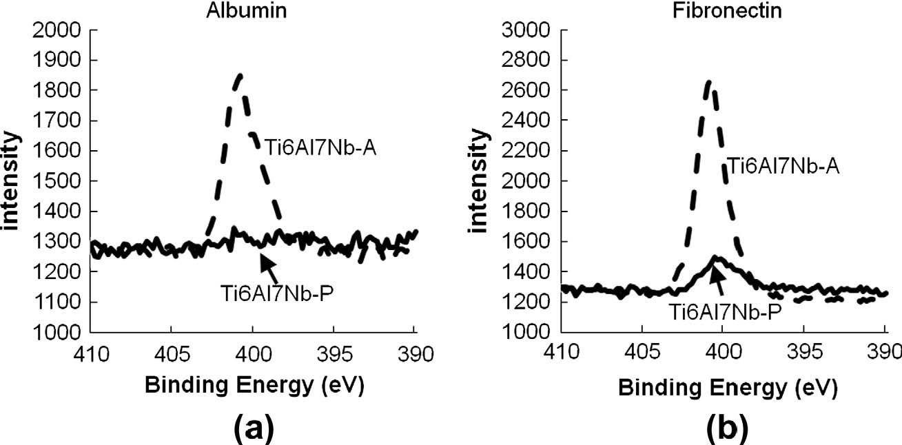
Fig. 3. Protein adsorption, whichwas analyzedusingXPS,in termsoftheN1s intensity,of Ti6Al7Nb-Pand Ti6Al7Nb-A specimens after5minof immersionin(a) albuminand
(b) ﬁbronectin containing solutions.

temperature. Subsequently, the OD values were measured using a microplate photometer at 550 nm. Higher OD values indicated greater cell mineralization. The measurements were performed in triplicate for each time point.
3. Results and discussion
3.1. Surface characterizations
Fig.1(a) and (b) shows FE-SEM micrographs of the Ti–6Al–7Nb specimens before and after the electrochemical anodization treatment, respectively. The upper-left inset of Fig. 1(b) shows a TEM micrograph of the cross-section of Ti6Al7Nb-A. The Ti6Al7Nb-P specimen exhibited a smooth surface, whereas the anodized Ti6Al7Nb-A specimen showed a nanoporous topography on its surface. The lateral pore size approximately varied between 10 nm and 100 nm, and the average size was approximately 70 nm. The cross-sectional TEM micrograph of the Ti6Al7Nb-A specimen(Fig.1(b)) revealed an oxide layer with an approximate thickness of 70 nm. The formation of a nanoporous oxide layer was attributed to the anodic dissolution and repassivation of the alloy during the electrochemical anodization procedure. The surface of Ti–6Al–7Nb specimens with and without electrochemical anodization treatment mainly contained TiO2 identiﬁed using XPS analysis [18].
Fig. 2(a) shows the three-dimensional surface topography of Ti–6Al–7Nb specimens analyzed using AFM. The AFM analysis results revealed no lm-scale difference in surface roughness Ra between the Ti6Al7Nb-P (Ra 0.064 lm) and Ti6Al7Nb-A (Ra
0.059 lm) specimens. Fig.2(b) shows the resultsof the wettability analysis, which were obtained by performing contact angle
H.-H. Huang et al. / Journal of Alloys and Compounds 615 (2014) S648–S654 S651
(a)

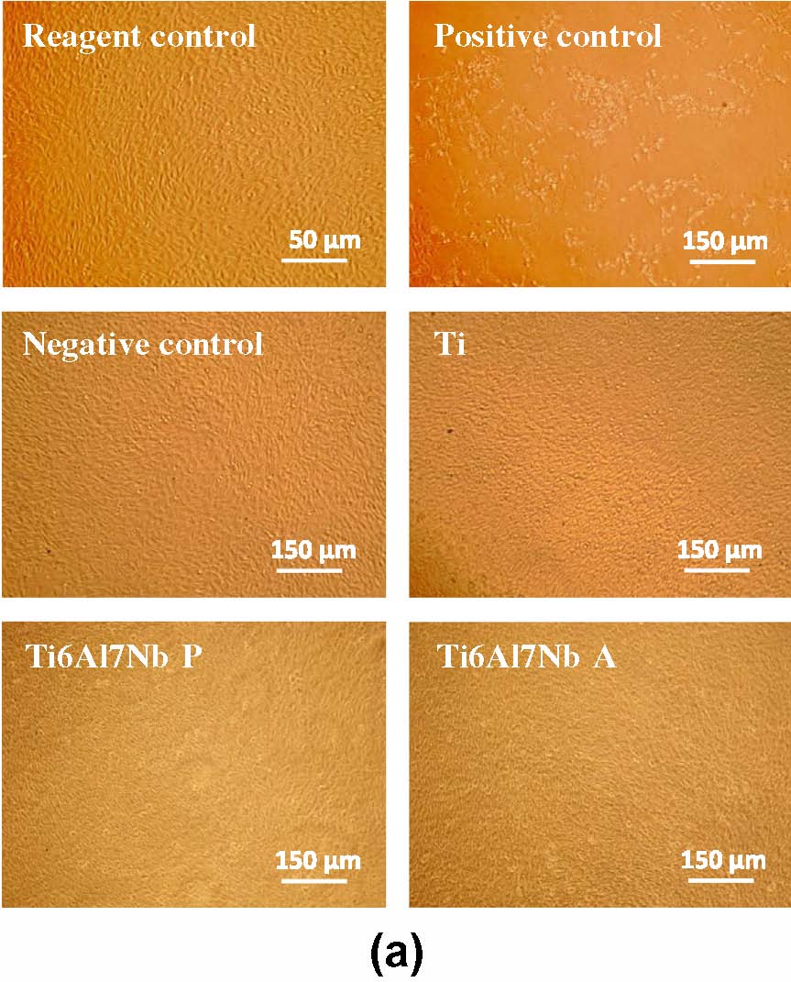
(b)

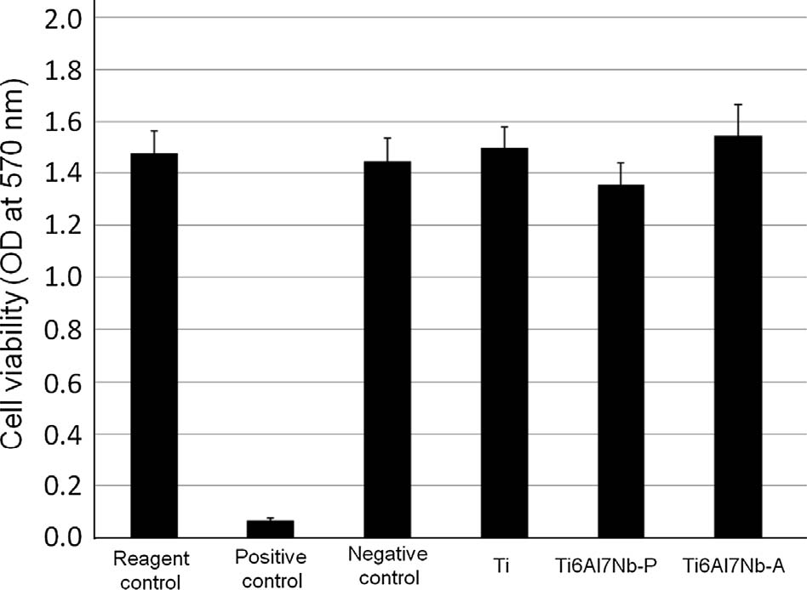
Fig. 4. ISO 10993-5 cytotoxicity assay results showing the (a) morphology and (b) viability of NIH 3T3 cells after1dof incubation in extract containing media.

analyses on the Ti–6Al–7Nb alloys. Ti6Al7Nb-A showed superior hydrophilicity with a contact angle of approximately 13o, whereas Ti6Al7Nb-P presented a contact angle of approximately 60o. According to the American Society for Testing and Materials (ASTM) D7334-08 speciﬁcations [19], the contact angles of 10–20o are indicative of excellent wetting. This result in Fig. 2 shows that the electrochemical anodization process produced a unique surface nanotopography with excellent surface hydrophilicity and did not alter the surface roughness of Ti–6Al–7Nb alloys on a lm scale (only5nm decreasein Ra). These results suggested that the nanoscale proteins in the body ﬂuid can easily penetrate the unique nanoporous structure on the Ti surface and promote the following cell growth.
3.2. Biological responses
The biological tests supported the hypothesis that a surface nanotopography enhances cell growth, including the adhesion, spreading, migration, and mineralization of Ti–6Al–7Nb alloys.
Fig. 3 shows the XPS surface analysis results, including N1s spectra, of Ti–6Al–7Nb specimens after5min of immersion in (a) albumin and (b) ﬁbronectin containing solutions. The anodized Ti6Al7Nb-Aspecimen showedahigher (>5-fold) N1s intensity than the Ti6Al7Nb-P specimen in albumin or ﬁbronectin containing solutions, which was indicative of greater protein adsorption on the Ti6Al7Nb-A specimen. The protein adsorption behavior on the surface of a biomaterial is the ﬁrst step of the biological responses to the material. The dimensions of the proteins are on the nanoscale level. Adsorbed protein may stimulate various types of biological responses [20]. Numerous proteins at the nanoscale level on cell membranes (e.g., integrin) can sense the nanoscale topography and induce subsequent cell responses, such as cell adhesion [21,22]. In the present study, the anodized Ti6Al7Nb-A specimen with a surface nanotopography demonstrated greater protein adsorption, which was expected to enhance the cell growth.
Fig. 4 shows the (a) morphology and (b) viability of NIH 3T3 cells after1d of culture in the extracts of Ti–6Al–7Nb specimens. NIH 3T3 cells cultured in extract containing media (Ti6Al7Nb-P and Ti6Al7Nb-A) were not morphologically different and demonstrated slightly greater viability than cells cultured without the extracts (reagent control). This result indicated that Ti–6Al–7Nb specimens with and without anodization treatment were noncytotoxic.
Fig.5.Fluorescence microscopy and FE-SEM micrographs of hMSCs on (a) Ti6Al7Nb-Pand(b) Ti6Al7Nb-A after24h of cell incubation.
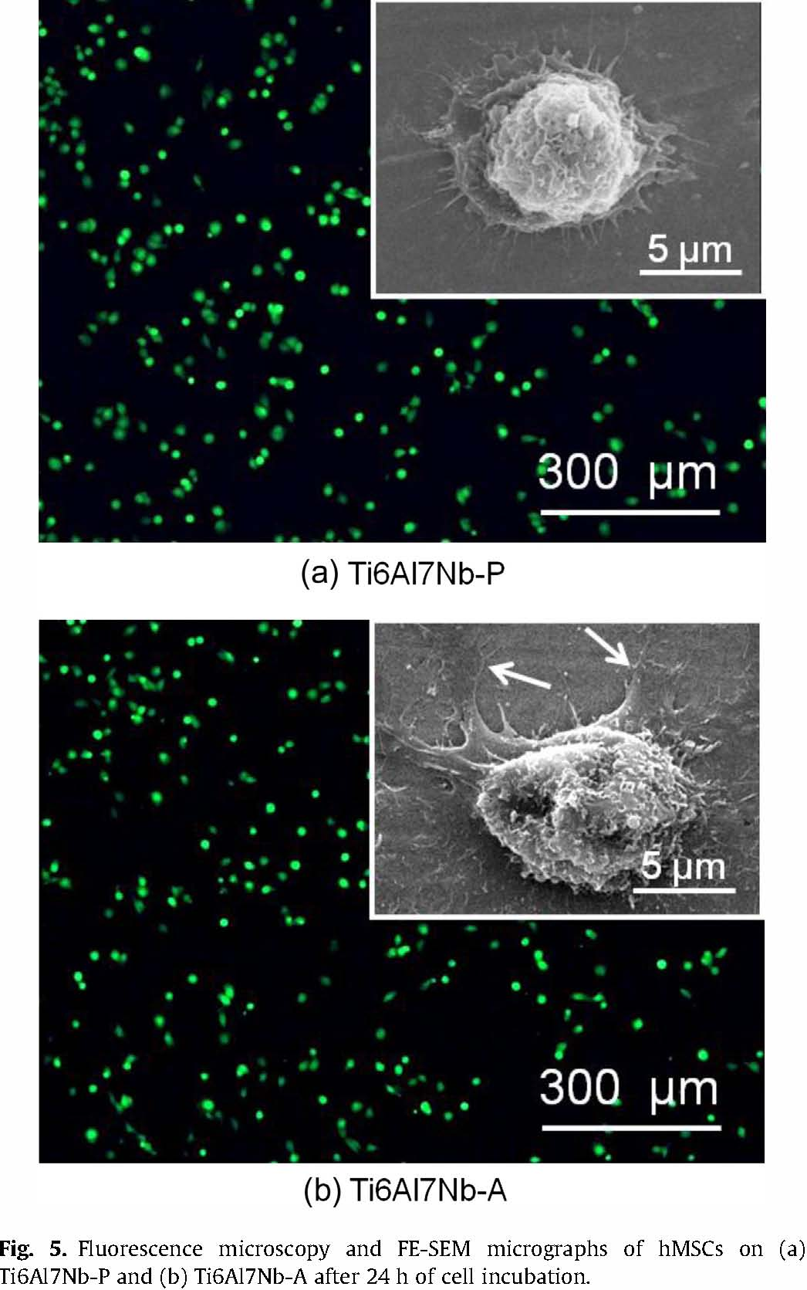
S652 H.-H. Huang et al. / Journal of Alloys and Compounds 615 (2014) S648–S654
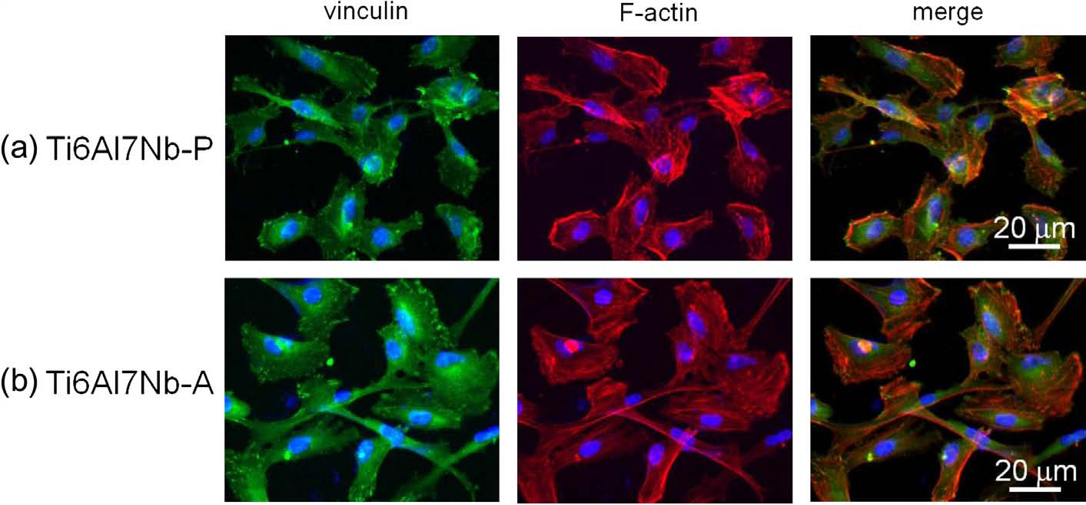
Fig. 6. Cell adhesion,as indicatedbythe immunoﬂuorescencestainingofhMSCs,on(a) Ti6Al7Nb-Pand(b) Ti6Al7Nb-Aafter6h:DAPIfornuclei(blue),rhodamine phalloidin for actin ﬁlaments (red), and anti-vinculin staining (green). (For interpretation of the references to colour in this ﬁgure legend, the reader is referred to the web version of this article.)
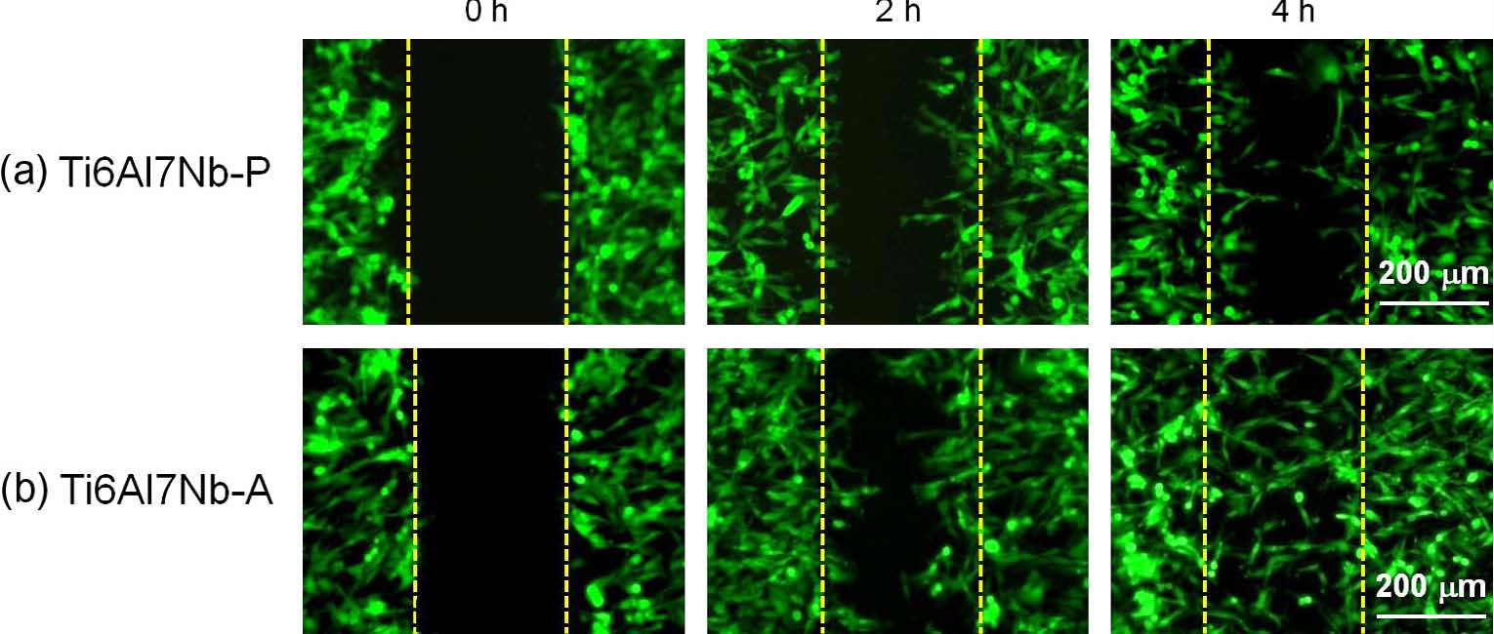
Fig. 7. In situ directional migrationof hMSCs on Ti–6Al–7Nb test specimens usinga wound-healing assay for more than4h.
Fig.8.Cell mineralization, which was analyzed by performing Alizarin Red S stainingonthe hMSCsof Ti–6Al–7Nb specimens during21d of cell incubationin osteogenic medium.
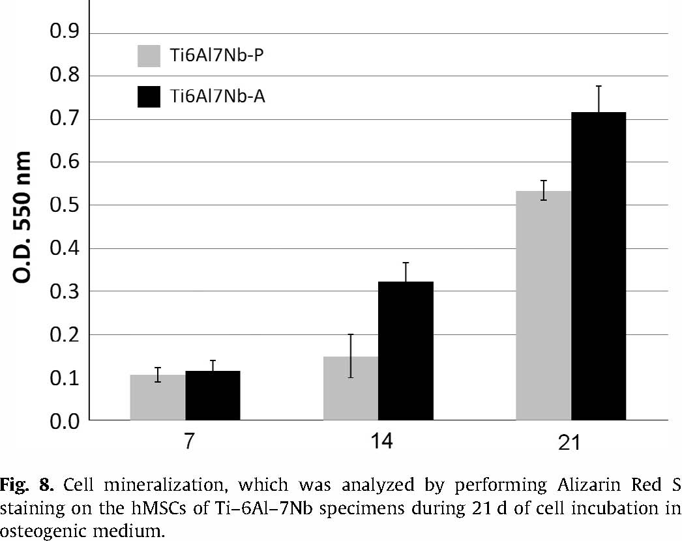
Fig.5 shows the ﬂuorescence microscopy and FE-SEM observationsof GFP-labeled hMSCs on Ti–6Al–7Nb specimens after24h of cell incubation. Considerable differences in the number of attached cells on the test specimens were not observed. However, at higher magniﬁcation, as indicated by the arrows, a more ﬂattened cell adhesion morphology with extended spreading was observed on the Ti6Al7Nb-A specimen compared to that of Ti6Al7Nb-P. Cell adhesion involves the propagation of a thin membrane, followed by the spreading of ﬁlopodia from the cells. The ﬂattening of cells on the surface of a material is an indication of healthy cell growth and material biocompatibility [23]. The result in Fig. 5 demonstrates the Ti6Al7Nb-A specimen had better quality of cell growth than the Ti6Al7Nb-Pspecimen.
Fig.6 shows the adhesion characteristics of the hMSCs, including the focal adhesion complex (vinculin protein) and cytoskeletal arrangement (F-actin ﬁlament) on Ti–6Al–7Nb specimens after6h of incubation via immunoﬂuorescent staining. Compared to the Ti6Al7Nb-P specimen, attached cells on the Ti6Al7Nb-A specimen showed greater focal adhesion through vinculin proteins (bright green points) and well organized F-actin stress ﬁbers (red ﬁlament). hMSCs cultured on the Ti6Al7Nb-A specimen exhibited greater cell spreading and superior ﬁlopodia extension morphology than cells cultured on the Ti6Al7Nb-P specimen. Cell ﬁlopodia, which are the main structures in cell growth cones, contain clusters of actin ﬁlaments, which provide shape and support. Cell ﬁlopodia are bound by the cell membrane, which includes receptors and cell adhesion molecules essential for the growth and guidance of cells. The osseointegrationis initially reliant on the cell adhesion and spreading on implant surface and thus these events are essential in the ﬁeld of implantology [24,25]. Fig. 6 indicates that the Ti6Al7Nb-A surface supported initial hMSCs attachment and spreading, which are necessary for other cellular functions, such as proliferation, migration, and differentiation.
H.-H. Huang et al. / Journal of Alloys and Compounds 615 (2014) S648–S654 S653

Fig.7 shows the in situ directional hMSCs migration on the Ti– 6Al–7Nb specimens using a wound-healing assay for more than 4h. More cells migrated toward the wound on the Ti6Al7Nb-A surface than the Ti6Al7Nb-P surface, and the wound on the Ti6Al7NbA surface was nearly coveredby cells after4hof incubation. The estimated one-directional cell migration rates on the Ti6Al7Nb-A and Ti6Al7Nb-P surfaces were approximately 30 lm/h and 15 lm/h, respectively;thus, the Ti6Al7Nb-A surface demonstrated superior (2-fold) cell migration support than the Ti6Al7Nb-P surface.
Fig. 8 shows the mineralization of the hMSCs on Ti–6Al–7Nb specimens during 21d of cell incubation, which was analyzed using Alizarin Red S staining to detect the calcium components. After7,14,and21d of incubationinthe osteogenic culture, cells on the Ti6Al7Nb-A specimen exhibited superior mineralization compared to the Ti6Al7Nb-Pspecimen. These results indicated that the hMSCs on the nanoporous surface demonstrated a higher potential for extracellular matrix mineralization than those on the polished surface.
After the biomaterials are implanted, biological species interact primarily with the outermost surface of the implant. Various surface modiﬁcations have been proposed for Ti-based biomedical implants [15–17,26–29]; however, a practical method applicable to enhance the cell growth on Ti–6Al–7Nb alloy implants has yet to be devised. The present study demonstrated that a nanoporous surface can be created on the Ti–6Al–7Nb surface in 10-min increments using an electrochemical anodization treatment. As expected, the nanoporous surface can positively enhance the cell growth(Figs. 5–8).
Previous studies have indicated the effect of pore size on cell adhesion [16,17,30–32]. Surface nanotopographies with cross-sectional spacing of few tens nm improve cell adhesion [30,31]. Compared to smooth surfaces, Ti surface nanoporosity with an average pore size of few tens to 100 nm can also enhance cell adhesion [16,17,32]. In the present study, the nanoporous surface that formed on the anodized Ti6Al7Nb-A specimen exhibited an average pore size of approximately 70 nm (ranging from 10 nm to 100nm)(Fig.1). The pore sizes of the nanopores were close to those shown to promote cell adhesion, which depends on integrin-mediated signal transduction. The nanoscale integrins are the major cell surface receptors for extracellular matrix molecules and play crucial roles in cell adhesion. The size range of nanopores on the Ti6Al7Nb-A surface enhanced the clustering of integrins within the cell membrane, resulting in superior cell growth, including the adhesion, spreading, migration, and mineralization (Figs. 5–8).
Beside the inﬂuence of the surface pore size on cellular responses, protein adsorption is also a crucial determinant ofcell responses to a biomaterial. Nanoscale proteins can interact with the nanoscale topography of surfaces to induce cell responses and modulate cell adhesion [22]. Additional adsorbed proteins on biomaterials can provide more sites for cellular bonding to the material surface, which may increase cell adhesion and enhance bone growth and implant stabilization [33,34]. Albumin is the most abundant protein in blood plasma and is the ﬁrst protein adsorbed on the surface of a biomaterial. Albumin plays a role in the regulationof osteoblasticcell function [35]. Moreover, ﬁbronectinplaysa crucial role in adhesion-dependent cellular activities, including the attachment, proliferation, and differentiation [36]. Nanoscale albumin and ﬁbronectin can easily attach onto the nanoporous surface of anodized Ti6Al7Nb-A. As shown in Fig. 3, the anodized Ti6Al7Nb-A specimen adsorbed approximately5times more albumin and ﬁbronectin than the untreated Ti6Al7Nb-P specimen, which improved the cell growth.
4. Conclusion
In the present study, an electrochemical anodization process was performed to form a nontoxic nanoporous surface (pore size ranging from 10 to 100 nm, with an average pore size of approximately 70 nm) on polished Ti–6Al–7Nb specimens for use in biomedical implants. The surface nanotopography on Ti–6Al–7Nb alloys enhanced the surface wettability, albumin and ﬁbronectin protein adsorption, and cell growth, including the adhesion, spreading, migration, and mineralization of hMSCs.
Acknowledgments
This study was ﬁnancially supported by the National Science Council of Taiwan (NSC 98-2314-B-010-011-MY3). We wish to thank Dr. Shih-Hwa Chiou of Taipei Veterans General Hospital, Taiwan for providing us with human bone marrow mesenchymal stem cells. Thanks are also due to Prof. Jyh-Wei Lee and Miss Mei-Chen Chiang, Ming Chi University of Technology, Taiwan, for their assistance in TEM analysis.
References
[1] S.D. Rogers, D.W. Howie, S.E. Graves, M.J. Pearcy, D.R. Haynes, J. Bone Joint Surg. Br. 79 (1997) 311–315.
[2] E. Eisenbarth, D. Velten, M. Müller, R. Thull, J. Breme, Biomaterials 25 (2004) 5705–5713.
[3] P. Mussali-Galante, V. Rodríguez-Lara, B. Hernández-Tellez, M.R. Avila-Costa, L. Colín-Barenque, P. Bizarro-Nevarez, M.A. Herrera-Enriquez, E. Tovar-Sánchez,
T.I. Fortoul, Toxicol. Ind. Health 21 (2005) 215–222.
[4] C. Castellini, E. Mourvaki, B. Sartini, R. Cardinali, E. Moretti, G. Collodel, E. Sabbionic, T. Renieri, Reprod. Toxicol. 27 (2009) 46–54.
[5] A.K. Chandra, R. Ghosh, A. Chatterjee, M. Sarkar, Toxicol. Mech. Methods 20 (2010) 306–315.
[6] M. Geetha, A.K. Singh, K. Muraleedharan, A.K. Gogia, R. Asokamani, J. Alloys Comp. 329 (2001) 264–271.
[7] L.A. Matlakhova, A.N. Matlakhov, S.N. Monteiro, S.G. Fedotov, B.A. Goncharenko, Mater. Sci. Eng.A 393 (2005) 320–326.
[8] S. Nishiguchi, S. Fujibayashi, H.M. Kim, T. Kokubo, T. Nakamura, J. Biomed. Mater. Res. 67A (2003) 26–35.
[9] S. Fujibayashi, M. Neo, H.M. Kim, T. Kokubo, T. Nakamura, Biomaterials 25 (2004) 443–450.
[10] P. Heinl, L. Müller, C. Körner, R.F. Singer, F.A. Müller, Acta Biomater.4 (2008) 1536–1544.
[11] D.Y. Kim, M. Kim, H.E. Kim, Y.H. Koh, H.W. Kim, J.H. Jang, Acta Biomater. 5 (2009) 2196–2205.
[12] Z. Li, G. Ning, D. Ding, H. Liu, L. Huang, J. Nanomater. 2012 (2012) 1–7.
[13] S. Bauer, S. Kleber, P. Schmuki, Electrochem. Commun.8 (2006) 1321–1325.
[14] A. Ghicov, J.M. Macak, H. Tsuchiya, J. Kunze, V. Haeublein, L. Frey, P. Schmuki, Nano Lett.6 (2006) 1080–1082.
[15] H.H. Huang, J.Y. Chen, M.C. Lin, Y.T. Wang, T.L. Lee, L.K. Chen, Clin. Oral Implants Res. 23 (2012) 379–383.
[16] C.Y. Chiang, S.H. Chiou, W.E. Yang, M.L. Hsu, M.C. Yung, M.L. Tsai, L.K. Chen,
H.H. Huang, Dent. Mater. 25 (2009) 1022–1029.
[17] W.E. Yang, M.C. Lin, M.L. Hsu, Z.H. Chen, L.K. Chen, H.H. Huang, J. Alloys Comp. 479 (2009) 642–647.
[18] H.H. Huang, C.P. Wu, Y.S. Sun, T.H. Lee, Thin Solid Films 528 (2013) 157–162.
[19] American Society for Testing and Materials (ASTM) D7334-08, Standard Practice for Surface Wettability of Coatings Substrates and Pigments by Advancing Contact Angle Measurement, ASTM International, West Conshohocken (PA, USA), 2013.
[20] B. Kasemo, Surf. Sci. 500 (2002) 656–677.
[21] G. Mendonça, D.B.S. Mendoça, L.G.P. Simões, A. Araújo, E.R. Leite, W.R. Date,
F.J.L. Aragão, L.F. Cooper, Biomaterials 30 (2009) 4053–4062.
[22] W. Song, H. Chen, Chin. Sci. Bull. 52 (2007) 3169–3173.
[23] G. Orsini, B. Assenza, A. Scarano, M. Piatelli, A. Piattelli, Int. J. Oral Maxillofac. Implants 15 (2000) 779–784.
[24] M.O. Klein, A. Bijelic, T. Ziebart, F. Koch, P.W. Kämmerer, M. Wieland, M.A. Konerding, B. Al-Nawas, Clin. Implant Dent. Relat. Res. 15 (2013) 166–175.
[25] E. Gongadze, D. Kabaso, S. Bauer, T. Slivnik, P. Schmuki, U. van Rienen, A. Iglicˇ, Int. J. Nanomedicine6(2011) 1801–1816.
[26] V.S. Saji, H.C. Choe, W.A. Brantley, Acta Biomater.5 (2009) 2303–2310.
[27] V.S. Saji, H.C. Choe, W.A. Brantley, J. Mater. Sci. 44 (2009) 3975–3982.
[28] C.H. Yang, Y.T. Wang, W.F. Tsai, C.F. Ai, M.C. Lin, H.H. Huang, Clin. Oral Implants Res. 22 (2011) 1426–1432.
[29] Y.S. Sun, J.H. Chang, H.H. Huang, Thin Solid Films 528 (2013) 130–135.
S654 H.-H. Huang et al. / Journal of Alloys and Compounds 615 (2014) S648–S654

[30]J.Park,S.Bauer,K.vonderMark,P. Schmuki,NanoLett.7(2007) 1686–1691. [34]I.Degasne,M.F.Basle,V.Demais,G.Hure,M.Lesourd,B.Grolleau,L.Mercier,D.
[31] M. Arnold, E.A. Cavalcanti-Adam, R. Glass, J. Blummel, W. Eck, M. Kantlehner, Chappard, Calcif. Tissue Int. 64 (1999) 499–507.
H. Kessler, J.P. Spatz, ChemPhysChem5 (2004) 383–388. [35] K. Ishida, M. Yamaguchi, Int. J. Mol. Med. 14 (2004) 1077–1081.
[32] W.E. Yang, H.H. Huang, Thin Solid Films 518 (2010) 7545–7550. [36] T. Sakai, K.J. Johnson, M. Murozono, K. Sakai, M.A. Magnuson, T. Wieloch, T.
[33] D.D. Deligianni, N. Katsala, S. Ladas, D. Sotiropoulou, J. Amedee, Y.F. Missirlis, Cronberg, A. Isshiki, H.P. Erickson, R. Fassler, Nat. Med.7 (2001) 324–330. Biomaterials 22 (2001) 1241–1251.
刀愀 ⸀ 㔀㤀딀洀
⠀愀⤀

⠀戀⤀

䘀椀最⸀㔀⸀䘀氀甀漀爀攀猀挀攀渀挀攀洀椀挀爀漀猀挀漀瀀礀愀渀搀䘀䔀ⴀ匀䔀䴀洀椀挀爀漀最爀愀瀀栀猀漀昀栀䴀匀䌀猀漀渀⠀愀⤀吀椀㘀䄀氀㜀一戀ⴀ倀愀渀搀⠀戀⤀吀椀㘀䄀氀㜀一戀ⴀ䄀愀昀琀攀爀㈀㐀栀漀昀挀攀氀氀椀渀挀甀戀愀琀椀漀渀⸀
䘀椀最⸀㠀⸀䌀攀氀氀洀椀渀攀爀愀氀椀稀愀琀椀漀渀Ⰰ眀栀椀挀栀眀愀猀愀渀愀氀礀稀攀搀戀礀瀀攀爀昀漀爀洀椀渀最䄀氀椀稀愀爀椀渀刀攀搀匀猀琀愀椀渀椀渀最漀渀琀栀攀栀䴀匀䌀猀漀昀吀椀ጠ㘀䄀氀ጠ㜀一戀猀瀀攀挀椀洀攀渀猀搀甀爀椀渀最㈀㄀搀漀昀挀攀氀氀椀渀挀甀戀愀琀椀漀渀椀渀漀猀琀攀漀最攀渀椀挀洀攀搀椀甀洀⸀

