Surface & Coatings Technology 259 (2014) 199–205

Contents lists available at ScienceDirect

Surface & Coatings Technology
journal homepage: www.elsevier.com/locate/surfcoat

Using submicroporous Ta oxide coatings deposited by a simple hydrolysis–condensation process to increase the biological responses to Ti surface
Ying-Sui Sun a, Jean-Heng Chang b, Her-Hsiung Huang a,c,d,e,f,g,⁎
a Department of Dentistry, National Yang-Ming University, Taipei 112, Taiwan b Dental Department, Cheng Hsin General Hospital, Taipei 112, Taiwan Institute of Oral Biology, National Yang-Ming University, Taipei 112, Taiwan d Graduate Institute of Basic Medical Science, China Medical University, Taichung 404, Taiwan
e
Department of Biomedical Informatics, Asia University, Taichung 413, Taiwan f Department of Stomatology, Taipei Veterans General Hospital, Taipei 112, Taiwan g Department of Medical Research, China Medical University Hospital, Taichung 404, Taiwan

article info abstract

Available online 27 March 2014
Keywords:
Hydrolysis–condensation Submicroporous Tantalum pentoxide Cell response
This study used a simple hydrolysis–condensation process to prepare a tantalum pentoxide (Ta2O5)coating with submicroporous topography on a titanium (Ti) substrate. This coating is capable of enhancing biological responses. Characteristics of the surface coating, including morphology, composition, occurrence of functional groups, crystallographic structure, and degree of adherence, were analyzed. The release of Ti ions from the specimens in simulated blood plasma was also measured. The cytotoxicity of the specimens was determined according to ISO10993-5 speciﬁcations. We then evaluated biological responses, including ﬁbronectin (FN) adsorption and human bone marrow mesenchymal stem cell (hBMSC) responses. Our results demonstrate that this simple hydrolysis–condensation process produced a negatively charged amorphous Ta2O5 coating with submicroporous topography and good adhesion to the Ti surface. Compared with an uncoated Ti surface, the Ta2O5 coating reduced the release of Ti ions and signiﬁcantly enhanced FN adsorption and hBMSC responses, including cytoskeletal arrangement, cell adhesion, and cell proliferation. Thus, the proposed submicroporous Ta2O5 coating on a Ti surface has considerable potential for bone implant applications.
© 2014 Elsevier B.V. All rights reserved.

1. Introduction
Surface topography is an important factor governing the biological response to implants. As a result, titanium (Ti) orthopedic implants have been subjected to a wide variety of surface modiﬁcations to improve their clinical performance [1,2]. Traditionally, the surface of Ti implants has been moderately roughened to promote osseointegration, and various methods, including chemical vapor deposition [3],acid etching [4], sandblasting [4], plasma spraying [5], and sol–gel processes [6], have been developed to control the degree of surface roughness. The hydrolysis–condensation process associated with the traditional sol–gel method is particularly attractive due to its simplicity, chemical homogeneity, and ﬂexibility in the creation of rough surfaces [7].However,few studies have addressed the use of hydrolysis–condensation for the roughening the surface of Ti implants.
⁎ Corresponding author at: Department of Dentistry, National Yang-Ming University, No. 155, Sec. 2, Li-Nong Street, Taipei 112, Taiwan. Tel.: +886 2 2826 7068; fax: +886 2 2826 4053.
E-mail address: hhhuang@ym.edu.tw (H.-H. Huang).
Tantalum (Ta) is an ideal substrate for the attachment, growth, and differentiation of human osteoblasts [8]. This material is also capable of promoting the formation of new bone and enhancing bone-to-bone contact adhesion [9]. These properties have lead to the widespread use of Ta in bone implant applications [10]. Furthermore, the corrosion resistance of Ta implants is far superior to that of more widely used Ti implants [11]. A tantalum pentoxide (Ta2O5) ﬁlm on Ti implant provides good initial cell adhesion and tissue ingrowth [12].Mahoetal. [6] previously developed the Ta2O5 coating for Ti implants using the sol–gel method to promote the formation of new bone following in vivo implantation. In an earlier study, we used a hydrolysis–condensation process to produce a Ta2O5 layer on a Ti surface. This coating increases biocorrosion resistance and initial cell spreading [13]. Nonetheless, no previous research has provided comprehensive information related to the biological responses (i.e., protein adsorption and cell growth) associated with Ta2O5 coatings.
This study hypothesized that a submicroporous Ta2O5 coating could improve the biological response to the Ti surface of bone implants. To avoid the complexity of the time-consuming sol–gel process, we used the simple hydrolysis–condensation process, described in our earlier study [13], to apply a non-cytotoxic submicroporous Ta2O5 coating on
http://dx.doi.org/10.1016/j.surfcoat.2014.03.033
0257-8972/© 2014 Elsevier B.V. All rights reserved.
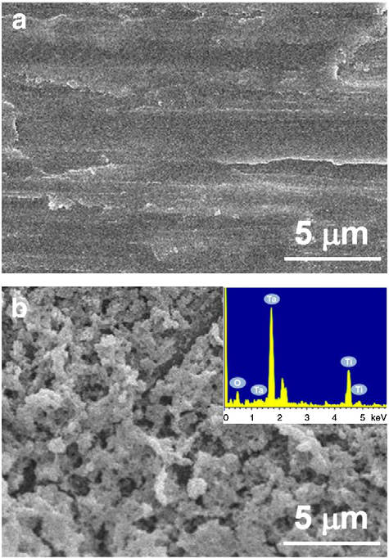

Fig. 1. FE-SEM images of (a) Ti specimen and (b) Ta2O5/Ti specimen as well as EDS pattern of surface coating.
the Ti surface. We then analyzed the resulting surface characteristics and biological responses, including cytotoxicity and protein adsorption, as well as the adhesion and proliferation of human bone marrow mesenchymal stem cells.
2. Materials and methods
2.1. Specimen preparation
Commercial grade 4 pure Ti disks (15 mm in diameter and 1 mm thick) were sequentially polished using 400–1200 grit silicon carbide sandpaper and ultrasonically cleaned in ethanol followed by distilled water. The Ti specimens were then immersed in a tantalum butoxide solution (60 mM) containing ethanol/toluene (1:1 in volume) for a few minutes. The hydrolysis–condensation process was then performed in deionized water for 10 min to form \OH functional groups, followed by drying at room temperature (25 °C). We repeated the hydrolysis– condensation process 10 times in order to produce a ﬁlm of sufﬁcient thickness. The Ti specimens coated with a Ta2O5 layer were designated as Ta2O5/Ti specimens.
2.2. Analysis of surface characteristics
To characterize the morphology and chemical composition of the Ta2O5 coating, the surfaces of the test specimens were examined using ﬁeld emission-scanning electron microscopy (FE-SEM) and energy dispersive spectroscopy (EDS), respectively. Functional groups on the surfaces of the test specimens were evaluated using attenuated total reﬂection-Fourier transform infrared spectroscopy (ATR-FTIR). The chemical composition of the outermost surfaces was evaluated using X-ray photoelectron spectroscopy (XPS). The surface crystallographic structure was analyzed using glancing angle X-ray diffraction (GAXRD). The thickness and microstructure of the coating layer were measured using transmission electron microscopy (TEM). The degree of coating adherence was examined using a cross-cut tape test in accordance with ASTM D3359 standards.
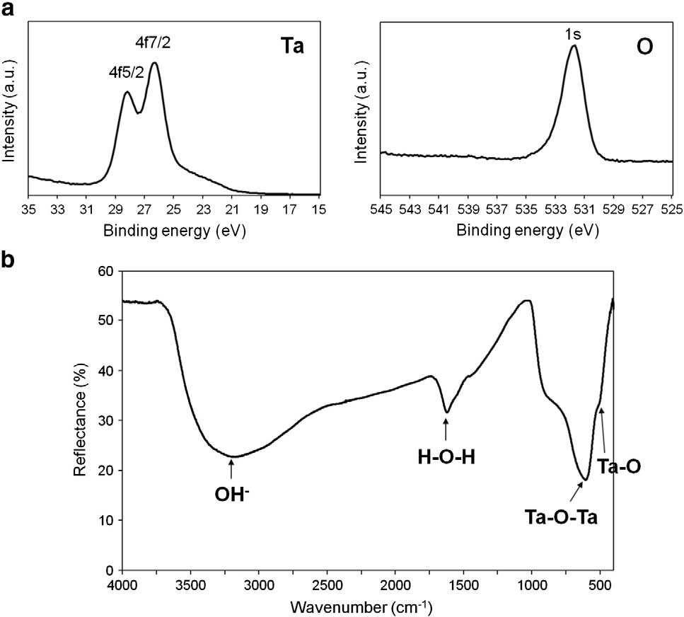
Fig. 2. (a) XPS spectra and (b) ATR-FTIR spectrum of the Ta2O5/Ti specimens.
2.3. Cytotoxicity assay
An in vitro cytotoxicity assay was performed according to the protocol described in ISO10993-5. L929 cells from a mouse ﬁbroblast cell line were selected to study the cytotoxicity of extracts from the Ti and Ta2O5/Ti specimens. The test specimens were maintained with Dulbecco's modiﬁed Eagle's medium (DMEM) in an incubator under 5% CO2 at 37 °C for 24 h. The extracts were then used to treat a cell monolayer for 24 h, whereupon the cells were examined for morphological changes to determine toxicity levels. Cell viability was evaluated using a 3-(4,5-dimethylthiazol-2-yl)-2,5-diphenyl tetrazolium bromide (MTT) assay, and optical density (OD) was measured using a microplate photometer (wavelength = 570 nm). Higher OD values also indicate greater cell viability. The base medium, DMEM, without extracts was used as a blank control; DMEM treated with 10% dimethyl sulfoxide was used as a positive control (PC); and a zirconia disk was used as a negative control (NC). In these experiments, a reduction in cell viability to b70% of the blank control indicated cytotoxic potential. Details of these experimental procedures are outlined in the ISO10993-5 speciﬁcations.
2.4. Biological responses
2.4.1. Protein adsorption
Human ﬁbronectin (FN) was used as a model protein in this study. Saline solution containing 200 μl of FN (50 ng/ml) was uniformly added to the Ti and Ta2O5/Ti specimens, which were subsequently incubated at 37 °C for 10 min. The intensity of C1 and N1 peaks of FN adsorption on the surface of the test specimens was evaluated using XPS. For this, the specimens were sequentially washed with deionized water, and the FN adsorbed on the surface of the specimens was analyzed. All measurements were performed in triplicate.
2.4.2. Cell culture
Human bone marrow mesenchymal stem cells (hBMSCs) were used for cell response tests. The hBMSCs were cultured in RPMI1640 solution supplemented with 5% fetal bovine serum and 10% horse serum. The cells were maintained in an incubator under 5% CO2 at 37 °C.
2.4.3. Cell adhesion
Immunoﬂuorescent staining of actin was used to study the cytoskeletal arrangement. For this, the hBMSCs were cultured on test specimens (5 × 104 cells/cm2) in an incubator under 5% CO2 at 37 °C. Following a 6 h incubation period, the cells were ﬁxed in 10% formalin and permeabilized using 0.2% Triton X-100 in phosphate buffered saline (PBS). The cells were then washed with PBS and incubated in diamidino-2phenylindole (DAPI) for nuclear staining and rhodamine phalloidin for actin ﬁlament staining. Images of the immunoﬂuorescence-stained hBMSCs were obtained using a ﬂuorescence microscope in order to examine the cytoskeletal arrangement.
We also investigated the cell adhesion morphology of hBMSCs cultured on the Ti and Ta2O5/Ti specimens at a seeding density of 5× 104 cells/specimen. Following incubation for 24 h, the attached cells were ﬁxed using 2% glutaraldehyde/4% paraformaldehyde for 30 min at 37 °C and held overnight at 4 °C. All test specimens were then dehydrated in a graded series of ethanol washes. Cell spreading and the morphology of cell-to-cell interactions were observed on the test specimens using FE-SEM.
2.4.4. Cell proliferation
This study cultured hBMSCs on the Ti and Ta2O5/Ti specimens at a seeding density of 1 × 104 cells/specimen; cells were then incubated for 24, 72, or 120 h. Cell proliferation on the surfaces of the specimens was measured using an MTT assay with the absorbance recorded at 570 nm. A higher optical density (OD) was regarded as an indication
Fig.3.(a)XRDpatternoftheTa2O5/Tispecimen;(b)cross-sectionalTEMimageoftheTa2O5/Tispecimen;theinsetof(b)isacorrespondingSADpatternoftheTa2O5coating.
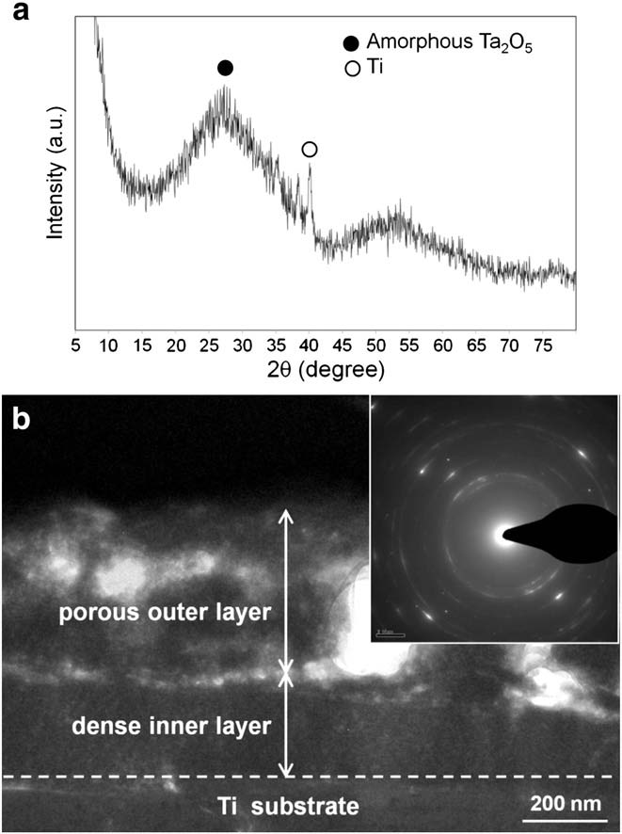
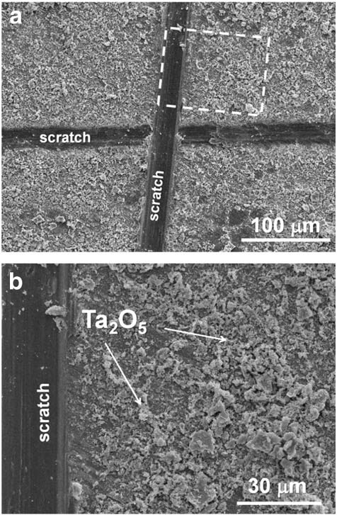
Fig. 4. (a) FE-SEM observation of the Ta2O5/Ti specimen after the cross-cut test; (b) higher magniﬁcation of (a).
of better cell viability. At least three samples were prepared for each test group.

2.5. Ion release
This study prepared 1000 ml of simulated blood plasma (SBP) containing NaCl (8.035 g), KCl (0.225 g), CaCl2·2H2O (0.388 g), NaHCO3
(0.355 g), MgCl2·6H2O(0.311 g), K2HPO4 (0.176 g), Na2SO4 (0.072 g), and C4H11NO3 (6.118 g). The test specimens were immersed in the SBP solution at 37 °C for 120 h. Sequentially, the solution was collected, whereupon inductively coupled plasma-mass spectrometry (ICP-MS) was used to measure the release of Ti ions from the test specimens. At least three samples were prepared for each test group.
3. Results
3.1. Surface characteristics
Fig. 1 presents FE-SEM images of surface morphology of the Ti and Ta2O5/Ti specimens as well as an analysis of the chemical compositions based on EDS pattern. The results indicate that a layer of Ta2O5 with submicroporous topography covered nearly the entire surface of the polished Ti specimens.
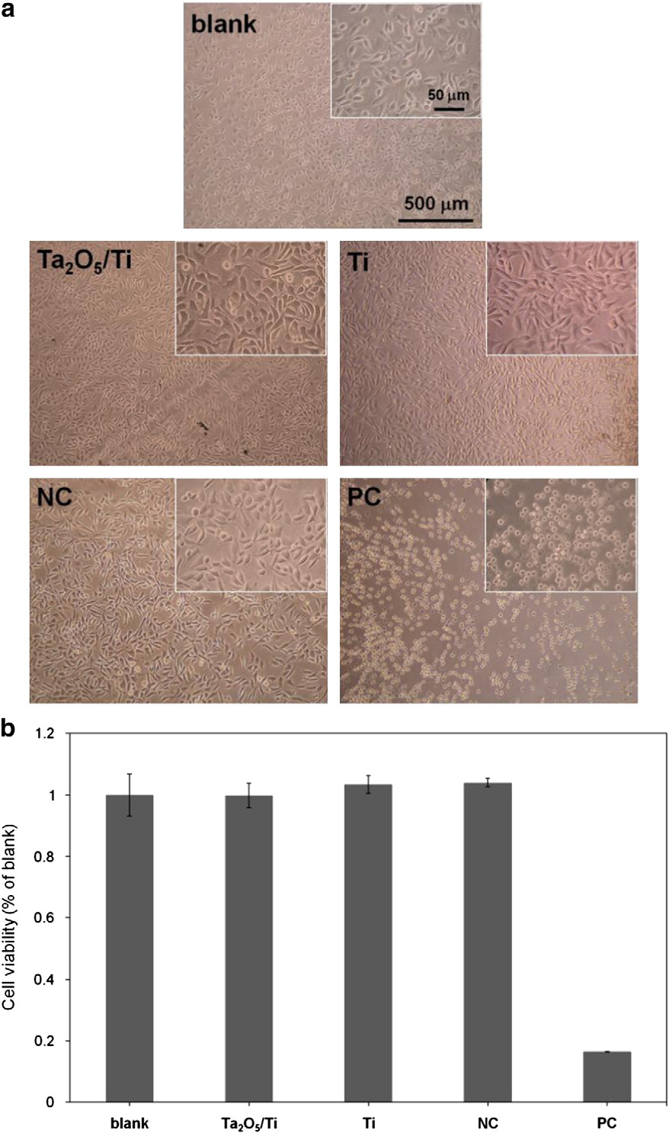
Fig. 5. ISO10993-5 cytotoxicity assay of the Ti and Ta2O5/Ti specimens, showing the (a) morphology and (b) viability of L929 cells after 1 d in the extract-containing media.
The stoichiometry of the outermost surface of the Ta2O5/Ti specimen was examined using XPS (Fig. 2(a)). The results revealed Ta4f and O1s core-level spectra on the Ta2O5/Ti specimen with a Ta-to-O atomic ratio of 2:4.7. Following background subtraction, we determined the atomic contents of Ta and O elements by dividing their individual peak areas in Fig. 2(a) by their respective atomic sensitivity factors
(2.93 for O1s; 8.62 for Ta4f). Fig. 2(b) presents typical ATR-FTIR spectrum for the prepared Ta2O5/Ti specimen, exhibiting two major absorption bands at 600.2 cm-1 (Ta–O–Ta) and 529.4 cm-1 (Ta–O). We also detected a broad band at 3400 cm-1, which corresponds to the presence of \OH groups. This indicates that the surface of Ta2O5/Ti specimen was negatively charged.
Fig. 3(a) presents GAXRD pattern of the Ta2O5/Ti specimens. According to JCPDS (Joint Committee on Powder Diffraction Standards) ﬁle No. 21-1198, Ta2O5 has three strong diffraction peaks at approximately 26.5°, 29.9°, and 36.1° 2θ. The broad reﬂections at 2θ = 26.5° and 29.9° clearly indicate that the Ta2O5 was in an amorphous state. Fig. 3(b) presents a TEM image and selected area diffraction (SAD) pattern of the porous Ta2O5 structure. The Ta2O5 layer (cross-sectional view) was delaminated into two separate morphologies: an outer porous layer and an inner dense layer. The porous layer was approximately 350 nm thick, and the dense layer was approximately 225 nm thick. The SAD pattern (Fig. 3(b), inset) suggests that the Ta2O5 coating has an amorphous-like structure, which is in agreement with the GAXRD results shown in Fig. 3(a).
Fig. 4 presents FE-SEM micrographs of the Ta2O5/Ti specimen after testing for degree of coating adhesion in accordance with ASTM D3359 standards. The results show that less than 5% of the coating area was removed from the surface of the Ta2O5/Ti specimen. This ﬁnding indicates that the Ta2O5 coating exhibited acceptable adherence to the Ti surface and could therefore be expected to remain attached to the Ti surface following bone implantation.
3.2. Biological responses
3.2.1. Cytotoxicity assay
Fig. 5 presents the viability of L929 cells co-cultured with extracts obtained from the Ti and Ta2O5/Ti specimens. In the positive control group, the L929 mouse ﬁbroblast cells demonstrated a positive cytotoxic reaction. Thus, the cells appear grainy and lack normal cytoplasmic spacing. In addition, the large open areas between the cells are indicative of extensive cell lysis (disintegration). Conversely, the blank and negative control groups showed a conﬂuent monolayer of well-deﬁned L929 mouse ﬁbroblast cells exhibiting cell-to-cell contact. This appearance is indicative of a non-cytotoxic (negative) response. L929 cells cultured in extract-containing media (Ti and Ta2O5/Ti) presented the same viability as those cultured in the extract-free medium (blank group), indicating that the Ta2O5 coating is as equally non-cytotoxic as commercial Ti.
3.2.2. Protein adsorption
Fig. 6 presents the intensity of the (a) C1 and (b) N1 peaks of FN adsorption on the surfaces of the Ti and Ta2O5/Ti specimens. In this ﬁgure, intensities are a function of surface sputtering depth after the specimens were immersed in an FN-containing saline solution for 10 min. The Ta2O5/Ti surface presented C1s and N1s of higher intensity than those of Ti surface. With an increase in sputtering depth, the difference in FN adsorption among the test specimens became increasingly deﬁned; however, the C1 and N1 peaks of the FN adsorption on the Ti surface were non-detectable at depths exceeding 10 nm.
3.2.3. Cell responses

Fig. 7 illustrates the adhesion of hBMSCs, in terms of cytoskeletal arrangement, on the Ti and Ta2O5/Ti specimens after 6 h of incubation. The Ta2O5/Ti specimen presented brighter red ﬂuorescence exhibited by the actin ﬁlaments in the cytoskeletal network, indicating a good cytoskeletal arrangement.
Fig.6.XPSanalysisresults,showingtheintensityofthe(a)C1sand(b)N1speaksoftheTiandTa2O5/TispecimensfollowingimmersioninFN-containingsalinesolutionfor10min.
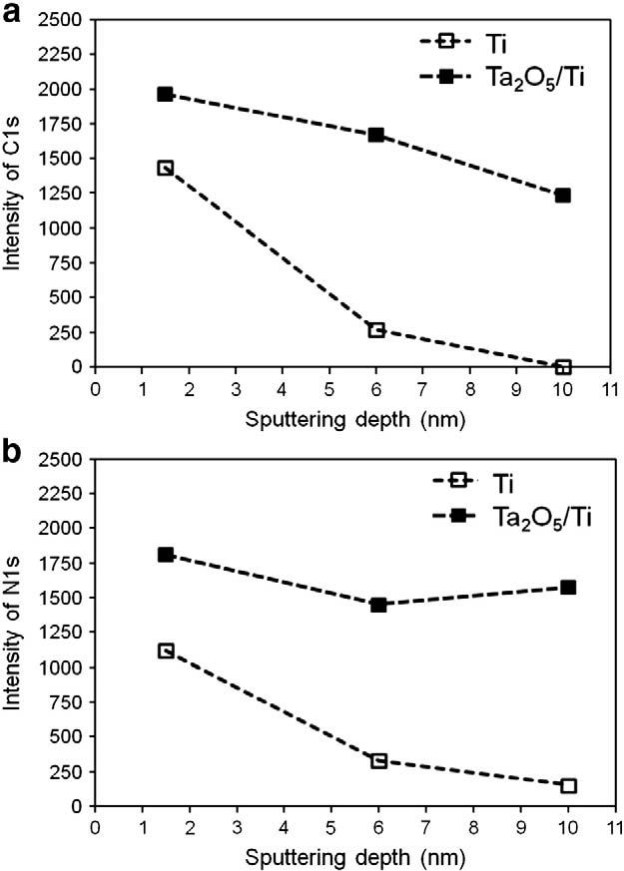
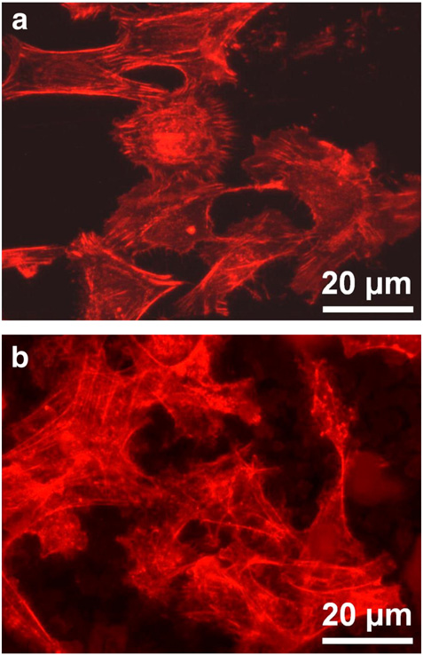
Fig. 7. Cytoskeletal arrangement, as indicated by immunoﬂuorescence staining, of hBMSCs on the (a) Ti and (b) Ta2O5/Ti specimens after 6 h of incubation. Staining was performed using rhodamine-phalloidin for actin ﬁlaments (red).
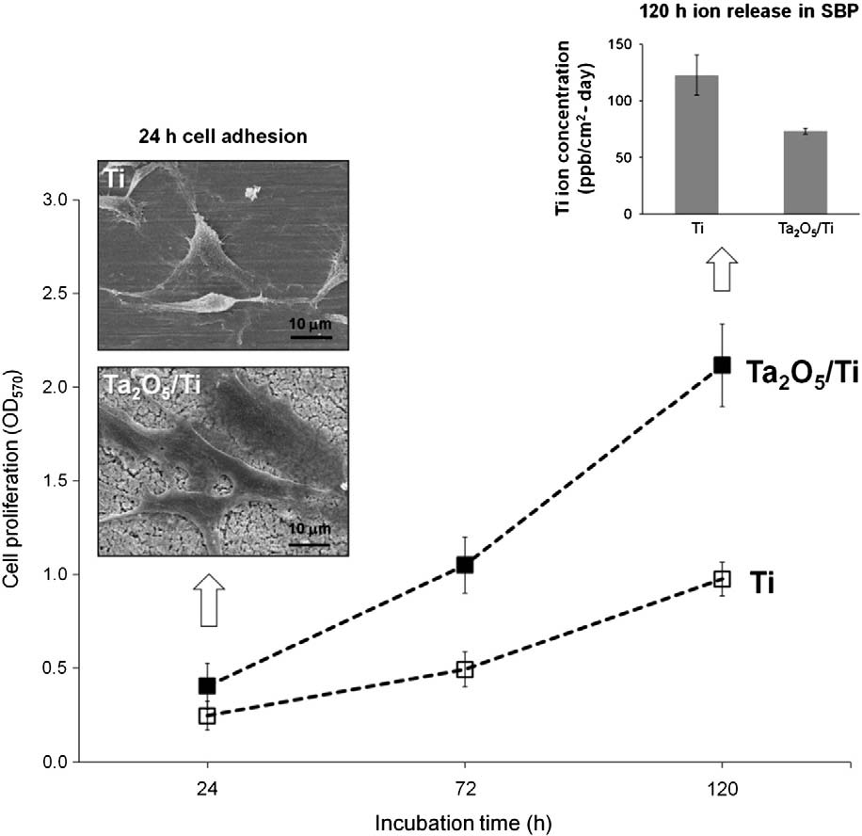
Fig. 8. Cell proliferation (24–120 h) on the Ti and Ta2O5/Ti specimens; FE-SEM images showing the cell adhesion morphology following incubation for 24 h; Ti ion release after 120 h of immersion in SBP solution.

Fig. 8 presents the proliferation of hBMSCs on the Ti and Ta2O5/Ti specimens after 24, 72, and 120 h of incubation. The Ta2O5/Ti specimens presented signiﬁcantly higher OD values than the Ti specimens. Compared with the Ti specimens, the OD values of the Ta2O5/Ti specimens were one time higher at 72 h and 1.4 times higher at 120 h. Thus, the hBMSCs on the Ta2O5/Ti specimens presented a higher proliferation than those on the Ti specimens. Fig. 8 also presents FE-SEM images of hBMSCs cultured on the Ti and Ta2O5/Ti specimens after 24 h of incubation. The cells on the Ta2O5/Ti specimens presented greater spreading than those on the Ti specimens.
4. Discussion
This study proposed a simple hydrolysis–condensation process as an alternative to the sol–gel method for the fabrication of a non-cytotoxic submicroporous Ta2O5 coating with a thickness of less than 1 μmona Ti surface. During the hydrolysis–condensation process, a highly reactive Ta butoxide precursor was hydrolyzed and condensed to form a Ta–O–Ta network on Ti surface. This led to the formation of an amorphous submicroporous Ta2O5 coating with \OH groups on the outermost surface. The formation of \OH groups can be attributed to the functional groups of ethanol and toluene during the hydrolysis– condensation process. Experimental results conﬁrmed our hypothesis that the submicroporous topography of the Ta2O5 coating on the Ti surface would improve biological responses, including protein adsorption and other cell responses.
Several surface characteristics, including surface chemistry [14–17] and surface topography [17–20], contribute to biological responses. Surface chemistry controls the adsorption of proteins on biomaterials, making it a key parameter inﬂuencing cell attachment as well as cell adhesion, spreading, and proliferation [21]. The presence of \OH bands suggests that the surface is highly hydrophilic [22], and hydrophilic \OH functionality supports the recruitment of focal adhesion proteins within adhesive structures [15]. The abovementioned studies have partially explained the improved adsorption of FN on the surface of hydrophilic and negatively charged Ta2O5/Ti specimens, compared to Ti surfaces (Fig. 6). FN is one of the ﬁrst extracellular matrix proteins produced by odontoblasts and osteoblasts. It has been shown to play an important role in the interaction between the surface of the implant and the surrounding tissue [23]. FN adsorbed on the Ti surface enhances cell arrangement and/or attachment [24,25], which partially explains how the Ta2O5/Ti specimen exhibited cell adhesion and proliferation superior to that of the Ti specimen (Figs. 7 and 8).
Surface topography also plays a role in cell responses. The roughening of Ti surfaces can enhance the focal contacts involved in cellular adhesion, thereby guiding the assembly of the cytoskeleton and the organization of membrane receptors [26,27]. Suitably roughened implant surfaces also promote the adsorption of FN [28], which is an important factor in cellular adherence and differentiation [29]. In this study, the submicroporous topography of the Ta2O5/Ti specimens provided a large surface area and suitable porosity for the adsorption of FN, compared with uncoated Ti surfaces. This greater surface area and submicroporosity enhanced cell adhesion in terms of cytoskeletal arrangement and cell spreading, as shown in Figs. 7 and 8.
One previous study reported no signiﬁcant difference in cell adhesion morphology between Ta2O5 and TiO2 [30]; nonetheless, information related to cell proliferation on these oxides remains limited. Cell proliferation is inﬂuenced by surface chemistry as well as surface topography [31]. Previous studies have reported that the presence of O-containing functional groups is capable of supporting the adhesion and growth of cells on material surfaces [32,33]. In this study, Ta2O5/Ti specimens yielded cell proliferation superior to that of bare Ti surfaces (the oxide ﬁlm of which is basically TiO2). This result can be attributed to the presence of \OH functional groups on the submicroporous surface of the Ta2O5/Ti specimens. Further study is currently underway to characterize cell differentiation and osseointegration on Ta2O5/Ti specimens with regard to long-term clinical applications.
Compared to the TiO2 ﬁlm that spontaneously forms on Ti surfaces, the Ta2O5 ﬁlm formed on Ta is more chemically and thermally stable and possesses superior corrosion resistance [34,35].Unfortunately,the Ta2O5 coating is bioinert [36], making it less capable of bonding to bone than bioactive coatings [37]. In this study, the presence of \OH groups on the submicroporous Ta2O5 surface enhanced the spreading, cytoskeletal arrangement, and proliferation of hBMSCs. Previous studies have reported that a negatively charged surface can facilitate the adsorption of Ca2+ ions, thereby attracting proteins that assist in cell adhesion (such as FN) [38].The \OH groups on the TiO2 coatings prepared using the sol–gel process provide a nucleus for the formation of apatite [39]. Thus, the negatively charged submicroporous Ta2O5 coating, deposited by a simple hydrolysis–condensation process, is expected to provide good osseointegration through the in vivo formation of apatite. Nonetheless, this supposition requires further in vivo investigation.
Porous Ta structures for metallic implants have been widely used to enhance the growth and differentiation of bone cells [40]. However, modifying bioinert Ta2O5 coatings to provide a porous topography requires that corrosion resistance in a biological environment be maintained. In this study, following immersion in SBP solution for 120 h, the surface of the Ta2O5/Ti specimen released approximately 44% fewer Ti ions than the surface of the Ti specimen (upper-right image in Fig. 8). It is clear that the negatively charged submicroporous surface topography of the Ta2O5 coatings was responsible for protein adsorption, cell adhesion, and cell growth, while the dense inner oxide layer of the Ta2O5 coating provided good corrosion resistance in the biological environment. However, further investigation is required to elucidate the mechanisms responsible for the good adherence of the Ta2O5 coating to the Ti surface.
5. Conclusions
This study applied a simple hydrolysis–condensation process to produce a negatively charged submicroporous, amorphous Ta2O5 coating on a Ti surface for the use in bone implant applications. Compared to an uncoated Ti surface, the surface \OH groups and submicroporous topography of the Ta2O5 coating enhanced biological responses, such as FN adsorption, hBMSC adhesion, cytoskeletal arrangement, and cell proliferation. However, we suggest that in vivo animal testing be performed prior to proceeding to clinical applications.
Conﬂict of interest
The authors declare that there is no conﬂict of interest associated with this publication.
Acknowledgments
This study was partially supported by the research grants (99F167CY06, 102F218C09) from Cheng Hsin General Hospital, Taipei, Taiwan. Thanks are also due to Dr. Shih-Hwa Chiou, Taipei Veterans General Hospital, Taiwan, for kindly providing us the human bone marrow mesenchymal stem cells.
References
[1] H.H. Huang, J.Y. Chen, M.C. Lin, Y.T. Wang, T.L. Lee, L.K. Chen, Clin. Oral Implants. Res. 23 (2012) 379–383.
[2] C.H. Yang, Y.T. Wang, W.F. Tsai, C.F. Ai, M.C. Lin, H.H. Huang, Clin. Oral Implants. Res. 22 (2011) 1426–1432.
[3] P. Metzler, C. von Wilmowsky, B. Stadlinger, W. Zemann, K.A. Schlegel, S. Rosiwal, S. Rupprecht, J. Craniomaxillofac. Surg. 41 (2013) 532–538.
[4] M. Herrero-Climent, P. Lázaro, J. Vicente Rios, S. Lluch, M. Marqués, J. Guillem-Martí,
F.J. Gil, J. Mater. Sci. Mater. Med. 24 (2013) 2047–2055.
[5] A. Cunha, R.P. Renz, E. Blando, R.B. de Oliveira, R. Hübler, J. Biomed. Mater. Res. A. 102 (2014) 30–36.
[6] A. Maho, S. Detriche, J. Delhalle, Z. Mekhalif, Mater. Sci. Eng. C 33 (2013) 2686–2697.
[7] S. Sakka, Sol–gel Science and Technology: Topics in Fundamental Research and Applications, Springer-Verlag, Berlin, Germany, 2011.
[8] K.J. Welldon, G.J. Atkins, D.W. Howie, D.M. Findlay, J. Biomed. Mater. Res.A 84 (2008) 691–701.
[9] Z. Tang, Y. Xie, F. Yang, Y. Huang, C. Wang, K. Dai, X. Zheng, X. Zhang, PLoS One 8 (2013) e66263.
[10] S. Bencharit, W.C. Byrd, S. Altarawneh, B. Hosseini, A. Leong, G. Reside, T. Morelli, S. Offenbacher, Clin. Implant Dent. Relat. Res. (2013), http://dx.doi.org/10.1111/cid. 12059.
[11] M.D. Bermúdez, F.J. Carrión, G. Martínez-Nicolás, R. López, Wear 258 (2005) 693–700.
[12] N. Donkov, A. Zykova, V. Safonov, V. Luk'yanchenko, D. Kolesnikov, Probl. Atom. Sci. Tech. 83 (2013) 195–197.
[13] Y.S. Sun, J.H. Chang, H.H. Huang, Thin Solid Films 528 (2013) 130–135.
[14] C.Y. Guo, J.P. Matinlinna, A.T.H. Tang, Int. J. Biomater. (2012) 1–5 (ID 381535).
[15] B.G. Keselowsky, D.M. Collard, A.J. García, Biomaterials 25 (2004) 5947–5954.
[16] C.H. Yang, Y.C. Li, W.F. Tsai, C.F. Ai, H.H. Huang, Clin. Oral Implants Res. (2013), http://dx.doi.org/10.1111/clr.12293.
[17] A. Ponche, M. Bigerelle, K. Anselme, J. Eng. Med. 224 (2010) 1471–1486.
[18] R. Jimbo, J. Sotres, C. Johansson, K. Breding, F. Currie, A. Wennerberg, Clin. Oral Implants Res. 23 (2012) 706–712.
[19] H.V. Unadkat, M. Hulsman, K. Cornelissen, B.J. Papenburg, R.K. Truckenmuller, A.E. Carpenter, M. Wessling, G.F. Post, M. Uetz, M.J.T. Reinders, D. Stamatialis, C.A. van Blitterswijk, J. de Boer, PNAS 108 (2011) 16565–16570.
[20] A. Palmquist, O.M. Omar, M. Esposito, J. Lausmaa, P. Thomsen, J. R. Soc. Interface 7 (2010) S515–S527.
[21] J.W. Park, Y.J. Kim, J.H. Jang, Clin. Oral Implants Res. 21 (2010) 398–408.
[22] D. Rana, T. Matsuura, R.M. Narbaitz, J. Membr. Sci. 282 (2006) 205–216.
[23] S.J. Ko, H.J. Park, Y. Ku, T.I. Kim, J. Chem, Biol. Interfaces 1 (2013) 49–52.
[24] E. Yoshida, Y. Yoshimura, M. Uo, M. Yoshinari, T. Hayakawa, J. Biomed. Mater. Res. A 100 (2012) 1556–1564.
[25] D.M. Rivera-Chacon, M. Alvarado-Velez, C.Y. Acevedo-Morantes, S.P. Singh, E. Gultepe, D. Nagesha, S. Sridhar, J.E. Ramirez-Vick, J. Biomed. Nanotechnol. 9 (2013) 1092–1097.
[26] M.M. Stevens, J.H. George, Science 310 (2005) 1135–1138.
[27] M. Jäger, C. Zilkens, K. Zanger, R. Krauspe, J. Biomed. Biotechnol. (2007) 1–19 (ID: 69036).
[28] A. Dolatshahi-Pirouz, T. Jensen, D.C. Kraft, M. Foss, P. Kingshott, J.L. Hansen, A.N. Larsen, J. Chevallier, F. Besenbacher, ACS Nano 4 (2010) 2874–2882.
[29] L.A. Hidalgo-Bastida, S.H. Cartmell, Tissue Eng. B Rev. 16 (2010) 405–412.
[30] S.A. Keçeli, H. Alanyali, Turk. J. Eng. Environ. Sci. 28 (2004) 49–54.
[31] M.O. Klein, A. Bijelic, T. Toyoshima, H. Götz, R.L. von Koppenfels, B. Al-Nawas, H. Duschner, Clin. Oral Implants Res. 21 (2010) 642–649.
[32] B. Feng, J. Weng, B.C. Yang, S.X. Qu, X.D. Zhang, Biomaterials 24 (2003) 4663–4670.
[33] D. Bhattacharyya, H. Xu, R.R. Deshmukh, R.B. Timmons, K.T. Nguyen, J. Biomed. Mater. Res. A 94 (2010) 640–648.
[34] C. Arnould, C. Volcke, C. Lamarque, P.A. Thiry, J. Delhalle, Z. Mekhalif, J. Colloid Interface Sci. 336 (2009) 497–503.
[35] V.A. Shvets, V.Sh. Aliev, D.V. Gritsenko, S.S. Shaimeev, E.V. Fedosenko, S.V. Rykhlitski,
V.V. Atuchin, V.A. Gritsenko, V.M. Tapilin, H. Wong, J. Non-Cryst. Solids 354 (2008) 3025–3033.
[36] V.S. Rudnev, K.N. Kilin, M.A. Medkov, I.V. Lukiyanchuk, E.E. Dmitrieva, Russ. J. Appl. Chem. 86 (2013) 1340–1343.
[37] E.D. Spoerke, S.I. Stupp, Biomaterials 26 (2005) 5120–5129.
[38] M. Ohgaki, T. Kizuki, M. Katsura, K. Yamashita, J. Biomed. Mater. Res. 57 (2001) 366–373.
[39] P. Li, C. Ohtsuki, T. Kokubo, K. Nakanishi, N. Soga, K. de Groot, J. Biomed. Mater. Res. 28 (1994) 7–15.
[40] V.K. Balla, S. Bodhak, S. Bose, A. Bandyopadhyay, Acta Biomater. 6 (2010) 3349–3359.
䘀椀最⸀㌀⸀

