ARD Online First, published on December 1, 2014 as 10.1136/annrheumdis-2014-206711
Letter

A comparison of safety proﬁles of tumour necrosis factor α inhibitors and rituximab therapy in patients with rheumatoid arthritis and chronic hepatitis C
Hepatitis C virus (HCV) infection is prevalent worldwide and is associated with cirrhosis and hepatocellular carcinoma. Although antitumour necrosis factor (anti-TNF) α agents may affect the competence of the immune system against viral infec- tion,1 some studies have demonstrated that TNF-α inhibitors may be safe in patients with chronic HCV infection.2 3 A recent randomised clinical trial showed that rheumatoid arthritis (RA) patients with chronic HCV were treated successfully with eta- nercept without elevation of transaminases and HCV viral

therapy. The mean duration of biological treatment was 25.8
±16.7 months. There were no signiﬁcant differences of serum ALT and HCV viral activity between baseline and the end of bio- logical treatment (ﬁgure 1A). HCV viral loads before and after various biological treatments are shown in ﬁgure 1B, C. When categorising biologics by mechanism of action, there was a statis- tically signiﬁcant difference in changes of HCV viral load between anti-TNF-α treatment and RTX therapy (ﬁgure 1C, p=0.003). The HCV viral load increased after RTX therapy. However, anti-TNF-α treatment did not seem to affect HCV viral replication.
Our study demonstrated B cell target therapy may inﬂuence HCV viral activity to a greater extent than TNF-α inhibitors. This preliminary result supports the 2012 update of the 2008 ACR recommendations for the use of etanercept in RA patients
9

load.4 However, rituximab (RTX) is associated with increasing
with history of hepatitis C.
Our results showed that the use of

HCV RNA levels in lymphoma patients undergoing RTX com- bined with chemotherapy.5 6 RTX-related HCV reactivation was also observed in RA patients.7 Therefore, biological therapies of different mechanism of action may inﬂuence on HCV replica- tion differently. To test this hypothesis, we conducted a retro- spective safety proﬁle review of RA patients with concomitant
adalimumab or golimumab for more than 2 years did not
increase HCV viral replication. Further study is necessary to clarify whether anti-TNF-α agents other than etanercept are safe in this clinical setting.
Previous controlled trials have shown the good safety proﬁle of RTX plus pegylated interferon-α and ribavirin in
10

HCV infection treated with TNF-α inhibitors and RTX.
HCV-related cryoglobulinemia.
5 6
However, consistent with pre-

In total, 26 patients who fulﬁlled the 1987 revised criteria of
vious studies of lymphoma,
our results demonstrated a poten-

the American College of Rheumatology (ACR) for RA and HCV infection were enrolled (table 1). Most of them had high disease activity.8 Anti-TNF-α agents were used in 20 patients (etanercept 12, adalimumab six and golimumab two), while six of them received RTX treatment. Serum alanine aminotransferase (ALT) and HCV viral load were measured before and after biological
tial safety alert of using RTX plus traditional disease-modifying
antirheumatic drugs in RA patients with HCV infection in absence of combination antiviral therapy. Although increased HCV viral load was not associated with elevated serum ALT levels, we observed a different impact on viral replication between anti-TNF-α agents and RTX. In our study, RTX patients were numerically older and treated with biologics for longer period of time but less likely to receive methotrexate than anti-TNF-α patients. All patients receiving RTX in this study had previous exposure to anti-TNF-α therapies in line with the reimbursement guidelines of the Taiwan National Health Insurance. Old age and prolonged immunosuppression therapy could also impair host immunity against HCV.
Table 1Demographic data and laboratory findings of rheumatoid
arthritis (RA) patients with HCV infection receiving anti-TNF-α and rituximab therapy*
Anti-TNF-αRituximab therapy n=20therapy n=6
Age at study entry (years)62.8±12.2
Gender (female, %)19 (95)
Disease duration (years)11.0±6.6
RF (IU/mL)155.0±231.9
Anti-CCP antibody (units)132.7±104.3
DAS285.3±1.3
ESR (mm/h)48.8±25.4
CRP (mg/dL)0.82±0.84
Daily prednisolone dose (mg)4.7±3.5
Methotrexate (%)6 (30)
Hydroxychloroquine (%)13 (65)
Sulfasalazine (%)3 (15)
Duration of biological therapy (months)23.4±13.7
70.1±11.2
6 (100)
11.3±7.6
232.1±363.0
88.9±72.8
5.3±1.6
30.2±14.7
0.47±0.41
5.4±1.0
0 (0)
4 (66.7)
1 (16.7)
36.2±22.7
*Values are mean±SD or the number (%) of patients.
CCP, cyclic citrullinated peptide; CRP, C reactive protein; DAS28, disease activity score for 28-joints; ESR, erythrocyte sedimentation rate; HCV, hepatitis C virus; RF, rheumatoid factor; TNF-α, tumour necrosis factor α.
In conclusion, use of anti-TNF-α agents seems to be safe in RA patients with HCV infection. Careful monitoring of HCV viral load is suggested with RTX treatment if combination anti- viral therapy for HCV is not given.

Yi-Ming Chen,1,2,3,4 Hsin-Hua Chen,1,2 Yi-Hsing Chen,1,2 Tsu-Yi Hsieh,1 Chia-Wei Hsieh,1,3,4 Wei-Ting Hung,1 Joung-Liang Lan,5,6
Der-Yuan Chen1,2,3,4,7
1Division of Allergy, Immunology and Rheumatology, Taichung Veterans General Hospital, Taichung, Taiwan
2Faculty of Medicine, National Yang Ming University, Taipei, Taiwan
3Institute of Biomedical Science, National Chung Hsing University, Taichung, Taiwan 4Rong Hsing Research Center for Translational Medicine, National Chung Hsing University, Taichung, Taiwan
5Division of Immunology and Rheumatology, China Medical University Hospital,
Taichung, Taiwan
6College of Medicine, China Medical University, Taichung, Taiwan
7Institute of Microbiology and Immunology, Chung Shan Medical University, Taichung, Taiwan
Correspondence to Dr Der-Yuan Chen, Division of Allergy, Immunology and Rheumatology, Taichung Veterans General Hospital, Taichung, Taiwan; No. 1650, Sec. 4, Taiwan Boulevard, Taichung 40705, Taiwan; dychen@vghtc.gov.tw

Ann Rheum Dis Month 2014 Vol 0 No 0
1

Copyright Article author (or their employer) 2014. Produced by BMJ Publishing Group Ltd (& EULAR) under licence.

Letter

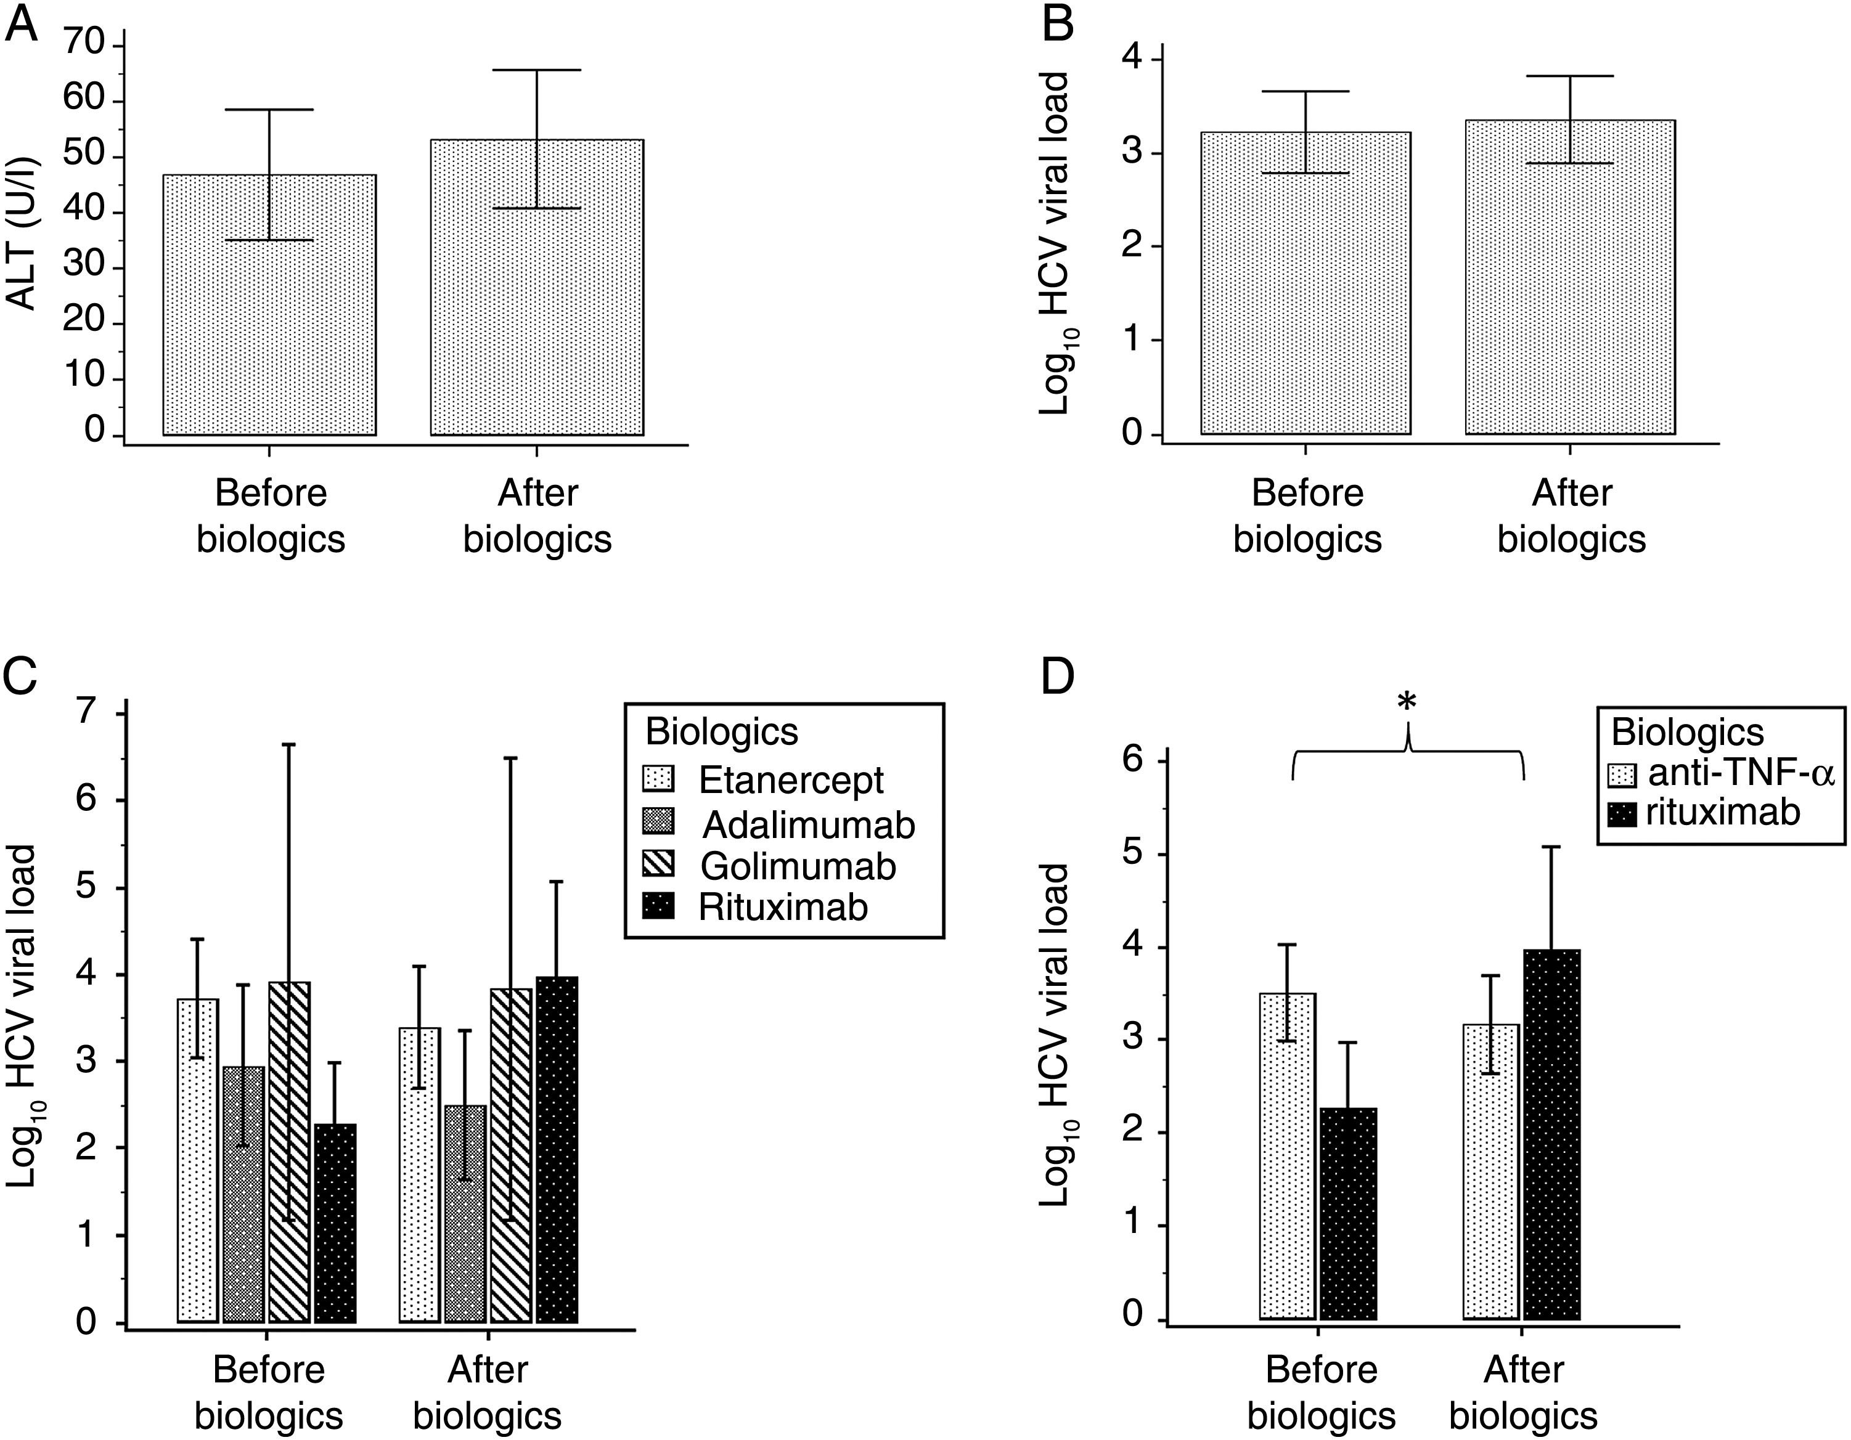
Figure 1 Comparisons of (A) serum alanine aminotransferase (ALT) and (B) hepatitis C virus (HCV) viral load before and after biological therapy by Wilcoxon signed-rank test. Biological treatments were categorised by (C) individual biologics and (D) mechanism of action. Data are mean±1 SEM. HCV viral loads were expressed as log10 of the detected values. *p=0.003 by generalised estimating equation.

Acknowledgements The authors are grateful to the Biostatistics Task Force of Taichung Veterans General Hospital, Taiwan, for assistance with statistical analysis.
Contributors All authors made substantial intellectual contributions to the conception of the work, analysis and interpretation of the data, and drafting and revising the manuscript.
Funding None.
Competing interests None.
Patient consent Obtained.
Ethics approval The Ethics Committee of Taichung Veterans General Hospital.
Provenance and peer review Not commissioned; externally peer reviewed.
To cite Chen Y-M, Chen H-H, Chen Y-H, et al. Ann Rheum Dis Published Online First: [ please include Day Month Year] doi:10.1136/annrheumdis-2014-206711
Ann Rheum Dis 2014;0:1–2. doi:10.1136/annrheumdis-2014-206711

REFERENCES
- Calabrese LH, Zein N, Vassilopoulos D. Safety of antitumour necrosis factor
(anti-TNF) therapy in patients with chronic viral infections: hepatitis C, hepatitis B, and HIV infection. Ann Rheum Dis 2004;63:ii18–24.
- Brunasso AM, Puntoni M, Gulia A, et al. Safety of anti-tumour necrosis factor agents in patients with chronic hepatitis C infection: a systematic review. Rheumatology (Oxford) 2011;50:1700–11.
- Pompili M, Biolato M, Miele L, et al. Tumor necrosis factor-α inhibitors and chronic hepatitis C: a comprehensive literature review. World J Gastroenterol 2013;19:7867–73.
- Iannone F, La Montagna G, Bagnato G, et al. Safety of etanercept and methotrexate in patients with rheumatoid arthritis and hepatitis C virus infection: a multicenter randomized clinical trial. J Rheumatol 2014;41:286–92.
- Ennishi D, Terui Y, Yokoyama M, et al. Monitoring serum hepatitis C virus (HCV) RNA in patients with HCV-infected CD20-positive B-cell lymphoma undergoing rituximab combination chemotherapy. Am J Hematol 2008;83:59–62.
- Ennishi D, Maeda Y, Niitsu N, et al. Hepatic toxicity and prognosis in hepatitis C virus infected patients with diffuse large B-cell lymphoma treated with
rituximab-containing chemotherapy regimens: a Japanese multicenter analysis.
Blood 2010;116:5119–25.
- Lin KM, Lin JC, Tseng WY, et al. Rituximab-induced hepatitis C virus reactivation in rheumatoid arthritis. J Microbiol Immunol Infect 2013;46:65–7.
- Smolen JS, Aletaha D, Bijlsma JW, et al. Treating rheumatoid arthritis to target: recommendations of an international task force. Ann Rheum Dis 2010;69:631–7.
- Singh JA, Furst DE, Bharat A, et al. 2012 update of the 2008 American College of Rheumatology recommendations for the use of disease-modifying antirheumatic drugs and biologic agents in the treatment of rheumatoid arthritis. Arthritis Care Res (Hoboken) 2012;64:625–39.
- Dammacco F, Tucci FA, Lauletta G, et al. Pegylated interferon-alpha, ribavirin, and rituximab combined therapy of hepatitis C virus-related mixed cryoglobulinemia:
a long-term study. Blood 2010;116:343–53.

2 Ann Rheum Dis Month 2014 Vol 0 No 0


A comparison of safety profiles of tumour

necrosis factor
α inhibitors and rituximab

therapy in patients with rheumatoid arthritis and chronic hepatitis C
Yi-Ming Chen, Hsin-Hua Chen, Yi-Hsing Chen, Tsu-Yi Hsieh, Chia-Wei Hsieh, Wei-Ting Hung, Joung-Liang Lan and Der-Yuan Chen

Ann Rheum Dis
published online December 1, 2014

Updated information and services can be found at: http://ard.bmj.com/content/early/2014/12/01/annrheumdis-2014-2067 11

References Email alerting
service

These include:
This article cites 10 articles, 6 of which you can access for free at: http://ard.bmj.com/content/early/2014/12/01/annrheumdis-2014-2067 11#BIBL
Receive free email alerts when new articles cite this article. Sign up in the box at the top right corner of the online article.

Notes

To request permissions go to:
http://group.bmj.com/group/rights-licensing/permissions

To order reprints go to:
http://journals.bmj.com/cgi/reprintform

To subscribe to BMJ go to:
http://group.bmj.com/subscribe/

