Title: Early Changes in Brain FDG Metabolism during Anticancer Therapy in Patients with Pharyngeal Cancer

Author: Te-Chun Hsieh∗, MD, Yu-Chin Wu∗, MD, Kuo-Yang Yen, BS, Shan-Wen Chen, MD, Chia-Hung Kao, MD

ABSTRACT

BACKGROUND
The current study aimed to evaluate whether therapy-related changes occurred in brain metabolism at an earlier stage during the course of anticancer therapy.
METHODS
We recruited 14 non-diabetic male patients with newly diagnosed pharyngeal squamous cell carcinoma. We analyzed the patients’ serial brain FDG PET/CT scans by SPM8 to establish whether any therapy-related changes had occurred in brain FDG metabolism, either during or after the course of therapy.
RESULTS
Decreased metabolism was noted during the anticancer therapy, displaying a symmetric pattern involving bilateral basal ganglia and bilateral occipital lobes. The decrease in FDG metabolism in these regions persisted after the anticancer therapy had terminated. However, relative recovery of the metabolism was noted in the bilateral occipital lobes, whereas further deterioration was noted in bilateral basal ganglia.
CONCLUSIONS
The current study revealed that unappreciable changes in brain metabolism can occur during the early course of anticancer therapy, and persist even after therapy has termi- nated. Although the exact mechanism remains unclear, these changes may be related to the systemic effects of chemotherapy or radiotherapy as well as subclinical cancer-related depressive or adjustment mood disorder.

Keywords: Brain FDG metabolism, anticancer therapy, pharyngeal cancer.

Te-Chun Hsieh and Yu-Chin Wu con- tributed equally.
Introduction
Cancers and anticancer therapies appear to be associated with an increased incidence of future cerebrovascular accidents, in comparison with the general population.1-6 Patients with can- cer may also experience many kinds of behavioral changes and psychiatric disorders. Many studies indicate that up to 50% of patients with cancer have identifiable psychiatric disorders.7,8
With the rapid recent development of neuroimaging modalities, medical knowledge has improved regarding the relationship between patients’ clinical symptoms and their affected brain regions. However, most of the studies in this area have focused on comparisons between patients and health control subjects. The time-points of such studies have mostly occurred at follow- up periods, after the patient has completed anticancer therapy. This type of research may not be well equipped to investi- gate therapy-related effects on brain functions, given the time span between the therapy and the neuroimaging evaluation. Comparisons of serial examinations, including during the ther- apy period, are necessary to glean more direct evidence of the effect of anticancer therapies on brain functions. The current study evaluated therapy-related effects on brain metabolism in patients with cancer, by comparing serial FDG PET/CT scans taken before, during, and after the therapy.

Materials and Methods
Patients

From July 2009 to March 2011, 26 patients with newly diagnosed pharyngeal squamous cell carcinoma participated in a prospective cohort study (DMR98-IRB-067) to evalu- ate the interim therapeutic effect and correlative volumetric measurement of intensity-modulated radiation therapy (IMRT) that applied a dynamic multi-leaf collimation to spare surroun- ding normal tissue from unnecessary radiation. Among them, 14 male patients and three female patients (17 patients) underwent serial fluorodeoxyglucose (FDG) scans by positron emission tomography (PET) and computerized tomography (CT). Each patient had three scans, one at each of the following time-points: before radiotherapy (1st scan); after ongoing radiotherapy for more than four weeks (2nd scan); and after completing radiotherapy (3rd scan). We excluded the three females from our analysis because of the potential confounding effect of estrogen on brain metabolism.9 The remaining 14 male patients were all non-diabetic, and were enrolled for the current retrospective cohort study (DMR99-IRB-010). None of the 14 enrolled patients had any known neurodegenerative disorder, psychiatric disease, previous cerebrovascular acci- dent, head trauma, or use of neuropsychological medication. Neuropsychological tests along with these scans were not available in all patients in this retrospective study since these tests were not routine work-up of oncological patients in our institute and not part of study design in the former prospective cohort study.10 The local institutional review board had approved both of our studies (DMR98-IRB-067 and DMR99- IRB-010).

FDG PET/CT Scans

Patients were asked to fast for at least four hours before scan- ning. Imaging was performed with a PET/CT scanner (Discov- ery STE, GE Medical Systems, Milwaukee, WI, USA) with low- r adiation-dose CT protocol (0.8-second rotation time, 120 kVp, v ariable mA with AutomA technique, 3.75-mm slice thickness, and 1.75:1 pitch). Whole body FDG PET/CT images were acquired approximately 60 minutes after intravenous injection of 370 MBq (10 mCi) of FDG. The PET emission images were acquired through CT scans at 2 min per field of view (FOV) in the 3-dimensional acquisition mode. The CT images were reconstructed onto a 512 × 512 matrix with a section thickness of 3.75 mm, then reconstructed onto a 128 × 128 matrix, and converted into 511-keV-equivalent attenuation factors for attenuation correction of the corresponding PET emission images. Each patient underwent serial scans at the following three time points: just before therapy started, about one into therapy, and at follow-up or restaging after completion of therapy.

Image Analysis

A voxel-by-voxel analysis called statistical parametric mapping (SPM) was performed using SPM8 package (Welcome Depart- ment of Cognitive Neurology, University College, London, UK) running on MATLAB (version 7.1; MathWorks Inc., Natick, MA, USA). We compared each patient’s serial FDG PET/CT scans to identify differences in regional brain glucose metabolism, using a paired t -test for each comparison. The FDG PET images were initially converted from DICOM to AN- ALYZE format using MRIcro (available at www.mricro.com), and were then transferred to SPM8. Thereafter, the data were spatially normalized to a standard PET template provided in SPM8 using a 12-parameter affine transformation, followed by nonlinear transformations and bilinear interpolation. The voxel size was 2 × 2 × 2 mm3 . Standardized data were then smoothed by a Gaussian filter (full width of half maximum, FWHM = 12 mm). Normalization of global cerebral metabolism was performed using proportional scaling to a mean brain blood flow of 50 mL per 100 g per minute and an analysis threshold masking by 80% of mean brain blood flow. Volume-correction that could potentially reduce the confounding effect of brain atrophy was not done because of a probably minimal effect in paired comparison between scans in a very short time interval of each individual. In addition, poor image quality of low-dose CT also precluded its application for volume correction. The statistical parametric map was initially obtained at the signif- icance threshold P < .05 (corrected with family-wise error), and then an extent volume cluster (k) was set as 50 voxels. The Talairach Daemon database was used to convert the coordi- nates of these statistically significant points into correspondent anatomical locations in the Talairach and Tournoux atlas. Results were listed with the Talairach coordinates (x, y, z) of the representative peak voxels, as well as their individual k value, Z score and Brodmann area (BA). The k value represented the number of significant voxels in the particular cluster.11

Results
Demographic data of patients’ characteristics are listed in Table 1. None of the 14 male patients had diabetes mellitus, cerebrovascular accident, or cardiovascular disease. The ma- jority of patients were smokers (12 patients). Hypertension had been diagnosed in 4 patients. Brain or other distant metastases were not found in any patients. The average absorbed dose to the primary tumor or gross lymphadenopathy was 71.19 Gy (95% confidence interval [CI]: 70.39 to 71.99 Gy), while the average absorbed dose to both uninvolved neck nodal stations was 50.01 Gy (95% CI: 49.18 to 50.84 Gy). The average time intervals between the start of therapy and the 2nd and 3rd scans, respectively, were 30.79 days (95% CI: 29.20 to 32.38 days) and 174.14 days (95% CI: 147.50 to 200.78 days), respectively. Two patients did not receive concurrent adjuvant chemotherapy or immunotherapy; in one case this was because of early-stage disease (patient 4), whereas the other case was caused by poor performance status (patient 14).
Decreased metabolism was noted in a symmetric pattern involving bilateral basal ganglia and bilateral occipital lobes during the anticancer therapy (Fig 1 and Table 2). The effect of decreased FDG metabolism was observed to persist in these regions after the anticancer therapy had ended (Fig 2 and Table 3). However, relative recovery of the metabolism was noted in bilateral occipital lobes, whereas further deterioration was noted in bilateral basal ganglia. In contrast, an increase in metabolism was observed in solitary small focal areas in the right posterior cingulate cortex during the anticancer therapy, and in the right prefrontal cortex after the anticancer therapy (Fig 3, 4, and Table 4). Moreover, these aforementioned brain areas with either increased or decreased FDG metabolism were not included in IMRT plans of all patients nor received therapeutic radiation.

Discussion
Historical Perspective: Atherosclerosis and Coagulopathy

Either cancers per se or cancer-related therapies may affect the metabolism of patients’ brains in certain brain regions.
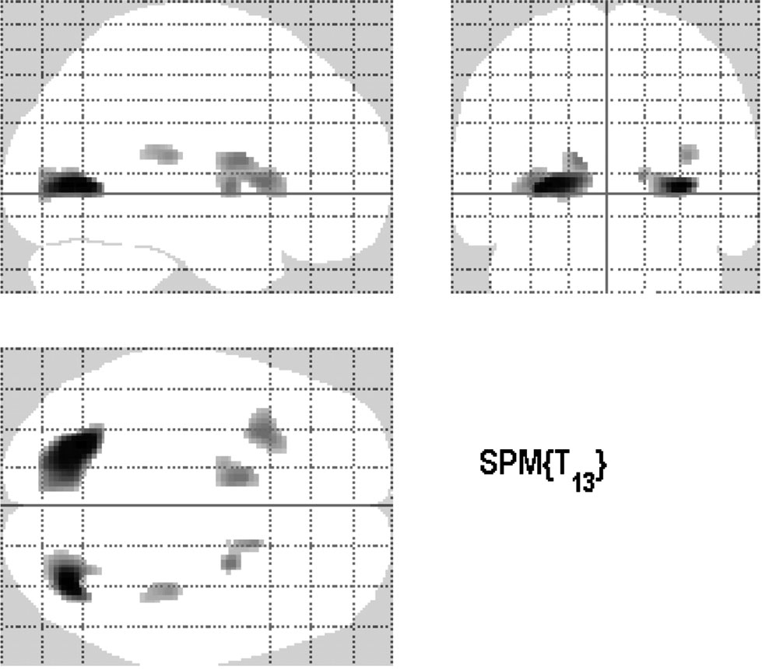

Fig 1. Graphic display of SPM results representing brain areas with decreased metabolism during the anticancer therapy.
Hypertension
Yes
Yes No Yes Yes No Yes Yes Yes Yes Yes Yes Yes Yes
No
No No No No No Yes Yes No No Yes No No Yes
For instance, radiation therapy to the head or neck region may produce or accelerate atherosclerosis, cause endothelial dysfunction in blood vessels within the radiation field,1,2,4,12,13 and increase the probability of future stroke.3, 13-17 Coagulation disorders are common in patients with cancer and can result in systemic and cerebral vascular thrombosis.1,18 However, the occurrence of stroke is seldom noted until five years after the initial exposure to radiation.13,19 Therefore, radiation exposure may have a remote effect on future occurrence of stroke, with the risk being present initially and then being exacerbated by a slow, incremental decrease in brain metabolism in the subclinical phases during and soon after the anticancer therapy.

Systemic Effect: Both Chemotherapy and Radiotherapy

Chemotherapy may also affect the brain metabolism pro- foundly through various mechanisms.5,20 For the patients in the current study, apart from universal radiotherapy the treat- ment modalities used were non-homogenous. Although these patients presented with non-homogeneous characteristics ac- cording to their therapeutic modalities, the SPM analysis still found statistically significant results, with the interesting feature of symmetrical hypometabolic changes. Such changes might imply a probable cause mediated by a systemic effect of anti- cancer therapy. Cisplatin has been known to cause cognitive impairment of patients.21 In contrast, the use of cetuximab has not yet been reported to be relevant to the development of cere- brovascular disease or cognitive impairment. As mentioned ear- lier, atherosclerosis and endothelial dysfunction of blood vessels within the radiation field are related to an increased incidence of stroke, which is likely to be associated with locoregional thera- peutic effect. However, a study of patients with testicular cancer revealed that even for patients receiving infra-diaphragmatic ra- diotherapy alone, cardiovascular risk factors may be increased by elevated serum markers of chronic inflammation and en- dothelial dysfunction. This finding suggests possible evidence of a systemic vascular effect by locoregional radiotherapy.22

Table 2. Brain Regions Reveal Decreased FDG Metabolism during the Anticancer Therapy by SPM Analysis

 |  |  |  | Talairach Coordinates
Cluster | k (voxels) | Z score | x | y | z | Anatomical location | Brodmann area
1 | 524 | 6.71 | −26 | −64 | 4 | Left occipital lobe | 19
2 | 229 | 6.67 | 32 | −72 | 4 | Right occipital lobe | 19
3 | 173 | 5.41 | −32 | 16 | 6 | Left insula | 13
4 | 135 | 5.02 | −16 | −2 | 6 | Left lentiform nucleus
5 | 80 | 5.35 | 24 | 2 | 4 | Right lentiform nucleus
6 | 60 | 5.15 | 36 | −26 | 16 | Right insula | 13

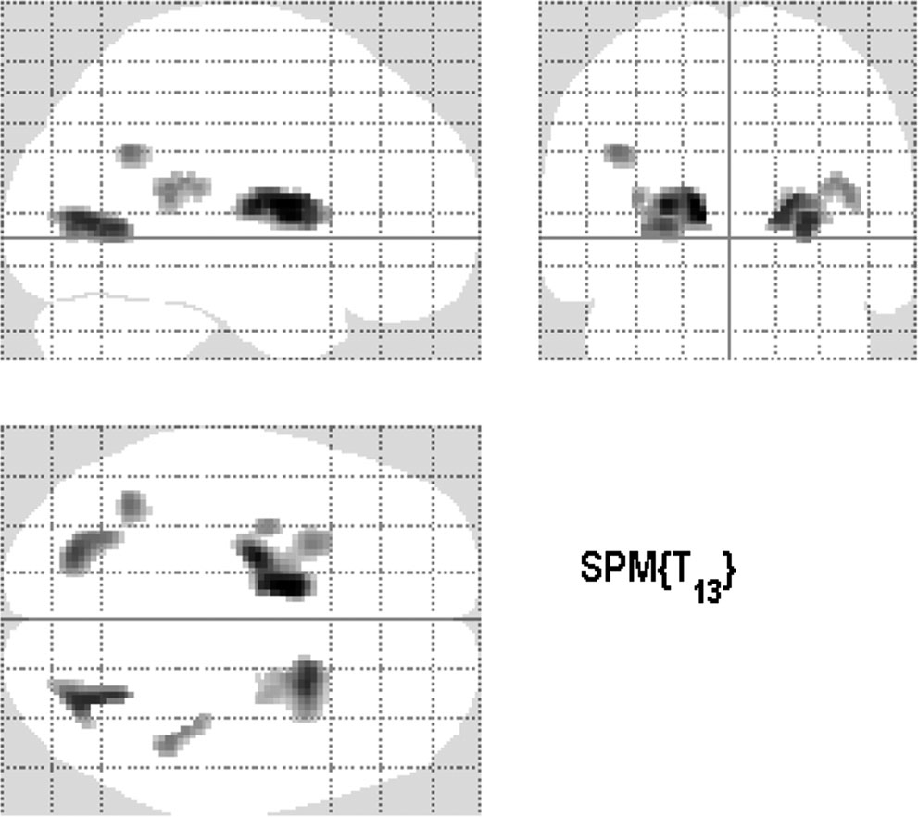

Fig 2. Graphic display of SPM results representing brain areas with decreased metabolism after the anticancer therapy.
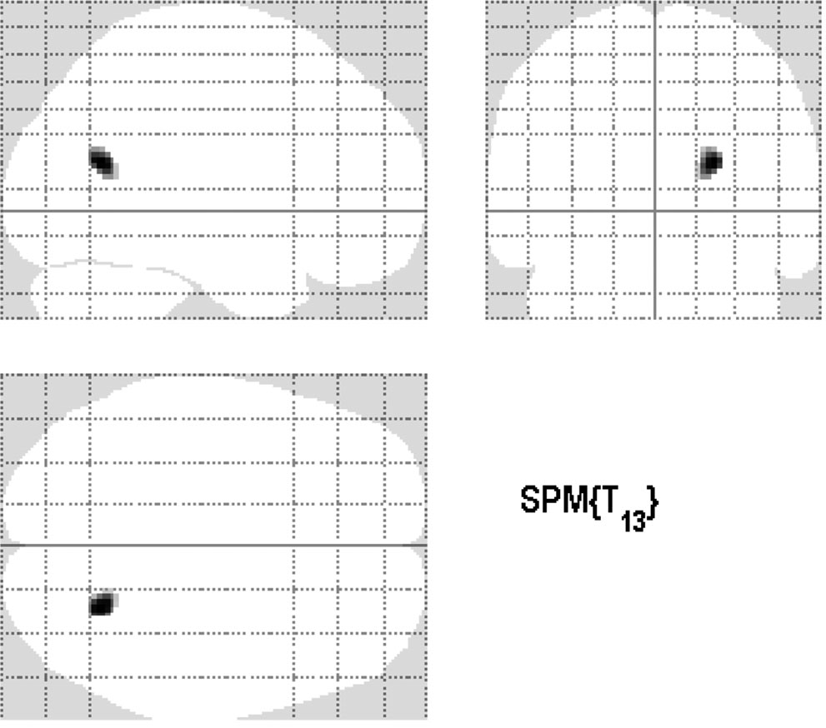

Endothelial Dysfunction or Damage

Other factors may also contribute to the alteration of brain metabolism through endothelial dysfunction. Cigarette smok- ing is relevant to atherosclerosis, endothelial dysfunction, and
Fig 3. Graphic display of SPM results representing the solitary brain area (right posterior cingulate cortex) with increased metabolism dur- ing the anticancer therapy.

vascular inflammation, which increase the incidence of cardio- vascular disease and stroke.23-26 Changes in brain metabolism in our study patients were likely to have been affected by their cigarette smoking because most of the patients were smokers.

Table 3. Brain Regions Reveal Decreased FDG Metabolism after the Anticancer Therapy by SPM Analysis

Talairach Coordinates

Cluster k (voxels) Z score x y z Anatomical location Brodmann area

1 | 449 | 5.90 | −22 | −8 | 12 | Left lentiform nucleus
2 | 172 | 5.52 | 26 | −60 | 4 | Right occipital lobe | 19
3 | 250 | 5.68 | 22 | 10 | 12 | Right lentiform nucleus
4 | 144 | 5.50 | −24 | −74 | 4 | Left occipital lobe
5 | 65 | 5.26 | −40 | −54 | 30 | Left temporal lobe | 39
6 | 69 | 5.09 | 36 | −30 | 18 | Right insula | 13

Table 4. Brain Regions Reveal Increased FDG Metabolism during and after the Anticancer Therapy by SPM Analysis

Talairach Coordinates

Condition k (voxels) Z score x y z Anatomical location Brodmann area

During therapy | 75 | 5.93 | 24 | −60 | 20 | Right posterior cingulate cortex | 31
After therapy | 125 | 5.79 | 54 | 22 | 40 | Right prefrontal cortex | 8

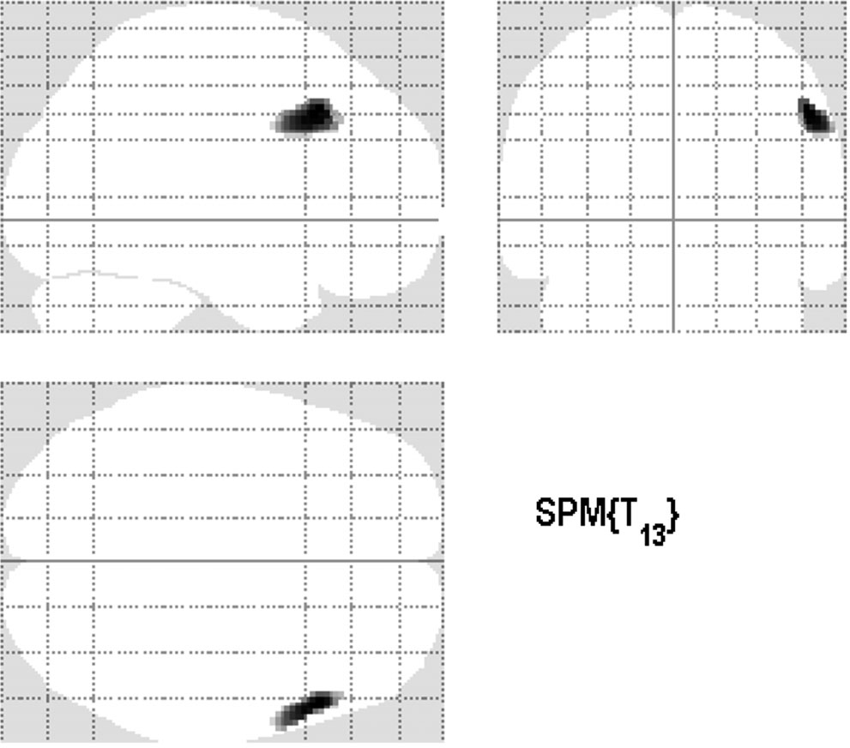

Fig 4. Graphic display of SPM results representing the solitary brain area (right prefrontal cortex) with increased metabolism after the anticancer therapy.

However, it is debatable whether the rapid and early changes in our study patients were all directly related to cigarette smoking. Previous studies found that cigarette smoking may increase the long-term risk of cardiovascular disease and stroke, and cessation of smoking can reduce these risks and improve inflammatory or pro-coagulant serum markers in a gradual manner, usually taking years.27-29 Although we did not investigate whether our patients had quit smoking or con- tinued, the limited time interval of our study may have meant that changes in the potential effects of smoking on vascular endothelium may have been minimal. Thus, cigarette smok- ing may have served as a contributing factor that rendered our patients more vulnerable to other etiologies that alter vascular function more rapidly.
Recently, a distinct clinical-radiological syndrome called reversible posterior leukoencephalopathy syndrome has been proposed as a potential therapy-related complication in cancer patients. It presents as cerebral vasogenic edema and is possibly due to therapy-related endothelial damage. Posterior cerebral circulation, such as occipital lobes of the cerebrum, tends to be affected more frequently,20,30 but is reversible after the precipitating event has been corrected.31 Although our patients did not have any documented symptoms relevant to this syndrome, the image findings of the current study may have reflected subclinical alterations in brain metabolism caused by similar mechanism.

Hypoxia

Differential hypometabolism may be attributable to an effect of hypoxia. Anemia may occur as a result of either neoplastic disease or cancer treatment, which predisposes the patient to hypoxia.32 The cause of anemia associated with cancer is multifactorial.33 Therapy-induced atherosclerosis or endothe- lial dysfunction may also contribute to the development of cerebral hypoxia in patients with cancer. Moreover, several
studies have recognized that the basal ganglia are subject to hypoxic encephalopathy.34-38 As a result, hypoxia may partly explain the hypometabolism observed in bilateral basal ganglia in our study.

Psychological Alteration

Because of the hypothesis of therapy-related hypometabolism mentioned above, it seems difficult to explain the presence of small areas in the posterior cingulate cortex and prefrontal cortex, which demonstrated relative hypermetabolism during and after anticancer therapy. However, this finding may be attributable to other concurrent etiology that may have simul- taneously affected brain FDG metabolism. For instance, rel- ative hypermetabolism in the posterior cingulate cortex has been reported in association with depressive or adjustment mood disorder in cancer patients.39,40 Other research has re- ported a disease-related decrease in metabolism together with a treatment-related increase in metabolism in the prefrontal cortex of cancer patients with depressive or adjustment mood disorder.39-43 Therefore, the increased FDG metabolism in the right posterior cingulate cortex and right prefrontal cortex in our study patients may be relevant to the cancer- or therapy- related neuropsychological changes that occur simultaneously during and after anticancer therapy. Future research should in- vestigate clinical correlations between the neuroimaging find- ings and concurrent neuropsychological examinations, to clar- ify their actual relevance.

Anticancer Therapy: Early and Dynamic Effect

We also noted time-dependent changes in brain metabolism relevant to different phases of cancer therapies. We found that decreased metabolism in bilateral basal ganglia and bilateral occipital lobes could be observed early in the therapy (about one month after initiating therapy), a finding not previously reported in the literature. In addition, brain hypometabolism persisted over time even after therapy. However, over time the basal ganglia became more hypometabolic, whereas the occipital lobes became less hypometabolic; this finding suggests differential therapy-related effects and recovery abilities of the affected areas.
There were several limitations to this study. First, the total number of enrolled patients was small. Second, because of the retrospective study design, our patients received non- homogeneous anticancer therapies, apart from the universal use of radiotherapy. Thus, changes in brain metabolism could not be specifically attributed to certain therapies, but we could only conclude a possibly “pooled” effect by various therapies. Although the data analysis yielded statistically significant differences, recruiting more patients with more homogenous clinical characteristics, including specific therapeutic modali- ties, could improve and refine the analytic result and provide a basis for more solid conclusions. Third, we did not perform neuropsychological evaluations of patients when we took their PET/CT scans at the three pre-determined time-points. Had we done so, the data could have been used to establish possible clinical correlations. Thus the current study suffered from the limitation that neuropsychological features could not be statis- tically related to the passage of time during and shortly after therapy, with regard to possible changes in brain metabolism.
However, we were still able to demonstrate the early influence by anticancer therapies on brain metabolism, even during the limited therapeutic period. These changes are frequently and informally observed in clinical practice, but are not reported objectively by neuroimaging findings. Fourth, we did not perform volume correction of our PET data although we considered that the paired comparison in our study could
offset most effects of volume loss. However, future PET study might be done with higher quality anatomical brain images, especially magnetic resonance imaging, to eliminate such potential confounding factor as possible. Finally, the seem- ingly continual changes in brain metabolism throughout the duration of anticancer therapies which are reported in our findings appear to imply that these anticancer therapies may affect the brain either temporarily or permanently. We were unable to draw firm conclusions in this regard, and do not wish to confound the interpretations of other investigators who may perform neuroimaging evaluations at different time-points. Further prospective studies, which are well constructed and which incorporate neuropsychological parameters, are advocated to evaluate specific therapy-related effects.

Conclusions
The current study revealed that unappreciable changes in brain metabolism can occur during the early course of anticancer therapy, and will persist even after the therapy has been com- pleted. Although the exact mechanism remains unclear, these changes may be related to the systemic effects of chemother- apy or radiotherapy, as well as to subclinical cancer-related depressive or adjustment mood disorder. Such changes may also be associated with future cognitive impairment, neuropsy- chological change, or increased incidence of cerebrovascular accident in patients with cancer. Further prospective studies are advocated. Ideally, these should recruit a greater number of patients, should follow up the patients over a longer time period, and should incorporate clinical neuropsychological pa- rameters to enable the analysis of possible correlations and specific therapy-related effects.
5. Silverman DH, Dy CJ, Castellon SA, et al. Altered frontocortical, cerebellar, and basal ganglia activity in adjuvant-treated breast can- cer survivors 5–10 years after chemotherapy. Breast Cancer Res Treat
2007;103:303-311.
6. Fan HG, Houede-Tchen N, Yi QL, et al. Fatigue, menopausal symptoms, and cognitive function in women after adjuvant chemotherapy for breast cancer: 1- and 2-year follow-up of a prospective controlled study. J Clin Oncol 2005;23:8025-8032.
7. Wein S, Sulkes A, Stemmer S. The oncologist’s role in manag- ing depression, anxiety, and demoralization with advanced cancer. Cancer J 2010;16:493-499.
8. Miovic M, Block S. Psychiatric disorders in advanced cancer. Can- cer 2007;110:1665-1676.
9. Joseph JA, Kochman K, Roth GS. Reduction of motor behavioural deficits in senescence via chronic prolactin or estrogen adminis- tration: time course and putative mechanisms of action. Brain Res
1989;505:195-202.
10. Kao CH, Hsieh TC, Yu CY, et al. 18F-FDG PET/CT-based gross tumor volume definition for radiotherapy in head and neck cancer: a correlation study between suitable uptake value threshold and tumor parameters. Radiat Oncol 2010;5:76.
11. Hsieh TC, Lin WY, Ding HJ, et al. Sex- and age-related differences in brain FDG metabolism of healthy adults: an SPM analysis. J Neuroimag 2012;22:21-27.
12. Cheng SW, Wu LL, Ting AC, et al. Irradiation-induced extracranial carotid stenosis in patients with head and neck malignancies. Am J Surg 1999;178:323-328.
13. Bowers DC, McNeil DE, Liu Y, et al. Stroke as a late treatment effect of Hodgkin’s Disease: a report from the Childhood Cancer Survivor Study. J Clin Oncol 2005;23:6508-6515.
14. Grandpierre S, Desandes E, Meneroux B, et al. Arterial foci of F-18 fluorodeoxyglucose are associated with an enhanced risk of subsequent ischemic stroke in cancer patients: a case-control pilot study. Clin Nucl Med 2011;36:85-90.
15. Smith GL, Smith BD, Buchholz TA, et al. Cerebrovascular disease risk in older head and neck cancer patients after radiotherapy. J Clin Oncol 2008;26:5119-5125.
16. Stokes EL, Tyldesley S, Woods R, et al. Effect of nodal irra- diation and fraction size on cardiac and cerebrovascular mor- tality in women with breast cancer treated with local and lo- coregional radiotherapy. Int J Radiat Oncol Biol Phys 2011;80:
403-409.
17. Haynes JC, Machtay M, Weber RS, et al. Relative risk of stroke in head and neck carcinoma patients treated with external cervical irradiation. Laryngoscope 2002;112:1883-1887.

18. Rogers LR. Cerebrovascular complications in patients with cancer.

This work was supported by the study projects (DMR-101-060 and DMR-101-061) in our hospital; Taiwan Department of Health Clinical Trial and Research Center and for Excellence (DOH101-TD-B-111-
004), Taiwan Department of Health Cancer Research Center for Excel- lence (DOH101-TD-C-111-005); and International Research-Intensive Centers of Excellence in Taiwan (I-RiCE) (NSC101-2911-I-002-303).

References
1. Rogers LR. Cerebrovascular complications in cancer patients. Neu- rol Clin 2003;21:167-192.
2. Beckman JA, Thakore A, Kalinowski BH, et al. Radiation therapy impairs endothelium-dependent vasodilation in humans. J Am Coll Cardiol 2001;37:761-765.
3. Scott AS, Parr LA, Johnstone PA. Risk of cerebrovascular events after neck and supraclavicular radiotherapy: a systematic review. Radiother Oncol 2009;90:163-165.
4. Stewart FA, Hoving S, Russell NS. Vascular damage as an underly- ing mechanism of cardiac and cerebral toxicity in irradiated cancer patients. Radiat Res 2010;174:865-869.
Semin Neurol 2010;30:311-319.
19. Jagsi R, Griffith KA, Koelling T, et al. Stroke rates and risk factors in patients treated with radiation therapy for early-stage breast cancer. J Clin Oncol 2006;24:2779-2785.
20. Allen JA, Adlakha A, Bergethon PR. Reversible posterior leukoen- cephalopathy syndrome after bevacizumab/FOLFIRI regimen for metastatic colon cancer. Arch Neurol 2006;63:1475-1478.
21. Ricard D, Taillia H, Renard JL. Brain damage from anticancer treatments in adults. Curr Opin Oncol 2009;21:559-565.
22. Wethal T, Kjekshus J, Roislien J, et al. Treatment-related differ- ences in cardiovascular risk factors in long-term survivors of testic- ular cancer. J Cancer Surviv 2007;1:8-16.
23. Ambrose JA, Barua RS. The pathophysiology of cigarette smok- ing and cardiovascular disease: an update. J Am Coll Cardiol
2004;43:1731-1737.
24. Csiszar A, Podlutsky A, Wolin MS, et al. Oxidative stress and accelerated vascular aging: implications for cigarette smoking. Front Biosci 2009;14:3128-3144.
25. Mazzone P, Tierney W, Hossain M, et al. Pathophysiological im- pact of cigarette smoke exposure on the cerebrovascular system with a focus on the blood-brain barrier: expanding the awareness

of smoking toxicity in an underappreciated area. Int J Environ Res
Public Health 2010;7:4111-4126.
26. Barbieri SS, Zacchi E, Amadio P, et al. Cytokines present in smok- ers’ serum interact with smoke components to enhance endothelial dysfunction. Cardiovasc Res 2011;90:475-483.
27. Yanbaeva DG, Dentener MA, Creutzberg EC, et al. Systemic ef- fects of smoking. Chest 2007;131:1557-1566.
28. Wannamethee SG, Lowe GD, Shaper AG, et al. Associations be- tween cigarette smoking, pipe/cigar smoking, and smoking cessa- tion, and haemostatic and inflammatory markers for cardiovascular disease. Eur Heart J 2005;26:1765-1773.
29. Shah RS, Cole JW. Smoking and stroke: the more you smoke the more you stroke. Expert Rev Cardiovasc Ther 2010;8:917-
932.
30. Marinella MA, Markert RJ. Reversible posterior leucoen- cephalopathy syndrome associated with anticancer drugs. Intern Med J 2009;39:826-834.
31. Rajasekhar A, George TJ, Jr. Gemcitabine-induced reversible pos- terior leukoencephalopathy syndrome: a case report and review of the literature. Oncologist 2007;12:1332-1335.
32. Wefel JS, Witgert ME, Meyers CA. Neuropsychological sequelae of non-central nervous system cancer and cancer therapy. Neuropsy- chol Rev 2008;18:121-131.
33. Ryan JL, Carroll JK, Ryan EP, et al. Mechanisms of cancer- related fatigue. Oncologist 2007;12(Suppl 1):22-34.
34. Hopkins RO, Fearing MA, Weaver LK, et al. Basal ganglia lesions following carbon monoxide poisoning. Brain Inj 2006;20:273-281.
35. Park S, Choi IS. Chorea following acute carbon monoxide poison- ing. Yonsei Med J 2004;45:363-366.
36. Hsiao CL, Kuo HC, Huang CC. Delayed encephalopathy after carbon monoxide intoxication–long-term prognosis and correla- tion of clinical manifestations and neuroimages. Acta Neurol Taiwan
2004;13:64-70.
37. Prockop LD, Chichkova RI. Carbon monoxide intoxication: an updated review. J Neurol Sci 2007;262:122-130.
38. Bird BA, Wright AD, Wilson MH, et al. High altitude ataxia- its assessment and relevance. Wilderness Environ Med 2011;22:
172-176.
39. Kumano H, Ida I, Oshima A, et al. Brain metabolic changes asso- ciated with predispotion to onset of major depressive disorder and adjustment disorder in cancer patients—a preliminary PET study. J Psychiatr Res 2007;41:591-599.
40. Tashiro M, Kubota K, Itoh M, et al. Regional cerebral glucose metabolism of patients with malignant diseases in different clinical phases. Med Sci Monit 2001;7:226-232.
41. Brody AL, Saxena S, Silverman DH, et al. Brain metabolic changes in major depressive disorder from pre- to post-treatment with paroxetine. Psychiatry Res 1999;91:127-139.
42. Videbech P. PET measurements of brain glucose metabolism and blood flow in major depressive disorder: a critical review. Acta Psychiatr Scand 2000;101:11-20.
43. Brody AL, Saxena S, Mandelkern MA, et al. Brain metabolic changes associated with symptom factor improvement in major depressive disorder. Biol Psychiatry 2001;50:171-178.

