Journal of Surgical Oncology 2001﹔78:101-109

仁orrelation of Human Papillomavirus 16 and 18 With 仁ervical Neoplasia in Histological Typing and 仁linical Stage in Taiwan: An In-Situ Polymerase 仁hain Reaction Approach

JEAN-SHIUNN SHYU, 10,1 仁HENG-JUENG 仁HEN, 10,2 仁HIA-仁HANG 仁HIU, 10,3 SU-仁HIN HUANG, BS,4 AN0 HORNG-JYH HARN, 10, Ph04,5*
1Department of Pathology, Armed Force Taoyuan Hospital, Taoyuan, Taiwan, RO仁
2Graduate Institute of Medical Sciences, National Defense Medical 仁enter, Taipei, Taiwan, RO仁 3Department of Surgery, Armed Force Taoyuan Hospital, Taoyuan, Taiwan, RO仁 4Department of Pathology, Tri-Service General Hospital, Taipei, Taiwan, RO仁
5Department of Emergency Medicine, Tri-Service General Hospital, Taipei, Taiwan, RO仁

Background and Objectives: In situ polymerase chain reaction (ISPCR) promises to considerably enhance our ability to detect a few copies of target nucleic acid sequences in fixed tissues and cells. The aim of this study was to investigate cervical carcinoma to determine the human papillomavirus (HPV) types on paraffin-embedded tissue sections by ISPCR and standard in situ hybridization. The results will correlate the morphological characteristics of lesions with viral typing results.
Methods: This study examined prevalence of HPV 16 and 18 DNA in biopsies from 85 cervical cancer patients by ISPCR, employing HPV 16, 18 consensus primers. There are 45 patients with squamous cell car- cinomas, 13 with adenocarcinoma, 2 with adenosquamous carcinomas, 3 with small cell carcinomas, and 22 carcinoma in situ. The relation between the types of HPV detected, tumor type, and clinical stage were analyzed.
Results: Fifty-two of 85 biopsies were HPV 16- or 18-positive, HPV 16 being the most prevalent type. Squamous cell carcinoma had a high prevalence of HPV 16 and adenocarcinoma had a high prevalence of HPV
18. HPV 18 was the predominant type among high clinical stage (III IV) cases while HPV 16 and mixed HPV 16 with HPV18 were significantly correlated with low clinical stage (0 I II).
Conclusion: Our results indicate that certain malignant cervical tumor phenotypes and stages correlate with specific HPV type, and that ISPCR is a sensitive and fast method to detect HPV in these patients.
J. Surg. Oneal. 2001;78:101-109. 。 2001 Wiley-Liss, Inc.

KEY WORDS: in situ polymerase chain reaction (ISPCR）﹔ human papillomavirus (HPV）﹔ human cervical cancer

INTRODUCTION
Polymerase chain reaction (PCR) and in-situ hybrid- ization (ISH) are very well established molecular techniques used in studies of gene detection, gene expression, and structure. ISH has the great advantage
。 2001 Wiley-Liss, Inc.
Grant sponsor: National Science Council of Taiwan, Taiwan, ROC﹔ Grant number: NSC 89-2320-B-016-137﹔ Grant sponsor: Armed Force General Hospital, Taoyuan, Taiwan, ROC﹔ Grant number: 9014.
*Correspondence to: Horng-Jyh Harn, MD, PhD, Department of Pathology, Tri-Service General Hospital, No. 325, Sec. 2, Cheng-Kung Rd., Neihu 114, Taipei, Taiwan, ROC. Fax: 886-2-87927372.
E-mail: Duke@ndmctsgh.edu.tw
Accepted 29 June 2001

of permitting localization of specific nucleic acid sequences to individual cells. In addition to morphologic identification of the cell types involved, ISH also allows some quantification of observations, for ex- ample, with respect to tumor burden or viral load. Unfortunately, the usefulness of ISH is frequently limited by its low detection sensitivity, with the reported sensitivity limits of 10 20 copies of mRNA/cell being approached in only the most sensitive protocols. PCR, on the other hand, is an extremely sensitive technique and is now routinely used to amplify rare or single-copy gene sequences to levels easily detectable by gel electrophoresis and Southern blot hybridization. How- ever, conventional solution-phase PCR requires cell or tissue destruction to isolate nucleic acids, and there- fore does not allow association of the amplification results with a specific histological cell type, correlation of results with histopathological features, or measure- ment of the percentage of cells that contain the target sequence.
A technique combining the extreme sensitivity of PCR and the cell-localizing ability of ISH has been described
﹝1 4﹞ The notion of employing a PCR-based amplifica- tion step to increase the sensitivity of ISH apparently came to several laboratories independently in the early 1990s ﹝1 4﹞. Although the protocols for in situ PCR (ISPCR) are not yet standardized, it seems likely that the relative importance of the variables identified will be agreed on and that some consensus concerning optimiza- tion of the multiple steps involved will emerge in the near future, allowing the use of ISPCR in diagnostic laboratories ﹝5 11﹞.
Human papilloma viruses (HPV) can induce neopla- sias of the skin and mucous membranes, and HPV-DNA has been found in cervical cancer and its precursors ﹝12﹞. During recent years, numerous studies have suggested that human papillomavirus (HPV), particularly type 16, and less commonly, types 18, 31, 33, and 35 are causative agents of cervical cancer ﹝13﹞ This might be an indi- cation that some types of HPV infection play a role in carcinogenesis ﹝14 15﹞, with HPV 18 infections perhaps leading to the development of adenocarcinoma
﹝16 18﹞ and HPV 16 primarily inducing squamous cell carcinoma. ﹝19 22﹞. Most of these studies utilized a primer-directed PCR to detect HPV. However, the inability of PCR to directly correlate the amplification results to a specific histological cell type under the microscope prevents adequate testing of these hypotheses.
In our study, we investigated cervical carcinoma to determine the HPV types on paraffin-embedded tissue sections by ISPCR and standard ISH. The results will correlate the morphological characteristics of lesions with viral typing results.
MATERIALS AND METHODS
From June 1988 through April 1995, 63 patients with invasive cervical cancer who received radical hyste- rectomy and bilateral pelvic lymphadenectomy and 22 patients with carcinoma in situ of cervix who received hysterectomy as a primary treatment at the Tri-Service General Hospital were enrolled in our study. Invasive cervical carcinoma was found with squamous cell carcinomas in 45 patients, adenocarcinomas in 13, adenosquamous carcinomas in 2, and small cell carcino- mas in 3. Of the remaining patients, carcinoma in situ was found in 11, and carcinoma in situ with glandular involvement was found in 11. Clinical stage was deter- mined according to the International Federation of Gynecology and Obstetrics Classification in 55 of 63 available cases.
The specimens were fixed in 10% buffered formalde- hyde with 10 h fixation times, and then routinely processed for paraffin embedding and cut into 5 µm- thick sections. One tissue section from each block was stained with hematoxylin eosin for histologic examina- tion by two independent pathologists. The other sections were mounted on aminoalkylsilane coated slides and stored at 4oC before being used for ISH and ISPCR.

In Situ Hybridization
The paraffin-embedded tissue sections were dewaxed in xylene, passed through ethanol, and air-dried. Specimens were rehydrated and then permeabilized in 20 µg/ml proteinase K at 37oC for 30 min. Hybridization was performed in a moist chamber for 2 h at 37oC with biotinylated screening probes for HPV (Enzo PathoGene human papillomavirus in situ screening assay for tissue section kit, Enzo). The probe was applied on each section. Immediately afterward both the DNA probe and the target DNA were denatured by heating at 95 100oC for 5 min. After hybridization with the screening biotinylated probes, the sections were washed with wash buffer. The slide was then placed on the 37oC heating block and enough AP Detection Reagent was added to each slide section followed by incubation for 30 min. The probe was revealed using NBT/BCIP (Nitro blue tetrazolium chloride/5-bromo-4-chloro-3-indolyl phosphate, tolui- dine salt) reaction mixture. The slides were rinsed with distilled water and the tissues counterstained with nuclear red.
Selection of Primers
A single primer pair was selected for simplicity of use and to lower costs. The HPV screening primers MY09 and MY11 (Perkin Elmer), each with 20 nucleotides, were used. These primers correspond to a part of the L1 major protein of the viral capsid, which is a gene region

common to 40 HPV types, including types 6, 11, 16, 18,
31, 33, 35, 39, 40, 42, 45, 52, 53, 54, 59. The primers 18.1
and 18.2 were specific for HPV 18 and the primer pair
16.1 and 16.2 were specific for HPV 16.
The Primer Sequences
The Primer Sequences are as follows:
MY09-5 tCGTCCMARRGGAWACTGATC-3 t﹔ MY11-5 tGCMCAGGGWCATAAYAATGG-3 t﹔ HPV18.1-5 tAAGGATGCTGCACCGGCTGA-3 t﹔ HPV18.2-5 tCACGCACACGCTTGGCAGGT-3 t﹔ HPV16.1-5 tTGCTAGTGCTTATGCAGCAA-3 t﹔ HPV16.2- 5 tATTTACTGCAACATTGGTAC-3 t
Direct In Situ Polymerase Chain Reaction (ISPCR）
PCR amplification. The ''hot start’’ and PCR modifications were applied to the tissue sections as previously described ﹝6﹞. This procedure reduces mis- priming and primer oligomerization and allows use of a single primer pair.
The 49.5 µl of ISPCR amplifying solution included 200 µM dATPµ200 µM dCTP µ200 µM dGTPµ 100 µM
dTTP (Perkin Elmer) 100 µM digoxigenin-11-dUTP, 1X reaction buffer (10 mM Tris-HCl, 50 mM KCl, pH 8.3)oC4.5 mM MgCl2oC and 50 pmol of upstream and downstream primers. The amplifying solution was placed in a thermal cycler of 85oC. The slide with the tissue sample for ISPCR was placed in the assembly tool (Perkin Elmer). When the temperatue rose to 70oC, 0.5 µl of Taq polymerase (20 units/µl, Perkin Elmer) was added to the PCR mixture and a total of 50 µl of amplifying solution was placed on the slide. The reaction mixture was enclosed onto the section with the Ampli- Cover clip and AmpliCover disk. The slide was then transferred into the GeneAmp ISPCR system 1000 thermal cycler (Perkin Elmer) preheated with a soak file to 70oC. The samples were denaturated at 94oC for 3 min. Thereafter, there were 30 cycles of 94oC 1 min, 55oC 1 min, and 74oC 2 min. At the end of the amplification, the slides were kept at 4oC, rinsed in Tris-HCL buffer (pH 7.4), dehydrated by ethanol, and air-dried. ISPCR products were directly detected by antidigoxigenin antibody.
Detection of digoxigenin. At the end of the cycling, the containment assemblies were disassembled from the slides with the disassembly tool and the slides were washed in 2 × SSC at 40oC for 5 min. Use of anti- digoxigenin conjugated alkaline phosphatase against the digoxigenin-11-dUTP, and revealed the signal using NBT BCIP.
Indirect In Situ Polymerase Chain Reaction
We used HPV 16 or HPV 18 infected DNA (extracted from fresh cervical tissue, amplified by MY09, MY11,
and typed by restriction fragment length polymorphism) to produce a genomic probe and labeled with digoxigenin for post-ISPCR hybridization.
The paraffin-embedded tissue sections were de-waxed in xylene, passed through ethanol, and air-dried. Speci- mens were then rehydrated, permeabilized in 20 µg/ml proteinase K for 30 min at 37oC.
PCR amplification. The 49.5 µl of IS-PCR amplify- ing solution included 200 µM dATP 200 µM dCTP 200 µM dGTP 200 µM dTTP (Perkin Elmer) 1X reaction buffer (10 mM Tris-HCl 50 mM KCl, pH 8.3, Perkin Elmer) 4.5 µM MgCl2 50 pmole of upstream and downstream primers respectively. The amplifying solu- tion was placed in a thermal cycler at 85oC. The slide with the tissue sample for ISPCR was placed in the assembly tool (Perkin Elmer). When the temperature reached 70oC. 0.5 µl of Taq polymerase (20 units/µl, Perkin Elmer) was added to the PCR mixture and a total of 50 µl of amplifying solution was placed on the slide. The reaction mixture was then enclosed onto the section with the AmpliCover Clip and AmpliCover Disc. The slide was then transferred into the GeneAmp ISPCR system 1000 thermal cycler (Perkin Elmer) preheated with a soak file to 70oC. The samples were denaturated at 94oC for 3 min. Thereafter, 35 cycles of at 94oC for 1 min, 55oC for 1 min, and 74oC for 2 min were preferred. At the end of the amplification, the slides were kept at 4oC, rinsed in Tris HCL buffer (pH 7.4), dehydrate by ethanol, and air-dried.
Post-PCR in situ hybridization. At the end of the thermal cycling program, each containment assembly was disassembled from the slides using the disassembly tool, and the slides were washed in 2×SSC at room temperature for 5 min. The sections were then fixed with 2% paraformaldehyde for 15 min., rinsed in PBS dehydrate to 100% ethanol and dried. The labeled genomic probe was then applied to each section of the hybridization buffers (2×SSC, 5% dextran sulfate, 10% formamide) and the AmpliCover disks and AmpliCover clips were reassembled. Returned to the cycler and denatured at 95oC for 5 min followed by hybridization at 37oC overnight.
Detection of digoxigenin. At the end of the cycling, disassemble the containment assemblies from the slides with the disassembly tool and the slides were washed in 2×SSC at 40oC for 5 min. Using the anti-digoxigenin conjugated alkaline phosphatase against the digoxigenin- 11-dUTP (Boehringer Mannheim, Indianapolis, IN), and revealed the signal using NBT BCIP.

Controls Used in ISPCR
We used of known positive and negative HPV infected paraffin sections of cervical carcinoma were used as

positive and negative control samples. These positive and negative control samples were all confirmed by Southern blot and solution PCR. The omission of DNA polymerase and omission of primers were included in each individual experiment. A reference control gene (actin or pyruvate dehydrogenase), irrelevant primers with a target probe and irrelevant primers with an irrelevant probe were also applied to assess the degree of amplification in each tissue section.

RESULTS
Fifty-two biopsies (82.5%) were HPV 16- or 18- positive, with HPV 16 being the most prevalent type (Fig. 1). Squamous cell carcinoma had a high prevalence of HPV 16 (66.7%) (Figs. 2 and 3) while adenocarcinoma had a high prevalence of HPV 18 (46.2%) (Fig. 4)

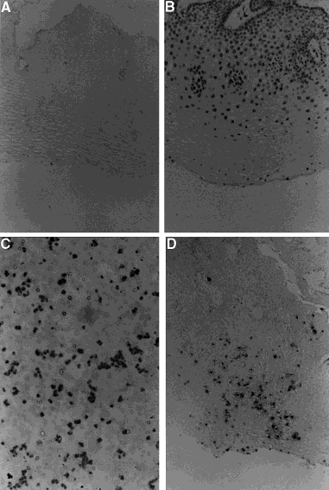
Fig. 1. HPV 16 in human cervical epithelium detected by IS and ISPCR. (A） Human papilloma virus type 16 (HPV 16) detected in human cervical epithelium by in situ hybridization. Positive signals were present only in the superficial layer. Magnification ×250. (B） HPV 16 detected by IS in a positive control cell line, composed of 20% HPV infected cells. (C） HPV 16 detected in human cervical epithelium by the ISPCR. Positive signals were present in the basal layer and the superficial layer. (D） For all of the slides shown, primer-independent controls or those with non-specific primers gave negative results.
(Table I). HPV 18 was the predominant type among cases with a high clinical stage (III IV) while HPV 16 and mixed HPV 16 with HPV18 were significantly correlated with a low clinical stage (0 I II) (Table II). Comparison of the sensitivity of ISPCR and IS revealed that 16 of 18 cases had a positive result in ISPCR while 10 of 18 cases has a positive result in ISH. Meanwhile, the detection rate between direct (23/26) and indirect ISPCR was almost identical (22/26) (Fig. 5).

DISCUSSION
ISPCR combines the techniques of PCR and ISH through the amplification of specific nucleic acid sequences inside single cells and increasing copy numbers to levels readily detectable by ISH or immuno- histochemistry. Experimental protocols for successful ISPCR share a number of important key steps. Including fixation and permeabilization during sample preparation, a mechanism for thermal cycling of cellular material in solution or on glass slides, and a means to detect the amplifications ﹝10, 23﹞.
It has been demonstrated that not all fixatives are equally permissive on ISPCR ﹝24, 25﹞. Successful in situ amplification has been achieved in samples fixed in 1 4% paraformaldehyde, 10% buffered formaldehyde solu- tion ﹝24, 25﹞ or mixtures of alcohol and acetic acid
﹝25﹞. Aldehyde fixing agents, such as formaldehyde and paraformaldehyde, are potent cross-linking agents. The majority of products are protein-protein cross-links with less cross-linking of protein to DNA and virtually no cross-linking of DNA to DNA at room temperature ﹝26﹞. Therefore, most ISPCR studies have used aldehyde fixation, with fixation times varying from 1 min to 16 h. Fixation is probably the single most important step in determining the success of ISPCR. Thus, in our study, 10% buffered formaldehyde with 10 h fixation times was applied to all of the samples.
Permeabilization of specimens has been achieved using proteases of different concentrations or detergents. There is usually only a very narrow range of fixation times and protease digestion times within which both PCR amplification and retention of amplified products occurs. Excessive protease digestion commonly leads to DNA end-labeling artifacts ﹝24﹞. In our experiment, permeabilization in 20 µg/ml proteinase K for 30 min at 37oC was selected as the most optimal condition.
For successful in situ amplification of target nucleic acids, different strategies to increase amplification efficiency, reduce mispriming, and increase retention of PCR products have been employed. Hot start modifica- tion of PCR ﹝27﹞ has been routinely suggested by several groups to reduce mispriming and primer oligomerization. Furthermore, to increase amplification efficiency, some

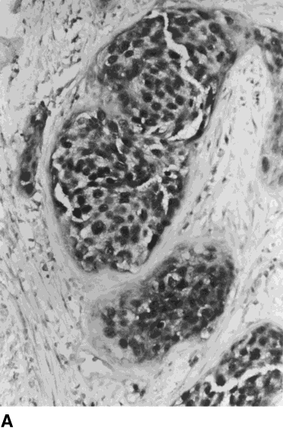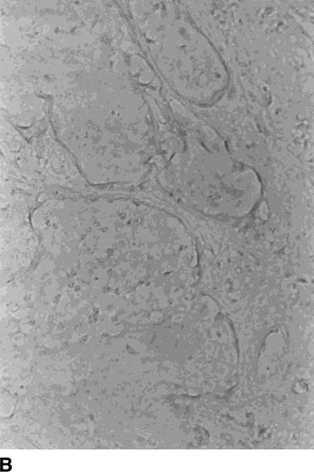

Fig. 2. Human papillomavirus type 16 (HPV 16) in cervical carcinoma of the squamous subtype detected by ISPCR (A）. Primer-independent controls or those with nonspecific primers gave negative result (B）. Magnification × 400.

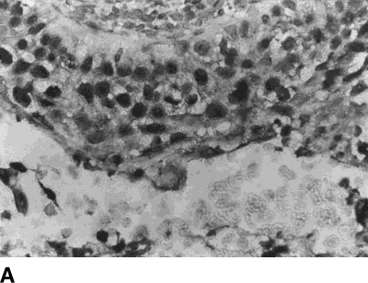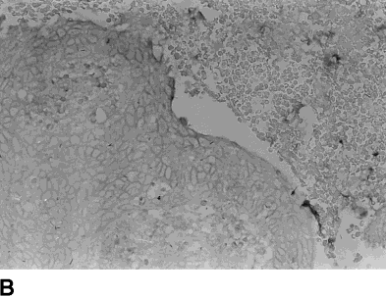

Fig. 3. Human papillomavirus type 16 (HPV 16) detected in cervical carcinoma of squamous subtype by ISPCR (A）. There was no positive signal present in the epithelial lining or adjacent red blood cells in negative control (B）.

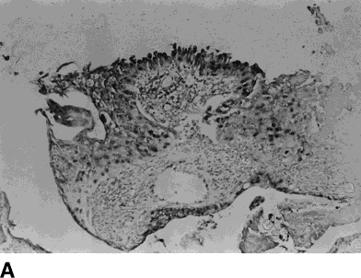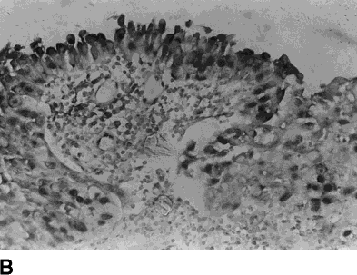

Fig. 4. Human papillomavirus type 18 (HPV 18) detected in cervical carcinoma of the adenocarcinoma subtype with focal squamous metaplasia by ISPCR. (A） Magnification × 250 and (B） magnification × 400.

researchers have used ISPCR reaction mixtures with higher concentrations of primers, magnesium or DNA polymerase than those used in traditional PCR protocols. In our ISPCR reaction, a total volume of 50 µl contained
200 µM of each of the four deoxynucleotide tripho- sphates, 1.0 µM of each primer, 4.5 mM of MgCl2, and 10 units of Taq polymerase. All reagents were used in concentrations 2 5 times higher than solution PCR reaction. The explanation for using such high concentra- tions is that some or all the reagents are sequestered during the reaction. Sequestration of reagents can occur by several methods including adherence of reagents adhering to the glass slides, coating of reagents on the slides, or by direct intercalation by the fixative residues present in the tissue.
Although some groups have used up to 50 PCR cycles, or 25 30 PCR cycles repeated one more time with the addition of a new PCR mixture and DNA polymerase,
25 30 PCR cycles were assumed to be adequate for in situ amplification in our experiment.
Adequate controls at each step are essential for the correct interpretation of ISPCR experiments as pre- viously described. These should include combinations of known negative samples, irrelevant primers for amplifi- cation and irrelevant probe for ISH. Irrelevant primers with irrelevant probe should not generate a PCR signal of the specific target probe. Using only one primer of the target sequence achieves an ''asymmetric PCR,’’ with accumulation of minimal product, which is not easily detectable. Excluding Taq DNA polymerase allows examination of the contribution of primer primer dimerization and primer oligomerization in generating false positive signals.
Direct ISPCR has also been attempted with radio- active or nonradioactive detection systems. It has been heralded as a rapid alternative to indirect ISPCR with the

TABLE I. Relationship Between Tumor Types in Human Cervical Cancer With HPV Types by ISPCR

HPV positive (No. of patients)

Tumor types | Total number | HPV 16  positive only | HPV 18  positive only | Both HPV 16 and 18 positive | Other HPV positive
Squamous cell | 38 | 27* | 2 | 3 | 6
carcinoma
Adenocarcinoma | 9 | 1 | 6* | 0 | 2
Adenosquamous | 2 | 2 | 0 | 0 | 0
carcinoma
Small cell carcinoma | 3 | 1 | 1 | 1 | 0
Total | 52 | 31 | 9 | 4 | 8
Fisher exact test was performed using SPSS 10.0.
*P < 0.01.

TABLE II. Relationship of HPV 16 and HPV 18 to Clinical Stages

HPV positive (No. of patients)

 | Total | HPV 16 | HPV 18 | Both HPV 16 and | Other HPV
Stage | number | positive only | positive only | 18 positive | positive
0 + I + II | 56 | 30* | 5 | 8 | 13
III + IV | 9 | 4 | 4* | 1 | 0
Total | 65 | 34 | 9 | 9 | 13
Fisher exact test was performed using SPSS 10.0.
*P < 0.05.

need for subsequent ISH. However, it has been shown that the direct detection approach yields less reliable results than indirect ISPCR and is not applicable to tissue sections ﹝32﹞. Nonspecific incorporation of labeled nucleotides into damaged DNA undergoing repair by the DNA polymerase may lead to false positive results. This phenomenon is both DNA polymerase- and cycling- dependent and even occurs after the omission of primers and with hot start ISPCR. In our experiment, there was almost the same detection rate between direct (23/26) and indirect ISPCR (22/26). The reasons for this may include lower incubation temperature used when the sample was de-waxed by fresh xylene within a short time period (30 min vs. 2 h at 37oC) and the use of fewer amplification cycles (30 vs. 35). The advantages of direct ISPCR over indirect ISPCR include not only saving time and convenience but also more diffuse and stronger intensity signal.
In this series, 52 biopsies (82.5%) were HPV 16- or 18-positive, HPV 16 being the most prevalent type. Squamous cell carcinoma was invariably associated with HPV 16 (66.7%) and adenocarcinoma with HPV 18 (46.2%). The reason for the association of HPV 18 with invasive cervical adenocarcinoma, and the associa- tion of HPV 16 with squamous cell carcinoma, is so far unknown. As with other viruses, cellular receptors with a specific potential for binding with each of the very heterologous HPV types may exist ﹝33﹞. Alternatively, it has been suggested that the HPV 18-associated adeno- carcinomas and the HPV 16-associated squamous cell carcinomas are derived from reserve cells predestined to develop into that particular cancer type, or that the target cell of primary HPV infection is truly bipotential and that the specific HPV infection actually directs tumor morphogenesis. Whether the reserve cell acts as the HPV target cell needs to be confirmed in further studies.

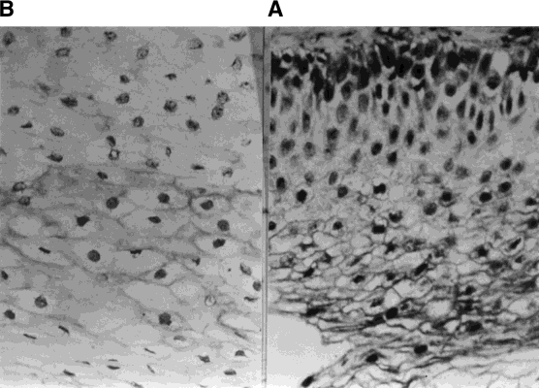

Fig. 5. HPV 16 in human cervical epithelium detected by direct ISPCR (A） and indirect ISPCR (B）. The intensity of signals present in direct ISPCR was stronger than those in indirect ISPCR.

In our investigation, HPV 18 was the predominant type among clinical high-stage (III,IV) cases while HPV 16 and mixed HPV 16 with HPV 18 were significantly correlated with a low clinical stage (0 I II). One reason may be that cervical cancer screenings tend to eliminate squamous cell carcinomas before the invasive stage but have significantly less impact on early stage endocervical adenocarcinoma. Kurman et al. ﹝34﹞ suggested that the deficit of type 18 in intraepithelial neoplasia as compared with invasive carcinoma could represent a rapid transit time through the precursor stage. Human papillomavirus type 18 may therefore play a role in the development of rapidly progressive cervical cancer. Walker et al. ﹝35﹞ also suggested that HPV 18-containing tumors might progress to invasion without a prolonged preinvasive stage. On the other hand, Barbosa et al. ﹝36﹞ further demonstrated that the rate of phosphorylation of Rb by HPV 16 and 18 E7 is varied, with HPV 18 E7 being two- fold faster than HPV 16 E7 which in turn is two-fold faster than HPV 6 E7. These results can explain why although all three of these viruses possess the E7 proteins, they differ with respect to their relative efficiency in carcinogenesis. So, the association of HPV 18 with advanced stage squamous carcinoma and with adeno- carcinoma may be explained by the apparently higher oncogenic potential of this virus.

REFERENCES
- Haase AT, Retzel EF, Staskus KA: Amplification and detection of lentiviral DNA inside cells. Proc Natl Acad Sci USA 1990﹔87: 4971 4975.
- Ray R, Komminoth P, Machado M, et al.: Combined polymerase chain reaction and in situ hybridization for the detection of single copy genes and viral genomic sequences in intact cells. Modern Pathol 1991﹔4:124A.
- Span W, Pachman K, Zabnienska H, et al.: In situ amplification of single copy gene segments in individuals cells by the polymerase chain reaction. Infection 1991﹔19:242 244.
- Nuova GJ, MacConnell P, Forde A, et al.: Detection of human papillomavirus DNA in formalin fixed tissues by in situ hybridization after amplification by PCR. Am J Pathol 1991﹔ 139:847 854.
- Nuova GJ: PCR in situ hybridization: In Nuovo GJ (ed): ''PCR In Situ Hybridization: Protocols and Applications.’’ New York, Raven Press, 1992:157.
- Nuova GJ: The hot start polymerase chain reaction. In Nuovo GJ (ed): PCR In Situ Hybridization: Protocols and Applications. New York, Raven Press, 1992:63.
- Bagasra O, Hauptman Sp, Lischner HW, et al.: Detection of human immunodeficiency virus type 1 provirus in mononuclear cells by in situ polymerase chain reaction. N. Engl J Med 1992﹔326:1385 1391.
- Komminoth P, Long AA, Ray R, et al.: In situ polymerase chain reaction detection of viral DNA, single-copy genes, and gene rearrangements in cell suspensions and cytospins. Diag Mol Pathol 1992﹔1:85.
- Gosden J, Hanratty D: PCR in situ: a rapid alternative to in situ hybridization for mapping short, low copy number sequences without isotopes. Biotechniques 1993﹔15:78.
- Komminoth P, Long AA: In situ polymerase chain reaction: an overview of methods, applications and limitations of a new

molecular technique Virchows Arch ﹝B﹞ Cell Pathology 1993﹔64: 67 73.
- Komminot P, Adams V, Long AA, et al.: Evaluation of method or hepatitis C virus detection in archival liver biopsies. Pathol Res Pract 1994﹔190:1017 1025.
- Macance DJ: Human papillomaviruses and cancer. Biochim Biophys Acta 1986﹔823:195 205.
- De Villiers EM: Heterogeneity of the human papillomavirus group. J Virol 1989﹔63:4898 4903.
- Durst M, Gissmann L, Ikeberg H, et al.: A papillomavirus DNA from a cervical carcinoma and its prevalence in cancer biopsies from different geographic regions. Proc Natl Acad Sci USA 1983﹔60:3812 3815.
- Chen SL, Han CP, Tsao YP, et al.: Identification and typing of human papillomavirus in cervical cancer in Taiwan. Cancer 1993﹔72:1939 1945.
- Tase T, Okagaki T, Clark BA, et al.: Human papillomavirus DNA in adenocarcinoma in situ, microinvasive adenocarcinoma of the uterine cervix, and coexisting cervical squamous intraepithelial neoplasia. Int J Gynecol Pathol 1989﹔8:8 17.
- Zehbe I, Wilander E: Human papillomavirus infection and invasive cervical neoplasia: a study of prevalence and morpho- logy. J Pathol 1997﹔181:270 275.
- Bosch FX, Manos MM, Mufioz N, et al.: Prevalence of human papillomavirus in cervical cancer: a worldwide perspective. J Natl Cancer Inst 1995﹔87:796 802.
- Lorinca AT, Temple GF, Kurman RJ, et al.: Oncogenic association of specific human papillomavirus types with cervical neoplasia. J Natl Cancer Inst 1987﹔79:671 677.
- Wilczynskin SP, Berg S, Walker J, et al.: Human papillomaviruses and cervical cancer: analysis of histopathologic features asso- ciated with different viral types. Hum Pathol 1988﹔19:697 704.
- Rose BR, Thompson CH, Simpson JM, et al.: Human papilloma- virus deoxyribo-nucleic acid as a prognostic indicator in early stage cervical cancer: a possible role for type 18. Am J Obstet Gynecol 1995﹔173:1461 1468.
- Abeler VM, Holm R, Nesland JM, et al.: Small cell carcinoma of the cervix一a clinicopathological study of 26 patients. Cancer 1994﹔73:672 677.
- O’Leary JJ, Chetty R, Graham AK, et al.: In situ PCR: pathologist dream or nightmare. J Pathol 1996﹔178:11 20.
- Nuova GJ, Gallery F, Hor R, et al.: Importance of different variables for enhancing in situ detection of PCR-amplified DNA. PCR Methods Appli 1993﹔2:305 312.
- O’Leary JJ, Browne G, Johnson MI, et al.: PCR in situ hybridisation detection of HPV16 in fixed CaSki ad fixed SiHa cells一an experimental model system. J Clin Pathol 1994﹔47: 933 938.
- Hopwood D: Cell and tissue fixation, 1972 1982. Histochem J 1985﹔17:389 442.
- Nuovo GJ, Gallery F, MacConnell P, et al.: An improved technique for the in situ detection of DNA after polymerase chain reaction amplification. Am J Pathol 1991﹔139:1239 1244.
- Yap EPH, McGee JO’D: Slide PCR: DNA amplification from cell samples on microscopic glass slides. Nucleic Acid Res 1991﹔19: 4294.
- Chiu K, Cohe H, Morris DW, et al.: Intracellullar amplification of proviral DNA I tissue sections using the polymerase chain reaction. J Histochem Cytochem 1992﹔4:333 341.
- Embleton MJ, Gorocov G, Jones PT, et al.: In cell PCR from mRNA: amplifying and linking the immunoglobulin heavy ad light V genes with single cells. Nucleic Acid Res 1992﹔20:3831 3837.
- Staskus KA, Couch L, Bitterman P, et al.: In situ amplification of visna virus DNA in tissue sections reveals a reservoir a latently infected cells. Microbiol Pathol 1991﹔11:67 76.
- Long AA, Komminoth P, Lee E, et al.: Comparison of indirect and direct in situ polymerase chain reaction in cell preparations and tissue sections. Detection of viral DNA, gene rearrange- ments and chromosomal translocations. Histochemistry 1993﹔99: 151 162.

- Dallenbach-Hellweg G, Lang G: Immunohistochemical studies on uterine tumors. Invasive squamous cell carcinomas of the cervix and their precursors. Pathol Res Pract 1991﹔187:36 43.
- Kurman RJ, Schiffman MH, Lancaster WD, et al.: Analysis of individual human papillomavirus types I cervical neoplasia: a possible role for HPV 18 in rapid progression. Am J Obstet Gynecol 1988﹔159:293 296.
- Walker J, Bloss JD, Liao SY, et al.: Human papillomavirus genotype as a prognostic indicator in carcinoma of the uterine cervix. Obstet Gynecol 1989﹔74:781 784.
- Barbosa MS, Edmonds C, Fisher C, et al.: The region of the HPV E7 oncoprotein homologous to adenovirus E1a and SV40 large T antigen contains separate domains for Rb binding and casein kinase II phosphorylation. EMBO J 1990﹔9:153 160.

