Cysteine conjugated gold nanoparticles and their scavenging free radicals properties
Chih-Wei Chou^{1, a} *, Jen-Ming Yang^{2,b}, Tsung-Shi Yang^{1, c} *, Yang-Chia Shih^{3, d}, Hui-Hsuan Hsieh^{4,e} , Ko-Hsin Chang^{5,f}, Ko-Shao Chen^{6,g}, Wu Lii Tzu^{7,h}, You-Cheng Hseu ^{1, i} and Yi-Syuan Wei^{6,j}
¹ Department of Cosmeceutic, China Medical University, Taichung, Taiwan, R.O.C.
²Department of Chemical and Materials Engineering, Chang Gung University, Tao-Yuan, Taiwan
³ Department of Biotechnology, Asia University, Taichung, Taiwan, R.O.C.
⁴ Department of Materials Science and Engineering, National Chung Hsing University, Taichung, Taiwan, R.O.C.
⁵ Ph.D. Program in Tissue Engineering and Regenerative Medicine, National Chung Hsing University, Taipei, Taiwan, R.O.C.
⁶ Department of Materials Science and Engineering, Tatung University, Taichung, Taiwan, R.O.C.
⁷ School of Medicine, China Medical University, Taichung, Taiwan, R.O.C.
ª cwchou@mail.cmu.edu.tw ^{b}jmyang@mail.cgu.edu.tw, ^{c} tsyang@mail.cmu.edu.tw, ^{d} angelashih@asia.edu.tw, ^{e} mieh1209@hotmail.com, ^{f} kohsin00319@hotmail.com, ^{g}kschen@ttu.edu.tw, ^{h}ltwu@mail.cmu.edu.tw, ^{i}ychseu@mail.cmu.edu.tw, ^{j}elve003@hotmail.com
Keywords: cysteine, conjugated, gold, free radical scavenging
Abstract. This study deals with cysteine on gold (Au) nanoparticles which prepared by sodium citrate reduction. The effects of cysteine conjugated Au nanoparticles (Cys-c-Au NPs) on the microstructure and properties of the were investigated by Ultraviolet-visible spectroscopy (UV-Vis), Fourier-transform infrared spectroscopy (FTIR), field emission scanning electron microscopy (FESEM), and free radical scavenging ability. The results of UV-Vis and FTIR show that the cysteine was conjugated on Au NPs surface and the conjugates were found to be stable in water. The Energy- dispersive spectrometer (EDS) result shows the typical pick of the element sulfur (S) on surface of Cys-c-Au NPs. Finally, conjugates exhibited free radical scavenging ability in presence of cysteine.
Introduction
Gold nanoparticles have received considerable attention as potential building blocks for a variety of applications, including chemical sensing, electronics, optics and biology. Gold nanoparticles (AuNPs) exhibit surface plasmon absorption in the visible region. Based on the optical properties, chromatic sensors using AuNPs have been widely investigated. One of effective strategies to develop color sensors with AuNPs is based on a chromatic change from red to blue-purple in an AuNPs solution, where aggregation of the AuNPs proceeds. Aggregation is induced by the formation of bridging structures between the AuNPs. L-cysteine is a small, zwitterionic molecule, and well used in biochemical and electrochemical research. The interaction of cysteine and gold nanoparticles via S-Au bonding provided more surface area for interaction with external species. On the other hand, due to cysteine conjugated on gold nanoparticles could enahance radical scavenging activities as a potent antioxidant and have good biocompatibility. Here we report the effects of cysteine on the size and scavenging free radicals activity of Au nanoparticles.
Experimental
All glassware used in the following procedures was cleaned of freshly prepared 3:1 v/v HCl: HNO₃ (aqua regia) and rinsed thoroughly in Milli-Q grade water prior to use. Aqueous solutions of HAuCl₄ (1mM) were prepared and the temperature was kept at 60 ºC for 10min., then sodium citrate solution (38.8mM) was added at 100 ºC for 10 min with continuous stirring and cool down until room temperature. Finally, use centrifuge at 13000rpm and collected concentrate.
Cysteine aqueous solution were prepared using sodium hydroxide (0.1N),then added into gold nanoparticles in an eppendorf and kept in water bath at 30 ºC. The amino acid conjugated gold nanoparticles formed were separated and purified by repeated centrifugation and collected concentrate. The surfaces of all the samples were analyzed by attenuated total reflectance Fourier-transform infrared spectroscopy (ATR-FTIR; Jasco 410). The angle of incidence used was 45º, and was held constant for all measurements.
A JEOL JSM-6700F field emission scanning electron microscope (FESEM) was used for studying the microstructure of the cysteine-Au nanoparticles. It was operated at a working distance of 11 mm, an acceleration voltage of 5 kV and a beam current of 1x10⁻¹⁰ A.
DPPH solution (32µm) was prepared in the methanol. Then, 3ml of DPPH solution was added to 1ml of the cysteine conjugated gold nanoparticles solution, and added 3ml of methanol to 1ml of the cysteine conjugated gold nanoparticles solution. In addition, the blank was prepared by adding DPPH solution (3ml) into deionized water (1ml). The above-mentioned mixtures was proceeded with n=3. The mixtures was shaken and incubated for 90min at room temperature. Finally, when the DPPH radical is scavenged by an antioxidant and transforms to 1,1-diphenyl-2-picrylhydrazyne (DPPH–H), the color of the solution turned from purple to yellow, which was detected by the decay inabsorbance at 520 nm. The degree of DPPH radical scavenging activity was calculated as:
RSA%=100% - [(A₁-A₂)100/A₀]
Here RSA% is the percentage of free radical scavenging activity, A₀ is the average absorbance of the blank, A₁ is the average absorbance of cysteine conjugated on gold nanoparticles in the DPPH, and A₂ is the average absorbance of cysteine conjugated on gold nanoparticles in the methanol
Results
Figure 1 shows the UV–vis absorption spectra of Au nanoparticles and cysteine-Au nanoparticles. The strong absorption in the spectra of gold nanoparticles was observed at 521 nm (curve a) that is the characteristic feature of gold plasmon resonance. A shift and broadening of the above band was observed in the spectra of cysteine-Au nanoparticles (curve b) at 532nm. From the surface plasmon resonance, the particles size change with the absorbance wavelength. Preliminary confirm that cysteine conjugated on gold nanoparticles. Figure 2 shows the FT-IR results of Au nanoparicles, cysteine and cysteine-Au nanoparticles. Generally, amino acids exit as zwitterions (internal salts) and exhibit spectra characteristic of both carboxylate and primary amine salts. It shows NH₃⁺ stretch (very broad) and COO⁻ (carboxylate ion) stretch (asymmetric/symmetric) as characteristic vibrations. The absorption regions of cysteine and cysteine-Au nanoparticles can be observed from these spectra. For Cys-c-Au NPs, the stretching vibration absorption band of the COO⁻ (1589 cm⁻¹) was observed in spectra. The absorption at 3446 cm⁻¹ was assigned to the stretching vibration of NH3⁺. For the cysteine, a absorption was observed at 2550 cm⁻¹. As known, the bands between 2500-2600 cm⁻¹ can be assigned to S-H bonds. With the cysteine-Au nanoparticles, the absorption of S-H bonds in this area disappeared. This disappear can be attributed to the influence of the formation of S-Au bonds. Moreover, Figure 3 shows the EDS results of cysteine-Au nanoparticles. The S atom can be detected on the surface of Au nanoparticles. FESEM images and particle size distributions of Au nanoparticles and Cys-c-Au nanoparticles are shown in Fig. 4. In Figure 4(b) shows the spherical Au nanoparticles with a corona of cysteine ligand appears like a cluster of particles. And it is distinctly distinguishable as compared to the Figure 4(a) of gold nanoparticles. To presume the differences of them are due to intermolecular hydrogen bonds between cysteine-Au nanoparticles, thus appears like a cluster particles. The mean diameter of gold nanoparticles about 17.1nm shown in Figure 5(a) and Cys-c-Au nanoparticles ranged about 19.8nm in Figure 5(b). Besides, the variation of particles size with cysteine conjugated was consistent with the surface chemical bonding observed in UV-Vis measurement. In Table 1, it is shown the free radical scavenging activity of the different volume of cysteine-Au nanoparticles solution. From this results, the pure Au nanoparticles demonstrated the free radical scavenging ability. The cysteine itself exhibited greater free radical scavenging effect. The presence of cysteine on Au nanoparticles enhanced the free radical scavenging ratio of the original Au. Especially, the radical scavenging ratio of Cys-c-Au nanoparticles was increased with increasing volume of Cys-c-Au nanoparticles.

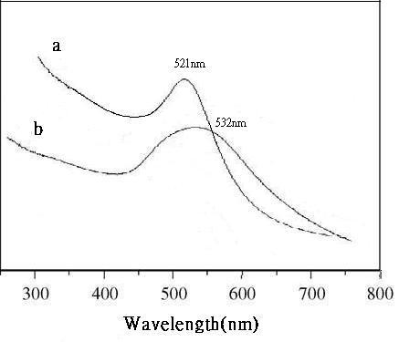
Fig.1. UV–vis spectra of (a) Au nanoparticles,(b) Cys-c-Au nanoparticles
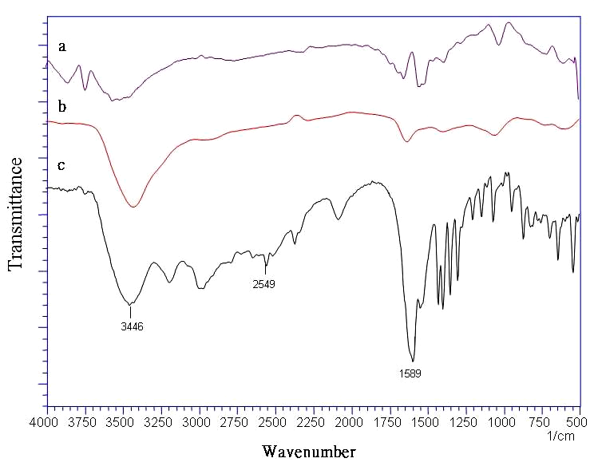
Fig.2. Infrared spectra of Au nanoparticles (spectrum a), Cys-c-Au nanoparticles (spectrum b) and pure cysteine (spectrum c)
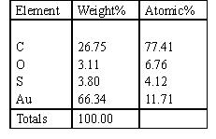
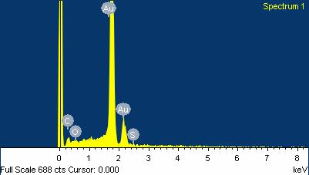
Fig.3 EDS analysis of Cys-c-Au nanoparticles.
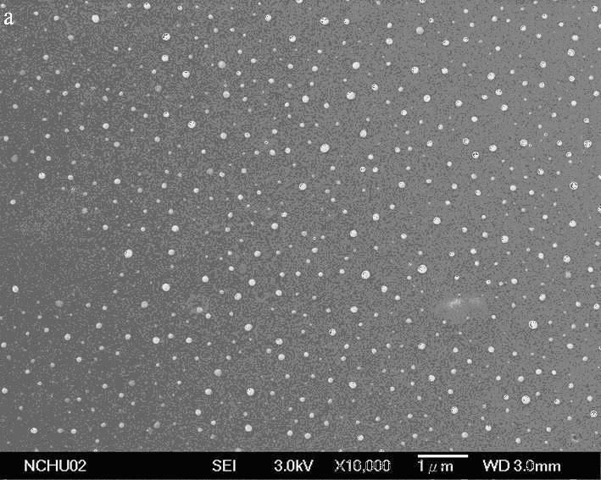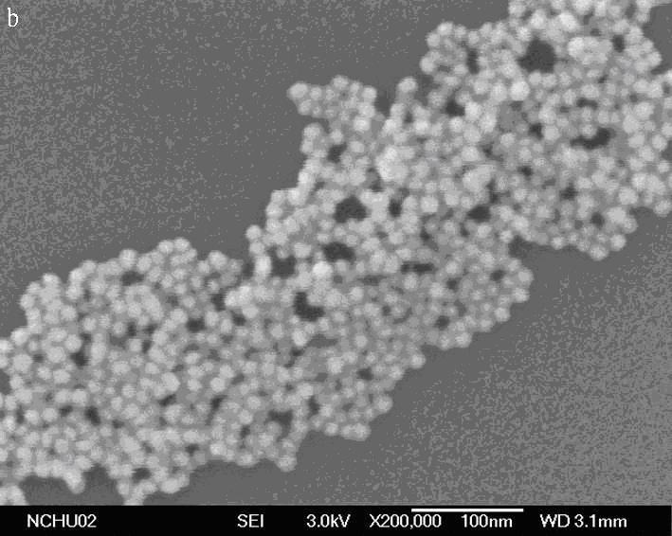
Fig.4. FESEM image of (a) Au nanoparticles and (b) Cys-c-Au nanoparticles
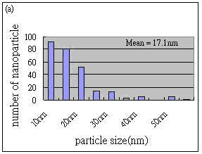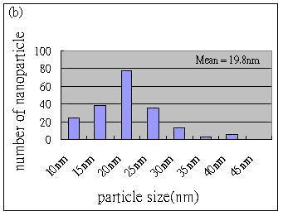
Fig.5. The size distribution of (a) Au nanoparticles and (b) Cys-c-Au nanoparticles

Table 1. The free radical scavenging activity of Au nanoparticles, cyteine and Cys-c-Au nanoparticles (0.5, 0.75, 1.0 ml)
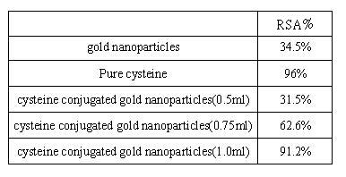
Conclusion
This research successfully synthesized amino acid conjugated gold nanoparticles by via S-Au bonding. We demonstrated that the cysteine was conjugated on Au by UV-Vis and FTIR. We can also see S on the cysteine capped gold in the energy- dispersive spectrometer (EDS). The batter free radical scavenging ability was associated with the surface activity of Au nanoparticles change in the presence of cysteine.
References
[1] R.C. Bailey, J.-M. Nam, C.A. Mirkin, J.T. Hupp, J. Am. Chem. Soc. 125 (44) (2003) 13541.
[2] W.J. Parak, D. Gerion, T. Pellegrino, D. Zanchet, C. Micheel,S.C. Williams, R. Boudreau, M.A. Le Gros, C.A. Larabell, A.P. Alivisatos, Nanotechnology 14 (2004) 15.
[3] M.K. Corbierre, N.S. Cameron, M. Sutton, S.G.J. Mochrie, L.B. Lurio, A. Ruhm, R.B. Lennox, J. Am. Chem. Soc. 123 (42) (2001)10411.
[4] T.K. Mandal, M.S. Fleming, D.R. Walt, Nano. Lett. 2 (1) (2002)3.
[5] J. Shan, M. Nuopponen, H. Jiang, E. Kauppinen, H. Tenhu, Macromolecules 36 (12) (2003) 4526.
[6] R. Levy, N.T.K. Thanh, R.C. Doty, I. Hussain, R.J. Nichols, D.J. Schiffrin, M. Brust, D.G. Fernig, J. Am. Chem. Soc. 126 (32) (2004)1007.
[7] Y.C. Sasaki, K. Yasuda, Y. Suzuki, T. Ishibashi, I. Satoh, Y. Fujiki,S. Ishiwata, Biophys. J. 72 (1997) 1842.
[8] I. Willner, E. Katz, B. Willner, R. Blonder, V. Heleg-Shabtai, A.F.B¨uckmann, Biosens. Bioelectron. 12 (1997) 337.
[9] J.L. Burt, C. Gutierrez-Wing, M. Miki-Yoshida, M. Jose-Yacaman, Langmuir 20 (26) (2004) 11778.
[10] Mucic, R.C., Storhoff, J.J., Mirkin, C.A., Letsinger, R.L. J. Am. Chem. Soc.1998, 120, 12674-12675D. Neher, Macromol. Rapid Commun., 22, (2001) 17
[11] N. Chanda, R. Shukla, A. Zambre, S. Mekapothula, R.R. Kulkarni, K. Katti et al. Pharm Res, 28 (2011) 279.
[12] P.S. Ghosh, C.K. Kim, G. Han, N.S. Forbes, V.M. Rotello, ACS Nano, 2 (2008), 2213.

