Anti-inﬂammatory effects of Antrodia camphorata, a herbal medicine,
in a mouse skin ischemia model
Tung-Chou Tsai a,1, Yu-Tang Tung a,1, Yueh-Hsiung Kuo c,d, Jiunn-Wang Liao b,
Hsin-Chung Tsai e, Kowit-Yu Chong f, Hsiao-Ling Chen g,n, Chuan-Mu Chen a,h,nn
a Department of Life Sciences, and Agricultural Biotechnology Center, National Chung Hsing University, Taichung 402, Taiwan
b Graduate Institute of Veterinary Pathobiology, National Chung Hsing University, Taichung 402, Taiwan
c Department of Chinese Pharmaceutical Sciences and Chinese Medicine Resources, China Medical University, Taichung 404, Taiwan
d Department of Biotechnology, Asia University, Taichung 413, Taiwan
e Department of Sugery, Taichung Hospital, Ministry of Health and Welfare, Taichung 403, Taiwan
f Department of Medical Biotechnology and Laboratory Science, Molecular Medicine Research Center, Chang Gung University, Tao-Yuan 333, Taiwan
g Department of Bioresources, Da-Yeh University, Changhua 515, Taiwan
h Rong-Hsing Translational Medicine Center, and the iEGG center, National Chung Hsing University, Taichung 402, Taiwan

art ic l e i nf o

Keywords:
Skin ischemia
Antrodia camphorata
ST1
Anti-inﬂammation
Skin ﬂap

a b s t r a c t

Ethnopharmacological evidence: Antrodia camphorata, a highly valued polypore mushroom native only to
Taiwan, has been traditionally used as a medicine for anti-inﬂammation.
Aim of the study: In this study, anti-inﬂammatory effects of Antrodia camphorata (AC) and its active
compound, ergostatrien-3β-ol (ST1), were investigated in a mouse skin ischemia model induced by skin
ﬂap surgery on the dorsal skin.
Materials and methods: A U-shaped ﬂap was elevated on the dorsal skin of the nine-week-old male mice.
Mice were randomly assigned to six groups for treatment (n ¼ 6) including normal skin/propylene glycol
(PG), surgical skin ﬂap/PG, solid-state-cultured AC (S/AC), wood-cultured AC (W/AC), high-dose ST1 (H-
ST1), low-dose ST1 (L-ST1). Antrodia camphorata was dissolved in 25 μL PG and smeared on the skin ﬂap
every six hours for 24 h. At the end of the experiment, each mouse was anesthetized, and skin tissues
were collected from their back for histopathological analysis, extracting RNA and protein according to our
previous reports.
Results: Skin-ﬂap-induced ischemia damage signiﬁcantly increased the expression of the iNOS, COX2,
and IL-6 proteins and decreased the expression of IκB protein. In addition, focal, moderate coagulative
necrosis with inﬂammatory cell inﬁltration was found in the epidermis, and moderate inﬂammatory cells
and necrosis with slight edema was noted in the sub-dermis at 24 h after skin ﬂap surgery. However,
treatment with solid-state-cultured or wood-cultured AC, or with its derived ST1 active compound,
signiﬁcantly reduced the necrosis and inﬂammatory cell inﬁltration in both the epidermis and sub-
dermis of the skin ﬂap. The treatments also reduced the inﬂammatory response by decreasing the
expression of inﬂammation-related genes including iNOS, IL-6, TNF-α, and NF-κB, as shown by changes
in RNA and protein expression, when compared with the surgical skin ﬂap procedure alone.
Conclusions: These results demonstrated that methanolic extracts of wood-cultured fruiting bodies and
solid-state-cultured mycelia from Antrodia camphorata have excellent anti-inﬂammatory activities and
thus have great potential as an addition for hydrocolloid dressings.

1. Introduction

n Corresponding author. Tel.: þ 886 4 8511888; fax: þ 886 4 8511326.
nn Correspondence to: Department of Life Sciences, Ofﬁce of Research and
Development, National Chung Hsing University, No. 250, Kuo Kuang Road, Taichung
402, Taiwan. Tel.: þ 886 4 22856309; fax: þ 886 4 22874740.
E-mail addresses: bellchen@mail.dyu.edu.tw (H.-L. Chen),
chchen1@dragon.nchu.edu.tw (C.-M. Chen).
1 These authors contributed equally to this work.

Skin damage induced by ischemia/reperfusion is a multifactor-
ial process that is often observed in plastic and reconstructive
surgery (Wang, 2009; Tamas et al., 2010). In clinical, the general
medical treatments for early stage (the vascular level) of ischemia–
reperfusion skin injury is steroid drug, but it accompanied with a
certain side effects. Moreover, in the late stage (the tissue level) of

Fig. 1. (A) HPLC proﬁling of the major compound (ergostatrien-3β-ol) of crude extract from Antrodia camphorata solid-state-cultured mycelia. (B) U-shaped ﬂap surgical
elevation of the skin (1.5 cm Â 3.5 cm) led to ischemia; (C) Animal experimental ﬂowchart.

ischemia skin damage, no available drugs efﬁciently used in the
clinical ﬂap surgery. Previous study showed that glucocorticoid
promotes a cardio-protective phenotype associated with the up-
regulation of AT1R and PKCɛ and down-regulation of AT2R in the
context of myocardial injury from ischemia/reperfusion (Xue et al.,
2014). Cyclosporine, which inhibits the opening of mitochondrial
permeability-transition pores, attenuates lethal myocardial injury
that occurs at the time of reperfusion (Piot et al., 2008). Many
medications still in the clinical trial stages now. The process of
ischemia injury includes hypoxia, inﬂammation, and oxidative
damage (Liu and McCullough, 2013). Inﬂammation is one of the
responses induced at the initial stage by hypoxia. The formation of
reactive oxygen species (ROS) during skin ischemia reperfusion
triggers lipid peroxidation, and damage to proteins and nucleic
acids (Siemionow and Arslan, 2004). Reducing the damage result-
ing from skin ischemia requires greater inhibition of the inﬂam-
matory reaction.

Antrodia camphorata is a well-known traditional Chinese medi-
cine in Taiwan. The main application of Antrodia camphorata (AC) is
for food and drug intoxication, abdominal pain, skin itching, hyper-
tension, and cancer (Peng et al., 2007). Recent studies showed that
the fruiting body of Antrodia camphorata exhibited immunomodula-
tory and antioxidative activities (Shen et al., 2004; Hsiao et al., 2003).
However, the fruiting body of Antrodia camphorata is rare and
expensive. Previous report showed that both of mycelia and fruiting
bodies of Antrodia camphorate extracts modulated inﬂammatory
mediator expression in mice with polymicrobial sepsis (Meng et al.,
2012). Our current study further demonstrated that methanolic
extracts of wood-cultured fruiting bodies and solid-state-cultured
mycelia from Antrodia camphorata have excellent anti-inﬂammatory
activities in the hyperoxia-induced systemic inﬂammatory responses
(Tung et al., 2014). A previous study showed that the fruiting
body and cultured mycelia of Antrodia camphorata have the same
lignans, fatty acids, sesquiterpenes, phenyl derivatives, steroids, and
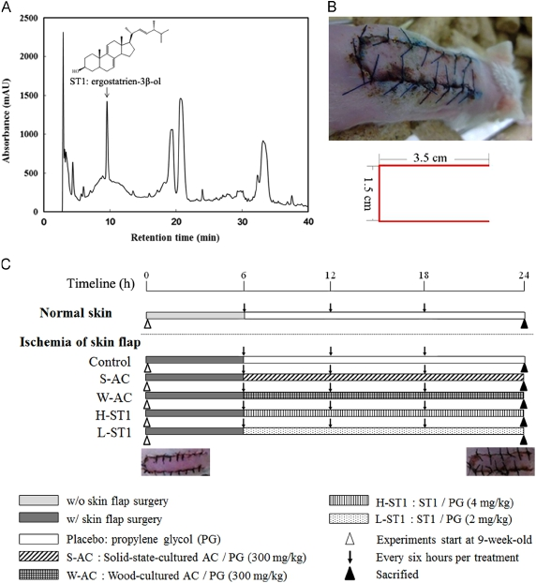

Fig. 2. The histopathological analysis time course in the skin tissues after skin ﬂap surgery. (A) 0 h after skin ﬂap surgery; (B) 12 h after skin ﬂap surgery; (C) 48 h after skin
ﬂap surgery; (D) 72 h after skin ﬂap surgery. The interested areas were marked by two different indicators as followed: yellow “n” for coagulative necrosis and red “arrows”
for inﬂammatory cells. Scale bar ¼ 50 μm. The insets show the partial enlarged picture with 400 Â magniﬁcation. (For interpretation of the references to color in this ﬁgure
legend, the reader is referred to the web version of this article).

triterpenoids (Geethangili and Tzeng, 2009). However, little informa-
tion is available concerning the effects of the immunomodulatory
and antioxidative activities of the fruiting body compared with
cultured mycelia of Antrodia camphorata.
The anti-inﬂammatory effect of the active compounds
extracted from Antrodia camphorata might be related to their
antioxidant properties (Hseu et al., 2010). Huang et al. showed
the anti-inﬂammatory effects of ergostatrien-3β-ol (ST1), one
major compound of Antrodia camphorata, on paw edema induced
by λ-carrageenin (Carr) in mice (Huang et al., 2010). Therefore, the
fruiting bodies and solid-state-cultured mycelia of Antrodia cam-
phorata and its active compound, ST1, may be good candidates for
further development as a remedy for skin ischemia-induced
systemic inﬂammatory responses. In this study, we focused on
the anti-inﬂammatory activity of wood-cultured fruiting bodies
and solid-state-cultured mycelia from Antrodia camphorata and
ST1 in the mouse skin ischemia model.

2. Material and methods

2.1. Extraction

Freeze-dried powder of Antrodia camphorata fruiting bodies
and solid-state-cultured mycelia was extracted 3 times with
methanol at room temperature (RT; 1 day each). The extract was
decanted, ﬁltered under vacuum, concentrated in a rotary eva-
porator, and then lyophilized. The extract was stored in an airtight
container at À 80 1C prior to further analysis.

2.2. Isolation and determination of the active compound

Freeze-dried powder (1.6 kg) of Antrodia camphorata was
extracted 3 times with methanol (16 L) at RT, 1 day each. The
methanol extract was evaporated in a vacuum to give a brown
residue, which was dissolved in H2O (1 L) and then fractionated
(3 times) with 1 L of ethyl acetate (EtOAc). The EtOAc fraction (95 g)

was chromatographed on silica gel using mixtures of hexane and
EtOAc of increasing polarity as eluents. ST1 (5.4 g) was eluted with
10% EtOAc in hexane and recrystallization with EtOH (Huang et al.,
2010). The active compound of Antrodia camphorata was determined
by high performance liquid chromatography (HPLC) using a PU-2080
pump (Tokyo, Japan) equipped with a MD-2010 multi-wavelength
detector and a 250 Â 4.6 mm2 i.d. 5 mm Luna C18 column (Phenom-
enex, Torrance, CA, USA). The mobile phase consisted of solvent A,
100% MeOH; and solvent B, ultrapure water. The elution conditions
were 0–30 min of 70–100% A and 30–40 min of 100–100% A at a ﬂow
rate of 1 mL/min, using a photodiode array detector at a wavelength
of 254 nm (Shao et al., 2008). The HPLC chemical ﬁngerprints of the
methanol extract from Antrodia camphorata solid-state-cultured
mycelia and wood-cultured fruiting bodies were also shown in our
previous report (Tung et al., 2014).

2.3. Animals trials

Eight-week-old male mice (FVB/NJNarl) were purchased from
the National Laboratory Animal Center (Taipei, Taiwan) and given
a standard laboratory diet and distilled water ad libitum. They
were kept on a 12 h light/dark cycle at 24 7 2 1C. This study was
conducted according to institutional guidelines and approved
by the Institutional Animal Care and Utilization Committee of
National Chung Hsing University, Taiwan (approval NO 102–26).
The male mice (nine-week-old) underwent skin ﬂap surgery on
their backs as previously described (Toutain et al., 2008). A U-shaped
ﬂap (3.5 cm length Â 1.5 cm width) was elevated on the dorsal skin
of the mouse, and two vascular pedicels from the lateral thoracic
arteries were sectioned (Fig. 1B). As shown in Fig. 1C, mice were
randomly assigned to six groups for treatment (n ¼ 6): (1) a normal
control group, no treatment (normal skin/propylene glycol (PG), a
commonly used medical solvent); (2) skin ﬂap surgery with placebo
treatment (surgical skin ﬂap/PG); (3) skin ﬂap surgery plus treat-
ment with 300 mg/kg body weight (B.W.) of Antrodia camphorata
(AC) solid-state-cultured mycelia (surgical skin ﬂap/S-AC); (4) skin
ﬂap surgery plus treatment with 300 mg/kg B.W. of wood-cultured
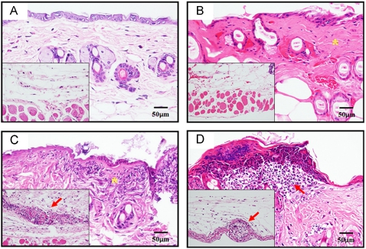

2.5. RT-PCR analysis

Total RNA from the skin tissue was extracted using TRIzol reagent
(Invitrogen, Carlsbad, CA, USA) as speciﬁed by the manufacturer.
Total RNA (2 μg) was re-suspended in 9 μL of diethylpyrocarbonate
(DEPC)-treated water, and the ﬁrst strand of cDNA was synthesized
with oligo-dT and ImProm-IITM reverse transcriptase in a total
volume of 20 μL. The reaction was carried out at 42 1C for 1 h (Tsai
et al., 2010). For further PCR ampliﬁcation, an aliquot (1:10) of the RT
product was adjusted to contain 0.1 μg of each primer, and addi-
tional buffer was added to a total volume of 20 μL. Aliquots of the
reverse transcriptase mix were used for PCR ampliﬁcation of vegf,
iNOS, IL-6, and β-actin. The primer sets and oligonucleotide
sequence information are shown in Supplementary Table S1. The
ampliﬁed RT-PCR products were subjected to electrophoresis in a
1.5% agarose gel. The ampliﬁed cDNA of β-actin was used as an
internal control. The quantiﬁcation of gene expression levels based
on RT-PCR products was performed using a densitometer (Kodak 1D
software, Japan) as described previously (Chen et al., 2012).

2.6. Western blot analysis

Protein expression levels in the skin tissue were measured by
Western blotting. Skin tissues were homogenized in 500 μL of
RIPA buffer (5 mM Tris–HCl pH 7.4, 0.15 M NaCl, 1% NP40, 0.25%
sodium deoxycholate, 5 mM EDTA, and 1 mM ethylene glycol-bis
(2-aminoethyl-ether)-N, N, N, N-tetraacetic acid). The homoge-
nates were centrifuged at 12,000g for 30 min at 4 1C. Protein
(40 μg) was then separated by SDS-PAGE in 10% polyacrylamide
and electrotransferred to polyvinylidene diﬂuoride (PDF) mem-
branes. The membranes were incubated in blocking solution (5%

Fig. 3. The protein expression time course in normal skin/PG and ischemia skin/PG
after skin ﬂap surgery. (A) The IκB, NF-κB, iNOS, COX2, IL-6, TNF-α, VEGF and β-
actin protein expressions in different time course were analyzed by Western blots.
(B) The quantiﬁcation data of IκB, NF-κB, iNOS, COX2, IL-6, TNF-α and VEGF protein
levels were normalized using an internal control of β-actin. Data were presented as
Mean 7 SE (n ¼ 6). Bars with the different superscript letters in the same assayed
protein represent a signiﬁcant difference (p o 0.05).

Antrodia camphorata fruiting bodies (surgical skin ﬂap/W-AC);
(5) skin ﬂap surgery plus treatment with a high-dose of 4 mg/kg
B.W. of ST1 (surgical skin ﬂap/H-ST1); and (6) skin ﬂap surgery plus
treatment with a low-dose of 2 mg/kg B.W. of ST1 (surgical skin ﬂap/
L-ST1). All of the animal trails were performed in duplicates.
Antrodia camphorata was dissolved in 25 μL PG and smeared on
the skin ﬂap every six hours for 24 h. At the end of the experiment,
each mouse was anesthetized, and skin tissues were collected from
their back for histopathological analysis, extracting RNA and protein
according to our previous reports (Tung et al., 2013b; Chang et al.,
2011; Tsai et al., 2013).

2.4. Histopathology

After 24 h of treatment, skin tissues were excised from the back
of each mouse, ﬁxed in 10% buffered formaldehyde, and examined
using hematoxylin and eosin (H&E) staining as described previously
(Tung et al., 2011; Tung et al., 2013a). The degree of the lesions was
graded from one to ﬁve depending on severity: 1 ¼ minimal ( o 1%);
2 ¼ slight (1–25%); 3 ¼ moderate (26–50%); 4 ¼ moderate/severe
(51–75%); 5 ¼ severe/high (76–100%), (Shackelford et al., 2002).
BSA) at room temperature for 1 h. The membranes were then
incubated with primary antibodies against IκB, NF-κB, iNOS, COX2,
IL-6, TNF-α, VEGF or β-actin at room temperature for 2 h. After
washing, the membranes were incubated with a goat anti-rabbit
IgG peroxidase-conjugated secondary antibody directed against
the primary antibody at room temperature for 1 h. The mem-
branes were developed by an enhanced chemiluminescence (ECL)
Western blot detection system as described previously (Wu et al.,
2007a).

2.7. Statistical analysis

Data were presented as the mean 7 standard error (SE). All data
were analyzed using the variance (ANOVA) test. Analysis was
continued with post hoc test with Duncan method to detect the
differences of parameters among control and treatment groups.
The results with p o 0.05 were considered to be statistically
signiﬁcant.

3. Results

3.1. Determination of ST1 compound in the crude extract of Antrodia
camphorata through HPLC proﬁling

A comprehensive HPLC proﬁle of the crude extract from
Antrodia camphorata solid-state-cultured mycelia exhibited many
peaks at retention times between 0 and 40 min. The ST1 com-
pound produced a secondary peak among the main chromato-
graphic peaks that was eluted at the 10 min time point (Fig. 1A).
The result showed that ST1 is one of the major compounds in
Antrodia camphorata.
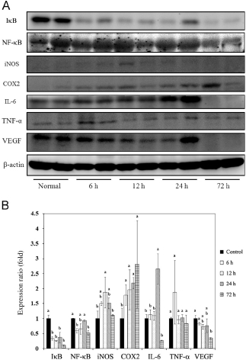

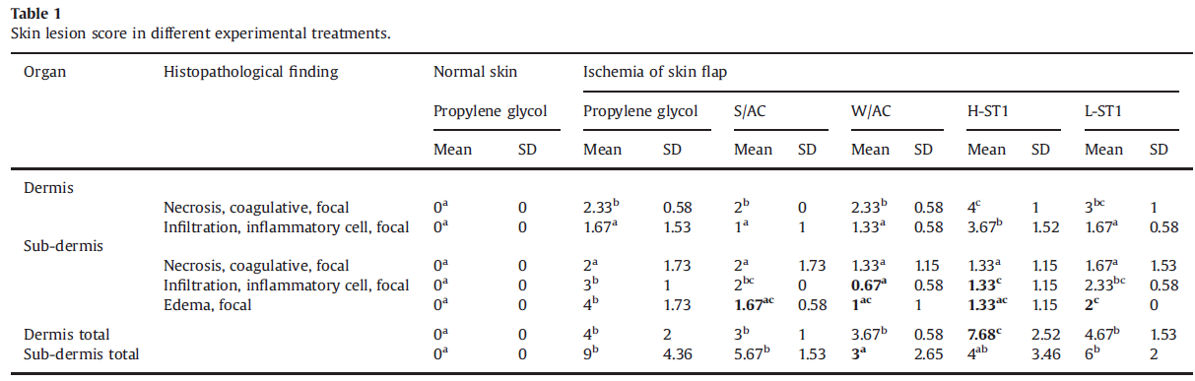

Degree of lesions was graded from one to ﬁve depending on severity: 1 ¼ minimal ( o 1%); 2: slight (1–25%); 3 ¼ moderate (26–50%); 4 ¼ moderate/severe (51–75%);
5 ¼ severe/high (76–100%).Data in the same row with different superscript letters (a, b and c) differ signiﬁcantly (p o 0.05).

3.2. Effects of time course on histological changes and inﬂammation-
related factors expression in the mouse skin ischemia model

The timeline of the animal trial to test whether the smear
administration of the crude extract of Antrodia camphorata and
ST1 can down-regulate inﬂammation in the mouse skin ischemia
model is shown in Fig. 1C. In the histopathological observation,
normal architecture of the epidermis, dermis, and sub-dermis was
observed in the mice (Fig. 2). Diffuse and severe high coagulative
necrosis with slight inﬁltration was found in the epidermis at 12 h
after skin ﬂap surgery, but no inﬂammatory cell presented in the
sub-dermis (Fig. 2B). Focal and moderate coagulative necrosis with
inﬂammatory cell inﬁltration was found in the epidermis, and
moderate inﬂammatory cells and necrosis with slight edema were
noted in the sub-dermis at 24 h after skin ﬂap surgery (Fig. 2C).
Diffuse and severe high coagulative necrosis with inﬂammatory
cell inﬁltration was found in the epidermis, and slight inﬂamma-
tory cell inﬁltration and necrosis with slight edema were noted in
the sub-dermis at 72 h after skin ﬂap surgery (Fig. 2D).
IκB protein predominately decreased in ischemia skin after 6 h
to 72 h of skin ﬂap surgery (Fig. 3A). Ischemic skin expressed iNOS
at a level approximately two-fold higher than that found in normal
skin at 12 h after skin ﬂap surgery and recovered the expression at
24 h after surgery. COX2 increased two-fold in ischemia skin
compared to normal skin at 24 h and 72 h after surgery. The main
pro-inﬂammatory factor, IL-6, was expressed at a level approxi-
mately 2.5 times higher than that of normal skin at 24 h after
surgery (Fig. 3B). According to these results, we chose 24 h as the
followed experimental end point.

3.3. Histological changes in ischemia injury treated with Antrodia
camphorata after skin ﬂap surgery

A previous study showed that acute inﬂammation of wound
healing would result in inﬁltration of macrophages into the wound
site (Roy et al., 2008). We analyzed the degree of lesion resulting
from inﬂammatory cell inﬁltration into the epidermis and sub-
dermis at 24 h after skin ﬂap surgery (Table 1). A degree of
approximately 25–50% in the epidermis and 25–75% in the sub-
dermis of the skin ﬂap was treated with propylene glycol (Fig. 4B).
The skin ﬂap treated with solid-state-cultured AC and wood-
cultured AC decreased the observed inﬂammatory cell inﬁltration
compared with the placebo group (propylene glycol alone).
Lesions of approximately about 1–25% in the epidermis and 25%
in the sub-dermis were found (Fig. 4C). The skin ﬂap treated with
wood-cultured AC showed less inﬂammatory cell inﬁltration
in sub-dermis than when treated with solid-state-cultured AC

(Table 1). In the high-dose of ST1 (H-ST1) group, the epidermis
showed more severe inﬂammatory cell inﬁltration (25–100%
degree), but less inﬂammatory cell inﬁltration was seen in the
sub-dermis of this group than was seen in the propylene glycol
group (0–25% degree, Fig. 4E). In the low-dose of ST1 (L-ST1)
group, the epidermis and sub-dermis showed less inﬂammatory
cell inﬁltration (1–25%, and 25–50%, respectively, Fig. 4F) than in
the propylene glycol group. The histopathological analysis indi-
cated that wood-cultured AC, solid-state-cultured AC, and ST1
smeared on the injured skin ﬂap reduced the levels of inﬂamma-
tory cell inﬁltration and edema in sub-dermis except necrosis. The
ability of wood-cultured AC to reduce inﬂammatory cell inﬁltra-
tion and edema was greater than those of solid-state-cultured AC
and ST1. However, data supposed that wood-cultured AC, solid-
state-cultured AC and ST1 all have signiﬁcant anti-inﬂammatory
ability.

3.4. Antrodia camphorata decreased the expression of iNOS and IL-6
at the transcriptional level at 24 h after skin ﬂap surgery

The transcriptional expression of iNOS and IL-6 were obviously
increased in the ischemia skin and AC could decrease those
expression levels, especially in the wood-cultured AC group
(Fig. 5). The iNOS expression in the solid-state-cultured AC group
and wood-cultured AC group decreased approximately 61%
(p o 0.05) and 58% (p o 0.05), respectively, compared with propy-
lene glycol group. The IL-6 expression in the solid-state-cultured
AC group and wood-cultured AC group decreased approximately
44% (p o 0.05) and 82% (p o 0.01), respectively, compared with the
propylene glycol group. However, Vegf expression in S/AC, W/AC,
H-ST1, and L-ST1 groups had no signiﬁcant change compared with
P.G. group.
3.5. Antrodia camphorata decreased the expression of IκB, NF-κB, IL-
6, and TNF-α at the translational level at 24 h after skin ﬂap surgery

At the translational level, Antrodia camphorata affected the
expression of IκB, NF-κB, iNOS, IL-6, and TNF-α in the mouse skin
ischemia model (Fig. 6). Wood-cultured AC signiﬁcantly decreased
the expression of NF-κB and TNF-α by approximately 54% and 70%,
respectively, compared with the propylene glycol group (p o 0.05).
Solid-state-cultured AC obviously decreased the expression of NF-κB,
IL-6, and TNF-α by approximately 58%, 57%, and 86%, respectively,
compared with the propylene glycol group (p o 0.05). In addition, the
high dose of ST1 decreased the expression of NF-κB and IL-6 by
approximately 66% and 67%, respectively, and increased IκB expres-
sion by approximately two-fold compared with the propylene glycol

Fig. 4. The histopathological analysis of the skin tissues at 24 h after skin ﬂap surgery in different treatment groups. (A) normal skin; (B) ischemia skin treated with
propylene glycol; (C) ischemia skin treated with solid-state-cultured AC; (D) ischemia skin treated with wood-cultured AC; (E) ischemia skin treated with H-ST1; (F) ischemia
skin treated with L-ST1. The red “arrows” were marked for inﬂammatory cells. Scale bar ¼ 50 μm. (For interpretation of the references to color in this ﬁgure legend, the reader
is referred to the web version of this article).

group (p o 0.05). The low dose of ST1 decreased the expression of
NF-κB and IL-6 by approximately 47% and 49%, respectively, com-
pared with propylene glycol group (p o 0.05).

4. Discussion

In our skin ﬂap model, the histopathological results showed
that no inﬂammatory cells were present in the sub-dermis at 12 h
after skin ﬂap surgery. Moderate numbers of inﬂammatory cells
and necrosis with slight edema were noted in the sub-dermis at
24 h, whereas very small numbers of inﬂammatory cells were
noted in the sub-dermis at 72 h after skin ﬂap surgery (Fig. 2). The
protein expression levels of IκB, COX2, and IL-6 all exhibited
signiﬁcant changes in the skin ﬂap tissue at 24 h after surgery
(Fig. 3). Therefore, we considered 24 h after skin ﬂap surgery to be
the best time point for studying the alterations of the inﬂamma-
tory response in our skin ﬂap model.
Previous study showed that mycelia and fruiting bodies of
Antrodia camphorate evaluated their inﬂuences on inﬂammatory
mediator expressions in septic mice (Meng et al., 2012). Tung et al.

(2014) demonstrated that methanolic extracts of wood-cultured
fruiting bodies and solid-state-cultured mycelia from Antrodia cam-
phorata have excellent anti-inﬂammatory activities in the hyperoxia-
induced systemic inﬂammatory responses. In this study, treatment
with solid-state-cultured AC and wood-cultured AC signiﬁcantly
decreased the mRNA levels of pro-inﬂammatory genes, such as IL-6
and iNOS, and decreased the protein expressions of TNF-α, NF-κB,
and IL-6 in this skin ﬂap model. These results indicate that Antrodia
camphorata affects IL-6, TNF-α, NF-κB, and iNOS, which reduce the
inﬂammatory response. The present study revealed that the extracts
of Antrodia camphorata fruiting body and mycelia have excellent anti-
inﬂammatory properties. However, the anti-inﬂammatory ability of
wood-cultured AC was greater than that of solid-state-cultured AC
and ST1.
In the initiation period of the inﬂammatory response, neutro-
phils are the host's ﬁrst line of defense, responding with rapid
generation of some cytokines, including IL-1β and TNF-α which
result in the synthesis of more distal cytokines-in a cytokine
cascade including SDF1, MCP-1, and IL-6 (Murdoch et al., 2005).
IL-6 is the major pro-inﬂammatory factor and the contribution of
IL-6 to inﬂammation in multiple cell types has been the subject of
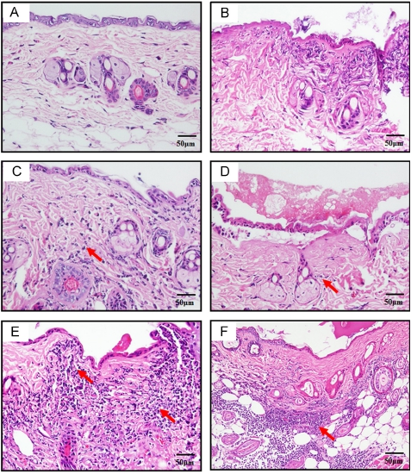

Fig. 5. The mRNA expression of vegf, iNOS, and IL-6 at 24 h after skin ﬂap surgery in normal skin/PG, surgical skin ﬂap/PG, surgical skin ﬂap/ S-AC, surgical skin ﬂap/ W-AC,
surgical skin ﬂap/H-ST1, and surgical skin ﬂap/L-ST1. (A) The vegf, iNOS, IL-6 and β-actin mRNA expressions in different treated groups were analyzed by RT-PCR. (B) The
quantiﬁcation data of vegf, iNOS and IL-6 mRNA levels were normalized against an internal control of β-actin. Data were presented as Mean 7 SE (n ¼ 6). Bars with the
different superscript letters in the same assayed gene represent a signiﬁcant difference (p o 0.05).

many studies (Yan et al., 1995). Previous studies showed that NF-
κB is considered to play a key role in the production of inﬂam-
matory mediators, activating the transcriptions of inﬂammatory
enzymes, including iNOS (Baldwin, 1996). Shen et al. (2004)
showed that extracts of Antrodia camphorata mycelia have an
anti-inﬂammatory effect by suppressing ROS production. Rao
et al. (2007) further demonstrated that extracts of the Antrodia
camphorata fruiting body inhibit the expression of NO, TNF-α, and
IL-12.
Previous studies demonstrated that extracts from the Antrodia
camphorata fruiting body have anti-inﬂammatory effects, which
might result in the inhibition of iNOS, COX-2, TNF-α, NO, IL-12, and
IL-6 (Liu et al., 2007; Wu et al., 2007b; Park and Park, 2013). Our
study proved that Antrodia camphorata could reduce the inﬂamma-
tory reaction by inhibiting the NF-κB pathway in ischemic skin
damage. Treatment with either the solid-state-cultured AC or wood-
cultured AC signiﬁcantly reduced the inﬂammatory response by
decreasing the expression of inﬂammation-related genes such as
iNOS, IL-6, NF-κB, and TNF-α in the skin ischemia model.
ST1, an active and major phytochemical from Antrodia camphor-
ata, was evaluated regarding its analgesic and anti-inﬂammatory
effects. ST1 decreased the nitric oxide levels in paw edema and in
serum at 5 h after Carr injection and had a dose-dependent effect
from 1 to 10 mg/kg. In addition, ST1 reduced the expression of the

serum tumor necrosis factor alpha (TNF-α) at 5 h after Carr injection,
except in the 1 mg/kg ST1 group (Huang et al., 2010). In this study,
inﬂammatory factors showed lower expression in response to
Antrodia camphorata treatment, but exhibited no obvious differences
in the ST1-treated groups. The result may be due to the dose of ST1
being lower (2–4 mg/kg, which is equivalent to a dose of 0.162–
0.32 mg/kg in humans) (Reagan-Shaw et al., 2008) than solid-state-
cultured AC and wood-cultured AC (300 mg/kg; 24.4 mg/kg equiva-
lent in humans). However, ST1 still tend to decrease the expression of
vegf and iNOS at the transcriptional level. The anti-inﬂammatory
mechanisms of ST1 might be related to the decrease in the level of
MDA, iNOS, and COX-2 in the edema through the suppression of TNF-
α and NO (Wen et al., 2011).
In this study, we ﬁrmly established skin ischemia by skin ﬂap
surgery. We also proved, by reducing iNOS, IL-6, NF-κB, and TNF-α
expression, that Antrodia camphorata, as well as its active component,
ST1, has protective anti-inﬂammatory properties. Therefore, these
products from Antrodia camphorata could be proposed to protect the
skin against a skin-ﬂap-surgery-induced inﬂammatory reaction.

Notes

The authors declare no competing ﬁnancial interest.
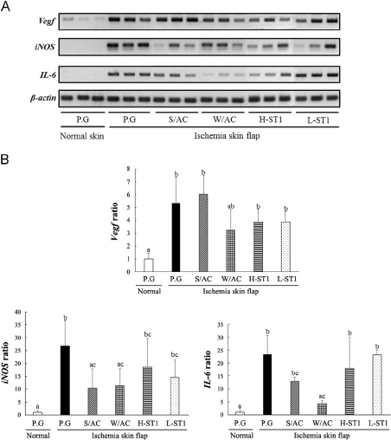

Chen, J.Y., Chen, H.L., Cheng, J.C., Lin, H.J., Tung, Y.T., Lin, C.F., 2012. A Chinese herbal
medicine, Gexia-Zhuyu Tang (GZT), prevents dimethylnitrosamine -induced
liver ﬁbrosis through inhibition of hepatic stellate cells proliferation. Journal of
Ethnopharmacology 142, 811–818.
Geethangili, M., Tzeng, Y.M., 2011. Review of pharmacological effects of Antrodia
camphorata and its bioactive compounds. Evidence-Based Complementary and
Alternative Medicine 2011, 212641.
Hseu, Y.C., Huang, H.C., Hsiang, C.Y., 2010. Antrodia camphorata suppresses
lipopolysaccharide-induced nuclear factor-κB activation in transgenic mice
evaluated by bioluminescence imaging. Food and Chemical Toxicology 48,
2319–2325.
Hsiao, G., Shen, M.Y., Lin, K.H., Lan, M.H., Wu, L.Y., Chou, D.S., Lin, C.H., Su, C.H.,
Sheu, J.R., 2003. Antioxidative and hepatoprotective effects of Antrodia cam-
phorata extract. Journal of Agricultural Food Chemistry 51, 3302–3308.
Huang, G.J., Huang, S.S., Lin, S.S., Shao, Y.Y., Chen, C.C., Hou, W.C., Kuo, Y.H., 2010.
Analgesic effects and the mechanisms of anti-inﬂammation of ergostatrien -3β-
ol from Antrodia camphorata submerged whole broth in mice. Journal of
Agricultural Food Chemistry 58, 7445–7452.
Liu, D.Z., Liang, H.J., Chen, C.H., Su, C.H., Lee, T.H., Huang, C.T., Hou, W.C., Lin, S.Y.,
Zhong, W.B., Lin, P.J., Hung, L.F., Liang, Y.C., 2007. Comparative anti-
inﬂammatory characterization of wild fruiting body, liquid-state fermentation,
and solid-state culture of Taiwanofungus camphoratus in microglia and the
mechanism of its action. Journal of Ethnopharmacology 113, 45–53.
Liu, F., McCullough, L.D., 2013. Inﬂammatory responses in hypoxic ischemic
encephalopathy. Acta Pharmacologica Sinica 34, 1121–1130.
Meng, L.M., Pai, M.H., Liu, J.J., Yeh, S.L., 2012. Polysaccharides from extracts of
Antrodia camphorata mycelia and fruiting bodies modulate inﬂammatory
mediator expression in mice with polymicrobial sepsis. Nutrition 28, 942–949.
Murdoch, C., Muthana, M., Lewis, C.E., 2005. Hypoxia regulates macrophage
functions in inﬂammation. Journal of Immunology 175, 6257–6263.
Park, D.K., Park, H.J., 2013. Ethanol extract of Antrodia camphorata grown on
germinated brown rice suppresses inﬂammatory responses in mice with acute
DSS-induced colitis. Evidence-Based Complementary and Alternative Medicine
2013, 914524.
Peng, C.C., Chen, K.C., Peng, R.Y., Chyau, C.C., Su, C.H., Hsieh-Li, H.M., 2007. Antrodia
camphorata extract induces replicative senescence in superﬁcial TCC, and
inhibits the absolute migration capability in invasive bladder carcinoma cells.
Journal of Ethnopharmacology 109, 93–103.
Piot, C., Croisille, P., Staat, P., Thibault, H., Rioufol, G., Mewton, N., Elbelghiti, R.,
Cung, T.T., Bonnefoy, E., Angoulvant, D., Macia, C., Raczka, F., Sportouch, C.,
Gahide, G., Finet, G., André-Fouët, X., Revel, D., Kirkorian, G., Monassier, J.P.,
Derumeaux, G., Ovize, M., 2008. Effect of cyclosporine on reperfusion injury in
acute myocardial infarction. New England Journal of Medicine 359, 473–481.
Rao, Y.K., Fang, S.H., Tzeng, Y.M., 2007. Evaluation of the anti-inﬂammatory and
antiproliferation tumoral cells activities of Antrodia camphorata, Cordyceps
sinensis, and Cinnamomum osmophloeum bark extracts. Journal of Ethnophar-

Fig. 6. The protein expression levels of IκB, NF-κB, iNOS, COX2, IL-6, TNF-α, and
VEGF at 24 h after skin ﬂap surgery in surgical skin ﬂap/PG, surgical skin ﬂap/ S-AC,
surgical skin ﬂap/ W-AC, surgical skin ﬂap/H-ST1, and surgical skin ﬂap/L-ST1.
(A) The IκB, NF-κB, iNOS, COX2, IL-6, TNF-α, VEGF and β-actin protein expressions
in different treated groups were analyzed by Western blots. (B) The quantiﬁcation
data of IκB, NF-κB, iNOS, COX2, IL-6, TNF-α and VEGF protein levels were
normalized against an internal control of β-actin. Data were presented as
Mean 7 SE (n ¼ 6). Bars with the different superscript letters in the same assayed
protein represent a signiﬁcant difference (p o 0.05).

Acknowledgments

This research was supported in part by Grants NSC-101-2313-B-
005-014-MY3 and MOST-103-2321-B-005-022 from the National
Science Council, Taiwan, and by Grant ATU-103-S0508 from the
Ministry of Education, Taiwan, under the Aiming for the Top
University (ATU) plan.

Appendix A. Supporting information

Supplementary data associated with this article can be found in
the online version at ttp://dx.doi.org/10.1016/j.jep.2014.11.015.

References

Baldwin Jr., AS., 1996. The NF-kappa B and I kappa B proteins: new discoveries and
insights. Annual Review of Immunology 14, 649–683.
Chang, Y.T., Chen, C.M., Tu, M.Y., Chen, H.L., Chang, S.Y., Tsai, T.C., Wang, Y.T.,
Hsiao, H.L., 2011. Effects of osteoporosis and nutrition supplements on
structures and nanomechanical properties of bone tissue. Journal of the
Mechanical Behavior of Biomedical Materials 4, 1412–1420.
macology 114, 78–85.
Reagan-Shaw, S., Nihal, M., Ahmad, N., 2008. Dose translation from animal to
human studies revisited. FASEB Journal 22, 659–661.
Roy, S., Khanna, S., Rink, C., Biswas, S., Sen, C.K., 2008. Characterization of the acute
temporal changes in excisional murine cutaneous wound inﬂammation by
screening of the wound-edge transcriptome. Physiological Genomics 34,
162–184.
Shao, Y.Y., Chen, C.C., Wang, H.Y., Chiu, H.L., Hseu, T.H., Kuo, Y.H., 2008. Chemical
constituents of Antrodia camphorata submerged whole broth. Natural Product
Research 22, 1151–1157.
Shen, Y.C., Wang, Y.H., Chou, Y.C., Chen, C.F., Lin, L.C., Chang, T.T., 2004. Evaluation of
the anti-inﬂammatory activity of zhankuic acids isolated from the fruiting
bodies of Antrodia camphorata. Planta Medica 70, 310–314.
Siemionow, M., Arslan, E., 2004. Ischemia/reperfusion injury: a review in relation to
free tissue transfers. Microsurgery 24, 468–475.
Tamas, R., Nemeth, N., Brath, E., Sasvari, M., Nyakas, C., Debreczeni, B., Miko, I.,
Furka, I., 2010. Hemorheological, morphological, and oxidative changes during
ischemia-reperfusion of latissimus dorsi muscle ﬂaps in a canine model.
Microsurgery 30, 282–288.
Toutain, C.E., Brouchet, L., Raymond, L.I., Vicendo, P., Bergès, H., Favre, J., Fouque,
M.J., Krust, A., Schmitt, A.M., Chambon, P., Gourdy, P., Arnal, J.F., Lenfant, F.,
2008. Prevention of skin ﬂap necrosis by estradiol involves reperfusion of a
protected vascular network. Circulation Research 104, 245–254.
Tsai, S.W., Tung, Y.T., Chen, H.L., Shen, C.J., Chuang, C.H., Tang, T.Y., Chen, C.M., 2013.
Treadmill running upregulates the expression of acetylcholine receptor in rat
gastrocnemius following Botulinum toxin A injection. Journal of Orthopaedic
Research 31, 125–131.
Tsai, T.C., Lin, W., Yang, S.H., Cheng, W.T., Cheng, E.H., Lee, M.S., Chong, K.Y., Chen, C.M.,
2010. Granzyme G is expressed in the two-cell stage mouse embryo and is required
for the maternal-zygotic transition. BMC Developmental Biology 10, 88.
Tung, Y.T., Chen, H.L., Lai, C.W., Shen, C.J., Lai, Y.W., Chen, C.M., 2011. Curcumin
reduces pulmonary tumorigenesis in vascular endothelial growth factor
(VEGF)-overexpressing transgenic mice. Molecular Nutrition & Food Research
55, 1036–1043.
Tung, Y.T., Chen, H.L., Lee, C.Y., Chou, Y.C., Lee, P.Y., Tsai, H.C., Yen, C.C., Lin, Y.L., Chen, C.M.,
2013a. Active component of Danshen (Salvia miltiorrhiza Bunge), Tanshinone I,
attenuates lung tumorigenesis via inhibitions of VEGF, cyclin A and cyclin B
expression. Evidence-Based Complementary and Alternative Medicine 2013,
319247.
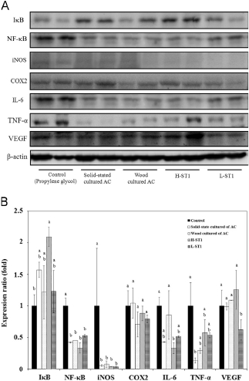

Tung, Y.T., Tsai, T.C., Kuo, Y.H., Yen, C.C., Sun, J.Y., Chang, W.H., Chen, H.L., Chen, C.M.,
2014. Comparison of solid-state-cultured and wood-cultured Antrodia cam-
phorata in anti-inﬂammatory effects using NF-κB/luciferase inducible trans-
genic mice. Phytomedicine 21, 1708–1716.
Tung, Y.T., Yen, C.C., Chen, H.L., Lee, P.Y., Tsai, H.C., Lin, M.F., Chen, C.M., 2013b.
Bovine lactoferrin inhibits lung cancer growth through suppression of inﬂam-
mation and VEGF expression. Journal of Dairy Science 96, 2095–2106.
Shackelford, C., Long, G., Wolf, J., Okerberg, C., Herbert, R., 2002. Qualitative and
quantitative analysis of nonneoplastic lesions in toxicology studies. Toxicologic
Pathology 30, 93–96.
Wang, W.Z., 2009. Investigation of reperfusion injury and ischemic preconditioning
in microsurgery. Microsurgery 29, 72–79.
Wu, S.C., Chen, H.L., Yen, C.C., Kuo, M.F., Yang, T.S., Wang, S.R., 2007a. Recombinant
porcine lactoferrin expressed in the milk of transgenic mice enhances offspring
growth performance. Journal of Agricultural Food Chemistry 55, 4670–4677.

Wu, Y.Y., Chen, C.C., Chyau, C.C., Chung, S.Y., Liu, Y.W., 2007b. Inﬂamamtion and
immunopharamcology modulation of inﬂammation-related genes of polysac-
charides fractionated from mycelia of medicinal basidiomycete Antrodia cam-
phorate. Acta Pharmacologica Sinica 28, 258–267.
Yan, S.F., Tritto, I., Pinsky, D., Liao, H., Huang, J., Fuller, G., Brett, J., May, L., Stern, D.,
1995. Induction of interleukin 6 (IL-6) by hypoxia in vascular cells. Journal of
Biological Chemistry 270, 11463–11471.
Wen, C.L., Chang, C.C., Huang, S.S., Kuo, C.L., Hsu, S.L., Deng, J.S., Huang, G.J., 2011.
Anti-inﬂammatory effects of methanol extract of Antrodia cinnamomea mycelia
both in vitro and in vivo. Journal of Ethnopharmacology 137, 575–584.
Xue, Q., Patterson, A.J., Xiao, D., Zhang, L., 2014. Glucocorticoid modulates
angiotensin II receptor expression patterns and protects the heart from
ischemia and reperfusion injury. PLoS One 9, e106827.

