BON-10553; No. of pages: 9; 4C:
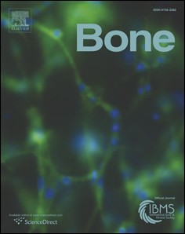
1
Original Full Length Article
Bone xxx (2014) xx
xx
Contents lists available at
ScienceDirec
Bone
journal homepage:
www.elsevier.com/locate/bon
- MicroRNA-20a regulates autophagy related protein-ATG16L1 in
- hypoxia-induced osteoclast differentiation
Q5₄Q4 Kuo-Ting Sun ^{a,b,c}, Michael Y.C. Chen ^{c,d}, Ming-Gene Tu ^{c}, I-Kuan Wang ^{a,e}, Shih-Sheng Chang ^{a,f}, Chi-Yuan Li ^{a,g,}⁎
- ª Graduate Institute of Clinical Medical Science, China Medical University, No. 91 Hsueh-Shih Rd., Taichung, Taiwan
- ^{b} Department of Pediatric Dentistry, China Medical University Hospital, No. 2 Yu-Der Rd., Taichung, Taiwan
- ^{c} School of Dentistry, China Medical University, No. 91 Hsueh-Shih Rd., Taichung, Taiwan
- ^{d} Department of Oral & Maxillofacial Surgeon, China Medical University Hospital, No. 2 Yu-Der Rd., Taichung, Taiwan
- ^{e} Division of Nephrology, Department of medicine, China Medical University Hospital, No. 2 Yu-Der Rd., Taichung, Taiwan
- ^{f} Division of Cardiology, Department of medicine, China Medical University Hospital, No. 2 Yu-Der Rd., Taichung, Taiwan
- ^{g} Department of Anesthesiology, China Medical University Hospital, No. 2 Yu-Der Rd., Taichung, Taiwan
1 2 a r t i c l e i n f o a b s t r a c t
- Article history: Autophagy and autophagy-related proteins (ATGs) play decisive roles in osteoclast differentiation. Emerging 27
- ^{Received 8 October 2014} lines of evidence show the deregulation of miRNA in autophagic responses. However, the role of hypoxia and in- Q728
- ^{Revised 25 November 2014} volvement of miRNA in osteoclast differentiation are unclear. In the present study, we demonstrate that hypoxia 29 16 Accepted 29 November 2014 caused induction of autophagy and osteoclast differentiation markers in RAW264.7 cells stimulated with M-CSF 30
17 Available online xxxx and RANKL. In addition, miR-20a was significantly repressed during hypoxia and identified as the prime candi- 31
18
- _{Edited by Hong-Hee Kim} date involved in hypoxia-induced osteoclast differentiation. The results from dual luciferase reporter assay re- 32 vealed that miR-20a directly targets Atg16l1 by binding to its 3′UTR end. Further, miR-20a transfection studies 33
- Keywords: showed significant down regulation of autophagic proteins (LC3-II and ATG16L1) and osteoclast differentiation 34
- Osteoclast markers (Nfatc1, Traf6, and Trap) thus confirming the functional role of miR-20a under hypoxic conditions. Re- 35
- Autophagy sults of chromatin immunoprecipitation assay showed that HIF-1α binds to miRNA-20a. From miRNA Q-PCR re- 36
- ^{Hypoxia} sults, we confirmed that shRNA HIF-1α knockdown significantly downregulated both autophagy (LC3, p62, Atg5, 37
- ^{HIF-1α} Atg12, Atg16l1, Atg7, Becn1, Atg9a) and osteoclast markers (Traf6, Nfatc1, Ctsk, cFos, Mmp9, Trap) in RAW264.7 38 microRNAs findings suggest that the regulatory axis of HIF-1α-miRNA-20a-Atg16l1 might be a critical mech- 25
- cells. Thus, our
Periodontal disease 26
- anism for hypoxia-induced osteoclast differentiation.
- © 2014 Published by Elsevier Inc.
4523
44
46 1. Introduction autophagosome formation [3]. Studies confirm that deletion of autoph- 61 agic proteins such as ATG5 and ATG7 was found to impair the ruffled 62 47 Bone homeostasis is a dynamic process involving a delicate balance border of osteoclasts and reduce osteoclastic bone resorption [4]. Au- 63
UNCORRECTED PROOF
- between formation and resorption. The osteoclasts and osteoblasts are tophagy and ATGs play a critical role in osteoclast differentiation. 64
- the major cells involved in bone remodeling [1]. However, when this Thus, regulation of osteoclast differentiation can be achieved by 65
- balance shifts towards increased osteoclast activity, it ultimately results targeting autophagy. So, it is important to understand these intriguing 66
- in bone loss leading to bone-related inflammatory diseases such as peri- mechanisms to develop potential strategies against bone-related in- 67
- odontal disease, rheumatoid arthritis and osteoporosis [2]. Bone- flammatory diseases. 68
- resorbing osteoclasts are multinuclear giant cells, which are derived MiRNAs are a novel class of small, single-stranded non-coding RNAs 69
- from hematopoietic cells of the monocyte/macrophage lineage in the that post-transcriptionally regulate gene expression via mRNA degrada- 70
- presence of RANKL (receptor activator of NF-kB ligand) and M-CSF tion or translational inhibition of protein synthesis. Recent studies sug- 71
- (macrophage colony stimulating factor) [1]. Initiation and progression gested that miRNAs participated in osteoclast differentiation [5]. MiR- 72
- of osteoclast differentiation of hematopoietic cells are manipulated 223 is highly expressed in rheumatoid arthritis synovium, and over ex- 73
- by genetic and epigenetic mechanisms. Autophagy is the principal pression of miR-223 could suppress osteoclastogenesis [6]. MiR-503 74
- catabolism for degradation of dysfunctional cellular components. was shown to inhibit receptor activator of RANKL-induced osteoclasto- 75
- The autophagy-related proteins (ATGs) are known to engage in genesis in CD14(+) peripheral blood mononuclear cells [7]. MiR-124 76 regulates proliferation and motility of osteoclast precursor macro- 77 phages by suppressing nuclear factor of activated T-cells, cytoplasmic, 78
⁎ Corresponding author at: Graduate Institute of Clinical Medical Science, China Medical
Q6 University, No. 91 Hsueh-Shih Rd., Taichung, Taiwan. Fax: +886 4 22333710. calcineurin-dependent 1 (NFATc1) expression [8]. MiR-21, -29b, -146a 79
E-mail address: cyli168@gmail.com (C.-Y. Li). and -210 all were proved to participate in the differentiation of 80
http://dx.doi.org/10.1016/j.bone.2014.11.026 8756-3282/© 2014 Published by Elsevier Inc.
81 RAW264.7 cells to osteoclast-like cells after treatment with TNF-α/ for 6 days. Cells (1 × 10⁵) were seeded onto 10-cm² dishes for western 139 82 RANKL [9]. Taken together, miRNAs are involved in regulation of osteo- blot, real-time PCR analysis, reporter gene assay and mimic transfection. 140 83 clast differentiation.
84 Hypoxia acts as a stimulator of osteoclast formation and bone re- 2.4. TRAP (Tartrate Resistant Acid Phosphatase) staining 141 85 sorption [10,11]. Autophagy and ATGs may mediate osteoclast differen-
- tiation induced by hypoxia through hypoxia-inducible factor 1-alpha Important characteristic feature and markers for the identification of 142
- (HIF-1α)/BCL2/adenovirus E1B 19kd-interacting protein 3 (BNIP3) OC differentiation include TRAP expression and the presence of multi- 143
- pathway [12]. More recent research shows miRNA as key regulators in nucleus [12]. Briefly, after respective treatment schedule, the cells 144
- autophagy [13,14]. However, the role of miRNAs on autophagy during were treated with TrypLE™ and fixed with 3.8% paraformaldehyde for 145
- hypoxia and its subsequent impact on hypoxia-induced osteoclast 10 min followed by ethanol/acetone (1:1) fixation for 1 min. Post- 146
- differentiation has not been explored. The present study was de- fixation, the cells were stained with TRAP staining solution for 1 h at 147
- signed to investigate whether and how miRNAs serve an important 37 °C and observed under a NIKONT100 inverted contrasting micro- 148 93 role in autophagy mediating osteoclast differentiation under hypox- scope. TRAP positive cells with more than 3 nuclei were counted as ma- 149
- ia circumstances. ture osteoclasts. 5 random fields were selected and counted for mature 150 osteoclasts and their average is represented as OCs/field. 151
- 2. Materials and methods
2.5. Prediction of miRNA target genes 152
- 2.1. Reagents
The miRWalk database was used to predict the binding site on the 3′ 153
- Recombinant human soluble RANKL and M-CSF were purchased UTR of Atg16l1 gene; this database combines several bioinformatic plat- 154
- from PeproTech (Rocky Hill, NJ). Dharmacon miR-20a miRNAmimics, forms including TargetScan 4.2 (http://targetscan.org), miRBase, 155
- anti-miR-20a miRNA inhibitors (AntagomiR) and Scramble were pur- RNA22, DIANA-mT, miRDB, PICTAR5, PITA, and miRanda. 156 100 chased from Dharmacon (Denver, CO). Roche UPL microRNA assay for
101 mmu-mir-20a, miRNA reverse transcription kit and universal PCR mas- 2.6. Construction of miRNAs and reporter vectors 157 102 ter mix was purchased from Roche (Welwyn Garden City, UK).
- TrypLE™, Lipofectamine 2000 transfection reagents were from Life miRNAs and reporter gene construction was performed as described 158
- Technologies (Carlsbad, CA). ChIP assay kit was purchased from previously [15,16]. Genomic fragments of miR-20a precursors were am- 159
- Millipore (Darmstadt, Germany). IgG or anti-HIF-1α antibody from plified by PCR using mouse genomic DNA as a template (the PCR 160
- Novus Biologicals (Southpark Way, USA). pmirGLO luciferase vector primers are listed as Supplementary data—Table 1). The PCR products 161
- from Promega (Madison, WI). Trizol Reagent, random hexamer primers, were cloned into the pLAS2-RFP vector at restriction sites NotI and 162
- First Strand Buffer, RNaseOUT, dithiothreitol, MMLV Reverse Transcrip- XhoI. RAW264.7 cells were virally infected with the miRNAs, the ex- 163
- tase, FITC and HRP-conjugated goat anti-rabbit IgG from Invitrogen pressions of which were then detected with the aid of quantitative 164
- (Carlsbad, CA). Primary antibodies against LC3 (NB100-2220), PCR (Q-PCR) (ABI Step-One Plus). The binding site for miR-20a in the 165
- ATG16L1 (NB110-60928), p62 (NBP1-48320SS) and ATG5 (NBP110- target genes and the entire Atg16l1 3′UTR sequence was cloned into 166
- 87318) were procured from Novus Biologicals (Southpark Way, USA). the pmirGLO luciferase vector at restriction sites PmeI and XhoI. Muta- 167
- Anti β-actin (AC-74) antibody was from Sigma (St. Louis, MO). All tion constructs were performed as described previously [17]. The mu- 168
- other chemicals were purchased from Sigma (St. Louis, MO). tant constructs of the Atg16l1 3′UTR were generated by a pair of 169 primers containing the mutant sequence. 170
UNCORRECTED PROOF
- 2.2. Cell culture and treatments
2.7. Reverse transcription of RNA and Q-PCR 171
- RAW264.7 mouse macrophage cells were purchased from American
- Type Culture Collection (ATCC-TIB71). The cells were grown in Total RNA was extracted from the RAW264.7 cells with Trizol Re- 172
- Dulbecco's modified eagle's medium (Gibco, Invitrogen) supplemented agent (Invitrogen) according to the manufacturer's instructions, and 173
- with 10% fetal bovine serum (FBS) and 1% penicillin/streptomycin. Cells the RNA concentration was determined using a NanoDrop 2000 spec- 174
- were used at 5 to 10 passages. Cells were seeded 24 h before the treat- trophotometer (Thermo Scientific Waltham, MA,). For reverse tran- 175
- ment. Cells in α-minimal essential medium supplemented with 10% FBS scription of RNA to first-strand cDNA, 1 μg of RNA was diluted in 176
- and 1% penicillin/streptomycin were exposed to normoxia (20% O₂) or 10 ml of ultrapure water (free of DNase and RNase); 1 μl of 50 mM ran- 177
- hypoxia (0.3% O₂) in the presence of 100 ng/ml RANKL and 20 ng/ml dom hexamer primers was added. The solution was denatured at 65 °C 178
- M-CSF for 24 h and were used for determination of autophagy and oste- for 5 min and 4 °C for 1 min, followed by the addition of 4 μl of 5× First 179
125Q8 oclast differentiation markers. For miR-20a mimic hypoxia study, cells Strand Buffer, 1 μl of 10 mM dNTP, 1 μl of RNaseOUT, 2 μl of 0.1 M dithio- 180
- were transfected with control or miR-20a mimic or antagomiR for threitol, and 1 ml of MMLV Reverse Transcriptase. The mixture was in- 181
- 24 h. Followed by which the cells were trypsinized, plated and allowed cubated at different temperatures and time points sequentially (25 °C, 182
- to settle for 4 h. Cells were then subjected to hypoxic treatment for 24 h 10 min; 45 °C, 60 min; 75 °C, 5 min). 183
- and after refreshing, osteoclast differentiation medium was added and
- exposed to normoxic conditions for 6 days. After the complete treat- 2.8. Western blot analysis 184
- ment schedule, cells were lysed and used for further analysis.
Cell lysis was performed using lysis buffer (Thermo Scientific, 185
- 2.3. Osteoclast differentiation Waltham, MA). Samples with equal protein concentration were subject- 186 ed to SDS-PAGE and transferred to a PVDF membrane (PerkinElmer, Life 187 133 Cells were seeded 24 h before treatment. RAW264.7 cells were Science). Blots were blocked with 5% skim milk–TBS–Tween 20 for 1 h 188
- grown in α-minimal essential medium supplemented with 10% FBS, at room temperature and probed with primary antibodies (1:500) 189
- 1% penicillin/streptomycin for 7 days under normoxic (20% O₂) condi- against LC3, ATG16L1, ATG5, p62 and β-actin overnight at 4 °C. Followed 190
- tion in the presence of 100 ng/ml RANKL and 20 ng/ml M-CSF. For hyp- by which blots were washed with PBS–Tween 20 and incubated with 191
- oxia, the cells were exposed to hypoxia for 24 h, followed by which horseradish peroxidase-conjugated secondary antibodies (1:1000) for 192
- medium was refreshed and incubated in normoxic (20% O₂) conditions 1 h at room temperature. The blots were washed and incubated in ECL 193
194  195  196  197  198  199  200  201 | solution (Thermo Scientific, Waltham, MA) for 1 min and then exposed by ImageQuant LAS4000 (GE Healthcare).  2.9. Transfection of miRNA mimics  The miRIDIAN miRNA mimics are single-stranded chemically enhanced oligonucleotides that were designed to mimic miRNA overexpression. RAW264.7 cells were transfected with 100 nM of either the miR-20a mimics or scramble mimics using the Lipofectamine 2000 reagent after 24 h, cells were plated for the luciferase reporter assay. | 2.15. Statistical analysis 244  All the experiments were performed as 3 independent experiments 245 in triplicates. The mean and standard deviation were calculated for each 246 of the determined parameters. Error bars represent standard deviation 247 (SD) of a triplicate set of experiments. Statistical analyses were per- 248 formed using unpaired Student's t test and ANOVA. The level of statisti- 249 cal significance was set at P b 0.05 and P b 0.01. 250  3. Results 251
- 2.10. miRNA Q-PCR for target gene validation 3.1. Hypoxia induces autophagy and ATG16L1 during osteoclast 252
differentiation 253
- Real-time PCR analysis was performed as described elsewhere [18].
- Real-time PCR was conducted using universal reverse primer, miRNA- To determine whether autophagy could be induced by hypoxia during 254
- specific forward primers, 2× Master mix and UPL probe-21. osteoclast differentiation, RAW264.7 cells were treated with 100 ng/ml 255
RANKL and 20 ng/ml M-CSF under hypoxia and normoxia conditions. 256
After 7 days of treatment (1 day of hypoxia with subsequent treatment 257
- 2.11. shRNA knockdown by viral infection under normoxia), a marked increase in the number of multinucleated 258 osteoclast-like cells was observed through TRAP staining (Fig. 1A). Fur- 259 207 Human embryonic kidney 293T (HEK293T) cells were cultured as thermore, immunofluorescence staining for LC3 (a major marker of au- 260
- described elsewhere [19]. RAW264.7 cells were infected with lentivirus tophagy) showed increase in LC3 expression under hypoxia but not 261
- expressing shRNA for HIF-1α (TRCN0000232221) in the presence of under normoxia (Fig. 1B). The expression levels of Traf6, an early mark- 262
- 8 μg/ml protamine sulfate for 24 h, followed by puromycin (2 μg/ml; er of osteoclast differentiation increased under hypoxia (Fig. 1C). In ad- 263
- 48 h) selection. shLacZ (TRC0000231726), which targets the LacZ dition, the levels of Nfatc1, Ctsk, cFos and Mmp9 were upregulated in 264
- gene, was used as a control. The knockdown efficiency of HIF-1α was hypoxia compared to normoxia (Fig. 1C). The mRNA expression of 265
- examined using RT-PCR (Biometra T1 thermo cycler). autophagy-related proteins such as LC3, Atg5, Atg12, Atg7 and Atg16l1 266 was upregulated under hypoxic conditions (Fig. 1D). Increased levels 267 of LC3 and ATG16L1 were further confirmed by western blotting 268
- 2.12. Immunostaining (Fig. 1E). These findings suggest that hypoxia could induce osteoclast 269 differentiation and expression of autophagy-related proteins, including 270 215 After the treatment schedule, RAW264.7 cells were fixed in 4% form- ATG16L1 during osteoclast differentiation (Fig. 1). 271 216 aldehyde. Followed by which cells were then washed with PBS, blocked 217 with 1% BSA and stained with primary antibodies against LC3 or
UNCORRECTED PROOF
218 ATG16L1 (1:100) for 60 min and incubated with FITC-conjugated sec- 3.2. Hypoxia reduces miR-20a expression and miR-20a modulates Atg16l1 272 219 ondary antibodies. The nuclei were counter stained with DAPI for
- 30 min. Immunofluorescence of cells was visualized under a Zeiss fluo- Atg16l1 gene is an important player in autophagosome formation. To 273
- rescence microscope with excitation (ex.) and emission (em.) wave- investigate miRNA target of Atg16l1 gene, bioinformatics platform— 274
- length, 488 nm and LP 505 respectively. Images captured were TargetScan 4.2 (http://targetscan.org) was used [20]. From the results 275 223 corrected for background and analyzed for fluorescence intensity seven miRNA candidates were selected: miR-19a-3p, -20a-5p, -93a- 276
- using Zen software (Ziess). 5p, -96-5p, -106b-5p, -130a-3p, and -142-3p. Next, we determined 277 the expression pattern of the 7 candidate miRNAs in RAW264.7 cells 278
- 2.13. Dual-luciferase reporter assay at an early stage (24 h) of commitment to osteoclast-like cells. The ex- 279 pression patterns of candidate miRNAs that may suppress osteoclast dif- 280
- RAW264.7 cells at 50% confluence were seeded in six-well plates ferentiation; we focused on miR-20a, which was down-regulated under 281
- and allowed for 24 h differentiation. Followed by which, co- hypoxia-induced osteoclast differentiation compared to normoxia con- 282
- transfection was performed with miR-20a mimics and Atg16l1 3′UTR re- dition (Fig. 2A). The level of miR-20a in osteoclast differentiation de- 283
- porter vector using Lipo2000; 1 μg of Atg16l1 3′UTR or control vector creased significantly at days 1, 3 and 5 after 24 h hypoxia treatment 284
- and 100 nM miR-20a mimics or scramble mimics per well. Cell extracts (Fig. 2B). In addition, ATG16L1 was up-regulated during hypoxia- 285
- were prepared at 24 h after transfection and luciferase activity was induced osteoclast differentiation as observed through immunofluores- 286
- measured using the Dual-Luciferase Reporter Assay System (Promega, cence (Fig. 2C). All these data suggested that hypoxia could repress miR- 287
- Madison, WI). 20a during osteoclast differentiation. 288
According to the bio-informatics database, we predicted that miR- 289
234  235  236  237  238  239  240  241  242  243 | 20a binding site was at the 3′-untranslated region (UTR) of Atg16l1 290
234  235  236  237  238  239  240  241  242  243 | 2.14. Chromatin immunoprecipitation (ChIP) assay  ChIP was performed according to the manufacturer's instructions (Magna ChIP A/G Chromatin Immunoprecipitation Kit, Millipore, Darmstadt, Germany). Briefly, after the treatment schedule, RAW264.7 cells were fixed with 1% paraformaldehyde and lysed by SDS lysis buffer. The cell lysate was sonicated and protein-DNA complexes were immuno-precipitated with control IgG or anti-HIF-1α antibody. Followed by this, protein/DNA complexes were eluted, reverse cross-linked to free DNA and purified. Q-PCR was performed with primers specific for mouse miR-20a promoter. | (Fig. 2D). To validate whether miR-20a directly binds to 3′UTR of 291 Atg16l1, we constructed a full length of 3′UTR of Atg16l1, which have 292 highly conserved binding site by miR-20a, and subcloned into a pmir- 293 GLO dual luciferase reporter at the 3′ end of firefly luciferase coding se- 294 quence as 3′UTR of Atg16l1 wild-type (WT), and mutated binding se- 295 quence from GCACTTTA to TTGACCC as 3′UTR of Atg16l1 mutant (MT) 296 (Fig. 2E). Luciferase reporter assay showed that transfection of miR- 297  20a mimics significantly repressed the activity in the 3′UTR of 298 Atg16l1-WT compared with 3′UTR of Atg16l1-MT (Fig. 2E). These results 299 confirmed the specificity of the miR-20a modulation to the 3′UTR of 300  Atg16l1. 301
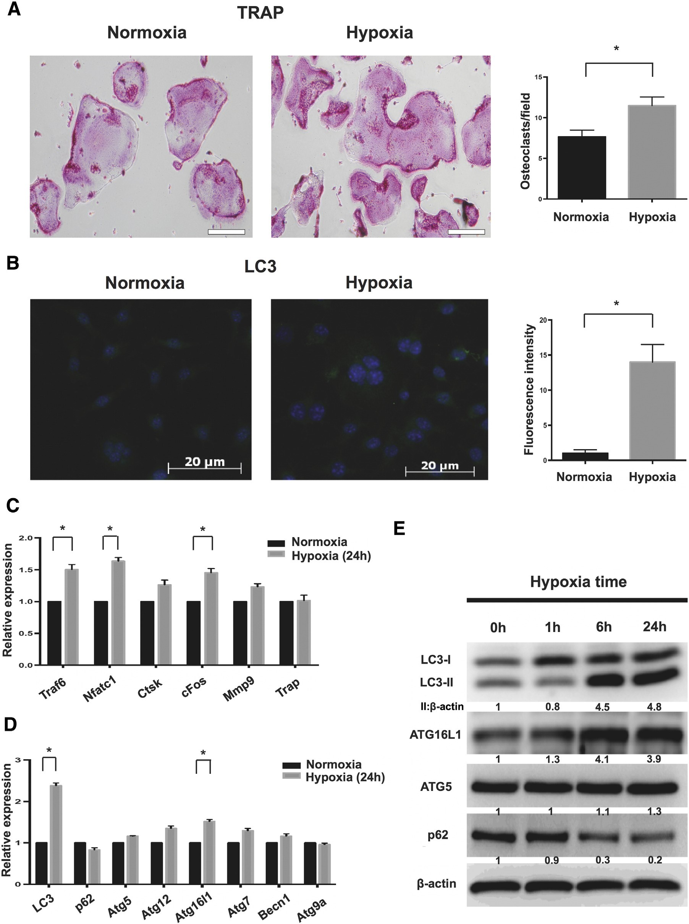
UNCORRECTED PROOF
Fig. 1. Hypoxia increases autophagy during osteoclast differentiation in RAW264.7 cells. (A). RAW264.7 cells cultured in the presence of RANKL and M-CSF (under 0.3% hypoxia for 24 h followed by normoxia for 6 days) showed increase in TRAP-positive multinucleated cells. Data are mean ± SD, representative of three independent experiments performed in triplicates. *P b 0.05 compared to normoxia. Magnification (100×); scale bar = 100 μm. (B). Immunostaining for LC3: Hypoxic treatment (24 h) enhanced the LC3 levels. LC3 protein visualized as green color; whereas the nucleus stained with DAPI appears in blue. *P b 0.05 compared to normoxia. Magnification (200×); scale bar = 20 μm. A representative image obtained from three individual experiments. qRT-PCR results (C) showing enhanced mRNA expression of osteoclast differentiation markers after 24 h hypoxia. (D). Expression of autophagy genes after 24 h hypoxia. The data are shown as the mean ± SD of three independent experiments performed in triplicates. *P b 0.05 compared to normoxia. (E). Hypoxic treatment increases
Q1 autophagic response through regulation of proteins LC3-I, LC3-II, ATG16L1, ATG5 and p62 in a time dependent manner in RAW264.7 cells. The relative protein expressions were determined against β-actin. (For interpretation of the references to color in this figure legend, the reader is referred to the web version of this article.)
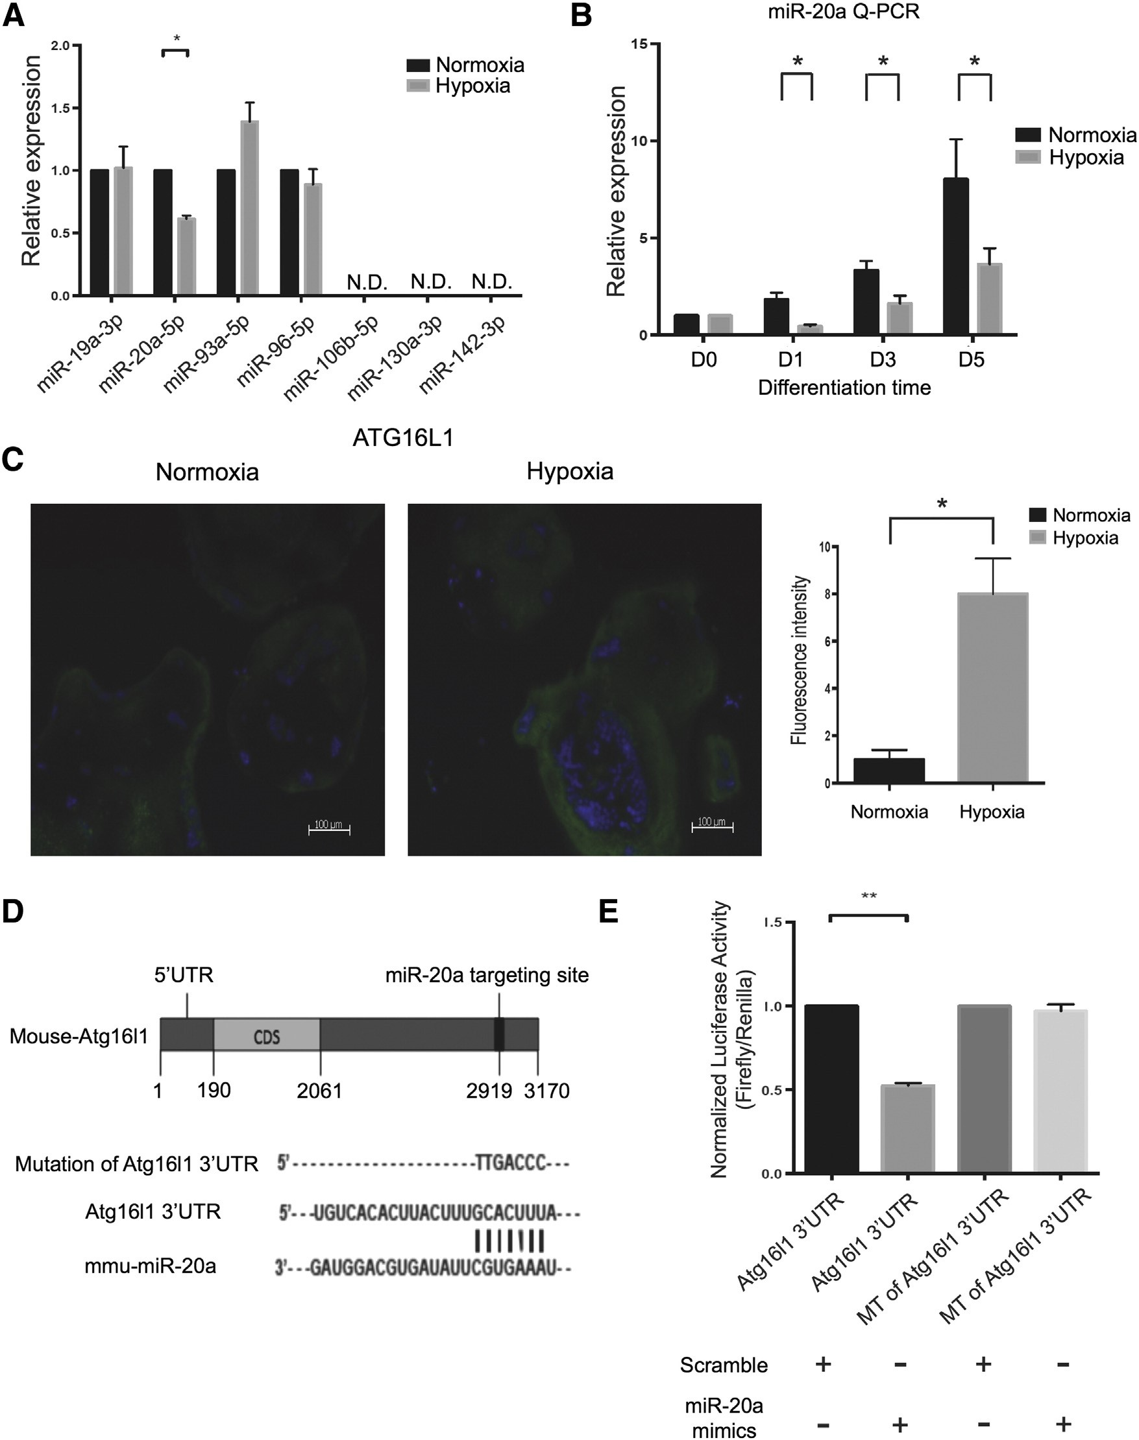
Fig. 2. Atg16l1 is a direct target for miR-20a during osteoclast differentiation under hypoxia. miRNA Q-PCR: (A). 7 candidate miRNAs of RAW264.7 cells post 24 h hypoxia; (B). miRNA-20a
UNCORRECTED PROOF
Q2 at differentiation time (days 0, 1, 3 and 5) post 24 h hypoxia. The data are shown as the mean ± SD of three independent experiments performed in triplicates. *P b 0.05 compared to normoxia. (C). ATG16L1 Immunostaining: RAW264.7 cells were monitored for ATG16L1 levels at day 7 during osteoclast differentiation under hypoxia (24 h). ATG16L1 protein visualized as green color, whereas the nucleus stained with DAPI appears in blue. A representative image obtained from three individual experiments. Magnification (100×); scale bar = 100 μm. *P b 0.05 compared to normoxia. (D). Base pairing comparison between mature miR-20a and wild type or mutant Atg16l1 3′UTR putative target site is shown according to the TargetScan database. (E). Luciferase reporter assay: The Atg16l1 3′UTR luciferase construct vector (1 μg) was co-transfected into RAW264.7 cells with miR-20a mimic (100 nM) or miR-scramble (100 nM). The results show significant repression of the 3′UTR of Atg16l-WT by miR-20a mimics. The data are shown as the mean ± SD of three independent experiments performed in triplicates. **P b 0.01 compared to normoxia. (For interpretation of the references to color in this figure legend, the reader is referred to the web version of this article.)
302  303  304  305 | 3.3. MiR-20a negatively regulates ATG16L1 of autophagy and osteoclast  differentiation  To examine the functional role of the miR-20a in osteoclast differentiation, we ectopically expressed the miR-20a by transfection mimics or | antagomiR and bafilomycin as a control for autophagic flux in 306 RAW264.7 pre-osteoclast cells prior to hypoxia-induced osteoclast dif- 307 ferentiation (Fig. 3A). Consistent with the reporter analysis of 3′UTR of 308 Atg16l1, overexpression of miR-20a significantly reduced lipidation of 309  LC3 (LC3-II isoform) and ATG16L1 protein level by immunoblots 310
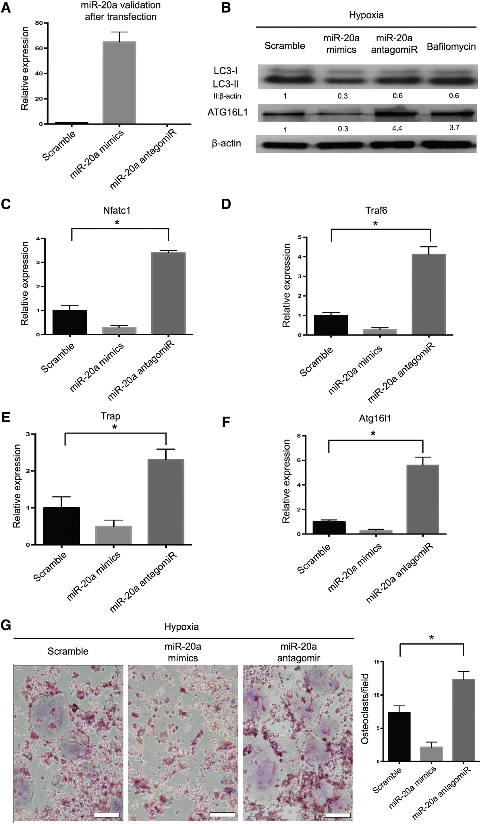
UNCORRECTED PROOF
311319
312
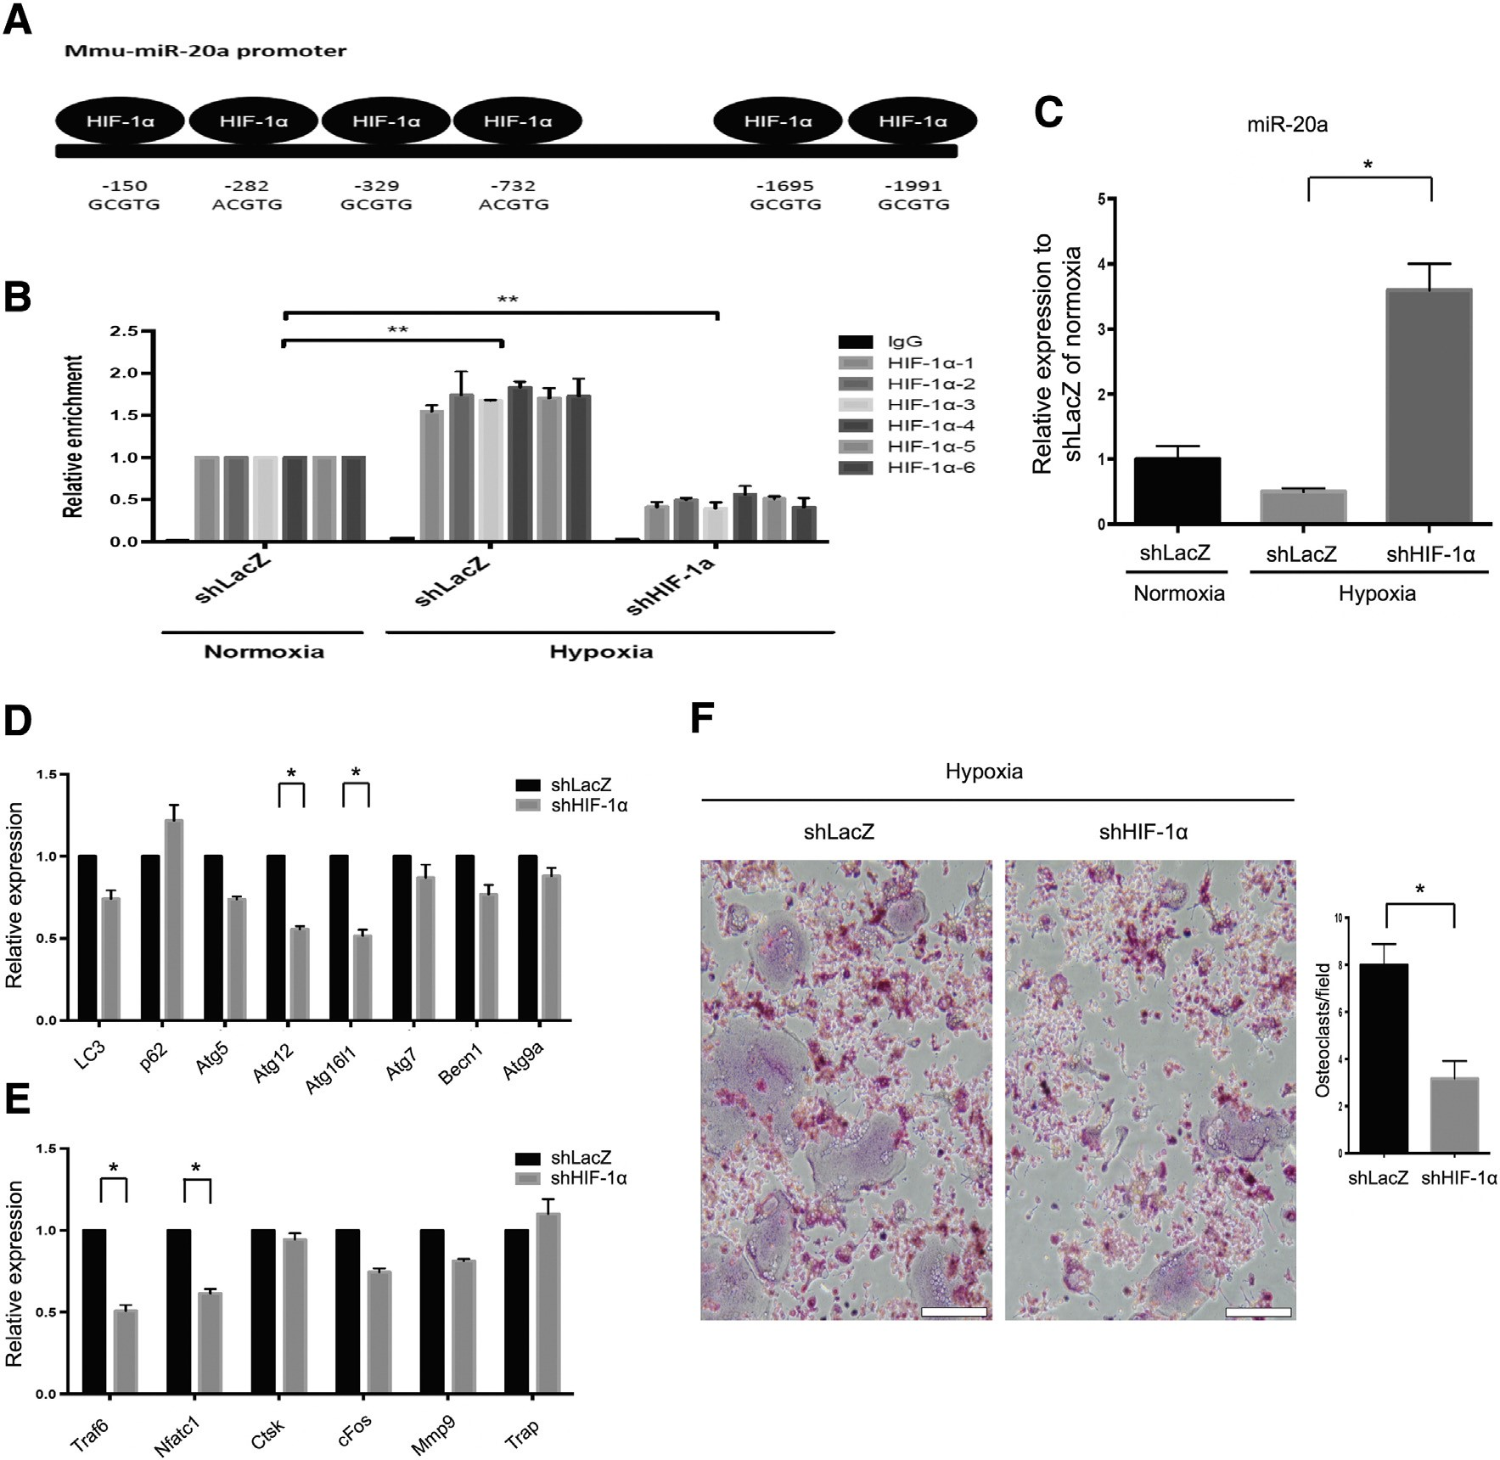
- Hypoxia regulates the expression of many genes via a highly con- 320
UNCORRECTED PROOF
(
Fig. 3
B). Furthermore, the marker genes of osteoclast differentiation
and
Atg16l1
decreased after transfection of miR-20a mimics (
Figs. 3
C,
D, E and F). Consistently, osteoclast formation demonstrated by TRAP
staining was inhibited by miR-20a mimics (
Fig. 3
G). However,
antagomiR-20a would restore the inhibitory effect of miR-20a on oste-
oclast differentiation and formation (
Figs. 3
C, D, E, F and G). Our data
demonstrate that miR-20a reduces autophagy by targeting 3
′
UTR of
Atg16l1
and osteoclast differentiation.
-1
. HIF
3.4
α
suppresses miR-20a under hypoxia
Fig. 4.
HIF-1
α
mediates transcriptional silencing of the miR-20a during hypoxia-induced osteoclast differentiation. (A). HIF-1
α
has six binding sites on mmu-miR-20a promoter region.
-1
B). ChIP assay of RAW264.7 cells treated with shHIF
(
α
showed marked reduction in binding of HIF-1
α
with the miR-20a-5p promoter. The data are shown as the mean ± SD of
three independent experiments performed in triplicates. **
P
b
0.01
compared to normoxia. (C). miR-20a was signi
fi
cantly upregulated in the presence of shHIF-1
α
under 24 h hypoxia,
as determined through miRNA Q-PCR. The data are shown as the mean ± SD of three independent experiments performed in triplicates. *
P
b
0.05
compared to shLacZ under hypoxia.
miRNA Q-PCR of osteoclast progenitor-RAW264.7 cells transduced with lentiviral vectors encoding control shLacZ or shHIF-1
α
.(
D). Inhibition of autophagy as demonstrated through reg
-
ulation of early autophagy markers
—
Lc3
,
P62
,
Atg5
,
Atg12
,
Atg16l1
,
Atg7
,
Becn1
and
Atg9a
E). Downregulation of early osteoclast differentiation markers
(
—
Traf6
,
Nfatc1
,
Ctsk
,
Cfos
,
Mmp9
and
Trap
. The data are shown as the mean ± SD of three independent experiments performed in triplicates. *
P
b
compared to shLacZ. (F). Cells were transduced with lentiviral vectors
0.05
encoding control shLacZ or shHIF-1
α
for 7 day osteoclast differentiation and analyzed for TRAPlevels. Cells with shHIF-1
α
showed TRAP-negative cells. Data are mean ± SD, representative
of three independent experiments performed in triplicates. Magni
fi
cation (100×); scale bar = 100
μ
m. *
P
b
0.05
compared to shLacZ.
- served transcription factor called hypoxia-inducible factor (HIF). To fur- 321
- ther elucidate the role of HIF-1α on miRNA regulation, the binding sites 322
- of HIF-1α located on miR-20a were determined using the Eukaryotic 323
- Promoter Database (http://epd.vital-it.ch/) for upstream positions 324
- of approximately −2000 to +100 bp. HIF-1α has six binding sites 325

Fig. 3. Inhibition of autophagy and osteoclast differentiation by miR-20a. (A) Relative expression of miR-20a in RAW264.7 cells transduced with miR-20a mimics or antagomiR under hypoxia (24 h). The data are shown as the mean ± SD of three independent experiments performed in triplicates. (B) miR-20a downregulates expression of ATG16L1 and, LC3 under hypoxic environment (24 h) as determined by western blot. The relative protein expressions were determined against β-actin. Relative expression of the osteoclast differentiation markers
Q3 (C) Nfatc1, (D) Traf6 and (E) Trap, and (F) autophagy marker Atg16l1 in osteoclast progenitor-RAW264.7 cells transduced with control scramble, miR-20a mimics or antagomiR. The data are shown as the mean ± SD of three independent experiments performed in triplicates. *P b 0.05 compared to scramble. (G) RAW264.7 cells were transduced with control scramble, miR-20a mimics or antagomiR as indicated and allowed to differentiate in the presence of RANKL and M-CSF. After 7 days, cells wereanalyzed for TRAP staining; cells with miR-20a mimics show TRAP-negative cells. Magnification-100×; scale bar = 100 μm. Data are mean ± SD, representative of three independent experiments performed in triplicates. *P b 0.05 compared to miR-20a mimics.
326  327  328  329  330  331  332  333  334  335  336  337 | on the promoter of miR-20a (Fig. 4A). The down-regulated miR-20a in hypoxia could be a direct interaction between HIF-1α and miR20a.  To determine whether miR-20a is directly regulated by HIF-1α, we performed loss-of-function experiments by lentiviral infection, viral vector containing short hairpin sequence knockdown to HIF-1α (shHIF-1α) or LacZ (shLacZ) as control to RAW264.7 cells. In addition, we confirmed transcriptional level binding by ChIP assay with HIF-1α antibody on miR-20a promoter. The binding of HIF-1α was markedly reduced at the miR-20a promoter in the shHIF-1α cells (Fig. 4B) compared to shLacZ cells. Consistently, cellular expression of miR-20a was increased in shHIF-1α cells by miRNA Q-PCR (Fig. 4C). We introduced | degradation of long-lived proteins are severely impaired in ATG16L1- 390 deficient cells [29]. Since, ATG16L1 is crucial for autophagy process, 391 we in the present study attempted to analyze miRNA target under hyp- 392 oxic conditions through in-silico gene prediction method. We observed 393 involvement of 7 candidate miRNAs, of which miR-20a-5p showed sig- 394 nificant suppression under hypoxic conditions. We further confirmed 395 that miR-20a directly targets 3′UTR of Atg16l1 and repressed autophagy 396 by downregulating autophagy-related proteins LC3 and ATG16L1. We 397 next focused on the effect of miR-20a on the expression levels of pro- 398 teins involved in osteoclast differentiation. MiR-20a under hypoxic con- 399 ditions significantly downregulated the levels of Nfatc1, Traf6 and Trap 400 and reduced TRAP positive cells. Taken together, modulation of autoph- 401
- shRNA via lentiviral transduction into macrophage cells RAW264.7, agy and autophagy-related proteins by miRNA is a critical mechanism in 402
- which are enriched for osteoclast progenitors, and then cultured them hypoxia-induced osteoclast differentiation. 403
- in RANKL/M-CSF-containing media to induce ex-vivo osteoclast differ- Studies show that lower O₂ tension alters bone homeostatic mecha- 404
- entiation. Functional analysis was then performed to evaluate 3 hall- nisms, thereby leading to bone loss [30]. Hypoxia-induced osteoclast 405
- marks of osteoclast differentiation: expression of the autophagy bone resorption functions through highly conserved transcription factor 406
- marker (Fig. 4D), expression of the osteoclast differentiation marker called hypoxia-inducible factor (HIF-α). During the normal oxygen ten- 407
- (Fig. 4E) and TRAP staining for mature osteoclast (Fig. 4F). Knockdown sion, HIF-α is rapidly destroyed by prolyl hydroxylase domain enzymes 408
- of HIF-1α significantly impaired autophagy-related proteins expression through proteasomal degradation. However, under hypoxic conditions, 409
- and osteoclast differentiation, as evidenced by a mean 10% to 50% reduc- HIF-1 α stabilizes and transactivates genes involved in adaptive re- 410
- tion in enucleation efficiency relative to scrambled shLacZ (Figs. 4D and sponses [31,32]. Increased osteoclast differentiation and subsequent re- 411
- 4E). Traf6 level and osteoclast differentiation decreased in shHIF-1α line sorption activity were observed under hypoxic conditions [33]. Studies 412
- (Figs. 4E and F). These findings highlight that HIF-1α may suppress demonstrate differential expression of hypoxia regulated miRNAs 413
- miR-20a expression on transcriptional level during hypoxia-induced os- (HRMs) under pathological conditions [34,35]. In the context of osteo- 414
- teoclast differentiation. clast differentiation, Sugatani et al. [21] was first to identify the involve- 415 ment of microRNA (miR-223) in bone metabolism through inhibition of 416
- 4. Discussion osteoclast differentiation in RAW264.7 cells. Recently, Lee et al. [8] have 417 showed that miR-124 suppresses NFATc1 expression and regulates os- 418 353 miRNA profiling of RAW 264.7 cells and monocyte/macrophage pre- teoclastogenesis in bone marrow macrophages. However, there is a 419
UNCORRECTED PROOF
- cursors shows hundreds of miRNA candidates involved in osteoclast dif- lack of clear understanding on the role of hypoxia–miRNA interaction 420
- ferentiation [9,21]. However, the role of hypoxia in enhancing osteoclast in osteoclast differentiation. We in the present study determined that 421
- differentiation through miRNA mediation remains elusive. Here, we HIF-1α has a regulatory role by binding to the promoter of miRNA- 422
- confirmed that the regulatory axis of HIF-1α–miRNA-20a–Atg16l1 is a 20a and represses its activity. Similar to our finding, He et al. showed 423
- critical mechanism in hypoxia-induced osteoclast differentiation. that HIF-1α down-regulates miR-17 and -20a by directly targeting 424
- Hypoxia and inflammatory cytokines are involved in initiation and p21 and STAT3 in myeloid leukemic cell differentiation [36]. We 425
- progression of osteoclast differentiation. Interleukin-1 mediates TNF- showed experimental evidence that there was a significant reduction 426
- induced osteoclastogenesis by enhancing the stromal cell expression in HIF-1α-miRNA-20a binding with concomitant increase in miR-20a 427
- of RANKL [22], while hypoxia enhances osteoclastogenesis via increased levels in the presence of shHIF-1α; thus shows clear evidence of HIF- 428
- RANKL expression in the periodontal ligament of the compressed (hyp- 1α in negative regulation of miRNA-20a. From HIF-1α knockdown 429
- oxic) side [23]. Growth differentiation factor 15, which is secreted from studies, we further confirmed effective down regulation of autopha- 430
- osteocytes, significantly promotes osteoclast differentiation under gy and osteoclast differentiation markers. Thus, these findings con- 431
- hypoxic condition [24]. From the present study, we demonstrated that firm that HIF-1α could modulate miRNA including miR-20a in 432
- hypoxia caused an increase in TRAP-positive cells with significant up- hypoxia-induced osteoclast differentiation. The interaction between 433
- regulation in osteoclast differentiation markers. Further, we also identi- HIF-1α and miRNAs may be an important mechanism in osteoclast 434
- fied that hypoxia caused significant enhancement in autophagy through differentiation. 435
- regulation of autophagy-related proteins in RAW 246.7 cells in the In summary, the present work highlights the role of miR-20a in 436
- presence of RANKL and M-CSF. Previous study conducted by Zhao autophagy-related osteoclast differentiation under hypoxia stress. The 437
- et al. reveals that autophagy regulates hypoxia-induced osteoclast dif- regulatory axis of HIF-1α–miR20a–Atg16l1 might be a critical mecha- 438
- ferentiation through HIF-1α/BNIP3 signaling pathway in RAW264.7 nism for hypoxia-induced osteoclast differentiation. 439
- cells [12]. Thus, induction of autophagy might be an important process Supplementary data to this article can be found online at http://dx. 440
- in osteoclast differentiation under hypoxic condition. doi.org/10.1016/j.bone.2014.11.026. 441
- The vital importance of miRNAs in the modulation of target genes in-
- volved in the autophagy pathway has recently been highlighted [25].
378 | MiR-376b controls autophagy by directly targeting the intracellular
379 | levels of two key autophagy proteins, ATG4C and beclin-1, in the 3′
380  381  382  383  384  385  386  387  388  389 | UTR of their mRNAs [26]. MiR-101 suppresses autophagy by targeting ras-related protein Rab-5A, stathmin 1, and ATG4D in MCF-7 breast cancer cells to sensitize chemotherapy for cell death [27]. Furthermore, miR-21 regulates osteoclastogenesis via down-regulating programmed cell death protein 4 (PDCD4) [21]. Gain and loss of miR-375 function reflect the regulation of ATG7 expression by autophagy under hypoxic conditions [28]. In the present study, we determined the candidate miRNA target for Atg16l1 gene, the complex protein which regulates autophagy. ATG16L1 complex is involved in LC3 lipidation for autophagosome formation. Both autophagosome formation and | This study was supported by Research Laboratory of Pediatrics, 443 Children's Hospital of China Medical University. This study was also 444Q9 supported by China Medical University Hospital (Grant Numbers 445 DMR-102-019), National Science Council (NSC-101-2314-B-039- 446 004-MYB), and Taiwan Department of Health Clinical Trial and Re- 447 search Center for Excellence (Grant Numbers MOHW103-TDU-B- 448  212-113002). 449Q10  450  Conflict of interest 451  None. 452
Acknowledgments 442
- References [19] Chien C-H, Sun Y-M, Chang W-C, Chiang-Hsieh P-Y, Lee T-Y, Tsai W-C, et al. Identi- 502 fying transcriptional start sites of human microRNAs based on high-throughput se- 503
- [1] Rodan GA, Martin TJ. Therapeutic approaches to bone diseases. Science 2000;289: quencing data. Nucleic Acids Res 2011;39:9345–56. 504
- 1508–14. [20] Lewis BP, Shih IH, Jones-Rhoades MW, Bartel DP, Burge CB. Prediction of mammalian 505
- [2] Boyle WJ, Simonet WS, Lacey DL. Osteoclast differentiation and activation. Nature microRNA targets. Cell 2003;115:787–98. 506
- 2003;423:337–42. [21] Sugatani T, Vacher J, Hruska K. A microRNA expression signature of osteoclastogen- 507
- [3] Hocking LJ, Whitehouse C, Helfrich MH. Autophagy: a new player in skeletal main- esis. Blood 2011;117:3648–57. 508 459 tenance? J Bone Miner Res 2012;27:1439–47. [22] Wei S, Kitaura H, Zhou P, Ross FP, Teitelbaum SL. IL-1 mediates TNF-induced osteo- 509
- [4] DeSelm C, Miller B, Zou W, Beatty W, van Meel E, Takahata Y, et al. Autophagy pro- clastogenesis. J Clin Invest 2005;115:282–90. 510
- teins regulate the secretory component of osteoclastic bone resorption. Dev Cell [23] Park HJ, Baek KH, Lee HL, Kwon A, Hwang HR, Qadir AS, et al. Hypoxia inducible 511
- 2011;21:966–74. factor-1alpha directly induces the expression of receptor activator of nuclear 512
- [5] Lian JB, Stein GS, van Wijnen AJ, Stein JL, Hassan MQ, Gaur T, et al. Micro RNA control factor-kappaB ligand in periodontal ligament fibroblasts. Mol Cells 2011;31:573–8. 513
- of bone formation and homeostasis. Nat Rev Endocrinol 2012;8:212–27. [24] Hinoi E, Ochi H, Takarada T, Nakatani E, Iezaki T, Nakajima H, et al. Positive regula- 514
- [6] Shibuya H, Nakasa T, Adachi N, Nagata Y, Ishikawa M, Deie M, et al. Overexpression tion of osteoclastic differentiation by growth differentiation factor 15 upregulated 515 466 of microRNA-223 in rheumatoid arthritis synovium controls osteoclast differentia- in osteocytic cells under hypoxia. J Bone Miner Res 2012;27:938–49. 516
- tion. Mod Rheumatol 2013;23:674–85. [25] Frankel LB, Lund AH. MicroRNA regulation of autophagy. Carcinogenesis 2012;33: 517
- [7] Chen C, Cheng P, Xie H, Zhou HD, Wu XP, Liao EY, et al. MiR-503 regulates osteoclas- 2018–25. 518
- togenesis via targeting RANK. J Bone Miner Res 2014;29:338–47. [26] Korkmaz G, le Sage C, Tekirdag KA, Agami R, Gozuacik D. miR-376b controls starva- 519
- [8] Lee Y, Kim HJ, Park CK, Kim YG, Lee HJ, Kim JY, et al. MicroRNA-124 regulates oste- tion and mTOR inhibition-related autophagy by targeting ATG4C and BECN1. Au- 520 471 oclast differentiation. Bone 2013;56:383–9. tophagy 2012;8:165–76. 521
UNCORRECTED PROOF
472 [9] Kagiya T, Nakamura S. Expression profiling of microRNAs in RAW264.7 cells treated [27] Frankel LB, Wen J, Lees M, Høyer-Hansen M, Farkas T, Krogh A, et al. microRNA-101 522 473 with a combination of tumor necrosis factor alpha and RANKL during osteoclast dif- is a potent inhibitor of autophagy. EMBO J 2011;30:4628–41. 523
- ferentiation. J Periodontal Res 2013;48:373–85. [28] Chang Y, Yan W, He X, Zhang L, Li C, Huang H, et al. miR-375 inhibits autophagy and 524
- [10] Dandajena TC, Ihnat MA, Disch B, Thorpe J, Currier GF. Hypoxia triggers a HIF- reduces viability of hepatocellular carcinoma cells under hypoxic conditions. Gastro- 525
- mediated differentiation of peripheral blood mononuclear cells into osteoclasts. enterology 2012;143:177–87 [e8]. 526
- Orthod Craniofac Res 2012;15:1–9. [29] Saitoh T, Fujita N, Jang MH, Uematsu S, Yang BG, Satoh T, et al. Loss of the autophagy 527
- [11] Utting JC, Flanagan AM, Brandao-Burch A, Orriss IR, Arnett TR. Hypoxia stimulates protein Atg16L1 enhances endotoxin-induced IL-1beta production. Nature 2008; 528
- osteoclast formation from human peripheral blood. Cell Biochem Funct 2010;28: 456:264–8. 529
- 374–80. [30] Knowles HJ, Cleton-Jansen AM, Korsching E, Athanasou NA. Hypoxia-inducible factor 530
- [12] Zhao Y, Chen G, Zhang W, Xu N, Zhu JY, Jia J, et al. Autophagy regulates hypoxia- regulates osteoclast-mediated bone resorption: role of angiopoietin-like 4. FASEB J 531
- induced osteoclastogenesis through the HIF-1alpha/BNIP3 signaling pathway. J 2010;24:4648–59. 532
- Cell Physiol 2012;227:639–48. [31] Wang GL, Jiang BH, Semenza GL. Effect of protein kinase and phosphatase inhibitors 533
- [13] Wu H, Wang F, Hu S, Yin C, Li X, Zhao S, et al. MiR-20a and miR-106b negatively reg- on expression of hypoxia-inducible factor 1. Biochem Biophys Res Commun 1995; 534
- ulate autophagy induced by leucine deprivation via suppression of ULK1 expression 216:669–75. 535
- in C2C12 myoblasts. Cell Signal 2012;24:2179–86. [32] Li H, Ko HP, Whitlock JP. Induction of phosphoglycerate kinase 1 gene expression by 536 487 [14] Kovaleva V, Mora R, Park YJ, Plass C, Chiramel AI, Bartenschlager R, et al. miRNA- hypoxia. Roles of Arnt and HIF1alpha. J Biol Chem 1996;271:21262–7. 537
- 130a targets ATG2B and DICER1 to inhibit autophagy and trigger killing of chronic [33] Knowles HJ, Athanasou NA. Acute hypoxia and osteoclast activity: a balance be- 538
- lymphocytic leukemia cells. Cancer Res 2012;72:1763–72. tween enhanced resorption and increased apoptosis. J Pathol 2009;218:256–64. 539
- [15] Chen JF, Mandel EM, Thomson JM, Wu Q, Callis TE, Hammond SM, et al. The role of [34] Crosby ME, Kulshreshtha R, Ivan M, Glazer PM. MicroRNA regulation of DNA repair 540
- microRNA-1 and microRNA-133 in skeletal muscle proliferation and differentiation. gene expression in hypoxic stress. Cancer Res 2009;69:1221–9. 541 492 Nat Genet 2006;38:228–33. [35] Bao B, Azmi AS, Ali S, Ahmad A, Li Y, Banerjee S, et al. The biological kinship of hyp- 542
- [16] Ma L, Young J, Prabhala H, Pan E, Mestdagh P, Muth D, et al. miR-9, a MYC/MYCN- oxia with CSC and EMT and their relationship with deregulated expression of
- activated microRNA, regulates E-cadherin and cancer metastasis. Nat Cell Biol miRNAs and tumor aggressiveness. Biochim Biophys Acta 1826;2012:272–96.
- 2010;12:247–56. [36] He M, Wang QY, Yin QQ, Tang J, Lu Y, Zhou CX, et al. HIF-1alpha downregulates miR-
- [17] Tay Y, Zhang J, Thomson AM, Lim B, Rigoutsos I. MicroRNAs to Nanog, Oct4 and Sox2 17/20a directly targeting p21 and STAT3: a role in myeloid leukemic cell differenti497 coding regions modulate embryonic stem cell differentiation. Nature 2008;455: ation. Cell Death Differ 2013;20:408–18.
- 1124–8.
- [18] Chen PS, Su JL, Cha ST, Tarn WY, Wang MY, Hsu HC, et al. miR-107 promotes tumor 500 progression by targeting the let-7 microRNA in mice and humans. J Clin Invest 2011;
501 121:3442–55.

