Activation of phosphoinositide 3-kinase by the NBS1 DNA repair protein

Yen-Chung Chen§, Hsiu-Yin Chiang§, Muh-Hwa Yang*, Shyue-Yih Chang#, Shu-Chun Teng^, Bart Vanhaesebroeck† and Kou-Juey Wu§¶
From the §Institute of Biochemistry and Molecular Biology, National Yang-Ming University, Taipei 112; *Division of Oncology, Department of Medicine, Taipei Veterans General Hospital, Taipei 112; #Department of Otolaryngology, Taipei Veterans General Hospital, Taipei 112; ^Graduate Institute of Microbiology, College of Medicine, National Taiwan University, Taipei 100, Taiwan; †Ludwig Institute for Cancer Research, 91 Riding House Street, London W1W 7BS, UK

Running title: Activation of PI 3-kinase by a DNA repair protein
¶Address correspondence to: Kou-Juey Wu, Institute of Biochemistry and Molecular Biology, National Yang-Ming University, Taipei 112, Taiwan, Tel: 011886228267328; Fax: 011886228264843; Email:kjwu2@ym.edu.tw

Class IA phosphoinositide 3-kinases (PI 3-kinases) are key signaling components downstream of tyrosine kinases and Ras, regulating many different cellular functions and contributing to tumorigenesis. Class IA PI 3-kinases are heterodimers comprised of a p85 regulatory and a p110 catalytic subunit. Nijmegen breakage syndrome (NBS) is a chromosomal instability syndrome associated with cancer predisposition, radiosensitivity, microcephaly, and growth retardation. The NBS gene product p95 (also known as NBS1) is part of the MRN complex, a central player associated with double-strand break (DSB) repair. We previously demonstrated that NBS1 overexpression induces transformation through activation of PI 3-kinase/Akt. Here we show that NBS1 directly interacts, through a C-terminal domain (a.a. 653-669) of NBS1, with the N-terminal domain (a.a. 1-108) of the p110α catalytic subunit of PI 3-kinase, and stimulates PI 3-kinase activity in vitro. These results demonstrate that NBS1 can function as an adaptor/activator of p110α PI 3-kinase, consistent with its possible role in cell transformation.

Phosphoinositide 3-kinase (PI 3-kinase) is a major signaling component downstream of many receptor tyrosine kinases and Ras (1). The class IA PI 3-kinase is a heterodimer comprised of a p85 regulatory and a p110 catalytic subunit, of which there are 3 isoforms (p110α, p110β and p110δ) (2). Specific phospho-tyrosine residues on activated receptors or associated adaptor proteins bind the Src-homology 2 (SH2) domains of the p85 and recruit the PI 3-kinase holo-enzyme to the membrane. The primary consequence of PI 3-kinase activation is the conversion of the phosphatidylinositol-4,5-diphosphate (PIP2) lipid to phosphatidylinositol-3,4,5-triphosphate (PIP3) in the plasma membrane, which then functions as a secondary messenger to activate downstream pathways (3). PIP3 recruits other downstream molecules, particularly the serine/threonine kinase Akt/protein kinase B (PKB), via binding to the pleckstrin homology (PH) domain of these target proteins (4). At the membrane, Akt is activated through phosphorylation at threonine 308 by PDK1 followed by phosphorylation at serine 473 to achieve full activation (3,4). Activated Akt then regulates a wide range of target proteins that control cell proliferation (e.g. GSK-3β), survival (e.g. BAD), and cell growth (e.g. mTOR) (3). The PI 3-kinase/Akt pathway regulates processes critical for tumorigenesis and its role in oncogenesis has been extensively investigated (5). Altered expression or mutation of many components of this pathway has been implicated in human cancer (3,6). In contrast to the class IA PI3Ks, the class IB PI3K (PI3Kγ) is regulated by G-protein coupled receptors (GPCR) through Gβγ subunits (7). PI3Kγ is a heterodimer consisting of a p110γ catalytic subunit and a p101 or p84/p87PIKAP (8,9) regulatory subunit, unrelated to p85. The p101 regulatory subunit is essential for Gβγ-mediated activation of PI3Kγ (10).
Nijmegen Breakage syndrome (NBS) is an autosomal recessive hereditary disorder characterized by microcephaly, a “bird-like” facial appearance, growth retardation, immunodeficiency, radiosensitivity, chromosomal instability and predisposition to tumor formation (11-13). The gene defective in NBS has been cloned and its gene product, NBS1 (p95, nibrin), is a member of the DNA double-strand break (DSB) repair complex (MRN complex) which includes hMre11, hRad50, and NBS1 (11-13). NBS1 is developmentally expressed in highly proliferating tissues (14) and the MRN complex is able to prevent DSB accumulation during chromosomal DNA synthesis to ensure cell cycle progression (15). Nbs1 knockout in mouse embryonic stem cells show phenotype of diminished expansion of the inner cell mass of mutant blastocysts (Nbs1 null) (16,17). Cellular proliferation defects were shown in Nbs1^{m/m} mouse embryonic fibroblasts (MEFs) (18). We previously demonstrated that NBS1 expression is directly activated by c-MYC oncoprotein (19). Overexpression of NBS1 induces transformation through the activation of PI 3-kinase/Akt (20) and NBS1 overexpression is a significant prognostic marker in the advanced stage of head and neck cancer patients (21). Overexpression of NBS1 induces epithelial-mesenchymal transition through the activation of Snail (22). All these results demonstrated the role of NBS1 overexpression in the process of tumorigenesis and metastasis. However, the detailed molecular mechanism of activation of PI 3-kinase by NBS1 overexpression still remains unknown.
In this report, we demonstrate that NBS1 directly interacts with the p110α subunit of PI 3-kinase. Mapping of the interaction domains revealed that a conserved C-terminal domain (a.a. 653-669) in NBS1 is capable of activating PI 3-kinase in vitro. These results provide a molecular mechanism for PI 3-kinase activation by NBS1 overexpression.

Experimental procedures

Cell lines
The Rat1a fibroblast, A549 lung carcinoma, Saos2 osteosarcoma, CB33 lymphoblastoid, and RatNBS cell lines have been described (19,20). RatpcDNA, RatNBS₁₋₇₀₄, and RatNBS₁₋₆₅₃ cell lines were generated by transfecting pcDNA3, pcDNA-NBS₁₋₇₀₄, or pcDNA₁₋₆₅₃ constructs (described in the section of plasmid construction) into Rat1a cells followed by G418 (400 μg/ml) selection.

Plasmid construction
The primers and restriction enzymes to digest PCR-amplified fragments and to generate the different full length/truncation mutants or fusion proteins are detailed in supplementary Table 1. Briefly, pFlag-NBS1 full length or truncation mutants were generated by PCR amplification of different NBS1 fragments from pHeBOCMVNBS (19) using appropriate primers, digested with appropriate restriction enzymes and inserted into the pFlag-CMV2 vector (obtained from Dr. A.M. Lin; National Yang-Ming Univ.) Flag-p110α full length or truncation mutants were generated by PCR amplification of different p110α fragments from p110α cDNA (obtained from Dr. J.H. Lin, Bristol Meyers Squibb, NJ) using appropriate primers, digested with appropriate restriction enzymes and inserted into the Flag-CMV2 construct. The pcDNA3-NBS₁₋₆₅₃, pcDNA3-NBS₂₂₁₋₇₅₄ and pcDNA3-NBS₁₋₇₀₄ constructs were generated by PCR amplification of different NBS1 fragments from pHeBOCMVNBS, digested, and subcloned into the pcDNA3 vector (Invitrogen, Carlsbad, CA). The pGEX-NBS₄₀₂₋₆₅₃, pGEX-NBS₆₅₃₋₇₅₄, pGEX-NBS₆₅₃₋₆₆₉, pGEX-NBS₆₇₀₋₆₈₆, and pGEX-NBS₆₈₇₋₇₀₄ constructs were generated by PCR amplification of appropriate NBS1 fragments, digested, and subcloned into the pGEX-4T-1 (GST) vector (obtained from Dr. Y.C. Wu; National Taiwan University). The pET32a-NBS4₀₂₋₆₅₃, pET32a-NBS6₅₃₋₆₆₉ and pET32a-NBS₆₅₃₋₇₅₄ constructs were generated by PCR amplification of appropriate NBS1 fragments, digested, and subcloned into the pET32a vector (Novagen, Darmstadt, Germany). The pCITE-4a-p110α₁₋₁₀₈ construct was generated from PCR amplification of the p110α (a.a. 1-108), digested, and subcloned into the pCITE-4a vector (Novagen). pHA-p110β, p110γ and p110δ constructs were generated by PCR amplification of the respective p110 family members, digested, and subcloned into the pCMV-HA vector (ClonTech, Mountain View, CA). All the vectors were confirmed by sequencing.

Co-immunoprecipitation procedure and Western blot analysis
Co-immunoprecipitation was performed by incubating anti-NBS1 or anti-p100α antibody for 5 h with 500 μl of whole cell extracts prepared by lysis in 150 mM NaCl, 1% Nonidet P-40, 1% deoxycholate, 0.1% SDS, 50 mM Tris.HCl-pH 7.5, and protease inhibitors, either from cell lines or from 293T cells overexpressing proteins of interest. The immune complexes were incubated overnight with protein-A beads, preblocked with 10% BSA. The immunoprecipitates were washed 3 times with TNTG buffer (20 mM Tris.HCl-pH 7.5, 150 mM NaCl, 0.1% Triton-X 100, 10% glycerol), mixed with 1x Laemmli dye, boiled for 10 min and loaded on SDS- polyacrylamide (SDS-PAGE) gels (19). After transfer, the filters were blocked with blocking buffer (19), probed with primary and secondary antibody sequentially and developed. The antibodies used are mentioned in supplementary Table 2. Data shown are representative of at least 2 experiments from independent cell cultures or different transfections.

In vitro transcription/translation of p110α₁₋₁₀₈ protein, synthesis of GST proteins and GST pull down assays
1 µg of pCITE-4a-p110α₁₋₁₀₈ was added to an aliquot of the TNT® Quick Master Mix with 2 µl ³⁵S-Methionine and incubated in a 50 µl reaction volume (rabbit reticulocyte lysate (Promega, Madison, WI)) for 90 min at 30°C. The synthesized proteins were analyzed by SDS-PAGE and detected by autoradiography. The pGEX-NBS fusion plasmids, which expressed different NBS1 fragments of interest fused to the GST construct, were transformed into E. coli BL21(DE3)pLysS. These GST fusion proteins were induced by 1 mM IPTG at 28ºC for 4 h, harvested, and lysed by French press. The GST-fusion proteins were affinity purified from clarified lysates with Glutathione-Sepharose (protocol from Pharmacia Amersham Biosciences, Piscataway, NJ). ³⁵S-Methionine-labeled p110α₁₋₁₀₈ proteins were incubated with different GST-NBS1 proteins (or GST as a control) and glutathione-Sepharose-4B resin (Pharmacia Amersham Biosciences) for 1 h at 4°C in 500 μl of binding buffer (142.5 mM NaCl, 10 mM Hepes pH 7.6, 5 mM MgCl₂, 1 mM EDTA, 0.25% IGEPAL CA-630, 2.5 mg/ml BSA). The resin was washed 3 times with 1 ml binding buffer and once with 1 ml binding buffer without BSA and the bound protein complexes were analyzed by SDS-PAGE and autoradiography.

Synthesis of thioredoxin proteins
Given that the amount of GST fusion proteins obtained was insufficient to achieve in vitro activation of PI 3-kinase, thioredoxin (Trx)-fusion proteins were generated. The pET32a expression construct for Trx was purchased from Novagen. pET32a-NBS fusion plasmids, which expressed the NBS1 fragments of interest fused to Trx, were transformed into E. coli BL21(DE3)pLysS, induced by 1 mM IPTG at 28ºC for 4 h, followed by harvest and lysis of the bacteria by French press. Trx-fusion proteins were affinity purified from clarified lysates with Ni-NTA column.

PI 3-kinase assay
PI 3-kinase assays were performed as described (20,23) using p110α immunoprecipitates of RatpcDNA, RatNBS, RatNBS₁₋₇₀₄, RatNBS₁₋₆₅₃ cell extracts. The in vitro PI 3-kinase was performed by adding purified Trx fusion proteins to p110α immunoprecipitates made from extracts of 293T cells transiently overexpressing p110α by transfection of the pFlag-p110α expression vector. Purified Trx, Trx-NBS₆₅₃₋₆₆₉ and Trx-NBS₆₅₃₋₇₅₄ proteins were added to final concentration of 90, 180, 360 and 720 μM followed by in vitro PI 3-kinase assay. The PIP3 product was measured by cutting the spots from TLC and counting by a scintillation counter. PIP2 was purchased from Sigma (St. Louis, Missouri). Data shown are representative of results from at least 2 experiments and using different RatNBS clones or different batches of Trx/Trx-NBS fusion proteins.

Results

Interaction between NBS1 and p110α
We previously demonstrated that NBS1 overexpression in cells leads to activation of the PI 3-kinase/Akt pathway (20). In order to gain more insight into the molecular mechanism by which NBS1 could activate PI 3-kinase, we carried out co-immunoprecipitation experiments on cell extracts of 3 different cell lines (A549 lung carcinoma, Saos2 osteosarcoma, and CB33 lymphoblastoid cells) using antibodies to either NBS1 or the p110α catalytic subunit of PI 3-kinase. Immunoblotting for p110α or NBS1, respectively, showed that p110α and NBS1 can be effectively co-immunoprecipitated (Figure 1A), suggesting that NBS1 may interact directly or indirectly with p110α. NBS1 and p110α could also be co-immunoprecipitated from 293T cells transiently overexpressing these proteins (Figure 1B, C).

Interaction of the C-terminal domain of NBS1 with the N-terminal domain of p110α
In order to map which domain of NBS1 interacts with p110α, a series of NBS1 deletion mutants were made and expressed in 293T cells. Co-immunoprecipitation experiments showed that the C-terminal domain (a.a. 653-754) of NBS1 interacted with full-length p110α (Figure 2A). A series of p110α deletion mutants were also made to map the domain in p110α interacting with NBS1. Figure 2B shows that the N-terminal domain (a.a. 1-321) of p110α interacted with the full length NBS1 in co-immunoprecipitation experiments. Further domain mapping experiments revealed that even a shorter N-terminal domain of p110α (a.a. 1-108) was capable of binding NBS1 (Figure 2C). These results demonstrate that the C-terminal domain (a.a. 653-754) of NBS1 (further referred to as NBS₆₅₃₋₇₅₄) interacts with the N-terminal domain (a.a. 1-108) of p110α (further referred to as p110α₁₋₁₀₈).
In order to test whether NBS1 directly interacted with p110α, a GST pull-down assay was performed using GST control, GST-NBS₄₀₂₋₆₅₃, and GST-NBS₆₅₃₋₇₅₄ and an in vitro transcribed/translated p110α₁₋₁₀₈. The results showed that only the GST-NBS₆₅₃₋₇₅₄ fragment was able to pull down p110α₁₋₁₀₈ (Figure 2D).

Activation of PI 3-kinase by the N-terminal domain of NBS1
In order to test whether NBS₆₅₃₋₇₅₄ was able to activate the PI 3-kinase activity, different thioredoxin (Trx) fusion proteins of NBS1 were generated in bacteria and incubated with immunoprecipitated p110α, followed by in vitro lipid kinase assay. Figure 3 shows that only the Trx-NBS₆₅₃₋₇₅₄ protein could activate PI 3-kinase. Taken together, these results demonstrate a direct interaction of NBS₆₅₃₋₇₅₄ with p110α₁₋₁₀₈ leading to in vitro activation of the PI 3-kinase complex.

A conserved domain in NBS1 protein interacts directly with p110α
In order to further narrow down the region in the C-terminal domain of NBS1 which interacts with p110α, a series of C-terminal truncation mutants of NBS1 were generated. Co-immunoprecipitation experiments showed that different NBS mutants (NBS₁₋₇₀₄, NBS₁₋₆₈₇, NBS₁₋₆₆₉) but not NBS₁₋₆₅₃, could co-immunoprecipitate p110α. The results show that the minimal region required to interact with p110α could be located in the a.a. 653-669 region of NBS1 (Figure 4A). In order to confirm the direct interaction, a pull down assay was performed using a series of GST fragments containing different regions of the NBS1 C-terminal domain. The results show that only GST-NBS₆₅₃₋₇₅₄ and GST-NBS₆₅₃₋₆₆₉ could pull down the in vitro translated p110α₁₋₁₀₈ (Figure 4B). This was not the case for GST-NBS₄₀₂₋₆₅₃ or the other regions located in the C-terminal NBS1 protein (GST-NBS₆₇₀₋₆₈₆ or GST-NBS₆₈₇₋₇₀₄) (Figure 4B). In summary, a minimal region of NBS1 consisting of a.a. 653-669 could directly interact with the N-terminal domain (a.a.1-108) of p110α.

PI 3-kinase activation in vitro by NBS domains
To assess whether the region (a.a. 653-669) in NBS1 protein could activate PI 3-kinase in vitro, an in vitro PI 3-kinase assay was performed using Trx-NBS₆₅₃₋₆₆₉, Trx-NBS₆₅₃₋₇₅₄, and the control Trx proteins. The results showed that Trx-NBS₆₅₃₋₆₆₉ and Trx-NBS₆₅₃₋₇₅₄ were able to activate PI 3-kinase in vitro (Figure 5A). This was not the case for control Trx or other Trx fusion proteins of NBS1 (data not shown). The enzymatic reactions using Trx, Trx-NBS₆₅₃₋₆₆₉ and Trx-NBS₆₅₃₋₇₅₄ proteins at different concentrations revealed that Trx-NBS₆₅₃₋₇₅₄ provided the strongest activation (~1.8 fold) compared to the whole C-terminal domain of NBS1 or the negative control Trx protein (Figure 5A). Interestingly, the a.a. 653-669 region of NBS1 was highly conserved amongst different species (human, mouse, dog, monkey, chicken, frog) (Figure 5B).

In vivo activation of PI 3-kinase by the conserved domain in NBS1 protein
In order to test whether the conserved region in NBS1 which can activate PI 3-kinase in vitro is also capable of activation of PI 3-kinase in vivo, Rat1a cells were generated that stably expressed full length or truncation mutants of NBS1. The phosphorylation levels of Akt, a downstream target of PI 3-kinase, were increased in both the RatNBS (overexpressing full length NBS1) and the RatNBS₁₋₇₀₄(overexpressing NBS1 a.a. 1-704) cell lines compared to the vector control or RatNBS₁₋₆₅₃(overexpressing NBS1 a.a. 1-653) cell lines (Figure 6A), suggestive of higher PI 3-kinase activity in these cells. Lipid kinase assays on p110α immunoprecipitates from these cell lines showed that both the RatNBS and RatNBS₁₋₇₀₄ cell lines had increased PI 3-kinase activity compared to the vector control or RatNBS₁₋₆₅₃ cell line (Figure 6B). These results demonstrate that expression of the C-terminal domain of NBS1 which contains a.a. 653-669 can lead to PI 3-kinase activation in vivo, consistent with the in vitro results (Figures 3, 5).

Discussion

In this report, we demonstrate that a conserved domain in the NBS1 protein can interact with the p110α catalytic subunit of PI 3-kinase, leading to its activation. This is the first example of a DNA repair protein activating PI 3-kinase, identifying a new adaptor/activator of PI 3-kinase. From the literature, only Ras and PIKE were previously shown to interact with and activate p110α (24-26). Preliminary co-immunoprecipitation experiments showed that NBS1 also interacts with the p110β and p110δ isoforms of class IA PI 3-kinase and weakly with p110γ (class IB) (Supplementary Figure 1), suggesting that NBS1 may activate other p110 family members to increase PI 3-kinase activity (27). From our results that increased NBS1 expression was observed in many different types of cancer and increased cytoplasmic expression was easily observed in the advanced stage of head and neck cancer samples (20,21), it is possible that NBS1 overexpression may exert its role in the cytoplasm through interacting with p110α to activate PI 3-kinase. It is also a possibility that NBS1 may serve as an adaptor/activator for PI 3-kinase present in the nucleus (28). Our findings provide a molecular mechanism for our recent observation that NBS1 overexpression can activate the PI 3-kinase/Akt pathway (20), and support our recent results that NBS1 overexpression is a prognostic factor in advanced head and neck cancer (21) and that NBS1 overexpression induces epithelial-mesenchymal transition (22), consistent with the role of NBS1 overexpression to mediate tumorigenesis and metastasis. PI 3-kinase and its downstream target, Akt, were shown to mediate cell growth through the regulation of mTOR (3). NBS1 null cells or NBS1^{m/m} cells show decreased cell growth (16-18), which can possibly be attributed to the reduced ability of NBS1 to regulate the PI 3-kinase pathway under those conditions.
The conserved domain (a.a. 653-669) in NBS1 protein which interacts with the N-terminal domain (a.a. 1-108) of p110α is located inside the C-terminal domain of NBS1 interacting with Mre11 (29). It will be of interest to perform fine mapping of the Mre11 interacting domain in NBS1 to determine whether NBS1 uses the same domain to interact with different molecules (p110α versus Mre11) and whether p110α competes with Mre11 for the same binding domain. This could lead to different outcomes, namely activation of PI 3-kinase versus formation of a DSB repair complex. It is interesting that NBS1 interacts with p110α through the domain binding to the p85 regulatory subunit (a.a. 1-108), which is different from the Ras binding domain (24). In the p85/p110 complex, it is the interSH2 region of p85 which interacts with the N-terminus of p110. Homology between the conserved NBS1 domain (a.a. 653-668) and the p85 interSH2 domain (a.a. 346-361) was very high (41%) compared with the homology between other domains in NBS1 and p85 (12%; Supplementary Figure 2A), suggesting the significant evolutionary conservation and the possibility that NBS1 competes with p85 to bind p110. There is also weak homology (~19%) between the p110α domain (a.a. 1-108) and the Mre11 domain (a.a. 1-115) which interacts with NBS1 (Supplementary Figure 2B), suggesting the conservation of these two domains to interact with NBS1.
The identification of a conserved domain in NBS1 capable of activating PI 3-kinase suggests the possible existence of other PI 3-kinase adaptors/activators and provides the mechanistic explanations of PI 3-kinase activation by NBS1 overexpression. Our results further strengthen the role of NBS1 overexpression to induce tumorigenesis/metastasis and support its prognostic value in different types of human cancer with increased PI 3-kinase activity. The finding that NBS1 serves as an adaptor/activator of PI 3-kinase connects the close link between molecular mechanism and clinical correlations.

References

- Cantley, L. C. (2002) Science 296, 1655-1657
- Hawkins, P. T., Anderson, K. E., Davidson, K., and Stephens, L. R. (2006) Biochem Soc. Trans. 34, 647-662
- Vivanco, I., and Sawyers, C. L. (2002) Nature Rev. Cancer. 2, 489-501
- Bellacosa, A., Chan, T. O., Ahmed, N. N., Datta, K., Malstrom, S., Stokoe, D., McCormick, F., Feng, J., and Tsichlis, P. (1998) Oncogene 17, 313-325
- Testa, J. R., and Bellacosa, A. (2001) Proc. Natl. Acad. Sci. USA 98, 10983-10985
- Luo, J., Manning, B. D., and Cantley, L. C. (2003) Cancer Cell 4, 257-262
- Vanhaesebroeck, B., and Waterfield, M. D. (1999) Exp. Cell Res. 253, 239-254
- Suire, S., Coadwell, J., Ferguson, G. J., Davidson, K., Hawkins, P., and Stephens, L. (2005) Curr. Biol. 15, 566-570
- Voigt, P., Dorner, M. B., and Schaefer, M. (2006) J. Biol. Chem. 281, 9977-9986
- Stephens, L. R., Eguinoa, A., Erdjument-Bromage, H., Lui, M., Cooke, F., Coadwell, J., Smrcka, A. S., Thelen, M., Cadwallader, K., Tempst, P., and Hawkins, P. T. (1997) Cell 89, 105-114
- Dugweed, M., and Sperling, K. (2004) DNA Repair 3, 1207-1217
- Stracker, T. H., Theunissen, J. W., Morales, M., and Petrini, J. H. J. (2004) DNA Repair 3, 845-854
- D’Amours, D., and Jackson, S. P. (2002) Nature Rev. Mol. Cell Biol. 3, 317-327
- Wilda, M., Demuth, I., Concannon, P., Sperling, K. and Hameister, H. (2000) Hum. Mol. Genet. 9, 1739-1744
- Costanzo, V., Robertson, K., Bibikova, M., Kim, E., Grieco, D., Gottesman, M., Carroll, D., and Gautier, J .(2001) Mol. Cell 8, 137-147
- Zhu, J., Petersen, S., Tessarollo, L., and Nussenzweig, A. (2001) Curr. Biol. 11, 105-109
- Williams, B. R., Mirzoeva, O. K., Morgan, W. F., Lin, J., Dunnick, W., and Petrini, J. H. J. (2002) Curr. Biol. 12, 648-653
- Kang, J., Bronson, R. T., and Xu, Y. (2002) EMBO J. 21, 1447-1455
- Chiang, Y. C., Teng, S. C., Su, Y. N., Hsieh, F. C., and Wu, K. J. (2003) J. Biol. Chem. 278, 19286-19291
- Chen, Y. C., Su, Y. N., Chou, P. C., Chiang, W. C., Chang, M. C., Wang, L. S., Teng, S. C., and Wu, K. J. (2005) J. Biol. Chem. 280, 32505-32511
- Yang, M. H., Chiang, W. C., Chou, T. Y., Chang, S. Y., Chen, P. M., Teng, S. C., and Wu, K. J. (2006) Clin. Cancer Res. 12, 507-515
- Yang, M. H., Chang, S. Y., Chiou, S. H., Liu, C. J., Chi, C. W., Chen, P. M., Teng, S. C. ,and Wu, K. J. (2007) Oncogene 26, 1459-1467
- Ueki, K., Algenstaedt, P., Mauvais-Jarvis, F., and Kahn, C. R. (2000) Mol. Cell. Biol. 20, 8035-8046
- Rodriguez-Viciana, P., Warne, P. H., Dhand, R., Vanhaesebroeck, B., Gout, I., Fry, M. J., Waterfield, M. D., and Downward, J. (1994) Nature 370, 527-532
- Rodriguez-Viciana, P., Warne, P. H., Vanhaesebroeck, B., Waterfield, M. D., and Downward,J. (1996) EMBO J. 15, 2442-2451
- Ye, K. (2006) Biochim. Biophys. Acta 176, 570-576
- Kang, S., Denley, A., Vanhaesebroeck, B., and Vogt, P. K. (2006) Proc. Natl. Acad. Sci. USA 103, 1289-1294
- Martelli, A. M., Fawnza, I., Billi, A. M., Manzoli, L., Evangelisti, C., Fala, F., and Cocco, L. (2006) Cell Signal. 18, 1101-1107
- Desai-Mehta, A, Cerosaletti, K. M., and Concannon, P. (2001). Mol. Cell. Biol. 21, 2184-2191

Footnotes

We thank Drs. Y.C.Wu, J.H.Lin, A.M.Lin, and the Genomic Center of National Yang-Ming University for providing pGEX-4T−1, mouse p110α, pFlag-CMV2, and human p110γ cDNA clones, respectively. We are grateful to the excellent technical assistance of W.C. Chiang. This work was supported in part by National Research Program for Genomic Medicine (DOH-96-TD-G-111-002) (K.J.W.), Taipei Veterans General Hospital V96-ER2-010 (S.Y.C), VGH 96-C1-126, V-96-ER2-008 (M.H.Y.), National Science Council (NSC-95-2320-B-010-065) (K.J.W.), and National Health Research Institutes (NHRI-EX-96-9611BI) (K.J.W.),

The abbreviations used are: NBS, Nijmegen Breakage Syndrome; Phosphatidylinositol 3-kinase, PI 3-kinase

Figure Legends

Figure 1. Interaction between NBS1 and p110α. (A) Co-immunoprecipitation assays using anti-NBS1, anti-p110α, or control immunoglobulin G (IgG) to pull down proteins from whole cell extracts of different cell lines. (B,C) Co-immunoprecipitation experiments using anti-NBS1 (B) or anti-p110α (C) to pull down proteins from 293T cells overexpressing NBS1 and p110α. IgG was used as a control antibody.

Figure 2. Domain mapping experiments showed that the C-terminal domain of NBS1 interacts with the N-terminal domain of p110α. (Α) The anti-p110α antibody was used to pull down different NBS mutants in co-immunoprecipitation assays. (B) The anti-NBS1 antibody was used to pull down different p110α mutants in co-immunoprecipitation assays. (C) The anti-NBS1 antibody was used to pull down the truncated p110α protein (a.a. 1-108) in co-immunoprecipitation assays. IgG was used as a control which showed negative result (data not shown). (D) GST pull down assay using the control GST, GST-NBS₄₀₂₋₆₅₃, or GST-NBS₆₅₃₋₇₅₄ protein to pull down the in vitro translated p110α₁₋₁₀₈ protein. The lower panel (Coomassie blue staining) showed the purified GST, GST-NBS₄₀₂₋₆₅₃, and GST-NBS₆₅₃₋₇₅₄ proteins. The GST-NBS₆₅₃₋₇₅₄ protein was easily degraded.

Figure 3. Activation of PI 3-kinase by the C-terminal domain of NBS1. Addition of the Trx-NBS_{653-754,} but not the control Trx or Trx-NBS₄₀₂₋₆₅₃ fragment, activated the in vitro PI 3-kinase activity. The lower panel (western blot) showed the purified Trx, Trx-NBS₄₀₂₋₆₅₃, and Trx-NBS₆₅₃₋₇₅₄ proteins. The Trx-NBS₆₅₃₋₇₅₄ contained a degraded product of lower molecular weight.

Figure 4. a.a. 653-669 of NBS1 directly interacts with p110α. (Α) Co-immunoprecipitation experiments of the C-terminal domain (a.a. 653-669) of NBS1 and p110α. (B) GST pull down assays document that the region responsible for direct interaction is located in the region of a.a. 653-669 in NBS1 protein. The lower panel (Coomassie blue staining) shows the various purified GST fragments. The GST-NBS₆₅₃₋₇₅₄ contained intact and degraded products.

Figure 5. Activation of PI 3-kinase in vitro by Trx-NBS fusion proteins and the homology in the conserved domain. (A) The Trx-NBS₆₅₃₋₆₆₉ has the strongest activation activity compared to the Trx-NBS₆₅₃₋₇₅₄ or the negative control Trx protein. (B) The homology of the conserved domain between the species of human, mouse, monkey, dog, chicken, and Xenopus.

Figure 6. In vivo activation of PI 3-kinase by the conserved domain in NBS1 protein. (A) Western blot analysis of different RatNBS clones showing the increased phosphorylation levels of Akt (p-Akt) in the RatNBS and RatNBS₁₋₇₀₄ clones but not in the control RatpcDNA or RatNBS₁₋₆₅₃ clone. The lower panel shows the quantification of p-Akt/actin levels of different clones. (B) PI 3-kinase activity in anti-p110α antibody immunoprecipitates from Rat1a control, RatNBS, RatNBS₁₋₇₀₄ and RatNBS₁₋₆₅₃ clones expressing different domains of NBS1. The lower panel shows the quantification of PI 3-kinase activity of different clones.

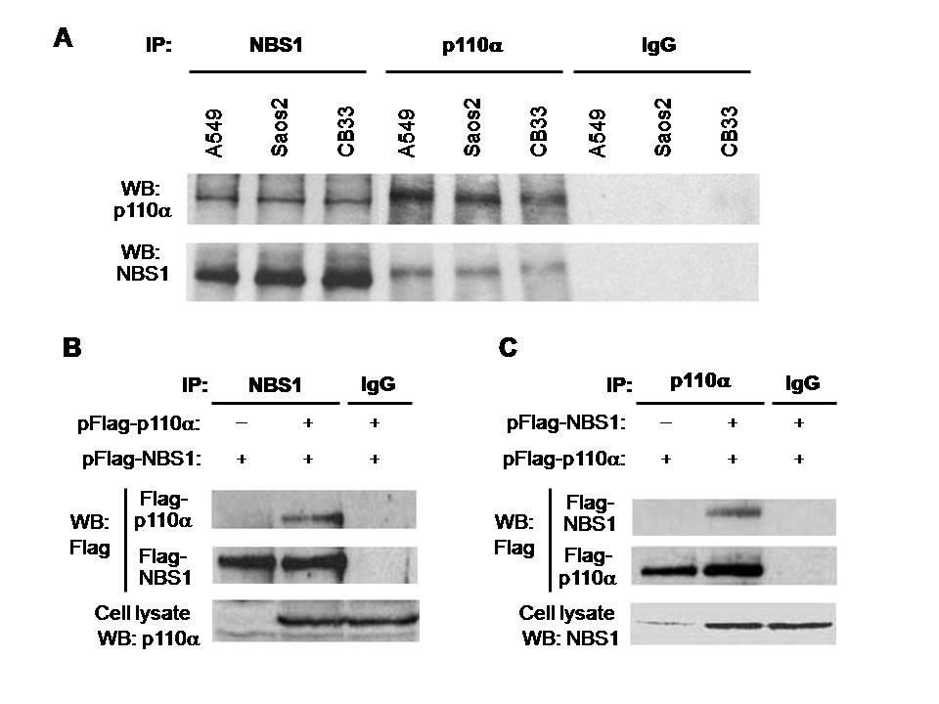
Figure 1
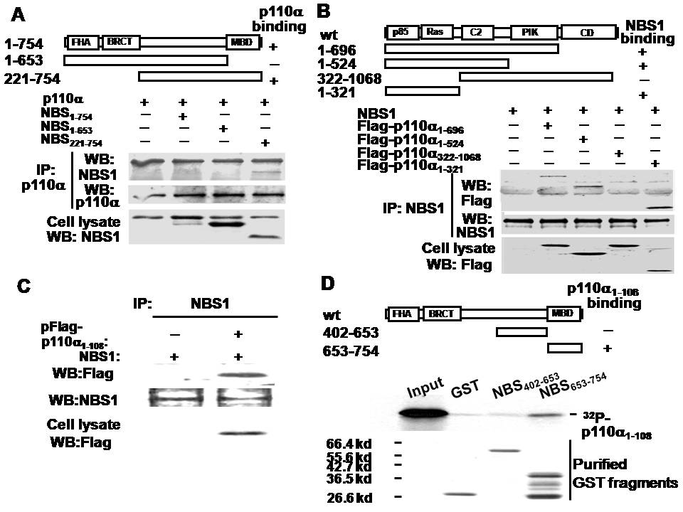
Figure 2
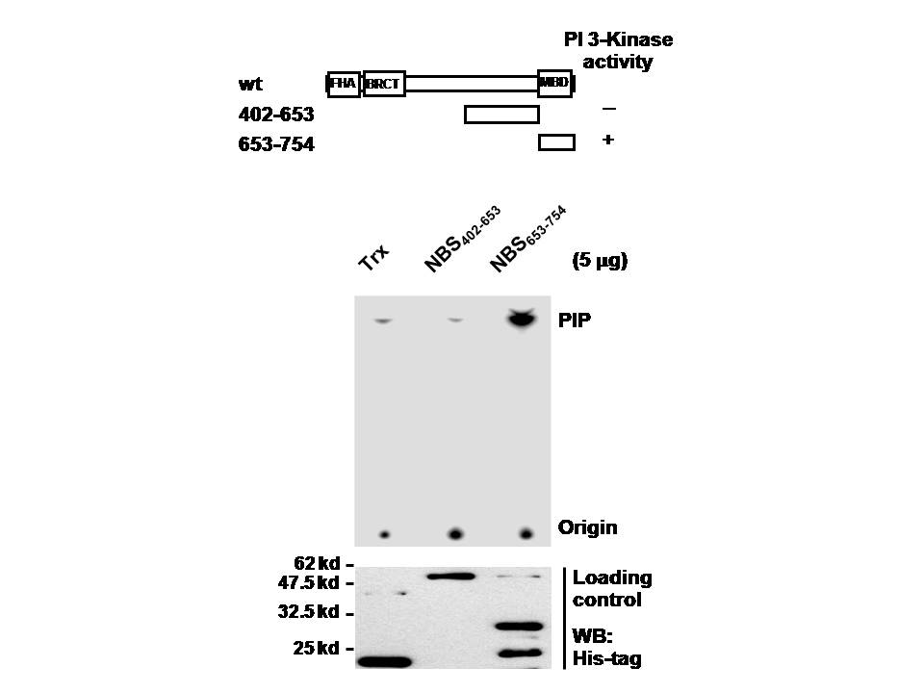
Figure 3
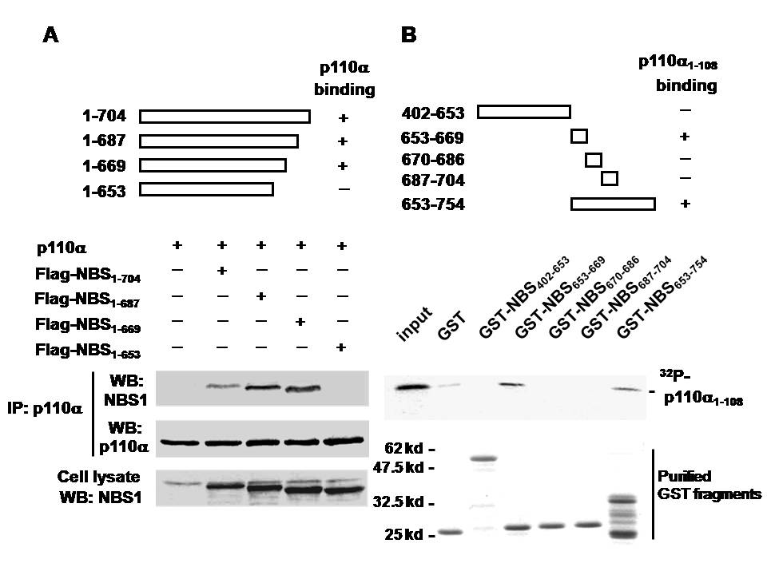
Figure 4
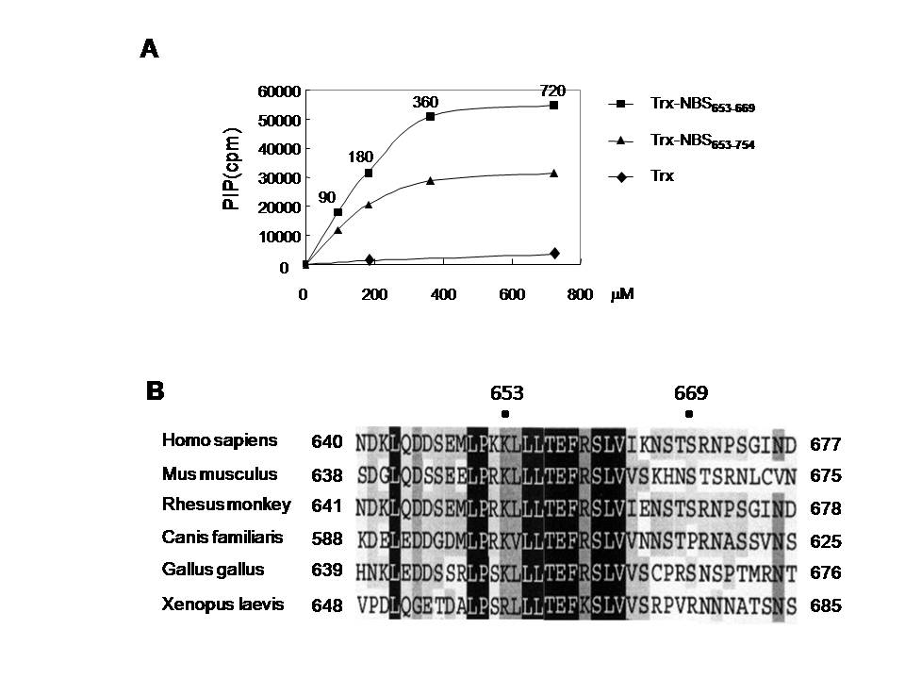
Figure 5
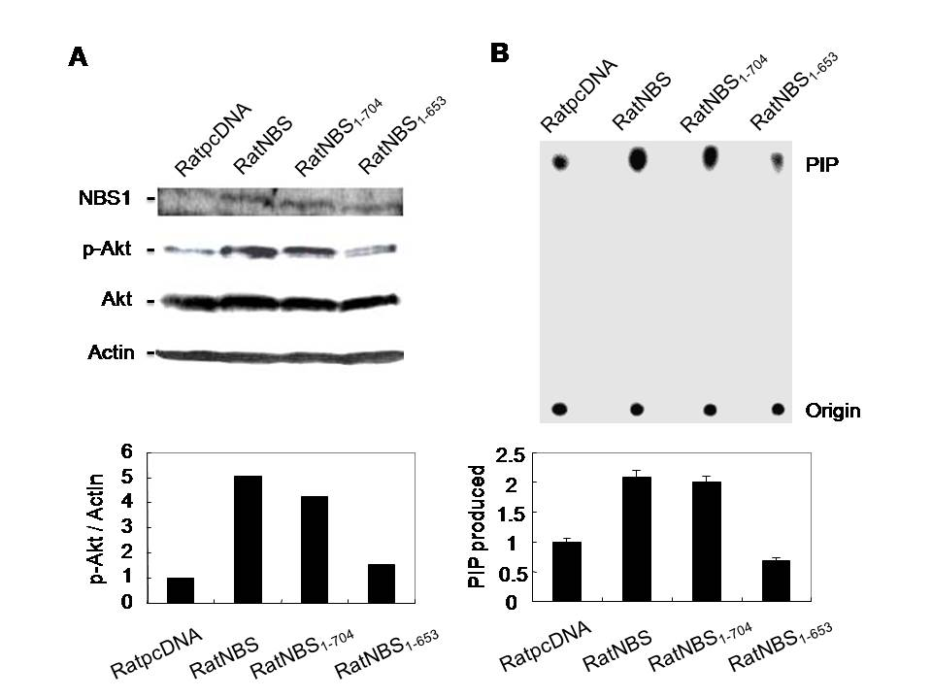
Figure 6

