Biochemical and Biophysical Research Communications 445 (2014) 566–571

Contents lists available at ScienceDirect

Biochemical and Biophysical Research Communications
journal homepage: www.elsevier.com/locate/ybbrc

E3-ligase Skp2 regulates b-catenin expression and maintains hematopoietic stem cell homing
Jing Wang a,b,1, Fei Han b,c,1, Szu-Wei Lee b,c, Juan Wu a,b, Chia-Hsin Chan b, Xian Zhang b,c, Yuan Gao b,c, Hong-Kai Su a, Zi-zhen Feng a,b, Da-zhi Xu a,b, Hui-Kuan Lin b,c,d,e,⇑
a State Key Laboratory of Oncology in South China and Department of Experimental Research, Sun Yat-Sen University Cancer Center, Guangzhou, Guangdong 510060, China b Department of Molecular and Cellular Oncology, M.D. Anderson Cancer Center, The University of Texas, Houston, TX 77030, USA c The University of Texas Graduate School of Biomedical Sciences at Houston, Houston, TX 77030, USA d Graduate Institute of Basic Medical Science, China Medical University, Taichung 404, Taiwan e Department of Biotechnology, Asia University, Taichung 404, Taiwan

article info abstract

Article history:
Received 3 February 2014 Available online 18 February 2014
Keywords:
Hematopoietic stem cell Homing S-phase kinase associated protein2 (Skp2) b-Catenin
The homing ability of hematopoietic stem cells (HSCs) was a critical step for transplantation and subsequent hematopoiesis. Although the HSC transplantation was widely used for many diseases, the mechanism by which HSC homing was regulated remained poorly understood. F-box protein S-phase kinase associated protein2 (Skp2), a component of the Skp2-SCF E3 ligase complex, was regarded as a cell cycle regulator by controlling the level of p21 and p27 through ubiquitination. We recently reported an important role of Skp2 in maintaining HSC pool size, quiescent stage and self-renewal ability. In this current study, we showed that Skp2 was a novel and critical regulator for maintaining the homing of HSCs as well as their residence in the endosteal niche. Microarray analysis together with biochemical validations revealed that Skp2 deﬁciency profoundly reduced the expression of b-catenin and its target genes. Knockdown of b-catenin mimicked the decline of HSC homing upon Skp2 deﬁciency, suggesting that Skp2 may regulate b-catenin and its target gene expression to orchestrate HSC homing. Our study not only identiﬁed Skp2 as a new regulator for maintaining b-catenin expression and HSC homing, but also suggested that Skp2 may serve as a predictive marker for monitoring the transplantation efﬁciency.
。 2014 Elsevier Inc. All rights reserved.

1. Introduction
Hematopoietic stem cells (HSCs) display a unique characteristic that enables them to home to bone marrow (BM) and spleen, which is a central process that not only maintains HSC pools important for lifetime hematopoiesis, but also determines the efﬁciency of HSC transplantation [1,2]. To date, HSC transplantation is widely used to cure many diseases, including autoimmune disease, genetic diseases, hematologic cancers and non-Hodgkin’s
Abbreviations: Skp2, S-phase kinase associated protein2; HSC, hematopoietic stem cells; BM, bone marrow; WT, wild type; BSA, Bovine Serum Albumin; DAPI, 40,6-diamidino-2-phenylindole; CFSE, carboxyﬂuorescein succinimidyl ester; LT-HSC, Lineage-Sca-1+c-Kit+Flk-CD34-; LSK, Lin-Sca-1+c-Kit+; shRNA, short hairpin RNA.
⇑ Corresponding author at: Department of Molecular and Cellular Oncology, University of Texas M.D. Anderson Cancer Center, Unit 108, Y7.6079, 1515 Holcombe Blvd, Houston, TX 77030, USA. Fax: +1 7137943270.
E-mail address: hklin@mdanderson.org (H.-K. Lin). These authors contributed equally to this work.
lymphoma as well [3,4]. However, there are several aspects that need to be improved in HSCT; for example, the control of toxic graft-versus-host diseases, immunological reconstitution after transplantation, the risk reduction of relapse and so on. Therefore, understanding the intrinsic factors that critically control the HSC homing ability may provide novel therapeutic approaches for patients that are in need of HSC transplantation.
S-phase kinase associated protein2 (Skp2), an F-box protein, is a component of the Skp2-SCF E3 ligase complex that regulates cell cycle progression by targeting cell-cycle inhibitors such as p21Cip/WAF1 and p27Kip1 for degradation [5]. Previous studies from our group demonstrated that Skp2 accelerates the tumorigenesis, invasion, and metastasis [6], promotes the K63-linked ubiquitination of NBS1 (the component of MRN complex), which is important for its interaction upon the DNA double-strand breaks, thereby facilitating ATM recruitment to DNA foci for activation [7]. We also found that Skp2-SCF complex is a critical E3 ligase for ErbB-receptor-mediated Akt ubiquitination and membrane recruitment in response to EGF, therefore affect Akt activation, glycolysis as well as breast cancer
http://dx.doi.org/10.1016/j.bbrc.2014.02.042
0006-291X/。 2014 Elsevier Inc. All rights reserved.
J. Wang et al. / Biochemical and Biophysical Research Communications 445 (2014) 566–571

progression [8]. Furthermore, we reported recently that Skp2 plays an important role in the regulation of HSC quiescence, pool size and self-renewal through affecting Cyclin D1 expression, which contributes to the HSC cycling [9]. Other group also found that Skp2 is involved in the basal homeostasis and stress-induced regeneration of HSC [10]. However, it is still unclear whether Skp2 also regulates HSC homing and its niche interaction.
In this study, we demonstrated that Skp2 maintains the HSC homing ability by mediating the binding between HSC and endosteal niches through the regulation of adhesion factor b-catenin in a cell cycle independent manner. Our ﬁndings not only reveal a novel regulating mechanism for HSC homing and its niche interaction but also underscore the critical function of Skp2 in the regulation of HSC transplantation efﬁciency.
2. Materials and methods
2.1. Mice and cells
Skp2-/-mice were maintained in 129 and C57/B6 mix background, and the primer sequences for genotyping were described previously [9]. WT and Skp2-/-MEFs were prepared from embryos
13.5 days by breeding Skp2 heterozygous mice. All animal experiments were performed according to our Animal Care and Use Form animal protocol, approved by M.D. Anderson Cancer Center. Total BM cells or sorted HSCs were cultured in serum-free medium (StemSpan SFEM, Stemcell Technologies, Vancouver, Canada) containing 10% Bovine Serum Albumin (BSA, Stemcell Technologies, Vancouver, Canada) supplied with IL-3 and SCF (PeproTech, Rocky Hill, NJ, USA).
2.2. Homing assay
Homing assay was performed as described [11]. In brief, BM cells were stained with carboxyﬂuorescein succinimidyl ester (CFSE, Sigma Aldrich, St. Louis, MO, USA) (5 lM per million cells) for 10 min in 37 0C in dark. To quench the staining, ﬁve volumes of ice-cold culture media were added to the cells and incubated for 5 min on ice. Cell pellets were obtained by centrifugation, washed three times with fresh media, and re-suspended in PBS. Those ﬂuorescence-labeled BM cells were injected into the irradiated recipient mice through the tail vein. 18 h after the injection, cells from BM and spleen of the recipient mice were collected for ﬂow cytometry analysis. The homing ability was reﬂected by the frequency of ﬂuorescence-positive cells. To assay the residence of HSCs to BM and spleen niche, we followed the protocols as described [12]. In brief, 18 h after the injection, tibia, femur and spleens from recipient mice were collected for frozen sections, and then the slides were stained with 40,6-diamidino-2-phenylindole (DAPI, Sigma Aldrich, St. Louis, MO, USA). The homing of HSCs was determined by the number of the ﬂuorescence-labeled cells residing to BM and spleen.
2.3. Cell sorting and ﬂow cytometry analysis
BM cells from 8 to 12 weeks old mice were stained with antibodies against various cell surface markers as described previously [9]. The antibodies (BD Bioscience, Franklin Lakes, NJ, USA) for surface markers included biotin-conjugated antibodies against 7 lineage markers (CD3, CD5, CD8, CD11b, Gr-1, B220, and Ter119), Sca-1 (PE-Cy5.5 conjugated), c-Kit (APC conjugated), CD34 (FITC conjugated), Flk-2 (PE conjugated), and secondary antibody for Lineage (PE-Cy7). Total BM cells were sorted by ﬂow cytometry (BD Bioscience, Franklin Lakes, NJ, USA) to obtain LT-HSC (Lineage-Sca-1+cKit+Flk-CD34-) or LSK (Lin-Sca-1+c-Kit+) cells.
2.4. Adhesion assay
The adhesion assay was described previously [12]. In brief, equal number of LSK cells from WT and Skp2-/-mice were directly sorted into 96-well plate coated with ﬁbronectin or collagen-I (BD Bioscience, Franklin Lakes, NJ, USA) for 3 h, after washed ﬁve times following the instructions, the attached cells were counted, and the ratio against the total number seeded were calculated.
2.5. Microarray analysis
We collected BM cells from WT and Skp2-/-mice (three mice from each group). We then sorted out the LT-HSCs and collected their total RNAs. Samples were delivered to the core facility of Department of Pathology of MDACC for gene expression analysis with Agilent chips. The data were analyzed and deposited to Gene Expression Omnibus (GEO), the record number is GSE23064 (http://www.ncbi.nlm.nih.gov/geo/query/acc.cgi?token=hﬁnxoms ugyialo&acc=GSE23064).
2.6. Viral infection
For lentiviral short hairpin RNA (shRNA) infection, 293T cells were co-transfected with shRNAs for b-catenin and packaging plasmids (p-Helper and p-Envelope) following calcium-phosphate transfection methods. The lentiviral shRNA sequences for b-catenin were listed here: shRNA#3: (50-GCTGATATTGACGGGCAGTAT-30), shRNA#5: (50-CCCAAGCCTTAGTAAACATAA-30). Two days after transfection, viral particles were used to infect MEF or BM cells. The infected MEF cells were selected with the medium containing 2 lg/ml puromycin (Sigma, St. Louis, MO, USA). For BM cells infection, the medium of 293T cells were changed to mixture containing 50% of BM culture medium on 24 h after transfection. Then medium was used for infection on 48 h after the transfection, the ratio to fresh BM medium is 1:3 (0.5 ml into 1.5 ml, total 2 ml). The BM cells were subjected for G0/G1 analysis at 48 h after the infection.
2.7. Western blot analysis
LSK cells were harvested and lysed with RIPA buffer and then subjected for immunoblotting according to the standard protocols as previously described [13]. The following antibodies were used for Western blot analysis: Anti-b-catenin (BD Biosciences, Franklin Lakes, New Jersey) and anti-b-actin (Sigma, St. Louis, MO, USA).
2.8. Real-time quantitative PCR
Total RNA extracted from freshly sorted LT-HSC cells using the mirVanaTMmiRNA Isolation Kit (Ambion, Grand Island, NY, USA) was treated with DNase I (Invitrogen, Grand Island, NY, USA), and cDNA was prepared with SuperScript II reverse transcriptase (Invitrogen, Grand Island, NY, USA) according to manufacturer’s instruction. Real-time PCR were performed by using Applied Biosystems 7300/7500 Real Time PCR System together with SYBR Green PCR master mix (Applied Biosystems, Grand Island, NY, USA). The transcription level of b-catenin, MMP7, c-Myc, NF-kB, CD44, Axin2 and GAPDH was assessed with the primers listed in Supplemental Table S2. GAPDH was used as an internal control.
2.9. Cell cycle analysis
Cell cycle analysis was performed as described [9]. In brief, the infected BM cells were washed with PBS, ﬁxed in 70% ethanol at4 0C for 24 h. Cells were stained with propidium iodide and RNaseA (Sigma, St. Louis, MO, USA), incubated at 37 0C for
J. Wang et al. / Biochemical and Biophysical Research Communications 445 (2014) 566–571

30 min in dark, then the cells were co-stained with Lineage, Sca1 and c-Kit, and subjected for ﬂow cytometry analysis. To dissect the G1 and G0 phase, infected BM cells were mixed with Hoechst 33342 (2 lg per million cells) at 37 0C for 45 min and then Pyronin Y were added to the ﬁnal concentration of 1 lg/ml for another 45 min at 37 0C in dark. These stained cells were then incubated with antibodies against surface markers (Lineage, Sca-1, c-Kit, CD34 and Flk-2), and then subjected for the ﬂow cytometry analysis.
2.10. Statistical analysis
Values were shown as mean ± s.d. The statistical analysis was performed with unpaired Student’s t-test. p < 0.05 was considered as statistically signiﬁcant.
3. Results and discussion
3.1. Skp2 orchestrates homing ability by maintaining the HSC binding to endosteal niche
As our previous report shows that HSC pool is expanded in the Skp2 deﬁcient mice [9], we next sought to determine whether the enhanced HSC number in Skp2 deﬁcient mice partly resulted from the increase in HSC homing ability. To test this possibility, we injected equal amounts of CFSE-labeled BM cells from wild type (WT) and Skp2-/-mice separately to WT recipient mice, and the HSCs homing ability and their residence to stem cell niche were examined. To our surprise, although Skp2 deﬁciency signiﬁcantly enhances HSC pools [9], it markedly reduced the homing ability of HSCs to both BM and spleen (Fig. 1A and B, p < 0.05, n = 4). In fur-
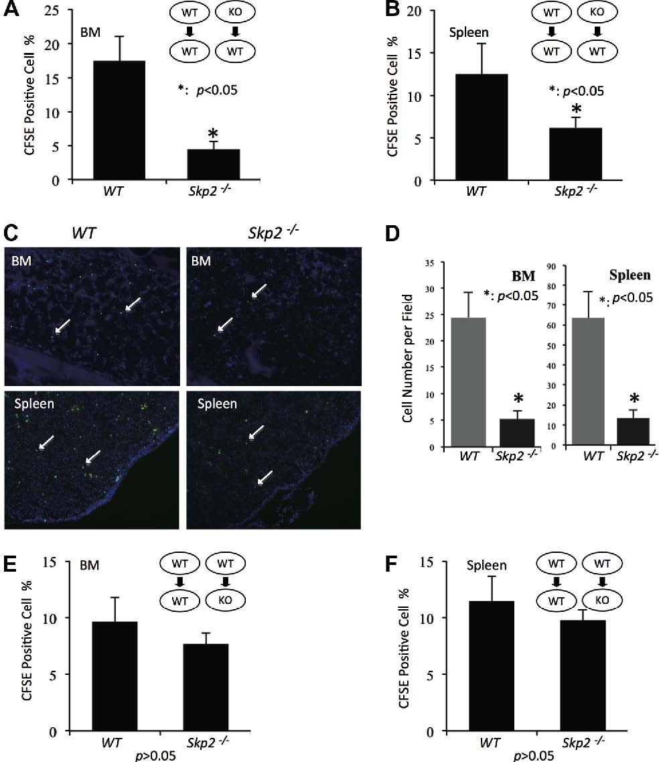

Fig. 1. Loss of Skp2 decreases HSC homing ability but does not affect the stem cell niche. (A, B) BM cells from WT and Skp2-/-mice were stained with CFSE and injected to lethally irradiated WT recipients separately, the cells were then taken from recipient BM (A) and spleen (B) 18 h after injection and subjected for ﬂow cytometry to detect the ﬂuorescence labeled cells. ⁄p < 0.05, using unpaired Student’s t-test, n = 4. (C, D) In homing assay, tibia, femur and spleens from recipient mice were collected for frozen sections 18 h after the injection. The slides were stained with 406-diamidino-2-phenylindole (DAPI) and then observed under ﬂuorescence microscope (Green: HSC; Blue: the nucleic of the cells in the stem cell niche; donors BM cells were indicated by white arrow). The representative images from recipient WT BM and spleen (C) and the statistical results (mean ± s.d) by counting 8 random areas of slides (D) were shown. ⁄p < 0.05, using unpaired Student’s t-test, n = 3. (E, F) BM cells from WT mice were stained with CFSE and injected to lethally irradiated WT and Skp2-/-recipients separately in order to deﬁne the differences of the stem cell niche function between WT and Skp2-/-mice. The cells were then taken from recipient BM (A) and spleen (B) 18 h after injection and subjected for ﬂow cytometry to detect the ﬂuorescence labeled cells. No signiﬁcant difference was found, p > 0.05, n =4.
J. Wang et al. / Biochemical and Biophysical Research Communications 445 (2014) 566–571

ther support of this notion, we found that ﬂuorescence-labeled Skp2-/-BM cells displayed marked reduction in their residence to BM and spleen niche in vivo compared to WT BM cells (Fig. 1C and D, p < 0.05, BM cells from donors were indicated by white arrow, n = 3). These results suggested that Skp2 is a critical factor for the maintenance of HSC homing.
Intrinsic HSC properties and endosteal niche are two important factors that may critically regulate HSC homing. We next determined whether Skp2 might regulate stem cell niche function and in turn orchestrate the homing ability of HSCs. We injected CFSE-labeled WT BM cells to WT and Skp2-/-recipients and found that the engraftment of WT HSCs to WT and Skp2-/-endosteal niche was comparable (Fig. 1E and F), suggesting that Skp2 does not alter endosteal niches to regulate HSC homing. Since the binding of HSCs to their niche is required for HSC homing, we determined whether Skp2 regulates HSC binding ability to stem cell niche related factors. We used a well-established in vitro adhesion assay as the readout for the HSC-endosteal niche interaction [12]. Collagen-I and ﬁbronectin were applied as adhesion molecules for HSC binding, since they are two major extracellular matrix molecules that are present on the endosteal surface of the bone (osteoblast niche) and released by osteoblastic lineage cells [12]. To this end, LSK cells from WT and Skp2-/-mice were sorted into the 96-well plates coated with collagen-I or ﬁbronectin, which mimicked the BM microenvironment, and the adherence of HSC to collagen-I or ﬁbronectin were counted. Notably, we found that Skp2 deﬁciency profoundly reduced the adhesion of HSCs to collagen-I and ﬁbronectin (Fig. 2A and B), implying that Skp2 regulated HSC homing ability partly due to its impact on the residence of HSC to the osteoblast niche. Our current result underscored a critical role of Skp2 in the HSC homing and residence to endosteal niche in a cell autonomous manner.
3.2. b-Catenin is downregulated in Skp2-/-HSC
Our previous data [9] reveals that Skp2 deﬁciency enhances HSC population and long-term reconstitution ability of HSCs, which appear to be counterintuitive to our current results that the homing ability of HSC from Skp2-/-mice was actually reduced. We reasoned that the pool size and repopulation ability of HSCs affected by Skp2 might be caused by the high expression of Cyclin D1 in Skp2-/-mice which rendered HSCs into the higher cycling and proliferation. However, the Skp2-mediated homing ability might possibly be modulated by other independent pathways. Our recent study along with others revealed a novel role of Skp2 in transcription regulation [6,14]. To gain further insight into how Skp2 may regulate the HSC homing ability, we performed the unbiased
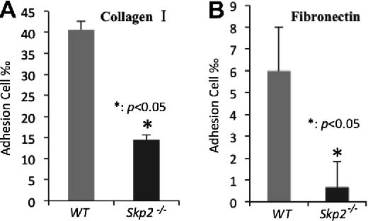
Fig. 2. Loss of Skp2 decreases the in vitro binding ability of HSC. (A, B) LSK cells from WT and Skp2-/-mice were sorted into 96-well plates coated with either collagen-I or ﬁbronection, the plates were washed several times 3 h after culture and the attached cells were counted under microscope. The in vitro adhesion ability was shown by the ratio between attached cells number and the total cell number seeded. ⁄p < 0.05, using unpaired Student’s t-test, n =3.
microarray analysis with total RNAs from WT and Skp2-/-LT-HSC cells (data were deposited to GEO as GSE23064). Among the genes regulated by Skp2, we found that b-catenin, a critical gene involved in the regulation of stem cell self-renewal and stem cells/niche interaction, was downregulated in Skp2-/-LT-HSCs (Supplemental Table S1).
b-Catenin is an important factor that binds to cadherins at the plasma membrane to form a critical complex of adhesion junctions for cell–cell contact [15]. This process prevents b-catenin from translocating to the nucleus to turn on its downstream target gene transcription. However, upon Wnt signaling activation, b-catenin is stabilized and translocated to the nucleus to induce numerous target genes involved in a wide range of biological functions. Although b-catenin signaling pathway is important for tumorigenesis and stem cell functions, its role in HSCs remains controversial. One report shows that ectopic expression of a constitutively active b-catenin causes an increase of HSC population in vitro and enhanced repopulation ability in vivo [16]. Other report using b-catenin conditional knockout mice model reveals that b-catenin is dispensable for both HSC frequency and function [17]. Thus, the distinct models used in these studies may likely explain the discrepancy. Whether or not b-catenin is involved in HSC homing process, which represents an important feature that dictates the hematopoiesis and stem cell transplantation, remains currently unclear.
We veriﬁed the microarray data by real-time PCR analysis and further found that the mRNA level of b-catenin and its target genes including MMP7, c-Myc, CD44, NF-kB and Axin2 were profoundly reduced (Fig. 3A). Besides the transcriptional evaluation, we also detected the b-catenin protein expression in LSK cells and found that b-catenin protein levels in LSK cells from Skp2 deﬁcient mice were much lower than that from WT mice (Fig. 3B). Thus, our results demonstrated that Skp2 is a critical regulator for the expression of b-catenin and its target genes in HSCs.
3.3. Skp2 and b-catenin maintain the HSC homing ability in a cell cycle independent manner
We next determined whether the loss of b-catenin mimics the homing defect of Skp2-/-HSCs. We ﬁrst used lentiviral short hairpin RNA (shRNA) to knockdown b-catenin in MEF cells to validate the shRNA knockdown efﬁciency and found that the shRNA #3 and shRNA #5 could efﬁciently knock down b-catenin expression (Supplemental Fig. S1A). We knocked down b-catenin in WT BM cells and assessed their homing ability. Consistent with the ﬁndings in Skp2-/-HSCs, the WT HSC homing ability was signiﬁcantly reduced after b-catenin knockdown, indicating that b-catenin is likely a downstream executor of Skp2 to maintain the HSC homing ability (Fig. 3C and D).
Our previous report shows the loss of Skp2 promotes the cell cycle entry of HSC cells, which was partly caused by high Cyclin D1 expression [9]. We then knocked down b-catenin in BM cells isolated from WT mice and checked the cell cycle proﬁle one week after cell culturing. Surprisingly, there was no signiﬁcant difference in the cell cycle proﬁle upon b-catenin knockdown (Supplemental Fig. S1B). We then further dissected the G0 and G1 phase of HSCs with Hoechst 33342 and Pyronin Y co-staining combined with HSC surface markers including Lineage, Sca-1, c-Kit, CD34 and Flk-3. Similarly, no difference was observed in the G0 and G1 phase cell populations upon b-catenin knockdown (Supplemental Fig. S2A-B). Taken together, these data suggest that the down-regulated b-catenin may contribute to the homing defect upon Skp2 deﬁciency in a cell cycle independent manner.
HSC and osteoblast niche interaction are critical steps for the maintenance of HSC quiescence, pool size, self-renewal, and long-term reconstitution ability. However, how HSC homing to
J. Wang et al. / Biochemical and Biophysical Research Communications 445 (2014) 566–571
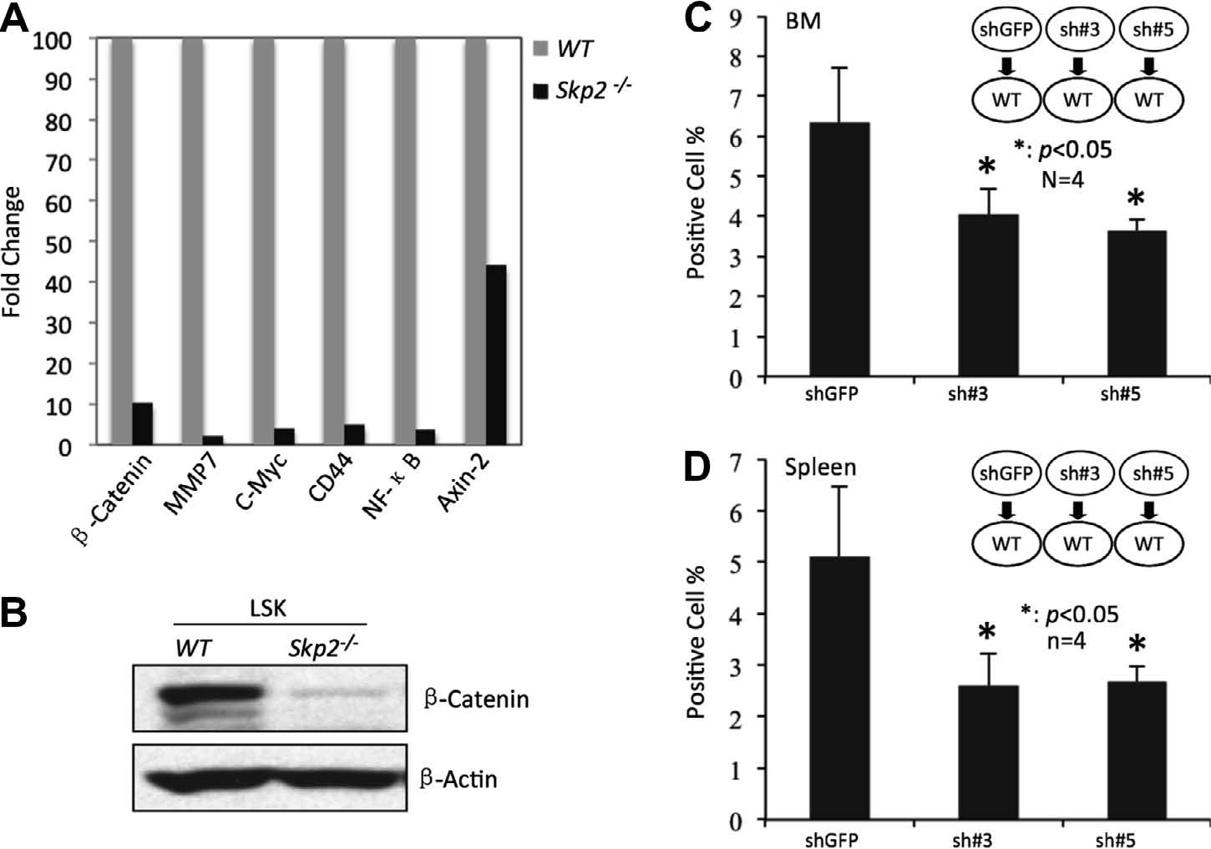

Fig. 3. Downregulated b-catenin mimics the BM homing defects in Skp2-/-mice. (A) LT-HSCs from WT and Skp2-/-mice were sorted and their total RNAs were subjected to real-time PCR to determine the transcription level of b-catenin and its target genes: MMP7, c-Myc, CD44, NF-kB, as well as Axin-2. (B) LSK cells from WT and Skp2-/-mice were sorted, lysed and subjected for Western blot analysis. b-catenin was detected and b-actin served as loading control. The expression level of b-catenin was reduced in Skp2 deﬁcient LSK cells compared to the WT LSK cells. (C, D) WT BM cells with vector control and b-Catenin knockdown were stained with CFSE and injected to lethally irradiated WT recipients. After 18 h, the cells were taken from recipient BM (C) and spleen (D), and the ﬂuorescence labeled cells was then detected by ﬂow cytometry.
⁄
p < 0.05, using unpaired Student’s t-test, n =5.
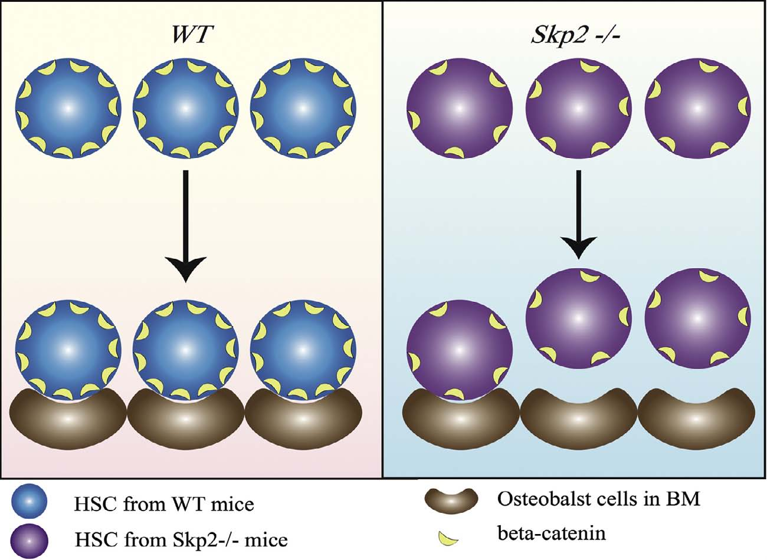
Fig. 4. Our working model on the role of Skp2 in HSC homing ability. HSCs bind to osteoblast niche when b-catenin expression is sufﬁcient in steady state (left panel), while their binding to osteoblast niche is reduced likely due to the reduction of expression of b-catenin and its target genes upon Skp2 deﬁciency, which subsequently attenuates HSC homing ability of HSCs (right panel).
BM and subsequent residence to BM niche are regulated is not and survival of mature osteoblast [20]. Furthermore, loss of well understood. Osteoblast cells from mesenchymal stem cell b-catenin is expected to inhibit not only Wnt signaling activa(MSC) play critical roles in the interaction of HSCs with the tion, but also disrupts the architecture of adhesion junctions, microenvironments. The differentiation of MSC is dependent on which may affect cell–cell contact and adhesion of HSC to stem multiple environmental, local, and hormonal factors including cell niche [21]. However, our study reveals for the ﬁrst time that Wnt/b-catenin pathway [18,19]. Wnt/b-catenin stimulates a vari-b-catenin plays an important role in HSC homing, as its knockety of responses in the osteoblast lineage cells, including progen-down displayed similar defect in HSC homing as Skp2 deﬁciency itor cell proliferation and commitment to the osteoblast lineage does.
J. Wang et al. / Biochemical and Biophysical Research Communications 445 (2014) 566–571

The previous report [9] from our group showing that Skp2 deﬁciency increases pool size and long-term reconstitution of HSCs implies that Skp2 may likely promote HSC homing. However, in this study we surprisingly found that Skp2 loss markedly reduces HSC homing and its niche interaction. This ﬁnding appeard to be counterintuitive to our previous observations. Although the detailed mechanism to explain this contradictory phenomenon remains unclear, we speculate that the Skp2 deﬁcient HSCs once entering the BM niches may undergo massive expansion to compensate for the loss of HSC pool size from the reduction in HSC homing, as we indeed found that Skp2 deﬁciency promotes Cyclin D1 expression and facilitates cycling and proliferation of HSCs [9]. More studies are required to further resolve this puzzle.
4. Conclusions
In this study, we provided convincing evidence that Skp2 is a novel and critical regulator for HSC homing and subsequent engraftment to the BM niche. Mechanistically, Skp2 regulates bcatenin transcription and expression of its target genes, which in turn maintains HSC homing and its niche interaction (Fig. 4). Our study not only reveals a novel molecular insight into how HSC homing and engraftment to the BM niche is regulated, but also identiﬁes Skp2 as a novel regulator in these processes. Importantly, we show that b-catenin plays an important role in HSC homing, although its role in HSC self-renewal has been so far controversial [17,21]. Understanding the mechanism by which Skp2 regulates the homing property of HSCs not only reveals novel insights into how HSC homing is regulated, but also provides novel paradigms for the treatment of stem cell-related diseases and improving stem cell transplantation efﬁciency.
Acknowledgments
We thank Drs. Pier Paolo Pandolﬁ and Keiichi Nakayama for the mice; Dr. Wei Zhang and his core facility at M.D. Anderson Cancer Center for performing the microarray analysis. This study was supported by CPRIT Grant and NIH RO1 Grants to H.K.L., and by the foundations to J.W. (81101521 and 2012CB967002, 2013M 540678).
Appendix A. Supplementary data
Supplementary data associated with this article can be found, in the online version, at http://dx.doi.org/10.1016/j.bbrc.2014.02.042.
References
[1] Z. Li, L. Li, Understanding hematopoietic stem-cell microenvironments, Trends Biochem. Sci. 31 (2006) 589–595.
[2] R.N. Kaplan, B. Psaila, D. Lyden, Niche-to-niche migration of bone-marrowderived cells, Trends Mol. Med. 13 (2007) 72–81.
[3] M. Sharma, F. Afrin, N. Satija, R.P. Tripathi, G.U. Gangenahalli, Stromal-derived factor-1/CXCR4 signaling: indispensable role in homing and engraftment of hematopoietic stem cells in bone marrow, Stem Cells Dev. 20 (2011) 933–946.
[4] E.A. Copelan, Hematopoietic stem-cell transplantation, N. Engl. J. Med. 354 (2006) 1813–1826.
[5] H.K. Lin, G. Wang, Z. Chen, J. Teruya-Feldstein, Y. Liu, C.H. Chan, W.L. Yang, H. Erdjument-Bromage, K.I. Nakayama, S. Nimer, P. Tempst, P.P. Pandolﬁ, Phosphorylation-dependent regulation of cytosolic localization and oncogenic function of Skp2 by Akt/PKB, Nat. Cell Biol. 11 (2009) 420–432.
[6] C.H. Chan, S.W. Lee, C.F. Li, J. Wang, W.L. Yang, C.Y. Wu, J. Wu, K.I. Nakayama,
H.Y. Kang, H.Y. Huang, M.C. Hung, P.P. Pandolﬁ, H.K. Lin, Deciphering the transcriptional complex critical for RhoA gene expression and cancer metastasis, Nat. Cell Biol. 12 (2010) 457–467.
[7] J. Wu, X. Zhang, L. Zhang, C.Y. Wu, A.H. Rezaelan, C.H. Chan, J.M. Li, J. Wang, Y. Gao, F. Han, Y.S. Jeong, X. Yuan, K.K. Khanna, J. Jin, Y.X. Zeng, H.K. Lin, Skp2 E3 ligase integrates ATM activation and homologous recombination repair by ubiquitinating NBS1, Mol. Cell (2012).
[8] C.H. Chan, C.F. Li, W.L. Yang, Y. Gao, S.W. Lee, Z. Feng, H.Y. Huang, K.K. Tsai, L.G. Flores, Y. Shao, J.D. Hazle, D. Yu, W. Wei, D. Sarbassov, M.C. Hung, K.I. Nakayama, H.K. Lin, The Skp2-SCF E3 ligase regulates Akt ubiquitination, glycolysis, herceptin sensitivity, and tumorigenesis, Cell 149 (2012) 1098– 1111.
[9] J. Wang, F. Han, J. Wu, S.W. Lee, C.H. Chan, C.Y. Wu, W.L. Yang, Y. Gao, X. Zhang,
Y.S. Jeong, A. Moten, F. Samaniego, P. Huang, Q. Liu, Y.X. Zeng, H.K. Lin, The role of Skp2 in hematopoietic stem cell quiescence, pool size, and self-renewal, Blood 118 (2011) 5429–5438.
[10] S. Rodriguez, L. Wang, C. Mumaw, E.F. Srour, C. Lo Celso, K. Nakayama, N. Carlesso, The SKP2 E3 ligase regulates basal homeostasis and stress-induced regeneration of HSCs, Blood 117 (2011) 6509–6519.
[11] V. Janzen, R. Forkert, H.E. Fleming, Y. Saito, M.T. Waring, D.M. Dombkowski, T. Cheng, R.A. DePinho, N.E. Sharpless, D.T. Scadden, Stem-cell ageing modiﬁed by the cyclin-dependent kinase inhibitor p16INK4a, Nature 443 (2006) 421–
426.
[12] G.B. Adams, K.T. Chabner, I.R. Alley, D.P. Olson, Z.M. Szczepiorkowski, M.C. Poznansky, C.H. Kos, M.R. Pollak, E.M. Brown, D.T. Scadden, Stem cell engraftment at the endosteal niche is speciﬁed by the calcium-sensing receptor, Nature 439 (2006) 599–603.
[13] W.L. Yang, J. Wang, C.H. Chan, S.W. Lee, A.D. Campos, B. Lamothe, L. Hur, B.C. Grabiner, X. Lin, B.G. Darnay, H.K. Lin, The E3 ligase TRAF6 regulates Akt ubiquitination and activation, Science 325 (2009) 1134–1138.
[14] J. Jin, J.W. Harper, A license to kill: transcriptional activation and enhanced turnover of Myc by the SCF(kp2) ubiquitin ligase, Cancer Cell 3 (2003) 517–
518.
[15] M. Perez-Moreno, E. Fuchs, Catenins: keeping cells from getting their signals crossed, Dev. Cell 11 (2006) 601–612.
[16] T. Reya, A.W. Duncan, L. Ailles, J. Domen, D.C. Scherer, K. Willert, L. Hintz, R. Nusse, I.L. Weissman, A role for Wnt signalling in self-renewal of haematopoietic stem cells, Nature 423 (2003) 409–414.
[17] M. Cobas, A. Wilson, B. Ernst, S.J. Mancini, H.R. MacDonald, R. Kemler, F. Radtke, Beta-catenin is dispensable for hematopoiesis and lymphopoiesis, J. Exp. Med. 199 (2004) 221–229.
[18] Z. Hamidouche, E. Hay, P. Vaudin, P. Charbord, R. Schule, P.J. Marie, O. Fromigue, FHL2 mediates dexamethasone-induced mesenchymal cell differentiation into osteoblasts by activating Wnt/beta-catenin signaling-dependent Runx2 expression, FASEB J. 22 (2008) 3813–3822.
[19] Y.W. Qiang, B. Hu, Y. Chen, Y. Zhong, B. Shi, B. Barlogie, J.D. Shaughnessy Jr., Bortezomib induces osteoblast differentiation via Wnt-independent activation of beta-catenin/TCF signaling, Blood 113 (2009) 4319–4330.
[20] L.H. Hoeppner, F.J. Secreto, D.F. Razidlo, T.J. Whitney, J.J. Westendorf, Lef1DeltaN binds beta-catenin and increases osteoblast activity and trabecular bone mass, J. Biol. Chem. 286 (2011) 10950–10959.
[21] S. Malhotra, P.W. Kincade, Wnt-related molecules and signaling pathway equilibrium in hematopoiesis, Cell Stem Cell 4 (2009) 27–36.

