5-Lipoxygenase Inhibitors Attenuate TNF-a-Induced
Inflammation in Human Synovial Fibroblasts

Han-Ching Lin1, Tzu-Hung Lin1, Ming-Yueh Wu1, Yung-Cheng Chiu2, Chih-Hsin Tang3, Mann-Jen Hour4,
Houng-Chi Liou1, Huang-Ju Tu1, Rong-Sen Yang5*, Wen-Mei Fu1*
1 Department of Pharmacology, College of Medicine, National Taiwan University and Hospital, Taipei, Taiwan, 2 Department of Orthopaedics, Taichung Veterans General
Hospital, Taichung, Taiwan, 3 Department of Pharmacology, College of Medicine, China Medical University, Taichung, Taiwan, 4 School of Pharmacy, College of Medicine,
China Medical University, Taichung, Taiwan, 5 Department of Orthopedics, College of Medicine, National Taiwan University and Hospital, Taipei, Taiwan

Abstract
The lipoxygenase isoform of 5-lipoxygenase (5-LOX) is reported to be overexpressed in human rheumatoid arthritis synovial
tissue and involved in the progress of inflammatory arthritis. However, the detailed mechanism of how 5-lipoxygenase
regulates the inflammatory response in arthritis synovial tissue is still unclear. The aim of this study was to investigate the
involvement of lipoxygenase pathways in TNF-a-induced production of cytokines and chemokines. Human synovial
fibroblasts from rheumatoid patients were used in this study. 5-LOX inhibitors and shRNA were used to examine the
involvement of 5-LOX in TNF-a-induced cytokines and chemokines expression. The signaling pathways were examined by
Western Blotting or immunofluorescence staining. The effect of 5-LOX inhibitor on TNF-a-induced chemokine expression
and paw edema was also explored in vivo in C57BL/6 mice. Treatment with 5-LOX inhibitors significantly decreased TNF-a-
induced pro-inflammatory mediators including interleukin-6 (IL-6) and monocyte chemo-attractant protein-1 (MCP-1) in
human synovial fibroblasts. Knockdown of 5-LOX using shRNA exerted similar inhibitory effects. The abrogation of NF-kB
activation was involved in the antagonizing effects of these inhibitors. Furthermore, 5-LOX inhibitor decreased TNF-a-
induced up-regulation of serum MCP-1 level and paw edema in mouse model. Our results provide the evidence that the
administration of 5-LOX inhibitors is able to ameliorate TNF-a-induced cytokine/chemokine release and paw edema,
indicating that 5-LOX inhibitors may be developed for therapeutic treatment of inflammatory arthritis.
* Email: rsyang@ntuh.gov.tw (R-SY); wenmei@ntu.edu.tw (W-MF)
Introduction
Rheumatoid arthritis (RA) is a chronic and systemic autoim-
mune syndrome, which is characterized by massive synovial
proliferation and inflammation and leads to the destruction of joint
cartilage and bone [1]. In addition, many kinds of cells infiltrate
into the joint cavity during arthritis, including immune cells (such
as macrophage, T cells and B cells) and erosive cells such as bone
resorptive osteoclasts.
Arachidonic acid (AA) is a key inflammatory intermediate from
the lipid composition. In response to a variety of stimuli, AA is
released from membrane phospholipid by phospholipase. Pru-
zanski et al. [2] reported that the phospholipase A2 (PLA2) activity
is increased in arthritis. Cytokines including TNF-a, IL-1 are
reported to stimulate the activity of PLA2 [3,4]. Both cyclooxy-
genase (COX) and lipoxygenase (LOX) pathways are involved in
the inflammatory actions related to AA [5].
The inflammatory synovial fluid in RA patients contains many
kinds of cytokines including high levels of leukotrienes [6].
Leukotriene B4 (LTB4) is a downstream product of 5-lipoxygenase
(5-LOX) and LTB4 is reported to be produced mainly by
1
neutrophils, macrophages and mast cells [7]. LTB4 is considered
as a powerful proinflammatory chemotactic agent and has been
implicated as an important mediator of joint inflammation in RA.
There are higher levels of LTB4 in the serum of RA patients than
patients with inactive arthritis or normal subjects [8]. Ahmadza-
deh et al. [9] demonstrate that the serum levels of LTB4 correlate
with the disease severity. In addition, neutrophil-derived LTB4 is
reported to contribute to arthritis induction and severity in a
mouse inflammatory arthritis model [10].
The 5-LOX cascades and the role of LTB4 in RA are well
documented. 5-LOX is required for the production of leukotrienes
(LTC4, LTD4, and LTE4) which are reported to be potent
broncho-constrictors and proinflammatory mediators [11]. These
leukotrienes are known as the cysteinly leukotrienes (cys-LTs). 5-
LOX enzyme is also involved in the production of LTB4. This
lipid is primarily synthesized in neutrophils and macrophages,
where the enzyme LTA4 hydrolase converts LTA4 to LTB4 [12].
In addition, 5-LOX enzyme is also involved in the production of
bioactive metabolites of 5-hydroxyeicosatetraenoic acid (5-HETE)
and 5-oxo-6,8,11,14-eicosatetraenoic acid (5-oxoETE) [13,14]. It

Figure 1. Inhibition of TNF-a-induced IL-6 expression by 5-LOX inhibitors in human synovial fibroblasts. Human synovial fibroblasts
were incubated with TNF-a (10 ng/ml) for indicated time intervals. mRNA and released IL-6 were determined by QPCR and ELISA respectively.
Treatment with TNF-a enhanced the IL-6 mRNA (A) expression and cytokine release (B) in a time-dependent manner. Pretreatment with two 5-LOX
inhibitors, NDGA (5 or 10 mM) or MK-886 (5 mM) for 1 hr significantly inhibited the TNF-a-induced mRNA (C) or protein levels (D) of IL-6. Data are
presented as mean 6 SEM. *, p,0.05 compared with vehicle control (con). #, p,0.05 compared with TNF-a treatment alone.
doi:10.1371/journal.pone.0107890.g001
has been reported that 5-LOX enzyme is present in the synovial
lining of rheumatoid tissue [15]. Moreover, Gheroghe et al. [16]
found that both 5-LOX and 15-LOX are present in RA and OA
(osteoarthritis) synovium and 5-LOX is highly expressed in lining
and sublining macrophages, neutrophils and mast cells.
PF-4191834, a novel selective 5-LOX inhibitor developed by
Pfizer, is found to decrease arthritis-associated pain and inflam-
mation in rat model [11]. However, the detailed mechanism of 5-
LOX involved in inflammatory arthritis is still unclear. Here we
found that blockade of 5-LOX by using commercial inhibitors or
shRNA could decrease TNF-a-induced IL-6 and MCP-1 expres-
sion in human synovial fibroblasts. We then analyzed the signaling
pathway and it was found that TNF-a-induced NF-kB activation
was antagonized by 5-LOX inhibitors. In mouse model, it was also
found that co-treatment of 5-LOX inhibitor could decrease TNF-
a-induced MCP-1 serum level and paw edema. Our results
demonstrate that 5-LOX is involved in TNF-a-induced inflam-
matory arthritis and may provide a new strategy for treating
rheumatoid arthritis.
ROC and approved by the Ethical Committee for Animal
Research of the National Taiwan University (IACUC: 20120439).
Materials
Mouse monoclonal antibody for a-tubulin, C23, NF-kB p65
and rabbit polyclonal antibody for IgG, IKKa/b, IkBa, NF-kB
p50, NF-kB p65 and goat anti-mouse or anti-rabbit secondary
antibody conjugated with horseradish peroxidase were purchased
from Santa Cruz Biotechnology (Santa Cruz, CA, USA). Mouse
monoclonal antibody for phosphor-IkBa and rabbit monoclonal
antibody for phosphor-IKKa/b were from Cell Signaling
Technology (Danvers, MA, USA). Rabbit anti-5-LOX antibody
was from Novus (Littleton, CO, USA). 5-LOX inhibitors,
including MK-886, Nordihydroguaiaretic acid (NDGA); leukotri-
ene B4 and leukotriene B4 receptor antagonist LY29311 were
from Cayman Chemical Company (Ann Arbor, MI, USA).
Collagenase and 49,6-diamidino-2-phenylindole (DAPI) were from
Sigma-Aldrich (St. Louis, MO, USA). Recombinant human TNF-
a and enhanced chemiluminescent HRP substrate (ECL) were
from Millipore (Bedford, MA, USA). We purchased RPMI-1640
medium, trypsin and anti-rabbit secondary antibody conjugated
with Alexa Fluor 488 from Invitrogen (Carlsbad, CA, USA) and
fetal bovine serum (FBS) from Biological Industries (Kibbutz Beit
Haemek, Israel). Tri-zol was from MDBIO (Taipei, Taiwan).
MMLV Reverse Transcriptase kit was from Promega (Madison,
WI, USA). Taqman PCR Master Mix and qPCR probes were
from Applied Biosystems/Invitrogen (Foster city, CA, USA).
Methods
Ethics Statement
The study was approved by the Institutional Review Board of
Taichung Veterans General Hospital (IRB TCVGH NO:
C09248), and informed written consent was obtained from
patients. All animal experiments were conducted in accordance
with the Guidelines for Animals Research of Agriculture Council,
2
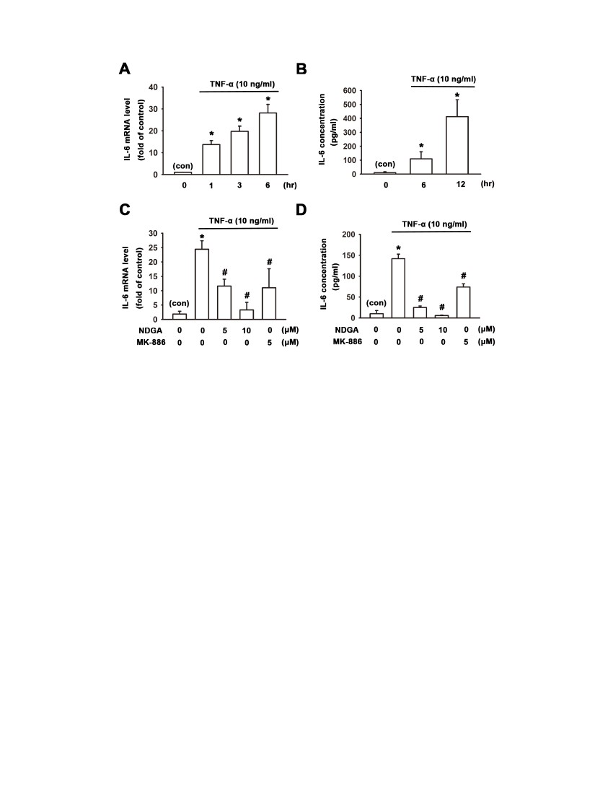
Quantitative real-time PCR
Total RNA were extracted from human synovial fibroblasts
using a Tri-zol kit. The absorbance was measured in a
spectrophotometer, Picodrop (Picodrop Ltd., Essex, UK) at 260
and 280 nm. RNA was used for RT-PCR by using two-step
MMLV RT kit. Gene expression was detected by Real-Time PCR
which was executed by using a SYBR Green PCR Master Mix
(Applied Biosystems, Foster city, CA, USA) and an ABI
StepOnePlus Real-time PCR system (Applied Biosystems). The
cDNA was amplified with gene specific primers as shown below:
GAPDH: [19].
Forward primer: TGGGTGTGAACCATGAGAAG.
Reverse primer: GCTAAGCAGTTGGTGGTGC.
IL-6: [20].
Forward primer: TCACTGGTCTTTTGGAGTTTGA.
Reverse primer: AGAGCCCTCAGGCTGGACT.
MCP-1/CCL-2: [21].
Forward primer: ATGCAATCAATGCCCCAGTC.
Reverse primer: TGCAGATTCTTGGGTTGTGG.
Amplification was performed in the following cycling condi-
tions: 50uC for 2 min and 95uC for 10 min and then 40 cycles at
95uC for 15 s followed by 60uC for 1 min. The optimal
concentrations of primers and templates used in each reaction
were established based on the standard curve created before
reaction and corresponding to nearly 100% efficiency of the
reaction. The reference household gene used to normalize the
amount of mRNA was GAPDH. The fold change in gene
expression relative to control was calculated by 22DDCT.
Measurement of cytokines and chemokines
After treatment with TNF-a or test substances, the levels of IL-6
or MCP-1 in the culture medium of human synovial fibroblasts
and serum from mice were determined by enzyme-linked
immunosorbent assay (ELISA). The conditioned medium or
serum from mice was obtained and IL-6 or MCP-1 was detected
according to the manufacturer’s protocol (R&D Systems, Min-
neapolis, MN, USA). All independent experiments were per-
formed and the absorbance was determined using microplate
reader (Bio-Tek, Winooski, VT, USA).
Figure 2. Attenuation of TNFa-induced MCP-1/CCL-2 expres-
sion by 5-LOX inhibitors in human synovial fibroblasts. Human
synovial fibroblasts were pretreated with NDGA (10 mM) or MK-886
(5 mM) for 1 hr, and then treated with TNF-a for another 6 hr. Cell lysate
was extracted for real-time PCR evaluation (A) and conditioned medium
was collected for ELISA measurement of MCP-1 (B). Note that 5-LOX
inhibitors NDGA and MK-886 antagonized TNF-a-induced mRNA and
protein levels of MCP-1/CCL-2. Data are presented as mean 6 SEM. *,
p,0.05 compared with control (con). #, p,0.05 compared with TNF-a-
treatment alone.
doi:10.1371/journal.pone.0107890.g002
Transfection of RNA interference
The 5-LOX-shRNA conjugated on the vector of pLKO.1 with
ampicillin-resistant region was purchased from National RNAi
Core Facility (RNAi Core, Taipei, Taiwan). 3 mg 5-LOX-shRNA
and 6 ml Lipofectamine 2000 (Invitrogen, Carlsbad, CA, USA)
were premixed with OPTI-MEM separately for 5 min and then
mixed with each other for 25 min and then applied to human
synovial fibroblasts. The empty vector of shRNA was used as
negative control. After 36 hr, the cells were harvested or the
culture medium was replaced with serum-free medium and test
substances.
Cell cultures
Human synovial fibroblasts were isolated by collagenase
treatment from synovial tissues obtained from patients with
rheumatoid arthritis (RA) undergoing total knee replacement
surgeries (Taichung Veterans General Hospital, Taichung,
Taiwan) [17]. Patients with RA were fulfilled with diagnostic
criteria of American College of Rheumatology (ACR). Fresh
synovial tissues were minced and digested in a solution of
collagenase, and DNase. Isolated synovial fibroblasts were filtered
through 70 mm nylon filters. The cells were then grown on culture
dishes in 95% air-5% CO2 with RPMI-1640, which was
supplemented with 10% heat-inactivated fetal calf serum,
100 U/ml penicillin, 100 mg/ml streptomycin, and 250 ng/ml
fungizone (pH 7.6). Over 90% cultured cells were fibroblasts
which were characterized by flow cytometry by using CD90 (Thy-
1) antibody [18]. Synovial fibroblasts of passages four to nine were
used in this study.
Western Blot
After treatment with test substances, synovial fibroblasts were
then washed with cold PBS and lysed for 30 min at 4uC with lysis
buffer as described previously [18]. For the separation of
cytoplasmic extracts (CE) and nuclear extracts, cells were cultured
onto 10 cm dish. After reaching confluence, cells were treated with
test substances, cytoplasmic extracts and nuclear extracts were
separated by NE-PER (Thermo Scientific-Pierce, Rockford, IL,
USA). Equal protein (30 mg) was applied per lane, and electro-
phoresis was performed under denaturing conditions on a 8% or
12% SDS gel and transferred to nitrocellulose membranes
3
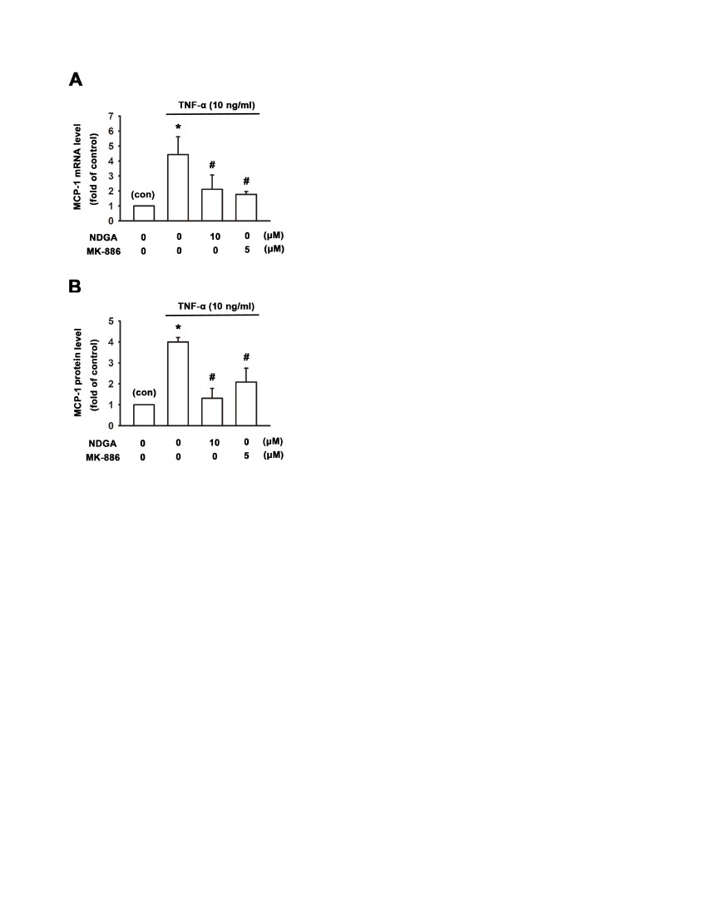
Figure 3. Involvement of leukotriene B4 in TNF-a-induced cytokine expression in human synovial fibroblasts. Human synovial
fibroblasts were pretreated with LTB4 receptor antagonist LY29311 (1 mM) for 1 hr, and then treated with TNF-a for another 6 hr. TNF-a-induced up-
regulation of IL-6 and MCP-1 were antagonized by LY29311 (A, B). RASFs were treated with TNF-a (10 ng/ml) for 4 and 12 hr, and the conditioned
medium was collected for ELISA measurement of LTB4. Data show that LTB4 was increased at 4 hr (C). (D) Human synovial fibroblasts were treated
with leukotriene B4 for 6 hrs at different concentrations, and conditioned medium was collected for ELISA assay. ELISA analysis showed that
treatment with leukotriene B4 enhanced IL-6 release in a concentration-dependent manner. Data are presented as mean 6 SEM. *, p,0.05 compared
with control (con). #, p,0.05 compared with TNF-a-treatment alone.
doi:10.1371/journal.pone.0107890.g003
(Invitrogen). The blots were blocked with 5% non-fat milk in TBS-
T (0.5% Tween 20 in 20 mM Tris and 137 mM NaCl) for 1 h at
room temperature and then probed with antibodies against 5-
LOX, phosphor-IkBa, IkBa, phospho-IKKa/b, IKKa/b, NF-kB
p50, NF-kB p65 (1:1000) at 4uC overnight. After 3 washes by
TBS-T, the blots were subsequently incubated with goat anti-
rabbit or anti-mouse peroxidase-conjugated secondary antibody
(1:10000) for 1 h at room temperature. The blots were visualized
by enhanced chemiluminescence using Amersham HyperfilmTM
ECL (GE Healthcare, Pollards Wood, UK) or Biospectrum
Imaging System (UVP, Upland, CA, USA). For normalization
purposes, the same blot was also probed with mouse anti-a-tubulin
antibody or mouse anti-C23 antibody (1:1000).
counterstained by DAPI and the confocal images were obtained by
using excitation wavelength 494 nm and emission wavelength
519 nm, respectively (for Alexa-488) (model SP5 TCS; Leica,
Heidelberg, Germany) and the thickness of optical sections was set
at 0.8 mm.
TNF-a-induced inflammation in animal models
8 weeks-old male C57BL/6 mice and 15-LOX knockout mice
were purchased from the Laboratory Animal Center of National
Taiwan University. All mice were kept under standard temper-
ature, humidity, and timed lighting conditions and provided
mouse chow and water ad libitum.
Recombinant mouse TNF-a (40 mg/kg) in the presence or
absence of 5-LOX inhibitor NDGA (10 mg/kg) was injected
intravenously from femoral vein of male C57BL/6 mice. Mice
were sacrificed 6 hr later and serum was collected to perform
ELISA analysis.
For the paw swelling experiment, TNF-a (200 ng dissolved in
10 ml PBS) in the presence or absence of NDGA (10 mM) or MK-
886 (10 mM) was injected intraplantarly into the right hind paw
and the PBS-injected left hind paw was used as control. Paw
thickness was measured with digimatic caliper (Mitutoyo, Japan).
The change of paw thickness was compared to the paw thickness
at 0 hr.
Immunofluorescent staining
For immunolabeling studies, synovial fibroblasts were seeded on
glass overnight and then treated with test substances. After TNF-a
(25 ng/ml) treatment for 30 min with or without inhibitors, 4%
paraformaldehyde was used to fix the cells for 15 min. 0.1% triton
was used to permeabilize the cells and 4% BSA was used for
blocking non-specific binding for 1 hr. Synovial fibroblasts were
stained with primary mouse monoclonal antibody against NFkB-
p65 (1:200) (Santa Cruz sc-8008) (Lin et al., 2011) overnight and
then with Alexa Fluor 488-conjugated goat anti-mouse secondary
antibody (Invitrogen, Carlsbad, California). The nucleus was
4
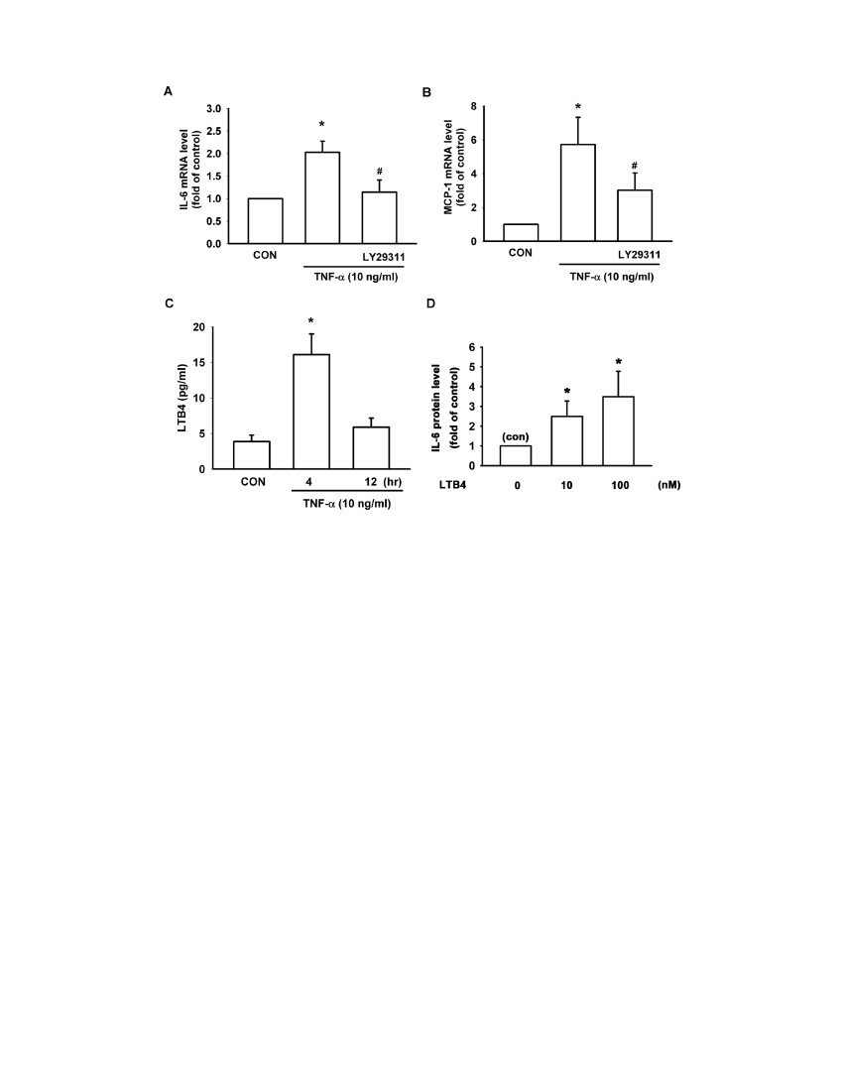
Figure 4. Knockdown of 5-LOX inhibits TNF-a-induced IL-6 and MCP-1 release in human synovial fibroblasts. Total protein extracts
from RASFs transfected with empty vector or 5-LOX shRNA were used for Western blotting. (A) Immunoblotting showed that cells transfected with 5-
LOX shRNA of clone No.3 and No.7 markedly decreased 5-LOX expression. Human synovial fibroblasts transfected with empty vector or 5-LOX shRNA
were treated with TNF-a for 6 hr. IL-6 and MCP-1 protein release in the conditioned medium was evaluated by ELISA. Note that knockdown of 5-LOX
decreased IL-6 (B) and MCP-1 (C) release following TNF-a treatment for 6 hr. Data are presented as mean 6 SEM. *, p,0.05 compared with empty
vector control (con).
doi:10.1371/journal.pone.0107890.g004
Statistics
The data given were means 6 S.E.M. The significance of
difference between the experimental group and control was
assessed by one-way analysis of variance (ANOVA) and 2-tailed
Student’s t-test. The difference is significant if the p value is less
than 0.05.
Results
Effect of 5-LOX inhibitors on TNF-a-induced IL-6
expression in human synovial fibroblasts
In inflammatory arthritis, synovial fibroblasts contribute to
synovium inflammation, angiogenesis, matrix degradation by its
abilities to produce inflammatory cytokines, matrix degradation
enzymes and angiogenic factor [22]. In addition, TNF-a is the
potent inflammatory cytokine and is responsible for synovial
fibroblasts-involved cartilage degradation. First of all, we exam-
ined whether TNF-a can enhance the production of pro-
5
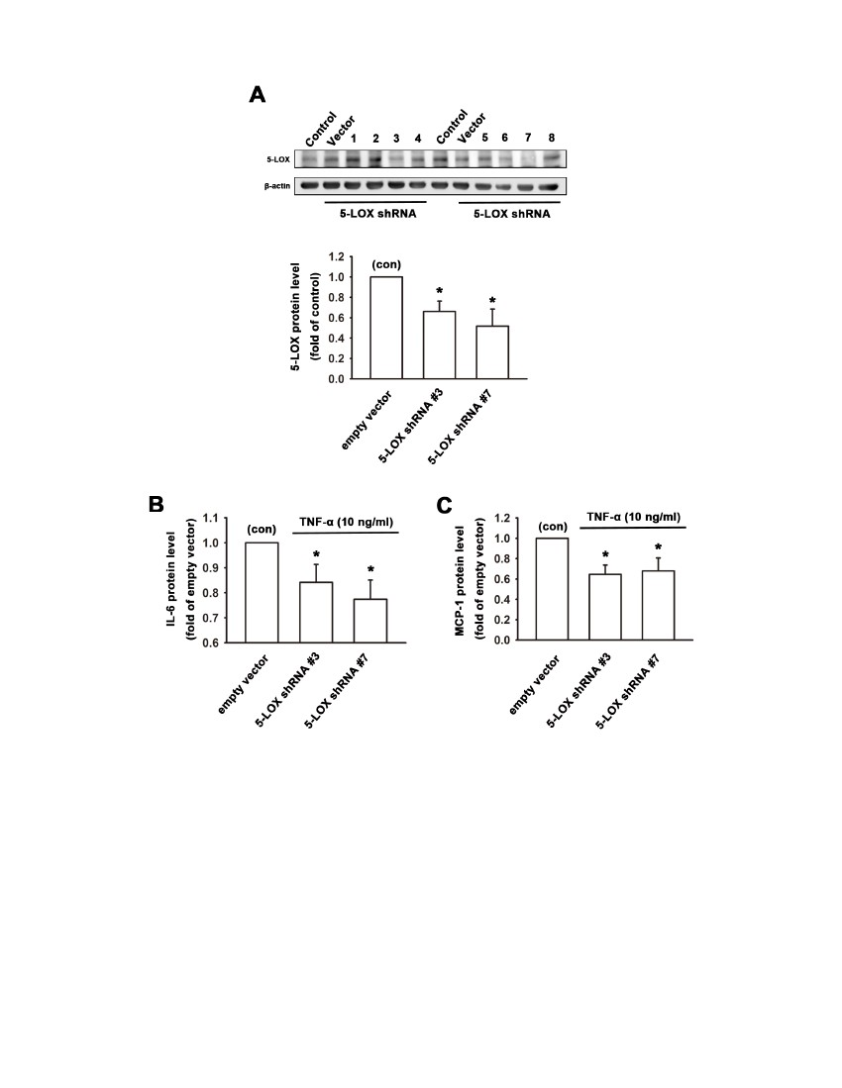
Figure 5. 5-LOX inhibitors antagonize TNF-a-induced IKKa/b activation, IkBa phosphorylation, IkBa degradation and NF-kB nuclear
translocation in human synovial fibroblasts. (A) Immunoblotting showed that treatment of TNF-a (10 ng/ml) enhanced the phosphorylation of
IkBa time-dependently in human synovial fibroblasts. (B) Human synovial fibroblasts were pre-incubated with 5-LOX inhibitors NDGA (10 mM) or MK-
886 (5 mM) for 1 hr and then exposed to TNF-a for another 10 min. Note that pretreatment with NDGA or MK-886 could antagonize TNF-a-induced
effects. (C) Human synovial fibroblasts were pretreated with NDGA (10 mM) or MK-886 (5 mM) for 1 hr. TNF-a (10 ng/ml) was then added for another
30 min. Cytosolic and nuclear extracts were separated by NE-PER kit. Note that NDGA or MK-886 significantly antagonized the nuclear translocation
of NF-kB subunits of p65 and p50. C23 was used as nucleus marker.
doi:10.1371/journal.pone.0107890.g005
inflammatory cytokine, IL-6. Human synovial fibroblasts were
incubated with TNF-a (10 ng/ml) in serum-free medium for
several time intervals. The mRNA and released protein level of IL-
6 were evaluated by quantitative PCR and ELISA, respectively.
Figures 1A and 1B showed that treatment with TNF-a enhanced
the mRNA and protein levels of IL-6 in a time-dependent manner.
Treatment of TNF-a for 6 hr increased mRNA expression of IL-6
to 28.263.9 fold of control (Figure 1A). In addition, treatment of
TNF-a also increased IL-6 protein release to 9.962.3 fold and
40.067.0 fold of control at 6 or 12 hr, respectively (Figure 1B).
To investigate the role of 5-LOX in rheumatoid arthritis,
human synovial fibroblasts were pretreated with 5-LOX inhibitors
NDGA (5 and 10 mM) and MK-886 (5 mM) for 1 hr and then
treated with TNF-a (10 ng/ml) for next 6 hr. mRNA extracted
from cell lysates was evaluated by quantitative PCR and the
conditioned medium collected was measured for IL-6 protein
release by ELISA assay. Real-time PCR analysis showed that
TNF-a significantly increased IL-6 mRNA levels and pretreat-
ment with 5-LOX inhibitors NDGA (5 and 10 mM) and MK-886
(5 mM) could inhibit the upregulatory effect of TNF-a by
54.766.0%, 91.464.3% and 57.3612.6%, respectively (Fig-
ure 1C). In addition, treatment with TNF-a increased the secreted
IL-6 in the conditioned medium and pretreatment of 5-LOX
inhibitors NDGA (5 and 10 mM) and MK-886 (5 mM) decreased
the TNF-a-induced IL-6 protein levels by 83.061.1%,
96.360.4% and 48.162.8%, respectively (Figure 1D).
Effect of 5-LOX inhibitors on TNF-a-induced MCP-1/CCL-2
expression in human synovial fibroblasts
One of potential therapy in RA is targeting chemokines and a
randomized clinical trial with an anti-CCL2/MCP-1 monoclonal
antibody in RA patients has been reported previously [23]. MCP-
1 plays a key role in leukocyte migration and recruitment of
mononuclear phagocytes during inflammation in the joint and
6
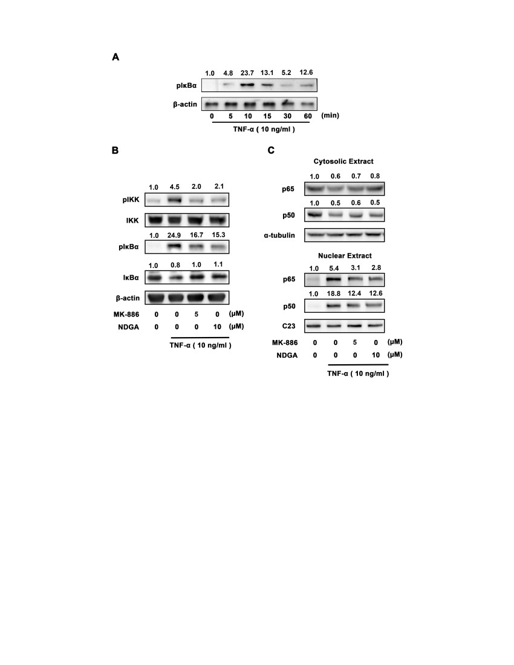
Figure 6. 5-LOX inhibitors antagonize TNF-a-induced nuclear translocation of p65. Immunofluorescent staining showed that p65
translocated into nucleus after treatment of TNF-a (25 ng/ml) for 30 min. Pretreatment of 5-LOX inhibitors NDGA (10 mM) or MK-886 (5 mM)
antagonized the nuclear translocation of p65. DAPI staining was used to indicate the location of nucleus. Scale: 5 mm.
doi:10.1371/journal.pone.0107890.g006
previous study indicated that there is overproduction of CCL-2/
MCP-1 in RA patient’s synovium [24]. To further elucidate the
anti-inflammatory effects of 5-LOX inhibitors in the rheumatoid
arthritis, human synovial fibroblasts were pretreated with 5-LOX
inhibitors NDGA (10 mM) and MK-886 (5 mM) for 1 hr and then
treated with TNF-a (10 ng/ml) for another 6 hr. mRNA levels
extracted from cell lysates was evaluated by Real-time PCR and
the supernatant was collected for measuring MCP-1 protein levels
by ELISA assay. Real-time PCR analysis showed that TNF-a
significantly increased MCP-1 mRNA expression to 4.560.5 fold
of vehicle control (Figure 2A). Pretreatment of 5-LOX inhibitors
NDGA (10 mM) and MK-886 (5 mM) decreased TNF-a-induced
MCP-1 mRNA levels by 70.6611.0%, and 77.963.2%, respec-
tively (Figure 2A). The released MCP-1 was analysed by ELISA
analysis and showed that treatment with TNF-a increased the
secreted MCP-1 in the conditioned medium to 4.060.1 fold of
vehicle control (Figure 2B). Pretreatment of 5-LOX inhibitors
NDGA (10 mM) and MK-886 (5 mM) antagonized TNF-a-
induced MCP-1 protein levels by 89.669.1%, and 63.8612.7%,
respectively (Figure 2B).
increase the expression of cytokines like TNF-a and IL-1b in
human synovial fibroblasts [26]. We thus investigated whether
LTB4 is involved incytokines release in human synovial fibroblasts.
Human synovial fibroblasts were pretreated with LTB4 receptor
antagonist LY29311 (1 mM) for 1 hr and then treated with TNF-a
(10 ng/ml) for another 6 hr. mRNA were extracted for Real-time
PCR analysis, and the results show that TNF-a-induced up-
regulation of IL-6 and MCP-1 were reduced by LY29311
(Figure 3A, 3B). In addition, treatment of TNF-a for 4 hr
increased the secretion of LTB4 from 3.960.9 to 16.162.9 (pg/
ml) (Figure 3C). Treatmentwith LTB4 at different concentrations
in serum-free RPMI medium for 6 hr and the quantity of IL-6 in
conditioned medium was measured. It was found that treatment
with LTB4 (10, 100 nM) increased secreted IL-6 protein levels to
2.560.5-fold and 3.560.3 fold of control, respectively (Figure 3D).
Knockdown of 5-LOX inhibits TNF-a-induced IL-6 and
MCP-1 release in human synovial fibroblasts
To further examine the role of 5-LOX in TNF-a-induced IL-6
and MCP-1 expression, 5-LOX knockdown was performed by
using 5-LOX shRNA and the protein release in the conditioned
medium in response to TNF-a administration was measured.
Total protein extracts from RASFs transfected with empty vector
or 5-LOX shRNA were analyzed by immunoblotting. Figure 4A
showed that cells transfected with 5-LOX shRNA No.3 and No.7
significantly decreased 5-LOX expression. Human synovial
fibroblasts transfected with empty vector or 5-LOX shRNA clone
No.3 and No.7 were then used to treat with TNF-a for 6 hr. IL-6
7
Involvement of leukotriene B4 in TNF-a-induced cytokine
expression in human synovial fibroblasts
Leukotriene B4 (LTB4) is one of 5-Lipoxygenase downstream
metabolites and plays an important role in pathogenesis of RA
[25]. Recent study has suggested that LTB4 is an essential and
non-redundant role in both acute and chronic inflammation of
rheumatoid arthritis [10]. In addition, exogenous LTB4 could
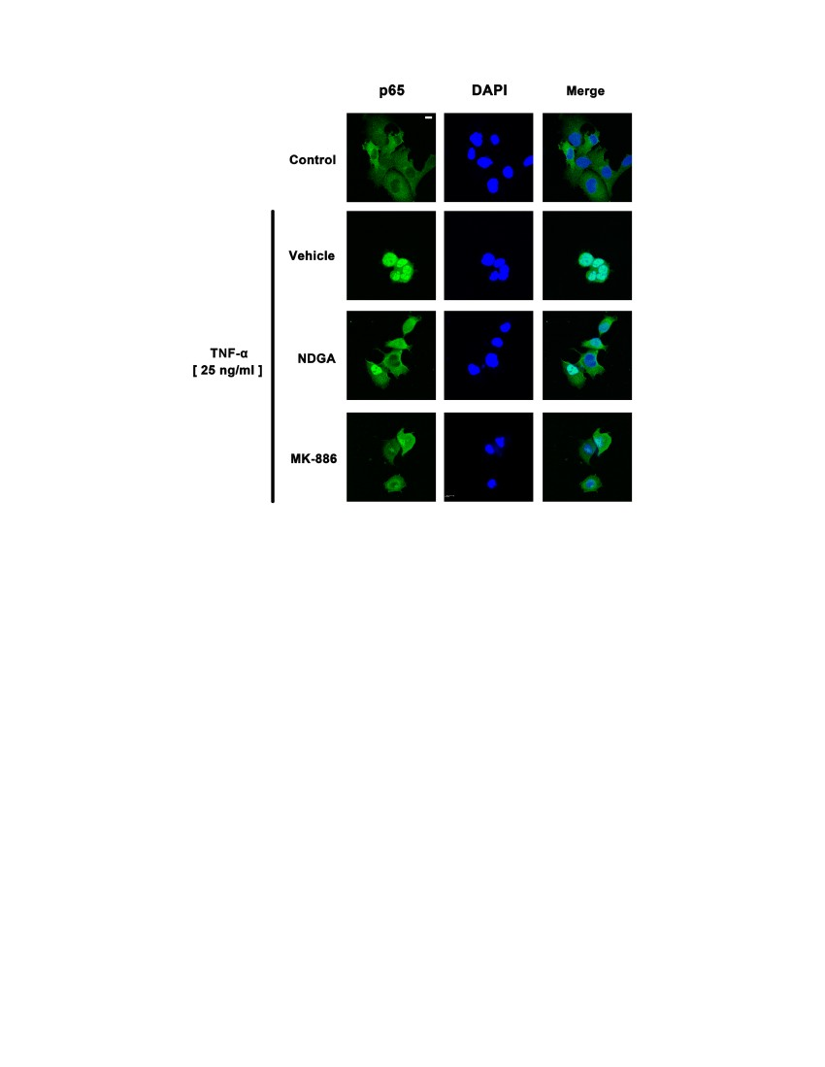
Figure 7. Antagonism by 5-LOX inhibitors on TNF-a-induced
up-regulation of serum monocyte chemo-attractant protein-1
(MCP-1) level and paw edema in mice. (A) Male C57BL/6 mice (8
weeks-old) were injected with TNF-a (40 mg/kg in 0.2 ml saline) into
femoral vein and 5-LOX inhibitor NDGA (10 mg/kg) was co-treated in
another cohort. After 6 hr, mice were sacrificed and serum was
collected for ELISA analysis. Note that mice injected with TNF-a
markedly increased MCP-1 levels in serum, which was inhibited by co-
treatment with 5-LOX inhibitor NDGA (10 mg/kg) (n = 4–5). (B) TNF-a
was intraplantarly injected onto the paw of male C57BL/6 mice (8
weeks-old). 5-LOX inhibitors, NDGA (10 mM) or MK-886 (10 mM) was co-
injected with TNF-a (10 ml). It was found that TNF-a induced acute paw
edema and increased paw thickness during 4–6 hr. Note that co-
administration of NDGA or MK-886 significantly attenuated TNF-a-
induced paw edema (n = 5). Data are presented as mean 6 SEM. *, p,
0.05 compared with vehicle control. #, p,0.05 compared with TNF-a-
treatment alone.
doi:10.1371/journal.pone.0107890.g007
Figure 8. Schematic diagram of the involvement of 5-LOX in
TNF-a-induced cytokine/chemokine release. TNF-a increased the
release of IL-6 and MCP-1 via the activation of NF-kB signaling in RASFs.
5-LOX inhibitors, NDGA or MK886 inhibited TNF-a-induced activation of
IKK and IkBa degradation. 5-LOX inhibitors also inhibited the
translocation of NF-kB subunits of p50 and p65 into nucleus (response
element) and then decreased TNF-a-induced IL-6 and MCP-1 release.
Knockdown of 5-LOX by RNAi exerted similar inhibitory effects.
doi:10.1371/journal.pone.0107890.g008
and MCP-1 protein release in the conditioned medium was
evaluated by ELISA analysis. It was found that knockdown of 5-
LOX with shRNA No.3 and No.7 decreased TNF-a-induced IL-6
protein release by 16.864.7% and 23.864.9%, respectively
(Figure 4B). In addition, knockdown of 5-LOX with shRNA
No.3 and No.7 reduced TNF-a-induced MCP-1 protein release by
36.665.2% and 32.667.9% following 6 hr treatment with TNF-a
(Figure 4C).
Effect of 5-LOX inhibitors on TNF-a-induced IKKa/b
activation, IkBa phosphorylation, IkBa degradation in
human synovial fibroblasts
NF-kB is implicated in the transcriptional regulation of
inflammatory response by TNF-a. Bondeson et al. [27] have
demonstrated that the activation of NF-kB plays an important role
in the inflammatory action of TNF-a in synovial fibroblasts. To
examine whether NF-kB pathway is involved in the antagonism of
5-LOX inhibitors on TNF-a-induced cytokine expression in
human synovial fibroblasts, IKKa/b activation, IkBa phosphor-
ylation, and IkBa degradation were evaluated by immunoblotting
after stimulation by TNF-a. Since the canonical NF-kB pathway is
induced by TNF-a and this activation leads to the recruitment and
activation of an IKK complex comprising IKK alpha and/or IKK
beta catalytic subunits. The IKK complex then phosphorylated
IkBa at ser32 and ser36 to produce ubiquitination of IkBa at
lysine residues and subsequent degradation by the 26 s protea-
some. NF-kB complex (p50 and p65), which is associated with IkB
to retain in the cytosol under resting state, is released and
translocates to the nucleus [28]. Therefore, we first investigated
the time-course of IkBa phosphorylation in human synovial
fibroblasts. Cells were treated by TNF-a (10 ng/ml) for 5, 10, 15,
30, and 60 min and total proteins were extracted for Western
blotting. The results showed that treatment with TNF-a (10 ng/
ml) enhanced the phosphorylation of IkBa time-dependently in
human synovial fibroblasts, and the phosphorylation of IkBa
reached a peak at 10 min (Figure 5A). Human synovial fibroblasts
were then pre-incubated with 5-LOX inhibitors NDGA (10 mM)
or MK-886 (5 mM) for 1 hr and then exposed to TNF-a for
another 10 min. It was found that pretreatment with NDGA or
MK-886 could antagonize TNF-a-induced IKKa/b activation,
IkBa phosphorylation and IkBa degradation (Figure 5B). Pre-
treatment of NDGA or MK-886 also inhibited the TNF-a-induced
nuclear translocation of NF-kB subunits of p50 and p65
(Figure 5C). Immunofluorescence staining was also used to
evaluate whether 5-LOX antagonized TNF-a-induced NF-kB
nuclear translocation. Human synovial fibroblasts were treated
8
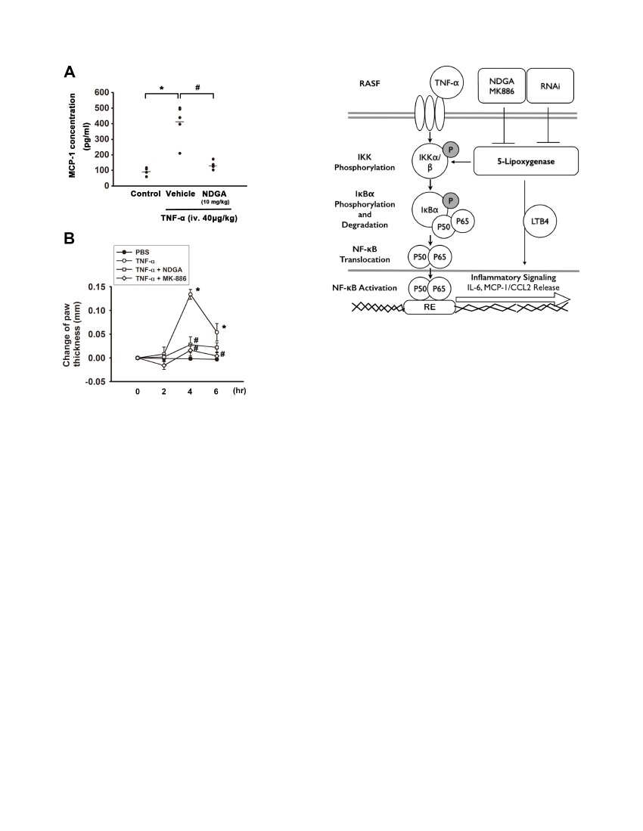
with TNF-a (25 ng/ml) for 30 min and p65 translocated into
nucleus (Figure 6). Pretreatment with 5-LOX inhibitors, including
NDGA (10 mM) and MK-886 (5 mM) for 1 hr antagonized TNF-
a-induced nuclear translocation of p65 (Figure 6). These results
indicated that 5-LOX inhibitors decreased TNF-a-induced
cytokine/chemokine expression via the abrogation of NF-kB
signalling.
Effect of 5-LOX inhibitors on TNF-a-induced monocyte
chemo-attractant protein-1 (MCP-1) release and paw
edema in animal model
We have elucidated the role of 5-LOX in TNF-a-induced
cytokines and chemokines production in vitro. We then examined
the effect of 5-LOX inhibitor in animal model. Male C57BL/6
mice were injected with TNF-a (40 mg/kg, via femoral vein) with
or without 5-LOX inhibitor NDGA (10 mg/kg). After 6 hr, mice
were sacrificed and serum was collected to perform ELISA
analysis. It was found that mice injected with TNF-a significantly
increased MCP-1 levels in serum to 4.460.6 fold of vehicle-treated
mice. However, co-treatment TNF-a with 5-LOX inhibitor
NDGA (10 mg/kg) significantly reduced TNF-a-induced MCP-1
protein release in serum by 67.964.3% (Figure 7A). Moreover, we
examined the effects of 5-LOX inhibitors on TNF-a-induced
acute paw edema in mice model. As shown in figure 7B,
intraplantar injection of TNF-a-increased the paw thickness and
the thickness reached the peak at 4 hr. Co-administration with 5-
LOX inhibitors, NDGA (10 mM) or MK-886 (10 mM) could
markedly ameliorate TNF-a-induced paw edema. These results
suggest that 5-LOX inhibitor can reduce TNF-a-induced
chemokine production and paw edema in vivo.
Discussion
Synovial fibroblasts play a pivotal role in early events of
rheumatoid arthritis [29]. Many factors contribute to synovial
fibroblasts activation and enhance the bone destruction [22].
Various reports have indicated that cytokines such as TNF-a, IL-
1b and IL-6 play key roles in driving the inflammation and
synovial cell proliferation characterizing rheumatoid arthritis-
associated joint destruction [30]. Moreover, synovial fibroblasts
have capacities to produce and secrete a wide range of pro-
inflammatory mediators, including cytokines like IL-1b, IL-6,
TNF-a and chemokines like MCP-1, MIP-1a [31]. Inflammatory
cytokines also can induce the release of additional inflammatory
factors and enhance the activation of synovial fibroblasts [32].
Furthermore, cytokines themselves can further promote more
inflammatory cytokines and chemokines in synovial fibroblasts,
amplifying inflammatory events in the synovium [33]. Therefore,
it is important to ameliorate the activation of synovial fibroblasts in
the treatment of inflammatory arthritis.
Current therapies of biologic agents for rheumatoid arthritis
have targeted these cytokines. Despite of the good efficacy of
biologic agents such as TNF-a or IL-1b blocker for many patients
with rheumatoid arthritis, augmented risk of some adverse side
effects such as infection [34] and malignancy [35] still persist in
concern. In addition, these biological therapies such as etanercept,
abatacept, rituximab, and tocilizumab for rheumatoid arthritis
directly target immune cells such as T and B cells and pro-
inflammatory cytokines. It indicates that other therapies and new
targets in the treatment of RA, especially ones targeting non-
immune cells like synovial fibroblasts may be possible.
5-lipoxygenase is reported to be present in RA synovium and
mostly expressed in macrophages, neutrophils and mast cells in the
sublining layer [16]. Here we found that synovial fibroblasts
9
isolated from rheumatoid arthritis patients express high protein
levels of 5-LOX which is consistent with high levels of leukotriene
B4, a 5-LOX downstream metabolite, found in synovial fluid in
rheumatoid arthritis patients [6]. Leukotrienes are regarded as
inflammatory mediators derived from the 5-LOX cascade of
arachidonic acid [36] and implicated in the pathogenesis of several
human acute and chronic inflammatory diseases such as athero-
sclerosis, dermatitis, cancer and rheumatoid arthritis [36]. Unlike
diseases such as asthma, allergic rhinitis, and ischemia/stroke that
associated with an overproduction of CysLTs, rheumatoid arthritis
is more linked to an overproduction of LTB4, another branch
downstream metabolite of 5-LOX [37]. LTB4 has long been
considered to have deleterious effects in arthritis. In atheroscle-
rosis, LTB4 can induce the overexpression of TNF-a, IL-6 and
MCP-1 mRNA in cultured monocytes, causing an inflammatory
environment [38]. In addition, we also found that exogenous
LTB4 increased IL-6 protein release in a concentration-dependent
manner in synovial fibroblasts, and the TNF-a-induced up-
regulation of IL-6 and MCP-1 were antagonized by the
pretreatment of leukotriene B4 receptor antagonist LY29311.
TNF-a is reported to be involved in the arachidonic acid
metabolism. TNF-a at 1 nM stimulates the lipoxygenase pathway,
and 5-LOX metabolites including LTB4 and 5-HETE increase in
human osteoblastic osteosarcoma cells [39]. Moreover, in immune
inflammation, it is found that TNF-a is involved in ovalbumin-
induced neutrophil migration through a LTB4-dependent mech-
anism so that MK-886, a 5-LOX inhibitor, inhibits the TNF-a-
induced neutrophil migration. TNF-a can also stimulate the
secretion of LTB4 from peritoneal cells [40]. LTB4 also promotes
TNF-a-induced CCL27 expression via the NF-kB pathway in
human keratinocytes [41]. Here we found that 5-LOX inhibitors,
including MK-886 and NDGA significantly antagonized TNF-a-
induced IL-6 and MCP-1 mRNA expression and protein release
in a concentration-dependent manner in human synovial fibro-
blasts. In addition, it was also found that knockdown of 5-LOX by
shRNA transient transfection reduced the protein release of IL-6
and MCP-1 in synovial fibroblasts, indicating that 5-LOX
pathway or even its downstream metabolites play a crucial role
in TNF-a-induced cytokine and chemokine upregulation in
human synovial fibroblasts. These findings are also consistent
with previous studies that mice lacking 5-LOX or treatment with
5-LOX inhibitor are protected from inflammatory arthritis [10].
NF-kB is activated during the early stage of joint inflammation
in human synovial tissue [42]. LTB4, the downstream metabolite
of 5-LOX, increases the mRNA expression of IL-6 and MCP-1 via
BLT1 and BLT2, G protein-coupled receptors of leukotrienes, via
a NF-kB-dependent mechanism in atherosclerosis [38]. Moreover,
LTB4 may amplify the NF-kB activation through Stat1-dependent
expression of MyD88 and reducing SOCS1 inhibition of MyD88
in mouse macrophages [43]. 5-LOX also plays a key role in LPS-
induced monocyte adhesion to vascular endothelium by increasing
expression of Mac-1 via NF-kB signaling pathways [44], indicating
that 5-LOX enzyme activities or its downstream metabolites may
be linked to NF-kB pathway. Here we found that 5-LOX
inhibitors including MK-886 and NDGA antagonized TNF-a-
induced IKKa/b activation, IkBa phosphorylation and IkBa
degradation in human synovial fibroblasts. Furthermore, 5-LOX
inhibitors also antagonized TNF-a-induced nuclear translocation
of NF-kB subunits of p65 and p50 in Western blotting and
immunofluorescent staining. Moreover, IkBa phosphorylation
and TNF-a-induced nuclear translocation of NF-kB subunits of
p65 were also antagonized by leukotriene B4 receptor antagonist
LY29311 (figure S1). These results suggest that 5-LOX and its
downstream products are involved in TNF-a-induced cytokines

and chemokines expression via the inhibition of NF-kB signaling
pathways in human synovial fibroblasts.
Here we found that mice treated with NDGA significantly
reduced TNF-a-induced up-regulation of MCP-1 in the serum
and TNF-a-induced paw edema, whereas 5-LOX inhibitor could
not completely reverse TNF-a-induced expression of IL-6 and
MCP-1, indicating that other signals are involved in this action. In
addition to LOX, arachidonic acid could also be metabolized by
COX-2 to produce the bioactive eicosanoids, which play another
pivotal part in the inflammatory arthritis. Developing novel 5-
LOX inhibitor or 5-LOX/COX-2 dual inhibitor is a therapeutic
strategy to treat inflammatory diseases including arthritis [45].
Neuro-inflammation of brain damage induced by permanent
cerebral ischemia and renal ischemia-reperfusion injury can be
protected by treatment of zileuton, a 5-LOX inhibitor [46,47]. 5-
LOX inhibitor, NDGA is reported to attenuate ovalbumin-
induced lung inflammation in rats [48]. Oral administration with
PF-4191834, which is developed by Pfizer, is able to ameliorate
arthritis-associated pain and inflammation in rat model [11]. In
addition, lecofelone, a COX/5-LOX inhibitor is reported to
inhibit the progress of osteoarthritis [49]. It has also been
demonstrated that PGE2 and LTB4 were increased in collagen
induced arthritis (CIA) paws, and combination of COX-2 and 5-
LOX inhibitors is able to inhibit the development of CIA [50]. In
RASF, TNF-a upregulates the secretion of PGE2 and IL-6, and
IL-6 can also be elevated by the addition of PGE2 [51].
Furthermore, TNF-a-induced IL-6 expression was reduced by
the treatment of selective COX-2 inhibitor NS-398. However,
PGE2 alone does not increase the expression of MCP-1 in RASF
[52]. These results reveal that both 5-LOX and COX are involved
in the TNF-a-induced up-regulation of cytokines. Other factors
may also be related to MCP-1 expression [53,54].
In conclusion, 5-LOX exerts a crucial role in chronic systemic
inflammation. We demonstrated that both 5-LOX inhibitors
antagonized TNF-a-induced IL-6 and MCP-1 expression via
inhibition of NF-kB activation in human RA synovial fibroblasts
(Figure 8). Moreover, 5-LOX inhibitor can reduce the TNF-a-
induced systemic inflammation and paw edema in vivo. Our
results reveal a novel mechanism in TNF-a-induced inflammation
and suggest new therapeutic strategies targeting 5-LOX for the
treatment of rheumatoid arthritis.
Supporting Information
Leukotriene B4 receptor antagonist LY29311
reverses TNF-a-induced IkBa phosphorylation and NF-
kB nuclear translocation in human synovial fibroblasts.
Human synovial fibroblasts were pre-incubated with leukotriene
B4 receptor antagonist LY29311 for 1 hr and then exposed to
TNF-a (10 ng/ml) for another 30 min. The whole cell lysate
results show that the phosphorylation of IkBa was decreased with
the treatment of LY29311 in RASF. Cytosolic and nuclear
extracts were separated by NE-PER kit. Note that LY29311
significantly antagonized the nuclear translocation of NF-kB
subunits of p65. C23 was used as nucleus marker.
(TIF)
Figure S1
Author Contributions
Performed the experiments: H.C. Lin THL. Analyzed the data: H.C. Lin
THL. Conceived the strategies and designed the experiments of this
manuscript: RSY WMF. Prepared the manuscript: H.C. Lin THL.
Supervised the project and edited the manuscript: RSY WMF. Performed
the animal studies: MYW H.C. Liou HJT. Contributed to obtain the
primary cell cultures: YCC CHT. Provided suggestions: MJH.
References
1. Brennan FM, McInnes IB (2008) Evidence that cytokines play a role in
rheumatoid arthritis. The Journal of clinical investigation 118: 3537–3545.
2. Pruzanski W, Vadas P, Stefanski E, Urowitz MB (1985) Phospholipase A2
activity in sera and synovial fluids in rheumatoid arthritis and osteoarthritis. Its
possible role as a proinflammatory enzyme. The Journal of rheumatology 12:
211–216.
3. Gilman SC, Chang J, Zeigler PR, Uhl J, Mochan E (1988) Interleukin-1
activates phospholipase A2 in human synovial cells. Arthritis and rheumatism
31: 126–130.
4. Bomalaski JS, Clark MA (1993) Phospholipase A2 and arthritis. Arthritis and
rheumatism 36: 190–198.
5. Martel-Pelletier J, Lajeunesse D, Reboul P, Pelletier JP (2003) Therapeutic role
of dual inhibitors of 5-LOX and COX, selective and non-selective non-steroidal
anti-inflammatory drugs. Annals of the rheumatic diseases 62: 501–509.
6. Davidson EM, Rae SA, Smith MJ (1983) Leukotriene B4, a mediator of
inflammation present in synovial fluid in rheumatoid arthritis. Annals of the
rheumatic diseases 42: 677–679.
7. Lewis RA, Austen KF, Soberman RJ (1990) Leukotrienes and other products of
the 5-lipoxygenase pathway. Biochemistry and relation to pathobiology in
human diseases. The New England journal of medicine 323: 645–655.
8. Gursel T, Firat S, Ercan ZS (1997) Increased serum leukotriene B4 level in the
active stage of rheumatoid arthritis in children. Prostaglandins, leukotrienes, and
essential fatty acids 56: 205–207.
9. Ahmadzadeh N, Shingu M, Nobunaga M, Tawara T (1991) Relationship
between leukotriene B4 and immunological parameters in rheumatoid synovial
fluids. Inflammation 15: 497–503.
10. Chen M, Lam BK, Kanaoka Y, Nigrovic PA, Audoly LP, et al. (2006)
Neutrophil-derived leukotriene B4 is required for inflammatory arthritis. The
Journal of experimental medicine 203: 837–842.
11. Masferrer JL, Zweifel BS, Hardy M, Anderson GD, Dufield D, et al. (2010)
Pharmacology of PF-4191834, a novel, selective non-redox 5-lipoxygenase
inhibitor effective in inflammation and pain. The Journal of pharmacology and
experimental therapeutics 334: 294–301.
12. Samuelsson B, Dahlen SE, Lindgren JA, Rouzer CA, Serhan CN (1987)
Leukotrienes and lipoxins: structures, biosynthesis, and biological effects. Science
237: 1171–1176.
13. Miller TA, Ghosh J, Myers CE, Macdonald TL (2000) 5-HETE congeners as
modulators of cell proliferation. Bioorganic & medicinal chemistry letters 10:
1913–1916.
14. Powell WS, Rokach J (2005) Biochemistry, biology and chemistry of the 5-
lipoxygenase product 5-oxo-ETE. Progress in lipid research 44: 154–183.
15. Hashimoto A, Murakami Y, Kitasato H, Hayashi I, Endo H (2007)
Glucocorticoids co-interact with lipoxin A4 via lipoxin A4 receptor (ALX) up-
regulation. Biomedicine & pharmacotherapy = Biomedecine & pharmacother-
apie 61: 81–85.
16. Gheorghe KR, Korotkova M, Catrina AI, Backman L, af Klint E, et al. (2009)
Expression of 5-lipoxygenase and 15-lipoxygenase in rheumatoid arthritis
synovium and effects of intraarticular glucocorticoids. Arthritis research &
therapy 11: R83.
17. Tang CH, Chiu YC, Tan TW, Yang RS, Fu WM (2007) Adiponectin enhances
IL-6 production in human synovial fibroblast via an AdipoR1 receptor, AMPK,
p38, and NF-kappa B pathway. Journal of immunology 179: 5483–5492.
18. Lin TH, Tang CH, Wu K, Fong YC, Yang RS, et al. (2011) 15-deoxy-
Delta(12,14) -prostaglandin-J2 and ciglitazone inhibit TNF-alpha-induced
matrix metalloproteinase 13 production via the antagonism of NF-kappaB
activation in human synovial fibroblasts. Journal of cellular physiology 226:
3242–3250.
19. Folco EJ, Sheikine Y, Rocha VZ, Christen T, Shvartz E, et al. (2011) Hypoxia
but not inflammation augments glucose uptake in human macrophages:
Implications for imaging atherosclerosis with 18fluorine-labeled 2-deoxy-D-
glucose positron emission tomography. Journal of the American College of
Cardiology 58: 603–614.
20. Philippe L, Alsaleh G, Suffert G, Meyer A, Georgel P, et al. (2012) TLR2
expression is regulated by microRNA miR-19 in rheumatoid fibroblast-like
synoviocytes. Journal of immunology 188: 454–461.
21. Cakmak H, Basar M, Seval-Celik Y, Osteen KG, Duleba AJ, et al. (2012) Statins
inhibit monocyte chemotactic protein 1 expression in endometriosis. Reproduc-
tive sciences 19: 572–579.
22. Neumann E, Lefevre S, Zimmermann B, Gay S, Muller-Ladner U (2010)
Rheumatoid arthritis progression mediated by activated synovial fibroblasts.
Trends in molecular medicine 16: 458–468.
23. Haringman JJ, Smeets TJ, Reinders-Blankert P, Tak PP (2006) Chemokine and
chemokine receptor expression in paired peripheral blood mononuclear cells
and synovial tissue of patients with rheumatoid arthritis, osteoarthritis, and
reactive arthritis. Annals of the rheumatic diseases 65: 294–300.
24. Koch AE, Kunkel SL, Harlow LA, Johnson B, Evanoff HL, et al. (1992)
Enhanced production of monocyte chemoattractant protein-1 in rheumatoid
arthritis. The Journal of clinical investigation 90: 772–779.
10

25. Mathis S, Jala VR, Haribabu B (2007) Role of leukotriene B4 receptors in
rheumatoid arthritis. Autoimmunity reviews 7: 12–17.
26. Xu S, Lu H, Lin J, Chen Z, Jiang D (2010) Regulation of TNFalpha and
IL1beta in rheumatoid arthritis synovial fibroblasts by leukotriene B4.
Rheumatology international 30: 1183–1189.
27. Bondeson J, Lauder S, Wainwright S, Amos N, Evans A, et al. (2007) Adenoviral
gene transfer of the endogenous inhibitor IkappaBalpha into human
osteoarthritis synovial fibroblasts demonstrates that several matrix metallopro-
teinases and aggrecanases are nuclear factor-kappaB-dependent. The Journal of
rheumatology 34: 523–533.
28. Perkins ND (2007) Integrating cell-signalling pathways with NF-kappaB and
IKK function. Nature reviews Molecular cell biology 8: 49–62.
29. Muller-Ladner U, Ospelt C, Gay S, Distler O, Pap T (2007) Cells of the
synovium in rheumatoid arthritis. Synovial fibroblasts. Arthritis research &
therapy 9: 223.
30. Park JY, Pillinger MH (2007) Interleukin-6 in the pathogenesis of rheumatoid
arthritis. Bulletin of the NYU hospital for joint diseases 65 Suppl 1: S4–10.
31. Abeles AM, Pillinger MH (2006) Statins as antiinflammatory and immunomod-
ulatory agents: a future in rheumatologic therapy? Arthritis and rheumatism 54:
393–407.
32. Noss EH, Brenner MB (2008) The role and therapeutic implications of
fibroblast-like synoviocytes in inflammation and cartilage erosion in rheumatoid
arthritis. Immunological reviews 223: 252–270.
33. Bartok B, Firestein GS (2010) Fibroblast-like synoviocytes: key effector cells in
rheumatoid arthritis. Immunological reviews 233: 233–255.
34. Dixon WG, Hyrich KL, Watson KD, Lunt M, Galloway J, et al. (2010) Drug-
specific risk of tuberculosis in patients with rheumatoid arthritis treated with
anti-TNF therapy: results from the British Society for Rheumatology Biologics
Register (BSRBR). Annals of the rheumatic diseases 69: 522–528.
35. Strangfeld A, Hierse F, Rau R, Burmester GR, Krummel-Lorenz B, et al. (2010)
Risk of incident or recurrent malignancies among patients with rheumatoid
arthritis exposed to biologic therapy in the German biologics register RABBIT.
Arthritis research & therapy 12: R5.
36. Peters-Golden M, Henderson WR, Jr. (2007) Leukotrienes. The New England
journal of medicine 357: 1841–1854.
37. Di Gennaro A, Haeggstrom JZ (2012) The leukotrienes: immune-modulating
lipid mediators of disease. Advances in immunology 116: 51–92.
38. Sanchez-Galan E, Gomez-Hernandez A, Vidal C, Martin-Ventura JL, Blanco-
Colio LM, et al. (2009) Leukotriene B4 enhances the activity of nuclear factor-
kappaB pathway through BLT1 and BLT2 receptors in atherosclerosis.
Cardiovascular research 81: 216–225.
39. Zhang W, Dziak R (1996) Tumor necrosis factor alpha stimulates arachidonic
acid metabolism in human osteoblastic osteosarcomal cells. Prostaglandins,
leukotrienes, and essential fatty acids 54: 427–431.
40. Canetti C, Silva JS, Ferreira SH, Cunha FQ (2001) Tumour necrosis factor-
alpha and leukotriene B(4) mediate the neutrophil migration in immune
inflammation. British journal of pharmacology 134: 1619–1628.
41. Kanda N, Watanabe S (2007) Leukotriene B(4) enhances tumour necrosis factor-
alpha-induced CCL27 production in human keratinocytes. Clinical and
experimental allergy: journal of the British Society for Allergy and Clinical
Immunology 37: 1074–1082.
42. Gilston V, Jones HW, Soo CC, Coumbe A, Blades S, et al. (1997) NF-kappa B
activation in human knee-joint synovial tissue during the early stage of joint
inflammation. Biochemical Society transactions 25: 518S.
43. Serezani CH, Lewis C, Jancar S, Peters-Golden M (2011) Leukotriene B4
amplifies NF-kappaB activation in mouse macrophages by reducing SOCS1
inhibition of MyD88 expression. The Journal of clinical investigation 121: 671–
682.
44. Lee SJ, Choi EK, Seo KW, Bae JU, Kim YH, et al. (2013) 5-Lipoxygenase plays
a pivotal role in endothelial adhesion of monocytes via an increased expression
of Mac-1. Cardiovascular research 99: 724–733.
45. Leone S, Ottani A, Bertolini A (2007) Dual acting anti-inflammatory drugs.
Current topics in medicinal chemistry 7: 265–275.
46. Patel NS, Cuzzocrea S, Chatterjee PK, Di Paola R, Sautebin L, et al. (2004)
Reduction of renal ischemia-reperfusion injury in 5-lipoxygenase knockout mice
and by the 5-lipoxygenase inhibitor zileuton. Molecular pharmacology 66: 220–
227.
47. Tu XK, Yang WZ, Wang CH, Shi SS, Zhang YL, et al. (2010) Zileuton reduces
inflammatory reaction and brain damage following permanent cerebral ischemia
in rats. Inflammation 33: 344–352.
48. Kim SY, Kim TB, Moon KA, Kim TJ, Shin D, et al. (2008) Regulation of pro-
inflammatory responses by lipoxygenases via intracellular reactive oxygen
species in vitro and in vivo. Experimental & molecular medicine 40: 461–476.
49. Brune K (2004) Safety of anti-inflammatory treatment–new ways of thinking.
Rheumatology 43 Suppl 1: i16–20.
50. Anderson GD, Keys KL, De Ciechi PA, Masferrer JL (2009) Combination
therapies that inhibit cyclooxygenase-2 and leukotriene synthesis prevent disease
in murine collagen induced arthritis. Inflammation research: official journal of
the European Histamine Research Society [et al] 58: 109–117.
51. Kunisch E, Jansen A, Kojima F, Loffler I, Kapoor M, et al. (2009) Prostaglandin
E2 differentially modulates proinflammatory/prodestructive effects of TNF-
alpha on synovial fibroblasts via specific E prostanoid receptors/cAMP. Journal
of immunology 183: 1328–1336.
52. Largo R, Diez-Ortego I, Sanchez-Pernaute O, Lopez-Armada MJ, Alvarez-
Soria MA, et al. (2004) EP2/EP4 signalling inhibits monocyte chemoattractant
protein-1 production induced by interleukin 1beta in synovial fibroblasts. Annals
of the rheumatic diseases 63: 1197–1204.
53. Kunisch E, Chakilam S, Gandesiri M, Kinne RW (2012) IL-33 regulates TNF-
alpha dependent effects in synovial fibroblasts. International journal of
molecular medicine 29: 530–540.
54. Villiger PM, Terkeltaub R, Lotz M (1992) Production of monocyte
chemoattractant protein-1 by inflamed synovial tissue and cultured synoviocytes.
Journal of immunology 149: 722–727.
11

