Different Cellular Responses of Dexmedetomidine at Infected Site and Peripheral Blood of Emdotoxemic BALB/c Mice
Rick Sai-Chuen Wu,1 King-Chuen Wu,2 Chiu-Chen Huang,1 Yi-Ying Chiang,1 Chia-Chen Chen,1 Ching-Lung Liao,3 Chin-Nan Chu,4 Jing-Gung Chung5,6
1Department of Anesthesiology, China Medical University Hospital, Taichung, Taiwan, Republic of China
2Department of Anesthesia, E-da Hospital / I-Shou University, Kaohsiung, Taiwan, Republic of China
3Graduate Institute of Chinese Medicine, China Medical University, Taichung 404, Taiwan
4Department of Radiation Oncology, China Medical University Hospital, Taichung, Taiwan, Republic of China
5Department of Biological Science and Technology, China Medical University, Taichung, Taiwan, Republic of China
6Department of Biotechnology, Asia University, Taichung, Taiwan, Republic of China
Received 9 September 2013; revised 21 May 2014; accepted 27 May 2014
ABSTRACT: Various sedative agents, including dexmedetomidine (dex), induce immunosuppression, and enhance infection progression. However, there was no information on how anesthetic affects local and systemic cellular immune function. We conducted this study to examine the impact of dex on the differentiation and function of immune cells at site of inﬂammation and in peripheral blood during endotoxemia of mice. In BALB/c mice with and without endotoxemia, we evaluated the inﬂuence of two dosages of 5 and 50 mcg/kg/h intravenous dex on immune cells: including number of T cells (CD3), B cells (CD19), natural killer cells (CD8a), monocytes (CD11b), and macrophages (Mac-3) in peripheral blood, the activities of macrophages in peripheral blood and in peritoneal lavage, and proliferation of B and T cells and of natural killer cells activity in the spleen. Endotoxemia increased the number of CD3 T cells, CD 19 B cells and macrophages in the peripheral blood, augmented macrophage activity in the peritoneum, and increased T cell proliferation and natural killer cell activity in the spleen. Further administration of 5 mcg/ kg/h dex attenuated systemic increase in number of T cells, B cells, and macrophages during endotoxemia and 50 mcg/kg/h dex signiﬁcantly attenuated the increase in activity of macrophages in the peripheral blood during endotoxemia. In the peritoneum, however, 5 mcg/kg/h dex preserved and 50 mcg/kg/h dexmedetomidine enhanced the activity of macrophages during endotoxemia. Increased in proliferation of T cells in spleen during endotoxemia was attenuated by both doses of dex. Last, 50 mcg/kg/h dex enhanced natural killer cells activity during endotoxemia. While preserving the effects of endotoxemia on macrophage’s activity in the infection site and natural killer cell’s activity in the spleen, dex decreased systemic fulminant immune reaction in endotoxemia, by attenuating the augmented response in the number
Correspondence to: Jing-Gung Chung; | Contract grant number: DMR-99-170
e-mail: jgchung@mail.cmu.edu.tw |  |  | Published | online | 00 | Month | 2014 | in | Wiley | Online | Library
Contract grant sponsor: China Medical University Hospital. |  | (wileyonlinelibrary.com). DOI: 10.1002/tox.22011
VC 2014 Wiley Periodicals, Inc.
 |  |  |  |  |  |  |  |  |  |  | 1

WU ET AL.
of T cells, B cells and macrophages, activity of macrophages in the peripheral blood, and proliferation of T cells in spleen during endotoxemia. V2014 Wiley Periodicals, Inc. Environ Toxicol 00: 000–000, 2014.
C
Keywords: dexmedetomidine; endotoxemia; BALB/c mice; immunomodulation
INTRODUCTION
Currently, sedation-related immune effects are important issues under investigation as recent studies showed that sedative agents modulate immune functions (Leonard and Redmond, 2003; Kurosawa and Kato, 2008; Yuki et al., 2011). However, while many studies on the effects of other common sedatives on the immune system had been conducted, there is little and inconsistent evidence on how dexmedetomidine (dex) affects immune functions at different tissue levels. There is a recent randomized controlled trial revealing the protective effect of dex against sepsis-related brain dysfunction and lung injury; the results of administrating dex had a better survival rate compared with those of lorazepam (Pandharipande et al., 2010). However, most dex studies were focused on the humoral component and less on cellular immune responses. Evidence from Nishina et al. showed that in both one and ten times the clinically relevant dosages, dex did not affect phagocytosis activity, chemotaxis or superoxide anion production of neutrophil in healthy volunteers in vitro (Nishina et al., 1999). However, studies on in vivo endotoxemic conditions reported that dex reduced neutrophil inﬁltration (Taniguchi et al., 2004), inhibited endotoxemiainduced augmentation of inﬂammatory cytokines, decreased cytokine responses of macrophages and monocytes (Straub et al., 1997; Taniguchi et al., 2004; Taniguchi et al., 2008), and improved survival rate (Taniguchi et al., 2008).
And there was no study comparing cellular responses of dex at different tissue levels (infected site and peripheral blood) to endotoxemia in the past. By administrating dex to BALB/c mice with or without endotoxemia and investigating the changes in cellular quantities (the number of B cells, T cells, monocytes, natural killer cells, and macrophages in peripheral blood) and functions (macrophages activity in peripheral blood and in peritoneal lavage, B cells and T cells proliferation, and the natural killer cells activity in spleen) of immune cells, we aim to study the differences. We postulated that dex may modulate different cellular immune responses at the infected site compared with that at the peripheral blood during endotoxemia. The results may be important in providing information on how dex may affect cellular immune response at the site of inﬂammation and in the peripheral blood during endotoxemia.
MATERIALS AND METHODS
The protocol for this study was designed to comply with the institutional animal ethical guidelines of China Medical Uni
versity Hospital and was approved by the Research Animal Resource Center Committee of China Medical University.
Endotoxemic BALB/c Mice Model
Male BALB/c mice (9-to 10-week-old, 20–30 g) from the National Laboratory Animal Center, Taipei, Taiwan were used. The mice were housed under 12-h light/dark cycles with free access to food and water.
Mice were anesthetized by intramuscular injection of
R
tiletamine-zolazepam 20 mg/kg (ZoletilV,Virbac) and xyla-
R
zine 10 mg/kg (RompunV, Bayer). Endotoxemia were induced by intraperitoneal injection of Escherichia coli (serotype: E. coli 055:B5, Sigma Co., St Louis, MO) lipopolysaccharides (LPS) 15 mg/kg (Gonzalez-Rey et al., 2006; Peng et al., 2013).
Study Design
Thirty mice were randomly allocated into ﬁve groups as following. Group 1 (Control): no treatment; Group 2 (LPS): intraperitoneal (i.p.) endotoxin with intravenous (i.v.) saline 2mLinfusion for 8h; Group3(LPS1Dex-5): i.p. endotoxin with i.v. dexmedetomidine 5 mcg/kg/h infusion for 8 h; Group 4 (LPS1Dex-50): i.p. endotoxin with i.v. dexmedetomidine high dose 50 mcg/kg/h infusion for 8 h; Group 5 (Dex-50): i.v. dexmedetomidine high dose 50 mcg/kg/h infusion for 8 h. According to the dosage in each group, dexmedetomidine was diluted with normal saline into 2 mL which was the controlled 8-h infusion volume.
Peripheral Blood Preparation and Staining for Cell Markers
One milliliter of whole blood was collected from each mouse. The blood samples were exposed to ammonium chloride in order to lyse the red blood cells, then washed and centrifuged at 1500 rpm at 40C for 15 min. Isolated white blood cells surface markers were stained with anti-CD3FITC (ﬂuorescein isothiocyanate), anti-CD19-PE, anti-CD11b-FITC, anti-CD8a-FITC, and anti-Mac-3-PE antibodies (BD Pharmingen, San Diego, CA) at 40Cfor 1h, and were examined for cell surface markers for T cells (CD3), B cells (CD19), monocytes (CD11b), natural killer cells (CD8a), and macrophages (Mac-3). The quantity for each cell surface marker was determined by ﬂow cytometry (FACS CaliburTM, Becton Dickinson, NJ) as described elsewhere by Loken et al. (Loken MR et al., 2000; Manhart et al., 2003).
Environmental Toxicology DOI 10.1002/tox
IMMUNOMODULATION OF DEXMEDETOMIDINE IN (ENDOTOXEMIC MICE)
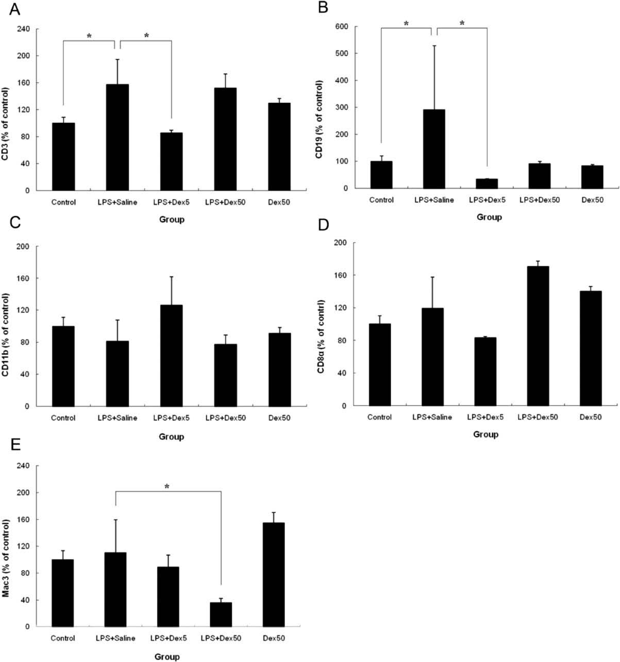
Fig. 1. The effects on white blood cell differential counts. (A) Dexmedetomidine decreased the surge of CD3 during endotoxemia; (B) Dexmedetomidine decreased the surge of CD19 during endotoxemia; (C) Dexmedetomidine has no signiﬁcant inﬂuence on the level of CD11b; (D) Dexmedetomidine has no signiﬁcant inﬂuence on the level CD8a; (E) Clinical relevant dose of dexmedetomidine (5 mg/kg/h) has no signiﬁcant inﬂuence on the level of Mac-3, but high dose does decrease the amount of macrophages. Levels of cell marker were presented as % of control. (*p < 0.05).

Analysis for Phagocytosis Activity of Macrophages
Macrophage phagocytosis was R
measured with PhagotestVkit (Glycotope Biotechnology GmbH, Heidelberg, Germany). Macrophages were isolated from peripheral blood and in peritoneal lavage. In order to allow phagocytosis, isolated cells from each group were incubated at 370Cwith opsonized FITC-labeled E. coli (20 3 1026 L) to allow phagocytosis. One hour later, the quenching solution (100 3 1026 L) was added to prevent further phagocytosis. After staining the DNA of the selected viable cells, their phagocytosis activity was determined by ﬂow cytometry in the manner described elsewhere by Tsou et al. (2009).
Assessment of Lymphocyte Proliferation
First, the splenocytes (1 3 105 cells/well) isolated from each mouse were mixed with RPMI-1640 medium (100 3 1026 L/well). Second, the splenocytes were cultured in phosphate-
Environmental Toxicology DOI 10.1002/tox
WU ET AL.
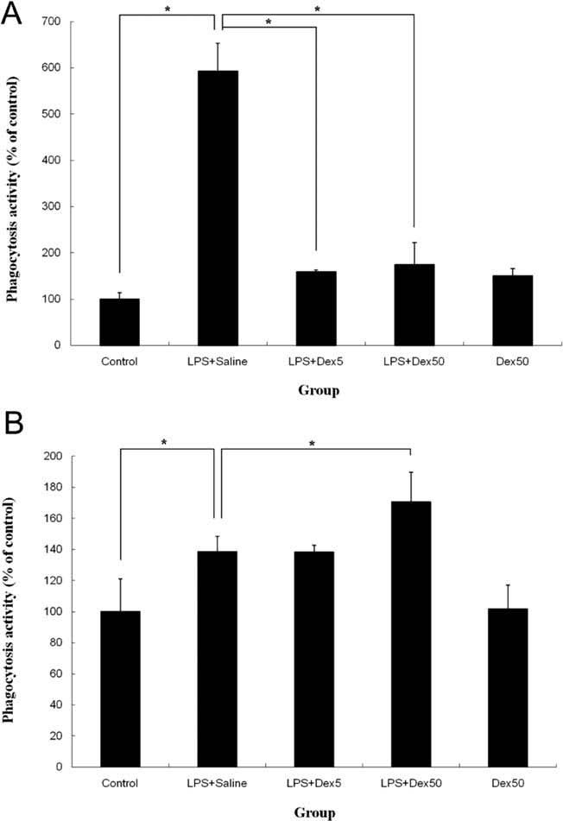
Fig. 2. The effects on macrophage activity. The phagocytosis activity of peripheral blood macrophage (A) and intraperitoneal macrophage (B). Endotoxemia stimulated both peripheral and intraperitoneal macrophage activity. Clinical relevant dose of dexmedetomidine (5 mg/kg/h) signiﬁcantly blunt the stimulation of peripheral macrophage. While systemic response of endotoxemia was depressed, the intraperitoneal macrophage activity was preserved (*p < 0.05).
buffered saline with LPS for 5 days before measuring the proliferation of B cells and were cultured in phosphate-buffered saline with Con A for 3 days before measuring the proliferation of T cells. After centrifugation at 1500 rpm for 5 min, cells proliferation was measured with CellTiter 96 Cell Proliferation Assay (MTS) kit (Promega, Madison, WI) in the manner described elsewhere by Kishikawa et al. (2008) and Yang et al. (2006).
Assay for Natural Killer Cells Activity
Splenocytes obtained from examined mice were cultured in RPMI-1640 medium (2.5 3 105 cells/mL). YAC-1 cells were prepared using the manufacture’s guidelines (PKH-67/ Dil.C buffer, Sigma-Aldrich Corp. St. Louis, MO). Splenocytes (1 3 105 cells/mL) mixed with YAC-1 cells (25 3 105 cells/mL) were incubated at 250C for 12 h. Natural killer cells activity was determined by ﬂow cytometry and propidium iodide exclusion as previously described by Lu et al (Yang et al., 2006; Lu et al., 2007).
Statistical Analysis
Data are shown as mean 6 SD. The statistical analyses were performed using SPSS 14.0 (SPSS Inc., Chicago, IL). Differences among groups were analyzed by One-way ANOVA followed by Student’s t test. The p value < 0.05 was considered statistically signiﬁcant.
RESULTS
Effects of Dexmedetomidine on White Blood Cells Differential Count in Endotoxemia
Endotoxemia in LPS group increased the numbers of T cells (CD3) and B cells (CD19) [Fig. 1(A,B)]. LPS1Dex-5 had signiﬁcant decreased in number of T cells (CD3) and B cells
Fig.3.TheeffectsonBcellsandTcellsproliferation.IsolatedsplenocyteswereculturedtodetermineBcells(A)andTcells(B)proliferation.(A)TherewasnosigniﬁcantchangeonBcellspro-liferation;(B)EndotoxemiaincreasedTcellsproliferationwhichwasreversedbyeitherdoseofdexmedetomidine(*p<0.05).
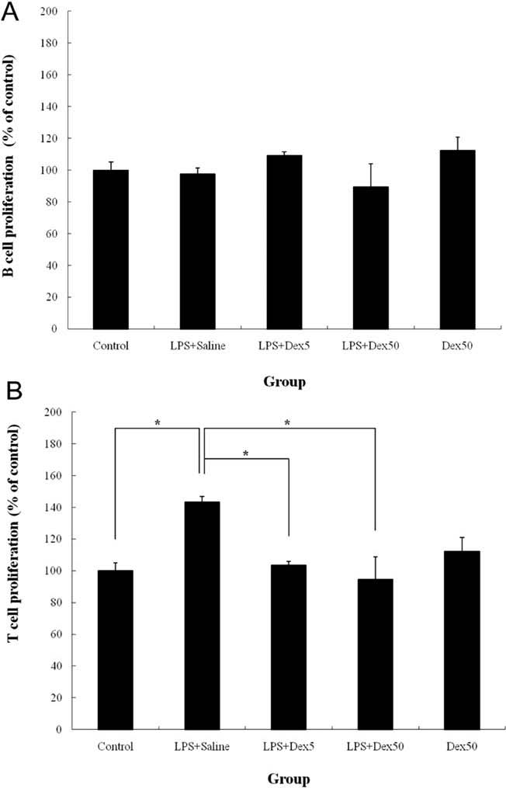
Environmental Toxicology DOI 10.1002/tox
IMMUNOMODULATION OF DEXMEDETOMIDINE IN (ENDOTOXEMIC MICE)
(CD19) induced by endotoxemia [Fig. 1(A,B)]. On the other hand, there was no signiﬁcant effect on the numbers of monocytes (CD11b), natural killer cells (CD8a) and macro-phages (Mac-3) [Fig. 1(C–E)]. LPS1Dex-50 did not further decrease the response of B cells (CD19) to endotoxemia [Fig. 1(B)] but decreased the number of macrophages (Mac3) during endotoxemia [Fig. 1(E)].
Effects of dex on Phagocytosis Activity of Macrophages in Endotoxemia
Endotoxemia in LPS group increased phagocytosis activity of macrophages in peripheral blood [Fig. 2(A)]. LPS1Dex-5 attenuated the effect on phagocytosis activity of circulating macrophages during endotoxemia [Fig. 2(A)] but did not signiﬁcantly affect the activity of intraperitoneal macro-phages [Fig. 2(B)]. LPS1Dex-50 did not further attenuate the effect of phagocytosis on circulating macrophages during endotoxemia [Fig. 2(A)] but increased the phagocytosis activity of intraperitoneal macrophages [Fig. 2(B)].
Effects of Dexmedetomidine on B Cells and T Cells Proliferation in Endotoxemia
In this study, neither doses of dexmedetomidine affected B cells proliferation; however, both doses of dexmedetomidine attenuated the proliferation of T cells during endotoxemia to a similar degree [Fig. 3(B)].
Effects of Dexmedetomidine on Natural Killer Cells Activity in Endotoxemia
Endotoxemia increased natural killer cells activity (Fig. 4). However, LPS1Dex-5 showed unremarkable effect on natural killer cells activity. In contrast, LPS1Dex-50 signiﬁcantly enhanced the activity of natural killer cells during endotoxemia.
The effects of dexmedetomidine on the quantity and the function of immune cells during endotoxemia are summarized in Table I.

DISCUSSION
In this in vivo experiment, endotoxemia increased the numbers of T cells (CD3) and B cells (CD19) but did not affect the numbers of monocytes (CD11b), natural killer cells (CD8a) or macrophages (Mac-3) in the peripheral blood (Fig. 1). On the other hand, Dex (5 mcg/kg/h) signiﬁcantly attenuated the augmentation of CD3 and CD19 during endotoxemia. These effects would probably attenuate hyper-reactive systemic inﬂammation response during endotoxemia. While circulating T cells and B cells were increased during endotoxemia, the analysis of the lymphocyte cultures showed that the potential of T cells proliferation was increased while no signiﬁcant response in B cells proliferation was observed. In this study, both doses of dex (5 mcg/kg/h, 50 mcg/kg/h) suppressed the stimulation of endotoxemia on T cells proliferation to a similar degree (Fig. 3). This ﬁnding provides possible mechanism that dex reduces vigorous inﬂammatory responses by suppressing the activation of adapted immune system, which in turn attenuates the augmentation of inﬂammatory cytokines, decreasing the responses of macrophages and monocytes (Straub et al., 1997; Taniguchi et al., 2004; Taniguchi et al., 2008).
Fig.4.TheeffectsonNKcellactivity.NKcellwasmixedwithtargetcellsintwodifferentproportions.Inbothpropor-tions,NKcellactivitywaspreservedwithclinicalrelevantdoseofdexmedetomidine.HighdosedexmedetomidinesigniﬁcantlyincreasestheNKcellactivity(*p<0.05).
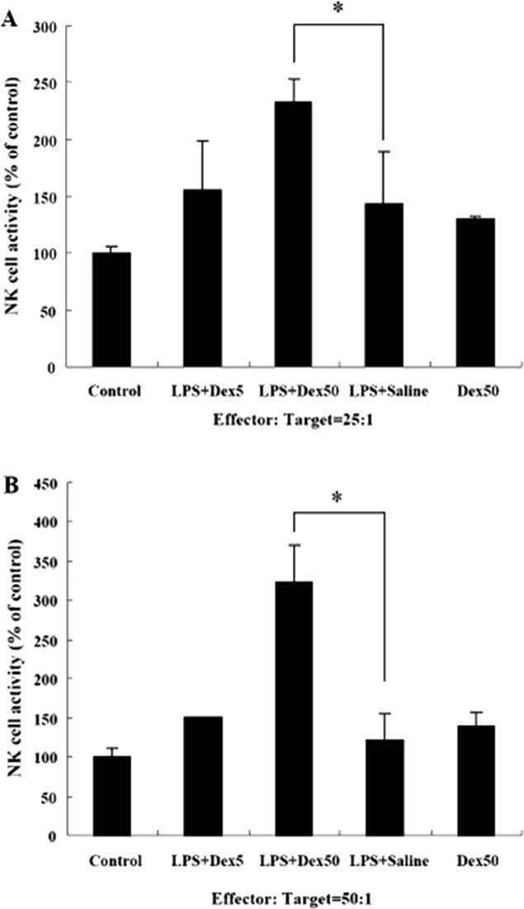
In addition, the numbers of circulating monocytes and macrophages, representing innate immune response, were not signiﬁcantly affected by endotoxemia in this study. Only 50 mcg/kg/h dex decreased the number of circulating macro-phages during endotoxemia [Fig. 1(E)]. Kishikawa et al.
Environmental Toxicology DOI 10.1002/tox
WU ET AL.
TABLE I. Summary of immune responses of endotoxemia and dexmedetomidine
Changes in Quantity
T Cells B Cells Monocytes Natural Killer Macrophages (CD3) (CD19) (CD11b) Cells (CD8a) (Mac-3)
LPS 1 Salinea "" —— — LPS 1 Dex5b ## —— — LPS 1 Dex50b— — — — #
Changes in Function
Macrophages Macrophages B cells T cells Natural killer in circulation from lavage proliferation proliferation cells activity
LPS 1 Salinea "" — "" LPS 1 Dex5b # —— # — LPS 1 Dex50b #" — #"
aCompared with control group. bCompared with LPS 1 Saline group.
showed that high dose dex induced human neutrophil apoptosis (Kishikawa et al., 2008). In our study, we suspected that the decreased number of circulating macrophages in endotoxemic mice after high dose dex treatment may be caused by an apoptotic effect of dex on immune cells. However, in contrast to Kishikawa’s study, we found that 50 mcg/kg/h dex not only reduced the number of macrophages but also augmented the effect of intraperiotoneal macro-phages activity. A possible hypothesis to explain the decreased number of circulating macrophages would be the dedication of the circulating macrophages into the infection site. Nonetheless, this hypothesis requires further study.
Macrophages, as antigen-presenting cells, not only initiate innate and adapted immune responses but also process antitumor activities (Unanue, 1984). Endotoxemia increases phagocytosis activity of circulating and intraperitoneal macrophages as shown in Figure 2(A,B), respectively. Systemically, dex signiﬁcantly attenuated the response of circulating macrophages to endotoxemia. The modulation of systemic macrophages activity was compatible with, and explained the results of, previous studies that showed decreased concentration of inﬂammatory cytokines during endotoxemia with the use of dex (Straub et al., 1997; Taniguchi et al., 2004; Taniguchi et al., 2008). Intraperitoneal macrophage activity was increased in only high but not low dose of dex, as shown in Figure 2(B). From the results, we can say that during endotoxemia, 5 mcg/kg/h dex preserved only the macrophages activity at the infection site and stabilized the systemic response. In contrast, 50 mcg/kg/h dex further increased macrophages activity at the infection site. Thus, we speculated that whenever infection is a concern, dex might be a reasonable choice for ICU sedation and surgical anesthesia.
Natural killer cells play a key role in bridging innate and adapted immune responses and provide defense in the beginning of an infection. More importantly, natural killer cells attack tumor cells and prevent tumor progression. It was reported in an in vivo human study that the number of natural killer cells signiﬁcantly decreased after the use of propofol and fentanyl, which are commonly used for ICU sedation and pain control.
Decreased number and suppressed activity of natural killer cells increase not only the risk of infection but also the susceptibility, recurrence, and metastases of tumors (Unanue, 1984; Haliotis et al., 1985; Trinchieri, 1989; Schreiber, 1999; Dunn et al., 2002; Brand et al., 2003; Vallejo et al., 2003; Kurosawa and Kato, 2008). In our study, there was no signiﬁcant change in the number of natural killer cells during endotoxemia with and without dex [Fig. 1(D)]. However, the activity of natural killer cells during endotoxemia was signiﬁcantly increased with 50 mcg/kg/h but not with 5 mcg/kg/h dex (Fig. 4).
In summary, while preserving infection site macrophages activity and systemic natural killer cells activity, 5 mcg/kg/h dex in endotoxemia modulated immune reaction by decreasing the augmentation of circulating B cells and T cells, by reducing T cells proliferation in the spleen, and by attenuating the activation of systemic macrophages. In addition, 50 mcg/kg/h dex in endotoxemia though did not produce cell proliferation, but did enhance the activity of natural killer cells and macrophages at the infection site.
The authors also thank Yu-tien Lee for her work in editing this manuscript.
REFERENCES
Benjamini E, Coico R, Sunshine G. 2003. Complement, Immunol
ogy: A Short Course, 5th edition, John Wiley and Son Inc.,
Hoboken, New Jersey Publication. pp 185–198.
Brand JM, Frohn C, Luhm J, Kirchner H, Schmucker P. 2003. Early alterations in the number of circulating lymphocyte
Environmental Toxicology DOI 10.1002/tox
IMMUNOMODULATION OF DEXMEDETOMIDINE IN (ENDOTOXEMIC MICE)

subpopulations and enhanced proinﬂammatory immune response during opioid-based general anesthesia. Shock 20: 213–217.
Dunn GP, Bruce AT, Ikeda H, Old LJ, Schreiber RD. 2002. Cancer immunoediting: From immunosurveillance to tumor escape. Nat Immunol 3:991–998.
Gonzalez-Rey E, Chorny A, Varela N, Robledo G, Delgado M. 2006. Urocortin and adrenomedullin prevent lethal endotoxemia by down-regulating the inﬂammatory response. Am J Pathol 168:1921–1930.
Haliotis T, Ball JK, Dexter D, Roder JC. 1985. Spontaneous and induced primary oncogenesis in natural killer (NK)-cell-deﬁcient beige mutant mice. Int J Cancer 35:505–513.
Kishikawa H, Kobayashi K, Takemori K, Okabe T, Ito K, Sakamoto A. 2008. The effects of dexmedetomidine on human neutrophil apoptosis. Biomed Res 29:189–194.
Kurosawa S, Kato M. 2008. Anesthetics, immune cells, and immune responses. J Anesth 22:263–277.
Leonard SA, Redmond HP. 2003. Effects of volatile and intravenous anesthetic agents on neutrophil function. Int Anesthesiol Clin 41:21–29.
Loken MR, Green CI, Wells DA. 2000. Immunoﬂuorescence of surface markers. In Flow Cytometry: A Practical Approach, Ormerod MG Edition, Oxford. Oxford University Press. pp 61–82.
Lu HF, Liu JY, Hsueh SC, Yang YY, Yang JS, Tan TW, Kok LF, Lu CC, Lan SH, Wu SY, et al. 2007. (-)-Menthol inhibits WEHI3 leukemia cells in vitro and in vivo. In Vivo 21:285–289.
Manhart N, Spittler A, Bergmeister H, Mittlbock M, Roth E. 2003. Inﬂuence of fructooligosaccharides on Peyer’s patch lymphocyte numbers in healthy and endotoxemic mice. Nutrition 19(7-8):657–660.
Nishina K, Akamatsu H, Mikawa K, Shiga M, Maekawa N, Obara H, Niwa Y. 1999. The effects of clonidine and dexmedetomidine on human neutrophil functions. Anesth Analg 88:452–458.
Pandharipande PP, Sanders RD, Girard TD, McGrane S, Thompson JL, Shintani AK, Herr DL, Maze M, Ely EW. 2010. Effect of dexmedetomidine versus lorazepam on outcome in patients with sepsis: an a priori-designed analysis of the MENDS randomized controlled trial. Crit Care 14:R38.
Peng M, Wang YL, Wang CY, Chen C. 2013. Dexmedetomidine attenuates lipopolysaccharide-induced proinﬂammatory response in primary microglia. J Surg Res 179:e219–225.
Schreiber H. 1999. Tumor immunology. In: Paul WE, editor. Fundamental Immunology. 4th Edn., Philadelphia: Lippincott-Raven Publishers pp 1237–1270.
Straub RH, Herrmann M, Berkmiller G, Frauenholz T, Lang B, Scholmerich J, Falk W. 1997. Neuronal regulation of interleukin 6 secretion in murine spleen: Adrenergic and opioidergic control. J Neurochem 68:1633–1639.
Taniguchi T, Kidani Y, Kanakura H, Takemoto Y, Yamamoto K. 2004. Effects of dexmedetomidine on mortality rate and inﬂammatory responses to endotoxin-induced shock in rats. Crit Care Med 32:1322–1326.
Taniguchi T, Kurita A, Kobayashi K, Yamamoto K, Inaba H. 2008. Dose-and time-related effects of dexmedetomidine on mortality and inﬂammatory responses to endotoxin-induced shock in rats. J Anesth 22:221–228.
Trinchieri G. 1989. Biology of natural killer cells. Adv Immunol 47:187–376.
Tsou MF, Peng CT, Shih MC, Yang JS, Lu CC, Chiang JH, Wu CL, Lin JP, Lo C, Fan MJ, Chung JG. 2009. Benzyl isothiocyanate inhibits murine WEHI-3 leukemia cells in vitro and promotes phagocytosis in BALB/c mice in vivo. Leuk Res 33:1505–1511.
Unanue ER. 1984. Antigen-presenting function of the macrophage. Annu Rev Immunol 2:395–428.
Vallejo R, Hord ED, Barna SA, Santiago-Palma J, Ahmed S. 2003. Perioperative immunosuppression in cancer patients. J Environ Pathol Toxicol Oncol 22:139–146.
Yang JS, Kok LF, Lin YH, Kuo TC, Yang JL, Lin CC, Chen GW, Huang WW, Ho HC, Chung JG. 2006. Diallyl disulﬁde inhibits WEHI-3 leukemia cells in vivo. Anticancer Res 26(1A):219–225.
Yuki K, Soriano SG, Shimaoka M. 2011. Sedative drug modulates T-cell and lymphocyte function-associated antigen-1 function. Anesth Analg 112:830–838.
Environmental Toxicology DOI 10.1002/tox
䘀椀最⸀㌀⸀吀栀攀攀昀昀攀挀琀猀漀渀䈀挀攀氀氀猀愀渀搀吀挀攀氀氀猀瀀爀漀氀椀昀攀爀愀琀椀漀渀⸀䤀猀漀氀愀琀攀搀猀瀀氀攀渀漀挀礀琀攀猀眀攀爀攀挀甀氀琀甀爀攀搀琀漀搀攀琀攀爀洀椀渀攀䈀挀攀氀氀猀⠀䄀⤀愀渀搀吀挀攀氀氀猀⠀䈀⤀瀀爀漀氀椀昀攀爀愀琀椀漀渀⸀⠀䄀⤀吀栀攀爀攀眀愀猀渀漀猀椀最渀椀ǻ挀愀渀琀挀栀愀渀最攀漀渀䈀挀攀氀氀猀瀀爀漀ⴀ氀椀昀攀爀愀琀椀漀渀㬀⠀䈀⤀䔀渀搀漀琀漀砀攀洀椀愀椀渀挀爀攀愀猀攀搀吀挀攀氀氀猀瀀爀漀氀椀昀攀爀愀琀椀漀渀眀栀椀挀栀眀愀猀爀攀瘀攀爀猀攀搀戀礀攀椀琀栀攀爀搀漀猀攀漀昀搀攀砀洀攀搀攀琀漀洀椀搀椀渀攀⠀⨀瀀㰀 ⸀ 㔀⤀⸀
䘀椀最⸀㐀⸀吀栀攀攀昀昀攀挀琀猀漀渀一䬀挀攀氀氀愀挀琀椀瘀椀琀礀⸀一䬀挀攀氀氀眀愀猀洀椀砀攀搀眀椀琀栀琀愀爀最攀琀挀攀氀氀猀椀渀琀眀漀搀椀昀昀攀爀攀渀琀瀀爀漀瀀漀爀琀椀漀渀猀⸀䤀渀戀漀琀栀瀀爀漀瀀漀爀ⴀ琀椀漀渀猀Ⰰ一䬀挀攀氀氀愀挀琀椀瘀椀琀礀眀愀猀瀀爀攀猀攀爀瘀攀搀眀椀琀栀挀氀椀渀椀挀愀氀爀攀氀攀瘀愀渀琀搀漀猀攀漀昀搀攀砀洀攀搀攀琀漀洀椀搀椀渀攀⸀䠀椀最栀搀漀猀攀搀攀砀洀攀搀攀琀漀洀椀搀椀渀攀猀椀最渀椀ǻ挀愀渀琀氀礀椀渀挀爀攀愀猀攀猀琀栀攀一䬀挀攀氀氀愀挀琀椀瘀椀琀礀⠀⨀瀀㰀 ⸀ 㔀⤀⸀

