Spontaneous bilateral dural arteriovenous fistulas with pulsatile tinnitus
January 19, 2015 by Tzu-Chieh Lin, MD; Hsiung-Kwang Chung, MD; Jeng-Nan Hsu, MD

Abstract
Pulsatile tinnitus with normal otoscopic findings often presents a diagnostic challenge to otolaryngologists and can be attributed to serious vascular malformations such as dural arteriovenous fistulas (DAVFs). Spontaneous DAVFs are relatively rare. A 65-year-old woman presented with sudden-onset subjective/objective pulsatile tinnitus on the right side that had persisted for 2 months. Angiography and magnetic resonance angiography revealed DAVF formation. Stereotactic radiosurgery was performed, and total remission of the DAVFs was achieved.

Introduction
Pulsatile tinnitus is the perception of a rhythmic sound with cardiac rhythm. It may be perceived only by the patient (subjective tinnitus) or by both the patient and the examining physician (objective tinnitus). Objective pulsatile tinnitus is a rare symptom that may be the first manifestation of potentially life-threatening disorders of the central nervous system.1 Vascular lesions, including dural arteriovenous fistulas (DAVFs), carotid cavernous fistulas, stenosis or dissection of brain-supplying arteries, and fibromuscular dysplasia are the most frequent causes of pulsatile tinnitus, followed by nonvascular causes such as glomus tumors and highly vascularized intracranial tumors.1-3 DAVFs, also known as dural arteriovenous malformations, are abnormal direct connections between a meningeal artery and a meningeal vein or dural venous sinus.
In this article, we present the case of a woman who had bilateral DAVFs but an otherwise normal medical profile. The DAVFs were detected by angiography and magnetic resonance angiography (MRA), and stereotactic radiosurgery alone was effective against the DAVFs.

Case report
A 65-year-old woman presented at our clinic on November 19, 2009. She complained of sudden-onset subjective/objective pulsatile tinnitus on the right side that had persisted for 2 months. She denied having any major underlying medical problem or any trauma history. Physical examination showed intact bilateral eardrums and a smooth nasopharyngeal mucosa with patent eustachian tube orifices. Her vital signs were within normal limits.
Pulsatile, roaring tinnitus was heard over the right upper neck and periauricular region. MRA conducted on November 30, 2009, showed numerous abnormal vessels adjacent to the right sigmoid /transverse sinuses (figure 1). The image findings indicated DAVFs. Angiography performed 10 days after the MRA showed arteriovenous fistulas at the torcular, right transverse sinus, and sigmoid sinus areas, with multiple feeding arteries from the right middle meningeal artery, right occipital artery, right meningohypophyseal trunk, left occipital artery, and both posterior meningeal arteries (figure 2). We diagnosed the patient with bilateral dural transverse/sigmoid sinus fistulas.

Figure 1. Time-of-flight MRA with maximum-intensity projection reconstruction shows numerous abnormal vessels (arrow) abutting the right tranverse/sigmoid sinus, indicating a dural arteriovenous fistula involving these dural sinuses.
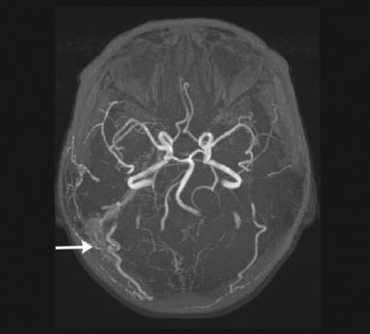

Figure 2. Angiography of the right ECA, early arterial phase, anteroposterior (A) and lateral (B) views, shows early filling of the right transverse and sigmoid sinuses (white arrows) and numerous feeding arteries from the right middle meningeal artery and occipital artery (black arrows). Angiography of the left ECA, early arterial phase, anteroposterior view (C), shows numerous feeding arteries from the left occipital artery (arrow) and early filling of the right transverse sinus. Angiography of the left vertebral artery (D) shows numerous feeding arteries from the posterior meningeal artery (arrow).
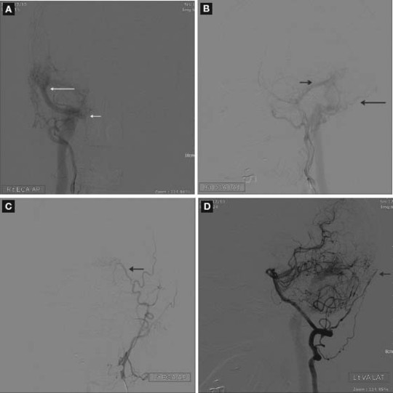
For treatment, stereotactic radiosurgery was conducted on January 5, 2010. The right pulsatile tinnitus completely resolved approximately 1 month after the surgery, and no major complications have been found thus far. MRA conducted in March (figure 3) and angiography conducted in July 2010 (figure 4) showed total remission of the fistulas.

Figure 3. Time-of-flight MRA obtained after stereotactic radiosurgery reveals that the abnormal vessels abutting the right transverse/sigmoid sinus have dramatically disappeared (compare to figure 1).
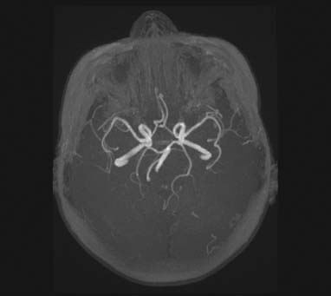

Figure 4. Angiography of the right common carotid artery (A), left common carotid artery (B), and vertebral artery (C) after stereotactic radiosurgery reveals no early filling of the right transverse/sigmoid sinus and disappearance of the feeding arteries.
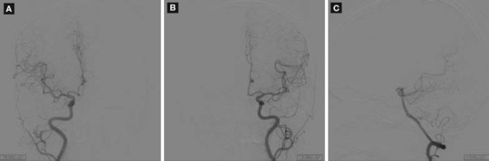

Discussion
To ensure optimal diagnosis when pulsatile tinnitus is a symptom, it is imperative to know the nature of the tinnitus (objective vs. subjective) and to thoroughly examine the medical history and physical parameters of the patient4; pulsatile tinnitus can indicate serious vascular malformations such as DAVFs.
The findings of otoscopy are mostly normal in patients with pulsatile tinnitus. Computed tomography scans have been found to be relatively insensitive for the detection of DAVFs; magnetic resonance imaging (MRI) and MRI/MRA are significantly more sensitive. A previous study showed that MRI/MRA examination reveals anatomic abnormalities corresponding with pulsatile tinnitus in 63% of patients with subjective tinnitus.5 Therefore, for subjective tinnitus, MRI/MRA is an appropriate initial diagnostic modality. When a patient has objective pulsatile tinnitus, the clinician may choose to conduct angiography to ensure that DAVFs are not missed.5
Three main theories have been put forth to describe the pathogenesis of DAVFs. The first states that DAVFs are formed because of dural sinus thrombosis and subsequent venous hypertension.6 The second theory states that DAVFs are formed as a result of an increase in the levels of angiogenic factors released from the brain or dura mater.7 Finally, the third theory cites an underlying hypercoagulable state as the causative factor for DAVF formation.8
Intracranial DAVFs are rare, but they often produce pulsatile tinnitus and are associated with a risk of catastrophic complications, such as intracranial hypertension and subsequent intracranial hemorrhage; hence, their early diagnosis is essential. MRA and angiography are the primary diagnostic tools for AVFs. A report by Tan et al suggested that carotid duplex sonography (CDS) is a useful screening tool for lateral DAVFs.9 Sonography is a useful, noninvasive tool for diagnosing intra/extracranial vessel abnormality.
In a 2002 study by Kim et al, the most common location of DAVFs was found to be the cavernous sinus, which was observed in about 64% of cases, and the most common clinical symptoms were found to be ocular, namely, proptosis and chemosis.3 The second most common symptom was tinnitus, which is also present with transverse/sigmoid sinus DAVFs.3 Although pulsatile tinnitus is a common symptom of DAVFs, as the disease progresses this symptom may become mild or even disappear as venous outflow is obstructed. This may, in fact, be an indication of more severe symptomatology of DAVFs, including visual disturbances and fatal intracranial hemorrhage.10
According to the presence or absence of cortical venous drainage and antegrade venous drainage through the ipsilateral sigmoid sinus and the jugular bulb, a grading system was established for DAVFs in a previous study.11 The researchers reported that as normal venous outflow gives way to aberrant cortical venous drainage in higher-grade DAVFs, there is a dramatically increased risk for adverse consequences, even with therapeutic intervention.
Treatment of DAVFs is difficult because these lesions can recruit additional vessels.12,13 Many therapeutic strategies have been used: surgical resection, occlusion of leptomeningeal drainage, arterial or venous embolization, radiosurgery, and various combinations of these.14 The selected treatment depends on the severity of the symptoms, the angiographic characteristics of the DAVF, and the risk of intracranial hemorrhage.
Low-risk DAVFs, which are either incidental or have minimal symptoms, can be treated conservatively with observation, blood pressure control, and manual carotid compression.
All high-risk DAVFs (Borden type II or III) should receive treatment because the probability of intracranial hemorrhage or neurologic deterioration is high. For small, well-circumscribed fistulas, radiosurgery can yield excellent results, but thrombosis can occur many months after the surgery. For large DAVFs with severe symptoms (vision deterioration, ophthalmoplegia with diplopia, seizures, or neurologic deficits) or with a high risk of hemorrhage (cortical venous drainage or venous varices), the first treatment option should be endovascular embolization. For DAVFs not amenable to embolization or after incomplete embolization, surgery should be considered if the DAVF is located in an easily accessible area because of its immediate and definite results.15
Stereotactic radiosurgery has been proven safe and effective for symptomatic relief and long-term angiographic obliteration in the treatment of DAVFs. Radiosurgery performed without embolization or before embolization may provide better clinical outcomes than that performed after partial or incomplete embolization. Radiosurgery is also a vital component in multimodality management and is necessary to maximize the clinical results of DAVF treatment.16
Angiography and MRA are recommended as the follow-up tools for determining the presence of residual DAVFs.16 CDS used to measure volume flow and the resistance index is recommended for confirming the effects of endovascular treatment.9

Conclusion
Pulsatile tinnitus poses a diagnostic challenge for otolaryngologists and may indicate serious vessel abnormality. Combined MRA, angiography, and CDS are most suitable for obtaining information for treatment planning, and they are also important for follow-up. Stereotactic radiosurgery alone can successfully cure DAVFs without causing any major complications.

References
- Waldvogel D, Mattle HP, Sturzenegger M, Schroth G. Pulsatile tinnitus-a review of 84 patients. J Neurol 1998; 245 (3): 137-42.
- Chung SJ, Kim JS, Kim JC ,et al. Intracranial dural arteriovenous fistulas: Analysis of 60 patients. Cerebrovasc Dis 2002; 13 (2): 79-88.
- Kim MS, Han DH, Kwon OK ,et al. Clinical characteristics of dural arteriovenous fistula. J Clin Neurosci 2002; 9 (2): 147-55.
- Park IH, Kang HJ, Suh SI, Chae SW. Dural arteriovenous fistula presenting as subjective pulsatile tinnitus. Arch Otolaryngol Head Neck Surg 2006; 132 (10): 1148-50.
- Shin EJ, Lalwani AK, Dowd CF. Role of angiography in the evaluation of patients with pulsatile tinnitus. Laryngoscope 2000; 110 (11): 1916-20.
- Kutluk K, Schumacher M, Mironov A. The role of sinus thrombosis in occipital dural arteriovenous malformations-development and spontaneous closure. Neurochirurgia (Stuttg) 1991; 34 (5): 144-7.
- Lawton MT, Jacobowitz R, Spetzler RF. Redefined role of angiogenesis in the pathogenesis of dural arteriovenous malformations. J Neurosurg 1997; 87 (2): 267-74.
- Kraus JA, Stüper BK, Berlit P. Association of resistance to activated protein C and dural arteriovenous fistulas. J Neurol 1998; 245 (11): 731-3.
- Tan TY, Lin YY, Schminke U, Chen TY. Pulsatile tinnitus in a case of traumatic temporal extradural arteriovenous fistula: Carotid duplex sonography findings before and after embolization. J Clin Ultrasound 2008; 36 (7): 432-6.
- Shah SB, Lalwani AK, Dowd CF. Transverse/sigmoid sinus dural arteriovenous fistulas presenting as pulsatile tinnitus. Laryngoscope 1999; 109 (1): 54-8.
- Lalwani AK, Dowd CF, Halbach VV. Grading venous restrictive disease in patients with dural arteriovenous fistulas of the transverse sigmoid sinus. J Neurosurg 1993; 79 (1): 11-15.
- Nishijima M, Takaku A, Endo S ,et al. Etiological evaluation of dural arteriovenous malformations of the lateral and sigmoid sinuses based on histopathological examinations. J Neurosurg 1992; 76 (4): 600-6.
- Uranishi R, Nakase H, Sakaki T. Expression of angiogenic growth factors in dural arteriovenous fistula. J Neurosurg 1999; 91 (5): 781-6.
- Giller CA, Barnett DW, Thacker IC ,et al. Multidisciplinary treatment of a large cerebral dural arteriovenous fistula using embolization, surgery, and radiosurgery. Proc (Bayl Univ Med Cent) 2008; 21 (3): 255-7.
- Katsaridis V. Treatment of dural arteriovenous fistulas. Curr Treat Options Neurol 2009; 11 (1): 35-40.
- Koebbe CJ, Singhal D, Sheehan J ,et al. Radiosurgery for dural arteriovenous fistulas. Surg Neurol 2005; 64 (5): 392-9.
From the Department of Otorhinolaryngology-Head and Neck Surgery (Dr. Lin and Dr. Chung) and the Department of Radiology (Dr. Hsu), China Medical University Hospital, Taiwan, Republic of China.
Corresponding author: Tzu-Chieh Lin, MD, Department of Otolaryngology-Head and Neck Surgery, China Medical University Hospital, No. 2, Yude Road, North District, Taichung City, Taiwan. Email: drofarmyhospital@yahoo.com.tw

Ear Nose Throat J. 2015 January;94(1):E10
- Otology
- Fistula
- Tinnitus

