Robust Kinect-based guidance and positioning of a multidirectional robot by Log-ab recognition

Zhi-Ren Tsai
Department of Computer Science & Information Engineering, Asia University, Taiwan
Graduate Institute of Biostatistics, China Medical University, Taiwan
ren@asia.edu.tw

Abstract
This paper introduces a robust, adaptive and learning approach, called a nonlinear Log-artificial-bee-colony in (‘a’,’b’) color space (Log-ab), for the recognition of colored markers. Log-ab optimizes the Recognition Performance Index (RPI) of the marker’s templates by using the proposed on-line Bee-colony method for the purpose of adapting in the varied light environment. Furthermore, Log-ab guides a multidirectional robot accurately to move on a desired path in the dynamic light’s disturbance by using Log-ab controller. Simultaneously, the proposed multidirectional robot with Kinect performs pattern recognition as well as measures the depth and orientation of a marker quite precisely. Then, for verification of the effectiveness of dynamic (‘a’,’b’) color space, the results of Signal to Noise (S/N) run as well as these results show the advantages of the proposed method over the existing color-based methods. Finally, Tracking Success Rate (TSR) of robot for a specific colorful marker shows the robustness of the proposed case as compared with the popular Scale Invariant Feature Transform (SIFT) and Phase-Only Correlation method (POC).
Keywords: CIE-Lab, bee-colony, Kinect, omnidirectional robot, guidance, positioning.

1. Introduction
Image matching or recognition plays a vital role in guiding multidirectional robots on a rocky road. A proper understanding of an image allows the successful identification of stable marker design with some templates that are present in the image. Many successful applications about robots [25] require image segmentation and the matching of information. For instance, the guiding and positioning problems for a robot with a camera, 3D reconstruction [1], pattern recognition [2-5] and positioning registration for a medical operation [6]. Various techniques for image segmentation are available in literature [7-16]. The proposed robot has the 60 Kg high load ability and suits for moving on the narrow roadway because of its omnidirectional wheels without the problem of radius of gyration, but this kind of robot control is difficult. Hence, the robust and stabilized vision servo for it is required and recommended in this paper.
About the image processing technique, color is a powerful descriptor in image segmentation, which simplifies marker identification and its extraction from a scene. There are quite a large number of existing methods for marker-based visual servo and 3D measurement to achieve position and guide a robot, for example, such as [2, 3, 25-28]. However, bad illumination and non-uniform backgrounds make the marker difficult for recognition. The methods [33, 34, 39] use the histogram of skin pixels to segment the hand, but these methods need a database for training and testing to satisfy an independent condition of the illumination. Once this database information is not rich enough for training and testing, then they will be failure because their mechanism does not have the adaptive and self-learning ability.
Although hands, fingers, faces or human bodies [35-39] are also some kinds of markers, they do not belong to the kind of customized marker. This customized marker in this paper has the following three advantages: (1) It is able to set up somewhere fixedly to be used for a positioning application. (2) Its size can be changed for the purpose of guiding a far-distance robot. (3) Its features may be designed for the purpose of being identified robustly.
Scale Invariant Feature Transform (SIFT) [2, 25, 26] and the Phase-Only Correlation (POC) [3] among them are the techniques for a corresponding points search. The scale invariant feature transform (SIFT) method [30] stands out among other image feature or relevant points detection techniques, and nowadays has become a method commonly used in landmark detection applications. But, these static methods are not applicable for correspondence regions because the numbers of correct points found by them are few and mostly unstable correspondence points. SIFT and POC are two of the popular techniques for correspondence search of images and frames. But points found by the SIFT method are sparse. Besides, the angle between the lines connecting an object and the cameras for the POC method is highly restricted, rendering large error in depth estimation [1]. There is a need to develop a robust dynamic technique with image optimization process, for guiding a robot with camera such as Kinect [17] (See Fig. 1).
Most recognition systems, such as machine vision, focus on the processing of images without light disturbance [1, 3, 6]. However, the identification result of an input image may contain many dynamic light disturbances to be varied largely. The situation becomes more difficult when the color marker is disturbed by light such as an example is shown in Figs. 2-3, and the markers shown in Figs. 2-3 and Table 2 may have different sizes, attitudes and positions. Another difficulty is that markers may have some similar colors in a complex background, and these colors similar to marker are a kind of noise. This problem is also addressed, and this paper focuses on the development of a robust matching system for the templates of marker using Kinect [17]. The correspondence regions search algorithm relies on CIE-Lab (CIELAB) colored patterns.
CIELab color space can be separated out the illumination better than YCbCr color space did that, because the relation of light and RGB color space is nonlinear and CIELab color space is a nonlinear transform of RGB color space. Besides, RGB and CMY color spaces can not be separated out this part of illumination. Moreover, HSI and YIQ color spaces can not be separated out two basic colors. In this paper, the assumption of the two basic colors is taken for this marker identification method. Hence, this CIELab color space is the best choice for the proposed method.
On the other hand, [18] A comparison of the performance of bee colony and an ant [10, 16, 19-23] colony heuristics, the bee algorithm performs slightly better than the ant algorithm, and largely faster than genetic algorithm [6] due to less the calculation of crossover and mutation. The bee-colony algorithm [18, 24] achieves better mean and maximum percentages and a higher number of best solutions in comparison to the ant algorithm. The time taken to solve the global optimal problems for both heuristics is approximately equal with the bee-colony algorithm being slightly faster. So, the bee-colony algorithm is chosen to optimize the parameters of color space dynamically for robust color segmentation and identification.
Firstly, the color parameters of CIE-Lab color model are transferred to (‘a’,’b’) extended for a nonlinear transform of the bee-colony algorithm, so that it supports a larger search space (Fig. 4a) for a giving fixed searching range. This extended, nonlinear bee-colony-based algorithm is used to finish color optimization for pattern recognition and guidance, so that the Log-ab controller guides the multidirectional robot accurately along a desired path given by user. Then, the proposed multidirectional robot with Kinect performs pattern recognition and measures the depth and central position of a marker quite well. Furthermore, Tracking Success Rate (TSR) of robot for a moving colorful marker shows the robustness of three cases: the popular SIFT [26, 31, 32] and POC, and the proposed color-based method as well as these results show the advantages of the proposed method over the above existing methods.
The proposed marker-based method extracts objects that are invariant to image scaling, rotation, and illumination or Kinect view-point changes. During the robot navigation process, detected invariant objects are observed from different points of view, angles, distances and under different illumination conditions and thus becomes a highly appropriated and dynamic landmark to be tracked for global and robust Simultaneous Localization and Mapping (SLAM) [32] performance by Kinect. The accuracy of the proposed segmentation method is evaluated under not only the relaxed illumination condition, but also to demonstrate the effectiveness of robust color identification. Analysis of tracking results under various disturbances from background is brought out through positioning result of the moving marker by Kinect mounted on this robot. Hence, this paper would mainly make two contributions: those are (1) robust and adaptive color identification and (2) the applications of marker-based visual servo and 3D positioning.
2. The Problem
As shown in Figs. 2-3, this pattern (Signal in pixel type) recognition problem is difficult in two ways. Firstly, due to the variation in light and background (Noise in pixel type), the images are discolored and disturbed, with noise (Table 1). Secondly, images captured from different views and poses easily change the shapes and sizes of markers in the images, due to skewing of the robot which moves on the rocky road. This renders the correspondence search in different views prone to mistakes. Hence, the following algorithm is proposed. Firstly, Algorithm 1 is extending from CIE-Lab and used to transfer the RGB color space to (‘a’,’b’) color space. Then, a second Algorithm recognizes the marker’s color templates/objects, based on this (‘a’,’b’) color space (Algorithm 1). Furthermore, this static (‘a’,’b’) recognition method (Algorithm 2) is extended to an initialization of dynamic Log-ab recognition algorithm (Algorithm 3), for some applications that use colored markers to guide an omnidirectional robot (Application 1 in experiments of Section 4) and be positioned by Kinect on this robot (Application 2 in experiments of Section 4).
3. Proposed Algorithms and Illustrations
Algorithm 1 for the Transform of (‘a’,’b’) Color Space from RGB:
Step 1: The visual-servo system begins to capture an RGB (Red, Green, and Blue) image of the frame sequence, $k$ from Kinect. Next, go to Step 2.
Step 2: Firstly, the Red $R∈ℜ^{M×N}$, Green $G∈ℜ^{M×N}$, and Blue $B∈ℜ^{M×N}$ components of the RGB image are converted to the normalized, $R_{N}$,$G_{N}$,$B_{N}$, respectively. Next, go to Step 3.
Step 3: Calculate $s=M⋅N$, and $R_{N}$,$G_{N}$,$B_{N}$ in the range, ${\bar{R}}_{N}∈ℜ^{1×s}$,${\bar{G}}_{N}∈ℜ^{1×s}$, ${\bar{B}}_{N}∈ℜ^{1×s}$, respectively. Next, go to Step 4.
Step 4: Set $I_{\text{RGB}}=\left[\begin{matrix}{\bar{R}}_{N} \\ {\bar{G}}_{N} \\ {\bar{B}}_{N}\end{matrix}\right]$, $A_{\text{XYZ}}=\left[\begin{matrix}0\text{.}\text{412453} & 0\text{.}\text{35758} & 0\text{.}\text{180423} \\ 0\text{.}\text{212671} & 0\text{.}\text{71516} & 0\text{.}\text{072169} \\ 0\text{.}\text{019334} & 0\text{.}\text{119193} & 0\text{.}\text{950227}\end{matrix}\right]$, and calculate
$I_{\text{XYZ}}=[X,Y,Z]^{T}=A_{\text{XYZ}}I_{\text{RGB}}$, $\bar{X}=\frac{X}{0\text{.}\text{950456}}$, $\bar{Y}=Y$, $\bar{Z}=\frac{Z}{1\text{.}\text{088754}}$. Next, go to Step 5.
Step 5: Set $\tilde{X}=\bar{X}$, $\tilde{Y}=\bar{Y}$, $\tilde{Z}=\bar{Z}$, and check every pixel $p$ of $\tilde{X}$,$\tilde{Y}$,$\tilde{Z}$ whether its value $p>T$ or not, where the threshold $T=0\text{.}\text{008856}$ of converting to binary image according to original CIE-Lab method. If $p>T$, then $p=1$, otherwise, $p=0$. Then
$\overset{˘}{X}=\text{xor} (\tilde{X},I)$,$\overset{˘}{Y}=\text{xor} (\tilde{Y},I)$,$\overset{˘}{Z}=\text{xor} (\tilde{Z},I)$, where $\text{xor}(⋅)$ is a logical exclusive-OR operator. Next, go to Step 6.
Step 6: Calculate $f_{X}=\tilde{X}⋅{\bar{X}}^{1/3}+\overset{˘}{X}⋅(7\text{.}\text{787 \{}\bar{X}+{\text{16}}/{\text{116}} I)$, $f_{Y}=\tilde{Y}⋅{\bar{Y}}^{1/3}+\overset{˘}{Y}⋅(7\text{.}\text{787} \bar{Y}+{\text{16}}/{\text{116}} I)$,
$f_{Z}=\tilde{Z}⋅{\bar{Z}}^{1/3}+\overset{˘}{Z}⋅(7\text{.}\text{787} \bar{Z}+{\text{16}}/{\text{116}})$. Next, go to Step 7.
Step 7: Calculate $\bar{a}=\text{500} I⋅(f_{X}−f_{Y})$, $\bar{b}=\text{200} I⋅(f_{Y}−f_{Z})$. Next, go to Step 8. This part has novelty and it works effective under various illumination conditions due to the affection of illumination doesn’t appear in $\bar{a}$ and $\bar{b}$.
Step 8: $\bar{a}$,$\bar{b}$are ranged in $a∈ℜ^{M×N}$, $b∈ℜ^{M×N}$, respectively, and $k=k+1$. Next, go to Step 1.

Algorithm 2 is proposed to recognize the marker’s color templates/objects, based on this (‘a’,’b’) color space through the following illustration of an example of two-colors objects.
Algorithm 2 for a Specific Marker with Two-colors Objects:
Step 1: Define the features of the colored marker with color objects no. $n$=2: (1) the ratios, r1(h_blue, w_blue)= h_blue/ w_blue and r2(h_orange, w_orange)= h_orange/ w_orange shown in Fig. 2a, for the height and width of the blue template/object, blue, and the orange template/object, orange, in the marker shown in Fig. 2a, respectively, (2) the ratios, r3(w_blue, w_orange)= w_blue/ w_orange and r4(h_blue, h_orange)= h_blue/ h_orange of the two widths and heights of blue and orange in the image, respectively, (3) the circular properties, circle_blue and circle_orange, of blue and orange, respectively. Next, go to Step 2. The descriptor of marker is formed with these features.
To avoid defining the meanings of some variables are not clear, such as circle_blue and circle_orange $∈\text{Rounding Property }(\text{RP})$. So, the following example (shown in Fig. 5a) illustrates how to compute the formula of circle in image. First, threshold this image to convert this original image (shown in Fig. 5a) to black and white in order to prepare for boundary tracing of the two objects in image. Then, remove the noise by using morphology functions, remove pixels which do not belong to the objects of interest (shown in Fig. 5b).
Second, find the white boundaries and concentrate only on the exterior boundaries and do the processing by preventing boundaries from searching for inner contours (shown in Fig. 5c). Third, determine each object's Rounding Property (RP) for RPI (Recognition Performance Index) in Algorithm 3. In this step (shown in Fig. 5) estimates their areas and perimeters of two objects (blue and orange object) of this marker. Use these results (shown in Fig. 5) to form the simple metrics of these two objects indicating the roundness of an object as Rounding Property (RP). If this object is an ideal circle, then its circular property is 1. Hence, RP is equal to one only for an ideal circle in image and it is less than one for any other shape. The discrimination process would be controlled by setting an appropriate range threshold for RP of rectangle shape such as the proposed marker. In this example use a range threshold of 0.65~0.75 so that only this rectangle object will be classified as rectangle.
RP=$(4π⋅\text{Area})/{{\text{Perimeter}}^{2}}$, (1)
where Area (pixel²) and Perimeter (pixel) are shown in Fig. 5d.
Step 2: First, collect the blue and orange as the two arrays $c_{1}∈ℜ^{M×N}$, $c_{2}∈ℜ^{M×N}$, and the other colors $c_{3}∈ℜ^{M×N}$, $c_{4}∈ℜ^{M×N}$, $c_{5}∈ℜ^{M×N}$, whose indexes 1~5 are color indexes, to train the color vector $V_{C}=[{\text{mean}}_{a}^{T}, {\text{mean}}_{b}^{T}]^{T}$. Next, go to Step 3.
To avoid defining the meanings of some variables are not clear, such as $V_{C}=[{\text{mean}}_{a}^{T}, {\text{mean}}_{b}^{T}]^{T}$. So, the following example (shown in Fig. 6) illustrates how to train the initial color vector in a colorful image such as red ball, blue ball, green ball and simplified background in image. You would see five major colors in the image: the two background colors, red, blue, and green. Notice how easily you visually distinguish these colors from one another (See Fig. 6a). The CIE-Lab color space (also known as CIELAB or CIE L*a*b*) enables you to quantify these visual differences. The CIE-Lab color space is derived from the CIE-XYZ tri-stimulus values. The CIE-Lab space consists of a luminosity 'L' or brightness layer, chromaticity layer 'a' indicating where color falls along the red-green axis, and chromaticity layer 'b' indicating where the color falls along the blue-yellow axis. Next, convert this RGB image into an ('a','b') image using Algorithm 1. My approach is to choose five small and triangular sample regions extracted with Fig. 6a and brings about the hollowed Fig. 6b out from Fig. 6a for each color and two background colors and to calculate each triangular sample region's average color in ('a','b') space such as the following results of ${\text{mean}}_{a}$ and ${\text{mean}}_{b}$:
${\text{mean}}_{a}=[a_{1},a_{2},\text{.}\text{.}\text{.},a_{5}]^{T}=[\text{141}\text{.}\text{6601, } \text{130}\text{.}\text{1533,} \text{ 80}\text{.}\text{4589, } \text{127}\text{.}\text{0968, } \text{128}] ^{T}$,
${\text{mean}}_{b}=[b_{1},b_{2},\text{.}\text{.}\text{.},b_{5}]^{T}=[\text{153}\text{.}\text{7059, } \text{99}\text{.}\text{4599, } \text{177}\text{.}\text{4521, } \text{127}\text{.}\text{8925,} \text{ 128}] ^{T}$.
You will use these average colors, ${\text{mean}}_{a}$ and ${\text{mean}}_{b}$, to classify each pixel. Each average color now has an 'a' and a 'b' value. You would classify each pixel in the ('a','b') image by calculating the Euclidean distance between that pixel and each average color.
The smallest distance will tell you that the pixel most closely matches that average color. For example, if the distance between a pixel and the red average color is the smallest, then the pixel would be labeled as a red pixel, and bring out the red, blue, green, and two background colors labeled matrices. Furthermore, 'a' and 'b' values of the five labeled colors are displayed in Fig. 6c and use label matrices of balls to separate red, blue, and green objects in the original image by color as Fig. 6d. Finally, perform classification of red, blue, and green balls and display results of Nearest Neighbor Classification (NNC) as Fig. 6d.
Step 3: The mean values $a_{1}\text{\sim }a_{5}$ of all $a$ pixels of $c_{1}\text{\sim }c_{5}$ in (‘a’,’b’) color space, respectively. Similarly, the mean values, $b_{1}\text{\sim }b_{5}$, for all $b$ pixels of $c_{1}\text{\sim }c_{5}$.
Next, the ${\text{mean}}_{a}=[a_{1},a_{2},\text{.}\text{.}\text{.},a_{5}]^{T}$ and ${\text{mean}}_{b}=[b_{1},b_{2},\text{.}\text{.}\text{.},b_{5}]^{T}$ are defined. Next, go to Step 4.
Step 4: The visual-servo system begins to capture the RGB (Red, Green, and Blue) image of the frame sequence, $k$, from Kinect. The CIE-Lab image is obtained from the RGB image and the [a_{5x1},b_{5x1}] value of each CIE-Lab pixel is compared with $V_{C}$=$\left\{V_{C1},V_{C2},\text{.}\text{.}\text{.},V_{C5}\right\}∈θ_{k}$ by calculating the distance vector, d: d²= (a-mean_{a})²+(b-mean_{b})², in order to decide this distance vector d which. The element with the smallest value is the color index. Next, go to Step 5.
Step 5: According to the classified result of Step 4, the label image of blue is obtained as follows: The intensity of blue’s pixels would be set to 1 and the intensity of the other pixels is set to 0. Similarly, the label image of orange is obtained, but there is still some noise around this marker. Hence, the lower level is filtered by adding the intensities along y-axis and x-axis, to generate the vertical and horizontal projection curves. Then, of the remainder of the noise in the two labeled image are filtered through the conjunction of the two label images along the y-axis. Next, the center of the higher level is defined as the center of the marker to guide the Kinect multidirectional-robot to follow a marker in Application 1 of Section 5. Finally, the rough range of this marker in the image is cropped and Step 6 follows.
Step 6: According to the definition of the features in Step 1, the features of this marker are calculated by measuring the properties of the regions of interest in the cropped image, to identify whether it is the target. Next, go to Step 7. This step has novelty and it works effective under these features because the descriptor of marker is complete to distinguish marker from background in images.
Step 7: If the fit of these features in Step 6 is good, then go to Step 4, otherwise go to Step 8.
Step 8: Due to the variation in environmental light, a nonlinear bee-colony-based algorithm is required, in order to optimize the color centers for specific recognition applications or projects. Next, go to Step 4.
Furthermore, this static (‘a’,’b’) recognition method (Algorithm 2) is extended as a dynamic Log-ab recognition algorithm (Algorithm 3) for the use in applications that use a colored marker to guide and position the robot. The following dynamic Log-ab method (Algorithm 3) is a type of nonlinear artificial-bee-colony-based (‘a’,’b’) algorithm that recognizes a marker with multi-objects in a disturbed background with variation of light’s illumination, using the (‘a’,’b’) color space to cancel the affection ‘L’ of illumination from CIE-Lab.
Algorithm 3 for a Specific Marker with Two-colors Objects:
Variable/Constant | Meaning
$$N_{E O}$$ | the colony size is equal to the number of employed bees plus the number of onlooker bees.
$$N={N_{E O}}/2$$ | the number of food sources equals the half the colony size.
$$m$$ | the maximum value of number of cycles $c$ for foraging is a stopping criterion.
$$O_{B}$$ | an objective function.
$$D$$ | the number of parameters of the problem to be optimized.
$b_{L}$ and $b_{U}$ | the lower and upper bounds of the parameters, respectively.
$$x_{i}∈x$$ | the $i\text{th}$food source of $x$ of bees, where $x∈ℜ^{N×D}$ is the population of food sources.
$$t_{R}=N⋅D$$ | the limited trials of searching for local-optimal food sources for the purpose of jumping to a local optimal zone. It is a vector holding trial numbers through which solutions $x$ can not be improved.
$$f_{i}∈O_{V}$$ | a vector holding $O_{B}$ values associated with food sources $x$.
$${\bar{f}}_{i}∈f_{S}$$ | a vector holding fitness (quality) values associated with food sources $x$.
$$P_{i}∈P_{B}$$ | a vector holding probabilities of food sources (solutions $x$) to be chosen.
$$y$$ | The final optimum solution.
$$γ_{i j}∈[−1,1]$$ | a randomly chosen parameter between -1 and 1.
$$\left\{ς_{i j},ς_{i}\right\}∈[0,1]$$ | a randomly chosen parameter between 0 and 1.
$$v$$ | a set of possibility better food sources.
$$c$$ | the searching cycle variable of employed bees.
$$V_{C}$$ | the specific greedy nonlinear transform.
$$x_{P}$$ | the upper bound of $x$.
$$x_{N}$$ | the lower bound of $x$.
Specific variables of the marker identification problem are described as follows:
Then there will be an objective function $O_{B}$ with $V_{C}$=$\left\{V_{C1},V_{C2},\text{.}\text{.}\text{.},V_{C5},\text{.}\text{.}\text{.},V_{C(D/2)}\right\}∈θ_{k}$ to be optimized, if $V_{C}$ has $D$ parameters for more than 5 colors to be trained . The ith food source $x_{i}=[x_{i1},x_{i2},\text{.}\text{.}\text{.},x_{i j},\text{.}\text{.}\text{.},x_{\text{iD}}]$ in $x$ which could not be improved through limited trials $t_{R}$ is abandoned by its employed bee, where $x$ is the population of food sources. Each row of $x$ matrix is a vector holding the parameters of this problem to be optimized. The number of rows of $x$ matrix equals the constant $N$. New solution $v=[v_{\text{11}},v_{\text{21}},\text{.}\text{.}\text{.},v_{i j},\text{.}\text{.}\text{.},v_{N D}]$ produced by $x_{i j}$ and its neighbor $x_{k j}$ as follows:
$v_{i j}=x_{i j}+γ_{i j}⋅(x_{k j}−x_{i j})$,
where $k$ is the index of the adjacent solution of i’s, and $γ_{i j}$ is a random value in the range [-1,1]. The above equation generates a new greedy solution and using Error to assess their source location (in food) $v_{i j}$; and $j$ is a randomly chosen parameter and $k$ is a randomly chosen solution different from $i$ as follow:
Error=0.01+(0.03|circle_blue_r–circle_blue|+0.03|circle_orange_r–circle_orange|
+0.01|r1r-r1|+0.01|r2r–r2|+0.01|r3r-r3|+0.01|r4r-r4|),
where the 6 desired values {(1) circle_blue_r, (2) circle_orange_r, (3) r1r, (4) r2r, (5), r3r, (6) r4r} of {(1) circle_blue($V_{C}$), (2) circle_orange($V_{C}$), (3) r1($V_{C}$), (4) r2($V_{C}$), (5), r3($V_{C}$), (6) r4($V_{C}$)} are assigned, respectively.
The optimum solution $y=\underset{c}{\text{min}}[x_{1},x_{2},\text{.}\text{.}\text{.},x_{c},\text{.}\text{.}\text{.},x_{m}]$ will be obtained by the Log-ab algorithm due to its holding the optimal value $x_{c}$ of each cycle in multiple cycles $m$.
The Log-ab algorithm is based on the biological observation that several phases: (1) employed bee phase, (2) onlooker bee phase, and (3) scout bee phase, can be more search-effective than one phase in which all the members are held together. Here, real numbers are used directly to form food sources to avoid a decoding operation [29]. For the random optimization problem, a food source, denoted as $x_{i}$, is defined as a collection of the components of the unknown vectors and matrices to be found. That is, $x_{i}=V_{C}$ . The details of the twelve steps of the Log-ab algorithm are noted as follows:
Step 1: All food sources are initialized. Assessment of the problem requires the population number of bees and initializes this population; Set $n=0$, $m≥\text{10}$, the initial cycle variable $c=1$, trial number $t_{r}=0$, and limited trials $t_{R}$. If the $i\text{th}$solution can not be improved, increase its trial counter. Because the intensity value of each pixel in (‘a’,’b’) color space is in the integer range of 0 to 255, the variables are initialized in a certain range matrix [lb, ub]=$[0_{\text{10}×1}, {\text{log}}_{\text{10}}(\text{255})_{\text{10}×1}]$ in this case, but each parameter is allowed to set a different range in this algorithm. There are 20 food sources $x_{i j}∈ℜ^{\text{20}×\text{10}}$ initialized by every random solution with j=10 parameters of the trained 5 color centers $V_{C1}=$[137.3121, 74.7994], $V_{C2}=$[177.2478, 163.2567], $V_{C3}=$[126.1929, 126.4555], $V_{C4}=$[104.2874, 167.8391], $V_{C5}=$[126.2132, 137.8631] initially. Set the maximum cycle cycle to max_cycle=10 and initial cycle cycle=0. Next, go to Step 2.
Step 2: Employed bee phase: Calculate the neighboring bees $v_{i j}$ of the employment bee $x_{i j}$. If the generated parameter value $v_{i j}$ is out of boundaries, it is shifted onto the boundaries. Then, go to the next step and evaluate a new solution $v_{i j}$.
Step 3: Calculate cost value $f_{i}(V_{C})$ of objective function $O_{B}$ by the following equation:
$$f_{i}(V_{C})=\text{Error}+{\text{10}}^{−5},$$
Furthermore, evaluate RPI (Recognition Performance Index) for the nonlinear i-th food source. This fitness ${\bar{f}}_{i}(V_{C})$=RPI($V_{C}$)=1/$f_{i}(V_{C})$.
If $0<x_{ij}≤x_{P}$, then $V_{C}=x_{ij}$; If $x_{ij}>x_{P}$, and $V_{C}={\text{10}}^{x_{ ij}}$;
If $0≥x_{ij}≥x_{N}$, then $V_{C}=x_{ij}$; If $x_{ij}<x_{N}$, then $V_{C}=−{\text{10}}^{\left|x_{ ij}\right|}$.
Hence, the relation between $V_{C}$ and $x_{ij}$ is nonlinear, so that it supports a larger search space for a fixed searching range matrix of $x_{ij}$ (Fig. 4a). In other words, the search is more efficient. This part has novelty and it works effective under cases study in Section 4 due to the comparison results of experiments. Next, go to the next step.
Step 4: $n←n+1$. If $n≤N$, then use a greedy selection method to get the selection between $x_{i}$ and $v_{i}$, otherwise go to Step 7: Onlooker bee phase. This greedy selection is applied between the $i\text{th}$current solution $x_{i}$ and its mutant $v_{i}$. If the mutant solution $v_{i}$ is better than the current solution $x_{i}$, replace this solution $x_{i}$ with the mutant $v_{i}$ and reset the trial counter $t_{r}=0$ of $i\text{th}$ solution, otherwise $t_{r}=t_{r}+1$.
Step 5: Go to Step 2.
Step 6: A food source is chosen with a probability which is proportional to its quality. Probability values $P_{i}({\bar{f}}_{i})$ are calculated by using fitness values ${\bar{f}}_{i}$ and normalized by dividing maximum fitness value $\underset{i}{\text{max}}{\bar{f}}_{i}$. So, calculate the probability values $P_{i}({\bar{f}}_{i})$ by $x_{i}$​ ​as follows:
$P_{i}=\frac{0\text{.}9{\bar{f}}_{i}}{\underset{i}{\text{max}}{\bar{f}}_{i}}+0\text{.}1∈P_{B},$ where ${\bar{f}}_{i}(V_{C})=\frac{1}{f_{i}(V_{C})},$
and the proposed greedy nonlinear transform:
$$V_{C}(x_{i})=\begin{aligned}\left\{x_{i}\text{ if }0<x_{i}≤x_{P}\text{ or }0≥x_{i}≥x_{N}, | \right.\left\{{\text{10}}^{x_{i}}\text{ if }x_{i}x_{P}, | \right.\end{aligned}$$
into the above equations and the greedy nonlinear transform result of a circle is shown in Fig. 4a. Hence, the relation between $V_{C}$ and $x_{i}$ is nonlinear, so that it supports a larger search space for a fixed searching range matrix of $x_{i}$ (See Fig. 4a). In other words, the search is more efficient.
Step 7: Onlooker bee phase: Set $n=0$, $i=1$ and go to the next step.
Step 8: If $n≤N$and $ς_{i}<P_{i}$, then $n←n+1$ and use a greedy selection method to get the selection between $x_{i}$ and $v_{i}$. If $n>N$, then go to Step 10: Scout bee phase, otherwise go to the next step.
Step 9: $i←i+1$. If $i=N+1$, then $i=1$. Go to Step 8.
Step 10: The best food source or elite $x_{c}$ is memorized.
Step 11: Scout bee phase: Determine the food sources whose trial counter $t_{r}$ exceeds the limited value $t_{R}$, then they are abandoned and replaced by the following equation:
$x_{i j}=\underset{j}{\text{min}}(x_{i j})+ς_{i j}[\underset{j}{\text{max}}(x_{i j})−\underset{j}{\text{min}}(x_{i j})]$.
Step 12: $c←c+1$. If $c≤m$, then go to Step 2, otherwise determine the following optimum solution:
$y=\underset{c}{\text{min}}[x_{1},x_{2},\text{.}\text{.}\text{.},x_{c},\text{.}\text{.}\text{.},x_{m}]$,
and stop the Log-ab procedure.
Finally, the above algorithms are used to guide and position a multidirectional robot with Kinect for a colored marker, such as the following experimental results.
4. Experimental results
The proposed Kinect-based omnidirectional robot, which has three multi-directional wheels, one Kinect, and one Log-ab controller in Fig. 1, can carry a 60 Kg payload and measures depth and direction to position itself, but how? First, Kinect is set to the front of the multidirectional robot to capture the image distorted by the different view and guide it. Next, the target’s colors are trained to optimize the color’s parameters, using the Log-ab method. Then, a filter removes the noise around the target and segments it into the different color templates. It is found that the boundaries and centers of colors are more stable if the properties of the regions of interest are measured. Finally, the complete marker is identified by using round properties of the marker’s templates.
According to the above algorithms, the first element, x_blue, of the center of mass of the region blue is defined as the horizontal coordinate (or x-coordinate) of the center of mass and the second element, y_blue, is the vertical coordinate (or y-coordinate). The actual numbers, area_blue and area_orange, apply to the pixels in the regions blue and orange, respectively. According to Fig. 2a, the lengths (in pixels) h_blue and h_orange of the major axis of the ellipse have the same normalized second central moments such as the regions blue and orange, respectively. The lengths (in pixels) w_blue and w_orange of the minor axis of the ellipse have the same normalized second central moments such as the regions blue and orange, respectively.
In this section, several experimental results and analysis of the proposed schemes are presented. Firstly, the experimental images were captured by a fixed Kinect on multidirectional robot. To compare the results (Table 1), the following 6 cases were used:
Case 1: Propose Signal to Noise (S/N) of the dynamic Log-ab for color pattern recognition, where Signal denotes that the pixels of the marker and other pixels in the same image belong to Noise.
Case 2: Consider Signal to Noise (S/N) of a dynamic Linear-ab for color pattern recognition. It’s a traditional ABC for linear searching method.
Case 3: Calculate Signal to Noise (S/N) of a static CIE-Lab for color pattern recognition.
Case 4: Compute Signal to Noise (S/N) of a static RGB for color pattern recognition.
Case 5: Count Signal to Noise (S/N) of a static HSI for color pattern recognition.
Case 6: Enumerate the Tracking Success Rate (TSR) of robot to this kind of marker in Picture no.3 is based on the correspondence point search of marker by SIFT. And, TSR is defined as follows:
TSR = Frames of successful correspondence by the cases / Total frames by Kinect.
Case 7: Be similar to Case 6 for listing the TSR by POC.
Next, boundary_blue and boundary_orange are defined by the matrices of the boundary positions of blue and orange in an image, respectively; r_blue is the radius of blue, and r_orange is the radius of orange. Then, the perimeter p_blue=$2π⋅r_{\text{blue}}$ of blue is calculated as follows:
p_blue²=$(2π⋅r_{\text{blue}})^{2}$= summation of (difference of boundary_blue)².
From Eq.(1), the Round Property (RP) of blue is defined as circle_blue, as follows:
circle_blue =$(4π⋅{\text{area}}_{\text{blue}})/(p_{{\text{blue}}^{2}})$. (2)
Similarly, the Round Property (RP) of orange is circle_orange:
circle_orange =$(4π⋅{\text{area}}_{\text{orange}})/(p_{{\text{orange}}^{2}})$. (3)
By measuring blue and orange physically, the desired RPI is obtained:
circle_blue_r=0.5188, circle_orange_r=0.6215,
r1r=2.6144, r2r=1.3593, r3r= 1/1.871, and r4r=1/ 0.9728.
Finally, the Error curve (Fig. 4b) of the nonlinear Log-ab algorithm and optimal color recognition parameters are obtained.
Kinect works on depth sensor, but its 3D identification algorithms for the recognized 3D objects spend too much computation time. Hence, the integration of the 2D marker identification and its extensive 3D applications based on the proposed robust and fast 2D pattern recognition by Kinect is considered in this paper. Another concern is that low cost of Kinect for the stereo servo applications. Kinect color window and the other cameras provide the same image, but Kinect can combine the 2D image on 3D data. The following two applications are also considered by using Kinect.
Application 1: Firstly, the proposed Log-ab controller, in Step 2 of Algorithm 2, guides the multidirectional robot accurately to move on a desired path given by user. Next, Fig. 7 shows this path’s tracking result for a marker by setting the desired central position of blue to 320 pixels width on the image and its desired width w_blue_r=55 pixels in the dynamic image, whose size is $\text{480}×\text{640}$(pixels²). Finally, the next application uses the extended Application 1.
Application 2: A specified marker is also this positioned target by Kinect in addition to telling this robot what to should be its target followed by itself. Firstly, the above Application 1’s method is used assign the center of marker as the center of the image of 320 pixels width. At the same time, this marker is moving and positioned by Kinect. Moreover, this multidirectional robot calculates the direction message dir (radian) and the distance information dis from robot to marker according to average ( x , z )=( dissin(dir) , discos(dir) ) of coordinate points for this located marker. Its positioning and distance errors are about approximately 10~30 mm in this experiment shown in Fig.8. Next, the positioning result of Kinect is completed. And, this Kinect performs pattern recognition as well as measures the depth and direction of the moving marker shown in Fig. 8 precisely through some auxiliaries such as Log-ab controller and robot. Finally, Tracking Success Rate (TSR) of robot for colorful marker shows the robustness of three cases: the popular SIFT and POC, and the proposed color-based method as well as these results (Table 2) show the advantages of the proposed method over the above existing methods.
From the results of Fig. 9, POC is more precise than SIFT, but POC is less TSR than SIFT according to the results of Table 2. Although, only use two pictures in the experiments, but the variation in light and background (noise) of these two pictures is enough large and the change in shapes and sizes of makers due to different views and poses to illustrate the similar results from other data captured in any environment such as 18 frames of Picture no.3 (Table 2).
5. Conclusions
Image matching divides an image into image segments and marker templates. There are problems with properties in that each color region is characterized by some features such as intensity, color etc. This paper uses fewer colors for each marker’s template in CIE-Lab color segmentation to check if the boundaries and distances between the centers of the color templates captured from different views match sufficiently. The results show that the CIE-Lab color complement of another image in varied light using the proposed nonlinear bee-colony method leads to a more consistent search for corresponding locations in the images captured from different views. In order to evaluate the performance of the color complement of the proposed technique, the Rounding Property (RP) is used. RP is the shape’s measurements based on circular definition. The effectiveness of the approach is demonstrated by a comparison of the correctness of two of the most popular algorithms; HSI and RGB color spaces. Furthermore, Log-ab optimized the RPI in dynamic light disturbance using the nonlinear bee-colony method. Next, Log-ab guides the multidirectional robot accurately to move on a desired path given by user. Finally, the proposed omnidirectional robot with Kinect performs pattern recognition and measures the depth and direction of the marker quite well by using the Log-ab controller.
Acknowledgment
The author would like to thank the support of National Science Council under contract NSC-97-2218-E-468-009, NSC-98-2221-E-468-022, NSC-99-2628-E-468-023, NSC-100-2628-E-468-001, NSC-101-2221-E-468-024 and Asia University under contract 98-ASIA-02, 100-asia-35 and 101-asia-29.
References
[1] J. Bouguet, Camera Calibration Toolbox for Matlab, http://www.vision.caltech.edu/bouguetj/, (2012).
[2] D. Lowe, Distinctive image features from scale-invariant keypoints, International Journal of Computer Vision, 60 (2004) 91-110.
[3] K. Takita, M.A. Muquit, T. Aoki, T. Higuchi, A sub-pixel correspondence search technique for computer vision applications, IEICE Trans. Fundamentals, E87-A (2004) 1913-1923.
[4] F. Chen, C. Fu, C. Huang, Hand gesture recognition using a real-time tracking method and hidden Markov models, Image and Vision Computing, 21 (2003) 745-758.
[5] L.G. Shapiro, G.C. Stockman, Computer Vision , Prentice Hall, New Jersey, (2001).
[6] Y.Z. Chang, Z.R. Tsai, S. Lee, 3D registration of human face using evolutionary computation and Kriging interpolation, Artificial Life and Robotics, 13 (2008) 242-245.
[7] A.Z. Chitade, Color based image segmentation using K-means clustering, International Journal of Engineering Science and Technology, 2 (2010) 5319-5325.
[8] P. Ganesan, Segmentation and edge detection of color images using CIELAB color space and edge detectors, IEEE Conference (2010) 393-397.
[9] H.C. Chen, Contrast-based color image segmentation, IEEE Signal Processing Letters, 11 (2004) 641-644.
[10] M.E. Lee, Segmentation of brain MR images using an ant colony optimization algorithm, IEEE International Conference on Bioinformatics and Bioengineering, (2009) 366-369.
[11] N.R. Pal, A review on image segmentation techniques, Pattern Recognition, 9 (1993) 1277-1294.
[12] R. Laptik, Application of ant colony optimization for image segmentation, Electronics and Electrical Engineering, 80 (2007) 13-18.
[13] P. Thakare, A study of image segmentation and edge detection techniques, International Journal on Computer Science and Engineering, 3 (2011) 899-904.
[14] S. Gupta, Implementing color image segmentation using biogeography based optimization, International Conference on Software and Computer Applications, 9 (2011) 79-86.
[15] S. Thilagamani, A survey on image segmentation through clustering, International Journal of Research and Reviews in Information Sciences, 1 (2011) 14-17.
[16] S. Bansal, D. Aggarwal, Color image segmentation using CIELab color space using ant colony optimization, International Journal of Computer Applications, 29 (2011) 28-34.
[17] Microsoft, Kinect, http://en.wikipedia.org/wiki/File:KinectTechnologiesE3.jpg, Wikipedia, (2010).
[18] C.S. Chong, M.Y.H. Low, A.I. Sivakumar, K.L. Gay, A bee colony optimization algorithm to job shop scheduling, Proceedings of the 2006 Winter Simulation Conference, (2006) 1955-1961.
[19] A.V. Baterina, Image edge detection using ant colony optimization, International Journal of Circuits, Systems and Signal Processing, 6 (2010) 58-67.
[20] C.I. Mary, A modified Ant-based clustering for medical data, International Journal on Computer Science and Engineering, 2 (2010) 2253-2257.
[21] L. Liu, H. Ren, Ant colony optimization algorithm based on space contraction, Proceedings of the IEEE on Information and Automation, (2010) 549-554.
[22] O.A.M. Jafar, Ant-based clustering algorithms: A brief survey, International Journal of Computer Theory and Engineering, 2 (2010) 787-796.
[23] S. Ouadfel, An efficient ant algorithm for swarm-based image clustering, Journal of Computer Science, 3 (2007) 162-167.
[24] G. Zhu, S. Kwong, Gbest-guided artificial bee colony algorithm for numerical function optimization, Applied Mathematics and Computation, (2010) 1-8.
[25] F. Boninfont, A. Ortiz, G. Oliver, Visual navigation for mobile robots: a survey, Journal of Intelligent and Robotic Systems, 53 (2008) 263-296.
[26] S. Se, D. Lowe, J. Little, Vision-based mobile robot localization and mapping using scale-invariant features, IEEE International Conference on Robotics and Automation, 2 (2001) 2051-2058.
[27] G. Jang, S. Lee, I. Kweon, Color landmark based self-localization for indoor mobile robots, IEEE International Conference on Robotics and Automation, 1 (2002) 1037-1042.
[28] K.J. Yoon, I.S. Kweon, C.H. Lee, J.K. Oh, I.T. Yeo, Landmark design and real-time landmark tracking using color histogram for mobile robot localization, Proceedings of the 32nd International Symposium on Robotics, (2001) 1083-1088.

[29] Y.Z. Chang, J. Chang, C.K. Huang, Parallel genetic algorithms for a neuro-control problem, Int. Joint Conf. on Neural Networks, (1999) 10-16.
[30] D.G. Lowe. Object recognition from local scale invariant features, In Proc. of International Conference on Computer Vision, (1999) 1150–1157.
[31] S. Se, D.G. Lowe, J. Little, Vision-based global localization and mapping for mobile robots, IEEE Transactions on Robotics, 21 (2005) 364–375.
[32] S. Se, D.G. Lowe, J. Little, Mobile robot localization and mapping with uncertainty using scale-invariant visual landmarks, The International Journal of Robotics Research, 21 (2002) 735–758.
[33] J.L. Raheja, M.B.L. Manasa, A. Chaudhary, S. Raheja, ABHIVYAKTI: hand gesture recognition using orientation histogram in different light conditions, The 5th Indian International Conference on Artificial Intelligence, (2011) 1687-1698.
[34] A. Chaudhary, A. Gupta, Automated switching system for skin pixel segmentation in varied lighting, 19th IEEE International Conference on Mechatronics and Machine Vision in Practice, (2012) 26-31.
[35] A. Chaudhary, J.L. Raheja, S. Raheja, Vision based geometrical method to find fingers positions in real time hand gesture recognition, Journal of Software, 7 (2012) 861-869.
[36] A Chaudhary, J.L. Raheja, Bent fingers' angle calculation using supervised ANN to control electro-mechanical robotic hand, Computers & Electrical Engineering, 39 (2013) 1-11.
[37] A Chaudhary, J.L. Raheja, K. Das, S. Raheja, A survey on hand gesture recognition in context of soft computing, Springer Berlin Heidelberg, 133 (2011) 46-55.
[38] T. Wang, H. Snoussi, Histograms of optical flow orientation for abnormal events detection, IEEE International Workshop on Performance Evaluation of Tracking and Surveillance, (2013) 45-52.
[39] J.Y. Zhu, W.S. Zheng, J.H. Lai, Logarithm gradient histogram: a general illumination invariant descriptor for face recognition, 10th IEEE International Conference and Workshops on Automatic Face and Gesture Recognition, (2013) 1-8.

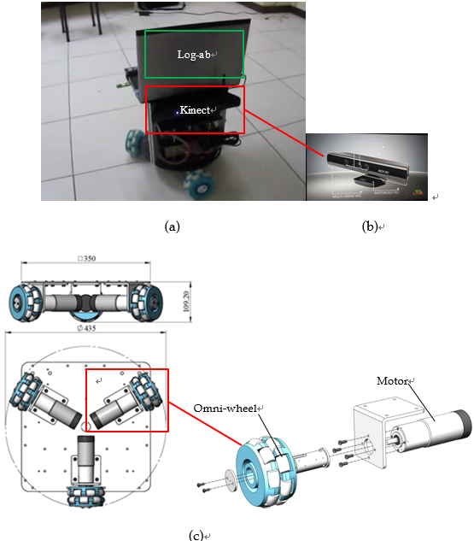
Figure 1. (a) Kinect (red box) mounted on three-wheeled multidirectional robot with Log-ab controller (green box), and (b) clear view of Kinect [17]. (c) Design parameters (mm) of three-wheeled multidirectional robot.

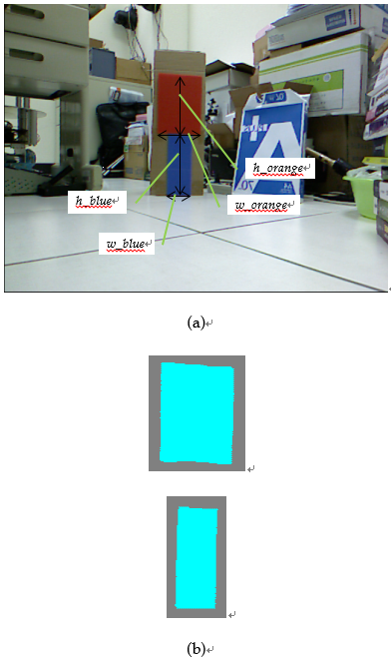
Figure 2. (a) Marker’s parameters (Green lines) in Picture no.1. (b) Segmentation Results of Log-ab image process for the marker of Picture no.1.
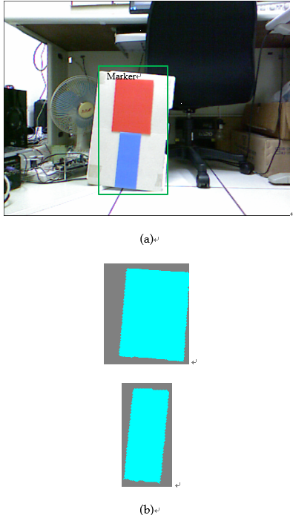
Figure 3. (a) Marker (Green box) in Picture no.2. (b) Segmentation results of Log-ab image process for the marker of Picture no.2.
S/N | Picture no.1 |  | Picture no.2
S/N | Blue template | Orange template | Blue template | Orange template
Case 1 | 0.3258 | 6.1825 | 0.8154 | 4.8027
Case 2 | 0.3017 | 5.8861 | 0.7805 | 4.3998
Case 3 | 0.2943 | 4.1273 | 0.6913 | 3.6747
Case 4 | 0.2539 | 1.0602 | 0.5143 | 1.2138
Case 5 | 0.23 | 0.2672 | 0.2006 | 0.1682

Table 1. Case 1 compares Signal to Noise (S/N) with Cases 2−3 in the images from Figs. 2-3, where Signal denotes the pixels of the marker and the other pixels in the same image belong to Noise.
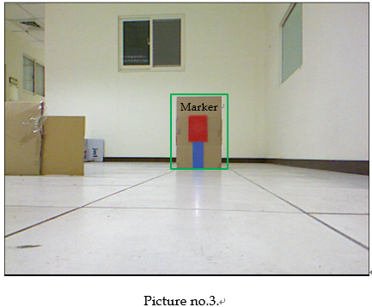
TSR=  Frames of successful correspondence  /Total frames | 18 frames of  Picture no.3
Case 1 | 18/18
Case 6 | 5/18
Case 7 | 4/18

Table 2. (a) One frame of Picture no.3 with Marker (Green box) is captured by Kinect. (b) Tracking Success Rate (TSR) of robot to this kind of marker in Picture no.3 shows the robustness of three cases: SIFT (Case 6), POC (Case 7), the proposed color-based method (Case 1).
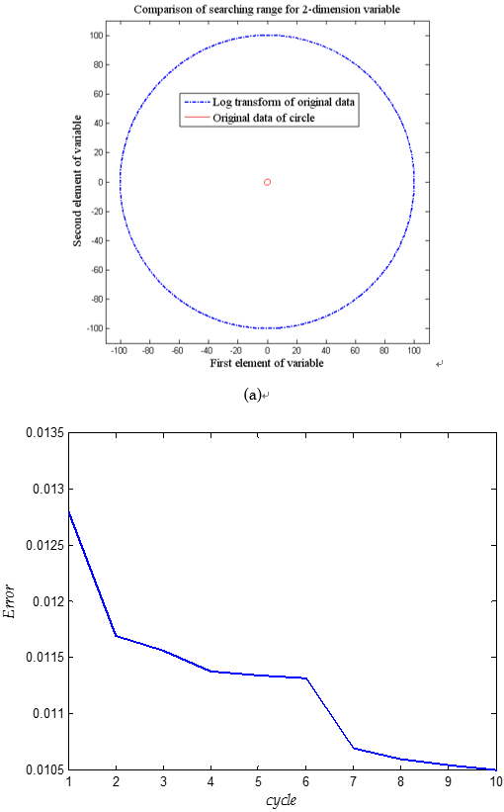
(b)
Figure 4. (a) Result of greedy distribution transform (blue dash-dot points) of circle (red points). (b) Learning curve Error of the proposed dynamic Log-ab algorithm.
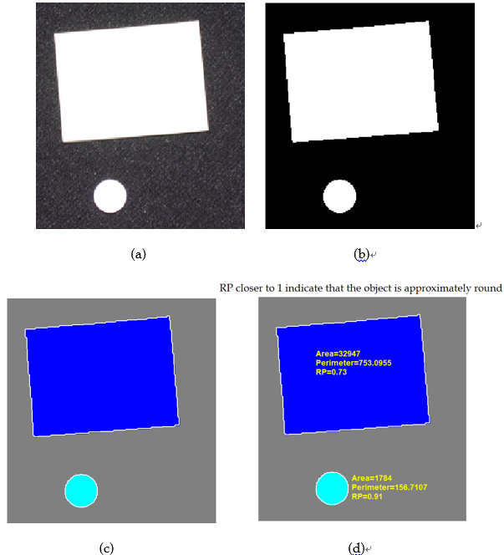
Figure 5. (a) Capture an original image. (b) Convert this image (a) to black and white image. (c) Find the white boundaries in this image (b). (d) Determine each object's Rounding Property (RP) for RPI (Recognition Performance Index) in Algorithm 3.

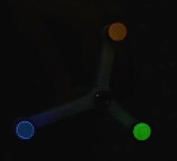
(a) (b)
(c)
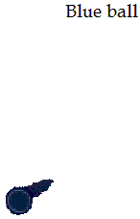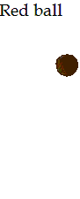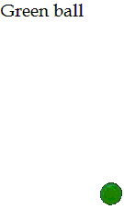
(d)
Figure 6. (a) Acquire an RGB image with three light balls. (b) Calculate sample colors in (‘a’,’b’) color space for each triangular sample region of balls. (c) Display 'a' and 'b' values of the five labeled colors. (d) Only classify each pixel of blue, red, and green balls as figure using the NNC rule.
Figure 7. Result for the robot (in Fig. 1) tracking a marker by setting the desired marker’s position to the 320 pixels width in the image and w_blue_r=55 pixels in the dynamic image whose size is $\text{480}×\text{640}$(pixels²).
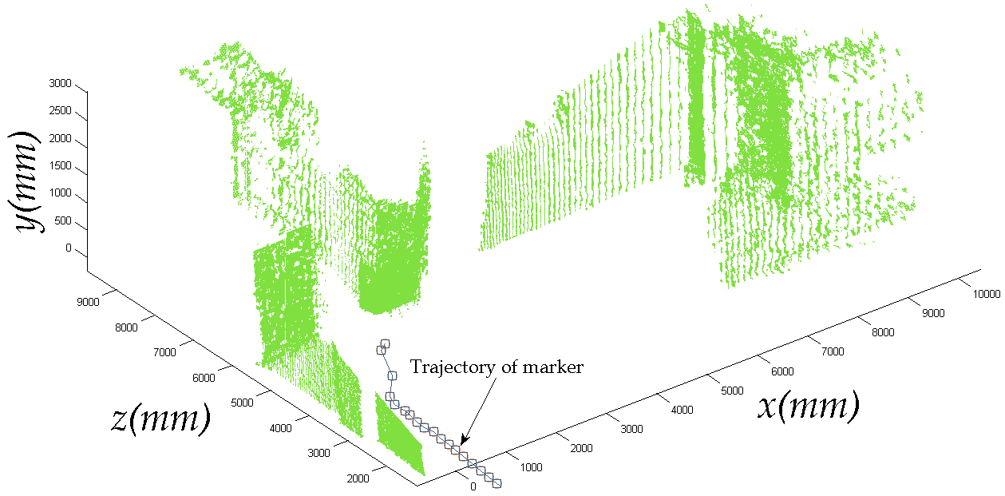
Figure 8. Positioning path (x, z) of a marker in Picture no.3 captured by Kinect on robot for Case 1.
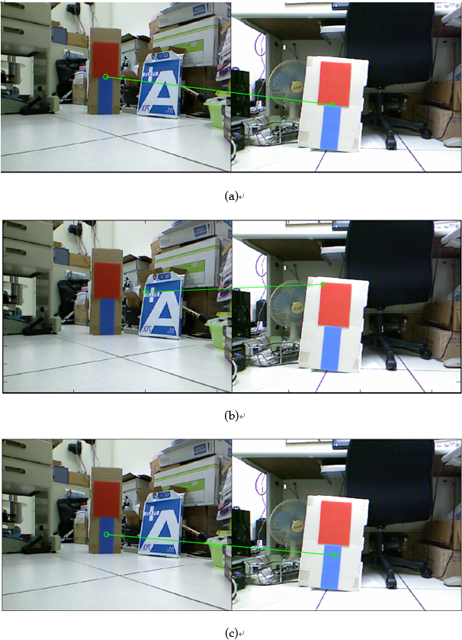
Figure 9. Best result of correspondence points (green circles) in marker for (a) the proposed dynamic Log-ab algorithm, (b) SIFT and (c) POC, respectively.

