JOURNAL OF MEDICINAL FOOD
J Med Food 17 (12) 2014, 1273–1280
# Mary Ann Liebert, Inc., and Korean Society of Food Science and Nutrition DOI: 10.1089/jmf.2013.3002

FULL COMMUNICATIONS

Chlorella Protects Against Hydrogen Peroxide-Induced Pancreatic b-Cell Damage
Chia-Yu Lin,1 Pei-Jane Huang,1 and Che-Yi Chao1,2
1Department of Health and Nutrition Biotechnology, Asia University, Taichung, Taiwan.
2Department of Medical Research, China Medical University Hospital, China Medical University, Taichung, Taiwan.

ABSTRACT Oxidative stress has been implicated in the etiology of pancreatic b-cell dysfunction and diabetes. Studies have shown that chlorella could be important in health promotion or disease prevention through its antioxidant capacity. However, whether chlorella has a cytoprotective effect in pancreatic b-cells remains to be elucidated. We investigated the protective effects of chlorella on H2O2-induced oxidative damage in INS-1 (832/13) cells. Chlorella partially restored cell viability after H2O2 toxicity. To further investigate the effects of chlorella on mitochondria function and cellular oxidative stress, we analyzed mitochondria membrane potential, ATP concentrations, and cellular levels of reactive oxygen species (ROS). Chlorella prevented mitochondria disruption and maintained cellular ATP levels after H2O2 toxicity. It also normalized intracellular levels of ROS to that of control in the presence of H2O2. Chlorella protected cells from apoptosis as indicated by less p-Histone and caspase 3 activation. In addition, chlorella not only enhanced glucose-stimulated insulin secretion (GSIS), but also partially restored the reduced GSIS after H2O2 toxicity. Our results suggest that chlorella is effective in amelioration of cellular oxidative stress and destruction, and therefore protects INS-1 (832/13) cells from H2O2-induced apoptosis and increases insulin secretion. Chlorella should be studied for use in the prevention or treatment of diabetes.

KEY WORDS: ● b-cell ● chlorella ● insulin ● oxidative stress

INTRODUCTION
iabetes is characterized by hyperglycemia and is associated with defects in insulin action and/or secre-
D
beneficial effects on overall health and disease prevention. Chlorella has been reported to possess antioxidative and anti-inflammatory properties both in in vitro and in vivo
13,14

tion, and pancreatic b-cell failure.1,2 Studies have suggested
studies.
Moreover, administration of chlorella im-

that increased levels of reactive oxygen species (ROS) might
proves glucose tolerance, insulin sensitivity, or insulin
15,16

have a role in causing b-cell dysfunction.2–4 Although
secretion both in normal or diabetic animals.
However,

ROS are produced during normal cellular metabolism and have physiological roles in cellular signaling systems,
other studies indicate chlorella may have no hypoglycemic
effect in diabetic rats but could reduce oxidative DNA
17

excessive ROS production may cause damage to cellular
damage and lipid peroxidation.
Since there is an increase

components.2,5,6 Moreover, mitochondrial dysfunction has been observed in pancreatic b-cells and other tissues in diabetes.7,8 In fact, the mitochondrial ROS-mediated dys- function could disrupt glucose-induced insulin secretion and modify cellular signal transductions, which influ- ence the pathogenesis of diabetes and its complications.9,10 It is possible that strategies for reducing cellular oxida- tive stress could prevent pancreatic b-cell damage and diabetes.
Chlorella has been used as dietary supplements in Japan and Taiwan, and it provides rich source of protein, poly- unsaturated fatty acids, many dietary antioxidants, vita- mins, and minerals.11,12 Many studies13–16 have shown

Manuscript received 29 July 2013. Revision accepted 2 July 2014.

Address correspondence to: Chia-Yu Lin, PhD, Department of Health and Nutrition Biotechnology, Asia University, 500, Lioufeng Road, Wufeng, Taichung 41354, Taiwan, E-mail: chiayulin@hotmail.com
in pancreatic b-cell damage and oxidative stress in diabe-
tes and there have been few studies on the direct effects of chlorella on pancreatic b-cell, this study was aimed to investigate the protective effects of chlorella on pancreatic b-cell after H2O2 toxicity.
MATERIALS AND METHODS
Cell culture
INS-1 (832/13) cells18 were kindly provided by Dr. Christopher Newgard (Duke University Medical Center, Durham, NC, USA). Cells were cultured in RPMI 1640 culture medium, supplemented with 10% fetal calf serum, 2 mM l-glutamine, 1 mM sodium pyruvate, 10 mM HEPES, 50 lM 2-mercaptoethanol, 100 U/mL penicillin, and 100 lg/ mL streptomycin (Gibco BRL Life Technologies, Grand Island, NY, USA) in a humidified atmosphere at 37°C and 5% CO2. Culture medium was changed the day after seeding and subsequently every other day.

1273

Chlorella preparation
Chlorella sp. DT, a desiccation-tolerant green alga iden- tified by Chen and Lai19 is routinely cultured at an initial concentration of 4 lg chlorophyll per milliliter in 100 mL Chlorella-medium with addition of 0.5% glucose in 250 mL flasks at 28°C in orbital incubator.20 The growth of algal culture was monitored by measuring chlorophyll content. Chlorella with at least 1 mg chlorophyll was collected and washed several times and harvested by centrifugation. Sample pellets were then mixed in 100 mL distilled water followed by homogenization. Final homogenized superna- tant was filtered and freeze-dried to obtain the lyophilized form of Chlorella. Chlorella stock solution was prepared in ethanol at 100 mg/mL.

MTT assay
INS-1 cells (3.5 · 104) were seeded in 100 lL culture me- dium in 96-well microplates and allowed to attach for a period of 24 h before treatment with chlorella and/or H2O2. After 24 h treatment with chlorella (150 and 300 lg/mL) and/or H2O2 (250 lM), the viability of the cells was determined us- ing a microtiter plate-based 3-(4,5-dimethylthiazol-2-yl)-2,5- diphenyl-terazolium bromide (MTT) assay (Sigma-Aldrich, St. Louis, MO, USA). This assay assesses the integrity of mitochondrial function. Briefly, at the end of treatment, the culture medium was changed to medium containing 1 mg/mL MTT solution (5 mg/mL stock solution in phosphate-buffered saline [PBS]) for 2 h according to the manufacturer’s in- structions.21 Cells were incubated with 60 lL MTT for 3 h in a CO2 incubator, after which 100 lL of 0.4 N HCI in 99% isopropanol was added to dissolve the formed formazan crystals. The absorbance was measured at a wavelength of 570 nm with a reference setting of 690 nm on a microplate reader (Synergy Mx; BioTek, Winooski, VT, USA). Percent viability was calculated by comparing with vehicle control. Percentage viability was calculated using the formula:
was used to estimate the proportion of cells in different phase of cell cycle. Cells that were sub-diploid ( < 2n) are apoptotic and quantified by Cell Lab Quanta SC Flow Cytometer (Beckman Coulter, Inc., Brea, CA, USA).

Cell proliferation
To study the effect of chlorella on the proliferation rate,
3.5 · 104 cells seeded in 96-well microplates were treated with chlorella 300 or 150 lg/mL for 24 h, and H2O2 300 lM was added to cells treating with chlorella 4 h before the end of treatment. At the end of treatment, cells were quantified by the colorimetric 5-bromo-20-deoxyuridine (BrdU) cell prolifera- tion assay from Calbiochem (Billerica, MA, USA). BrdU is incorporated into newly synthesized DNA strands of prolif- erating cells; therefore, the extent of BrdU incorporation is reflected in the intensity of absorbance of the final reaction.23 Data are expressed in percent of ethanol treated control cells.

Assessments of mitochondrial membrane potential
8 · 100,000 cells were seeded in 12-well 1 day before treatment. On the day of treatment, culture medium was changed to medium containing 300 or 150 lg/mL of chlor- ella and kept for 24 h before collecting for flow cytometry analysis of mitochondrial membrane potential (MMP). H2O2 300 lM was added 2 h before the end of treatment. Cellular MMP was determined after chlorella and H2O2 treatment. Changes in the MMP were measured by flow cytometry using JC-1 10 lg/mL (Molecular Probes, Eugene, OR, USA). JC-1 forms aggregates in cells with a high FL-2 fluorescence during a normal MMP, while loss of membrane potential results in a reduction in FL-2 fluorescence and a shift to monomeric state in FL-1 fluorescence. Briefly, cells were trypsinized, washed in PBS, and resuspended in JC-1 for 15 min at 37°C.22 After which, cells were washed with PBS twice and resuspended in PBS. The 10,000 cells were analyzed for fluorescence for each sample in a FL-1

Mean absorbance of sample — Mean absorbance of medium

Viability (%) ¼ Mean absorbance of control
—
· 100
Mean absorbance of medium

Measurement of DNA content
8 · 100,000 cells were seeded in 12-well 1 day before treatment. On the day of treatment, culture medium was changed to medium containing 300 or 150 lg/mL of chlor- ella and kept for 24 h before collecting for flow cytometry analysis of the DNA content. H2O2 300 lM was added 4 h before the end of treatment. Briefly, cells were collected by centrifugation at 162 · g for 10 min. Cells were then washed in PBS followed by resuspension and fixation in ice- cold 95% ethanol for at least 24 h. Following washes with PBS, cells were incubated in PI/RNAse solution (50 lg/mL propidium iodide, 0.05% Triton-X 100, and RNAse A
0.1 mg/mL) at 37°C for 30 min.22 Afterward, 10,000 cells were subjected to flow cytometry analysis. Propidium iodide
(525 nm, green) versus FL-2 (575 nm, red) on a Cell Lab Quanta SC Flow Cytometer (Beckman Coulter, Inc.).

Measurements of ATP levels
About 4 · 100,000 cells were seeded in a 24-well plate 1 day before treatment. On the day of treatment, culture me- dium was changed to medium containing 300 or 150 lg/mL of chlorella and kept for 24 h before collecting for cellular ATP analysis. H2O2 300 lM was added 2 or 4 h before the end of treatment. Cells were exposed to chlorella and H2O2. Cellular ATP levels were then quantified using a fluoro- metric assay kit. Briefly, cells were rinsed with PBS and lysed in ATP assay buffer. Cell lysate was then taken for ATP concentrations analysis according to the manufacturer’s

instruction. A standard curve was generated using solutions of known ATP concentrations. Portions of lysates were used for protein determination. ATP levels were calculated and corrected for protein.24 Data are normalized to the levels in ethanol-treated control.
DPPH assay
The antioxidant activity of chlorella was determined using 2,2-diphenyl-1-picryl-hydrazyl-hydrate (DPPH) as a free radical. The test compound was diluted in a 1:1 ratio with the DPPH solution (0.5 mM in methanol).25 The decrease in ab- sorbance was determined at 517 nm after 30 min of reaction using a microplate reader (Synergy Mx). The ability to scavenge DPPH radical was measured by the discoloration of the solution. Ascorbic acid was used as positive control.
Measurement of intracellular ROS production
Around 8 · 100,000 cells were seeded in 12-well 1 day before treatment. On the day of treatment, culture medium was changed to media containing 300 or 150 lg/mL of chlorella and kept for 24 h before ROS measurement. H2O2 300 lM was added 2 h before the end of treatment. In- tracellular ROS generation was measured by 5-(and-6-) chloromethyl-20,70-dichlorodihydrofluorescein diacetate (CM- H2DCFDA) (Invitrogen, Grand Island, NY, USA). Cells were incubated in the dark with 10 lM CM-H2DCFDA at 37°C for 45 min and then washed twice with PBS. Oxidation of H2DCFDA by ROS finally converts the molecule to fluo- rescent DCF. Cells were collected and absorbance was de- termined at 480/520 nm using a Synergy Mx microplate reader. Cells were lysed in RIPA buffer for protein analysis.24 Intracellular ROS are expressed as fold change of the fluo- rescence intensity normalized to protein contents against ethanol-treated control cells.
Insulin secretion
4 · 100,000 cells were seeded in 24-well 1 day before treatment. On the day of treatment, culture medium was changed to media containing 300 or 150 lg/mL of chlorella and kept for 24 h before insulin secretion analysis. H2O2 300 lM was added 2 h before the end of treatment. At the end of the experiment, acute insulin release in response to glucose was performed. Cells were washed and preincubated (30 min) in Krebs–Ringer bicarbonate buffer (KRB) containing 2.8 mM glucose and 0.5% bovine serum albumin. KRB was then re- placed by KRB 2.8 mM glucose for 1 h (basal state), followed by an additional 1 h in KRB 16.7 mM glucose (glucose stim- ulated state).26 Supernatants from both basal and glucose stimulated states were collected for insulin secretion analysis using rat insulin ELISA kit (Millipore, Billerica, MA, USA).
Western blot
2.5 · 106 cells were seeded in six-well plates 1 day before treatment. On the day of treatment, culture medium was changed to media containing 300 or 150 lg/mL of chlorella and kept for 24 h. H2O2 300 lM was added 5 h before the end of treatment. At the end of the treatment, cells were washed in
PBS and collected in RIPA buffer (50 mM Tris-HCl, pH 8.0, 150 mM sodium chloride, 1.0% NP-40, 0.5% sodium deox- ycholate, and 0.1% sodium dodecyl sulfate [SDS]; Sigma- Aldrich) with protease and phosphatase inhibitor cocktail (Sigma-Aldrich). Whole cell lysates were then incubated on ice for 10 min and cleared by centrifugation at 8000 g for 10 min at 4°C to pellet cell debris. Protein concentrations of sample supernatants were determined by Bio-Rad protein assay. Samples (60 lg total protein) were then subjected to SDS–polyacrylamide gel electrophoresis and electrically trans- ferred to polyvinylidene fluoride membranes. After transfer, membranes were blocked with 5% nonfat dry milk in TBS with 0.1% Tween 20 (TBS-T) and incubated overnight at 4°C with anti-phospho-Histone H2A.X and anti-caspase 3 (1:1000; Cell Signaling Technology, Danvers, MA, USA), and anti-GAPDH (1:10,000; Millipore) antibodies. Membranes were then washed with TBS-T and incubated with horseradish peroxidase (HRP)- conjugated antibodies (1:5000; Jackson ImmunoResearch Laboratories, Inc., West Grove, PA, USA) for 1 h. Blots were developed using chemiluminescent HRP substrate (Millipore), and they were visualized by ImageQuant LAS 400mini (GE Healthcare, Buckinghamshire, United Kingdom).
Statistical analysis
Statistical analysis was performed using the nonpaired two-tailed t-test. Data are presented as mean – SEM. A P-value < .05 is considered statistically significant.
RESULTS
Improved cell survival and replication by chlorella after H2O2 toxicity
H2O2 treatment decreased viable cells to 55% of controls, whereas chlorella at 150 and 300 lg/mL improved survival by more than 10% and 20%, respectively in the presence of H2O2 after 24 h (Fig. 1, P < .05). There was no significant difference between the two concentrations of chlorella. Chlorella at both

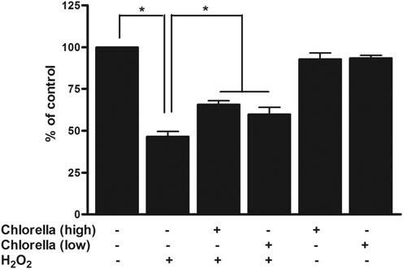
FIG. 1. INS-1 (832/13) cells were treated with chlorella (150 lg/mL) and/or H2O2 (250 lM) for 24 h. 3-(4,5-dimethylthiazol-2-yl)-2,5-diphenyl- terazolium bromide (MTT) assay was then performed to determine cell viability. Chlorella partially restored cell viability after H2O2 toxicity (P < .05). Data are shown as the mean – SEM of six individual experiments.
*indicates statistical significance.

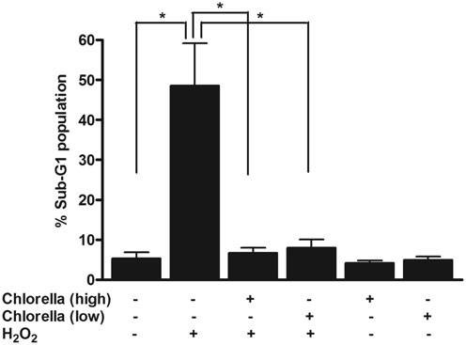
mitochondrial activity by JC-1 and cellular ATP in cells exposed to H2O2. Short-term H2O2 treatment (2 and 4 h) decreased cellular ATP concentration to about one-third of that of control. Chlorella at both concentrations significantly increased ATP levels close to that of control after both 2 and 4h H2O2 treatment (Fig. 4A, P < .05). No differences were found between high and low concentrations of chlorella after either 2 or 4 h H2O2 treatment. This restored cellular ATP also reflects to the recovery of mitochondria membrane potential (Fig. 4B, P < .05) by chlorella at both concentra- tions. Chlorella alone appears to further enhance mito- chondrial function.

FIG. 2. Apoptotic sub-G1 cells were quantified after chlorella 300 lg/mL (high)/150 lg/mL (low) and H2O2 (300 lM, 4 h) treat- ment. Chlorella at both concentrations significantly blocked H2O2- induced cell death (P < .05). Data are shown as the mean – SEM of five to six individual experiments. *indicates statistical significance.
Antioxidative effect of chlorella
Chlorella exhibited the ability to scavenge DPPH radical dose dependently. This DPPH radical reduction effect of

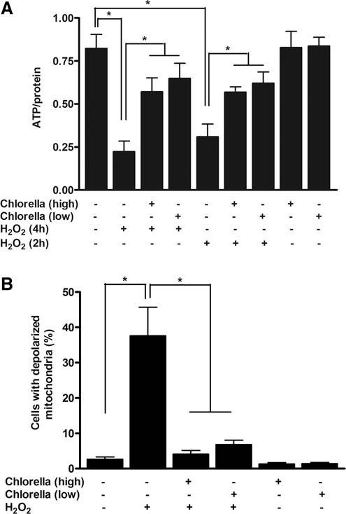
concentrations also dramatically reduced short-term H2O2- induced apoptotic cells as indicated by the decreased sub-G1 cells (Fig. 2, P < .05). Furthermore, this increased number of viable cells by chlorella could therefore enhance BrdU incor- poration in the presence of H2O2 (Fig. 3). There were only about 29% of cells entering S phase of the cell cycle after H2O2 (300 lM, 4 h) treatment. Cell replications were dose dependently partially restored by chlorella in presence of H2O2, and there were about 44% and 59% of cells entering the cell cycle after 150 and 300 lg/mL chlorella treatment, respectively (Fig. 3, P < .05).
Maintenance of mitochondrial function by chlorella after H2O2 toxicity
To address the involvement of chlorella in the preserva- tion of mitochondrial function of b-cells, we examined

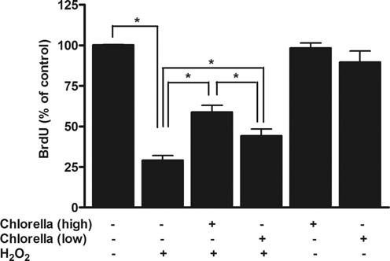
FIG. 3. Cell proliferation was quantified after chlorella 300 lg/mL (high)/150 lg/mL (low) and H2O2 (300 lM, 4 h) treatment. The de- creased cell proliferation after H2O2 toxicity were significantly in- creased with chlorella treatment (P < .05). Data are shown as the mean – SEM. Individual experiments were repeated four times. *in- dicates statistical significance.
FIG. 4. (A) H2O2 (300 lM, 2 and 4 h) treatment lowered ATP con- centration. This lower cellular ATP after H2O2 toxicity was enhanced to the levels similar to that of control with chlorella (low—150 lg/mL and high—300 lg/mL for 24 h) treatment (P < .05). Individual experiments were repeated three to four times. (B) H2O2 (300 lM, 2 h) induced much more mitochondrial membrane potential reduction, which was recovered by the treatment of chlorella (low—150 lg/mL and high— 300 lg/mL for 24 h) (P < .05). Individual experiments were repeated four to six times. Data are shown as the mean – SEM. *indicates sta- tistical significance.

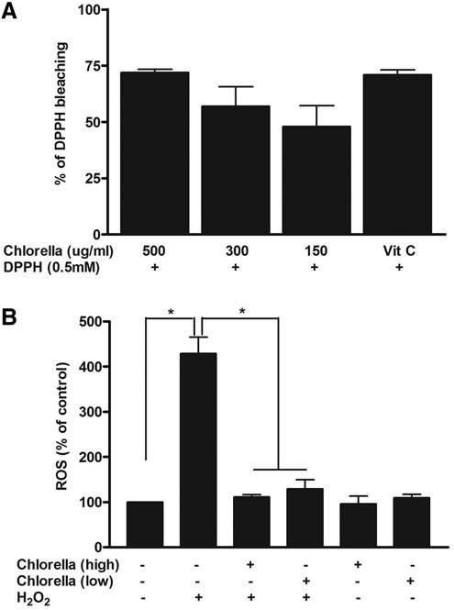

FIG. 5. (A) Chlorella (150–500 lg/mL) showed a dose-dependent 2,2-diphenyl-1-picryl-hydrazyl-hydrate (DPPH) radical bleaching ef- fect. The scavenging effect of chlorella at 500 lg/mL was similar to that of vitamin C (0.5 mM). Individual experiments were repeated four to five times. (B) Cells were exposed to chlorella (low—150 lg/mL and high—300 lg/mL, 24 h) and H2O2 (300 lM, 2 h). Treatment of chlorella significantly decreased intracellular reactive oxygen species (ROS) generation after H2O2 toxicity (P < .05). Individual experiments were repeated five times. Data are shown as the mean – SEM. *in- dicates statistical significance.

chlorella at 500 lg/mL is similar to that of vitamin C (0.5 mM) (Fig. 5A). Since mitochondria represent not only the major source of ROS but also the main target for ROS damage, we also examined cellular ROS levels. Treatment of chlorella both at high or low concentrations dramatically normalized cellular ROS levels after H2O2 toxicity. There was a four-fold increase in ROS with H2O2 treatment alone (Fig. 5B, P < .05).

Improved insulin secretion after chlorella treatment
Glucose at 16.7 mM stimulated insulin secretion in vehicle control cells. Chlorella treatment dose dependently enhanced glucose-stimulated insulin secretion (GSIS). There was a further increase in GSIS after chlorella (300 lg/mL) treat- ment compared with that of vehicle (1.7-fold) (Fig. 6A, P < .05). Chlorella at 150 lg/mL increased GSIS by 1.3-fold, but was not significantly different from the vehicle control. While H2O2 alone negatively affected GSIS, chlorella at 300 lg/mL significantly restored insulin secretion close to

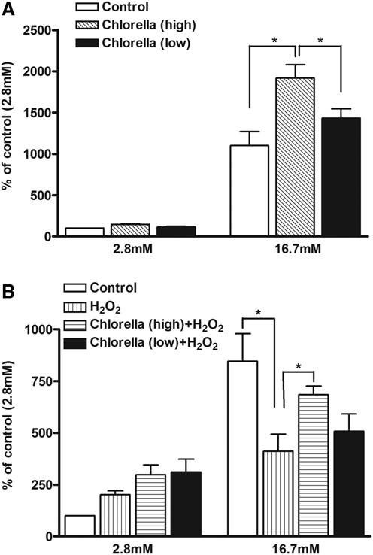
FIG. 6. Cells were tested for glucose-stimulated insulin secretion by static incubation. (A) Chlorella at 300 lg/mL for 24 h induced a much higher level of insulin secretion than that of control (P < .05). Individual experiments were repeated four to six times. (B) H2O2 (300 lM, 2 h) blunted insulin secretion. Chlorella at 300 lg/mL sig- nificantly recovered the reduced insulin secretion due to H2O2 toxicity (P < .05). Individual experiments were repeated three to four times. Data are shown as the mean – SEM. *indicates statistical significance.

80% of vehicle control group (Fig. 6B, P < .05). Chlorella at 150 lg/mL showed a slight but not significant enhancement of insulin secretion.

Chlorella attenuates H2O2-induced apoptosis
To delineate the mechanism of protective effect of chlorella in H2O2-induced cytotoxicity in INS-1 (832/13) cells and protein expressions related to cellular apoptosis were analyzed. H2O2 induction of INS-1 (832/13) cell ap- optosis, as indicated by the enhanced expressions of cleaved caspase 3 and p-Histone, was evaluated. Chlorella signifi- cantly blocked the activation of caspase 3 and p-Histone due to toxic effects of H2O2 (Fig. 7).

DISCUSSION
Diabetes represents one of the serious health burdens with the presence of insulin resistance and the progression of b-

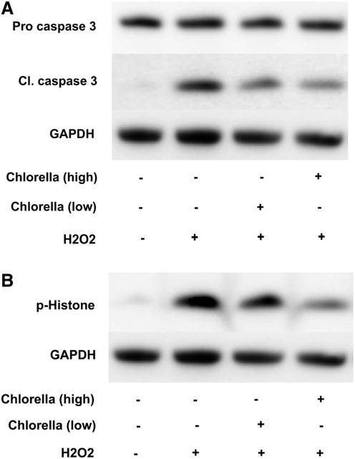
FIG. 7. Protein expressions were quantified after chlorella 300 lg/ mL (high)/150 lg/mL (low) and H2O2 (300 lM, 5 h) treatment. Chlorella significantly blocked H2O2-induced activation of caspase 3
(A) and p-Histone (B). Data are presented as mean – SEM of three independent experiments.

cell dysfunction.27,28 Moreover, oxidative stress is thought to be one of the causes of pancreatic b-cell dysfunction, which adversely affects insulin secretion2 and mediates the patho- genesis of diabetes.29,30 In fact, pancreatic b-cell damage is often related to mitochondrial dysfunction and enhanced ROS production. Several studies have reported that lowering ROS levels and treatment with antioxidants (such as NAC, vitamin C, and vitamin E) improves b-cell destruction and func- tion.31,32 In this study, we have indicated that chlorella inhibits cellular ROS and maintains mitochondrial function in the presence of H2O2. This could lead to a dramatic reduction in cells distributed in the sub-G1 phase, which would possibly be committed to apoptosis. We have observed less activation of caspase 3 and more survived cells. Finally, the b-cells are preserved and insulin secretion is restored.
It has been shown that the impaired mitochondrial function belong to key dysfunctions in the progression of diabetes.33–35 Mitochondria usually play pivotal roles in controlling elec- tron transport, oxidative phosphorylation and ATP produc- tion, release of caspase-activating proteins, and cellular redox potential. When those roles or functions are disrupted, cell death could occur.36 To address the involvement of chlorella preservation of mitochondrial function, we examined mito- chondrial activity by JC-1 and ROS in b-cell exposed to H2O2. We have observed that H2O2 treatment induces an
inhibition of mitochondria membrane potential and ATP production with the parallel detection of enhanced cellular ROS levels and therefore overall cell death occurs. As an early event in the apoptotic pathway,33,37 MMP reduction appears,36 leading to the drops in ATP levels. The mito- chondrial pathway is regulated by Bcl-2 families, which control the release of apoptogenic factors, such as cytochrome c, into cytosol.38 Cytosolic cytochrome c can therefore acti- vate caspase 9, caspase 3, and downstream poly(ADP-ribose) polymerase (PARP) cleavage.39 It has been shown that Bcl-2 can prevent ROS production and oppose the effect of Bax, which further inhibit caspase activation and cell apopto- sis.38,40 In this study, chlorella significantly increases ATP and inhibits ROS levels, which reflects mitochondrial function and therefore the recovered numbers of functional b-cell. There is an increase in cell viability with a decrease in apoptotic cells after chlorella treatment in the presence of H2O2 toxicity. In fact, mitochondria are not only central for b-cell function, but also an important mediator for b-cell apoptosis.33,37 We have observed that mitochondria-dependent apoptotic signals such as disruption of MMP and activation of caspase 3, followed by histone protein phosphorylation, resulting in cellular DNA fragmentation and apoptosis, are significantly increased by H2O2, and the activations of death signals are dramatically inhibited by chlorella treatment. More viable cells can enter the proliferation phase. It could be speculated that chlorella attenuates H2O2-induced pancreatic b-cell disruption possibly through the modulation of anti-apoptotic Bcl-2 and Bcl-xl proteins, cytochrome c release, or other mitochondria-mediated apoptotic pathways. Furthermore, pancreatic b-cells are par- ticularly sensitive to oxidative stress as they contain relatively low antioxidant capabilities, such as superoxide dismutase, catalase, and glutathione peroxidase, making them vulnerable to oxidative stress induced b-cell death.3,6 Chlorella could possibly alter cellular antioxidant status and decrease oxi- dative burdens on cells, and therefore protect b-cell.
High concentrations of H2O2 negatively influence MMP and ATP generation, and Ca2 + influx,41 which play a critical role in regulating insulin secretion in pancreatic b-cell.41,42 Because the decreased ATP production could lead to the opening of K+ ATP channels and cell membrane hyperpo- larization, which will close voltage-dependent Ca2 + chan- nels, eventually insulin secretion will be inhibited.43 In this study, chlorella treated alone or in the presence of H2O2 could enhance or partially correct GSIS. It can be expected that Ca2 + influx might be modulated by chlorella treatment. Chlorella might play a role in supporting health or disease prevention according to the results of numerous studies. These include anticancer effect, enhancing hepatic choles- terol degradation and reducing serum cholesterol, and pre- venting dyslipidemia,44–47 besides improving glucose metabolism, insulin sensitivity, or oxidative stress.13–17 Al- though a previous in vivo study15 evaluated insulin sensi- tivity, the effects of chlorella on insulin secretion are not known. Despite the positive effects of chlorella on metabolic regulations from in vivo studies, it is not clear how chlorella acts directly in b-cell. It is possible that those being observed in in vivo studies of chlorella with diabetic improvement

could be partially due to the direct effect of chlorella in b-cell. In conclusion, our data suggest that chlorella may protect pancreatic b-cell against H2O2 toxicity, which might be re- lated to its effects on mitochondria function recovery and decrease of oxidative stress, leading to the decreased apo- ptosis. Finally, more b-cells are preserved and insulin se- cretion is increased. Therefore, chlorella should be studied in animal models and humans for possible efficacy in the pre- vention or treatment of diabetes.
ACKNOWLEDGMENTS
This study was supported by grants from the National Science Council in Taiwan (NSC 99-2632-B-468-001-MY3 and NSC 102-2320-B-468-003).
AUTHOR DISCLOSURE STATEMENT
The authors declare that no competing financial inter- ests exist.
REFERENCES
- Lin Y, Sun Z: Current views on type 2 diabetes. J Endocrinol
2010;204:1–11.
- Evans JL, Goldfine ID, Maddux BA, Grodsky GM: Are oxidative stress-activated signaling pathways mediators of insulin resis- tance and beta-cell dysfunction? Diabetes 2003;52:1–8.
- Lenzen S: Oxidative stress: the vulnerable beta-cell. Biochem Soc Trans 2008;36:343–347.
- Robertson AP: Chronic oxidative stress as a central mechanism for glucose toxicity in pancreatic islet beta cells in diabetes.
J Biol Chem 2004;279:42351–42354.
- Zadak Z, Hyspler R, Ticha A, et al.: Antioxidants and vitamins in clinical conditions. Physiol Res 2009;58 Suppl 1:S13–S17.
- Valko M, Leibfritz D, Moncol J, Cronin MT, Mazur M, Telser J: Free radicals and antioxidants in normal physiological functions and human disease. Int J Biochem Cell Biol 2007;39:44–84.
- Anello M, Lupi R, Spampinato D, et al.: Functional and mor- phological alterations of mitochondria in pancreatic beta cells from type 2 diabetic patients. Diabetologia 2005;48:282–289.
- Ritov VB, Menshikova EV, Azuma K, et al.: Deficiency of electron transport chain in human skeletal muscle mitochondria in type 2 diabetes mellitus and obesity. Am J Physiol Endocrinol Metab 2010;298:E49–E58.
- Sakai K, Matsumoto K, Nishikawa T, et al.: Mitochondrial reactive oxygen species reduce insulin secretion by pancreatic b-cells. Biochem Biophys Res Commun 2003;300:216–222.
- Araki E: Impact of mitochondrial ROS production in the patho-
genesis of diabetes mellitus and its complications. Antioxid Redox Signal 2007;9:343–353.
- Lubitz JA: The protein quality, digestibility, and composition of
algae, chlorella 71105. J Food Sci 1963;28:229–232.
- Christaki E, Florou-Paneri P, Bonos E: Microalgae: a novel in- gredient in nutrition. Int J Food Sci Nutr 2011;62:794–799.
- Guzman S, Gato A, Calleja JM: Anti-inflammatory activities of the marine microalgae. Chlorella stigmatophora and Phaeodacty- lum tricornutum. Phytother Res 2001;15:224–230.
- Amin A: Chemopreventive effect of chlorella on the antioxidant system in DMBA-induced oxidative stress in liver. Int J Phar- macol 2008;4:169–176.
- Cherng JY, Shih MF: Potential hypoglycemic effects of Chlorella in streptozotocin-induced diabetic mice. Life Sci 2005:77; 980–990.
- Jeong H, Kwon HJ, Kim MK: Hypoglycemic effect of Chlorella vulgaris intake in type 2 diabetic Goto-Kakizaki and normal Wistar rats. Nutr Res Pract 2009;3:23–30.
- Aizzat O, Yap SW, Sopiah H, et al.: Modulation of oxidative stress by Chlorella vulgaris in streptozotocin (STZ) induced di- abetic Sprague-Dawley rats. Adv Med Sci 2010;55:281–288.
- Hohmeier HE, Mulder H, Chen G, Henkel-Rieger R, Prentki M, Newgard CB: Isolation of INS-1-derived cell lines with robust ATP-sensitive K + channel-dependent and -independent glucose- stimulated insulin secretion. Diabetes 2000;49:424–430.
- Chen PC, Lai CL: Physiological adaptation during cell dehy- dration and rewetting of a newly-isolated Chlorella species. Physiol Plant 1996;96:453–457.
- Chien LF, Kuo TT, Liu BH, Lin HD, Feng TY, Huang CC: Solar- to-bioH2 production enhanced by homologous overexpression of hydrogenase in green alga Chlorella sp. DT. Int J Hydrogen Energy 2012;37:17738–17748.
- Abate G, Mashana RN, Miorner H: Evaluation of a colorimetric assay based on 3-(4,5-dimethylthiazol-2-yl)-2,5-diphenyl tetra- zolium bromide (MTT) for rapid detection of rifampicin resis- tance in Mycobacterium tuberculosis. Int J Tuberc Lung Dis 1998;2:1011–1016.
- Darzynkiewicz Z, Bruno S, Del Bino G: Features of apoptotic cells measured by flow cytometry. Cytometry 1992;13:795–808.
- Muir D, Varon S, Manthorpe M: An enzyme-linked immuno- sorbent assay for bromodeoxyuridine incorporation using fixed microcultures. Anal Biochem 1990;185:377–382.
- Lu CC, Yang JS, Huang AC, et al.: Chrysophanol induces ne- crosis through the production of ROS and alteration of ATP levels in J5 human liver cancer cells. Mol Nutr Food Res 2010; 54:967–976.
- Wu HC, Chen HM, Shiau CY: Free amino acids and peptides as related to antioxidant properties in protein hydrolysates of mack- erel (Scomber austriasicus). Food Res Int 2003;36:949–957.
- Maedler K, Schulthess FT, Bielman C, et al.: Glucose and leptin induce apoptosis in human beta-cells and impair glucose-stimu- lated insulin secretion through activation of c-Jun N-terminal kinases. FASEB J 2008;22:1905–1913.
- Ashcroft FM, Rorsman P: Diabetes mellitus and the b cell: the last ten years. Cell 2012;148:1160–1171.
- Gupta D, Krueger CB, Lastra G: Over-nutrition, obesity and insulin resistance in the development of b-cell dysfunction. Curr Diabetes Rev 2012;8:76–83.
- Rahimi R, Nikfar S, Larijani B, Abdollahi M: A review on the
role of antioxidants in the management of diabetes and its complications. Biomed Pharmacother 2005;59:365–373.
- Robertson RP, Harmon JS: Diabetes, glucose toxicity, and oxi-
dative stress: a case of double jeopardy for the pancreatic islet b
cell. Free Radic Biol Med 2006;41:177–184.
- Robertson RP, Harmon J, Tran PO, Tanaka Y, Takahashi H: Glucose toxicity in b-cells: type 2 diabetes, good radicals gone bad, and the glutathione connection. Diabetes 2003;52:581–587.
- Cheng Q, Law PK, de Gasparo M, Leung PS: Combination of the dipeptidyl peptidase IV inhibitor LAF237 [(S)-1-[(3-hydroxy-1- adamantyl)ammo] acetyl-2-cyanopyrrolidine] with the angiotensin II type 1 receptor antagonist valsartan [N-(1-oxopentyl)-N-[[20-(1H- tetrazol-5-yl)-[1, 10-biphenyl]-4-yl] methyl]-L-valine] enhances

pancreatic islet morphology and function in a mouse model of type 2 diabetes. J Pharmacol Exp Ther 2008;327:683–691.
- Supale S, Ning L, Brun T, Maechler P: Mitochondrial dysfunc- tion in pancreatic b cells. Trends in Endocrinol Metab 2012; 23:477–487.
- Newsholme P, Gaudel C, Krause M: Mitochondria and diabetes. An intriguing pathogenetic role. Adv Exp Med Biol 2012;942: 235–247.
- Patti ME, Corvera S: The role of mitochondria in the patho- genesis of type 2 diabetes. Endocr Rev 2010;31:364–395.
- Green DR, Reed JC: Mitochondria and apoptosis. Science 1998; 281:1309–1312.
- Chen J, Fontes G, Saxena G, Poitout V, Shalev A: Lack of TXNIP protects against mitochondria-mediated apoptosis but not against fatty acid-induced ER stress-mediated beta-cell death. Diabetes 2009;59:440–447.
- Jourdain A, Martinou JC: Mitochondrial outer-membrane per- meabilization and remodelling in apoptosis. Int J Biochem Cell Biol 2009;41:1884–1889.
- Hong SJ, Dawson TM, Dawson VL: Nuclear and mitochondrial conversations in cell death: PARP-1 and AIF signaling. Trends Pharmacol Sci 2004;25:259–264.
- Yang Y, Wang W, Liu Y, et al.: a-Lipoic acid inhibits high glucose-induced apoptosis in HIT-T15 cells. Dev Growth Differ 2012;54:557–565.
- Maechler P, Jornot L, Wollheim CB: Hydrogen peroxide alters mitochondrial activation and insulin secretion in pancreatic b cells. J Biol Chem 1999;274:27905–27913.
- Li F, Porterfield DM, Zheng XY, Wang WJ, Xu Y, Zhang ZM:
Abnormal mitochondrial function impairs calcium influx in dia- betic mouse pancreatic beta cells. Chin Med J (Engl) 2012;125: 502–510.
- Wiederkehr A, Wollheim CB: Impact of mitochondrial calcium on the coupling of metabolism to insulin secretion in the pan- creatic beta-cell. Cell Calcium 2008;44:64–76.
- Cherng JY, Shih MF: Preventing dyslipidemia by Chlorella pyrenoidosa in rats and hamsters after chronic high fat diet treatment. Life Sci 2005;76:3001–3013.
- Lee HS, Park HJ, Kim MK: Effect of Chlorella vulgaris on lipid metabolism in Wistar rats fed high fat diet. Nutr Res Pract 2008; 2:204–210.
- Shibata S, Hayakawa K, Egashira Y, Sanada H: Hypocholester- olemic mechanism of Chlorella: Chlorella and its indigestible fraction enhance hepatic cholesterol catabolism through up-reg- ulation of cholesterol 7alpha-hydroxylase in rats. Biosci Bio- technol Biochem 2007;71:916–925.
- Sheng J, Yu F, Xin Z, Zhao L, Zhu X, Hu Q: Preparation, identification and their antitumor activities in vitro of poly- saccharides from Chlorella pyrenoidosa. Food Chem 2007;105: 533–539.

